SUPPLEMENTARY MATERIAL
Structure related α-glucosidase inhibitory activity and molecular docking analyses of phenolic compounds from Paeonia suffruticosa
Po-Chun Chen,^{1,2} Bongani Sicelo Dlamini,³ Chiy-Rong Chen,⁴ Yueh-Hsiung Kuo,^{5,6,7} Wen-Ling Shih,⁸ Yun-Sheng Lin,⁹ Chien-Hsing Lee,^{10,11} and Chi-I Chang^{8✉}
✉ Chi-I Chang
changchii@mail.npust.edu.tw
¹Department of Radiation oncology, Pingtung Christian Hospital, Pingtung 90054, Taiwan
²Graduate Institute of Bioresources, National Pingtung University of Science and Technology, Pingtung 91201, Taiwan
³Department of Tropical Agriculture and International Cooperation, National Pingtung University of Science and Technology, Pingtung 91201, Taiwan
⁴Department of Life Science, National Taitung University, Taitung 95002, Taiwan
⁵Department of Chinese Pharmaceutical Sciences and Chinese Medicine Resources, China Medical University, Taichung 40402, Taiwan
⁶Department of Biotechnology, Asia University, Taichung 41354, Taiwan
⁷Chinese Medicine Research Center, China Medical University, Taichung 40402, Taiwan
⁸Department of Biological Science and Technology, National Pingtung University of Science and Technology, Pingtung 91201, Taiwan
⁹Department of Biological Science and Technology, Meiho University, Pingtung 91201, Taiwan
¹⁰Department of Pharmacology, Graduate Institute of Medicine, College of Medicine, Kaohsiung Medical University, Kaohsiung 80708, Taiwan
¹¹Department of Pharmacology, School of Medicine; School of Post-Baccalaureate Medicine, College of Medicine, Kaohsiung Medical University, Department of Medical Research, Kaohsiung Medical University Hospital, Kaohsiung 80708, Taiwan

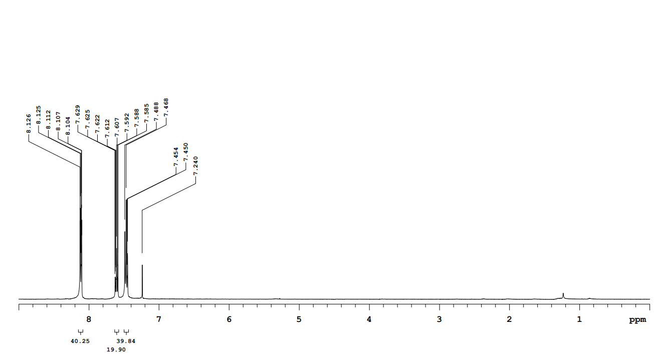
Figure S1. ¹H NMR spectrum for compound 1.

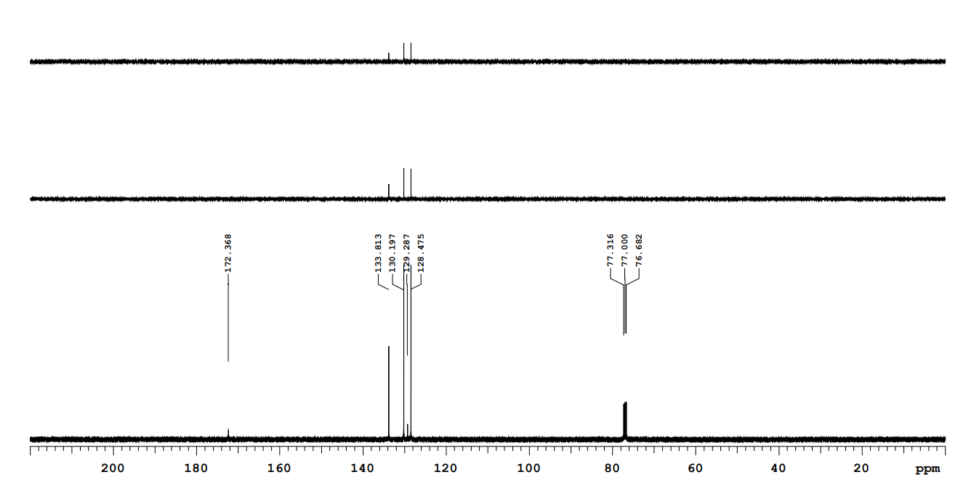
Figure S2. ¹³C NMR spectrum and DEPT for compound 1.
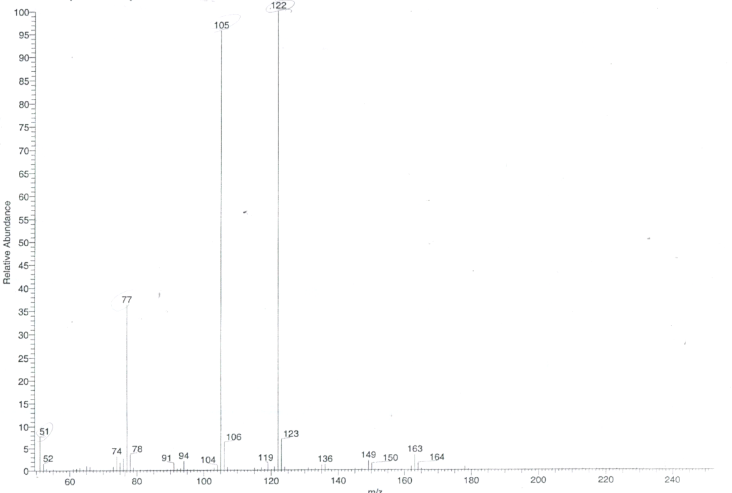
Figure S3. MS spectrum for compound 1.
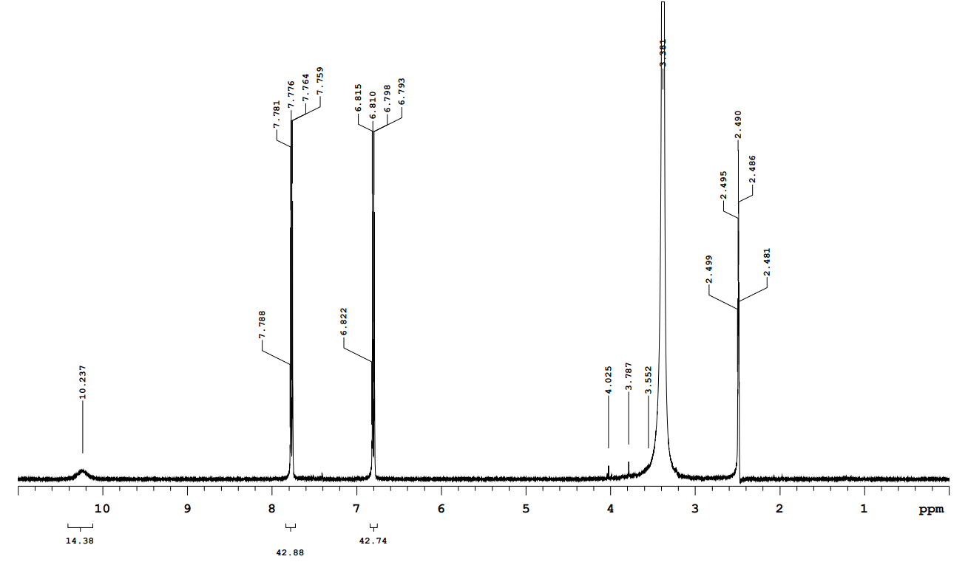
Figure S4. ¹H NMR spectrum for compound 2.
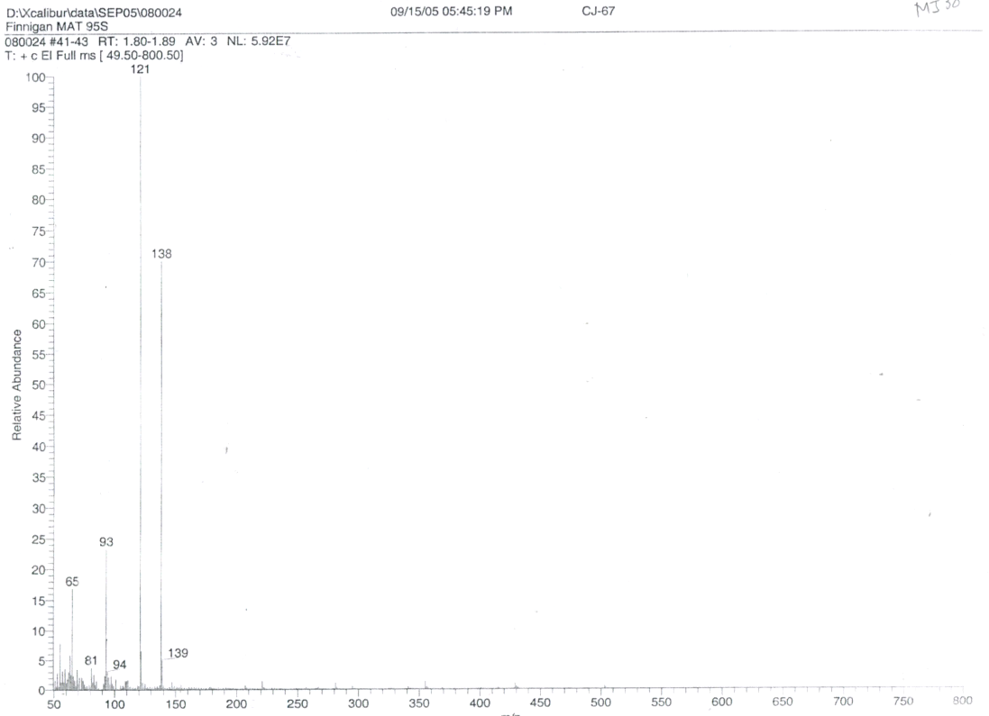
Figure S5. MS spectrum for compound 2.
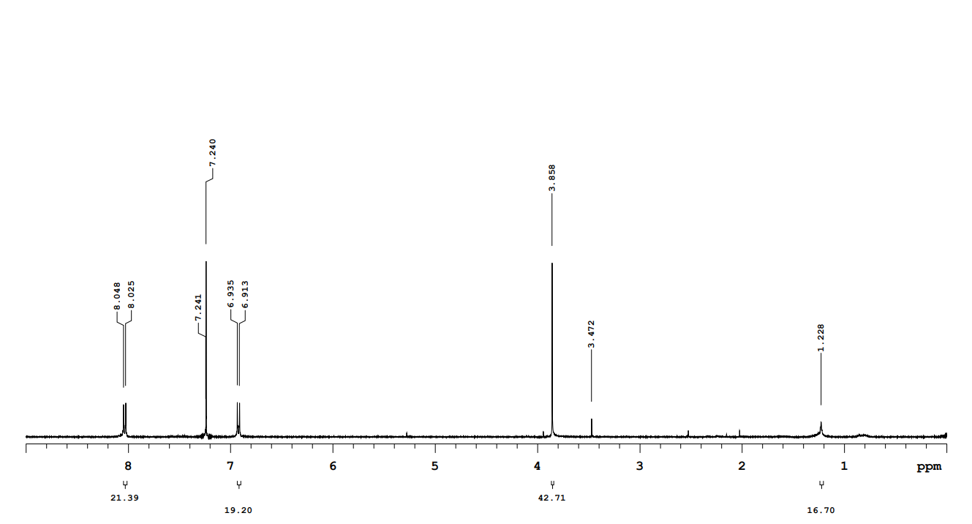
Figure S6. ¹H NMR spectrum for compound 3.
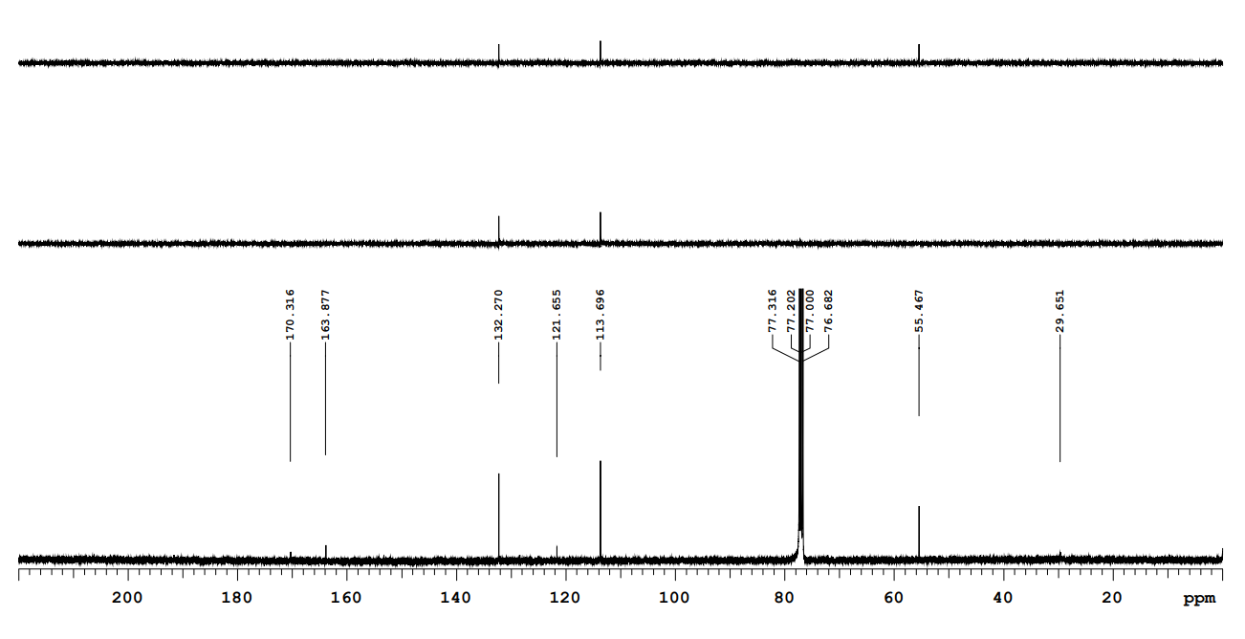
Figure S7. ¹³C NMR spectrum and DEPT for compound 3.
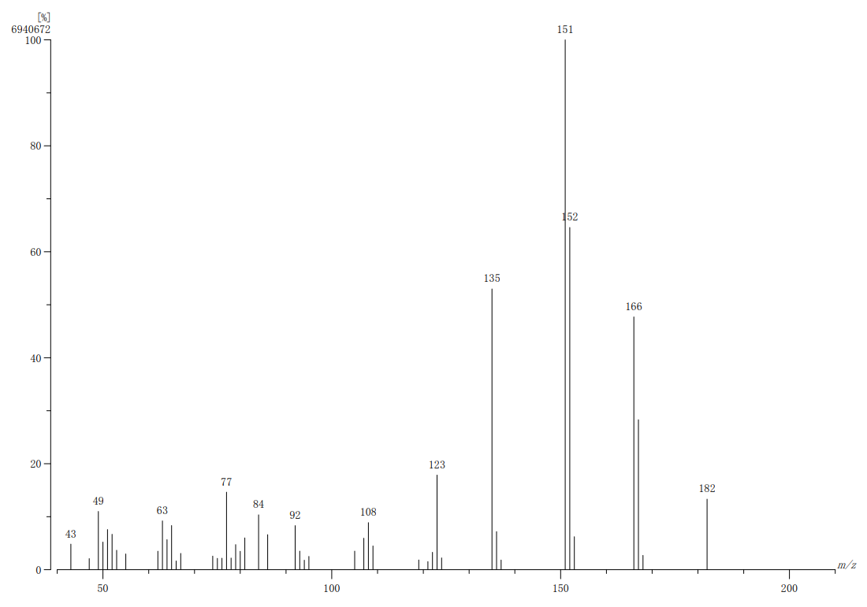
Figure S8. MS spectrum for compound 3.
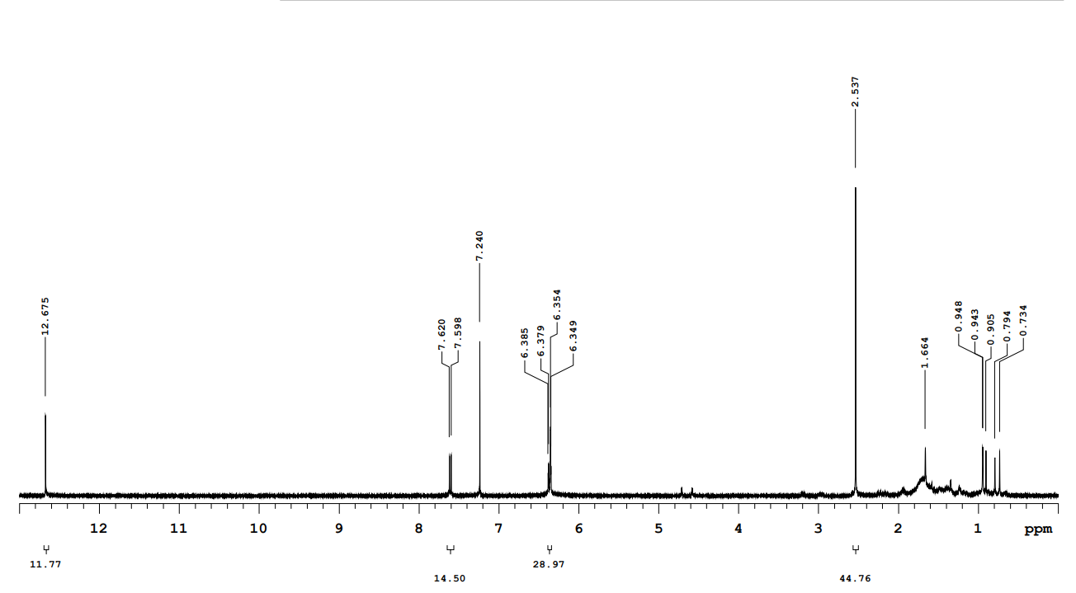
Figure S9. ¹H NMR spectrum for compound 4.
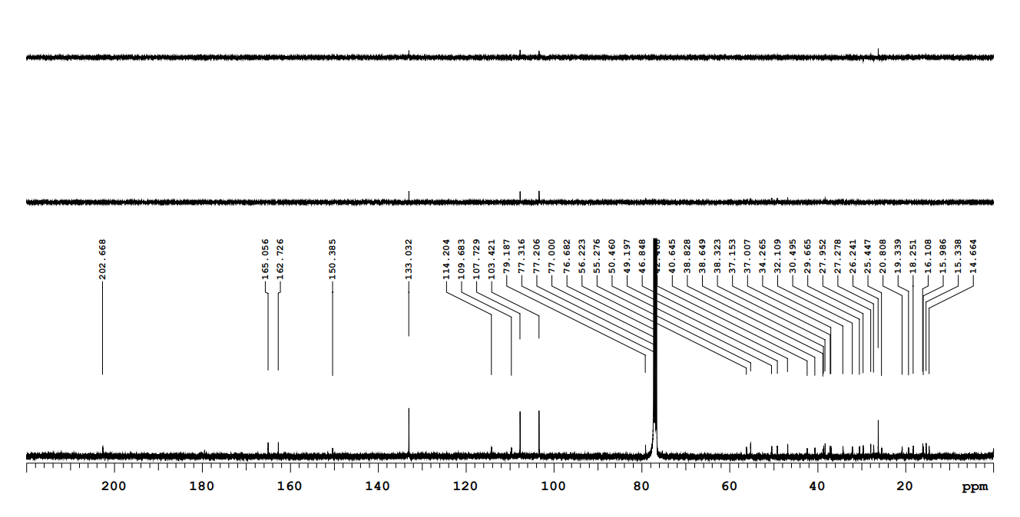
Figure S10. ¹³C NMR spectrum and DEPT for compound 4.
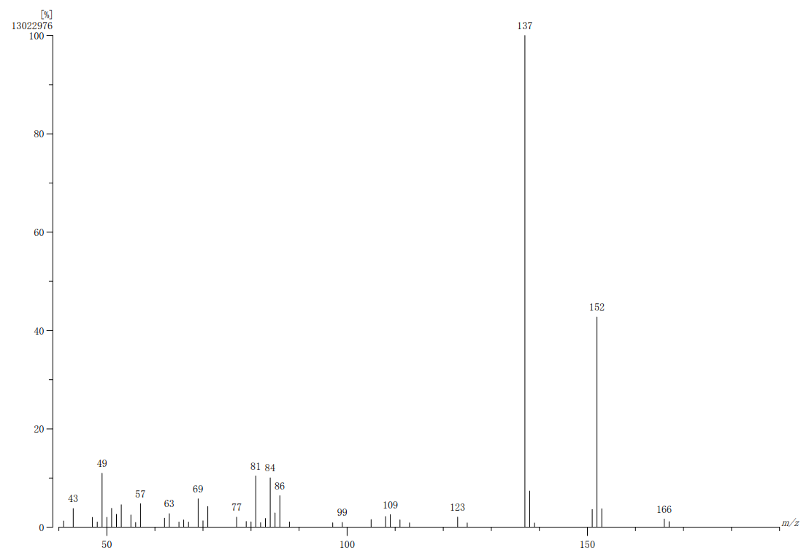
Figure S11. MS spectrum for compound 4.
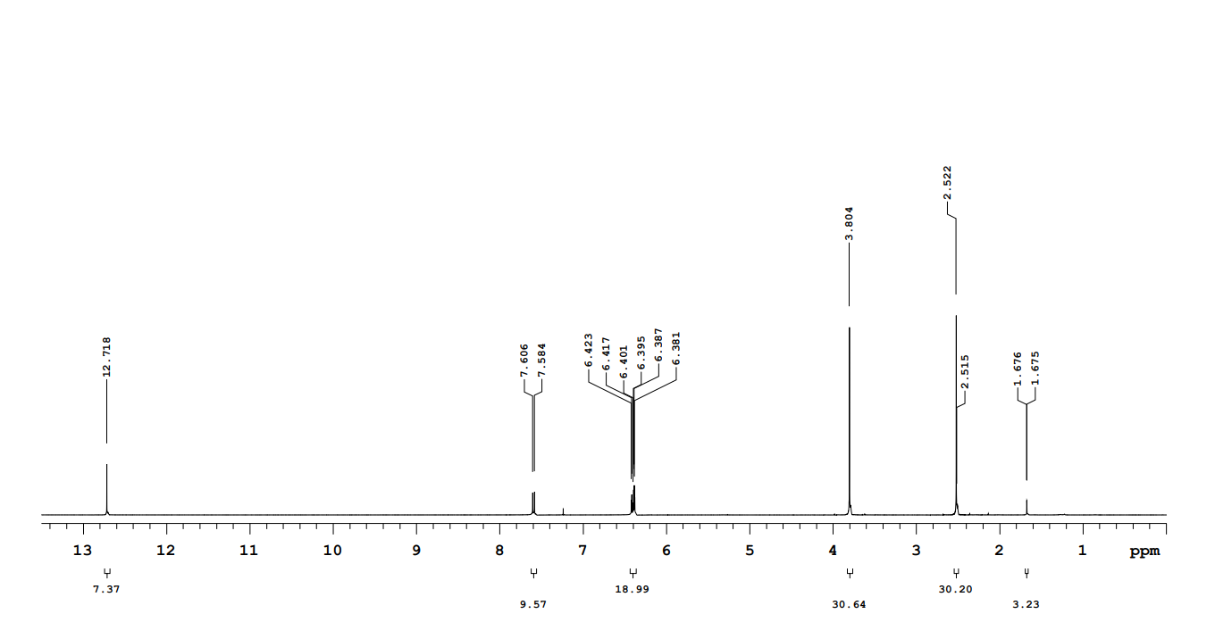
Figure S12. ¹H NMR spectrum for compound 5.

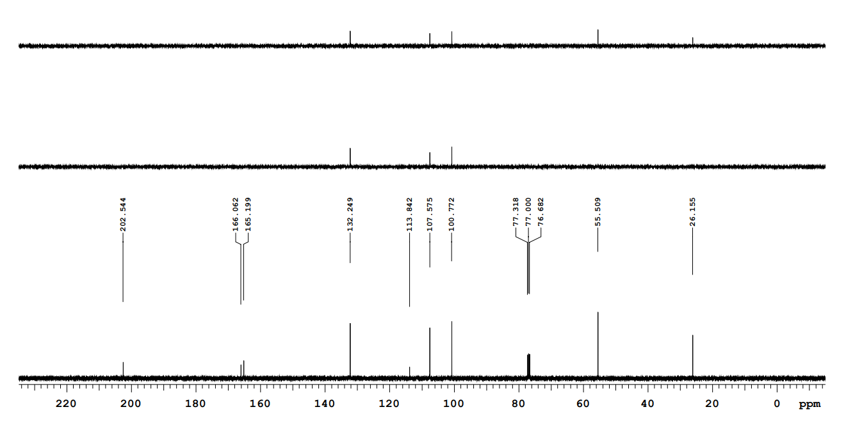
Figure S13. ¹³C NMR spectrum and DEPT for compound 5.

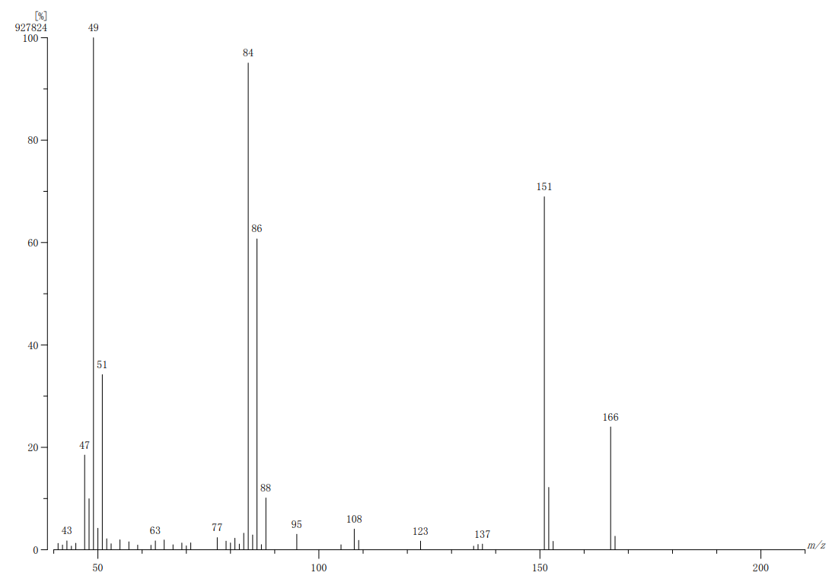
Figure S14. MS spectrum for compound 5.

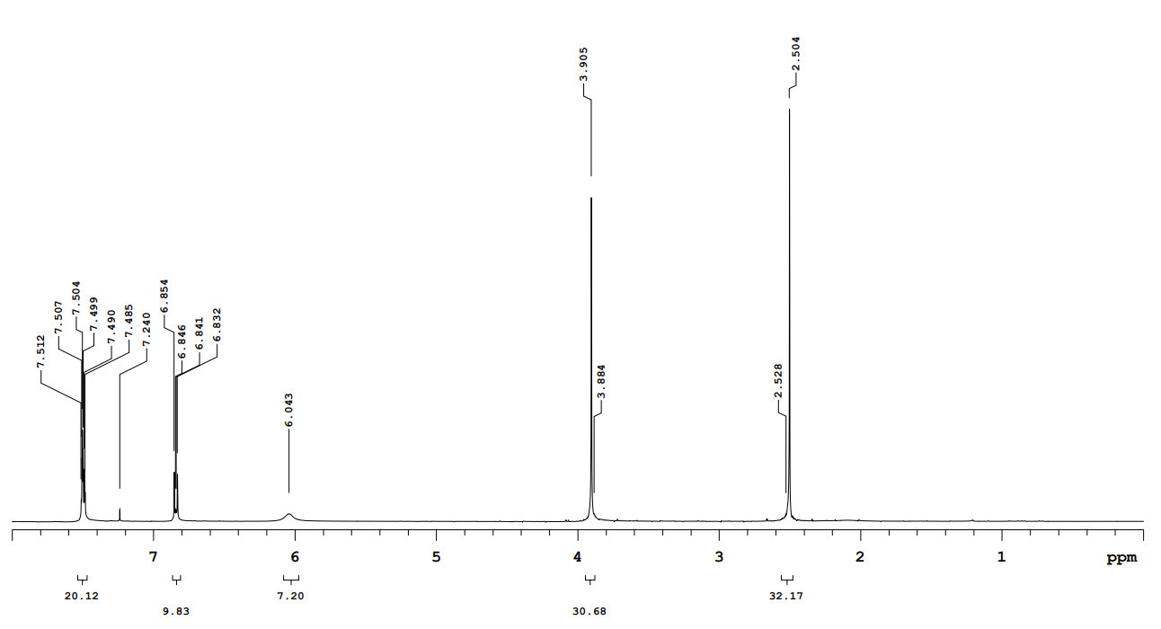
Figure S15. ¹H NMR spectrum for compound 6.

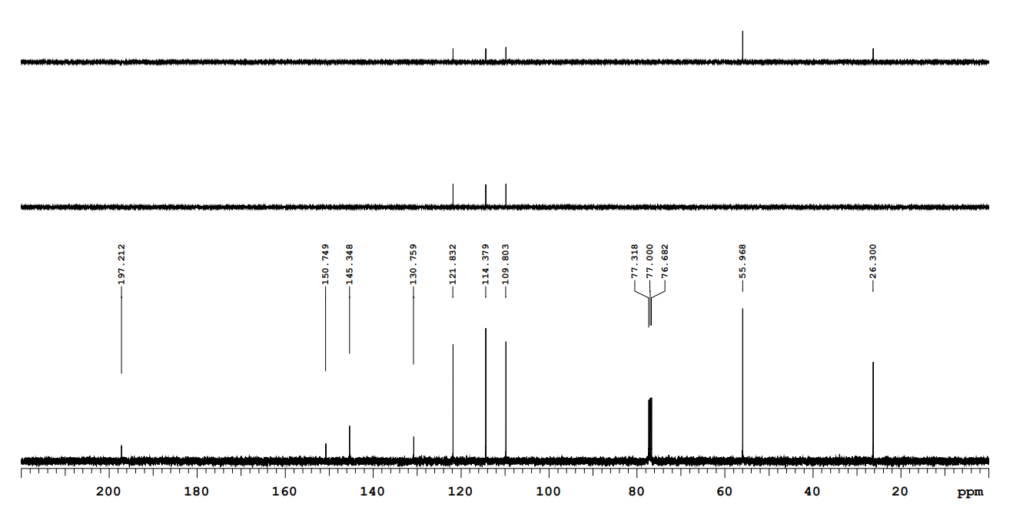
Figure S16. ¹³C NMR spectrum and DEPT for compound 6.
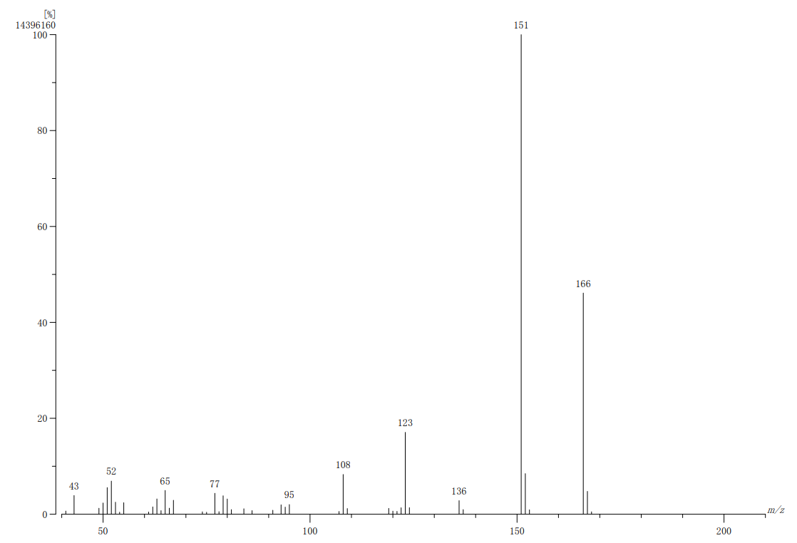
Figure S17. MS spectrum for compound 6.
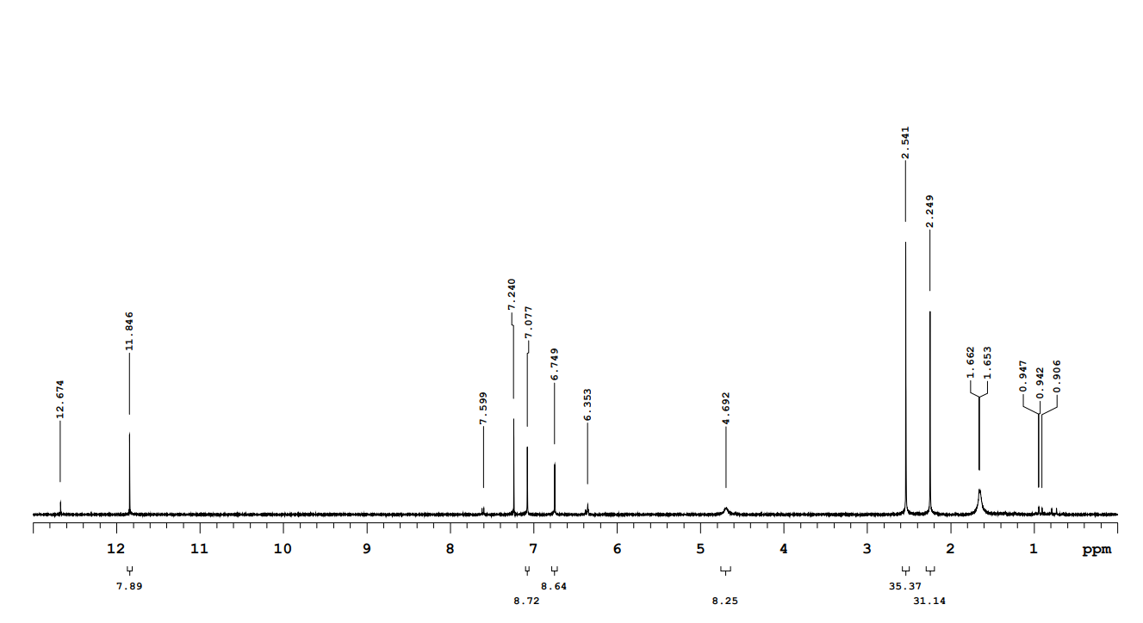
Figure S18. ¹H NMR spectrum for compound 7.

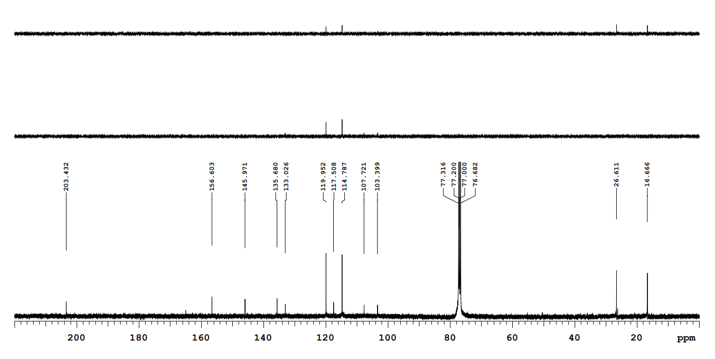
Figure S19. ¹³C NMR spectrum and DEPT for compound 7.

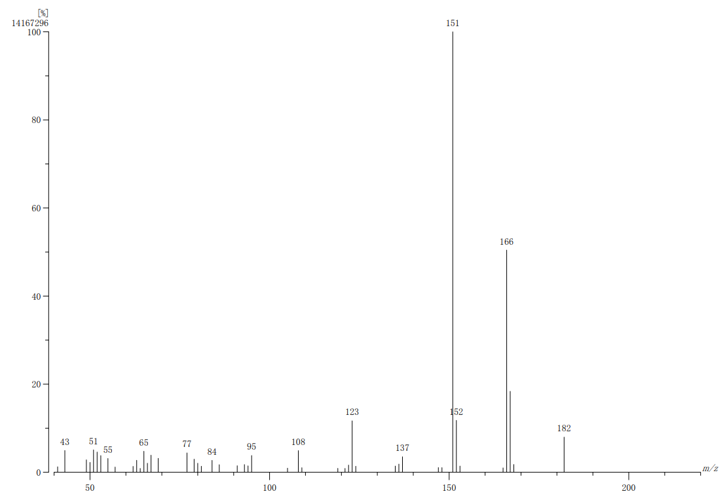
Figure S20. MS spectrum for compound 7.

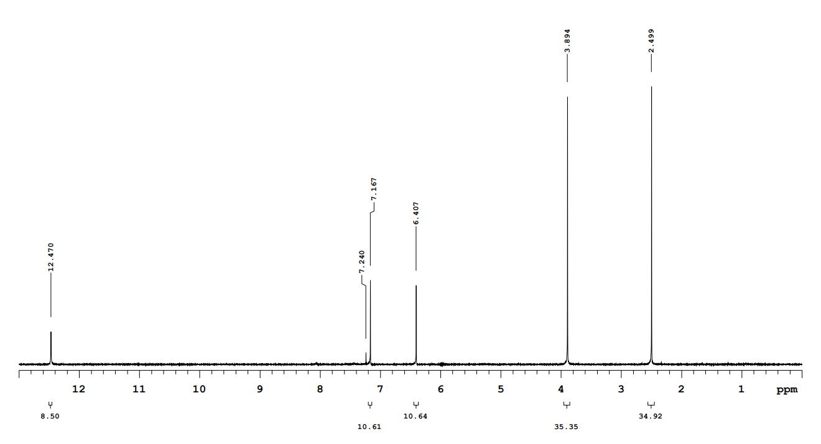
Figure S21. ¹H NMR spectrum for compound 8.

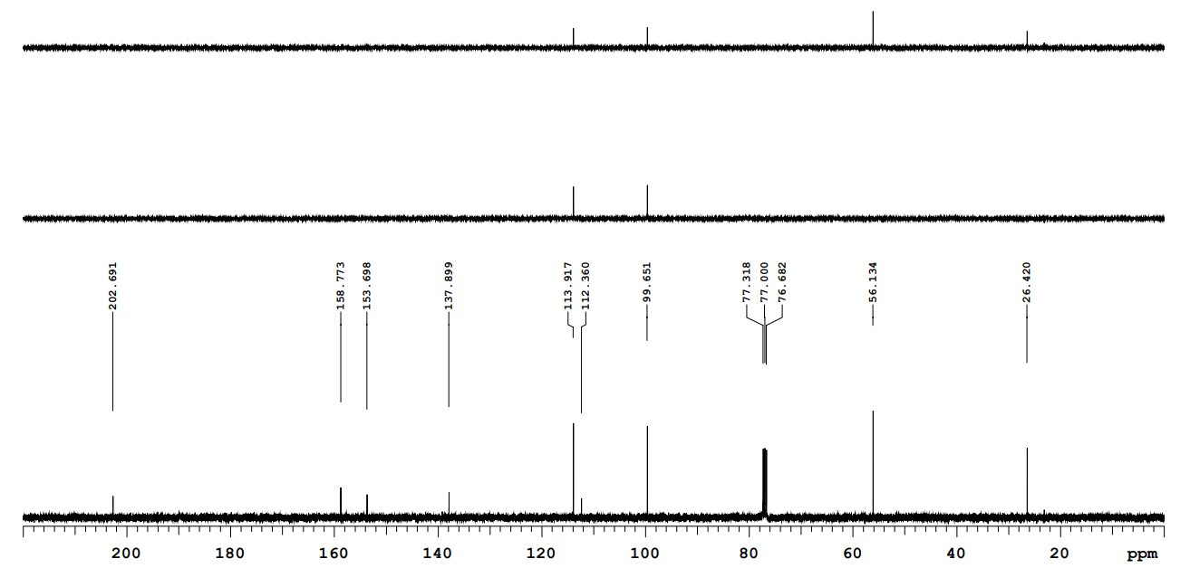
Figure S22. ¹³C NMR spectrum and DEPT for compound 8.

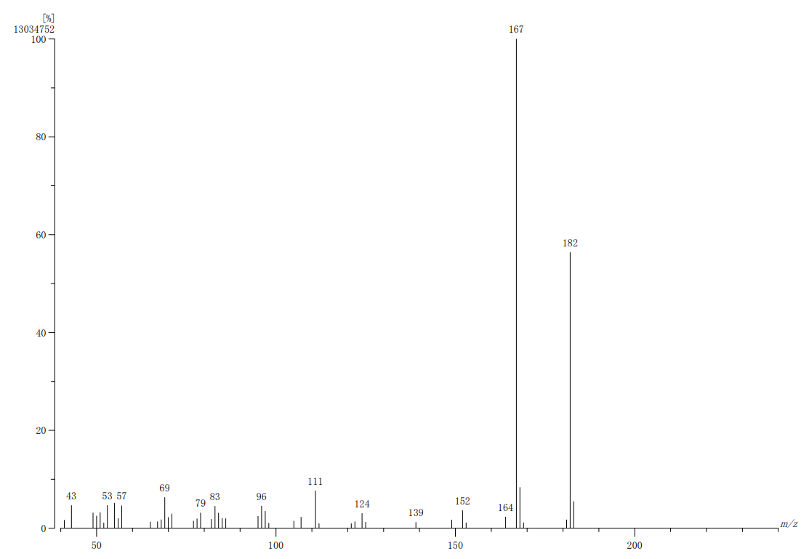
Figure S23. MS spectrum for compound 8.
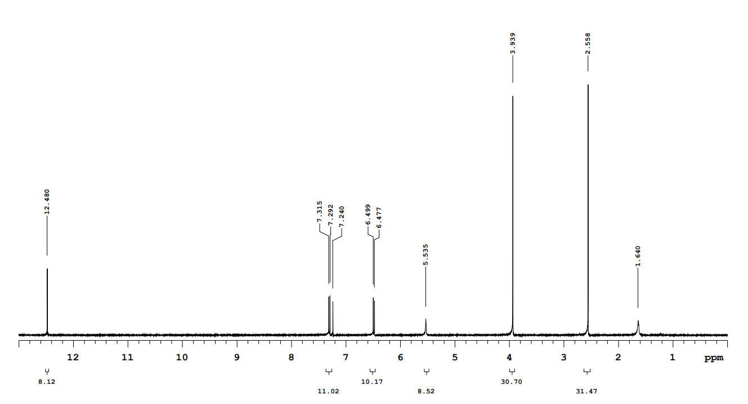
Figure S24. ¹H NMR spectrum for compound 9.

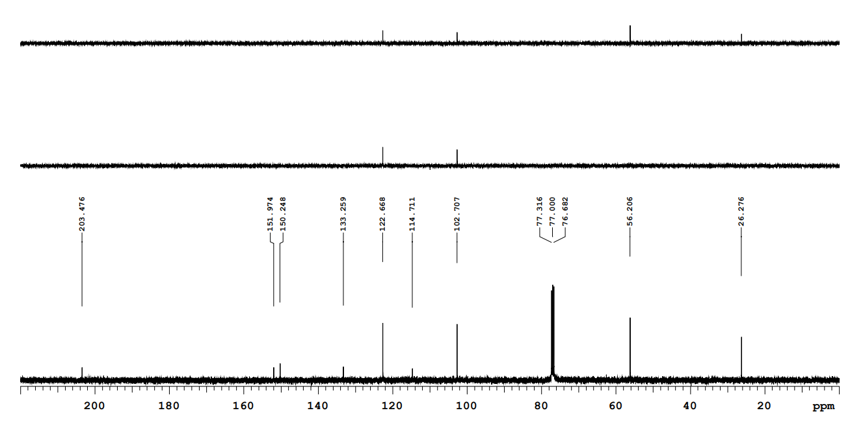
Figure S25. ¹³C NMR spectrum and DEPT for compound 9.

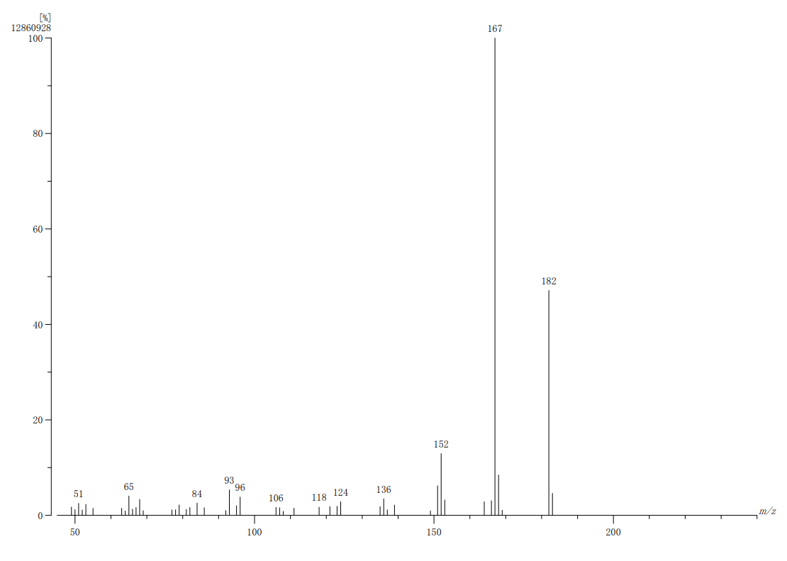
Figure S26. MS spectrum for compound 9.

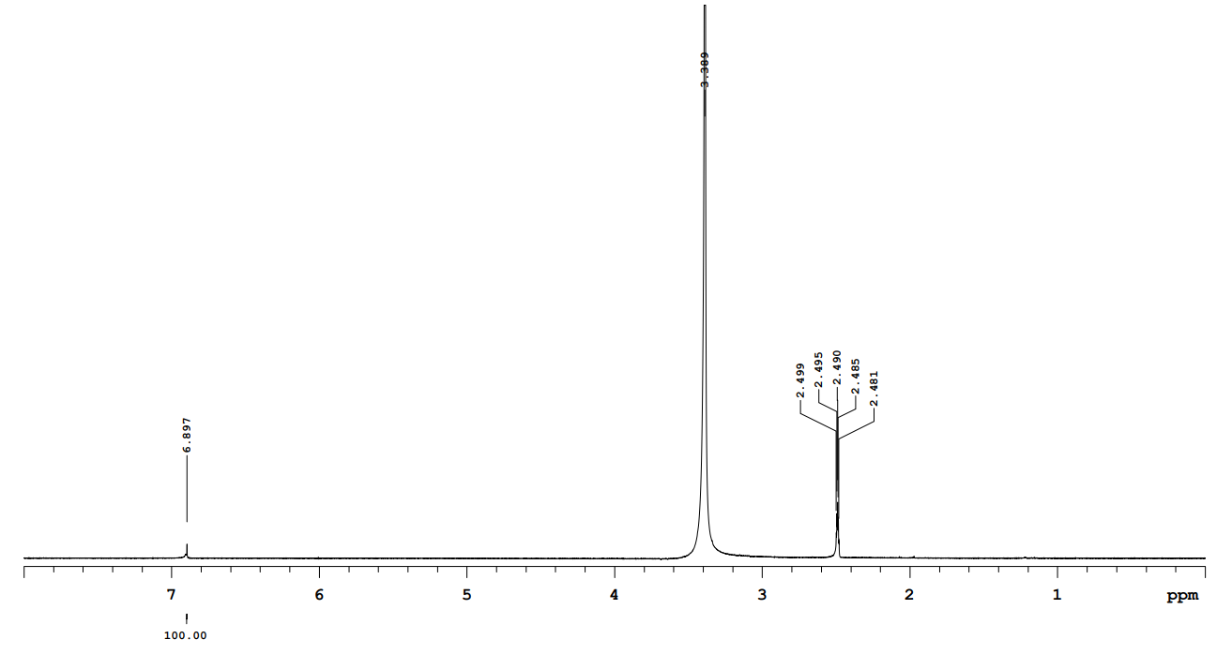
Figure S27. ¹H NMR spectrum for compound 10.
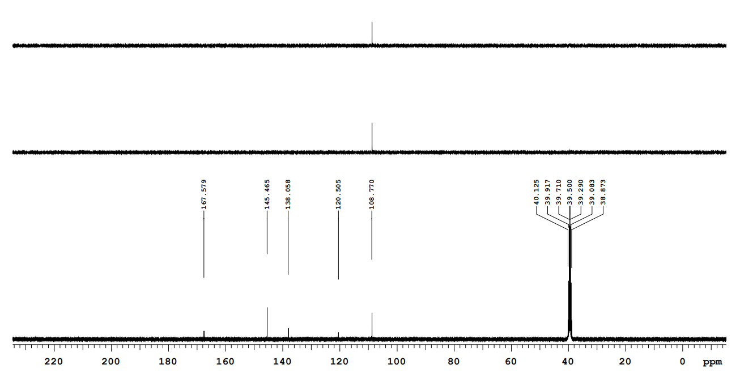
Figure S28. ¹³C NMR spectrum and DEPT for compound 10.
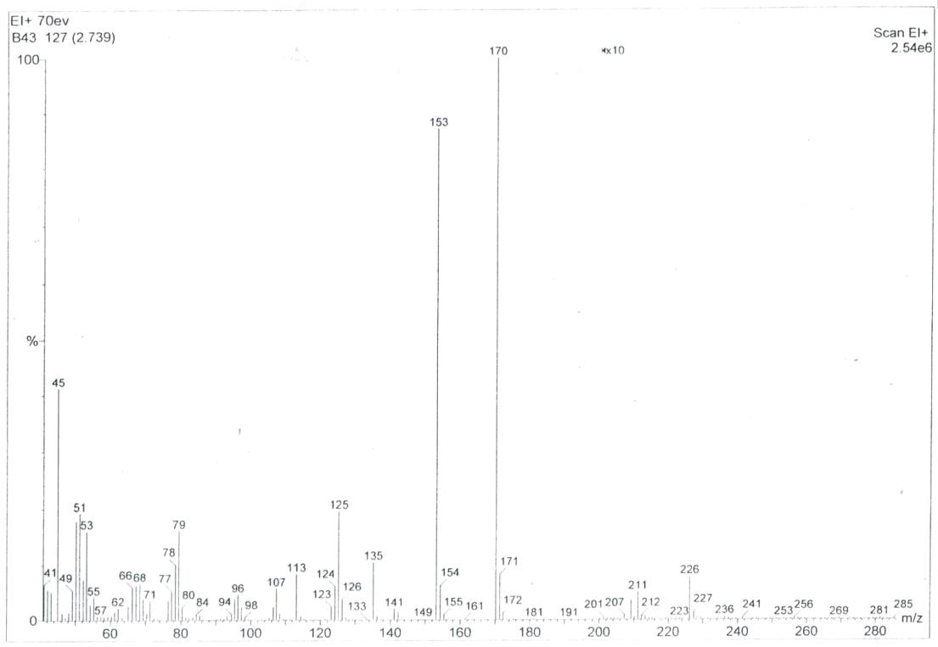
Figure S29. MS spectrum for compound 10.

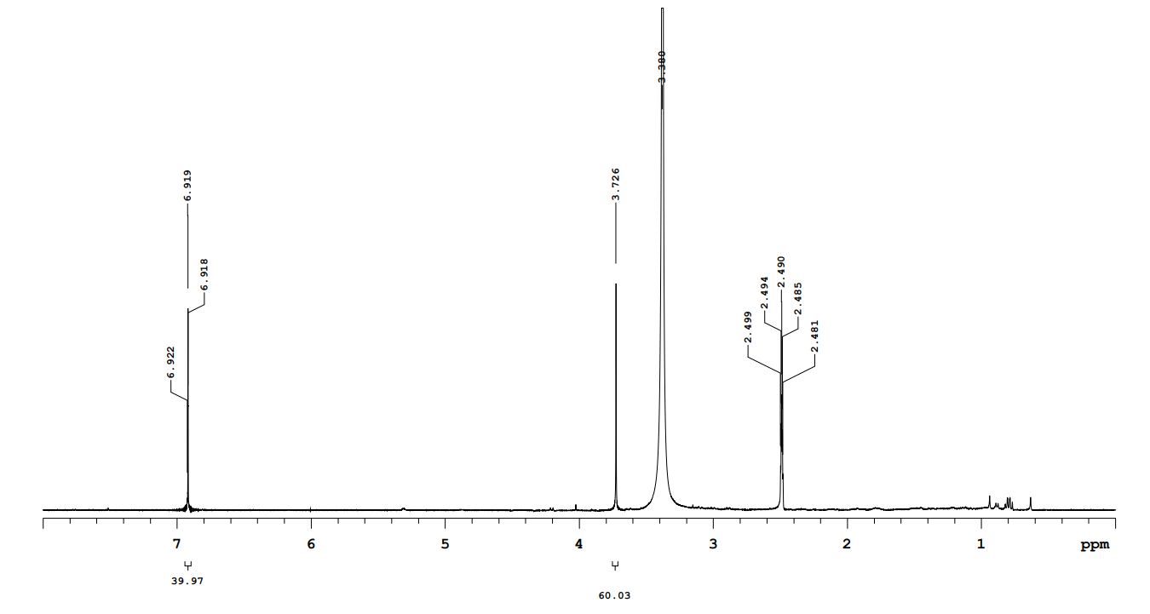
Figure S30. ¹H NMR spectrum for compound 11.

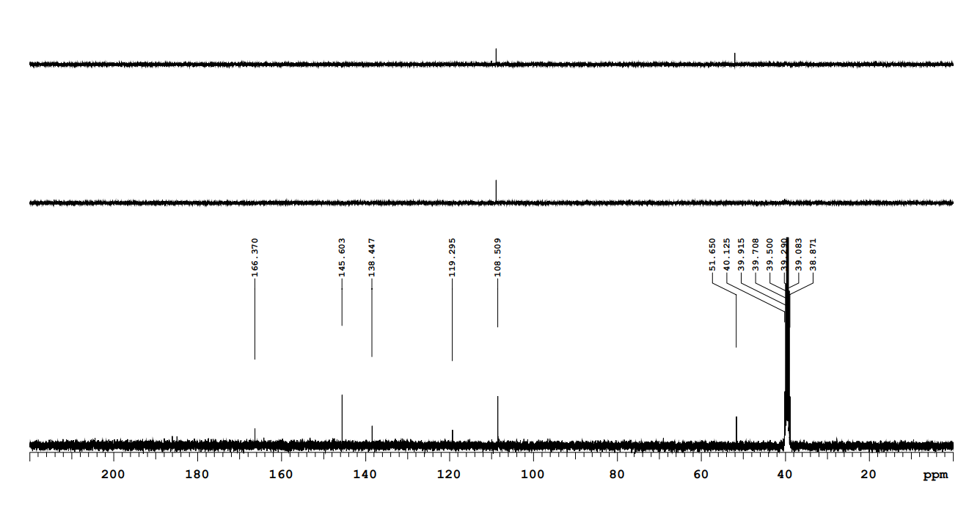
Figure S31. ¹³C NMR spectrum and DEPT for compound 11.
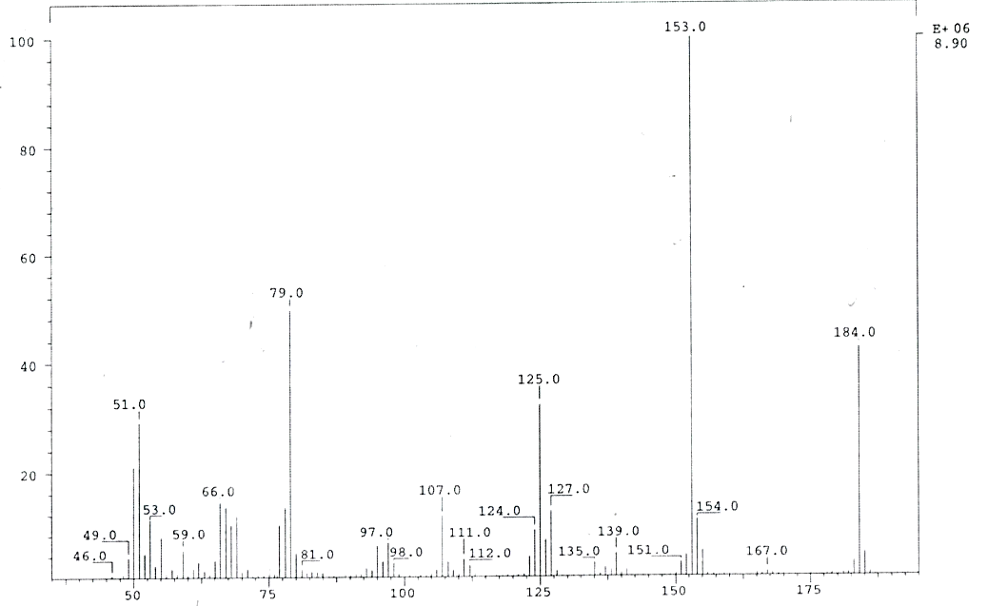
Figure S32. MS spectrum for compound 11.

