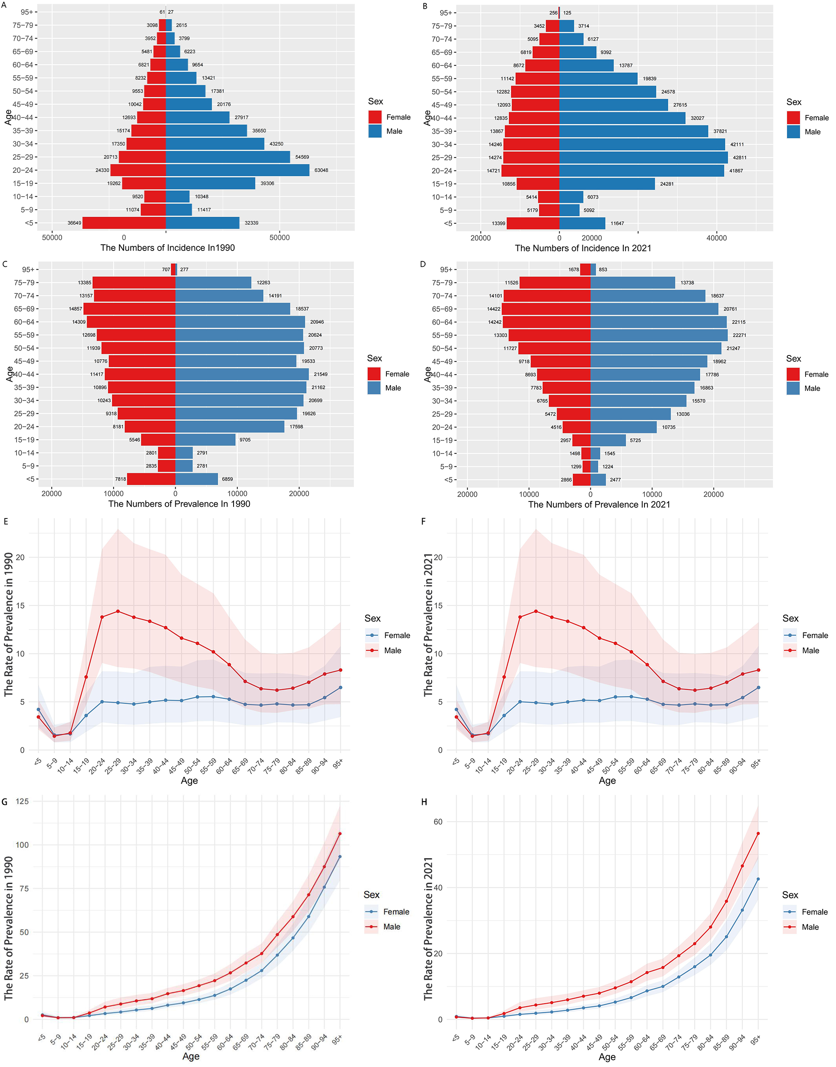

Supplementary Figure 1. Age-specific numbers and age-standardized incidence and prevalence rates of MVRI leading to VF in Global in 1990 and 2021. (A) Age-specific incidence numbers in 1990. (B) Age-specific incidence numbers in 2021. (C) Age-specific prevalence numbers in 1990. (D) Age-specific prevalence numbers in 2021. (E) The age-standardized incidence rate in 1990. (F) The age-standardized incidence rate in 2021. (G) Age-standardized prevalence rates in 1990. (H) The age-standardized prevalence rate in 2021.

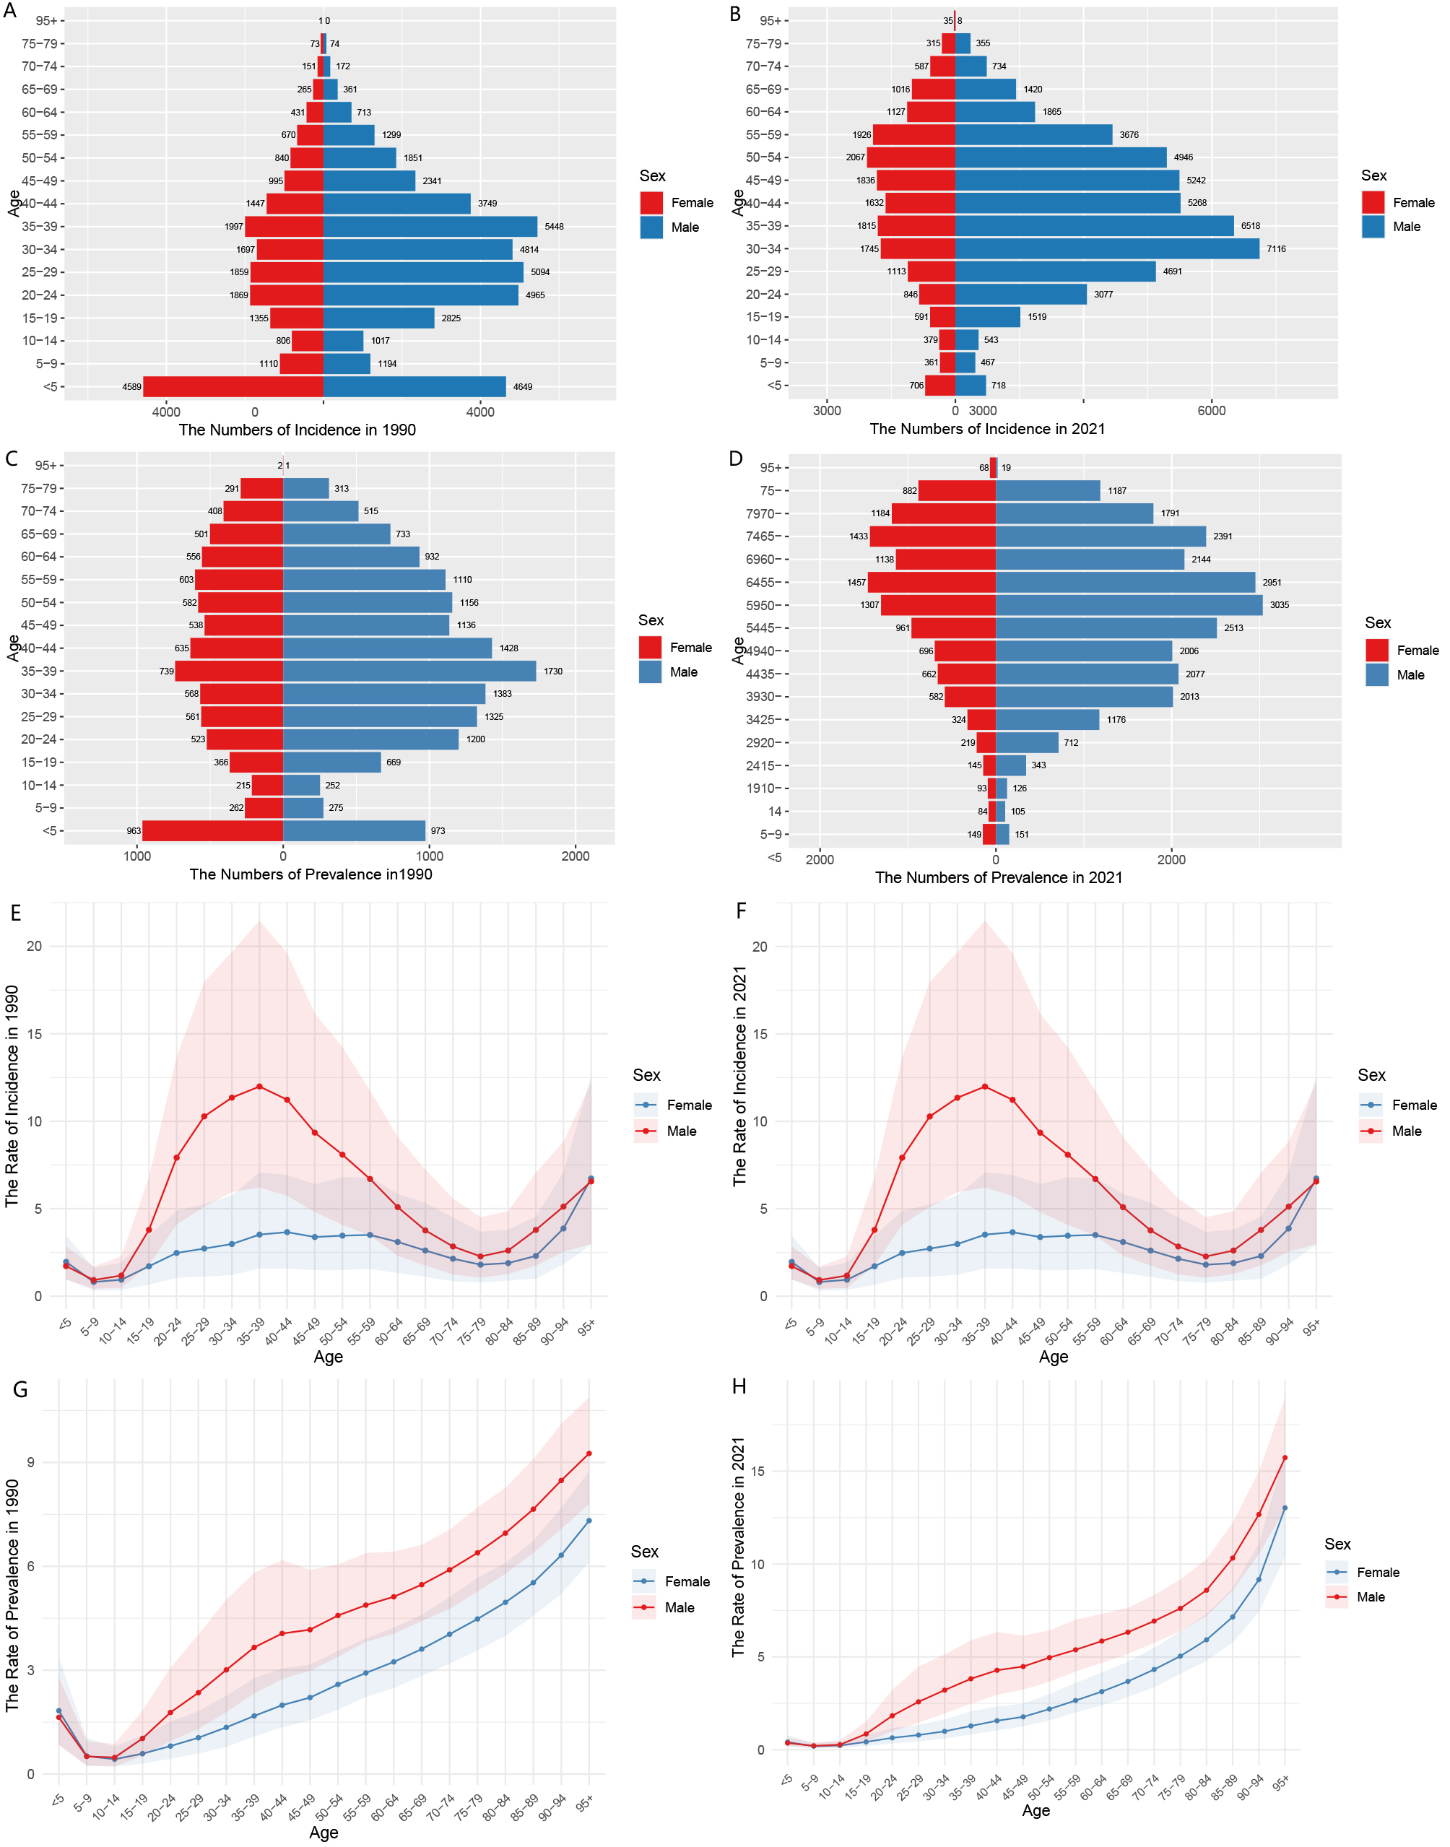
Supplementary Figure 1. Age-specific numbers and age-standardized incidence and prevalence rates of MVRI leading to VF in India in 1990 and 2021. (A) Age-specific incidence numbers in 1990. (B) Age-specific incidence numbers in 2021. (C) Age-specific prevalence numbers in 1990. (D) Age-specific prevalence numbers in 2021. (E) The age-standardized incidence rate in 1990. (F) The age-standardized incidence rate in 2021. (G) Age-standardized prevalence rates in 1990. (H) The age-standardized prevalence rate in 2021.

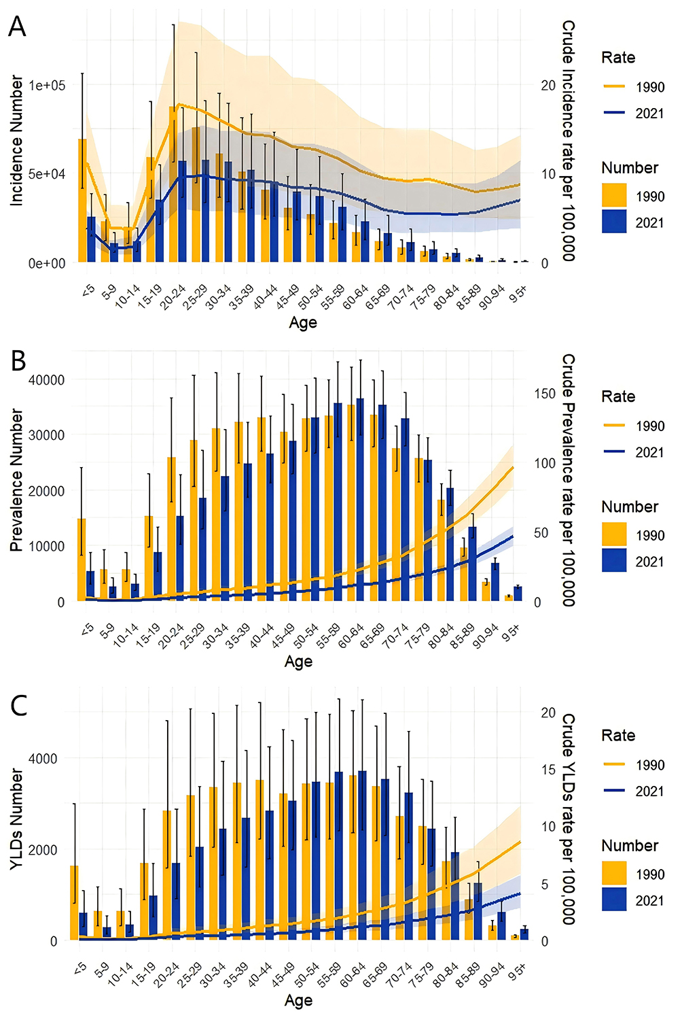
Supplementary Figure 2. Trends in All-Age Cases and Age-Standardized Incidence, Prevalence, and Years of Disabled Life Lost (YLDs) Rates for VFs by Sex in Global, 1990-2021 (A) Number and Rate of Incidence (B) Number and Rate of Prevalence (C) Number and Rate of YLDs.

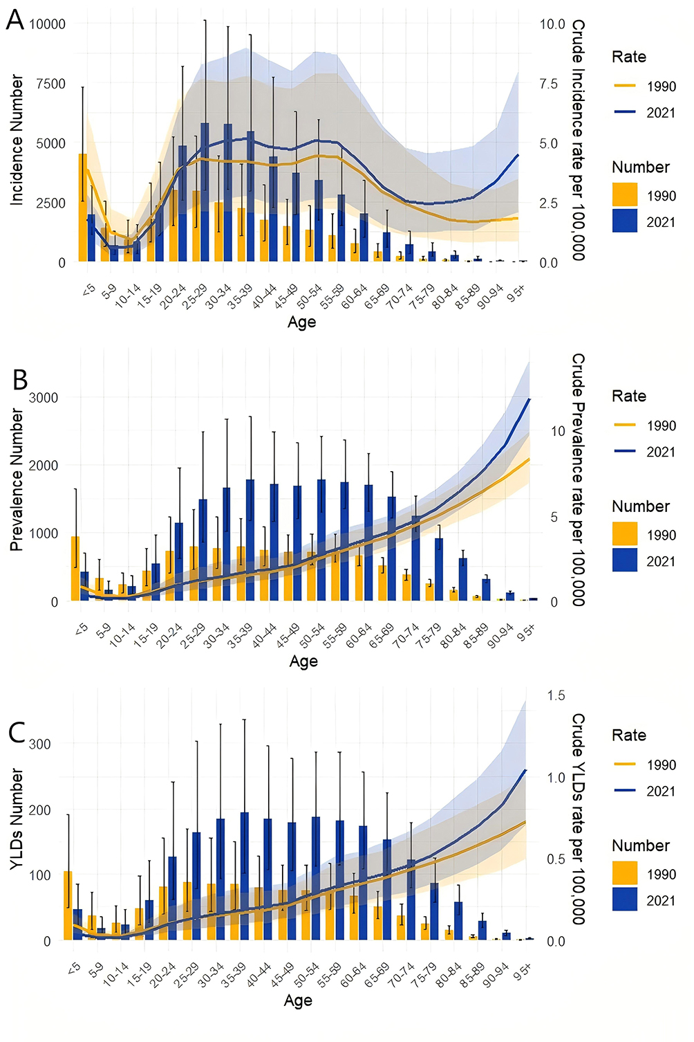
Supplementary Figure 2. Trends in All-Age Cases and Age-Standardized Incidence, Prevalence, and Years of Disabled Life Lost (YLDs) Rates for VFs by Sex in India, 1990-2021 (A) Number and Rate of Incidence (B) Number and Rate of Prevalence (C) Number and Rate of YLDs.

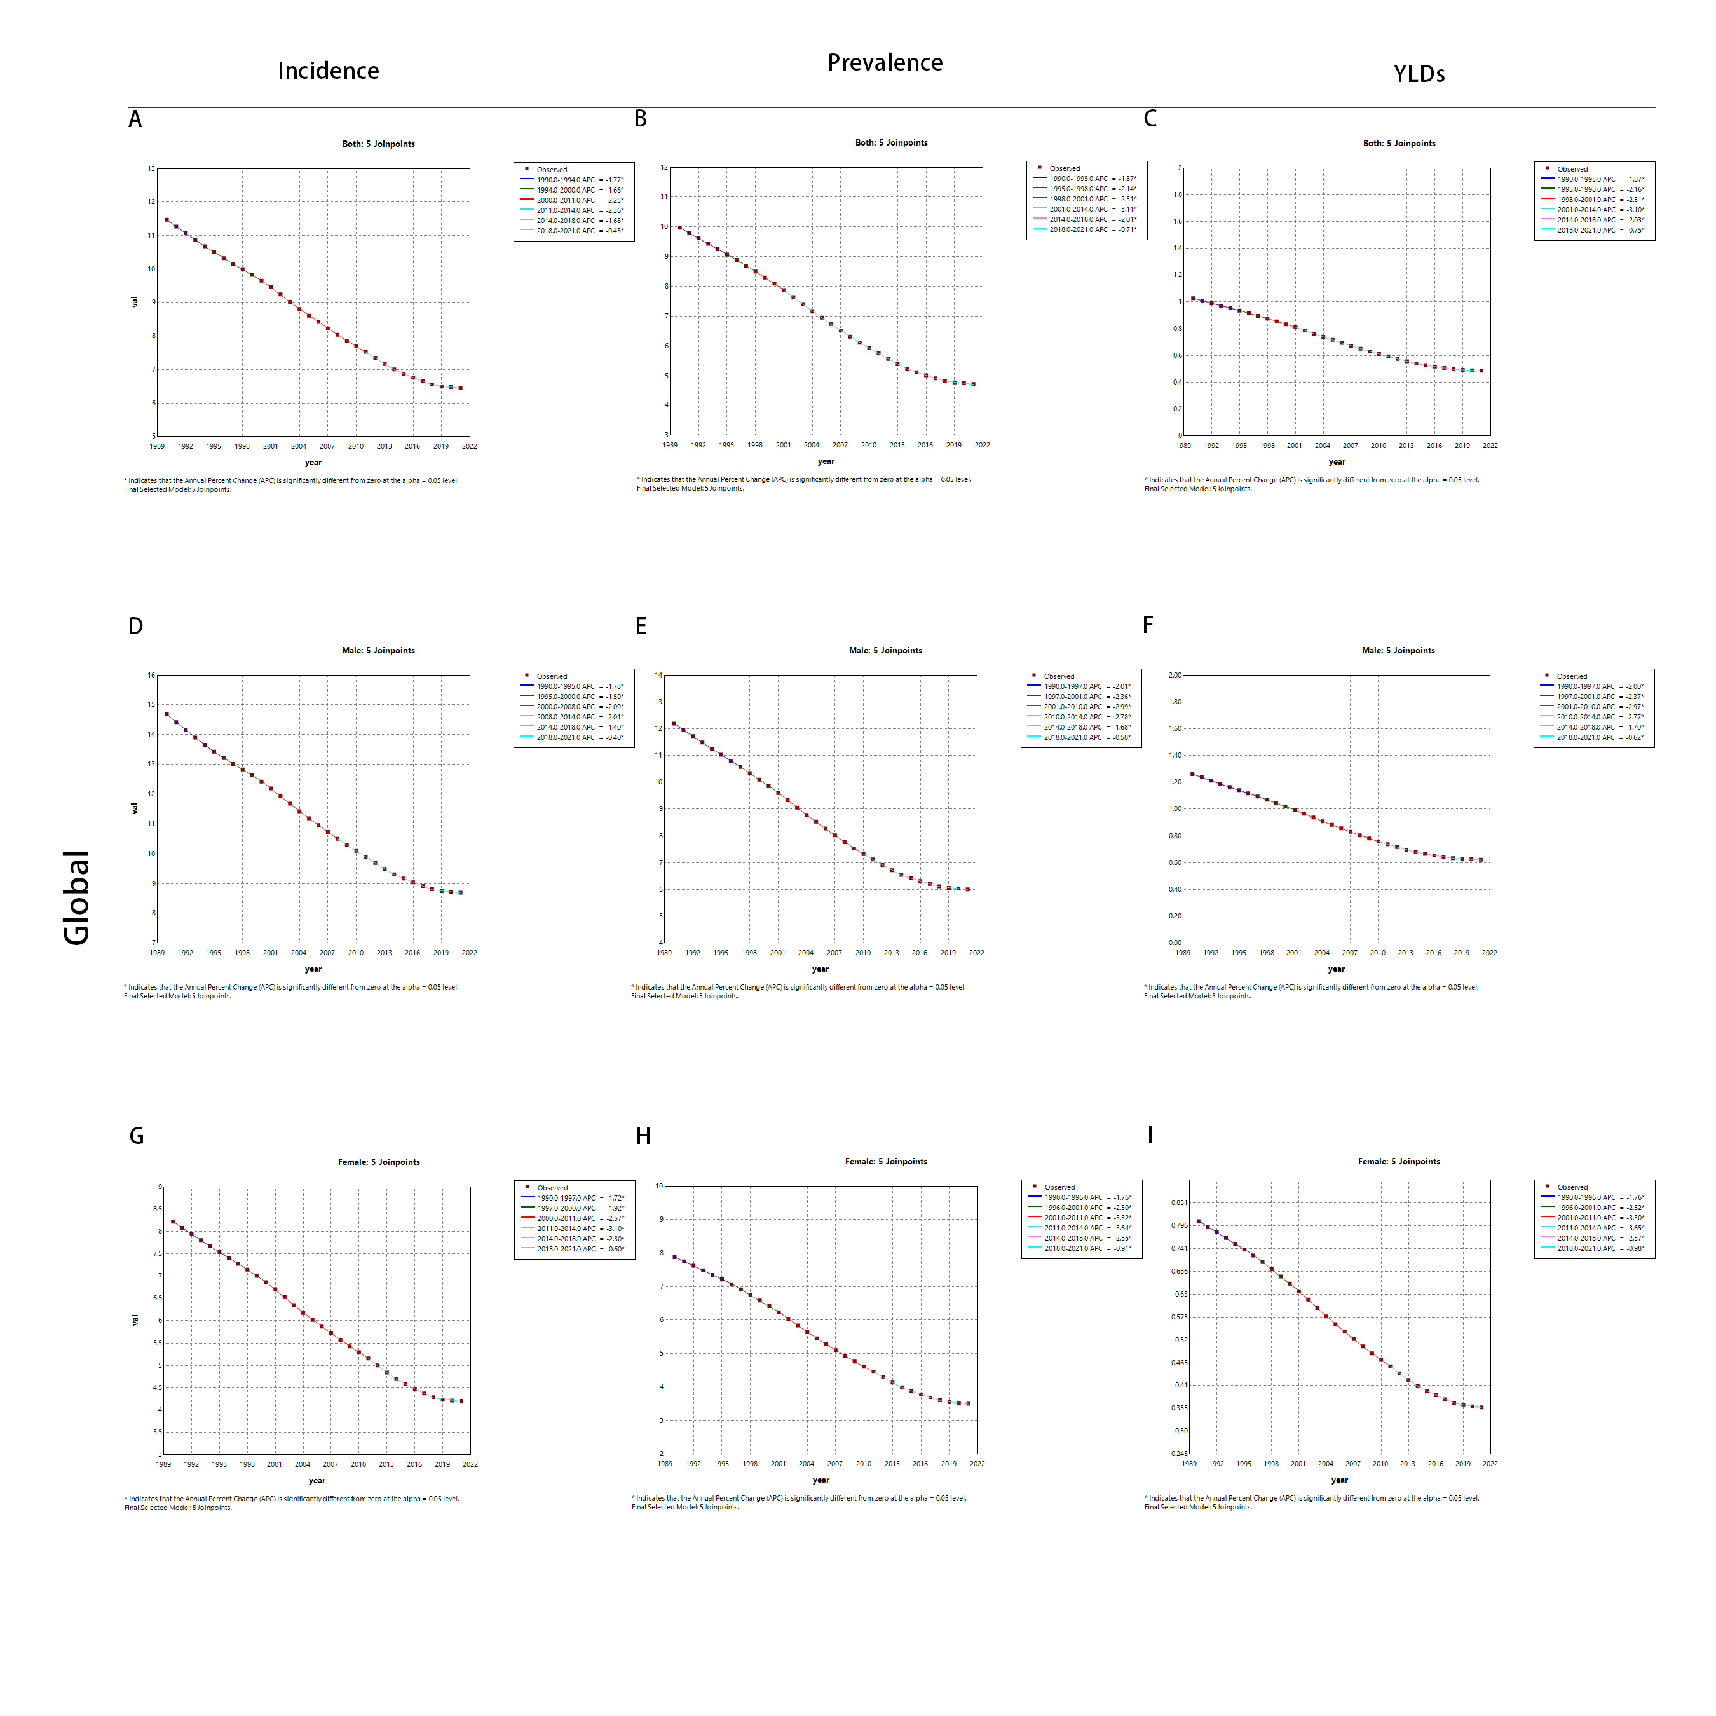
Supplementary Figure 3. In Global from 1990 to 2021, Joinpoint regression analysis was applied to the ASIR, ASPR and ASYR of VFs due to MVRI among males, females and both sexes, with a significance level of p<0.05.

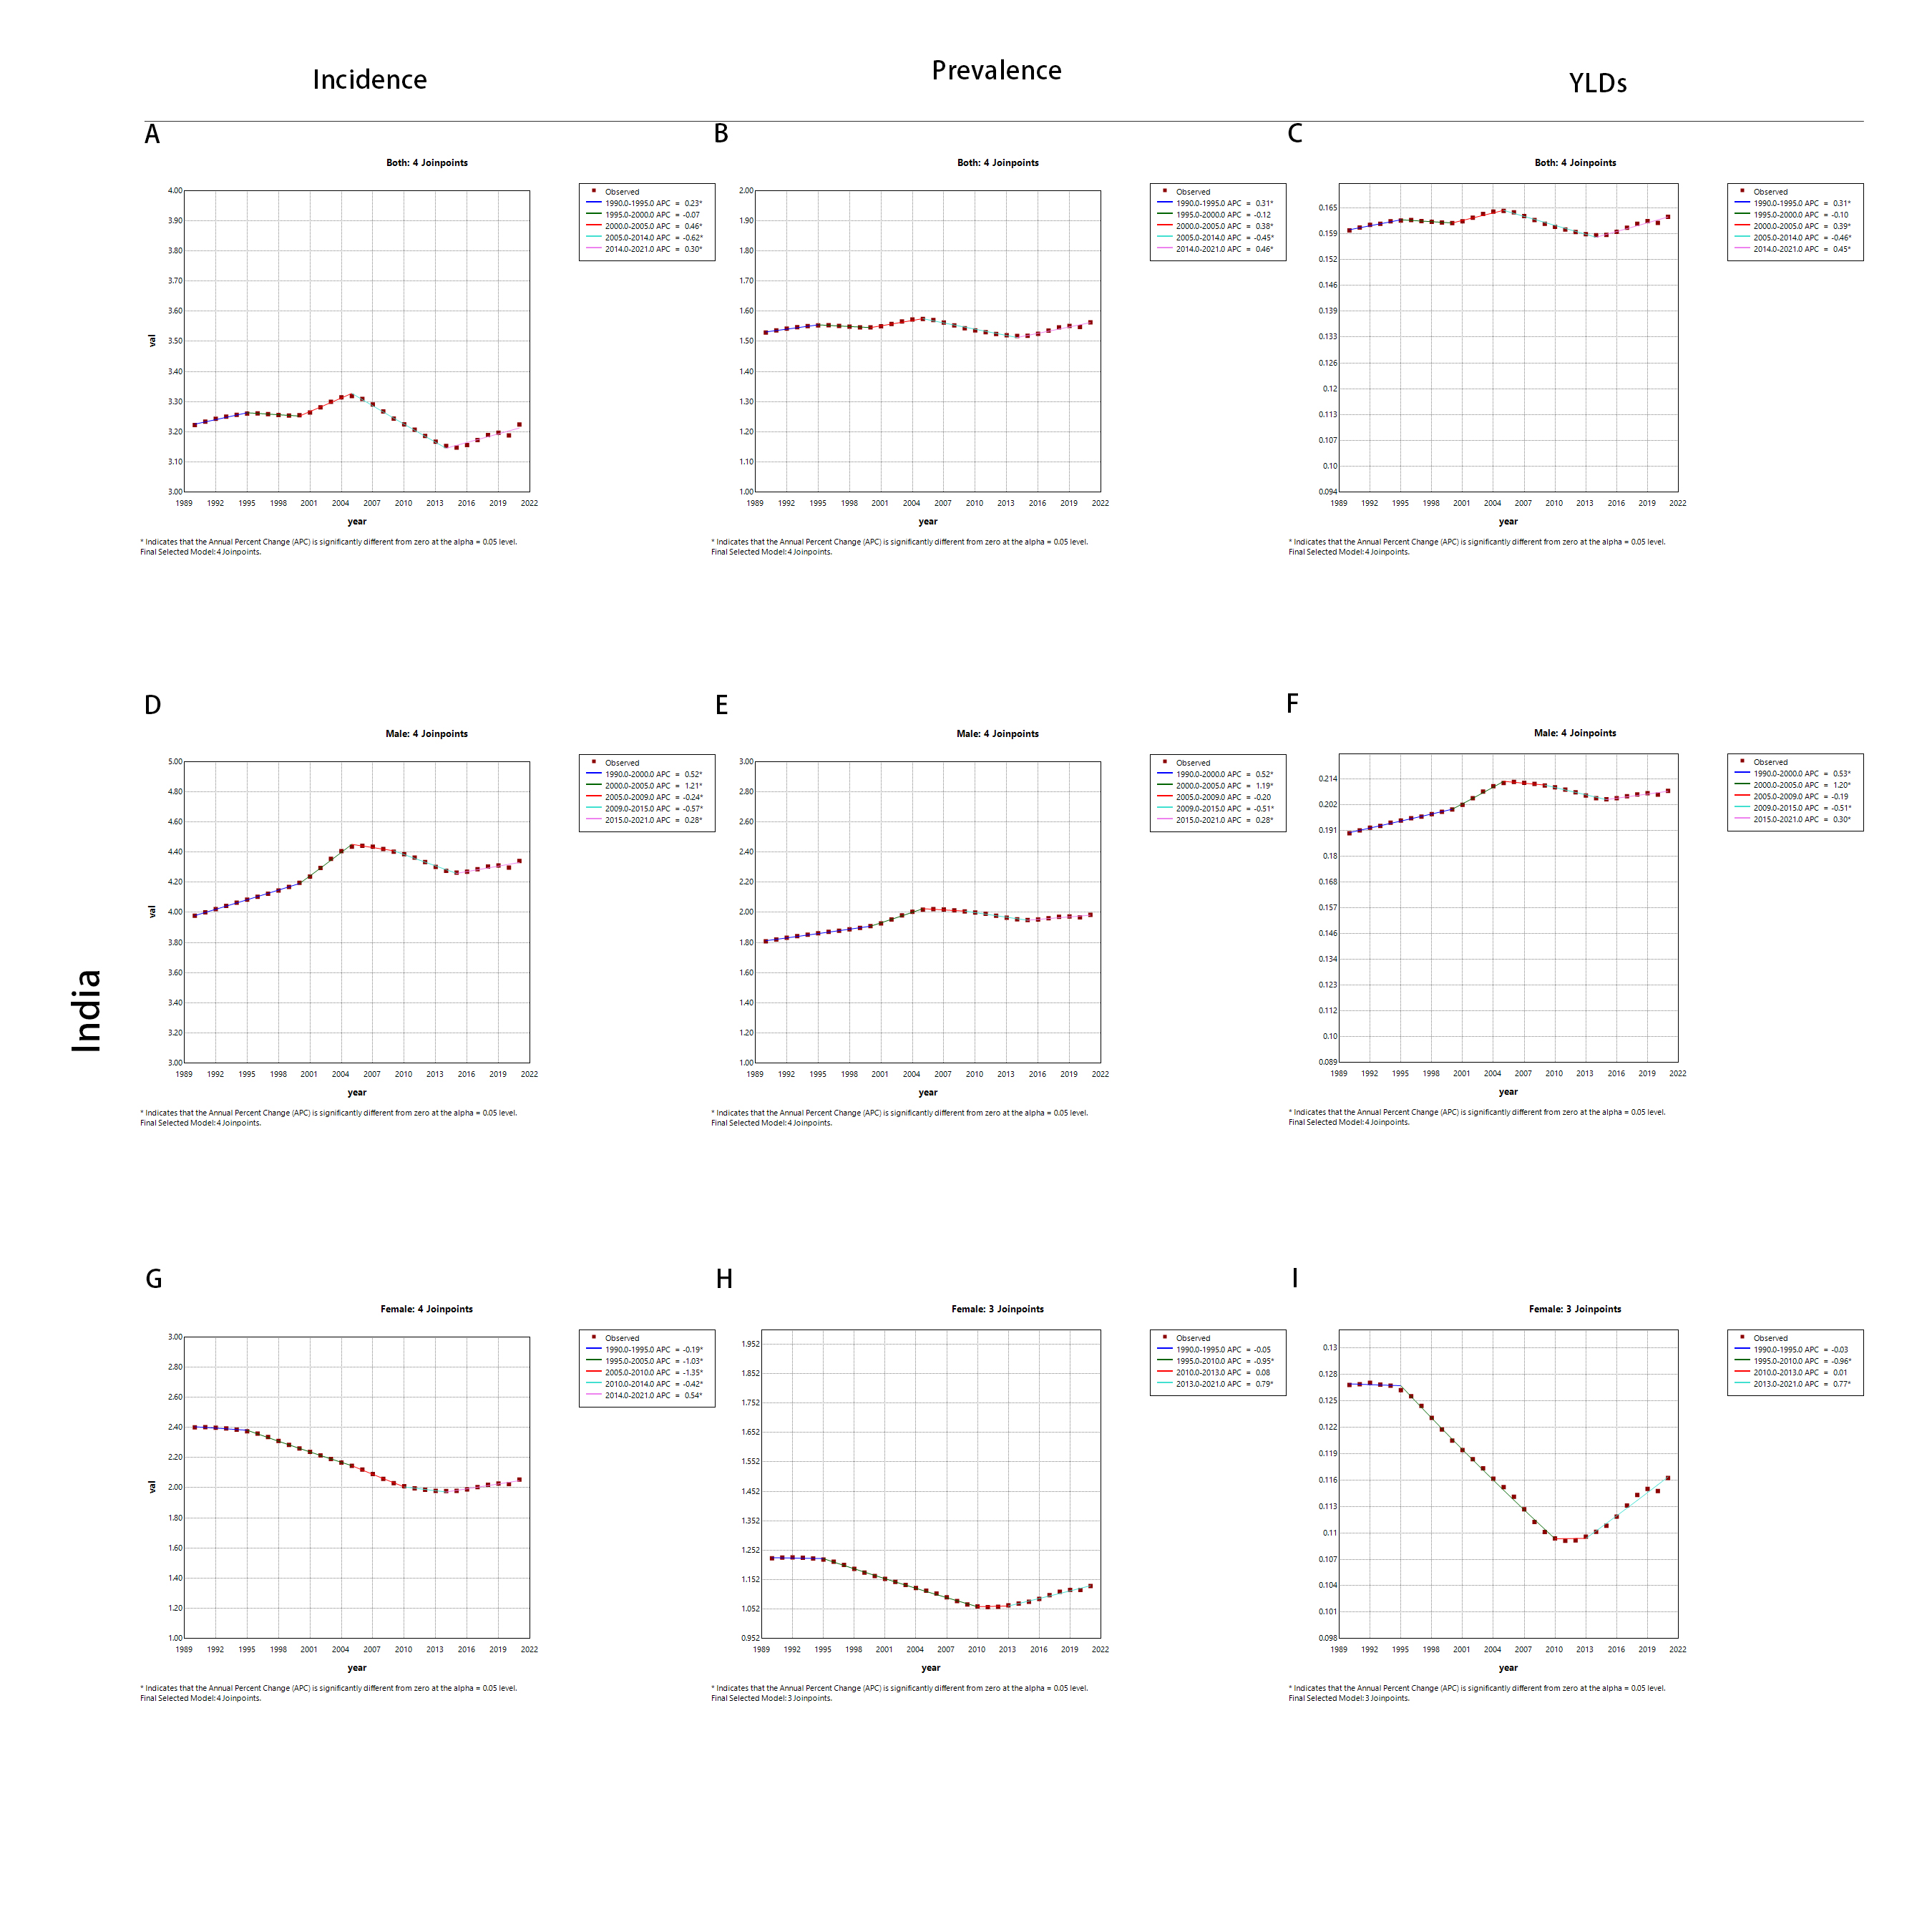
Supplementary Figure 3. In India from 1990 to 2021, Joinpoint regression analysis was applied to the ASIR, ASPR and ASYR of VFs due to MVRI among males, females and both sexes, with a significance level of p<0.05.

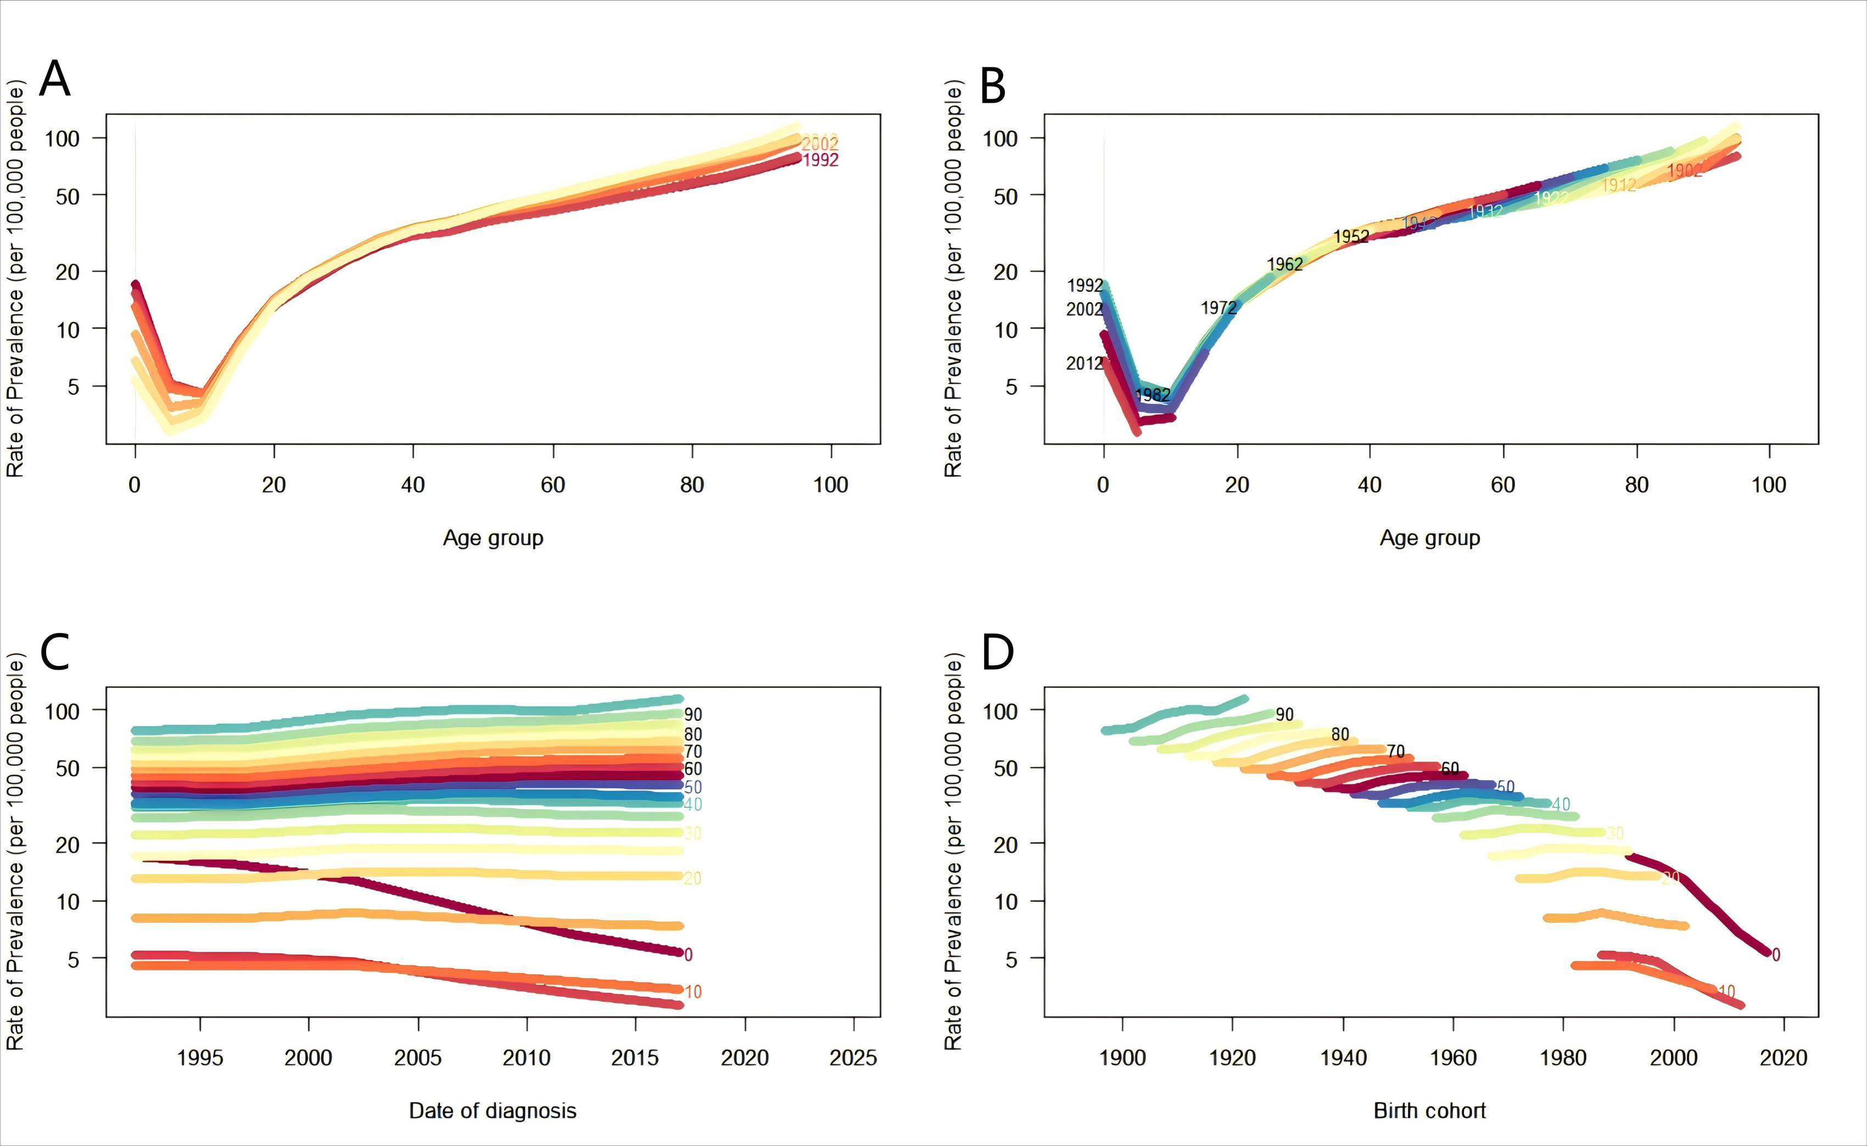
Supplementary Figure 4. Age, period, and cohort effects on the prevalence of VFs in China. (A) ASPRs of VFs in different periods. each line connects ASPRs of 5 years. (B) ASPRs of VFs in different birth cohorts. each line connects age-specific prevalence rates of a 5-year birth cohort. (C) Period-specific prevalence rates for VFs in different age cohorts. Each line connects a 5-year age-specific prevalence rate for the age cohort. (D) Birth cohort-specific prevalence rates for VFs in different age groups. Each line connects a birth cohort-specific prevalence rate for a 5-year age group. ASPR Age-standardized prevalence rate.

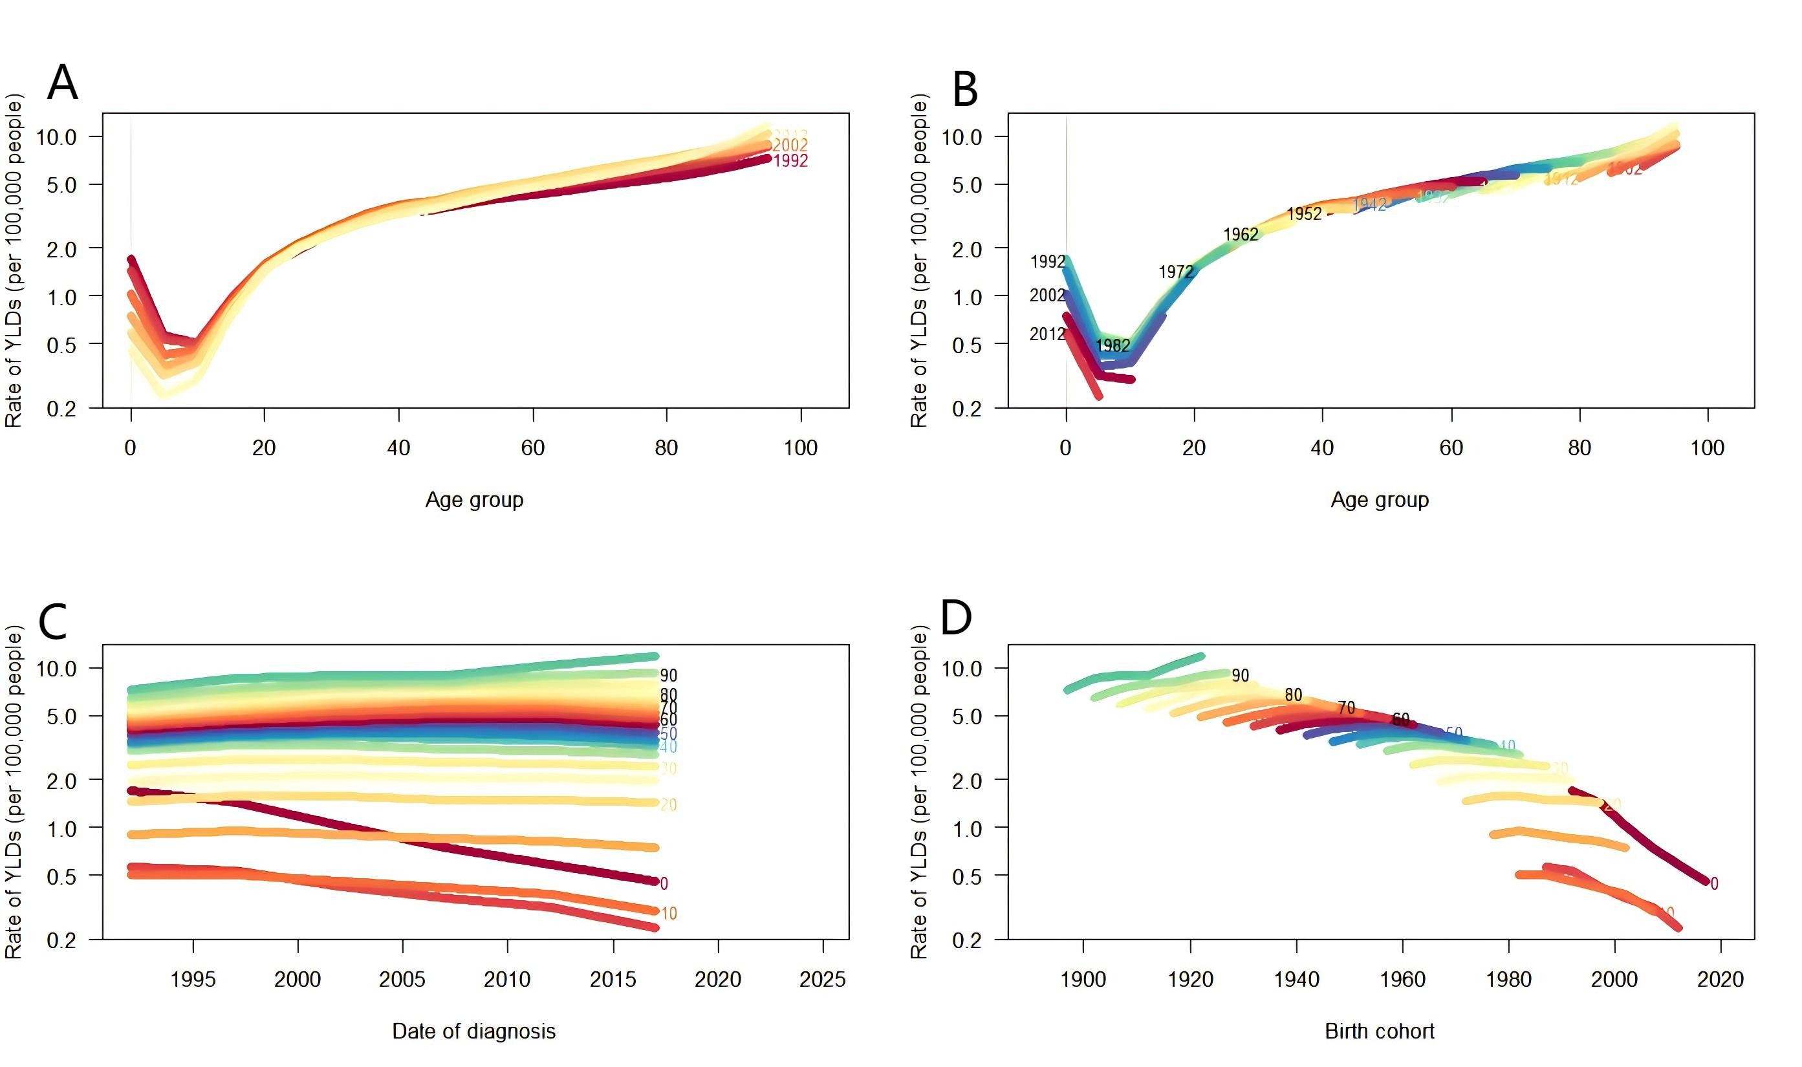
Supplementary Figure 4. Age, period, and cohort effects on the YLDs of VFs in China. (A) ASYRs of VFs in different periods. each line connects ASYRs of 5 years. (B) ASYRs of VFs in different birth cohorts. each line connects age-specific YLDs rates of a 5-year birth cohort. (C) Period-specific YLDs rates for VFs in different age cohorts. Each line connects a 5-year age-specific YLDs rate for the age cohort. (D) Birth cohort-specific YLDs rates for VFs in different age groups. Each line connects a birth cohort-specific YLDs rate for a 5-year age group. ASYR Age-standardized YLDs rate.

