Supplementary Figures for
A Deep Learning-based Land-Atmosphere Coupled Model
for Heatwave Prediction
Dongjin Cho¹, Yoo-Geun Ham^{1,2}*, Suyeon Jeong¹ and Seon-Yu Kang¹
1Environmental Planning Institute, Seoul National University, Seoul, Republic of Korea
2Department of Environmental Managements, Graduate School of Environmental Studies, Seoul National University, Seoul, Republic of Korea
Correspondence to: Yoo-Geun Ham (yoogeun@sun.ac.kr)

This includes 5 Supplementary Figures.
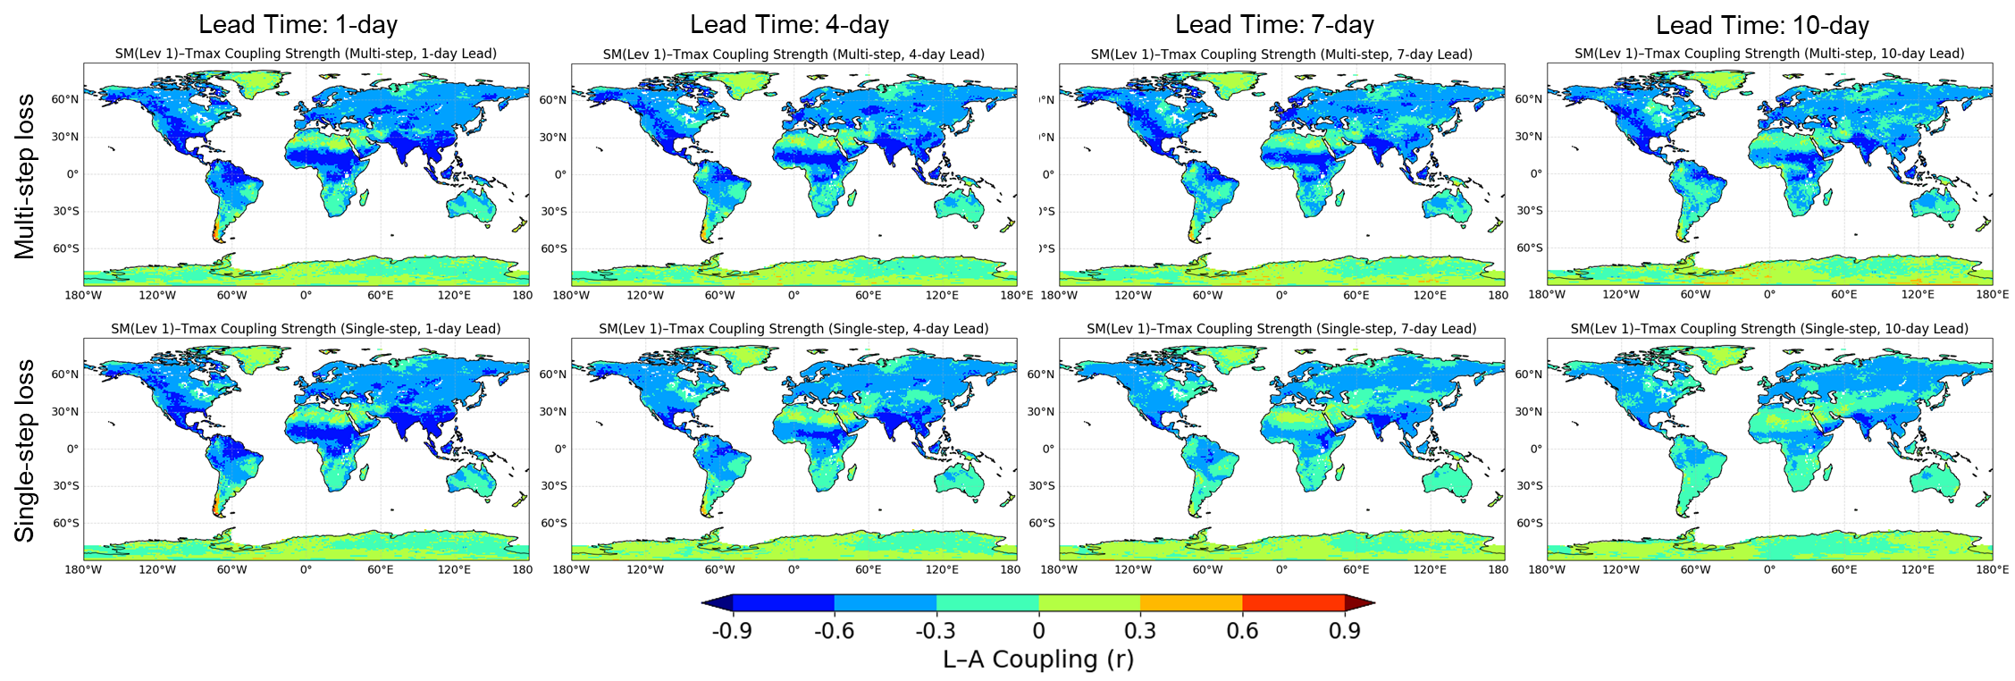
Figure S1. Spatial distribution of land–atmosphere (L–A) coupling strength during June–August (JJA) of 2018–2023, derived from the L–A coupled model at lead times up to 10 days. Coupling strength is defined as the Pearson correlation between daily anomalies of soil moisture at the first layer (SM, Lev 1) and maximum temperature (Tmax). The top and bottom rows show results from the coupled model trained with multi-step and single-step loss, respectively.
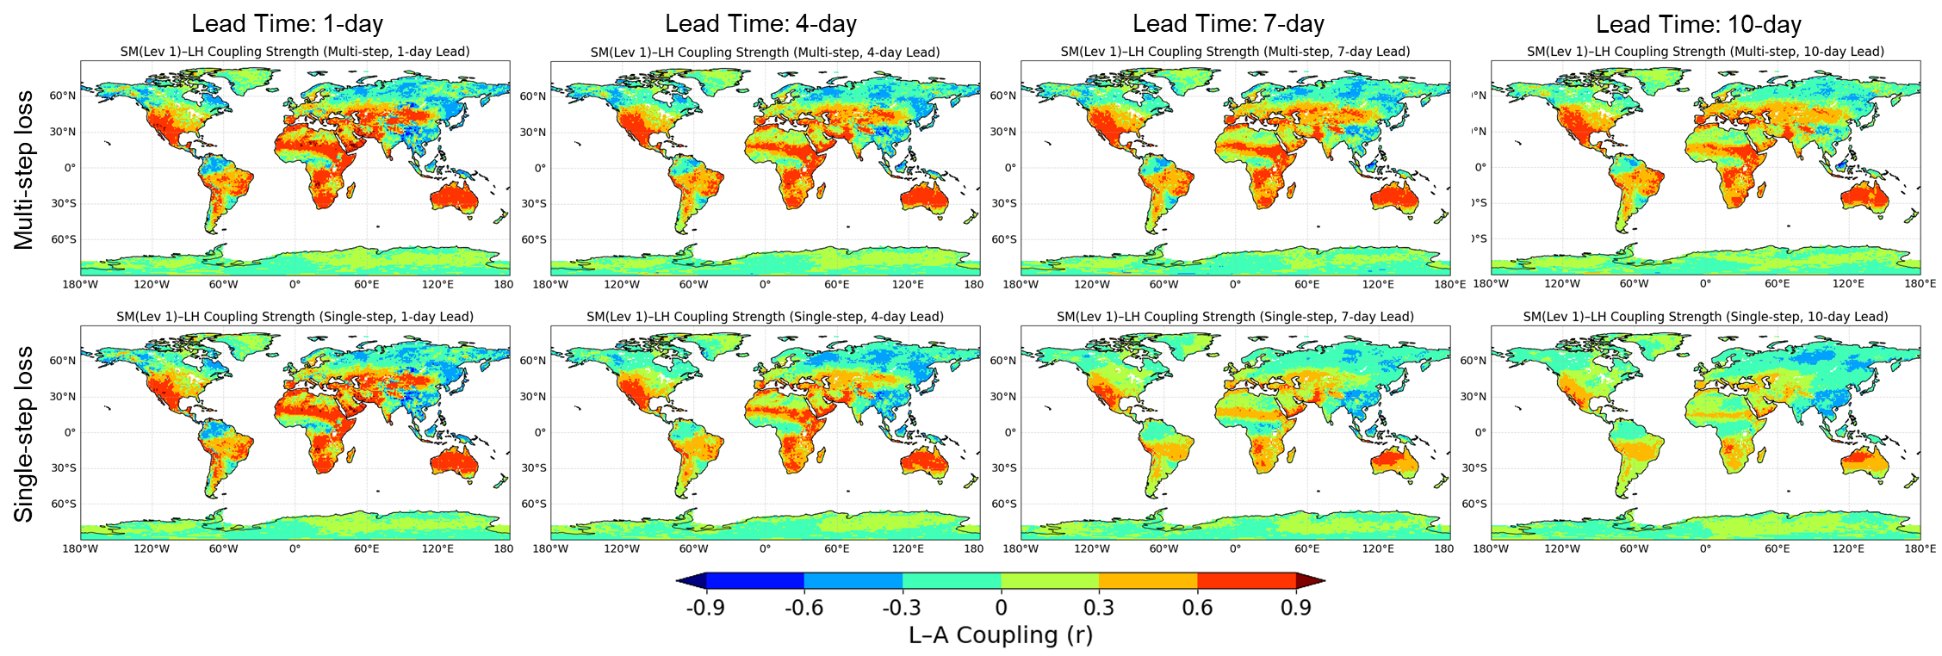
Figure S2. Spatial distribution of land–atmosphere (L–A) coupling strength during June–August (JJA) of 2018–2023, derived from the L–A coupled model at lead times up to 10 days. Coupling strength is defined as the Pearson correlation between daily anomalies of soil moisture at the first layer (SM, Lev 1) and latent heat flux (LH). The top and bottom rows show results from the coupled model trained with multi-step and single-step loss, respectively.
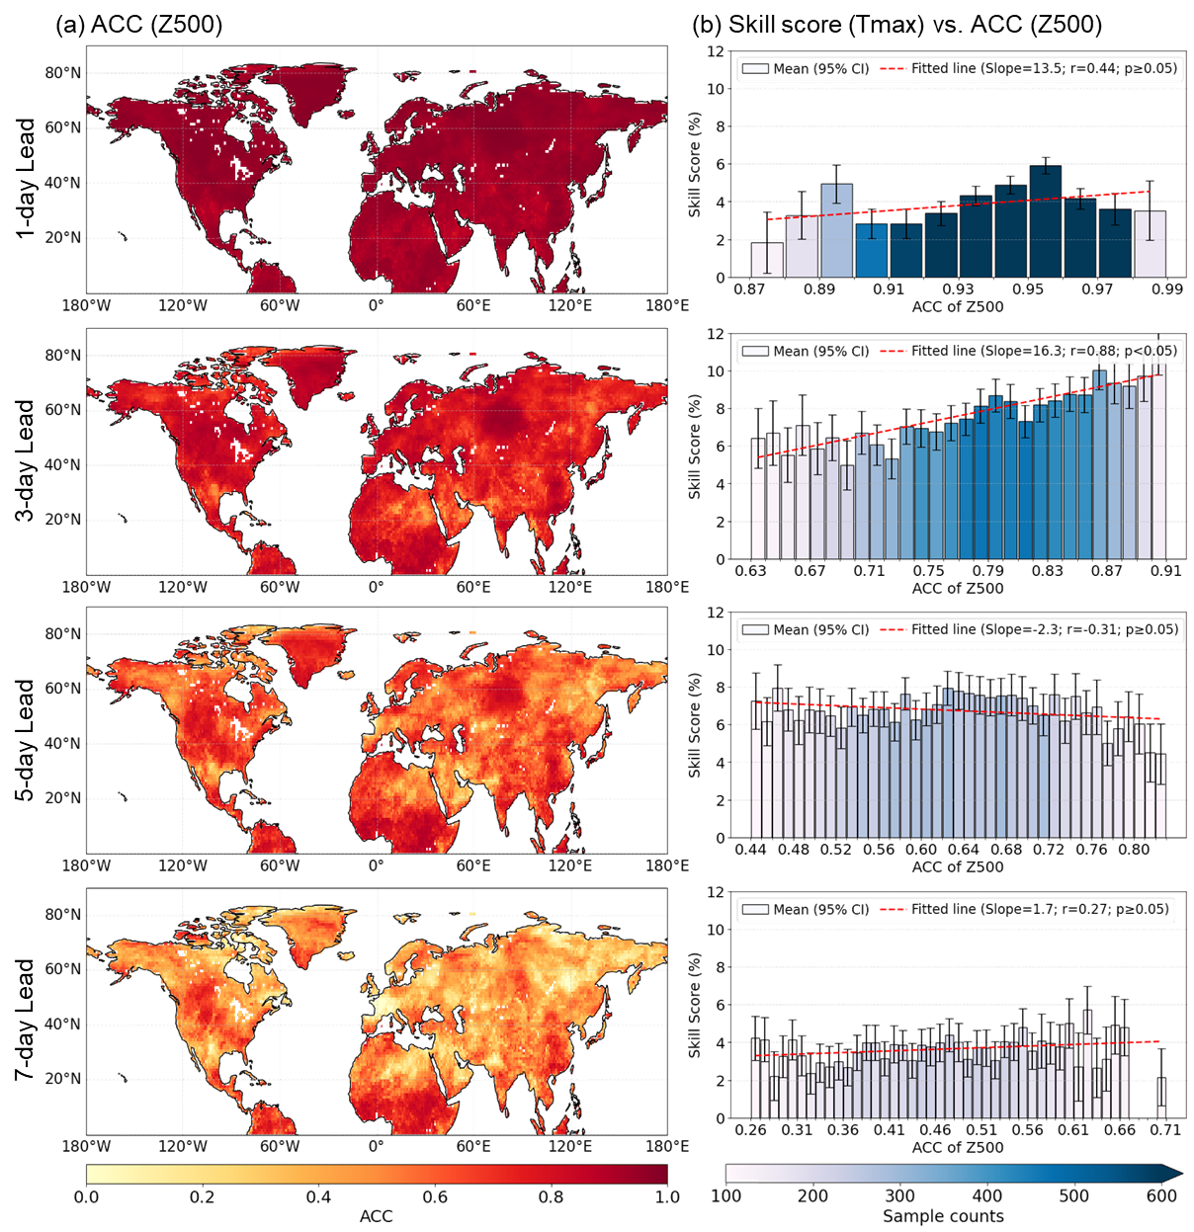
Figure S3. (a) Spatial distribution of Z500 forecast skill (ACC) from the coupled model under heatwave conditions (defined as grid points exceeding the 90th percentile of Tmax during June–August (JJA) from 2018 to 2023). (b) Skill score as a function of Z500 skill (bin-averaged with 95% confidence intervals) and fitted regression slopes. In (b), the analysis was restricted to regions with statistically meaningful SM–Tmax coupling strength (r≤–0.3) based on ground-truth observations, and bins with fewer than 100 samples were excluded.
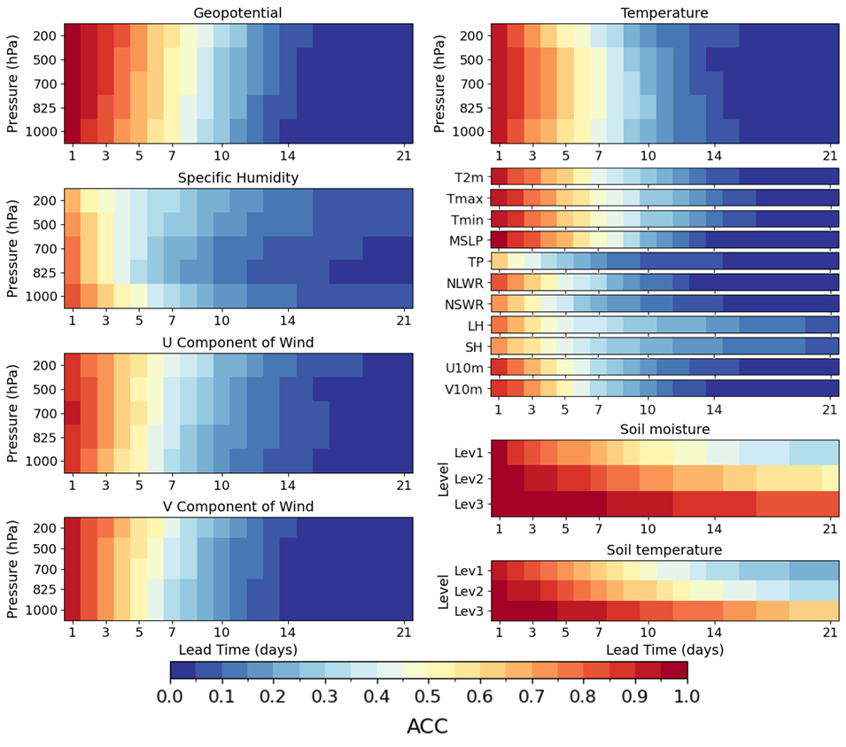
Figure S4. Anomaly correlation coefficients (ACC) of the land–atmosphere coupled model for all predicted variables, evaluated over the globe during June–August (JJA) of 2018–2023. ACC values are presented across different lead times, providing a comprehensive assessment of the model’s prediction skill.
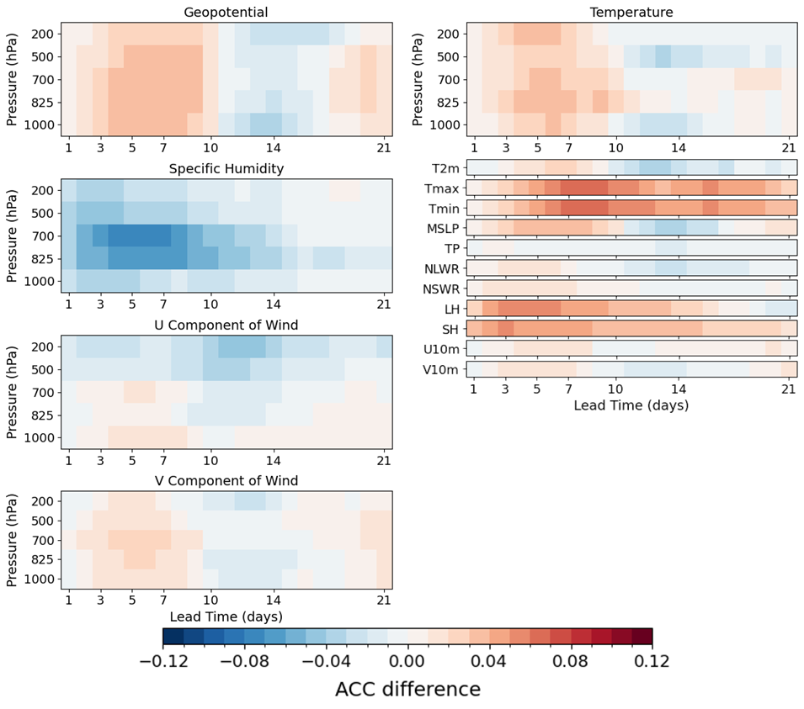
Figure S5. Anomaly correlation coefficient (ACC) differences between the land–atmosphere coupled model (Coupled) and the atmosphere-only model (ATM), evaluated over the globe during June–August (JJA) of 2018–2023. Positive values (red) indicate better prediction skill by the Coupled model, while negative values (blue) indicate better performance by the ATM model. Soil moisture and soil temperature not predicted by the ATM model are excluded from the comparison.

