Design, Synthesis and Biological Evaluation of Novel Hydroxamic Acids Bearing Coumarin Moieties as Histone Deacetylase Inhibitors and Cytotoxic Agents
Tran-Duy Thanh¹, Luu-Van Chinh², Do-Thi Thao³, Thach-Lien Nguyen⁴, Hai Pham–The⁵ and Tran-Khac Vu^{1*}
¹Department of Chemical Engineering, School of Chemistry and Life Sciences, Hanoi University of Science and Technology, No 1, Dai Co Viet, Bach Mai–Hanoi, Vietnam
²Institute of Chemistry, Vietnam Academy of Science and Technology, 18–Hoang Quoc Viet–Nghia Do–Hanoi, Vietnam
³Institute of Biotechnology, Vietnam Academy of Science and Technology, 18–Hoang Quoc Viet–Nghia Do–Hanoi, Vietnam
⁴Hanoi University of Pharmacy, 13-15 Le Thanh Tong, Cua Nam, Hanoi, Vietnam
⁵University of Science and Technology of Hanoi (USTH), Vietnam Academy of Science and Technology, 18 Hoang Quoc Viet, Nghia Do, Hanoi, Vietnam

*Corresponding author, e-mail: vu.trankhac@hust.edu.vn

Table of contents
1. Experimental section
2. Spectral data of compounds
1. Experimental section
1.1 Chemistry
All products were examined by thin-layer chromatography (TLC), performed on Whatman 250 lm Silica Gel GF Uniplates and visualized under UV light at 254 nm. Melting points were determined in open capillaries on the Electrothermal IA 9200 Shimazu apparatus and uncorrected. Purification was done by crystallization and the open flash silica gel column chromatography using Merck silica gel 60 (240–400 mesh). IR spectra were recorded on FT-IR IMPACT-410 using KBr discs. Nuclear magnetic resonance spectra (¹H and ¹³C NMR) were recorded using tetramethylsilane (TMS) as an internal standard on a Bruker 600 MHz spectrometer with DMSO–d₆ as solvents. Chemical shifts are reported in parts per million (ppm) downfield from TMS as an internal standard and coupling constants (J) are expressed in hertz (Hz). Multiplicities are shown as the abbreviations: s (singlet), brs (broad singlet), d (doublet), t (triplet), m (multiplet). High–resolution mass spectra were recorded on Agilent 6200 MS. The elemental (C, H, N) analyses were performed on a Perkin Elmer model 2400 elemental analyser. Reagents and solvents were purchased from Aldrich or Fluka Chemical Corp. (Milwaukee, WI, USA) or Merck unless noted otherwise. Solvents were distilled and dried before use.

General procedure for the synthesis of compounds 2a–g
In a round-bottom flask, a solution of substituted 2-hydroxybenzaldehyde (1a–g) (5.6 gram, 40 mmol) and Meldrum’s acid (7.3 gram, 48 mmol) was stirred in aqueous methanol at reflux for 5-6 h. The precipitate was obtained by filtration and washing with cold water to give the solid (2a–g) and was used directly for the next step without further purification.

General procedure for the synthesis of compounds 3a–g
A mixture of 2a–g (200 mg) and ethyl 7-aminoheptanoate (1.5 eq), EDC.HCl (1.5eq), 4-DMAP (1 eq) in DCM (5 mL) was stirred at room temperature for 6 hours. The reaction was monitored by TLC using CH₂Cl₂:MeOH =20:1 as a developing solvent system. The reaction mixture was evaporated using a rotovapor. The resulting precipitate was filtered, washed with ice–cold diluted HCl, NaCO₃ and MeOH and dried at 60ºC for 10 hours to obtain the desired products and were used directly for the next step without further purification. The corresponding ester intermediates was then hydrolyzed in the mixture of MeOH:H₂O = 4:1 using LiOH (10 eq) for 5 hours. At the end of this reaction, the solvent was evaporated and the resulting mixture was diluted with ice–cooled water and acidified with HCl 1M until pH = 3. The resulting precipitate was filtered, washed with ice–cooled water to give the carboxylic acid intermediates 3a-g.

7-(2-Oxo-2H-chromene-3-carboxamido)heptanoic acid (3a)
White solid; yield: 63% (210 mg). Mp: 155ºC–156ºC, R_{f} = 0.64 (CH₂Cl₂:MeOH = 10:1). ¹H–NMR (600 MHz, DMSO–d₆): δ 11.97 (s, 1H, COOH), 8.84 (s, 1H, H–4), 8.70 (t, J = 5.4Hz, CONH), 7.98 (dd, J = 7.8 Hz, 1.2 Hz, 1H, H–5), 7.74 (dt, J = 7.8 Hz, 1.2 Hz, 1H, H–7), 7.50 (d, J = 8.4Hz, 1H, H–8), 7.44 (dt, J = 7.8 Hz, 1.2 Hz, 1H, H–6), 3.32 (m, 2H, NHCH₂), 2.50 (t, J = 7.2Hz, CH₂), 1.54–1.50 (m, 4H, CH₂), 1.32–1.31 (m, 4H, CH₂). ¹³C–NMR (125MHz, DMSO–d₆): δ 174.38, 160.94 , 160.34, 153.79, 147.17, 133.92, 130.14, 125.04, 119.11, 118.43, 116.06, 33.55, 28.75, 28.17, 26.08, 24.37.
7-(7-Fluoro-2-oxo-2H-chromene-3-carboxamido)heptanoic acid (3b)
White solid; yield: 54% (174 mg). Mp: 187ºC–188ºC, R_{f} = 0.68 (CH₂Cl₂:MeOH = 10:1). ¹H–NMR (600 MHz, DMSO–d₆): δ 11.94 (s, 1H, OH), 8.81 (s, 1H, H–4), 8.66 (br, 1H, NH), 7.88 (m, 1H, H–5), 7.63 (m, 1H, H–6), 7.57 (m, 1H, H–8), 2.20 (t, J = 8.4 Hz, 2H, CH₂), 1.52–1.50 (m, 4H, CH₂), 1.32–1.30 (m, 4H, CH₂). ¹³C–NMR (125MHz, DMSO–d₆): δ 174.39, 160.72, 160.06, 157.18, 150.22, 146.21, 121.29, 120.19, 119.42, 118.17, 115.11, 33.54, 28.72, 28.16, 26.06, 24.36.
7-(7-Bromo-2-oxo-2H-chromene-3-carboxamido)heptanoic acid (3c)
White solid; yield: 59% (174 mg). Mp: 223ºC–224 ºC, R_{f} = 0.71 (CH₂Cl₂:MeOH = 10:1). ¹H–NMR (600 MHz, DMSO–d₆): δ 12.04 (br, 1H, COOH) 8.82 (s, 1H, H–4), 8.63 (d, J = 5.4Hz, 1H, NH), 7.92 (d, J = 7.8Hz, 1H, H–5), 7.84 (s, 1H, H–8), 7.65 (m, 1H, H–6), 3.31 (m, 2H, NHCH₂), 2.20 (t, J = 7.2Hz, 2H, CH₂), 1.52 (s, 4H, CH₂), 1.31 (s, 4H, CH₂). ¹³C–NMR (150MHz, DMSO–d₆): δ 174.42, 160.82, 159.80, 154.06, 146.50, 131.51, 128.23, 126.94, 119.50, 119.16, 117.78, 33.56, 28.75, 28.28, 26.09, 24.39.
7-(7-Methoxy-2-oxo-2H-chromene-3-carboxamido)heptanoic acid (3d)
White solid; yield: 68% (214 mg). Mp: 141ºC–142 ºC, R_{f} = 0.64 (CH₂Cl₂:MeOH = 10:1). ¹H–NMR (600 MHz, DMSO–d₆): δ 11.95 (s, 1H, OH), 8.81 (s, 1H, H–4), 8.62 (t, J = 6.0 Hz, NH), 7.90 (d, J = 8.4 Hz, 1H, H–5), 7.11 (d, J = 2.4 Hz, 1H, H–8), 7.04 (dd, J = 2.4 Hz, 8.4 Hz, 1H, H–6), 3.90 (s, 3H, OCH₃), 3.30 (m, 2H, CH₂), 2.19 (t, J = 7.8Hz, CH₂), 1.52–1.49 (m, 4H, CH₂), 1.32–1.30 (m, 4H, CH₂). ¹³C–NMR (125MHz, DMSO–d₆): δ 174.38, 164.30, 161.24, 160.84, 156.06, 147.56, 131.44, 114.98, 113.55, 112.10, 100.23, 55.19, 33.55, 28.81, 28.17, 26.09, 24.37.
7-(6-Methyl-2-oxo-2H-chromene-3-carboxamido)heptanoic acid (3e)
White solid; yield: 51% (165 mg). Mp: 181ºC–182 ºC, R_{f} = 0.66 (CH₂Cl₂:MeOH = 10:1). ¹H–NMR (600 MHz, DMSO–d₆): δ 13.00 (s, 1H, COOH), 8.75 (s, 1H, H–4), 8.68 (t, J = 5.4Hz, 1H, CONH), 7.74 (s, 1H, H–5), 7.56 (d, J = 8.4Hz, 1H, H–7), 7.39 (d, J = 8.4Hz, 1H, H–8), 3.30 (m, 2H, CH₂), 2.38 (s, 3H, CH₃), 2.20 (t, J = 7.2Hz, 2H, CH₂CO), 1.51 (m, 4H, CH₂), 1.31 (m, 4H, CH₂). ¹³C–NMR (125MHz, DMSO–d₆): δ 174.40, 160.98, 160.50, 151.98, 147.13, 134.89, 134.43, 129.58, 118.90, 118.15, 115.82, 33.56, 28.76, 28.18, 26.09, 24.38, 20.17.
7-(6-Bromo-2-oxo-2H-chromene-3-carboxamido)heptanoic acid (3f)
White solid; yield: 43% (127 mg). Mp: 243ºC–244 ºC, R_{f} = 0.68 (CH₂Cl₂:MeOH = 10:1). ¹H–NMR (600 MHz, DMSO–d₆): δ 11.95 (s, 1H, COOH), 8.79 (s, 1H, H–4), 8.63 (t, J = 5.4Hz, 1H, CONH), 8.24 (s, 1H, H–5), 7.87 (d, J = 9.0Hz, 1H, H–7), 7.46 (d, J = 8.4Hz, 1H, H–8), 3.31 (q, J = 6.6Hz, 2H, CH₂NH), 2.20 (t, J = 7.2Hz, 2H, CH₂), 1.51 (m, 4H, CH₂), 1.31 (m, 4H, CH₂). ¹³C–NMR (125MHz, DMSO–d₆): δ 174.37, 160.64, 159.82, 152.80, 145.82, 136.06, 131.98, 120.31, 120.27, 118.33, 116.56, 33.54, 28.71, 28.16, 26.06, 24.36.
7-(6-Methoxy-2-oxo-2H-chromene-3-carboxamido)heptanoic acid (3g)
White solid; yield: 55% (173 mg). Mp: 167ºC–168 ºC, R_{f} = 0.68 (CH₂Cl₂:MeOH = 10:1). ¹H–NMR (600 MHz, DMSO–d₆): δ 11.95 (s, 1H, COOH), 8.80 (s, 1H, H–4), 8.70 (t, J = 5.4Hz, 1H, CONH), 7.54 (d, J = 3.0Hz, 1H, H–5), 7.44 (d, J = 9.0Hz, 1H, H–8), 7.32 (dd, J = 9.0Hz; 3.0Hz, 1H, H–8), 3.83 (s, 3H, OCH₃), 3.31 (m, 2H, CH₂), 2.20 (t, J = 7.2Hz, 2H, CH₂), 1.51 (m, 4H, CH₂), 1.31 (m, 4H, CH₂). ¹³C–NMR (125MHz, DMSO–d₆): δ 174.38, 160.94, 160.48, 155.90, 148.28, 147.07, 121.81, 119.14, 118.89, 117.17, 111.77, 55.78, 33.54, 28.75, 28.16, 26.08, 24.37.
General procedure for the synthesis of compounds 5a–g, 7a–g.
Compounds 5a-g and 7a-g were synthesized as illustrated in scheme 1. The procedures were similar to that described for compound 3a-g using commercially available methyl 4-(aminomethyl)benzoate and methyl 3-(aminomethyl)benzoate instead of ethyl 7-aminoheptanoate.

4-((2-Oxo-2H-chromene-3-carboxamido)methyl)benzoic acid (5a)
White solid; yield: 71% (241 mg). Mp: 277ºC–278ºC. R_{f} = 0.63 (CH₂Cl₂:MeOH = 10:1). ¹H–NMR (600 MHz, DMSO–d₆): δ: 9.21 (t, J = 6.0 Hz, NH), 8.88 (s, 1H, H–4), 7.99 (dd, J = 7.8 Hz; 1.2 Hz, 1H, H–5), 7.91 (d, J = 8.4 Hz, 2H, H–3΄; H–5΄), 7.75 (td, J = 7.8 Hz; 1.2 Hz, 1H, H–7), 7.51 (d, J = 8.4 Hz, 1H, H–8), 7.47 (d, J = 8.4 Hz, 2H, H–2΄; H–6΄), 7.43 (m, 1H, H–6), 4.62 (d, J = 6.0 Hz, 2H, NHCH₂). ¹³C–NMR (125MHz, DMSO–d₆): δ: 167.08, 161.41, 160.20, 153.86, 147.54, 144.09, 134.05, 130.20, 129.39, 129.36, 127.26, 125.06, 119.01, 118.40, 116.07, 42.49.
4-((7-Fluoro-2-oxo-2H-chromene-3-carboxamido)methyl)benzoic acid (5b)
White solid; yield: 67% (210 mg). Mp: 252ºC–253ºC. R_{f} = 0.60 (CH₂Cl₂:MeOH = 10:1). ¹H–NMR (600 MHz, DMSO–d₆): δ 12.90 (br, 1H, OH), 9.23 (t, J = 6.0 Hz, 1H, CONH), 8.85 (s, 1H, H–4),7.92 (d, J = 8.4 Hz, 2H, H–3΄; H–5΄), 7.89 (dd, J=3.0Hz, 8.4Hz, 1H, H–5), 7.65–7.61 (dt, J=3.0Hz, 8.4Hz, 1H, H–6), 7.58–7.56 (dd, J=4.2Hz, 8.4Hz, 1H, H–8), 7.46 (d, J = 8.4 Hz, 2H, H–2΄; H–6΄), 4.62 (d, J = 6.6 Hz, 2H, NHCH₂). ¹³C–NMR (125MHz, DMSO–d₆): δ 167.13, 161.21, 159.97, 159.13, 150.32, 146.63, 144.08, 129.39, 127.29, 121.41, 120.07, 119.40, 118.22, 115.20, 42.58.
4-((7-Bromo-2-oxo-2H-chromene-3-carboxamido)methyl)benzoic acid (5c)
White solid; yield: 53% (158 mg). Mp: 221ºC–222ºC. R_{f} = 0.57 (CH₂Cl₂:MeOH = 10:1). ¹H–NMR (600 MHz, DMSO–d₆): δ 9.17 (t, J = 6.0 Hz, NH), 8.86 (s, 1H, H–4), 7.91 (m, 3H, H–5; H–3΄, H–5΄), 7.85 (s, 1H, H–8), 7.65 (dd, J = 8.4 Hz, 1.8 Hz, 1H, H–6), 7.46 (d, J = 8.4 Hz, 2H, H–2΄; H–6΄), 4.58 (d, J = 6.0 Hz, 2H, CH₂). ¹³C–NMR (125MHz, DMSO–d₆): δ 167.63, 161.80, 160.16, 154.62, 147.37, 144.58, 132.60, 129.88, 128.77, 127.79, 127.61, 119.88, 119.68, 118.62, 118.23, 43.07.
4-((7-Methoxy-2-oxo-2H-chromene-3-carboxamido)methyl)benzoic acid (5d)
White solid; yield: 75% (241 mg). Mp: 265ºC–266ºC. R_{f} = 0.61 (CH₂Cl₂:MeOH = 10:1). ¹H–NMR (600 MHz, DMSO–d₆): δ 12.89 (br, 1H, COOH), 9.17 (t, J = 6.0 Hz, NH), 8.84 (s, 1H, H–4), 7.91 (m, 3H, H–5; H–3΄, H–5΄), 7.45 (d, J = 7.8 Hz, 2H, H–2΄; H–6΄) 7.11 (d, J = 1.8 Hz, 1H, H–8), 7.04 (dd, J = 8.4 Hz, 2.4 Hz, 1H, H–6), 4.58 (d, J = 6.0 Hz, 2H, NHCH₂), 3.90 (s, 3H, OCH₃). ¹³C–NMR (125MHz, DMSO–d₆): δ 167.16, 164.44, 161.73, 160.74, 156.19, 147.98, 144.22, 131.54, 129.49 129.40, 127.27, 114.80, 113.59, 112.10, 100.27, 56.22, 42.49.
4-((6-Methyl-2-oxo-2H-chromene-3-carboxamido)methyl)benzoic acid (5e)
White solid; yield: 67% (221 mg). Mp: 271ºC–272ºC. R_{f} = 0.59 (CH₂Cl₂:MeOH = 10:1). ¹H–NMR (600 MHz, DMSO–d₆): δ: 9.13 (t, J = 6.0 Hz, NH), 8.76 (s, 1H, H–4), 7.91 (d, J = 8.4 Hz, 2H, H–3΄; H–5΄), 7.71 (s, 1H, H–5), 7.55 (dd, J = 8.4 Hz; 1.8 Hz, 1H, H–7), 7.46 (d, J = 8.4 Hz, 2H, H–2΄; H–6΄), 7.36 (d, J = 9.0 Hz, 1H, H–8), 4.62 (d, J = 6.0 Hz, 2H, NHCH₂), 2.38 (s, 3H, CH₃). ¹³C–NMR (125MHz, DMSO–d₆): δ: 167.21, 161.56, 160.46, 152.12, 147.61, 144.20, 135.14, 134.57, 129.72, 129.47, 127.38, 118.80, 118.18, 115.92, 42.61, 20.24.
4-((6-Bromo-2-oxo-2H-chromene-3-carboxamido)methyl)benzoic acid (5f)
White solid; yield: 55% (160 mg). Mp: 286ºC–287ºC. R_{f} = 0.61 (CH₂Cl₂:MeOH = 10:1). ¹H–NMR (600 MHz, DMSO–d₆): δ: 12.89 (br, 1H, COOH), 9.19 (t, J = 6.0 Hz, NH), 8.83 (s, 1H, H–4), 8.25 (d, J = 2.4 Hz, 1H, H–5),7.91 (d, J = 8.4 Hz, 2H, H–3΄; H–5΄), 7.55 (dd, J = 9.0 Hz; 2.4 Hz, 1H, H–7), 7.48 (d, J = 9.0 Hz, 1H, H–8), 7.46 (d, J = 8.4 Hz, 2H, H–2΄; H–6΄), 4.61 (d, J = 6.0 Hz, 2H, NHCH₂). ¹³C–NMR (125MHz, DMSO–d₆): δ: 167.08, 161.13, 159.59, 152.89, 146.20, 144.04, 136.20, 132.05, 129.35, 127.27, 120.29, 120.19, 118.36, 116.57, 42.55.
4-((6-Methoxy-2-oxo-2H-chromene-3-carboxamido)methyl)benzoic acid (5g)
White solid; yield: 69% (231 mg). Mp: 228ºC–229ºC. R_{f} = 0.64 (CH₂Cl₂:MeOH = 10:1). ¹H–NMR (600 MHz, DMSO–d₆): δ: 12.89 (br, 1H, COOH), 9.25 (t, J = 6.0 Hz, NH), 8.84 (s, 1H, H–4), 7.92 (d, J = 7.8 Hz, 2H, H–3΄; H–5΄), 7.55 (d, J = 3.0 Hz, 1H, H–5), 7.44–7.47 (m, 3H, H–8; H–2΄; H–6΄), 7.34 (dd, J = 9.0 Hz; 3.0 Hz, 1H, H–7), 4.63 (d, J = 6.0 Hz, 2H, NHCH₂), 3.83 (s, 3H, OCH₃). ¹³C–NMR (125MHz, DMSO–d₆): δ: 167.13, 161.46, 160.39, 155.93, 148.39, 147.49, 144.14, 129.41, 127.29, 121.99, 119.04, 118.88, 117.24, 111.82, 55.80, 42.46.
3-((2-Oxo-2H-chromene-3-carboxamido)methyl)benzoic acid (7a)
White solid; yield: 72% (243 mg). Mp: 215ºC–216ºC. R_{f} = 0.58 (CH₂Cl₂:MeOH = 10:1). ¹H–NMR (600 MHz, DMSO–d₆): δ: 9.23 (t, J = 6.0 Hz, NH), 8.89 (s, 1H, H–4), 7.99 (dd, J = 7.8 Hz; 1.2 Hz, 1H, H–4΄), 7.96 (s, 1H, H–2΄), 7.84 (d, J = 7.8 Hz, 1H, H-5) 7.74 (td, J = 7.8 Hz; 1.2 Hz, 1H, H–7), 7.61 (d, J = 7.8 Hz, 1H, H-6΄), 7.51 (d, J = 8.4 Hz, 1H, H–8), 7.47 (t, J = 7.2 Hz, 1H, H–5΄), 7.44 (td, J = 7.2 Hz; 1.2 Hz, 1H, H–6), 4.62 (d, J = 6.0 Hz, 2H, NHCH₂). ¹³C–NMR (125MHz, DMSO–d₆): δ: 167.72, 161.87, 160.73, 154.40, 148.13, 140.08, 134.59, 132.47, 131.36, 130.73, 129.09, 128.82, 128.39, 125.59, 119.48, 118.93, 116.60, 43.00.
3-((7-Fluoro-2-oxo-2H-chromene-3-carboxamido)methyl)benzoic acid (7b)
White solid; yield: 63% (194 mg). Mp: 264ºC–265ºC. R_{f} = 0.63 (CH₂Cl₂:MeOH = 10:1). ¹H–NMR (600 MHz, DMSO–d₆): δ(ppm) 9.23 (t, J = 6.0 Hz, 1H, CONH), 8.86 (s, 1H, H–4),7.96 (s, 1H, H–2΄), 7.88 (dd, J = 7.8Hz, 2.4Hz, 1H, H–5), 7.84 (d, J = 7.8Hz, 1H, H–4΄) 7.65–7.61 (m, 2H, H–6, H–6΄), 7.58–7.56 (dd, J = 8.4Hz, 4.2Hz, 1H, H–8), 7.46 (t, J = 7.8 Hz, 1H, H–5΄), 4.61 (d, J = 6.0 Hz, 2H, NHCH₂). ¹³C–NMR (125MHz, DMSO–d₆): δ 167.15, 161.09, 159.89, 159.08, 150.27, 146.59, 139.43, 131.89, 130.85, 128.52, 128.25, 127.85, 121.37, 120.03, 119.35, 118.15, 115.12, 42.58.
3-((7-Bromo-2-oxo-2H-chromene-3-carboxamido)methyl)benzoic acid (7c)
White solid; yield: 50% (148 mg). Mp: 282ºC–283ºC. R_{f} = 0.57 (CH₂Cl₂:MeOH = 10:1). ¹H–NMR (600 MHz, DMSO–d₆): δ(ppm) 9.18 (t, J = 6.0 Hz, 1H, CONH), 8.86 (s, 1H, H–4),7.95 (s, 1H, H–2΄), 7.92 (d, J = 7.8Hz, 1H, H–5), 7.85–7.83 (m, 2H, H–4΄, H-6΄) 7.64 (dd, J = 8.4Hz, 1.8Hz 1H, H–6), 7.62–7.60 (m, 1H, H–8), 7.47 (t, J = 7.8 Hz, 1H, H–5΄), 4.60 (d, J = 6.0 Hz, 2H, NHCH₂). ¹³C–NMR (125MHz, DMSO–d₆): δ 167.25, 161.25, 159.70, 154.16, 146.97, 139.56, 132.01, 131.59, 128.61, 128.34, 127.93, 127.32 127.13, 119.35, 119.20, 117.76, 117.28, 42.55.
3-((7-Methoxy-2-oxo-2H-chromene-3-carboxamido)methyl)benzoic acid (7d)
White solid; yield: 68% (228 mg). Mp: 218ºC–219ºC. R_{f} = 0.59 (CH₂Cl₂:MeOH = 10:1). ¹H–NMR (600 MHz, DMSO–d₆): 9.17 (s, 1H, NH), 8.84 (s, 1H, H–4), 7.94 (s, 1H, H–2΄), 7.88 (dd, J = 6.6 Hz; 1.8 Hz, 1H, H–4΄), 7.84 (d, J = 7.8 Hz, H–5), 7.60 (d, J = 7.8 Hz, 1H, H–6΄) 7.46 (t, J = 7.8 Hz, 1H, H–5΄), 7.10 (s, 1H, H–8), 7.03 (d, J = 7.8 Hz, H–6) 4.60 (d, J = 4.8 Hz, 2H, NHCH₂), 3.89 (s, 3H, OCH₃). ¹³C–NMR (125MHz, DMSO–d₆): δ 167.24, 164.46, 161.69, 160.74, 156.20, 148.02, 139.72, 131.97, 131.55 130.88, 128.61, 128.29, 127.88, 114.79, 113.60, 112.11, 100.29, 56.23, 42.44.
3-((6-Methyl-2-oxo-2H-chromene-3-carboxamido)methyl)benzoic acid (7e)
White solid; yield: 60% (165 mg). Mp: 234ºC–235ºC. R_{f} = 0.63 (CH₂Cl₂:MeOH = 10:1). ¹H–NMR (600 MHz, DMSO–d₆): δ: 9.23 (t, J = 6.0 Hz, NH), 8.78 (s, 1H, H–4), 7.95 (s, 1H, H–2΄), 7.84 (d, J = 7.2 Hz, 1H, H–4΄) 7.73 (s, 1H, H–5), 7.61 (d, J = 7.8 Hz, 1H, H–6΄), 7.55 (d, J = 8.4Hz; 1.8 Hz, 1H, H–7), 7.45 (t, J = 7.8 Hz, 1H, H–5΄), 7.38 (d, J = 8.4 Hz, 1H, H–8), 4.60 (d, J = 6.0 Hz, 2H, NHCH₂), 2.37 (s, 3H, CH₃). ¹³C–NMR (125MHz, DMSO–d₆): δ: 167.26, 161.47, 160.42, 152.11, 147.61, 139.61, 135.12, 134.54, 132.03, 130.91, 129.70, 128.65, 128.34, 127.94, 118.79, 118.17, 115.91, 42.53, 20.22.
3-((6-Bromo-2-oxo-2H-chromene-3-carboxamido)methyl)benzoic acid (7f)
White solid; yield: 54% (160 mg). Mp: 276ºC–277ºC. R_{f} = 0.61 (CH₂Cl₂:MeOH = 10:1). ¹H–NMR (600 MHz, DMSO–d₆): δ: 9.21 (t, J = 6.0 Hz, NH), 8.78 (s, 1H, H–4), 8.24 (d, J = 2.4 Hz, 1H, H–5) 7.95 (s, 1H, H–2΄), 7.88 (dd, J = 9.0Hz; 2.4 Hz, 1H, H–7), 7.84 (d, J = 7.8 Hz, 1H, H–4΄), 7.61 (d, J = 7.8 Hz, 1H, H–6΄), , 7.45 (m, 2H, H–5΄, H–8), 4.60 (d, J = 6.0 Hz, 2H, NHCH₂). ¹³C–NMR (125MHz, DMSO–d₆): δ: 167.70, 161.59, 160.22, 153.42, 146.77, 140.01, 136.71, 132.56, 132.48, 131.35, 129.08, 128.82, 128.40, 120.82, 120.40, 118.88, 117.08, 43.03.
3-((6- Methoxy-2-oxo-2H-chromene-3-carboxamido)methyl)benzoic acid (7g)
White solid; yield: 67% (225 mg). Mp: 220ºC–221ºC. R_{f} = 0.65 (CH₂Cl₂:MeOH = 10:1). ¹H–NMR (600 MHz, DMSO–d₆): δ: 9.26 (t, J = 6.0 Hz, NH), 8.84 (s, 1H, H–4), 7.96 (s, 1H, H–2΄), 7.85 (d, J = 7.8 Hz, 1H, H–4΄), 7.61 (d, J = 7.8 Hz, 1H, H–6΄), 7.54 (d, J = 3.0Hz, 1H, H–5), 7.46 (m, 2H, H–5΄, H–8), 7.32 (dd, J = 9.0Hz; 3.0Hz, 1H, H–7), 4.62 (d, J = 6.0 Hz, 2H, NHCH₂), 3.83 (s, 3H, OCH₃). ¹³C–NMR (125MHz, DMSO–d₆): δ: 167.19, 161.36, 160.35, 155.91, 148.37, 147.48, 139.53, 131.91, 130.87, 128.56, 128.25, 127.87, 121.95, 118.99, 118.85, 117.19, 111.82, 55.78, 42.47
Spectral data of compounds
Figure S1. ¹H NMR of compound 3a
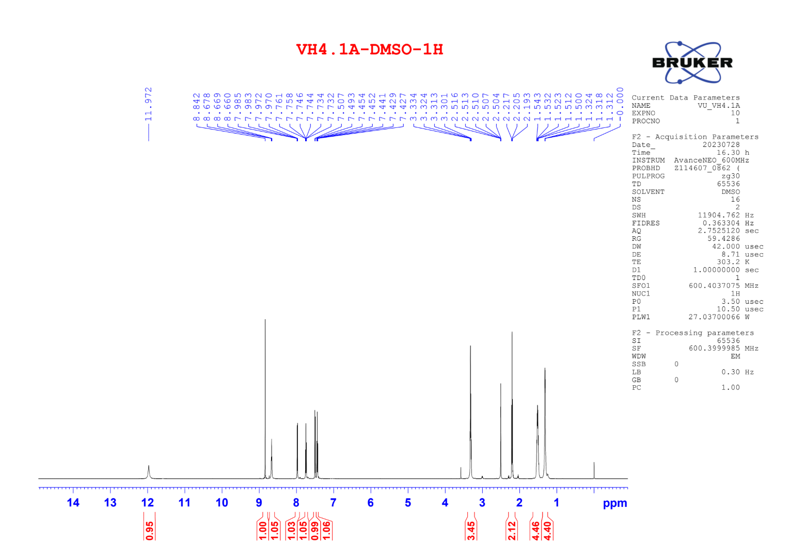

Figure S2. ¹³C NMR of compound 3a
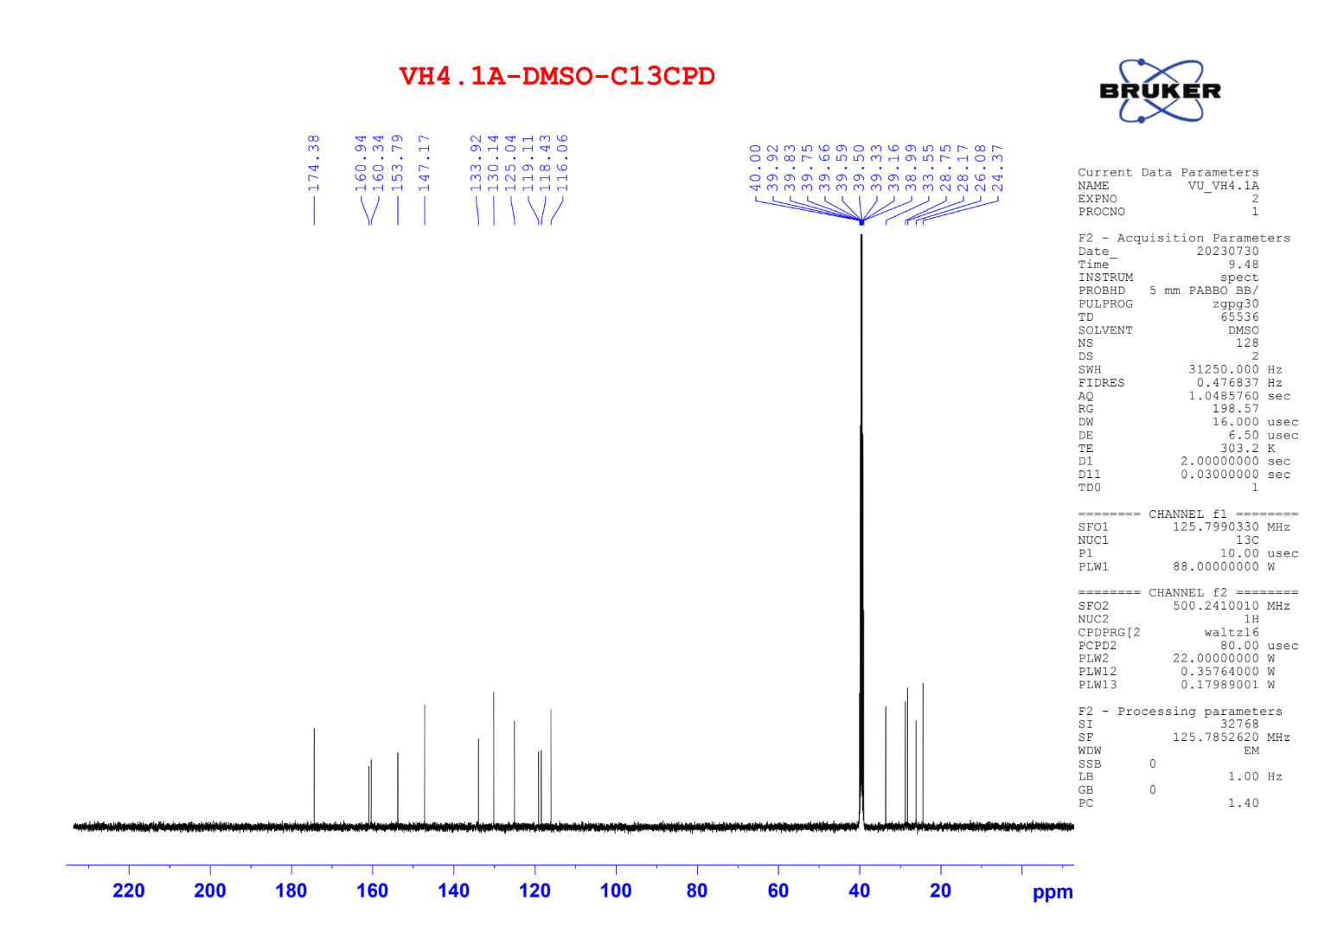

Figure S3. ¹H NMR of compound 3b
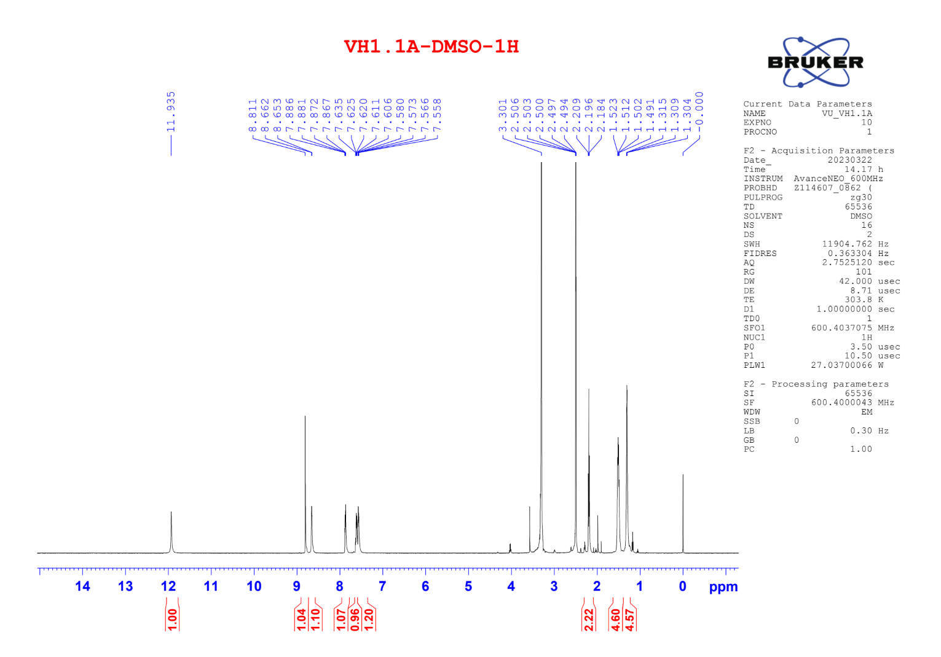

Figure S4. ¹³C NMR of compound 3b
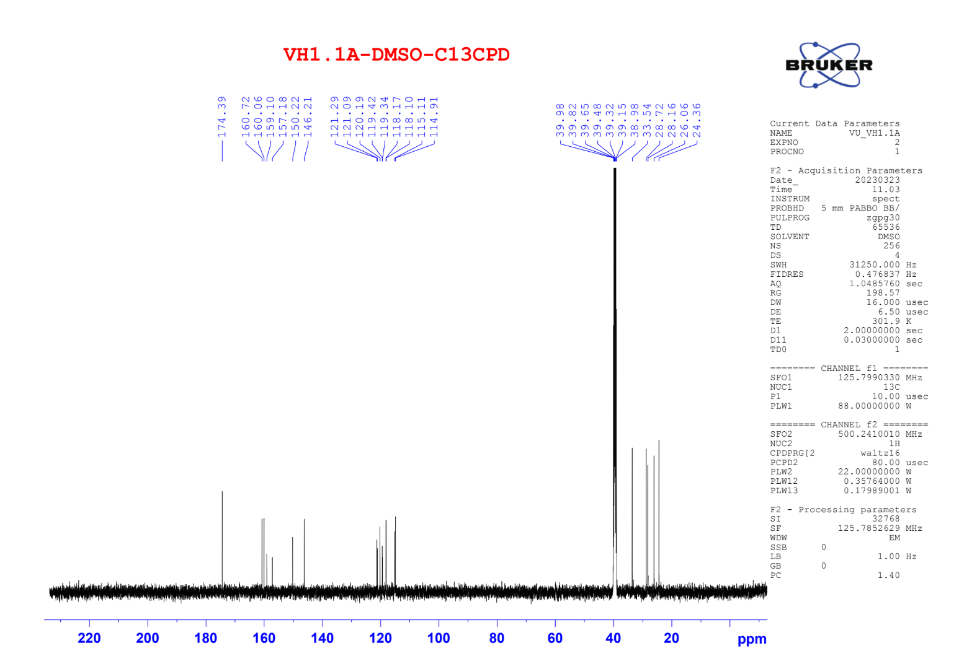

Figure S5. ¹H NMR of compound 3c
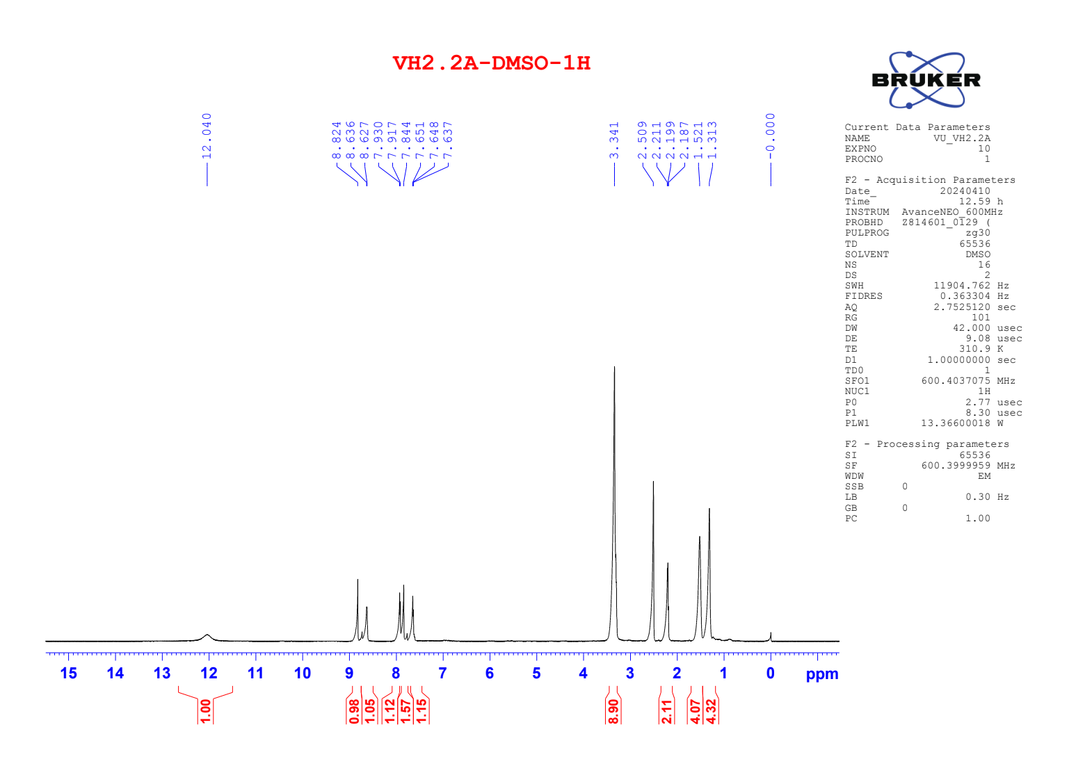

Figure S6. ¹³C NMR of compound 3c
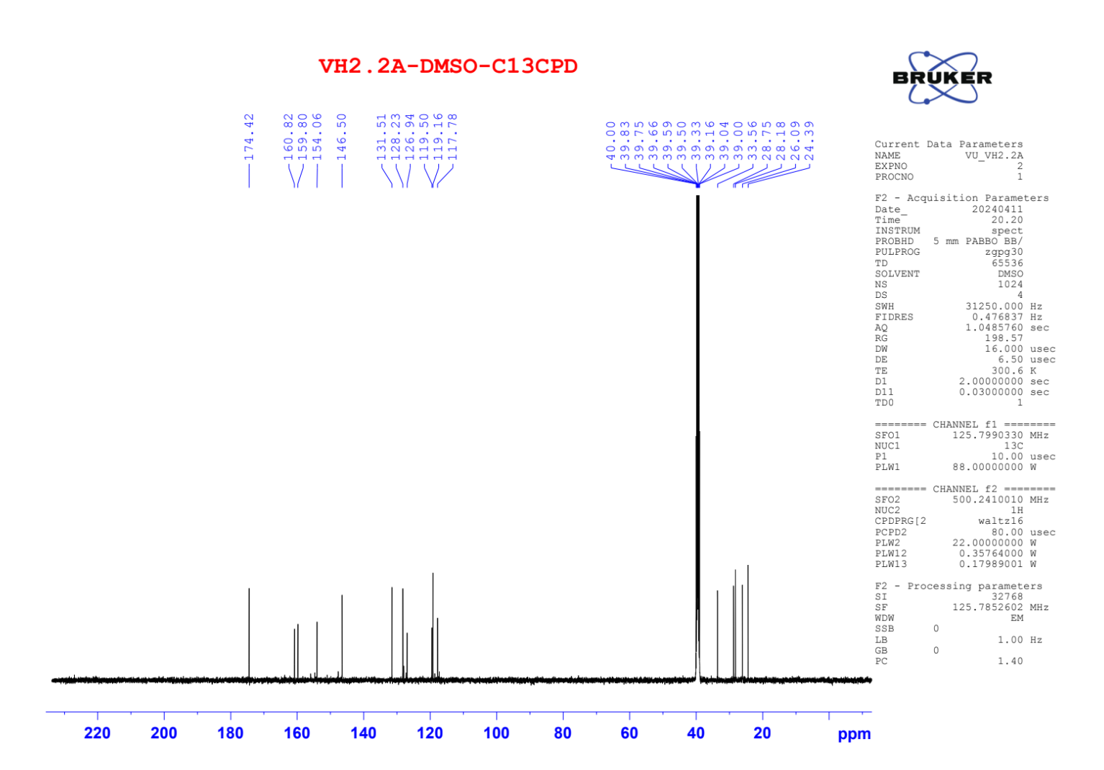

Figure S7. ¹H NMR of compound 3d
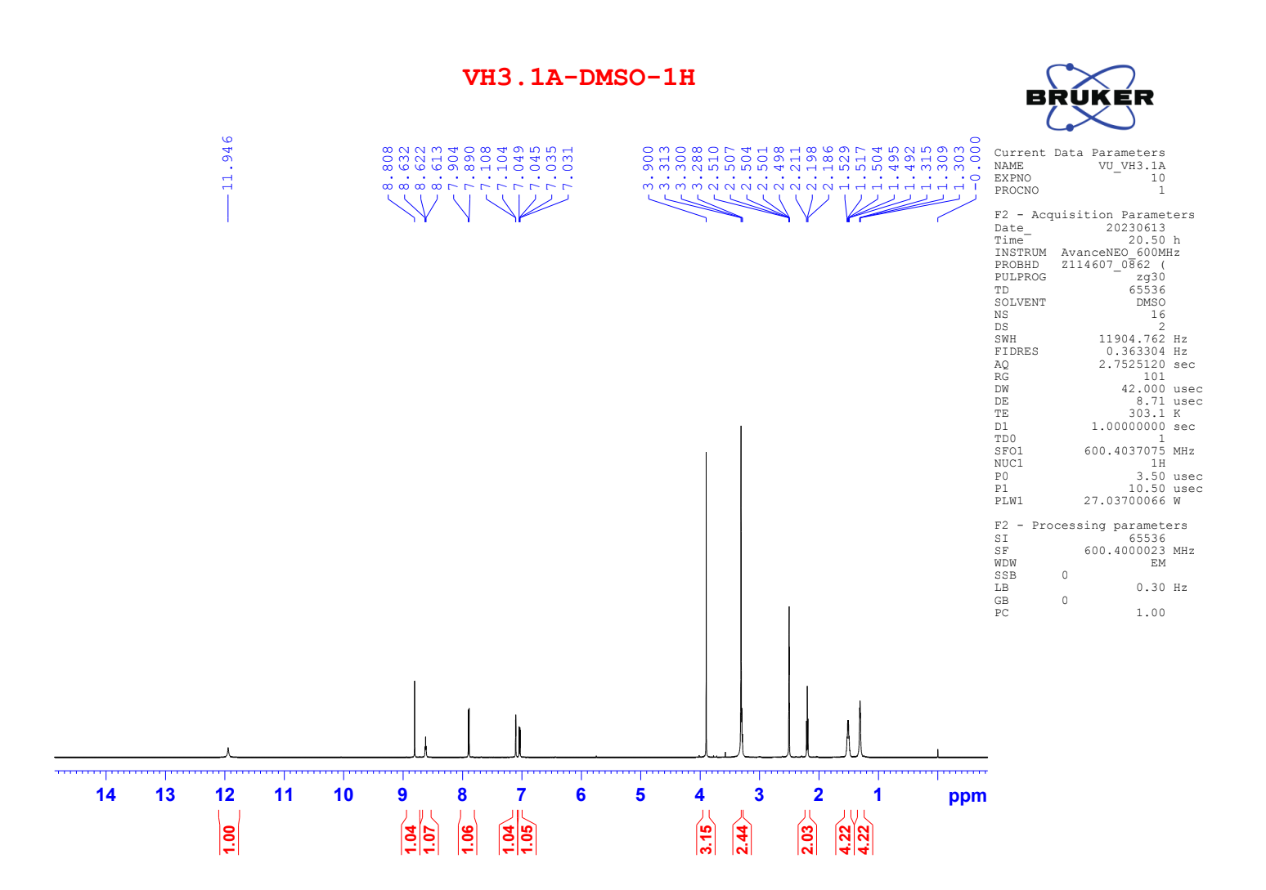

Figure S8. ¹³C NMR of compound 3d
`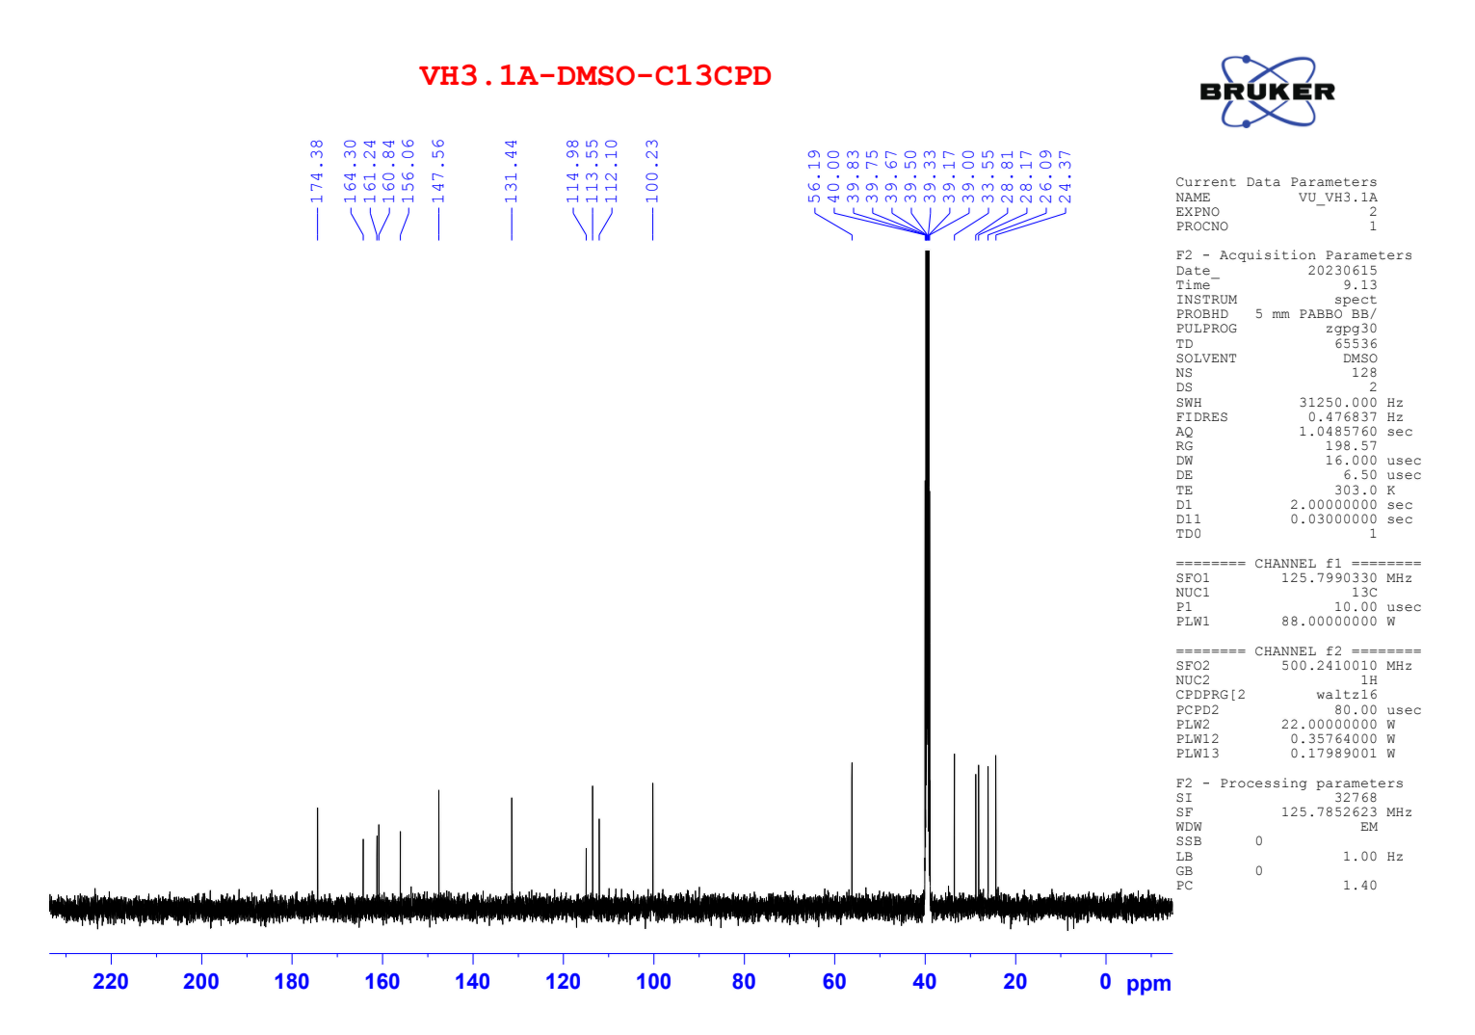

Figure S9. ¹H NMR of compound 3e
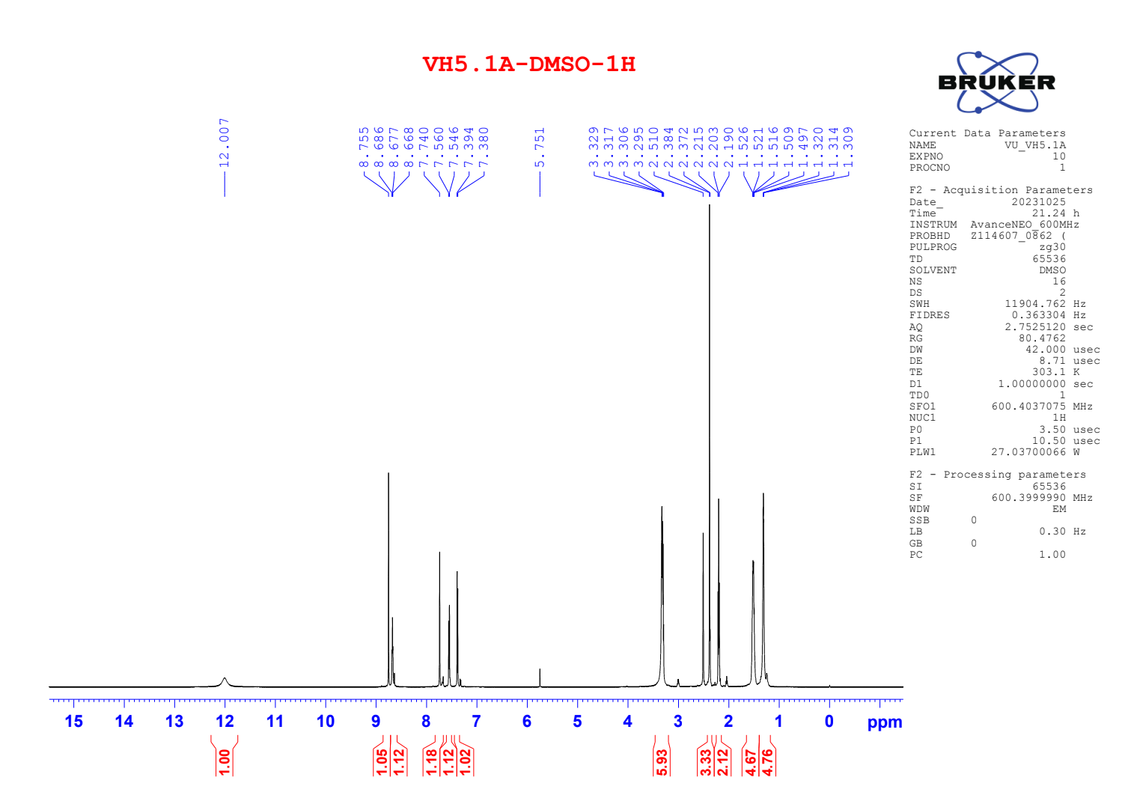

Figure S10. ¹³C NMR of compound 3e
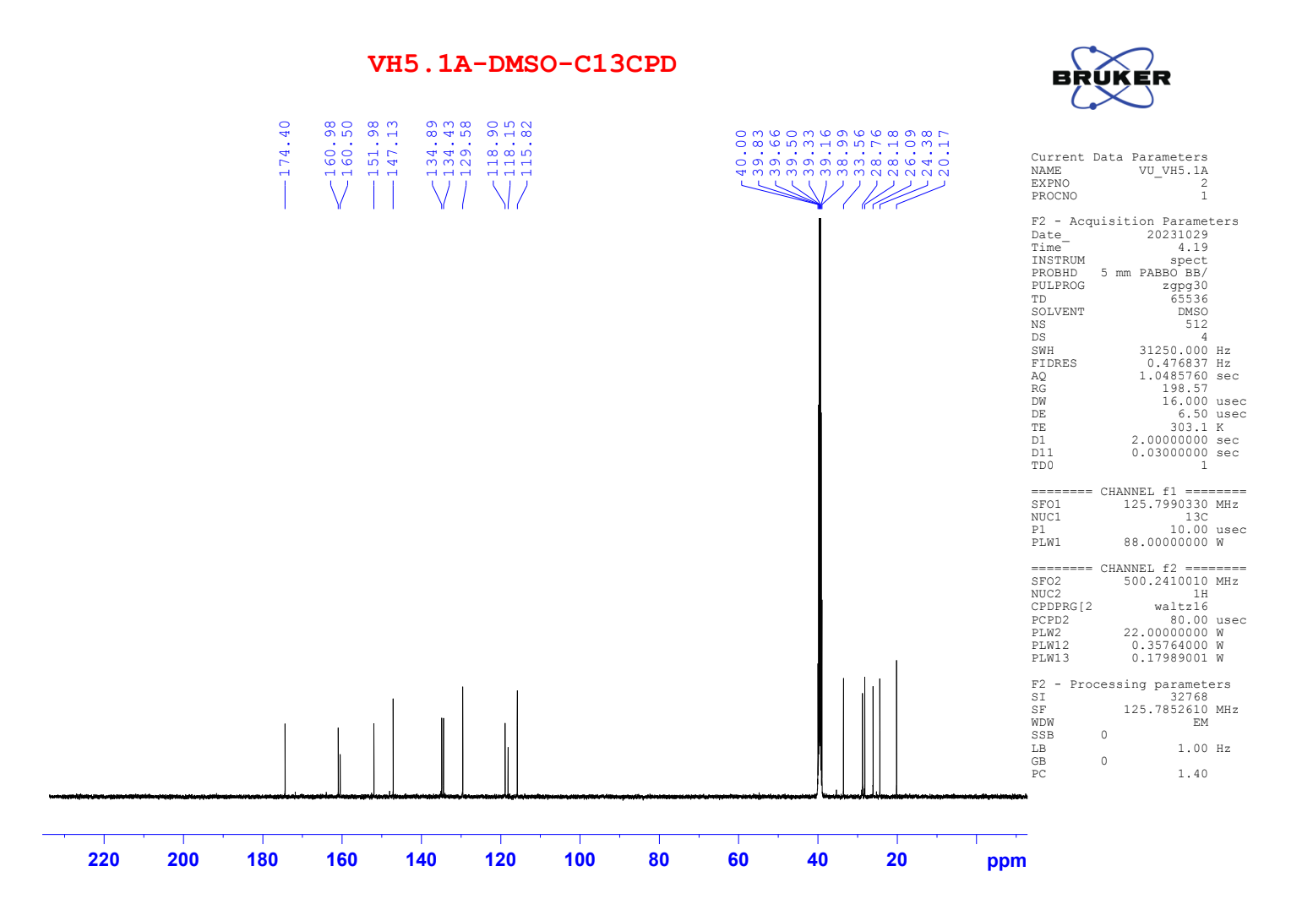

Figure S11. ¹H NMR of compound 3f
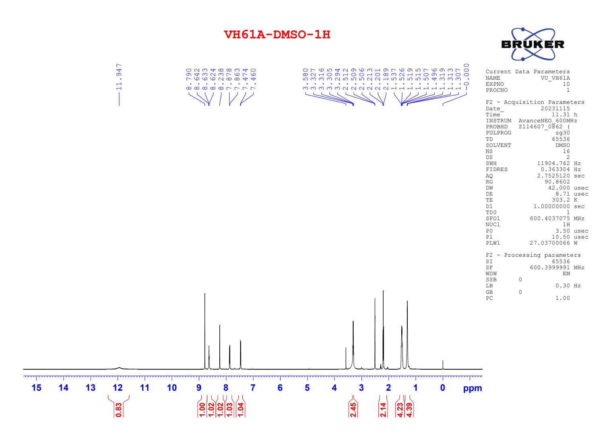

Figure S12. ¹³C NMR of compound 3f
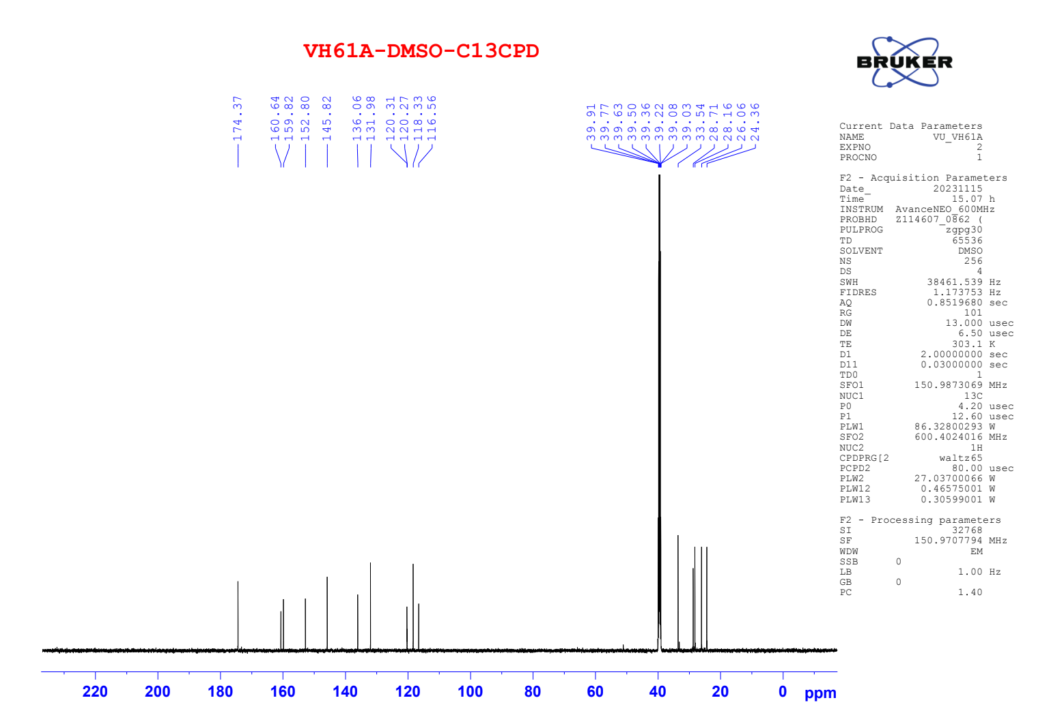

Figure S13. ¹H NMR of compound 3g
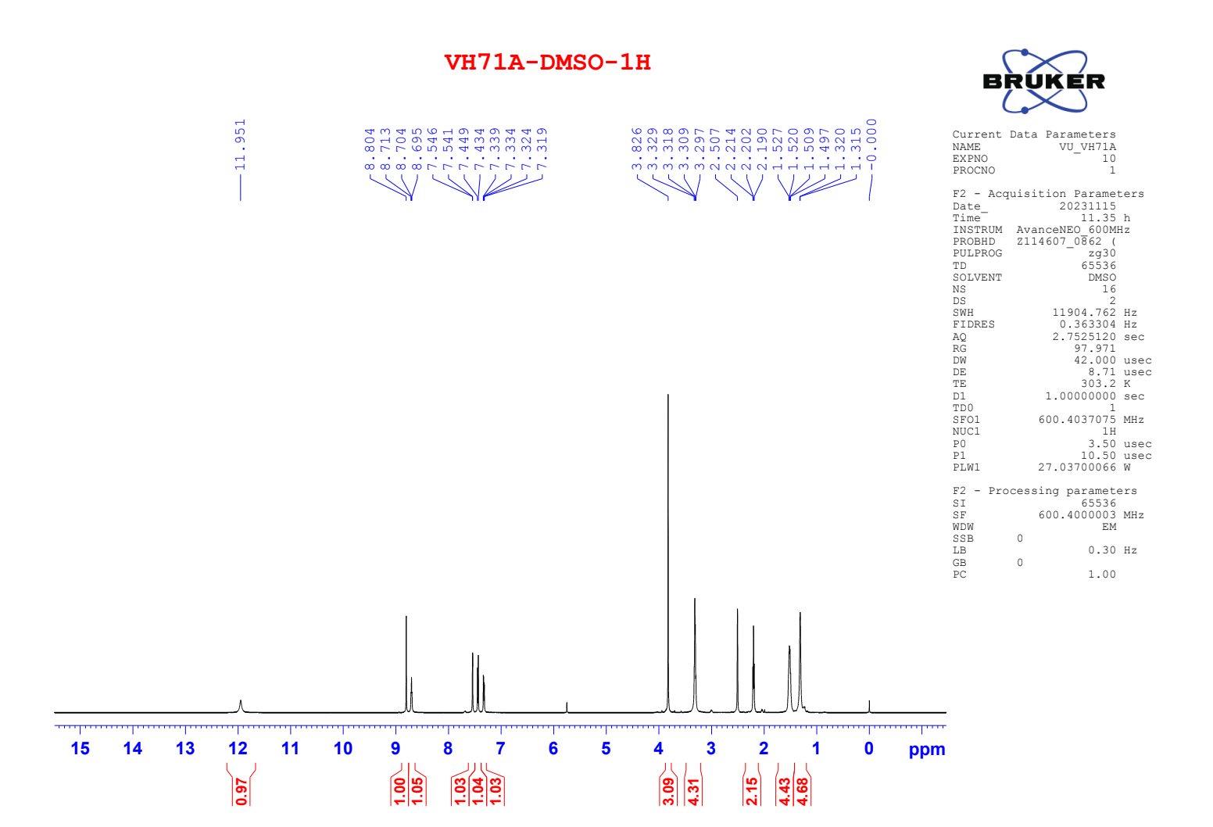

Figure S14. ¹³C NMR of compound 3g
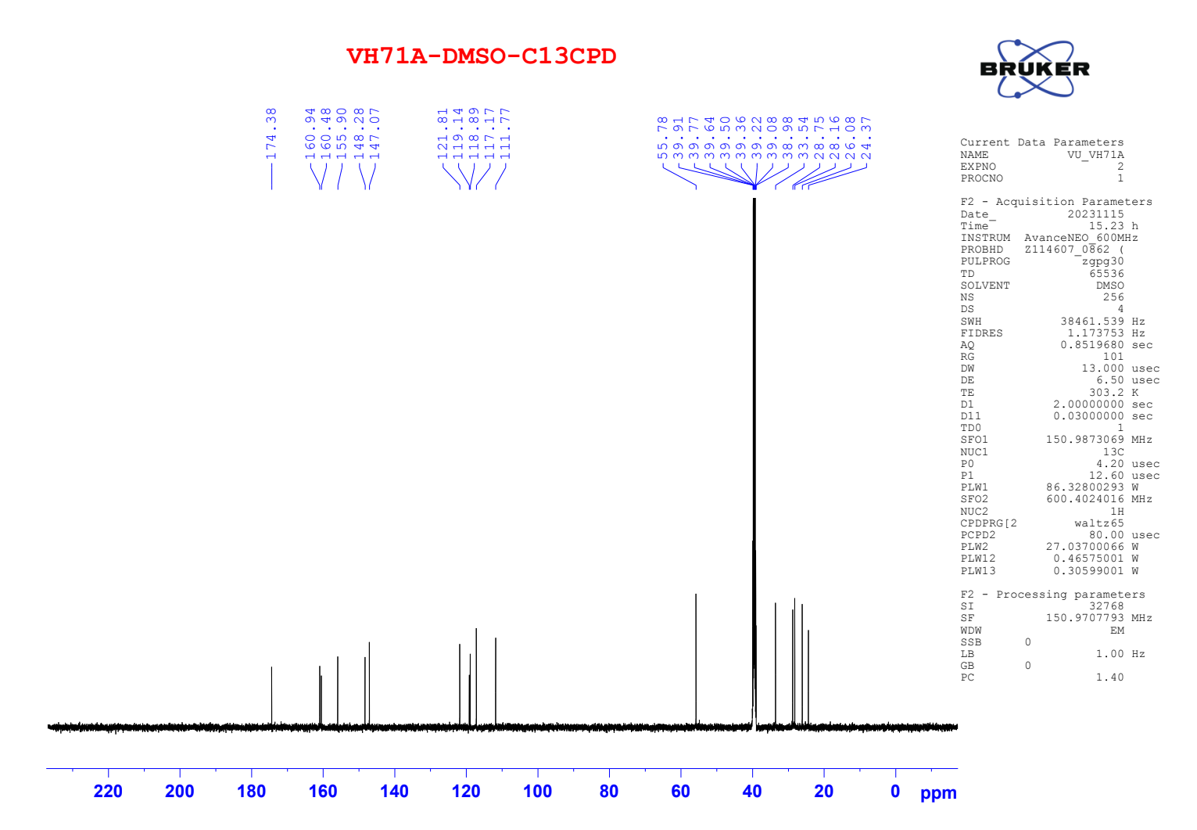

Figure S15. ¹H NMR of compound 4a
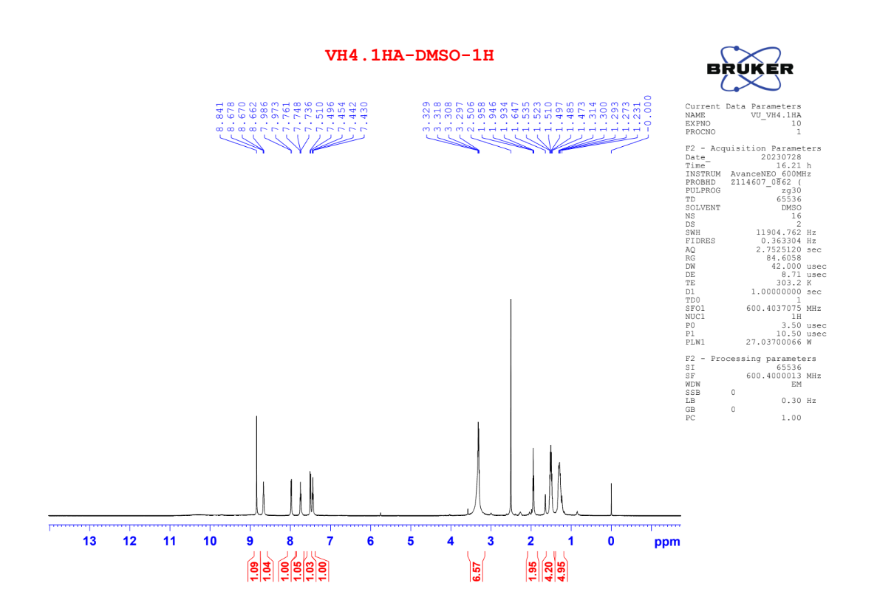

Figure S16. ¹³C NMR of compound 4a
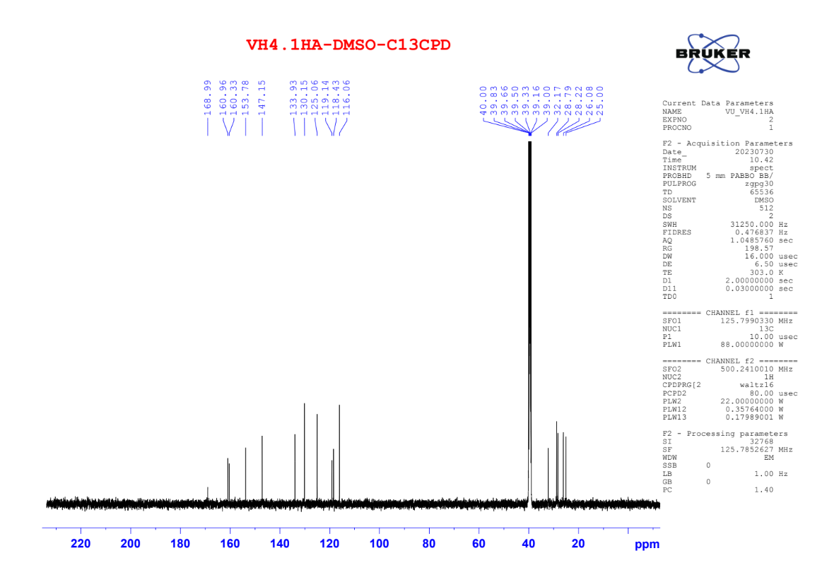

Figure S17. HRMS of compound 4a
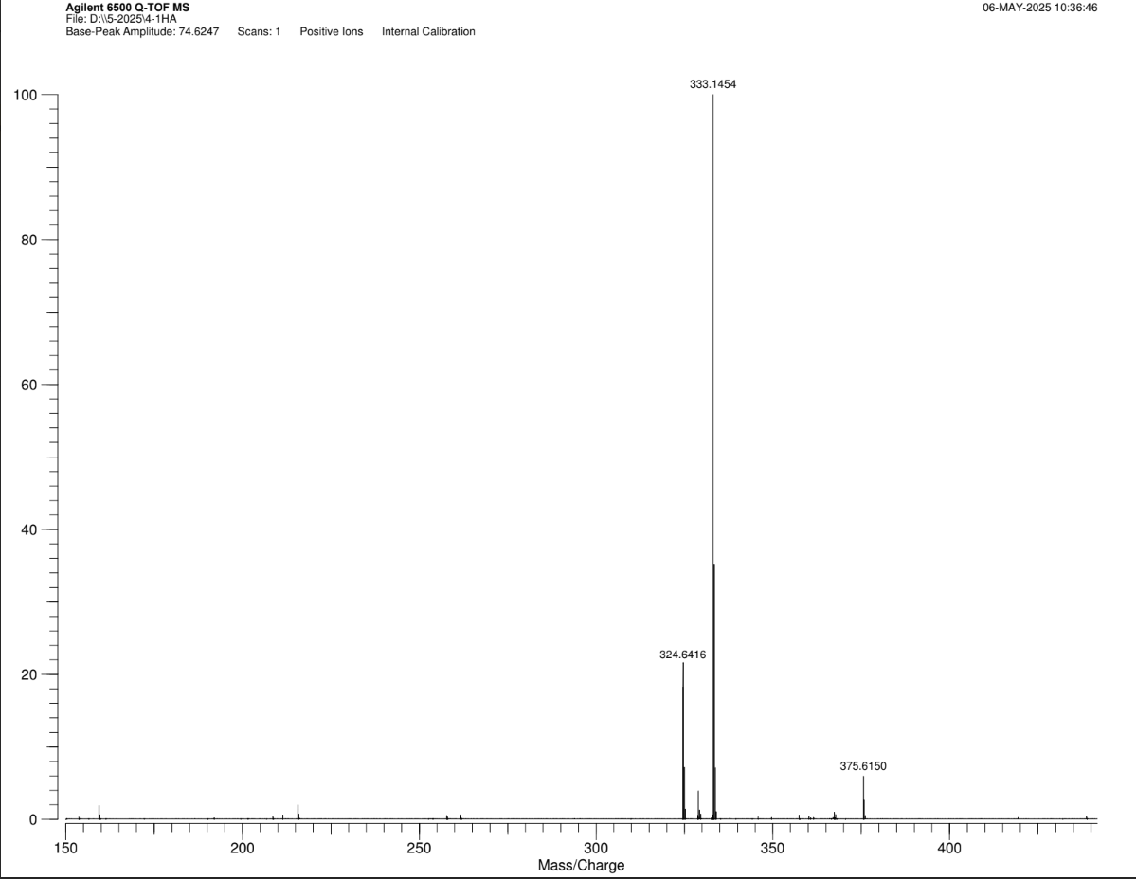

Figure S18. ¹H NMR of compound 4b
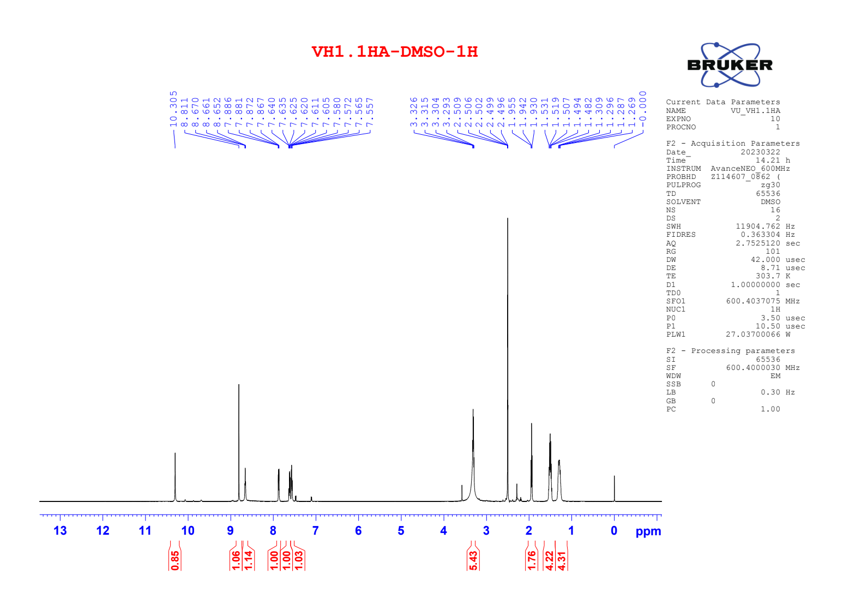

Figure S19. ¹³C NMR of compound 4b
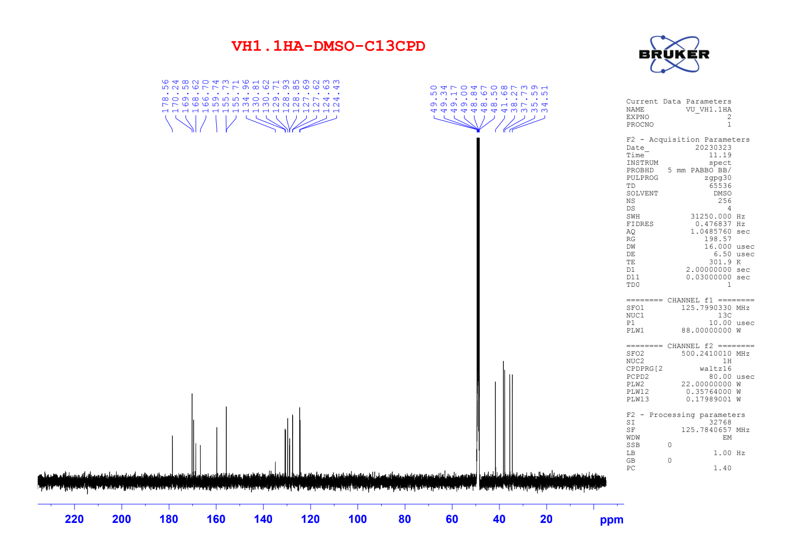

Figure S20. HRMS of compound 4b
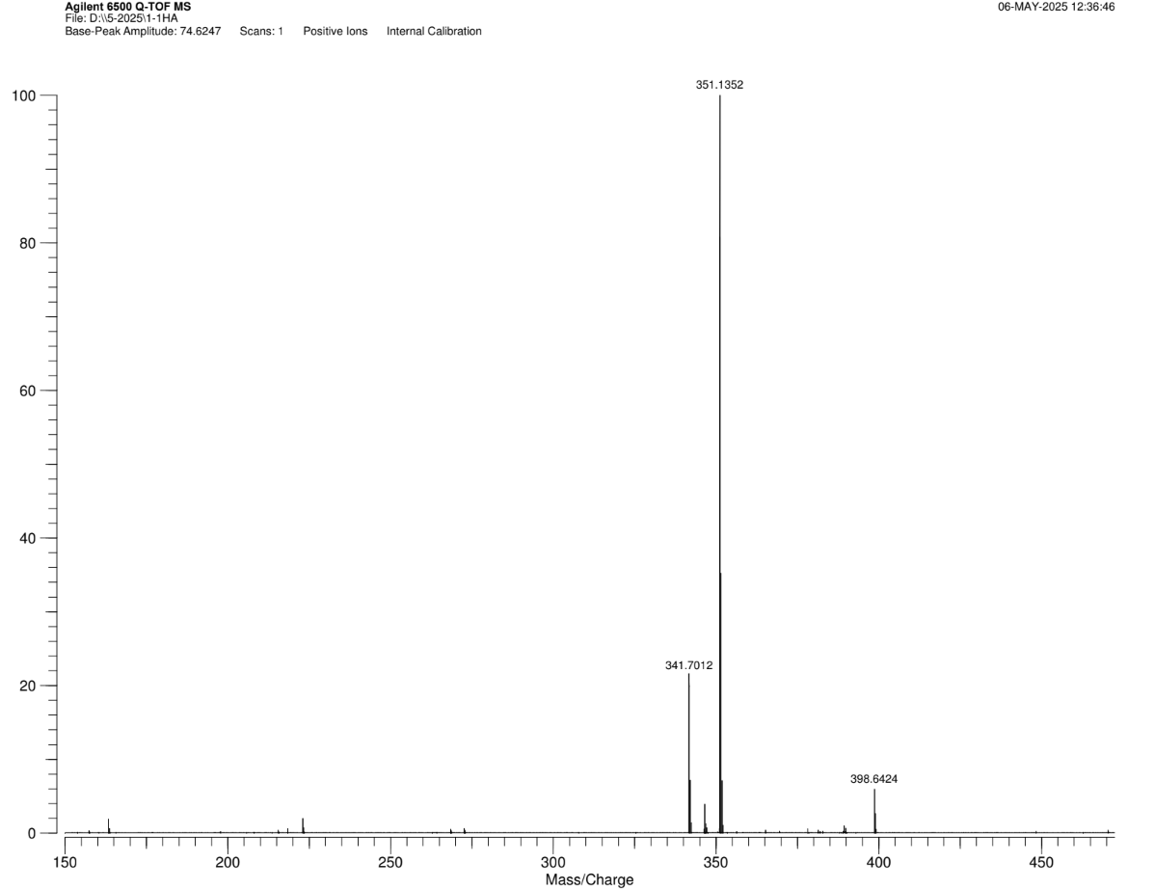

Figure S21. ¹H NMR of compound 4c
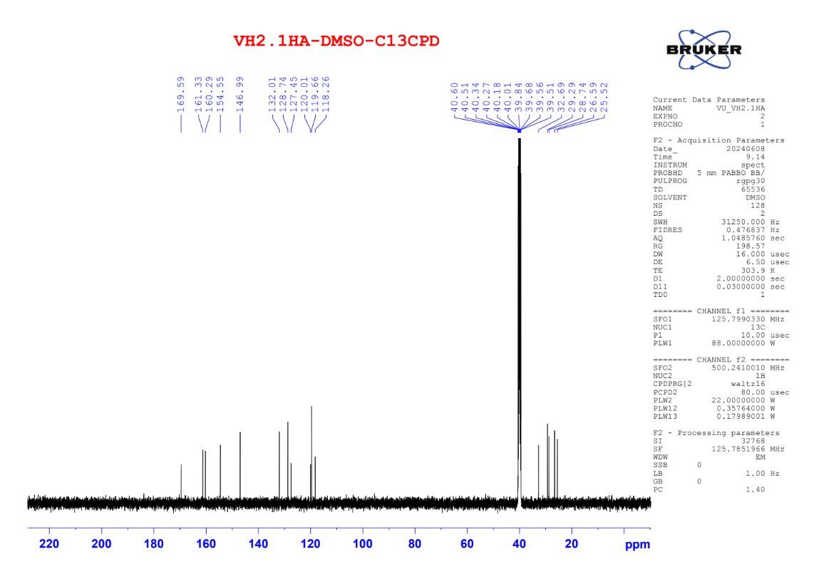

Figure S22. ¹³C NMR of compound 4c
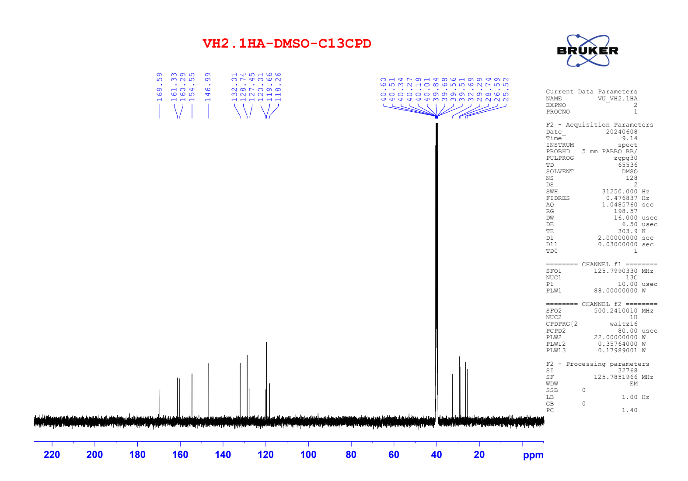

Figure S23. ¹H NMR of compound 4d
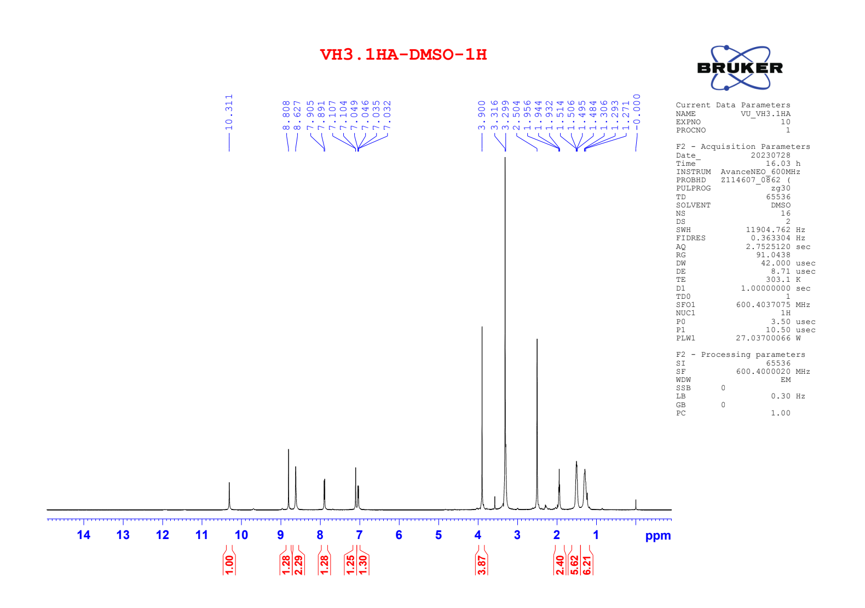

Figure S24. ¹³C NMR of compound 4d
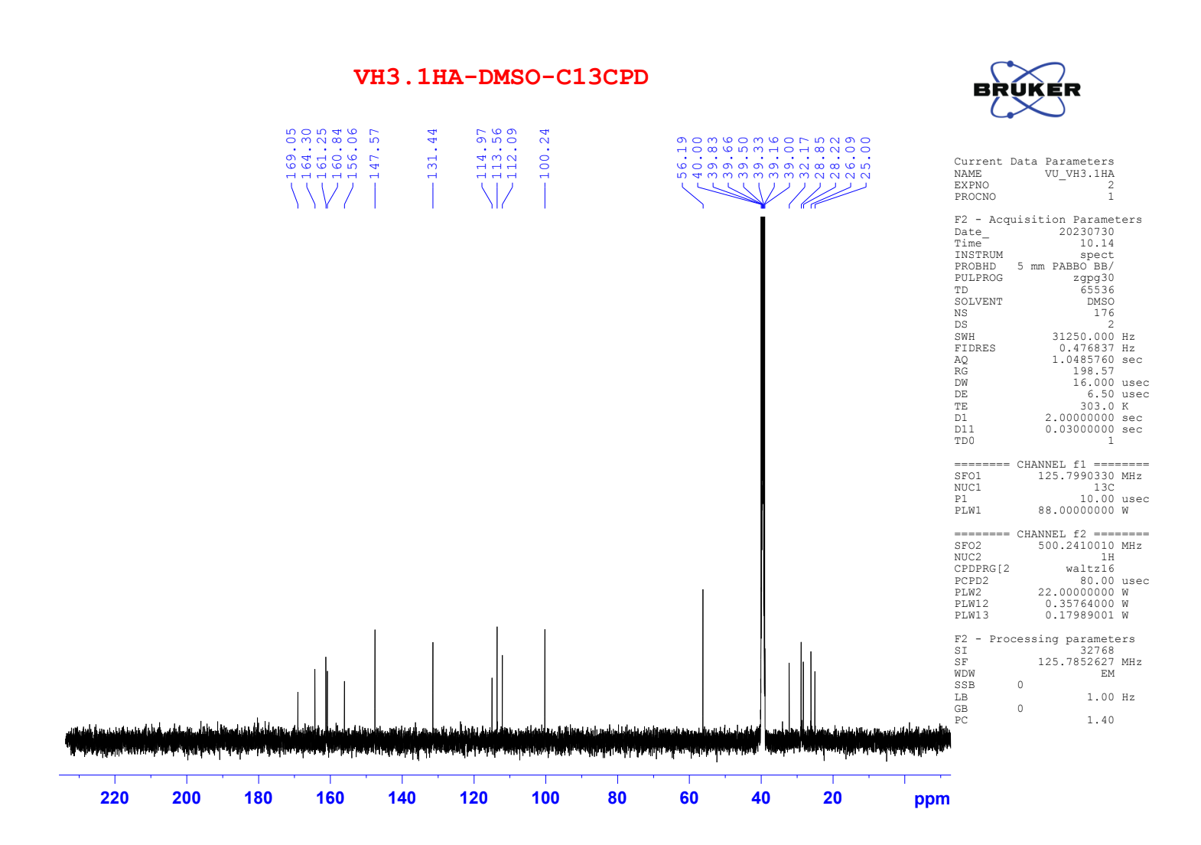

Figure S25. ¹H NMR of compound 4e
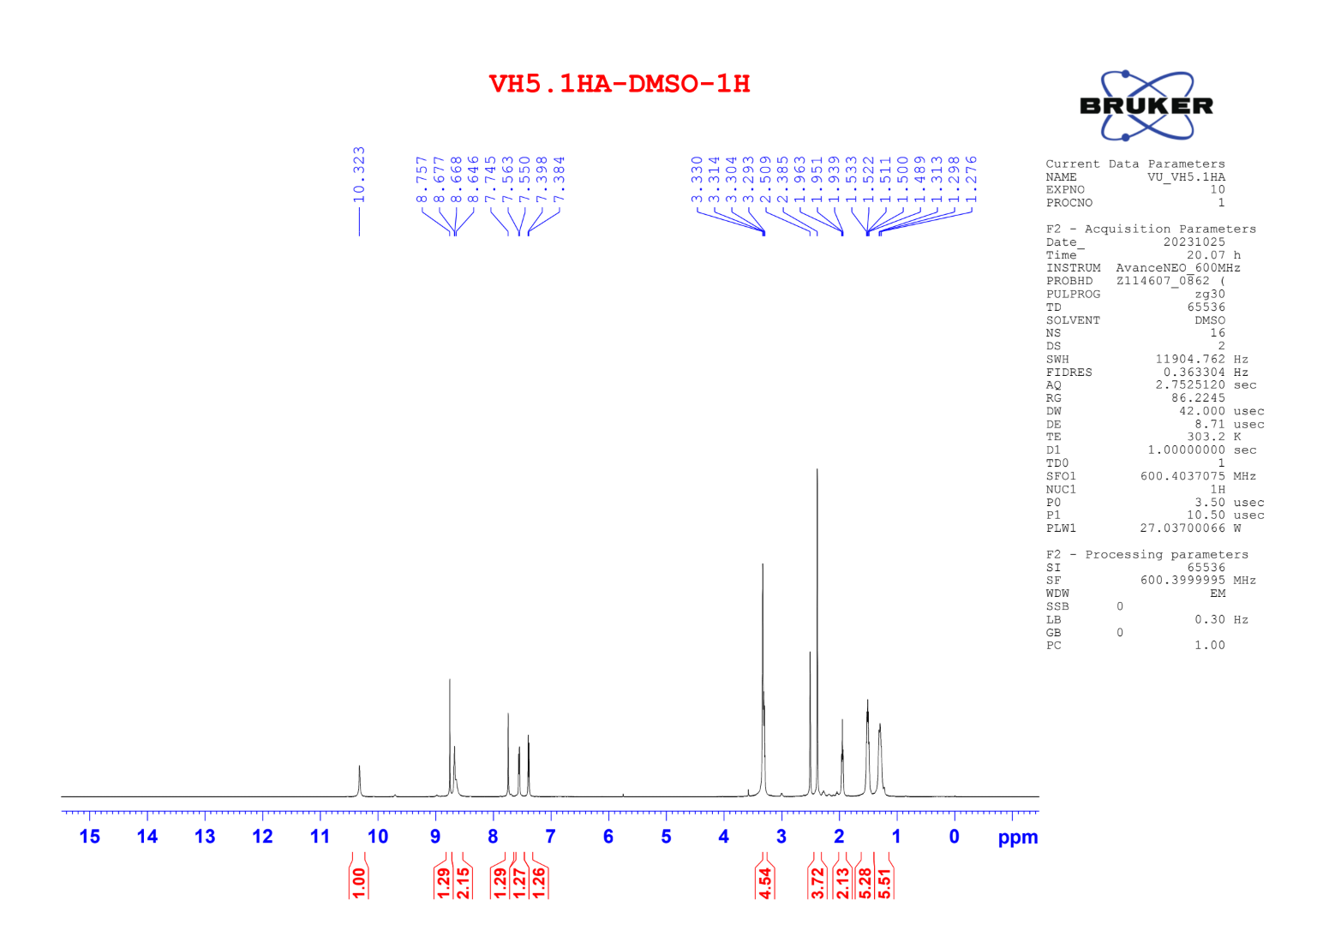

Figure S26. ¹³C NMR of compound 4e
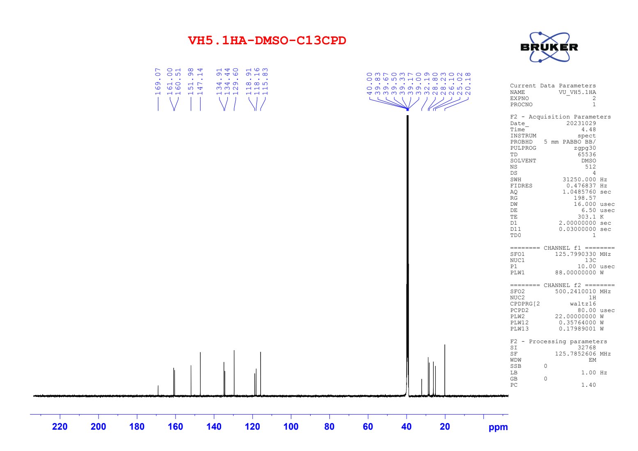

Figure S27. HRMS of compound 4e
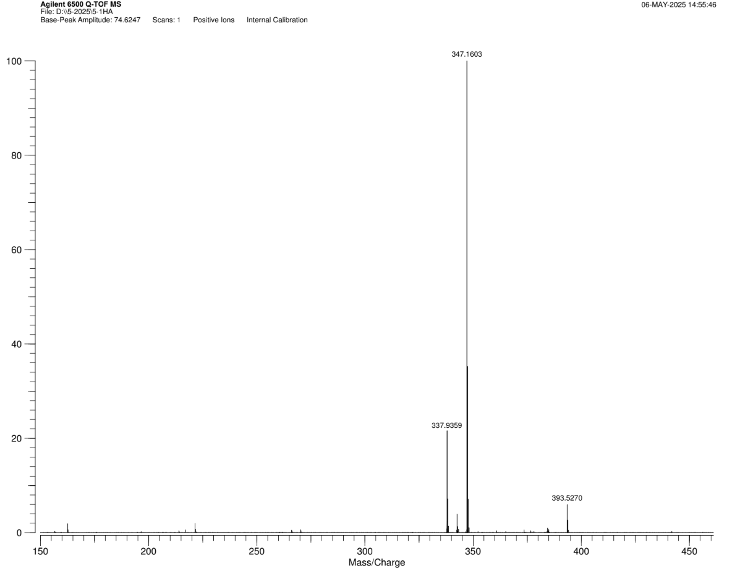

Figure S28. ¹H NMR of compound 4f
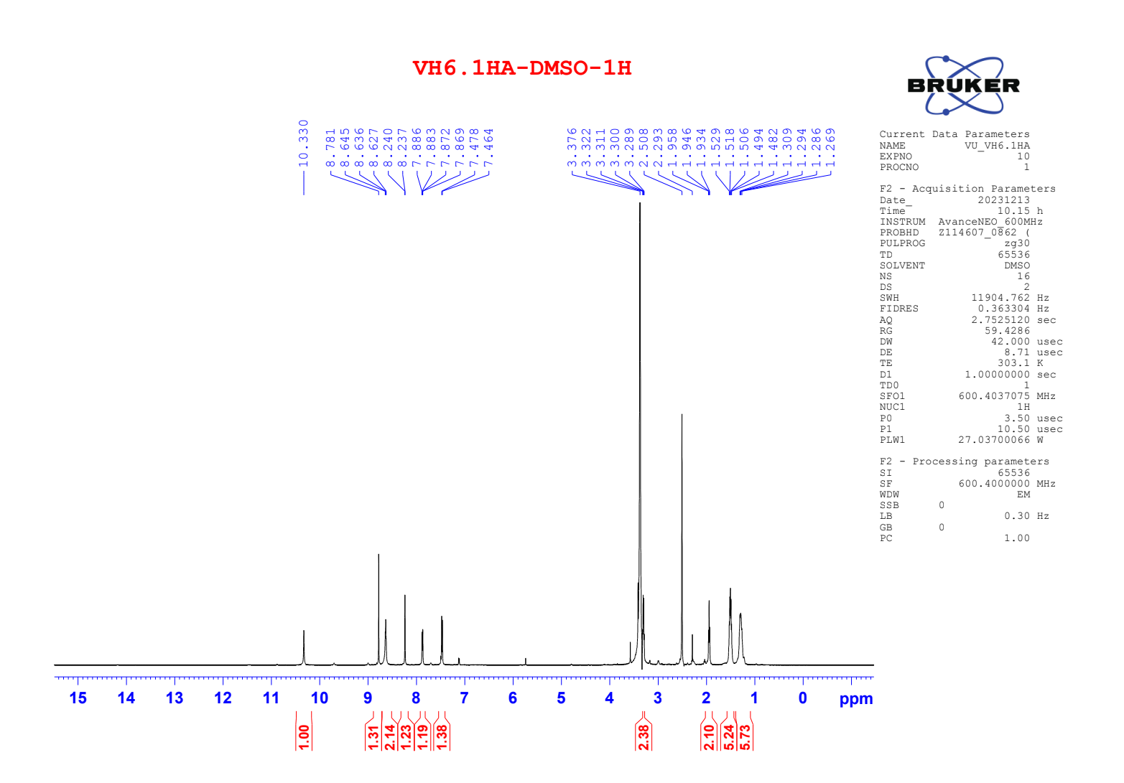

Figure S29. ¹³C NMR of compound 4f
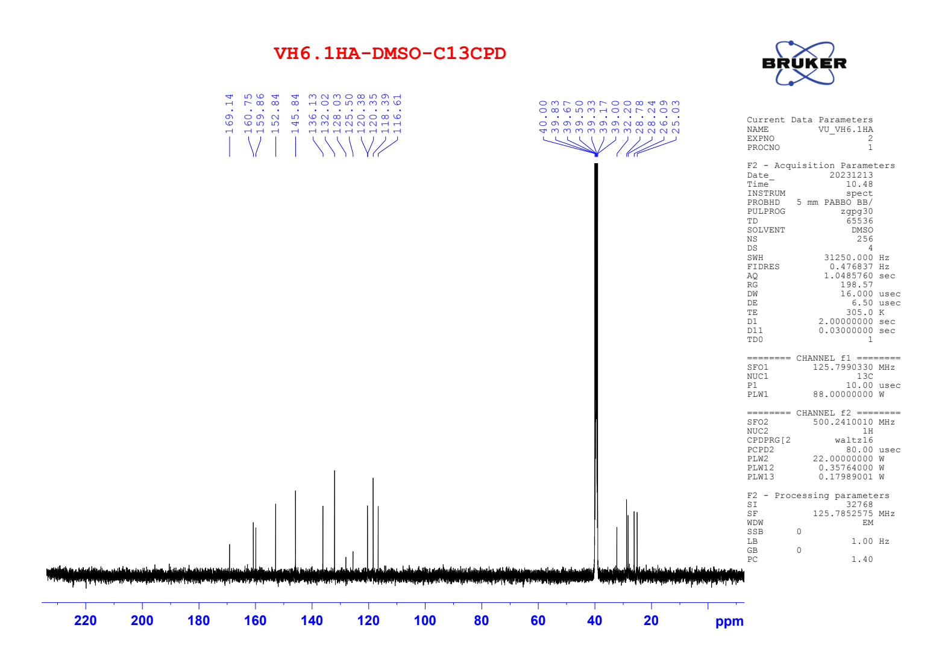

Figure S30. HRMS of compound 4f
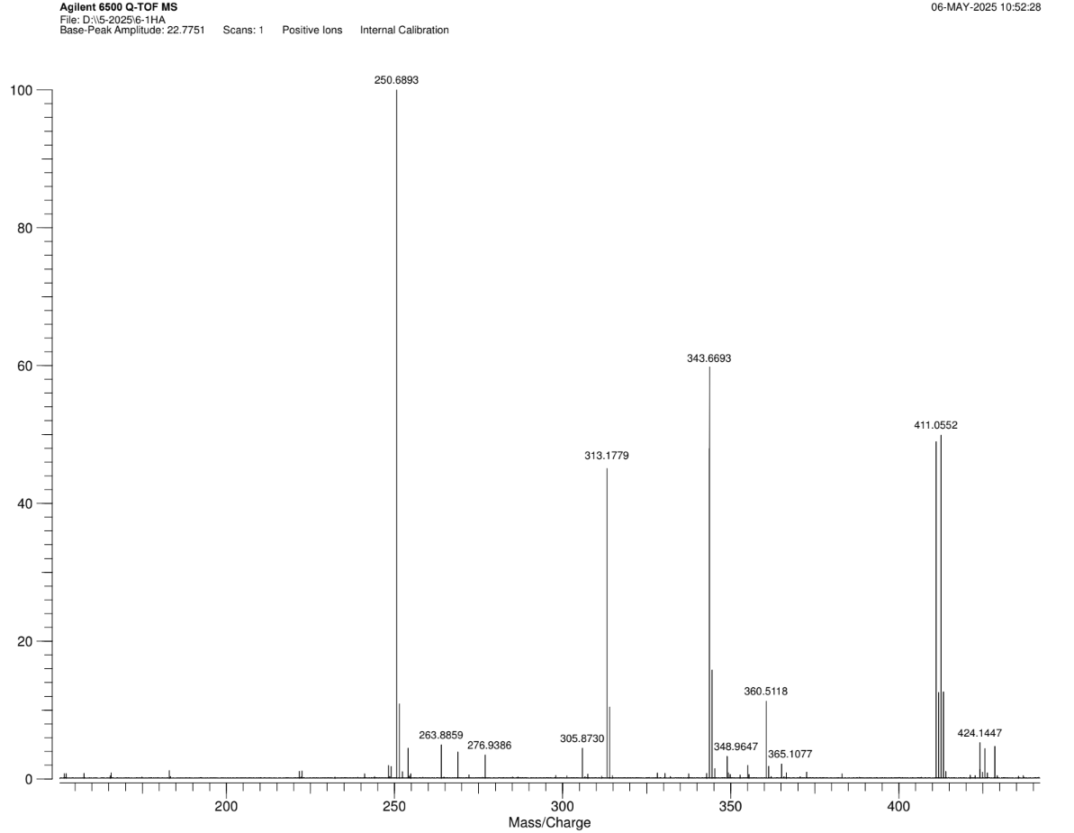

Figure S31. ¹H NMR of compound 4g
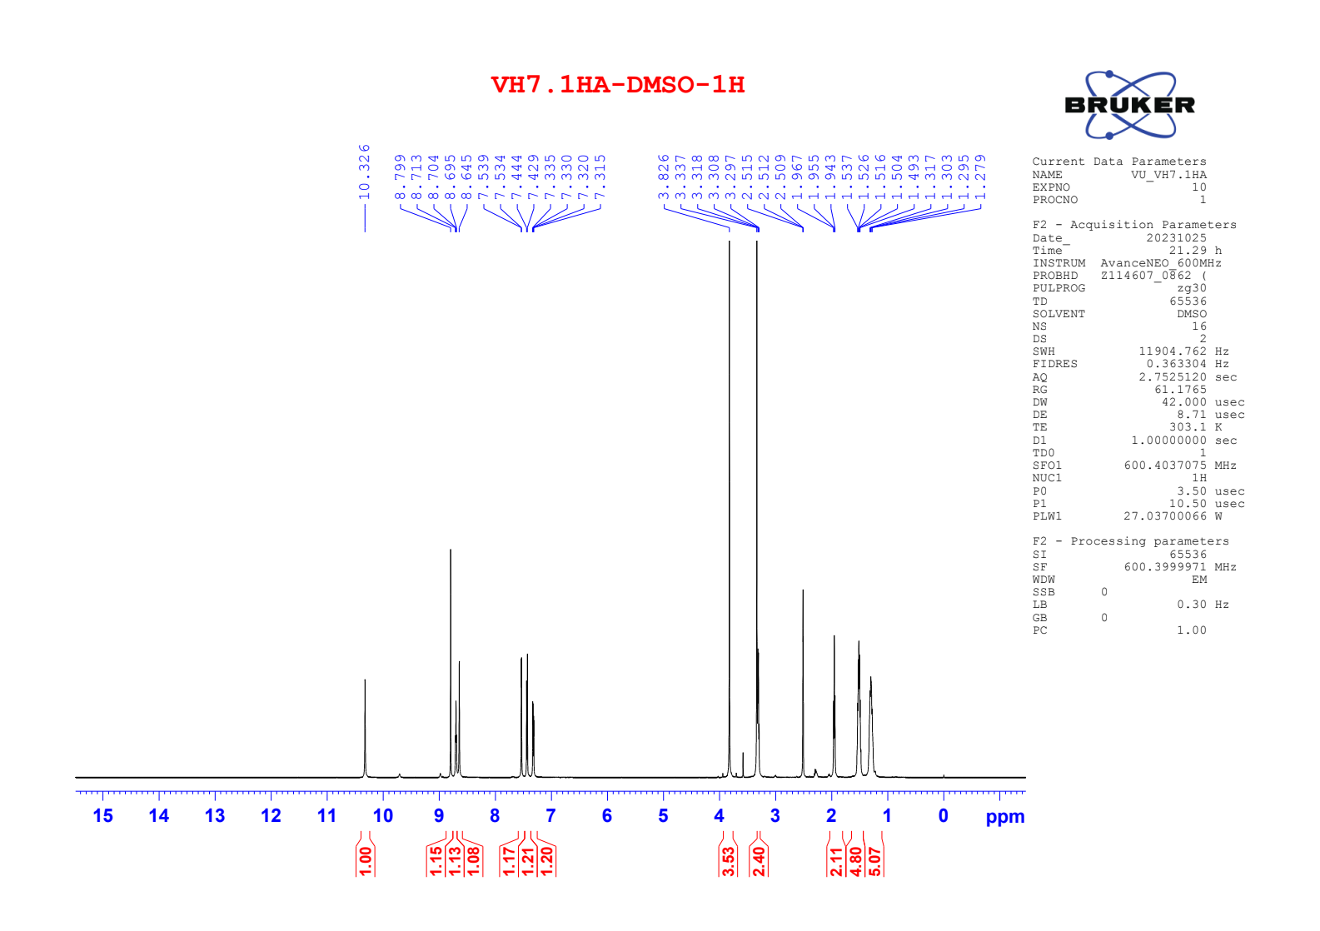

S32. ¹³C NMR of compound 4g
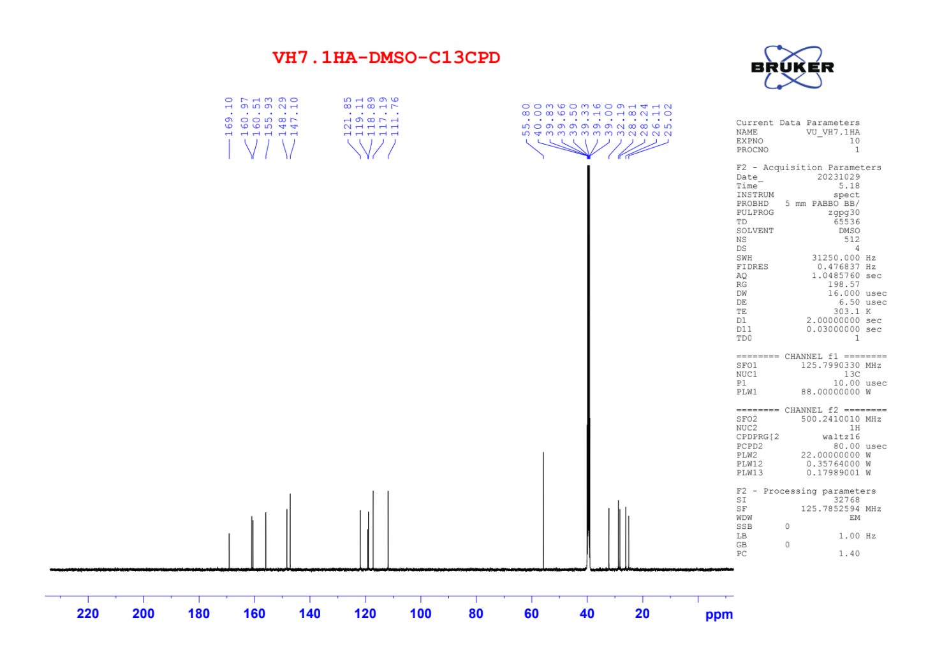

Figure S33. HRMS of compound 4g
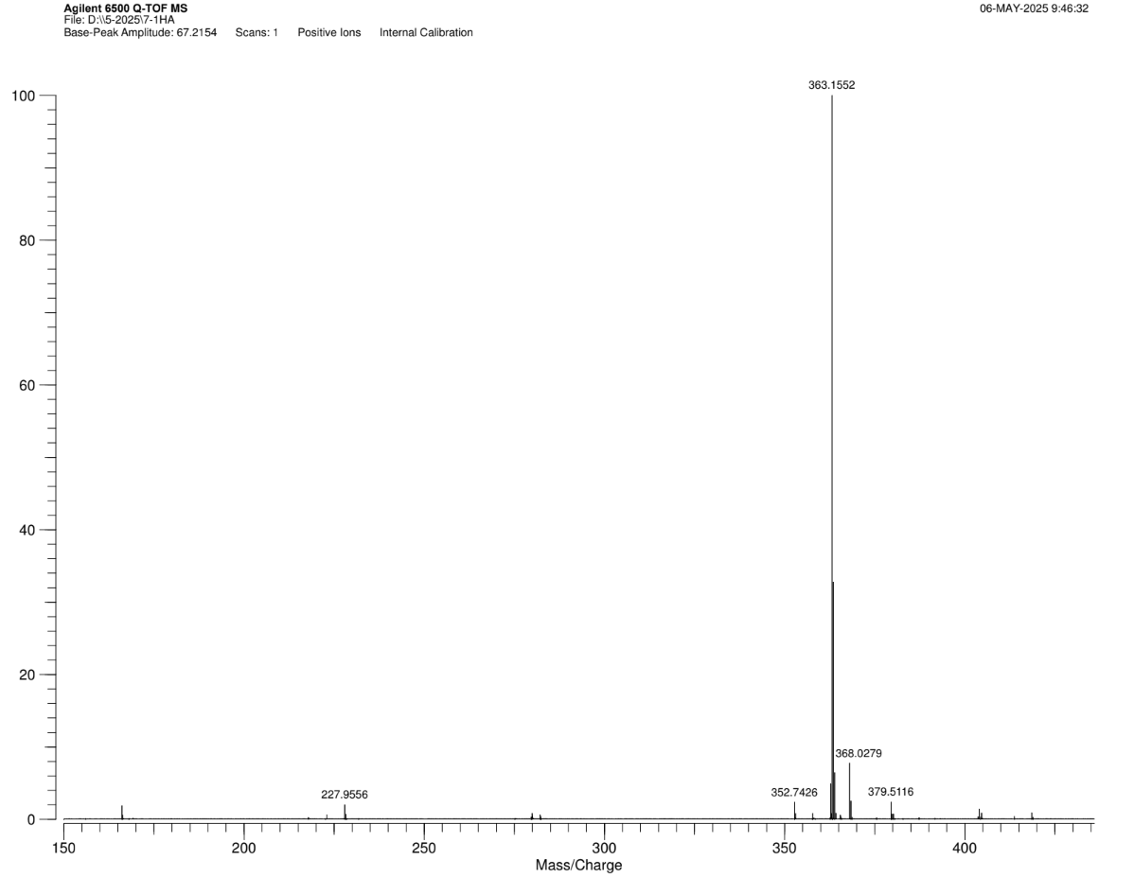

Figure S34. ¹H NMR of compound 5a
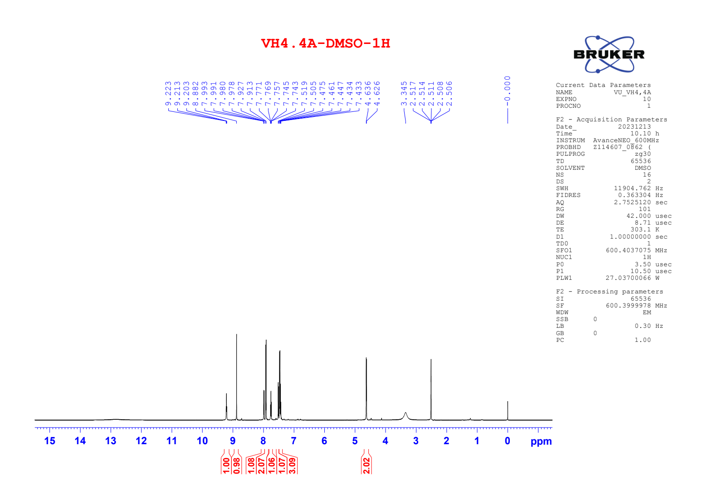

Figure S35. ¹³C NMR of compound 5a
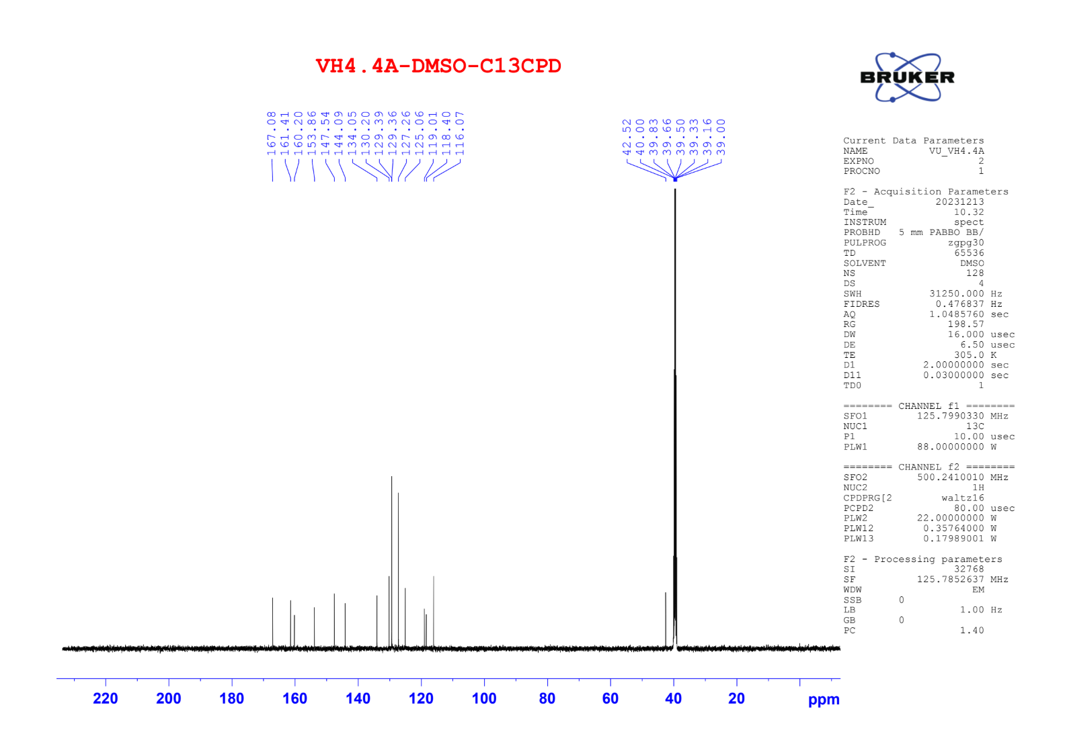

Figure S36. ¹H NMR of compound 5b
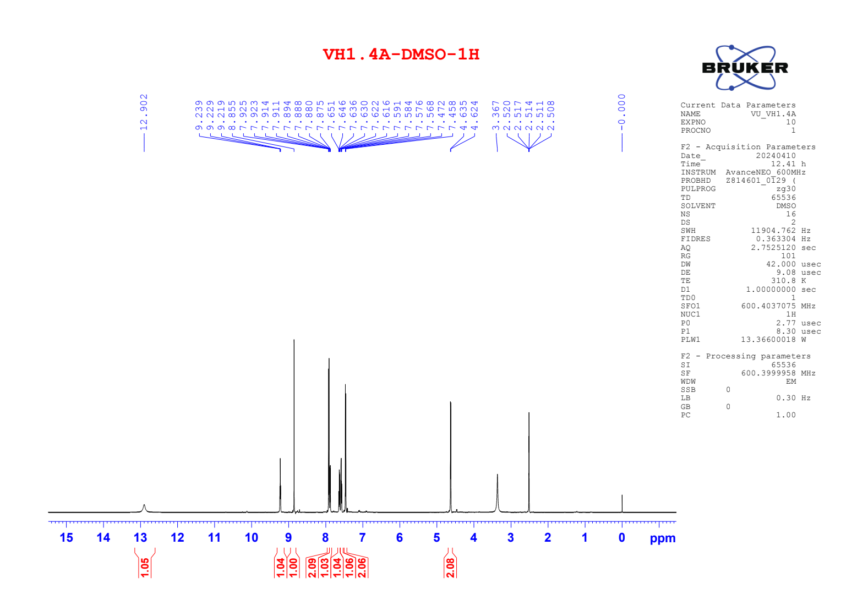

Figure S37. ¹³C NMR of compound 5b
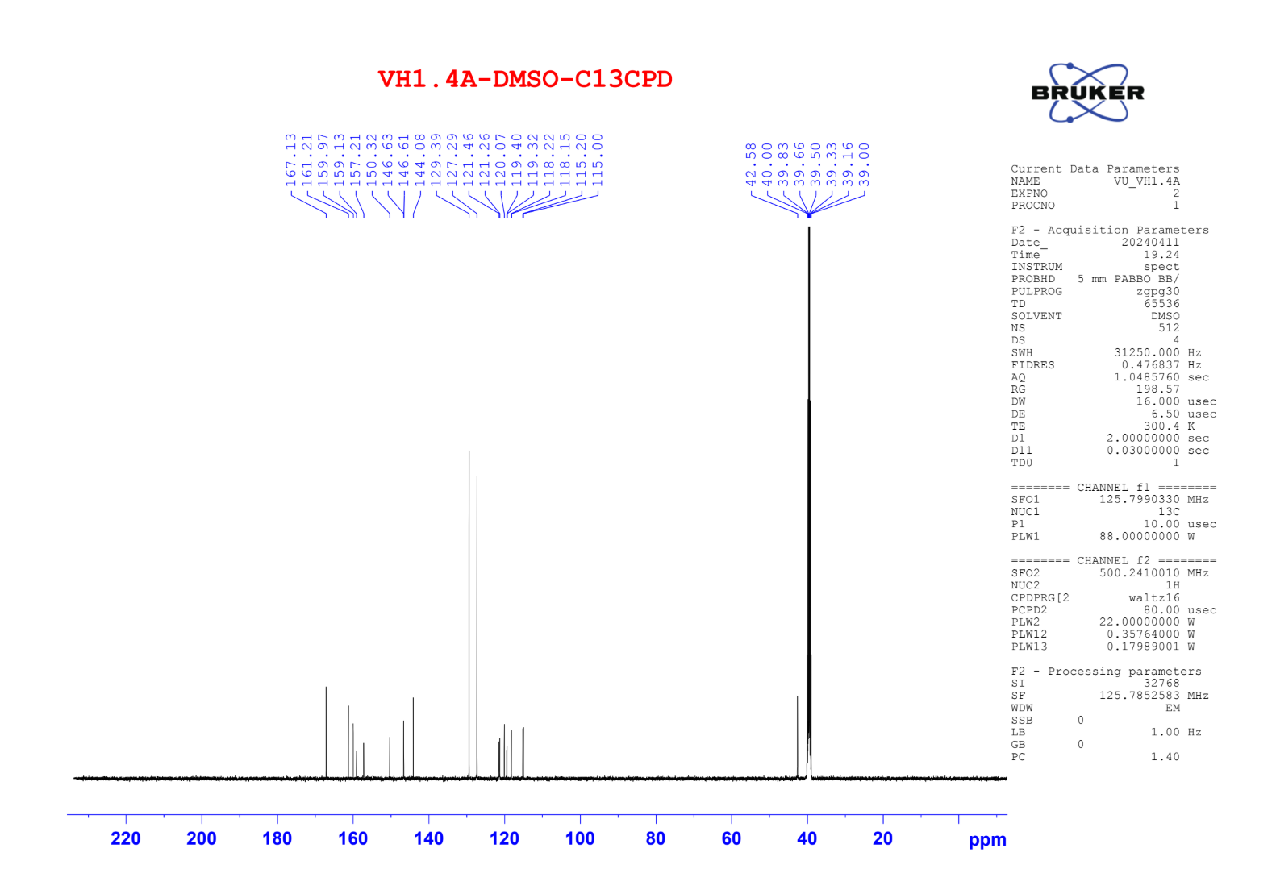

Figure S38. ¹H NMR of compound 5c
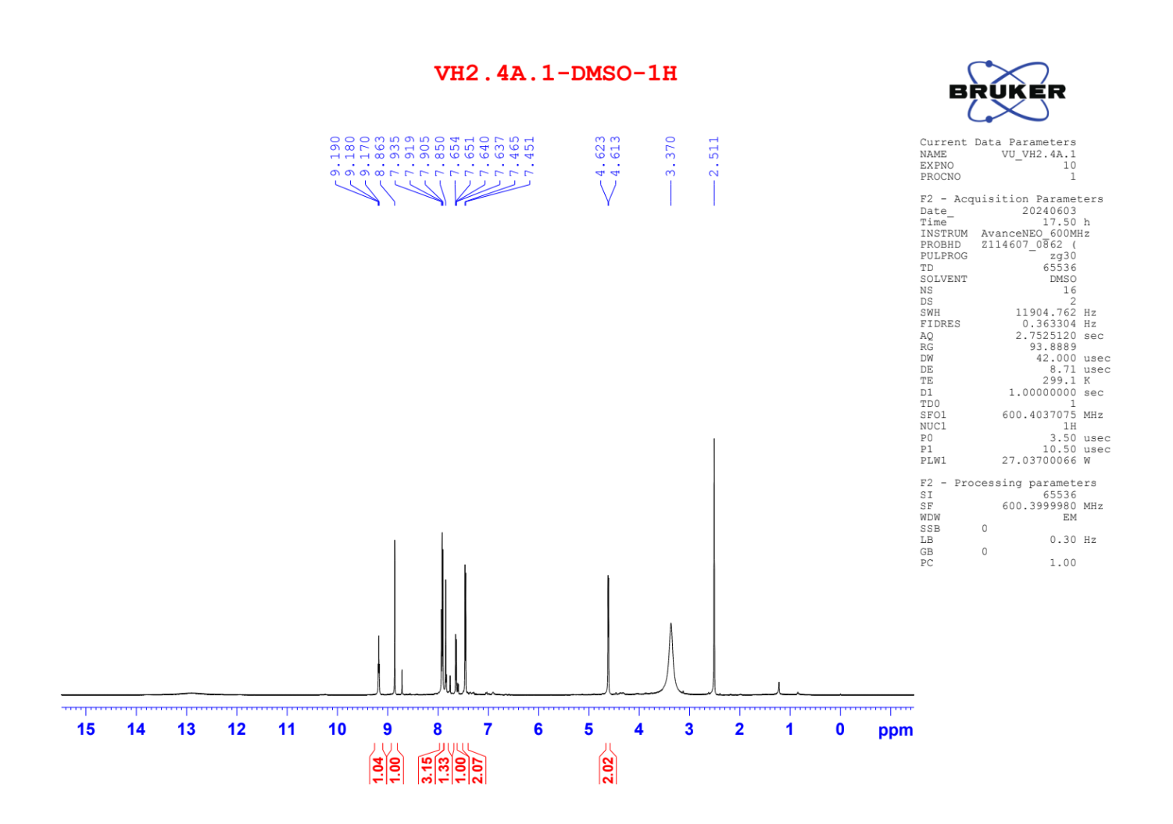

Figure S39. ¹³C NMR of compound 5c
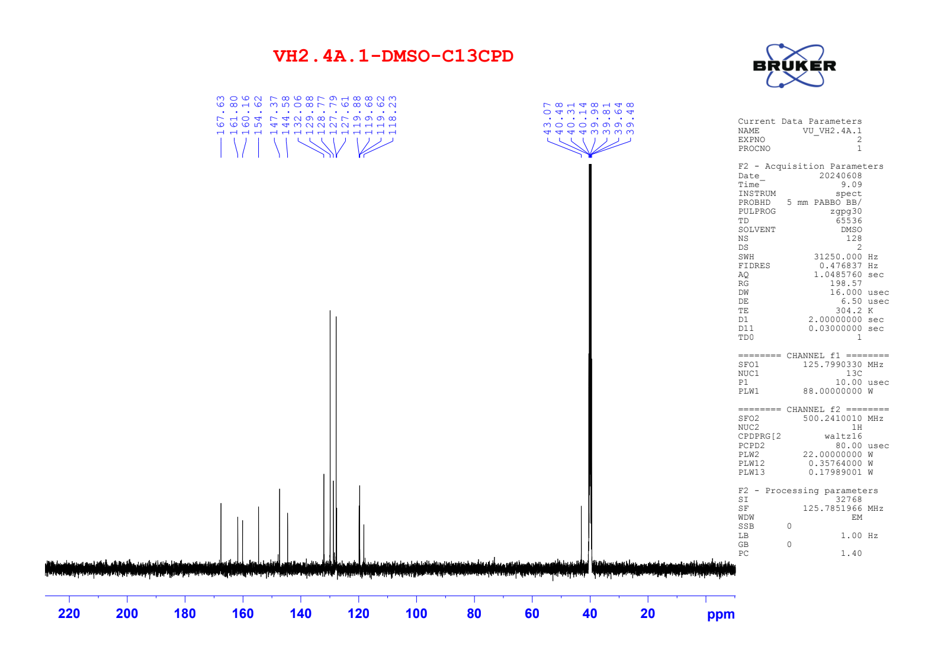

Figure S40. ¹H NMR of compound 5d
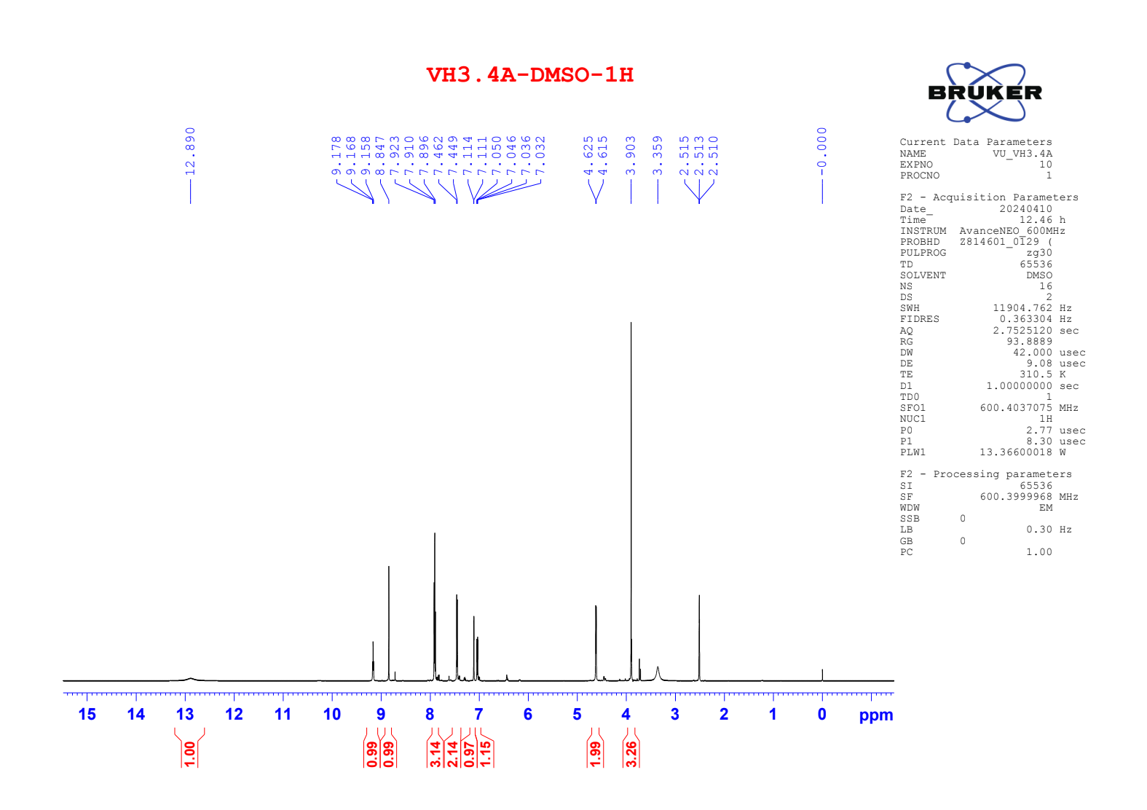

Figure S41. ¹³C NMR of compound 5d
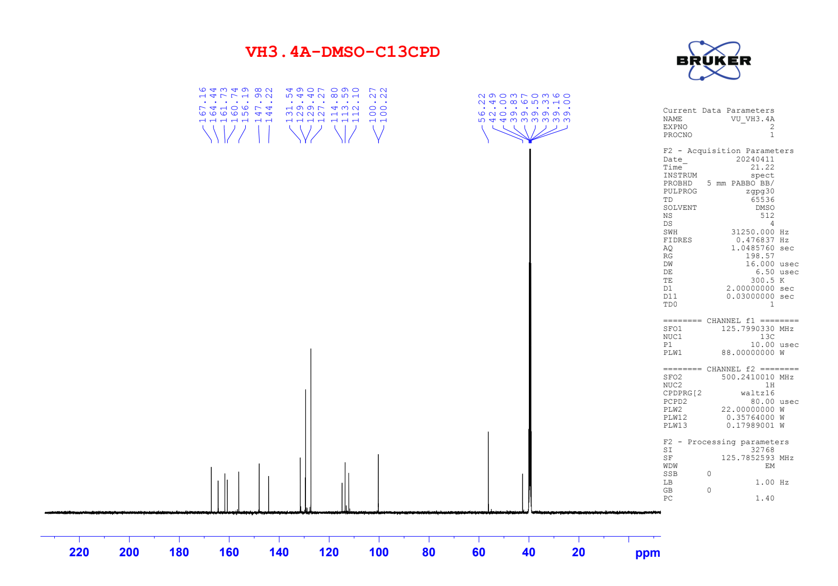

Figure S42. ¹H NMR of compound 5e
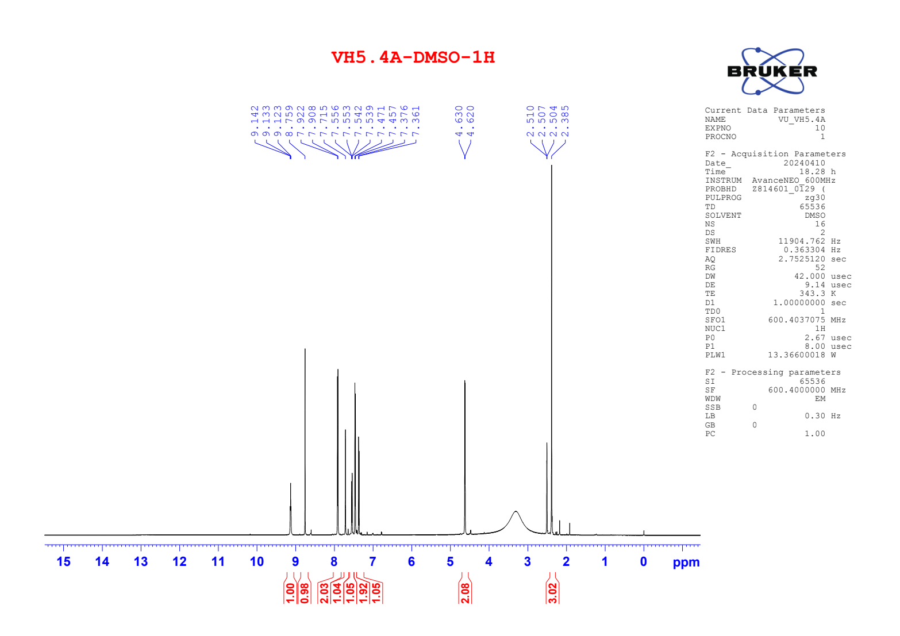

Figure S43. ¹³C NMR of compound 5e
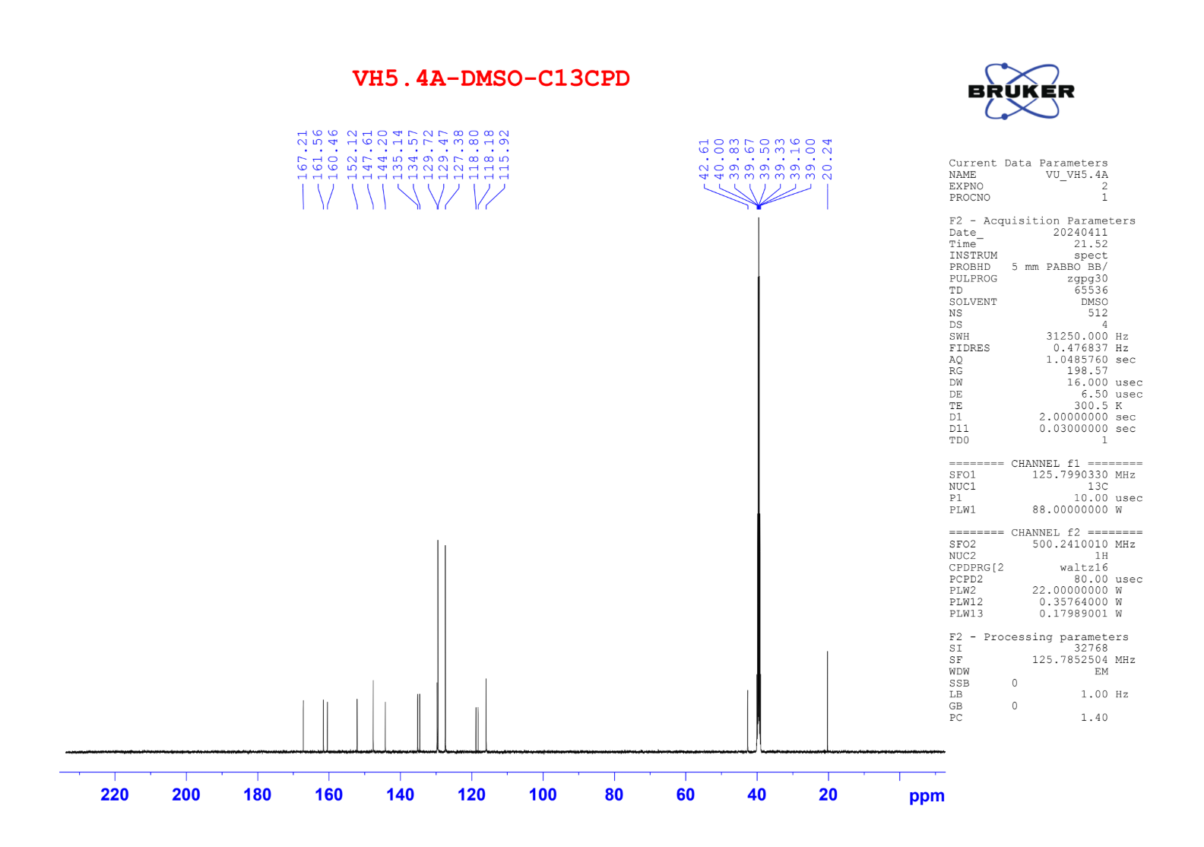

Figure S44. ¹H NMR of compound 5f
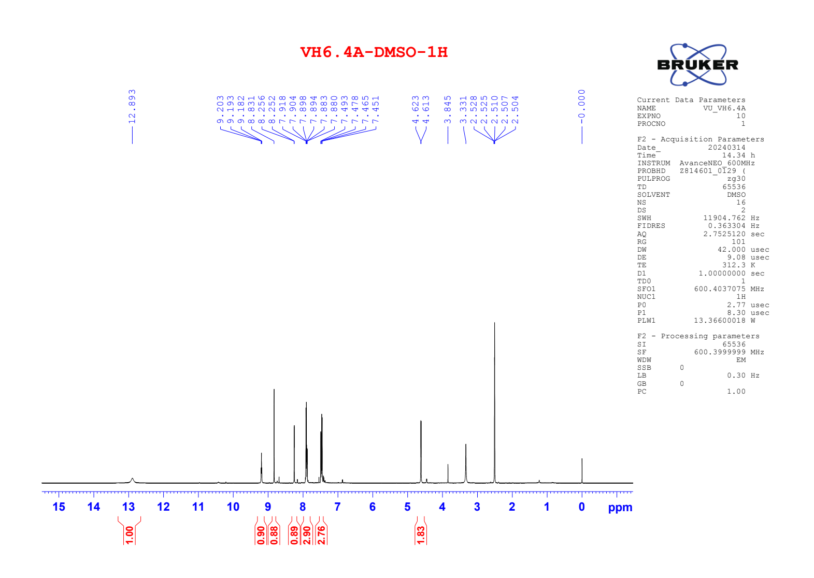

Figure S45. ¹³C NMR of compound 5f
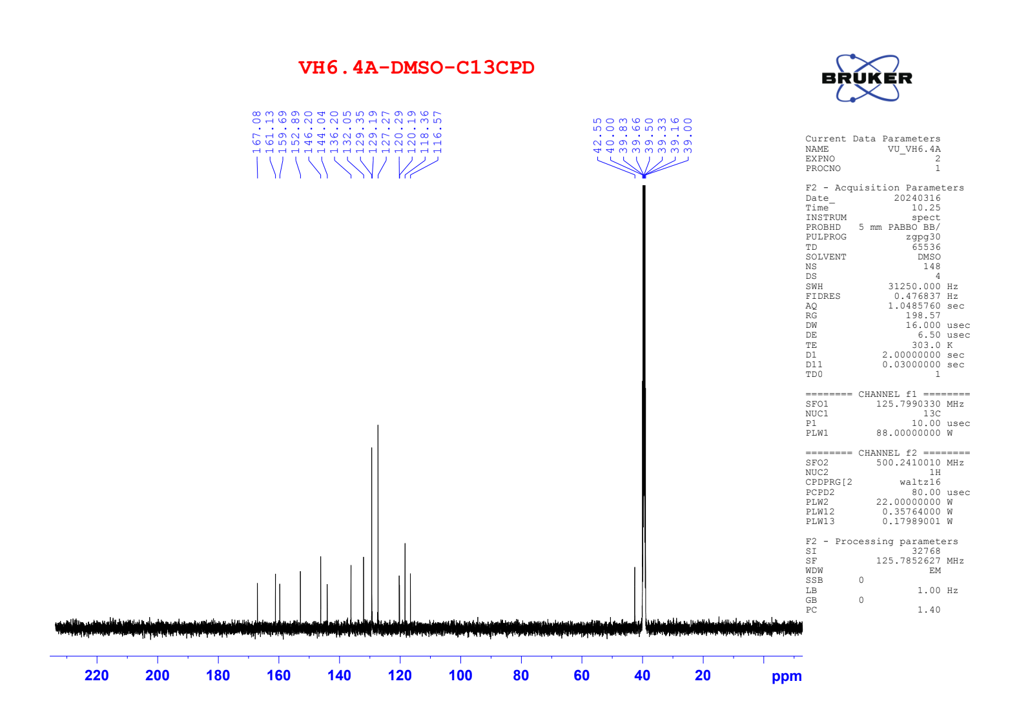

Figure S46. ¹H NMR of compound 5g
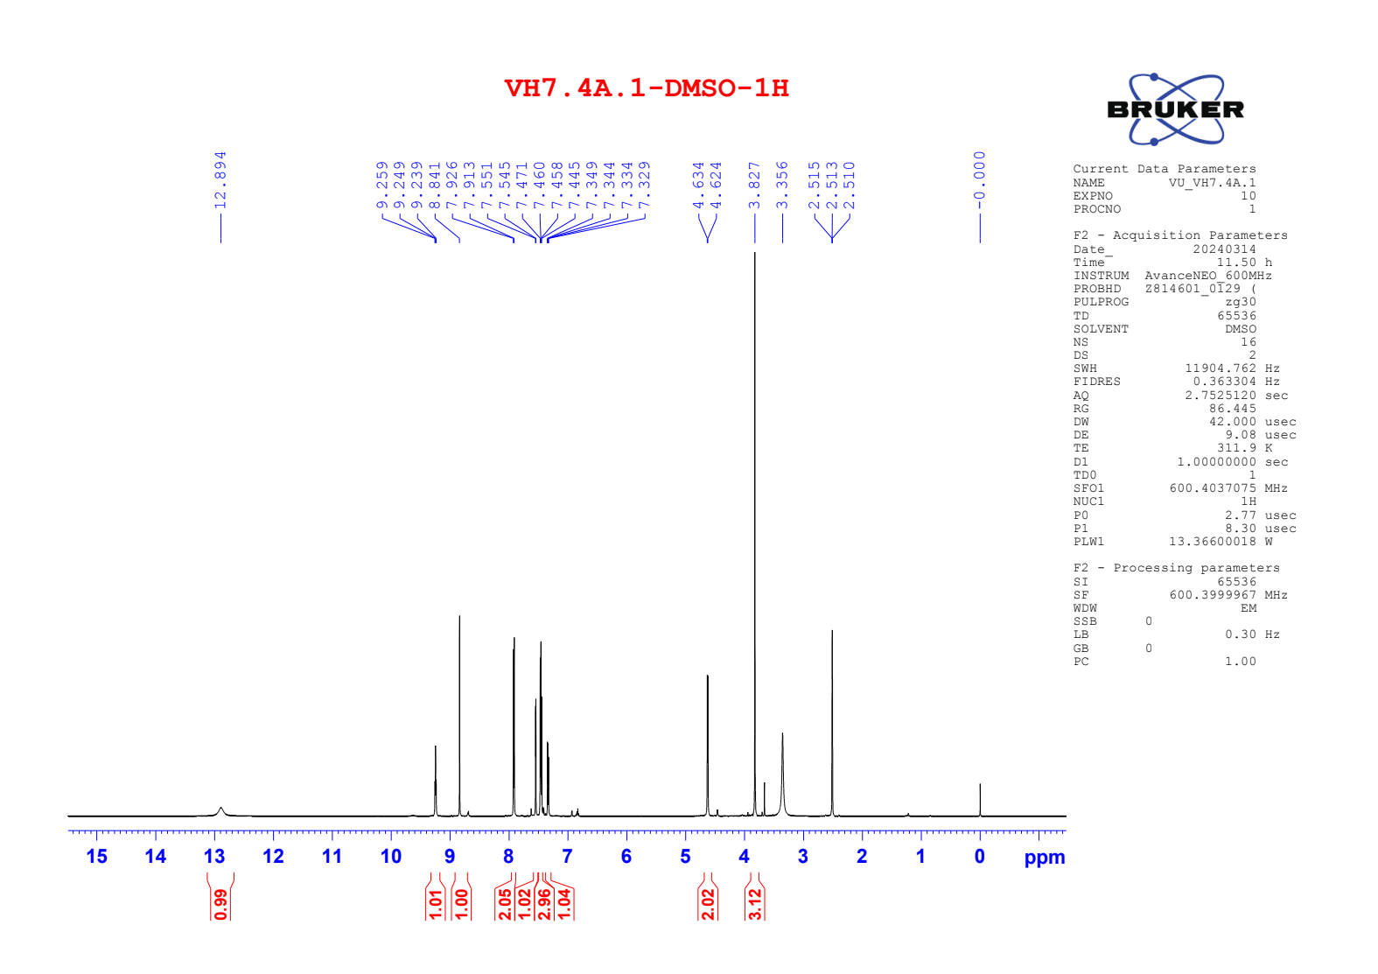

Figure S47. ¹³C NMR of compound 5g
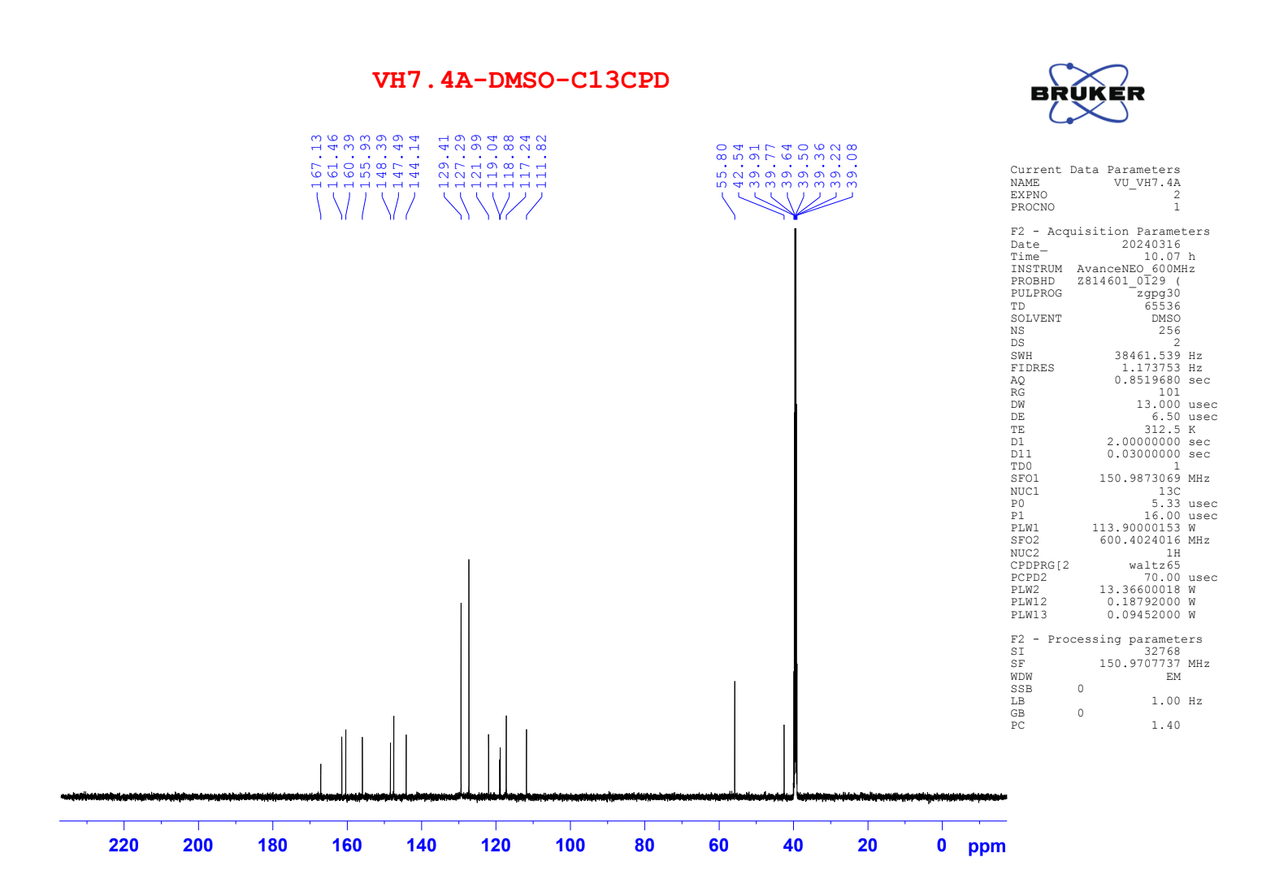

Figure S48. ¹H NMR of compound 6a
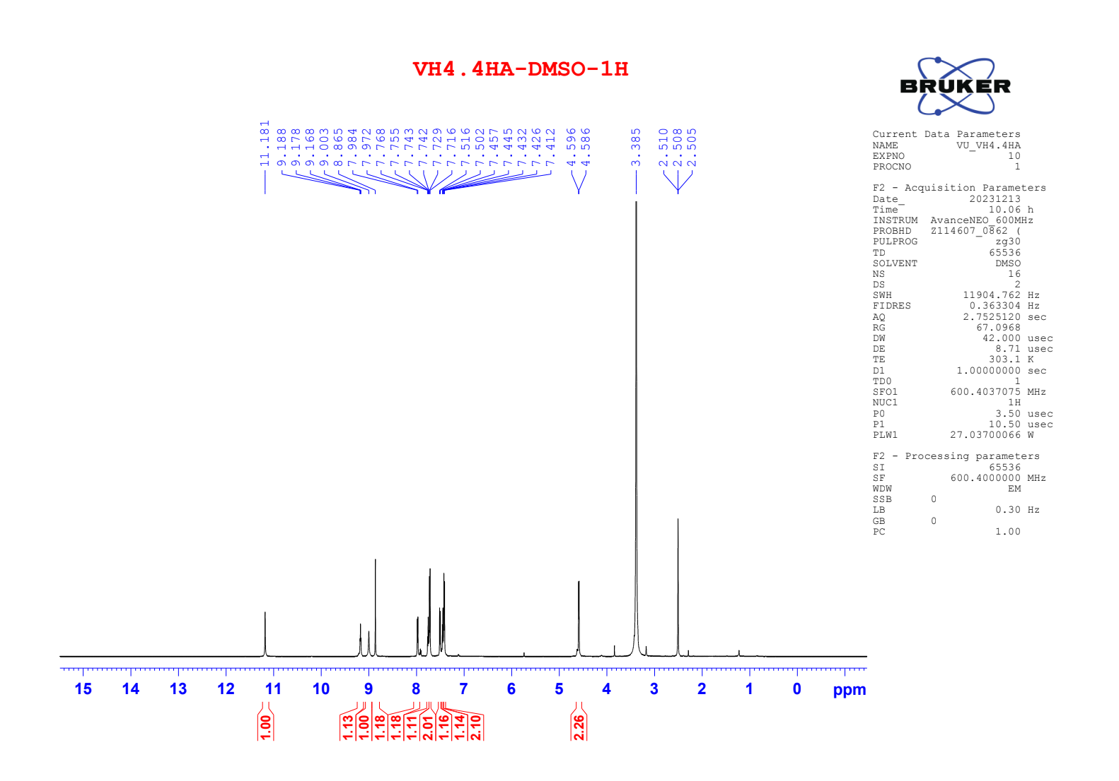

Figure S49. ¹³C NMR of compound 6a
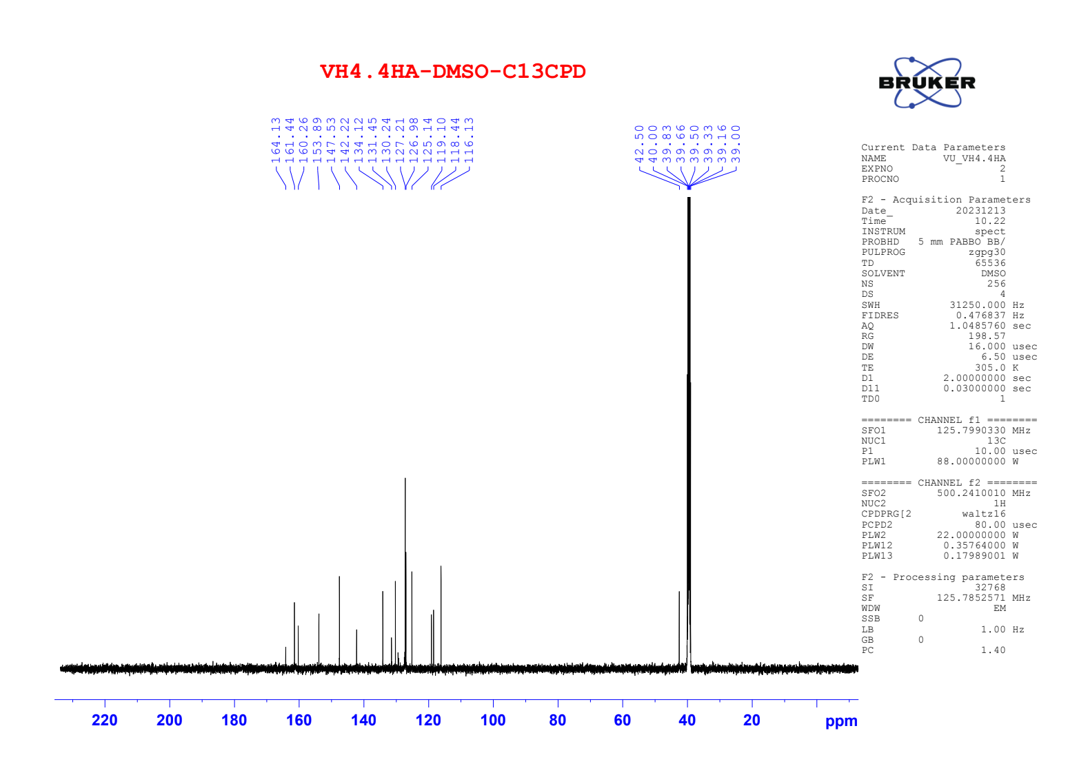

Figure S50. ¹H NMR of compound 6b
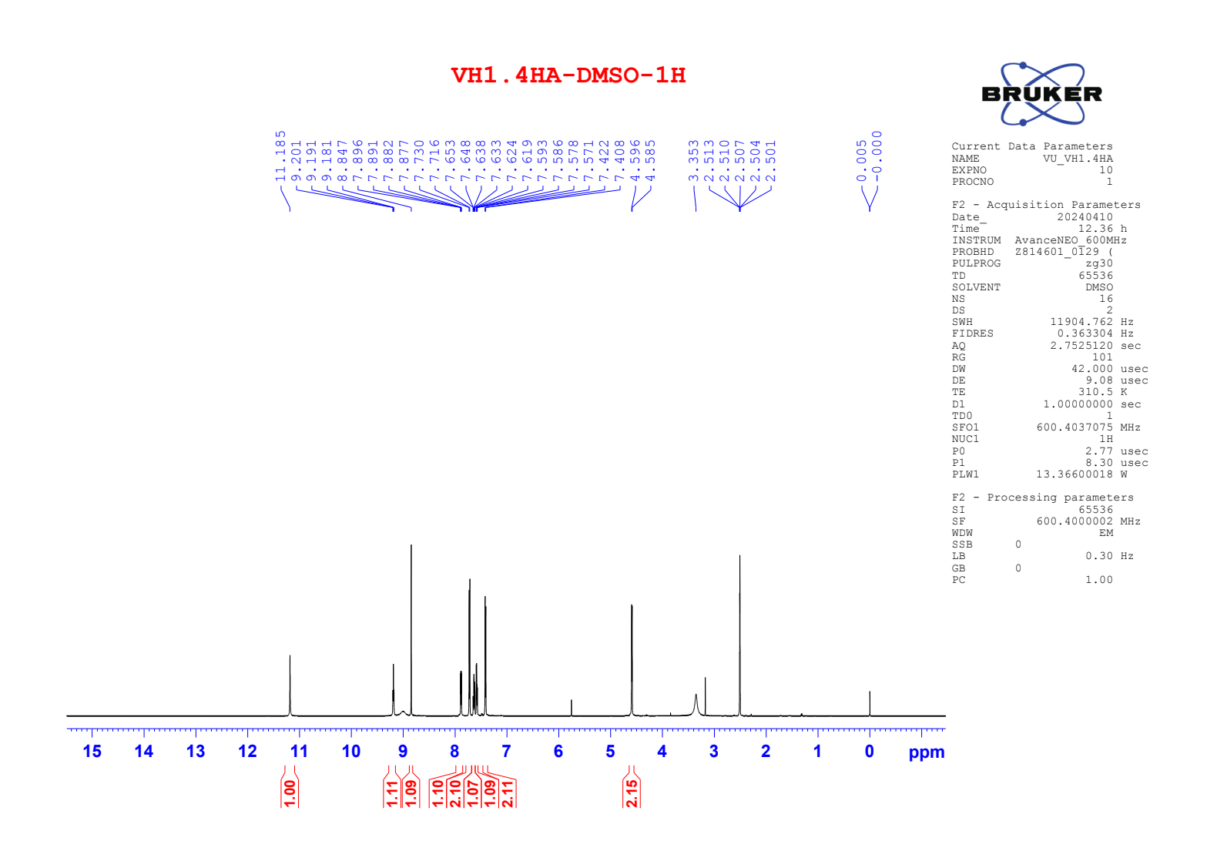

Figure S51. ¹³C NMR of compound 6b
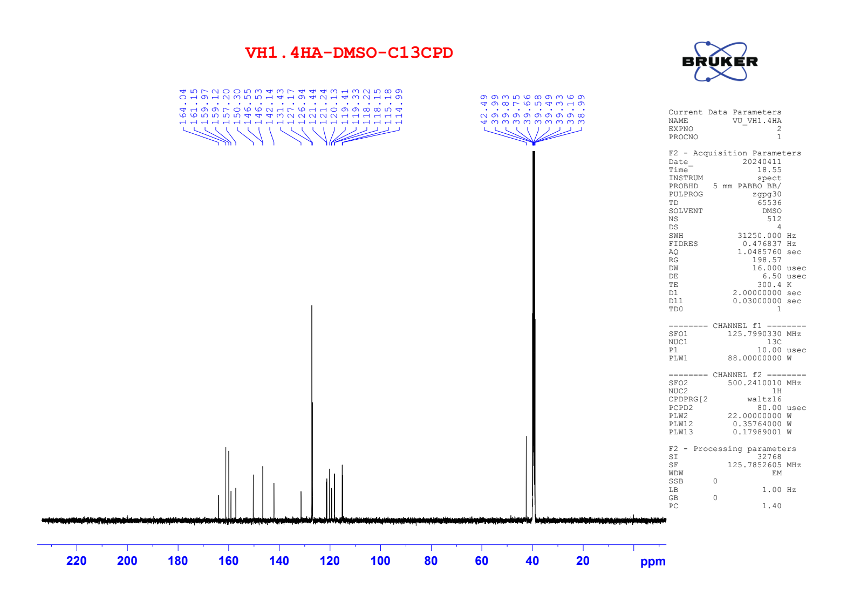

Figure S52. ¹H NMR of compound 6c
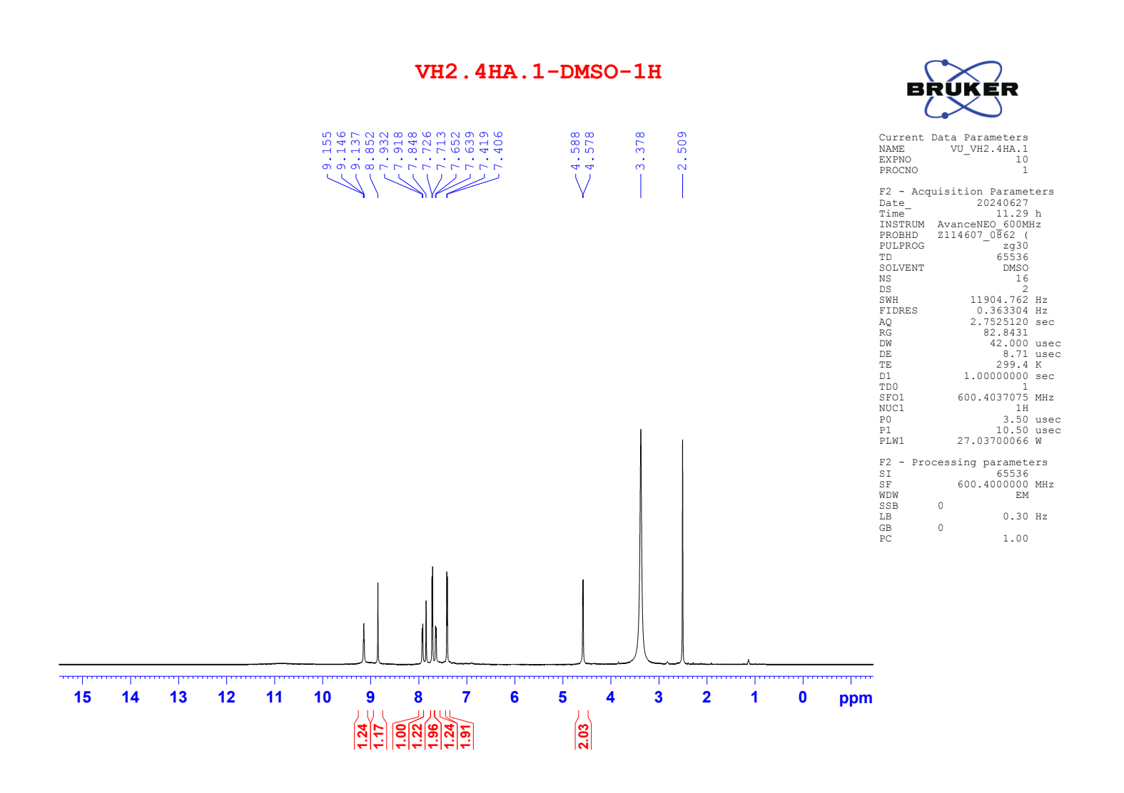

Figure S53. ¹³C NMR of compound 6c
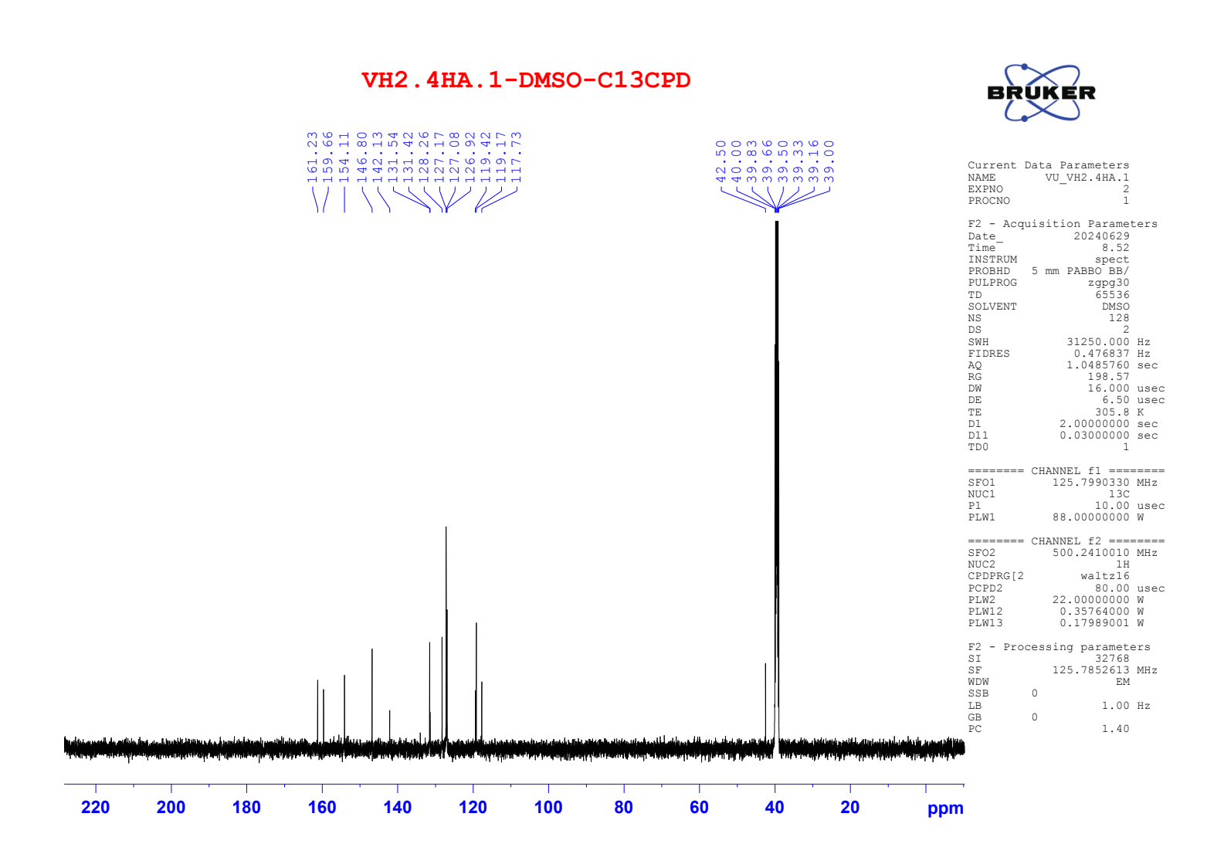

Figure S54. ¹H NMR of compound 6d
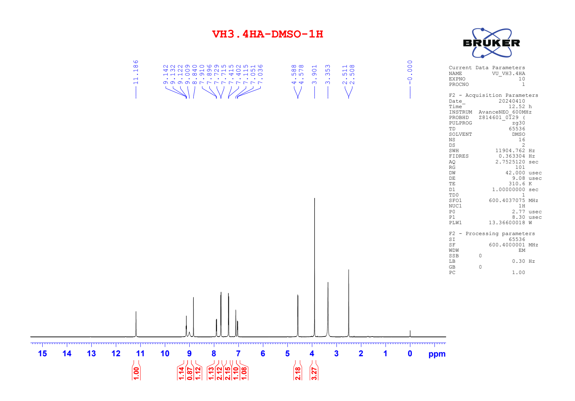

Figure S55. ¹³C NMR of compound 6d
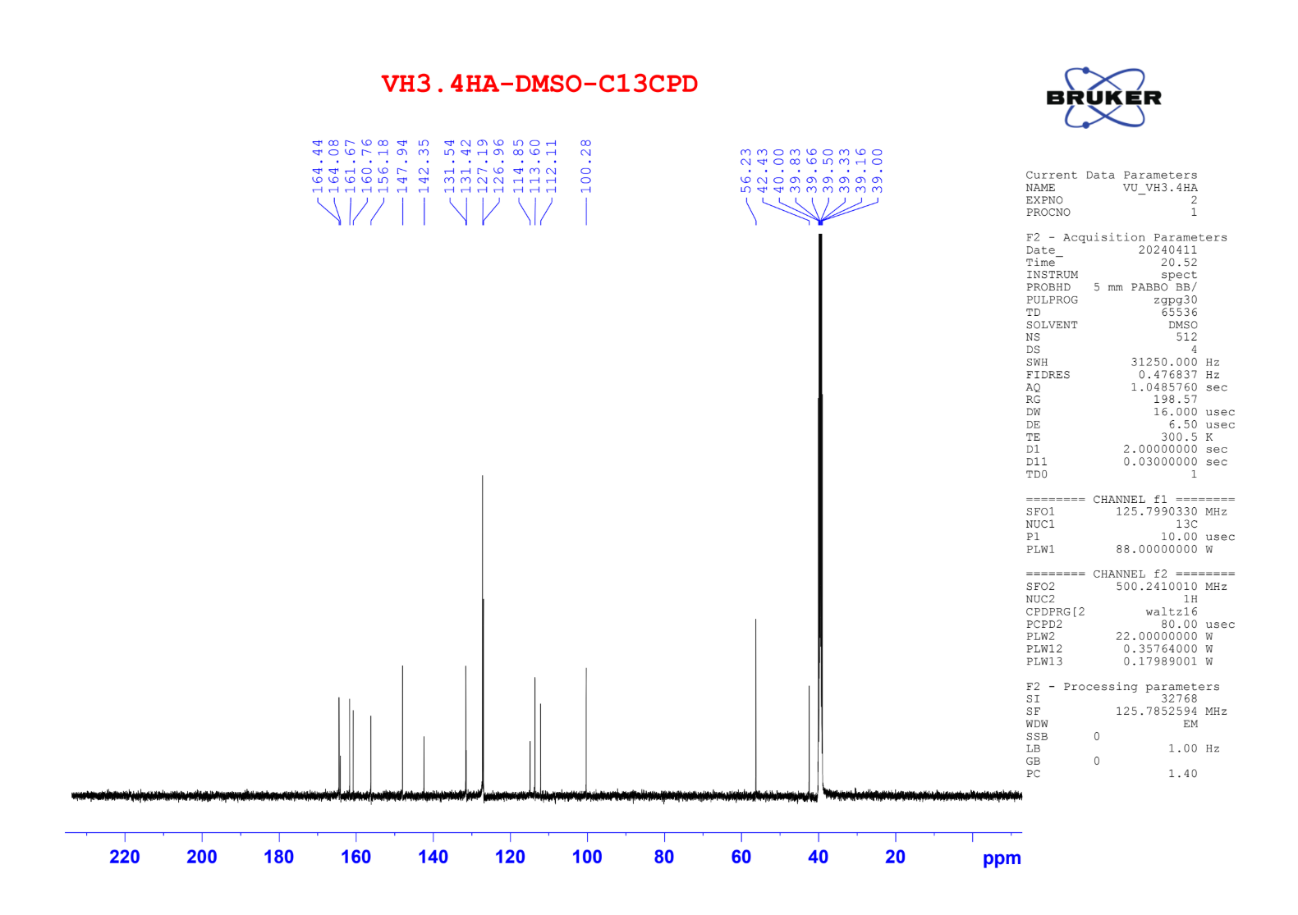

Figure S56. ¹H NMR of compound 6e
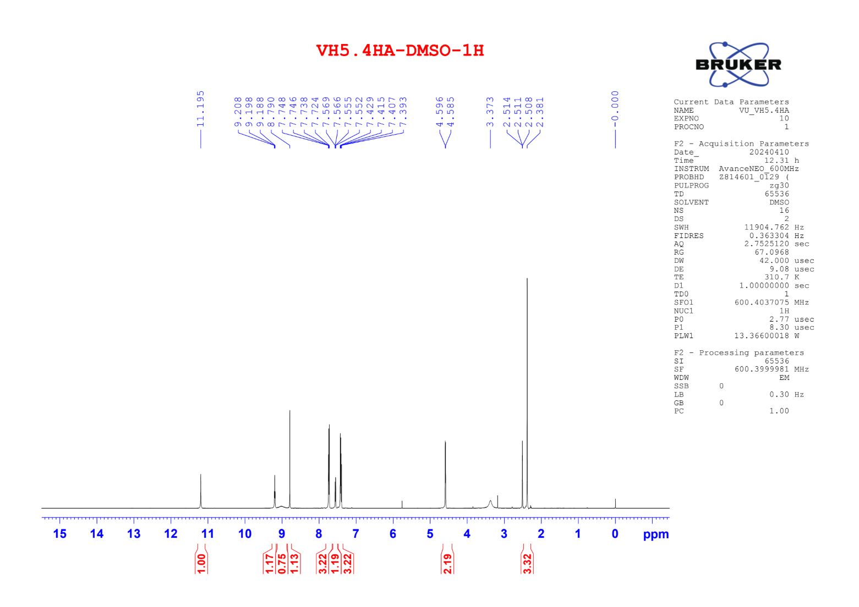

Figure S57. ¹³C NMR of compound 6e
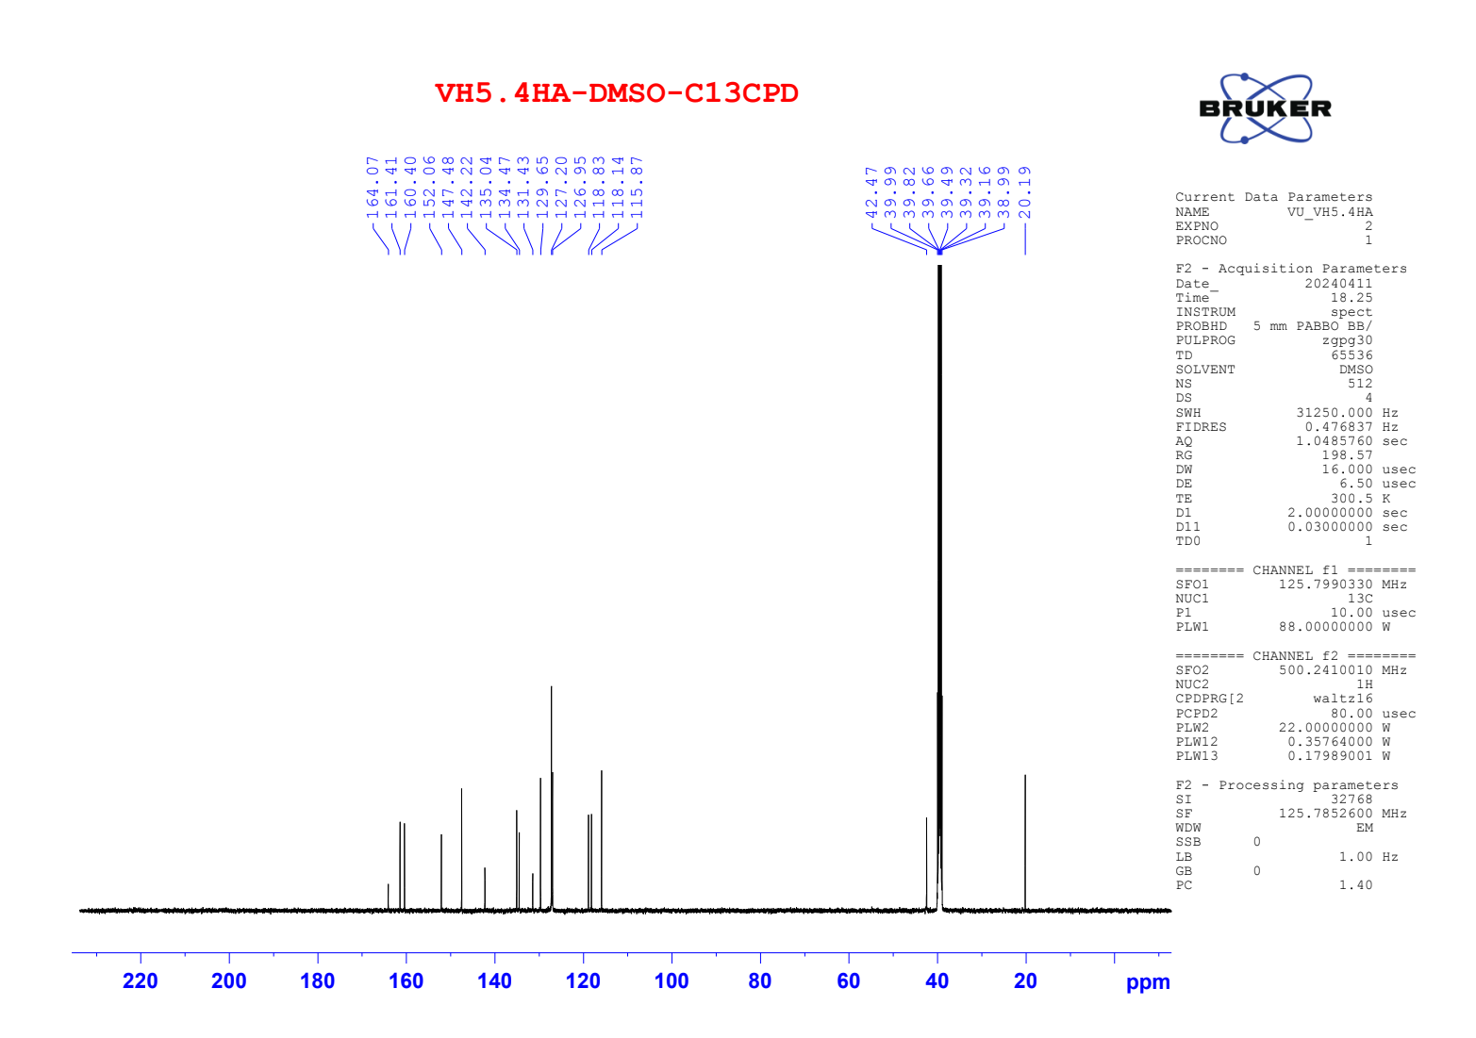

Figure S58. ¹H NMR of compound 6f
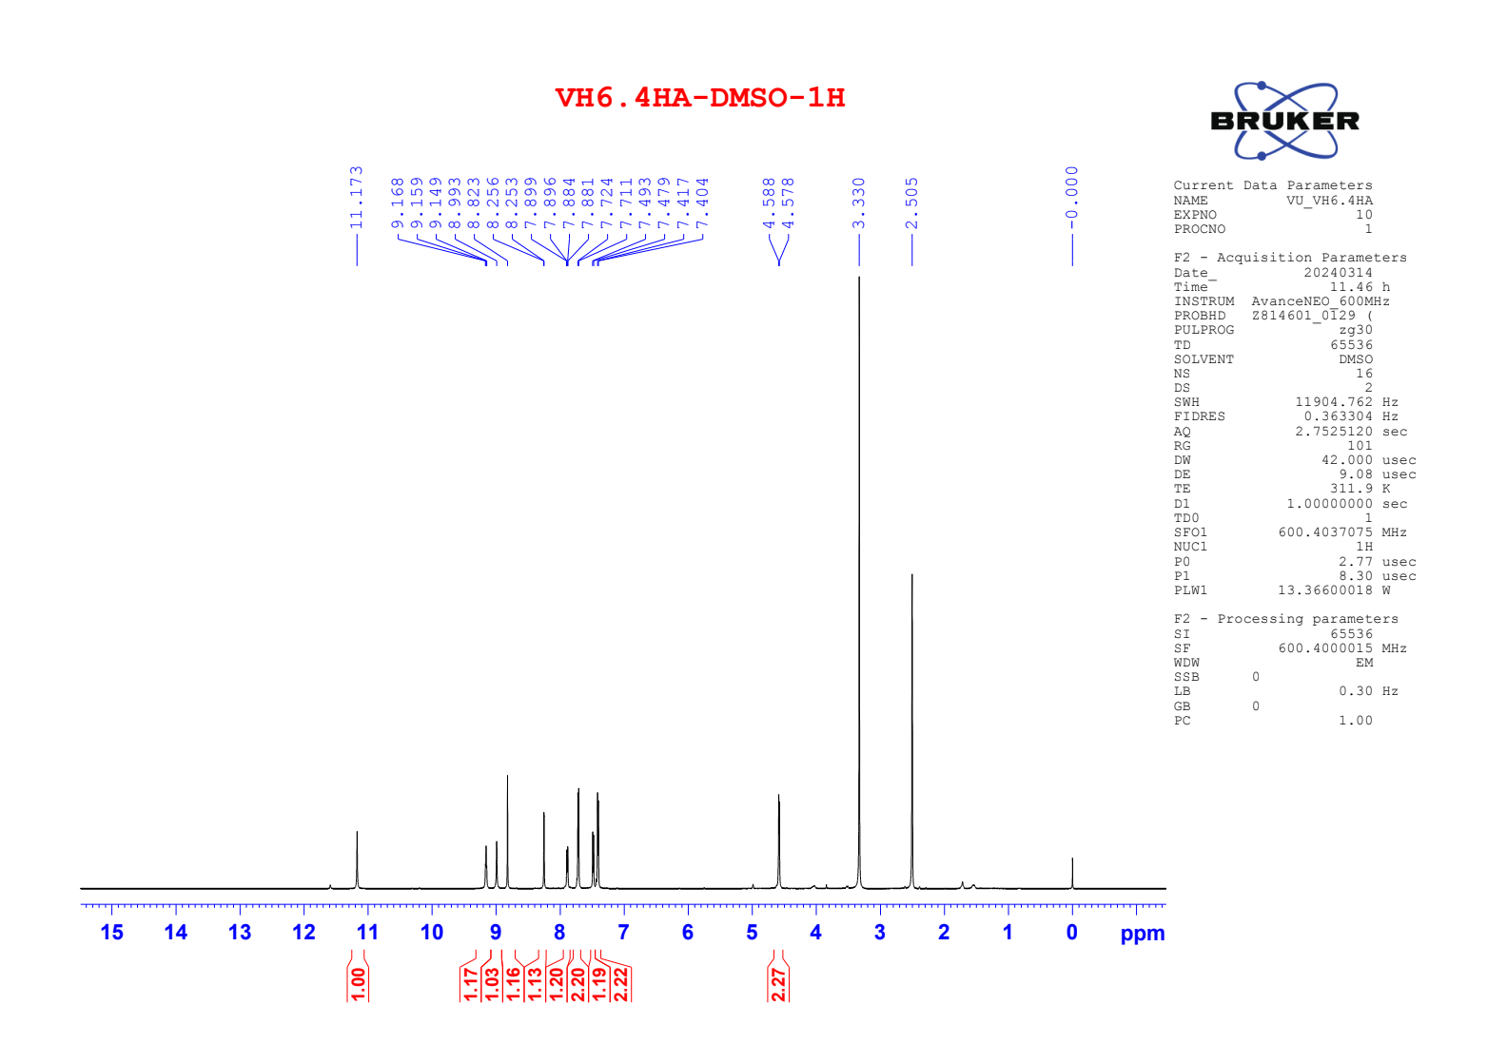

Figure S59. ¹³C NMR of compound 6f
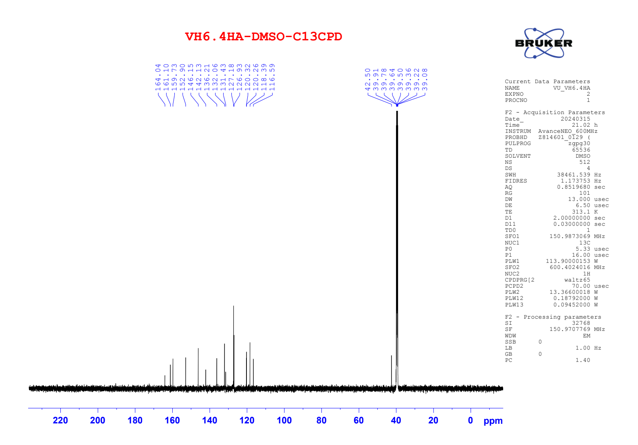

Figure S60. ¹H NMR of compound 6g
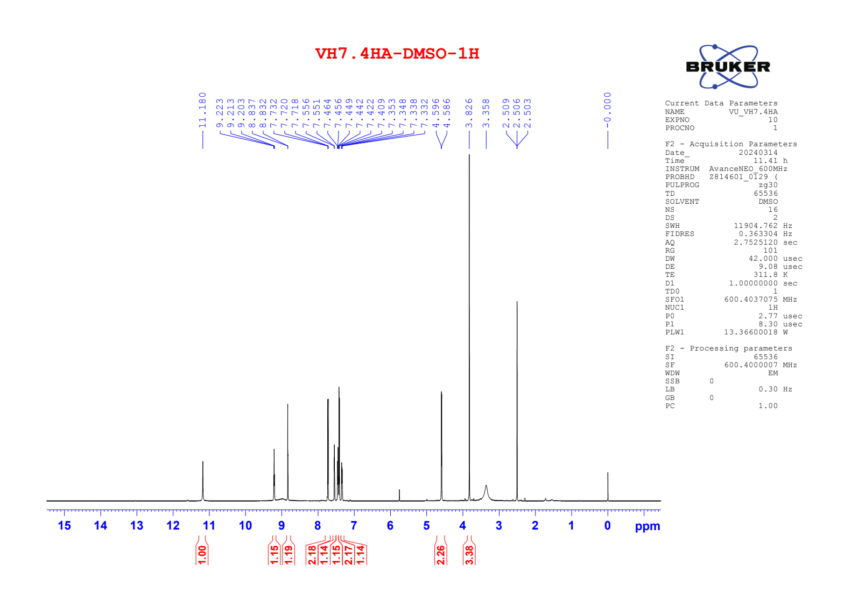

Figure S61. ¹³C NMR of compound 6g
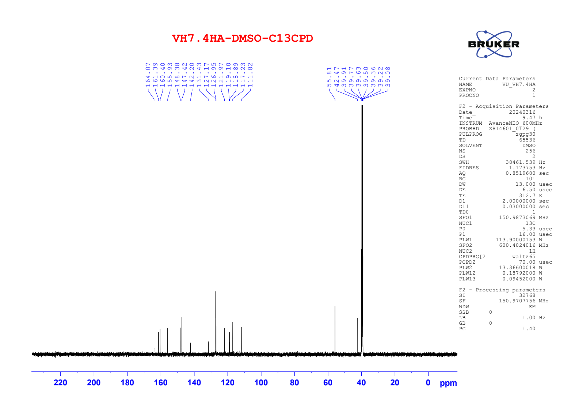

Figure S62. ¹H NMR of compound 7a
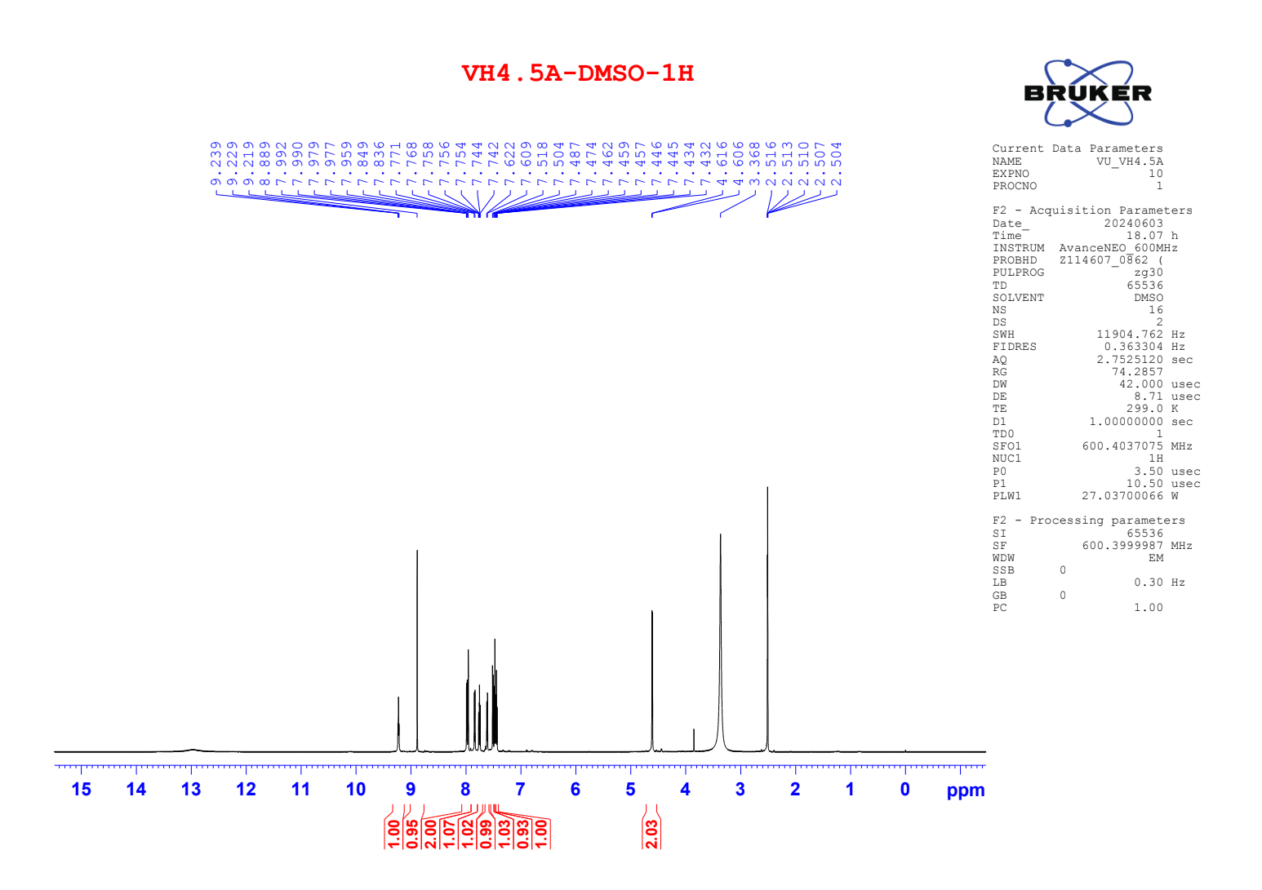

Figure S63. ¹³C NMR of compound 7a
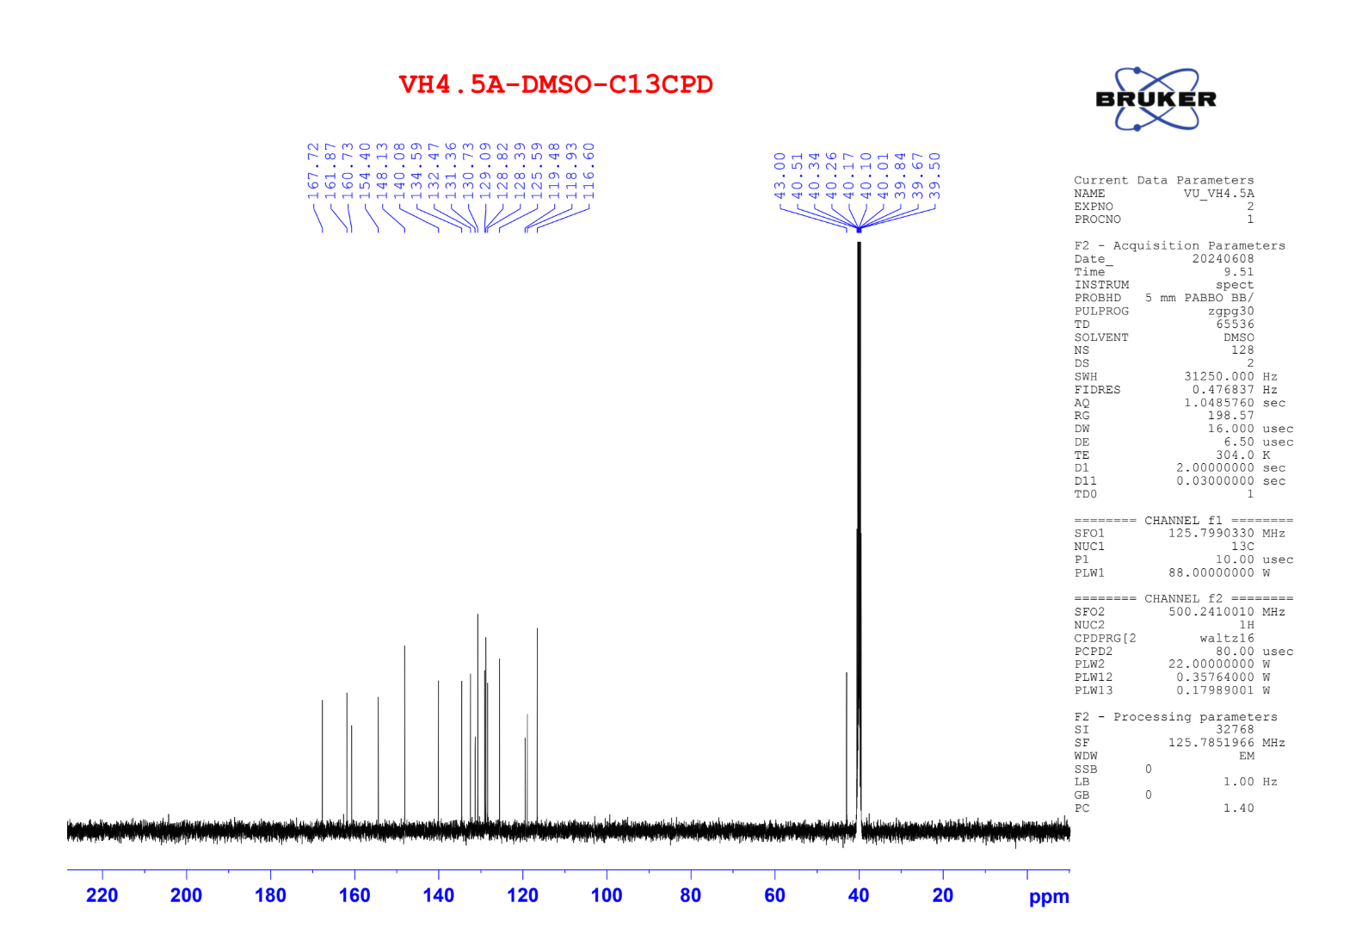

Figure S64. ¹H NMR of compound 7b
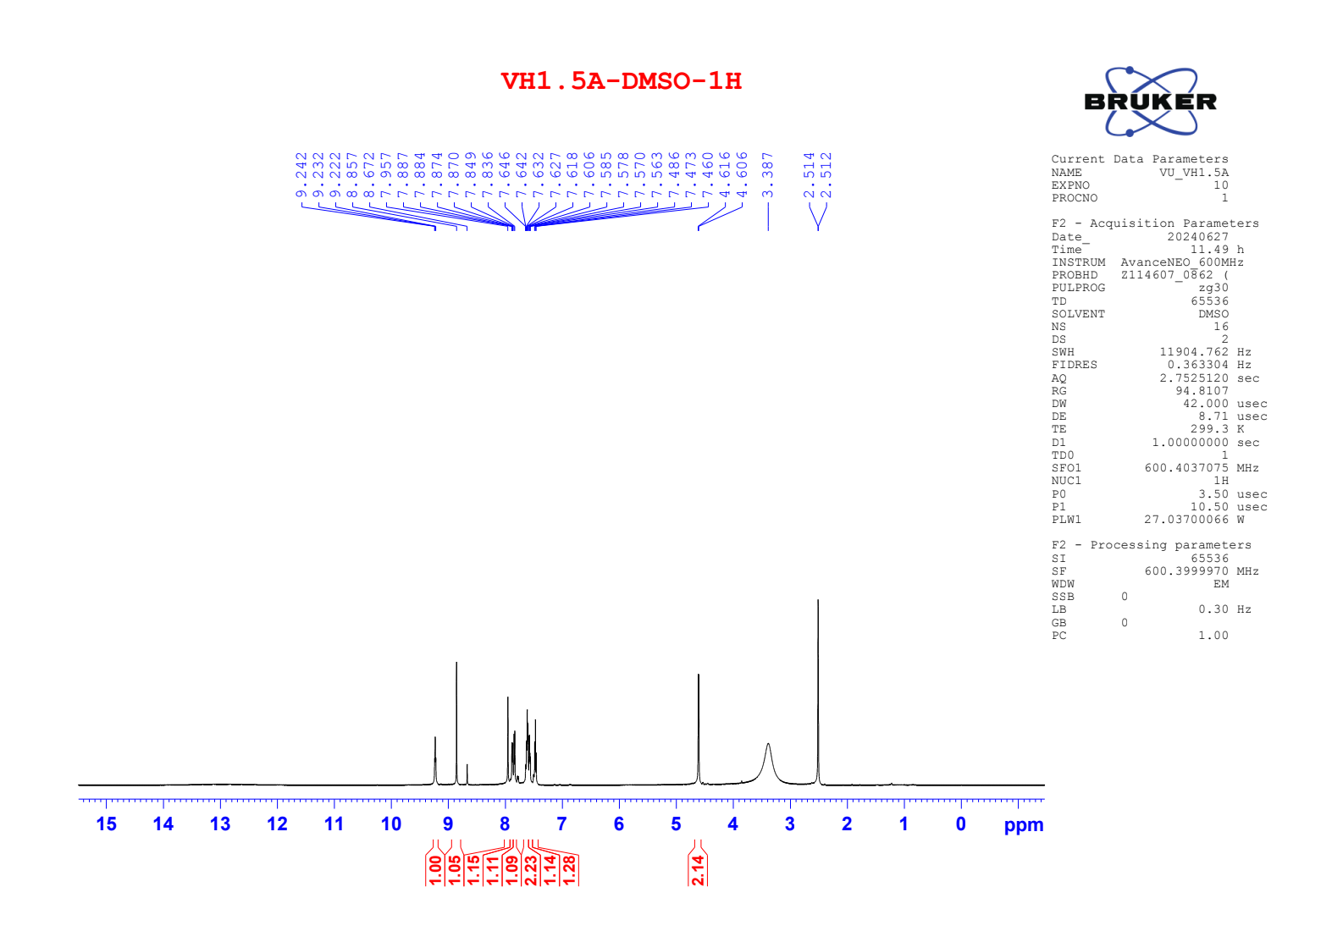

Figure S65. ¹³C NMR of compound 7b
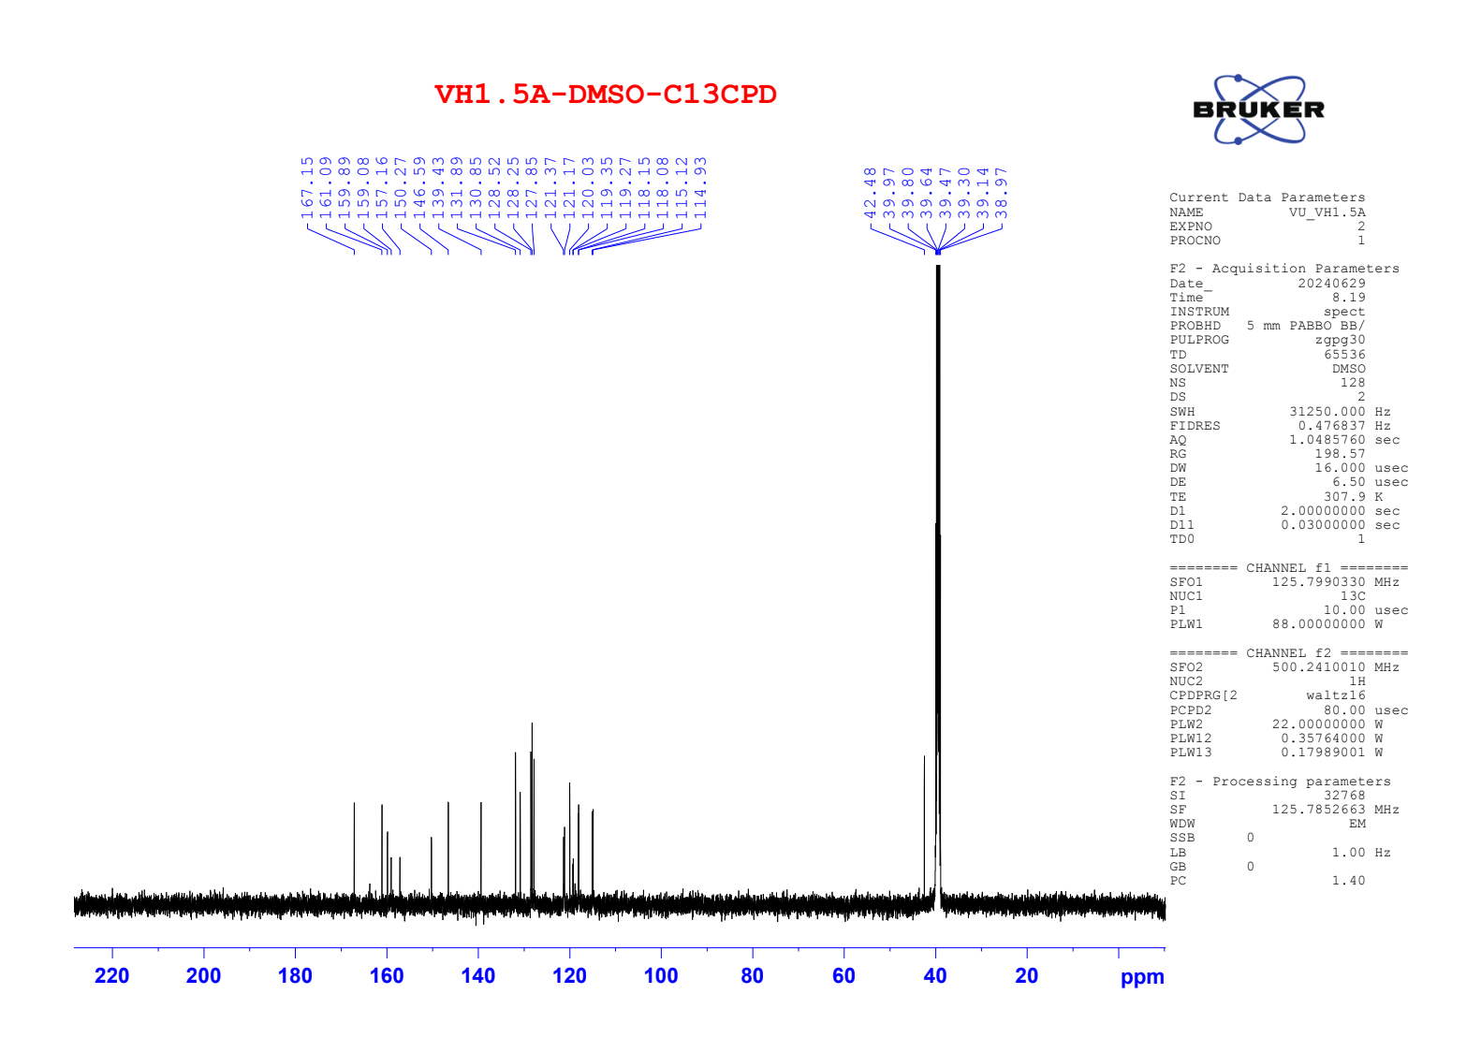

Figure S66. ¹H NMR of compound 7c
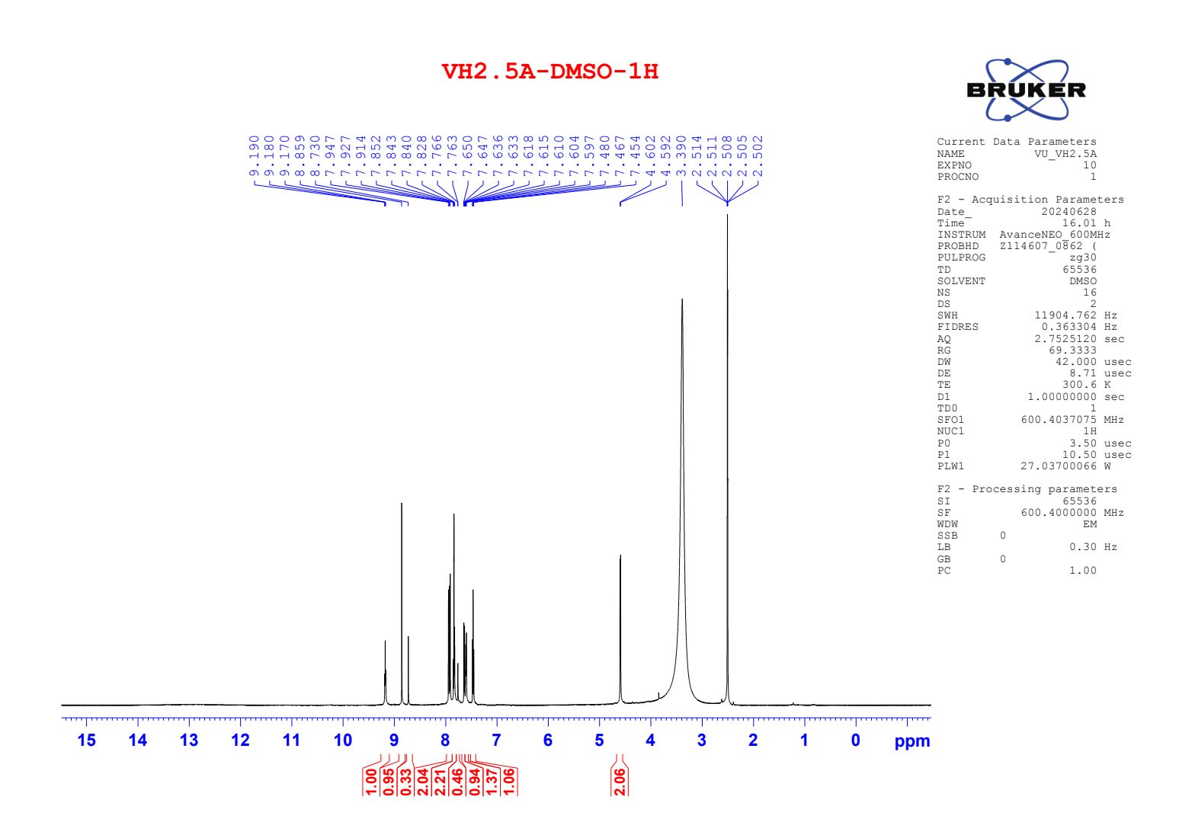

Figure S67. ¹³C NMR of compound 7c
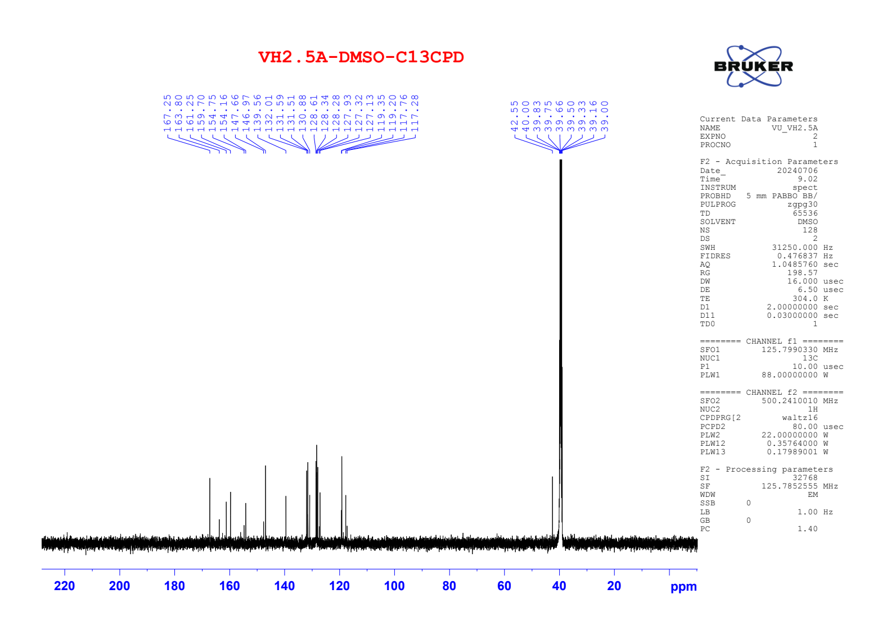

Figure S68. ¹H NMR of compound 7d
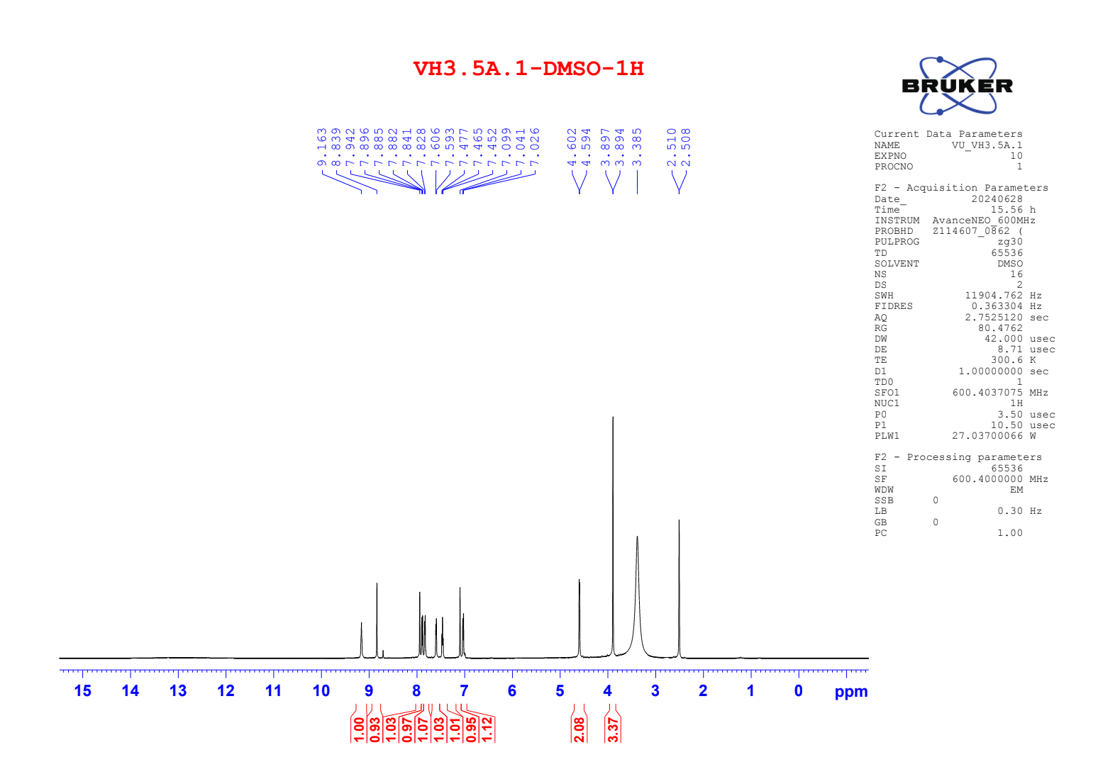

Figure S69. ¹³C NMR of compound 7d
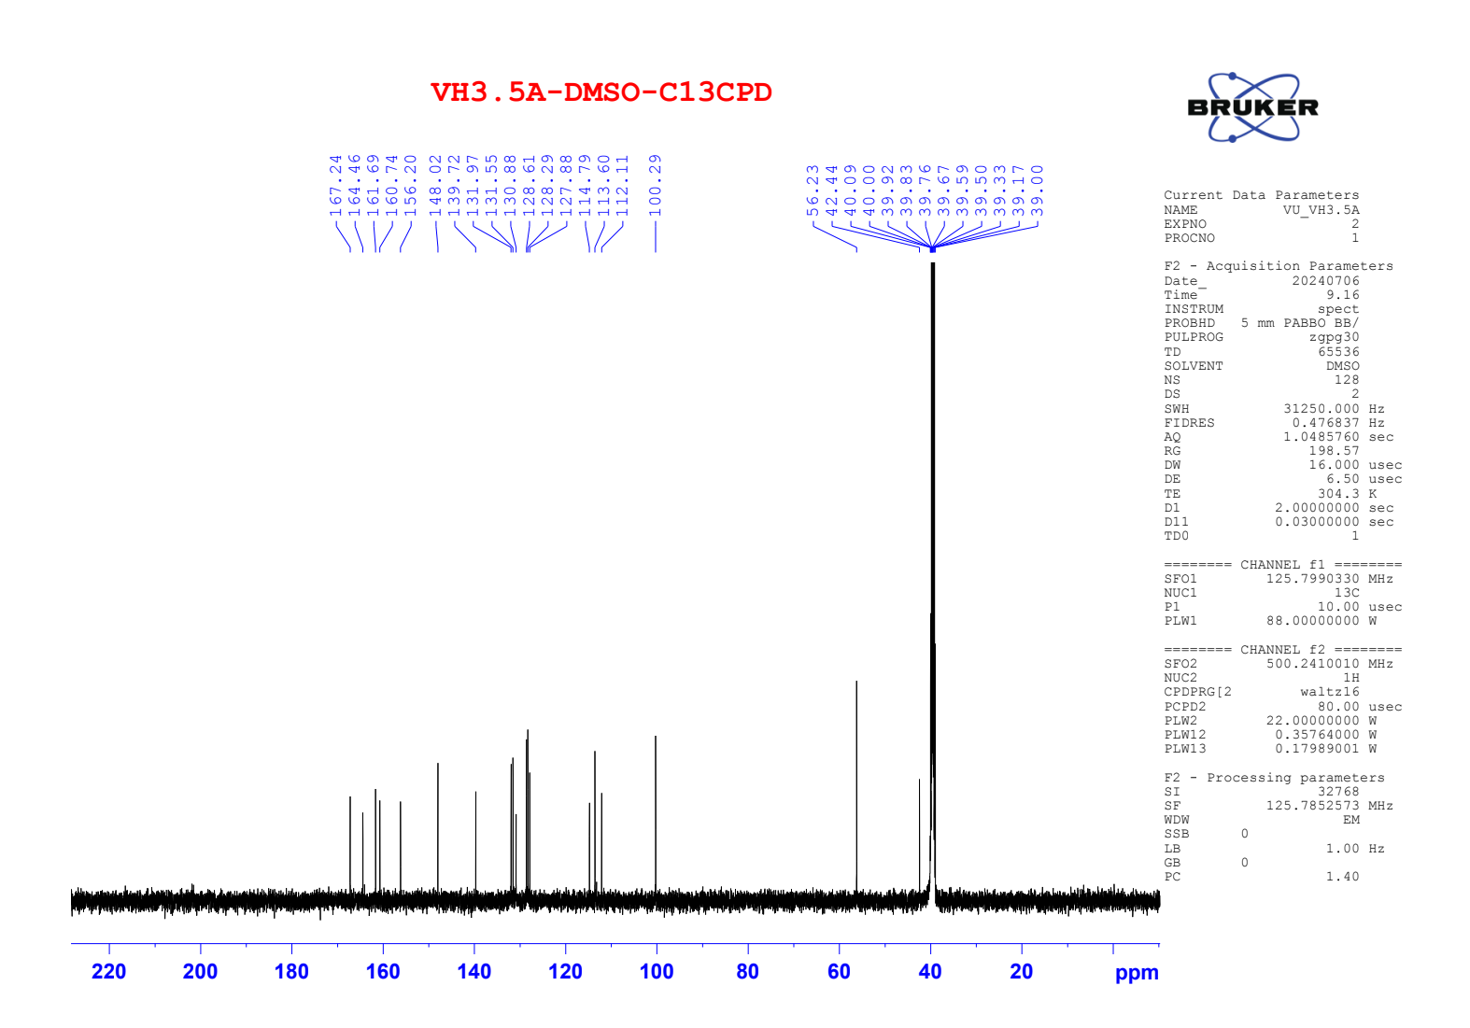

Figure S70. ¹H NMR of compound 7e
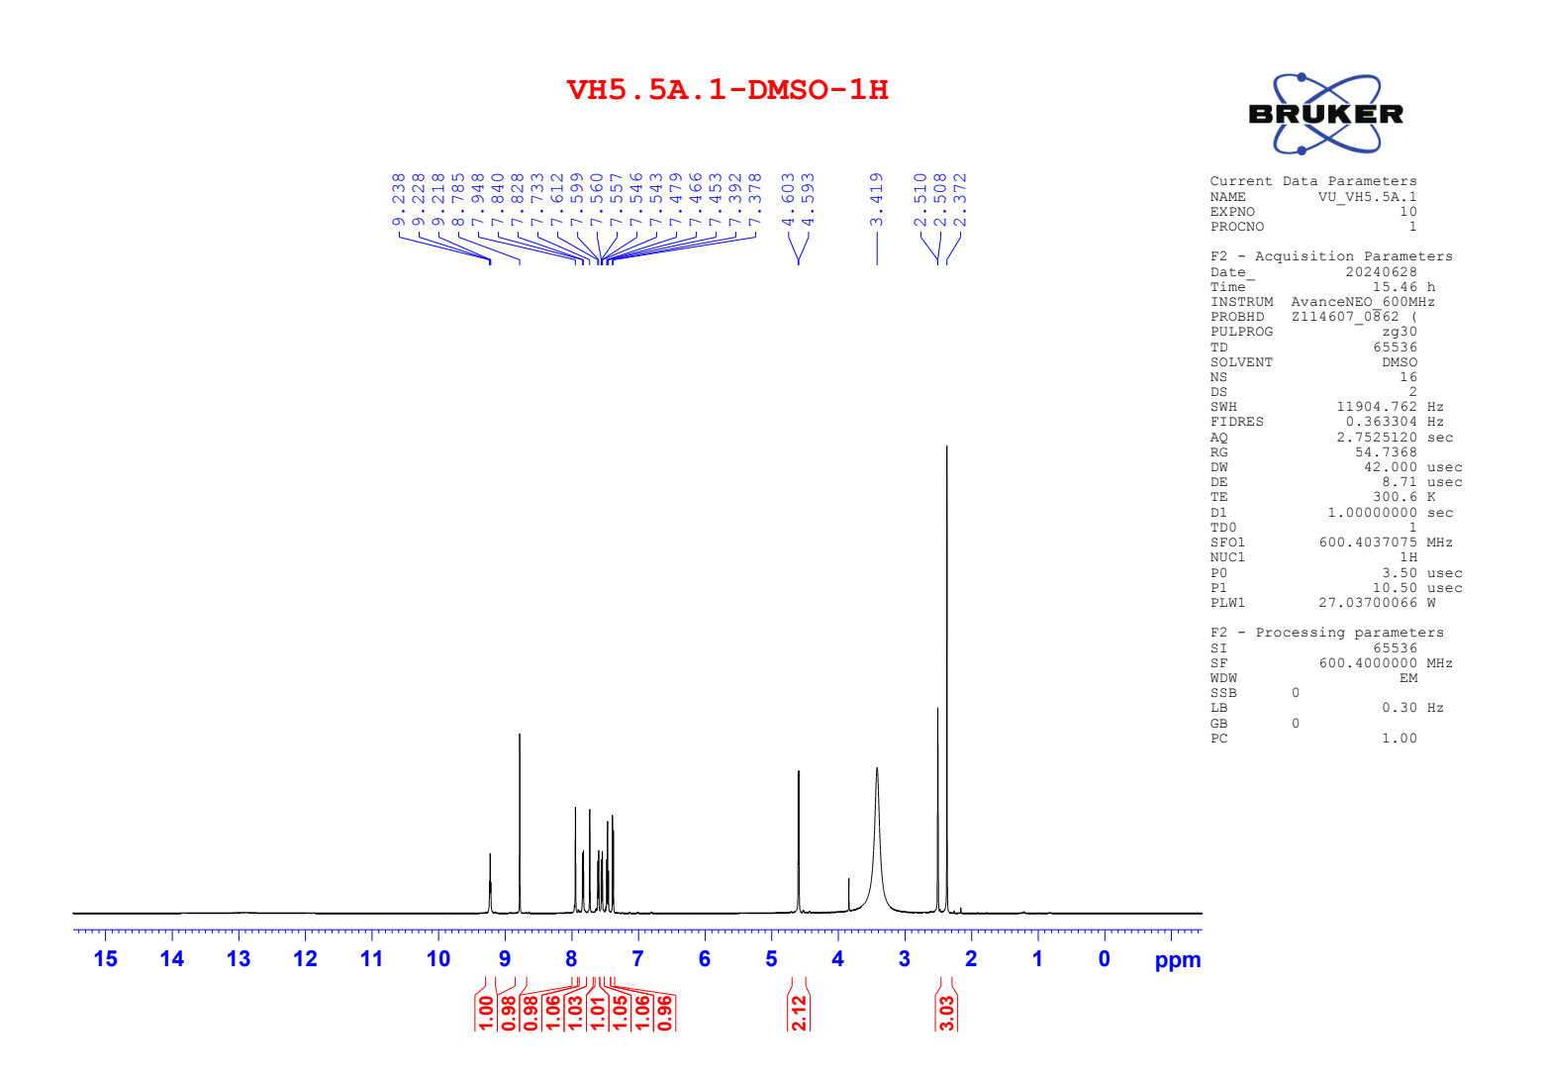

Figure S71. ¹³C NMR of compound 7e
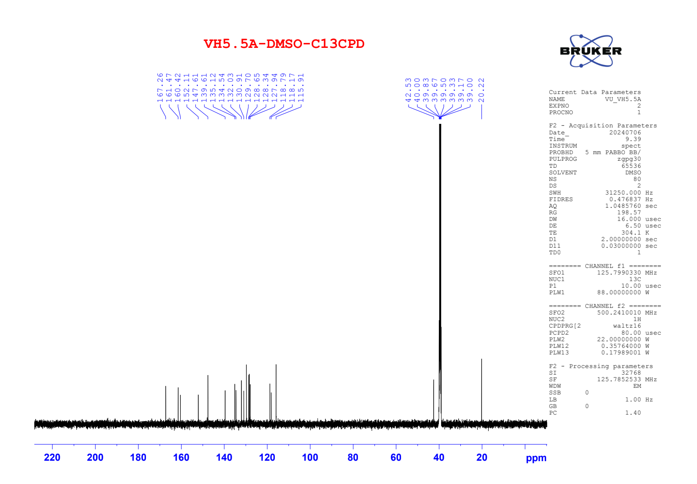

Figure S72. ¹H NMR of compound 7f
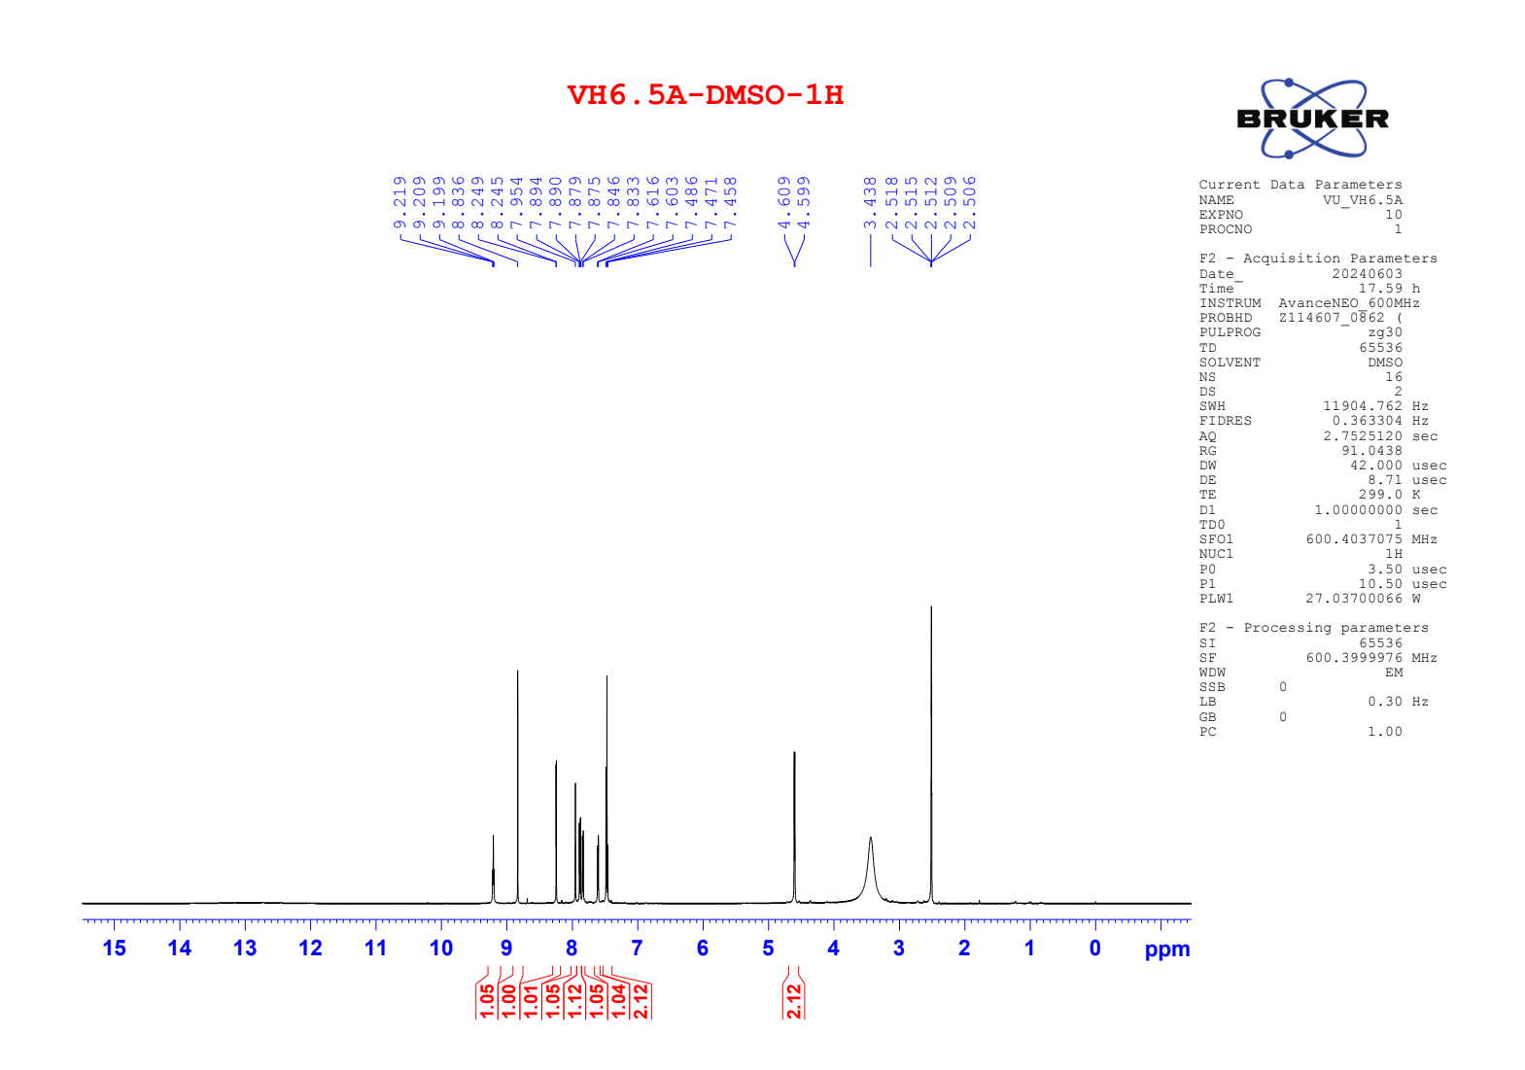

Figure S73. ¹³C NMR of compound 7f
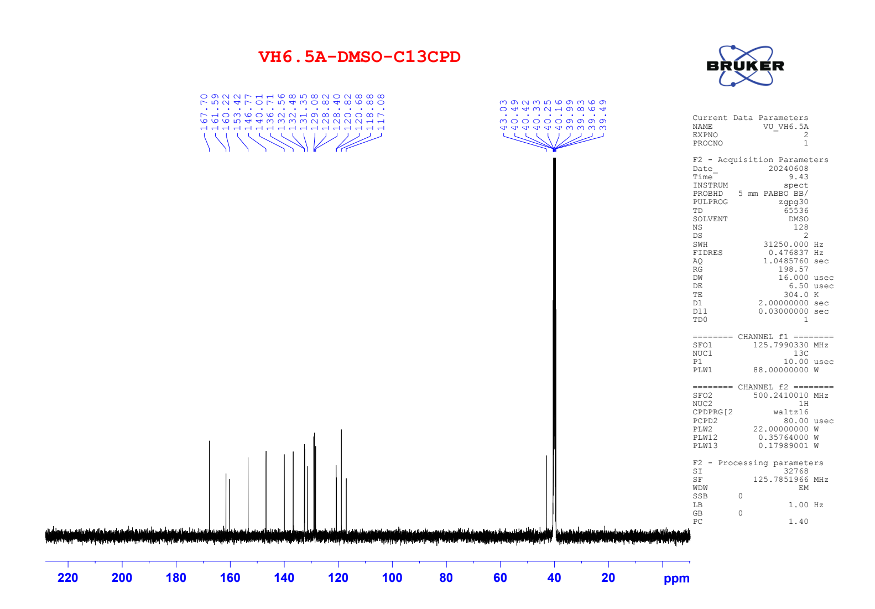

Figure S74. ¹H NMR of compound 7g
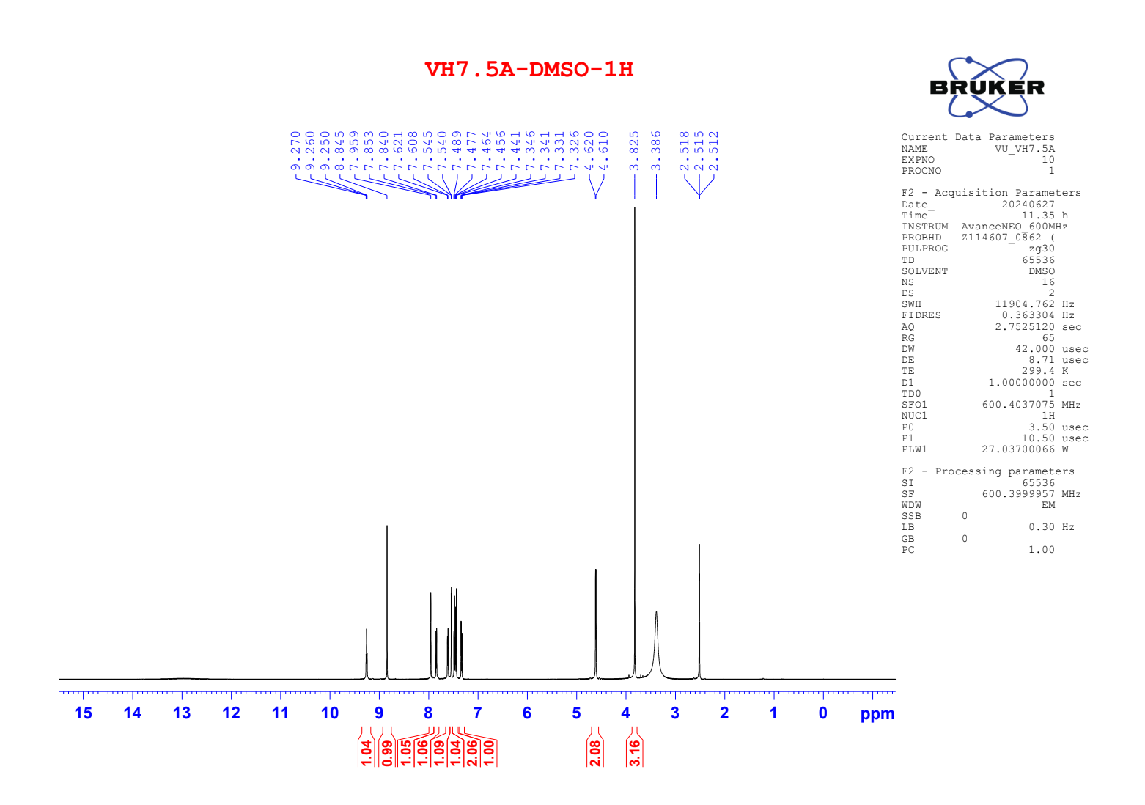

Figure S75. ¹³C NMR of compound 7g
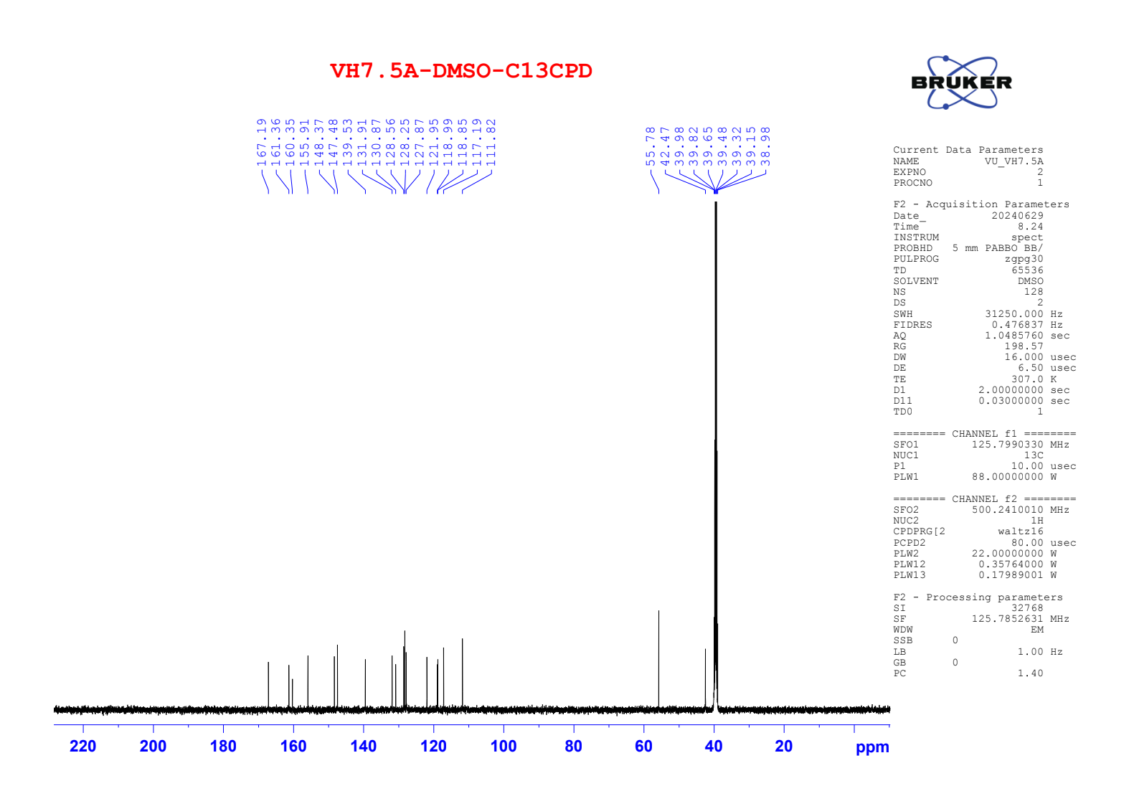

Figure S76. ¹H NMR of compound 8a
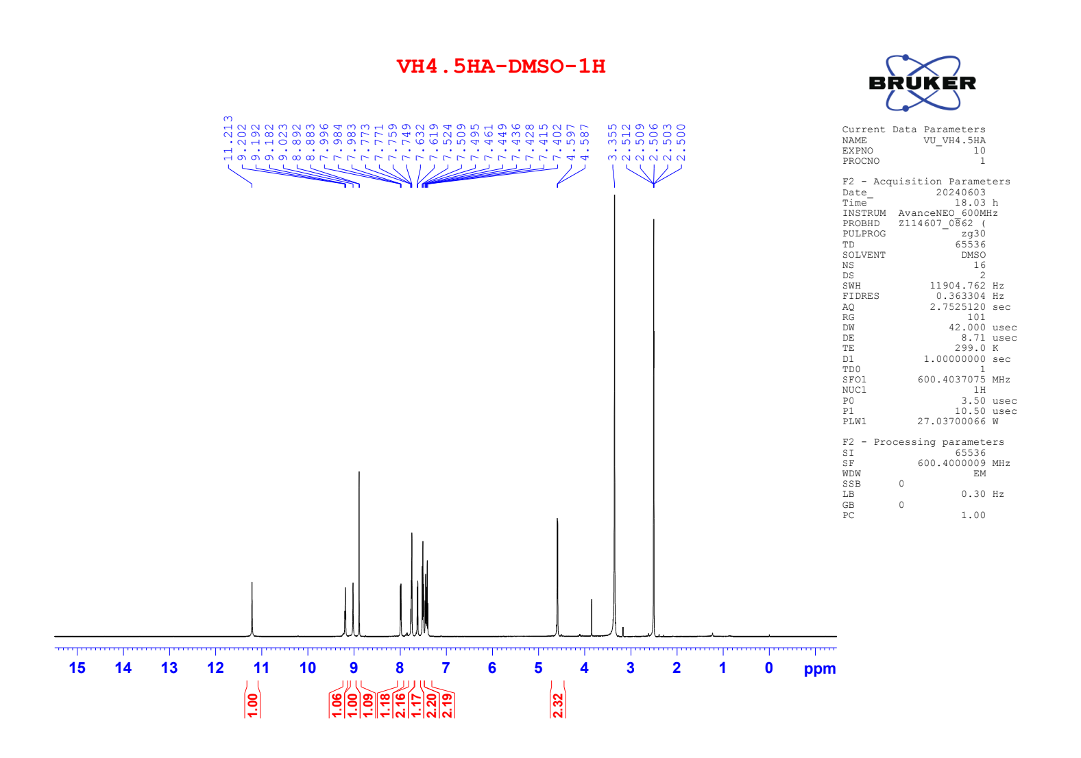

Figure S77. ¹³C NMR of compound 8a

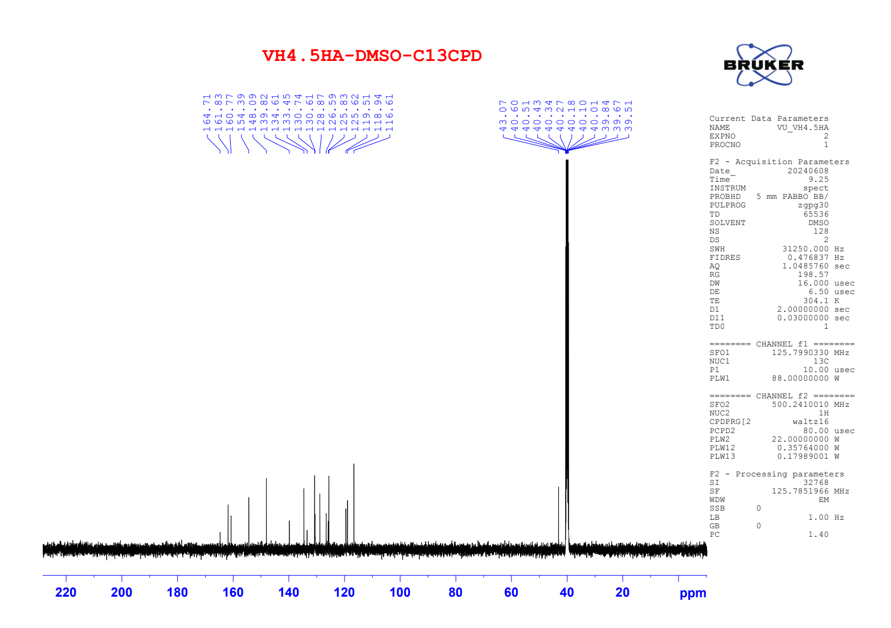

Figure S78. HRMS of compound 8a
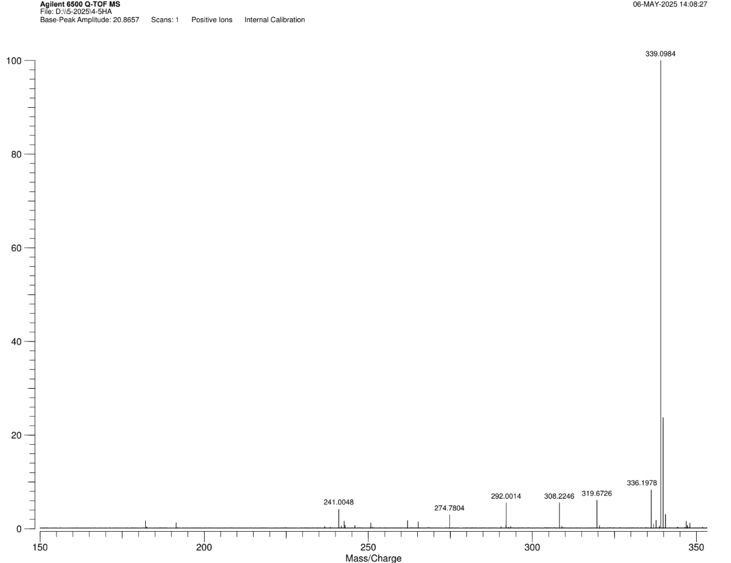

Figure S79. ¹H NMR of compound 8b
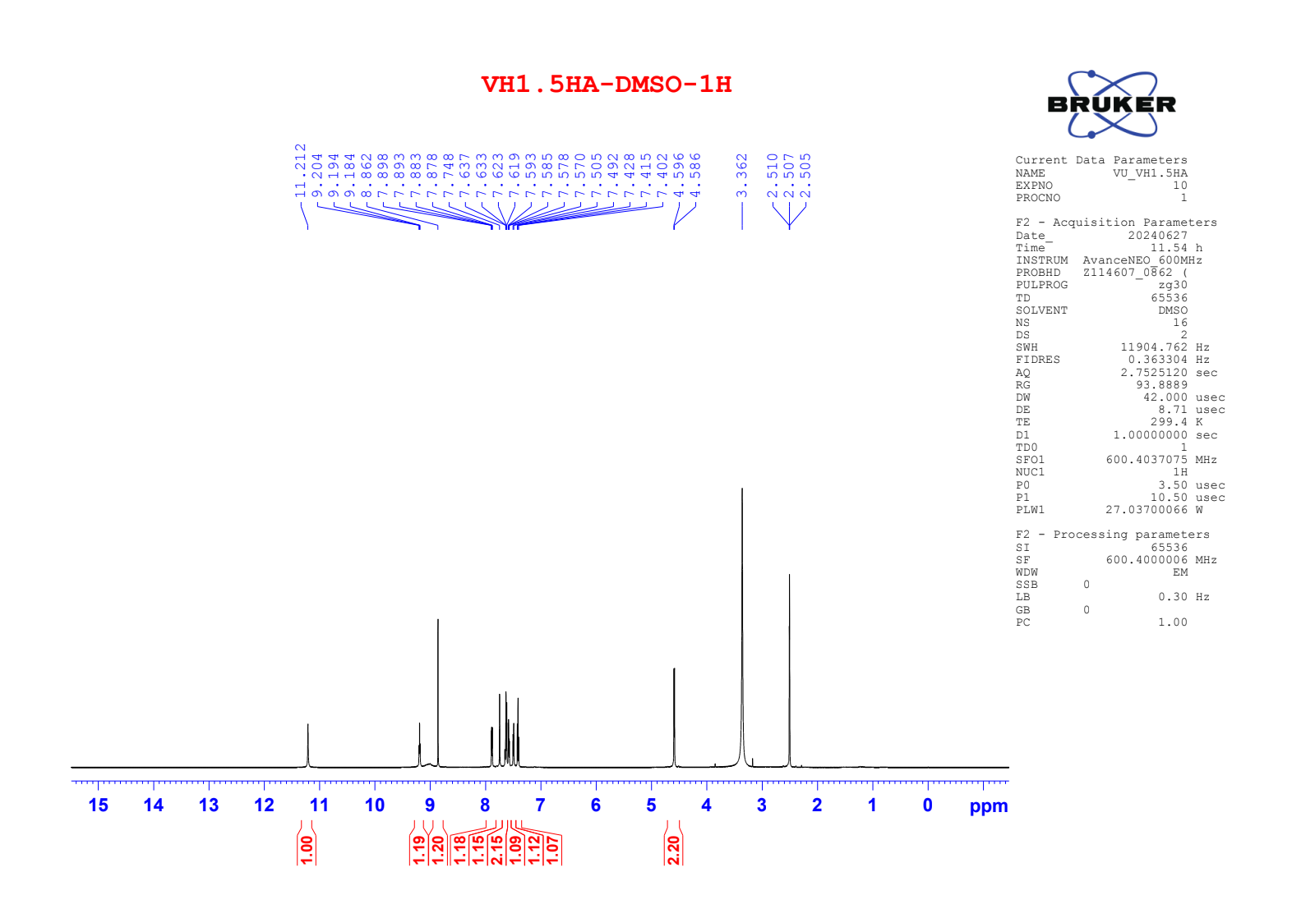

Figure S80. ¹³C NMR of compound 8b
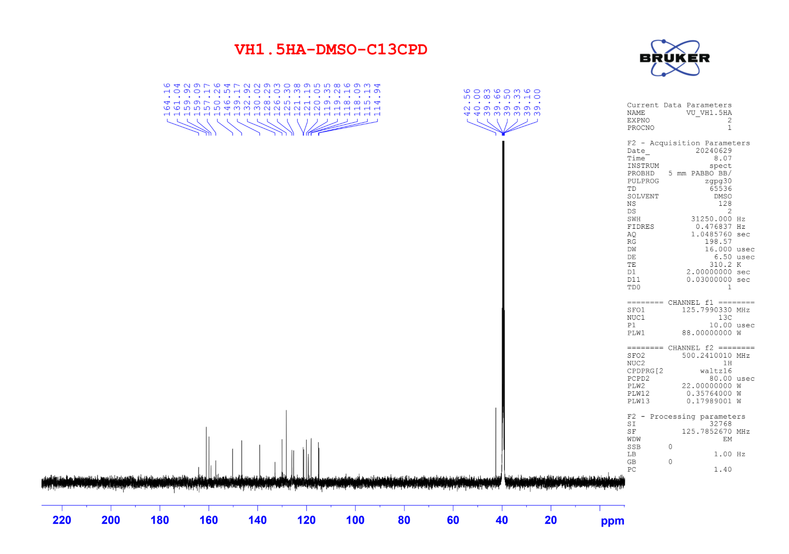

Figure S81. HRMS of compound 8b
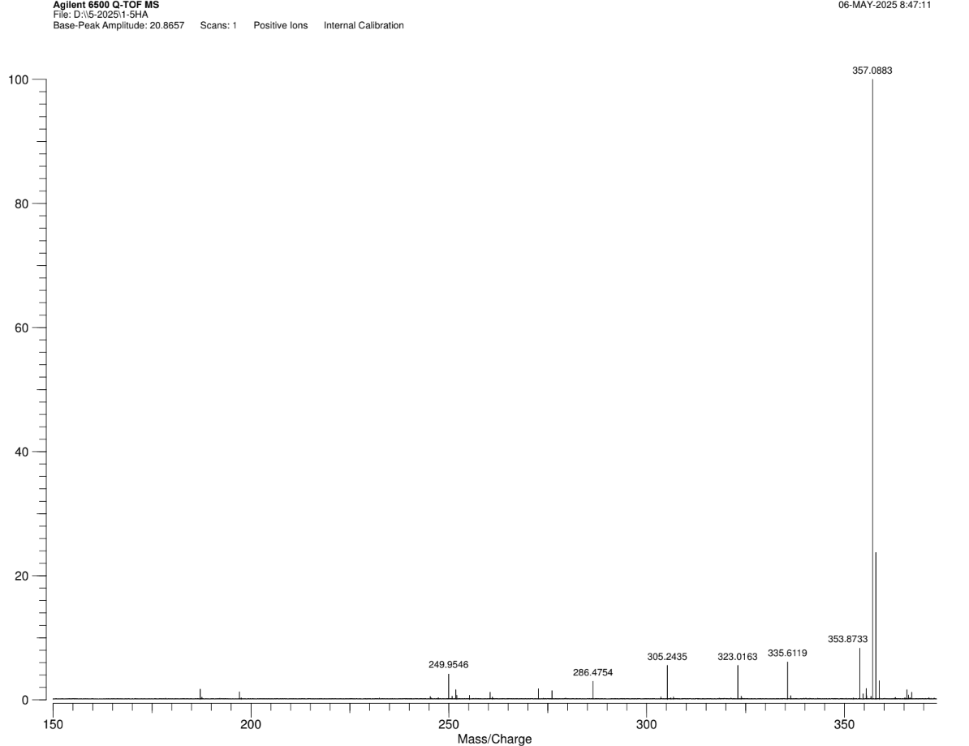

Figure S82. ¹H NMR of compound 8c
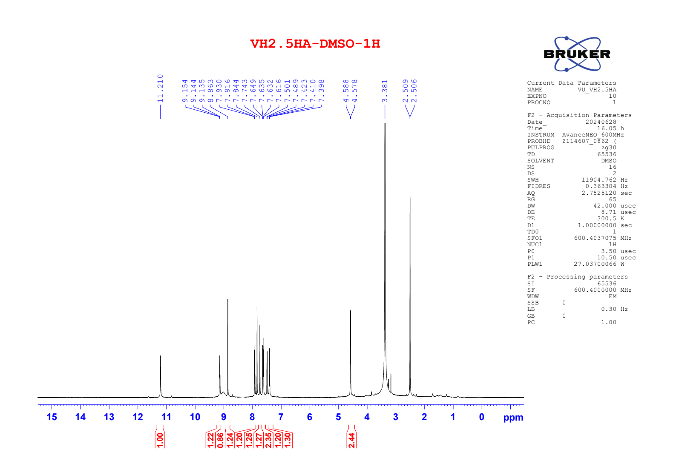

Figure S83. ¹³C NMR of compound 8c
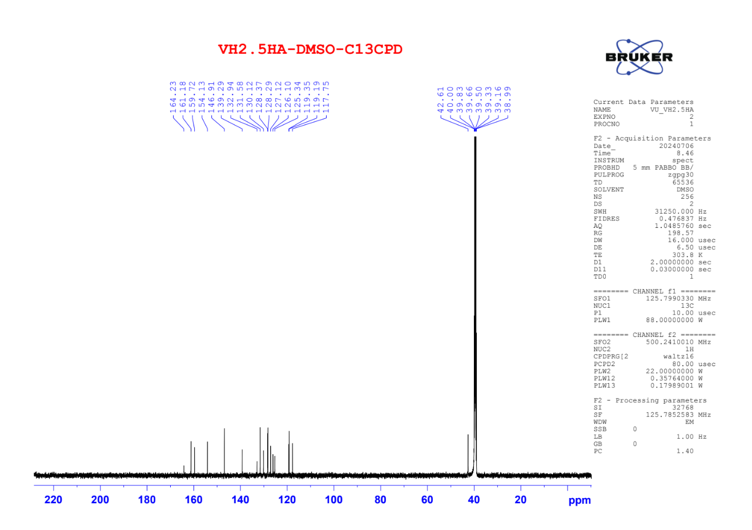

Figure S84. ¹H NMR of compound 8d
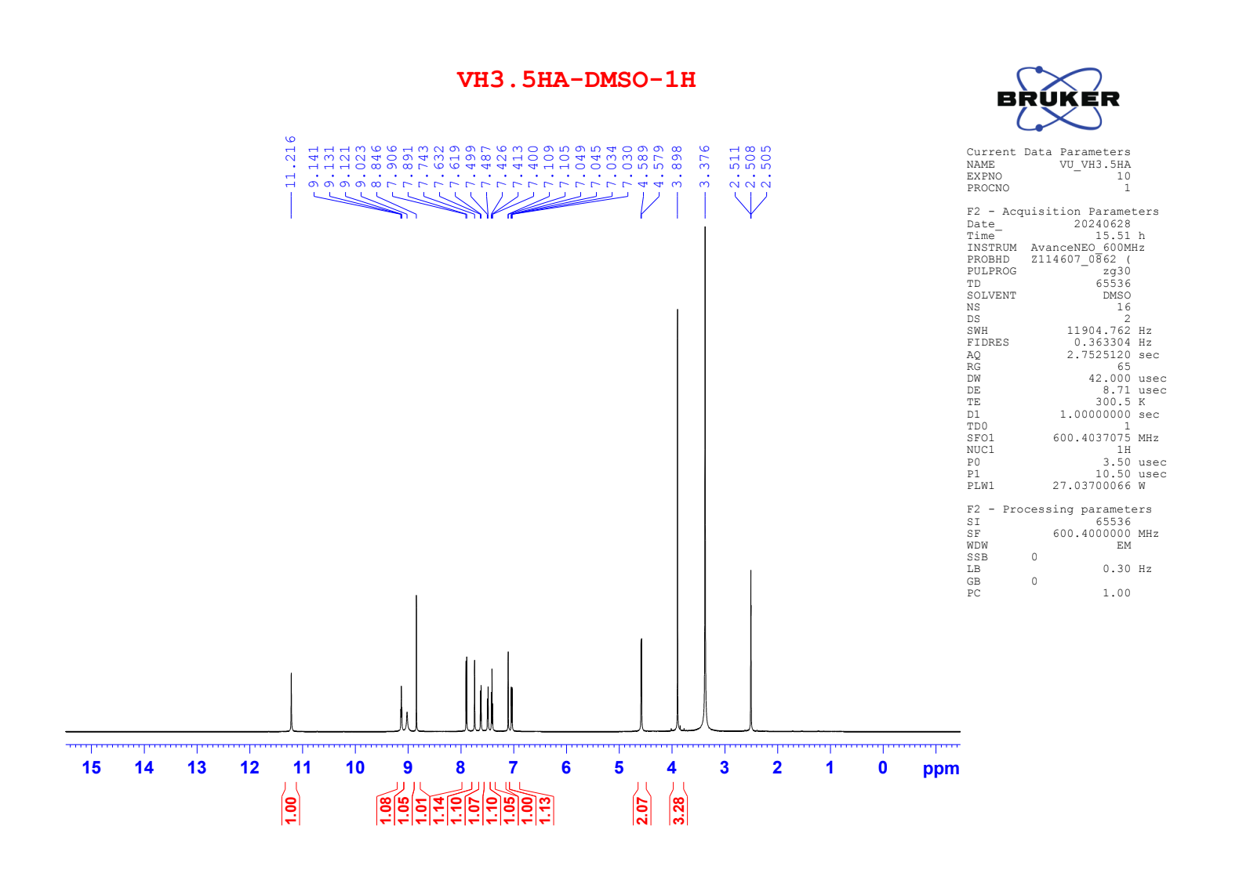

Figure S85. ¹³C NMR of compound 8d
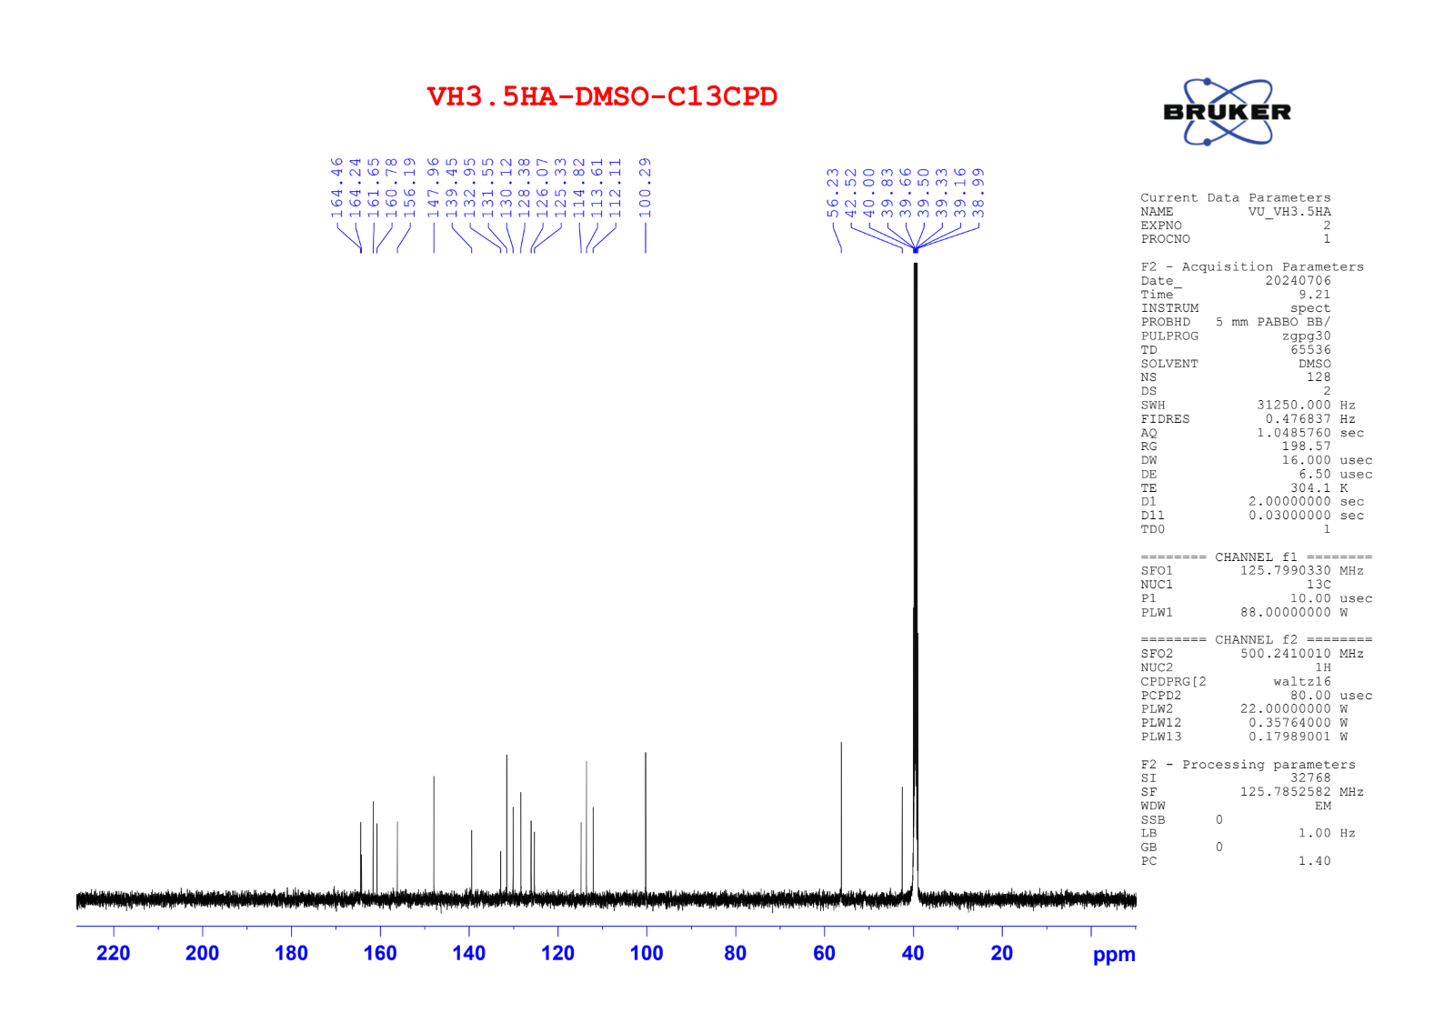

Figure S86. ¹H NMR of compound 8e
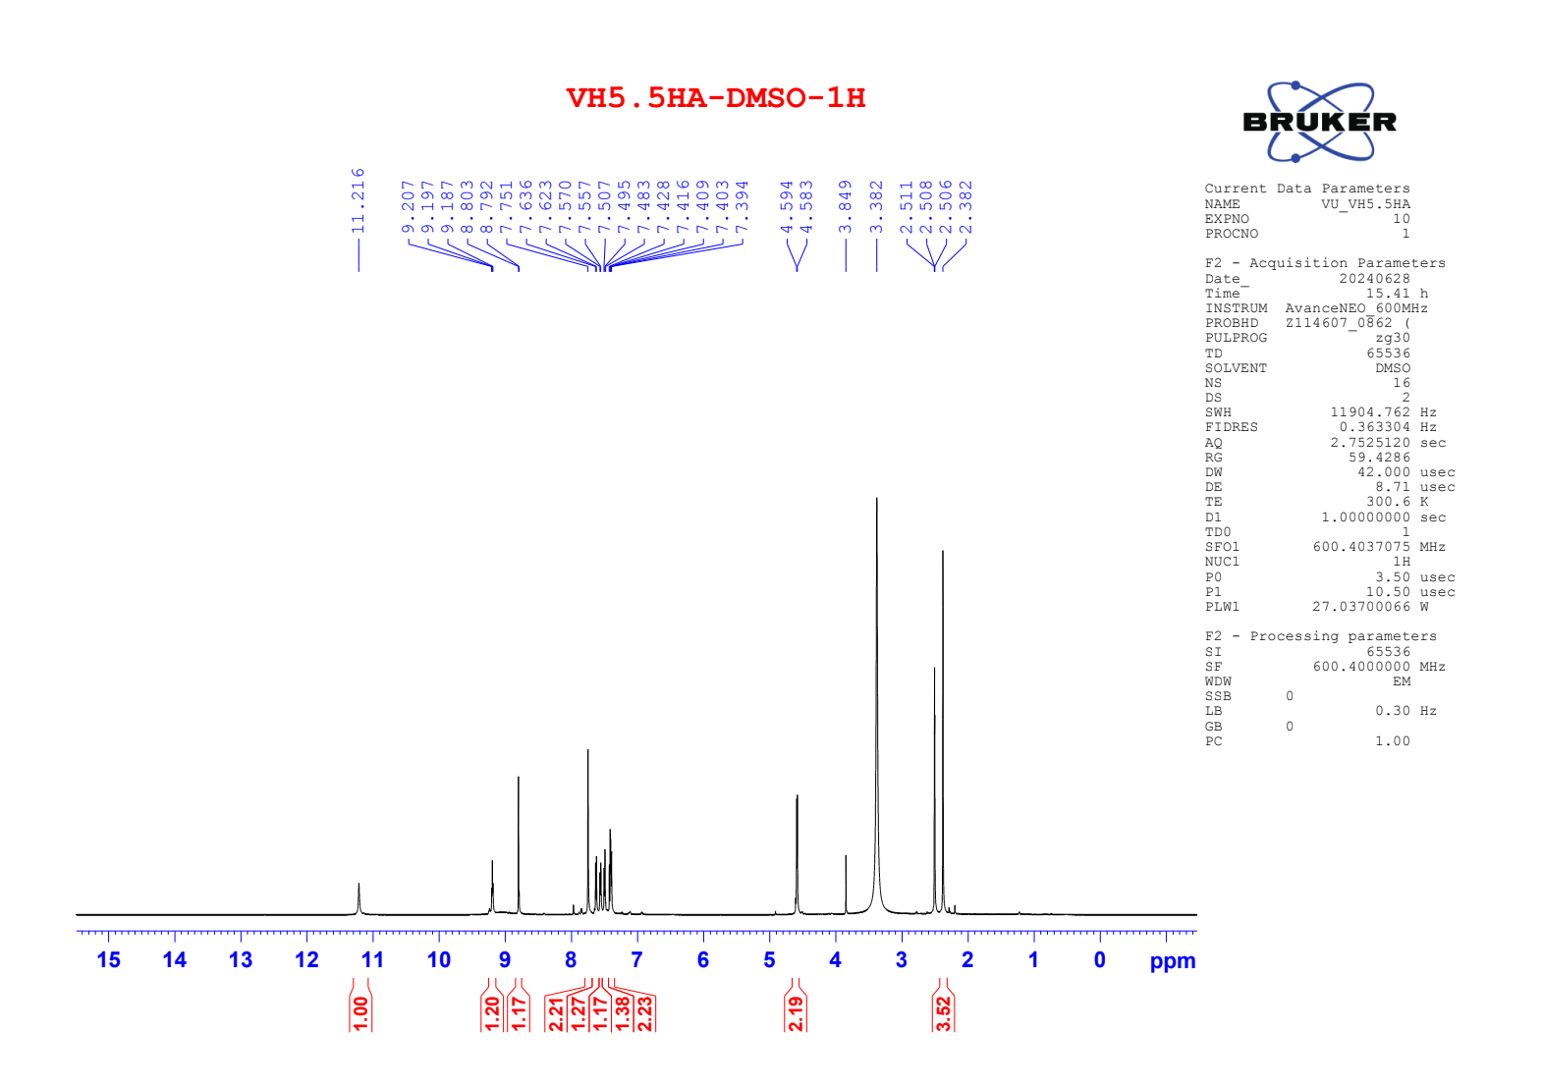

Figure S87. ¹³C NMR of compound 8e
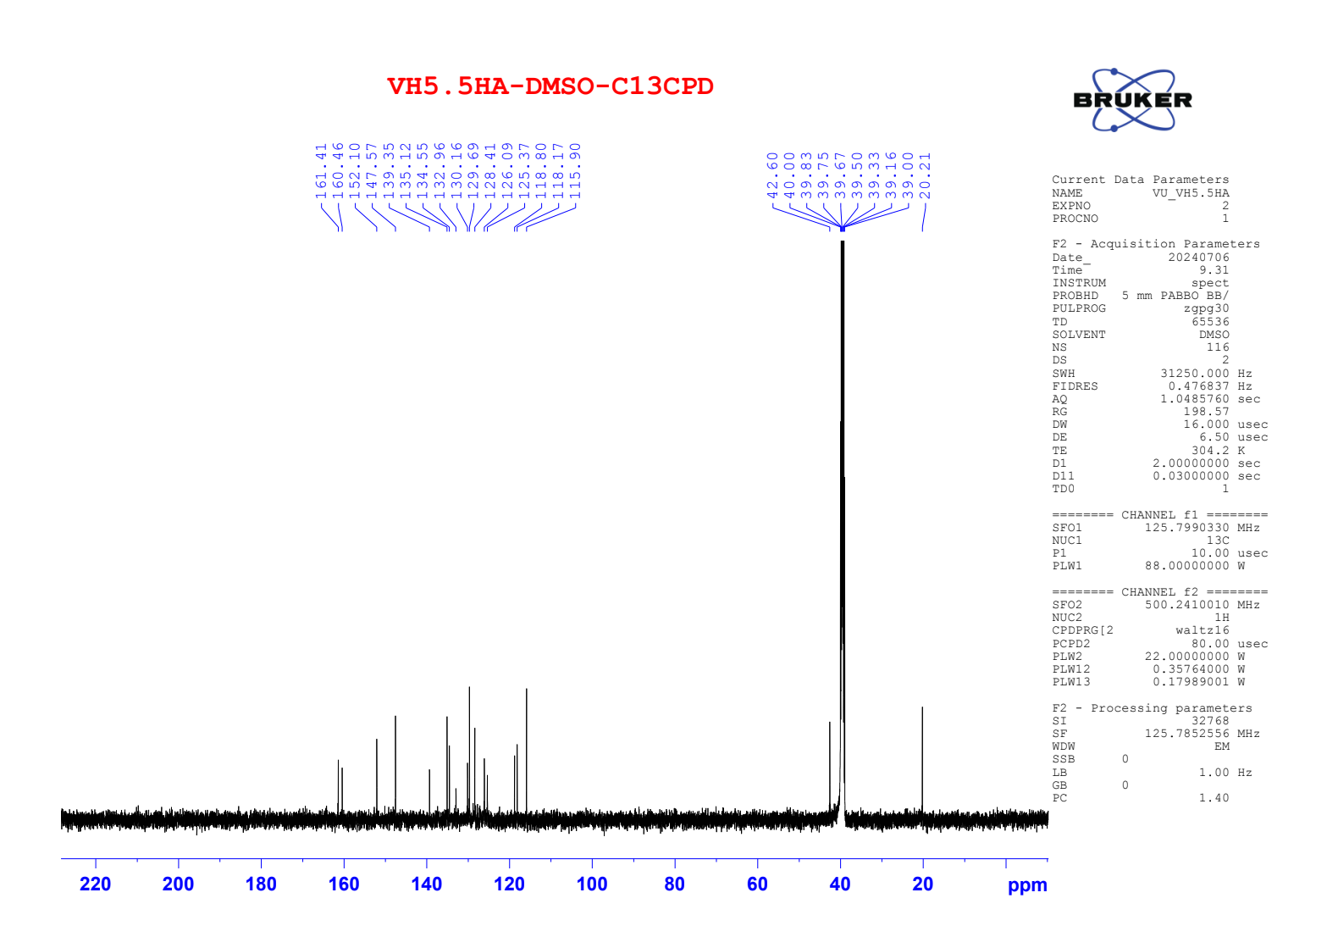

Figure S88. HRMS of compound 8e
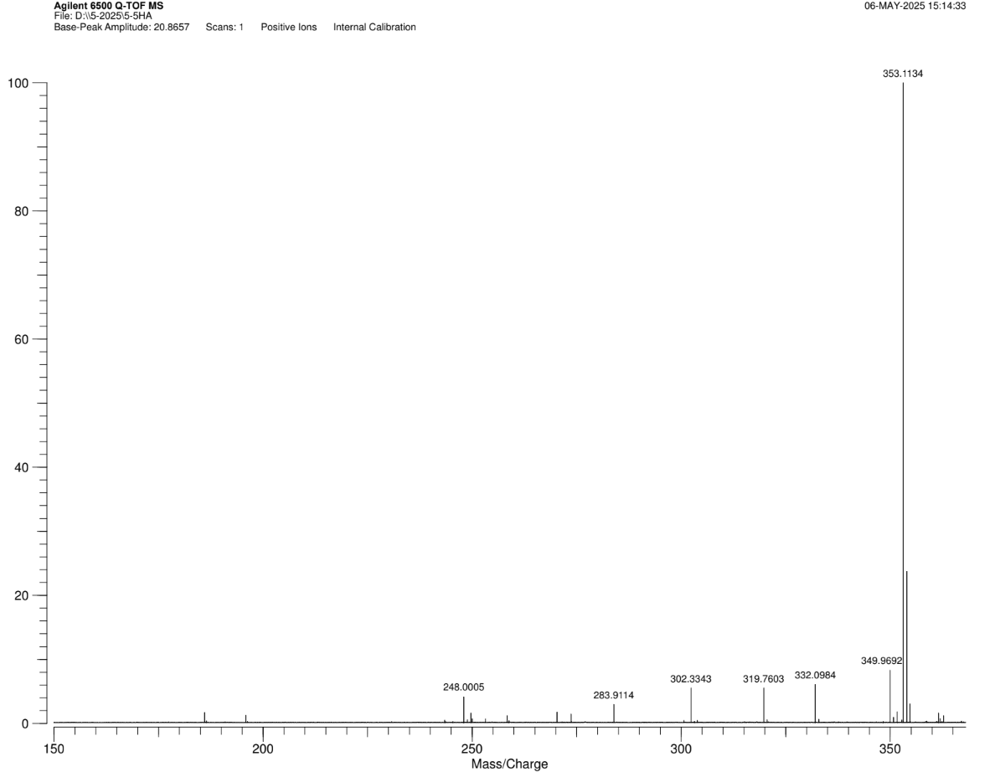

Figure S89. ¹H NMR of compound 8f
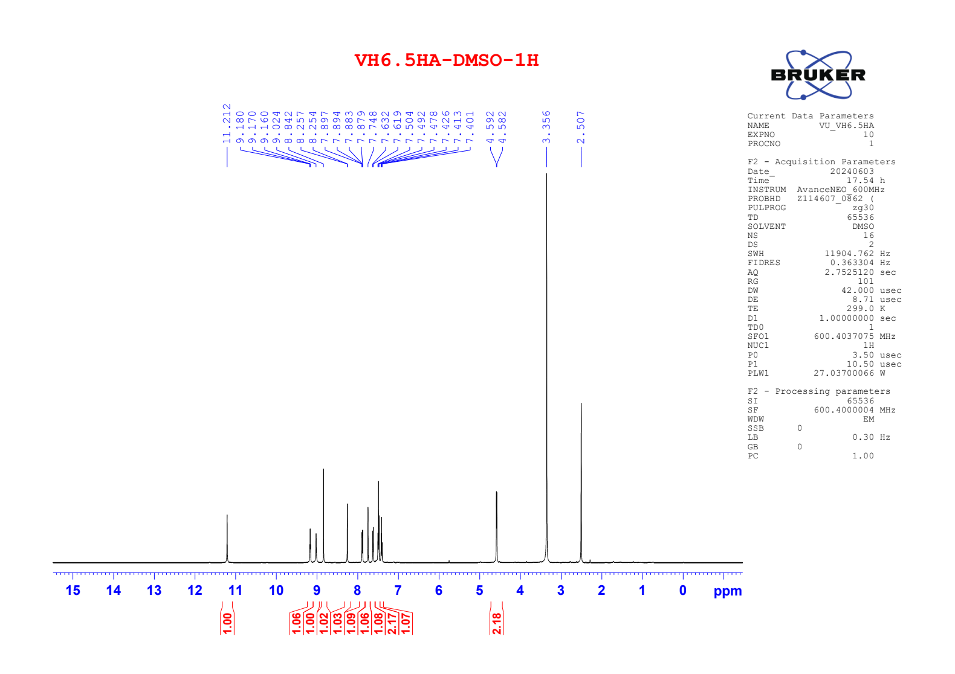

Figure S90. ¹³C NMR of compound 8f
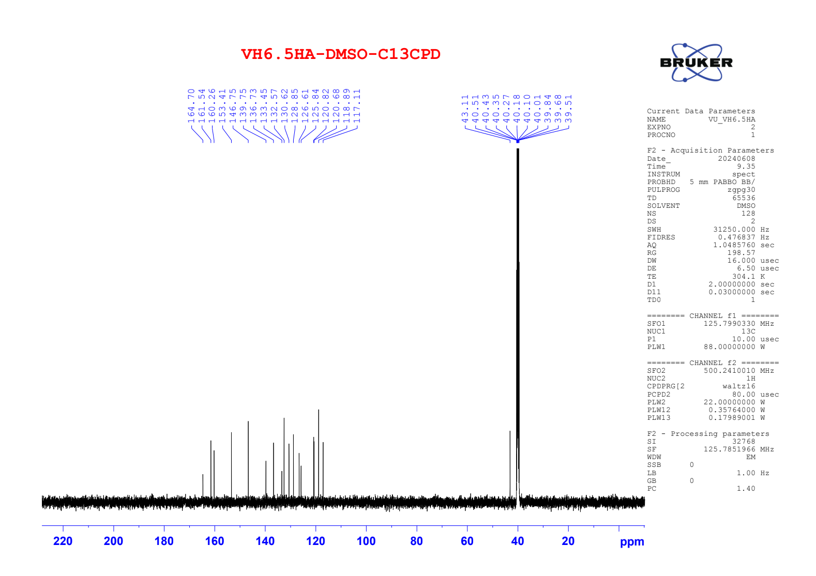

Figure S91. HRMS of compound 8f
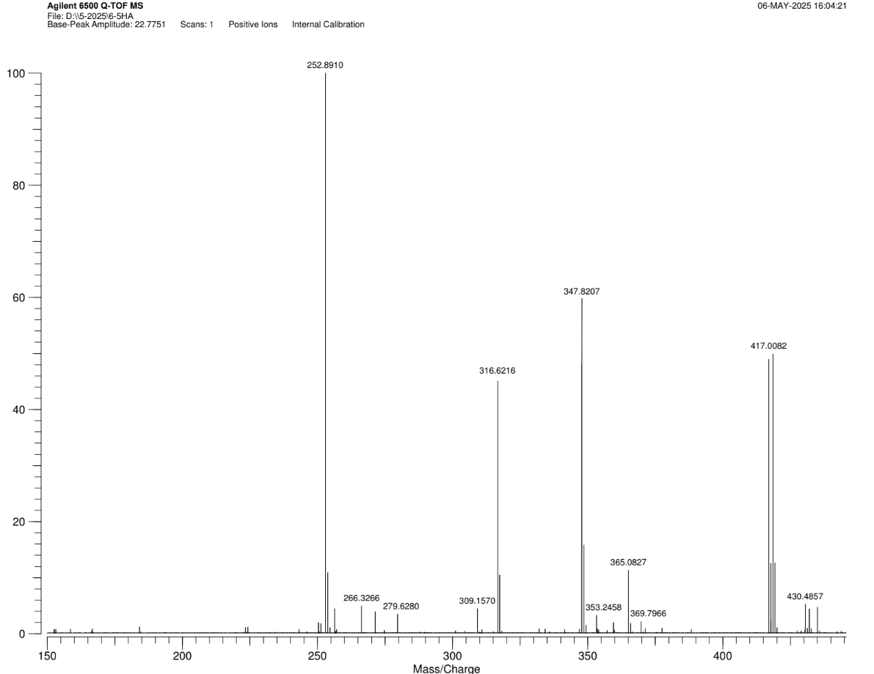

Figure S92. ¹H NMR of compound 8g
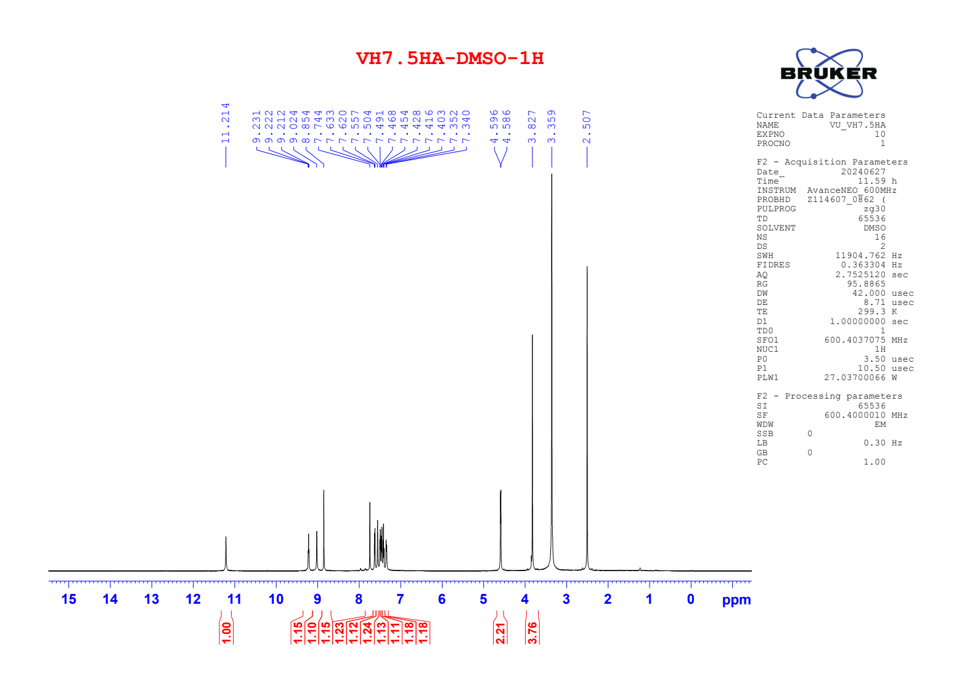

Figure S94. ¹³C NMR of compound 8g
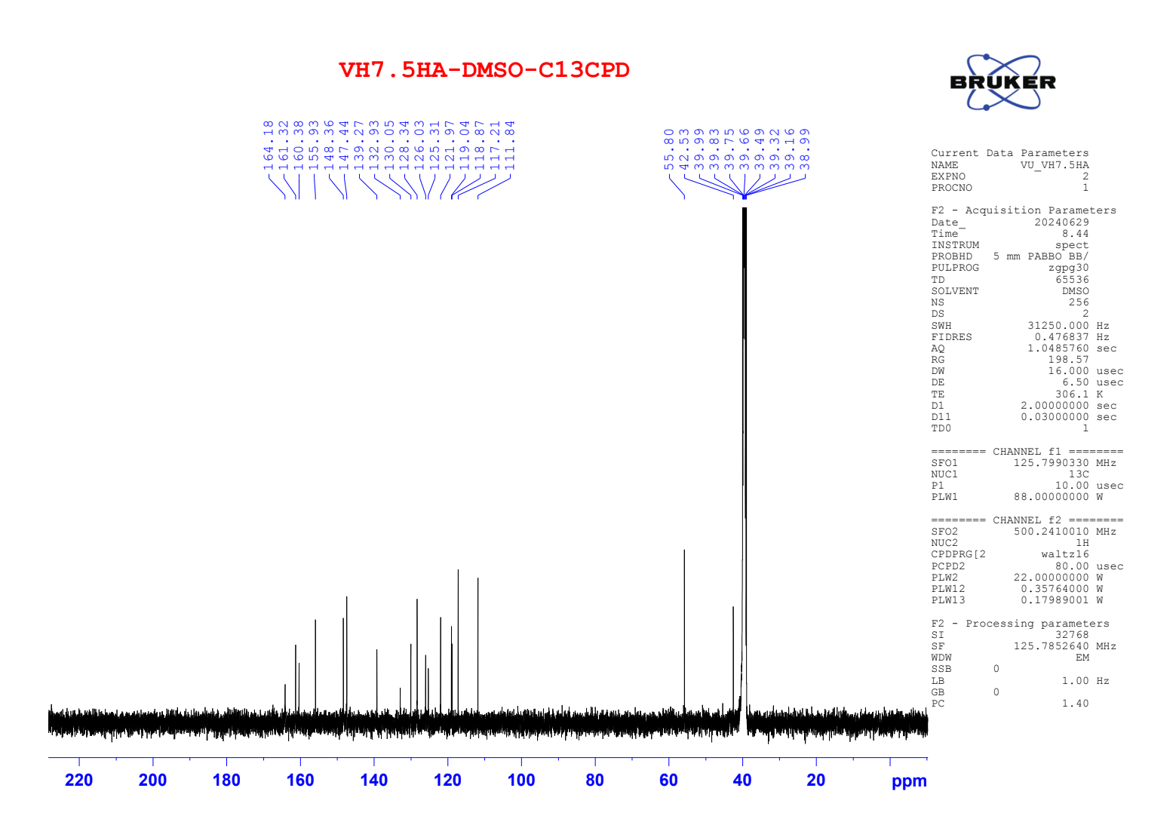

Figure S95. ¹³C NMR of compound 8g