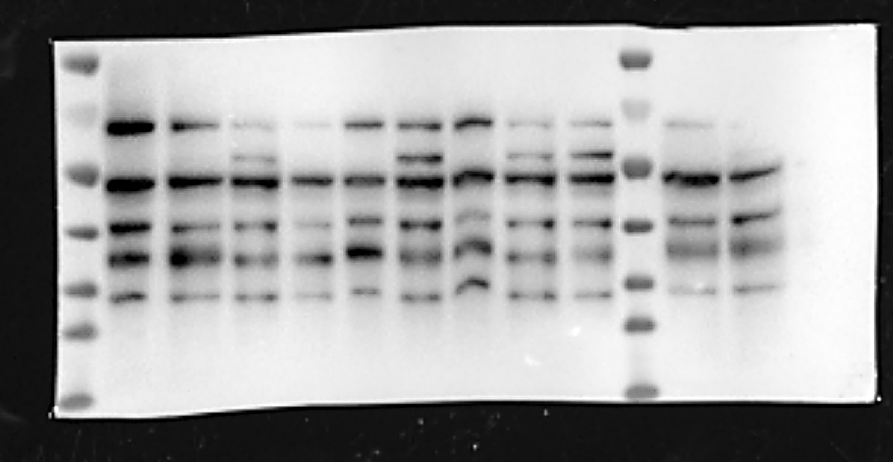
15KD
20KD
25KD
70KD
Con
Marker
35KD
50KD
IκBα 41KD
AAV9-GFP
AAV9-IκBα
Con
AAV9-GFP
AAV9-IκBα
Con
AAV9-GFP
AAV9-IκBα
Marker
Figure1
Figure 1. IκBα expression in aortic plaques in three different groups IκBα overexpression in the plaque. Representative western blot bands of IκBα in control, AAV9-GFP, and AAV9-IκBα groups. n = 3 per group. There were no differences in IκBα protein or gene expression between the control and AAV9-GFP groups. In the AAV9-IκBα group, the protein levels of IκBα were increased compared to control values, respectively (Figure 1, P < 0.05).
AAV9-IκBα
AAV9-GFP
Con
AAV9-GFP
AAV9-IκBα
AAV9-IκBα
AAV9-GFP
Con
Con
GAPDH 37KD
APDH
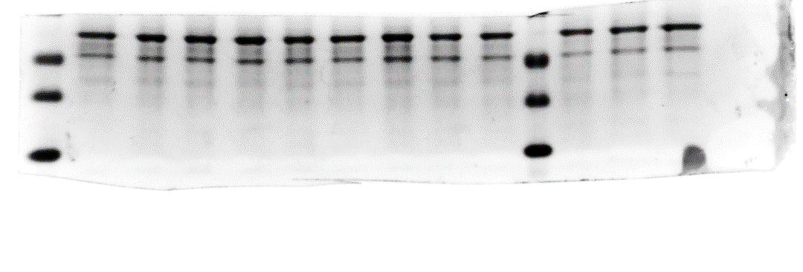
20KD Marker
35KD
25KD
Marker
Figure2
Figure 2. GAPDH expression in aortic plaques in three different groups Representative western blot bands of GAPDH in control, AAV9-GFP, and AAV9-IκBα groups. n = 3 per group. There were no differences in GAPDH protein expression between three groups. (Figure 2, P > 0.05).

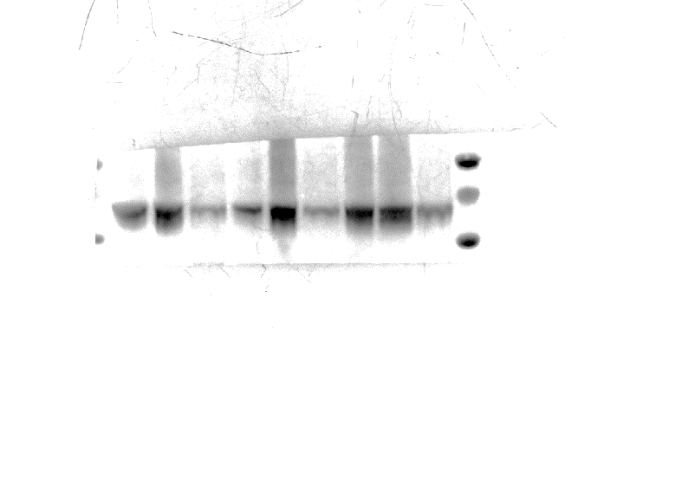
Con
Con
P-P65 65KD
APDH
100KD
70KD
55KD Marker
Con
AAV9-GFP
AAV9-IκBα
AAV9-GFP
AAV9-IκBα
AAV9-IκBα
AAV9-GFP
Figure3
Figure 3. Aorta and plaque protein expression levels of NF-κB signaling pathway in 3 groups of mice. Western blot analysis of P-P65 protein expression levels in 3 groups of mice. (n = 3 per group). There were no differences in P-P65 protein expression between the control and AAV9-GFP groups. In the AAV9-IκBα group, the protein levels of P-P65were decreased compared to control values, respectively (Figure 3, P < 0.05).

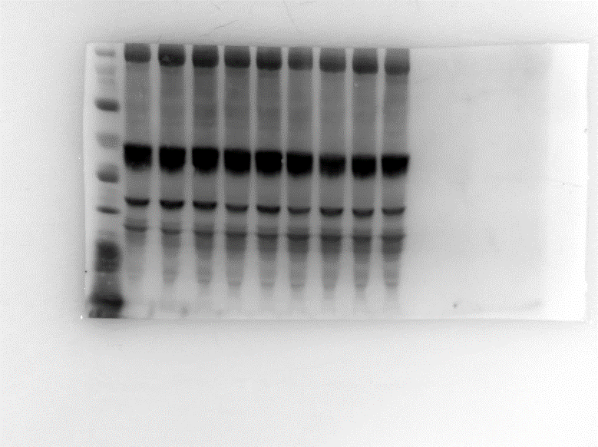
Con
GAPDH 37KD
APDH
P65 65KD
APDH
130KD
100KD
70KD
Marker
35KD
50KD
Con
AAV9-IκBα
AAV9-GFP
Con
AAV9-GFP
AAV9-IκBα
AAV9-GFP
AAV9-IκBα
Figure4
Figure 4. Aorta and plaque protein expression levels of NF-κB signaling pathway in 3 groups of mice. Western blot analysis of P65 protein and GAPDH expression levels in 3 groups of mice. (n = 3 per group). There were no differences in P65 and GAPDH protein expression between the three groups. (Figure 4, P > 0.05).

