Supplements
Table 1 Search strategies for the Medline, Embase and Cochrane CENTRAL databases.
Embase | #1 ‘AVF’  #2 ‘Arteriovenous fistula’  #3 ‘Arteriovenous shunt’  #4 ‘Vascular access’  #5 ‘Dialysis access’  #6 ‘Arteriovenous Anastomosis’  #7 ‘Arteriovenous Shunt, Surgical’  #8 ‘Blood Vessel Prosthesis’  #9 #1 OR #2 OR #3 OR #4 OR #5 OR #6 OR #7 OR #8  #10 ‘Drug eluting balloon’  #11 ‘Paclitaxel coated balloon’  #12 ‘Drug coated balloon’  #13 ‘paclitaxel’  #14 #10 OR #11 OR #12 OR #13  #15 #9 AND #14
PubMed | (((((((Arteriovenous fistula OR Arteriovenous shunt) OR Vascular access) OR Dialysis access) OR Arteriovenous Anastomosis) OR Arteriovenous Shunt, Surgical) OR Blood Vessel Prosthesis)) AND ((((Drug eluting balloon) OR Paclitaxel coated balloon) OR Drug coated balloon) OR paclitaxel))
Cochrane CENTRAL | #1 ‘AVF’  #2 ‘Arteriovenous fistula’  #3 ‘Arteriovenous shunt’  #4 ‘Vascular access’  #5 ‘Dialysis access’  #6 ‘Arteriovenous Anastomosis’  #7 ‘Arteriovenous Shunt, Surgical’  #8 ‘Blood Vessel Prosthesis’  #9 #1 OR #2 OR #3 OR #4 OR #5 OR #6 OR #7 OR #8  #10 ‘Drug eluting balloon’  #11 ‘Paclitaxel coated balloon’  #12 ‘Drug coated balloon’  #13 ‘paclitaxel’  #14 #10 OR #11 OR #12 OR #13  #15 #9 AND #14

Figure S1 Funnel plot of targeted-lesion primary patency (A), target-lesion reintervention (B), access circuit primary patency (C), and access circuit reintervention (D).
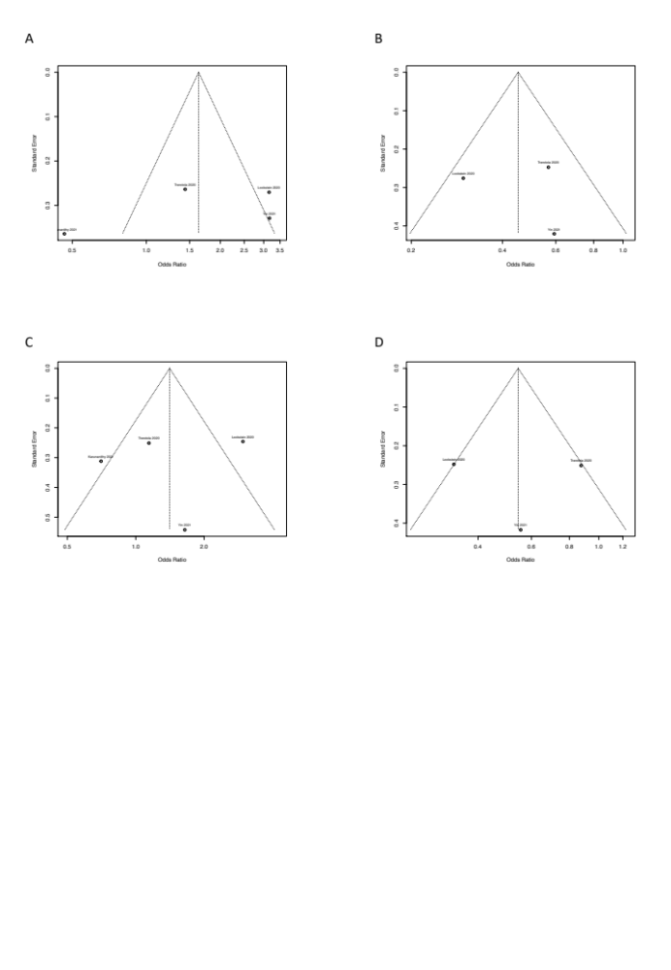
Figure S2 Baujat plot of targeted-lesion primary patency (A), target-lesion reintervention (B), access circuit primary patency (C), and access circuit reintervention (D).
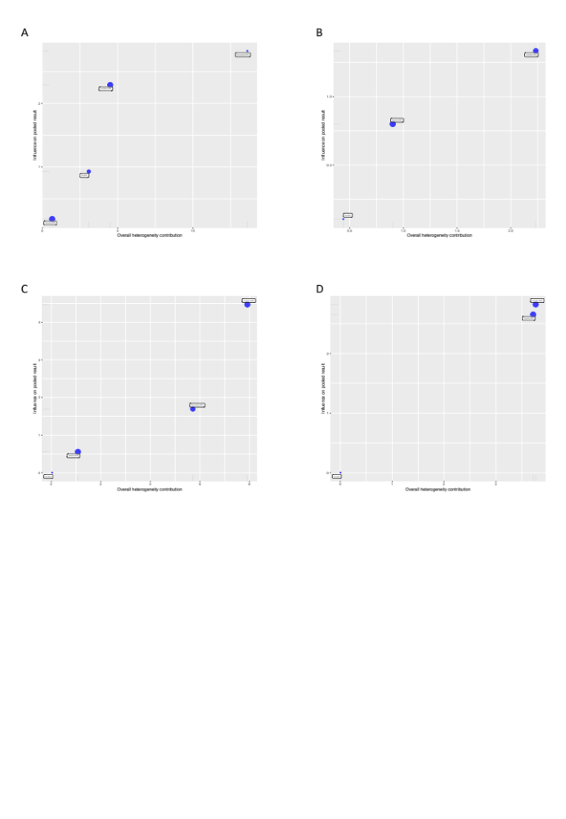
Figure S3 Forrest plot of leave-one-out meta-analyses of targeted-lesion primary patency (A) and target-lesion reintervention (B).
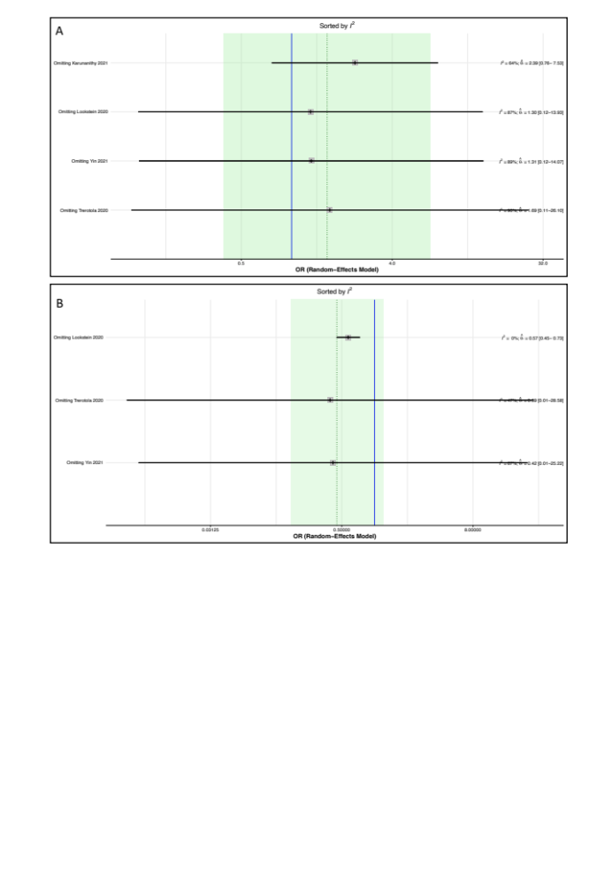
Figure S4 Forrest plot of leave-one-out meta-analyses of access circuit primary patency (A) and access circuit reintervention (B).
