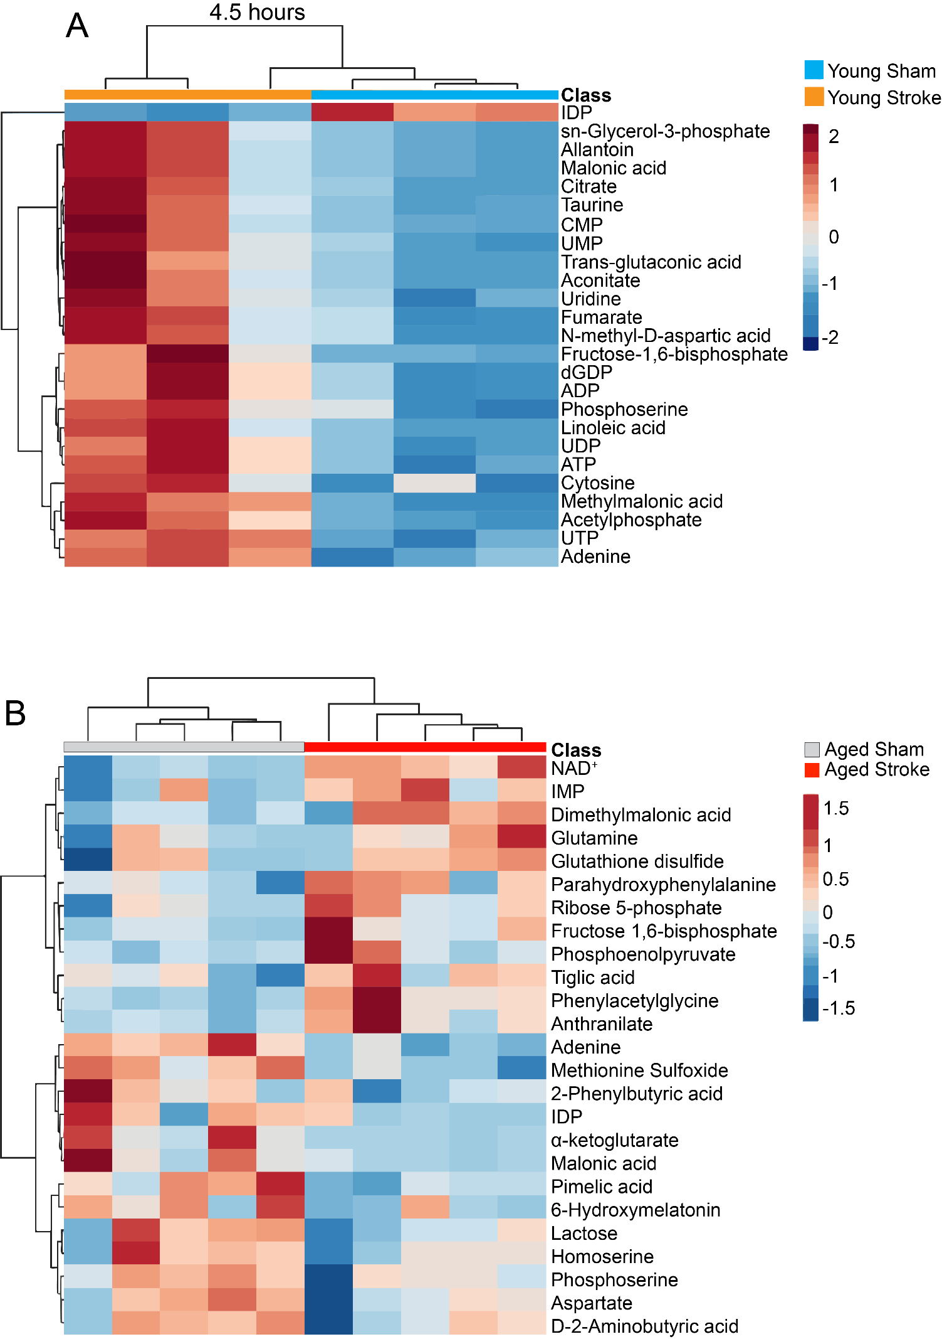

Supplementary Figure S1
Metabolomic profiling of blood monocytes from young and aged mice at 4.5 hours after stroke. Unsupervised hierarchical clustering of metabolic factors in blood monocytes isolated from (A) young (3–6 mo) and (B) aged (18–20 mo) sham and stroke mice at 4.5 hours after stroke. Scale represents z-score values from one-way ANOVA of mean total ion counts. n=3–5 male mice per group.

Supplementary Figure S2
Metabolomic profiling of blood monocytes from young and aged mice at 24 hours after stroke. Unsupervised hierarchical clustering of metabolic factors in blood monocytes isolated from (A) young (3–6 mo) and (B) aged (18–20 mo) sham and stroke mice at 24 hours after stroke. Scale represents z-score values from one-way ANOVA of mean total ion counts. n=4–5 male mice per group.
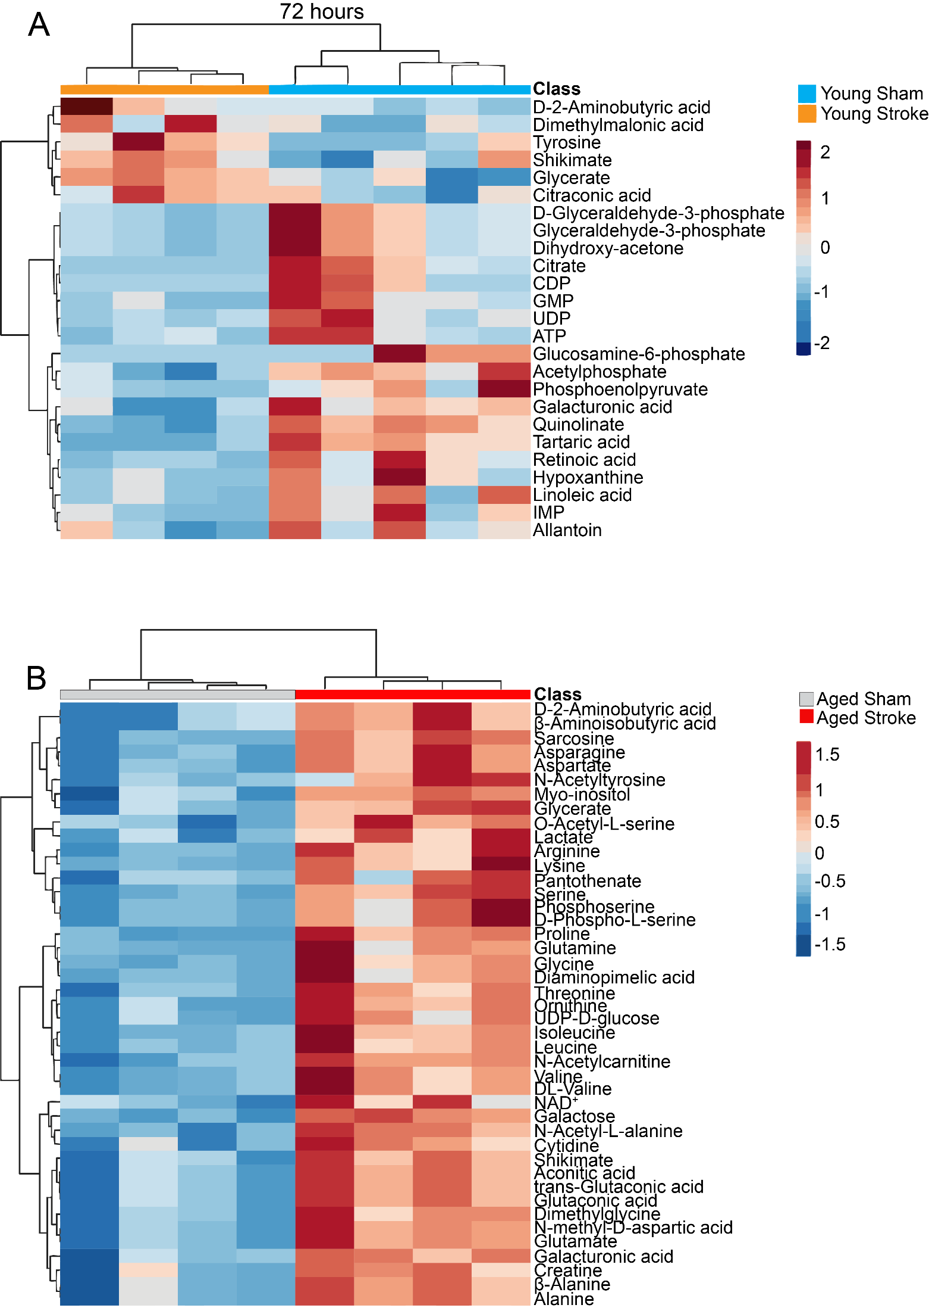
Supplementary Figure S3
Metabolomic profiling of blood monocytes from young and aged mice at 72 hours after stroke. Unsupervised hierarchical clustering of metabolic factors in blood monocytes isolated from (A) young (3–6 mo) and (B) aged (18–20 mo) sham and stroke mice at 72 hours after stroke. Scale represents z-score values from one-way ANOVA of mean total ion counts. n=4–5 male mice per group.

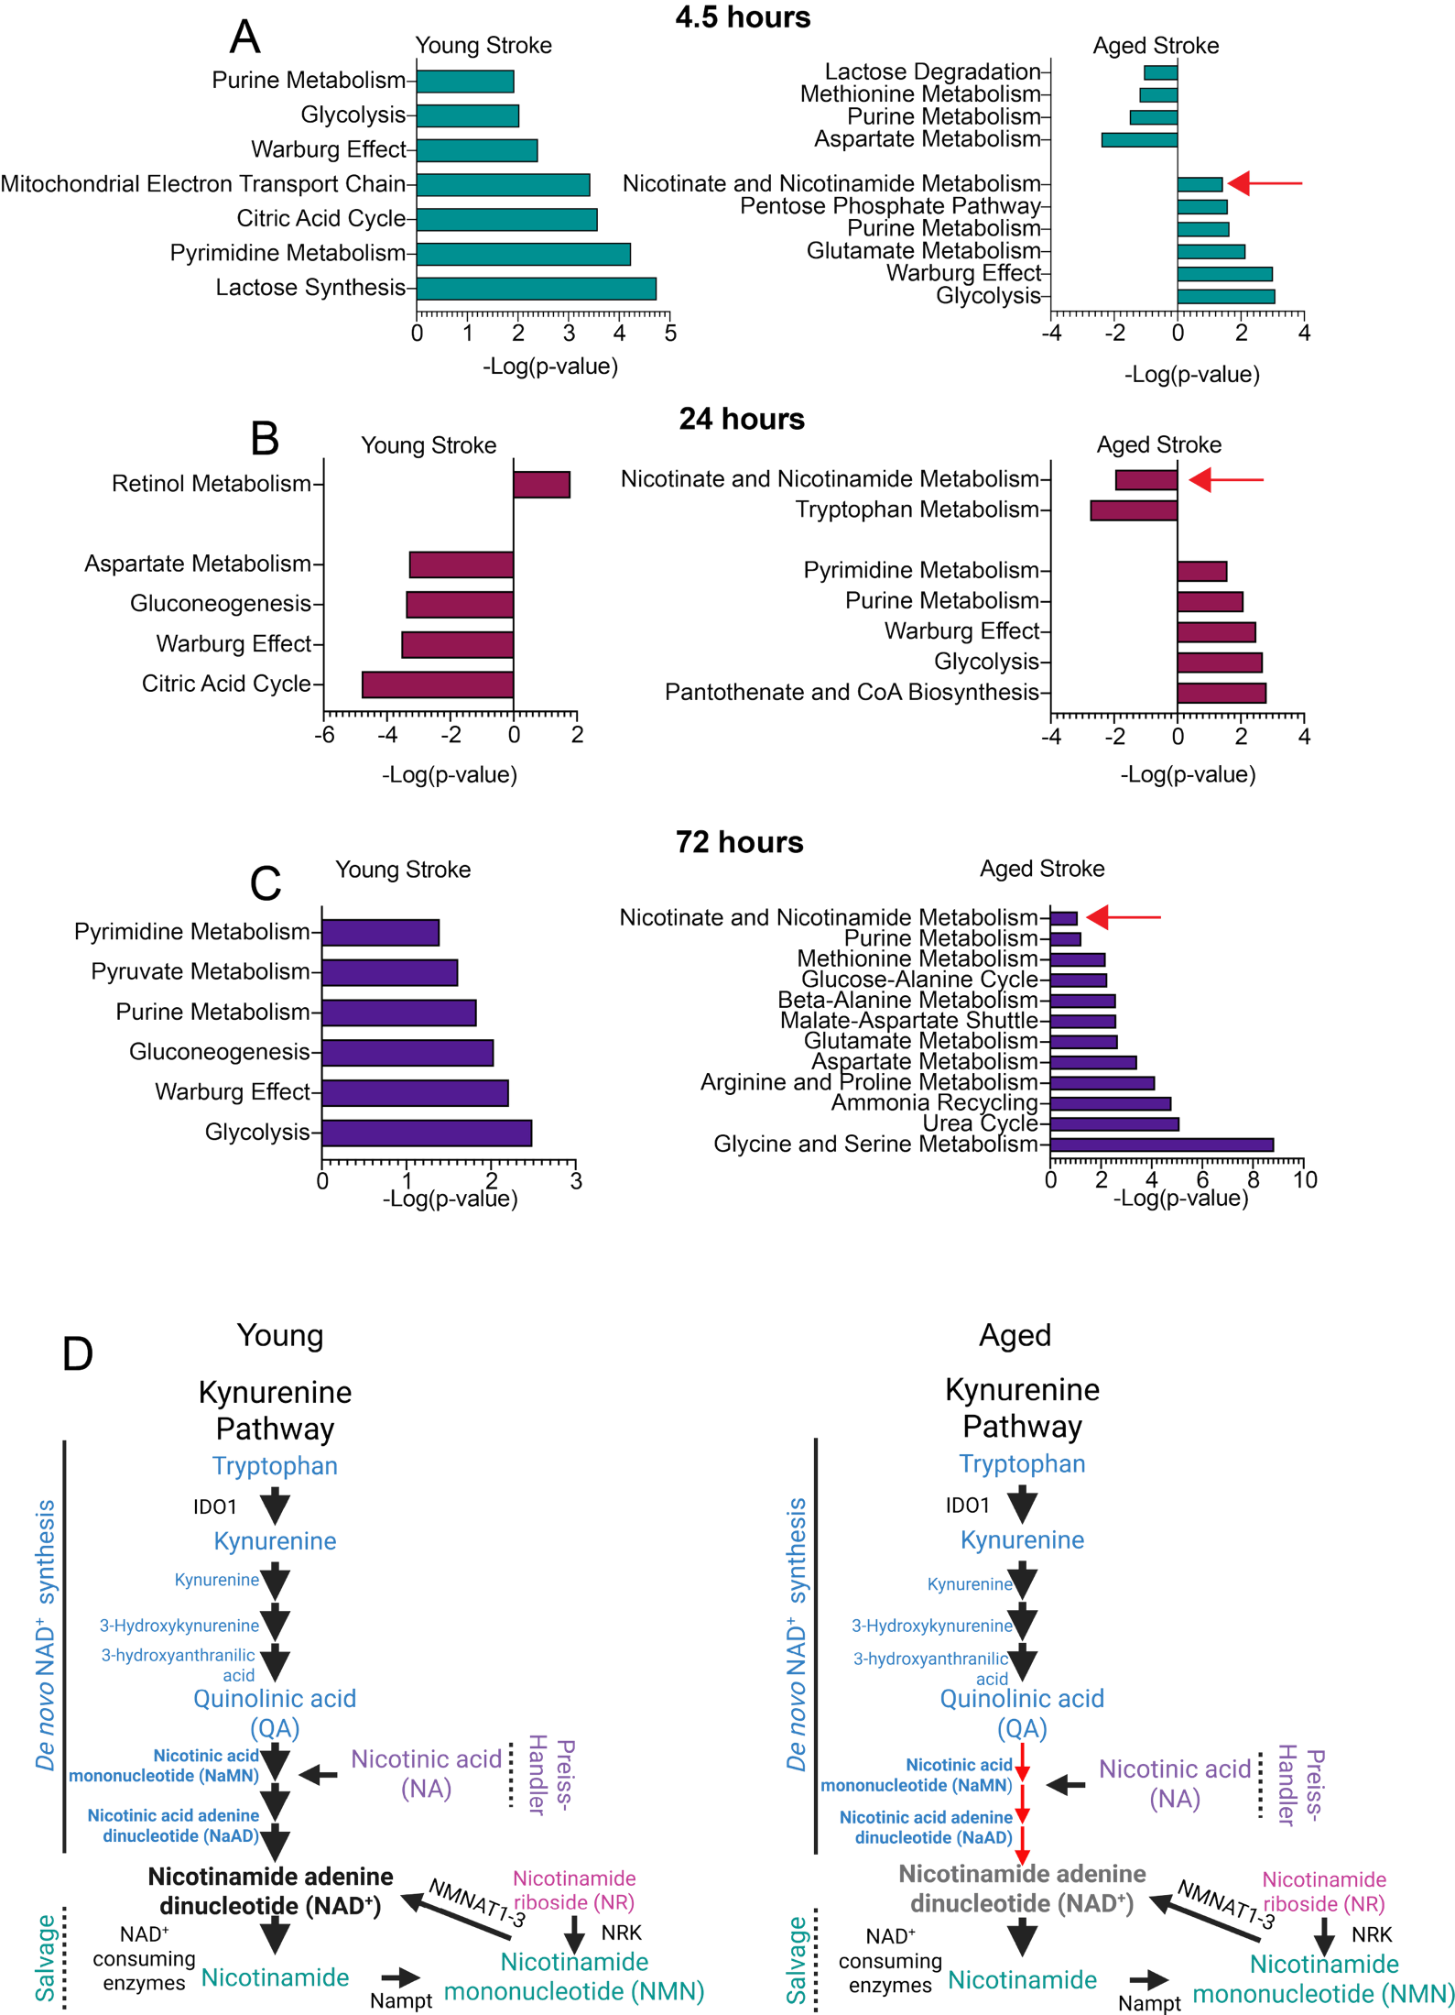
Supplementary Figure S4
NAD⁺ metabolic pathway is differentially changed in aged mice after stroke. Analysis of enriched metabolic pathways in blood monocytes isolated from young (3–6 mo) and aged (18–20 mo) mice at (A) 4.5 hours, (B) 24 hours, and (C) 72 hours after stroke. Data were analyzed using MetaboAnalyst 6.0. Red arrows indicate changes in nicotinamide adenine dinucleotide (NAD+) metabolic pathways. Negative and positive values indicate decreased and increased pathways respectively. (D) Schematic illustrating increased accumulation of QA along the kynurenine pathway (KP) in young (left) mice compared to aged mice (right). Black bold short arrows indicate a homeostatic metabolic flux through the KP, and red thin arrows indicate reduced metabolic flux through the KP. Schematic was created in Biorender.
Supplementary Figure S5
NR treatment timeline and immune profiling of blood plasma after stroke. (A) Timeline for 4-week nicotinamide riboside (NR) or vehicle (water) treatment in young (3–6 mo) and aged (18–20 mo) mice via oral gavage followed by dMCAo (distal middle cerebral artery occlusion) and collection of blood plasma including blood monocytes, brain and gut tissue at 24 hours post stroke. Unsupervised hierarchical clustering of significantly regulated immune factors measured by multi-analyte Luminex of blood plasma from young and aged sham and stroke mice at (B) 4.5 hours, (C) 24 hours and (D) 72 hours after stroke. Scale represents z-score values from one-way ANOVA of mean fluorescent intensity values. n=5 male mice per group.
Supplementary Figure S6
Nicotinamide riboside reduces inflammation in aged mice after stroke. (A) Representative flow cytometry gating strategy to identify and quantify monocyte-derived macrophages (MDMs), tissue resident macrophages (TRMs), P1 (Ly6C^{Hi} MHCII^{Low}), P2 (Ly6C^{Int} MHCII^{Hi}) and P3 (Ly6C^{low} MHCII^{Hi}) macrophages isolated from the gut of sham (vehicle; water), stroke control (vehicle; water) and NR-treated young (3–6 mo) and aged (18–20 mo) mice 24 hours after stroke. Multi-analyte Luminex quantification of differences in the expression of immune factors in the blood plasma isolated from sham control, stroke control and stroke NR-treated (B) young and (C) aged at 24 hours post stroke. n=4–8 male mice per group. Data are represented as the mean ± SEM. p-values were calculated using one-Way ANOVA with Bonferroni correction. Multi-analyte Luminex quantification of differences in the expression of immune factors in the gut isolated from sham control, stroke control and stroke NR-treated (D) young and (E) aged mice at 24 hours post stroke. n=4–5 male mice per group. Data are represented as the mean ± SEM. p-values were calculated using one-Way ANOVA with Bonferroni correction.

Appendix

