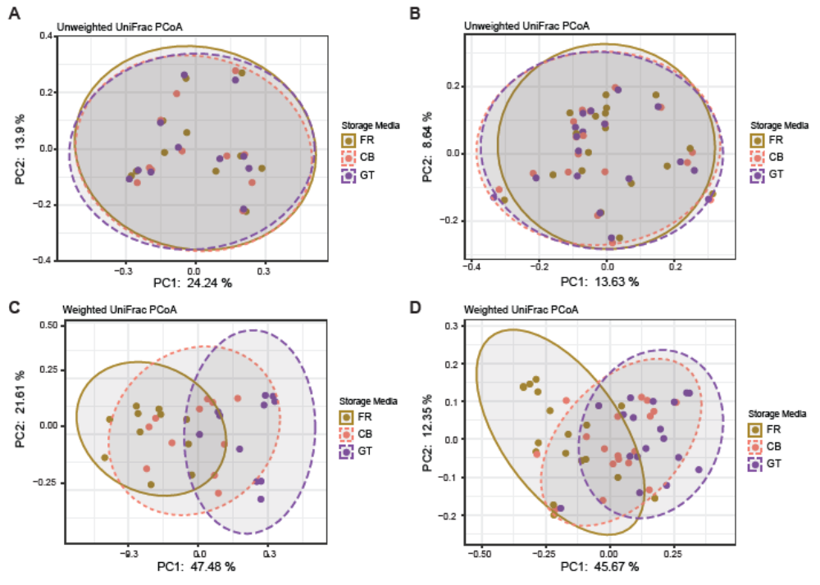
Supplemental Figure 1. Comparison of beta diversity between storage conditions. (A) Principal coordinate analysis of the unweighted UniFrac distance among the 3 storage conditions in the non-PAD group [R² = 0.02, F = 0.368, p = 1]. (B) Principal coordinate analysis of the unweighted UniFrac distance among the 3 storage conditions in the PAD group [R² = 1.42, F = 0.402, p = 1]. (C) Principal coordinate analysis of the weighted UniFrac distance among the 3 storage conditions in the non-PAD group [R² = 0.334, F = 9.424, p = 0.0001]. (D) Principal coordinate analysis of the weighted UniFrac distance among the 3 storage conditions in the PAD group [R² = 0.233, F = 8.698, p = 0.0001]. Each comparison was done with 9999 permutations.

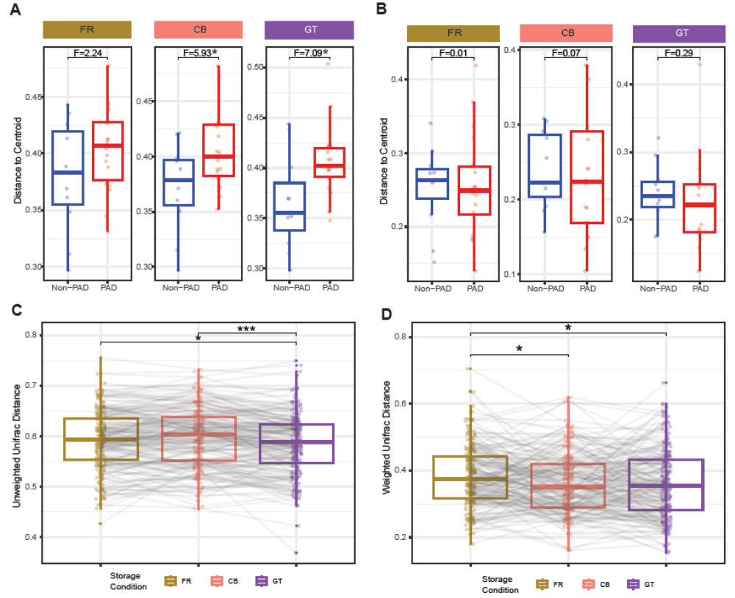Supplemental Figure 2. Comparison of beta diversity within and between groups. Dispersion of samples in non-PAD and PAD groups in 3 storage conditions using unweighted (CB, *, p = 0.025; GT, *, p = 0.012) (A) and weighted UniFrac (B) distances. Paired Wilcoxon rank sum test of PAD vs. non-PAD distances between storage conditions using unweighted (*, p = 0.043; ***, p = 0.0001) (C) and weighted UniFrac (FR-CB, *, p = 0.012; FR-GT, *, p = 0.026) (D) distances.
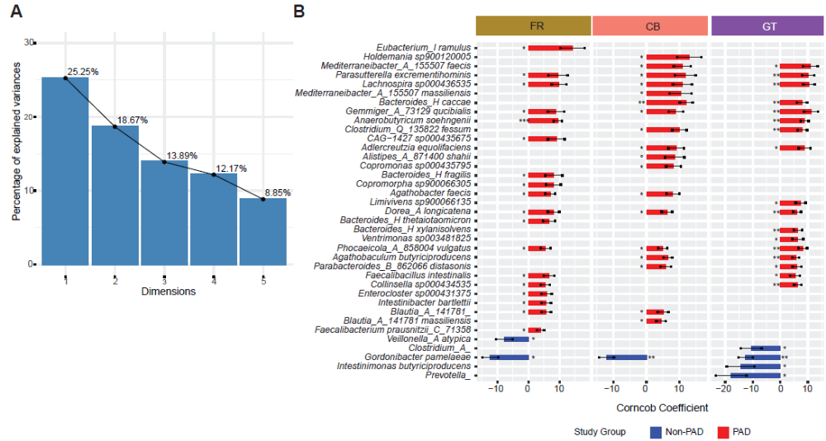Supplemental Figure 3. Dimensionality reduction and differential variability. (A) Percent of variance explained by each principal component after dimensionality reduction of multiple covariates including age, sex, race, body mass index, smoking, storage time and sequencing batch. (B) Differentially variable species between non-PAD and PAD groups in 3 storage conditions.

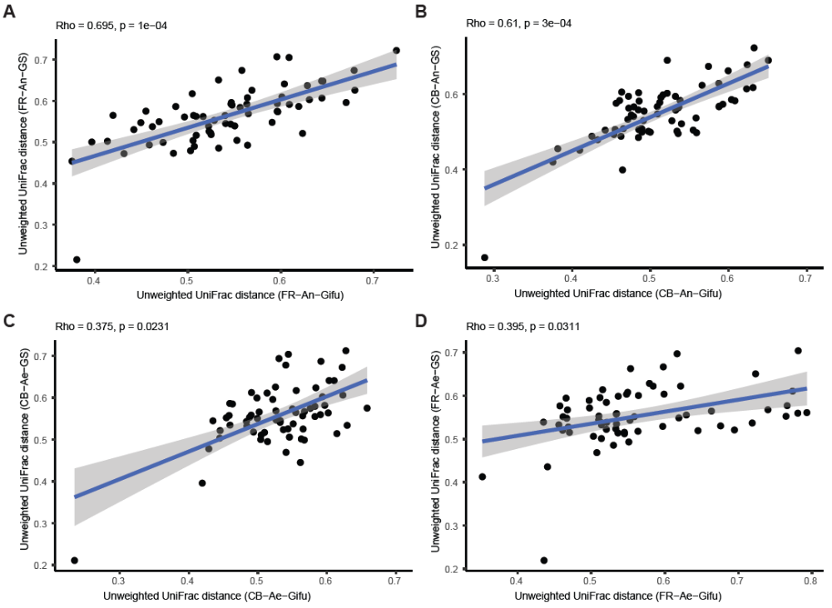Supplemental Figure 4. Mantel correlation of unweighted UniFrac distances in colonies and glycerol stocks (GS). Mantel correlation between FR-An-GS and FR-An-Gifu (A), CB-An-GS and CB-An-Gifu (B), CB-Ae-GS and CB-Ae-Gifu (C), and FR-Ae-GS and FR-Ae-Gifu (D). Number of permutations = 9999. Colonies are represented on X-axis and GS are represented on Y-axis. An, anaerobic processing. Ae, anaerobic processing.

Supplemental Table 1. Mantel correlations between unweighted and weighted UniFrac distances in the 3 storage conditions in non-PAD and PAD groups.

Clinical group | Storage condition 1 | Storage condition 2 | Spearman  Correlation coefficient | p | Distance
PAD | FR | CB | 0.749 | 1.00E-04 | Unweighted UniFrac
PAD | FR | GT | 0.756 | 1.00E-04 | Unweighted UniFrac
PAD | CB | GT | 0.721 | 1.00E-04 | Unweighted UniFrac
NonPAD | FR | CB | 0.872 | 1.00E-04 | Unweighted UniFrac
NonPAD | FR | GT | 0.838 | 1.00E-04 | Unweighted UniFrac
NonPAD | CB | GT | 0.844 | 1.00E-04 | Unweighted UniFrac
PAD | FR | CB | 0.3 | 1.00E-04 | Weighted UniFrac
PAD | FR | GT | 0.269 | 1.00E-04 | Weighted UniFrac
PAD | CB | GT | 0.326 | 1.00E-04 | Weighted UniFrac
NonPAD | FR | CB | 0.387 | 1.00E-04 | Weighted UniFrac
NonPAD | FR | GT | 0.404 | 1.00E-04 | Weighted UniFrac
NonPAD | CB | GT | 0.543 | 1.00E-04 | Weighted UniFrac

