Appendices

Annex 1. Search terms and Boolean operators
Database |  | Keywords | PCC search terms with Boolean operators (combined vertically for searching in the databases)
PubMed (searching anywhere) | Population | Children, Adolescents, Infant, Teenager | children OR adolescent OR infant OR teenager  AND
PubMed (searching anywhere) | Concept | behavior change wheel, behavior change wheel, com-b, capability, opportunity, motivation | behaviour change wheel OR behavior change wheel com-b OR capability OR opportunity OR motivation  AND
PubMed (searching anywhere) | Context | Nutrition, Diet, Food, eating | Nutrition OR diet OR food OR eating  AND
PubMed (searching anywhere) | Context | Intervention, Project, program* | Intervention OR project OR program*
Other databases (searching in the abstracts) | Population | Children, child, Adolescents, Youth, teenager | children OR child OR adolescents OR youth OR teenager  AND
Other databases (searching in the abstracts) | Concept | behavior change wheel,  behavior change wheel | behaviour change wheel OR behavior change wheel  AND
Other databases (searching in the abstracts) | Context | Nutrition, Diet, food, food intake, eating, nourishment | nutrition OR diet OR food OR food intake OR eating OR nourishment  AND
Other databases (searching in the abstracts) | Context | Intervention, Project, program* | intervention OR project OR program*

Annex 2. Data charting
The data charting included the following rubrics and details.
- Study characteristics: The key elements, especially the year of publication and country or region, were drawn from (46), but the researcher also added information needed to contextually understand the review:
  - Author(s)
  - Year of publication
  - Publication title
  - Description – nutrition focus, rural or (peri-)urban, pilot, scaled-up
  - Country/region – specifying the geographical location of the intervention
  - Total participants or sample size used in the review articles
  - Age group – specifying the child age group
  - Research design – Identifying whether the design upon which the publication is based is experimental, quasiexperimental, cross-sectional, qualitative, quantitative, or systematic.

- Intervention context—recognizing the importance and effect of context on interventions [28], the researcher’s positionality as embedded in development and humanitarian settings allowed the inclusion of three familiar types of contexts anecdotally known to have differential effects on nutrition outcomes:
  - secure/stable for development, long-term interventions
  - emergency allowing short-term and/or quick interventions, or
  - humanitarian in protracted crisis, allowing mid-/long-term interventions.

- Main foci of the nutrition intervention – all major forms of malnutrition as defined by WHO (2024) or targeted nutrition issues to address were charted to gauge their presence or absence in the articles under review:
  - Stunting: a form of undernutrition among children, defined as being too short for one’s age, emanating from chronic or recurrent malnutrition (WHO, 2024)
  - Wasting: a form of undernutrition among children, defined as too low for weight for one’s height because of persisting and severe weight loss (WHO, 2024)
  - Overweight/obesity: a form of overnutrition among children, defined as being too heavy for one’s height, with excessive fat accumulation (WHO, 2024)
  - (Micro)nutrient deficiencies: Inadequate intake of vitamins and minerals creates an imbalance in the production of enzymes, hormones, and other substances required for growth and development (WHO, 2024).

- The BCW—identifying whether/which BCW components listed below as adapted from Michie, Van Stralen and West (2011)—was used; its presence was coded as 1, and its absence was coded as 0:
  - Nine intervention functions:
    - Modeling: providing an example for children to imitate nutrition or diet role models for them to adopt healthy eating habits to address malnutrition
    - Environmental restructuring: changing context, such as schools and family settings, ensuring that diverse, healthy foods are available in terms of quality and quantity
    - Restrictions: establishing and using rules to minimize or eliminate unhealthy eating habits or to maximize healthy child nutritional behaviors and outcomes
    - Education: increasing knowledge or understanding of healthy vs. unhealthy nutrition or eating habits and their effects on children’s health and growth
    - Persuasion: using communication, such as audiovisuals, to induce positive or negative feelings or stimulate action to achieve nutritional outcomes
    - Incentivization: creating expectations of rewards and outcome expectations among children as primary beneficiaries but also among parents or caretakers
    - Coercion: pointing out the negative consequences of poor nutrition for children, such as noncommunicable diseases, highlighting the resulting burden as too much punishment or more costly
    - Training: Imparting skills and knowledge for improved nutrition
    - Enablement: Increasing means/reducing barriers to increase capability or opportunity for adopting healthy eating habits
  - Seven policy categories:
    - Guidelines: Creating documents that recommend or mandate minimum food types in children’s menus
    - Environmental/Social Planning: Designing and/or controlling the physical or social environment by allowing children’s access to diversified diets
    - Communication/marketing: using conventional (print, electronic, telephone or broadcast media) and unconventional or social media messaging
    - Legislation: Making or changing laws prohibiting or encouraging good nutrition among children in the children’s socioeducational environments
    - Service provision: Providing or delivering healthy foods to children
    - Regulation: Establishing rules or principles of behavior or practice, leading to the adoption of good practices or allowing bad practices
    - Fiscal measures: When more taxes are imposed on fast or unhealthy foods in children’s socioeducational environment, fewer taxes are imposed on healthy foods.
  - Capability-Opportunity-Motivation and Behavior:
    - Capability: Children’s and parents’ or caretakers’ or key actors’ psychological and physical capacity to engage in activities addressing malnutrition, including the necessary knowledge and skills to perform healthy nutrition.
    - Opportunity: social and physical factors beyond an individual’s control; all structural, institutional, and regulatory factors that make behavior possible or prompt it to reduce malnutrition
    - Motivation: intrinsic factors that come from brain processes to energize and direct nutrition behaviors resulting from habitual processes, emotional and rational responses and decisions
    - Behavior: desired or promoted behavior or discouraged behavior

- Theoretical justification: identify any justification for using the BCW intervention functions, policy categories, and COM-B model.

- The timing of utilizing the BCW and the COM-B model:
    - Design: During needs/feasibility assessment, the development of interventions and their packages and delivery modalities
    - Implementation: During the execution of the intervention to produce the requisite change at the individual, social, and structural levels to promote healthy behavior
    - Evaluation: During the evaluation, we considered what worked or did not work in all intervention components to achieve nutritional outcomes.

- Intervention summary results: listing key nutrition results for children
- Theoretical insights: identify theoretical gaps and/or strengths as reported.

Annex 3. Deductive codes used in Atlas.ti
Deductive codes used in the review/analysis
○ 1a. Author
○ 1b. Publication year
○ 1c. Publication title
○ 1d. Abstract (Publication description)
○ 1e. Country or region
○ 1f. Sample size
○ 1 g. Age (of the study group)
○ 1h1. Research design – experimental
○ 1h2. Research design – quasiexperimental
○ 1h3. Research design - cross-sectional
○ 1h4. Research design – qualitative
○ 1h5. Research design – quantitative
○ 1h6. Research design - systematic review
○ 1h10. Research design – Other
○ 2a. Intervention context – stable
○ 2b. Intervention context – emergency
○ 2c. Intervention context – humanitarian
○ 3a. Main focus – stunting
○ 3b. Main focus – wasting
○ 3c. Main focus - overweight/obesity
○ 3d. Main focus - nutrient deficiencies
○ 3e. Main focus - Overall improved nutrition
○ 4a1. BCW - Intervention function: Modeling
○ 4a2. BCW - Intervention function: Environmental restructuring
○ 4a3. BCW - Intervention function: Restrictions
○ 4a4. BCW - Intervention function: Education
○ 4a5. BCW - Intervention function: Persuasion
○ 4a6. BCW - Intervention function: Incentivization
○ 4a7. BCW - Intervention function: Coercion
○ 4a8. BCW - Intervention function: Training
○ 4a9. BCW - Intervention function: Enablement
○ 4b1. BCW - Policy category: Guidelines
○ 4b2. BCW - Policy category: Enviro/Social Planning
○ 4b3. BCW - Policy category: Comm/Marketing
○ 4b4. BCW - Policy category: Legislation
○ 4b5. BCW - Policy category: Service provision
○ 4b6. BCW - Policy category: Regulation
○ 4b7. BCW - Policy category: Fiscal measures
○ 4c1. BCW - COM-B: Capability
○ 4c2. BCW - COM-B: Opportunity
○ 4c3. BCW - COM-B: Motivation
○ 4c4. BCW - COM-B: Behavior
○ 4d1 Other theories
○ 5a1. BCW - Theoretical justification/alignment
○ 5a2. Other theoretical justification/alignment
○ 6a. Timing of BCW – design
○ 6b. Timing of BCW – implementation
○ 6c. Timing of BCW – evaluation
○ 7a. Theoretical Insights on BCW – Gaps
○ 7b. Theoretical Insights on BCW – Strengths
○ 7c. Other theoretical strengths
○ 7d. Other theoretical gaps

Annex 4. Number of articles retrieved per database
Search database | Raw number of articles retrieved
PubMed | 1301
Academic Search Complete | 428
CINAHL Plus | 354
Medline | 259
APA PsycInfo | 111
Child Development & Adolescent Studies | 4
APA PsycArticles | 3

Annex 5. Key characteristics of the sources of evidence
Author(s) | Publication year | Publication title | Country or region | Sample and sample size | Age group | Research design | Intervention context: stable, emergency or humanitarian
Bestle, S.M.S. et al. | 2024 | Reduction in intake of discretionary foods and drinks among Danish schoolchildren: dietary results from the real-life cluster-randomized controlled trial “Are You Too Sweet?” | Danish municipality,  Denmark | 6 schools randomized to the intervention group (n=4) or the control group (n=2). Participants: 153 children | 5–7 years | Two-arm cluster-randomized controlled trial | Stable context
Chai, L.K. et al. | 2019 | Development of text messages targeting healthy eating for children in the context of parenting partnerships | Australia | 20 parents and 28 health experts | 39 (mean age - SD±9.87) | Mixed methods - Likert scale + open text | Stable context
Costello, N. et al. | 2017 | Snap-N-Send: A valid and reliable method for assessing the energy intake of elite adolescent athletes | United Kingdom | 12 elite adolescent male rugby players | 16–18 years | Counterbalanced, crossover design | Stable context
Cox, J.S. et al. | 2023 | Integrating COM-B and the person-based approach to develop an ACT-based therapy programme to raise self-determination in adolescents with obesity | United Kingdom | Semistructured interviews with 12 families (parents or adolescent interviews) | 14.5 (mean age) | Qualitative research | Stable context
Curtis, K., Atkins, L. and Brown, K. | 2017 | Big hearts, small hands: a focus group study exploring parental food portion behaviors | United Kingdom | Family weight management case workers (n=4). Participants in weight management programmes (n=14) comprising of females (n=12) and males (n=2) and had children classified as very overweight (53%), overweight (33%) and healthy weight (7%). | Participants with overweight children >5 age | Qualitative research | Stable context
Erzse, A. et al. | 2023 | Participatory prioritization of interventions to improve primary school food environments in Gauteng, South Africa | South Africa | 26 interviews with primary school staff + Delphi survey respondents (n=38) | No age specified for participants, but intervention targets primary schoolchildren | Mixed methods: interviews and a Delphi survey | Stable context
Fernández-Álvarez, M.M. et al. | 2020 | A nutrition education intervention in adolescents who play soccer: The IDEHA-F project | Principality of Asturias in Spain | 319 adolescent soccer players | 14.2 (mean age, SD=1.09 | Randomized pilot trial | Stable context
Grant, A. et al. | 2019 | Understanding health behavior in pregnancy and infant feeding intentions in low-income women from the UK through qualitative visual methods and application to the COM-B (Capability, Opportunity, Motivation-Behavior) model | United Kingdom | 10 pregnant women | Less than 30 weeks pregnant at Time 1 | Interpretivist paradigm | Stable context
Hart, C.S. and Page, A. | 2020 | The capability approach and school food education and culture in England: “gingerbread men ain’t gonna get me very far” | England | Surveys of food teachers (n= 1503), senior school leaders and class teachers (n=684), parents and carers (n=573) and a mixed methods study of pupils in primary and secondary schools (n=240). | Pupils aged 5–14 years | Mixed methods: online surveys and participatory research | Stable context
Lee, S.Y. et al. | 2020 | A 24-week intervention based on nutrition care process improves diet quality, body mass index, and motivation in children and adolescents with obesity | Seoul and Gyeonggi province, South Korea | 104 children | mean age: 10.95 years | Consecutive randomization procedure | Stable context
Litterbach, E.-K. et al. | 2017 | Factors Influencing Engagement and Behavioral Determinants of Infant Feeding in an mHealth Program: Qualitative Evaluation of the Growing Healthy Program | Australia | 24 individual mothers | With infants between 6 and 9 months old | Quasiexperimental design | Stable context
Livingstone, K.M. et al. | 2023 | Do food-related capabilities, opportunities and motivations of adolescents mediate the association between socioeconomic position in adolescence and diet quality in early adulthood? | Australia | 774 adolescents (males n=183; females n=591) | Adolescents approximately 16–17 years old (mean age 16.9) | Structural equation modeling | Stable context
Musgrave, L.M. et al. | 2021 | Baby Buddy App for Breastfeeding and Behavior Change: Retrospective Study of the App Using the Behavior Change Wheel | United Kingdom | Not applicable (NA), document review (access to all reports, market research, and interview and focus group findings) | NA | Qualitative methods | Stable context
Nuampa, S. et al. | 2024 | “The way to obtain freedom and equality”: Experiences and needs of Thai adolescent mothers in terms of the use smartphone applications for breastfeeding support | Thailand | Forty-eight (48) adolescent mothers through in-depth interviews with six focus group discussions and 12 nurses | Adolescent mothers age, 15–19 years with children 1 to 6 months after childbirth | Formative qualitative study (focus groups and in-depth interviews) | Stable context
Page, D. et al. | 2017 | Optimizing early neonatal nutrition using translational research methodology | Australia | Nineteen (19) medical and nursing staff participated in semistructured interviews | Preterm infants, no months/age specified | Individual interviews | Stable context
Pallan, M. et al. | 2019 | Cultural adaptation of a children’s weight management programme: Child weigHt mANaGement for Ethnically diverse communities (CHANGE) study | United Kingdom | Interviews or focus groups with 31 parents of children with excess weight | Children aged 4–11 years | Qualitative study | Stable context
Phillips, R. et al. | 2018 | Development of a novel motivational interviewing (MI) informed peer-support intervention to support mothers to breastfeed for longer | United Kingdom | Health professionals and service providers (n=14) and focus groups with mothers (n=14), fathers (n=3), and breastfeeding peer-supporters (n=15); consultation with a combined professional and lay Stakeholder Group (n=23). | No age specified but intervention is about breastfeeding | Qualitative interviews and focus groups | Stable context
Ray, D. et al. | 2022 | A collaborative approach to develop an intervention to strengthen health visitors’ role in prevention of excess weight gain in children | County Durham, England | Five Health Visitors teams worked across different rural and urban areas within the County of Durham. SR included 50 studies from nine countries | 0-2-year-olds | Mixed-methods systematic review | Stable context
Russell, C.G. et al. | 2018 | Impact of the Growing Healthy mHealth Program on Maternal Feeding Practices, Infant Food Preferences, and Satiety Responsiveness: Quasi-Experimental Study | New South Wales and Victoria, Australia | A total of 645 parents at Time 1, reducing to a sample size of 546 at Time 2 and a sample size of 518 at Time 3. Pregnant (30+ weeks gestation) or parent/caregiver of an infant aged under 3 months | Target: infants under 3 months at baseline | Quasiexperimental study | Stable context
Sutherland, R. et al. | 2021 | A Multicomponent mHealth-Based Intervention (SWAP IT) to Decrease the Consumption of Discretionary Foods Packed in School Lunchboxes: Type I Effectiveness-Implementation Hybrid Cluster Randomized Controlled Trial | New South Wales, Australia | Parents with a child enrolled in classes from kindergarten to year 6 (5-12 years) | 5-12 years | Effectiveness -implementation hybrid cluster randomized controlled trial | Stable context
Thomson, G. and Crossland, N. | 2019 | Using the behavior change wheel to explore infant feeding peer support provision; insights from a North West UK evaluation | North West, United Kingdom | 23 interviews (n = 14 - individual; n = 9 - group) and 409 completed surveys | No age specified but intervention benefits infants | Mixed methods evaluation | Stable context
Toomey, E. et al. | 2020 | A collaborative approach to developing sustainable behavior change interventions for childhood obesity prevention: Development of the Choosing Healthy Eating for Infant Health (CHErIsH) intervention and implementation strategy | Ireland | Five (5) evidence syntheses and two primary qualitative studies with Health Care Professionals (HCPs) and parents, formal and informal consultations with policy, practice, and researcher stakeholders | Parents of infants aged ≤6 weeks | Systematic review, qualitative evidence synthesis, and qualitative focus groups | Stable context

Annex 6. Foci and types of interventions using BCW and their theoretical rationales
# | Authors of the article and year of publication | Summary of Key Findings: nutrition outcomes | Number of Supporting Sources (n=22) | Proportion of Supporting Sources (%) (n=22) | Types of nutrition interventions for children | Mention of BCW and/or COM-B |  |  | Theoretical justification for use of, or alignment with, BCW and COM-B model or other theories | Theoretical strengths | Theoretical gaps
 |  |  |  |  |  | Design | Implementation | Evaluation |  | Theoretical strengths | Theoretical gaps
1 | Costello et al., 2017 | Interventions on overall improved child nutrition | 14 | 64% | Nutrition interventions in social and/or clinical settings: Measuring energy intake among adolescent athletes | Forty-seven (47) behavior change techniques were identified across six intervention domains, five policy categories, within the design of the preliminary workshop and dietary assessment methods | The identified behavior change techniques were delivered across four modes of delivery |  | A comprehensive behavior change intervention enhances the validity of the conventional dietary assessment, with evidence provided on the importance of deploying a comprehensive behavior change approach.
2 | Litterbach et al., 2017 | Interventions on overall improved child nutrition | 14 | 64% | Pregnancy, neonatal, and breastfeeding nutrition interventions: Behavioral determinants of infant feeding practices | A feasibility study of the Growing Healthy programme and extensive formative work were conducted to identify target behaviors for the program design which was guided by the BCW framework |  |  | Data coding was informed by the COM-B model for behavioral determinants. The programme provided social support (opportunity), increased skills, knowledge, and confidence in breastfeeding (capability), and influenced motivation to continue the promoted behaviors. |  | The program was less able to influence motivation in terms of infant feeding plans and intentions as these were reportedly formed before joining the program, an indication that the timing of the programme delivery or mistimed stage of change was an important limitation.
3 | Page et al., 2017 | Interventions on overall improved child nutrition | 14 | 64% | Pregnancy, neonatal, and breastfeeding nutrition interventions: early neonatal nutrition | The BCW and COM-B model was followed to identify key strategies required to effectively address the barriers uncovered through behavior change techniques. Using Theoretical Domain Framework (TDF), eight barrier ‘domains’ were identified, and four steps were followed to assess the influencing factors and the design of implementation strategies. | Using the TDF, potential interventions were selected to identify the barriers to the delivery of early optimal nutrition to inform the project implementation. |  | The theory domains were aligned with sources of behavior using the COM-B system and mapped through the BCW intervention functions. | Prioritized targeted strategies on the biggest challenges, able to uncover barriers to early nutrition.
4 | Phillips et al., 2018 | Interventions on overall improved child nutrition | 14 | 64% | Pregnancy, neonatal, and breastfeeding nutrition interventions: longer breastfeeding | The BCW guided intervention development process: the behavior to change; sources of this behavior based on the COM-B model; intervention functions that could alter this behavior; and mode of delivery for the intervention. |  |  | The intervention used evidence to identify the target behavior, its sources and remedies based on the COM-B model and implementation modality. The BCW framework was used to model and characterize the flexible and iterative intervention development process. An initial coding framework was developed using the BCW as a guide, reinforced by adding Motivational Interviewing (MI). | Working with people, and not imposing anything onto them to elicit change, a MI informed approach was used to guide mothers in reflecting on their breastfeeding goals and outcomes, using open questions and simple and complex reflections to explore their own beliefs, motivations, and ambivalence. In addition to BCW/COM-B model, MI's added value on relational and interpersonal techniques to strongly influence intervention effectiveness. | The Behavior Change Technique Taxonomy version 1 which was used focuses on technical behavior change methods, such as goal setting and problem solving, and pays less attention to interpersonal-relational factors.
5 | Russell et al., 2018 | Interventions on overall improved child nutrition | 14 | 64% | Pregnancy, neonatal, and breastfeeding nutrition interventions: digital apps for healthy infant feeding | Promising behavior change techniques (BCTs) were selected using the BCW framework as a guide to identify determinants of the target behaviors and their alternatives (less desirable behaviors) and to map BCT using behavior change taxonomy. |  | Drawing on the BCW/COM-B model, a three-data points quasiexperimental evaluation was conducted at baseline, midline and endline. | Acknowledged that interventions adhering to behavioral theories such as the BCW are more likely to be effective. | A number of feeding behaviors were targeted across a diverse sample of participants. Available evidence on the likely relationships between the COM-B elements and the BCTs most likely to be effective in changing them was used. The programme drew on the BCW/COM-B framework to select BCTs likely to be effective in changing the target behaviors. | No evidence of independent effects on COM-B from BCTs for infant feeding, especially in an mHealth context. As such, it is difficult to know how successful each of these were in influencing target behaviors. The programme effects on COM were not detected in the outcome measures, yet alternative determinants of behaviors such as social norms could have had an influence on outcomes.
6 | Chai et al., 2019 | Interventions on overall improved child nutrition | 14 | 64% | Home- of family-based nutrition interventions: Improvement in child eating behaviors with text messaging developed through parenting partnerships | Phased-in development of text messages (acceptable to experts and parents) underpinned with BCW and COM-B model and TDF. |  |  | Used in similar contexts, the COM-B model (which depicts behaviors as the result of interactions among COM-B components), coupled with the Theoretical Domain Framework (TDF) were used to develop a bank of text messages targeting healthy eating within families. | Applied the TDF and COM-B models for the development of text messages underpinned by relevant theory and informed by the evidence on efficacious child weight management. The text messages developed were grounded in theory and evidence concerning the importance of parenting partnership. | It is unclear whether the text messages were developed in an ad hoc way, informed by behavior change theoretical frameworks, reviewed by health experts, or codeveloped with feedback from the intended recipients.
7 | Grant et al., 2019 | Interventions on overall improved child nutrition | 14 | 64% | Pregnancy, neonatal, and breastfeeding nutrition interventions: health behavior in pregnancy and infant feeding | Alcohol, smoking and infant feeding were mapped to the COM-B model, with psychological capability, social opportunity and environmental opportunity reported to impact on reflective motivation, and eventually women’s behavior. |  |  | In addition to mapping behaviors to COM-B model, it is argued that COM factors interact to produce behavior, positing that BCW framework offered many options to achieve the desired behavior. | Implying the role of policy categories and intervention functions requiring multiple factors and actors, mothers and health professionals were consulted as key players to garner and confirm key themes and generate additional insights. | The lack of validation of findings by participants may decontextualize insights.
8 | Thomson and Crossland, 2019 | Interventions on overall improved child nutrition | 14 | 64% | Pregnancy, neonatal, and breastfeeding nutrition interventions: infant feeding peer support | The BCW was not used to inform the design of the peer support service, but the service development evolved over time to explore whether and how infant feeding support should be provided. | The BCW framework added valuable insights into how peer support is gradually operationalized to identify positive delivery features. | No full process evaluation, but the BCW's three layers were used to structure the analysis to describe the policy categories and intervention functions that influenced women’s COM to breastfeed. | The BCW three layers were used to analyze evaluation data. The inner layers guided the development of COM for behavior change in infant feeding. By reanalyzing raw data through the BCW, the study emphasized the ecological perspective of behavior change, highlighting the need for psychological and physical capabilities, social and physical opportunities, and motivation to drive individual behavior change. | The BCW's policies layer helped examine broader contexts, resources, and practices for peer support. Findings align with literature which emphasizes the need for multiple support opportunities for infant feeding. Encouraging women to experience a "first feed" emerged as a key strategy, as it could dispel myths, reduce anxieties, leading to breastfeeding continuation. | Not using the BCW to inform the design the intervention could have contributed to overzealous breastfeeding which instilled guilt and blame, rather than motivation. Unlike the comprehensive nature of BCW requiring multiple stakeholders, the targeted community support provided by one individual was also considered inappropriate and unsustainable.
9 | Fernández-Álvarez et al., 2020 | Interventions on overall improved child nutrition | 14 | 64% | Nutrition interventions in social (or clinical) settings: nutrition education among adolescent players | Based on the BCW model for adherence to healthy eating habits, the study assessed the feasibility of an educational intervention adapted to the characteristics and preferences of the adolescent soccer players. |  |  | Used the BCW and its COM-B model as the backbone to facilitate the development of web-based, personalized interventions adapted to the needs of the target population. Noting the limitations of knowledge effect on behavioral determinants, persuasion, reportedly a success factor, was used as a strategy to create a social environment conducive to change. | Focus on motivational factors to maintain healthy behaviors, as these can deteriorate over time, achievable through supportive resources or environmental restructuring.
10 | Musgrave et al., 2021 | Interventions on overall improved child nutrition | 14 | 64% | Pregnancy, neonatal, and breastfeeding nutrition interventions: digital apps for increased breastfeeding | A three-stage process was followed in this retrospective study to shed light on the BCW-informed Baby buddy app design: (i) Understanding breastfeeding as a target behavior; (ii) Identifying how intervention and policy functions were used; and (iii) Identifying content and implementation choices. | Using affordability, practicability, effectiveness, affordability, safety, and equity (APEASE) defined in the BCW, these steps provided insights into how the content was implemented and to understand the choices made throughout the implementation. | Retrospective application of the BCW in a three-stage process evaluation of the change mechanisms and behaviors was needed to improve breastfeeding by mapping breastfeeding barriers and enablers onto the COM-B model and by identifying successful intervention functions and policy categories in the breastfeeding app content. | Physical and psychological capability were identified as needing to be addressed by the intervention functions identified in the video content mapped onto BCW and COM-B model. Of the 39 videos in the app, 19 (49%) addressed physical capabilities related to breastfeeding and demonstrated positive breastfeeding behaviors. | Multiple stakeholders cocreated and participated in all stages of app development, implementation, evaluation, and promotion. Baby Buddy app was mapped to the BCW as a guide, genuinely codesigned with several BCTs used in the app to identify potential future opportunities, peer-to-peer content for breastfeeding. The constructs (social norms, peer influence, social support, etc.) of COM in sustaining breastfeeding were backed by evidence. | The retrospective, subjective, documentary review and application of the BCW was a theoretical limitation. Prospective analysis of the app development using the BCW would potentially result in an effective behavior change intervention tool, although the app was not primarily designed to change behavior but a resource to inform and empower pregnant women.
11 | Livingstone et al., 2023 | Interventions on overall improved child nutrition | 14 | 64% | Home- or family-based nutrition interventions: Association between COM of adolescents, socioeconomic status and diet quality |  |  |  | The COM-B model was used as a framework to inform the analysis performed alongside the COM determinants. Home availability of fruits and vegetables (COM's Opportunity) was found to be a positive driving factor.
12 | Bestle et al., 2024 | Interventions on overall improved child nutrition | 14 | 64% | School-based nutrition interventions: reduction in intake of discretionary foods and drinks among schoolchildren | Designed using a multicomponent theory-based approach involving school health nurses and families to identify intervention components to limit the intake of discretionary foods and drinks among schoolchildren |  | The COM-B's elements of capabilities (i.e., awareness or knowledge) for the recommended discretionary drinks were successful factors, but no change of the social and structural settings. | The Social Cognitive Theory was selected as a guide for developing the intervention using several components, as it aims to describe cognitive determinants (including COM's capability) for behavioral changes. | Providing new guidelines through local school health nurses and knowledge- and capability-building materials for the reduction of intake of discretionary foods and drinks | The intake of discretionary foods and drinks during weekend days is outside the school context, an indication that parents, homes and social settings (i.e., COM's Opportunity) were unaccounted for, yet relevant in interventions focusing on discretionary foods and drinks.
13 | Nuampa et al., 2024 | Interventions on overall improved child nutrition | 14 | 64% | Pregnancy, neonatal, and breastfeeding nutrition interventions: digital apps for breastfeeding support | The design of a smartphone app through interviews to map potential inhibiting and driving factors and needs to the COM-B model. |  |  | Built on COM-B positing that individuals' COM pave the way for breastfeeding through interaction among the tripartite prerequisite conditions. The COM-B model helped uncover relevant factors for breastfeeding: motivation as a core part of the target behavior, which is influenced by capabilities and opportunities offered by the app. | The key strengths include the mapping of key factors, perceptions, and needs affecting smartphone apps support to the COM-B to guide the design and plan for implementing optimal breastfeeding among adolescent mothers. | With external validity threats due to a positive attitude about healthcare technology during the COVID-19 pandemic, the theoretical gaps might not have been identified.
14 | Sutherland et al., 2021 | Interventions on overall improved child nutrition | 14 | 64% | School-based nutrition interventions: reduction of the consumption of discretionary foods in school lunchboxes | The BCW was used to codesign the multicomponent SWAP IT intervention |  |  | The BCW was used to assess barriers, acceptability of intervention strategies, and content and delivery mode. A literature review of existing lunchbox interventions was undertaken to select BCTs and strategies to support parents to pack healthy school lunchboxes. | The intervention was integrated into an existing school communication app that had already been adopted by schools and downloaded by parents. Embedding digital interventions within existing systems already supported by additional behavior change strategies may be superior to developing and implementing new, standalone digital health interventions alone.
 | Bestle et al., 2024 | Child nutrition interventions addressing overweight or obesity | 13 | 59% | Same as row number 12 | Same as row number 12 | Same as row number 12 | Same as row number 12 | Same as row number 12 | Same as row number 12 | Same as row number 12
 | Chai et al., 2019 |  | 13 | 59% | Same as row number 6 | Same as row number 6 | Same as row number 6 | Same as row number 6 | Same as row number 6 | Same as row number 6 | Same as row number 6
 | Costello et al., 2017 |  | 13 | 59% | Same as row number 1 | Same as row 1 | Same as row 1 | Same as row 1 | Same as row 1 | Same as row 1 | Same as row 1
15 | Cox et al. 2023 |  | 13 | 59% | Nutrition interventions in social (or clinical) settings: Weight-management therapy-based intervention for children and young people | Brought together the COM-B theory and evidence-based approach for intervention design, analyzed and reanalyzed behaviors to understand and determine iteratively what needs to change and how. | The COM-B model guided intervention implementation options to bring about the expected change, including reanalyses. |  | Acknowledged COM as a prerequisite to perform the target Behavior, the COM-B is credited to offer a framework upon which to develop the content, design interventions, and specify the effective behavior change techniques and delivery mode to bring about change. | The COM-B, the person-based approach, and the contribution of a Patient-Public-Involvement (PPI) representative integrate lived-experience in intervention design, thus aligning with requirements of taking into account the views of children, young people and their families. To translate theory into practice in this intervention, contributions from patients and their families led to targeting self-determination and intrinsic motivation. | The COM-B was applied with a limited number of PPI advisors with similar age and weight-status of the intervention in avoidance of overburdening young people involved in another research trial. Replacement sample of young people, although with relevant lived experience to contribute to this early PPI work, does not necessarily make the samples similar to correctly apply the theory across the sample.
16 | Curtis, Atkins, and Brown, 2017 |  | 13 | 59% | Home- or family-based nutrition interventions: interinfluence among parents' COM to produce the desired behaviors | Acknowledged how intervention developers started with a COM-B analysis of the problem and linked it to the BCW intervention functions to overcome limitations observed in other theories. |  |  | The BCW steps led to the selection of the target behavior: food portion size regulation. Additionally, in alignment with other research evidence, the application of the BCW framework is justified to identify interactive COM-B components that need to change to influence portion size behaviors. | A theoretical analysis suggested potential contributory factors: parents’ own overweight status (which parents may not wish to address); shifting the locus of control elsewhere including grandparents. The BCW holistic approach was used to overcome limitations of previous theories of behavior change which do not account for environmental influences on behavior. The TDF/COM-B approaches guided the research and analysis of the target behavior and allowed the identification of further determinants and strategies, thus enabling more extensive ways of targeting this behavior for change.
17 | Erzse et al. 2023 |  | 13 | 59% | School-based nutrition interventions: improving school food environments | Invited stakeholders to comment on interventions iteratively developed through a three-phased process, mapped against the BCW and the behavioral drivers to consensually reach priority interventions. |  |  | A theory-based model used to analyze behavior change, with TDF's fourteen domains mapped onto the COM-B components. Assigning TDFs to identified barriers and facilitators allowed a more granular understanding of factors influencing behavior. The framework analysis using the COM-B and TDF revealed 31 unique contextual drivers that school staff either perceived to limit or facilitate a healthy school food environment. Interventions cut across all seven policy categories and all nine intervention functions of the BCW. | Emphasis was placed on inclusion and securing the buy-in of diverse stakeholders from schools, government, academia, and civil society in identifying what needs to change and informing the prioritization of interventions, thus underscoring the comprehensive nature of the theoretical approach. | Some factors (i.e., age, years of experience, views of students and caregivers) that could have theoretically influenced their selection of priority interventions were not captured nor accounted for.
18 | Hart and Page, 2020 |  | 13 | 59% | School-based nutrition interventions: school food education and culture |  | Monitoring of school food provision and development of wider health supporting school food practices | Evaluation of school food provision and development of wider health supporting school food practices | School food culture is a product of a school’s physical and social food environment in and outside the classrooms or school premises. With evidence from other research, the focus was laid on individual and collective capabilities, social and environmental opportunities. It is argued that a combination of individual's COM lead to behavior change but also external conditions have to be in place.
19 | Lee et al. 2020 |  | 13 | 59% | Nutrition interventions in social (or clinical) settings: nutrition care and education to address children and adolescent obesity | Evaluated the intervention baseline of self-efficacy and stage of change using the Transtheoretical Model which includes some COM-B components of motivation and capability (i.e., self-efficacy). |  |  | The participant motivation was identified as an important factor to solve dietary problems through increased self-efficacy. Increased motivation, coupled with goal-setting, was key to producing positive impacts on dietary problems. |  | Confined to the motivation of the Transtheoretical Model, not of the COM-B model, other BCW and COM-B model components were not covered.
20 | Pallan et al. 2019 |  | 13 | 59% | Nutrition interventions in social (or clinical) settings: child weight management in communities | Through iterative planning, mapped data onto the BCW framework and Typology of Cultural Adaptation to develop an intervention programme outline | Used evidence to identify the barriers and facilitators to implementing weight management programmes for children. |  | The data were mapped to the BCW framework, and the adaptation process was guided by BCW and the Typology of Cultural Adaptation and Programme Theory of health promotion interventions. The COM-B model provided a theoretical understanding of the factors undermining the desired behaviors. This was achieved through the mapping of qualitative data from parents onto the different elements of the COM-B model. | The adaptation made in the study occurred at surface (i.e., visible characteristics of a minority ethnic group) and deep (i.e., less visible aspects such as core values and beliefs) structure levels.
21 | Ray et al. 2022 |  | 13 | 59% | Nutrition interventions in social (or clinical) settings: prevention of child overweight | A systematic development of an intervention in which stakeholder engagement was combined with the steps of the BCW framework and an evidence-based approach. Guided by the BCW, the design process was collaborative and iterative. |  |  | The health visitors (HV) level barriers, including HVs’ beliefs and assumptions about parent-level factors, were mapped to the COM-B model components. The BCW informed the selection of intervention functions to address the factors identified in the COM-B behavioral analysis. An important consideration was that the behaviors of interest for this intervention are multiple behaviors, hence the inclusion of reflective, automatic, and motivational processes. | The COM-B analysis of the barriers and facilitators enabled the identification of key behavioral processes to target with an intervention. The proposed links between the COM-B and the TDF facilitated the identification of the specific theoretical domains of behavior representing relevant change processes. Guided by the BCW, the design process was collaborative and iterative. A logic model of the intervention was developed to graphically represent the BCTs included in the proposed intervention and the different hypothesized processes through which they influence behavior. | This research focused on behavior change at the level of the individual, and therefore, leaving policy aside with limited understanding of which BCTs or groups of BCTs likely to be most useful to target a particular theoretical determinant of behavior. The BCT taxonomy provides examples of how each BCT can be operationalized, but there is no consensus or guidance in the literature on determining how best to operationalize and deliver selected BCTs within an intervention.
 | Russell et al., 2018 |  | 13 | 59% | Same as row number 5 | Same as row number 5 | Same as row number 5 | Same as row number 5 | Same as row number 5 | Same as row number 5 | Same as row number 5
 | Sutherland et al., 2021 |  | 13 | 59% | Same as row number 14 | Same as row number 14 | Same as row number 14 | Same as row number 14 | Same as row number 14 | Same as row number 14 | Same as row number 14
22 | Toomey et al. 2020 |  | 13 | 59% | Pregnancy, neonatal, and breastfeeding nutrition interventions: childhood obesity prevention through improved infant feeding behaviors | The BCW was used to guide the development of both the parent-level intervention and the implementation strategy of an evidence-based intervention aimed at improving parental infant feeding behaviors. | Identified and specified BCTs and their operationalization, the BCTs and their operationalization and modes of delivery were specified. |  | The BCW/COM-B model was used to systematically develop the parent-level intervention and implementation strategy by integrating insights from practice, policy, and parents. By acknowledging COM constructs as prerequisite to behavior change, parent-level barriers and enablers were identified and coded based on the COM-B constructs, ensuring a thorough and transparent approach to behavior change. | By using the BCW, the program theory was clarified by developing a logic model that links intervention components to outcomes through intended change pathways. The BCW, designed to enhance evidence-based practice, has proven effective in creating implementation strategies for patient-level interventions. | By using a comprehensive approach, integrating findings, and tracing the contributions of each source was challenging, especially as many were conducted simultaneously due to time constraints, with findings iteratively combined during intervention development.
 | Costello et al., 2017 | Stunting | 1 | 5% | Same as row number 1 | Same as row number 1 | Same as row number 1 | Same as row number 1 | Same as row number 1 | Same as row number 1 | Same as row number 1
 | Costello et al., 2017 | Wasting | 1 | 5%
 | Costello et al., 2017 | Nutrition deficiencies | 1 | 5%

Annex 7. Mapping the presence of BCW intervention functions
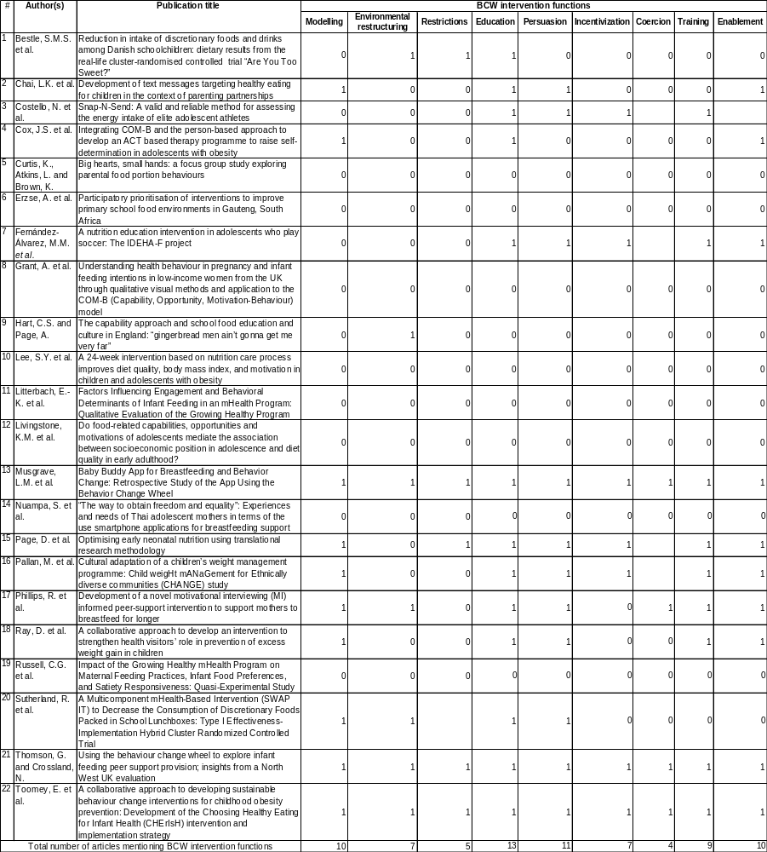
Notes: 1=presence, 0=absence

Annex 8. Mapping the presence of BCW policy categories
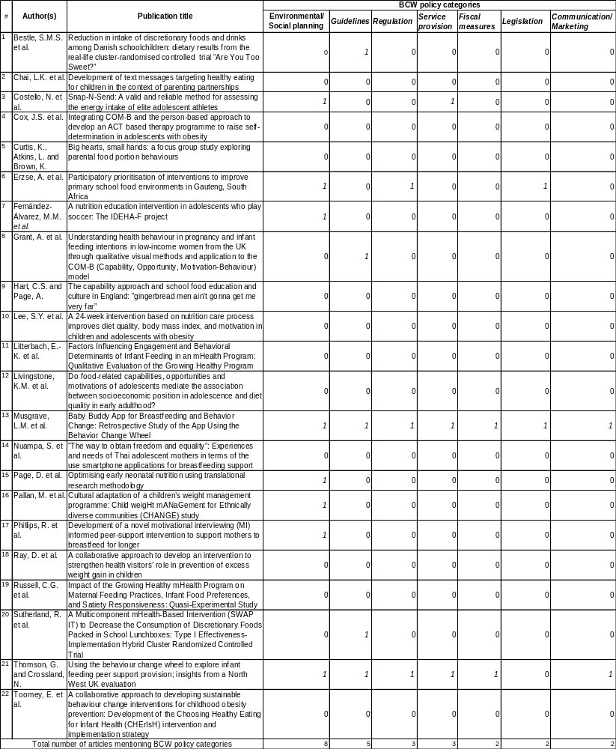
Notes: 1=presence, 0=absence

Annex 9. Presence of the COM-B model in child nutrition interventions
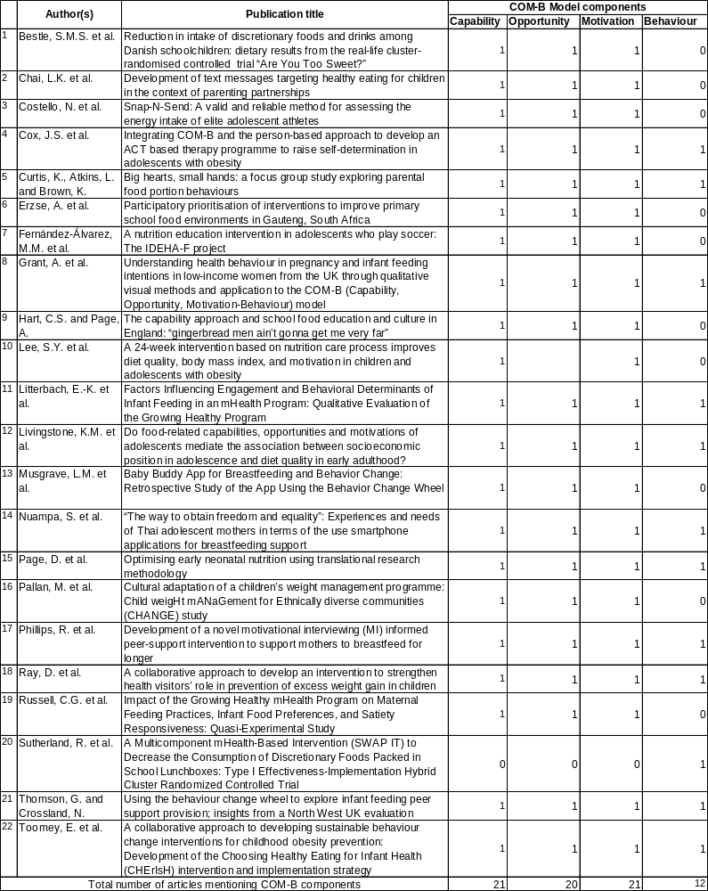
Notes: 1=presence, 0=absence
Annex 10. Adaptation of BCW functions, policy categories and COM-B (Source: Michie, Van Stralen and West [19]

BCW intervention functions
- Modeling: This function involves providing exemplars and role models of healthy nutrition or diets, thereby encouraging children, their parents or guardians, and other relevant stakeholders to emulate role models who adopt healthy eating behaviors to address malnutrition among children.
- Environmental restructuring: This is defined as altering contextual factors, such as those within schools and family settings, to ensure that diverse, healthy foods are available in terms of quality and quantity within children’s study, play, or living spaces.
- Restrictions: This function is about establishing and enforcing rules aimed at minimizing or eliminating unhealthy eating practices while promoting healthy behaviors that contribute to improved child nutritional outcomes.
- Education: This function seeks to enhance knowledge and understanding of healthy versus unhealthy nutritional practices and to raise awareness about their effects on children’s health and growth.
- Persuasion: This function uses various communication methods and channels, such as audiovisuals, to induce positive or negative feelings and stimulate behavioral changes to achieve positive nutritional outcomes in children.
- Incentivization: This is about creating expectations of rewards and improved outcomes among children as the primary target group but also among parents, caretakers, and other key actors for child nutrition interventions.
- Coercion: This function highlights the adverse consequences of poor nutrition for children—such as an elevated risk of noncommunicable diseases—emphasizing that the repercussions can be both excessively punitive and economically burdensome.
- Training: This function is about imparting skills and knowledge for improved nutritional practices, targeting all stakeholders, including children, parents, and guardians.
- Enablement: This is about reducing barriers or increasing opportunities to improve children’s and other stakeholders’ ability to adopt and sustain healthy eating habits among children.

The seven policy categories are coded according to their adapted definitions:
- Guidelines: These refer to regulatory documents or frameworks that prescribe or mandate the inclusion of minimum food standards in children’s menus or school lunches or meal boxes.
- Environmental/social planning: This policy category prescribes the physical and social environments to ensure that children and their parents or guardians have access to a diverse array of dietary options.
- Communication/marketing: This involves the use of both conventional media channels (such as print, electronic, telephone, or broadcast media) and unconventional or social media for messaging child nutrition and healthy eating habits.
- Legislation: The policy category is about the enactment or modification of laws aimed at prohibiting detrimental nutritional practices or encouraging optimal nutrition standards within children’s socioeducational environments.
- Service provision: This category pertains to the systematic delivery of healthy foods to children within the environments in which they live, learn, and interact socially.
- Regulation: This involves the establishment and enforcement of rules or guiding principles of behavior or practice that encourage the adoption of healthy practices and deter unhealthy ones, thereby fostering improved nutritional outcomes in children.
- Fiscal measures: These measures are designed to leverage taxation policies by imposing higher taxes on fast or nutritionally poor foods within children’s socioeducational environments while concurrently applying lower tax rates to healthy foods for children.

The COM-B model adapted for this review
- Capability refers to the psychological and physical capacities of children, parents, caretakers, and other key stakeholders to engage in activities addressing child malnutrition. This capability encompasses the necessary knowledge and skills required through nutrition interventions to adopt and maintain healthy eating practices for children.
- Opportunity comprises social and physical factors beyond a child’s individual direct control; it encompasses structural, institutional, and regulatory factors that make healthy nutritional behavior possible or that reduce child malnutrition or poor eating habits among children.
- Motivation involves intrinsic factors that come from neurocognitive processes that energize and direct nutritional behaviors. These factors emerge from habitual processes as well as emotional and rational responses and decisions, collectively and individually influencing decision-making regarding dietary practices for children.
- Behavior denotes either the desired or discouraged behavior to enhance child nutritional outcomes and is based on interventions designed to support children’s healthy eating habits for improved nutritional outcomes.

The following search strings in the abstracts were used with EBSCOhost as interface: AB ( children OR child OR adolescents OR youth OR teenager ) AND AB ( behaviour change wheel OR behavior change wheel ) AND AB ( nutrition OR diet OR food OR food intake OR eating OR nourishment ) AND AB ( intervention OR project OR program* )

