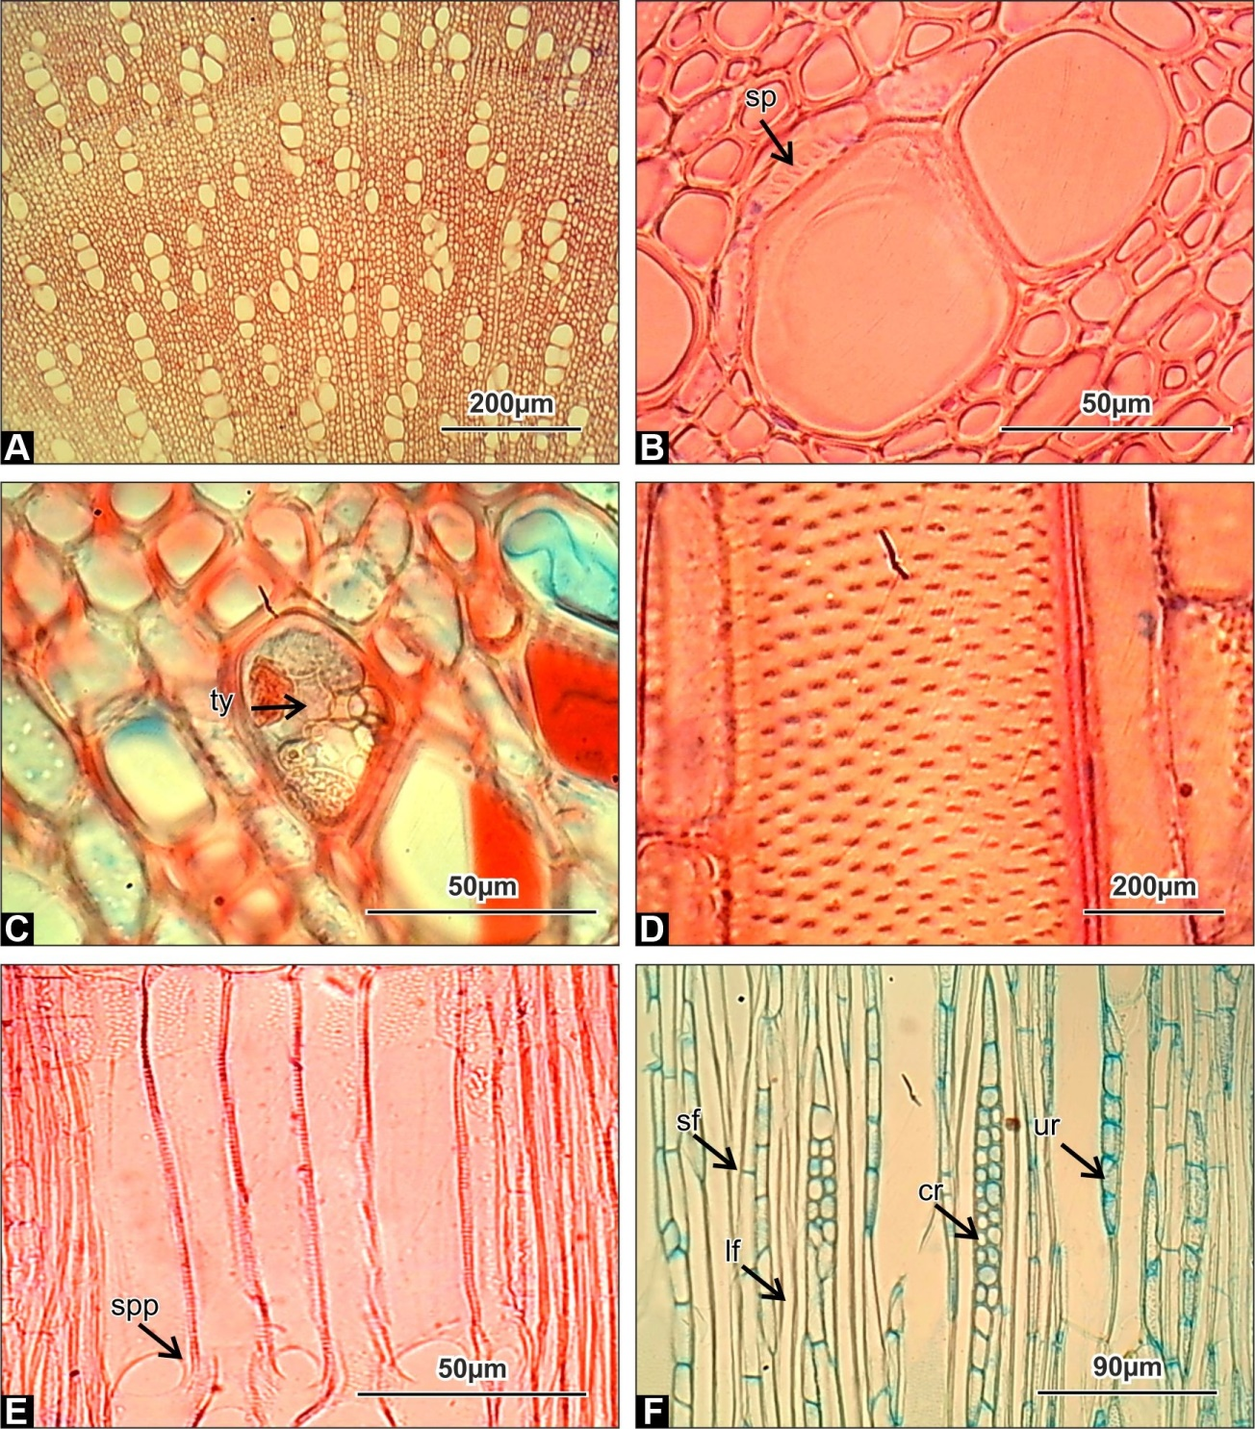

Plate1a:
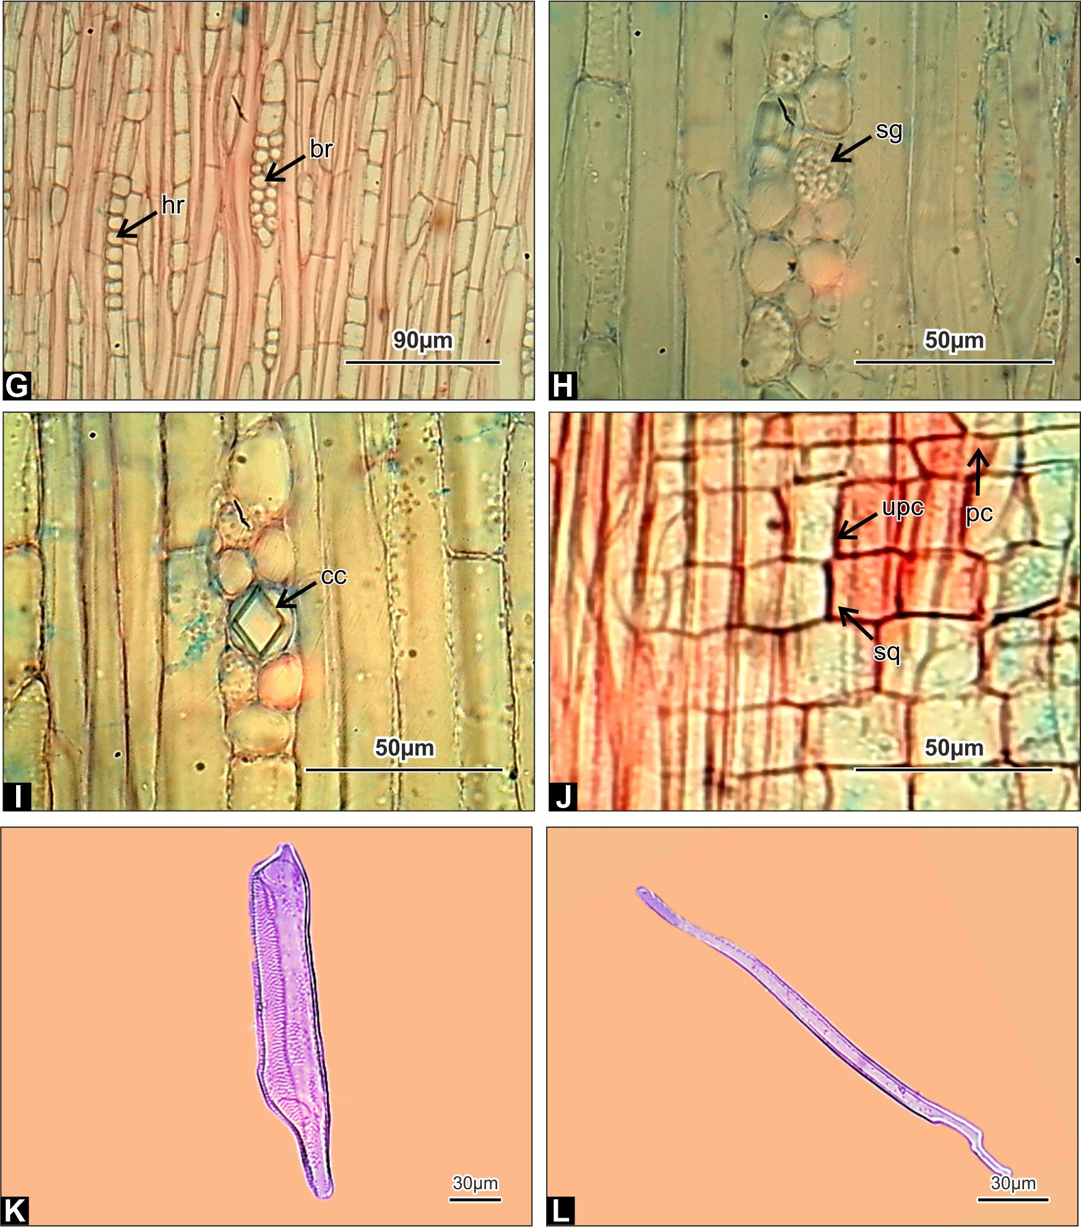

Plate 1b:
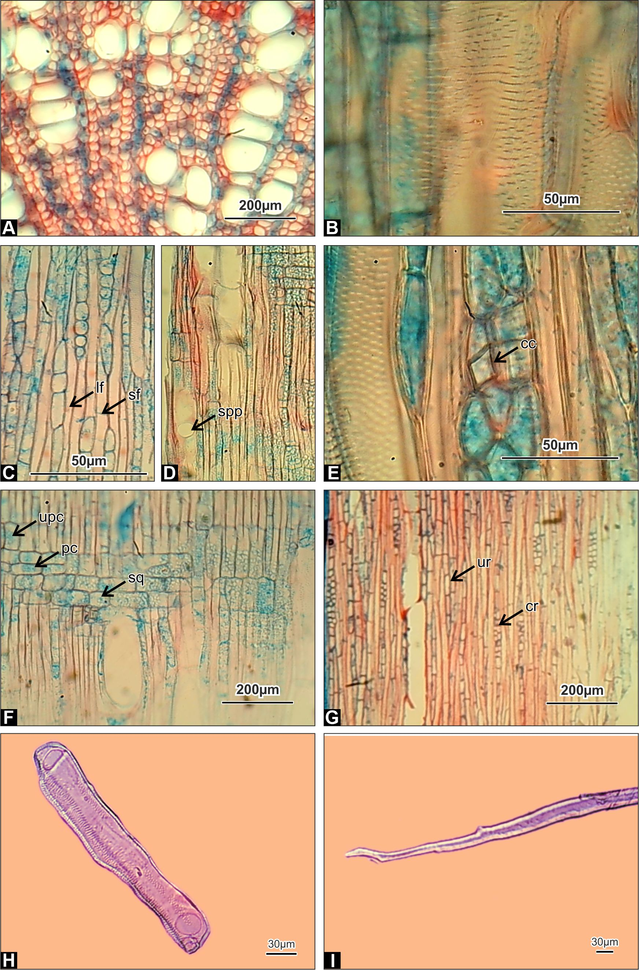

Plate 2:

- Wrightia coccinea Sims' stem wood's internal structure is depicted in Plate 1 a & 1b.
- Wood reveals diffuse porous pattern in Transverse Section
- Transverse Section of illustrating the scanty paratracheal parenchyma in magnified portion
- Tyloses seen in magnified portion
- Tangential Longitudinal Section illustrating the vestured intervascular pits
- Radial Longitudinal Section showing the storied arrangement of vessels
- Tangential Longitudinal Section the exhibits the uniseriate, compound rays, libriform fibres and non-septate
- Homocellular uniseriate rays and heterocellular biseriate rays seen in Tangential Longitudinal Section
- Tangential Longitudinal Section explaining the starch grains in rays
- Chambered crystals present in rays
- Upright, square and procumbent cells in R.L.S.
- Coalescent pits in vessels with tail
- Figure showing Libriform fibres
Abbreviations in Plate: sp- scanty paratracheal parenchyma, spp- simple perforation plate, ty- tyloses, , sf- septate fibre, lf- libriform fibre, cr- compound rays, ur- uniseriate rays, hr- homocellular rays, br- biseriate rays, cc-chambered crystal, sq- square cell, upc- upright cell, pc-procumbent cell, sg- starch grain

- Wrightia coccinea Sims' root wood's internal structure is depicted in Plate 2.
- Transverse Section of wood reveals diffuse porous pattern
- Magnified image revealing coalescent pits within vessels

- Lebriform and septate fibres are visible in the tangential longitudinal section.

- Simple perforation plate exhibits in Tangential Longitudinal Section of wood
- T.L.S of wood explaining the chambered crystals in rays
- upright, square and procumbent ray cells in Tangential Longitudinal Section
- T.L.S illustrating the both uniseriate and compound rays
- A Vessel element with simple perforation plate and Coalescent pits
- A Libriform fiber
Abbreviations in Plate: sf- septate fibre, lf- libriform fibre, spp- simple perforation plate, cc- chambered crystals, sq- square cell, upc- upright cell, pc- procumbent cell, ur- uniseriate rays, cr- compound rays

