Synthesis, characterization and density functional theoryof a novel Dichloro (2-(1-anthracene-9-ylmethyl)-1H-1,2,3-triazole-5-yl) pyridine)Cu(II) and polymeric Dichloro (2-(1-anthracene-9-ylmethyl)-1H-1,2,3-triazole-5-yl)pyridine)Cd(II) complexes

K.M. Tawfiqª , S.J. Coles^{b} ,C. Wilson^{c}, J.H. Potgieter^{d}, GJ Miller^{e}, Rasha Ahmed Hashim^{a,f}, Aly Abdou^{g}, Musa E. Mohamed Babiker^{h}, O.A.Farghaly^{h}, Ali Y.Alzahrani^{h}, Antar A. Abdelhamid^{g,h}*

ªDepartment of Chemistry, College of Education for Pure Science (Ibn Al-Haitham), University of Baghdad, Baghdad, Iraq
^{b}EPSRC National Crystallography Service, School of Chemistry, University of Southampton, Southampton SO17 1BJ, England, UK.
^{c}School of Chemistry, University of Glasgow, Joseph Black Building, University Avenue, Glasgow G12 8QQ, Scotland, UK
^{d}Division of Chemistry and Environmental Science, Manchester Metropolitan University, Manchester M1 5GD, UK
^{e}School of Chemical and Metallurgical Engineering, University of the Witwatersrand, Private Bag X3, Wits 2050, South Africa
^{f}Analytical Sciences, Manchester Metropolitan University, Chester Street, Manchester M1 5GD, England,
^{g}Department of Chemistry, Faculty of Science, Sohag University, Sohag 8252, Egypt.
^{h}Department of Chemistry, Faculty of Science, Al-Baha University, Al-Baha, Saudi Arabia.
*Corresponding authors: drantar25@yahoo.com (A. A. Abdelhamid).

2.3. Instrumental conditions
M.P. were assessment by a Stuart Scientific melting points – SMP1 (Bibby, UK).IR spectra were documented as lessened total reflectance(ATR) via a ATR attachment on a Thermo-Nicolet FT–IR spectrometer (AVATAR 320) in the range 4000–500 cm⁻¹. UV–Vis spectra were gained on a PerkinElmer Lambda 40 UV/Vis spectrometer. Each sample (1 × 10⁻³ M or 1x 10⁻⁶ M) was analyzed using a constant blank of spectroscopic grade dimethyl sulphoxide (DMSO). A pair of identical quartz cells through a path length of 1 cm were used to decrease the interference from the cells themselves. Further spectra were gained for specific complexes at a concentration of 1x10⁻⁶ M when some absorbance was visible albeit at a very low level. The absorbance was recorded over a wavelength range of 245 nm–900 nm. Fluorescence measurements were carry out in 1cm² path length quartz cells on freshly equipped solutions (10⁻⁶M) by an absorbance < 0.1 au using a Hitachi fluorescence F-4500 spectrophotometer, and the data analyzed by the Hitachi FL solution software. Solutions (10⁻⁶M) were equipped, by dilution of a 10⁻³M stock solution by spectroscopic grade DMSO and purged with nitrogen. The ligand, complexes(10⁻⁶M) and the anthracene standard were excited at (350λ_{ex}), and the emission spectra recorded between370-550nm.Mass spectra were gained by HRMS (P + NSI) and in the case of (L) using a Thermo LTQ Orbitrap XL spectrometer used to analyse in volatile molecules in the mass range m/z 50–2000 or m/z 200–4000 Daltons. Positive Electrospray (ESI-MS) mass spectra time of flight (TOF) (MALDI-TOF), were documented on Voyager DE-STR used to analyse in volatile molecules in the mass range 200 to 200000 Daltons.NMR spectra (¹H, ¹³C, DEPT, ¹H–¹H COSY, ¹³C–1HHMQC NMR) were attained in DMSO-d₆ for(L) and Cd solutions using a JEOL Lambda 400 MHz spectrometer with tetramethylsilane (TMS) for 1H NMR spectra. Single-crystal X-ray diffraction analyses were achieved in the Chemical Crystallography Laboratory at the National Crystallography Service, School of Chemistry, University of Southampton, United Kingdom. Conductivity measurements were carried out using aqueous DMSO solutions (1.0 x 10⁻³ M) at 294K using a Hanna digital conductivity meter (model EC 214) with a conductivity electrode, type H1 76300. Magnetic moments were verified at room temperature (294K) using a magnetic susceptibility balance (Johnson Matthey Catalytic System Division).

2.4. Magnetic susceptibility
Magnetic susceptibility is determined with a Gouy magnetic susceptibility balance. The gram magnetic susceptibility for a substance is computed from:
χ_{g} = (Cbal) (l) (R – R_{o}) / (10⁹) (m)
where l = height of sample in the tube in units of centimeters, m= mass of the sample in units of grams, R =reading for tube plus sample, R_{o} = reading for the empty tube and Cbal = balance calibration constant = 1.0. The molar magnetic susceptibility is then computed from the gram magnetic susceptibility via the following equation.
χ_{m} = (χ_{g}) (molar mass)
The active magnetic moment for a particular material is estimated from the molar magnetic susceptibility [36] using the following equation (T represents the Kelvin temperature (294 K)):
U_{eff}= 2.83 [(Χ_{m}) (T)] ^{½}
The calculated U_{eff} values for the [Cu(L)₂Cl₂] complexes are given in the experimental characterization data and discussed in section 3.2
2.5 X-ray diffraction
Single crystal X-ray diffraction quantities for L, [CuLCl₂] and [CdLCl₂] was accomplished via a Rigaku Saturn 724 þ area detector mounted at the window of an FR-Eþ rotating anode generator through Mo Ka, λ= 0.71075 Å. The crystals were mounted on nitrogen loops and the data were collected at 100 K under N₂ flow from an Oxford Cryosystems Cobra device. Data were processed and empirical absorption corrections were also performed via Crystal Clear SM-Expert [37]. The structures were solved by direct procedures using SHELXS (Sheldrick, 2008) [38] within the OLEX2 [39] software. All refinements on Fo2 by fullmatrix least squares refinement were done using the SHELXL program package (Sheldrick, 2015) [40].
All non-hydrogen atoms were advanced with anisotropic displacement parameters and hydrogen atoms were adding at calculated positions and included as part of a riding model with C-H (aromatic) 0.95 Å UISO = 1.2Ueq (C); C-H (methyl) 0.98 Å UISO = 1.5Ueq (C) [41]. Perspective drawings of the molecular structures of [CuLCl₂] and [CdLCl₂], also showing the atom numbering scheme used, are shown in Fig. (2), and Fig. (3). Crystallographic data are presented in Table (1) in supplementarydata, with nominated bond lengths, bond angles and torsion angles in Table (3) and Table (6) (supplementarydata) . Crystallographic data has been placed at the Cambridge Crystallographic Data Centre with code numbers, 2012ncs0656 and 2014ncs0425 for[CuLCl₂] and [CdLCl₂] respectively(supplementarydata). Additional crystallographic result is provided that in the Electronic Supplementary
2.6. Theoretical approach
2.6. DFT calculations
In this work, all of the calculations have been achieved using DFT technique by B3LYP [42-44] with 6-311G(d, p) [45,46] and LANL2DZ [47,48] for the (C,H, N) and (Cu, Cd) atoms, respectively. The optimized structures are visualized by Gauss view 5.0.8 version. Geometry of the free ligand, Cadmium (II)& copper (II) complex materials were completely improved. This optimization was undoubtedly proved with no having imaginary frequency. In the Density Functional Theory (DFT) [49], the relationship with ionization energy (I) and electron affinity (A) of quantum chemical descriptors like electronegativity (χ), chemical potential (μ), hardness (η) and softness (σ) were computed based on the HOMO-LUMO values [50,51].

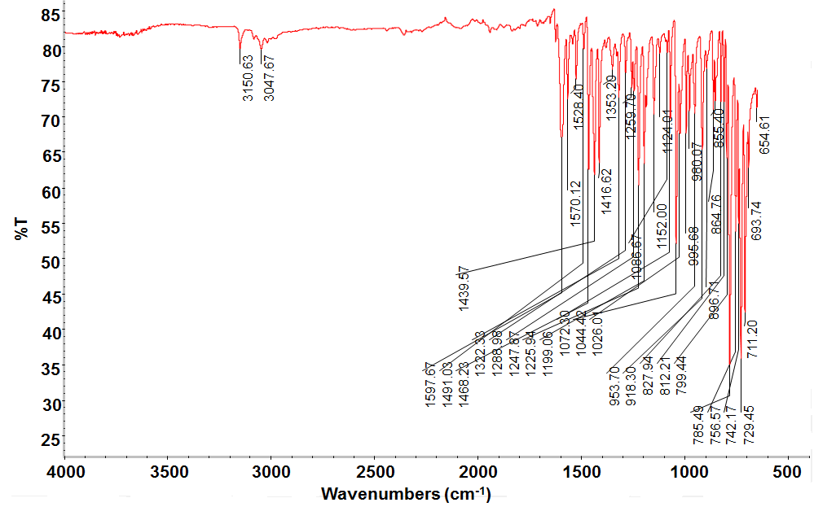
Figure S1: FTIR spectra of the free ligand (L).

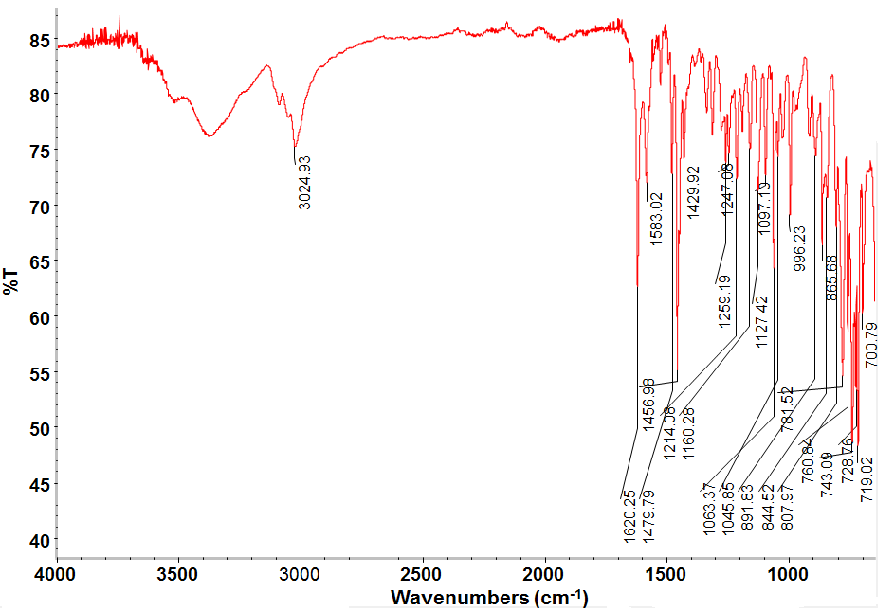
Figure S2: FTIR spectra of the Cu complex with(L).
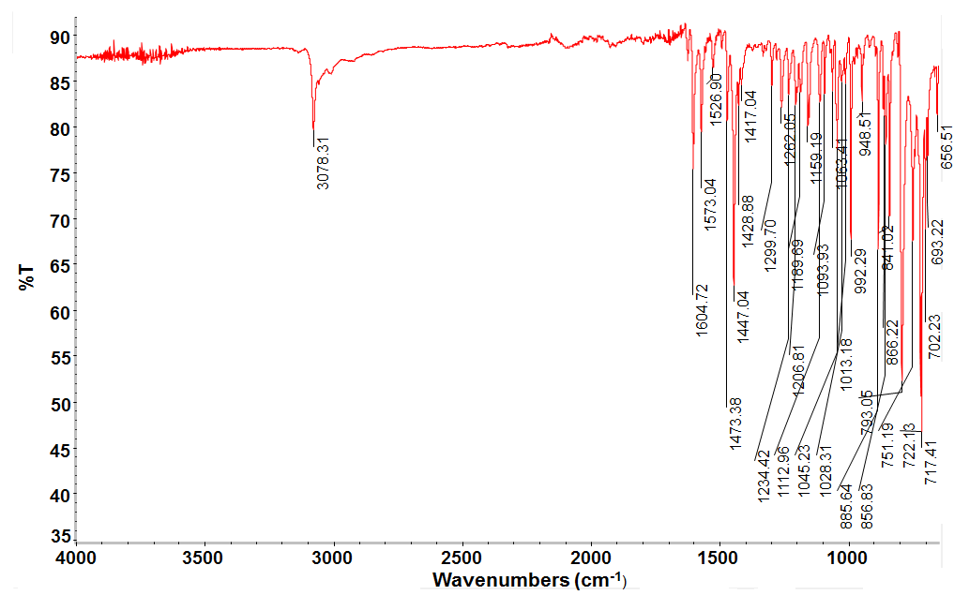
Figure S3: FTIR spectra of the Cd complex with(L).

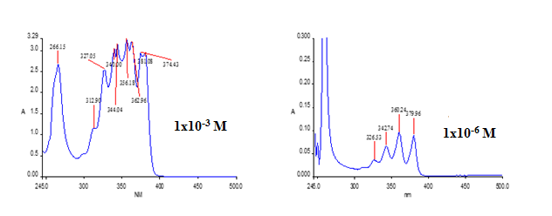
Figure S4: UV-Vis spectrum of the standard anthracene in DMSO solution at 1x10⁻³ and 1x10⁻⁶M

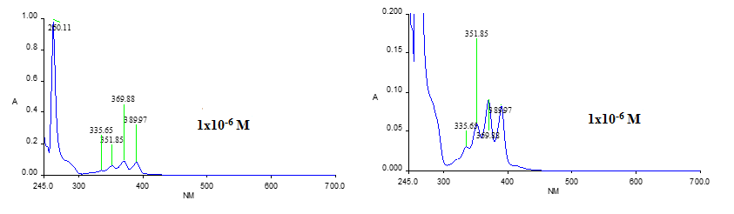

Figure S5: UV-Vis spectrum of Ligand in DMSO solution at 1x10⁻⁶M

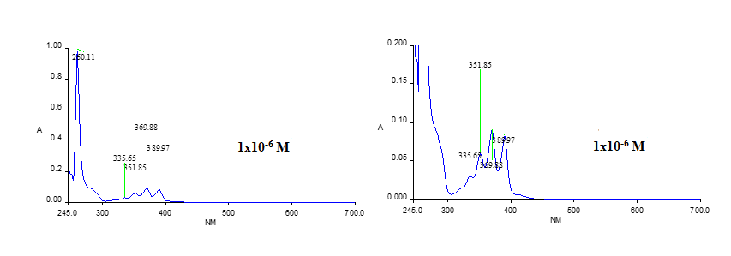
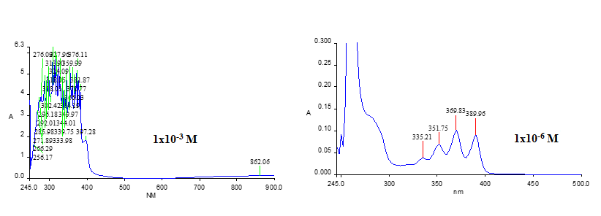
Figure S6: UV-Vis spectrum of Cu complex in DMSO solution at 1x10⁻³M and 1x10⁻⁶M

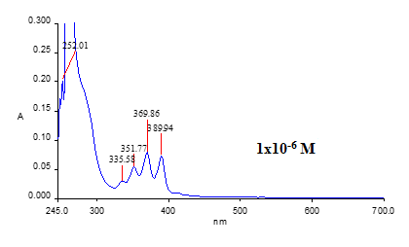

Figure S7: UV-Vis spectrum of Cu complex in DMSO solution at 1x10⁻³M and 1x10⁻⁶M

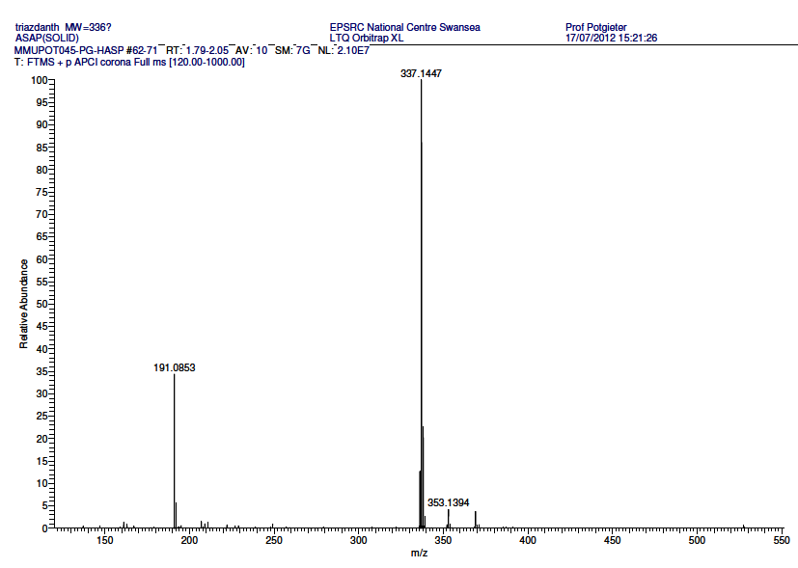
Figure S8: HRMS (P+NSI) - ES (+) mass spectrum of (L).

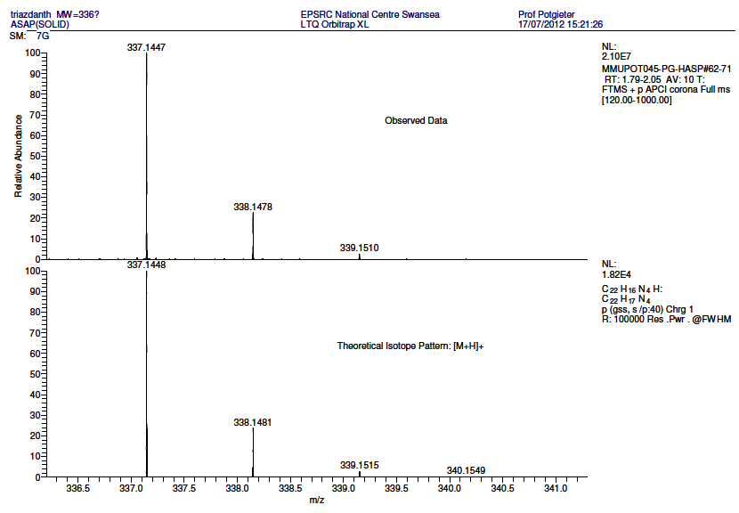
Figure S9:The calculated mass spectrum of (L).

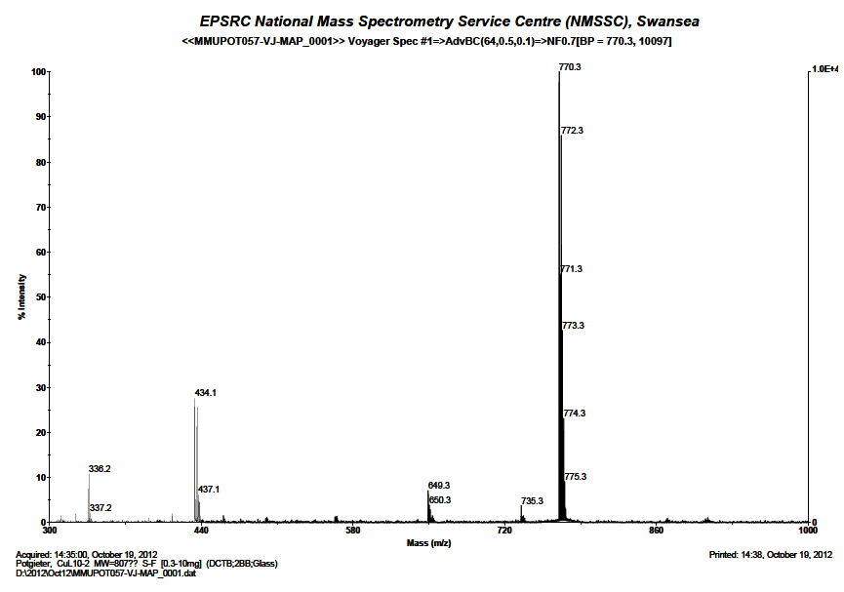
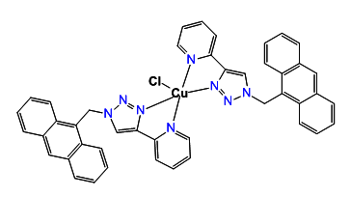
[M-Cl]⁺
Figure S10: HRMS TOF (MALDI)-MS (+) mass spectrum of complex [Cu(L)₂Cl₂].

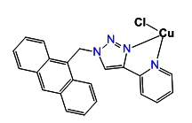
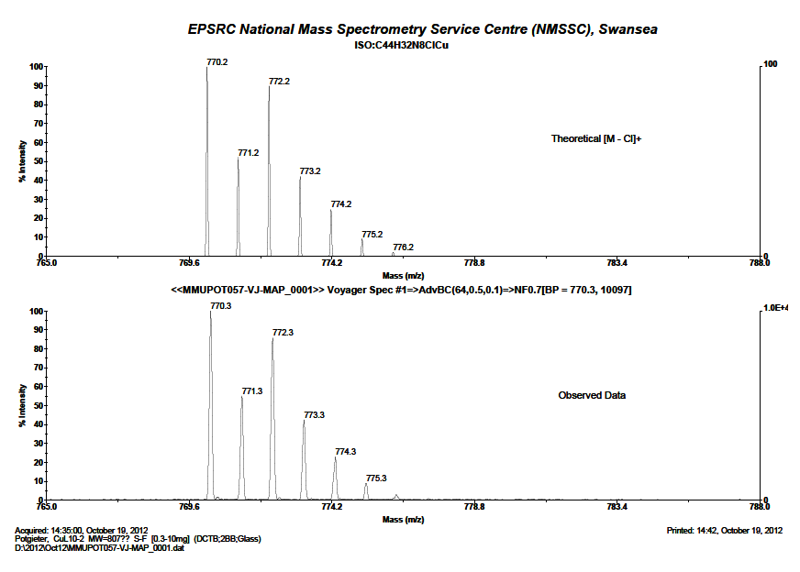
Figure S11: The calculated mass spectrum of complex [Cu(L)₂Cl₂].

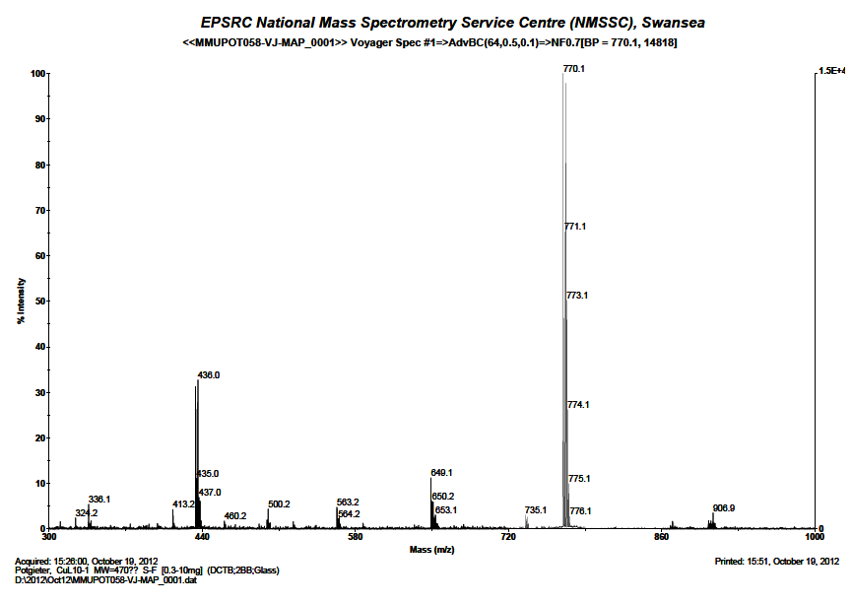
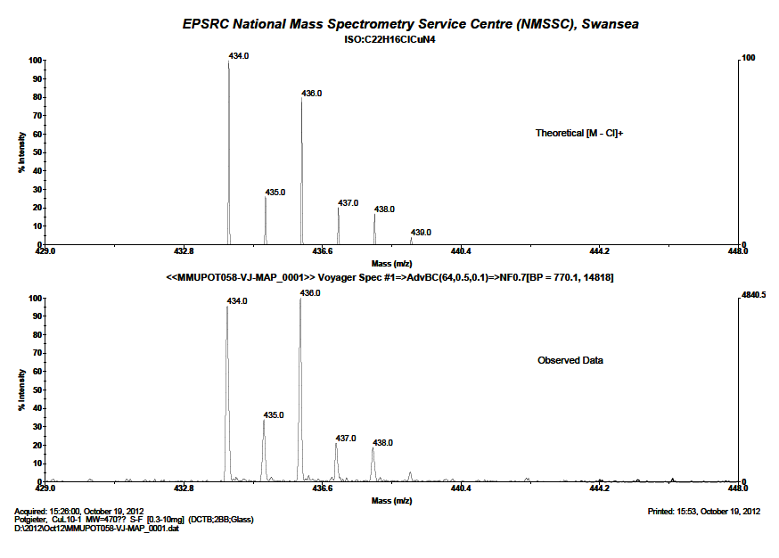
Figure S12: HRMS TOF (MALDI)-MS (+) mass spectrum of complex [Cu(L)Cl₂].
Figure S13: The calculated mass spectrum of complex [Cu(L)Cl₂].
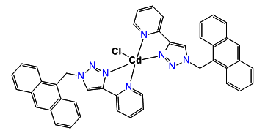
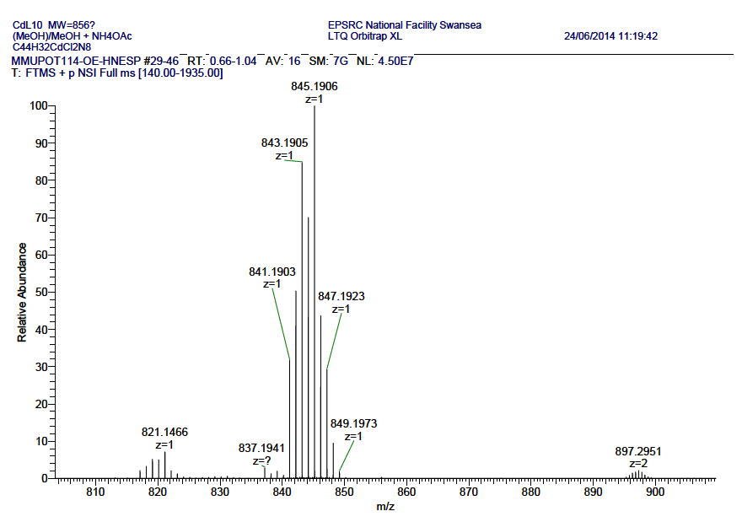
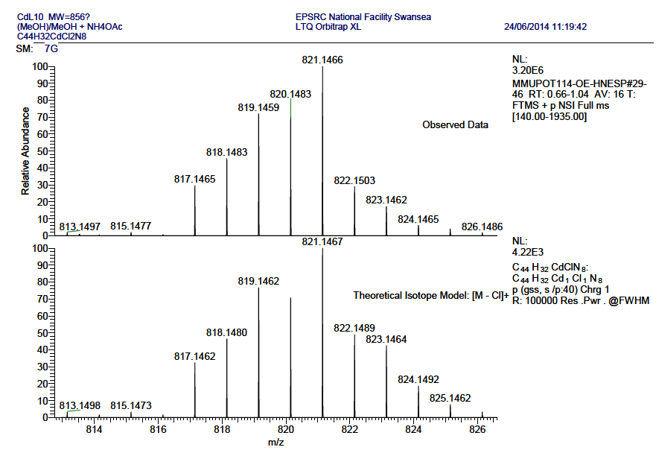
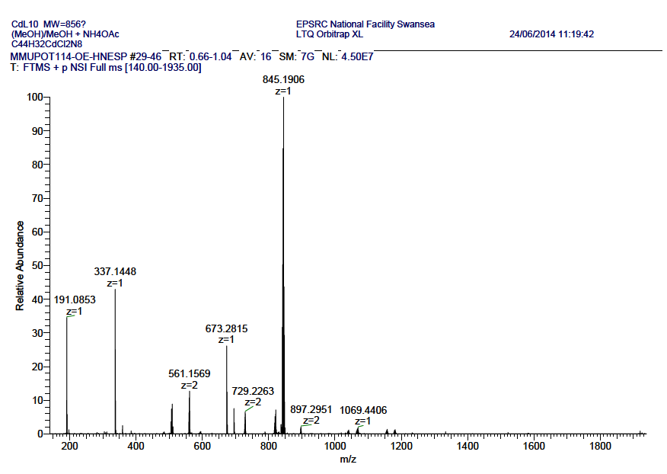
Figure S14: HRMS TOF (MALDI)-MS (+) mass spectrum of complex [Cd(L)₂Cl₂].
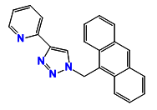

Figure S15: The calculated mass spectrum of complex [Cd(L)₂Cl₂].
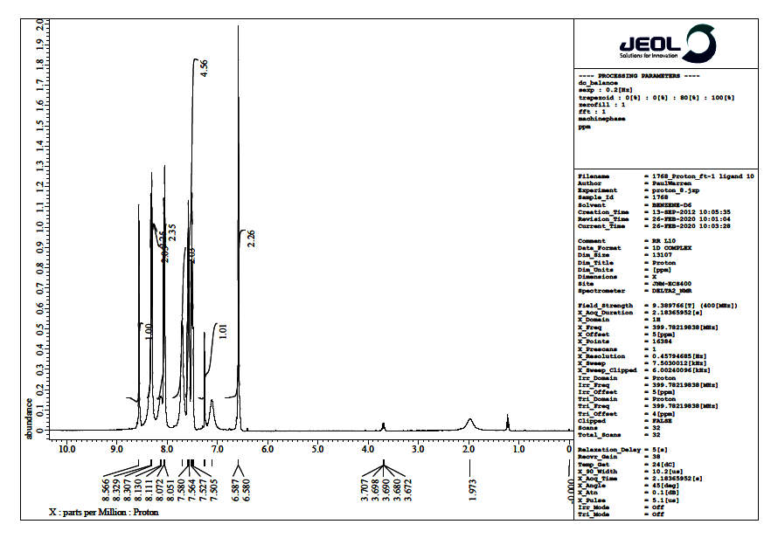

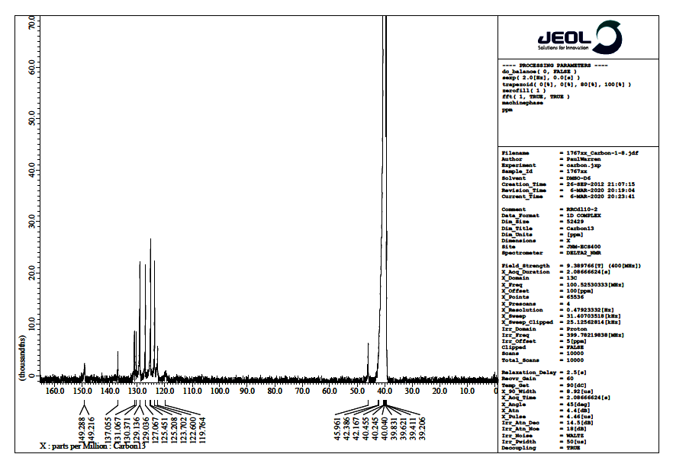
Figure S16: The ¹H NMR spectrum of [L] in DMSO-d₆
Figure S17: The ¹³C NMR spectrum of [L] in DMSO-d₆

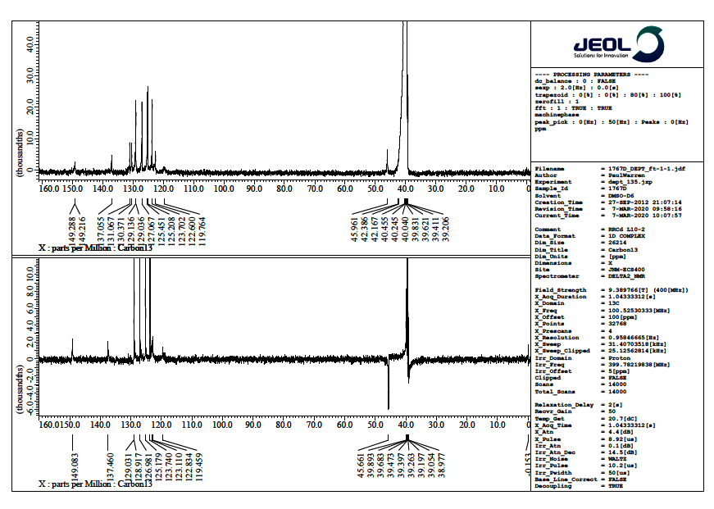

Figure S18: The ¹³C NMR and dept NMR spectrum of [L] in DMSO-d₆

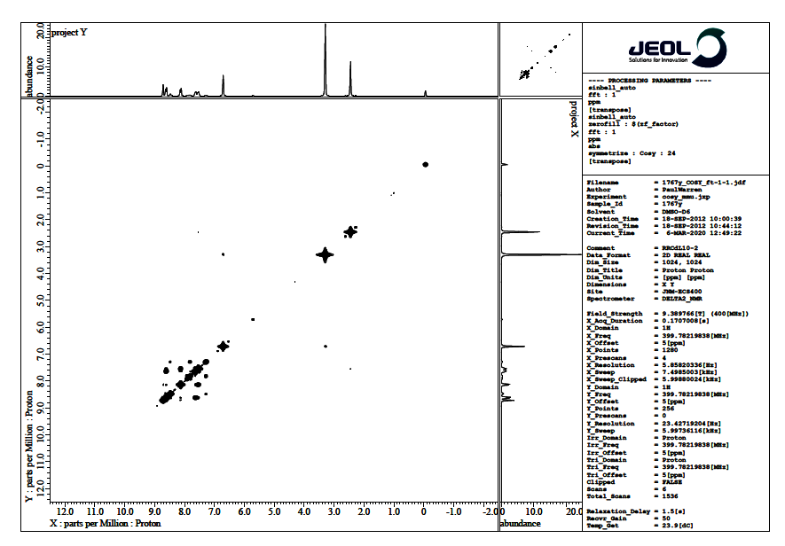

Figure S19: The 2D 1H-1HCOSY correlation spectrum of [(L)] in DMSOd₆

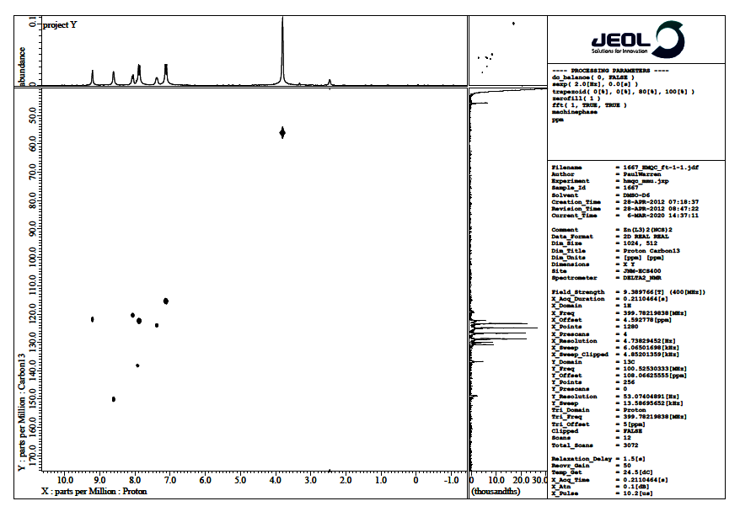

Figure S20: The 2D ¹H-¹³C HMQC correlation spectrum of [L)] in DMSOd₆

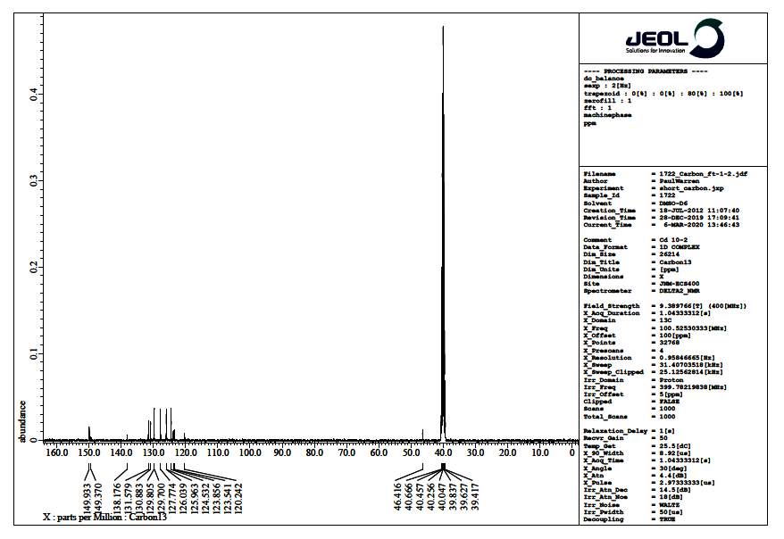
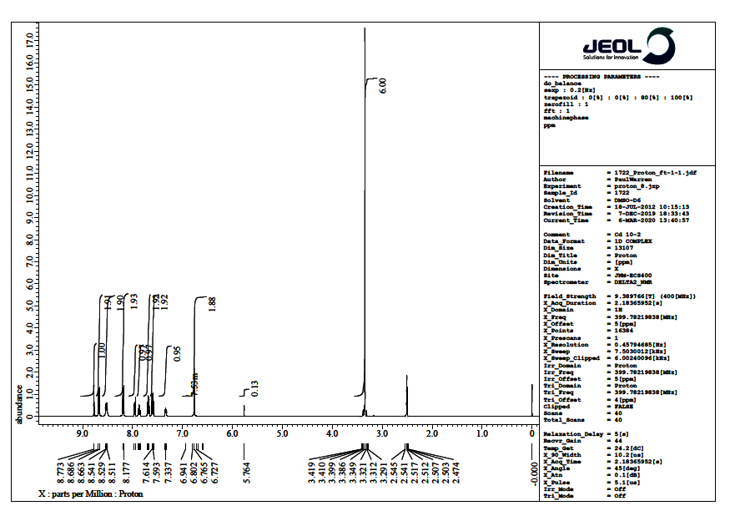
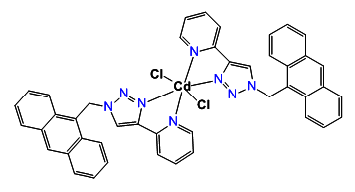
Figure S21: The ¹H NMR spectrum of [Cd(L)₂Cl₂] in DMSO-d₆

Figure S22: The¹³C NMR and dept NMR spectrum of [Cd(L)₂Cl₂] in DMSO-d6
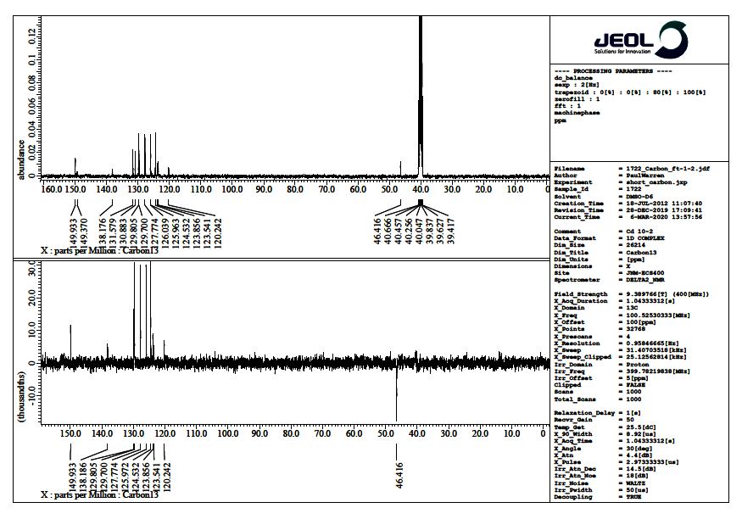
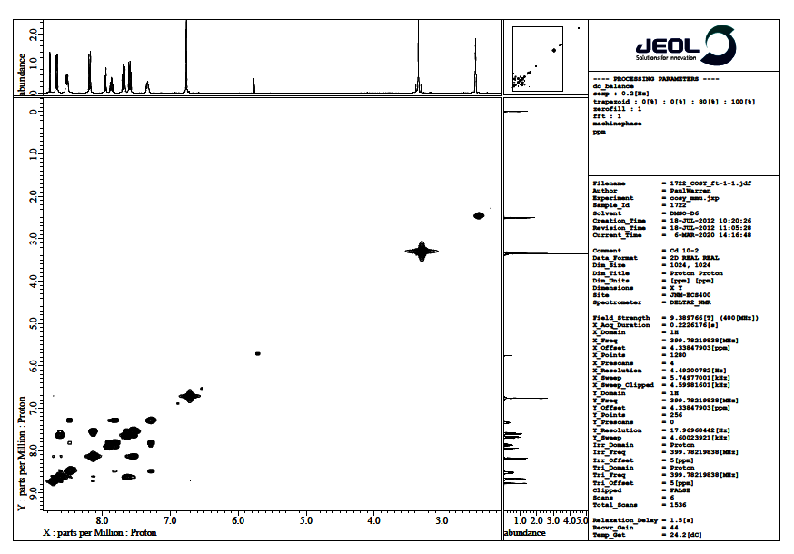
Figure S23:The ¹³C NMR and dept NMR spectrum of [Cd(L)₂Cl₂]in DMSO-d₆Fig:
Figure S24: The 2D 1H-1HCOSY correlation spectrum of [(Cd(L)₂Cl₂] in DMSOd₆
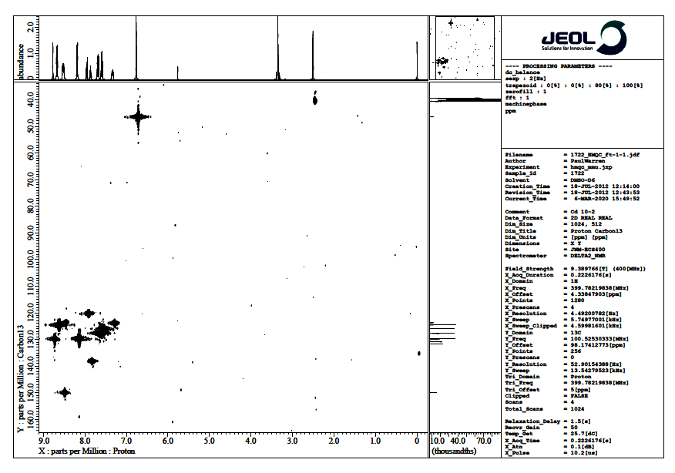
Figure S25: The 2D ¹H-¹³C HMQC correlation spectrum of [(Cd(L)₂Cl₂] in DMSOd₆

Figure S26: The fluorescence emission spectra of ligands (St Anthracene) in DMSO excited at 350 nm (C= 1X10⁻⁶M).

Figure S27: The fluorescence emission spectra of ligands (L) in DMSO excited at 350 nm (C= 1X10⁻⁶M).

Figure S28: The fluorescence emission spectra of ligands (L) with Cu(II)in DMSO excited at 350 nm (C= 1X10⁻⁶M).

Figure S29: The fluorescence emission spectra of ligands (L) with Cd(II) in DMSO excited at 350 nm (C= 1X10⁻⁶M).

Table 1.Crystal data and structure refinement details.

Identification code 2012ncs0658
Empirical formula C₂₂H₁₆N₄
Formula weight 336.39
Temperature 100(2) K
Wavelength 0.71075 Å
Crystal system Monoclinic
Space group P21/c

Unit cell dimensions a = 10.2532(10) Å α = 90°
b = 9.2994(8) Å β = 99.252(7)°
c = 17.2596(15) Å γ= 90°
Volume 1624.3(3) Å³
Z 4
Density (calculated) 1.376 Mg / m³
Absorption coefficient 0.084 mm⁻¹
F(000) 704
Crystal needle; Colourless
Crystal size 0.06 × 0.04 × 0.03 mm³
θ range for data collection 3.08 − 27.47°
Index ranges −7 ≤ h ≤ 13, −11 ≤ k ≤ 8, −22 ≤ l ≤ 17
Reflections collected 7519
Independent reflections 3674 [R_{int} = 0.1012]
Completeness to θ = 27.47° 98.8 %
Absorption correction Semi−empirical from equivalents
Max. and min. transmission 1.000 and 0.627
Refinement method Full-matrix least-squares on F²
Data / restraints / parameters 3674 / 0 / 235
Goodness-of-fit on F² 0.996
Final R indices [F²> 2σ(F²)] R1 = 0.0958, wR2 = 0.2442
R indices (all data) R1 = 0.2268, wR2 = 0.3074
Largest diff. peak and hole 0.795 and −0.335 e Å⁻³

Diffractometer:Rigaku AFC12 goniometer equipped with an enhanced sensitivity (HG) Saturn724+ detector mounted at the window of an FR-E+ SuperBright molybdenum rotating anode generator with VHF Varimax optics (70µm focus). Cell determination anddata collection:CrystalClear-SM Expert 2.0 r13 (Rigaku, 2011). Data reduction, cellrefinement andabsorption correction: CrystalClear-SM Expert 3.1 b8 (Rigaku, 2012). Structure solution: SHELXS97(Sheldrick, G.M. (2008). Acta Cryst. A64, 112-122). Structure refinement: SHELXL97(Sheldrick, G.M. (2008). Acta Cryst. A64, 112-122) within OLEX2. Graphics:OLEX2 (Dolomanov, O. V., Bourhis, L. J., Gildea, R. J., Howard, J. A. K. &Puschmann, H. (2009). J. Appl. Cryst. 42, 339-341).

Figure 1. View showing 2012ncs0658 with atom labelling scheme. Displacement elliposoids drawn at 50% probability level.
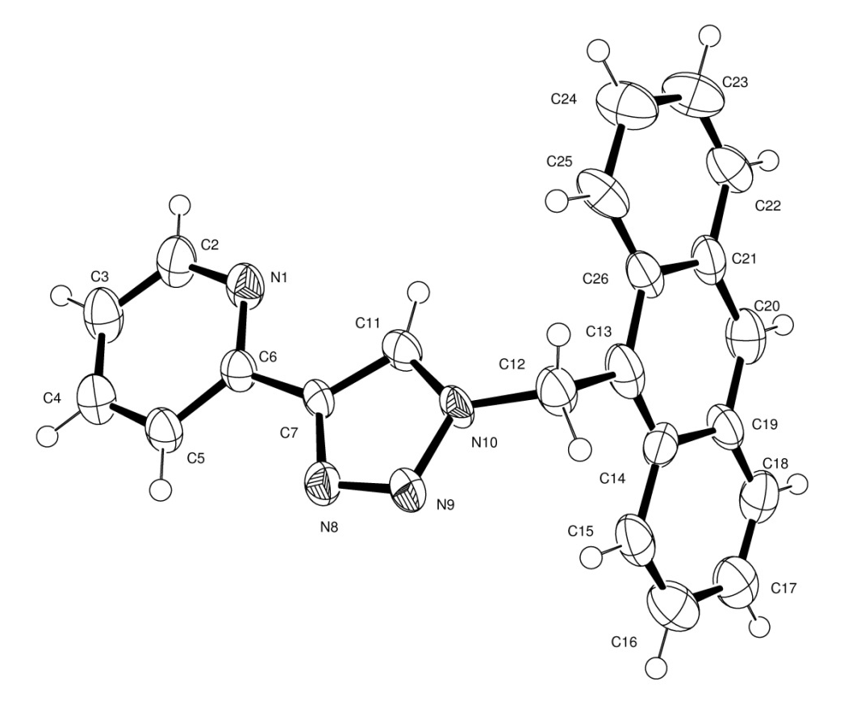

Table 2.Atomic coordinates [× 10⁴], equivalent isotropic displacement parameters [Å²× 10³] and site occupancy factors. U_{eq} is defined as one third of the trace of the orthogonalized U^{ij} tensor.

Atom x y z U_{eq} S.o.f.

N1 4353(4) 4094(4) 3960(2) 41(1) 1
N8 5133(4) 7872(4) 3775(2) 36(1) 1
N9 4521(4) 8952(4) 4056(2) 38(1) 1
N10 3525(4) 8375(4) 4384(2) 32(1) 1
C2 4717(6) 2773(5) 3750(3) 49(1) 1
C3 5668(6) 2528(5) 3285(3) 51(2) 1
C4 6299(6) 3688(5) 3035(3) 48(1) 1
C5 5964(5) 5057(5) 3238(3) 39(1) 1
C6 4977(5) 5208(5) 3701(3) 32(1) 1
C7 4548(4) 6622(5) 3930(2) 29(1) 1
C11 3518(5) 6932(5) 4317(3) 36(1) 1
C12 2656(6) 9306(5) 4746(3) 45(1) 1
C13 1173(6) 9055(6) 4398(3) 48(1) 1
C14 629(6) 9726(5) 3713(3) 45(1) 1
C15 1375(6) 10550(5) 3257(3) 49(2) 1
C16 778(7) 11196(6) 2592(3) 56(2) 1
C17 −591(6) 11071(6) 2334(3) 52(2) 1
C18 −1337(6) 10284(6) 2738(3) 52(2) 1
C19 −785(6) 9595(5) 3417(3) 45(1) 1
C20 −1530(6) 8711(6) 3838(3) 51(2) 1
C21 −939(5) 7985(5) 4545(3) 45(1) 1
C22 −1707(6) 7082(5) 4959(3) 46(1) 1
C23 −1155(6) 6386(6) 5602(3) 56(2) 1
C24 216(6) 6494(7) 5867(3) 59(2) 1
C25 990(6) 7339(6) 5494(3) 46(1) 1
C26 440(5) 8126(5) 4828(3) 40(1) 1
Table 3.Bond lengths [Å] and angles [°].

N1−C6 1.332(6)
N1−C2 1.350(6)
N8−N9 1.318(5)
N8−C7 1.354(6)
N9−N10 1.355(5)
N10−C11 1.347(6)
N10−C12 1.453(6)
C2−C3 1.378(7)
C2−H2 0.9300
C3−C4 1.363(7)
C3−H3 0.9300
C4−C5 1.379(7)
C4−H4 0.9300
C5−C6 1.394(7)
C5−H5 0.9300
C6−C7 1.461(6)
C7−C11 1.368(6)
C11−H11 0.9300
C12−C13 1.560(7)
C12−H12A 0.9700
C12−H12B 0.9700
C13−C14 1.373(7)
C13−C26 1.429(7)
C14−C15 1.409(7)
C14−C19 1.463(8)
C15−C16 1.351(7)
C15−H15 0.9300
C16−C17 1.408(8)
C16−H16 0.9300
C17−C18 1.332(7)
C17−H17 0.9300
C18−C19 1.375(7)
C18−H18 0.9300
C19−C20 1.403(7)
C20−C21 1.440(7)
C20−H20 0.9300
C21−C22 1.420(7)
C21−C26 1.426(7)
C22−C23 1.330(7)
C22−H22 0.9300
C23−C24 1.409(8)
C23−H23 0.9300
C24−C25 1.352(7)
C24−H24 0.9300
C25−C26 1.402(7)
C25−H25 0.9300

C6−N1−C2 116.7(5)
N9−N8−C7 109.2(4)
N8−N9−N10 106.7(4)
C11−N10−N9 110.6(4)
C11−N10−C12 129.4(4)
N9−N10−C12 120.0(4)
N1−C2−C3 123.9(5)
N1−C2−H2 118.0
C3−C2−H2 118.0
C4−C3−C2 118.1(5)
C4−C3−H3 121.0
C2−C3−H3 121.0
C3−C4−C5 120.0(6)
C3−C4−H4 120.0
C5−C4−H4 120.0
C4−C5−C6 118.2(5)
C4−C5−H5 120.9
C6−C5−H5 120.9
N1−C6−C5 123.1(4)
N1−C6−C7 115.3(4)
C5−C6−C7 121.6(4)
N8−C7−C11 108.5(4)
N8−C7−C6 123.8(4)
C11−C7−C6 127.7(4)
N10−C11−C7 104.9(4)
N10−C11−H11 127.5
C7−C11−H11 127.5
N10−C12−C13 111.9(4)
N10−C12−H12A 109.2
C13−C12−H12A 109.2
N10−C12−H12B 109.2
C13−C12−H12B 109.2
H12A−C12−H12B 107.9
C14−C13−C26 123.2(5)
C14−C13−C12 119.9(5)
C26−C13−C12 116.9(5)
C13−C14−C15 123.1(5)
C13−C14−C19 120.4(5)
C15−C14−C19 116.5(5)
C16−C15−C14 120.3(6)
C16−C15−H15 119.9
C14−C15−H15 119.9
C15−C16−C17 121.6(6)
C15−C16−H16 119.2
C17−C16−H16 119.2
C18−C17−C16 120.5(6)
C18−C17−H17 119.8
C16−C17−H17 119.8
C17−C18−C19 120.6(6)
C17−C18−H18 119.7
C19−C18−H18 119.7
C18−C19−C20 122.1(5)
C18−C19−C14 120.5(5)
C20−C19−C14 117.3(5)
C19−C20−C21 121.6(5)
C19−C20−H20 119.2
C21−C20−H20 119.2
C22−C21−C26 118.8(5)
C22−C21−C20 120.8(5)
C26−C21−C20 120.4(5)
C23−C22−C21 120.8(6)
C23−C22−H22 119.6
C21−C22−H22 119.6
C22−C23−C24 120.3(5)
C22−C23−H23 119.9
C24−C23−H23 119.9
C25−C24−C23 121.2(5)
C25−C24−H24 119.4
C23−C24−H24 119.4
C24−C25−C26 120.3(5)
C24−C25−H25 119.8
C26−C25−H25 119.8
C25−C26−C21 118.6(5)
C25−C26−C13 124.5(5)
C21−C26−C13 116.9(5)

Table 4.Anisotropic displacement parameters [Å²× 10³]. The anisotropic displacement
factor exponent takes the form: −2π²[h²a*²U¹¹ + ...+ 2 h k a* b* U¹² ].

Atom U¹¹ U²² U³³ U²³ U¹³ U¹²

N1 25(2) 36(2) 61(3) −2(2) 6(2) −4(2)
N8 25(2) 34(2) 48(2) 1(2) 7(2) 2(2)
N9 24(2) 41(2) 50(2) 4(2) 12(2) 2(2)
N10 16(2) 35(2) 47(2) −3(2) 11(2) −4(2)
C2 32(3) 34(3) 80(4) −4(3) 7(3) −3(3)
C3 37(3) 41(3) 74(4) −16(3) 10(3) 0(3)
C4 37(3) 50(3) 57(3) −5(3) 10(3) 6(3)
C5 26(3) 42(3) 49(3) −2(2) 7(2) −1(2)
C6 24(3) 33(2) 39(2) −4(2) 3(2) −2(2)
C7 17(2) 34(2) 37(2) 1(2) 7(2) 1(2)
C11 24(3) 35(3) 49(3) 0(2) 10(2) −7(2)
C12 37(3) 34(2) 69(3) −6(2) 22(3) −3(2)
C13 29(3) 50(3) 68(4) −12(3) 17(3) −2(3)
C14 37(3) 31(2) 71(3) 7(3) 17(3) 9(2)
C15 42(4) 38(3) 73(4) −17(3) 27(3) −4(3)
C16 59(4) 62(4) 49(3) −10(3) 19(3) −8(3)
C17 53(4) 47(3) 58(3) −16(3) 14(3) −4(3)
C18 40(4) 47(3) 69(4) −2(3) 5(3) 10(3)
C19 30(3) 47(3) 64(3) −1(3) 22(3) 1(3)
C20 29(3) 58(3) 65(3) −9(3) 4(3) 4(3)
C21 31(3) 40(3) 66(3) −6(3) 19(3) 3(3)
C22 46(4) 43(3) 55(3) −16(3) 23(3) −15(3)
C23 56(4) 65(4) 48(3) −3(3) 12(3) −29(3)
C24 45(4) 84(4) 46(3) 7(3) 3(3) −18(3)
C25 39(3) 60(3) 41(3) −16(3) 16(3) −19(3)
C26 35(3) 32(3) 59(3) −12(2) 24(3) −6(2)

Table 5.Hydrogen coordinates [× 10⁴] and isotropic displacement parameters [Å²× 10³].

Atom x y z U_{eq} S.o.f.

H2 4301 1980 3931 59 1
H3 5874 1599 3147 61 1
H4 6955 3555 2727 57 1
H5 6386 5858 3071 47 1
H11 2940 6287 4495 43 1
H12A 2883 10301 4666 54 1
H12B 2788 9126 5306 54 1
H15 2281 10649 3413 59 1
H16 1284 11736 2297 67 1
H17 −978 11542 1880 63 1
H18 −2238 10200 2558 63 1
H20 −2427 8590 3656 61 1
H22 −2606 6975 4778 56 1
H23 −1675 5827 5879 67 1
H24 594 5974 6306 70 1
H25 1891 7398 5679 55 1

Table 6.Torsion angles [°].

C7−N8−N9−N10 −0.7(5)
N8−N9−N10−C11 0.6(5)
N8−N9−N10−C12 −179.8(4)
C6−N1−C2−C3 −0.8(8)
N1−C2−C3−C4 1.4(8)
C2−C3−C4−C5 −1.0(8)
C3−C4−C5−C6 0.1(7)
C2−N1−C6−C5 −0.2(7)
C2−N1−C6−C7 179.3(4)
C4−C5−C6−N1 0.6(7)
C4−C5−C6−C7 −178.9(4)
N9−N8−C7−C11 0.6(5)
N9−N8−C7−C6 −180.0(4)
N1−C6−C7−N8 174.6(4)
C5−C6−C7−N8 −5.9(7)
N1−C6−C7−C11 −6.0(7)
C5−C6−C7−C11 173.5(4)
N9−N10−C11−C7 −0.2(5)
C12−N10−C11−C7 −179.8(4)
N8−C7−C11−N10 −0.2(5)
C6−C7−C11−N10 −179.6(4)
C11−N10−C12−C13 −55.1(7)
N9−N10−C12−C13 125.4(5)
N10−C12−C13−C14 −83.4(6)
N10−C12−C13−C26 97.3(5)
C26−C13−C14−C15 −174.7(4)
C12−C13−C14−C15 5.9(8)
C26−C13−C14−C19 4.5(8)
C12−C13−C14−C19 −174.9(5)
C13−C14−C15−C16 −179.3(5)
C19−C14−C15−C16 1.4(7)
C14−C15−C16−C17 0.0(8)
C15−C16−C17−C18 −1.2(8)
C16−C17−C18−C19 0.8(8)
C17−C18−C19−C20 −177.3(5)
C17−C18−C19−C14 0.6(8)
C13−C14−C19−C18 179.0(5)
C15−C14−C19−C18 −1.7(7)
C13−C14−C19−C20 −3.0(7)
C15−C14−C19−C20 176.3(4)
C18−C19−C20−C21 179.5(5)
C14−C19−C20−C21 1.5(7)
C19−C20−C21−C22 −179.4(4)
C19−C20−C21−C26 −1.4(7)
C26−C21−C22−C23 0.5(7)
C20−C21−C22−C23 178.5(5)
C21−C22−C23−C24 −2.4(8)
C22−C23−C24−C25 2.4(9)
C23−C24−C25−C26 −0.3(8)
C24−C25−C26−C21 −1.6(7)
C24−C25−C26−C13 179.5(5)
C22−C21−C26−C25 1.5(7)
C20−C21−C26−C25 −176.5(4)
C22−C21−C26−C13 −179.4(4)
C20−C21−C26−C13 2.5(7)
C14−C13−C26−C25 174.8(5)
C12−C13−C26−C25 −5.8(7)
C14−C13−C26−C21 −4.2(7)
C12−C13−C26−C21 175.2(4)

Table 1.Crystal data and structure refinement details.

Identification code 2012ncs0656
Empirical formula C₂₂H₁₆Cl₂CuN₄
Formula weight 470.83
Temperature 100(2) K
Wavelength 0.71073 Å
Crystal system Monoclinic
Space group C2/c

Unit cell dimensions a = 49.247(4) Å α = 90°
b = 4.9437(4) Å β = 103.335(7)°
c = 16.0003(11) Å γ= 90°
Volume 3790.5(5) Å³
Z 8
Density (calculated) 1.650 Mg / m³
Absorption coefficient 1.452 mm⁻¹
F(000) 1912
Crystal lath; green
Crystal size 0.07 × 0.03 × 0.01 mm³
θ range for data collection 3.21 − 27.48°
Index ranges −63 ≤ h ≤ 63, −6 ≤ k ≤ 6, −16 ≤ l ≤ 20
Reflections collected 17198
Independent reflections 4336 [R_{int} = 0.1689]
Completeness to θ = 27.48° 99.3 %
Absorption correction Semi−empirical from equivalents
Max. and min. transmission 1.000 and 0.724
Refinement method Full-matrix least-squares on F²
Data / restraints / parameters 4336 / 13 / 262
Goodness-of-fit on F² 0.867
Final R indices [F²> 2σ(F²)] R1 = 0.0672, wR2 = 0.1431
R indices (all data) R1 = 0.1758, wR2 = 0.1693
Largest diff. peak and hole 1.709 and −1.084 e Å⁻³

Diffractometer:Rigaku AFC12 goniometer equipped with an enhanced sensitivity (HG) Saturn724+ detector mounted at the window of an FR-E+ SuperBright molybdenum rotating anode generator with VHF Varimax optics (70µm focus). Cell determination anddatacollection:CrystalClear-SM Expert 2.0 r13 (Rigaku, 2011). Data reduction, cellrefinementandabsorption correction: CrystalClear-SM Expert 3.1 b8 (Rigaku, 2012). Structure solution: SHELXS97(Sheldrick, G.M. (2008). Acta Cryst. A64, 112-122. Structure refinement: SHELXL97(Sheldrick, G.M. (2008). Acta Cryst. A64, 112-122) within OLEX2. Graphics:OLEX2 (Dolomanov, O. V., Bourhis, L. J., Gildea, R. J., Howard, J. A. K. &Puschmann, H. (2009). J. Appl. Cryst. 42, 339-341).

Special details:
There remain 2 residual electron density peaks around the Cl atoms which are not
in chemically sensible locations. Twinning was investigated and the possibility of
Cc as the spacegroup but neither of these improved this. Restraints were applied
to the displacement parameters of 2 C atoms.
Figure 1. View showing 2012ncs0656 with atom labelling scheme.

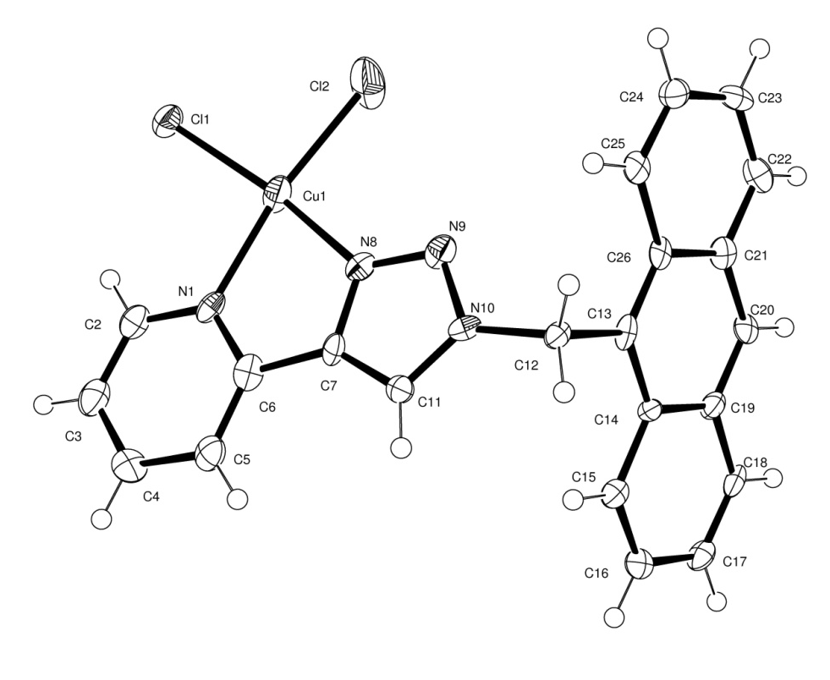

Table 2.Atomic coordinates [× 10⁴], equivalent isotropic displacement parameters [Å²× 10³] and site occupancy factors. U_{eq} is defined as one third of the trace of the orthogonalized U^{ij} tensor.

Atom x y z U_{eq} S.o.f.

Cu1 5709(1) 5023(2) 3069(1) 29(1) 1
Cl1 5412(1) 4439(3) 1808(1) 28(1) 1
Cl2 5964(1) 8213(6) 2593(1) 65(1) 1
N1 5520(1) 2197(10) 3695(3) 21(1) 1
N8 5894(1) 5766(10) 4285(3) 22(1) 1
N9 6085(1) 7553(11) 4653(3) 26(1) 1
N10 6112(1) 7194(10) 5507(3) 18(1) 1
C2 5328(1) 344(14) 3321(4) 26(2) 1
C3 5209(1) −1406(15) 3781(5) 31(2) 1
C4 5281(1) −1312(13) 4676(5) 28(2) 1
C5 5479(1) 599(13) 5080(4) 26(2) 1
C6 5594(1) 2301(13) 4571(4) 24(2) 1
C7 5803(1) 4312(13) 4890(4) 20(2) 1
C11 5943(1) 5248(13) 5671(4) 18(1) 1
C12 6319(1) 8859(12) 6112(4) 17(1) 1
C13 6617(1) 8207(12) 6084(4) 17(1) 1
C14 6759(1) 6137(12) 6617(4) 17(1) 1
C15 6635(1) 4592(12) 7181(4) 19(1) 1
C16 6778(1) 2611(12) 7678(4) 21(2) 1
C17 7062(1) 2082(13) 7671(4) 22(2) 1
C18 7187(1) 3525(13) 7164(4) 22(2) 1
C19 7045(1) 5617(12) 6612(4) 20(2) 1
C20 7170(1) 7085(12) 6070(4) 19(1) 1
C21 7028(1) 9069(13) 5528(4) 20(2) 1
C22 7160(1) 10600(13) 4973(4) 27(2) 1
C23 7023(1) 12540(13) 4442(4) 24(2) 1
C24 6741(1) 13096(13) 4438(4) 26(2) 1
C25 6607(1) 11705(12) 4947(4) 21(2) 1
C26 6743(1) 9622(12) 5530(4) 17(1) 1
Table 3.Bond lengths [Å] and angles [°].

Cu1−N8 1.983(5)
Cu1−N1 2.062(5)
Cu1−Cl1 2.2220(17)
Cu1−Cl2 2.256(2)
N1−C2 1.352(8)
N1−C6 1.365(8)
N8−N9 1.325(7)
N8−C7 1.363(8)
N9−N10 1.354(7)
N10−C11 1.337(7)
N10−C12 1.484(7)
C2−C3 1.354(9)
C2−H2 0.9300
C3−C4 1.395(9)
C3−H3 0.9300
C4−C5 1.405(9)
C4−H4 0.9300
C5−C6 1.379(9)
C5−H5 0.9300
C6−C7 1.440(8)
C7−C11 1.361(8)
C11−H11 0.9300
C12−C13 1.511(7)
C12−H12A 0.9700
C12−H12B 0.9700
C13−C26 1.383(8)
C13−C14 1.411(8)
C14−C15 1.423(8)
C14−C19 1.432(8)
C15−C16 1.353(8)
C15−H15 0.9300
C16−C17 1.424(8)
C16−H16 0.9300
C17−C18 1.332(9)
C17−H17 0.9300
C18−C19 1.433(8)
C18−H18 0.9300
C19−C20 1.380(8)
C20−C21 1.387(8)
C20−H20 0.9300
C21−C22 1.430(9)
C21−C26 1.434(7)
C22−C23 1.354(8)
C22−H22 0.9300
C23−C24 1.414(8)
C23−H23 0.9300
C24−C25 1.349(9)
C24−H24 0.9300
C25−C26 1.446(8)
C25−H25 0.9300

N8−Cu1−N1 78.8(2)
N8−Cu1−Cl1 166.59(15)
N1−Cu1−Cl1 94.36(14)
N8−Cu1−Cl2 92.07(16)
N1−Cu1−Cl2 170.75(14)
Cl1−Cu1−Cl2 94.89(7)
C2−N1−C6 118.2(6)
C2−N1−Cu1 126.3(4)
C6−N1−Cu1 115.5(4)
N9−N8−C7 110.6(5)
N9−N8−Cu1 132.7(4)
C7−N8−Cu1 116.6(4)
N8−N9−N10 104.8(5)
C11−N10−N9 111.9(5)
C11−N10−C12 129.6(5)
N9−N10−C12 118.5(5)
N1−C2−C3 122.6(6)
N1−C2−H2 118.7
C3−C2−H2 118.7
C2−C3−C4 119.9(6)
C2−C3−H3 120.1
C4−C3−H3 120.1
C3−C4−C5 118.6(7)
C3−C4−H4 120.7
C5−C4−H4 120.7
C6−C5−C4 118.3(6)
C6−C5−H5 120.9
C4−C5−H5 120.9
N1−C6−C5 122.4(6)
N1−C6−C7 112.9(6)
C5−C6−C7 124.6(6)
C11−C7−N8 107.1(5)
C11−C7−C6 136.9(6)
N8−C7−C6 116.0(5)
N10−C11−C7 105.7(5)
N10−C11−H11 127.2
C7−C11−H11 127.2
N10−C12−C13 112.9(5)
N10−C12−H12A 109.0
C13−C12−H12A 109.0
N10−C12−H12B 109.0
C13−C12−H12B 109.0
H12A−C12−H12B 107.8
C26−C13−C14 121.3(5)
C26−C13−C12 119.5(5)
C14−C13−C12 119.1(5)
C13−C14−C15 123.1(5)
C13−C14−C19 118.6(5)
C15−C14−C19 118.2(5)
C16−C15−C14 121.4(5)
C16−C15−H15 119.3
C14−C15−H15 119.3
C15−C16−C17 120.4(6)
C15−C16−H16 119.8
C17−C16−H16 119.8
C18−C17−C16 119.9(6)
C18−C17−H17 120.1
C16−C17−H17 120.1
C17−C18−C19 122.3(6)
C17−C18−H18 118.9
C19−C18−H18 118.9
C20−C19−C14 119.4(5)
C20−C19−C18 122.8(5)
C14−C19−C18 117.8(6)
C19−C20−C21 122.1(5)
C19−C20−H20 119.0
C21−C20−H20 119.0
C20−C21−C22 121.9(6)
C20−C21−C26 119.0(6)
C22−C21−C26 119.1(6)
C23−C22−C21 122.2(6)
C23−C22−H22 118.9
C21−C22−H22 118.9
C22−C23−C24 119.2(6)
C22−C23−H23 120.4
C24−C23−H23 120.4
C25−C24−C23 121.0(6)
C25−C24−H24 119.5
C23−C24−H24 119.5
C24−C25−C26 122.3(6)
C24−C25−H25 118.8
C26−C25−H25 118.8
C13−C26−C21 119.4(5)
C13−C26−C25 124.4(5)
C21−C26−C25 116.2(6)

Table 4.Anisotropic displacement parameters [Å²× 10³]. The anisotropic displacement
factor exponent takes the form: −2π²[h²a*²U¹¹ + ...+ 2 h k a* b* U¹² ].

Atom U¹¹ U²² U³³ U²³ U¹³ U¹²

Cu1 19(1) 48(1) 20(1) −4(1) 4(1) 0(1)
Cl1 26(1) 34(1) 21(1) −1(1) 0(1) 0(1)
Cl2 50(1) 121(2) 26(1) −6(1) 15(1) −44(1)
N1 18(2) 23(3) 19(3) −2(2) −1(2) 9(2)
N8 23(3) 25(3) 16(3) 0(2) 1(2) 2(2)
N9 21(3) 35(4) 21(3) −1(3) 4(2) 3(2)
N10 22(3) 18(3) 13(3) 1(2) 5(2) 7(2)
C2 22(3) 29(4) 24(4) −3(3) 2(3) 5(3)
C3 26(3) 27(4) 35(5) −1(3) −3(3) 4(3)
C4 28(3) 12(4) 43(5) 5(3) 9(3) 7(3)
C5 18(3) 33(5) 28(4) 0(3) 5(3) 6(3)
C6 22(3) 24(4) 26(4) −8(3) 4(3) 3(3)
C7 11(3) 27(4) 21(4) −2(3) 0(2) 1(3)
C11 15(3) 18(4) 21(4) 2(3) 5(2) 3(3)
C12 20(3) 13(3) 16(4) −1(3) −1(2) 1(2)
C13 15(3) 18(4) 16(4) −14(3) 1(2) 1(2)
C14 19(3) 16(3) 13(3) 2(3) 0(2) −2(2)
C15 22(3) 14(4) 18(3) −3(3) 1(2) 2(3)
C16 30(3) 14(4) 19(4) −7(3) 5(3) −5(3)
C17 24(3) 16(4) 22(4) 0(3) −4(3) 5(3)
C18 18(3) 20(4) 21(4) −4(3) −7(3) 2(3)
C19 19(3) 19(4) 19(4) 1(3) −3(2) 1(2)
C20 20(3) 11(3) 24(4) −5(3) 3(3) −1(3)
C21 21(3) 22(4) 19(4) −8(3) 6(2) −1(3)
C22 26(3) 23(4) 33(4) −7(3) 12(3) −5(3)
C23 44(4) 14(4) 16(4) −3(3) 12(3) −7(3)
C24 31(4) 21(4) 22(4) 0(3) 0(3) −3(3)
C25 25(3) 11(4) 23(4) −8(3) 1(3) −2(3)
C26 19(3) 10(3) 21(4) −10(3) 0(2) −1(2)

Table 5.Hydrogen coordinates [× 10⁴] and isotropic displacement parameters [Å²× 10³].

Atom x y z U_{eq} S.o.f.

H2 5276 268 2725 31 1
H3 5080 −2669 3500 37 1
H4 5199 −2490 4999 33 1
H5 5532 713 5676 31 1
H11 5925 4657 6207 22 1
H12A 6296 8569 6691 21 1
H12B 6283 10755 5973 21 1
H15 6452 4951 7208 23 1
H16 6691 1589 8028 25 1
H17 7160 731 8019 27 1
H18 7372 3162 7168 26 1
H20 7356 6732 6069 22 1
H22 7346 10251 4977 32 1
H23 7113 13494 4084 29 1
H24 6646 14441 4079 31 1
H25 6421 12101 4922 25 1

Table 6.Torsion angles [°].

N8−Cu1−N1−C2 −178.2(5)
Cl1−Cu1−N1−C2 13.5(5)
Cl2−Cu1−N1−C2 −167.1(8)
N8−Cu1−N1−C6 3.7(4)
Cl1−Cu1−N1−C6 −164.6(4)
Cl2−Cu1−N1−C6 14.8(12)
N1−Cu1−N8−N9 −179.2(6)
Cl1−Cu1−N8−N9 −118.7(7)
Cl2−Cu1−N8−N9 2.6(5)
N1−Cu1−N8−C7 −3.7(4)
Cl1−Cu1−N8−C7 56.8(9)
Cl2−Cu1−N8−C7 178.1(4)
C7−N8−N9−N10 −0.1(6)
Cu1−N8−N9−N10 175.6(4)
N8−N9−N10−C11 −0.1(6)
N8−N9−N10−C12 178.2(5)
C6−N1−C2−C3 −0.4(9)
Cu1−N1−C2−C3 −178.5(5)
N1−C2−C3−C4 0.9(10)
C2−C3−C4−C5 −0.8(9)
C3−C4−C5−C6 0.2(9)
C2−N1−C6−C5 −0.2(9)
Cu1−N1−C6−C5 178.1(5)
C2−N1−C6−C7 178.7(5)
Cu1−N1−C6−C7 −3.0(6)
C4−C5−C6−N1 0.3(9)
C4−C5−C6−C7 −178.5(6)
N9−N8−C7−C11 0.3(7)
Cu1−N8−C7−C11 −176.1(4)
N9−N8−C7−C6 179.7(5)
Cu1−N8−C7−C6 3.3(7)
N1−C6−C7−C11 179.1(6)
C5−C6−C7−C11 −2.0(11)
N1−C6−C7−N8 −0.1(8)
C5−C6−C7−N8 178.8(6)
N9−N10−C11−C7 0.3(6)
C12−N10−C11−C7 −177.8(5)
N8−C7−C11−N10 −0.4(6)
C6−C7−C11−N10 −179.6(7)
C11−N10−C12−C13 111.2(7)
N9−N10−C12−C13 −66.9(7)
N10−C12−C13−C26 91.1(7)
N10−C12−C13−C14 −88.1(6)
C26−C13−C14−C15 −178.6(5)
C12−C13−C14−C15 0.6(9)
C26−C13−C14−C19 3.5(9)
C12−C13−C14−C19 −177.3(5)
C13−C14−C15−C16 179.6(6)
C19−C14−C15−C16 −2.5(9)
C14−C15−C16−C17 2.2(9)
C15−C16−C17−C18 −0.7(9)
C16−C17−C18−C19 −0.3(10)
C13−C14−C19−C20 −2.0(9)
C15−C14−C19−C20 180.0(5)
C13−C14−C19−C18 179.4(5)
C15−C14−C19−C18 1.4(9)
C17−C18−C19−C20 −178.6(6)
C17−C18−C19−C14 0.0(9)
C14−C19−C20−C21 0.2(9)
C18−C19−C20−C21 178.7(6)
C19−C20−C21−C22 179.5(6)
C19−C20−C21−C26 0.2(9)
C20−C21−C22−C23 180.0(6)
C26−C21−C22−C23 −0.7(9)
C21−C22−C23−C24 0.6(9)
C22−C23−C24−C25 −0.7(9)
C23−C24−C25−C26 1.1(9)
C14−C13−C26−C21 −3.1(8)
C12−C13−C26−C21 177.7(5)
C14−C13−C26−C25 177.9(6)
C12−C13−C26−C25 −1.2(9)
C20−C21−C26−C13 1.2(8)
C22−C21−C26−C13 −178.1(6)
C20−C21−C26−C25 −179.7(5)
C22−C21−C26−C25 1.0(8)
C24−C25−C26−C13 177.8(6)
C24−C25−C26−C21 −1.2(9)

Table 1.Crystal data and structure refinement details.

Identification code 2014ncs0425
Empirical formula C₄₄H₃₂Cd₂Cl₄N₈
Formula weight 1039.37
Temperature 100(2) K
Wavelength 0.71075 Å
Crystal system Triclinic
Space group P−1
Unit cell dimensions a = 8.2419(5) Å α = 109.895(6)°
b = 9.9817(7) Å β = 98.440(8)°
c = 13.4818(12) Å γ = 104.344(7)°
Volume 977.37(14) Å³
Z 1
Density (calculated) 1.766 Mg / m³
Absorption coefficient 1.407 mm⁻¹
F(000) 516
Crystal Plate; colourless
Crystal size 0.15 × 0.06 × 0.02 mm³
θ range for data collection 2.290 − 27.495°
Index ranges −10 ≤ h ≤ 10, −12 ≤ k ≤ 12, −17 ≤ l ≤ 17
Reflections collected 12811
Independent reflections 4466 [R_{int} = 0.2067]
Completeness to θ = 25.242° 99.6 %
Absorption correction Semi−empirical from equivalents
Max. and min. transmission 1.000 and 0.225
Refinement method Full-matrix least-squares on F²
Data / restraints / parameters 4466 / 0 / 262
Goodness-of-fit on F² 1.025
Final R indices [F²> 2σ(F²)] R1 = 0.0653, wR2 = 0.1705
R indices (all data) R1 = 0.0729, wR2 = 0.1768
Extinction coefficient n/a
Largest diff. peak and hole 2.794 and −3.180 e Å⁻³

Diffractometer: Rigaku AFC12 goniometer equipped with an enhanced sensitivity (HG) Saturn724+ detector mounted at the window of an FR-E+ SuperBright molybdenum rotating anode generator with HF Varimax optics (100m focus). Cell determination and data collection: CrystalClear-SM Expert 3.1 b25 (Rigaku, 2013). Data reduction, cell refinement and absorption correction: CrystalClear-SM Expert 3.1 b25 (Rigaku, 2013). Structure solution: SHELXS97 (Sheldrick, G.M. (2008). Acta Cryst. A64, 112-122). Structure refinement: SHELXL2014 (Sheldrick, G.M. (2013). Within OLEX2. Graphics: OLEX2 (Dolomanov, O. V., Bourhis, L. J., Gildea, R. J., Howard, J. A. K. &Puschmann, H. (2009). J. Appl. Cryst. 42, 339-341).

Special details:
Figure 1. View showing structure and atom labelling scheme for 2014ncs0425. The asymmetric unit contains half of the complex which is completed by inversion symmetry. Displacement ellipsoids are drawn at 50% probability level.
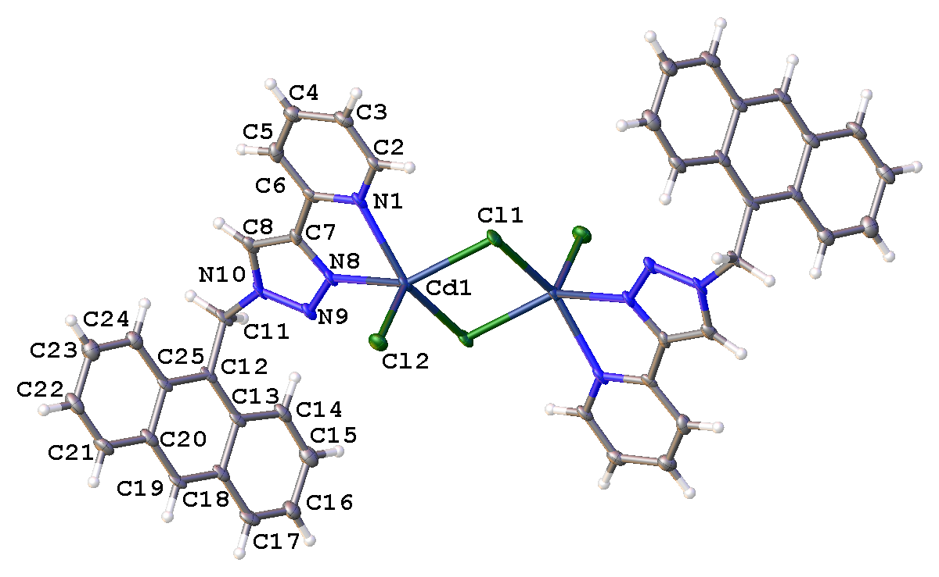
Table 2.Atomic coordinates [× 10⁴], equivalent isotropic displacement parameters [Å²× 10³] and site occupancy factors. U_{eq} is defined as one third of the trace of the orthogonalized U^{ij} tensor.

Atom x y z U_{eq} S.o.f.

Cd1 1586(1) 5649(1) 4244(1) 17(1) 1
Cl1 510(2) 6852(1) 5930(1) 20(1) 1
Cl2 318(2) 6372(1) 2838(1) 23(1) 1
N1 4332(5) 7530(5) 5111(3) 17(1) 1
N8 3697(5) 4671(5) 3624(3) 17(1) 1
N9 3635(5) 3364(5) 2871(3) 17(1) 1
N10 5227(5) 3593(5) 2704(3) 17(1) 1
C2 4610(6) 8918(5) 5859(3) 18(1) 1
C3 6195(7) 10026(6) 6240(4) 21(1) 1
C4 7572(7) 9704(6) 5824(4) 22(1) 1
C5 7299(7) 8281(6) 5048(4) 21(1) 1
C6 5661(6) 7225(5) 4713(3) 16(1) 1
C7 5294(6) 5690(6) 3909(3) 16(1) 1
C8 6284(6) 4998(6) 3328(4) 19(1) 1
C11 5647(7) 2357(6) 1924(3) 19(1) 1
C12 4553(6) 1788(5) 767(3) 17(1) 1
C13 3104(7) 495(6) 376(3) 18(1) 1
C14 2510(7) −325(6) 1013(4) 21(1) 1
C15 1111(8) −1584(6) 597(4) 26(1) 1
C16 157(7) −2140(6) −513(4) 25(1) 1
C17 640(7) −1387(6) −1153(4) 23(1) 1
C18 2116(7) −72(6) −747(4) 18(1) 1
C19 2620(7) 683(5) −1406(3) 18(1) 1
C20 4061(7) 1960(6) −1022(4) 20(1) 1
C21 4604(7) 2703(6) −1717(4) 24(1) 1
C22 6057(8) 3925(6) −1346(4) 25(1) 1
C23 7025(7) 4514(6) −243(4) 26(1) 1
C24 6540(7) 3854(6) 446(4) 21(1) 1
C25 5057(6) 2548(5) 84(3) 17(1) 1
Table 3.Bond lengths [Å] and angles [°].

Cd1−Cl1 2.5794(11)
Cd1−Cl1^{i} 2.5724(13)
Cd1−Cl2 2.4349(10)
Cd1−N1 2.374(4)
Cd1−N8 2.322(4)
Cl1−Cd1^{i} 2.5724(13)
N1−C2 1.346(6)
N1−C6 1.344(6)
N8−N9 1.336(6)
N8−C7 1.355(6)
N9−N10 1.341(6)
N10−C8 1.346(7)
N10−C11 1.478(6)
C2−H2 0.9500
C2−C3 1.376(7)
C3−H3 0.9500
C3−C4 1.396(7)
C4−H4 0.9500
C4−C5 1.386(7)
C5−H5 0.9500
C5−C6 1.389(7)
C6−C7 1.469(7)
C7−C8 1.361(7)
C8−H8 0.9500
C11−H11A 0.9900
C11−H11B 0.9900
C11−C12 1.516(6)
C12−C13 1.400(7)
C12−C25 1.423(6)
C13−C14 1.433(7)
C13−C18 1.449(6)
C14−H14 0.9500
C14−C15 1.355(8)
C15−H15 0.9500
C15−C16 1.428(7)
C16−H16 0.9500
C16−C17 1.365(7)
C17−H17 0.9500
C17−C18 1.424(7)
C18−C19 1.393(7)
C19−H19 0.9500
C19−C20 1.386(7)
C20−C21 1.436(7)
C20−C25 1.431(6)
C21−H21 0.9500
C21−C22 1.363(8)
C22−H22 0.9500
C22−C23 1.419(7)
C23−H23 0.9500
C23−C24 1.362(7)
C24−H24 0.9500
C24−C25 1.426(7)
Cl1^{i}−Cd1−Cl1 85.34(4)
Cl2−Cd1−Cl1^{i} 108.20(4)
Cl2−Cd1−Cl1 105.97(4)
N1−Cd1−Cl1 88.97(10)
N1−Cd1−Cl1^{i} 147.49(8)
N1−Cd1−Cl2 104.14(9)
N8−Cd1−Cl1 145.57(9)
N8−Cd1−Cl1^{i} 96.30(11)
N8−Cd1−Cl2 106.09(9)
N8−Cd1−N1 71.31(14)
Cd1^{i}−Cl1−Cd1 94.66(4)
C2−N1−Cd1 125.3(3)
C6−N1−Cd1 115.9(3)
C6−N1−C2 118.2(4)
N9−N8−Cd1 133.3(3)
N9−N8−C7 110.2(4)
C7−N8−Cd1 115.1(3)
N8−N9−N10 105.0(4)
N9−N10−C8 112.0(4)
N9−N10−C11 120.0(4)
C8−N10−C11 127.9(4)
N1−C2−H2 118.5
N1−C2−C3 122.9(5)
C3−C2−H2 118.5
C2−C3−H3 120.7
C2−C3−C4 118.6(5)
C4−C3−H3 120.7
C3−C4−H4 120.5
C5−C4−C3 119.0(5)
C5−C4−H4 120.5
C4−C5−H5 120.7
C4−C5−C6 118.7(5)
C6−C5−H5 120.7
N1−C6−C5 122.5(4)
N1−C6−C7 116.1(4)
C5−C6−C7 121.4(4)
N8−C7−C6 120.0(4)
N8−C7−C8 107.6(4)
C8−C7−C6 132.4(5)
N10−C8−C7 105.2(5)
N10−C8−H8 127.4
C7−C8−H8 127.4
N10−C11−H11A 108.9
N10−C11−H11B 108.9
N10−C11−C12 113.2(3)
H11A−C11−H11B 107.7
C12−C11−H11A 108.9
C12−C11−H11B 108.9
C13−C12−C11 119.5(4)
C13−C12−C25 121.1(4)
C25−C12−C11 119.3(5)
C12−C13−C14 124.4(4)
C12−C13−C18 118.9(4)
C14−C13−C18 116.8(5)
C13−C14−H14 118.8
C15−C14−C13 122.5(4)
C15−C14−H14 118.8
C14−C15−H15 119.9
C14−C15−C16 120.3(5)
C16−C15−H15 119.9
C15−C16−H16 120.1
C17−C16−C15 119.9(5)
C17−C16−H16 120.1
C16−C17−H17 119.4
C16−C17−C18 121.3(4)
C18−C17−H17 119.4
C17−C18−C13 119.3(4)
C19−C18−C13 119.5(5)
C19−C18−C17 121.2(4)
C18−C19−H19 119.1
C20−C19−C18 121.8(4)
C20−C19−H19 119.1
C19−C20−C21 121.4(4)
C19−C20−C25 119.9(4)
C25−C20−C21 118.7(5)
C20−C21−H21 119.5
C22−C21−C20 121.1(4)
C22−C21−H21 119.5
C21−C22−H22 120.0
C21−C22−C23 119.9(5)
C23−C22−H22 120.0
C22−C23−H23 119.6
C24−C23−C22 120.8(5)
C24−C23−H23 119.6
C23−C24−H24 119.4
C23−C24−C25 121.2(5)
C25−C24−H24 119.4
C12−C25−C20 118.8(5)
C12−C25−C24 122.8(4)
C24−C25−C20 118.3(4)

Symmetry transformations used to generate equivalent atoms:
(i) −x,−y+1,−z+1

Table 4.Anisotropic displacement parameters [Å²× 10³]. The anisotropic displacement
factor exponent takes the form: −2π²[h²a*²U¹¹ + ...+ 2 h k a* b* U¹² ].

Atom U¹¹ U²² U³³ U²³ U¹³ U¹²

Cd1 21(1) 22(1) 10(1) 3(1) 7(1) 13(1)
Cl1 28(1) 21(1) 12(1) 2(1) 10(1) 13(1)
Cl2 27(1) 28(1) 16(1) 9(1) 4(1) 12(1)
N1 26(2) 22(2) 9(2) 5(2) 7(1) 16(2)
N8 23(2) 22(2) 9(2) 4(2) 8(1) 14(2)
N9 23(2) 21(2) 10(2) 4(2) 8(1) 15(2)
N10 26(2) 25(2) 6(2) 5(2) 8(1) 19(2)
C2 25(2) 20(2) 9(2) 3(2) 5(2) 14(2)
C3 30(3) 19(2) 12(2) 3(2) 3(2) 12(2)
C4 25(2) 24(3) 17(2) 4(2) 3(2) 11(2)
C5 24(2) 27(3) 21(2) 11(2) 12(2) 16(2)
C6 23(2) 20(2) 7(2) 5(2) 3(2) 13(2)
C7 19(2) 24(2) 12(2) 9(2) 7(2) 12(2)
C8 24(2) 27(3) 12(2) 7(2) 5(2) 17(2)
C11 28(2) 23(2) 9(2) 2(2) 6(2) 19(2)
C12 27(2) 20(2) 9(2) 2(2) 7(2) 18(2)
C13 28(2) 20(2) 11(2) 2(2) 8(2) 17(2)
C14 31(3) 25(3) 13(2) 6(2) 9(2) 18(2)
C15 37(3) 24(3) 21(2) 8(2) 12(2) 18(2)
C16 30(3) 24(3) 19(2) 2(2) 10(2) 10(2)
C17 30(3) 22(2) 13(2) −2(2) 4(2) 15(2)
C18 26(2) 19(2) 12(2) 2(2) 7(2) 15(2)
C19 28(2) 18(2) 9(2) 0(2) 5(2) 15(2)
C20 30(3) 19(2) 12(2) 4(2) 7(2) 16(2)
C21 35(3) 27(3) 12(2) 7(2) 5(2) 16(2)
C22 42(3) 23(3) 17(2) 9(2) 13(2) 19(2)
C23 33(3) 25(3) 26(3) 10(2) 13(2) 15(2)
C24 27(2) 22(3) 17(2) 7(2) 8(2) 14(2)
C25 25(2) 17(2) 11(2) 2(2) 7(2) 15(2)

Table 5.Hydrogen coordinates [× 10⁴] and isotropic displacement parameters [Å²× 10³].

Atom x y z U_{eq} S.o.f.

H2 3671 9142 6135 21 1
H3 6349 10990 6775 25 1
H4 8679 10448 6069 27 1
H5 8214 8034 4752 26 1
H8 7467 5418 3358 23 1
H11A 5477 1512 2167 23 1
H11B 6883 2711 1930 23 1
H14 3120 27 1755 26 1
H15 764 −2100 1046 31 1
H16 −813 −3031 −805 30 1
H17 −21 −1748 −1885 27 1
H19 1959 314 −2138 22 1
H21 3939 2338 −2448 29 1
H22 6422 4381 −1824 30 1
H23 8023 5379 16 32 1
H24 7201 4271 1182 25 1
Table 6.Torsion angles [°].
Cd1−N1−C2−C3 −171.9(3)
Cd1−N1−C6−C5 172.3(3)
Cd1−N1−C6−C7 −8.7(4)
Cd1−N8−N9−N10 166.0(3)
Cd1−N8−C7−C6 10.4(4)
Cd1−N8−C7−C8 −169.3(2)
N1−C2−C3−C4 0.8(6)
N1−C6−C7−N8 −1.1(5)
N1−C6−C7−C8 178.5(4)
N8−N9−N10−C8 0.2(4)
N8−N9−N10−C11 178.8(3)
N8−C7−C8−N10 0.9(4)
N9−N8−C7−C6 178.8(3)
N9−N8−C7−C8 −0.8(4)
N9−N10−C8−C7 −0.7(4)
N9−N10−C11−C12 61.3(5)
N10−C11−C12−C13 −98.2(5)
N10−C11−C12−C25 84.1(5)
C2−N1−C6−C5 0.4(6)
C2−N1−C6−C7 179.4(3)
C2−C3−C4−C5 −0.3(6)
C3−C4−C5−C6 −0.1(6)
C4−C5−C6−N1 0.1(6)
C4−C5−C6−C7 −178.9(4)
C5−C6−C7−N8 178.0(4)
C5−C6−C7−C8 −2.5(7)
C6−N1−C2−C3 −0.8(6)
C6−C7−C8−N10 −178.7(4)
C7−N8−N9−N10 0.4(4)
C8−N10−C11−C12 −120.3(5)
C11−N10−C8−C7 −179.2(4)
C11−C12−C13−C14 2.8(7)
C11−C12−C13−C18 −177.3(4)
C11−C12−C25−C20 177.1(4)
C11−C12−C25−C24 −1.3(7)
C12−C13−C14−C15 −179.1(5)
C12−C13−C18−C17 180.0(4)
C12−C13−C18−C19 −0.4(7)
C13−C12−C25−C20 −0.6(7)
C13−C12−C25−C24 −179.0(4)
C13−C14−C15−C16 −0.4(8)
C13−C18−C19−C20 0.8(7)
C14−C13−C18−C17 −0.1(7)
C14−C13−C18−C19 179.5(4)
C14−C15−C16−C17 −1.0(8)
C15−C16−C17−C18 1.8(8)
C16−C17−C18−C13 −1.2(7)
C16−C17−C18−C19 179.1(5)
C17−C18−C19−C20 −179.6(4)
C18−C13−C14−C15 0.9(7)
C18−C19−C20−C21 178.0(4)
C18−C19−C20−C25 −1.0(7)
C19−C20−C21−C22 −177.6(5)
C19−C20−C25−C12 0.9(7)
C19−C20−C25−C24 179.4(4)
C20−C21−C22−C23 −2.3(8)
C21−C20−C25−C12 −178.1(4)
C21−C20−C25−C24 0.4(7)
C21−C22−C23−C24 1.4(8)
C22−C23−C24−C25 0.5(8)
C23−C24−C25−C12 177.1(5)
C23−C24−C25−C20 −1.3(7)
C25−C12−C13−C14 −179.6(4)
C25−C12−C13−C18 0.3(7)
C25−C20−C21−C22 1.5(8)

Symmetry transformations used to generate equivalent atoms:
(i) −x,−y+1,−z+1

Table (S1): Bond length, Bona angle, and dihedral angle of the free ligand and its Cu(II) and Cd(II) complexes.
Free Ligand |  | Cu(II) complex |  | Cd(II) complex
Bond length |  | Bond length |  | Bond length
C(25)-H(42) | 1.096 | N(28)-Cu(45) | 1.967 | Cl(88)-Cd(90) | 2.414
C(25)-N(26) | 1.349 | C(27)-H(44) | 1.082 | Cl(88)-Cd(89) | 2.411
C(24)-H(41) | 1.094 | C(27)-N(28) | 1.299 | Cl(87)-Cd(90) | 2.448
C(24)-C(25) | 1.396 | C(26)-H(43) | 1.082 | N(70)-Cd(90) | 2.132
C(23)-H(40) | 1.095 | C(26)-C(27) | 1.479 | C(69)-H(86) | 1.081
C(23)-C(24) | 1.390 | C(25)-H(42) | 1.082 | C(69)-N(70) | 1.360
C(22)-H(39) | 1.096 | C(25)-C(26) | 1.343 | C(68)-H(85) | 1.082
C(22)-C(23) | 1.391 | C(24)-H(41) | 1.082 | C(68)-C(69) | 1.398
C(21)-N(26) | 1.366 | C(24)-C(25) | 1.481 | C(67)-H(84) | 1.082
C(21)-C(22) | 1.402 | C(23)-N(28) | 1.445 | C(67)-C(68) | 1.399
N(19)-N(20) | 1.272 | C(23)-C(24) | 1.340 | C(66)-H(83) | 1.082
C(18)-C(21) | 1.454 | N(21)-Cu(45) | 1.931 | C(66)-C(67) | 1.398
C(18)-N(19) | 1.410 | N(21)-N(22) | 1.265 | C(65)-N(70) | 1.365
C(17)-H(38) | 1.093 | C(20)-C(23) | 1.479 | C(65)-C(66) | 1.400
C(17)-C(18) | 1.390 | C(20)-N(21) | 1.407 | N(63)-Cd(90) | 2.062
N(16)-N(20) | 1.375 | C(19)-H(40) | 1.082 | N(63)-N(64) | 1.266
N(16)-C(17) | 1.395 | C(19)-C(20) | 1.326 | C(62)-C(65) | 1.462
C(15)-H(37) | 1.114 | N(18)-N(22) | 1.404 | C(62)-N(63) | 1.403
C(15)-H(36) | 1.114 | N(18)-C(19) | 1.435 | C(61)-H(82) | 1.081
C(15)-N(16) | 1.484 | C(17)-H(39) | 1.107 | C(61)-C(62) | 1.325
C(14)-H(35) | 1.101 | C(17)-H(38) | 1.111 | N(60)-N(64) | 1.402
C(13)-H(34) | 1.095 | C(17)-N(18) | 1.458 | N(60)-C(61) | 1.433
C(13)-C(14) | 1.360 | C(16)-H(37) | 1.081 | C(59)-H(81) | 1.105
C(12)-H(33) | 1.095 | C(15)-H(36) | 1.083 | C(59)-H(80) | 1.108
C(12)-C(13) | 1.425 | C(15)-C(16) | 1.338 | C(59)-N(60) | 1.461
C(11)-H(32) | 1.096 | C(14)-H(35) | 1.083 | C(58)-H(79) | 1.077
C(11)-C(12) | 1.360 | C(14)-C(15) | 1.474 | C(57)-H(78) | 1.083
C(10)-C(15) | 1.500 | C(13)-H(34) | 1.084 | C(57)-C(58) | 1.396
C(9)-C(14) | 1.435 | C(13)-C(14) | 1.335 | C(56)-H(77) | 1.082
C(9)-C(10) | 1.406 | C(12)-C(17) | 1.520 | C(56)-C(57) | 1.391
C(8)-C(11) | 1.434 | C(11)-C(16) | 1.492 | C(55)-H(76) | 1.084
C(8)-C(9) | 1.422 | C(11)-C(12) | 1.364 | C(55)-C(56) | 1.392
C(7)-H(31) | 1.098 | C(10)-C(13) | 1.478 | C(54)-C(59) | 1.528
C(7)-C(8) | 1.396 | C(10)-C(11) | 1.496 | C(53)-C(58) | 1.418
C(6)-H(30) | 1.101 | C(9)-H(33) | 1.085 | C(53)-C(54) | 1.432
C(5)-C(10) | 1.406 | C(9)-C(10) | 1.338 | C(52)-C(55) | 1.405
C(5)-C(6) | 1.435 | C(8)-H(32) | 1.079 | C(52)-C(53) | 1.420
C(4)-C(7) | 1.396 | C(7)-C(12) | 1.500 | C(51)-H(75) | 1.086
C(4)-C(5) | 1.422 | C(7)-C(8) | 1.352 | C(51)-C(52) | 1.394
C(3)-H(29) | 1.096 | C(6)-C(9) | 1.468 | C(50)-H(74) | 1.076
C(3)-C(4) | 1.434 | C(6)-C(7) | 1.488 | C(49)-C(54) | 1.432
C(2)-H(28) | 1.095 | C(5)-H(31) | 1.083 | C(49)-C(50) | 1.419
C(2)-C(3) | 1.360 | C(5)-C(6) | 1.343 | C(48)-C(51) | 1.394
C(1)-H(27) | 1.095 | C(4)-H(30) | 1.082 | C(48)-C(49) | 1.421
C(1)-C(6) | 1.360 | C(4)-C(5) | 1.474 | C(47)-H(73) | 1.084
C(1)-C(2) | 1.424 | C(3)-H(29) | 1.082 | C(47)-C(48) | 1.405
Bond angle |  | C(3)-C(8) | 1.477 | C(46)-H(72) | 1.083
C(25)-N(26)-C(21) | 119.564 | C(3)-C(4) | 1.336 | C(46)-C(47) | 1.392
H(42)-C(25)-N(26) | 115.512 | Cl(2)-Cu(45) | 2.271 | C(45)-H(71) | 1.083
H(42)-C(25)-C(24) | 122.633 | Cl(1)-Cu(45) | 2.271 | C(45)-C(50) | 1.396
N(26)-C(25)-C(24) | 121.856 | Bond angle |  | C(45)-C(46) | 1.391
H(41)-C(24)-C(25) | 120.257 | N(28)-Cu(45)-N(21) | 90.220 | Cl(44)-Cd(90) | 2.411
H(41)-C(24)-C(23) | 120.837 | N(28)-Cu(45)-Cl(2) | 89.854 | Cl(44)-Cd(89) | 2.414
C(25)-C(24)-C(23) | 118.906 | N(28)-Cu(45)-Cl(1) | 168.812 | Cl(43)-Cd(89) | 2.448
H(40)-C(23)-C(24) | 120.323 | N(21)-Cu(45)-Cl(2) | 170.157 | N(26)-Cd(89) | 2.132
H(40)-C(23)-C(22) | 120.049 | N(21)-Cu(45)-Cl(1) | 79.929 | C(25)-H(42) | 1.081
C(24)-C(23)-C(22) | 119.627 | Cl(2)-Cu(45)-Cl(1) | 100.762 | C(25)-N(26) | 1.360
H(39)-C(22)-C(23) | 120.525 | Cu(45)-N(28)-C(27) | 129.527 | C(24)-H(41) | 1.082
H(39)-C(22)-C(21) | 120.422 | Cu(45)-N(28)-C(23) | 107.756 | C(24)-C(25) | 1.398
C(23)-C(22)-C(21) | 119.052 | C(27)-N(28)-C(23) | 122.714 | C(23)-H(40) | 1.082
N(26)-C(21)-C(22) | 120.995 | H(44)-C(27)-N(28) | 120.261 | C(23)-C(24) | 1.399
N(26)-C(21)-C(18) | 116.726 | H(44)-C(27)-C(26) | 120.724 | C(22)-H(39) | 1.082
C(22)-C(21)-C(18) | 122.279 | N(28)-C(27)-C(26) | 119.015 | C(22)-C(23) | 1.398
N(19)-N(20)-N(16) | 108.264 | H(43)-C(26)-C(27) | 120.118 | C(21)-N(26) | 1.365
N(20)-N(19)-C(18) | 110.661 | H(43)-C(26)-C(25) | 120.402 | C(21)-C(22) | 1.400
C(21)-C(18)-N(19) | 123.561 | C(27)-C(26)-C(25) | 119.480 | N(19)-Cd(89) | 2.062
C(21)-C(18)-C(17) | 129.551 | H(42)-C(25)-C(26) | 120.037 | N(19)-N(20) | 1.266
N(19)-C(18)-C(17) | 106.888 | H(42)-C(25)-C(24) | 119.696 | C(18)-C(21) | 1.462
H(38)-C(17)-C(18) | 130.681 | C(26)-C(25)-C(24) | 120.267 | C(18)-N(19) | 1.403
H(38)-C(17)-N(16) | 124.932 | H(41)-C(24)-C(25) | 120.123 | C(17)-H(38) | 1.081
C(18)-C(17)-N(16) | 104.386 | H(41)-C(24)-C(23) | 121.310 | C(17)-C(18) | 1.325
N(20)-N(16)-C(17) | 109.801 | C(25)-C(24)-C(23) | 118.567 | N(16)-N(20) | 1.402
N(20)-N(16)-C(15) | 123.269 | N(28)-C(23)-C(24) | 119.957 | N(16)-C(17) | 1.433
C(17)-N(16)-C(15) | 126.931 | N(28)-C(23)-C(20) | 115.172 | C(15)-H(37) | 1.108
H(37)-C(15)-H(36) | 107.948 | C(24)-C(23)-C(20) | 124.871 | C(15)-H(36) | 1.105
H(37)-C(15)-N(16) | 101.455 | N(21)-N(22)-N(18) | 109.658 | C(15)-N(16) | 1.461
H(37)-C(15)-C(10) | 104.149 | Cu(45)-N(21)-N(22) | 141.460 | C(14)-H(35) | 1.077
H(36)-C(15)-N(16) | 102.100 | Cu(45)-N(21)-C(20) | 108.538 | C(13)-H(34) | 1.083
H(36)-C(15)-C(10) | 103.869 | N(22)-N(21)-C(20) | 109.756 | C(13)-C(14) | 1.396
N(16)-C(15)-C(10) | 135.389 | C(23)-C(20)-N(21) | 118.312 | C(12)-H(33) | 1.082
H(35)-C(14)-C(13) | 120.981 | C(23)-C(20)-C(19) | 132.969 | C(12)-C(13) | 1.391
H(35)-C(14)-C(9) | 118.001 | N(21)-C(20)-C(19) | 108.558 | C(11)-H(32) | 1.084
C(13)-C(14)-C(9) | 121.013 | H(40)-C(19)-C(20) | 127.335 | C(11)-C(12) | 1.392
H(34)-C(13)-C(14) | 120.651 | H(40)-C(19)-N(18) | 126.057 | C(10)-C(15) | 1.528
H(34)-C(13)-C(12) | 118.772 | C(20)-C(19)-N(18) | 106.514 | C(9)-C(14) | 1.419
C(14)-C(13)-C(12) | 120.577 | N(22)-N(18)-C(19) | 105.402 | C(9)-C(10) | 1.432
H(33)-C(12)-C(13) | 118.811 | N(22)-N(18)-C(17) | 123.115 | C(8)-C(11) | 1.405
H(33)-C(12)-C(11) | 120.922 | C(19)-N(18)-C(17) | 124.177 | C(8)-C(9) | 1.421
C(13)-C(12)-C(11) | 120.266 | H(39)-C(17)-H(38) | 103.823 | C(7)-H(31) | 1.086
H(32)-C(11)-C(12) | 121.038 | H(39)-C(17)-N(18) | 109.514 | C(7)-C(8) | 1.394
H(32)-C(11)-C(8) | 118.339 | H(39)-C(17)-C(12) | 112.441 | C(6)-H(30) | 1.077
C(12)-C(11)-C(8) | 120.623 | H(38)-C(17)-N(18) | 110.233 | C(5)-C(10) | 1.432
C(15)-C(10)-C(9) | 119.917 | H(38)-C(17)-C(12) | 110.259 | C(5)-C(6) | 1.418
C(15)-C(10)-C(5) | 120.055 | N(18)-C(17)-C(12) | 110.391 | C(4)-C(7) | 1.394
C(9)-C(10)-C(5) | 120.025 | H(37)-C(16)-C(15) | 117.368 | C(4)-C(5) | 1.420
C(14)-C(9)-C(10) | 122.175 | H(37)-C(16)-C(11) | 121.462 | C(3)-H(29) | 1.084
C(14)-C(9)-C(8) | 118.163 | C(15)-C(16)-C(11) | 121.148 | C(3)-C(4) | 1.405
C(10)-C(9)-C(8) | 119.658 | H(36)-C(15)-C(16) | 119.481 | C(2)-H(28) | 1.082
C(11)-C(8)-C(9) | 119.321 | H(36)-C(15)-C(14) | 118.834 | C(2)-C(3) | 1.392
C(11)-C(8)-C(7) | 120.669 | C(16)-C(15)-C(14) | 121.683 | C(1)-H(27) | 1.083
C(9)-C(8)-C(7) | 120.011 | H(35)-C(14)-C(15) | 119.086 | C(1)-C(6) | 1.396
H(31)-C(7)-C(8) | 119.768 | H(35)-C(14)-C(13) | 119.576 | C(1)-C(2) | 1.391
H(31)-C(7)-C(4) | 119.765 | C(15)-C(14)-C(13) | 121.337 | Bond length
C(8)-C(7)-C(4) | 120.466 | H(34)-C(13)-C(14) | 119.063 | Cl(88)-Cd(90)-Cl(87) | 117.381
H(30)-C(6)-C(5) | 117.952 | H(34)-C(13)-C(10) | 120.268 | Cl(88)-Cd(90)-N(70) | 110.782
H(30)-C(6)-C(1) | 120.888 | C(14)-C(13)-C(10) | 120.669 | Cl(88)-Cd(90)-N(63) | 107.014
C(5)-C(6)-C(1) | 121.144 | C(17)-C(12)-C(11) | 120.629 | Cl(88)-Cd(90)-Cl(44) | 107.662
C(10)-C(5)-C(6) | 122.271 | C(17)-C(12)-C(7) | 120.342 | Cl(87)-Cd(90)-N(70) | 131.748
C(10)-C(5)-C(4) | 119.679 | C(11)-C(12)-C(7) | 119.003 | Cl(87)-Cd(90)-N(63) | 82.560
C(6)-C(5)-C(4) | 118.047 | C(16)-C(11)-C(12) | 122.415 | Cl(87)-Cd(90)-Cl(44) | 79.725
C(7)-C(4)-C(5) | 119.997 | C(16)-C(11)-C(10) | 116.386 | N(70)-Cd(90)-N(63) | 81.011
C(7)-C(4)-C(3) | 120.647 | C(12)-C(11)-C(10) | 121.195 | N(70)-Cd(90)-Cl(44) | 88.857
C(5)-C(4)-C(3) | 119.355 | C(13)-C(10)-C(11) | 118.747 | N(63)-Cd(90)-Cl(44) | 145.251
H(29)-C(3)-C(4) | 118.327 | C(13)-C(10)-C(9) | 119.502 | Cl(88)-Cd(89)-Cl(44) | 107.657
H(29)-C(3)-C(2) | 121.007 | C(11)-C(10)-C(9) | 121.738 | Cl(88)-Cd(89)-Cl(43) | 79.737
C(4)-C(3)-C(2) | 120.667 | H(33)-C(9)-C(10) | 120.070 | Cl(88)-Cd(89)-N(26) | 88.862
H(28)-C(2)-C(3) | 120.961 | H(33)-C(9)-C(6) | 119.342 | Cl(88)-Cd(89)-N(19) | 145.295
H(28)-C(2)-C(1) | 118.811 | C(10)-C(9)-C(6) | 120.566 | Cl(44)-Cd(89)-Cl(43) | 117.402
C(3)-C(2)-C(1) | 120.227 | H(32)-C(8)-C(7) | 122.340 | Cl(44)-Cd(89)-N(26) | 110.802
H(27)-C(1)-C(6) | 120.718 | H(32)-C(8)-C(3) | 117.055 | Cl(44)-Cd(89)-N(19) | 106.974
H(27)-C(1)-C(2) | 118.760 | C(7)-C(8)-C(3) | 120.593 | Cl(43)-Cd(89)-N(26) | 131.706
C(6)-C(1)-C(2) | 120.522 | C(12)-C(7)-C(8) | 123.250 | Cl(43)-Cd(89)-N(19) | 82.559
Dihedral angle |  | C(12)-C(7)-C(6) | 118.225 | N(26)-Cd(89)-N(19) | 81.007
C(24)-C(25)-N(26)-C(21) | 0.023 | C(8)-C(7)-C(6) | 118.466 | Cd(90)-Cl(88)-Cd(89) | 72.341
H(42)-C(25)-N(26)-C(21) | -179.971 | C(9)-C(6)-C(7) | 118.842 | Cd(90)-N(70)-C(69) | 125.740
C(23)-C(24)-C(25)-N(26) | 0.012 | C(9)-C(6)-C(5) | 120.571 | Cd(90)-N(70)-C(65) | 112.635
C(23)-C(24)-C(25)-H(42) | -179.993 | C(7)-C(6)-C(5) | 120.531 | C(69)-N(70)-C(65) | 121.595
H(41)-C(24)-C(25)-N(26) | -179.988 | H(31)-C(5)-C(6) | 120.871 | H(86)-C(69)-N(70) | 120.229
H(41)-C(24)-C(25)-H(42) | 0.006 | H(31)-C(5)-C(4) | 119.015 | H(86)-C(69)-C(68) | 119.965
C(22)-C(23)-C(24)-C(25) | -0.025 | C(6)-C(5)-C(4) | 120.091 | N(70)-C(69)-C(68) | 119.806
C(22)-C(23)-C(24)-H(41) | 179.975 | H(30)-C(4)-C(5) | 119.865 | H(85)-C(68)-C(69) | 120.264
H(40)-C(23)-C(24)-C(25) | 179.987 | H(30)-C(4)-C(3) | 120.170 | H(85)-C(68)-C(67) | 120.283
H(40)-C(23)-C(24)-H(41) | -0.013 | C(5)-C(4)-C(3) | 119.953 | C(69)-C(68)-C(67) | 119.453
C(21)-C(22)-C(23)-C(24) | 0.003 | H(29)-C(3)-C(8) | 119.730 | H(84)-C(67)-C(68) | 119.993
C(21)-C(22)-C(23)-H(40) | 179.991 | H(29)-C(3)-C(4) | 120.028 | H(84)-C(67)-C(66) | 119.991
H(39)-C(22)-C(23)-C(24) | 179.982 | C(8)-C(3)-C(4) | 120.242 | C(68)-C(67)-C(66) | 120.013
H(39)-C(22)-C(23)-H(40) | -0.030 | Dihedral angle |  | H(83)-C(66)-C(67) | 120.036
C(18)-C(21)-N(26)-C(25) | 179.909 | C(23)-N(28)-Cu(45)-Cl(1) | 28.345 | H(83)-C(66)-C(65) | 121.170
C(22)-C(21)-N(26)-C(25) | -0.047 | C(23)-N(28)-Cu(45)-Cl(2) | -169.941 | C(67)-C(66)-C(65) | 118.790
C(18)-C(21)-C(22)-C(23) | -179.920 | C(23)-N(28)-Cu(45)-N(21) | 0.217 | N(70)-C(65)-C(66) | 120.311
C(18)-C(21)-C(22)-H(39) | 0.101 | C(27)-N(28)-Cu(45)-Cl(1) | -152.272 | N(70)-C(65)-C(62) | 115.742
N(26)-C(21)-C(22)-C(23) | 0.034 | C(27)-N(28)-Cu(45)-Cl(2) | 9.443 | C(66)-C(65)-C(62) | 123.906
N(26)-C(21)-C(22)-H(39) | -179.945 | C(27)-N(28)-Cu(45)-N(21) | 179.600 | N(63)-N(64)-N(60) | 110.242
C(18)-N(19)-N(20)-N(16) | 0.210 | C(26)-C(27)-N(28)-C(23) | -0.129 | Cd(90)-N(63)-N(64) | 138.863
C(17)-C(18)-C(21)-C(22) | 19.688 | C(26)-C(27)-N(28)-Cu(45) | -179.430 | Cd(90)-N(63)-C(62) | 111.981
C(17)-C(18)-C(21)-N(26) | -160.267 | H(44)-C(27)-N(28)-C(23) | 179.706 | N(64)-N(63)-C(62) | 109.069
N(19)-C(18)-C(21)-C(22) | -160.501 | H(44)-C(27)-N(28)-Cu(45) | 0.404 | C(65)-C(62)-N(63) | 118.508
N(19)-C(18)-C(21)-N(26) | 19.544 | C(25)-C(26)-C(27)-N(28) | 0.117 | C(65)-C(62)-C(61) | 132.387
C(17)-C(18)-N(19)-N(20) | -0.037 | C(25)-C(26)-C(27)-H(44) | -179.717 | N(63)-C(62)-C(61) | 109.105
C(21)-C(18)-N(19)-N(20) | -179.884 | H(43)-C(26)-C(27)-N(28) | -179.966 | H(82)-C(61)-C(62) | 127.181
N(16)-C(17)-C(18)-N(19) | -0.147 | H(43)-C(26)-C(27)-H(44) | 0.200 | H(82)-C(61)-N(60) | 126.394
N(16)-C(17)-C(18)-C(21) | 179.688 | C(24)-C(25)-C(26)-C(27) | -0.018 | C(62)-C(61)-N(60) | 106.420
H(38)-C(17)-C(18)-N(19) | 179.394 | C(24)-C(25)-C(26)-H(43) | -179.935 | N(64)-N(60)-C(61) | 105.137
H(38)-C(17)-C(18)-C(21) | -0.771 | H(42)-C(25)-C(26)-C(27) | 179.975 | N(64)-N(60)-C(59) | 113.877
C(15)-N(16)-N(20)-N(19) | 179.639 | H(42)-C(25)-C(26)-H(43) | 0.057 | C(61)-N(60)-C(59) | 132.930
C(17)-N(16)-N(20)-N(19) | -0.309 | C(23)-C(24)-C(25)-C(26) | -0.069 | H(81)-C(59)-H(80) | 101.659
C(15)-N(16)-C(17)-C(18) | -179.671 | C(23)-C(24)-C(25)-H(42) | 179.938 | H(81)-C(59)-N(60) | 109.726
C(15)-N(16)-C(17)-H(38) | 0.754 | H(41)-C(24)-C(25)-C(26) | -179.984 | H(81)-C(59)-C(54) | 97.993
N(20)-N(16)-C(17)-C(18) | 0.276 | H(41)-C(24)-C(25)-H(42) | 0.024 | H(80)-C(59)-N(60) | 110.006
N(20)-N(16)-C(17)-H(38) | -179.300 | C(20)-C(23)-N(28)-C(27) | -179.854 | H(80)-C(59)-C(54) | 97.325
C(10)-C(15)-N(16)-C(17) | -105.042 | C(20)-C(23)-N(28)-Cu(45) | -0.420 | N(60)-C(59)-C(54) | 135.271
C(10)-C(15)-N(16)-N(20) | 75.018 | C(24)-C(23)-N(28)-C(27) | 0.040 | H(79)-C(58)-C(57) | 116.203
H(36)-C(15)-N(16)-C(17) | 130.460 | C(24)-C(23)-N(28)-Cu(45) | 179.474 | H(79)-C(58)-C(53) | 122.684
H(36)-C(15)-N(16)-N(20) | -49.480 | C(20)-C(23)-C(24)-C(25) | 179.945 | C(57)-C(58)-C(53) | 121.112
H(37)-C(15)-N(16)-C(17) | 19.052 | C(20)-C(23)-C(24)-H(41) | -0.142 | H(78)-C(57)-C(58) | 119.900
H(37)-C(15)-N(16)-N(20) | -160.888 | N(28)-C(23)-C(24)-C(25) | 0.062 | H(78)-C(57)-C(56) | 119.744
C(12)-C(13)-C(14)-C(9) | 0.244 | N(28)-C(23)-C(24)-H(41) | 179.975 | C(58)-C(57)-C(56) | 120.356
C(12)-C(13)-C(14)-H(35) | -178.977 | C(20)-N(21)-Cu(45)-Cl(1) | -174.636 | H(77)-C(56)-C(57) | 120.011
H(34)-C(13)-C(14)-C(9) | -179.883 | C(20)-N(21)-Cu(45)-Cl(2) | 90.448 | H(77)-C(56)-C(55) | 120.042
H(34)-C(13)-C(14)-H(35) | 0.896 | C(20)-N(21)-Cu(45)-N(28) | 0.034 | C(57)-C(56)-C(55) | 119.947
C(11)-C(12)-C(13)-C(14) | 0.973 | N(22)-N(21)-Cu(45)-Cl(1) | 12.065 | H(76)-C(55)-C(56) | 118.771
C(11)-C(12)-C(13)-H(34) | -178.902 | N(22)-N(21)-Cu(45)-Cl(2) | -82.852 | H(76)-C(55)-C(52) | 120.751
H(33)-C(12)-C(13)-C(14) | -179.333 | N(22)-N(21)-Cu(45)-N(28) | -173.266 | C(56)-C(55)-C(52) | 120.477
H(33)-C(12)-C(13)-H(34) | 0.792 | C(20)-N(21)-N(22)-N(18) | 2.630 | C(59)-C(54)-C(53) | 120.197
C(8)-C(11)-C(12)-C(13) | -0.561 | Cu(45)-N(21)-N(22)-N(18) | 175.879 | C(59)-C(54)-C(49) | 120.856
C(8)-C(11)-C(12)-H(33) | 179.753 | C(19)-C(20)-C(23)-C(24) | -4.617 | C(53)-C(54)-C(49) | 118.945
H(32)-C(11)-C(12)-C(13) | 179.410 | C(19)-C(20)-C(23)-N(28) | 175.272 | C(58)-C(53)-C(54) | 122.659
H(32)-C(11)-C(12)-H(33) | -0.277 | N(21)-C(20)-C(23)-C(24) | -179.390 | C(58)-C(53)-C(52) | 117.635
C(5)-C(10)-C(15)-N(16) | 90.789 | N(21)-C(20)-C(23)-N(28) | 0.499 | C(54)-C(53)-C(52) | 119.706
C(5)-C(10)-C(15)-H(36) | -145.313 | C(19)-C(20)-N(21)-N(22) | -0.689 | C(55)-C(52)-C(53) | 120.473
C(5)-C(10)-C(15)-H(37) | -32.384 | C(19)-C(20)-N(21)-Cu(45) | -176.259 | C(55)-C(52)-C(51) | 119.119
C(9)-C(10)-C(15)-N(16) | -89.800 | C(23)-C(20)-N(21)-N(22) | 175.279 | C(53)-C(52)-C(51) | 120.408
C(9)-C(10)-C(15)-H(36) | 34.097 | C(23)-C(20)-N(21)-Cu(45) | -0.291 | H(75)-C(51)-C(52) | 119.560
C(9)-C(10)-C(15)-H(37) | 147.026 | N(18)-C(19)-C(20)-N(21) | -1.483 | H(75)-C(51)-C(48) | 119.581
C(8)-C(9)-C(14)-C(13) | -1.810 | N(18)-C(19)-C(20)-C(23) | -176.630 | C(52)-C(51)-C(48) | 120.854
C(8)-C(9)-C(14)-H(35) | 177.433 | H(40)-C(19)-C(20)-N(21) | 175.142 | H(74)-C(50)-C(49) | 122.939
C(10)-C(9)-C(14)-C(13) | 178.865 | H(40)-C(19)-C(20)-C(23) | -0.005 | H(74)-C(50)-C(45) | 115.939
C(10)-C(9)-C(14)-H(35) | -1.892 | C(17)-N(18)-N(22)-N(21) | -154.541 | C(49)-C(50)-C(45) | 121.111
C(8)-C(9)-C(10)-C(5) | -4.381 | C(19)-N(18)-N(22)-N(21) | -3.455 | C(54)-C(49)-C(50) | 122.850
C(8)-C(9)-C(10)-C(15) | 176.208 | C(17)-N(18)-C(19)-C(20) | 153.620 | C(54)-C(49)-C(48) | 119.585
C(14)-C(9)-C(10)-C(5) | 174.934 | C(17)-N(18)-C(19)-H(40) | -23.060 | C(50)-C(49)-C(48) | 117.562
C(14)-C(9)-C(10)-C(15) | -4.477 | N(22)-N(18)-C(19)-C(20) | 2.929 | C(51)-C(48)-C(49) | 120.461
C(7)-C(8)-C(11)-C(12) | 179.077 | N(22)-N(18)-C(19)-H(40) | -173.752 | C(51)-C(48)-C(47) | 119.037
C(7)-C(8)-C(11)-H(32) | -0.894 | C(12)-C(17)-N(18)-C(19) | 109.255 | C(49)-C(48)-C(47) | 120.500
C(9)-C(8)-C(11)-C(12) | -1.038 | C(12)-C(17)-N(18)-N(22) | -105.040 | H(73)-C(47)-C(48) | 120.765
C(9)-C(8)-C(11)-H(32) | 178.991 | H(38)-C(17)-N(18)-C(19) | -12.799 | H(73)-C(47)-C(46) | 118.752
C(7)-C(8)-C(9)-C(10) | 1.409 | H(38)-C(17)-N(18)-N(22) | 132.907 | C(48)-C(47)-C(46) | 120.482
C(7)-C(8)-C(9)-C(14) | -177.933 | H(39)-C(17)-N(18)-C(19) | -126.426 | H(72)-C(46)-C(47) | 120.057
C(11)-C(8)-C(9)-C(10) | -178.477 | H(39)-C(17)-N(18)-N(22) | 19.280 | H(72)-C(46)-C(45) | 120.000
C(11)-C(8)-C(9)-C(14) | 2.180 | C(14)-C(15)-C(16)-C(11) | -0.088 | C(47)-C(46)-C(45) | 119.941
C(4)-C(7)-C(8)-C(9) | 1.550 | C(14)-C(15)-C(16)-H(37) | 178.210 | H(71)-C(45)-C(50) | 119.890
C(4)-C(7)-C(8)-C(11) | -178.565 | H(36)-C(15)-C(16)-C(11) | -179.559 | H(71)-C(45)-C(46) | 119.721
H(31)-C(7)-C(8)-C(9) | -178.953 | H(36)-C(15)-C(16)-H(37) | -1.261 | C(50)-C(45)-C(46) | 120.389
H(31)-C(7)-C(8)-C(11) | 0.931 | C(13)-C(14)-C(15)-C(16) | -0.911 | Cd(90)-Cl(44)-Cd(89) | 72.341
C(4)-C(5)-C(10)-C(9) | 4.401 | C(13)-C(14)-C(15)-H(36) | 178.563 | Cd(89)-N(26)-C(25) | 125.734
C(4)-C(5)-C(10)-C(15) | -176.190 | H(35)-C(14)-C(15)-C(16) | 179.541 | Cd(89)-N(26)-C(21) | 112.640
C(6)-C(5)-C(10)-C(9) | -174.964 | H(35)-C(14)-C(15)-H(36) | -0.985 | C(25)-N(26)-C(21) | 121.595
C(6)-C(5)-C(10)-C(15) | 4.446 | C(10)-C(13)-C(14)-C(15) | 0.358 | H(42)-C(25)-N(26) | 120.234
C(4)-C(5)-C(6)-C(1) | 1.719 | C(10)-C(13)-C(14)-H(35) | 179.904 | H(42)-C(25)-C(24) | 119.965
C(4)-C(5)-C(6)-H(30) | -176.813 | H(34)-C(13)-C(14)-C(15) | -179.664 | N(26)-C(25)-C(24) | 119.802
C(10)-C(5)-C(6)-C(1) | -178.906 | H(34)-C(13)-C(14)-H(35) | -0.117 | H(41)-C(24)-C(25) | 120.264
C(10)-C(5)-C(6)-H(30) | 2.562 | C(7)-C(12)-C(17)-N(18) | 100.693 | H(41)-C(24)-C(23) | 120.281
C(3)-C(4)-C(7)-C(8) | 178.603 | C(7)-C(12)-C(17)-H(38) | -137.269 | C(25)-C(24)-C(23) | 119.455
C(3)-C(4)-C(7)-H(31) | -0.893 | C(7)-C(12)-C(17)-H(39) | -21.929 | H(40)-C(23)-C(24) | 119.987
C(5)-C(4)-C(7)-C(8) | -1.531 | C(11)-C(12)-C(17)-N(18) | -81.220 | H(40)-C(23)-C(22) | 120.001
C(5)-C(4)-C(7)-H(31) | 178.972 | C(11)-C(12)-C(17)-H(38) | 40.819 | C(24)-C(23)-C(22) | 120.008
C(3)-C(4)-C(5)-C(6) | -2.188 | C(11)-C(12)-C(17)-H(39) | 156.158 | H(39)-C(22)-C(23) | 120.029
C(3)-C(4)-C(5)-C(10) | 178.420 | C(10)-C(11)-C(16)-C(15) | 1.488 | H(39)-C(22)-C(21) | 121.175
C(7)-C(4)-C(5)-C(6) | 177.945 | C(10)-C(11)-C(16)-H(37) | -176.740 | C(23)-C(22)-C(21) | 118.793
C(7)-C(4)-C(5)-C(10) | -1.447 | C(12)-C(11)-C(16)-C(15) | -177.753 | N(26)-C(21)-C(22) | 120.315
C(2)-C(3)-C(4)-C(5) | 1.072 | C(12)-C(11)-C(16)-H(37) | 4.019 | N(26)-C(21)-C(18) | 115.741
C(2)-C(3)-C(4)-C(7) | -179.062 | C(10)-C(11)-C(12)-C(7) | 6.516 | C(22)-C(21)-C(18) | 123.904
H(29)-C(3)-C(4)-C(5) | -178.974 | C(10)-C(11)-C(12)-C(17) | -171.597 | N(19)-N(20)-N(16) | 110.231
H(29)-C(3)-C(4)-C(7) | 0.892 | C(16)-C(11)-C(12)-C(7) | -174.279 | Cd(89)-N(19)-N(20) | 138.856
C(1)-C(2)-C(3)-C(4) | 0.599 | C(16)-C(11)-C(12)-C(17) | 7.608 | Cd(89)-N(19)-C(18) | 111.982
C(1)-C(2)-C(3)-H(29) | -179.353 | C(9)-C(10)-C(13)-C(14) | 179.810 | N(20)-N(19)-C(18) | 109.075
H(28)-C(2)-C(3)-C(4) | -179.792 | C(9)-C(10)-C(13)-H(34) | -0.168 | C(21)-C(18)-N(19) | 118.507
H(28)-C(2)-C(3)-H(29) | 0.255 | C(11)-C(10)-C(13)-C(14) | 1.099 | C(21)-C(18)-C(17) | 132.391
C(2)-C(1)-C(6)-C(5) | -0.080 | C(11)-C(10)-C(13)-H(34) | -178.880 | N(19)-C(18)-C(17) | 109.102
C(2)-C(1)-C(6)-H(30) | 178.409 | C(9)-C(10)-C(11)-C(12) | -1.396 | H(38)-C(17)-C(18) | 127.178
H(27)-C(1)-C(6)-C(5) | -179.823 | C(9)-C(10)-C(11)-C(16) | 179.352 | H(38)-C(17)-N(16) | 126.405
H(27)-C(1)-C(6)-H(30) | -1.334 | C(13)-C(10)-C(11)-C(12) | 177.285 | C(18)-C(17)-N(16) | 106.412
C(6)-C(1)-C(2)-C(3) | -1.112 | C(13)-C(10)-C(11)-C(16) | -1.966 | N(20)-N(16)-C(17) | 105.154
C(6)-C(1)-C(2)-H(28) | 179.271 | C(6)-C(9)-C(10)-C(11) | -2.588 | N(20)-N(16)-C(15) | 123.191
H(27)-C(1)-C(2)-C(3) | 178.636 | C(6)-C(9)-C(10)-C(13) | 178.740 | C(17)-N(16)-C(15) | 125.305
H(27)-C(1)-C(2)-H(28) | -0.981 | H(33)-C(9)-C(10)-C(11) | 179.121 | H(37)-C(15)-H(36) | 101.667
 |  | H(33)-C(9)-C(10)-C(13) | 0.449 | H(37)-C(15)-N(16) | 110.025
 |  | C(6)-C(7)-C(12)-C(11) | -7.667 | H(37)-C(15)-C(10) | 94.597
 |  | C(6)-C(7)-C(12)-C(17) | 170.451 | H(36)-C(15)-N(16) | 109.721
 |  | C(8)-C(7)-C(12)-C(11) | 169.494 | H(36)-C(15)-C(10) | 95.948
 |  | C(8)-C(7)-C(12)-C(17) | -12.388 | N(16)-C(15)-C(10) | 139.066
 |  | C(6)-C(7)-C(8)-C(3) | -3.779 | H(35)-C(14)-C(13) | 115.936
 |  | C(6)-C(7)-C(8)-H(32) | 174.910 | H(35)-C(14)-C(9) | 122.942
 |  | C(12)-C(7)-C(8)-C(3) | 179.067 | C(13)-C(14)-C(9) | 121.112
 |  | C(12)-C(7)-C(8)-H(32) | -2.244 | H(34)-C(13)-C(14) | 119.890
 |  | C(5)-C(6)-C(9)-C(10) | -176.136 | H(34)-C(13)-C(12) | 119.721
 |  | C(5)-C(6)-C(9)-H(33) | 2.167 | C(14)-C(13)-C(12) | 120.388
 |  | C(7)-C(6)-C(9)-C(10) | 1.149 | H(33)-C(12)-C(13) | 120.007
 |  | C(7)-C(6)-C(9)-H(33) | 179.452 | H(33)-C(12)-C(11) | 120.050
 |  | C(5)-C(6)-C(7)-C(8) | 3.864 | C(13)-C(12)-C(11) | 119.940
 |  | C(5)-C(6)-C(7)-C(12) | -178.837 | H(32)-C(11)-C(12) | 118.756
 |  | C(9)-C(6)-C(7)-C(8) | -173.422 | H(32)-C(11)-C(8) | 120.760
 |  | C(9)-C(6)-C(7)-C(12) | 3.877 | C(12)-C(11)-C(8) | 120.482
 |  | C(4)-C(5)-C(6)-C(7) | -1.360 | C(15)-C(10)-C(9) | 120.856
 |  | C(4)-C(5)-C(6)-C(9) | 175.879 | C(15)-C(10)-C(5) | 120.190
 |  | H(31)-C(5)-C(6)-C(7) | -179.574 | C(9)-C(10)-C(5) | 118.952
 |  | H(31)-C(5)-C(6)-C(9) | -2.335 | C(14)-C(9)-C(10) | 122.849
 |  | C(3)-C(4)-C(5)-C(6) | -1.190 | C(14)-C(9)-C(8) | 117.564
 |  | C(3)-C(4)-C(5)-H(31) | 177.057 | C(10)-C(9)-C(8) | 119.584
 |  | H(30)-C(4)-C(5)-C(6) | -179.898 | C(11)-C(8)-C(9) | 120.499
 |  | H(30)-C(4)-C(5)-H(31) | -1.651 | C(11)-C(8)-C(7) | 119.040
 |  | C(4)-C(3)-C(8)-C(7) | 1.313 | C(9)-C(8)-C(7) | 120.460
 |  | C(4)-C(3)-C(8)-H(32) | -177.444 | H(31)-C(7)-C(8) | 119.574
 |  | H(29)-C(3)-C(8)-C(7) | -178.622 | H(31)-C(7)-C(4) | 119.569
 |  | H(29)-C(3)-C(8)-H(32) | 2.622 | C(8)-C(7)-C(4) | 120.851
 |  | C(8)-C(3)-C(4)-C(5) | 1.279 | H(30)-C(6)-C(5) | 122.687
 |  | C(8)-C(3)-C(4)-H(30) | 179.983 | H(30)-C(6)-C(1) | 116.201
 |  | H(29)-C(3)-C(4)-C(5) | -178.787 | C(5)-C(6)-C(1) | 121.110
 |  |  |  | C(10)-C(5)-C(6) | 122.659
 |  |  |  | C(10)-C(5)-C(4) | 119.699
 |  |  |  | C(6)-C(5)-C(4) | 117.642
 |  |  |  | C(7)-C(4)-C(5) | 120.413
 |  |  |  | C(7)-C(4)-C(3) | 119.118
 |  |  |  | C(5)-C(4)-C(3) | 120.470
 |  |  |  | H(29)-C(3)-C(4) | 120.749
 |  |  |  | H(29)-C(3)-C(2) | 118.772
 |  |  |  | C(4)-C(3)-C(2) | 120.479
 |  |  |  | H(28)-C(2)-C(3) | 120.046
 |  |  |  | H(28)-C(2)-C(1) | 120.007
 |  |  |  | C(3)-C(2)-C(1) | 119.947
 |  |  |  | H(27)-C(1)-C(6) | 119.900
 |  |  |  | H(27)-C(1)-C(2) | 119.748
 |  |  |  | C(6)-C(1)-C(2) | 120.352
 |  |  |  | Dihedral angle
 |  |  |  | Cd(89)-Cl(88)-Cd(90)-Cl(44) | -0.009
 |  |  |  | Cd(89)-Cl(88)-Cd(90)-N(63) | -177.721
 |  |  |  | Cd(89)-Cl(88)-Cd(90)-N(70) | 95.641
 |  |  |  | Cd(89)-Cl(88)-Cd(90)-Cl(87) | -87.378
 |  |  |  | Cd(90)-Cl(88)-Cd(89)-N(19) | -176.149
 |  |  |  | Cd(90)-Cl(88)-Cd(89)-N(26) | 111.506
 |  |  |  | Cd(90)-Cl(88)-Cd(89)-Cl(43) | -115.662
 |  |  |  | Cd(90)-Cl(88)-Cd(89)-Cl(44) | 0.009
 |  |  |  | C(65)-N(70)-Cd(90)-Cl(44) | -143.667
 |  |  |  | C(65)-N(70)-Cd(90)-N(63) | 2.970
 |  |  |  | C(65)-N(70)-Cd(90)-Cl(87) | -68.555
 |  |  |  | C(65)-N(70)-Cd(90)-Cl(88) | 107.852
 |  |  |  | C(69)-N(70)-Cd(90)-Cl(44) | 38.324
 |  |  |  | C(69)-N(70)-Cd(90)-N(63) | -175.040
 |  |  |  | C(69)-N(70)-Cd(90)-Cl(87) | 113.436
 |  |  |  | C(69)-N(70)-Cd(90)-Cl(88) | -70.158
 |  |  |  | C(68)-C(69)-N(70)-C(65) | 1.996
 |  |  |  | C(68)-C(69)-N(70)-Cd(90) | 179.840
 |  |  |  | H(86)-C(69)-N(70)-C(65) | -178.000
 |  |  |  | H(86)-C(69)-N(70)-Cd(90) | -0.156
 |  |  |  | C(67)-C(68)-C(69)-N(70) | -0.670
 |  |  |  | C(67)-C(68)-C(69)-H(86) | 179.326
 |  |  |  | H(85)-C(68)-C(69)-N(70) | 179.530
 |  |  |  | H(85)-C(68)-C(69)-H(86) | -0.475
 |  |  |  | C(66)-C(67)-C(68)-C(69) | -0.607
 |  |  |  | C(66)-C(67)-C(68)-H(85) | 179.194
 |  |  |  | H(84)-C(67)-C(68)-C(69) | -179.892
 |  |  |  | H(84)-C(67)-C(68)-H(85) | -0.092
 |  |  |  | C(65)-C(66)-C(67)-C(68) | 0.598
 |  |  |  | C(65)-C(66)-C(67)-H(84) | 179.883
 |  |  |  | H(83)-C(66)-C(67)-C(68) | -178.735
 |  |  |  | H(83)-C(66)-C(67)-H(84) | 0.550
 |  |  |  | C(62)-C(65)-N(70)-C(69) | 175.747
 |  |  |  | C(62)-C(65)-N(70)-Cd(90) | -2.357
 |  |  |  | C(66)-C(65)-N(70)-C(69) | -2.012
 |  |  |  | C(66)-C(65)-N(70)-Cd(90) | 179.885
 |  |  |  | C(62)-C(65)-C(66)-C(67) | -176.883
 |  |  |  | C(62)-C(65)-C(66)-H(83) | 2.442
 |  |  |  | N(70)-C(65)-C(66)-C(67) | 0.684
 |  |  |  | N(70)-C(65)-C(66)-H(83) | -179.992
 |  |  |  | C(62)-N(63)-Cd(90)-Cl(44) | 71.737
 |  |  |  | C(62)-N(63)-Cd(90)-N(70) | -2.988
 |  |  |  | C(62)-N(63)-Cd(90)-Cl(87) | 131.481
 |  |  |  | C(62)-N(63)-Cd(90)-Cl(88) | -112.090
 |  |  |  | N(64)-N(63)-Cd(90)-Cl(44) | -104.308
 |  |  |  | N(64)-N(63)-Cd(90)-N(70) | -179.033
 |  |  |  | N(64)-N(63)-Cd(90)-Cl(87) | -44.564
 |  |  |  | N(64)-N(63)-Cd(90)-Cl(88) | 71.865
 |  |  |  | C(62)-N(63)-N(64)-N(60) | 1.247
 |  |  |  | Cd(90)-N(63)-N(64)-N(60) | 177.367
 |  |  |  | C(61)-C(62)-C(65)-C(66) | -2.238
 |  |  |  | C(61)-C(62)-C(65)-N(70) | -179.906
 |  |  |  | N(63)-C(62)-C(65)-C(66) | 177.457
 |  |  |  | N(63)-C(62)-C(65)-N(70) | -0.211
 |  |  |  | C(61)-C(62)-N(63)-N(64) | -0.252
 |  |  |  | C(61)-C(62)-N(63)-Cd(90) | -177.501
 |  |  |  | C(65)-C(62)-N(63)-N(64) | 179.986
 |  |  |  | C(65)-C(62)-N(63)-Cd(90) | 2.738
 |  |  |  | N(60)-C(61)-C(62)-N(63) | -0.810
 |  |  |  | N(60)-C(61)-C(62)-C(65) | 178.906
 |  |  |  | H(82)-C(61)-C(62)-N(63) | 178.362
 |  |  |  | H(82)-C(61)-C(62)-C(65) | -1.922
 |  |  |  | C(59)-N(60)-N(64)-N(63) | -154.751
 |  |  |  | C(61)-N(60)-N(64)-N(63) | -1.706
 |  |  |  | C(59)-N(60)-C(61)-C(62) | 147.007
 |  |  |  | C(59)-N(60)-C(61)-H(82) | -32.173
 |  |  |  | N(64)-N(60)-C(61)-C(62) | 1.486
 |  |  |  | N(64)-N(60)-C(61)-H(82) | -177.695
 |  |  |  | C(54)-C(59)-N(60)-C(61) | 153.076
 |  |  |  | C(54)-C(59)-N(60)-N(64) | -63.622
 |  |  |  | H(80)-C(59)-N(60)-C(61) | 28.997
 |  |  |  | H(80)-C(59)-N(60)-N(64) | 172.298
 |  |  |  | H(81)-C(59)-N(60)-C(61) | -82.044
 |  |  |  | H(81)-C(59)-N(60)-N(64) | 61.258
 |  |  |  | C(56)-C(57)-C(58)-C(53) | 0.266
 |  |  |  | C(56)-C(57)-C(58)-H(79) | 179.780
 |  |  |  | H(78)-C(57)-C(58)-C(53) | -179.655
 |  |  |  | H(78)-C(57)-C(58)-H(79) | -0.142
 |  |  |  | C(55)-C(56)-C(57)-C(58) | -0.078
 |  |  |  | C(55)-C(56)-C(57)-H(78) | 179.843
 |  |  |  | H(77)-C(56)-C(57)-C(58) | 179.974
 |  |  |  | H(77)-C(56)-C(57)-H(78) | -0.104
 |  |  |  | C(52)-C(55)-C(56)-C(57) | -0.169
 |  |  |  | C(52)-C(55)-C(56)-H(77) | 179.779
 |  |  |  | H(76)-C(55)-C(56)-C(57) | -179.941
 |  |  |  | H(76)-C(55)-C(56)-H(77) | 0.006
 |  |  |  | C(49)-C(54)-C(59)-N(60) | 89.201
 |  |  |  | C(49)-C(54)-C(59)-H(80) | -142.491
 |  |  |  | C(49)-C(54)-C(59)-H(81) | -39.559
 |  |  |  | C(53)-C(54)-C(59)-N(60) | -90.243
 |  |  |  | C(53)-C(54)-C(59)-H(80) | 38.066
 |  |  |  | C(53)-C(54)-C(59)-H(81) | 140.998
 |  |  |  | C(52)-C(53)-C(58)-C(57) | -0.200
 |  |  |  | C(52)-C(53)-C(58)-H(79) | -179.681
 |  |  |  | C(54)-C(53)-C(58)-C(57) | 179.644
 |  |  |  | C(54)-C(53)-C(58)-H(79) | 0.163
 |  |  |  | C(52)-C(53)-C(54)-C(49) | 1.765
 |  |  |  | C(52)-C(53)-C(54)-C(59) | -178.782
 |  |  |  | C(58)-C(53)-C(54)-C(49) | -178.076
 |  |  |  | C(58)-C(53)-C(54)-C(59) | 1.378
 |  |  |  | C(51)-C(52)-C(55)-C(56) | -179.638
 |  |  |  | C(51)-C(52)-C(55)-H(76) | 0.130
 |  |  |  | C(53)-C(52)-C(55)-C(56) | 0.231
 |  |  |  | C(53)-C(52)-C(55)-H(76) | 179.999
 |  |  |  | C(51)-C(52)-C(53)-C(54) | -0.028
 |  |  |  | C(51)-C(52)-C(53)-C(58) | 179.821
 |  |  |  | C(55)-C(52)-C(53)-C(54) | -179.896
 |  |  |  | C(55)-C(52)-C(53)-C(58) | -0.047
 |  |  |  | C(48)-C(51)-C(52)-C(53) | -1.157
 |  |  |  | C(48)-C(51)-C(52)-C(55) | 178.712
 |  |  |  | H(75)-C(51)-C(52)-C(53) | 179.676
 |  |  |  | H(75)-C(51)-C(52)-C(55) | -0.455
 |  |  |  | C(48)-C(49)-C(54)-C(53) | -2.345
 |  |  |  | C(48)-C(49)-C(54)-C(59) | 178.205
 |  |  |  | C(50)-C(49)-C(54)-C(53) | 176.903
 |  |  |  | C(50)-C(49)-C(54)-C(59) | -2.547
 |  |  |  | C(48)-C(49)-C(50)-C(45) | -1.190
 |  |  |  | C(48)-C(49)-C(50)-H(74) | 177.601
 |  |  |  | C(54)-C(49)-C(50)-C(45) | 179.548
 |  |  |  | C(54)-C(49)-C(50)-H(74) | -1.662
 |  |  |  | C(47)-C(48)-C(51)-C(52) | -178.915
 |  |  |  | C(47)-C(48)-C(51)-H(75) | 0.251
 |  |  |  | C(49)-C(48)-C(51)-C(52) | 0.560
 |  |  |  | C(49)-C(48)-C(51)-H(75) | 179.726
 |  |  |  | C(47)-C(48)-C(49)-C(50) | 1.391
 |  |  |  | C(47)-C(48)-C(49)-C(54) | -179.321
 |  |  |  | C(51)-C(48)-C(49)-C(50) | -178.076
 |  |  |  | C(51)-C(48)-C(49)-C(54) | 1.212
 |  |  |  | C(46)-C(47)-C(48)-C(49) | -0.671
 |  |  |  | C(46)-C(47)-C(48)-C(51) | 178.804
 |  |  |  | H(73)-C(47)-C(48)-C(49) | 179.710
 |  |  |  | H(73)-C(47)-C(48)-C(51) | -0.816
 |  |  |  | C(45)-C(46)-C(47)-C(48) | -0.309
 |  |  |  | C(45)-C(46)-C(47)-H(73) | 179.319
 |  |  |  | H(72)-C(46)-C(47)-C(48) | -179.784
 |  |  |  | H(72)-C(46)-C(47)-H(73) | -0.156
 |  |  |  | C(46)-C(45)-C(50)-C(49) | 0.252
 |  |  |  | C(46)-C(45)-C(50)-H(74) | -178.619
 |  |  |  | H(71)-C(45)-C(50)-C(49) | 179.967
 |  |  |  | H(71)-C(45)-C(50)-H(74) | 1.096
 |  |  |  | C(50)-C(45)-C(46)-C(47) | 0.519
 |  |  |  | C(50)-C(45)-C(46)-H(72) | 179.995
 |  |  |  | H(71)-C(45)-C(46)-C(47) | -179.196
 |  |  |  | H(71)-C(45)-C(46)-H(72) | 0.279
 |  |  |  | Cd(89)-Cl(44)-Cd(90)-N(63) | 176.169
 |  |  |  | Cd(89)-Cl(44)-Cd(90)-N(70) | -111.465
 |  |  |  | Cd(89)-Cl(44)-Cd(90)-Cl(87) | 115.655
 |  |  |  | Cd(89)-Cl(44)-Cd(90)-Cl(88) | 0.009
 |  |  |  | Cd(90)-Cl(44)-Cd(89)-N(19) | 177.705
 |  |  |  | Cd(90)-Cl(44)-Cd(89)-N(26) | -95.670
 |  |  |  | Cd(90)-Cl(44)-Cd(89)-Cl(43) | 87.378
 |  |  |  | Cd(90)-Cl(44)-Cd(89)-Cl(88) | -0.009
 |  |  |  | C(21)-N(26)-Cd(89)-N(19) | -2.973
 |  |  |  | C(21)-N(26)-Cd(89)-Cl(43) | 68.567
 |  |  |  | C(21)-N(26)-Cd(89)-Cl(44) | -107.809
 |  |  |  | C(21)-N(26)-Cd(89)-Cl(88) | 143.710
 |  |  |  | C(25)-N(26)-Cd(89)-N(19) | 175.050
 |  |  |  | C(25)-N(26)-Cd(89)-Cl(43) | -113.411
 |  |  |  | C(25)-N(26)-Cd(89)-Cl(44) | 70.213
 |  |  |  | C(25)-N(26)-Cd(89)-Cl(88) | -38.268
 |  |  |  | C(24)-C(25)-N(26)-C(21) | -1.998
 |  |  |  | C(24)-C(25)-N(26)-Cd(89) | -179.855
 |  |  |  | H(42)-C(25)-N(26)-C(21) | 177.997
 |  |  |  | H(42)-C(25)-N(26)-Cd(89) | 0.140
 |  |  |  | C(23)-C(24)-C(25)-N(26) | 0.667
 |  |  |  | C(23)-C(24)-C(25)-H(42) | -179.328
 |  |  |  | H(41)-C(24)-C(25)-N(26) | -179.533
 |  |  |  | H(41)-C(24)-C(25)-H(42) | 0.473
 |  |  |  | C(22)-C(23)-C(24)-C(25) | 0.606
 |  |  |  | C(22)-C(23)-C(24)-H(41) | -179.194
 |  |  |  | H(40)-C(23)-C(24)-C(25) | 179.885
 |  |  |  | H(40)-C(23)-C(24)-H(41) | 0.085
 |  |  |  | C(21)-C(22)-C(23)-C(24) | -0.591
 |  |  |  | C(21)-C(22)-C(23)-H(40) | -179.869
 |  |  |  | H(39)-C(22)-C(23)-C(24) | 178.727
 |  |  |  | H(39)-C(22)-C(23)-H(40) | -0.551
 |  |  |  | C(18)-C(21)-N(26)-C(25) | -175.759
 |  |  |  | C(18)-C(21)-N(26)-Cd(89) | 2.356
 |  |  |  | C(22)-C(21)-N(26)-C(25) | 2.021
 |  |  |  | C(22)-C(21)-N(26)-Cd(89) | -179.865
 |  |  |  | C(18)-C(21)-C(22)-C(23) | 176.896
 |  |  |  | C(18)-C(21)-C(22)-H(39) | -2.414
 |  |  |  | N(26)-C(21)-C(22)-C(23) | -0.695
 |  |  |  | N(26)-C(21)-C(22)-H(39) | 179.996
 |  |  |  | C(18)-N(19)-Cd(89)-N(26) | 2.993
 |  |  |  | C(18)-N(19)-Cd(89)-Cl(43) | -131.432
 |  |  |  | C(18)-N(19)-Cd(89)-Cl(44) | 112.118
 |  |  |  | C(18)-N(19)-Cd(89)-Cl(88) | -71.709
 |  |  |  | N(20)-N(19)-Cd(89)-N(26) | 179.049
 |  |  |  | N(20)-N(19)-Cd(89)-Cl(43) | 44.624
 |  |  |  | N(20)-N(19)-Cd(89)-Cl(44) | -71.826
 |  |  |  | N(20)-N(19)-Cd(89)-Cl(88) | 104.347
 |  |  |  | C(18)-N(19)-N(20)-N(16) | -1.245
 |  |  |  | Cd(89)-N(19)-N(20)-N(16) | -177.375
 |  |  |  | C(17)-C(18)-C(21)-C(22) | 2.191
 |  |  |  | C(17)-C(18)-C(21)-N(26) | 179.881
 |  |  |  | N(19)-C(18)-C(21)-C(22) | -177.473
 |  |  |  | N(19)-C(18)-C(21)-N(26) | 0.218
 |  |  |  | C(17)-C(18)-N(19)-N(20) | 0.262
 |  |  |  | C(17)-C(18)-N(19)-Cd(89) | 177.517
 |  |  |  | C(21)-C(18)-N(19)-N(20) | 179.999
 |  |  |  | C(21)-C(18)-N(19)-Cd(89) | -2.746
 |  |  |  | N(16)-C(17)-C(18)-N(19) | 0.794
 |  |  |  | N(16)-C(17)-C(18)-C(21) | -178.893
 |  |  |  | H(38)-C(17)-C(18)-N(19) | -178.369
 |  |  |  | H(38)-C(17)-C(18)-C(21) | 1.943
 |  |  |  | C(15)-N(16)-N(20)-N(19) | 154.900
 |  |  |  | C(17)-N(16)-N(20)-N(19) | 1.694
 |  |  |  | C(15)-N(16)-C(17)-C(18) | -153.936
 |  |  |  | C(15)-N(16)-C(17)-H(38) | 25.236
 |  |  |  | N(20)-N(16)-C(17)-C(18) | -1.469
 |  |  |  | N(20)-N(16)-C(17)-H(38) | 177.703
 |  |  |  | C(10)-C(15)-N(16)-C(17) | -128.881
 |  |  |  | C(10)-C(15)-N(16)-N(20) | 83.339
 |  |  |  | H(36)-C(15)-N(16)-C(17) | 105.574
 |  |  |  | H(36)-C(15)-N(16)-N(20) | -42.206
 |  |  |  | H(37)-C(15)-N(16)-C(17) | -5.483
 |  |  |  | H(37)-C(15)-N(16)-N(20) | -153.263
 |  |  |  | C(12)-C(13)-C(14)-C(9) | -0.265
 |  |  |  | C(12)-C(13)-C(14)-H(35) | 178.593
 |  |  |  | H(34)-C(13)-C(14)-C(9) | -179.978
 |  |  |  | H(34)-C(13)-C(14)-H(35) | -1.121
 |  |  |  | C(11)-C(12)-C(13)-C(14) | -0.526
 |  |  |  | C(11)-C(12)-C(13)-H(34) | 179.188
 |  |  |  | H(33)-C(12)-C(13)-C(14) | -179.991
 |  |  |  | H(33)-C(12)-C(13)-H(34) | -0.277
 |  |  |  | C(8)-C(11)-C(12)-C(13) | 0.317
 |  |  |  | C(8)-C(11)-C(12)-H(33) | 179.781
 |  |  |  | H(32)-C(11)-C(12)-C(13) | -179.301
 |  |  |  | H(32)-C(11)-C(12)-H(33) | 0.164
 |  |  |  | C(5)-C(10)-C(15)-N(16) | 84.101
 |  |  |  | C(5)-C(10)-C(15)-H(36) | -146.260
 |  |  |  | C(5)-C(10)-C(15)-H(37) | -44.000
 |  |  |  | C(9)-C(10)-C(15)-N(16) | -95.364
 |  |  |  | C(9)-C(10)-C(15)-H(36) | 34.275
 |  |  |  | C(9)-C(10)-C(15)-H(37) | 136.535
 |  |  |  | C(8)-C(9)-C(14)-C(13) | 1.219
 |  |  |  | C(8)-C(9)-C(14)-H(35) | -177.557
 |  |  |  | C(10)-C(9)-C(14)-C(13) | -179.535
 |  |  |  | C(10)-C(9)-C(14)-H(35) | 1.690
 |  |  |  | C(8)-C(9)-C(10)-C(5) | 2.365
 |  |  |  | C(8)-C(9)-C(10)-C(15) | -178.164
 |  |  |  | C(14)-C(9)-C(10)-C(5) | -176.867
 |  |  |  | C(14)-C(9)-C(10)-C(15) | 2.604
 |  |  |  | C(7)-C(8)-C(11)-C(12) | -178.798
 |  |  |  | C(7)-C(8)-C(11)-H(32) | 0.812
 |  |  |  | C(9)-C(8)-C(11)-C(12) | 0.680
 |  |  |  | C(9)-C(8)-C(11)-H(32) | -179.710
 |  |  |  | C(7)-C(8)-C(9)-C(10) | -1.221
 |  |  |  | C(7)-C(8)-C(9)-C(14) | 178.052
 |  |  |  | C(11)-C(8)-C(9)-C(10) | 179.309
 |  |  |  | C(11)-C(8)-C(9)-C(14) | -1.419
 |  |  |  | C(4)-C(7)-C(8)-C(9) | -0.567
 |  |  |  | C(4)-C(7)-C(8)-C(11) | 178.912
 |  |  |  | H(31)-C(7)-C(8)-C(9) | -179.730
 |  |  |  | H(31)-C(7)-C(8)-C(11) | -0.252
 |  |  |  | C(4)-C(5)-C(10)-C(9) | -1.779
 |  |  |  | C(4)-C(5)-C(10)-C(15) | 178.746
 |  |  |  | C(6)-C(5)-C(10)-C(9) | 178.051
 |  |  |  | C(6)-C(5)-C(10)-C(15) | -1.424
 |  |  |  | C(4)-C(5)-C(6)-C(1) | 0.197
 |  |  |  | C(4)-C(5)-C(6)-H(30) | 179.699
 |  |  |  | C(10)-C(5)-C(6)-C(1) | -179.637
 |  |  |  | C(10)-C(5)-C(6)-H(30) | -0.135
 |  |  |  | C(3)-C(4)-C(7)-C(8) | -178.704
 |  |  |  | C(3)-C(4)-C(7)-H(31) | 0.459
 |  |  |  | C(5)-C(4)-C(7)-C(8) | 1.170
 |  |  |  | C(5)-C(4)-C(7)-H(31) | -179.667
 |  |  |  | C(3)-C(4)-C(5)-C(6) | 0.060
 |  |  |  | C(3)-C(4)-C(5)-C(10) | 179.899
 |  |  |  | C(7)-C(4)-C(5)-C(6) | -179.812
 |  |  |  | C(7)-C(4)-C(5)-C(10) | 0.027
 |  |  |  | C(2)-C(3)-C(4)-C(5) | -0.254
 |  |  |  | C(2)-C(3)-C(4)-C(7) | 179.620
 |  |  |  | H(29)-C(3)-C(4)-C(5) | 179.998
 |  |  |  | H(29)-C(3)-C(4)-C(7) | -0.129
 |  |  |  | C(1)-C(2)-C(3)-C(4) | 0.191
 |  |  |  | C(1)-C(2)-C(3)-H(29) | 179.944
 |  |  |  | H(28)-C(2)-C(3)-C(4) | -179.768
 |  |  |  | H(28)-C(2)-C(3)-H(29) | -0.015
 |  |  |  | C(2)-C(1)-C(6)-C(5) | -0.264
 |  |  |  | C(2)-C(1)-C(6)-H(30) | -179.796
 |  |  |  | H(27)-C(1)-C(6)-C(5) | 179.652
 |  |  |  | H(27)-C(1)-C(6)-H(30) | 0.120
 |  |  |  | C(6)-C(1)-C(2)-C(3) | 0.067
 |  |  |  | C(6)-C(1)-C(2)-H(28) | -179.974
 |  |  |  | H(27)-C(1)-C(2)-C(3) | -179.849
 |  |  |  | H(27)-C(1)-C(2)-H(28) | 0.110

Table (S2): NBO charge on each atom of Cu(II) and Cd(II) complexes
Cu(II) complex |  |  | Cd(II) complex
Atom No | Charge |  | Atom No | Charge
Cl 1 | -0.09533 |  | C 1 | -0.19581
Cl 2 | -0.15999 |  | C 2 | -0.21582
C 3 | -0.09591 |  | C 3 | -0.16922
C 4 | -0.10255 |  | C 4 | -0.061
C 5 | -0.09096 |  | C 5 | -0.05696
C 6 | -0.02429 |  | C 6 | -0.2071
C 7 | -0.02556 |  | C 7 | -0.13503
C 8 | -0.09743 |  | C 8 | -0.05787
C 9 | -0.0755 |  | C 9 | -0.05448
C 10 | -0.02492 |  | C 10 | 0.01235
C 11 | -0.02274 |  | C 11 | -0.17804
C 12 | -0.00133 |  | C 12 | -0.20874
C 13 | -0.08727 |  | C 13 | -0.19009
C 14 | -0.10907 |  | C 14 | -0.19898
C 15 | -0.09406 |  | C 15 | -0.25515
C 16 | -0.10415 |  | N 16 | -0.2314
C 17 | -0.11772 |  | C 17 | -0.00461
N 18 | -0.1123 |  | C 18 | 0.06817
C 19 | -0.0039 |  | N 19 | -0.33048
C 20 | 0.03934 |  | N 20 | 0.06111
N 21 | -0.11152 |  | C 21 | 0.21495
N 22 | 0.03368 |  | C 22 | -0.22638
C 23 | 0.09053 |  | C 23 | -0.15666
C 24 | -0.10418 |  | C 24 | -0.22846
C 25 | -0.08273 |  | C 25 | 0.12579
C 26 | -0.11458 |  | N 26 | -0.5957
C 27 | 0.08122 |  | H 27 | 0.21942
N 28 | -0.24289 |  | H 28 | 0.22017
H 29 | 0.1138 |  | H 29 | 0.21704
H 30 | 0.11113 |  | H 30 | 0.20173
H 31 | 0.10862 |  | H 31 | 0.2145
H 32 | 0.11344 |  | H 32 | 0.21549
H 33 | 0.10892 |  | H 33 | 0.21971
H 34 | 0.11007 |  | H 34 | 0.2266
H 35 | 0.11012 |  | H 35 | 0.2304
H 36 | 0.10852 |  | H 36 | 0.25017
H 37 | 0.09014 |  | H 37 | 0.24219
H 38 | 0.12268 |  | H 38 | 0.23695
H 39 | 0.13129 |  | H 39 | 0.2216
H 40 | 0.1155 |  | H 40 | 0.23011
H 41 | 0.11381 |  | H 41 | 0.23697
H 42 | 0.11681 |  | H 42 | 0.25301
H 43 | 0.11895 |  | Cl 43 | -0.68853
H 44 | 0.1293 |  | Cl 44 | -0.54944
Cu 45 | 0.53299 |  | C 45 | -0.18965
 |  |  | C 46 | -0.20809
 |  |  | C 47 | -0.18296
 |  |  | C 48 | -0.05771
 |  |  | C 49 | -0.05216
 |  |  | C 50 | -0.19069
 |  |  | C 51 | -0.13462
 |  |  | C 52 | -0.06204
 |  |  | C 53 | -0.05641
 |  |  | C 54 | 0.01223
 |  |  | C 55 | -0.17039
 |  |  | C 56 | -0.21741
 |  |  | C 57 | -0.19764
 |  |  | C 58 | -0.20684
 |  |  | C 59 | -0.25182
 |  |  | N 60 | -0.23182
 |  |  | C 61 | -0.00318
 |  |  | C 62 | 0.06843
 |  |  | N 63 | -0.33148
 |  |  | N 64 | 0.05366
 |  |  | C 65 | 0.21422
 |  |  | C 66 | -0.22612
 |  |  | C 67 | -0.15654
 |  |  | C 68 | -0.22807
 |  |  | C 69 | 0.12581
 |  |  | N 70 | -0.59567
 |  |  | H 71 | 0.23069
 |  |  | H 72 | 0.21792
 |  |  | H 73 | 0.21365
 |  |  | H 74 | 0.2358
 |  |  | H 75 | 0.21349
 |  |  | H 76 | 0.21614
 |  |  | H 77 | 0.21904
 |  |  | H 78 | 0.21878
 |  |  | H 79 | 0.20501
 |  |  | H 80 | 0.23843
 |  |  | H 81 | 0.24508
 |  |  | H 82 | 0.23939
 |  |  | H 83 | 0.22202
 |  |  | H 84 | 0.23027
 |  |  | H 85 | 0.23692
 |  |  | H 86 | 0.25306
 |  |  | Cl 87 | -0.69149
 |  |  | Cl 88 | -0.54906
 |  |  | Cd 89 | 1.07854
 |  |  | Cd 90 | 1.08083

