Electronic Supporting Information (ESI)
Strong antiferromagnetic interaction in μ-Oxo-bridged diiron(III) complex of pyridoxal Schiff base ligand
Viera Murašková^{*[a]}, Václav Eigner^{[b]}, David Sedmidubský^{[a]}
^{[a]} Department of Inorganic Chemistry, Faculty of Chemical Technology, University of Chemistry and Technology, Technická 5, 166 28 Prague 6, Czech Republic

^{[b]} Institute of Physics AS CR, v.v.i., Na Slovance 2, 182 21 Prague 8, Czech Republic
*Corresponding author: E-mail: viera.muraskova@vscht.cz, Faculty of Chemical Technology, University of Chemistry and Technology, Technická 5, 166 28 Prague 6, Czech Republic, Tel: +420220444047

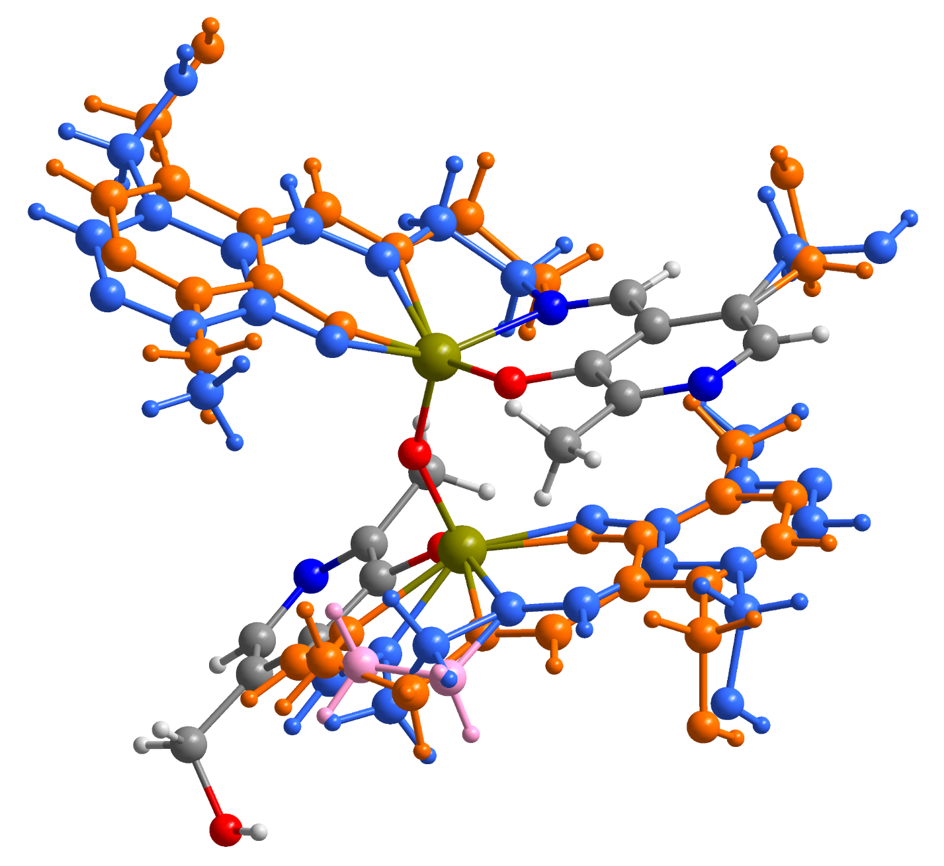
Fig. S1. The disorder in complex 1. The atoms are depicted as spheres of arbitrary radii. Water molecules were omitted for clarity. The positions with the highest occupancy are depicted in orange, the second most populated in blue, and the weakest in pink.
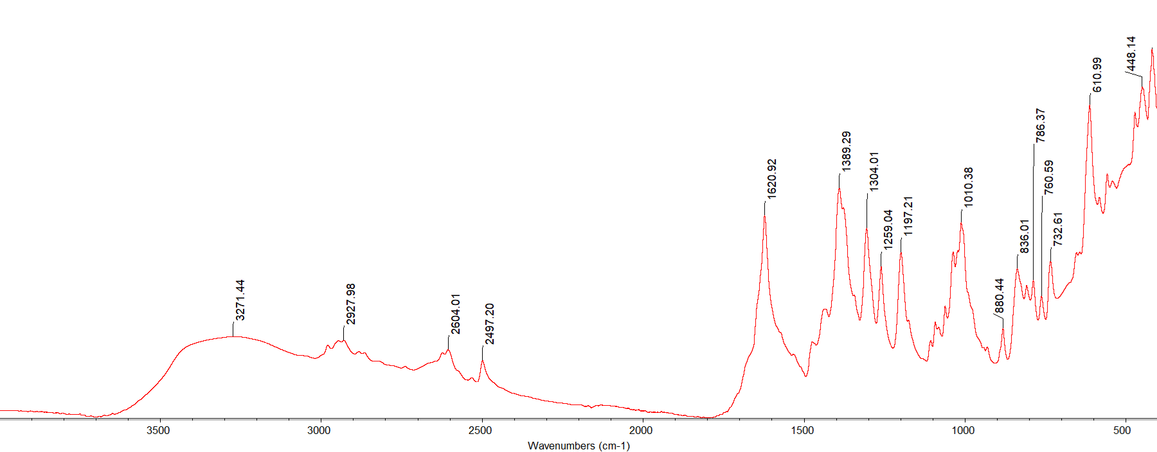

Fig. S2a. Infrared spectra of complex [{FeL}₂(μ-O)]·2.2H₂O (1).

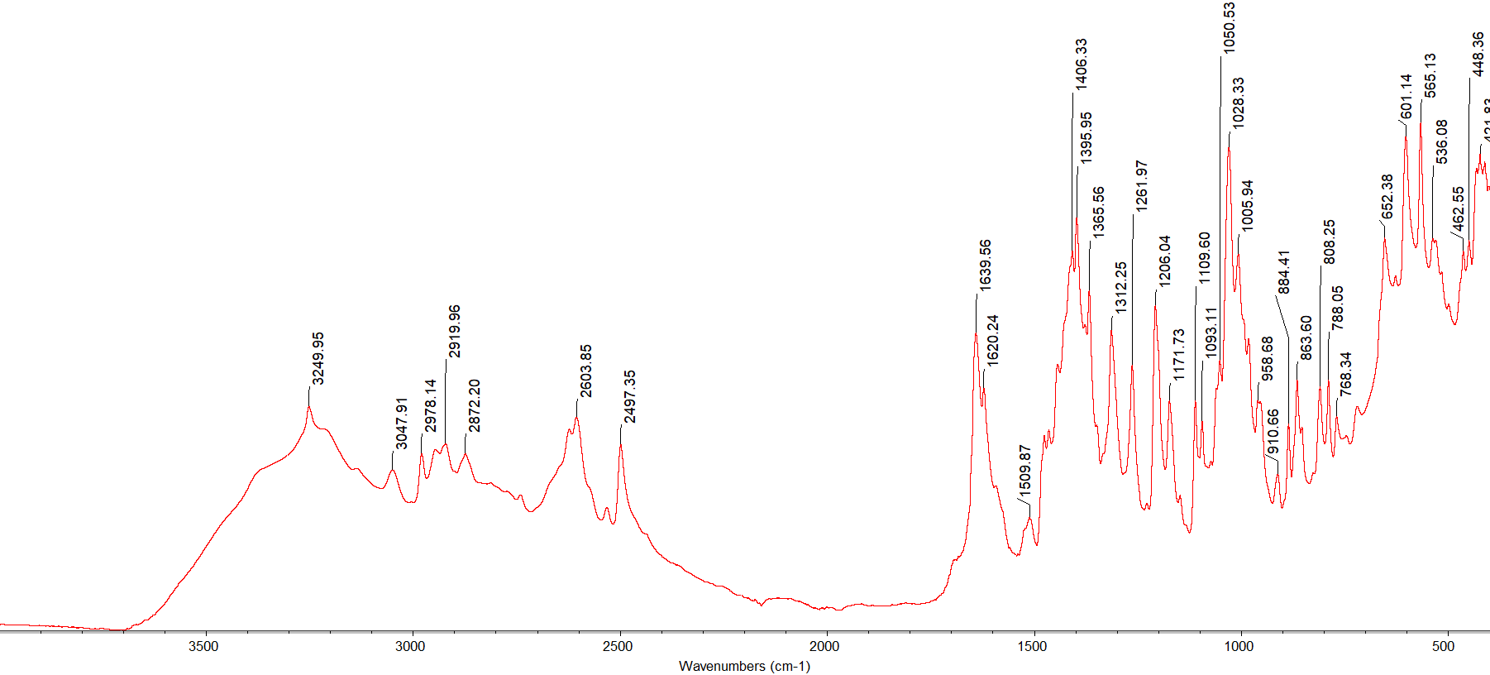

Fig. S2b. Infrared spectra of complex [NiL’(H₂O)]·2H₂O (2).
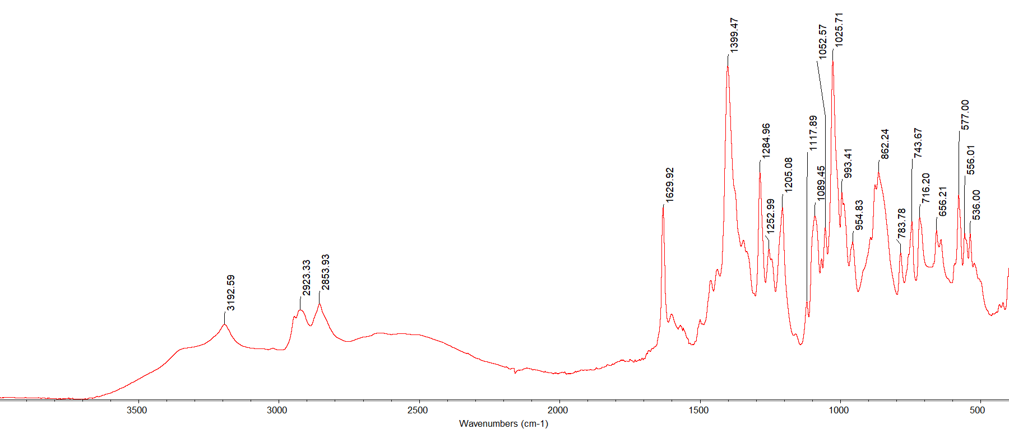

Fig. S2c. Infrared spectra of ligand H₂L’ [1].

Fig. S3. The positive ion mode ESI-MS full spectrum of complex [{FeL}₂(μ-O)]·2.2H₂O (1) and zoomed ESI-MS spectrum of the complex showing its specific isotopic profile.
Fig. S4. The negative ion mode ESI-MS full spectrum of complex [{FeL}₂(μ-O)]·2.2H₂O (1) and zoomed ESI-MS spectrum of the complex showing its specific isotopic profile.
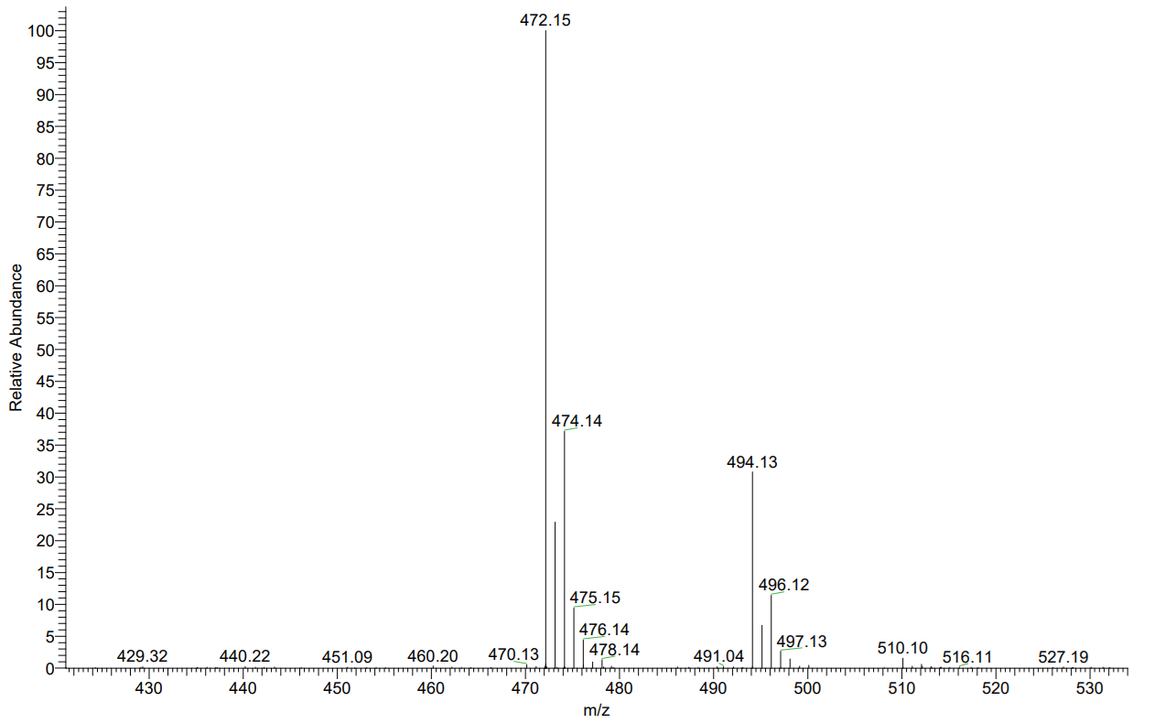
Fig. S5. The positive ion mode ESI-MS full spectrum of complex [NiL’(H₂O)]·2H₂O (2) and zoomed ESI-MS spectrum of the complex showing its specific isotopic profile.
Fig. S6. The negative ion mode ESI-MS full spectrum of complex [NiL’(H₂O)]·2H₂O (2) and zoomed ESI-MS spectrum of the complex showing its specific isotopic profile.
Magnetic model
A theoretical model that incorporates ZFS was employed for the theoretical evaluation of experimental magnetic data. The spin-Hamiltonian for a = x, y, z directions was proposed for the mononuclear system (Eq. S1) [2]:
${\hat{H}}_{a}^{zfs}= {\hat{H}}_{a}^{s-B}+{\hat{H}}^{s-s}={\overline{h}}^{-1}μ_{B}g_{a}B_{a}{\hat{S}}_{a}+{\overline{h}}^{-2}\left[D\left({\hat{S}}_{z}^{2}-{\hat{S}}^{2}/3\right)+E\left({\hat{S}}_{x}^{2}-{\hat{S}}_{y}^{2}\right)\right]$ (S1)

where the initial term denotes the Zeeman contribution, while the second term represents the zero-field splitting (ZFS) characterized by the axial ZFS parameter D and the rhombic ZFS parameter E.
The matrix elements related to the ZFS part are detailed in Table S1 [3].

Table S1. Spin-spin interaction matrix for ZFS system, S = 5/2.
$$\left(\begin{aligned}\begin{matrix}\left(10/3\right)D & 0 & \sqrt{10}E \\ 0 & -\left(2/3\right)D & 0 \\ \sqrt{10}E & 0 & -\left(8/3\right)D\end{matrix} \\ \begin{matrix} 0 & \sqrt{18}E & 0 \\ 0 & 0 & \sqrt{18}E \\ 0 & 0 & 0\end{matrix}\end{aligned} \begin{aligned}\begin{matrix}0 & 0 & 0 \\ \sqrt{18}E & 0 & 0 \\ 0 & \sqrt{18}E & 0\end{matrix} \\ \begin{matrix} -\left(8/3\right)D & 0 & \sqrt{10}E \\ 0 & -\left(2/3\right)D & 0 \\ \sqrt{10}E & 0 & \left(10/3\right)D\end{matrix}\end{aligned}\right)$$

The Hamiltonian ${\hat{H}}_{a}$ (D, E, g_{a}) yields three groups of eigenvalues: ε_{i,z}, ε_{i,x}, and ε_{i,y}, which can be derived through the diagonalization of the matrix. To obtain an analytical expression for the energy levels, the Taylor expansion is utilized (Eq. S2):
$ε_{i,a}= {ε_{i,a}^{\left(0\right)}+ε}_{i,a}^{\left(1\right)}B+ ε_{i,a}^{\left(2\right)}B^{2}$ (S2)

where the coefficients $ε_{i,a}^{\left(j\right)}$ result from a parabolic fitting of three sets of eigenvalues concerning the reference field B. Magnetization in the direction a = x, y, z is determined by differentiating the partition function Z=$\sum_{i}{\text{exp}\left(-ε_{i,a}/kT\right)}$ regarding the applied magnetic field (Eq. S3) [2].

$M_{a}=\frac{N_{A}}{Z_{a}}\left(\frac{∂Z_{a}}{∂B_{a}}\right)=\frac{N_{A}}{Z_{a}} \sum_{i}{\left(-\frac{∂ε_{i,a}}{∂B_{a}}\right)\text{exp}\left(-ε_{i,a}/kT\right)}$ (S3)

Magnetic susceptibility is defined as the proportion of magnetization and magnetic field (Eq. S4), analogous to the treatment of the experimental magnetic moment data.
$χ_{a}=\frac{N_{A}}{ZB}\sum_{i}{\left(-\frac{∂ε_{i,a}}{∂B_{a}}\right)\text{exp}\left(-ε_{i,a}/kT\right)}$ (S4)

References

1. Murašková V, Eigner V, Dusek M, Sedmidubský D (2021) Iron(III) and cobalt(III) complexes with pentadentate pyridoxal Schiff base ligand - structure, spectral, electrochemical, magnetic properties and DFT calculations. Polyhedron 197:115019. https://doi.org/10.1016/j.poly.2021.115019
2. Boča R (2012) A handbook of magnetochemical formulae. Elsevier, San Francisco;San Diego;Heidelberg;Oxford;Tokyo;Singapore;Paris;Boston;Amsterdam;London;Sydney;
3. Boča R (2004) Zero-field splitting in metal complexes. Coord Chem Rev 248:757–815 . https://doi.org/http://dx.doi.org/10.1016/j.ccr.2004.03.001

