SUPPLEMENTAL INFORMATION
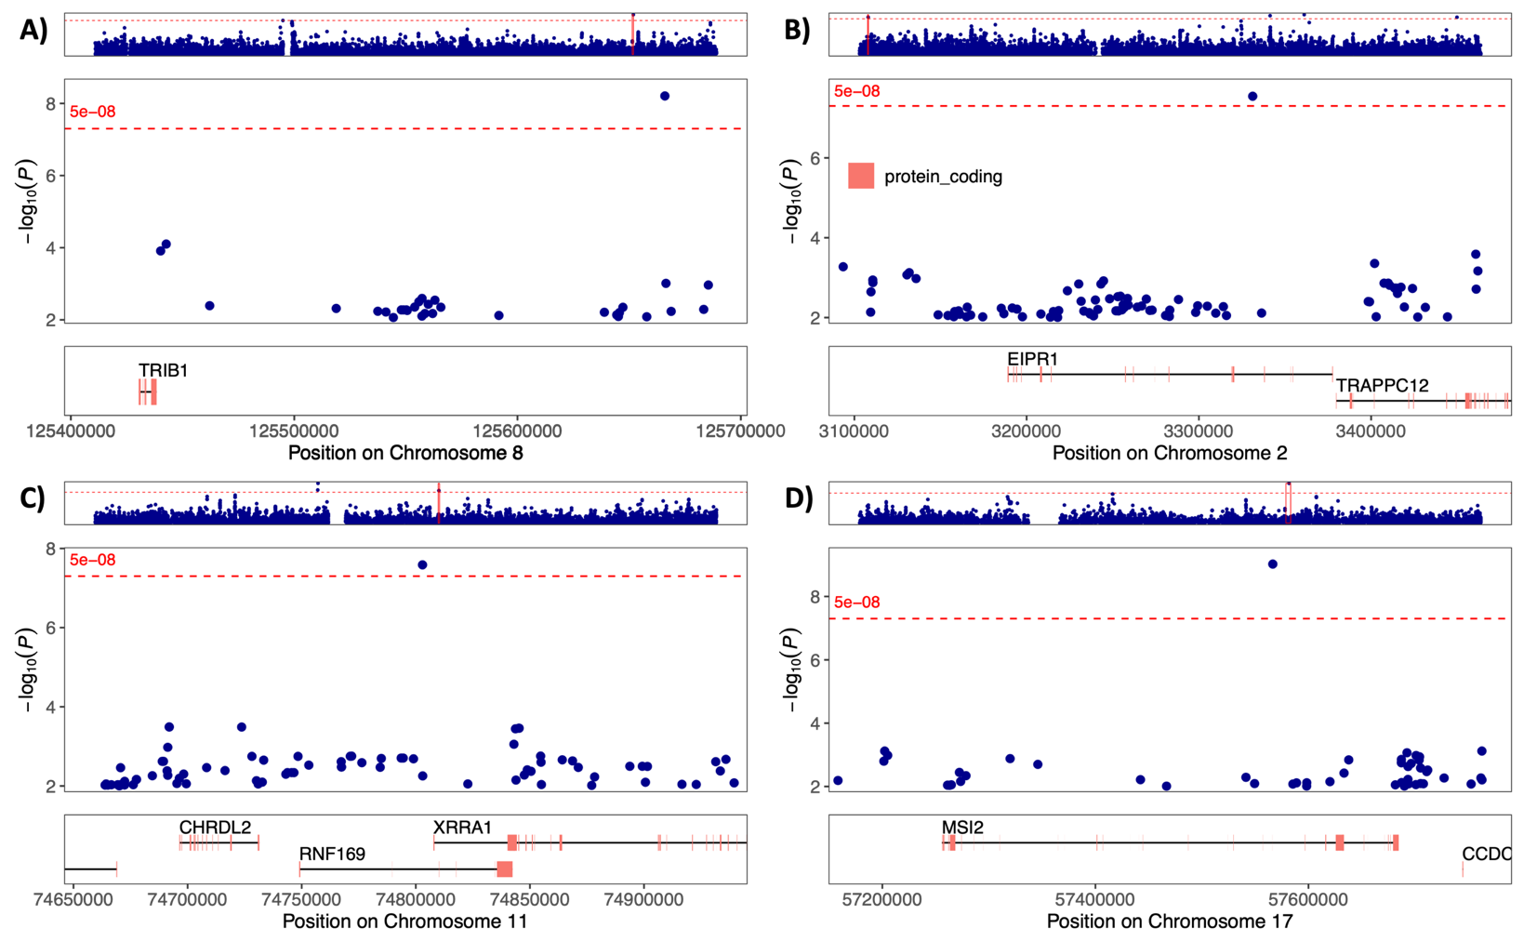
Figure S1. Region plots illustrating singletons for Nephrotic Syndrome in the Multi-ancestry group, A) TRIB1 Region, B) EIPR1 Region, C) RNF169 Region, D) MSI2 Region. The x-axis displays the genomic position across chromosomes. The y-axis displays the -log10(P). The red horizontal line represents the Bonferroni-corrected significance threshold of P = 5.0x10⁻⁸.

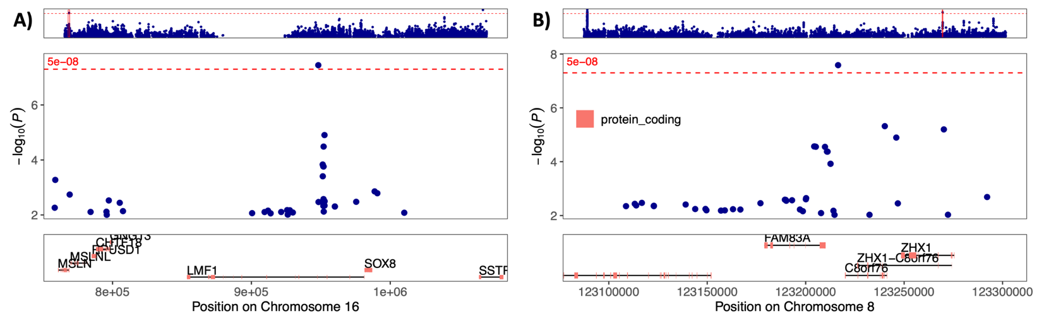
Figure S2. Region plots illustrating suspected singletons for Nephrotic Syndrome in the Multi-ancestry group, , A) LMF1 Region, B) FAM83A Region. The x-axis displays the genomic position across chromosomes. The y-axis displays the -log10(P). The red horizontal line represents the Bonferroni-corrected significance threshold of P = 5.0x10⁻⁸.

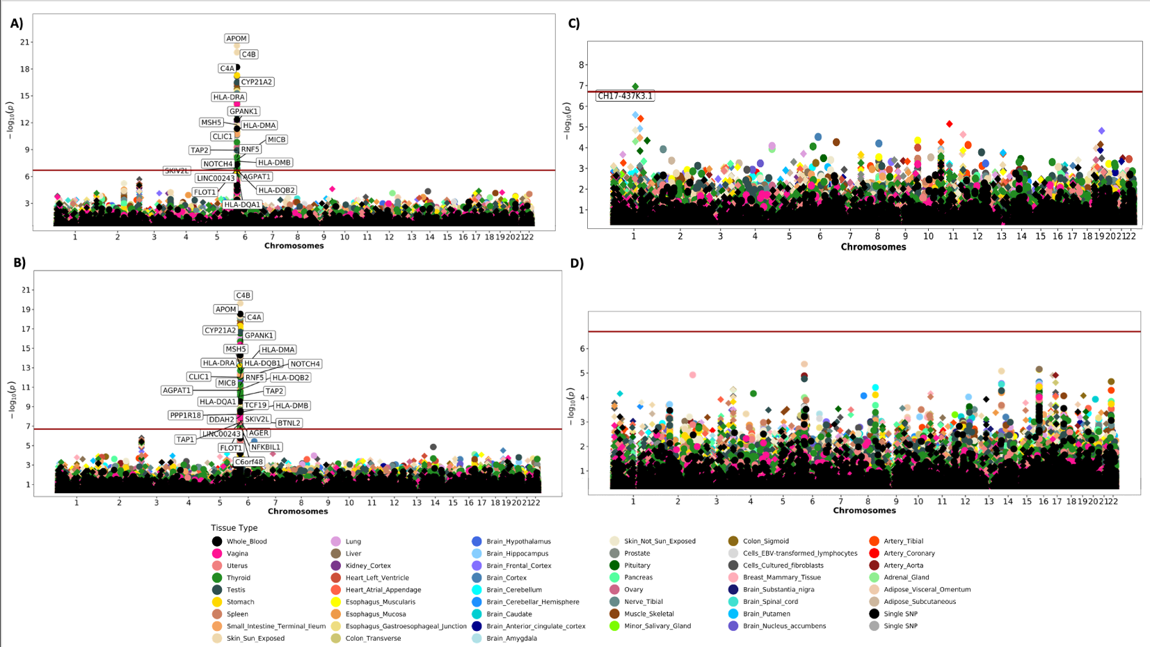
Figure S3. Miami plots illustrating GPGE results for Nephrotic Syndrome in each ancestry group, A) Multi-ancestry B) NH-EUR ancestry C) NH-AFR ancestry D) EAS ancestry. The x-axis displays the genomic position across chromosomes. The y-axis displays the -log10(P) for each gene-tissue pair. The red horizontal line represents the Bonferroni-corrected significance threshold of P = 1.55x10⁻⁶.

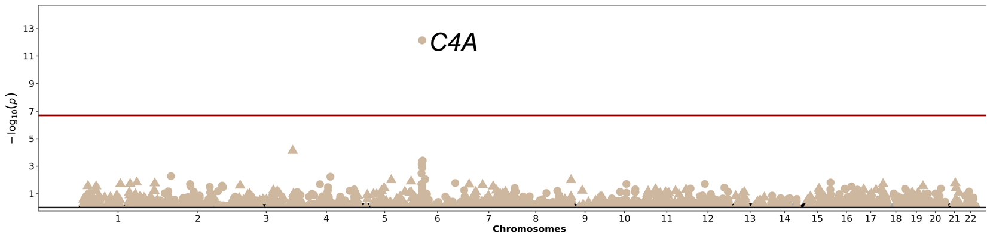
Figure S4. GPGE analysis for the multi-ancestry group pinpointing the C4A gene in the kidney cortex. The x-axis represents genomic locations, and the y-axis shows -log10(P) for associations between gene expression and nephrotic syndrome. The horizontal red line indicated Bonferroni corrected significant (P = 1.55x10⁻⁶).

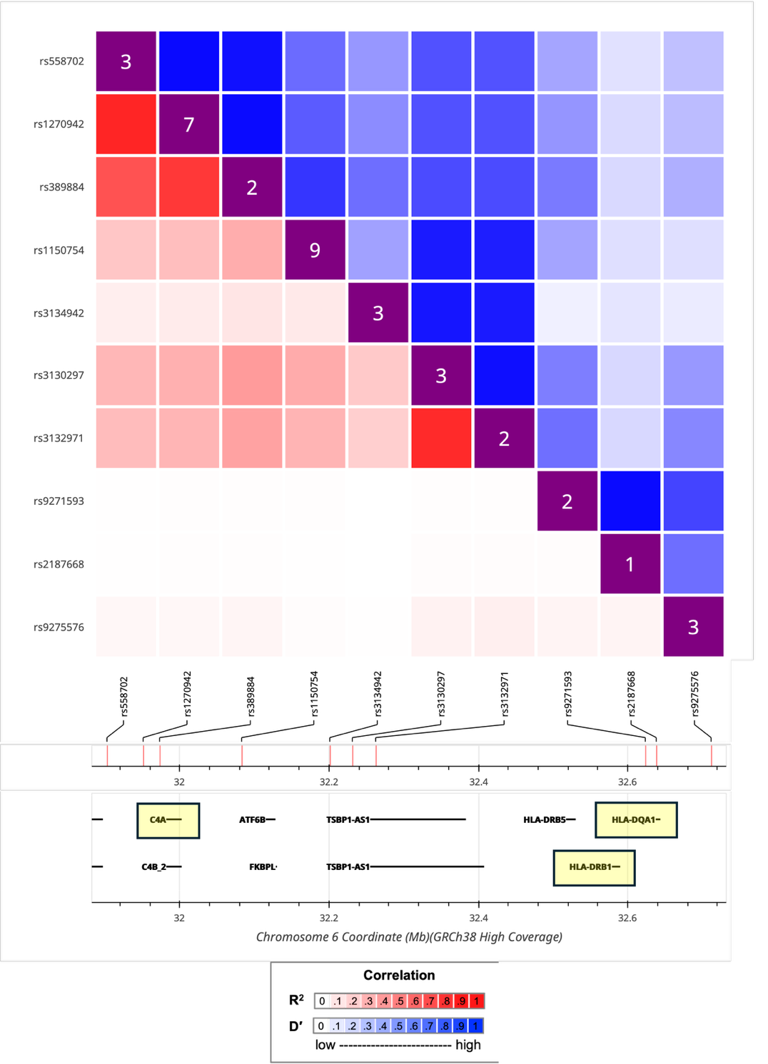
Figure S5. LD and D’ matrix of the HLA Region Comparing 8.1 Ancestral Haplotype and C4A expression Quantitative Trait Loci

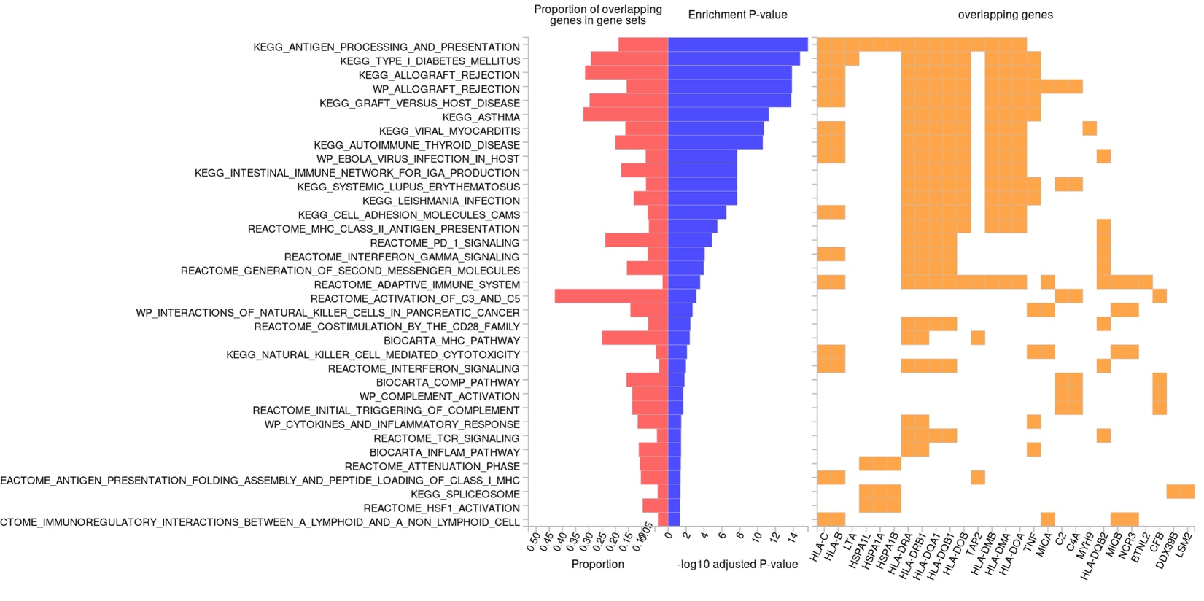
Figure S6. Canonical pathway analysis results using FUMA for multi-ancestry GWAS data. The y-axis represents individual pathways identified through gene-set enrichment analysis, and the x-axis shows the -log10(P) of their enrichment significance as well as the proportion of overlapping genes in the gene sets. Pathways are listed in order of significance.

