Supplementary material
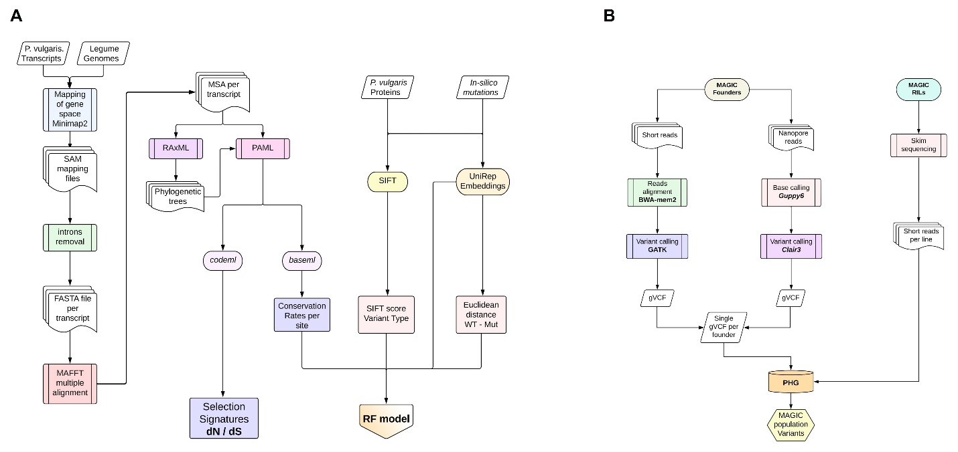
Figure S1. Bioinformatic pipeline for the identification of selection signatures and Random Forest (RF) model training (A), and valiant calling and imputation using the Practical Haplotype Graph (PHG) for the MAGIC population (B). WT: Wild type, SIFT: Sorting Intolerant from Tolerant. MAGIC: Multiparent Advanced Generation Inter-cross.
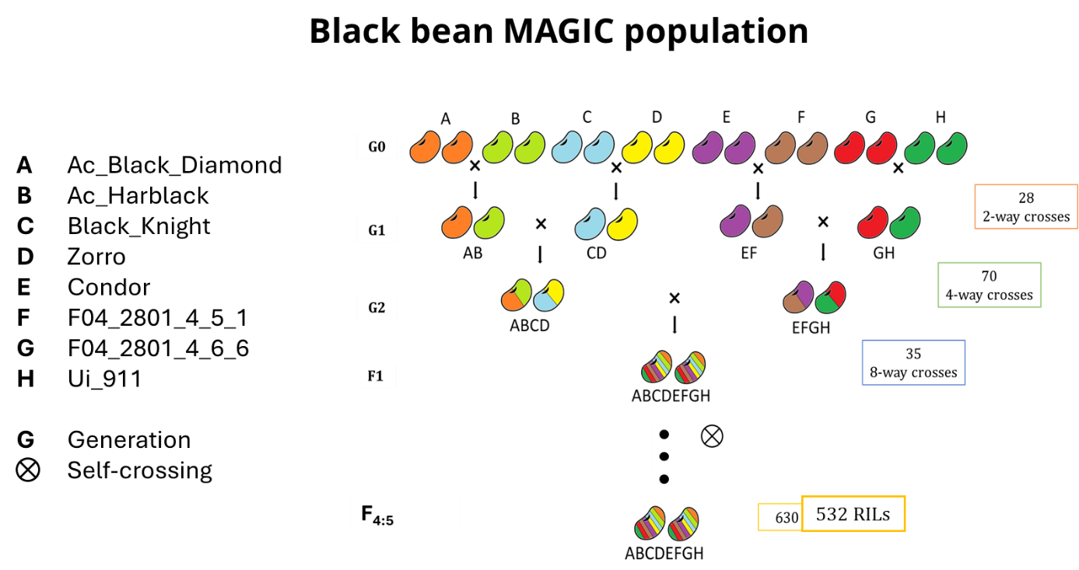
Figure S2. Schematic representation of the crossing scheme for the black bean MAGIC population. The two-way crosses were multi-funnel (diallelic) having all the parental combinations. Crosses with the same parents either as female or male were considered reciprocal.

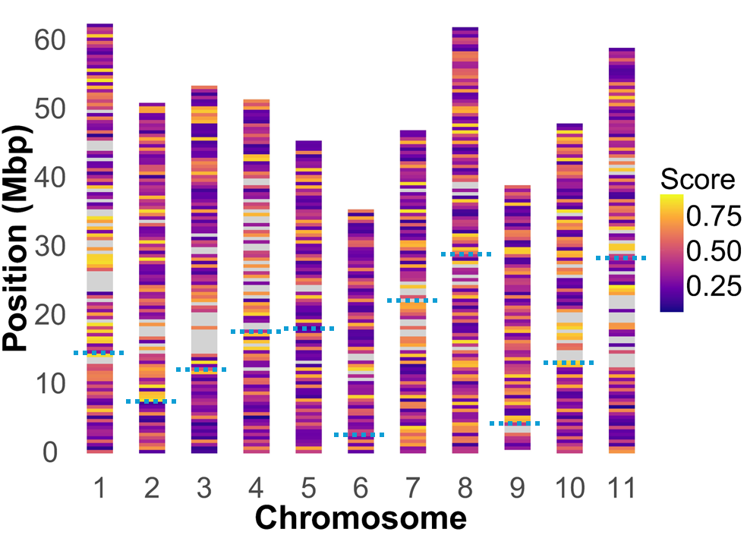
Figure S3. Distribution of deleterious scores per chromosome based on the sequencing of the eight parents of the black bean MAGIC population.
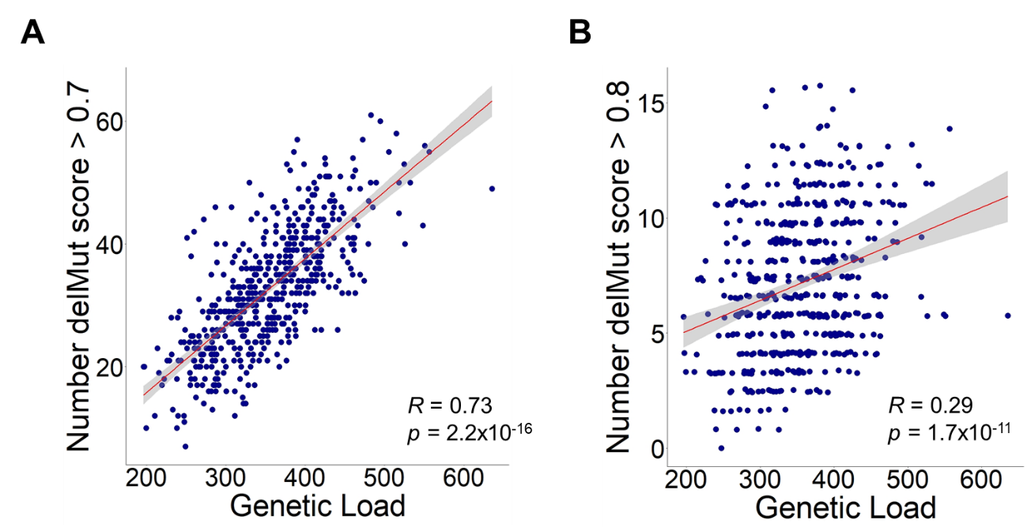
Figure S4. Correlation between the number of deleterious alleles with score > 0.70 (A) and > 0.80 (B) and genome-wise genetic load in MAGIC population RILs. Pearson’s correlation coefficient – R is indicated with the p-value of the test.

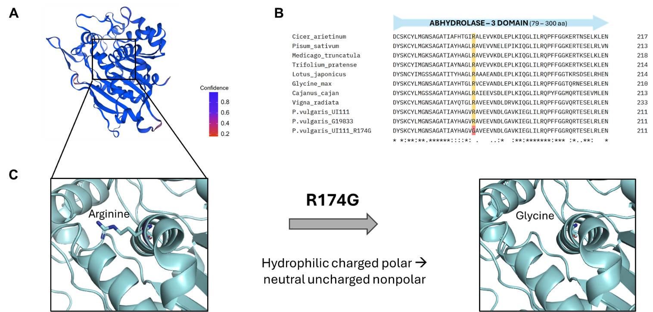
Figure S5. Predicted tertiary structure (A) and multiple sequence alignment (B) of the P. vulgaris UI111 Carboxylesterase 9-related protein (PvUI111.04G120200). Amino acid substitution predicted as deleterious in the AB hydrolase-3 protein domain (C).

References for Table S1
Espina, M.J.C., Lovell, J.T., Jenkins, J., Shu, S., Sreedasyam, A., Jordan, B.D., Webber, J., Boston, L.B., Brůna, T., Talag, J., Goodstein, D., Grimwood, J., Stacey, G., Cannon, S.B., Lorenz, A.J., Schmutz, J., Stupar, R.M., 2024. Assembly, comparative analysis, and utilization of a single haplotype reference genome for soybean. The Plant Journal 120, 1221–1235. https://doi.org/10.1111/TPJ.17026
Sanderson, L.A., Caron, C.T., Tan, R., Shen, Y., Liu, R., Bett, K. 2019. KnowPulse: A Web-Resource Focused on Diversity Data for Pulse Crop Improvement. Front. Plant Sci, 10. https://doi.org/10.3389/fpls.2019.00965.
Sato, S., Nakamura, Y., Kaneko, T., Asamizu, E., Kato, T., Nakao, M., Sasamoto, S., Watanabe, A., Ono, A., Kawashima, K., Fujishiro, T., Katoh, M., Kohara, M., Kishida, Y., Minami, C., Nakayama, S., Nakazaki, N., Shimizu, Y., Shinpo, S., Takahashi, C., Wada, T., Yamada, M., Ohmido, N., Hayashi, M., Fukui, K., Baba, T., Nakamichi, T., Mori, H., Tabata, S., 2008. Genome Structure of the Legume, Lotus japonicus. DNA Research 15, 227–239. https://doi.org/10.1093/DNARES/DSN008
Tang, H., Krishnakumar, V., Bidwell, S., Rosen, B., Chan, A., Zhou, S., Gentzbittel, L., Childs, K., Yandell, M., Gundlach, H., Mayer, K., Zchwartz, D., Town, C. 2014. An improved genome release (version Mt4.0) for the model legume Medicago truncatula. BMC Genomics 15, 312. https://doi.org/10.1186/1471-2164-15-312.

