Online Supplementary Material
Title: The Protective Role of Residential Greenness on Diabetes Risk and Insulin Sensitivity: Results from a Nationwide Cohort Studies

Characteristic | Model S1
Characteristic | OR | 95% CI | p-value
NDVI (continuous) | 0.44 | 0.23, 0.84 | 0.012
NDVI
Q1 | — | —
Q2 | 0.77 | 0.66, 0.89 | <0.001
Q3 | 0.92 | 0.79, 1.08 | 0.318
Q4 | 0.77 | 0.66, 0.89 | <0.001
P for trend |  |  | 0.011
Adjusted for Age, Gender, Education, Marital status, Residence, GDP, Annual household expenditure, Smoking status, Drinking status, Ever had heart problem, Ever had high blood pressure, Annual Average Temperature, PM2.5, and Annual Average Dryness.
Table S1: Association between NDVI and baseline diabetes risk.
NDVI, Normalized Difference Vegetation Index; GDP, Gross Domestic Product; PM2.5, Particulate Matter 2.5.

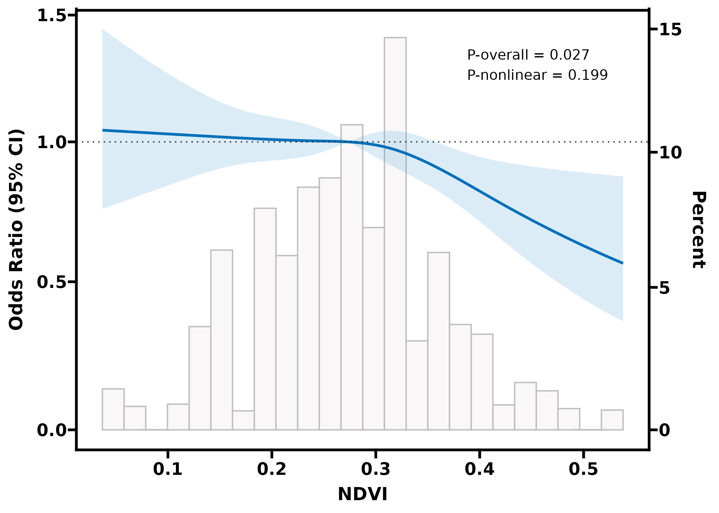
Adjusted for Age, Gender, Education, Marital status, Residence, GDP, Annual household expenditure, Smoking status, Drinking status, Ever had heart problem, Annual Average Temperature, PM2.5, and Annual Average Dryness.
Fig S1: RCS of association between NDVI and baseline diabetes risk.
RCS, Restricted Cubic Spline; NDVI, Normalized Difference Vegetation Index; GDP, Gross Domestic Product; PM2.5, Particulate Matter 2.5.

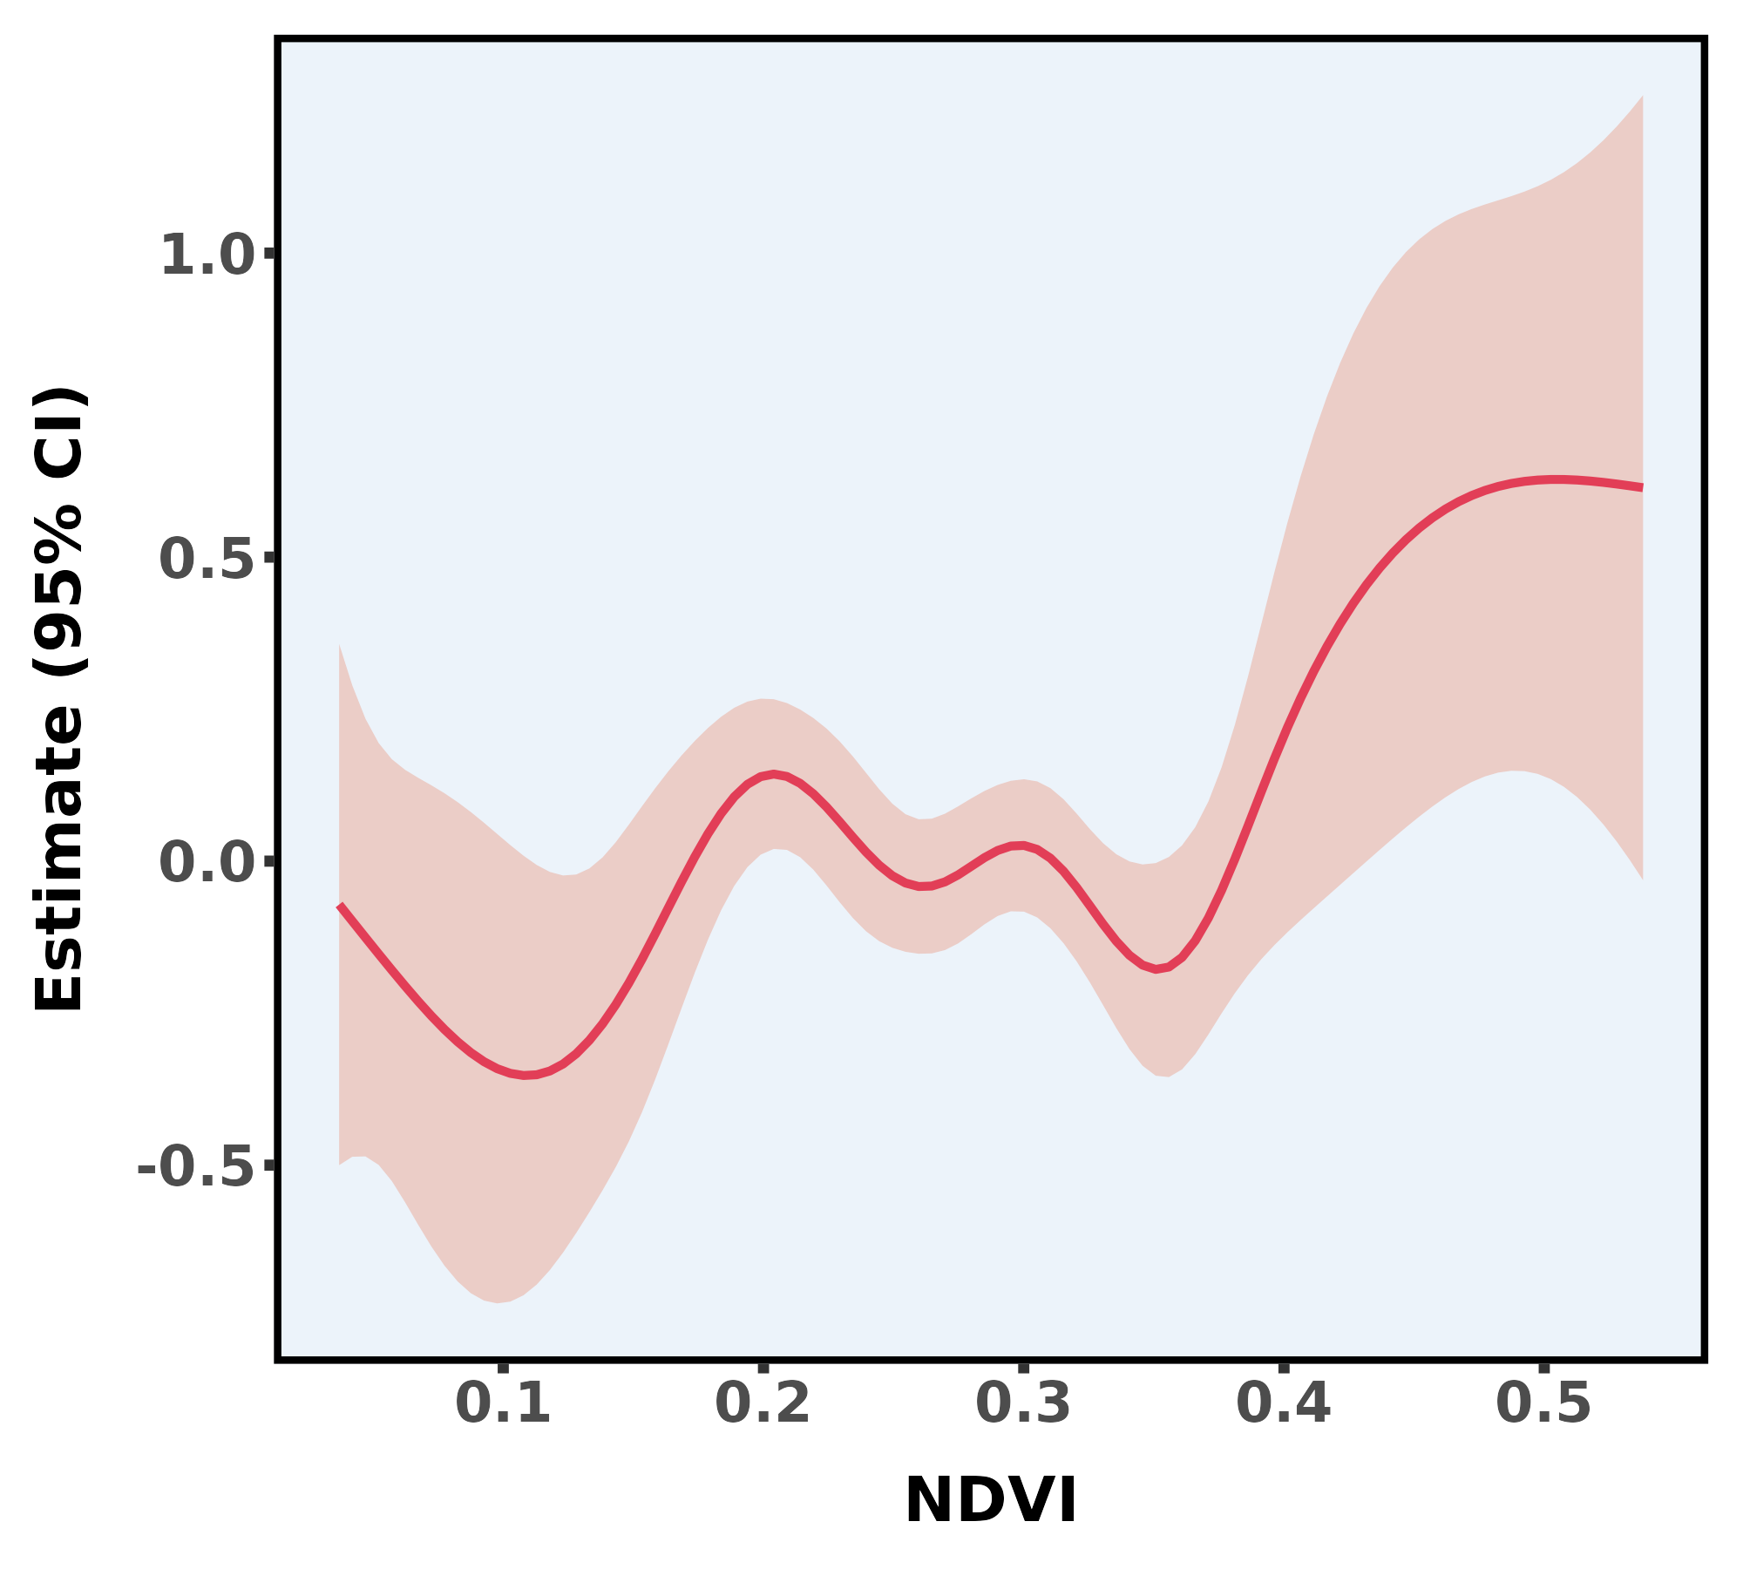
Adjusted for Age, Gender, Education, Marital status, Residence, GDP, Annual household expenditure, Smoking status, Drinking status, Ever had heart problem, Ever had high blood pressure, Annual Average Temperature, PM2.5, and Annual Average Dryness.
Fig S2: GAM of association between NDVI and baseline eGDR.
GAM, Generalized Additive Models; NDVI, Normalized Difference Vegetation Index; eGDR, the estimated glucose disposal rate; GDP, Gross Domestic Product; PM2.5, Particulate Matter 2.5.

 | Model S1
 | Beta | 95% CI | p-value
NDVI (continuous) × Time | 0.13 | -0.06, 0.32 | 0.175
NDVI
Q1 × Time
Q2 × Time | 0.08 | 0.03, 0.13 | 0.001
Q3 × Time | 0.01 | -0.04, 0.06 | 0.726
Q4 × Time | 0.08 | 0.03, 0.12 | <0.001
P for trend |  |  | 0.03
Adjusted for Age, Gender, Education, Marital status, Residence, GDP, Annual household expenditure, Smoking status, Drinking status, Ever had heart problem, Annual Average Temperature, PM2.5, and Annual Average Dryness.
Table S2: Linear mixed-effects model analysis of the association between NDVI and eGDR progression.
NDVI, Normalized Difference Vegetation Index; eGDR, the estimated glucose disposal rate; GDP, Gross Domestic Product; PM2.5, Particulate Matter 2.5.

