Performance and limitations of smartwatch estimation of VO₂max during free-living activity in non-athletes

Alexandra Jamieson¹, Lee Hamill Howes¹, Siana Jones¹, Yatharth Ranjan², Amos Folarin², Richard Dobson², Claire Steves³, Nicholas Timpson⁴, Nishi Chaturvedi¹, Alun D Hughes¹, Michele Orini^{1,5}

¹MRC Unit for Lifelong Health and Ageing, UCL, UK
²Department of Biostatistics and Health Informatics, King’s College London, UK
³Department of Twin Research and Genetic Epidemiology, King’s College London, UK
⁴MRC Integrative Epidemiology Unit, University of Bristol, UK
⁵Department of Biomedical Engineering, King’s College London, UK

Corresponding author:
Michele Orini
Address: St Thomas’s Hospital, Westminster Bridge Rd, London SE1 7EH
Email: m.orini@kcl.ac.uk (cc: alexandra.jamieson@ucl.ac.uk)

Supplementary Table 1
Supplementary Table 1. Single and multi-variable models of the associations between the absolute error (difference between smartwatch and CPET VO₂max) and possible factors affecting the accuracy of smartwatch VO₂max. CI (confidence interval), VO₂max (maximal oxygen consumption), %pVO₂max (percentage of predicted VO₂max), %pHRmax (percentage of predicted maximum heart rate).
 | Single variable model |  |  |  | Multi-variable model
Parameter | Beta | CI1 | CI2 | p-value | Beta | CI1 | CI2 | p-value
%pVO2max [-1SD] | 0.72 | 0.63 | 0.82 | 6.0E-34 | 0.66 | 0.55 | 0.77 | 4.0E-25
Valid days [-1SD] | 0.20 | 0.06 | 0.34 | 4.1E-03 | 0.11 | 0.02 | 0.21 | 2.1E-02
%pHRmax [-1SD] | 0.42 | 0.30 | 0.55 | 3.8E-10 | 0.11 | 0.00 | 0.22 | 5.9E-02
Light Activity [yes] | 0.59 | 0.23 | 0.94 | 1.5E-03 | -0.04 | -0.32 | 0.24 | 7.7E-01
Fatigue [yes] | 0.06 | -0.27 | 0.38 | 7.3E-01 | -0.07 | -0.30 | 0.17 | 5.7E-01
Long COVID [yes] | -0.04 | -0.32 | 0.24 | 7.8E-01 | -0.09 | -0.30 | 0.12 | 3.9E-01

Supplementary Figure 1
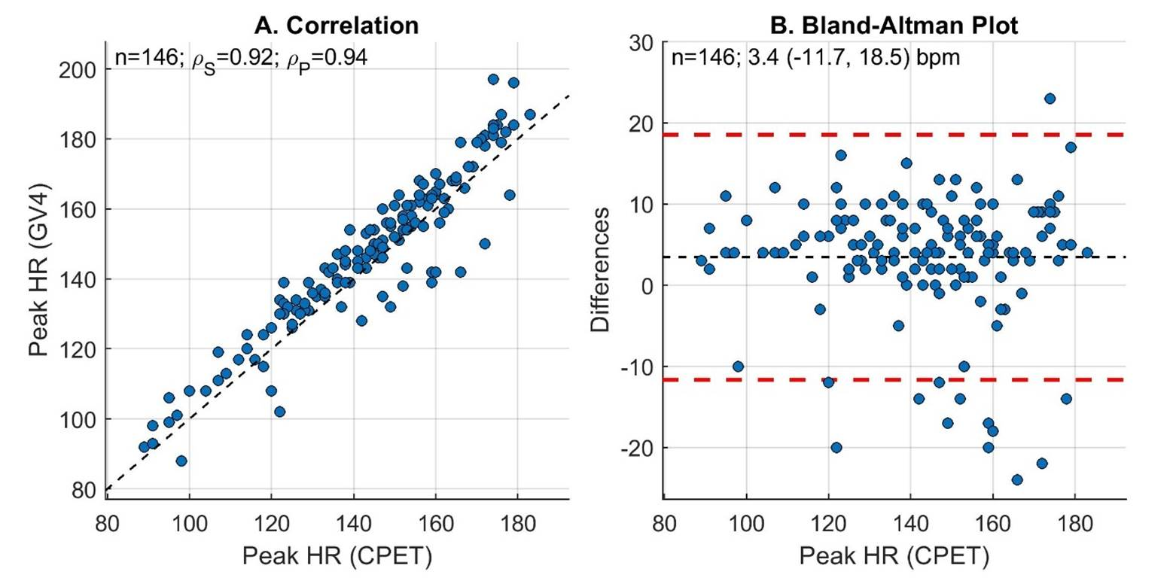
Supplementary Figure 1. Correlation and Bland-Altman plots demonstrating levels of agreement between smartwatch (GV4) peak heart rate (HR) and peak HR measured by cardiopulmonary exercise test (CPET). In the correlation plot, the identity line is reported in black. In the Bland-Altman plot, bias and limits of agreement are reported in black and red, respectively.

Supplementary Equations
Wasserman, K., et al., Principles of exercise testing and interpretation: including pathophysiology and clinical applications. Medicine and Science in Sports and Exercise, 2005. 37(7): p. 1249.
Reference equations from Wasserman and Whipp's textbook, Principles of exercise testing and interpretation, Chapter 7, Tables 7.2 & 7.3:
For men:
Ideal weight (kg) = 0.79 × height (cm) − 60.7
If actual weight equals or exceeds ideal weight:
Peak VO₂ = 0.0337 × height − 0.000165 × age × height − 1.963 + 0.006 × weight (actual − ideal)
If actual weight is less than ideal weight:
Peak VO₂ = 0.0337 × height − 0.000165 × age × height − 1.963 + 0.014 × weight (actual − ideal)
(Use age of 30 years old for adults younger than 30 years old)
For women:
Ideal weight (kg) = 0.65 × height (cm) − 42.8
Peak VO₂ = 0.001 × height × (14.783 − 0.11 × age) + 0.006 × weight (actual − ideal)
(Use age of 30 years old for adults younger than 30 years old)

