Supplementary material
Nanoparticle-enhanced multi-target RNAi in Myzus persicae: molecular mechanisms, cross-kingdom siRNA transfer, and efficacy for sustainable pest management
Rusul A. Alghadab^{1,2} and Leonardo Velasco¹
¹Instituto Andaluz de Investigación y Formación Agraria (IFAPA), 29140 Churriana, Málaga, Spain
²Universidad de Málaga, Málaga, Spain

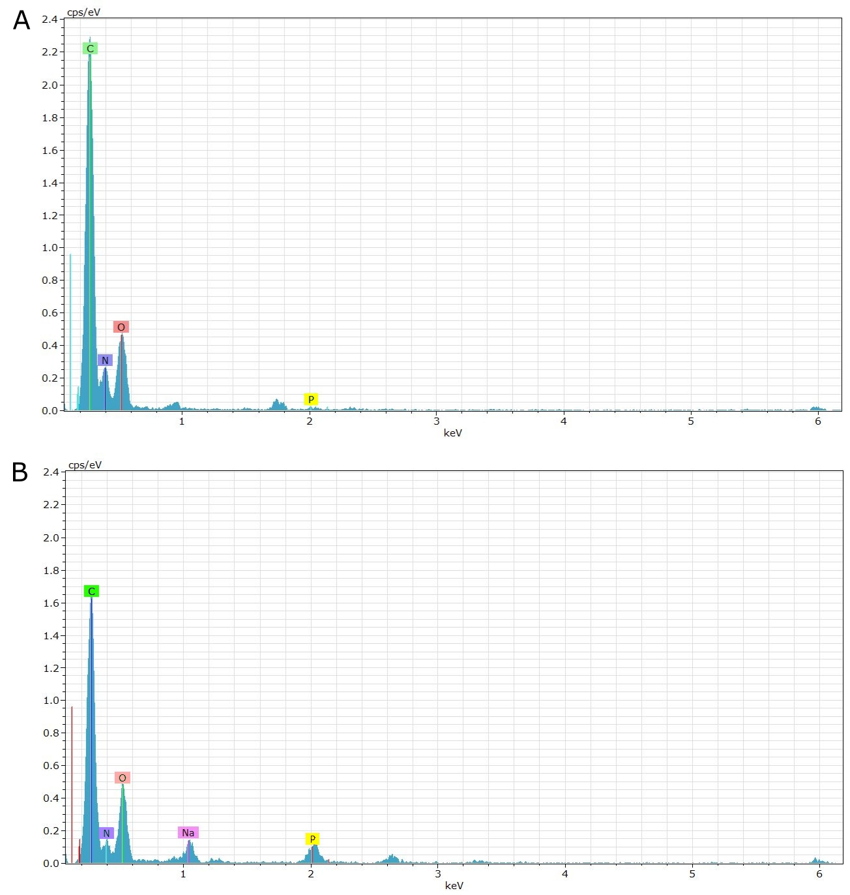
Supp. Fig. 1. Energy-dispersive X-ray spectroscopy (EDX) analytical spectra of chitosan nanoparticles and ChNP loaded with double-stranded RNA (ChNP:dsRNA), acquired using a ChemiSTEM Super-X detector on a Talos F200X electron microscope. The spectra are plotted as counts per second per electron volt (cps/eV) over the 0–6 keV range. A) ChNP shows strong peaks for carbon (C), nitrogen (N), and oxygen (O), which are characteristic of chitosan and TPP. There is no detectable phosphorus (P) signal, indicating the absence of nucleic acids in the sample. B) ChNP:dsRNA displays pronounced peaks for C, N, and O, and, importantly, a clear phosphorus (P) Kα signal at ~2.01 keV, marking the presence of the phosphate backbone from adsorbed dsRNA. Sodium (Na) is also detected, likely from TPP or buffer components. Elemental peaks are color-coded: C, N (blue), O (green), Na (pink), and P (magenta) for ease of identification. Both spectra confirm the elemental composition changes that accompany dsRNA complexation with chitosan nanoparticles.

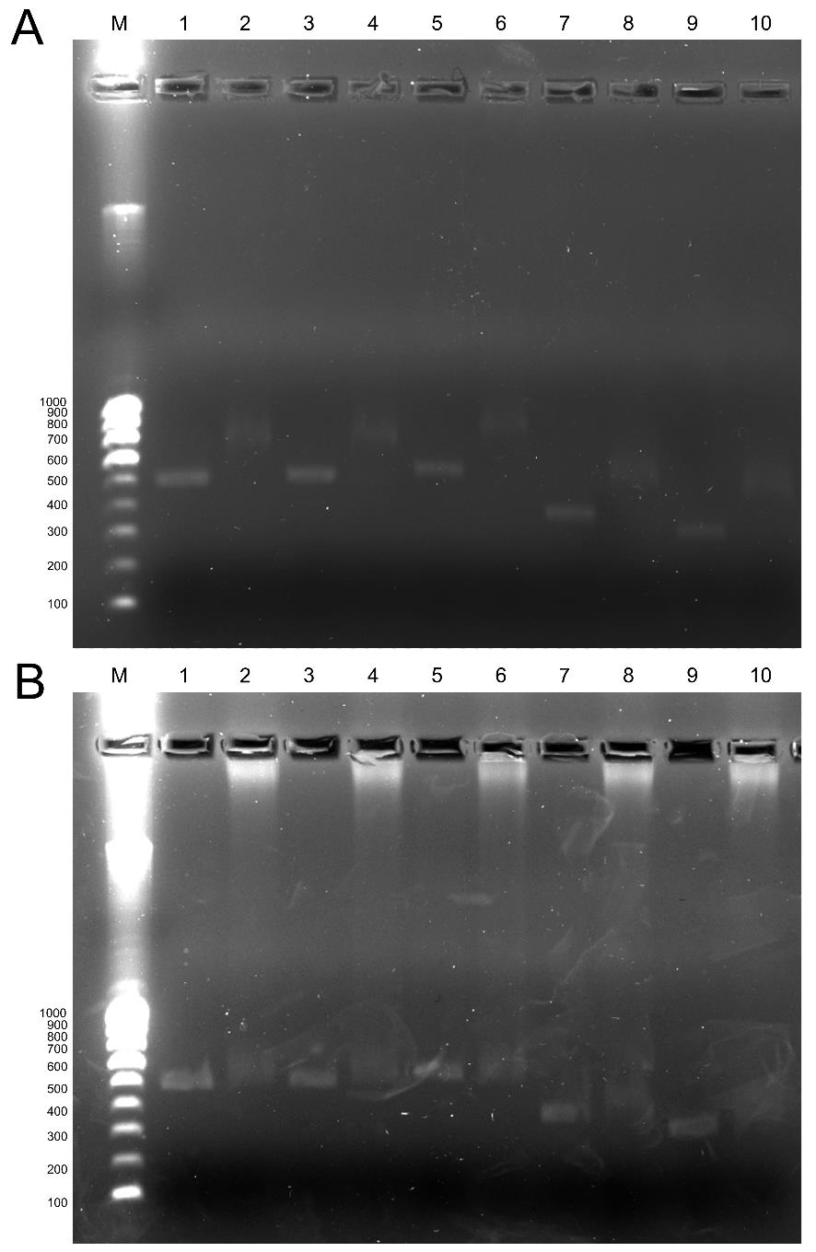
Supp. Fig. 2. Agarose retardation gels of pristine dsRNAs and nanoparticle-coated dsRNA. (A) Pristine dsRNAs of ACE, CARB, NACHR, P450, and YA1 (lanes 1, 3, 5, 7, 9) and the corresponding dsRNAs coated with ChNPs at a 4:1 ratio (lanes 2, 4, 6, 8, 10). (B) The same dsRNAs and the CD-coated dsRNAs at 4:1 ratios. M, NZYTech 100‑bp ladder.

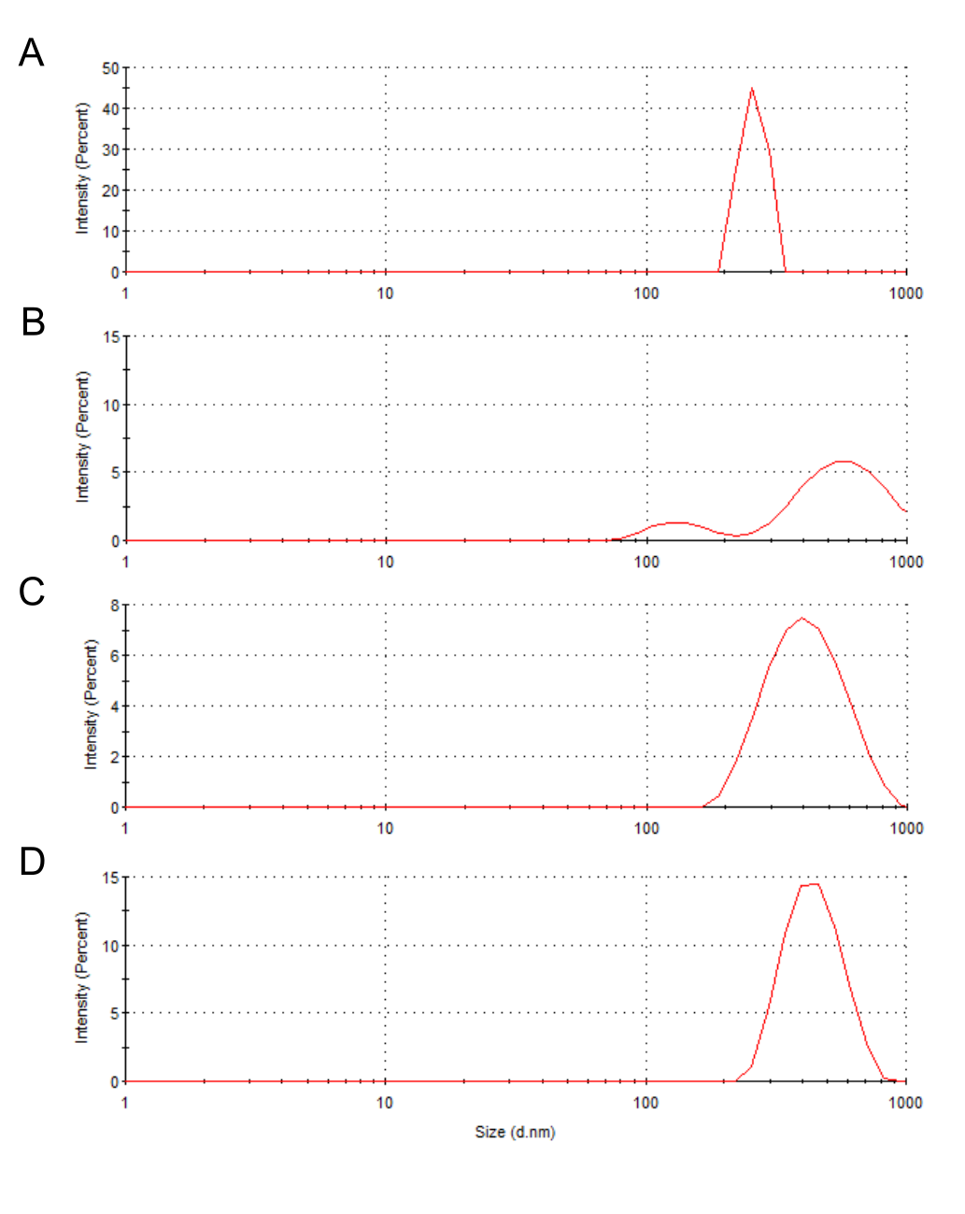
Supp. Fig. 3. Hydrodynamic size (DLS) determined from different ChNP preparations. The ChNPs were prepared using the same amounts and ratios of deacetylated chitosan and TPP but changing the amount of Tween 80 in the chitosan precursor (A) 0.01%, (B) 0.02%, (C) 0.05% and (D) 0.1%.

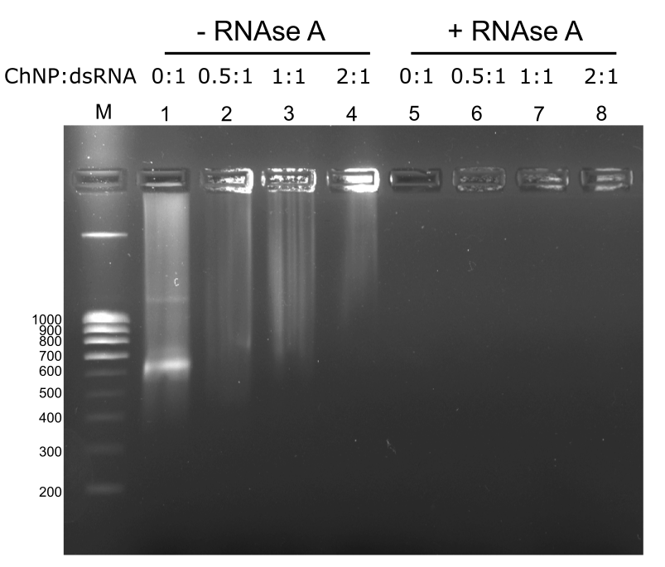
Supp. Fig. 4. Gel retardation assay of ChNP:dsRNA (dsACHE) complexes with and without RNase A. A fixed amount of dsRNA was mixed with chitosan nanoparticles at the indicated mass ratios (ChNP:dsRNA = 0:1, 0.5:1, 1:1, 2:1), incubated to allow complexation, and then either left untreated (lanes 1–4) or digested with RNase A (1 U per µg dsRNA; lanes 5–8) before electrophoresis on a 2% agarose gel. In the absence of RNase A, increasing ChNP promoted retention of dsRNA in the wells, consistent with complex formation. Following RNase treatment, the dsRNA band disappeared in all formulations, indicating degradation despite complexation; ChNPs did not protect dsRNA from RNase A under these conditions. M, NZYTech 100‑bp ladder.

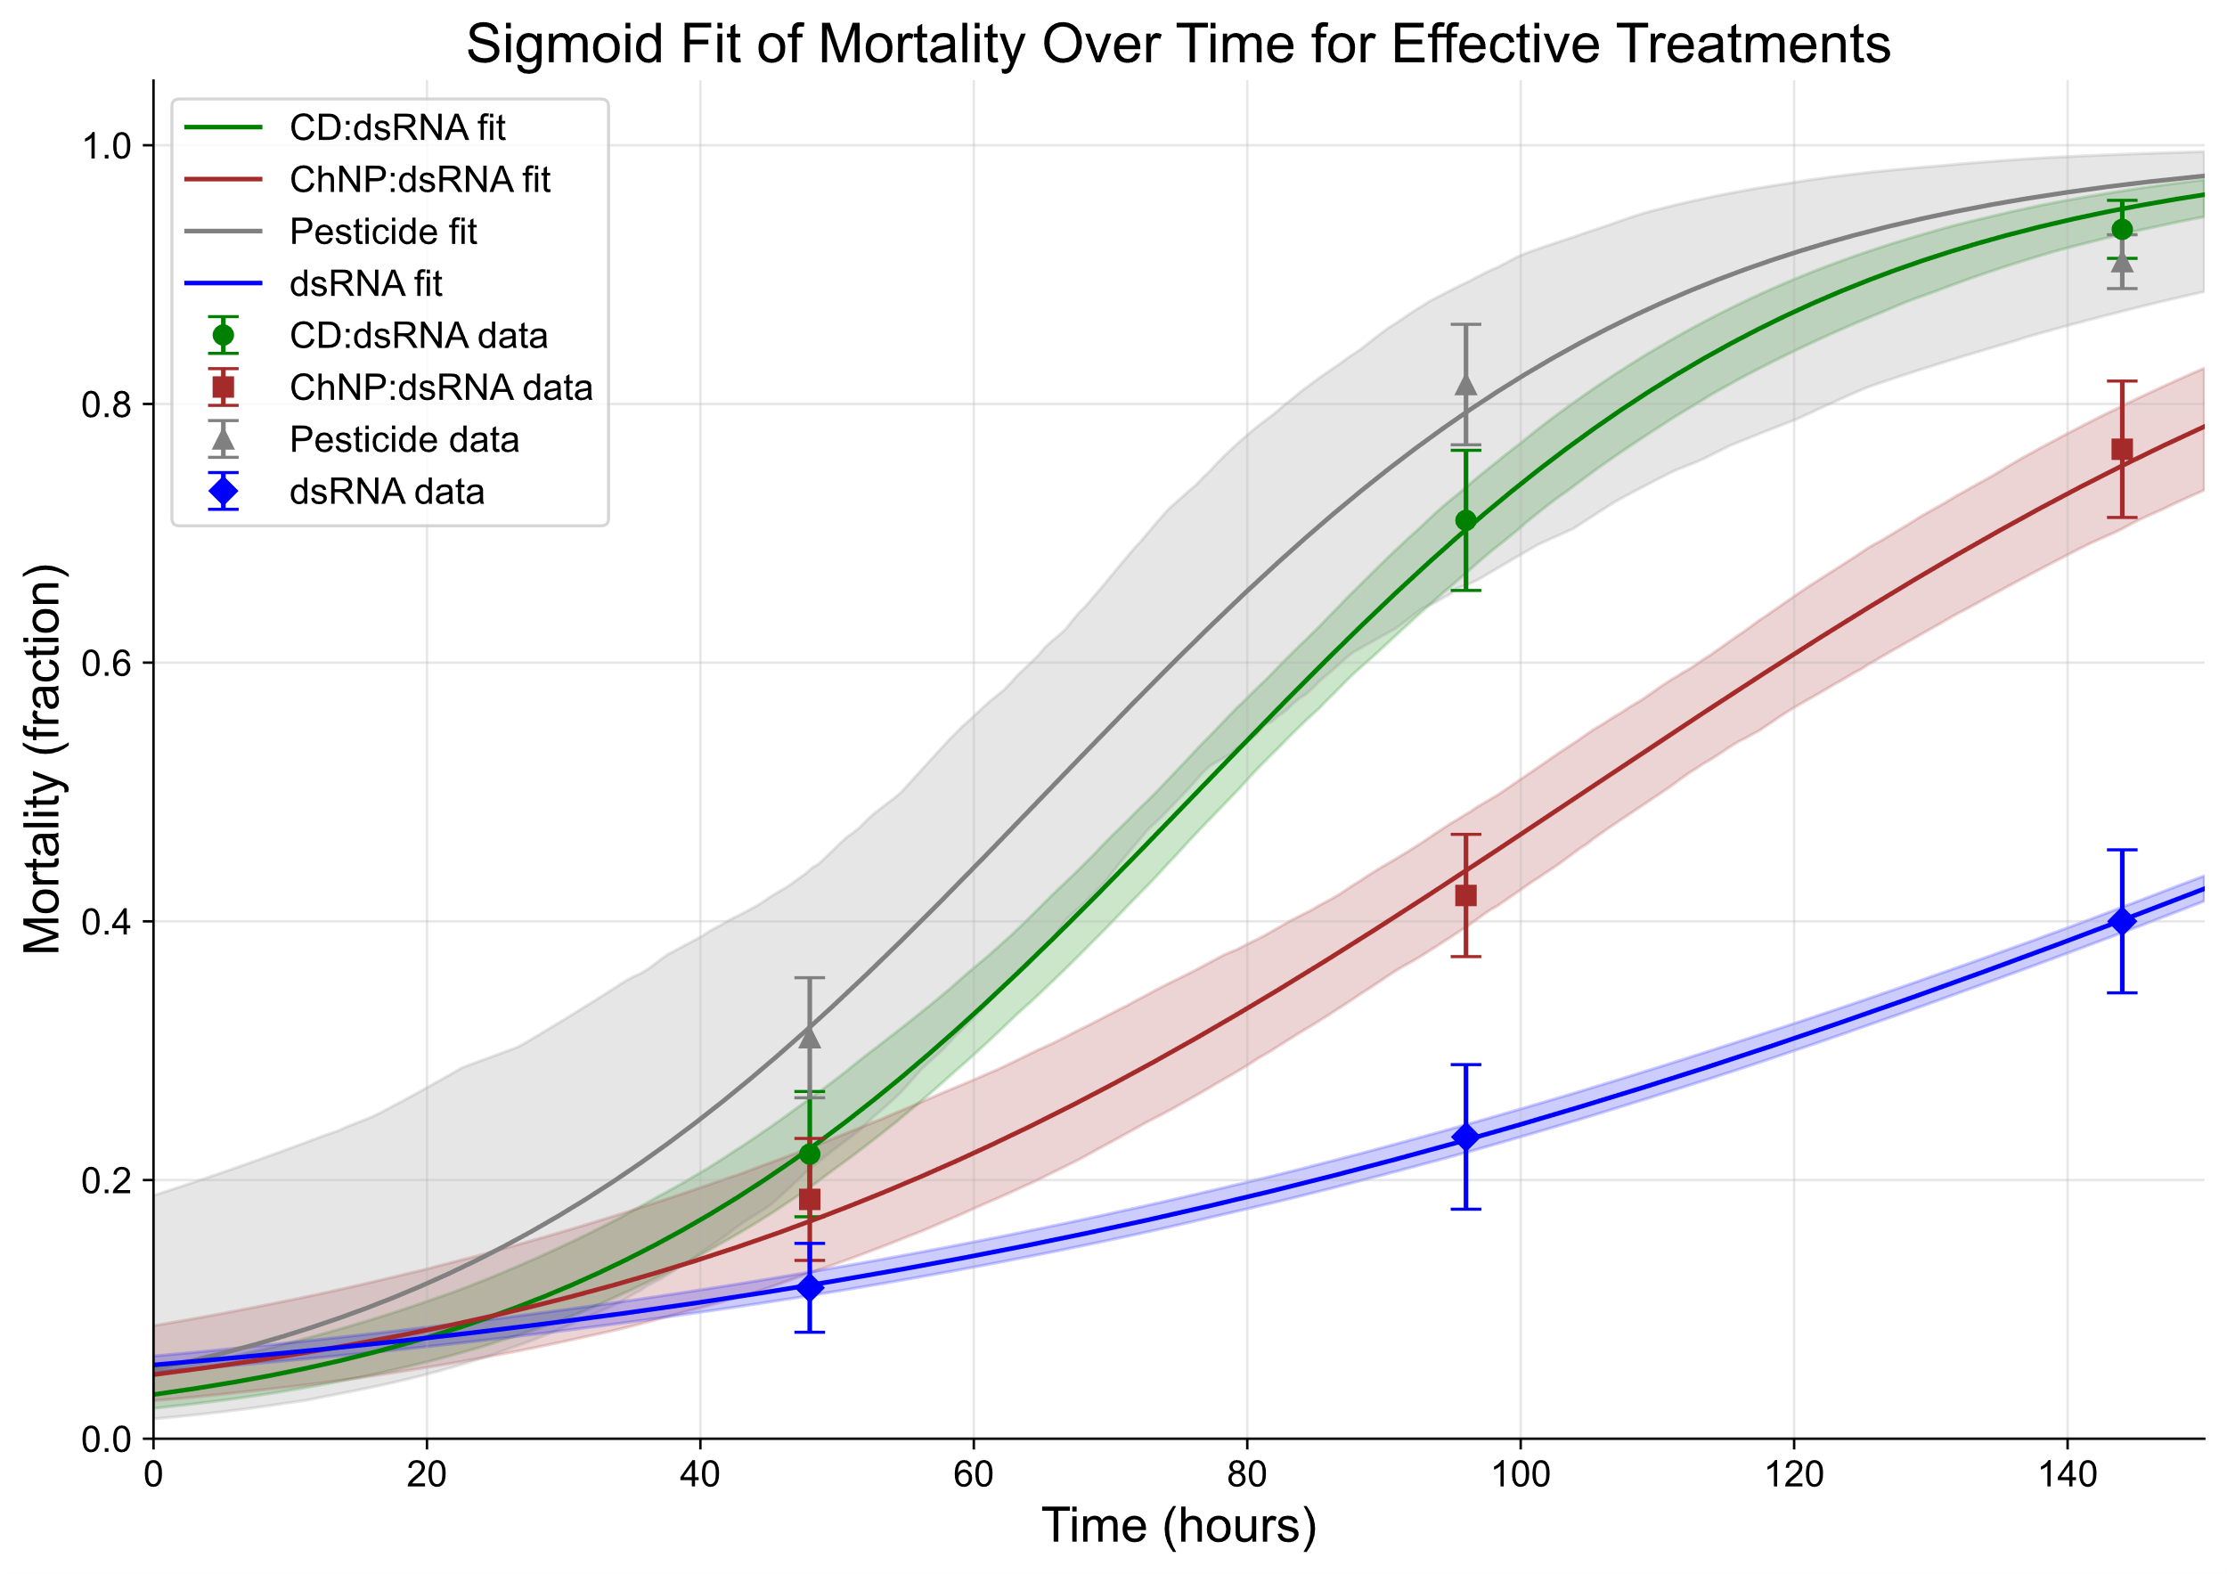
Supp. Fig. 5. Sigmoid curves of mortality progression in Myzus persicae exposed to different dsRNA treatments and pesticide. The plot shows mortality rates (as a fraction) of aphids over time (hours) following treatment application. Data points (markers with error bars indicating standard error.

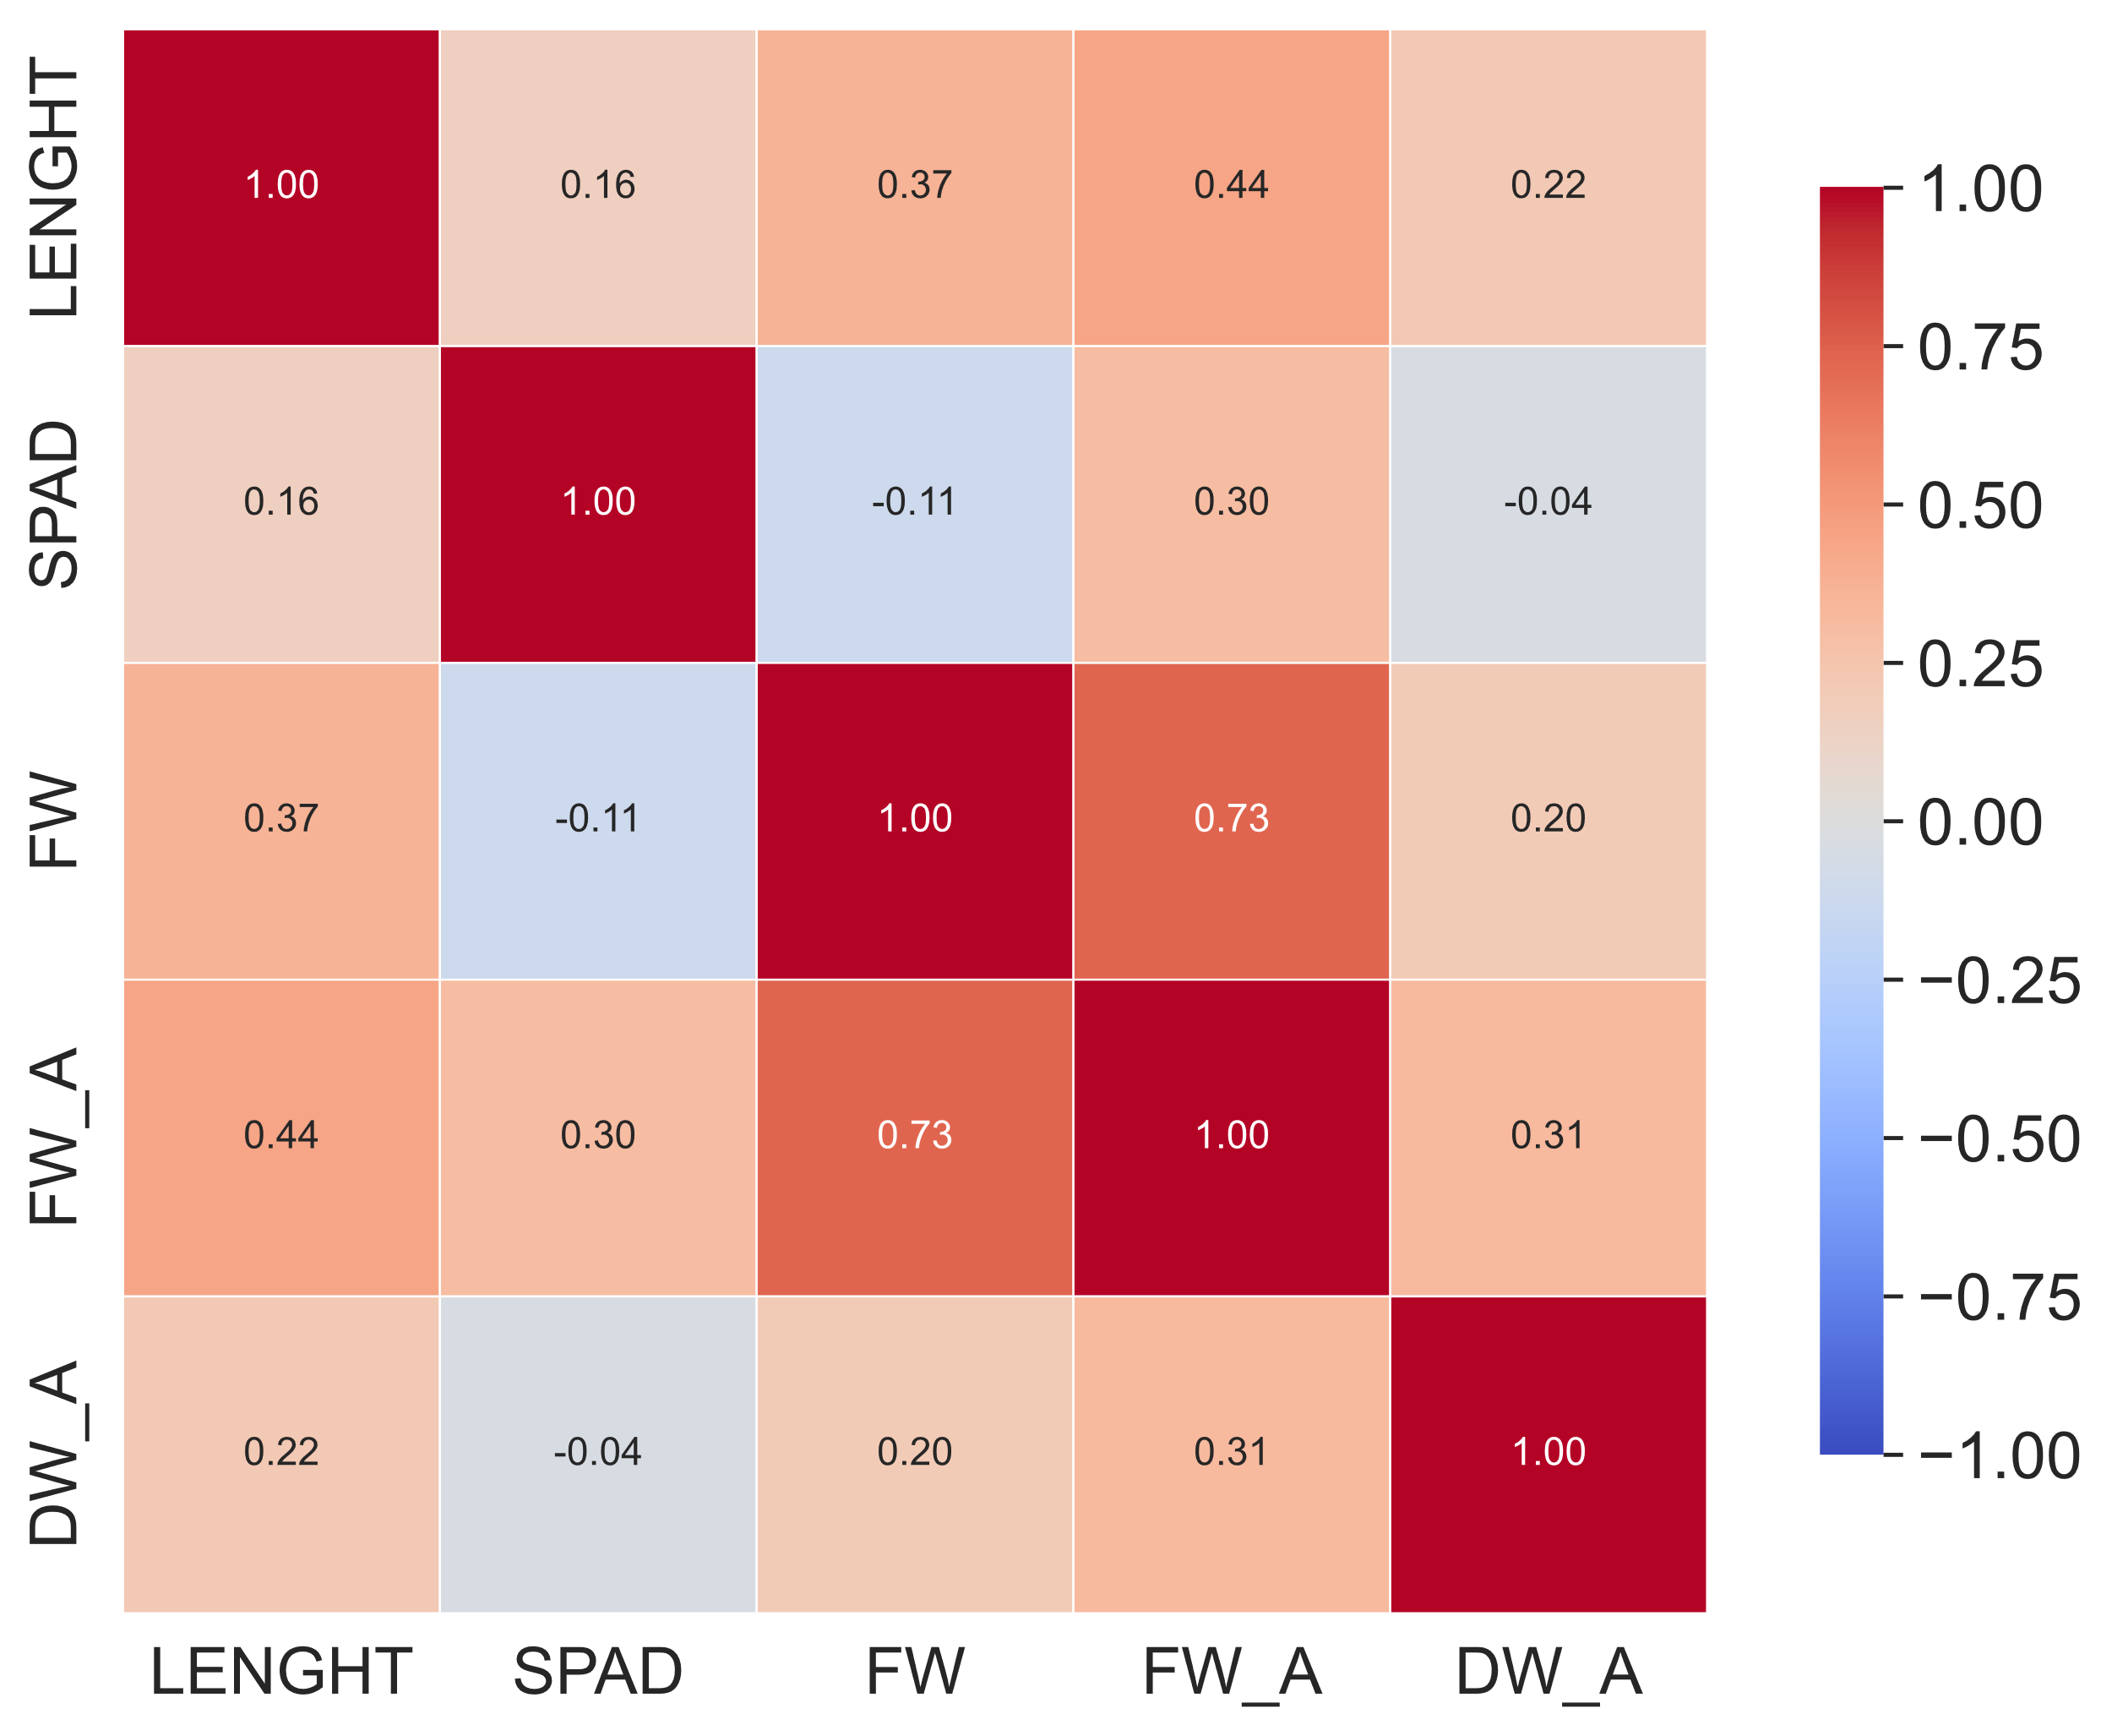
Supp. Fig. 6. Correlation matrix of physiological and growth parameters in pepper plants exposed to different treatments. The heatmap shows Pearson correlation coefficients among stem length (LENGTH), chlorophyll content (SPAD), total fresh weight (FW), fresh weight of aerial parts (FW_A), and dry weight of aerial parts (DW_A) measured in pepper plants subjected to water (mock control), pesticide, chitosan-dsRNA nanocomposite, or carbon dot-dsRNA nanocomposite treatments. Color intensity indicates the strength and direction of the correlation, with blue representing negative and red positive correlations and the respective numerical values are indicated within each cell.

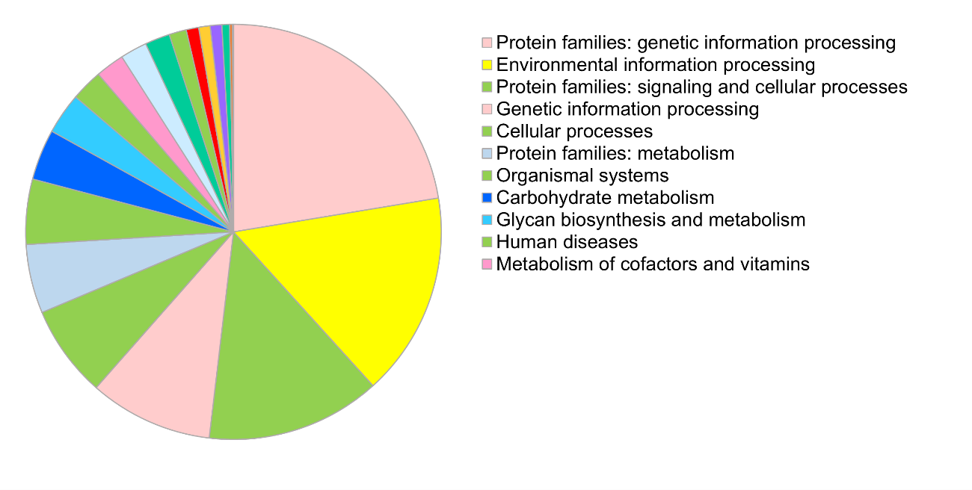
Supp. Fig. 7. KEGG pathway enrichment analysis of proteins regulated by differentially expressed miRNAs in aphids treated with dsRNAs. The pie chart illustrates the distribution of proteins across major KEGG functional categories, including genetic and environmental information processing, cellular processes, metabolism, organismal systems and diseases, identified using the KEGG database. Each color represents a distinct pathway category.

Name | Sequence | Destination | Reference
INF_ACE_F | CGGTATCGATAAGCTAGAAAAACGTGGTGGTGTCTCG | In-Fusion cloning of M. per. genes | This work
INF_ACE_R | GGAGACCGGCAGATCGAGACGTGACCCAAGACCC | " | "
INF_CARB_F | CGGTATCGATAAGCTCATACATGGCGGCGGATAC | " | "
INF_CARB_R | GGAGACCGGCAGATCTATGGCCTTTGCTGGTCTGG | " | "
INF_NACHR_F | CGGTATCGATAAGCTTTCCTGTGCGTGCTAGTGTTC | " | "
INF_NACHR_R | GGAGACCGGCAGATCTCTCTCTCCTCTCTG CGCTTG | " | "
INF_P450_F | CGGTATCGATAAGCTATCAG GCCGATTCCGTTGTTC | " | "
INF_P450_R | GGAGACCGGCAGATCTCGTCTTGAGCTTTC CCGACG | " | "
INF_YA1_F | CGGTATCGATAAGCTTTTCTCTTTTAAACCTAAAAAACC | " | "
INF_YA1_R | GGAGACCGGCAGATCGTACATCGGATGTGACTG | " | "
MpACE_qF | CCGAAATGGACAGGGGTGAT | Quantitation dsRNA | "
MpACE_qR | CGTGACCCAAGACCCTTCAA | " | "
MpCARB_qF | CATACATGGCGGCGGATACT | " | "
MpCARB_qR | CCTGTCAAAACACCATCGCC | " | "
MpNACHR_qF | TTCCTGTGCGTGCTAGTGTT | " | "
MpNACHR_qR | GCGATGAGCGGCAGTACTAA | " | "
MpP450_qF | ACTCGGATTTAGCGGCGAAT | " | "
MpP450_qR | TCGTCTTGAGCTTTCCCGAC | " | "
MpYA1_qF | TGGGCGCTGAAAAGGTATCC | " | "
MpYA1_qR | CATCAATTGGTTGGTGGCTGG | " | "
qACE_464R | CGGCAGTTGTCATCACAATTGT | Quantitation of M. pers. mRNAs | "
qACE_203F | ACATTTGAAGGGTCTTGGGTCA | " | "
qCARB_94F | TGCTGGGATGTCCAACGAATAA | " | "
qCARB_224R | TGGACCAAACGGTGTAAAAGGA | " | "
MpNACHR_qF | TTCCTGTGCGTGCTAGTGTT | " | "
qNACHR_1620R | TTCCGCCGTAGATTTCGATGAT | " | "
qP450_537F | CGGGAAAGCTCAAGACGATGTA | " | "
qP450_668R | CGGTCGAATACTTCCCCATGAT | " | "
qYA1_83F | TCTCGATTCCGGCATAACACAT | " | "
qYA1_179R | TCAGCGCCCATTTTTGATTTGT | " | "
ActinF | GGTGTCTCACACACAGTGCC | M. pers. internal reference | Bass et al. 2011
ActinR | CGGCGGTGGTGGTGAAGCTG | " | "
CaREV05-F | GGACCAGCAAAGGTTGATTT | C. annuum internal reference | Cheng et al. 2017
CaREV05-R | CAGATGGAGGGTTGATTCCT | “ | “
LCO1490 | GGTCAACAAATCATAAAGATATTGG | COX1 sequencing | Folmer et al. (1994)
HCO2198 | TAAACTTCAGGGTGACCAAAAAATCA | " | "
Mper-miR-184-3p | TGGACGGAGAACTGATAAGGGC | Quantitation of Mper-MiRNAs | This work
Mper-miR-190-5p | AGATATGTTTGATATTCTTGGTTG | " | "
Mper-miR-2765-5p | TGGTAACTCCACCACCGATTGCG | " | "
Mper-miR-277-3p | TAAATGCACTATCTGGTACGACA | " | "
Mper-miR-3031-3p | TTGCTTTTTAACAAGTTTCTTG | " | "
Mper-miR-6042-5p | AAGGAACGTTAAAAACCATTGT | " | "
Mper-miR-968-5p | TAAGTAGTAGCGCCAACGGTGA | " | "
Mper-novel-30-3p | TGGCTACGGTTTATACTAACGAT | " | "
Mper-novel-7-5p | AGGAAGTTTTGAATGTTTTGTA | " | "
Supp. Table 1. Primers used in this work.

Sample | Teatment | replicate | Species | Reads | Quality Q33 | Reads 18-24 | Reads 18-30
1 | dsRNA | 1 | Capsicum annuum | 6.089.510 | >81% | 208,449 | 1,514,911
2 | dsRNA | 2 | Capsicum annuum | 7.494.960 | >81% | 357,073 | 2,068,704
3 | dsRNA | 3 | Capsicum annuum | 7.925.951 | >81% | 285,558 | 1,931,029
4 | dsRNA | 4 | Capsicum annuum | 7.638.162 | >81% | 234,075 | 1,651,019
5 | CD:dsRNA | 1 | Capsicum annuum | 10.386.736 | >81% | 656,907 | 2,402,722
6 | CD:dsRNA | 2 | Capsicum annuum | 10.703.407 | >81% | 816,825 | 3,615,341
7 | CD:dsRNA | 3 | Capsicum annuum | 9.615.569 | >81% | 986,376 | 3,213,104
8 | ChNP dsRNA | 1 | Capsicum annuum | 8.802.315 | >81% | 385,363 | 2,071,857
9 | ChNP dsRNA | 2 | Capsicum annuum | 6.850.209 | >81% | 249,654 | 1,602,814
10 | ChNP dsRNA | 3 | Capsicum annuum | 7.869.556 | >81% | 432,192 | 1,609,501
11 | Control | 1 | Myzus persicae | 10.477.451 | >81% | 2,632,320 | 3,872,439
12 | Control | 2 | Myzus persicae | 9.780.705 | >81% | 2,156,682 | 3,425,627
13 | Control | 3 | Myzus persicae | 10.277.743 | >81% | 2,402,237 | 4,027,610
14 | dsRNA | 1 | Myzus persicae | 12.228.415 | >81% | 2,962,052 | 4,960,644
15 | dsRNA | 2 | Myzus persicae | 11.044.742 | >81% | 2,910,545 | 4,273,430
16 | dsRNA | 3 | Myzus persicae | 9.182.399 | >81% | 2,406,856 | 3,626,607
17 | dsRNA | 4 | Myzus persicae | 10.019.227 | >81% | 2,686,214 | 3,850,573
Supp. Table 2. Samples used in this study for HTS.

