ONLINE SUPPLEMENTARY INFORMATION
SECTION A. THE CONSTRUCTION, ADAPTATION, AND FINAL COMPONENTS OF THE PATRIARCHY INDEX
For the purposes of this paper, the original computation of the PI (Gruber and Szołtysek, 2016) had to be adjusted due to some information structure differences in IPUMS-International files. This is because the IPUMS International data do not provide an elaborated number of kinship categories for all files, and if there are elaborated kinship categories, they are not consistent for all available files (variable RELATED). Only a reduced number is available for all files (variable RELATE): head; spouse/partner; child; other relative; non-relative; other relative or non-relative; unknown.

The presence of the pointer variables (MOMLOC, POPLOC, SPLOC) enables the reconstruction of a large part of the lineal kinship relationships (ancestors and descendants). The main disadvantage is that it is not possible to bridge a missing generation, e.g. from ego to grandchild, if the parents of the grandchild are missing.

With the pointers to the parents, we can reconstruct the parents and grandparents of Ego and his spouse. Using the pointers to these parents, we can also reconstruct the other children of these parents: Uncles and aunts, siblings and children. The following generations can also be found: Grandchildren, nephews/nieces and cousins or great-grandchildren, great-nephews and great-cousins. The references to the spouses make it possible to reconstruct the spouses of the reconstructed relatives. These reconstructions were verified using a subsample of the Mosaic data files (N = 446,983 individuals) that already had these pointer variables by comparing the reconstructed relationships with the coded relationships. Overall, this provides confidence that the reconstructed links correctly reflect the majority of potentially existing relationships (calculations available on request).

All necessary adjustments when compared to the original format of the index in Gruber and Szołtysek (2016) are presented in Table A1 below).

Overview of the adapted variables:

*Proportion of wives who are older than their husbands (older wives)
Description: this is the proportion of all of the wives who are older than their husbands among all of the couples for whom the ages of both partners are known. If a husband is married to more than one wife, only the first wife is considered here. We use an age standardized measure to account for different age structures in different societies at different points in time.
Adaptation: The SPLOC-variable is used for identifying spouses.

Table A1: The components and characteristics of the abridged version of the Patriarchy Index

Domain | Components | Original definition | Relationship with patriarchy | Original version possible?
MALE DOMINATION | Female household heads | The proportion of all female household heads (20+ years) among all adult heads of family households | Negative | Yes
MALE DOMINATION | Young brides | The proportion of ever-married women in the age group 15-19 years | Positive | Yes
MALE DOMINATION | Older wives | The proportion of all wives who are older than their husbands among all couples for whom the ages of both spouses are known | Negative | Adaptation necessary*
MALE DOMINATION | Female non-kin | The proportion of women aged 20-34 years who live as non-kin, usually as lodgers or servants | Negative | Yes
GENERATIONAL DOMINATION | Younger household head | The proportion of men aged 65+ years living in a household headed by a male household head of a younger generation | Negative | Adaptation necessary**
GENERATIONAL DOMINATION | Neolocal | The proportion of male household heads living without any relatives except spouses/children among ever-married men aged 20-29 years | Negative | Yes
GENERATIONAL DOMINATION | Lateral | The proportion of people aged 65+ years living with at least one lateral relative in the household | Positive | Adaptation necessary***
GENERATIONAL DOMINATION | Elderly without kin | The proportion of people aged 65+ years living without relatives or spouses | Negative | Adaptation necessary^
PATRILOCALITY | Married daughters living patrilocally | The proportion of ever-married women aged 15 to 30 years who reside with at least one adult male relative of their husband or his mother | Positive | Adaptation necessary^^
SON PREFERENCE | Boy as last child | The proportion of boys among the last children (if the last child is one of a set of siblings of both sexes, he or she will be excluded from the analysis). | Positive | Adaptation necessary^^^
SON PREFERENCE | Sex ratio | The sex ration (boys to 100 girls) in the youngest age-group (0-4 years old) | Positive | Yes

**Proportion of elderly men co-residing with a younger household head (younger household head)
Description: This is the proportion of elderly men (aged 65+) living in a household headed by a male of a younger age. Only family households are considered here, and the elderly men must be relatives of the household head.
Adaptation: A younger age is used instead of a younger generation.

***Proportion of elderly people living with lateral relatives (lateral)
Description: this is the proportion of elderly people (aged 65+) living with at least one lateral relative in the household. Lateral relatives are defined as siblings, uncles/aunts, nephews/nieces, great-nephews/nieces, cousins and other distant relatives (including in-laws). In addition, two married relatives of the same generation form a lateral extension (this applies to lineal relatives: children, parents, grandchildren and grandparents). This measure only applies to family households.
Adaptation: All relatives, who are not identified as lineal relatives are treated as lateral relatives. Identification of kinship relationships is based on pointer variables (POPLOC, MOMLOC, SPLOC).

^Proportion of elderly people living without relatives (without relatives)
Description: this is the proportion of elderly people (aged 65+) living without relatives or spouses.
Adaptation: Identification of kinship relationships is based on pointer variables (POPLOC, MOMLOC, SPLOC).

^^Proportion of married women living patrilocally
Description: this is the proportion of ever-married women aged 15 to 30 years who reside with at least one adult male relative of their husband or his mother. This measure only applies to family households.
Adaptation: The husband lives with at least one parent and the wife does not live with any parent.

^^^Proportion of boys among the last child (boy as last child)
Description: this is the proportion of boys among the last children (if the last child is one of a set of siblings of both sexes, he or she will be excluded from the analysis). The analysis is restricted to the 10–14 age group because, in the younger age groups, we cannot know whether the last child really is the last child and, in the older age groups, we cannot know whether one of the children has already left the parental household through marriage or going into service. This measure only applies to family households.
Adaptation: The analysis is based on the POPLOC variable and therefore groups of siblings. It is no longer restricted to households heads. It is restricted to POPLOC, because the inclusion of MOMLOC, too, would duplicate the children with both parents in the census while those children with only one parent in the census would be only once in the analysis.
SECTION B. INDEX’ CONSTRUCT VALIDATION

The PI represents a hybrid (reflective-formative) type of index. According to the reflective-formative Type II model (Becker et al. 2012), the eleven input variables serve as reflective indicators organized hierarchically into four domains or sub-indices: domination of men over women, domination of the older generation, patrilocal bias, and son preference. Collectively, these sub-indices form the higher-order construct of familial patriarchy, encapsulating its influence on potential outcome variables (see also Diamantopoulos and Winklhofer 2001). The overall patriarchy measure (the PI), as a higher-order construct, is a nested average of these eleven indicators across the four domains.

As the PI represents a hybrid (reflective-formative) type of index, not all its items and dimensions should be required to be highly correlated (Becker et al. 2012; DeVellis and Thorpe 2022; Diamantopoulos & Winklhofer 2001). The actual correlation matrix in Fig. B1 reflects this feature of our measure.

Figure B1: Correlation matrix of the four sub-indices of patriarchy (Kendall's Tau).
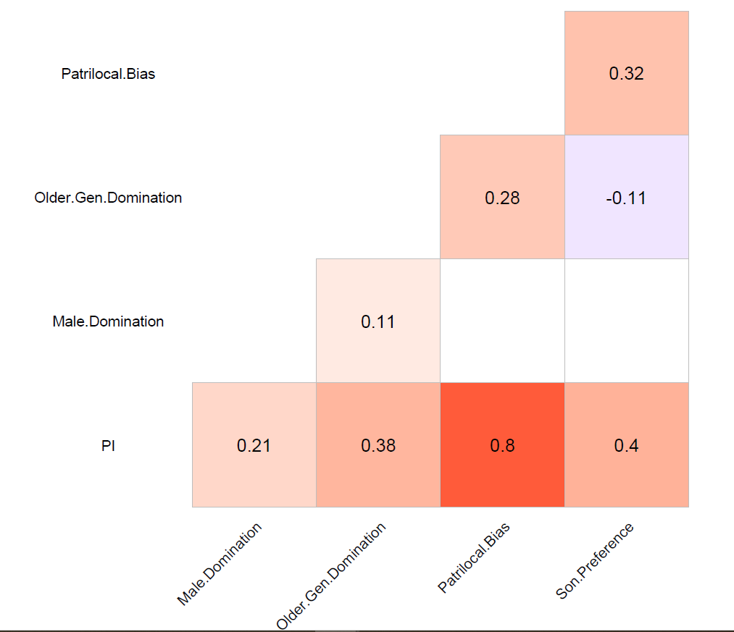

Source: as in Fig. 1 in the main text. Note: all colour quadrants indicate significant correlation (p-value<0.05).
The PI’s construct validity (Campbell and Fiske 1959) was tested by examining the relationships between the country-level PI (and its main components) and the five principal gender (in)equality and empowerment indices available at the country level, and the available subnational data on gender (in)equality in outcomes (Figure B2). In contexts where directly comparable convergent measures are limited (as in our case), demonstrating that an instrument both aligns with and diverges from related constructs provides a reasonable framework for establishing overall construct validity (Campbell and Fiske 1959; DeVellis and Thorpe 2022).

Figure B2: Country-level correlations of the PI and its components with main gender (in)equality indices
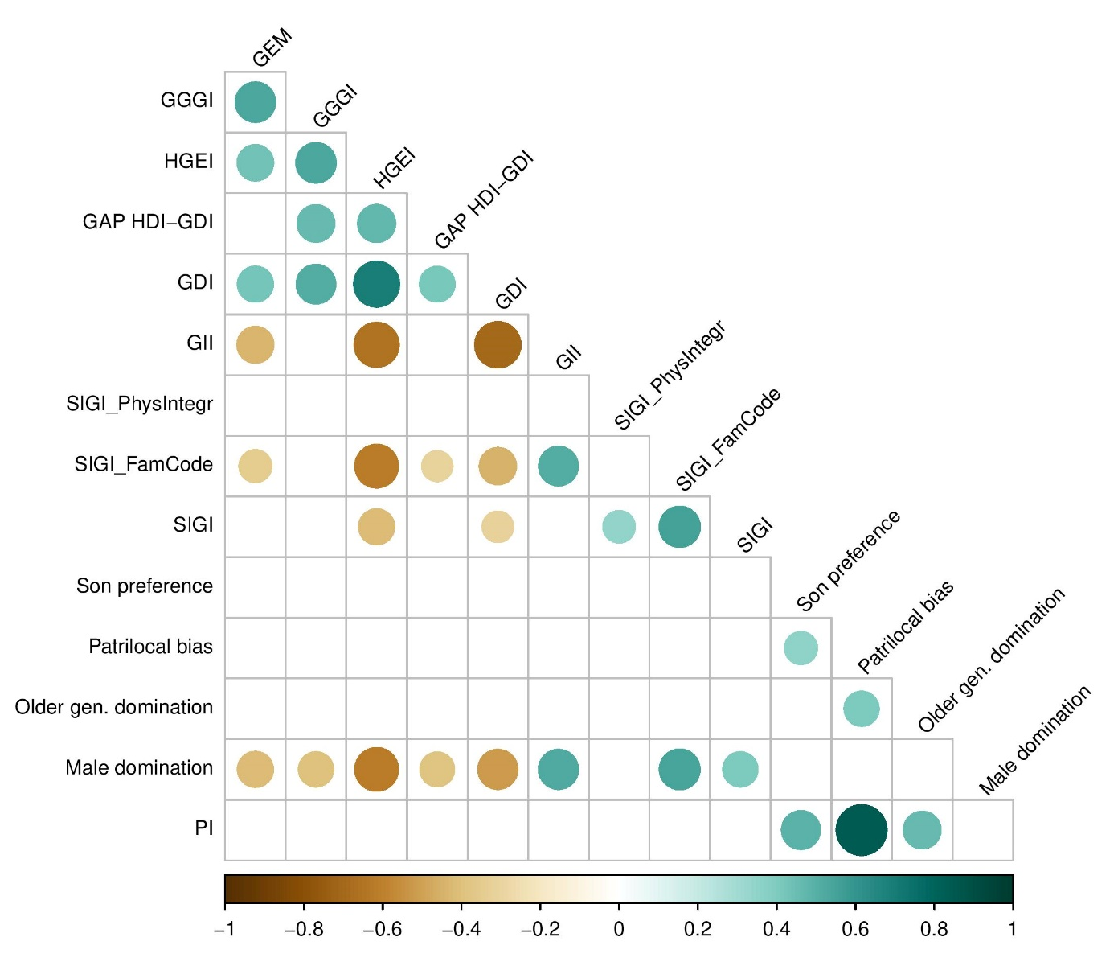
Source: for the PI and its four domains, as in Fig. 1 in the main text.

Sources for other indices in order of appearance:
(GEM) Gender Empowerment Measure- values are from the closest available date to the census year
(i.e., 1995, 2006 [India], or 2009, 2011 [Cambodia]). Higher value (closer to 1) = Greater empowerment of women

For India: United Nations Development Programme (UNDP). (2009). Gendering human development indices: Recasting the Gender Development Index and Gender Empowerment Measure for India – Summary report. Ministry of Women and Child Development, Government of India
For Cambodia: Asian Development Bank. (2012). Cambodia: Country gender analysis.
For all others:
United Nations Development Programme. (1995). Human development report 1995: Gender and human development. Oxford University Press.
United Nations Development Programme. (2009). Human development report 2009: Overcoming barriers—Human mobility and development. Palgrave Macmillan.

(GGGI) Global Gender Gap Index - values are from the closest available date to the census year (i.e.,
2006, 2011, 2019, 2020, 2022). Higher score (closer to 1.00) = More gender parity.

World Economic Forum. (2015). The global gender gap report 2015. Geneva: World Economic Forum. https://www3.weforum.org/docs/GGGR2015/cover.pdf

(HGEI) Historical Gender Equality Index – the closest available date (1997-2003) to the census year.
Higher score = More equality.

Sarah Carmichael, Selin Dilli, and Auke Rijpma (2019). The Historical Gender Equality Index. Clio Infra. https://clio-infra.eu/Indicators/HistoricalGenderEqualityIndex.html

(GDI) Gender Development Index – exact census years.
Values below 1 indicate higher human development for men than women, while values above 1 indicate the opposite (very rare).
Human Development Reports, https://hdr.undp.org/gender-development-index#/indicies/GDI

The gap between HDI and GDI (expressed as a difference) is used following Schüler, D. (2006). The uses and misuses of the Gender‐related Development Index and Gender Empowerment Measure: A review of the literature. Journal of Human Development, 7(2), 161–181. It is meant to serve as a useful proxy for the developmental costs associated with gender inequality.

(GII) Gender Inequality Index -– exact census years.
Higher score =More low inequality between women and men.

Human Development Reports, https://hdr.undp.org/data-center/thematic-composite-indices/gender-inequality-index#/indicies/GII

(SIGI) Social Institutions and Gender Index – values are from the closest available date to the census
year (i.e., 2009, 2012, 2014).
Higher score =More gender-based discrimination

Global Ranking in Social Institution and Gender Index (SIGI), https://landportal.org/book/indicators/indoecd1-0

(SIGI_FamCode) Discriminatory Family Code component of the SIGI – values are from the
closest available date to the census year (i.e., 2009, 2012, 2014).
Higher score =More discrimination.

Global Ranking in Social Institution and Gender Index (SIGI), https://landportal.org/book/indicators/indoecd1-0

(SIGI_PhysIntegr) Restricted Physical Integrity component of the SIGI – all values from 2019.
Higher score =More restriction.

Global Ranking in Social Institution and Gender Index (SIGI), https://landportal.org/book/indicators/indoecd1-0

Figure B2 (above) reveals that at the country-level the overall PI does not exhibit significant correlations with established gender inequality indices (whereas one of its subindexes does). This indicates that while certain dimensions of the PI align with conventional gender measures, the overall index captures a distinct construct. This matches theoretical expectations given that none of these indices were designed to capture family patriarchy as such, nor indicators of men’s greater status and control over women at the household level.

Table B1 provides the results of assessing the relationship of the various subnational gender (in)equality measures with the PI.

Table B1: Correlations of the Patriarchy Index with available subnational measures of gender (in)equality

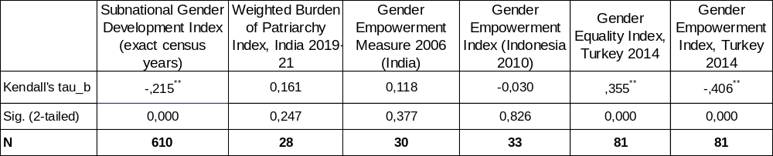
Source: for the PI, as in Fig. 1 in the main text. A smaller N indicates challenges in matching all IPUMS-International census regions with their respective Global Data Lab territorial classifications.
Notes: for the auxiliary secondary data, see below:

The Subnational Gender Development Index (SGDI) - a direct ratio of gender-specific Human
Development Indices at the subnational level.
Higher score = more advantageous position of females relative to males
The Global Data Lab, https://globaldatalab.org/shdi/metadata/sgdi/; also Smits, J., & Permanyer, I. (2019). The Subnational Human Development Database. Scientific Data, 6, 190038.
Weighted Burden of Patriarchy Index (India) – incorporates 20 indicators, organized into seven key domains:
endowments, voice, mobility, son preference, behavioural control, violence, and political participation. The index draws primarily on data from the National Family Health Survey (NFHS-5, 2019–21) and supplements it with political participation data from Government of India sources.
A higher value = a greater burden of patriarchy (i.e., more intense and widespread gender inequality) across the seven dimensions.

Dutta, S., Kelkar, G., & Nathan, D. (2024). The burden of patriarchy: Is there a geography of patriarchy in India? Institute for Human Development. Working Paper 01/2024.

Gender Empowerment Measure (India) – all values are from 2006
Higher value (closer to 1) = Greater empowerment of women

United Nations Development Programme (UNDP). (2009). Gendering human development indices: Recasting the Gender Development Index and Gender Empowerment Measure for India – Summary report. Ministry of Women and Child Development, Government of India (https://www.undp.org/sites/g/files/zskgke326/files/migration/in/gendering_human_development_indices_summary_report.pdf )

Gender Empowerment Index (Indonesia) – all values are from 2010. Adaptation of the Gender Empowerment
Measure (GEM) developed by the UNDP (above)
Higher score = Greater empowerment

BPS-Statistics Indonesia Kalimantan Barat Province. (April 28, 2025). Gender Empowerment Index by
Province, 2010. Retrieved on July 2, 2025, from https://kalbar.bps.go.id/en/statistics-table/2/MzI0IzI=/gender-empowerment-index-by-province.html

Gender Empowerment Index (Turkey) – all values are from 2014 (the earliest available). Developed by TEPAV
(The Economic Policy Research Foundation of Turkey), is a localized adaptation of the UN’s Gender Inequality Index (GII) and Gender Empowerment Measure (GEM). Focuses on women’s status—not just gender gaps— in domains of Health, Education, Labor force participation, Political representation. Emphasizes women’s absolute standing (not just gender gaps) in each domain.

Higher score = Better representation across domains

Kavas, A. (2018, March 22). Comparative gender equality scorecard for 81 provinces in Turkey. TEPAV.
https://www.tepav.org.tr/tr/haberler/s/4324

Gender Equality Index (Turkey) - all values are from 2014 (the earliest available). Developed by TEPAV
(The Economic Policy Research Foundation of Turkey). Consists of 3 sub-indexes and 11 indicators. The 3 sub-indexes, all equally weighted on the index value, are: (i) representation in politics and economy, (ii) participation in production, and (iii) educational attainment.
Higher score = Less equality

Kavas, A. (2018, March 22). Comparative gender equality scorecard for 81 provinces in Turkey. TEPAV.
https://www.tepav.org.tr/tr/haberler/s/4324

Across 610 subnational cases, the Patriarchy Index (PI) showed a modest, highly significant negative correlation with the Subnational Gender Development Index (SGDI), consistent with expectations that higher patriarchy aligns with lower gender equality; the large N ensures robust power. Strong, coherent correlations in 81 Turkish provinces with the Gender Equality Index and Gender Empowerment Index reinforce convergent validity despite temporal mismatch. In three small datasets from India and Indonesia, non-significant correlations likely reflect contextual divergence, small N, or PI’s capture of distinct facets—especially as other indices often fail to correlate strongly with each other.
Altogether, the PI appears to have sound convergent validity in certain contexts (as evidenced by the relationship with SGDI and the Turkish indices) while differentiating itself from other indices in contexts where the constructs measured diverge or where methodological constraints are present. This pattern—validity in some contexts, differentiation in others—is consistent with cross-context measurement of complex constructs (Cheung et al. 2024; Byrne & Watkins 2003), and neither significant correlation approached redundancy (Cheung et al. 2024; McGillivray & White 1993).

Reference list for this section:
Becker, J.-M., Klein, K., & Wetzels, M. (2012). Hierarchical latent variable models in PLS-SEM: Guidelines for using reflective-formative type models. Long Range Planning: International Journal of Strategic Management, 45(5-6), 359–394
Byrne, B. M., & Watkins, D. (2003). Testing for the multi-population invariance of factor covariance matrices: A comparison of approaches. British Journal of Mathematical and Statistical Psychology, 56(2), 275–300.
Campbell, D. T., & Fiske, D. W. (1959). Convergent and discriminant validation by the multitrait-multimethod matrix. Psychological Bulletin, 56
Cheung, G. W., Cooper-Thomas, H. D., Lau, R. S., & Wang, L. C. (2024). Reporting reliability, convergent and discriminant validity with structural equation modeling: A review and best-practice recommendations. Asia Pacific Journal of Management, 41, 745–783
DeVellis, R. F., & Thorpe, C. T. (2022). Scale development: Theory and applications (5th ed.). SAGE Publications.
Diamantopoulos, A., & Winklhofer, H. M. (2001). Index construction with formative indicators: An alternative to scale development. Journal of Marketing Research, 38(2), 269–277.
Dutta, S., Kelkar, G., & Nathan, D. (2024). The burden of patriarchy: Is there a geography of patriarchy in India? Institute for Human Development. Working Paper 01/2024.
Edwards, J. R., & Bagozzi, R. P. (2000). On the nature and direction of relationships between constructs and measures. Psychological Methods, 5(2), 155–174.
Kavas, A. (2018, March 22). Comparative gender equality scorecard for 81 provinces in Turkey. TEPAV.
Smits, J., & Permanyer, I. (2019). The Subnational Human Development Database. Scientific Data, 6, 190038.

SECTION C. FULL MODEL RESULTS FROM FIGURE 7 (main text)
 | relative female LFP |  | relative female LFP |  | relative female LFP |  | relative female LFP |  | relative female LFP
Predictors | Estimates | p | Estimates | p | Estimates | p | Estimates | p | Estimates | p
(Intercept) | 0.6595 | 0.021 | 2.2629 | <0.001 | 1.0077 | 0.003 | 0.4927 | 0.077 | 0.6382 | 0.021
GNI | 0.0265 | 0.446 | 0.0300 | 0.237 | -0.0052 | 0.887 | 0.0187 | 0.594 | -0.0055 | 0.876
% urban | -0.0037 | <0.001 | -0.0047 | <0.001 | -0.0032 | 0.001 | -0.0032 | 0.001 | -0.0025 | 0.008
PI | -0.0112 | 0.010
Male Dom. |  |  | -0.0680 | <0.001
Older Dom. |  |  |  |  | -0.0115 | 0.011
Patrilocality |  |  |  |  |  |  | 0.0062 | 0.328
Son Pref. |  |  |  |  |  |  |  |  | 0.0284 | <0.001
Observations | 504 |  | 504 |  | 504 |  | 504 |  | 504
R² / R² adjusted | 0.061 / 0.056 |  | 0.499 / 0.496 |  | 0.061 / 0.055 |  | 0.050 / 0.045 |  | 0.078 / 0.073

 | Wtot ratio |  | Wtot ratio |  | Wtot ratio |  | Wtot ratio |  | Wtot ratio
Predictors | Estimates | p | Estimates | p | Estimates | p | Estimates | p | Estimates | p
(Intercept) | 0.5578 | 0.019 | 0.4297 | 0.077 | 0.5045 | 0.067 | 0.7348 | 0.001 | 0.7766 | 0.001
GNI | 0.0357 | 0.208 | 0.0327 | 0.247 | 0.0466 | 0.115 | 0.0309 | 0.276 | 0.0353 | 0.217
% urban | 0.0010 | 0.195 | 0.0010 | 0.190 | 0.0006 | 0.408 | 0.0009 | 0.217 | 0.0006 | 0.457
PI | 0.0108 | 0.003
Male Dom. |  |  | 0.0130 | <0.001
Older Dom. |  |  |  |  | 0.0063 | 0.086
Patrilocality |  |  |  |  |  |  | 0.0161 | 0.003
Son Pref. |  |  |  |  |  |  |  |  | -0.0066 | 0.212
Observations | 652 |  | 652 |  | 652 |  | 652 |  | 652
R² / R² adjusted | 0.027 / 0.023 |  | 0.034 / 0.030 |  | 0.018 / 0.014 |  | 0.027 / 0.022 |  | 0.016 / 0.012

 | school ratio nearest year |  | school ratio nearest year |  |  | school ratio nearest year |  | school ratio nearest year |  | school ratio nearest year
Predictors | Estimates | p | Estimates |  | p | Estimates | p | Estimates | p | Estimates | p
(Intercept) | 1.0617 | <0.001 | 1.0473 |  | <0.001 | 1.1459 | <0.001 | 1.0389 | <0.001 | 1.0367 | <0.001
GNI | -0.0050 | 0.544 | -0.0047 |  | 0.569 | -0.0102 | 0.237 | -0.0046 | 0.580 | -0.0045 | 0.587
% urban | -0.0005 | 0.015 | -0.0005 |  | 0.020 | -0.0005 | 0.030 | -0.0005 | 0.019 | -0.0005 | 0.019
PI | -0.0013 | 0.237
Male Dom. |  |  | -0.0004 |  | 0.694
Older Dom. |  |  |  |  |  | -0.0025 | 0.017
Patrilocality |  |  |  |  |  |  |  | -0.0010 | 0.535
Son Pref. |  |  |  |  |  |  |  |  |  | -0.0008 | 0.599
Observations | 652 |  | 652 |  |  | 652 |  | 652 |  | 652
R² / R² adjusted | 0.029 / 0.025 |  | 0.028 / 0.023 |  |  | 0.036 / 0.031 |  | 0.028 / 0.023 |  | 0.028 / 0.023
 | cgfr 100 |  | cgfr 100 |  | cgfr 100 |  | cgfr 100 |  | cgfr 100
Predictors | Estimates | p | Estimates | p | Estimates | p | Estimates | p | Estimates | p
(Intercept) | 2.7829 | <0.001 | 3.4298 | <0.001 | 2.8511 | <0.001 | 2.3179 | <0.001 | 2.5364 | <0.001
GNI | -0.1997 | <0.001 | -0.2392 | <0.001 | -0.2533 | <0.001 | -0.1851 | <0.001 | -0.2225 | <0.001
% urban | -0.0020 | <0.001 | -0.0009 | 0.093 | -0.0007 | 0.251 | -0.0021 | <0.001 | -0.0016 | 0.015
PI | -0.0276 | <0.001
Male Dom. |  |  | -0.0323 | <0.001
Older Dom. |  |  |  |  | -0.0048 | 0.167
Patrilocality |  |  |  |  |  |  | -0.0404 | <0.001
Son Pref. |  |  |  |  |  |  |  |  | -0.0187 | <0.001
Observations | 348 |  | 348 |  | 348 |  | 348 |  | 348
R² / R² adjusted | 0.581 / 0.577 |  | 0.561 / 0.557 |  | 0.432 / 0.427 |  | 0.567 / 0.563 |  | 0.463 / 0.458

 | life expectancy gap  nearest year mean |  | life expectancy gap  nearest year mean |  | life expectancy gap  nearest year mean |  | life expectancy gap  nearest year mean |  | life expectancy gap  nearest year mean
Predictors | Estimates | p | Estimates | p | Estimates | p | Estimates | p | Estimates | p
(Intercept) | -0.0280 | 0.292 | 0.0402 | 0.085 | -0.0164 | 0.556 | -0.0362 | 0.135 | -0.0045 | 0.852
GNI | 0.0092 | 0.003 | 0.0105 | <0.001 | 0.0084 | 0.006 | 0.0110 | <0.001 | 0.0080 | 0.008
% urban | 0.0000 | 0.564 | -0.0000 | 0.699 | 0.0000 | 0.573 | 0.0000 | 0.790 | 0.0000 | 0.531
PI | 0.0008 | 0.037
Male Dom. |  |  | -0.0024 | <0.001
Older Dom. |  |  |  |  | 0.0004 | 0.314
Patrilocality |  |  |  |  |  |  | 0.0024 | <0.001
Son Pref. |  |  |  |  |  |  |  |  | 0.0003 | 0.517
Observations | 328 |  | 328 |  | 328 |  | 328 |  | 328
R² / R² adjusted | 0.086 / 0.078 |  | 0.172 / 0.164 |  | 0.077 / 0.068 |  | 0.128 / 0.119 |  | 0.075 / 0.066

While the “older wives” indicator could hypothetically reflect structural demographic factors—such as elevated female remarriage rates—rather than signify a weakening of patriarchal norms, this explanation does not hold for the dataset in question.
https://www.undp.org/sites/g/files/zskgke326/files/migration/in/gendering_human_development_indices_summary_report.pdf
https://www.adb.org/sites/default/files/institutional-document/33752/files/cambodia-country-gender-analysis.pdf
To the best of our knowledge, the only widely available gender (in)equality indicator that corresponds to the maximum number of subnational units for which our PI measure was computed is Subnational Gender Development Index (henceforth, SGDI; Smits et al. 2019), whereas other subnational data on gender (in)equality in outcomes could be harvested only for a few specific countries.

