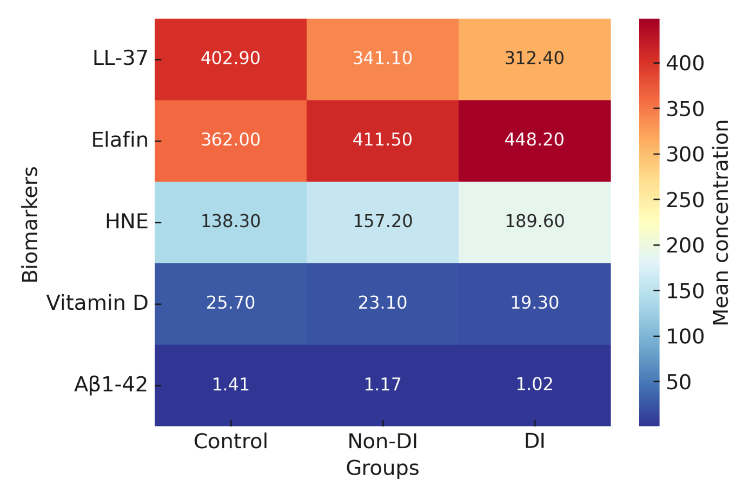
Supplementary Figure S1. Heatmap of biomarker distribution across study groups.
Each column represents an individual participant, and each row a biomarker. Higher values are displayed in red, lower values in blue. Diabetic incontinence patients exhibited the most divergent biomarker profile.

