Supplementary Information Contents

S1 Studies Reported Outcomes Page 26

S2 Excluded papers from full text review Page 26-33

S3 Search strategy Page 34

S4 Prisma Checklist Page 35-37
Author & Year | NPV | PPV | Sen | Spec
K, Shahid, et al, 2019 | NR | NR | 69% | 85%
C, den Heijer, et al, 2012 | 60% | 83% | 75 | 70
Z, Shimoni, et al, 2018 | NR | NR | 96.90% | NR
K, Latour, et al, 2022 | 96.00% | NR | 93.8 | 20.7
M, Couderta, et al, 2019 | 91% | 54% | 92% | 50%
Table S1 Reported outcomes.

Table S2 Excluded studies.
Study | Author | Year | Reason
Evidence-based appraisal of two guidelines for the diagnosis of suspected, uncomplicated urinary tract infections in primary care: a diagnostic accuracy validation study | Fanshawe T.R., Judge R.K., Mort S., Butler C.C., Hayward G.N. AO - Fanshawe, Thomas R.; | 2023 | Wrong population
Validating the prediction of lower urinary tract infection in primary care: sensitivity and specificity of urinary dipsticks and clinical scores in women | Paul Little, Sheila Turner, Kate Rumsby, Rachel Jones,* Greg Warner, Michael Moore, J Andrew Lowes, Helen Smith, Catherine Hawke, Geraldine Leydon, and Mark Mullee | 2010 | Wrong population
Dipsticks and diagnostic algorithms in urinary tract infection: development and validation, randomised trial, economic analysis, observational cohort and qualitative study | P Little, S Turner, K Rumsby, G Warner, M Moore, JA Lowes, H Smith, C Hawke, D Turner, GM Leydon, A Arscott and M Mullee | 2009 | Wrong population
Developing clinical rules to predict urinary tract infection in primary care settings: sensitivity and specificity of near patient tests (dipsticks)and clinical scores | Paul Little, SheilaTurner, Kate Rumsby, Greg Warner, Michael Moore, J Andrew Lowes, Helen Smith, Catherine Hawke and Mark Mullee | 2006 | Wrong population
Interleukin-6 concentrations in the urine and dipstick analyses were related to bacteriuria but not symptoms in the elderly: a cross sectional study of 421 nursing home residents | Pär-Daniel Sundvall, Marie Elm, Peter Ulleryd, Sigvard Mölstad, Nils Rodhe, Lars Jonsson, Bengt Andersson, Mirjana Hahn-Zoric and Ronny Gunnarsson | 2014 | Incorrect Outcome
What is the Diagnostic Accuracy of Novel Urine Biomarkers for Urinary Tract Infection? | George Edwards, Anna Seeley, Adam Carter, Maia Patrick Smith, Elizabeth LA Cross, Kathryn Hughes, Ann Van den Bruel, Martin J Llewelyn, Jan Y Verbakel and Gail Hayward | 2022 | Incorrect Outcome
Diagnosing and treating urinary tract infections in older people | Kirsty Armstrong | 2015 | Literature review not for inclusion
Toward A Simple Diagnostic Index for Acute Uncomplicated Urinary Tract Infections | Bart J. Knottnerus, Suzanne E. Geerlings, Eric P. Moll van Charante | 2013 | Wrong population
The uncertainties of the diagnosis and treatment of a suspected urinary tract infection in elderly hospitalized patients | Paul Froom and Zvi Shimoni | 2018 | This is a review therefore not applicable
Urine analysis and decision-making on cystitis in general practice | B. J. BOLANN, G. THUE & S. SANDBERG | 2004 | Incorrect Outcome
The urine dipstick test useful to rule out infections. A meta-analysis of the accuracy | Walter LJM Devillé, Joris C Yzermans, Nico P van Duijn, P Dick Bezemer, Daniëlle AWM van der Windt and Lex M Bouter | 2004 | meta-analysis therefore not includable
The Diagnosis and Management of UTI in >65s: To Dipstick or Not? The Argument Against Dipsticks | Amelia Joseph | 2020 | Incorrect Outcome
Developing clinical rules to predict urinary tract infection in primary care settings: sensitivity and specificity of near patient tests (dipsticks)and clinical scores | Paul Little, SheilaTurner, Kate Rumsby, Greg Warner, Michael Moore, J Andrew Lowes, Helen Smith, Catherine Hawke and Mark Mullee | 2006 | Wrong population
Validating the prediction of lower urinary tract infection in primary care: sensitivity and specificity of urinary dipsticks and clinical scores in women | Paul Little, Sheila Turner, Kate Rumsby, Rachel Jones,* Greg Warner, Michael Moore, J Andrew Lowes, Helen Smith, Catherine Hawke, Geraldine Leydon, and Mark Mullee | 2010 | Wrong population
Performance of the dipstick screening test as a predictor of negative urine culture | Alexandre Gimenes Marques, André Mario Doi, Jacyr Pasternak, Márcio dos Santos Damascena, Carolina Nunes França, Marinês Dalla Valle Martino | 2017 | Wrong population
Diagnostic Challenges and Opportunities in Older Adults With Infectious Diseases | David van Duin | 2012 | Incorrect Outcome
Validity of the urine dipslide under daily practice conditions | Ron Winkens, Hanny Nelissen-Arets and Ellen Stobberingh | 2003 | Wrong population
Predictive value of the urinary dipstick test in the management of patients with urinary tract infection-associated symptoms in primary care in Indonesia: a cross-sectional study | Franciscus Ginting, Adhi Kristianto Sugianli, R Lia Kusumawati, Ida Parwati, Menno D de Jong, Constance Schultsz, Frank van Leth | 2018 | Wrong population
P23 Prevalence of asymptomatic bacteriuria and associated risk factors in an adult population relevant to UK primary care: a systematic review and meta-analysis | Abi Moore, Conor Coyle, Anna Seeley, Phoebe Cherrington-Walker, Maaedah Khan,ThomasFanshawe,Koen Pouwels,Donna Lecky,Gail Hayward, Emily Cooper | 2023 | Wrong population
Biomarkers for diagnosing serious bacterial infections in older outpatients: a systematic review | Oghenekome A. Gbinigie, Igho J. Onakpoya, Georgia C. Richards, Elizabeth A. Spencer, Constantinos Koshiaris, Niklas Bobrovitz and Carl J. Heneghan | 2019 | This is a review therefore not applicable
Inadequate adherence to Swedish guidelines for uncomplicated lower urinary tract infections among adults in general practice | HEIDI LINDBACK, JOHAN LINDBACK and ASA MELHUS | 2017 | Wrong population
Urinary tract infections in general practice patients: diagnostic tests versus bacteriological culture | Sita Nys, T. van Merode, A. I. M. Bartelds and E. E. Stobberingh | 2006 | Wrong population
Predictive value of the urinary dipstick test in the management of patients with urinary tract infection-associated symptoms in primary care in Indonesia: a cross-sectional study | Franciscus Ginting, Adhi Kristianto Sugianli, R Lia Kusumawati, Ida Parwati, Menno D de Jong, Constance Schultsz, Frank van Leth | 2018 | Wrong population
The adherence of GPs to guidelines for the diagnosis and treatment of lower urinary tract infections in women is poor | Carl Llor, Gloria Rabanaque, Ana Lopez and Josep Maria Cots | 2011 | Wrong population
Cost effectiveness of management strategies for urinary tract infections: results from randomised controlled trial | David Turner, Paul Little, James Raftery, Sheila Turner, Helen Smith, Kate Rumsby, Mark Mullee | 2010 | Wrong population
[Urinalysis: what a primary care physician needs to know] | V Latini Keller, N Junod Perron, J-D Graf, C Stoermann Chopard | 2005 | Unable to get full text email to author - nil response
What do general practitioners do when patients present with symptoms indicative of urinary tract infections? | McLeod and kljakovic | 1998 | Wrong population
An Evaluation in General Practice of the Use of Dip‐Slide Urine Cultures in Combination with Antimicrobial Sensitivity Testing in Patients with Symptoms of Acute Cystitis Treated with Pivmecillinam | Newby, M. R. | 1983 | Wrong population
Current controversies in urinary tract infections: ICI-RS 2017 | Marcio A. Averbeck, Angela Rantell, Ruth Kirschner-Hermanns, Vik Khullar, Adrian Wagg, Linda Cardozo | 2017 | Incorrect Outcome
Implementation of an intervention to reduce urine dipstick testing in aged care homes: a qualitative study of enablers and barriers, and strategies to enhance delivery | Lyn-li Lim, Kate Williams, Jill J Francis, Melanie Wroth, Juanita Breen | 2024 | Incorrect Outcome
Screening Urine Dipstick Testing in Patients at a Primary Healthcare Clinic in Mankweng Hospital, Limpopo Province | Indiran Govender | 2016 | Wrong population

S3 – Search strategy
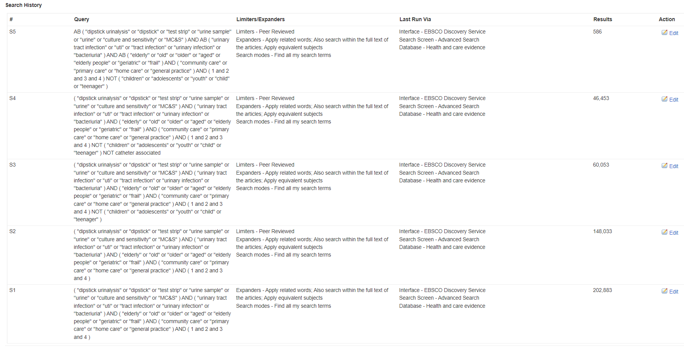
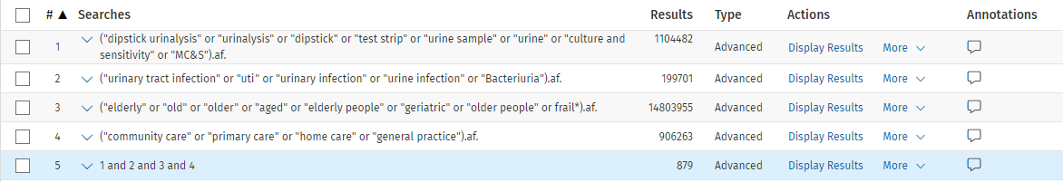

S4 - Prisma Checklist
Section and Topic | Item # | Checklist item | Location where item is reported
TITLE
Title | 1 | Identify the report as a systematic review. | 1
ABSTRACT
Abstract | 2 | See the PRISMA 2020 for Abstracts checklist. | 2 - 3
INTRODUCTION
Rationale | 3 | Describe the rationale for the review in the context of existing knowledge. | 4 - 6
Objectives | 4 | Provide an explicit statement of the objective(s) or question(s) the review addresses. | 6
METHODS
Eligibility criteria | 5 | Specify the inclusion and exclusion criteria for the review and how studies were grouped for the syntheses. | 7
Information sources | 6 | Specify all databases, registers, websites, organisations, reference lists and other sources searched or consulted to identify studies. Specify the date when each source was last searched or consulted. | 7
Search strategy | 7 | Present the full search strategies for all databases, registers and websites, including any filters and limits used. | Sup - S3
Selection process | 8 | Specify the methods used to decide whether a study met the inclusion criteria of the review, including how many reviewers screened each record and each report retrieved, whether they worked independently, and if applicable, details of automation tools used in the process. | 7
Data collection process | 9 | Specify the methods used to collect data from reports, including how many reviewers collected data from each report, whether they worked independently, any processes for obtaining or confirming data from study investigators, and if applicable, details of automation tools used in the process. | 8
Data items | 10a | List and define all outcomes for which data were sought. Specify whether all results that were compatible with each outcome domain in each study were sought (e.g. for all measures, time points, analyses), and if not, the methods used to decide which results to collect. | 8
Data items | 10b | List and define all other variables for which data were sought (e.g. participant and intervention characteristics, funding sources). Describe any assumptions made about any missing or unclear information. | 7-8
Study risk of bias assessment | 11 | Specify the methods used to assess risk of bias in the included studies, including details of the tool(s) used, how many reviewers assessed each study and whether they worked independently, and if applicable, details of automation tools used in the process. | 8
Effect measures | 12 | Specify for each outcome the effect measure(s) (e.g. risk ratio, mean difference) used in the synthesis or presentation of results. | 8
Synthesis methods | 13a | Describe the processes used to decide which studies were eligible for each synthesis (e.g. tabulating the study intervention characteristics and comparing against the planned groups for each synthesis (item #5)). | 7-8
Synthesis methods | 13b | Describe any methods required to prepare the data for presentation or synthesis, such as handling of missing summary statistics, or data conversions. | 7-8
Synthesis methods | 13c | Describe any methods used to tabulate or visually display results of individual studies and syntheses. | 7-8
Synthesis methods | 13d | Describe any methods used to synthesize results and provide a rationale for the choice(s). If meta-analysis was performed, describe the model(s), method(s) to identify the presence and extent of statistical heterogeneity, and software package(s) used. | 7-8
Synthesis methods | 13e | Describe any methods used to explore possible causes of heterogeneity among study results (e.g. subgroup analysis, meta-regression). | Na
Synthesis methods | 13f | Describe any sensitivity analyses conducted to assess robustness of the synthesized results. | Na
Reporting bias assessment | 14 | Describe any methods used to assess risk of bias due to missing results in a synthesis (arising from reporting biases). | 9
Certainty assessment | 15 | Describe any methods used to assess certainty (or confidence) in the body of evidence for an outcome. | Na
RESULTS
Study selection | 16a | Describe the results of the search and selection process, from the number of records identified in the search to the number of studies included in the review, ideally using a flow diagram. | 23 fig 1
Study selection | 16b | Cite studies that might appear to meet the inclusion criteria, but which were excluded, and explain why they were excluded. | Table S2 in draft
Study characteristics | 17 | Cite each included study and present its characteristics. | 21
Risk of bias in studies | 18 | Present assessments of risk of bias for each included study. | 24
Results of individual studies | 19 | For all outcomes, present, for each study: (a) summary statistics for each group (where appropriate) and (b) an effect estimate and its precision (e.g. confidence/credible interval), ideally using structured tables or plots. | Table 2
Results of syntheses | 20a | For each synthesis, briefly summarise the characteristics and risk of bias among contributing studies. | 9
Results of syntheses | 20b | Present results of all statistical syntheses conducted. If meta-analysis was done, present for each the summary estimate and its precision (e.g. confidence/credible interval) and measures of statistical heterogeneity. If comparing groups, describe the direction of the effect. | Na
Results of syntheses | 20c | Present results of all investigations of possible causes of heterogeneity among study results. | Na
Results of syntheses | 20d | Present results of all sensitivity analyses conducted to assess the robustness of the synthesized results. | Na
Reporting biases | 21 | Present assessments of risk of bias due to missing results (arising from reporting biases) for each synthesis assessed. | ROB - Fig 2
Certainty of evidence | 22 | Present assessments of certainty (or confidence) in the body of evidence for each outcome assessed. | Na
DISCUSSION
Discussion | 23a | Provide a general interpretation of the results in the context of other evidence. | 11-14
Discussion | 23b | Discuss any limitations of the evidence included in the review. | 11-14
Discussion | 23c | Discuss any limitations of the review processes used. | 11-14
Discussion | 23d | Discuss implications of the results for practice, policy, and future research. | 11-14
OTHER INFORMATION
Registration and protocol | 24a | Provide registration information for the review, including register name and registration number, or state that the review was not registered. | 1
Registration and protocol | 24b | Indicate where the review protocol can be accessed, or state that a protocol was not prepared. | 7
Registration and protocol | 24c | Describe and explain any amendments to information provided at registration or in the protocol. | 8
Support | 25 | Describe sources of financial or non-financial support for the review, and the role of the funders or sponsors in the review. | 16
Competing interests | 26 | Declare any competing interests of review authors. | 16
Availability of data, code and other materials | 27 | Report which of the following are publicly available and where they can be found: template data collection forms; data extracted from included studies; data used for all analyses; analytic code; any other materials used in the review. | 15

