Supplementary file and the corresponding figure legends

Figure S1. Volcano plot assessment of differentially expressed transcriptomes between iERM and PVR patients.
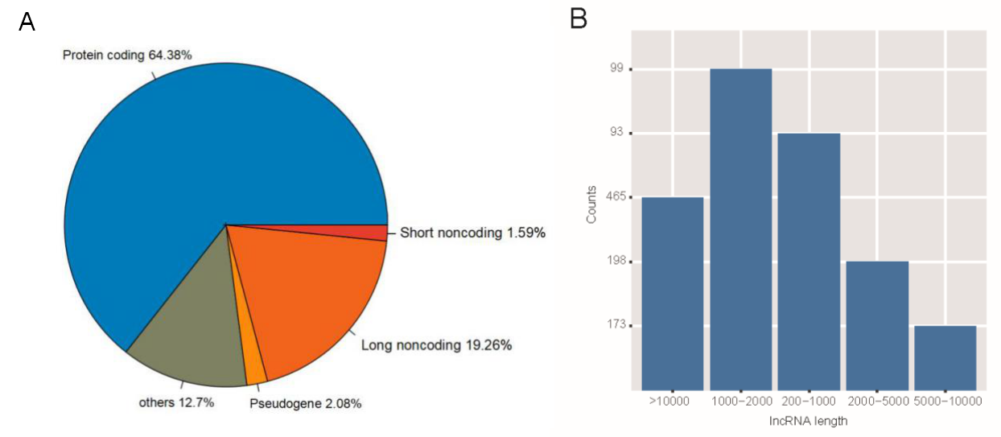
Figure S2. The distributions of the differentially expressed transcriptomes (A) and lengths of differentially expressed lncRNAs (B).
Figure S3. Pathway analysis of downregulated genes between iERM and PVR patients. (A) GO analysis data and (B) KEGG analysis data. GO, Gene Ontology; KEGG, Kyoto Encyclopedia of Genes and Genomes.
Figure S4. Pathway analysis of downregulated lncRNAs between iERM and PVR patients. (A) GO analysis data and (B) KEGG analysis data. GO, Gene Ontology; KEGG, Kyoto Encyclopedia of Genes and Genomes.

