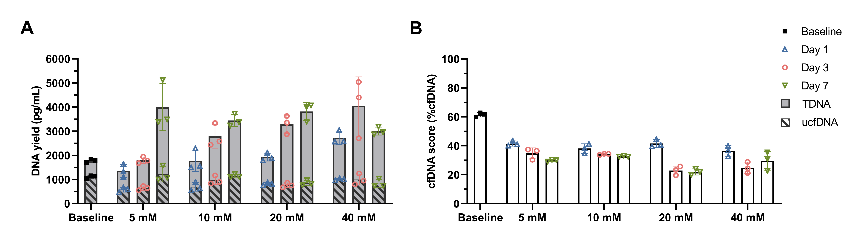
Figure S1. Effects of 5–40 mM EDTA on the TDNA yields and ucfDNA quality of WU samples. (A) ucfDNA and TDNA yields of EDTA-treated (5–40 mM) WU samples stored at RT for 1, 3, and 7 days. (B)The %cfDNA scores of ucfDNA extracted from EDTA-treated (5–40 mM) WU samples stored at RT for 1, 3, and 7 days. ucfDNA, urinary cell-free DNA; TDNA, total DNA; DNA yield, pg DNA/mL urine; WU, whole urine; RT, room temperature.

Figure S2. Evaluation of ucfDNA quality of EDTA-treated (10 mM) urine samples. (A) ucfDNA and TDNA yields of EDTA-treated (10 mM) WU and US samples stored at RT for 7 days. (B) The %cfDNA scores of ucfDNA extracted from EDTA-treated (10 mM) WU and US samples stored at RT for 7 days. (C) Electropherogram profile of ucfDNA extracted from EDTA-treated (10 mM) WU samples stored at RT for 7 days and FWU samples stored at -20°C for 7 days followed by three thawing methods. (D) Electropherogram profile of ucfDNA extracted from EDTA-treated (10 mM) US samples stored at RT for 7 days and from FUS samples stored at -20°C for 7 days followed by three thawing methods. ucfDNA, urinary cell-free DNA; TDNA, total DNA; DNA yield, pg DNA/mL urine; WU, whole urine; US, urine supernatant; FWU, frozen whole urine; FUS, frozen urine supernatant; RT, room temperature; n.s., nonsignificant; *p < 0.05. ***p < 0.001. ****p < 0.0001. Statistical significance was determined with repeated measures one-way ANOVA.

