Supplementary Figure 1. Relative dauer diapause of the worms losing each flp gene.
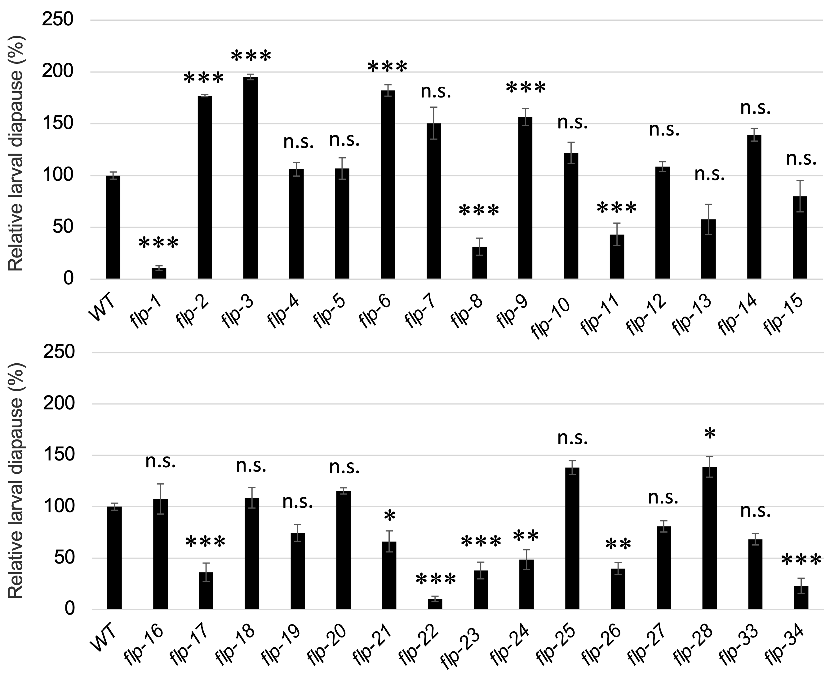

Supplementary Figure 1. Relative dauer diapause of the worms losing each flp gene.
The relative percentages of dauer formation in each knockout mutant, exposed to dauer-inducing pheromone, are compared to the wild-type strain. The deletion mutant nematodes were not outcrossed with the wild-type nematodes. Data are expressed as the mean ± SEM. *p < 0.05, **p < 0.01, ***p < 0.001. n.s., not significant. Multiple comparisons between groups were made using Dunnett’s test. Detailed parameters including numbers, trials, p-values, and values of mean ± SEM. are shown in Supplementary Table 3A.

Supplementary Figure 2. Secretion of DAF-7::mCherry in each flp-disrupted nematode.

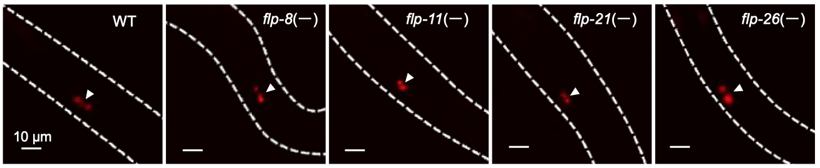

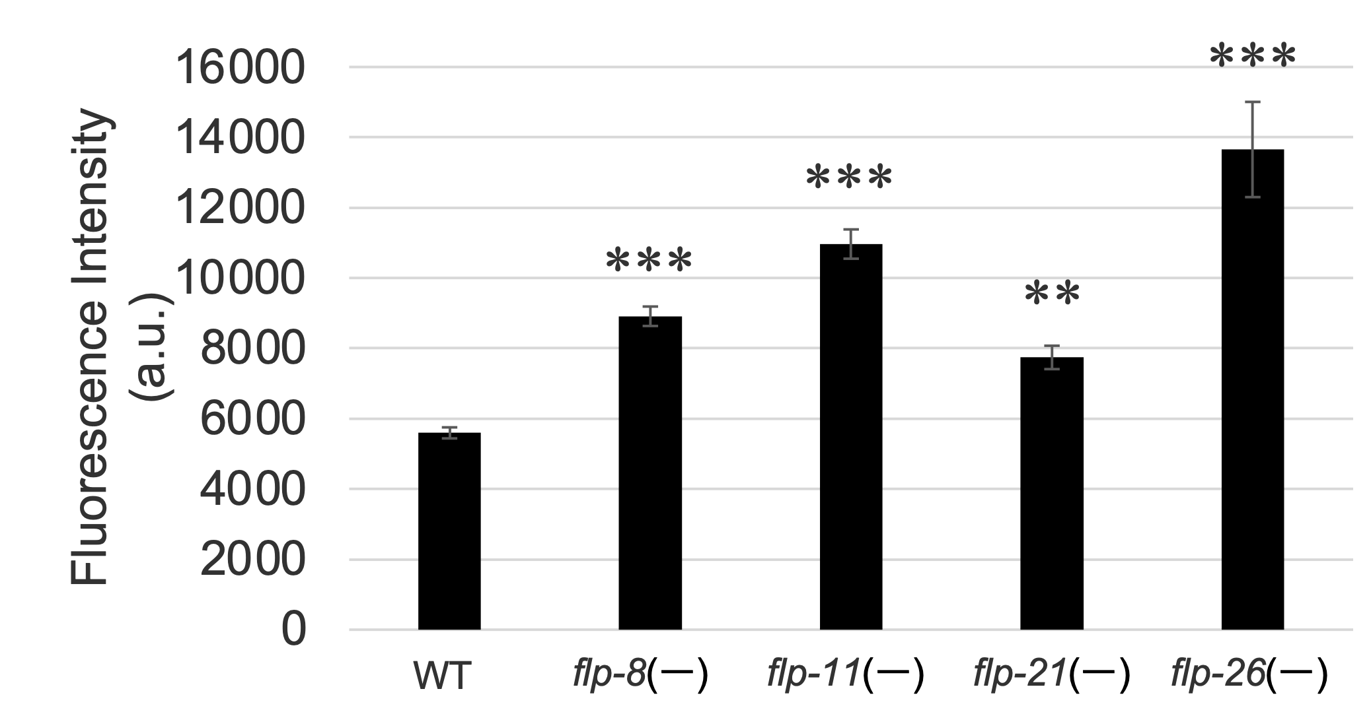

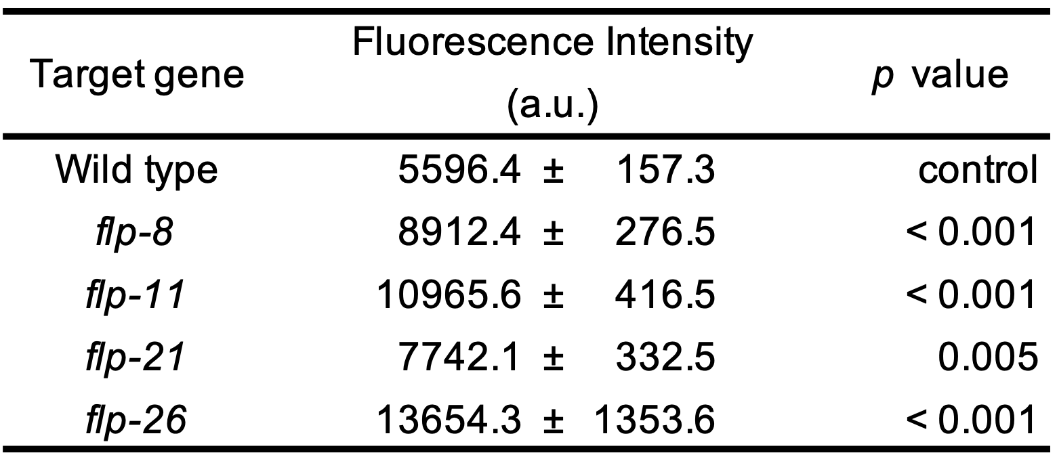

Supplementary Figure 2. Secretion of DAF-7::mCherry in each flp-disrupted nematode.
The secretion of DAF-7::mCherry into coelomocytes is indicated by arrowheads in the microscopic images. The fluorescence intensity of DAF-7::mCherry taken up by coelomocytes is presented in both the graph and the table. Data are expressed as the mean ± SEM. **p < 0.01, ***p < 0.001. Multiple comparisons between groups were made using Dunnett’s test. Detailed parameters including p-values and values of mean ± SEM. are also shown. The respective fluorescence intensity under background of the flp-9, flp-17, flp-22, flp-23, flp-24, flp-28, and flp-34 disruption is almost the same to that in the wild-type background (data not shown).

Supplementary Figure 3. flp-11 is not involved in the DAF-28 production and secretion.

(A) The DAF-28 production (B) The DAF-28 secretion
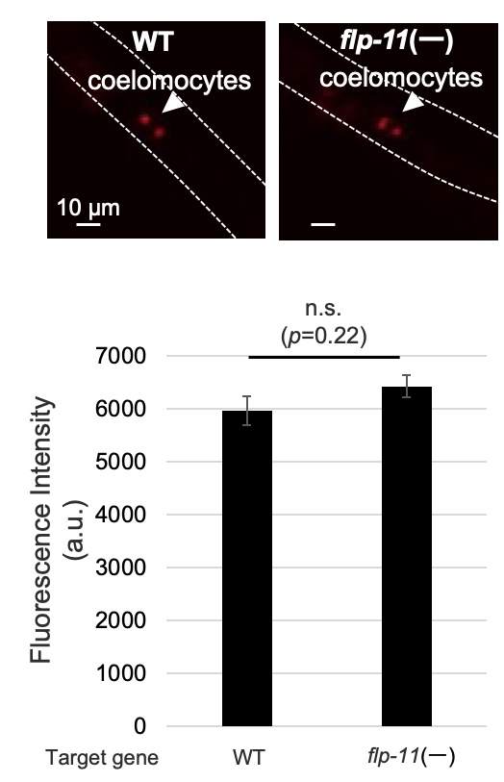
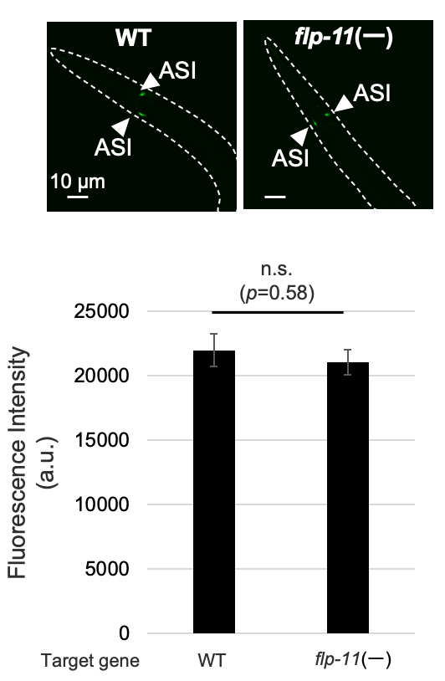

The GR1455(mgIs44) nematodes, expressing stably daf-28p::GFP and the tmIs4109 nematodes, expressing stably daf-28p::DAF-28::mCherry were crossed with flp-11(tm2706) nematodes, respectively. The fluorescent intensity of the GFP, representing DAF-28 production, and that of the mCherry, representing DAF-28 secretion, were compared. A comparison between groups was made using Student’s t-tests. Data are expressed as mean ± SEM. n.s., not significant. n = 5.

Supplementary Figure 4. npr-22 is not involved in the DAF-28 secretion.
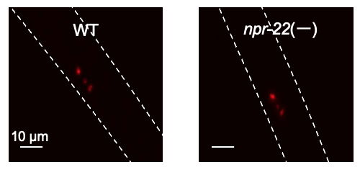

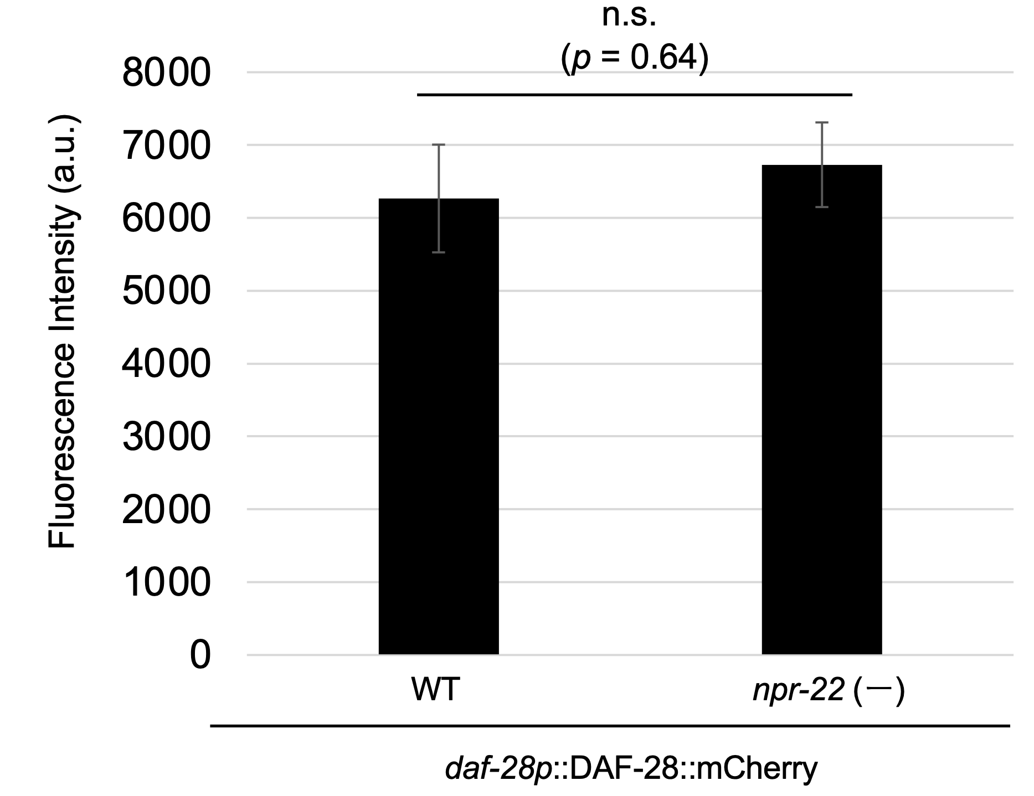

The tmIs4109 nematodes, expressing stably daf-28p::DAF-28::mCherry were crossed with npr-22(tm8953) nematodes. The fluorescent intensity of the mCherry, representing DAF-28 secretion, was compared. A comparison between groups was made using Student’s t-tests. Data are expressed as mean ± SEM. n.s., not significant. n = 5.

Supplementary Table 1. The list of mutant nematodes used in this study.
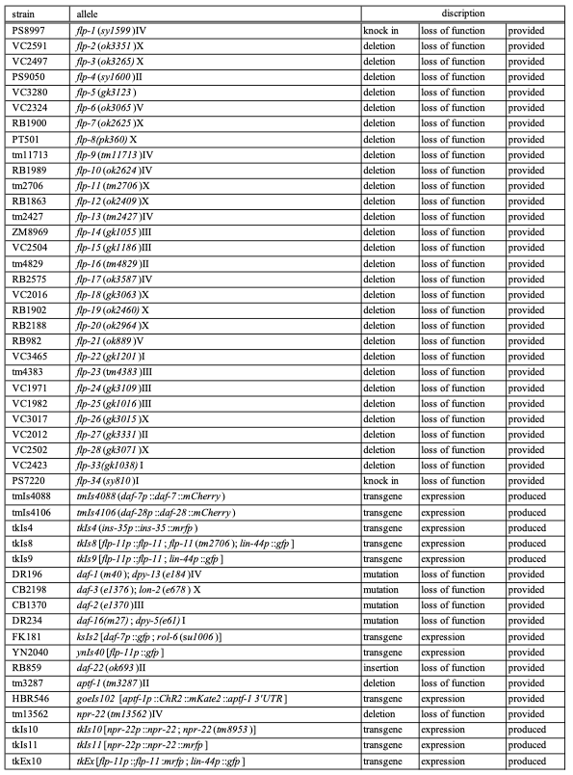

Supplementary Table 2. The sequences of PCR primers used in this study.
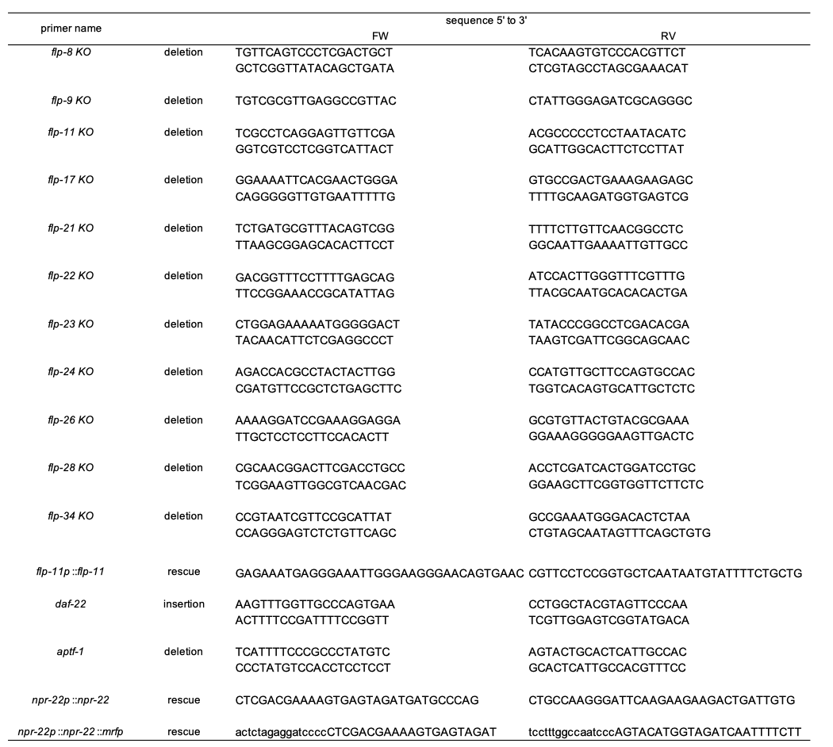

Supplementary Table 2. The sequences of PCR primers used in this study.
The sequences of PCR primers used for detection of deletion/insertion and for construction of transgene are shown. The sequences consisting of small letters were utilized for an In-Fusion reaction.

Supplementary Table 3A. Dauer diapause of the nematodes losing each flp gene.
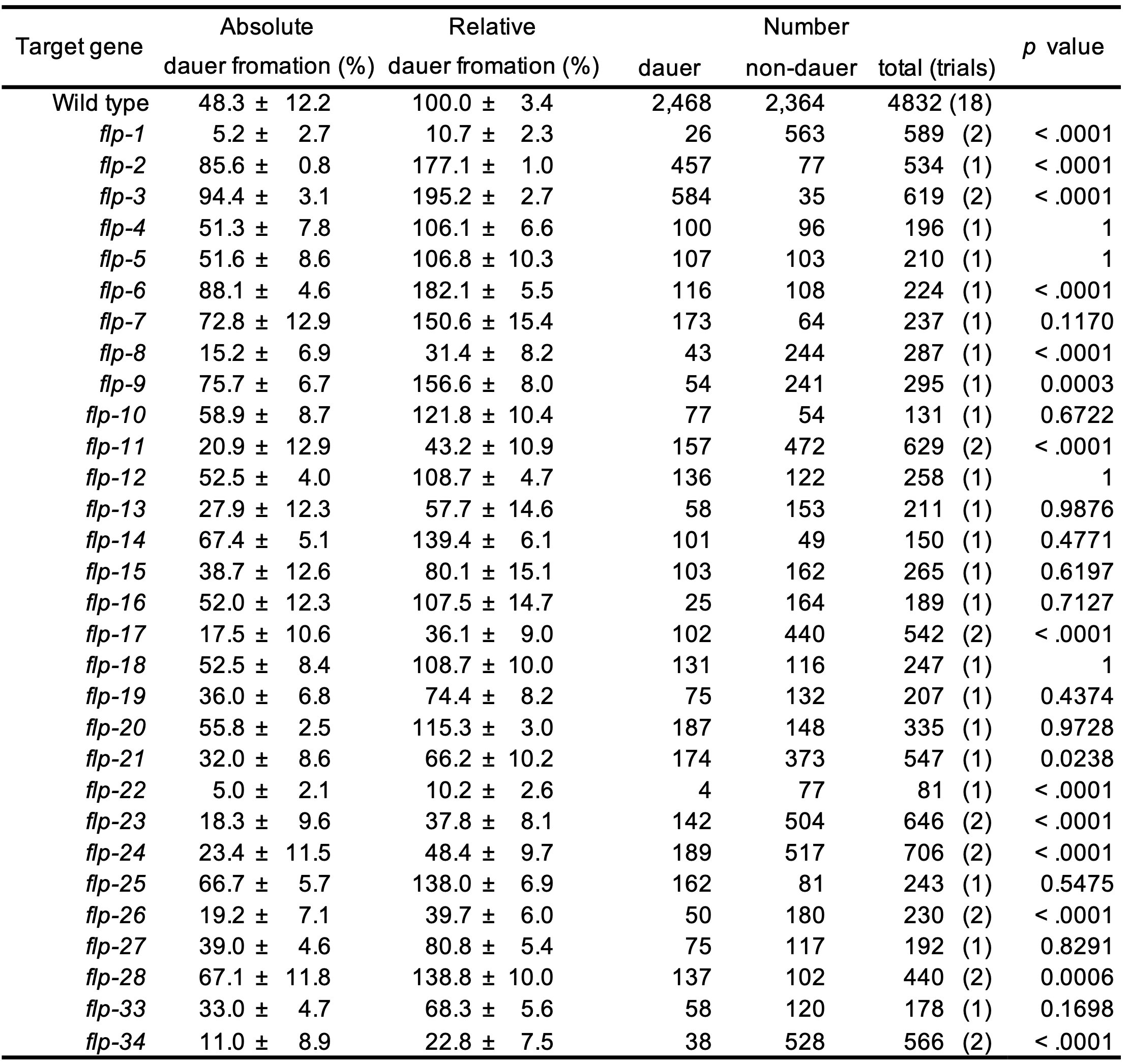

Supplementary Table 3A. Dauer diapause of the worms losing each npr gene.
The percentages of dauer formation in each deletion mutant in the presence of dauer-inducing pheromone, in comparison to the wild type, are presented. For every dauer formation assay, 3-4 autonomous plates were examined. Data are represented as the mean ± SEM.
Supplementary Table 3B. The flp-11 gene is involved in modulation of dauer diapause.
(Figure 1D)
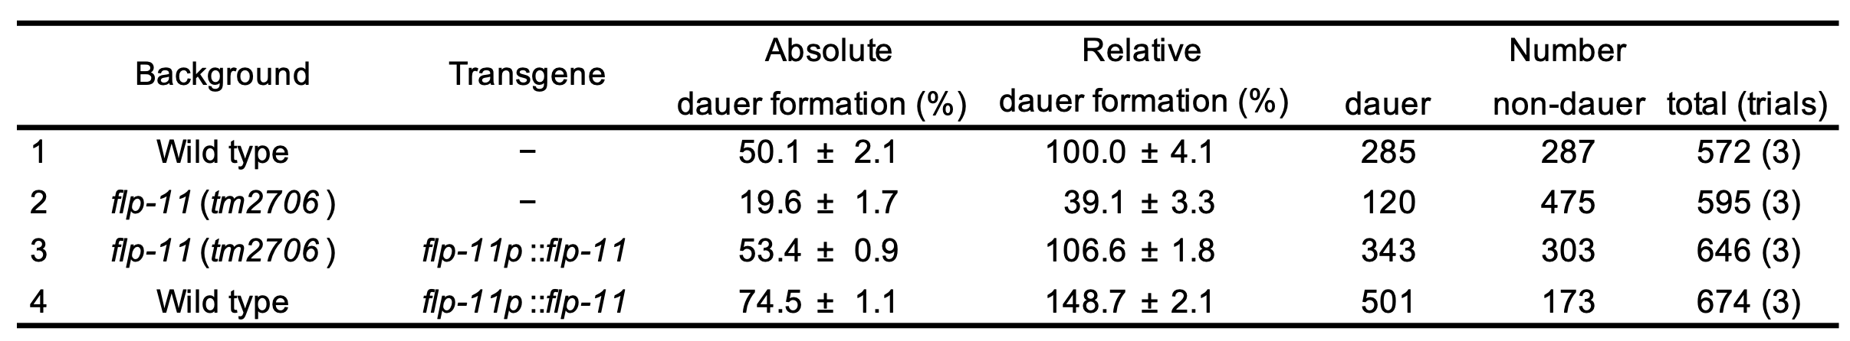

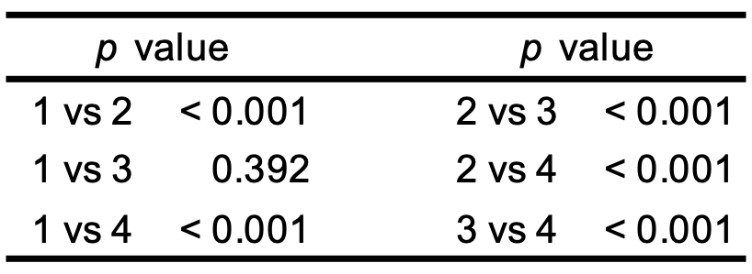

Supplementary Table 3B. The flp-11 gene is involved in modulation of dauer diapause.
The relative percentages of dauer formation in each mutant nematode, when compared to wild-type, in the presence of dauer pheromone. Detailed parameters, including raw data, trials, p values, and mean ± SEM are shown.

Supplementary Table 3C. The npr-22 gene is involved in modulation of dauer diapause.
(Figure 1F)
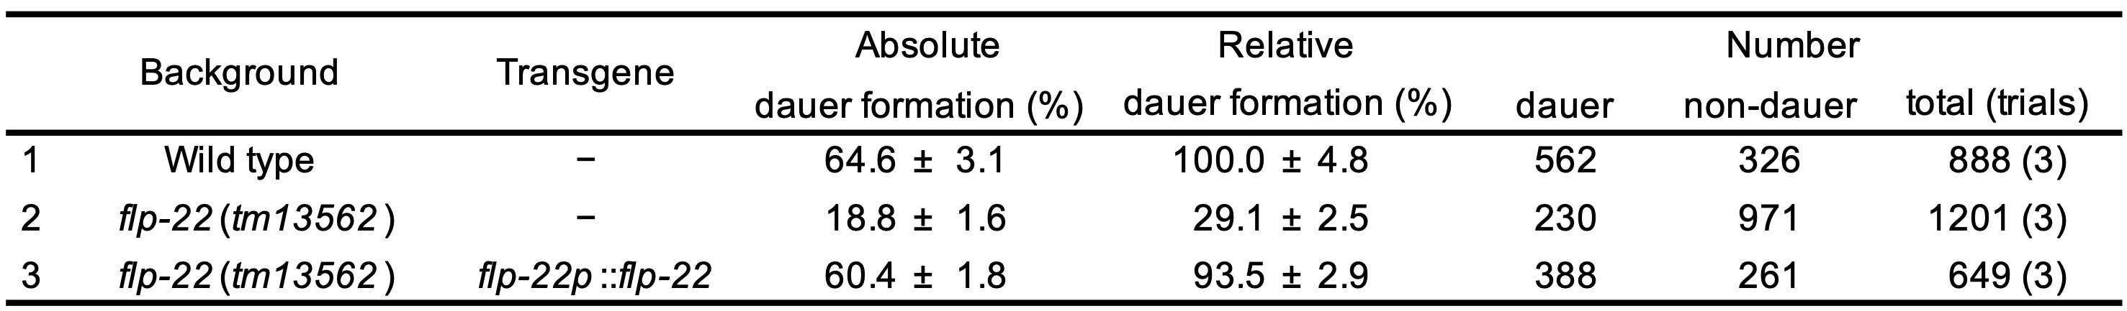

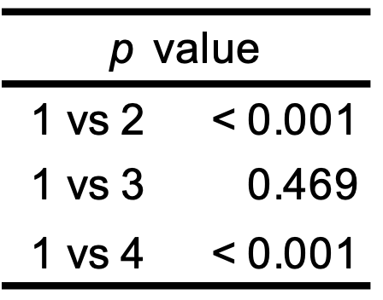

Supplementary Table 3C. The npr-22 gene is involved in modulation of dauer diapause.
The relative percentages of dauer formation in each mutant nematode, when compared to wild-type, in the presence of dauer pheromone. Detailed parameters, including raw data, trials, p values, and mean ± SEM are shown.

Supplementary Table 3D. The npr-22 gene is located downstream of the flp-11 gene to regulate larval development. (Figure 1G)
The relative percentages of dauer formation in each mutant nematode, when compared to wild-type, in the presence of dauer pheromone. Detailed parameters, including raw data, trials, p values, and mean ± SEM are shown.

flp-11 over-expression vs npr-22 defect (Fig. 1G left)
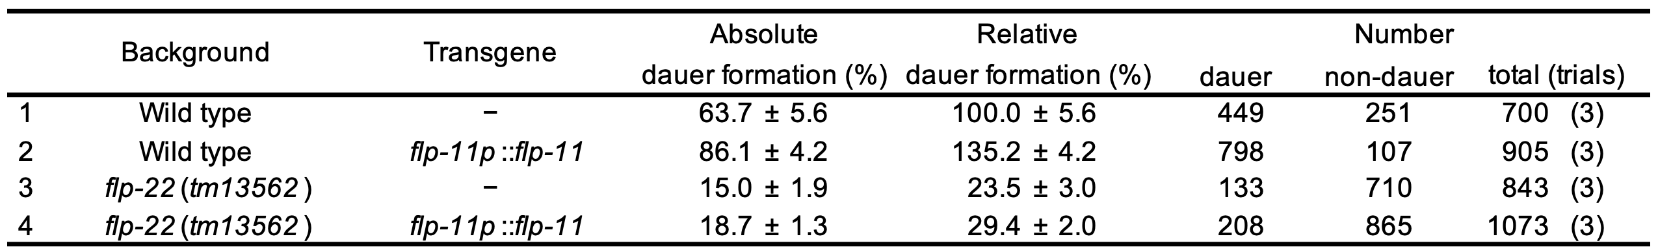

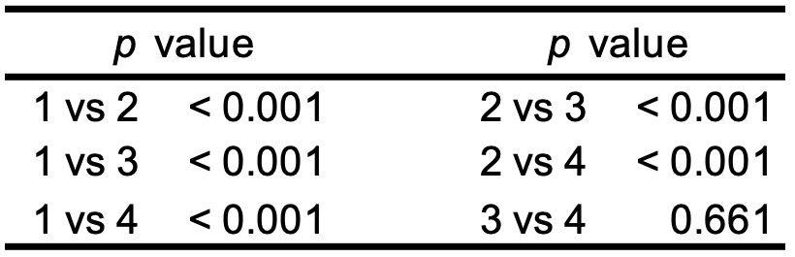

npr-22 defect and flp-11 defect showed no additive effect on dauer diapause (Fig. 1G right)
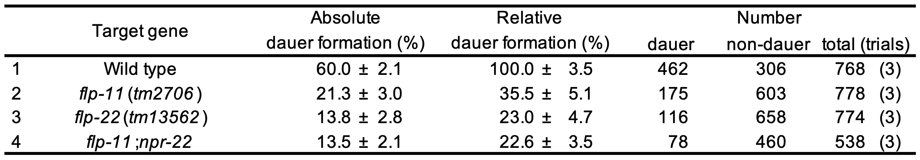

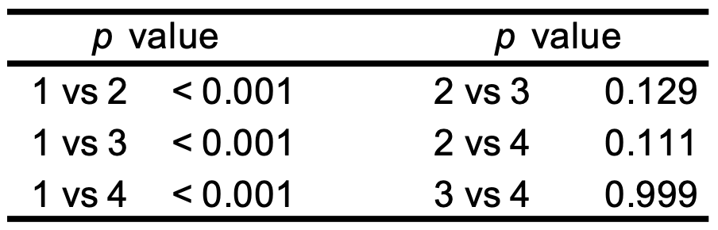

Supplementary Table 3E. flp-11 vs daf-1. (Figure 3A)
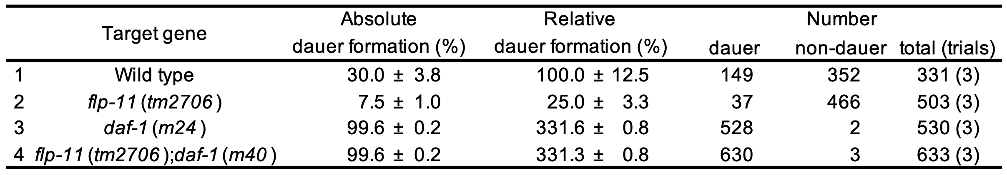

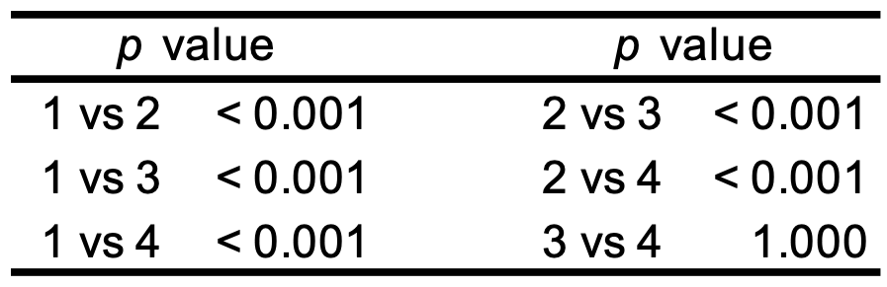

Supplementary Table 3F. flp-11 vs daf-2. (Figure 3B)
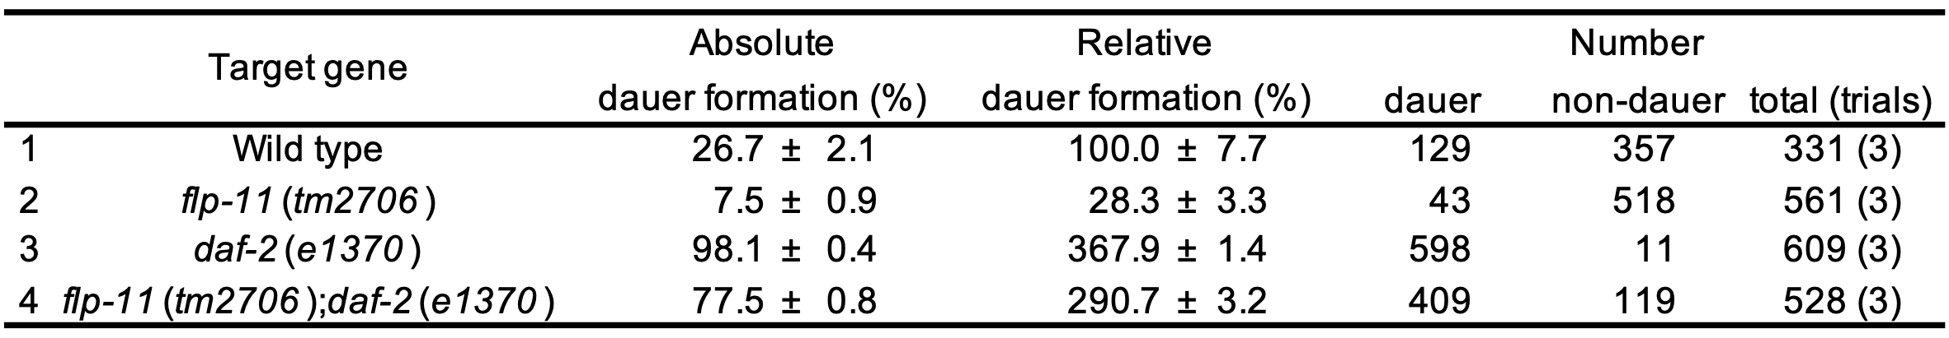

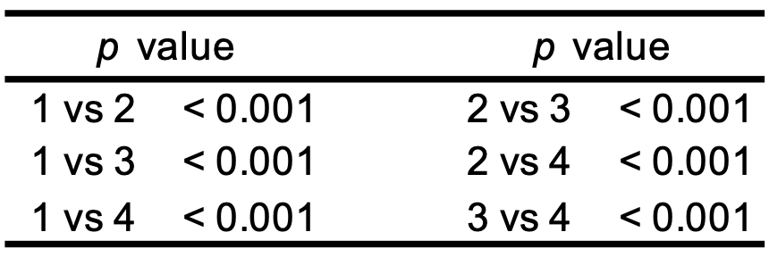

Supplementary Table 3G. flp-11 vs daf-3. (Figure 3C)
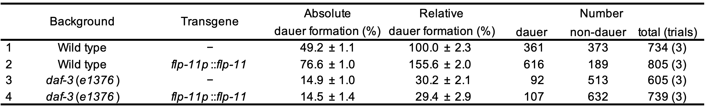

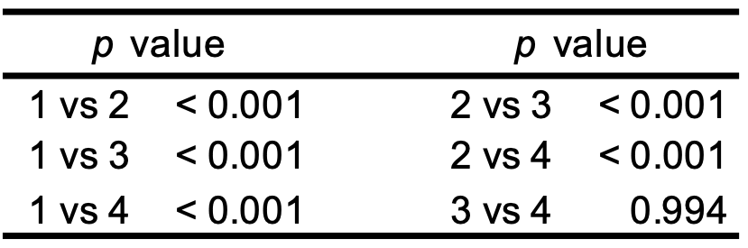

Supplementary Table 3H. flp-11 vs daf-16. (Figure 3D)
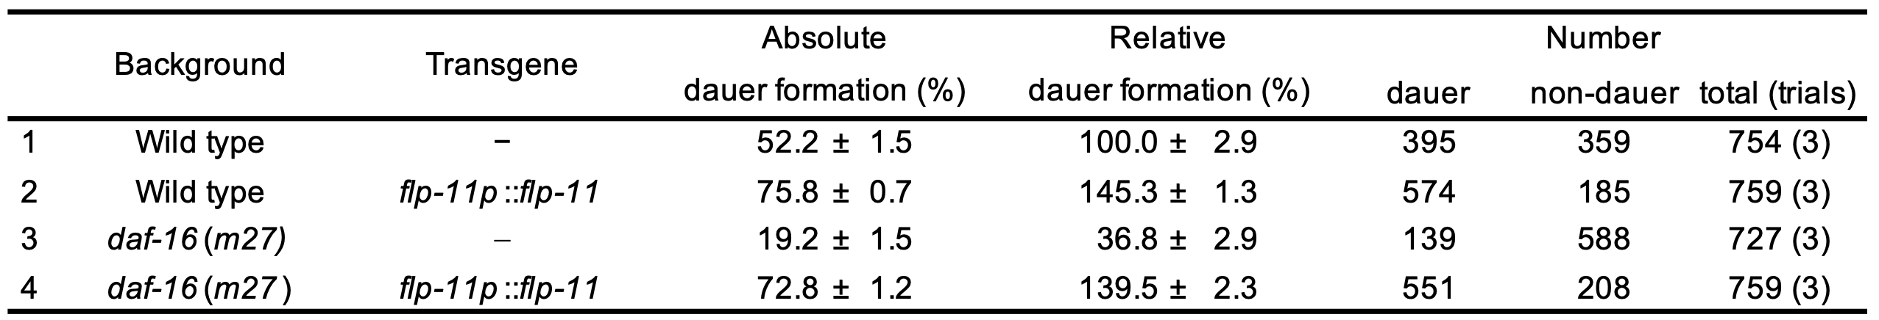

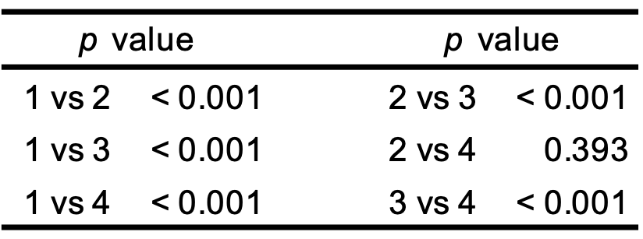

Supplementary Table 3I. The aptf-1 is not involved in larval development. (Figure 6B)

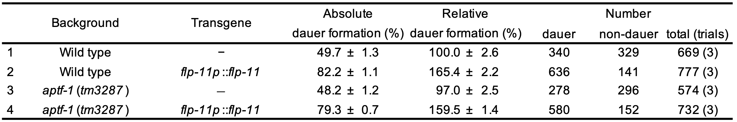

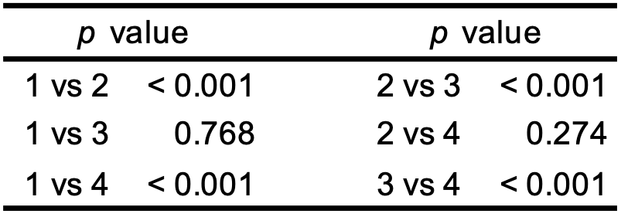

Supplementary Table 4A. DAF-7 secretion. (Figure 2A)

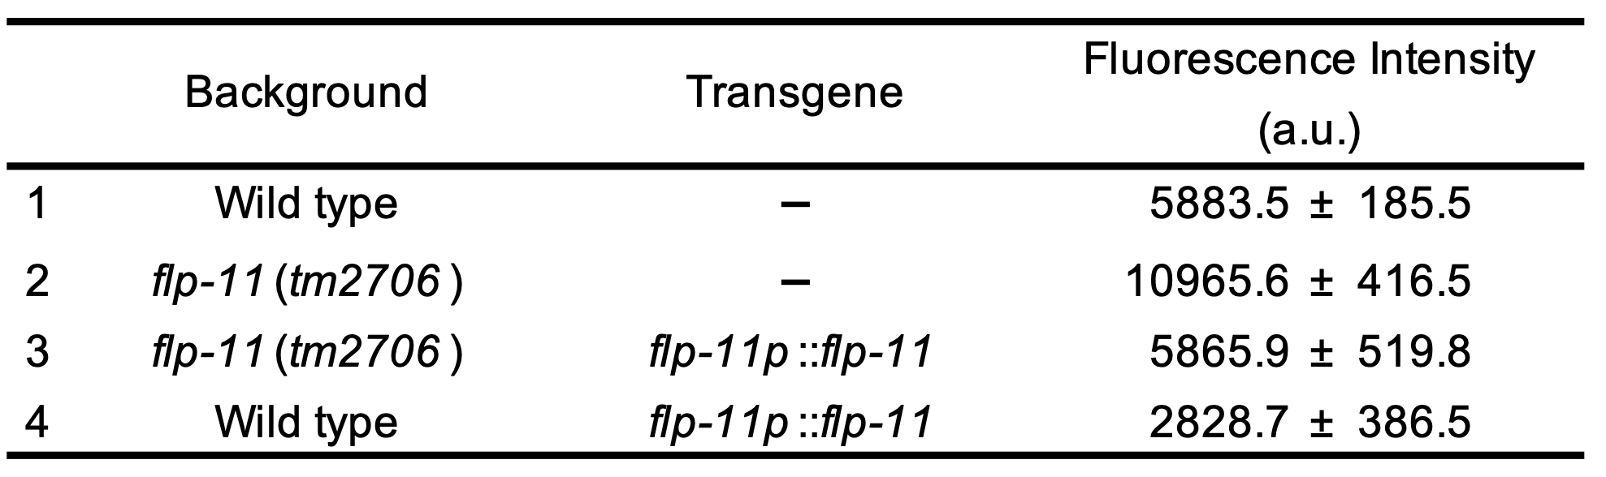
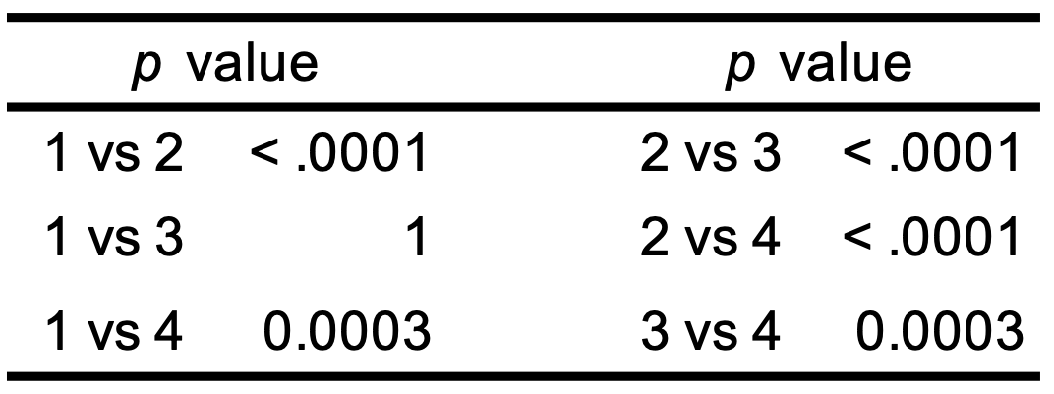

Supplementary Table 4B. DAF-7 production. (Figure 2B)

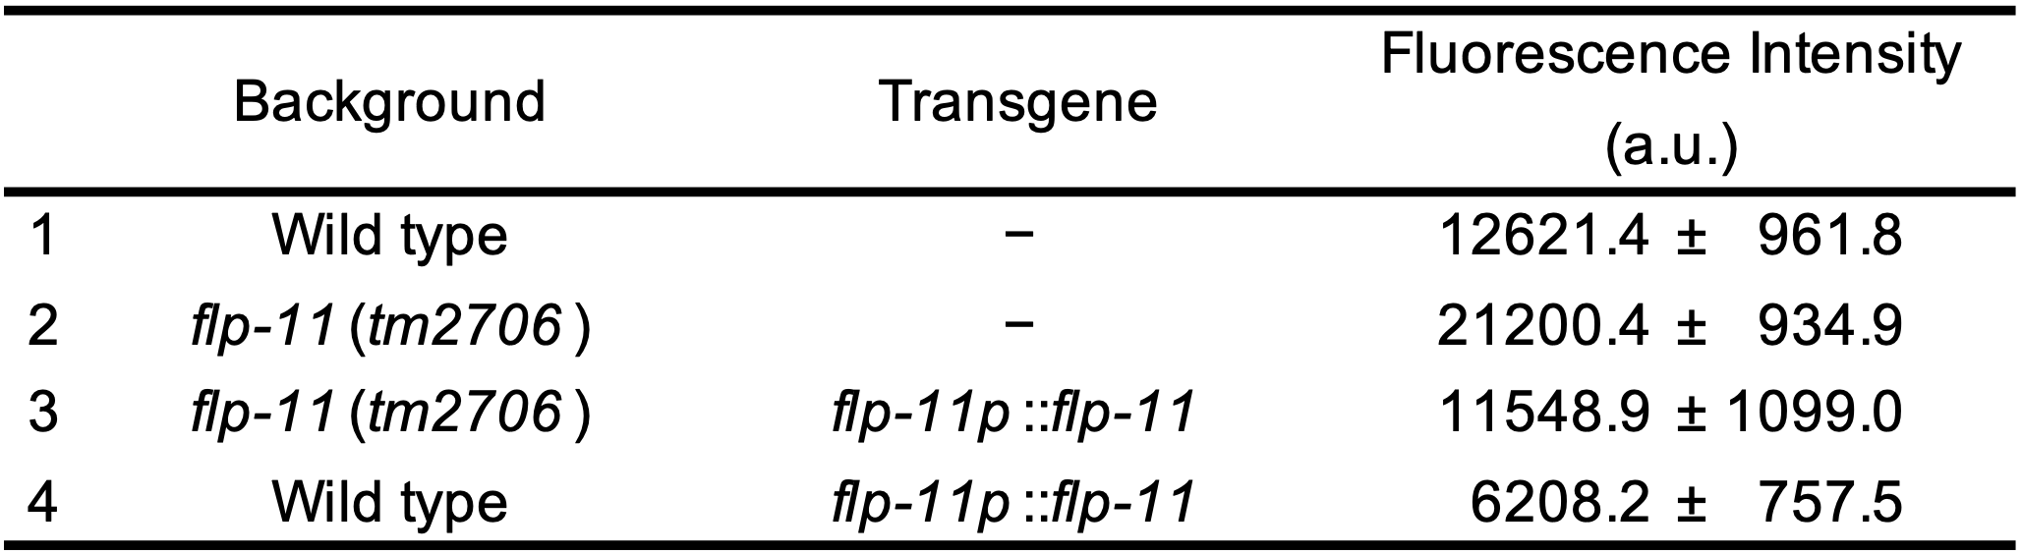
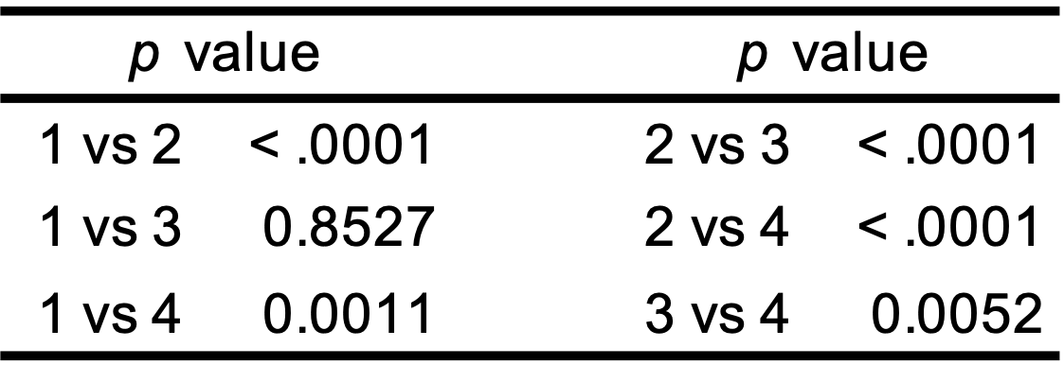

Supplementary Table 4C. The fluorescence intensity of flp-11p::GFP in several neurons.
(Figure 4)

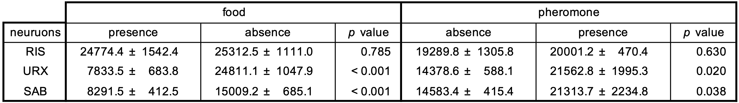

Supplementary Table 4D. Effect of food and dauer pheromones on the secretion of FLP-11. (Figure 5)

Effect of food on FLP-11 secretion (Figure 5 A)
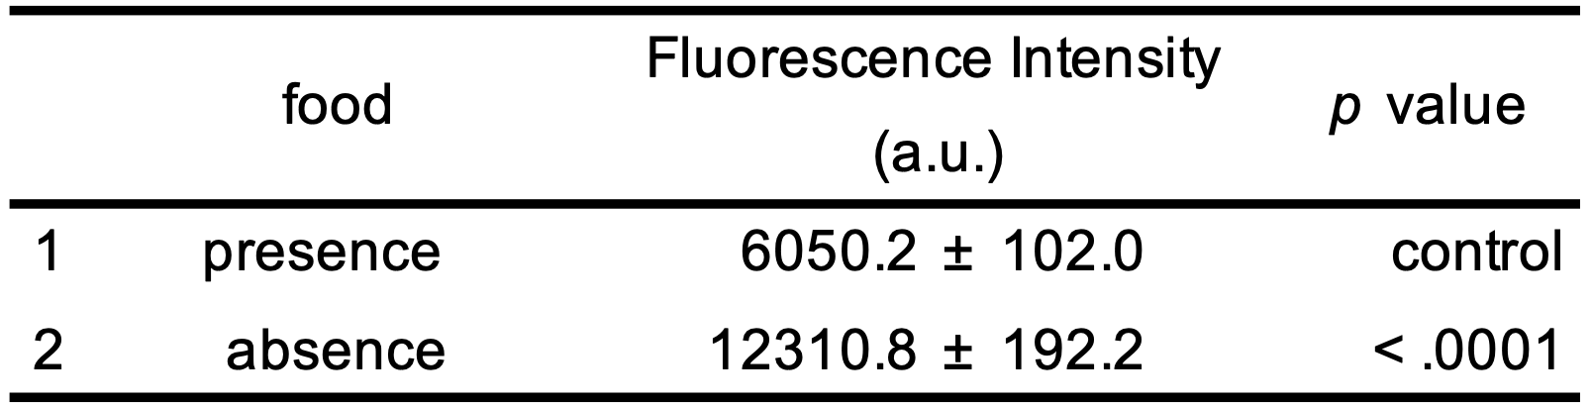

Effect of pheromone on FLP-11 secretion (Figure 5 B)

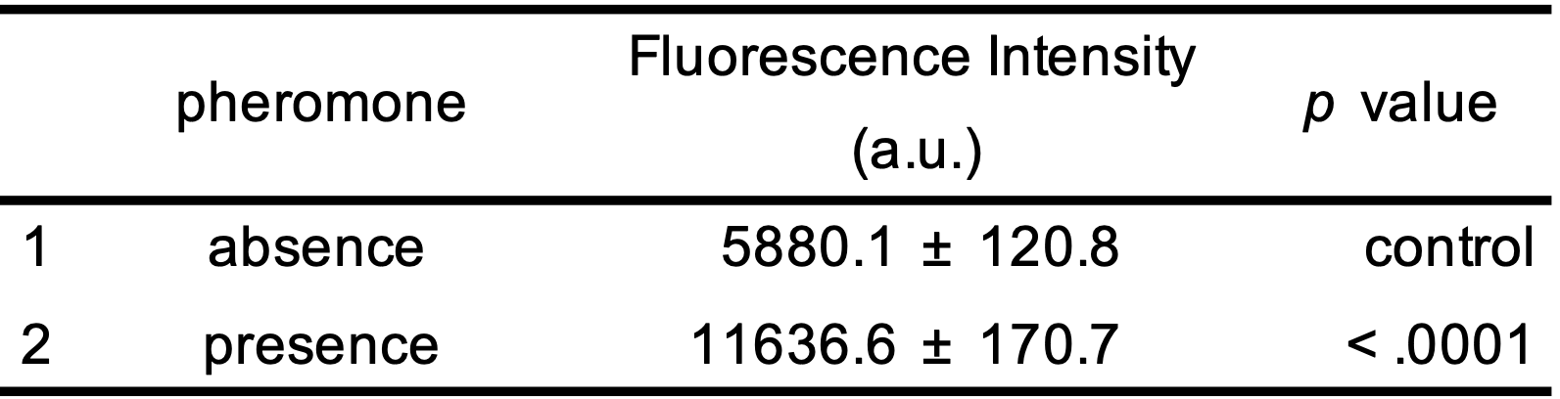

Supplementary Table 4E. (Figure 6A)

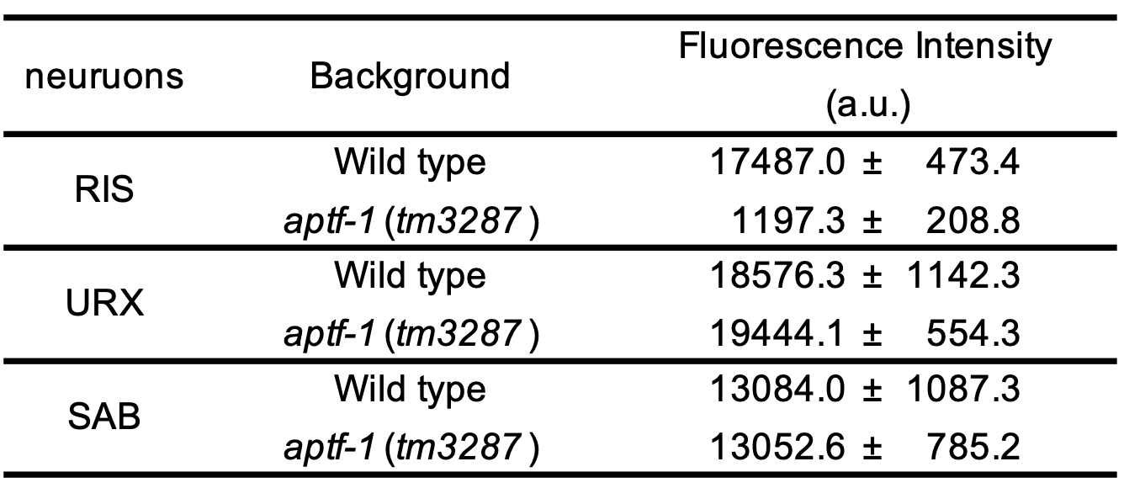

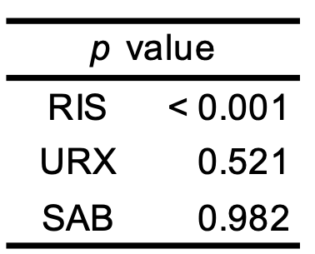

Supplementary Table 4F. Effect the npr-22 on DAF-7 production and secretion. (Figure 7B)

Effect on DAF-7 production. (Fig. 7. left)
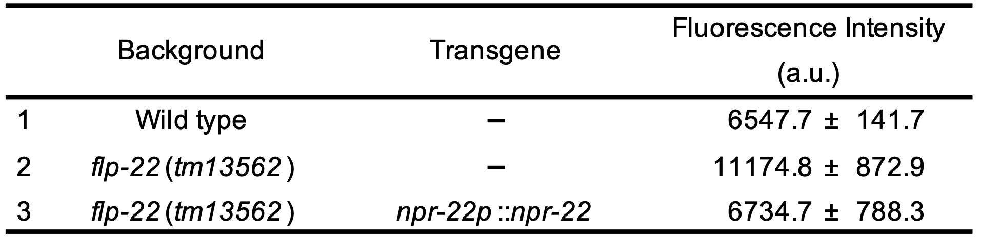
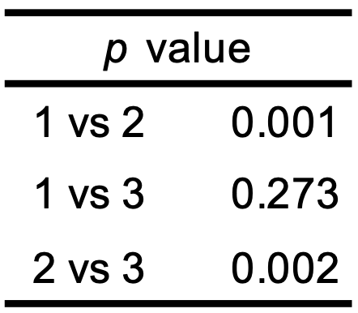

Effect on DAF-7 secretion. (Fig. 7. right)
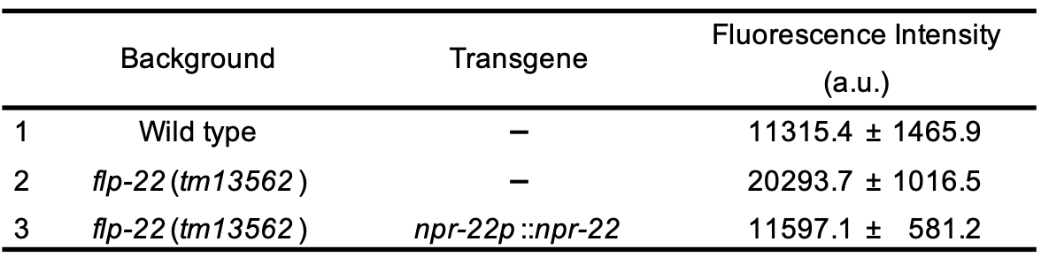
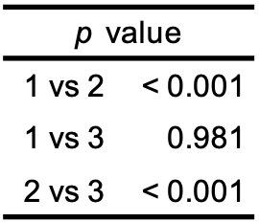

Supplementary Table 5. Expression of NPRs in ASI neurons and a machine-learning for pairing FLP-11/the NPRs.
