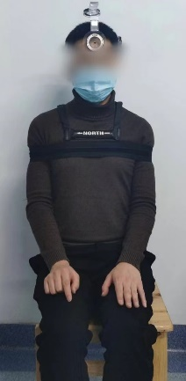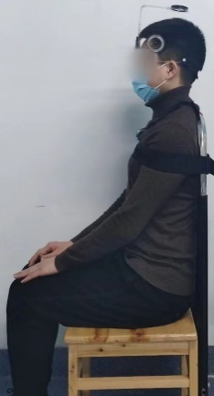
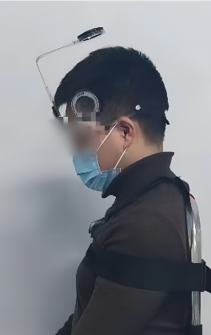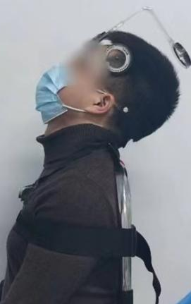
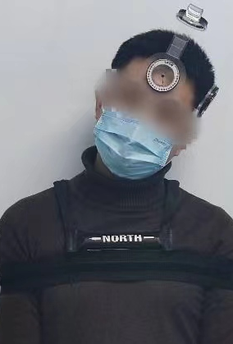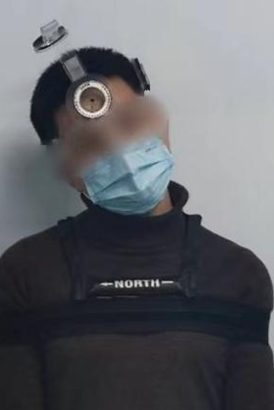
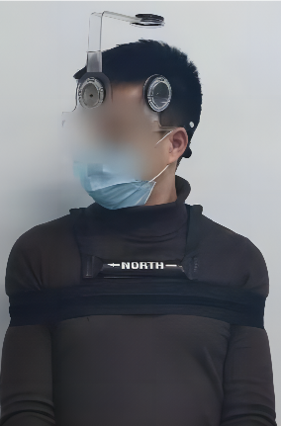
Supplemental 1:Measurement of ACROM,From top to bottom are neutral position, flexion and extension (FE),lateral bending (LB),and axial rotation (AR)

Supplemental 2: Head-Cervical Spine Range of Motion Data of the Healthy Population
(measured by the CROM device)
Age(yrs) | Gender | Tool | Flexion | Extension | Left LB | Right LB | LeftAR | Right AR
20-29 | Male | CROMTM | 52.35(5. 19) | 73.21(6. 17) | 44.05(4.37) | 42. 18(3.58) | 70.51(4.29) | 70.05(4.87)
20-29 | Female | CROMTM | 54.52(5.49) | 74.51(5.46) | 47.50(4.50) | 43.27(6. 11) | 71.95(4.79) | 71.58(3.97)
30-39 | Male | CROMTM | 50.83(5.91) | 64.54(7.39) | 42.48(4.81) | 39. 16(4.35) | 69.23(4.72) | 68.67(4.53)
30-39 | Female | CROMTM | 52.09(5.56) | 71.59(7.59) | 44. 16(4.79) | 40.79(4.46) | 71.91(5. 14) | 71.97(5. 13)
40-49 | Male | CROMTM | 49. 19(5.97) | 60.03(8.01) | 40.45(5.31) | 37.55(4.02) | 66. 19(5.56) | 66.74(4.69)
40-49 | Female | CROMTM | 48.53(5.98) | 64. 19(7.41) | 42.32(3.94) | 38.31(4.21) | 68.03(5.26) | 67.67(4.79)
50-59 | Male | CROMTM | 45.45(5. 17) | 56.91(7. 12) | 39.26(4.42) | 35.29(4.82) | 64.69(5.32) | 63.30(5.38)
50-59 | Female | CROMTM | 47.30(4.26) | 58.61(6.29) | 39. 17(4.56) | 35.20(5.22) | 65.89(5.30) | 65.31(5.95)
≥60 | Male | CROMTM | 45.22(4. 17) | 54.32(7.48) | 37.00(4.86) | 33.45(4.34) | 62.21(6.39) | 61.42(5.98)
≥60 | Female | CROMTM | 45.69(3.81) | 55.97(7.94) | 36.82(5.22) | 34.38(5.72) | 62.84(6.41) | 62.29(6.36)
Data were express in Mean(SD)
Supplemental 2:baseline dataset for normal population

Supplemental 3:sample size
group |  | ACDF-1 | ACDF-2 | LAMP | ACDF-3
flexion | Retention rate | 84.83% | 74.91% | 70.56% | 65.18%
flexion | SD | 3.59% | 4.52% | 6.52% | 2.90%
flexion | Sample size | 5 | 5 | 5 | 5
extention | Retention rate | 81.84% | 71.40% | 67.90% | 62.86%
extention | SD | 5.48% | 8.31% | 8.20% | 4.32%
extention | Sample size | 7 | 7 | 7 | 7
Left LB | Retention rate | 85.58% | 73.99% | 72.27% | 71.19%
Left LB | SD | 5.39% | 5.11% | 6.78% | 5.34%
Left LB | Sample size | 6 | 6 | 6 | 6
Ringt LB | Retention rate | 85.28% | 74.52% | 73.81% | 71.69%
Ringt LB | SD | 5.92% | 5.44% | 7.84% | 6.99%
Ringt LB | Sample size | 9 | 9 | 9 | 9
Left AR | Retention rate | 89.72% | 82.61% | 80.38% | 76.81%
Left AR | SD | 1.99% | 3.54% | 3.93% | 3.61%
Left AR | Sample size | 4 | 4 | 4 | 4
Right AR | Retention rate | 90.15% | 82.95% | 80.85% | 76.36%
Right AR | SD | 2.26% | 4.58% | 4.67% | 3.65%
Right AR | Sample size | 5 | 5 | 5 | 5

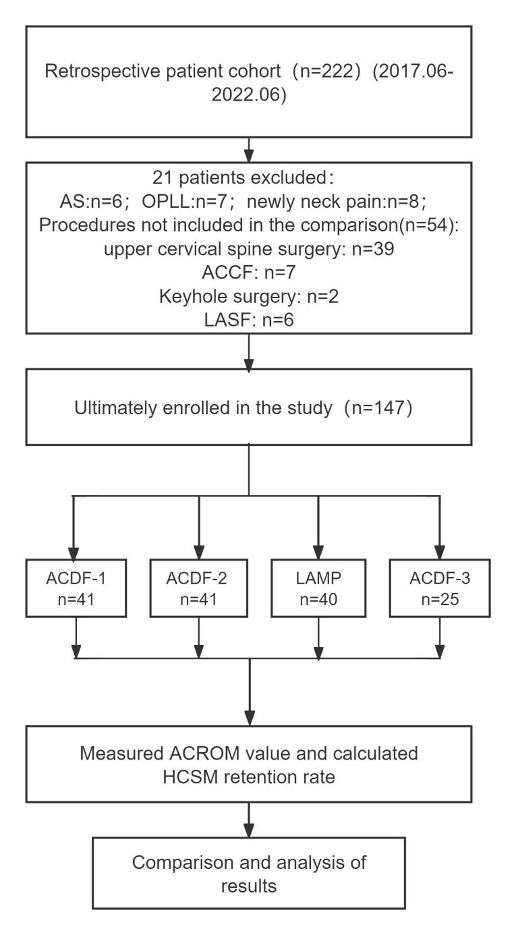
Supplemental 4:The research route

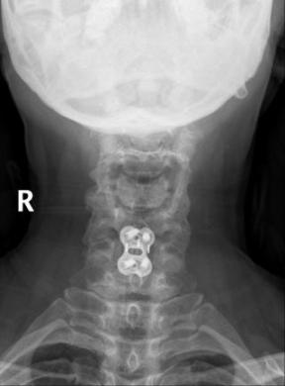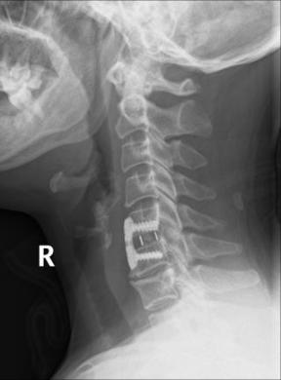
(1)ACDF-1
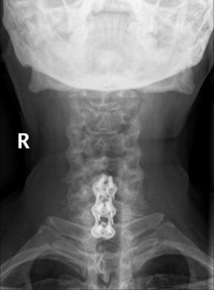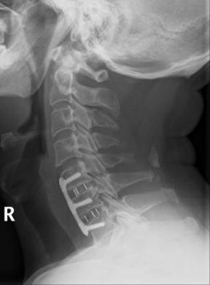
(2)ACDF-2
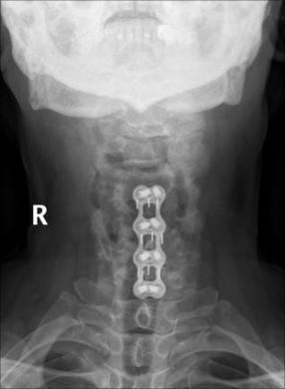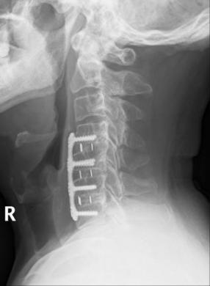
(3)ACDF-3
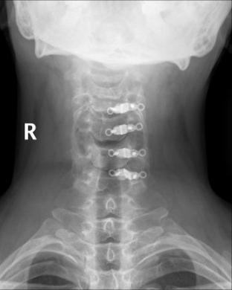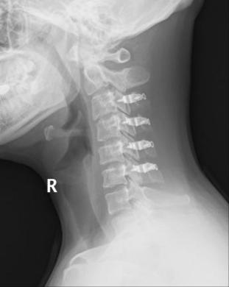
(4)LAMP
Supplemental 5:the postoperative X-ray of the patients

Group | Age  (years) | Sex  (male/female) | Height  (cm) | Weight  (kg)
ACDF-1 | 56.64(8.01) | 18/23 | 162.54(5.62) | 63.57(8.78)
ACDF-2 | 54.05(9.28) | 24/17 | 163.98(7.67) | 67.39(11.11)
LAMP | 57.20(12.05) | 26/14 | 162.95(8.25) | 67.19(12.52)
ACDF-3 | 54.84(10.20) | 23/20 | 164.24(5.53) | 64.68(8.78)
P value | 0.464 | 0.174 | 0.691 | 0.298
The data are express as the Mean (SD)

Supplemental 6:demographic data

