Supplementary Information
AI-driven Adoptive Non-invasive Continuous Glucose Monitoring:
Personalized Biosensor for Each Unique Patient

Chuanjie Yao^{1, +}, Xinshuo Huang^{1, +}, Xinze Wang^{1, +}, Lukang Gao^{1, +}, Haolin Wang¹, Shuang Huang^{1, 2}, Guanbin Li³, Xiongqi Han⁴, Hanqi Yang¹, Zhengjie Liu¹, Shanshan Liang⁵, Peng Yun⁶, Yunuo Wang⁷, Mingqiang Li⁸, Ji Wang⁷, Hui-jiuan Chen¹, Xi Xie^{1,2,7,} *

¹State Key Laboratory of Optoelectronic Materials and Technologies, Guangdong Province Key Laboratory of Display Material and Technology, School of Electronics and Information Technology, Sun Yat-sen University, Guangzhou 510006, China.
²Guangdong Provincial Key Laboratory of Sensor Technology and Biomedical Instrument, School of Biomedical Engineering, Sun Yat-sen University, Shenzhen 518107, China.
³Computer Science and Engineering, Sun Yat-sen University, Guangzhou 510006, China.
⁴Shenzhen SiSensing Co., Ltd. Shenzhen, China.
⁵National Innovation Center for Advanced Medical Devices, Shenzhen, Guangdong, China.
⁶Department of Endocrinology, The Seventh Affiliated Hospital, Sun Yat-sen University, Shenzhen, China.
⁷The First Affiliated Hospital of Sun Yat-sen University, Sun Yat-sen University, Guangzhou 510080, China.
⁸Laboratory of Biomaterials and Translational Medicine, Center for Nanomedicine, The Third Affiliated Hospital, Sun Yat-sen University, Guangzhou 510630, China.
*Corresponding author: xiexi27@mail.sysu.edu.cn.

S1-1. The derivation of the MHC-related parameters
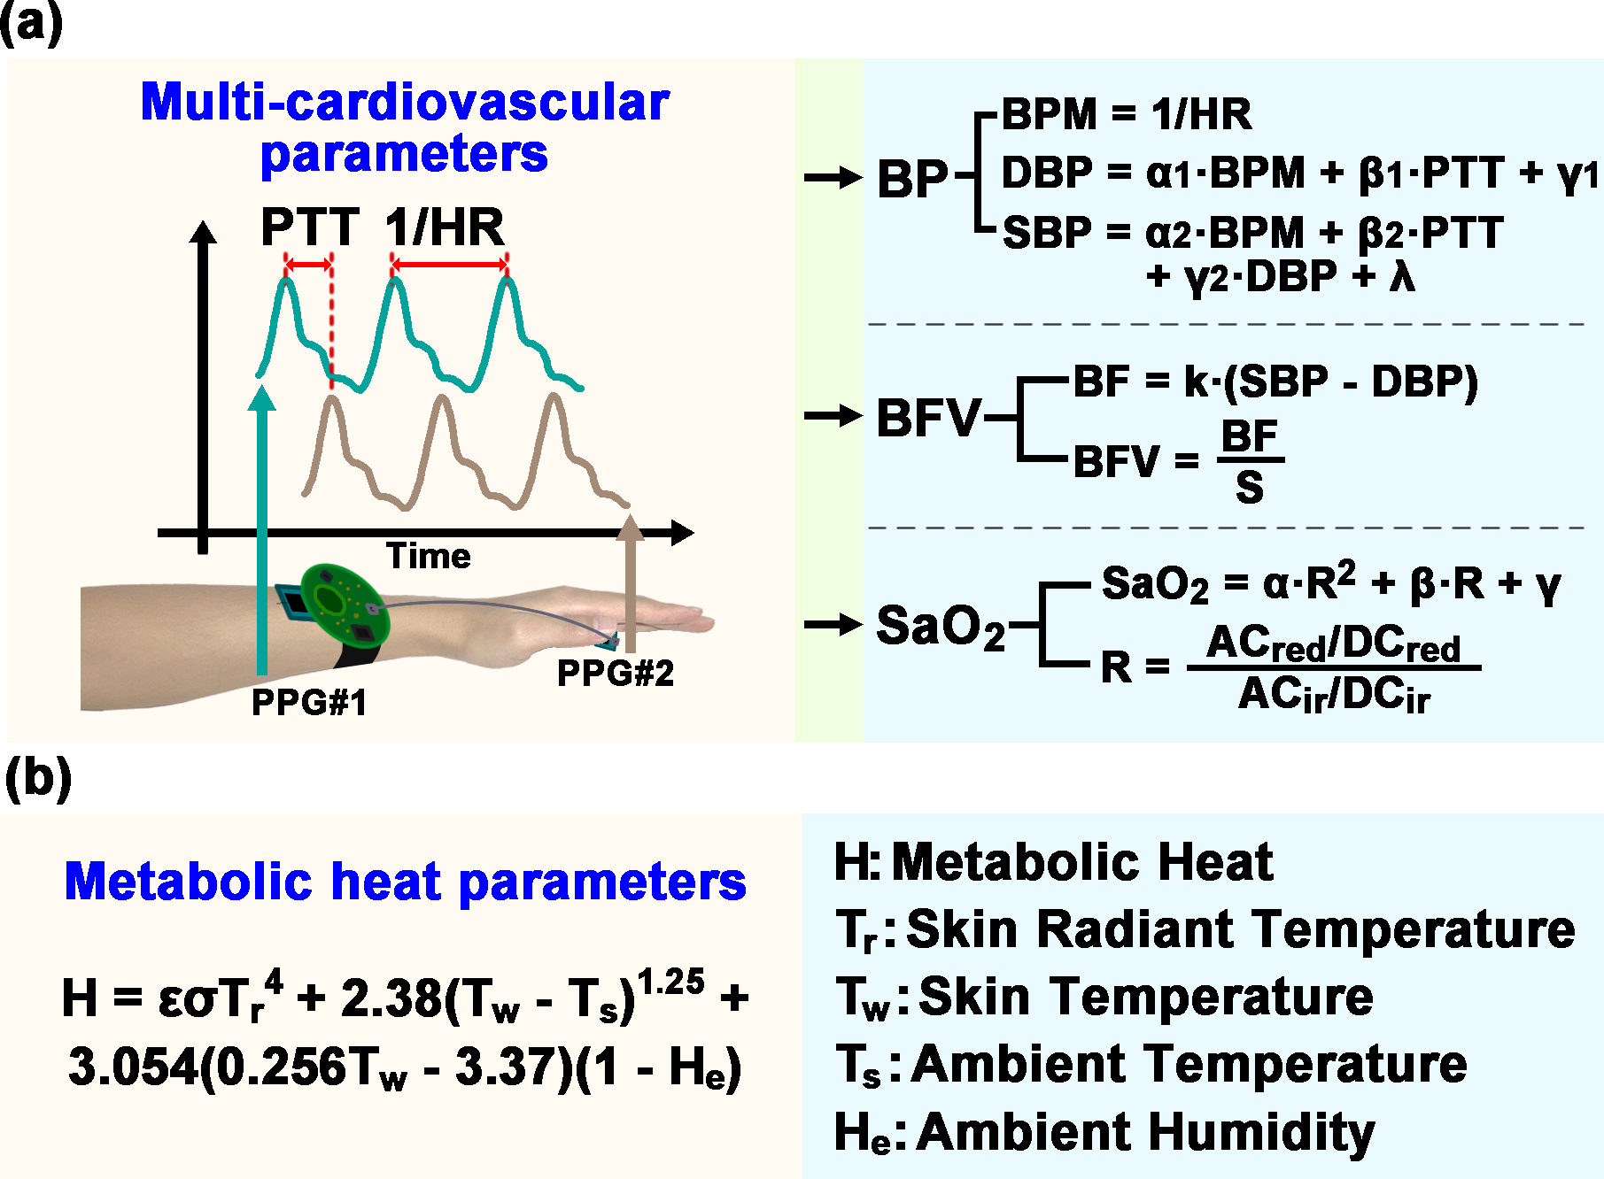
Figure S1-1. The derivation of the MHC-related parameters included the multi-cardiovascular parameters and the metabolic heat parameters. (a) Schematic of multi-cardiovascular parameters collected by PPG sensors, with PPG#1 sensor fixed to the wrist and PPG#2 fixed to the finger area for dual-pulse wave signals. These dual-pulse wave signals were rich in cardiovascular information and enabled the derivation of critical cardiovascular parameters such as PTT, HR, BP, BFV and SaO₂. (b) The MHP generated by the vital activities was approximately equal to the total heat dissipation emitted by the human body to the external environment, which included thermal radiation, heat convection and heat evaporation. Specifically, the thermal radiation and heat convection were related to the skin surface temperatures and ambient temperatures, while the heat evaporation was related to ambient humidity additionally. Thus, the MHP could be derived indirectly from the skin surface temperature, skin thermal radiation, ambient temperature, and ambient humidity.

S2-1 Relative response current of the microelectrode upon glucose sensing
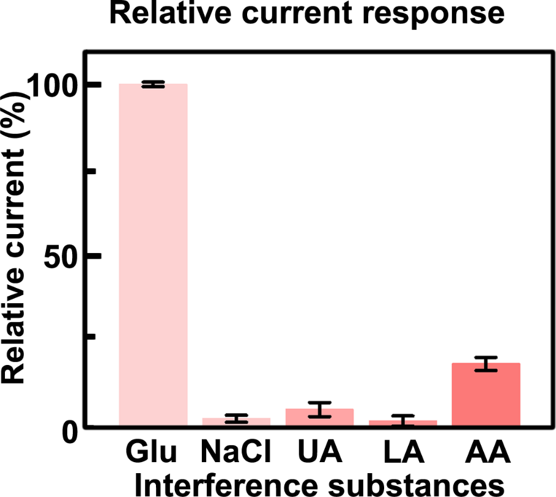
Figure S2-1. Relative response current of the microelectrode upon glucose sensing. The responses of the microelectrode to the target and interfering substances were evaluated by adding 10 mmol/L glucose, 10 mmol/L sodium chloride (NaCl), 0.1 mmol/L uric acid (UA), 5 mmol/L lactic acid (LA), and 0.1 mmol/L ascorbic acid (AA) sequentially to the solution for selectivity test. Compared to the glucose response, the signal perturbations caused by NaCl, UA, LA, and AA were 2.2%, 4.9%, 1.5% and 18.2%, respectively. Graph bars represented the SD.

S2-2 Batch-to-batch reproducibility and relative sensitivity of the five microelectrodes.
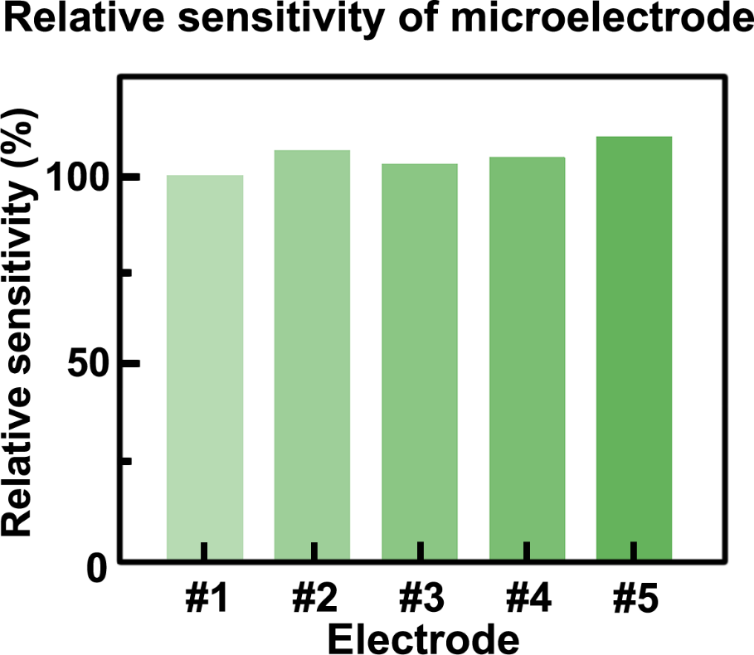
Figure S2-2. Batch-to-batch reproducibility and relative sensitivity of the five microelectrodes. The average sensitivity across 5 microelectrodes in different batches was 0.25 nA/mM, with the R²>0.9984. Graph bars represented the SD.

S2-3 Performance of the MI-CGM module compared against commercial electrochemical workstations in vitro detection.
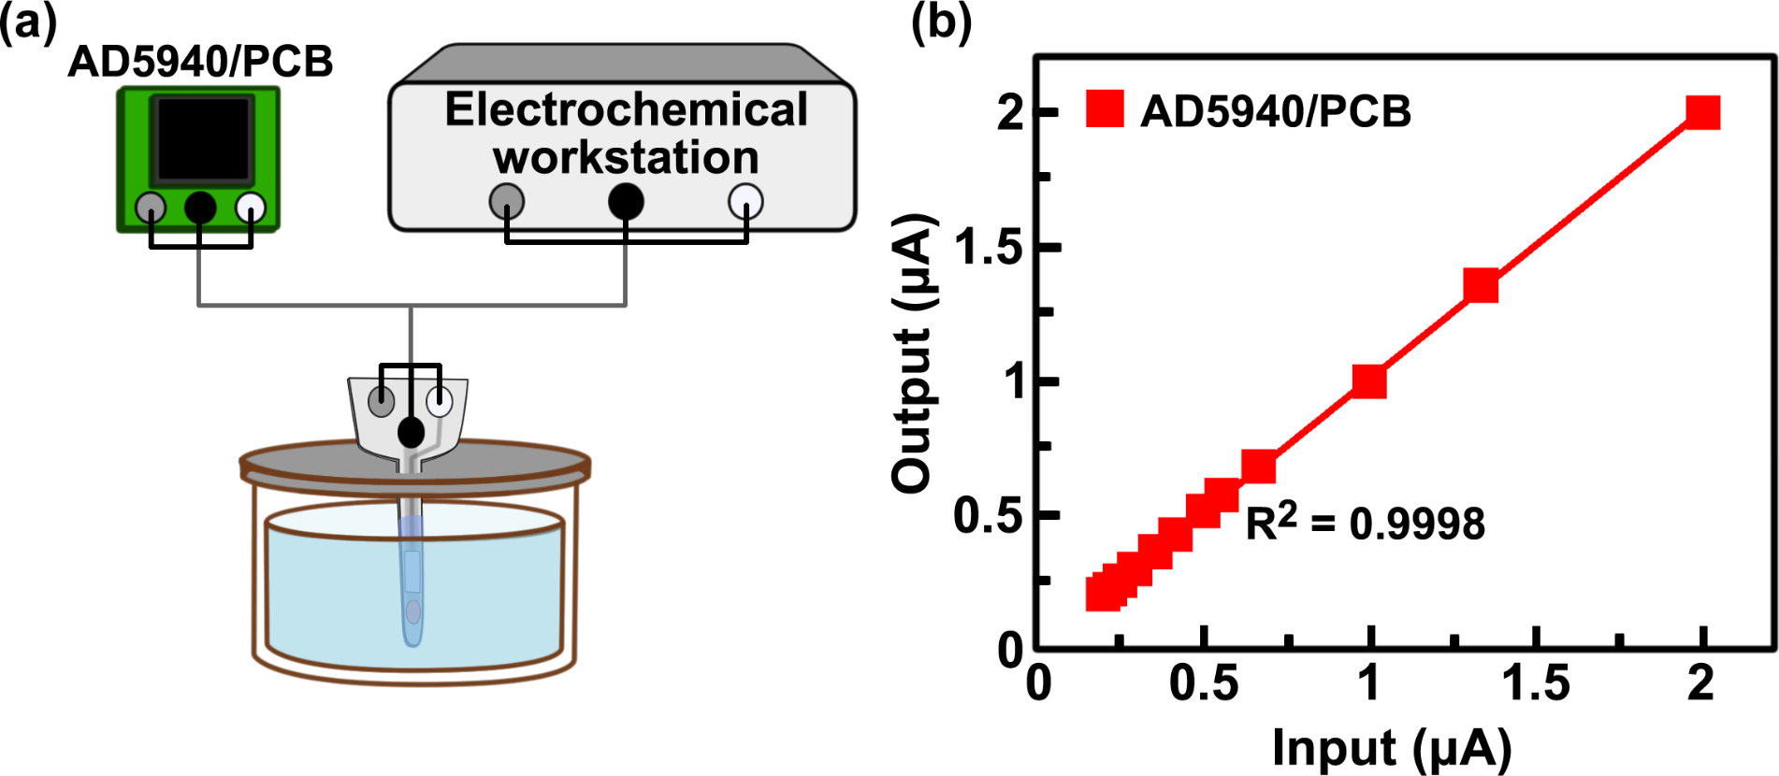
Figure S2-3. Performance of the MI-CGM module compared against commercial electrochemical workstations in vitro detection. (a) The microelectrode was integrated with the AD5940 chip-based electrochemical signal acquisition circuit to form the MI-EC module, and compared to that connected with commercial electrochemical workstations. (b) Recording electrochemical current detected by the AD5940 chip-based circuit, with the R²=0. 9998.

S3-1 The circuit of the personalized-based Adoptive Non-invasive CGM device
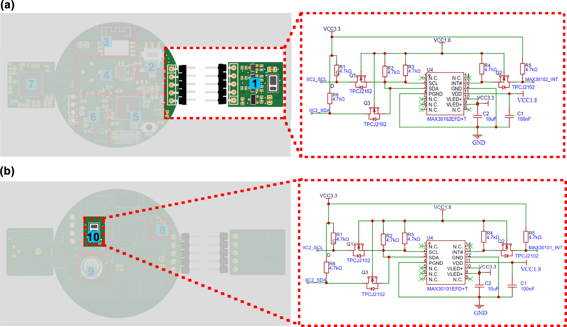
Figure S3-1. The printed circuit board (PCB) and schematic diagrams of the cardiovascular sensors of the Adoptive Non-invasive CGM device. The cardiovascular sensors consisted of (a)-(b) two photoplethysmograph (PPG) sensors, which emitted green (530 nm), red (660 nm), or infrared (880 nm) light onto the skin surface and detected the reflected or scattered light signals to monitor the cardiovascular pulse signals. The sensors could convert the collected analogue signals into digital signals and perform pre-processing operations, including amplification, filtering, sampling and quantization of the electrical signals. The peripheral circuits outside the PPG sensors ensured power supply and data communication.

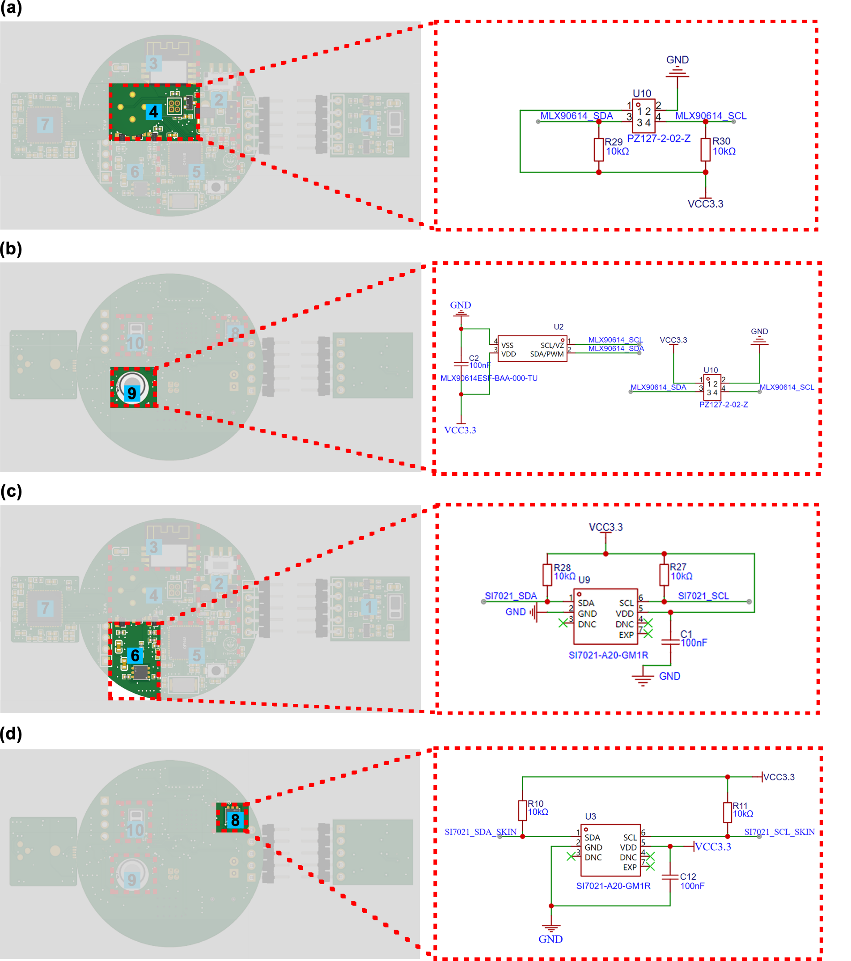
Figure S3-2. The PCB and schematic diagram of the metabolic heat sensors of the Adoptive Non-invasive CGM device. The metabolic heat sensors consisted of an infrared radiation sensor, a surface temperature sensor, and an ambient temperature and humidity sensors. (a)-(b) The infrared radiation sensor consisted of the MLX90614-DAA chip and peripheral circuits, which detected the infrared radiational temperature on the skin surface and transmitted the signals to the MCU via the SMBus protocol. (c) The surface temperature sensor comprised of the SI7021-A20 chip, which possessed the built-in calibrated humidity and temperature sensing element, analogue-to-digital converter, signal processor, and an IIC interface. (d) The ambient temperature and humidity sensors were also employed the SI7021-A20 chip for detected the environmental temperature and humidity.
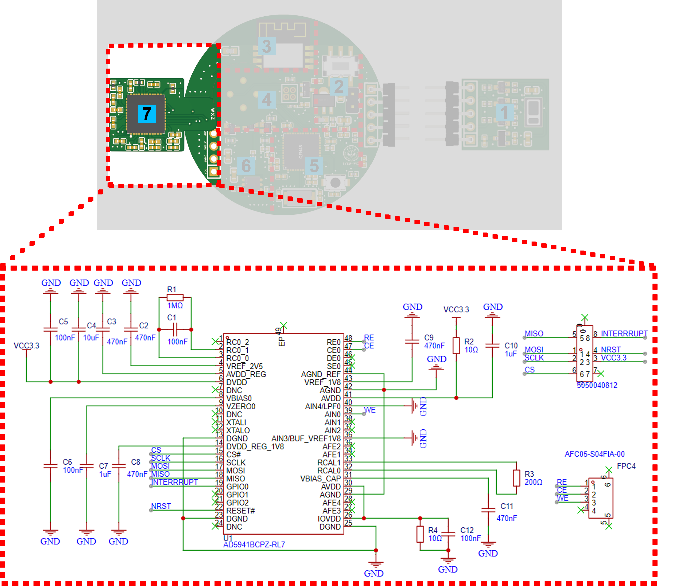
Figure S3-3. The PCB and schematic diagram of the electrochemical acquisition circuit of the MI-CGM module of the Adoptive Non-invasive CGM device. The MI-CGM module constructed from the AD5941 analogue front-end (AFE). The AD5941 was a high-precision, low-power AFE designed for portable applications requiring high-precision, electrochemical measurement techniques. The AD5941 possessed an adjustable three-electrode detection system, which converted the current signal from microelectrodes into a voltage signal by configuring the internal programmable gain amplifier (PGA) or adjustable resistors. The processed signal was then transmitted to the MCU via the SPI protocol. Microelectrodes can be integrated into the MI-CGM module by connecting the RE pin, CE pin, and WE pin to the interface of the MI-CGM module.

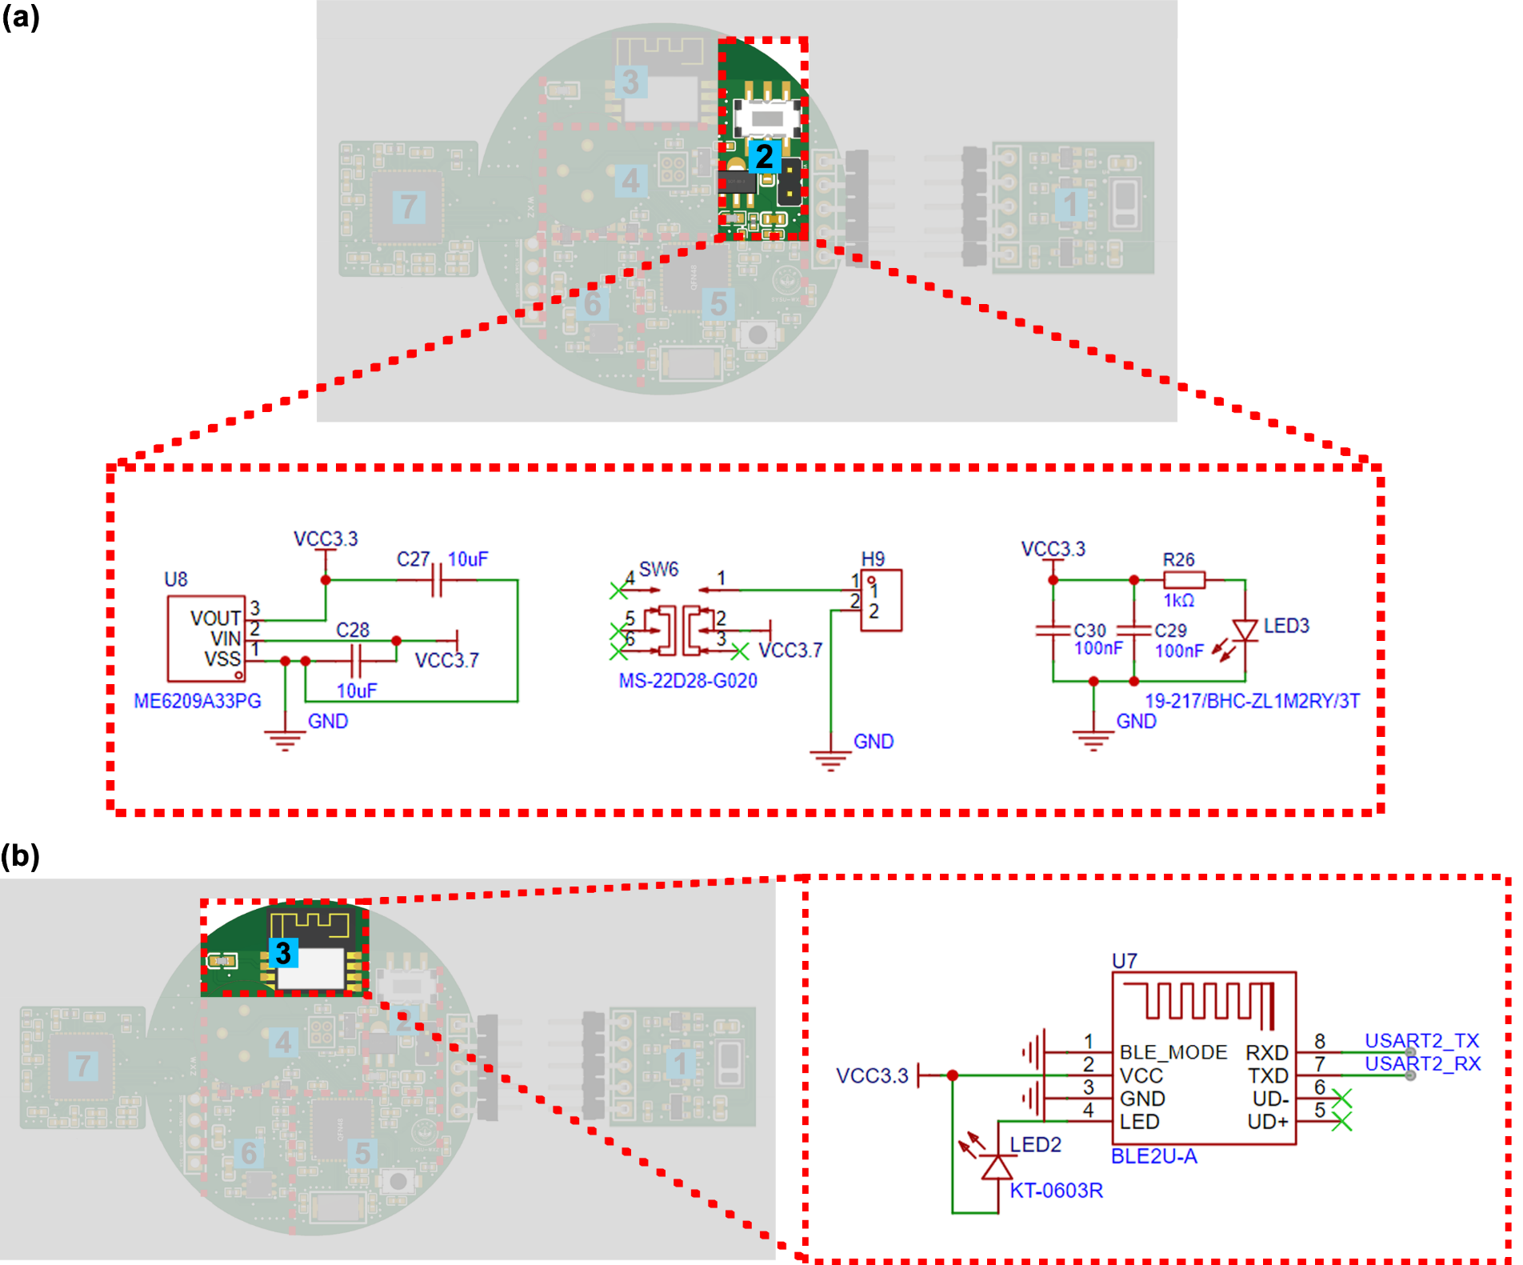
Figure S3-4. The PCB and schematic diagram of the power module and Bluetooth module of the MI-CGM module of the Adoptive Non-invasive CGM device. (a) The power module converted the Li-ion battery power (3.7 V) into a stable 3.3 V power supply through a low dropout linear regulator (LDO, ME6209A33). The peripheral circuits were designed with a power charging protection and provided a mechanical paddle switch with an LED indicator to determine the power supply condition. (b) The Bluetooth module was composed of a BLE2U-A chip and peripheral circuits, enabling wireless data transmission and reception between the wearable device and the host computer via the UART protocol.

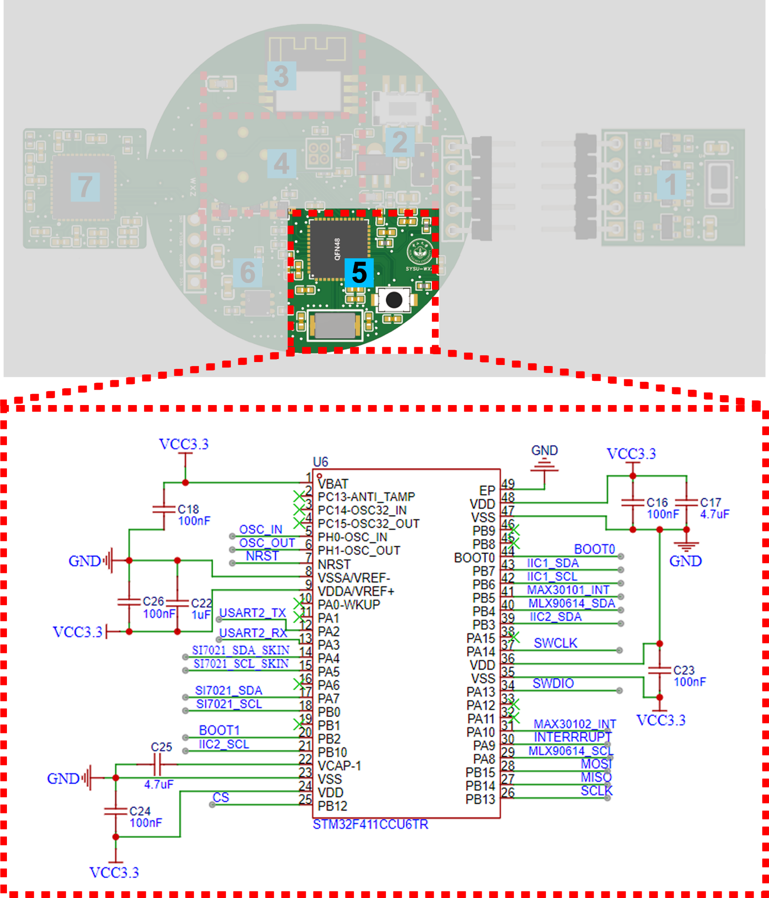
Figure S3-5. The PCB and schematic diagram of the micro controller unit (MCU) of the Adoptive Non-invasive CGM device. The system consisted of a STM32F411 chip, a power supply circuit, a clock circuit, a resistor-capacitor reset circuit, a debugging circuit, and a reference voltage power supply circuit. Based on the ARM Cortex-M4 core of STM32, the MCU provided adequate external interfaces, allowing the coordination of signal acquisition, data processing, and real-time transmission among different components.

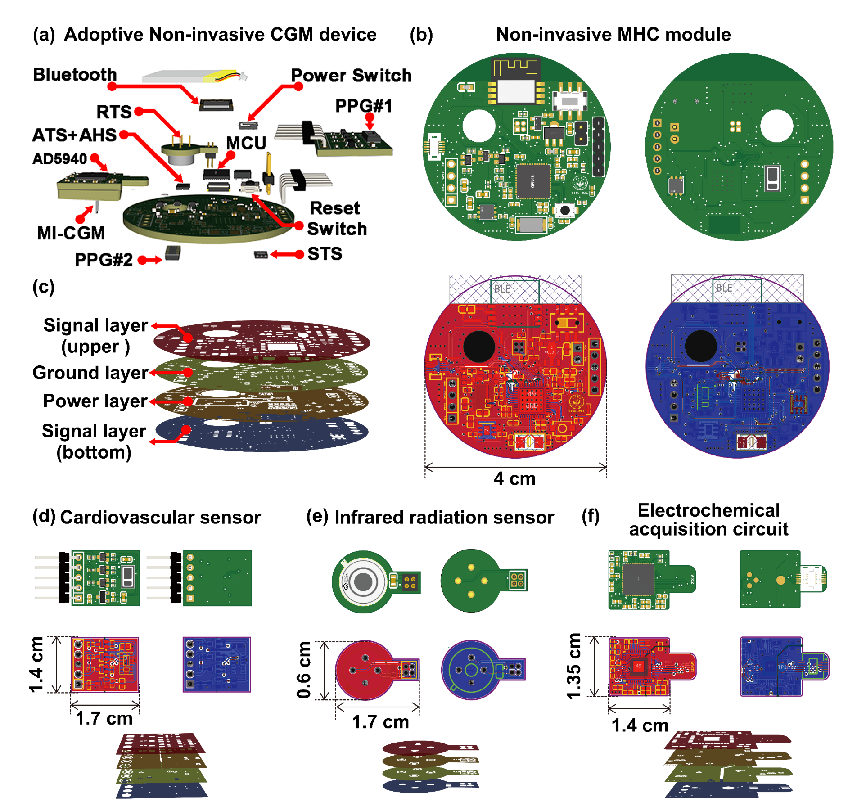
Figure S3-6. Exploded illustrations and PCB of the Adoptive Non-invasive CGM device. (a) Detailed exploded view of the personalized Adoptive Non-invasive CGM device with the key components and sensors clearly marked. (b) PCB of the Non-invasive MHC module of the wearable device, which was only 4 cm in diameter. (c) Schematic diagram of the PCB layer structure of the Non-invasive MHC module, including upper signal layer, the ground layer, the power layer and the bottom signal layer. (d) PCB and layer structural diagram of the cardiovascular sensor fixed at the finger site, which was only 1.4 cm × 1.7 cm. (e) PCB and layer structural diagram of the infrared radiation sensor of metabolic heat sensors, which was only 0.6 cm × 1.7 cm. (f) PCB and layer structural diagram of the electrochemical acquisition circuit of MI-CGM module, which was only 1.35 cm × 1.4 cm.

S4-1. The derivation of the BG trend with different sliding windows
The BG fluctuations involved both minor variations over short intervals and major trends spanning longer periods, necessitating a holistic approach to capture the overall dynamics of BG changes. Therefore, different sliding window size of 15 min, 30 min, 45 min, 60 min, 75 min, and 90 min were used in the calculation process of trends for each BG data point. During the BG monitoring, two different calculation approaches of BG trends were used to provide a comprehensive evaluation of the BG fluctuations.
(1) The calculation approach of BG trend#1:
The calculation approach of the BG trend#1 considered the overall fluctuations between all data points within the sliding time window. As presented in Figure S4-1, a 15-min sliding window size was used as an example. When calculating the BG trend for BG (t_{n}), expressed as Trand_{15 min}(t_{n}), a sliding window of 15-min size was first created with t_{n} as the center time. The average BG trends of each data points contained within that sliding window were then calculated, using as the overall trend values of BG (t_{n}) within the 15-min scale. The algorithm for calculating the trend for each data point within the sliding window was to subtract the BG value of the previous moment from the later moment, then divided by the time difference between the two data points. Finally, the trend values of all data points within the sliding window were weighted and averaged to obtain the overall trend value of Trand_{15 min}(t_{n}). For example, to calculate the trend values of Trand_{15 min}(t₂), it was necessary to calculate the trend values between BG(t₁), BG(t₂), and BG(t₃) within the 15-min sliding window of t₂, respectively. The Trand_{15 min}(t₂) was expressed as:
Similarly, for t₃, t₄, and t_{n}, the overall trends of Trand_{15 min}(t₃), Trand_{15 min}(t₄), Trand_{15 min}(t_{n}) were expressed as:
where S_{win} is the number of BG data points contained within the 15-min sliding windows. In this work, the S_{win} within the 15-min sliding windows were usually ~3 data points.
Thus, the overall trends of BG data points with the 30-min, 45-min, 60-min, 75-min, and 90-min sliding windows were calculated as:
Of these, the number of BG data points S_{win} contained within 30-min, 45-min, 60-min, 75-min, and 90-min sliding windows were usually ~6, ~9, ~12, ~15, and ~18 data points, respectively.
(2) Trend calculation approach#2:
The calculation approach of the BG trend#2 considered the average trends between the BG data points forward half and backward half of the sliding window. As presented in Figure S4-2, a 15-min sliding window size was used as an example. When calculating the Trand_{15 min}(t_{n}) of the BG (t_{n}), sliding window of 15 min was first created with tn as the center time. The average BG trends for the forward and backward half of the 15-min sliding windows were then calculated, employing as the overall trend values of the BG (t_{n}) within the 15-min scale. The algorithm for calculating the trends of the forward and backward half was that, used the average BG value of the forward half minus the that of the backward half, then divided it by the average time difference between the first and second halves. For example, the Trand_{15 min}(t₂) was expressed as:
Similarly, for t₃, t₄, and t_{n}, the overall trends of Trand_{15 min}(t₃), Trand_{15 min}(t₄), Trand_{15 min}(t_{n}) were expressed as:
Where S_{win} was the number of BG data points contained within the 15-min sliding windows, the t_{forward} was the average time of the forward BG data, and the t_{backward} was the average time of the backward BG data.
In this work, the S_{win} within the 15-min sliding windows were usually ~3 data points.
Hence, the overall trends of BG data points with the 30-min, 45-min, 60-min, 75-min, and 90-min sliding windows were calculated as:
Where the number of BG data points S_{win} contained within 30-min, 45-min, 60-min, 75-min, and 90-min sliding windows were usually ~6, ~9, ~12, ~15, and ~18 data points, respectively.
In summary, the average values of BG trend#1 and BG trend#2 were used as the trend values for continuous BG monitoring. By employing scanning windows ranging from 15 to 90 minutes, the average trends of BG data points before and after each measurement were independently computed, thereby deriving the corresponding BG fluctuation trend values for different time scales. This comprehensive trend indicator integrated the average fluctuations across various time ranges, providing a robust characterization of both minor and major BG fluctuations for each measurement.

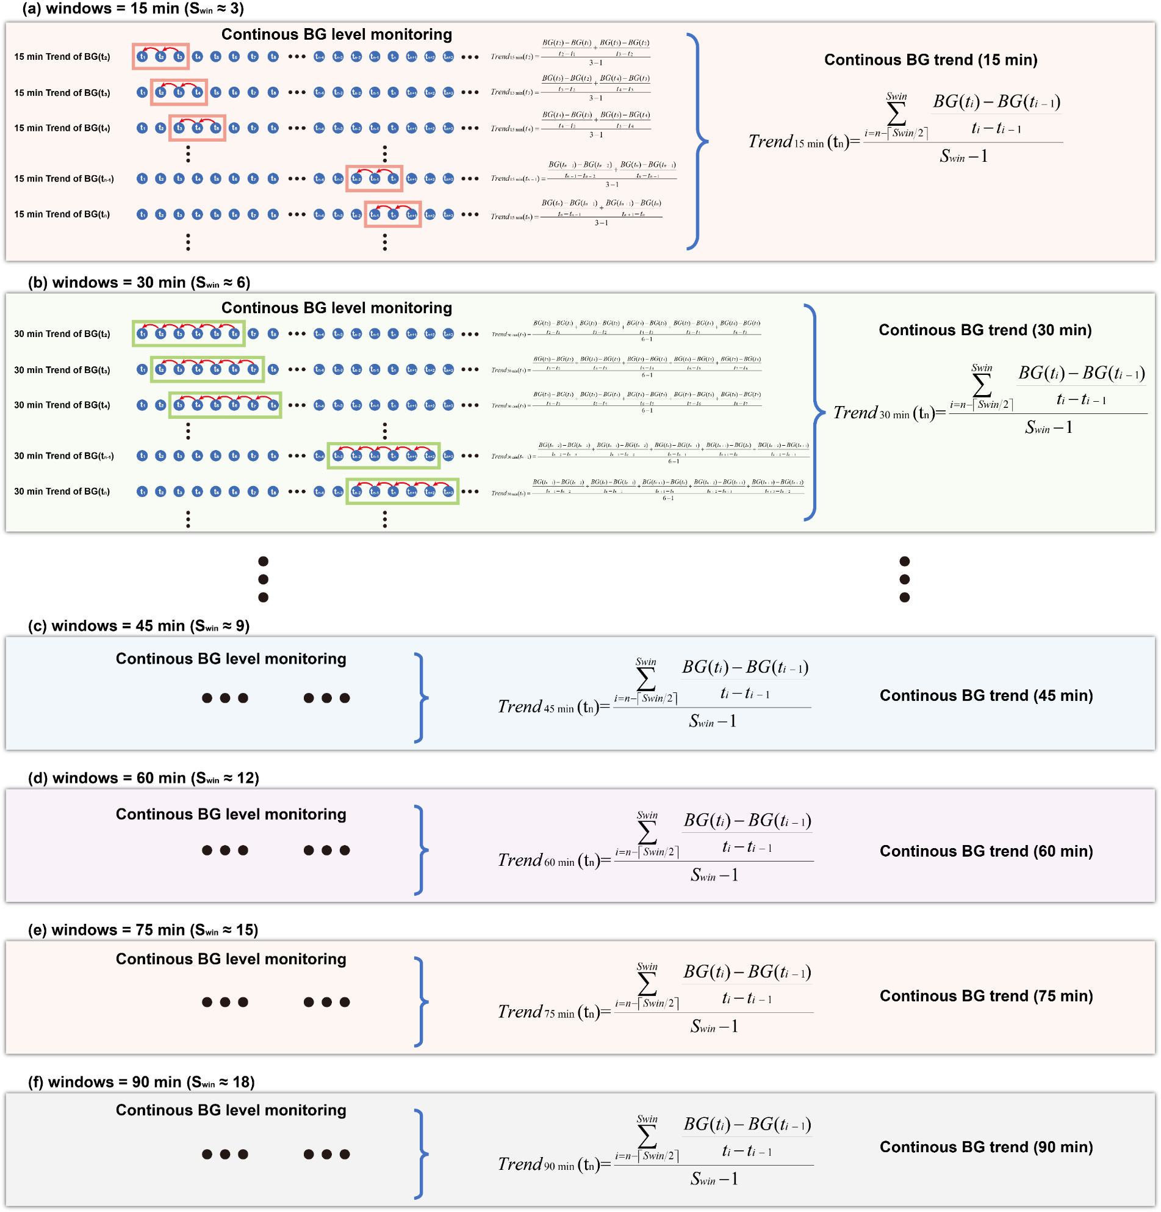
Figure S4-1. Schematic diagram of calculation principle of the BG trend#1. This approach considered the overall fluctuations between all data points within the sliding time window, which ranging from 15 min to 90 min. To calculate BG trends, a sliding window of 15-90 min was created centered on that BG data time. The average BG trends of each data points contained within that sliding window were then calculated, employing as the overall trend values of that BG data. The algorithm for calculating the trend for each data point within the sliding window was to subtract the BG value of the previous moment from the later moment, which was then divided by the time difference between the two data points. Finally, the trend values of all data points within the sliding window were weighted and averaged to obtain the overall trend value of that BG data.

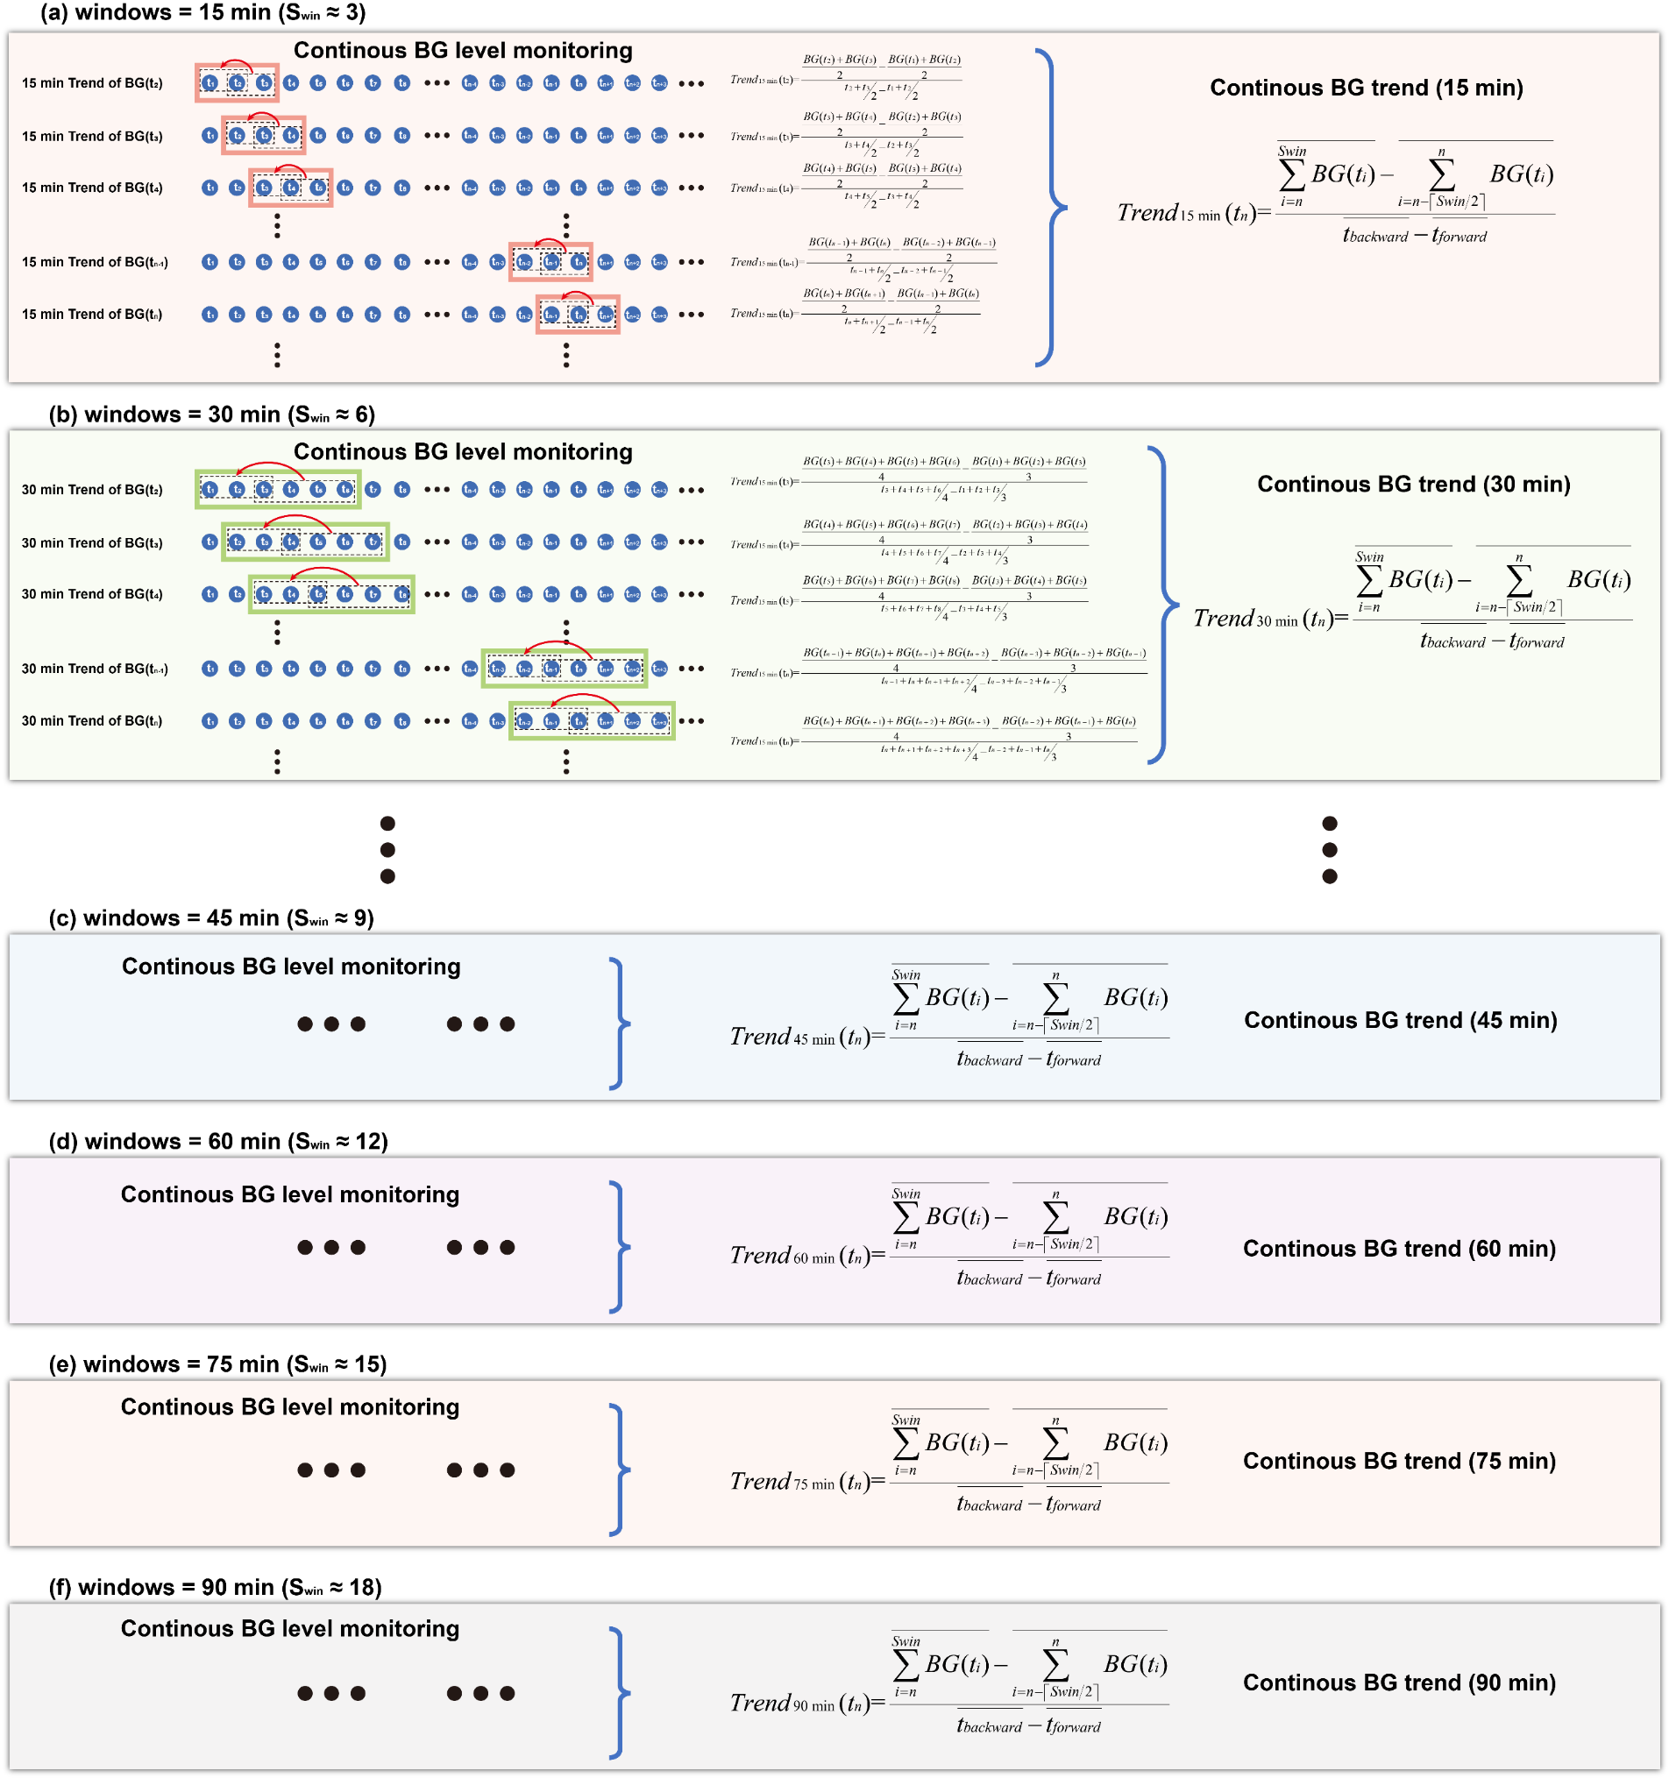
Figure S4-2. Schematic diagram of calculation principle of the BG trend#2. This approach considered the average trends between the BG data points forward half and backward half of the sliding window, which ranging from 15 min to 90 min. When calculating BG trends, a sliding window of 15-90 min was first created centered with that BG data time. The average BG trends for the forward and backward half of the sliding windows were then calculated to use as the overall trend values of that BG data.
The algorithm for calculating the trends of the forward and backward half was that, used the average BG value of the forward half minus the that of the backward half, then divided it by the average time difference between the first and second halves.
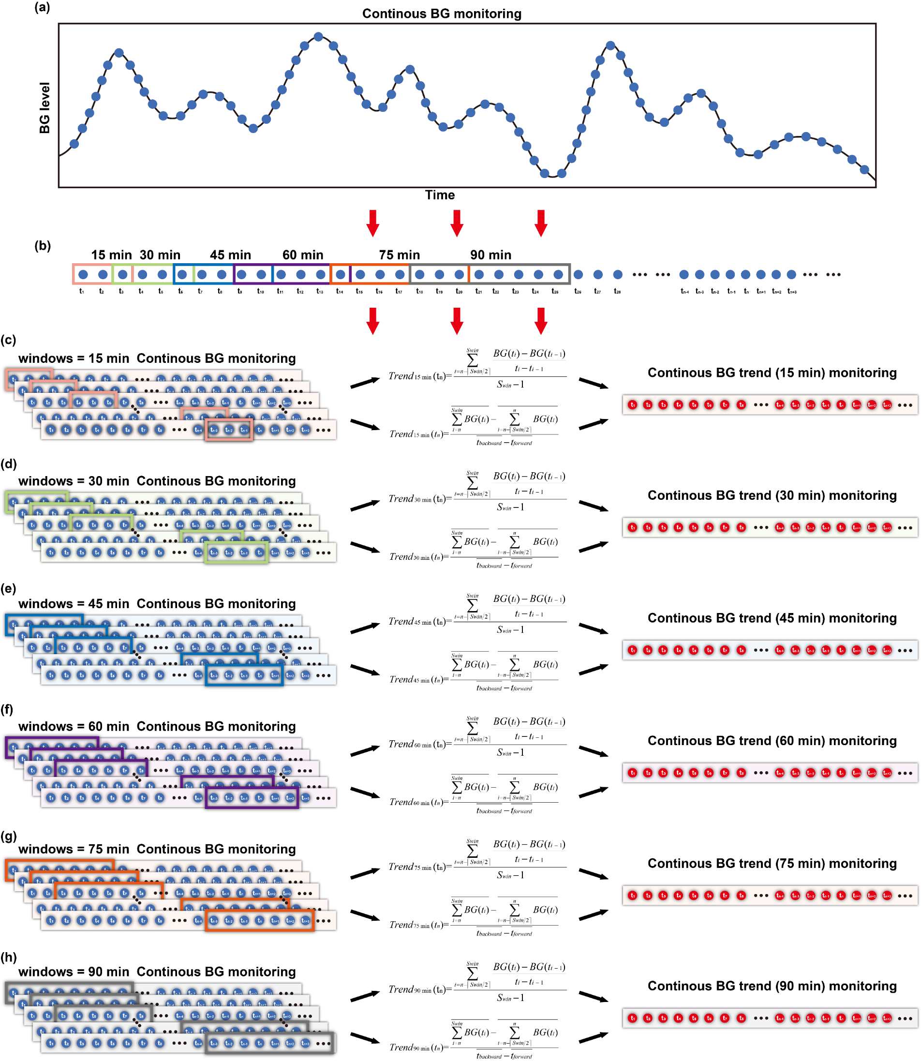
Figure S4-3. Schematic diagram of calculation principle for the average of BG trend#1 and BG trend#2. The computational framework employed sliding time windows to systematically evaluated BG dynamics. The average trends of BG data points before and after each measurement were calculated independently using scanning windows ranging from 15 to 90 min, resulting in corresponding trend values for BG fluctuations on different time scales. This comprehensive trend metric combined the average fluctuations over different time scales, providing a reliable characterization of both minor and major BG fluctuations for each BG measurement.

S4-2 Schematic diagram of the personalized MI/NI-BG datasets for individual patients
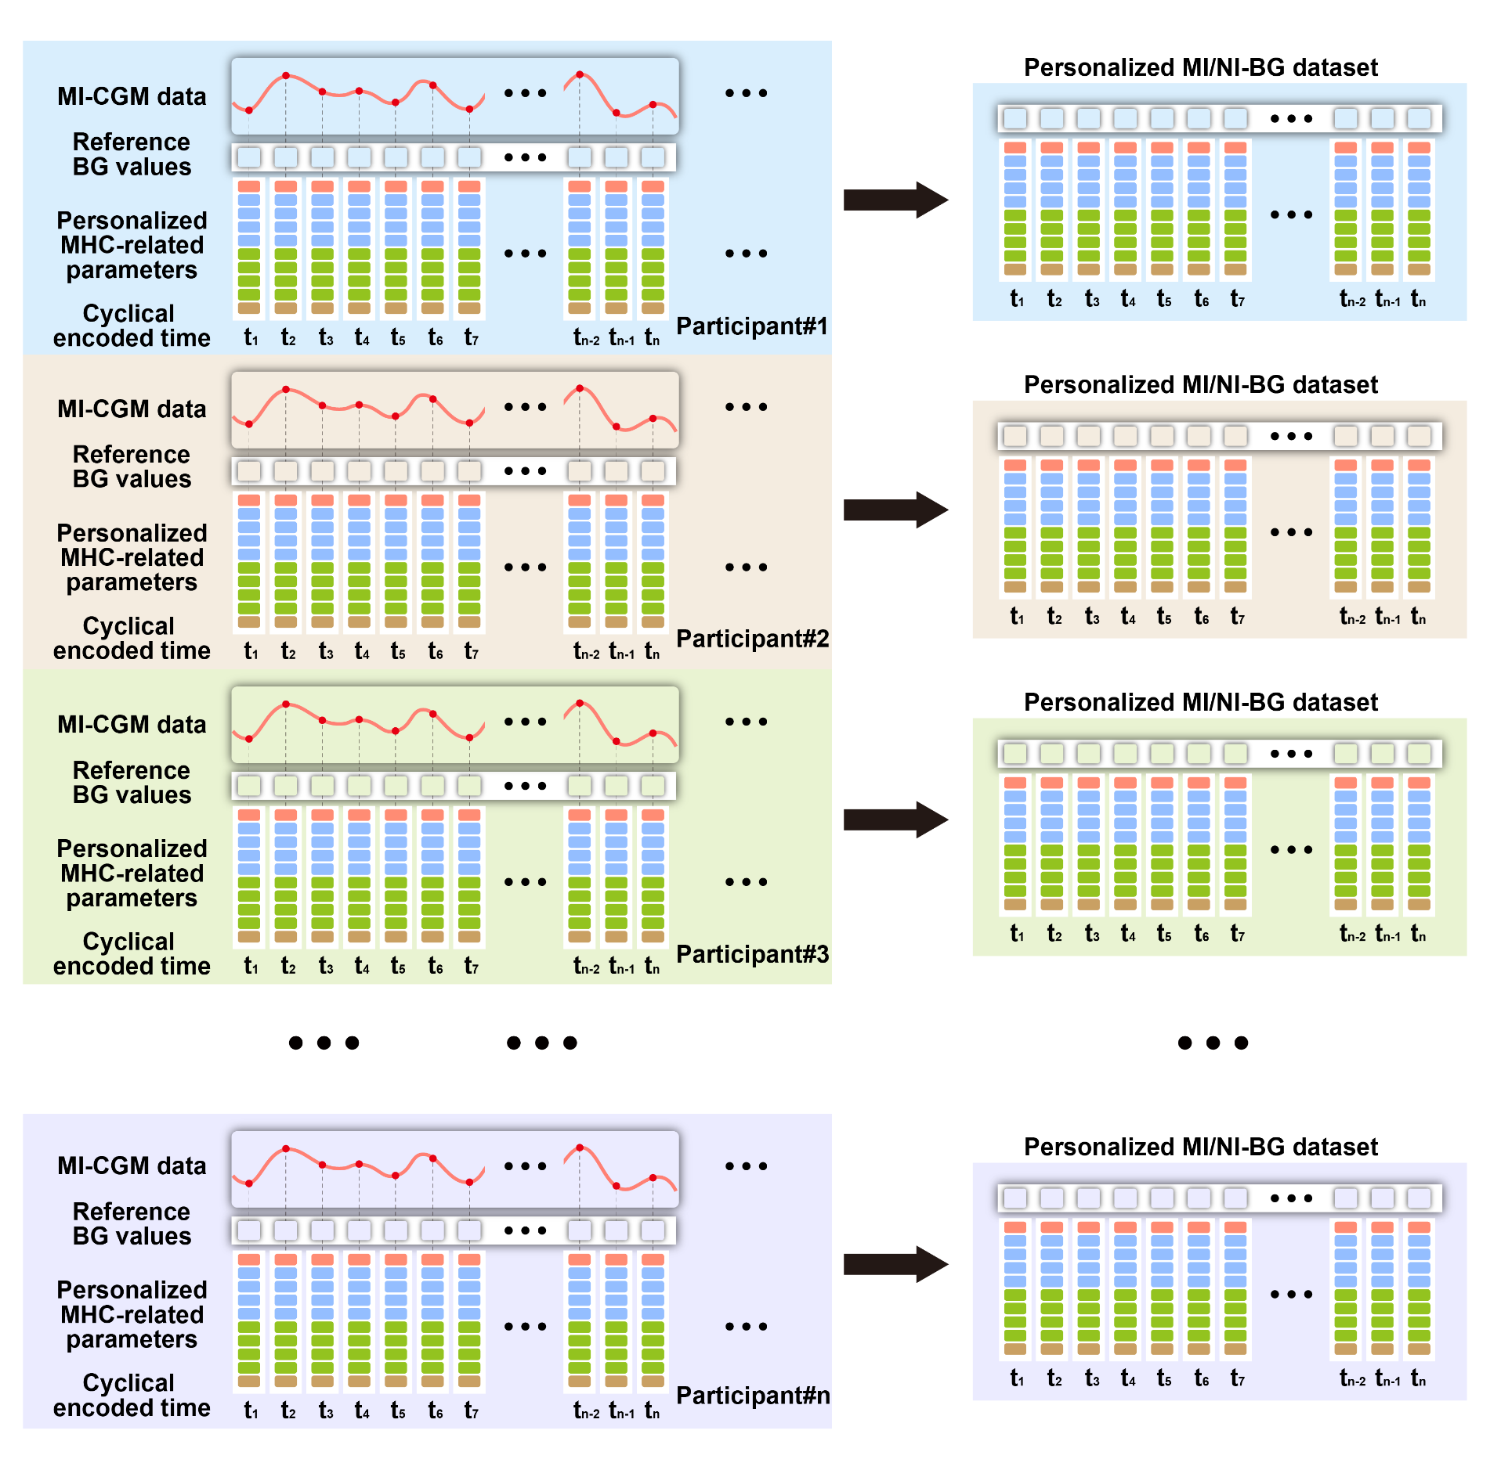
Figure S4-4. Schematic diagram of the personalized MI/NI-BG datasets for individual patients. The personalized MI/NI-BG datasets comprised of the Mini-invasive CGM data, the Non-invasive CGM data, and the cyclical encoded time. Wherein, the Mini-invasive CGM data was collected from the MI-CGM module, which possessed the reference BG values for the training and transfer learning of the computational AI models. The Non-invasive CGM data collected from the NI-CGM module was employed for non-invasive BG derivation, which contained the patient-specific MHC-related parameters. Based on the personalized MI/NI-BG datasets, a personalized AI model that specifically tailored for that individual could be transferred from the pre-trained AI model, thus achieving the accurate non-invasive BG monitoring. Specifically, the initial 1.5 days of data was employed for personalized training, while the subsequent 3.5 days of data was used to assess the accuracy of the model.

S4-3 Time cyclical encoding of the MI/NI-BG datasets
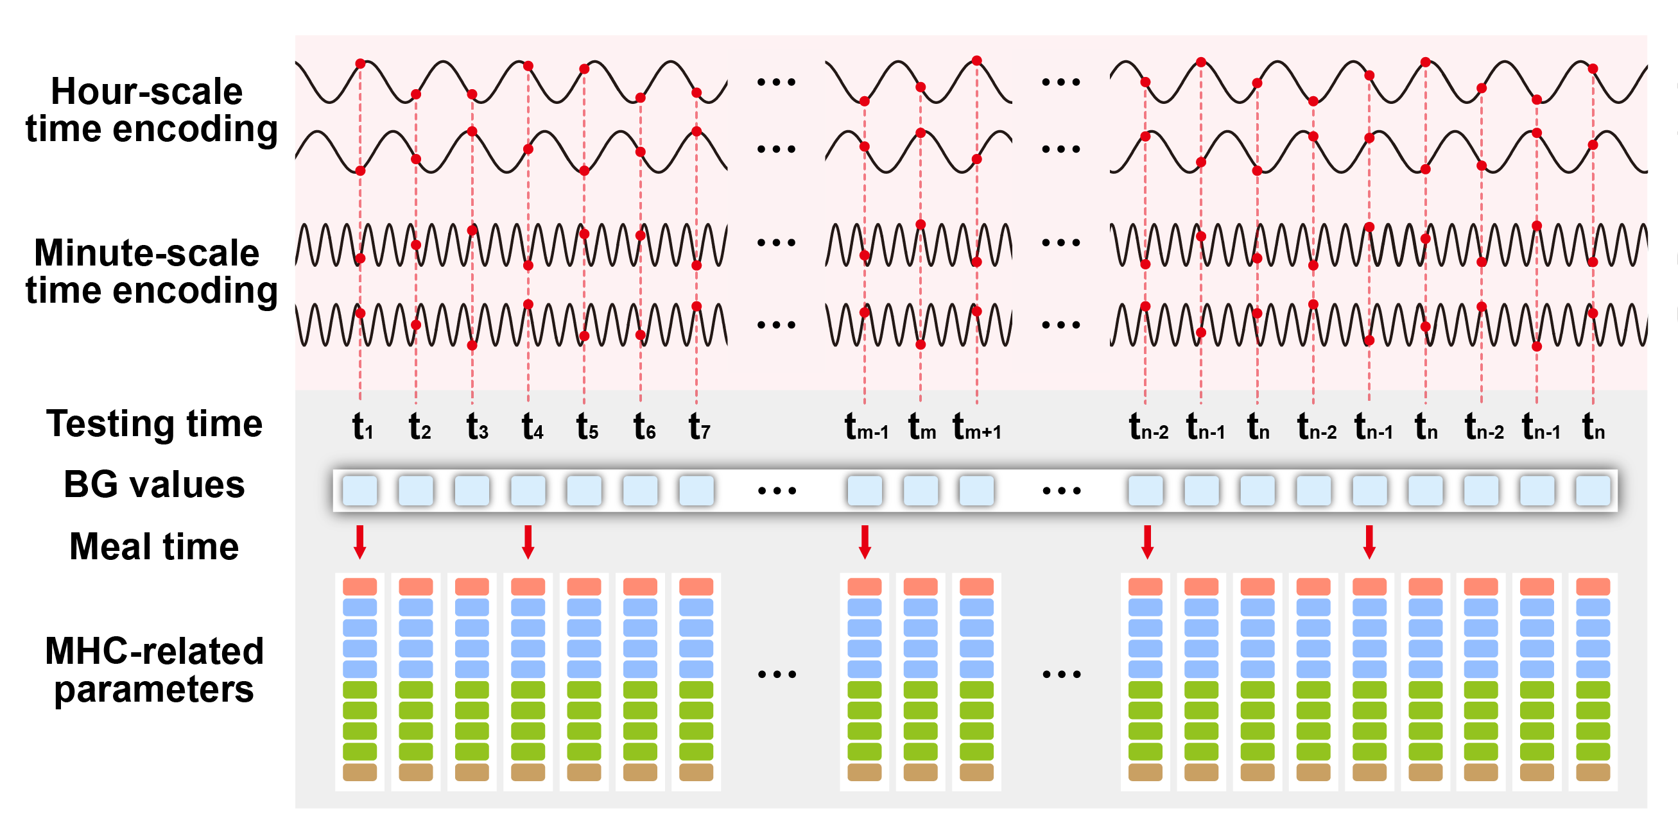
Figure S4-5. Time cyclical encoding of the MI/NI-BG datasets. Using the sine-cosine embedded transformations, the testing time of the BG values could be cyclical encoding on the hour-scale and minute-scale, thus representing the cyclical characteristics of the BG values in a simple and effective way. After integrating encoded time characteristics, BG values, meal times, and MHC-related parameters, the MI/NI-BG dataset possessed dynamic time-series features for the computational models to interpret the BG values effectively.

S4-4 The tailored loss function of the Personalized AI model
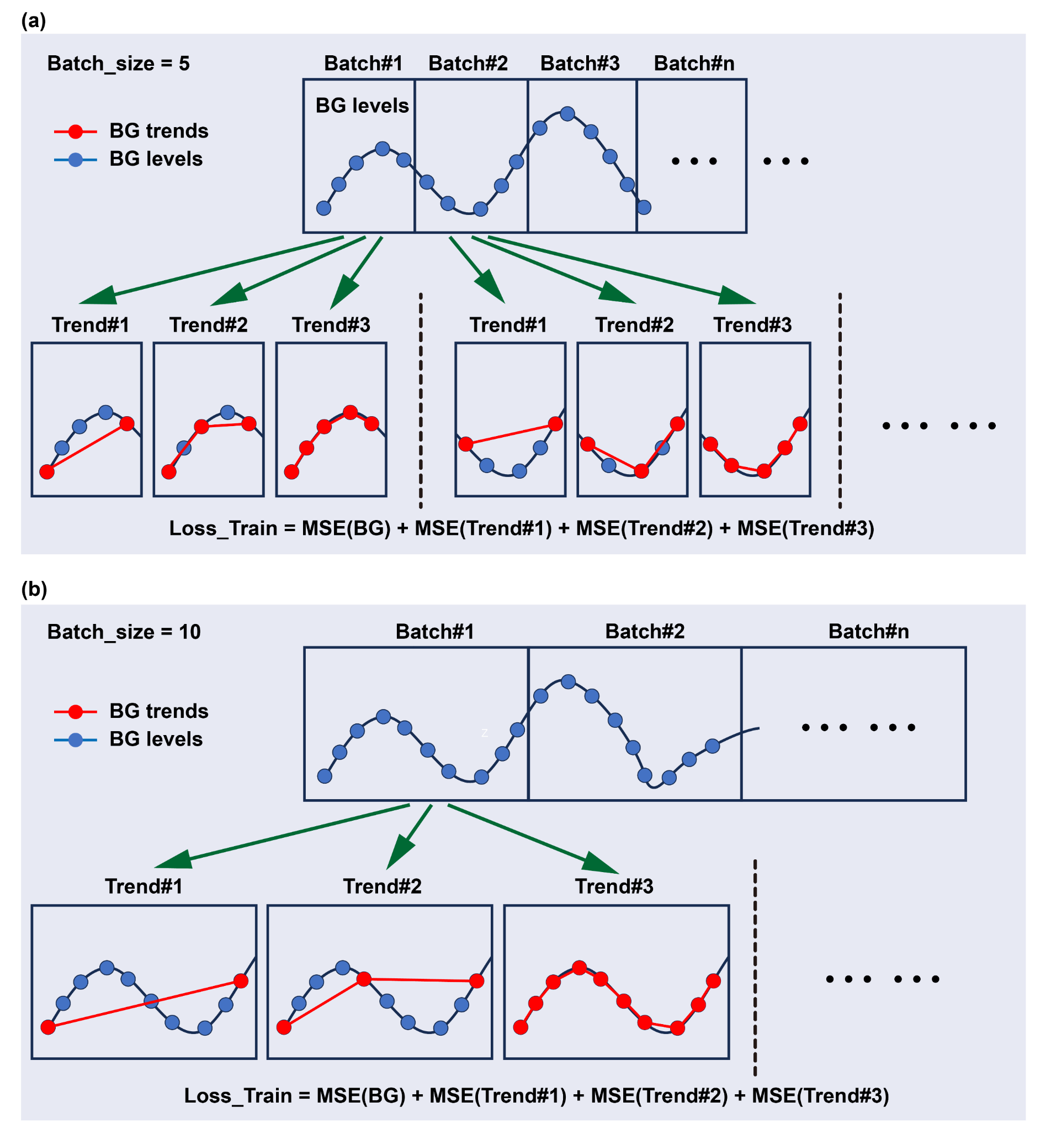
Figure S4-6. The tailored loss function of the Personalized AI model. This loss function was designed to simultaneously account for discrepancies in both the current BG values and the temporal BG trends. During the training iterative process, the MI/NI-BG training datasets would be split into multiple batch size, such as (a) batch of five-BG data points or (b) batch of ten-BG data points. By calculating the mean square error (MSE) of the BG values and fluctuation trends, the loss function yielded a weighted loss value for model training and iteration.

S4-5 Schematic diagram of the general dataset for population patients
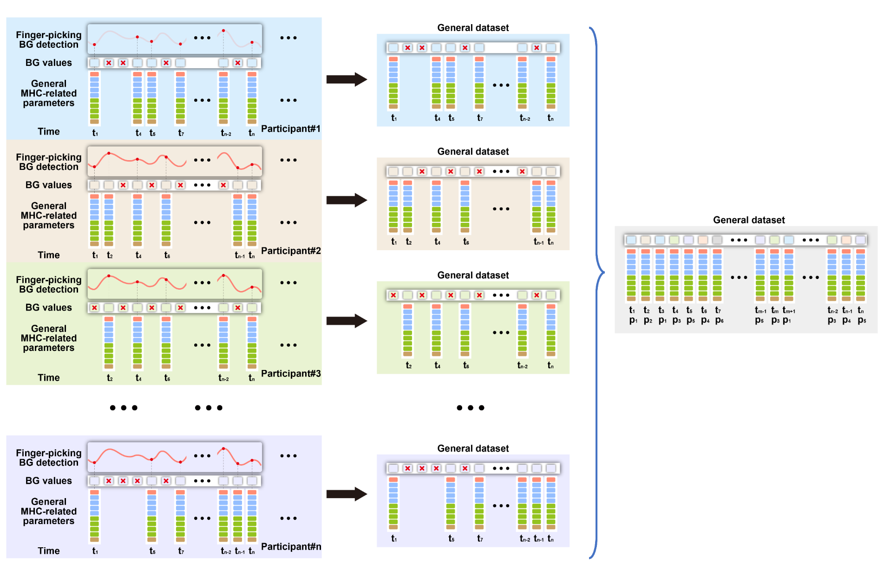
Figure S4-7. Schematic diagram of the general dataset for population patients. The general dataset comprised of the finger-picking BG detection data, the general non-invasive parameters data, and the testing time. In particular, the discrete data from the finger-picking BG detection was utilized as reference BG values for the training and transfer learning of the general computational AI models. The non-invasive parameters data collected from the universal sensors was employed for non-invasive BG derivation. Based on the general population-based dataset, the general AI model deployed for different patients was transferred from the pre-trained AI model, which failed to addressed the issue of individual diversity.

S4-6 Reorganization of different individual MI/NI-BG datasets into a population-based general dataset
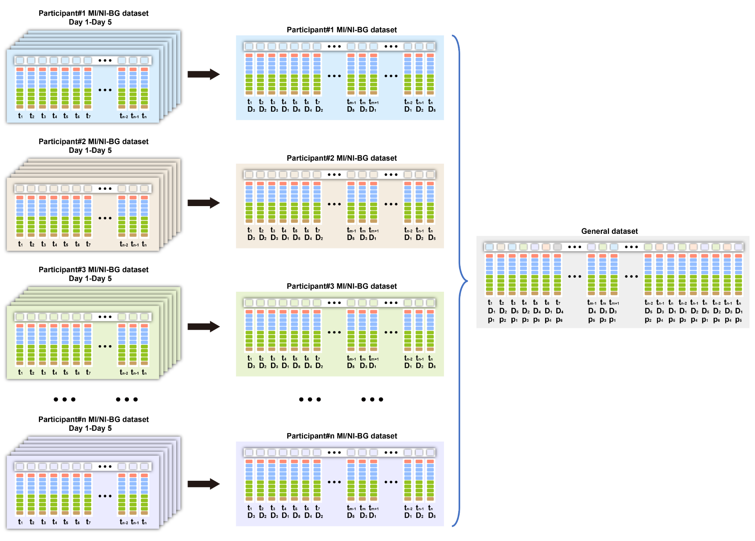
Figure S4-8. Reorganization of different individual MI/NI-BG datasets into a population-based general dataset. After collection of the individual MI/NI-BG data from all participants, the 5-days MI/NI-BG datasets of different patients were reorganized according to the testing time of the day, which were same as the general discrete datasets. These datasets inherently lacked the ability to capture individualized physiological states or the intrinsic time-series dynamics of BG levels in participants. The discrete datasets from various participants were then recombined into a general population-based dataset depending on the testing time of the MI/NI-BG data. In addition, primary information such as age, gender, and diabetes history of different patients was also integrated into the general dataset for routine individual calibration. As the general training dataset, the MI/NI-BG dataset from the initial 1.5 days of all participants was employed to generated the General AI model from the pre-trained GRU model directly. The primary information of different patients was also fed into the model as individual parameters to participate in the training process. For model testing, the MI/NI-BG dataset from the last 3.5 days was input into the General AI model, using to evaluate the accuracy of the BG monitoring.

S5-1 BG trend curves for all participants during the short-term Round#1-CGM test
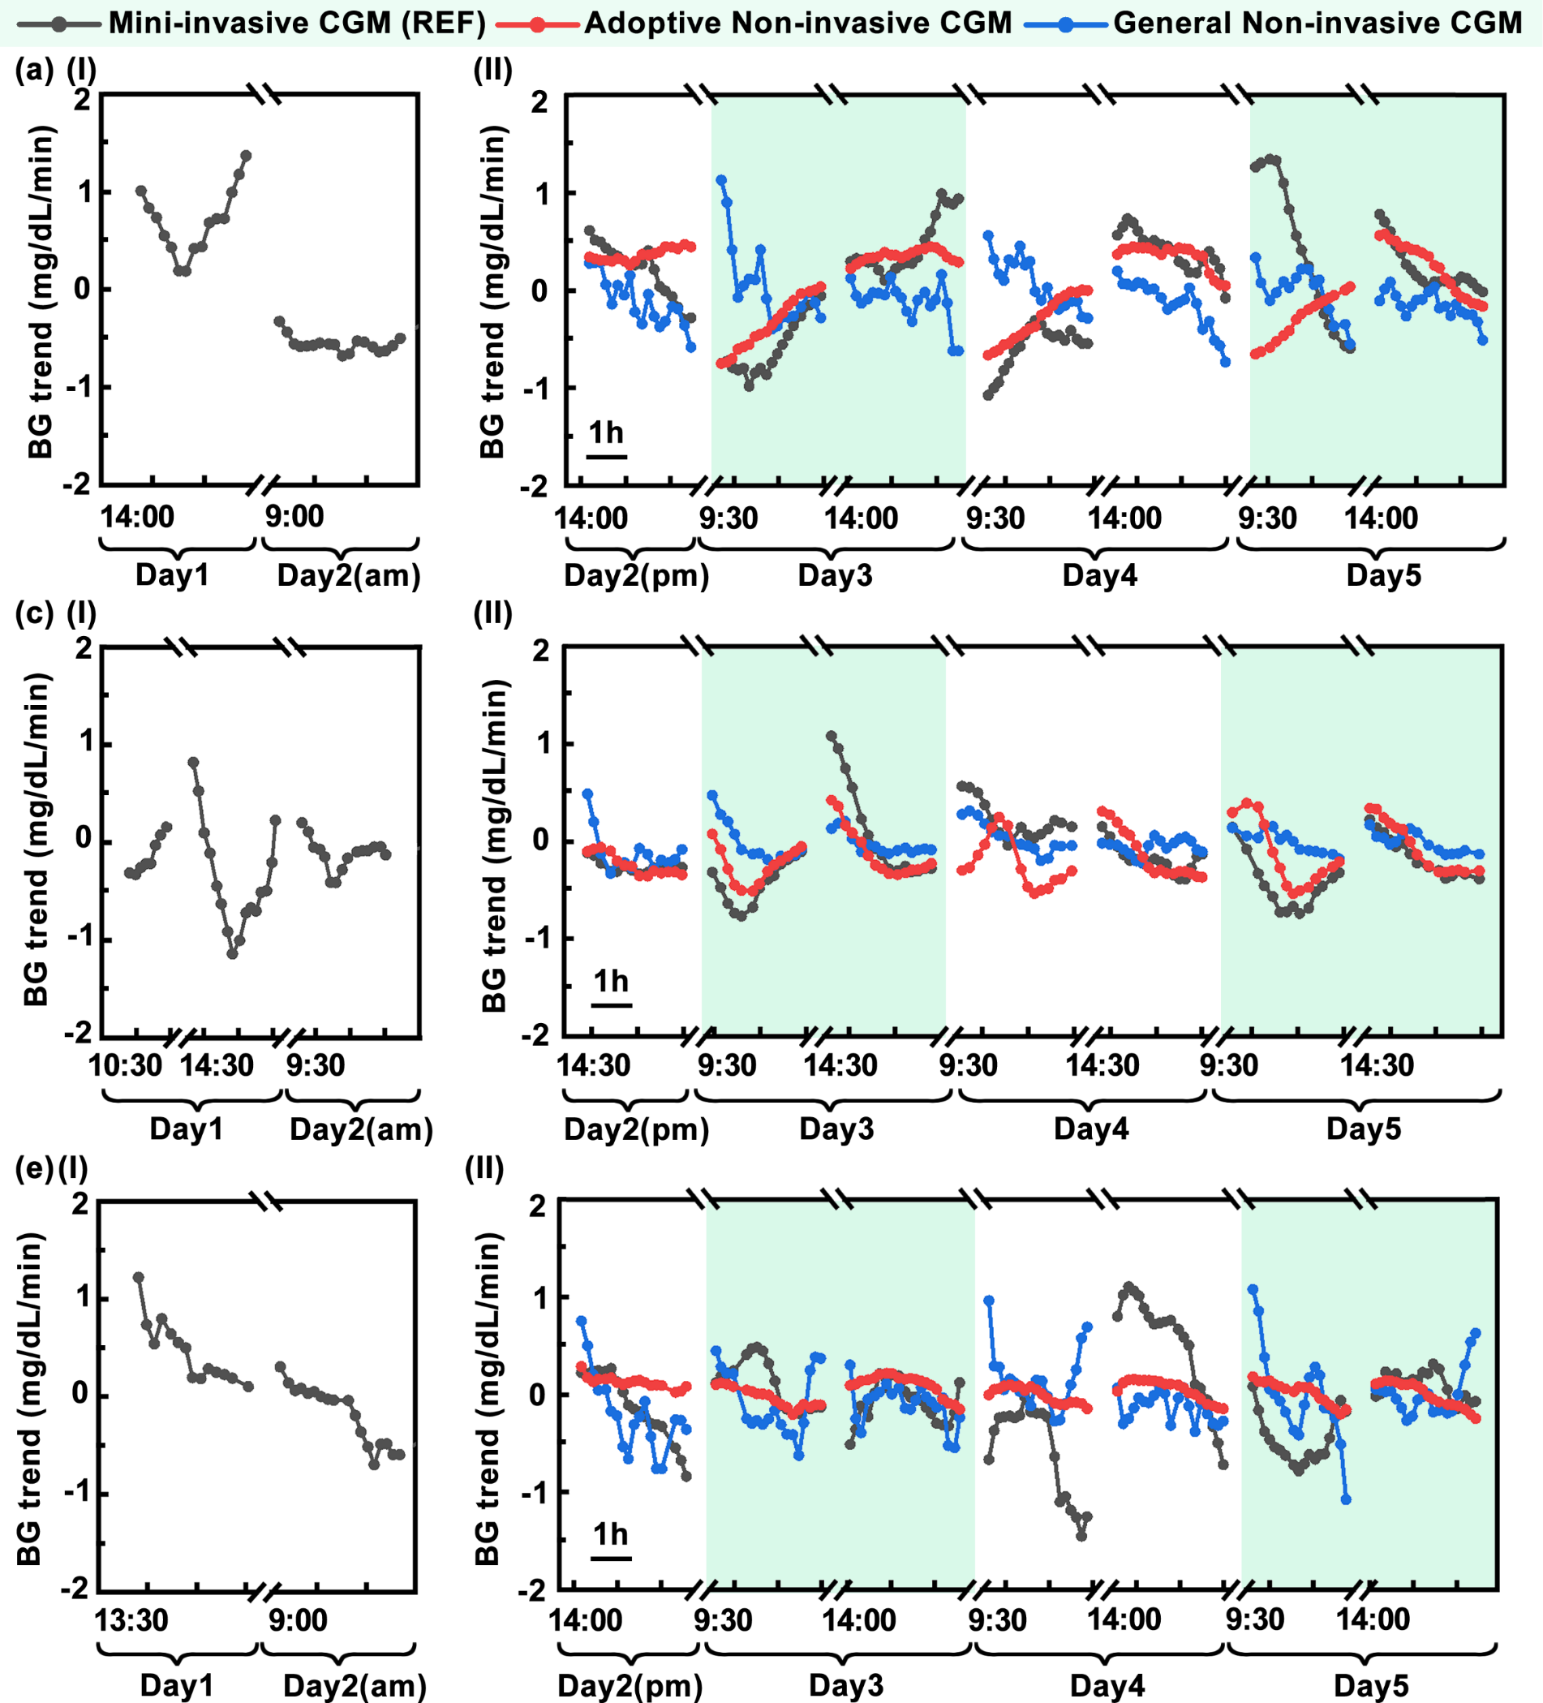
Figure S5-1 BG trend curves for diabetic participants (a) P#1, (b) P#2, and (c) P#3, during the short-term Round#1-CGM test, respectively. The comparisons of the reference BG trends and derived BG trends via the Mini-invasive CGM (black curves), the Adoptive Non-invasive CGM (red curves), and the General Non-invasive CGM (blue curves). The (I) initial 1.5 days data were used as the transfer learning dataset, which only contained the BG trends of the reference Mini-invasive CGM. The (II) following 3.5-days data were used as the testing dataset, which including the BG trends of the reference Mini-invasive CGM, the Adoptive Non-invasive CGM, and the General Non-invasive CGM.

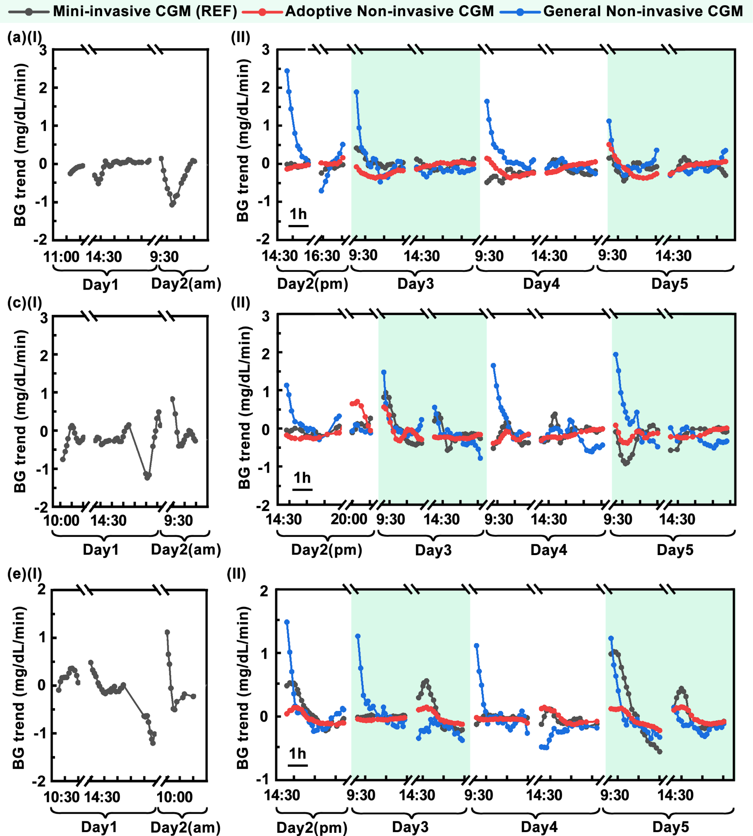
Figure S5-2. BG trend curves for heathy participants (a) P#4, (b) P#5, and (c) P#6, during the short-term Round#1-CGM test, respectively. The comparisons of the reference BG trends and derived BG trends via the Mini-invasive CGM (black curves), the Adoptive Non-invasive CGM (red curves), and the General Non-invasive CGM (blue curves). The (I) initial 1.5 days data were used as the transfer learning dataset, which only contained the BG trends of the reference Mini-invasive CGM. The (II) following 3.5-days data were used as the testing dataset, which including the BG trends of the reference Mini-invasive CGM, the Adoptive Non-invasive CGM, and the General Non-invasive CGM.

S5-2 Heatmaps of the BG values and trends for all participants with the Adoptive NI-CGM and MI-CGM during short-term Round#1-CGM test
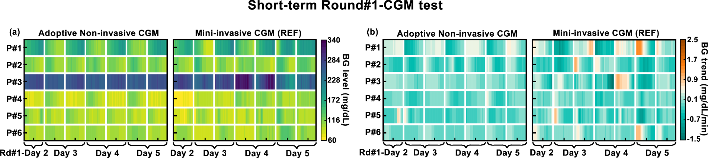
Figure S5-3. Heatmaps of the BG values and trends during short-term Round#1-CGM test. (a) Heatmaps of the BG values for all participants with the Adoptive NI-CGM and MI-CGM. (b) Heatmaps of the BG trends for all participants with the Adoptive NI-CGM and MI-CGM. The lighter colors corresponded to lower BG values or trends errors, while the color uniformity reflected the variability in the performance of the Adoptive NI-CGM and the General NI-CGM across individual participants.

S5-3 Clark's error grid analysis of the BG values across different participants during initial training
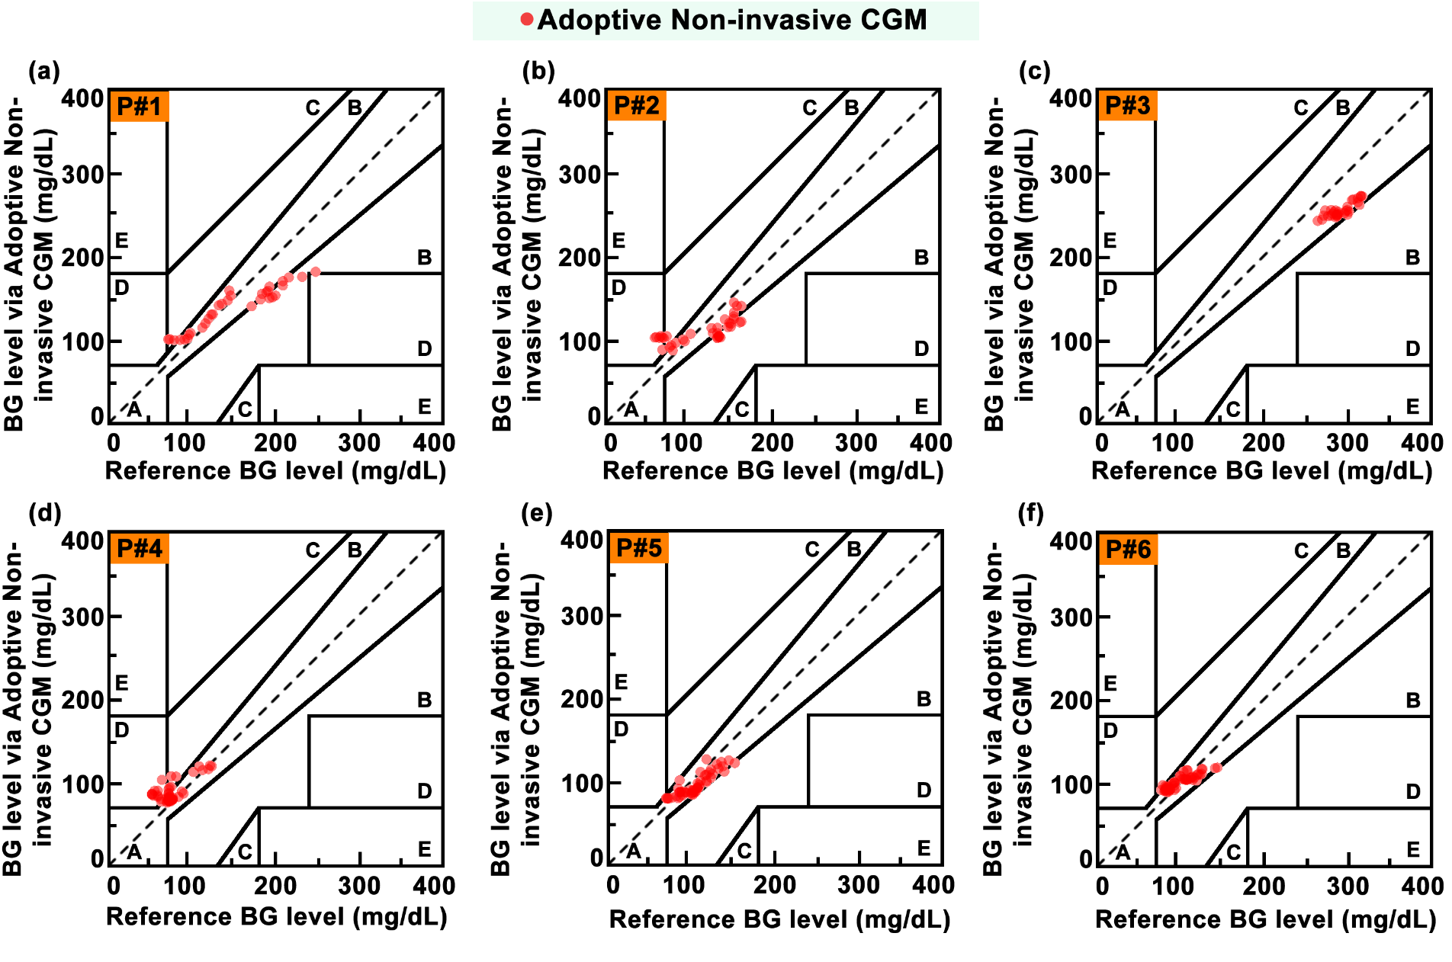
Figure S5-4. Clark's error grid analysis of the BG values for (a) P#1, (b) P#2, (c) P#3, (d) P#4, (e) P#5, and (f) P#6 during initial 1.5-days training of the Adoptive Non-invasive CGM, respectively. The comparisons of the BG values derived from the Adoptive Non-invasive CGM (red dots) with the reference BG via the Mini-invasive CGM. For the Adoptive Non-invasive CGM, most of the BG values data in the MI/NI-BG training dataset for each participant were distributed in zone A (corresponding to detection error < 20%), which was satisfied the clinical requirement of error <15%.

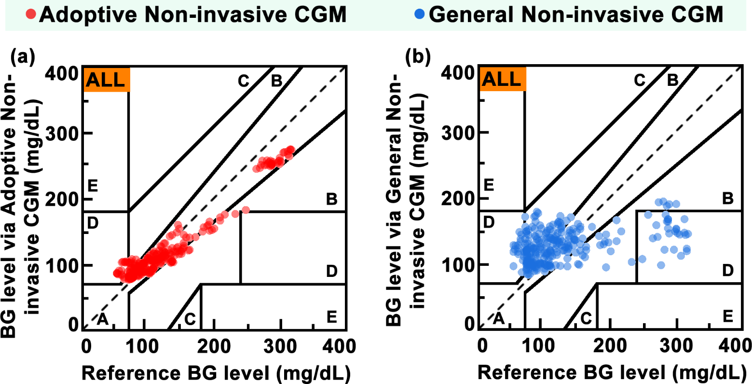
Figure S5-5. Clark's error grid analysis of the BG values for all participants during initial 1.5-days training. The comparisons of the BG values derived from (a) the Adoptive Non-invasive CGM and (b) the General Non-invasive CGM with the reference BG via the Mini-invasive CGM. For the Adoptive Non-invasive CGM, most of the BG values data in the MI/NI-BG training dataset for all participants were distributed in zone A, which was satisfied the clinical requirement of error <15%. For the General Non-invasive CGM, all of the BG values data in the MI/NI-BG training dataset for all participants were distributed in zone A, zone B, and zone D.

S5-4 The CG-EGAs of the BG trends across different participants during initial training
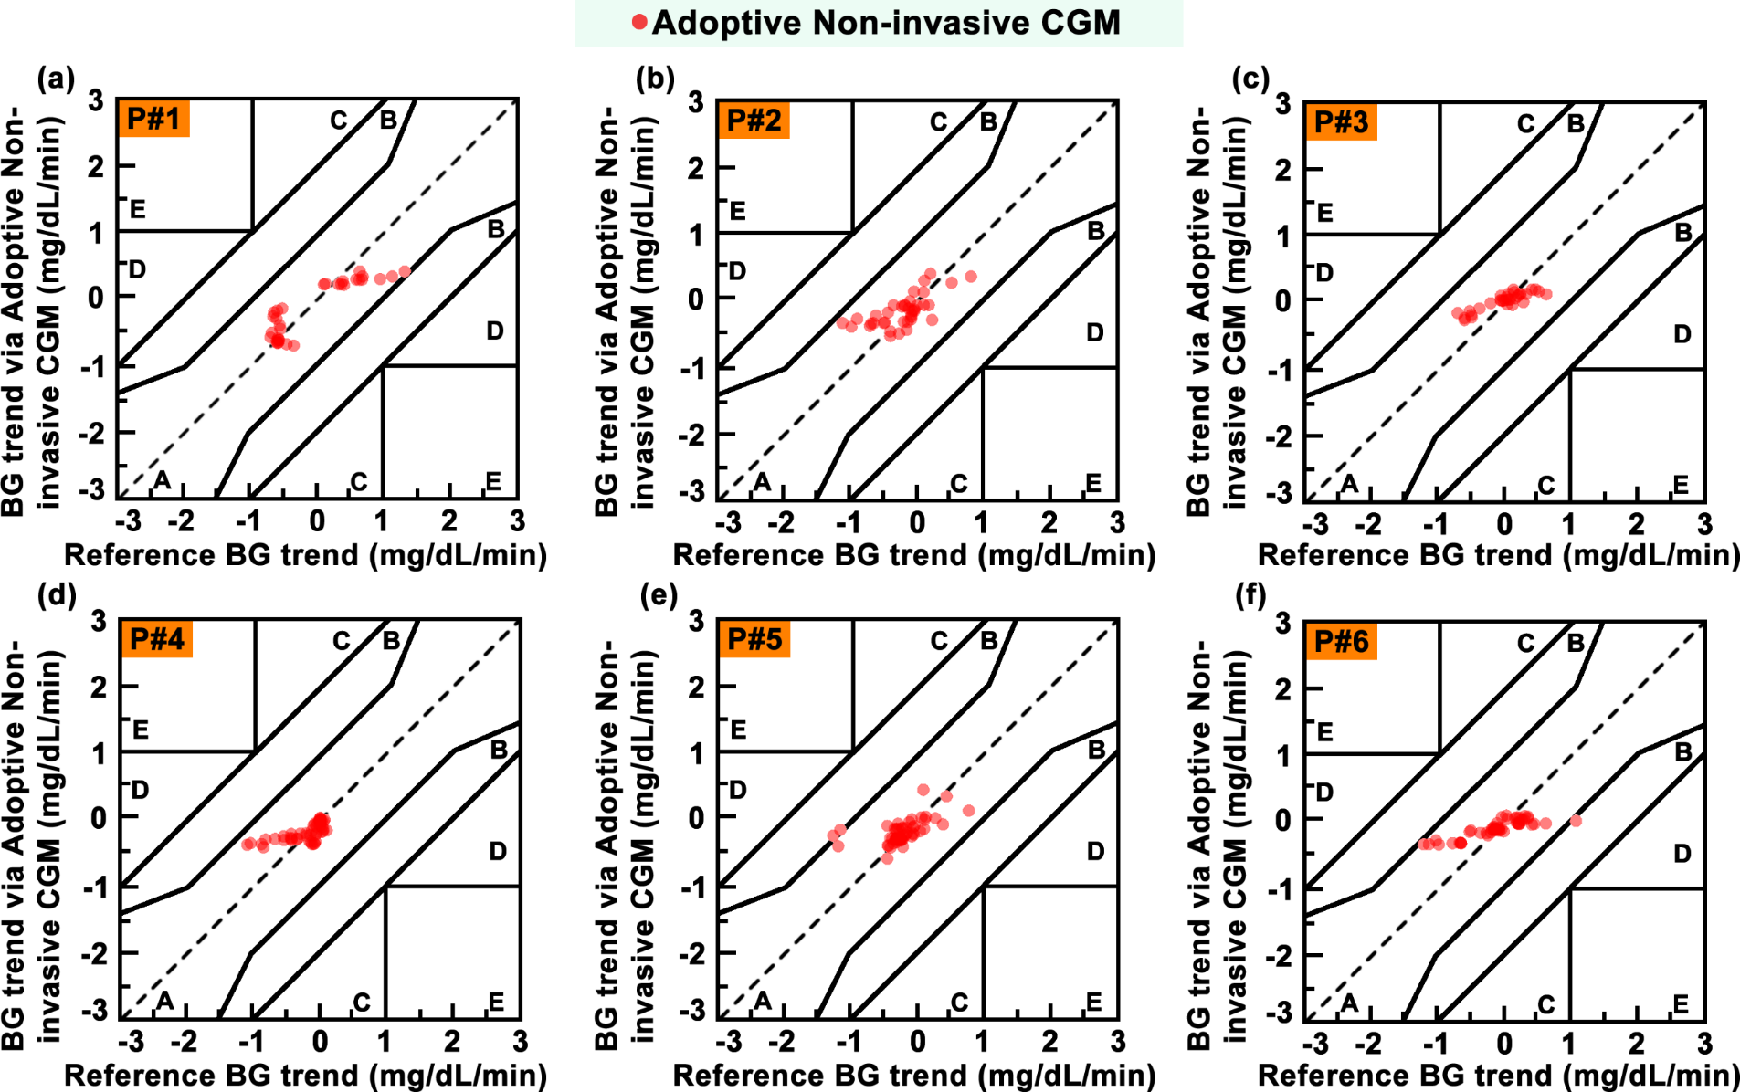
Figure S5-6. The CG-EGAs of the BG trends for (a) P#1, (b) P#2, (c) P#3, (d) P#4, (e) P#5, and (f) P#6 during initial 1.5-days training of the Adoptive Non-invasive CGM, respectively. The comparisons of the BG trends derived from the Adoptive Non-invasive CGM with the reference BG via the Mini-invasive CGM. For the Adoptive Non-invasive CGM, most of the BG trends data in the MI/NI-BG training dataset across each participant were distributed in zone A.

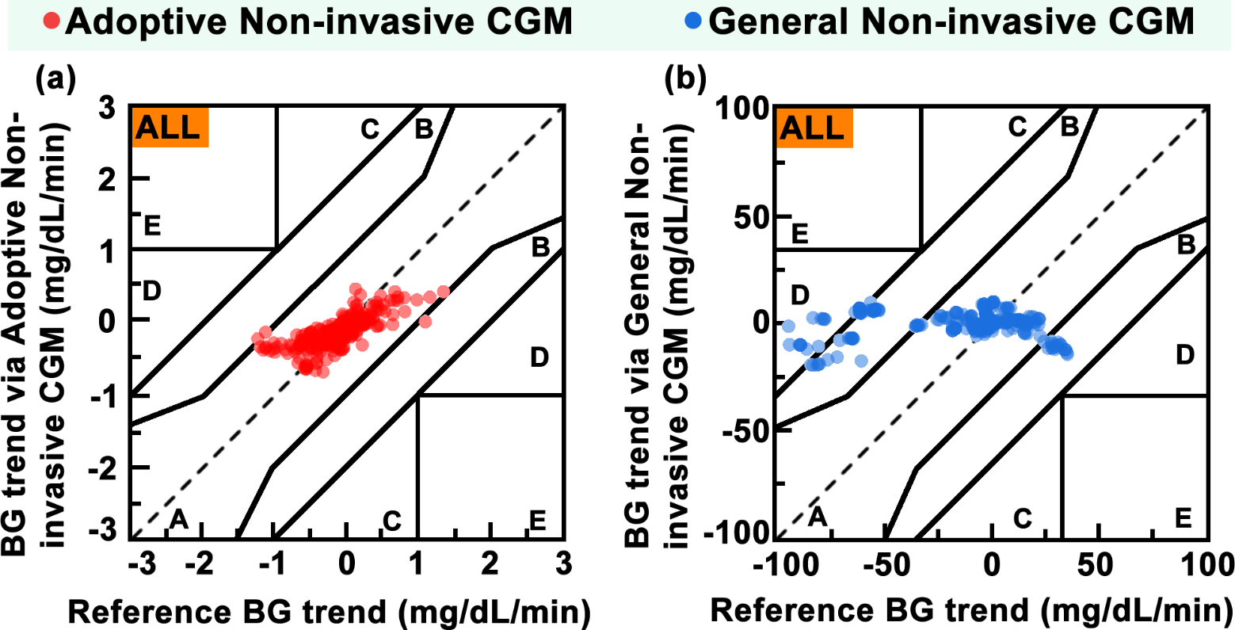
Figure S5-7. The CG-EGAs of the BG trends for all participants during initial 1.5-days training. The comparisons of the BG trends derived from (a) the Adoptive Non-invasive CGM and (b) the General Non-invasive CGM with the reference BG via the Mini-invasive CGM. For the Adoptive Non-invasive CGM, most of the BG trends data in the MI/NI-BG training dataset for all participants were distributed in zone A, while minority of them allocated in zone B. For the General Non-invasive CGM, most of the BG trends data in the MI/NI-BG training dataset for all participants were distributed in zone A and zone B, while minority of them allocated in zone D.

S5-5 The CG-EGAs of the BG trends (15 min) for all participants
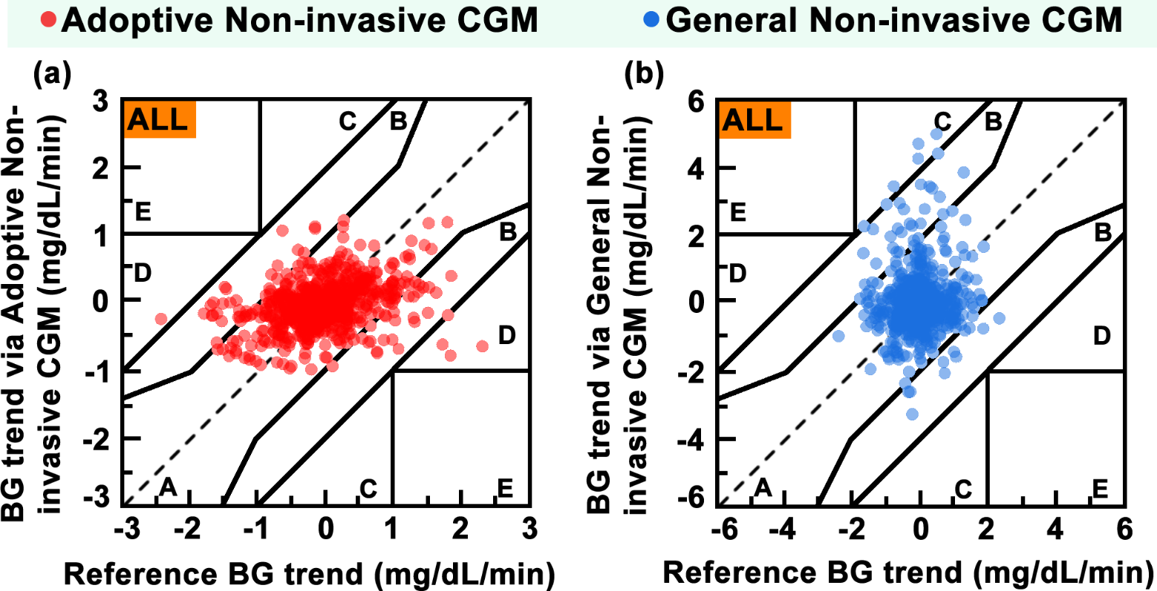
Figure S5-8. The CG-EGAs of the BG trends with the scan window of 15 min for all participants during 3.5-days BG monitoring. The comparisons of the BG trends with the scan window of 15 min derived from (a) the Adoptive Non-invasive CGM and (b) the General Non-invasive CGM with the reference BG via the Mini-invasive CGM. For the Adoptive Non-invasive CGM, most of the BG trends data in the MI/NI-BG training dataset for all participants were distributed in zone A, while minority of them allocated in zone B and zone D. For the General Non-invasive CGM, most of the BG trends data in the MI/NI-BG training dataset for all participants were distributed in zone A and zone B, while minority of them allocated in zone C.

S5-6 The CG-EGAs of the BG trends (45 min) for all participants
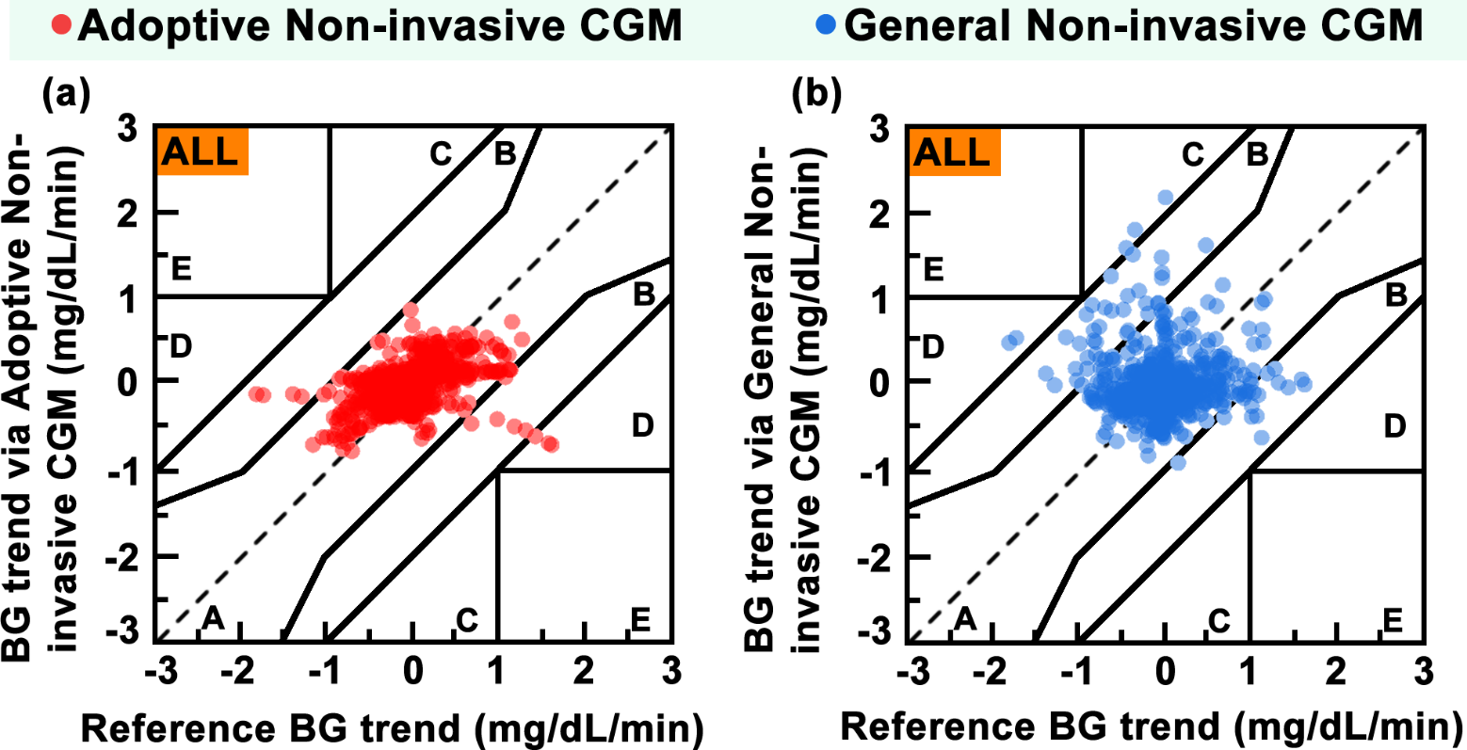
Figure S5-9. The CG-EGAs of the BG trends with the scan window of 45 min for all participants during 3.5-days BG monitoring. The comparisons of the BG trends with the scan window of 45 min derived from (a) the Adoptive Non-invasive CGM and (b) the General Non-invasive CGM with the reference BG via the Mini-invasive CGM. For the Adoptive Non-invasive CGM, most of the BG trends data in the MI/NI-BG training dataset for all participants were distributed in zone A, while minority of them allocated in zone B and zone D. For the General Non-invasive CGM, most of the BG trends data in the MI/NI-BG training dataset for all participants were distributed in zone A and zone B, while minority of them allocated in zone C and zone D.

S5-7 The CG-EGAs of the BG trends (90 min) for all participants
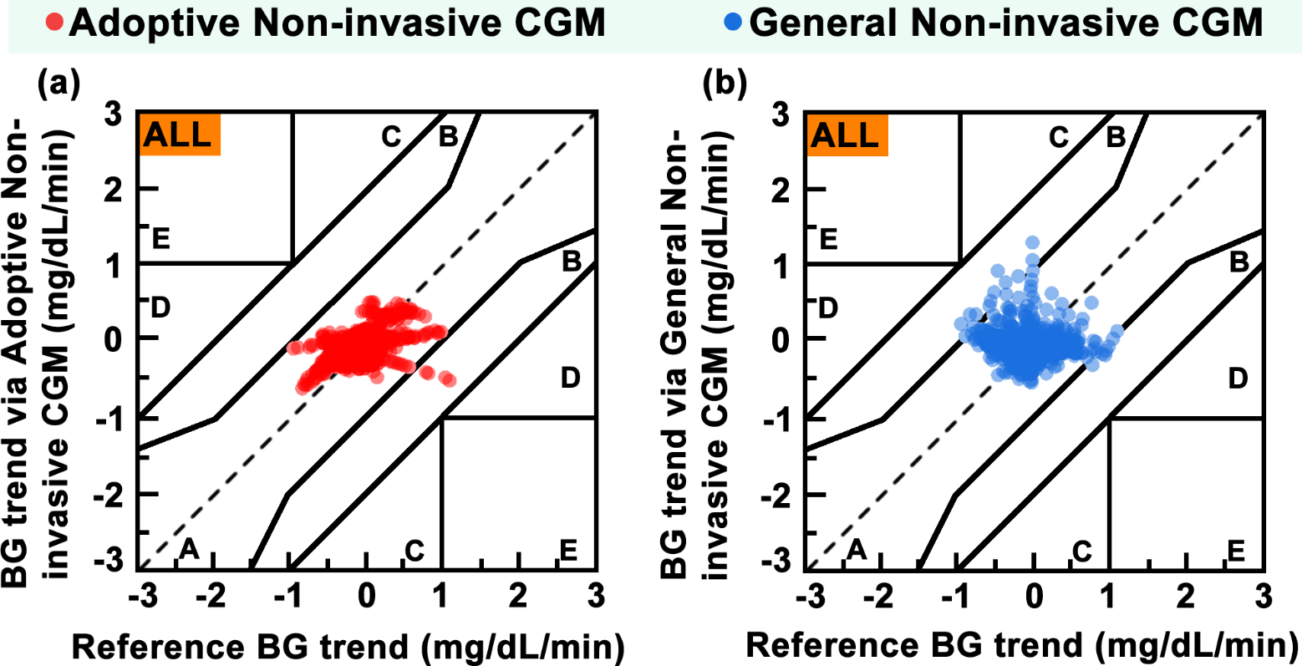
Figure S5-10. The CG-EGAs of the BG trends with the scan window of 90 min for all participants during 3.5-days BG monitoring. The comparisons of the BG trends with the scan window of 90 min derived from (a) the Adoptive Non-invasive CGM and (b) the General Non-invasive CGM with the reference BG via the Mini-invasive CGM. For the Adoptive Non-invasive CGM, most of the BG trends data in the MI/NI-BG training dataset for all participants were distributed in zone A, while minority of them allocated in zone B. For the General Non-invasive CGM, most of the BG trends data in the MI/NI-BG training dataset for all participants were scattered at zone A and zone B.

S5-8 Clark's error grid analysis of the BG values for diabetic and healthy participants using the Adoptive Non-invasive CGM
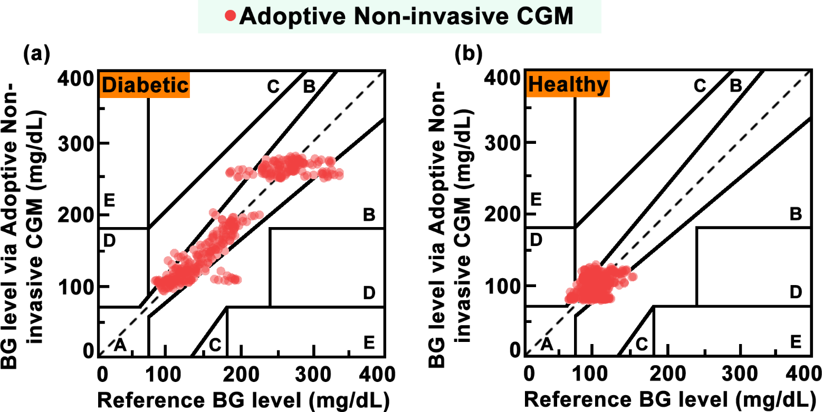
Figure S5-11. Clark's error grid analysis of the BG values for (a) diabetic and (b) healthy participants using the Adoptive Non-invasive CGM during last 3.5-days testing, respectively. The comparisons of the BG values derived from the Adoptive Non-invasive CGM with the reference BG via the Mini-invasive CGM. For the diabetic participants, most of the BG value data was distributed in zone A, while a few data allocated in zone B. Similarly, for the healthy participants, most of the BG value data was distributed in zone A, while minor amount of data was allocated in zone B and D.

S5-9 Clark's error grid analysis of the BG values for diabetic and healthy participants using the General Non-invasive CGM
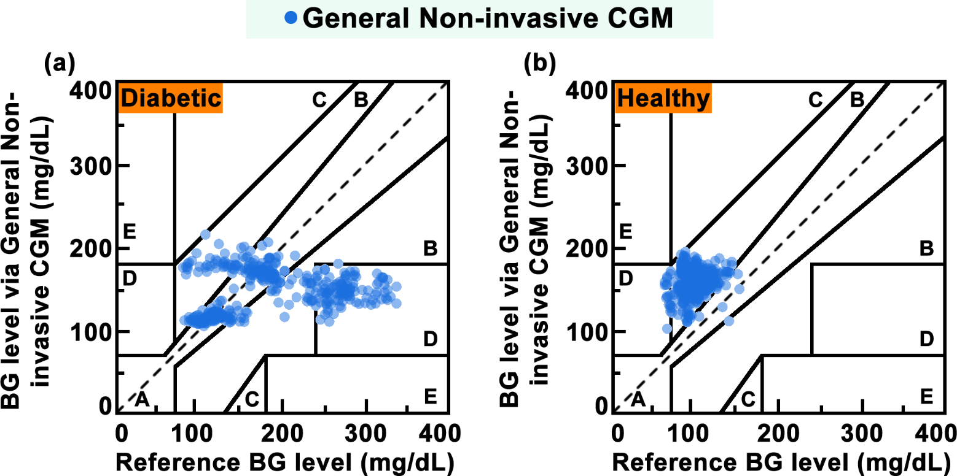
Figure S5-12. Clark's error grid analysis of the BG values for (a) diabetic and (b) healthy participants using the General Non-invasive CGM during last 3.5-days testing, respectively. The comparisons of the BG values derived from the General Non-invasive CGM with the reference BG via the Mini-invasive CGM. For the diabetic participants, the BG value data was scattered across zone A, zone B, and zone D. As for the healthy participants, most of the BG value data was distributed in zone B, while minor amount of data was allocated in zone A, zone C, and zone D.

S5-10 The CG-EGAs of the BG trends for diabetic and healthy participants using the Adoptive Non-invasive CGM
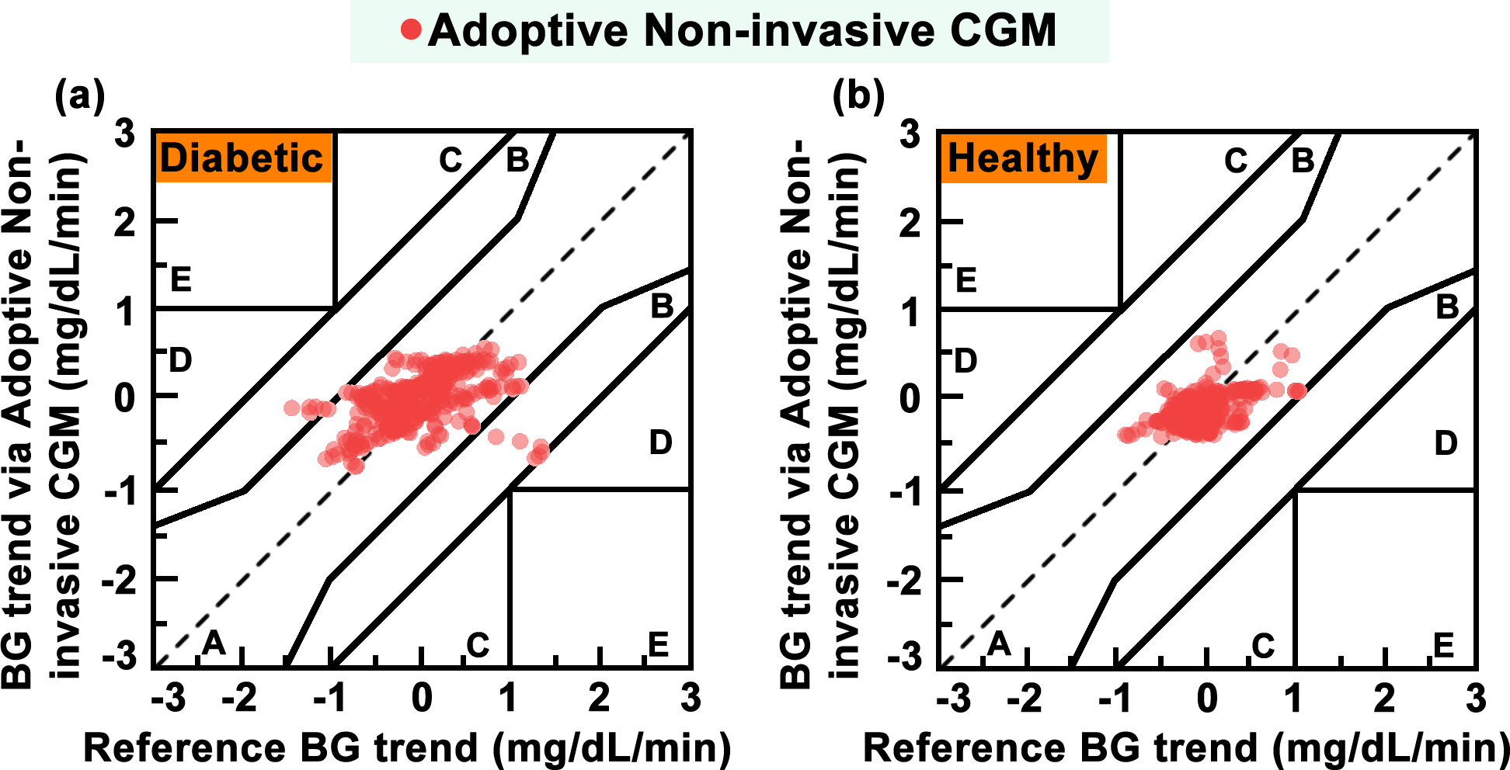
Figure S5-13. The CG-EGAs of the BG trends for (a) diabetic and (b) healthy participants using the Adoptive Non-invasive CGM during last 3.5-days testing, respectively. The comparisons of the BG trends derived from the Adoptive Non-invasive CGM with the reference BG via the Mini-invasive CGM. For the diabetic participants, most of the BG trend data was distributed in zone A, while very few of BG trend data allocated in zone B and zone D. As for the healthy participants, all of the BG value data was distributed in zone A.

S5-11 The CG-EGAs of the BG trends for diabetic and healthy participants using the General Non-invasive CGM
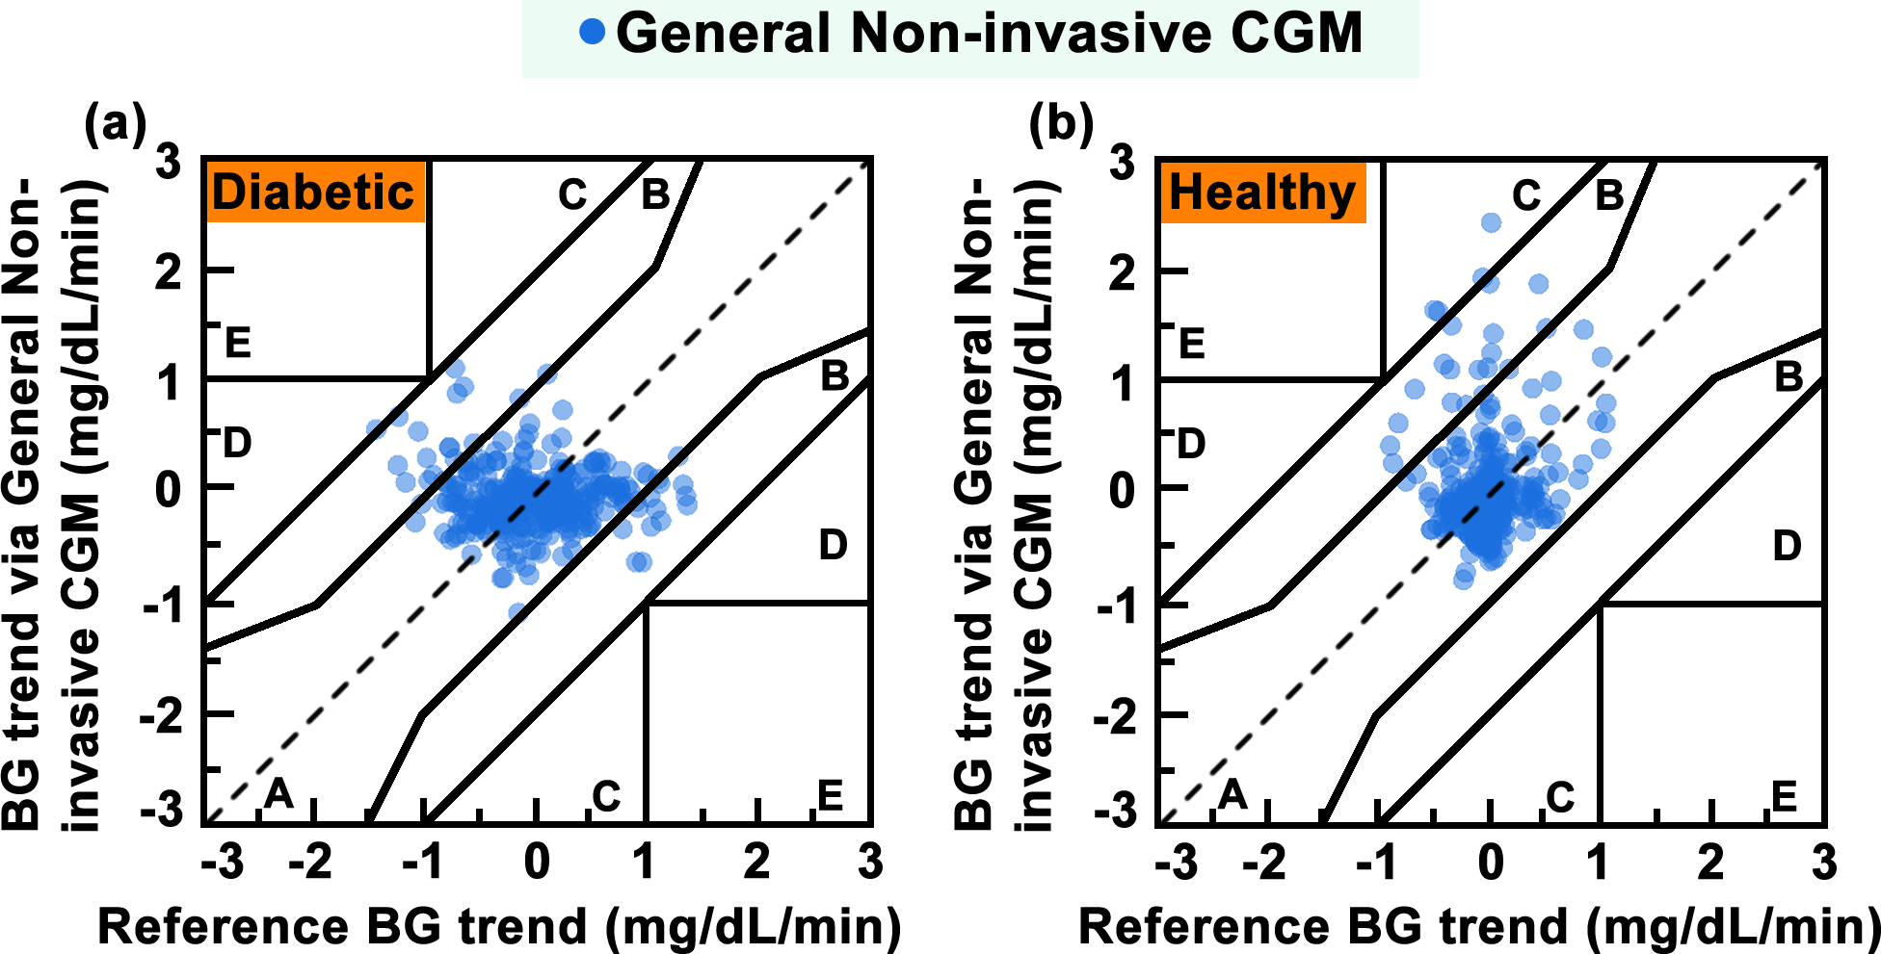
Figure S5-14. The CG-EGAs of the BG trends for (a) diabetic and (b) healthy participants using the General Non-invasive CGM during last 3.5-days testing, respectively. The comparisons of the BG trends derived from the General Non-invasive CGM with the reference BG via the Mini-invasive CGM. For the diabetic participants, most of the BG trend data was distributed in zone A, while some of BG trend data scattered across zone B and zone D. As for the healthy participants, most of the BG value data was distributed in zone A, and a few of BG trend data scattered across zone B and zone C.

S5-12 The violin plots of the errors of BG levels and trends for diabetic and healthy participants
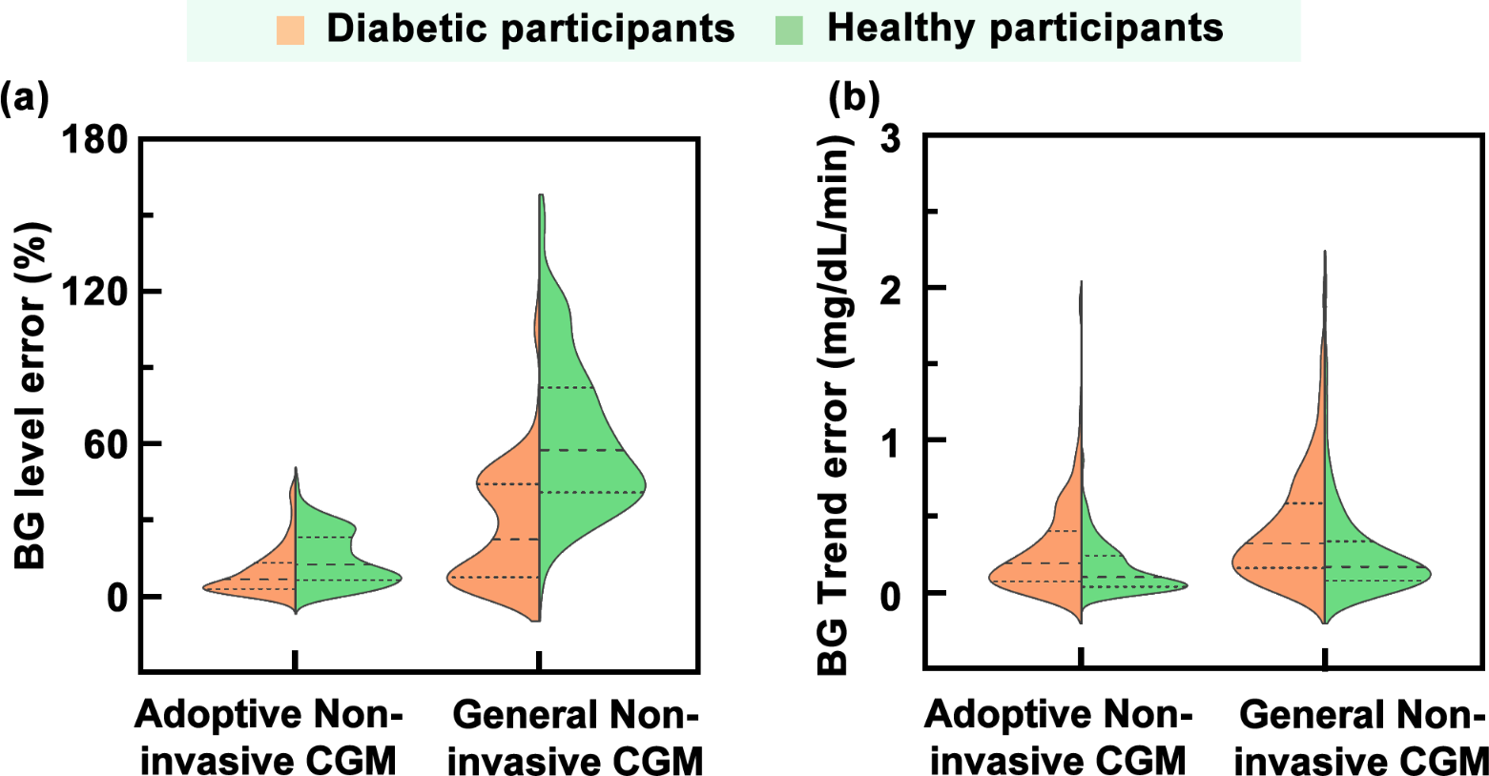
Figure S5-15. Comparison of violin plots of the BG level errors and BG trend errors between healthy and diabetic participants. (a) Comparison of violin plots of BG levels errors for healthy and diabetic participants. For the Adoptive Non-invasive CGM, the errors of BG levels for both diabetic and healthy patients were minor, and the violin plots were more symmetrical. As for the General Non-invasive CGM, the errors of BG levels were larger for both diabetic and healthy patients, while the violin plots presented an asymmetric distribution. (b) Violin plots of the variations of the BG trends for healthy and diabetic participants. Compared to the Non-invasive CGM, the errors of BG trends using the Adoptive Non-invasive CGM for both diabetic and healthy patients were minor.

S5-13 Heatmaps of the BG monitoring results for all participants with the Adoptive NI-CGM and MI-CGM during short-term Round#2-CGM test
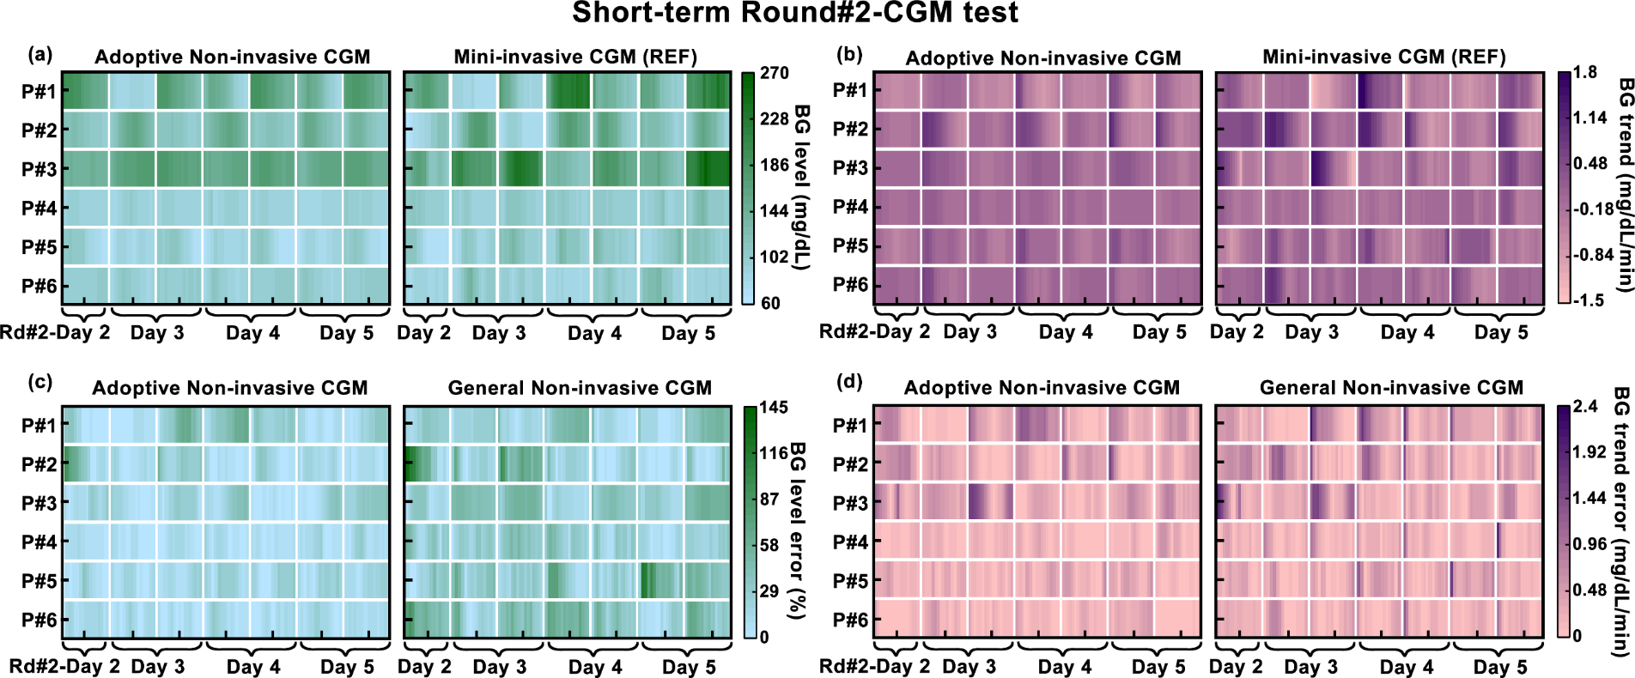
Figure S5-16. Heatmaps of the BG monitoring results for all participants with the Adoptive NI-CGM and MI-CGM during short-term Round#2-CGM test. (a) Heatmaps of the BG levels for all participants with the Adoptive NI-CGM and the reference MI-CGM. (b) Heatmaps of the BG trends for all participants with the Adoptive NI-CGM and the reference MI-CGM. (c) Heatmaps of the errors of BG levels for all participants with the Adoptive NI-CGM and the General NI-CGM. (d) Heatmaps of the errors of the BG trends for all participants with the Adoptive NI-CGM and the General NI-CGM. The lighter colors corresponded to lower BG values or trends errors, while the color uniformity reflected the variability in the performance of the Adoptive NI-CGM and the General NI-CGM across individual participants.

S5-14 The Clark’s EGA of the BG levels across different participants in short-term Round#2-CGM test
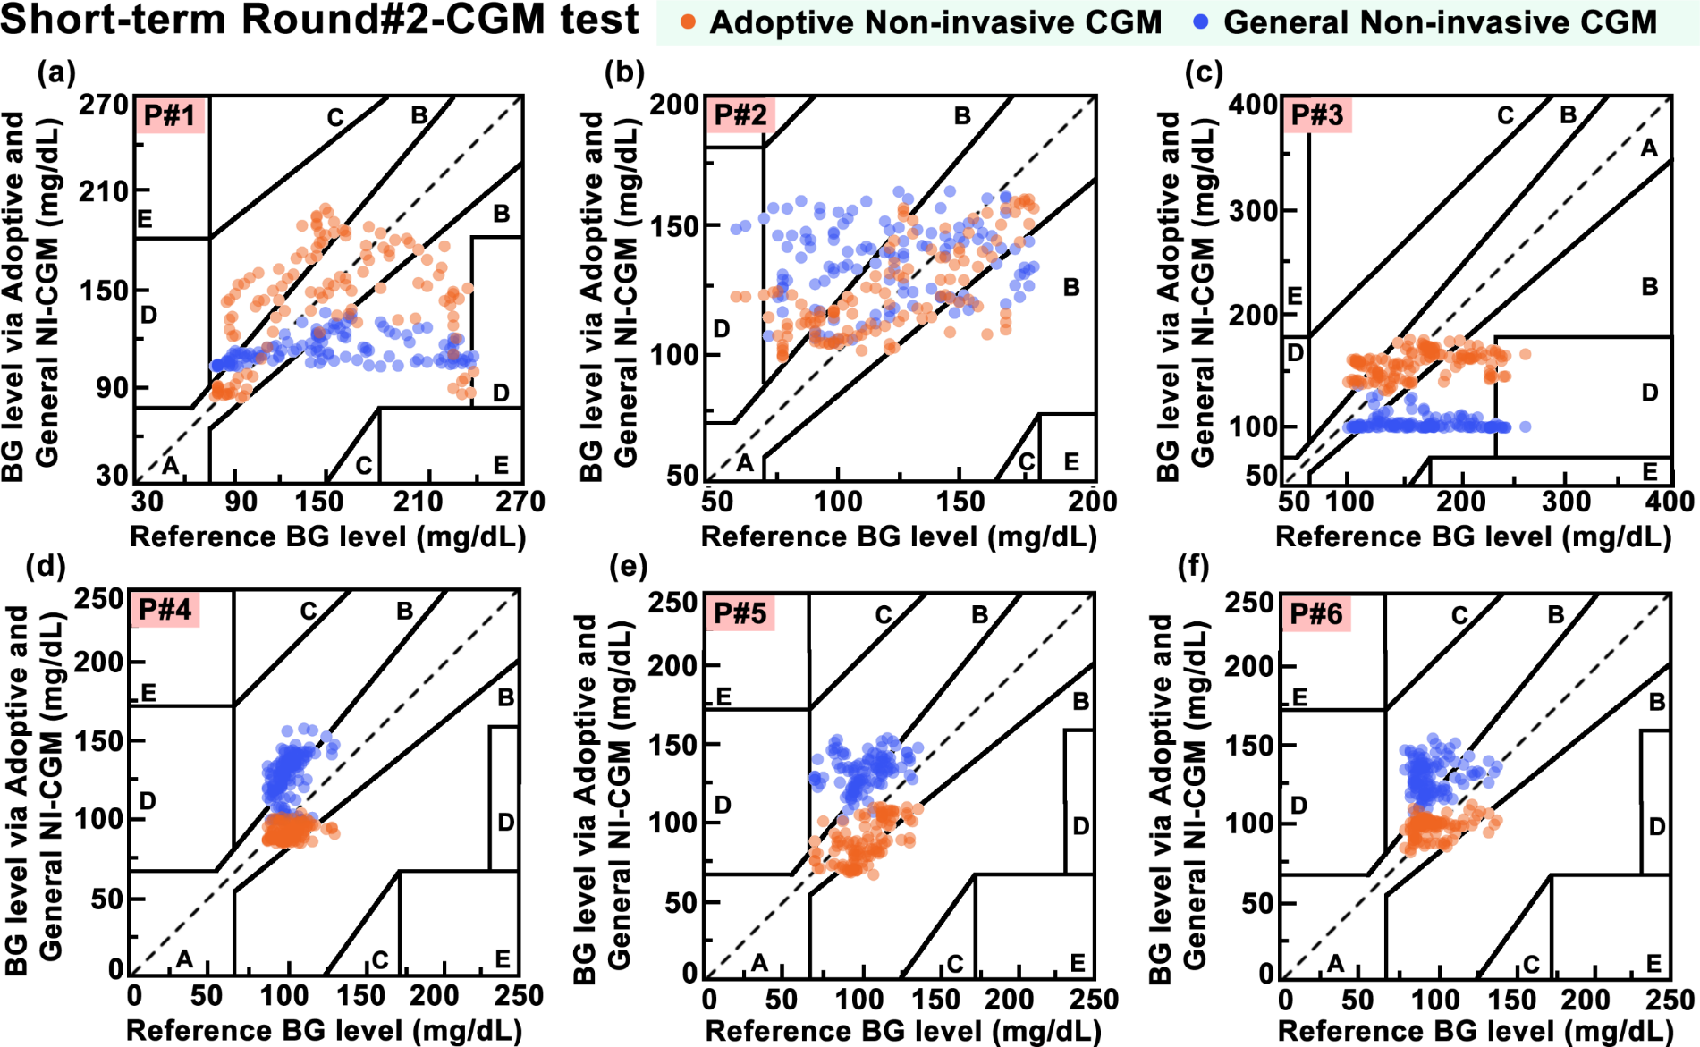
Figure S5-17. The Clark’s EGA of the last 3.5-days BG monitoring for (a)-(f) P#1 to P#6 in short-term Round#2-CGM test, respectively. Comparisons of the BG values derived from the Adoptive Non-invasive CGM and the General Non-invasive CGM with the reference BG via the Mini-invasive CGM. For the Adoptive Non-invasive CGM, most of the BG values data in the MI/NI-BG training dataset across each participant were distributed in zone A.

S5-15 The CG-EGA of the BG trends across different participants in short-term Round#2-CGM test
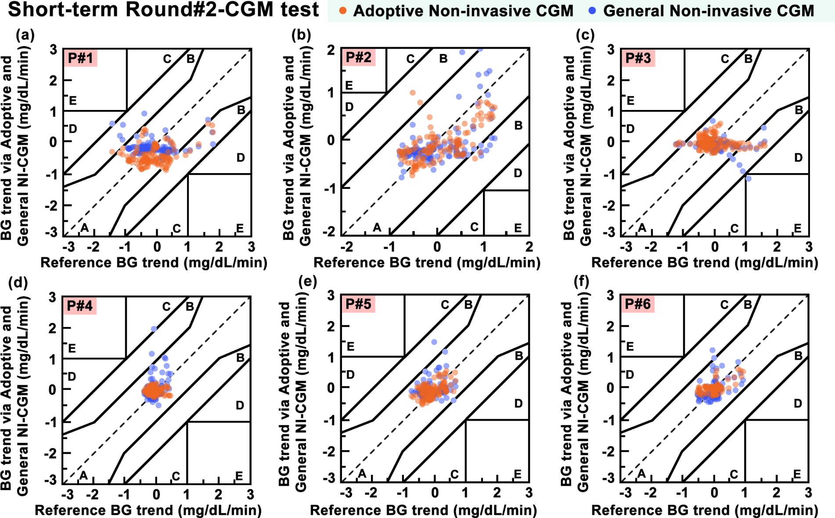
Figure S5-18. The CG-EGA of the last 3.5-days BG monitoring for (a)-(f) P#1 to P#6 in short-term Round#2-CGM test, respectively. Comparisons of the BG trends derived from the Adoptive Non-invasive CGM and the General Non-invasive CGM with the reference BG via the Mini-invasive CGM. For the Adoptive Non-invasive CGM, most of the BG trends data in the MI/NI-BG training dataset across each participant were distributed in zone A.

S5-16 Statistical histograms of the BG levels and trends across different participants in short-term Round#2-CGM test
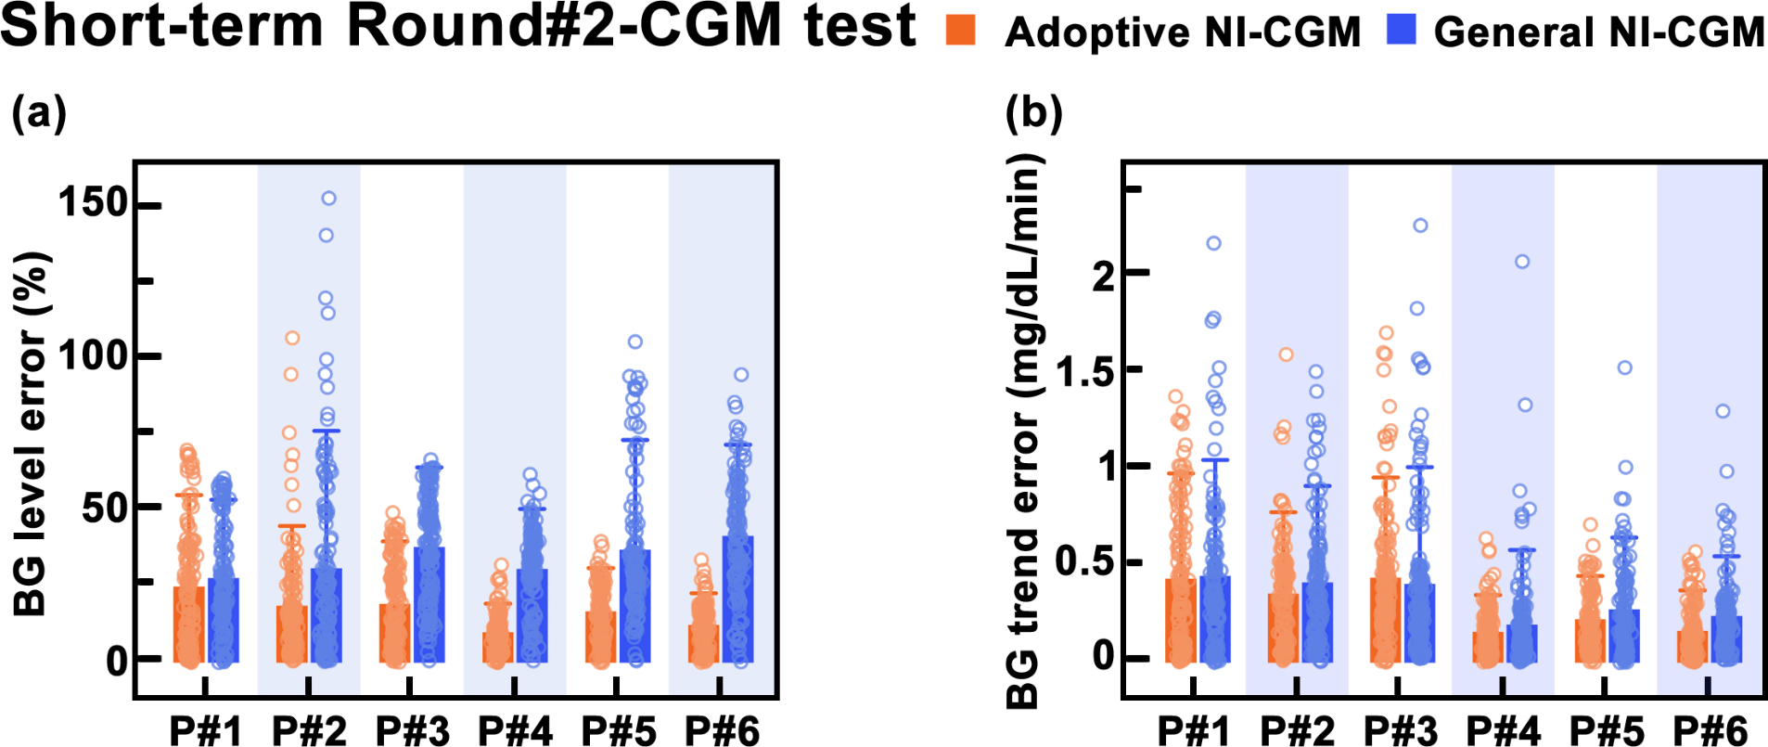
Figure S5-19. Statistical histograms of the BG levels and trends across different participants in short-term Round#2-CGM test. (a) Statistical histograms exhibited last 3.5-days testing results of BG values via the Adoptive NI-CGM and the General NI-CGM across different participants in short-term Round#2-CGM test. (b) Statistical histograms exhibited last 3.5-days testing results of BG trends via the Adoptive NI-CGM and the General NI-CGM across different participants in short-term Round#2-CGM test. Graph bars represented the SD.

S5-17 Violin plots of BG levels and trends across all participants in short-term Round#2-CGM test
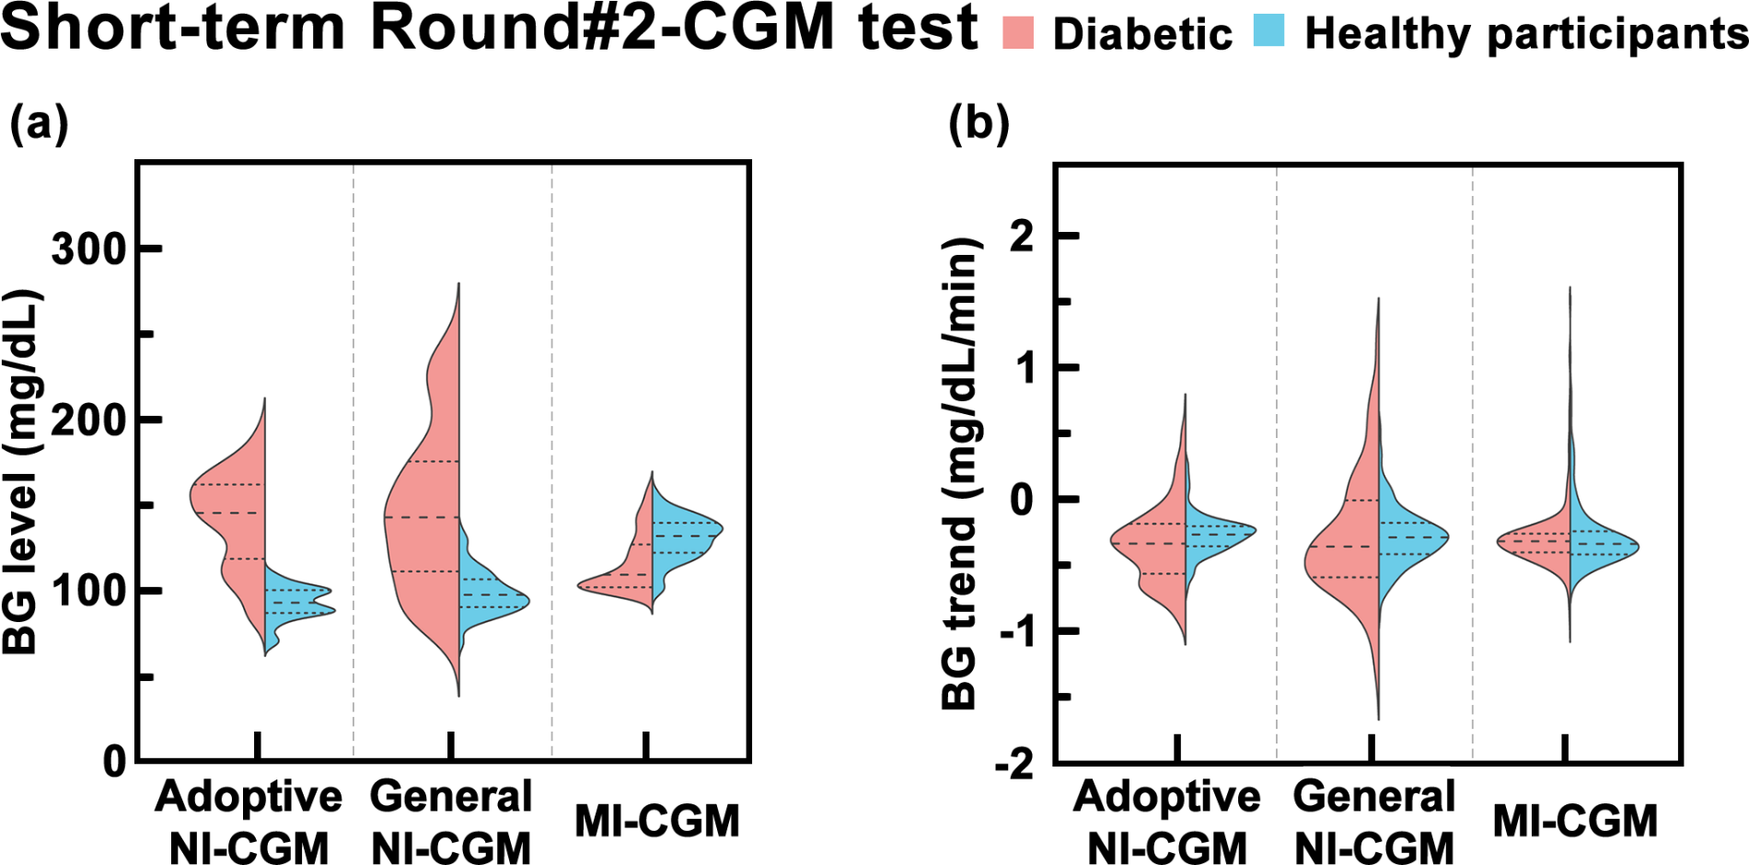
Figure S5-20. Violin plots of BG levels and trends across all participants in short-term Round#2-CGM test. Violin plots of the variation in (a) BG values and (b) BG trends between healthy participants (n=3) and diabetic participants (n=3) with the Adoptive Non-invasive CGM, General Non-invasive CGM, and reference Mini-invasive CGM. Means and confidence intervals were labelled with dashed lines in the graph separately.

S5-18 Heatmaps of the BG monitoring results for all participants with the Adoptive NI-CGM and MI-CGM during long-term Rd#1&2-CGM test
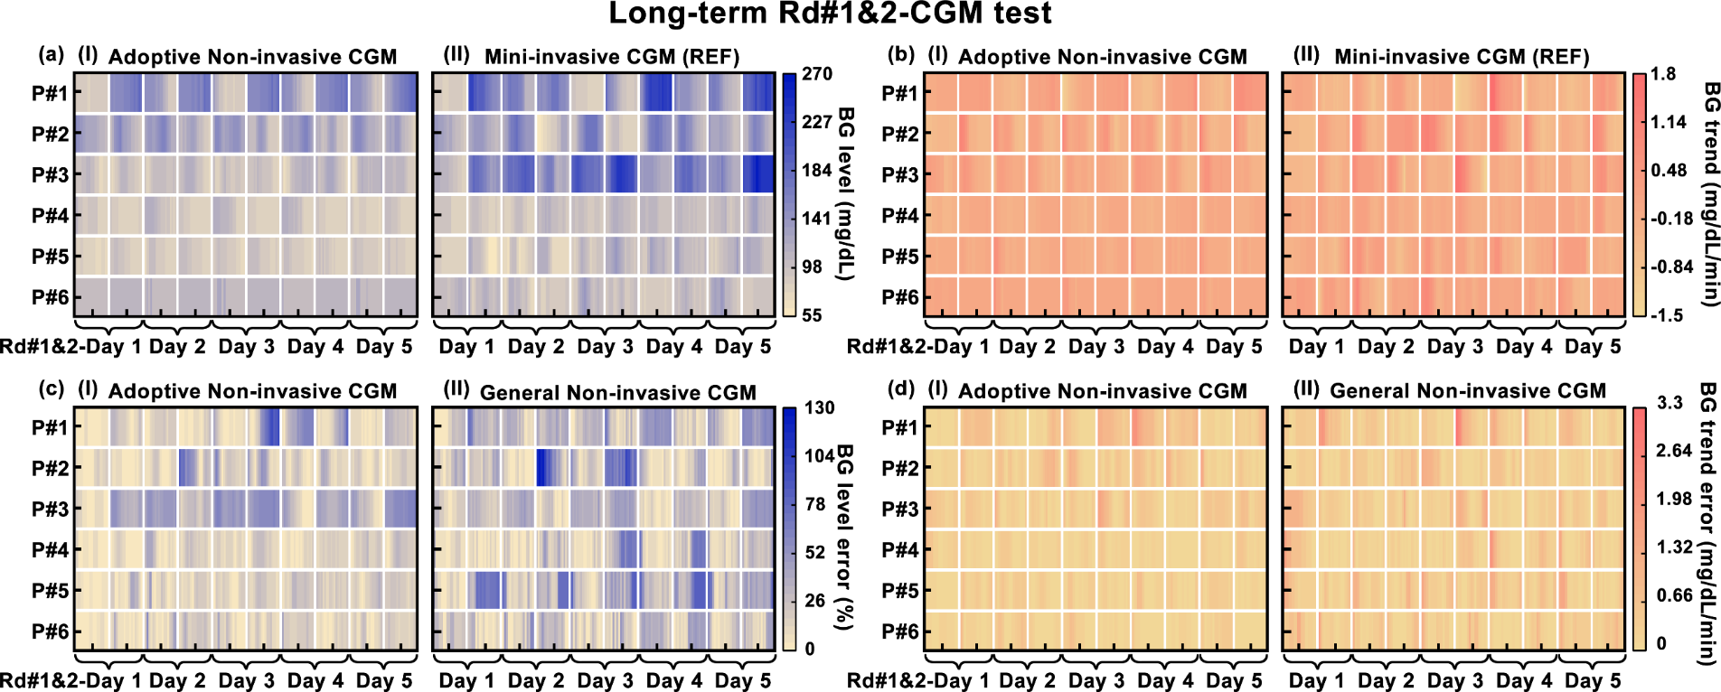
Figure S5-21. Heatmaps of the BG monitoring results for all participants with the Adoptive NI-CGM and MI-CGM during long-term Rd#1&2-CGM test. (a) Heatmaps of the BG levels for all participants with the Adoptive NI-CGM and the reference MI-CGM. (b) Heatmaps of the BG trends for all participants with the Adoptive NI-CGM and the reference MI-CGM. (c) Heatmaps of the errors of BG levels for all participants with the Adoptive NI-CGM and the General NI-CGM. (d) Heatmaps of the errors of the BG trends for all participants with the Adoptive NI-CGM and the General NI-CGM. The lighter colors corresponded to lower BG values or trends errors, while the color uniformity reflected the variability in the performance of the Adoptive NI-CGM and the General NI-CGM across individual participants.

S5-19 The Clark’s EGA of the BG levels across different participants in long-term Rd#1&2-CGM test
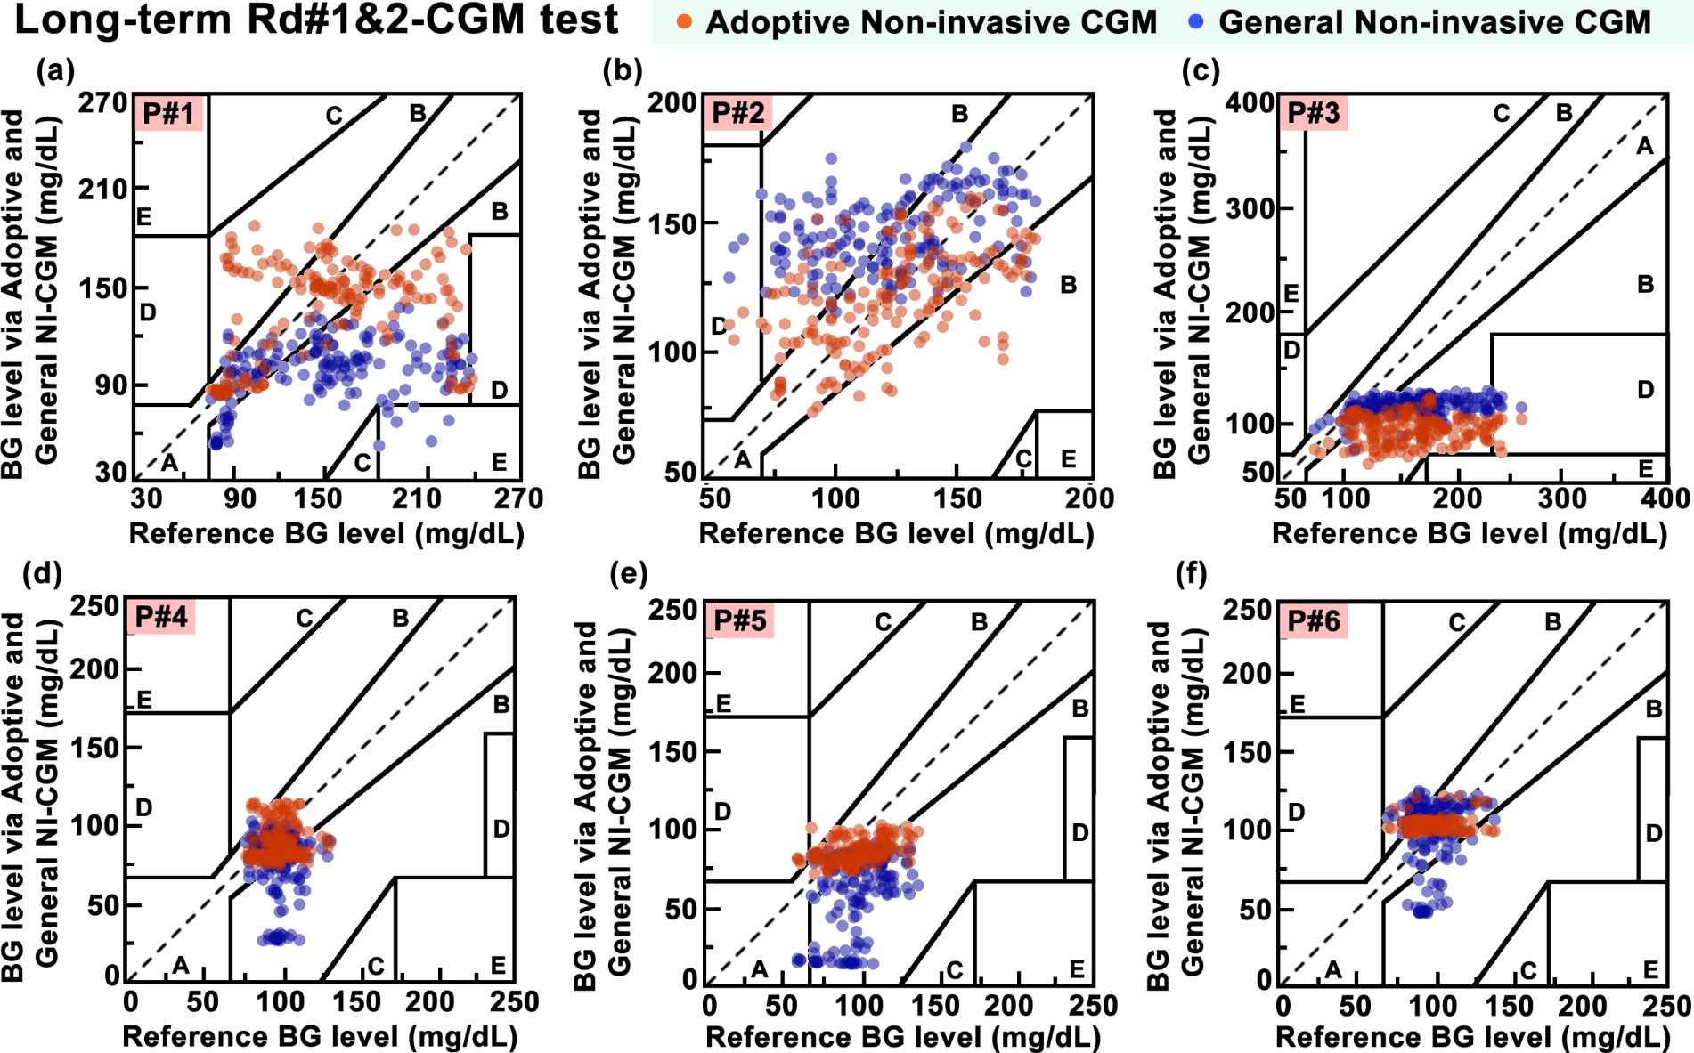
Figure S5-22. The Clark’s EGA of the last 3.5-days BG monitoring for (a)-(f) P#1 to P#6 in long-term Rd#1&2-CGM test, respectively. Comparisons of the BG values derived from the Adoptive Non-invasive CGM and the General Non-invasive CGM with the reference BG via the Mini-invasive CGM.

S5-20 The CG-EGA of the BG trends across different participants in long-term Rd#1&2-CGM test
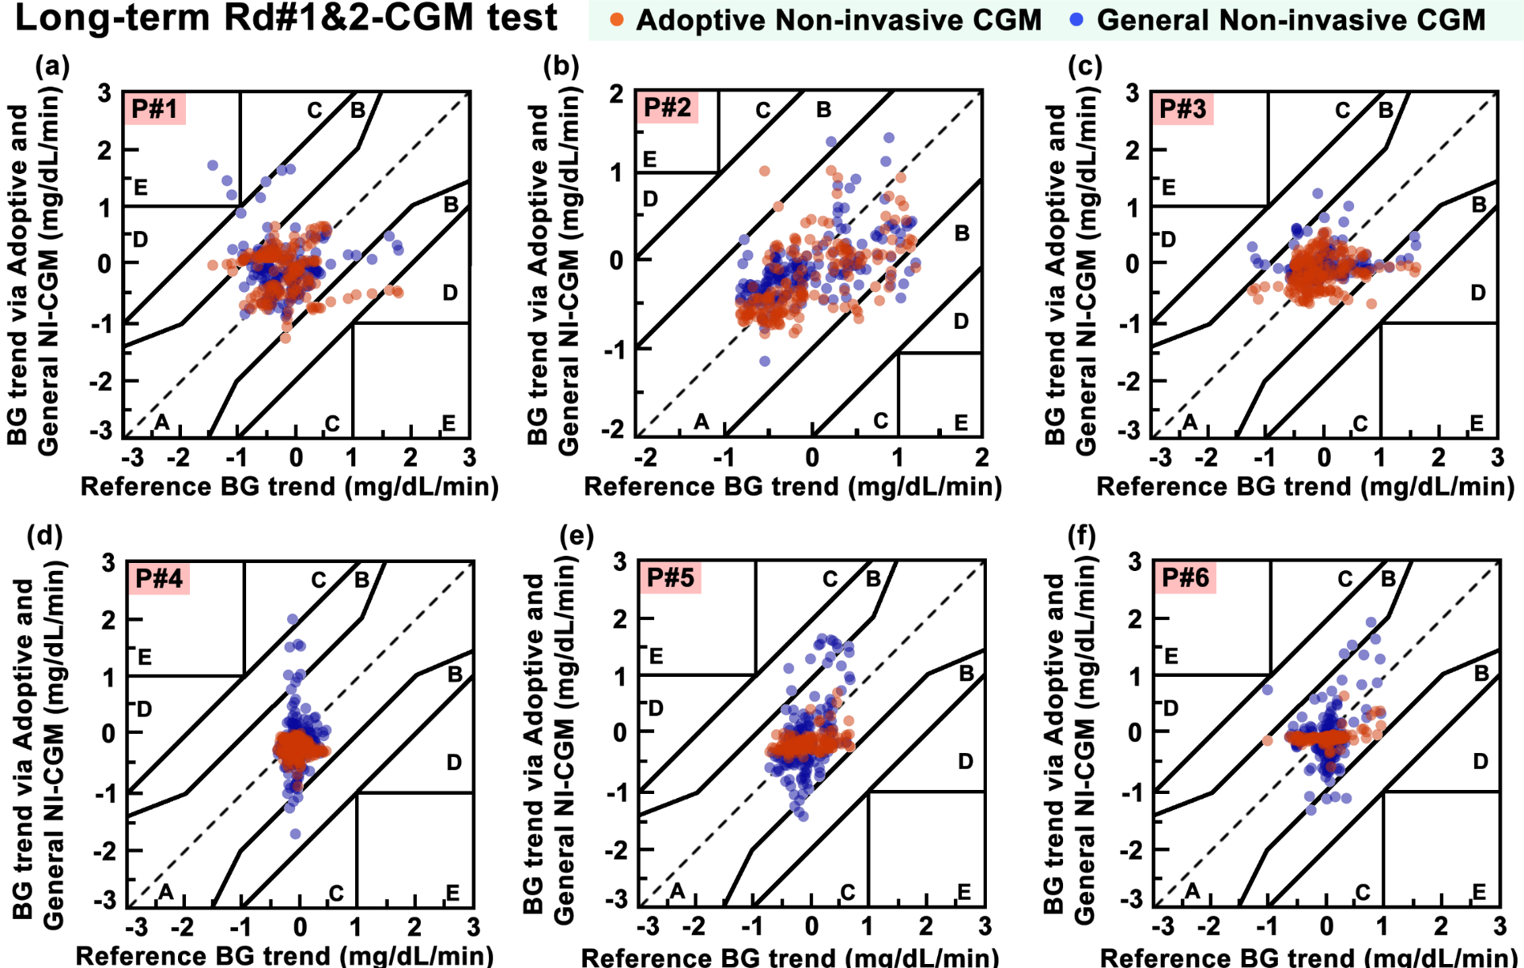
Figure S5-23. The CG-EGA of the last 3.5-days BG monitoring for (a)-(f) P#1 to P#6 in long-term Rd#1&2-CGM test, respectively. Comparisons of the BG trends derived from the Adoptive Non-invasive CGM and the General Non-invasive CGM with the reference BG via the Mini-invasive CGM.

S5-21 Statistical analysis of the BG trend errors for each individual in the long-term Rd#1&2-CGM test
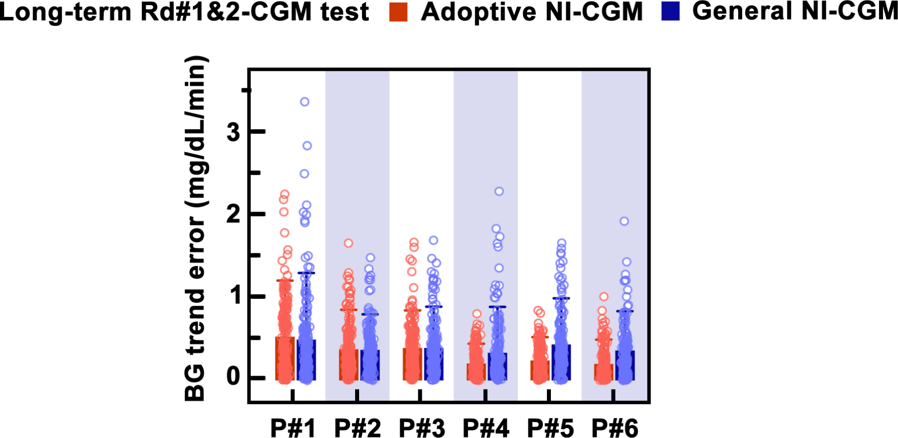
Figure S5-24. Statistical histograms of the BG trend error across different participants in long-term Rd#1&2-CGM test. Statistical histograms exhibited 5-days testing results of BG values via the Adoptive NI-CGM and the General NI-CGM across different participants in the Round#2-CGM test.

S5-22 Violin plots of BG levels and trends across all participants in long-term Rd#1&2-CGM test
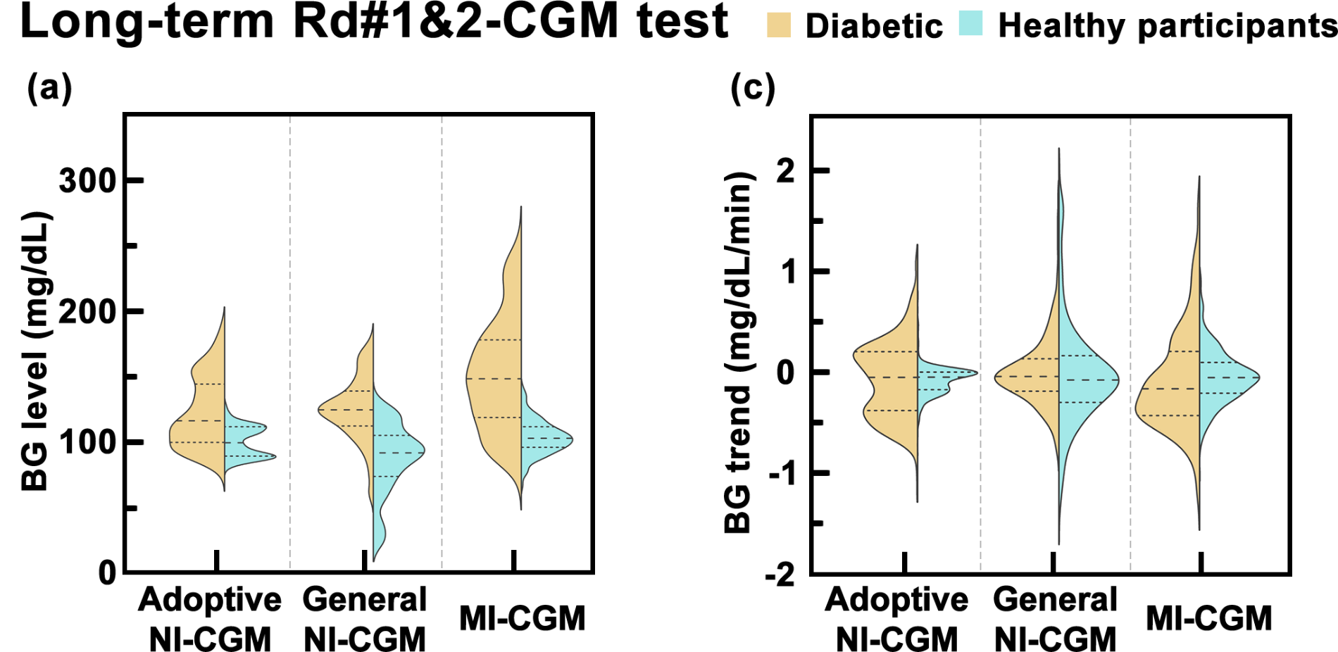
Figure S5-25. Violin plots of BG levels and trends across all participants in long-term Rd#1&2-CGM test. Violin plots of the variation in (a) BG values and (b) BG trends between healthy participants (n=3) and diabetic participants (n=3) with the Adoptive Non-invasive CGM, General Non-invasive CGM, and reference Mini-invasive CGM. Means and confidence intervals were labelled with dashed lines in the graph separately.

S5-23 Statistical histograms of the errors of the Adoptive NI-CGM in long-term Rd#1&2-CGM test
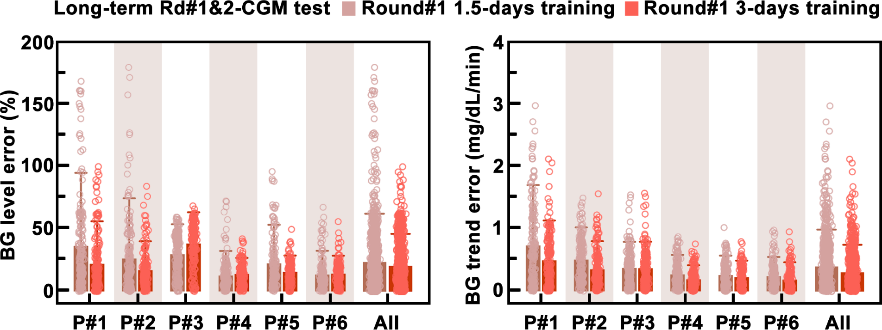
Figure S5-26. Statistical histograms of the BG level error and BG trend error across different participants in long-term Rd#1&2-CGM test. (a) Statistical histograms of the BG level error of the Adoptive NI-CGM training with the 1.5-days dataset from Round#1 versus that training with the 3-days dataset from Round#2. (a) Statistical histograms of the BG trend error of the Adoptive NI-CGM training with the 1.5-days dataset from Round#1 versus that training with the 3-days dataset from Round#2. Graph bars represented the SD.

S5-24 Different combinations of derive forward- and retrospective-sequence CGM
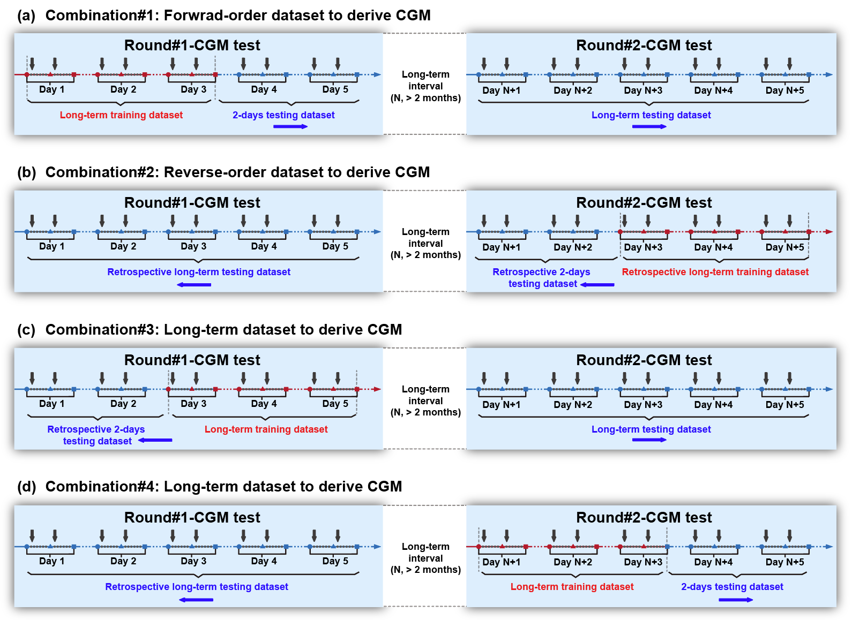
Figure S5-27. Different combinations of derive forward- and retrospective-sequence CGM in long-term Rd#1&2-CGM test. (a) Forward-order dataset of combination#1 to derive real-time CGM, with the MI/NI-CGM dataset from Day 1 to Day 3 was served as the training dataset, and the else 7-days dataset was used as the testing dataset. (b) Reverse-order dataset of combination#2 to derive retrospective CGM, with the MI/NI-CGM dataset from Day N+3 to Day N+5 was served as the training dataset, and the else 7-days dataset was used as the testing dataset. (c) Forward-order dataset of combination#3 to derive real-time CGM, with the MI/NI-CGM dataset from Day 3 to Day 5 was served as the training dataset, and the else 7-days dataset was used as the testing dataset. (d) Reverse-order dataset of combination#4 to derive retrospective CGM, with the MI/NI-CGM dataset from Day N+1 to Day N+3 was served as the training dataset, and the else 7-days dataset was used as the testing dataset.

