SUPPLEMENTAL DATA
Supplemental Table 1. Sites Included in the Study
Site | Investigator(s)
Barts Health NHS Trust, London | John Conibear
Bradford Royal Infirmary, Bradford Teaching Hospitals NHS Foundation Trust, Bradford | Andrew Conn
Brighton and Sussex University Hospitals NHS Trust, Brighton and Haywards Heath | Juliet Brock
The Clatterbridge Cancer Centre NHS Foundation Trust, Bebington, Wirral | Carles Escriu
Nottingham University Hospitals NHS Trust, Nottingham | Sarah Khan
Singleton Hospital, Swansea Bay University Health Board, Port Talbot | Jason Lester, Ceri Powell
South Tees Hospitals NHS Foundation Trust, Middlesbrough | Talal Mansy
Velindre NHS Trust, Cardiff | Emma Hudson
York Teaching Hospital NHS Foundation Trust, York | Samuel Chan
NHS, UK National Health Service.

Supplemental Table 2. Outcomes of Patients Who Did Not Receive Second-Line Therapy
n (%) | Any first-line therapy  (n=716) | First-line therapy subgroup
n (%) | Any first-line therapy  (n=716) | Chemotherapy (n=469) | Immuno-oncology monotherapy (n=151) | Targeted therapy (n=96)
Ongoing treatment | 92 (12.8) | 9 (1.9) | 48 (31.8) | 35 (36.5)
Stopped treatment (alive) | 73 (10.2) | 44 (9.4) | 18 (11.9) | 11 (11.5)
Died | 551 (77.0) | 416 (88.7) | 85 (56.3) | 50 (52.1)

Supplemental Figure 1. Estimated NSCLC Population Size in England Based on 2018-2019 Data
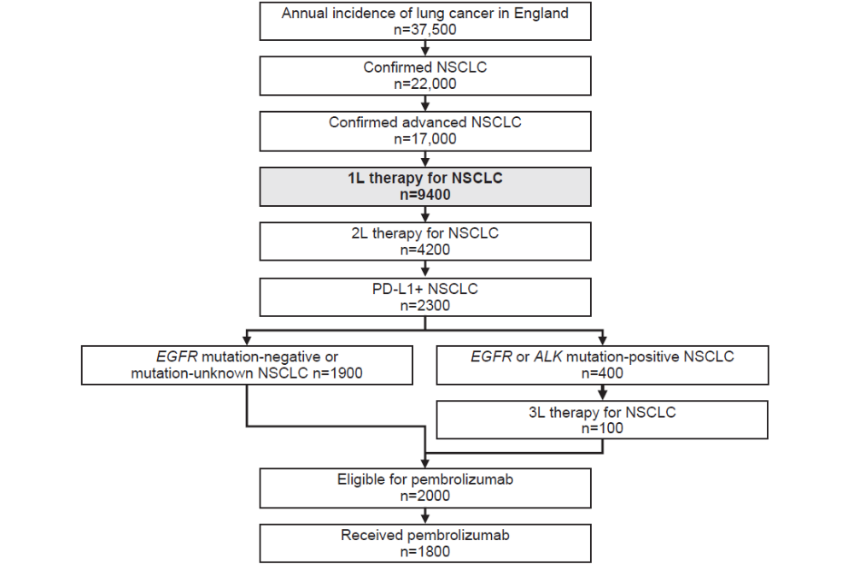
1L, first-line; 2L, second-line; 3L, third-line; ALK, anaplastic lymphoma kinase; EGFR, epidermal growth factor receptor; NSCLC, non-small-cell lung cancer; PD-L1, programmed death-ligand 1.

Source for estimated population sizes in each step:
National Institute for Health and Care Excellence. Resource impact report: Pembrolizumab for treating PD-L1-positive non-small-cell lung cancer after chemotherapy (TA428). September 2017. Available at https://www.nice.org.uk/guidance/ta428/resources/resource-impact-report-pdf-4355528077. Accessed May 20, 2020.

Supplemental Figure 2. Treatment Sequences in the Study Population. Percentage values were calculated using the denominator of patients who received the preceding therapy in the sequence
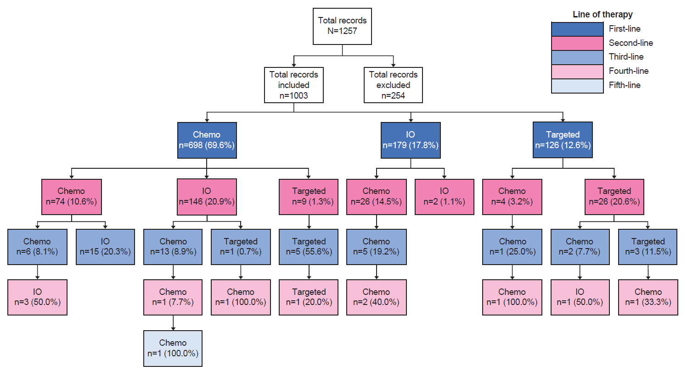
Chemo, chemotherapy; IO, immuno-oncology monotherapy; Targeted, targeted therapy.

