Supplementary Information for

Streaming-Charge Triggered Catalysis on Liquid-Solid Interface:Common Origin for Piezocatalysis, Sonocatalysis, and Tribocatalysis

Mahalakshmi Vedanarayanan¹, Utkarsh Kumar², Cheng-Wei Lee¹, Hsiu-Fu Nien¹, Roshni Yadav¹, Wei-Chen Peng¹, Wei-Chun Yang¹, Chiu-Hsien Wu³, Ying-Chih Lai^{1, 2, 3, 4*}, Heng-Jui Liu^{1,*}
¹ Department of Materials Science and Engineering, National Chung Hsing University, Taichung, 40227, Taiwan.
² i-Center for Advanced Science and Technology, National Chung Hsing University, Taichung, 40227, Taiwan.
³ Department of Physics, National Chung Hsing University, Taichung 40227, Taiwan
⁴ Innovation and Development Center of Sustainable Agriculture, National Chung Hsing University, Taichung 40227, Taiwan

Table of Contents
Supplementary Notes 3
Supplementary Figures 17
Supplementary Tables 33
Supplementary References 34

Supplementary Notes
Supplementary Note 1: Structural Characterization by X-ray absorption spectroscopy
To investigate the local coordination environment of B-site cations in the high entropy perovskite system, X-ray absorption spectroscopy (XAS) was systematically performed (Supplementary Fig. 1). The extended X-ray absorption fine structure (EXAFS) analysis provides detailed information about the local atomic arrangements around each absorbing atom. The radial distribution functions (Fig. 1f) obtained from EXAFS analysis for Ti, Zr, Hf, Sn, and Nb reveal well-defined characteristic peaks at two distinct ranges: 1–2 Å and 3–3.5 Å, corresponding to first-shell metal–oxygen (M–O) and second-shell metal–metal (M–M) interactions, respectively. The remarkable similarity in local coordination environments across all B-site elements provides strong evidence for successful incorporation of each cation into the perovskite lattice structure. This structural homogeneity is crucial for maintaining the integrity of the high entropy perovskite phase. The observed systematic shifts in M–O bond lengths for all B-site cations compared to their bulk oxide references indicate substantial lattice distortion throughout the crystal structure. This lattice distortion is a characteristic feature of high entropy materials, arising from the size and electronic mismatch among different cationic species occupying the same crystallographic sites^{1,2}.

Supplementary Note 2: Photoluminescence detection of reactive oxygen species
Photoluminescence (PL) spectroscopy was conducted to validate the formation of hydroxyl radicals (·OH) and superoxide radicals (·O₂⁻) during the ultrasonic catalytic process using molecular fluorescent probes (Supplementary Fig. 2). For ·OH detection, terephthalic acid (TA) acts as a highly selective probe that specifically reacts with hydroxyl radicals to produce 2-hydroxyterephthalic acid (TAOH), which exhibits characteristic fluorescence at approximately 425 nm. This reaction provides a direct method for quantifying ·OH generation in the system. For superoxide detection, hydroethidine (HE) was employed as a specific molecular probe that selectively interacts with ·O₂⁻ radicals to form 2-hydroxyethidium (2-OH-E⁺), displaying fluorescence emission at around 615 nm. Time-resolved fluorescence measurements demonstrated progressive intensity increases at both 425 nm and 615 nm, indicating continuous formation of TAOH and 2-OH-E⁺ products, respectively. These fluorescence changes provide direct spectroscopic evidence for the ongoing generation of both ·OH and ·O₂⁻ species throughout the ultrasonic treatment of STZHSN. The successful identification of these reactive oxygen intermediates confirms the mechanoresponsive nature of the STZHSN catalyst and supports the radical-based catalytic mechanism³.

Supplementary Note 3: X-ray diffraction characterization of oxide materials
In addition to STZHSN, the other three samples (SrTiO₃, PMNZTH, and BiFeO₃) were synthesized with high crystallinity, as confirmed by X-ray diffraction (Supplementary Fig. 3), with no secondary phases detected. The XRD patterns demonstrate excellent phase purity for all materials, ensuring reliable comparative analysis. From a compositional standpoint, STZHSN and PMNZTH are classified as high-entropy systems with multiple cationic species, whereas STO and BFO are conventional single-component oxides. This compositional distinction allows for systematic investigation of how compositional complexity influences catalytic performance under ultrasonic activation⁴.

Supplementary Note 4: Bulk piezoelectric coefficient (d₃₃) of four oxide catalysts
Functionally, the four oxide materials exhibit distinct piezoelectric characteristics as determined by measuring their bulk piezoelectric coefficients (Supplementary Fig. 4). PMNZTH and BFO are ferroelectric materials possessing spontaneous polarization and intrinsic piezoelectric properties, while STO and STZHSN are non-ferroelectric dielectrics with negligible piezoelectric response. The piezoelectric coefficient (d₃₃) of the samples was measured using a commercial d₃₃ meter (SINOCERA YE2730). Prior to measurement, each pellet was fabricated into a standard capacitor configuration by depositing Pt thin films on both sides. To maximize the measurable d₃₃ response, the samples were poled by applying a DC electric field of 1.5 kV mm⁻¹ for 10 minutes using a custom-built setup, ensuring alignment of the grain polar axes. The results revealed that PMNZTH exhibited the highest d₃₃ value of 161 pC N^{–1}, followed by BFO with 36 pC N^{–1}, while STZHSN and STO showed no detectable d₃₃ response⁵.

Supplementary Note 5: EPR spectroscopy for hydroxyl radical detection
Electron paramagnetic resonance (EPR) measurements with 5,5-dimethyl-1-pyrroline N-oxide (DMPO) as a spin-trapping agent (Supplementary Fig. 5) confirmed ·OH radical generation in all investigated oxides. After 90 min of ultrasonication in DI water, distinct DMPO–OH signals were detected. Notably, BFO displayed the weakest signal, aligning with its lowest RhB degradation efficiency⁶.

Supplementary Note 6: Band gap energy and surface potential analysis
Within this unified mechanistic framework, the two principal material parameters, band gap energy and surface potential emerge as fundamental descriptors of catalytic performance. Supplementary Fig. 6 presents the ultraviolet-visible (UV–Vis) spectra of the studied oxides, revealing band gaps of 3.31 eV (STZHSN), 3.24 eV (STO), 3.41 eV (PMNZTH), and 2.12 eV (BFO). Surface potentials measured by KPFM (Supplementary Fig. 7) were 194 mV (STZHSN), 191 mV (STO), 176 mV (PMNZTH), and 60 mV (BFO). According to energy band theory, semiconductor catalysts with narrower band gaps are expected to exhibit higher catalytic activity due to more efficient carrier excitation. However, both the current results and previous findings contradict this assumption. Despite its narrower band gap, BFO shows the lowest catalytic efficiency among the four materials. Instead, a more consistent correlation is observed between surface potential and catalytic performance under ultrasonication. These observations suggest that surface potential–driven screening charge effects may be more influential than either band gap energy or intrinsic piezoelectricity in governing the generation and utilization of reactive species during ultrasonication-assisted catalysis⁷.

Supplementary Note 7: Mechanical agitation experiments for the tested oxide materials
A custom-designed blade agitation system was employed to enabled to validate catalyst-driven dye degradation under significantly lower energy input compared to ultrasonication. Continuous and uniform mechanical stirring ensured homogeneous dispersion of catalyst particles and dye molecules within the reaction medium. The blades were positioned ~1 mm above the beaker bottom to avoid direct compression or abrasive contact with catalyst particles, thereby eliminating issues commonly encountered in magnetic-stirrer-based tribocatalysis setups. Comparative experiments using STZHSN, STO, PMNZTH, and BFO under identical mechanical agitation conditions (Fig. 3c) revealed that all catalysts achieved nearly complete dye degradation after 10 h stirring. To quantitatively assess catalytic reactivity, the degradation kinetics were fitted using a pseudo-first-order model (Supplementary Fig. 8). The extracted rate constants, summarized in the inset of Fig. 3c, indicate that STZHSN and PMNZTH exhibited comparable rate constants of 0.61 and 0.60 h⁻¹, respectively, both higher than those of STO (0.52 h⁻¹) and BFO (0.51 h⁻¹). This trend parallels that observed under ultrasonication, reinforcing the conclusion that surface charge states, rather than intrinsic material properties such as piezoelectricity, predominantly govern solid–liquid interfacial interactions and catalytic performance in mechanically driven systems⁸.

Supplementary Note 8: Computational fluid dynamics analysis of hydrodynamic parameters
To elucidate the key hydrodynamic parameters influencing catalytic degradation efficiency, Computational Fluid Dynamics (CFD) simulations were performed using the SolidWorks Flow Simulation package. These simulations were designed to quantify fluid–solid interaction metrics under various blade agitation conditions, enabling mechanistic interpretation of the observed catalytic behavior. Three primary flow parameters were identified as being closely linked to dye degradation outcomes: turbulent viscosity, turbulence intensity, and shear stress. In the k-ε turbulence model, turbulent viscosity represents the momentum diffusivity caused by turbulent eddies and is directly proportional to the local kinetic energy of the flow. Turbulence intensity, a dimensionless measure of flow instability, quantifies the fluctuation of local velocity vectors relative to the mean. Shear stress reflects the tangential force per unit area generated by velocity gradients within the fluid and is determined by both molecular and turbulent viscosity components. Detailed definitions and visualizations are provided in Supplementary Fig. 9:
- Turbulent viscosity ($μ_{t}$): Also termed as flow or eddy viscosity, $μ_{t}$ is introduced in the k–ε turbulence model to describe momentum transfer induced by turbulent eddies. The turbulent kinetic energy k quantifies the total kinetic energy per unit mass carried by eddies and directly reflects turbulence intensity. It is expressed as:
$μ_{t}=ρ∙C_{μ}∙\frac{k^{2}}{ε}$ (1)
$k=\frac{3}{2}{\left(\overline{u}I\right)}^{2}$ (2)
where $ρ$ is the fluid density, $C_{μ}$ an empirical constant in the turbulence model, $ε$ the turbulent dissipation rate, $\overline{u}$ the mean velocity of fluid, and $I$ the turbulence intensity.
- Turbulence intensity (I): A dimensionless parameter quantifying velocity fluctuations in the flow. It measures deviations of instantaneous velocity u(t) from the mean velocity $\overline{u}$, based on Reynolds decomposition into mean ($\overline{u}$) and a fluctuating component ($u^{'}$).
$I=\frac{u^{'}}{\overline{u}}$ (3)
where $u^{'}$ is root-mean square value of velocity fluctuations.
- Shear stress ($τ$): Represents the tangential force per unit area arising from velocity gradients in turbulent flow. It is expressed as:
$τ=μ_{eff}∙\left(\frac{∂u}{∂y}\right)$ (4)
$μ_{eff}$=$μ_{t}$+$μ_{int.}$ (5)
where $τ$ is the shear flow stress, $μ_{eff}$ the effective viscosity, $μ_{int.}$ the intrinsic molecular viscosity, $μ_{t}$ the turbulence viscosity, ${∂u}/{∂y}$ the velocity gradient normal to the flow direction.
Computational Fluid Dynamics (CFD) simulations revealed distinct flow patterns under different agitation conditions (Supplementary Figs. 10–12).
At constant blade geometry (15 blades, 45° tilt), increasing rotation speed from 500 to 1500 rpm raised turbulence viscosity (0.021, 0.042, to 0.061 Pa·s) and shear stress (147, 312, to 474 Pa), while turbulence intensity remained nearly unchanged (4.94, 4.71, to 4.73%) (Supplementary Fig. 10). At 1000 rpm, altering blade angle from 45° to 90° reduced turbulence intensity (4.71% to 4.48%) but slightly increased turbulence viscosity (0.042 to 0.049 Pa·s), with a concurrent drop in shear stress (312 to 246 Pa) (Supplementary Fig. 11). Varying blade number (3, 9, 15) at 90° tilt and 1000 rpm showed that fewer blades increased turbulence intensity (5.27, 4.82, to 4.48 %) and viscosity (0.063, 0.058, to 0.049 Pa·s), though shear stress varied nonlinearly (381, 198, and 246 Pa, respectively) (Supplementary Fig. 12).
Integrating these results with dye degradation data (Fig. 3h) revealed a strong positive correlation between turbulent viscosity and catalytic efficiency, whereas turbulence intensity and shear stress were more condition dependent. Enhanced turbulent viscosity, particularly at higher Reynolds numbers, promoted vigorous eddy formation that disrupted diffusion barriers, improved reactant renewal, and strengthened liquid–solid interfacial coupling. These effects collectively facilitated charge transfer, reactive oxygen species generation, and catalytic turnover^{9,10}.

Supplementary Note 9: Triboelectric measurements and charge transfer mechanisms
To further substantiate the capability of STZHSN to facilitate effective charge transfer via dynamic interactions with the solution, triboelectric measurements were conducted. First, STZHSN powder was uniformly coated onto a copper (Cu) foil to fabricate a working electrode (Supplementary Fig. 13), which was evaluated under two common triboelectric configurations: the single-electrode contact–separation mode and the droplet-flow mode. In the contact–separation mode (Fig. 4a), the open-circuit voltage (V_{OC}) output was recorded using either Ecoflex or nylon as the counter surface. When paired with Ecoflex, the system consistently generated a stable V_{OC} of approximately 12 V across various operation frequencies. In contrast, the voltage output with nylon increased only modestly from 0.5 V to ~1 V as the frequency increased. This discrepancy in different triboelectric series can be attributed to the intrinsic surface charge states of the contact polymer materials. Ecoflex exhibits strong electron affinity and tends to acquire a negative surface potential, while nylon typically possesses a positive surface potential under ambient conditions. Given that STZHSN also exhibits a positive surface potential (as confirmed by KPFM), its interaction with negatively charged Ecoflex yields more pronounced charge separation and higher voltage output compared to nylon. In the droplet-flow mode (Fig. 4d), a sliding water droplet on the STZHSN-coated surface induced current pulses when contacting the upper Cu electrode. The current peaks were well correlated with droplet movement, with amplitudes 2–3 times higher than background noise, attributed to contact electrification between the droplet and the STZHSN surface. As the droplet contacts the STZHSN surface, the positive surface potential of STZHSN induces rapid internal charge separation within the droplet, where negative charges are attracted to the STZHSN surface and positive charges move in the opposite direction. Upon the droplet reaching the upper Cu electrode, the accumulated negative charges on the bottom electrode rapidly flow toward the upper electrode to neutralize positive charges within the droplet, resulting in a transient current signal. As the droplet departs, the reverse flow completes the cycle. These observations strongly suggest that interfacial molecular relative motion at the solid–liquid boundary (friction effect) plays a pivotal role in mediating charge separation and transfer, providing direct experimental evidence for the proposed liquid–solid friction model in catalytic systems^{11,12}.

Supplementary Note 10: Infrared Evidence of Surface Charge Modulation in Dye Degradation
Complementary FTIR analysis further confirmed these interactions, as immersion of STZHSN in RhB dye solution led to the appearance of new vibrational features corresponding to new IR peaks appeared corresponding to characteristic vibrational modes, including CH₂/CH₃ stretching (2975–2840 cm^{–1}), CH₃ bending (~1392 cm^{–1}), C–N stretching (~1235 cm^{–1}), and C–O stretching (~1061 cm^{–1}). Similar IR signatures were also detected after exposure to CV, MB, and MO (Supplementary Fig. 14), indicating that STZHSN preferentially adsorbs specific functional groups during catalytic dye degradation. Despite the comparable surface-bound chemical species, notable differences in surface potential were observed. KPFM analysis (Supplementary Fig. 15) revealed that the surface potentials of STZHSN are 210, 125, 80, and 60 mV after RhB, CV, MB, and MO degradation, respectively, consistent with the relative dye removal efficiencies^{13,14}.

Supplementary Note 11: Agitation experiments under different environments
Atmospheric conditions exert a pronounced influence on catalytic efficiency. As shown in Fig. 5e, agitation experiments conducted under ambient air resulted in significantly enhanced RhB degradation compared to those performed under an Ar atmosphere. This difference is further corroborated by PL spectra (Supplementary Fig. 16), where the TAOH signal, indicative of ·OH radical generation, is substantially stronger under ambient conditions. The underlying reason lies in the dissolved oxygen content: aqueous solutions in air naturally retain higher oxygen concentrations than those purged with Ar. During mechanical agitation, this dissolved oxygen interacts with the catalyst surface, where it is reduced to superoxide radicals (·O₂–). These species readily undergo protonation or disproportionation to generate ·OH radicals in the presence of moisture, amplifying the oxidative environment. Therefore, the intensified ·OH signal and improved dye degradation efficiency under air highlight the critical role of dissolved oxygen and emphasize that environmental atmosphere is a decisive factor governing liquid–solid interfacial catalysis¹⁵.

Supplementary Figures

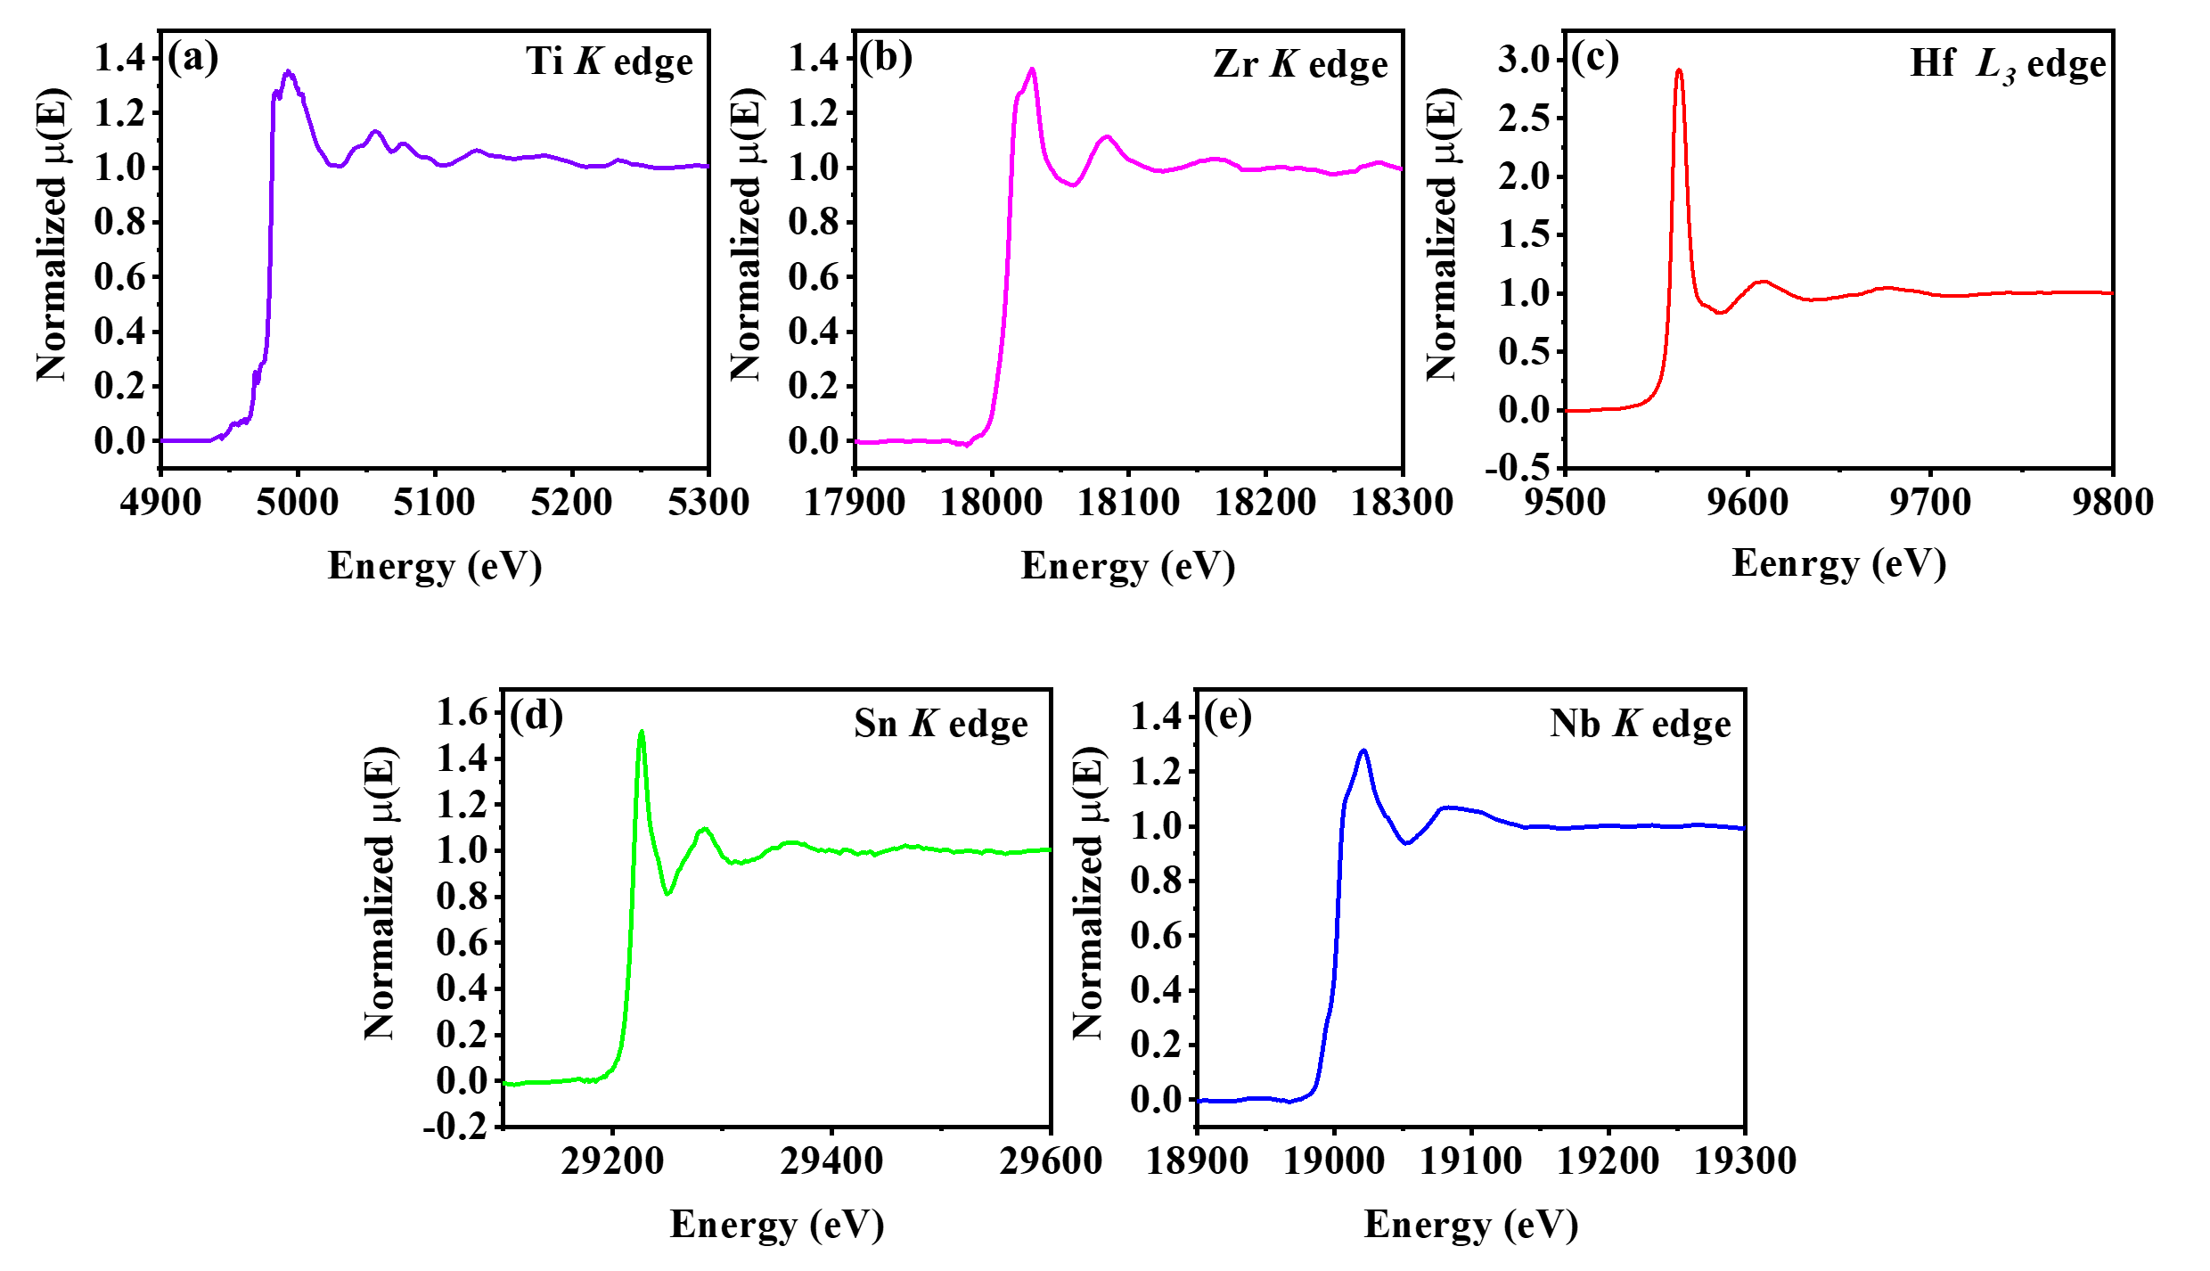
Supplementary Fig. 1. XAS spectra of STZHSN in 1 M KOH: (a) Ti K-edge, (b) Zr K-edge, (c) Hf L₃-edge, (d) Sn K-edge, and (e) Nb K-edge.

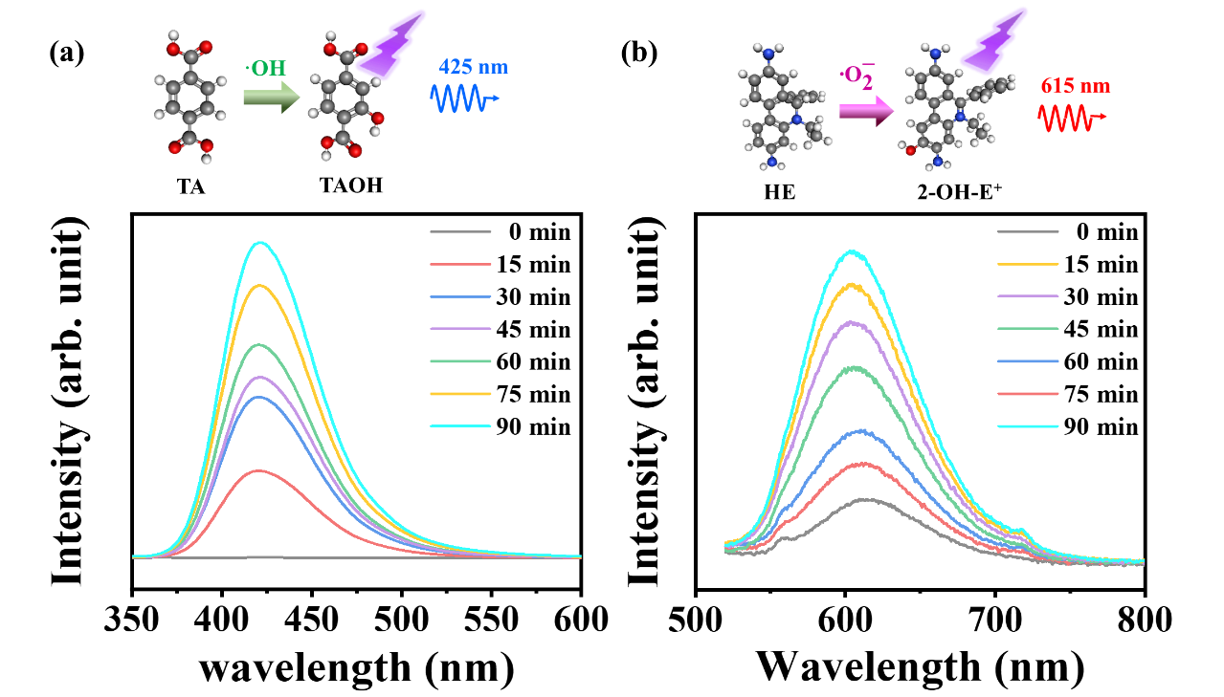
Supplementary Fig. 2. Fluorescence intensity changes over time: (a) terephthalic acid (TA) detecting hydroxyl radicals (·OH) under 425 nm irradiation, and (b) hydroethidine (HE) detecting superoxide radicals (·O₂⁻) with emission at 615 nm.

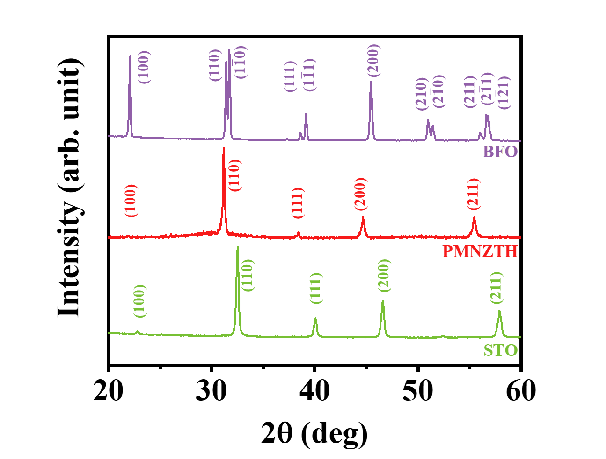
Supplementary Fig. 3. XRD patterns of BFO, PMNZTH, and STO.

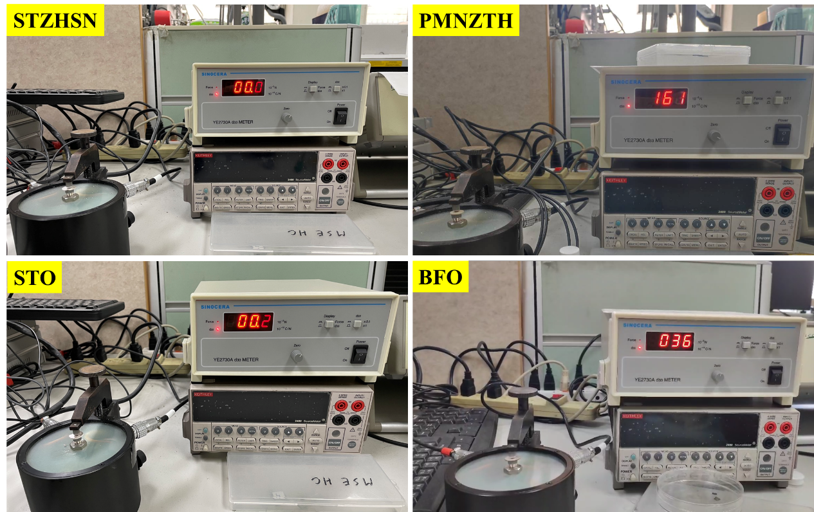

Supplementary Fig. 4. Experimental setups for piezo-catalytic measurements of STZHSN, PMNZTH, STO, and BFO catalysts, showing the sample configurations during testing.
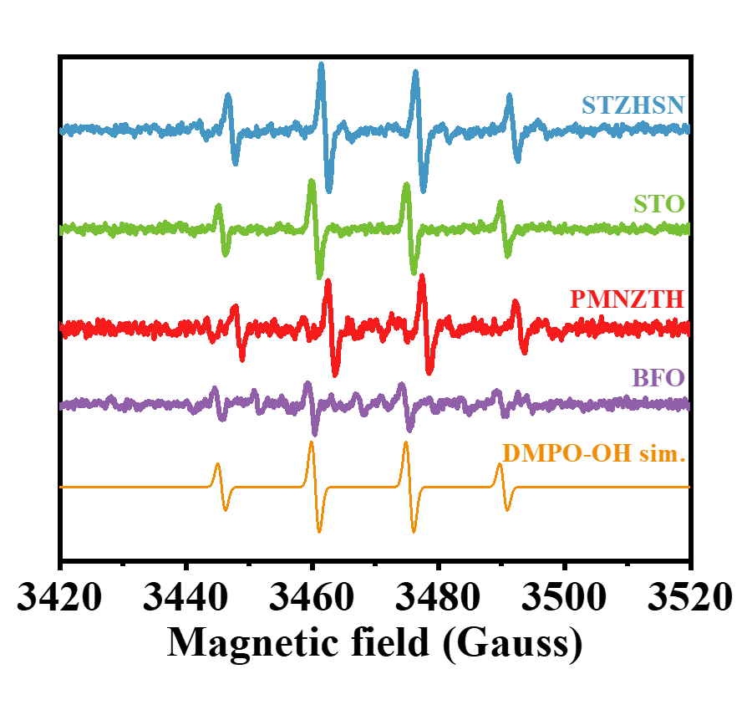
Supplementary Fig. 5. EPR spectra of STZHSN, STO, PMNZTH, and BFO, with DMPO-OH simulation for hydroxyl radical (·OH) detection.

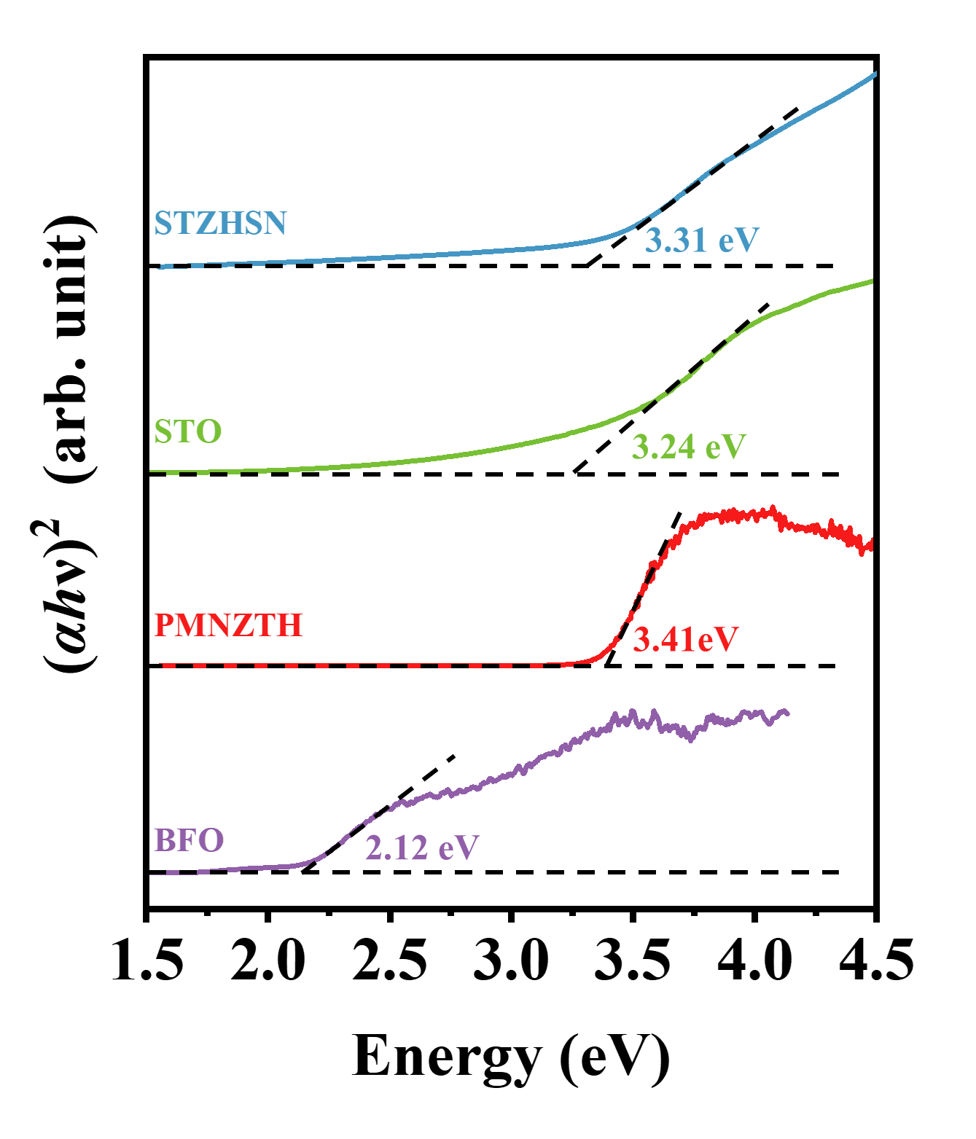
Supplementary Fig. 6. Tauc plots of STZHSN, STO, PMNZTH, and BFO showing band gap energies of 3.31, 3.24, 3.41, and 2.12 eV, respectively.
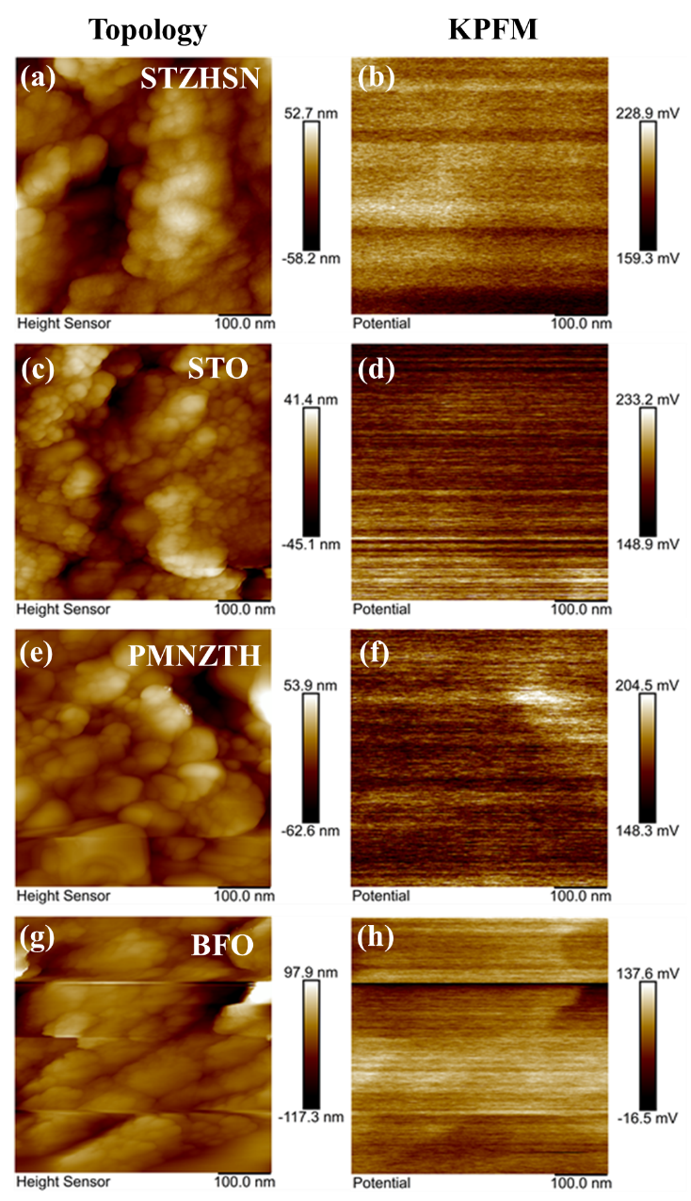
Supplementary Fig. 7. Surface topology images of (a) STZHSN, (c) STO, (e) PMNZTH, and (g) BFO catalysts, and corresponding KPFM images of (b) STZHSN, (d) STO, (f) PMNZTH, and (h) BFO during friction catalysis in RhB dye solution.

Supplementary Fig. 8. First-order kinetic plots of dye degradation over stirring time for STZHSN, STO, PMNZTH, and BFO catalysts.

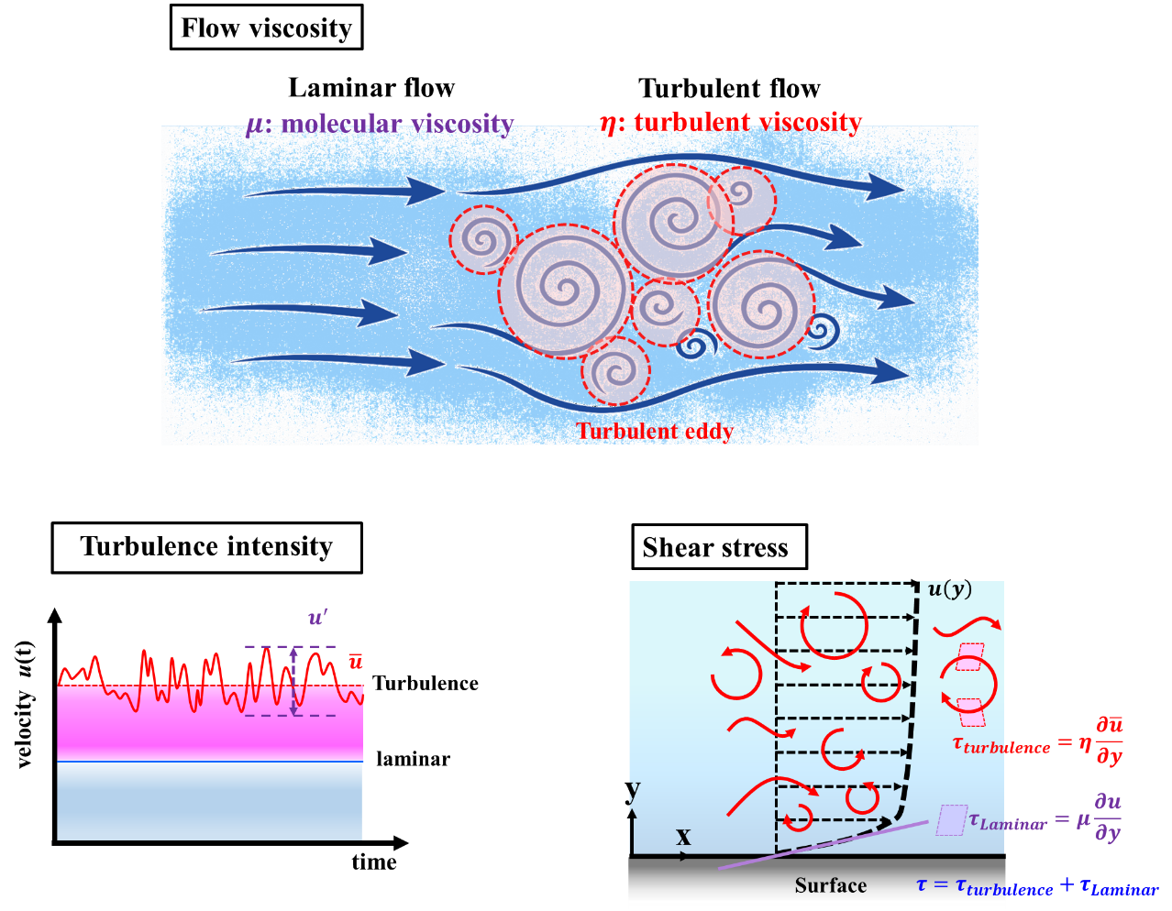
Supplementary Fig. 9. SolidWorks Flow Simulation trajectories showing motion path simulation.

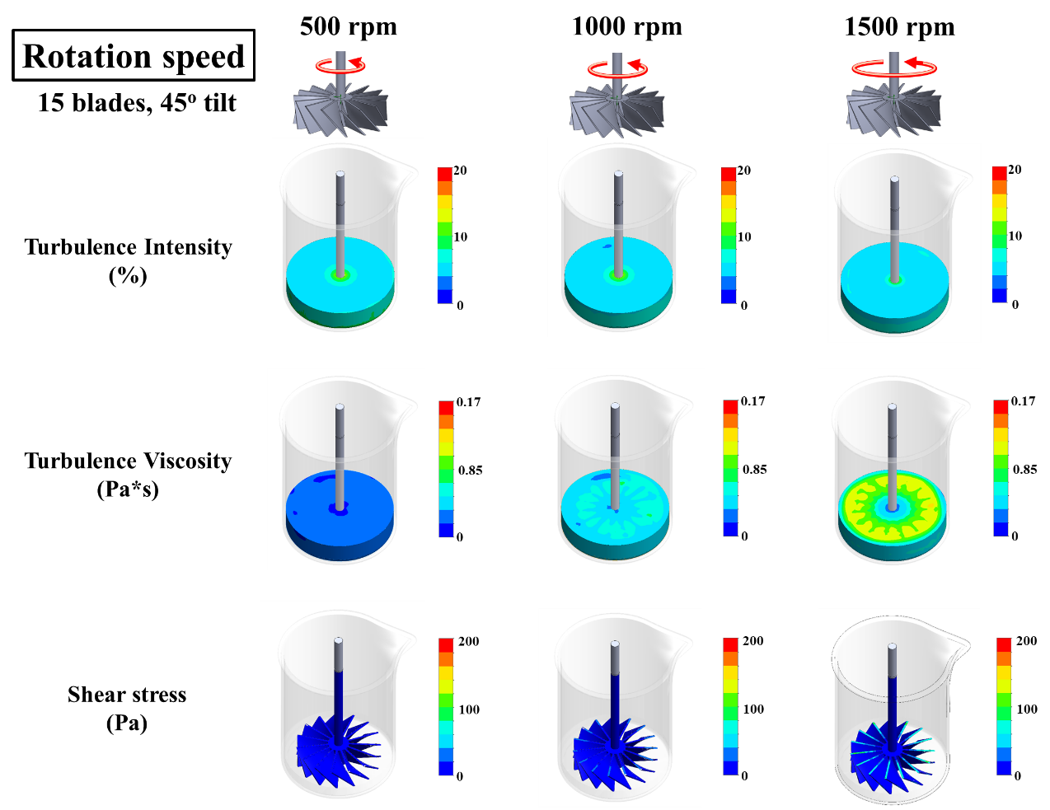
Supplementary Fig. 10. Turbulent viscosity, turbulence intensity, and shear stress distributions at 500, 1000, and 1500 rpm using a 15-blade impeller tilted at a 45° angle.
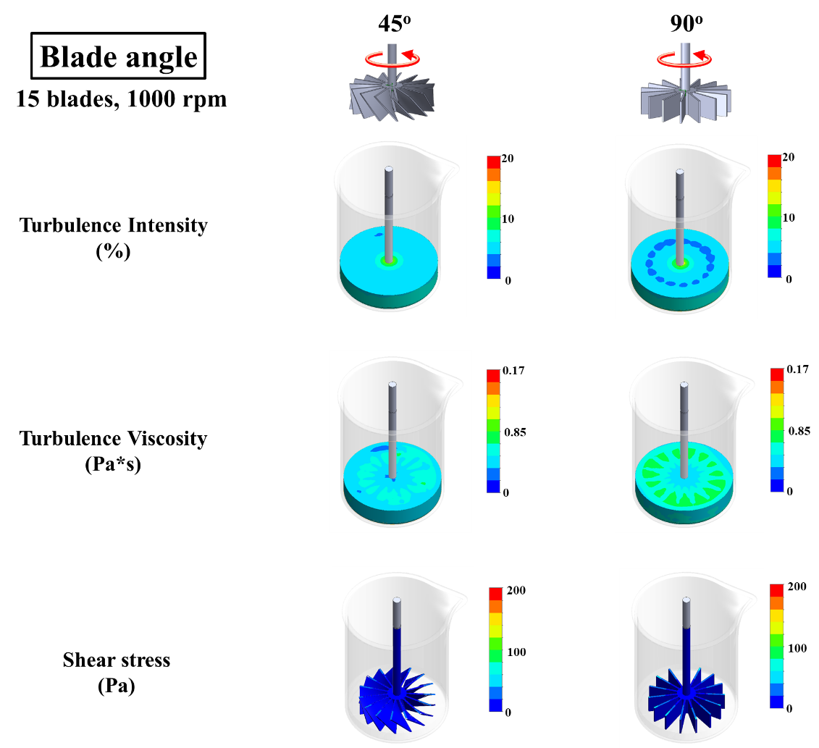
Supplementary Fig. 11. Distribution of turbulent viscosity, turbulence intensity, and shear stress at 1000 rpm for a 15-blade impeller with blade angles of 45° and 90°.
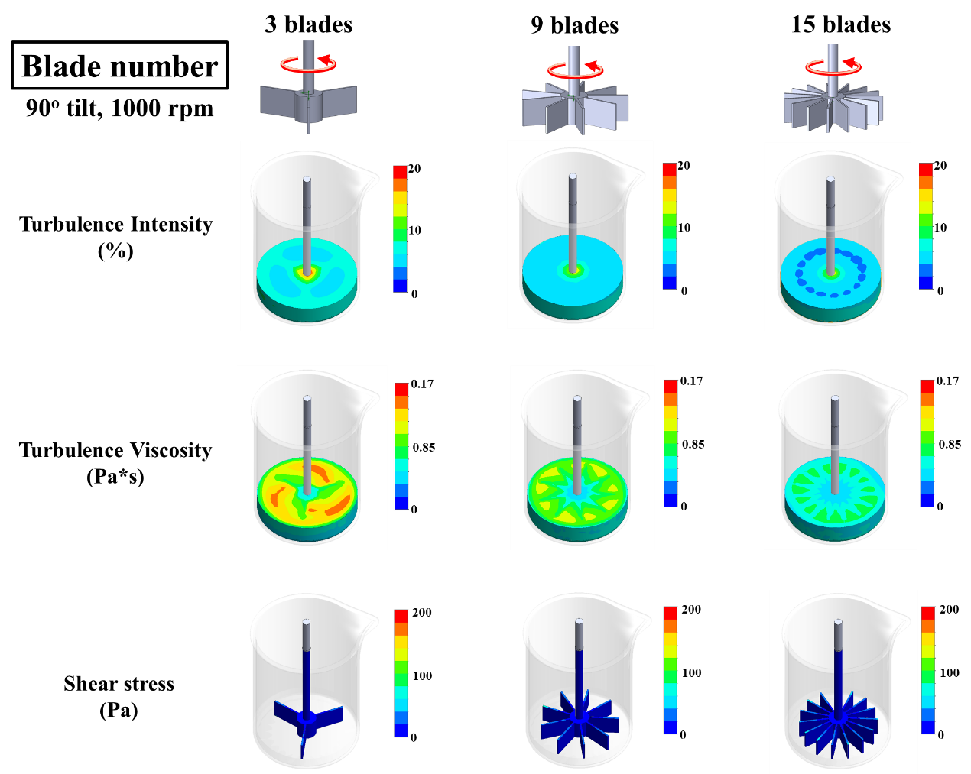
Supplementary Fig. 12. Turbulent viscosity, turbulence intensity, and shear stress profiles at 1000 rpm for impellers with 3, 9, and 15 blades oriented at a 90° angle.

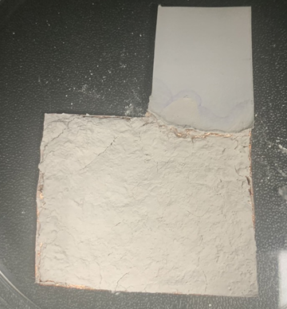
Supplementary Fig. 13. STZHSN-coated copper foil electrode tested in contact–separation and droplet-flow triboelectric modes.

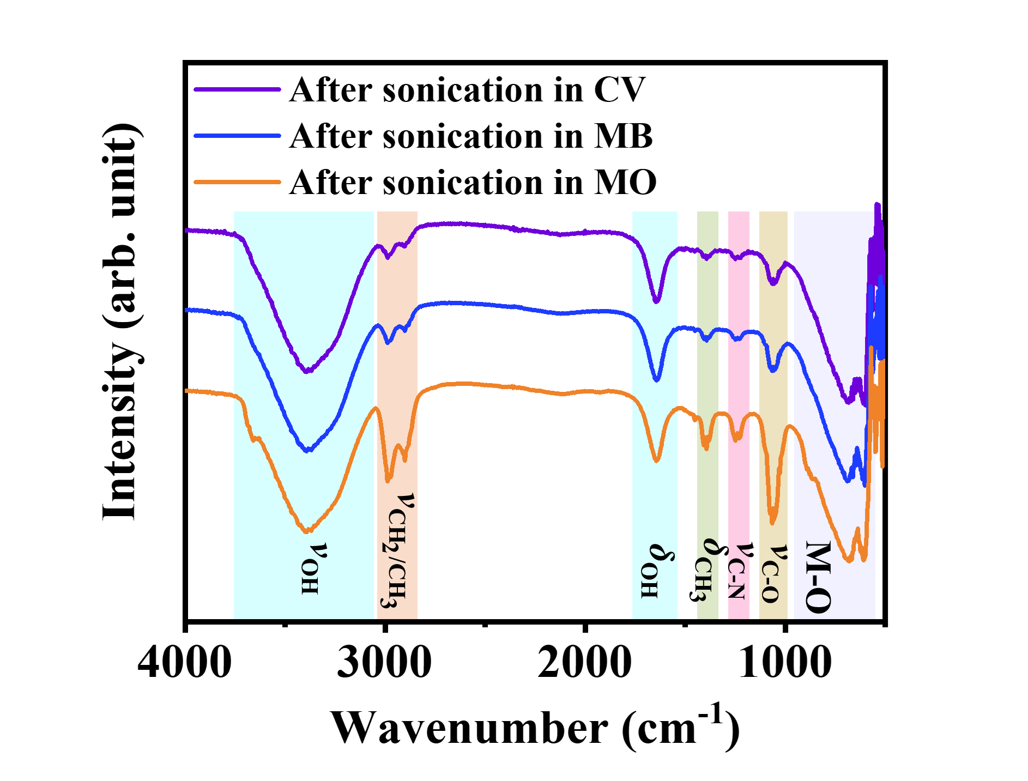
Supplementary Fig. 14. FTIR spectra of STZHSN after sonication with CV, MB, and MO dyes.
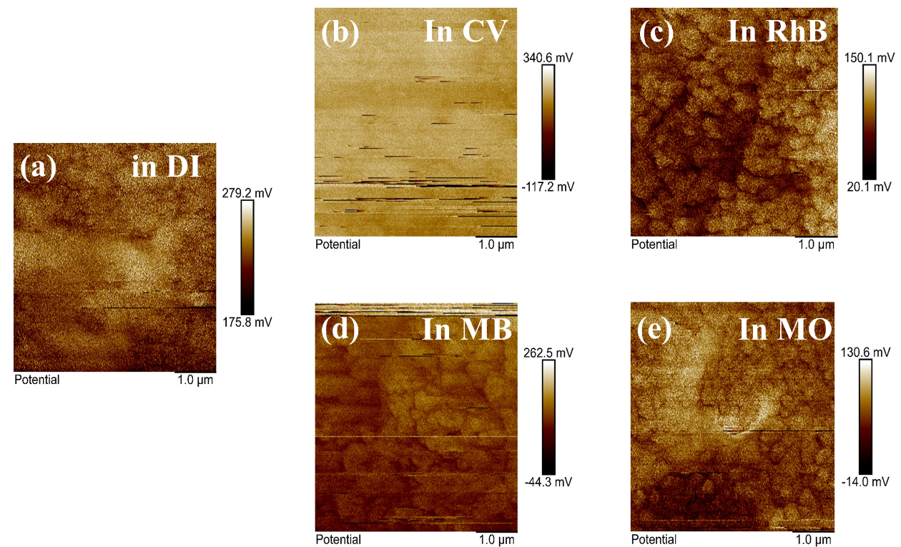
Supplementary Fig. 15. AFM topography of STZHSN surface after ultrasonication in (a) DI water, (b) CV, (c) RhB, (d) MB, and (e) MO.

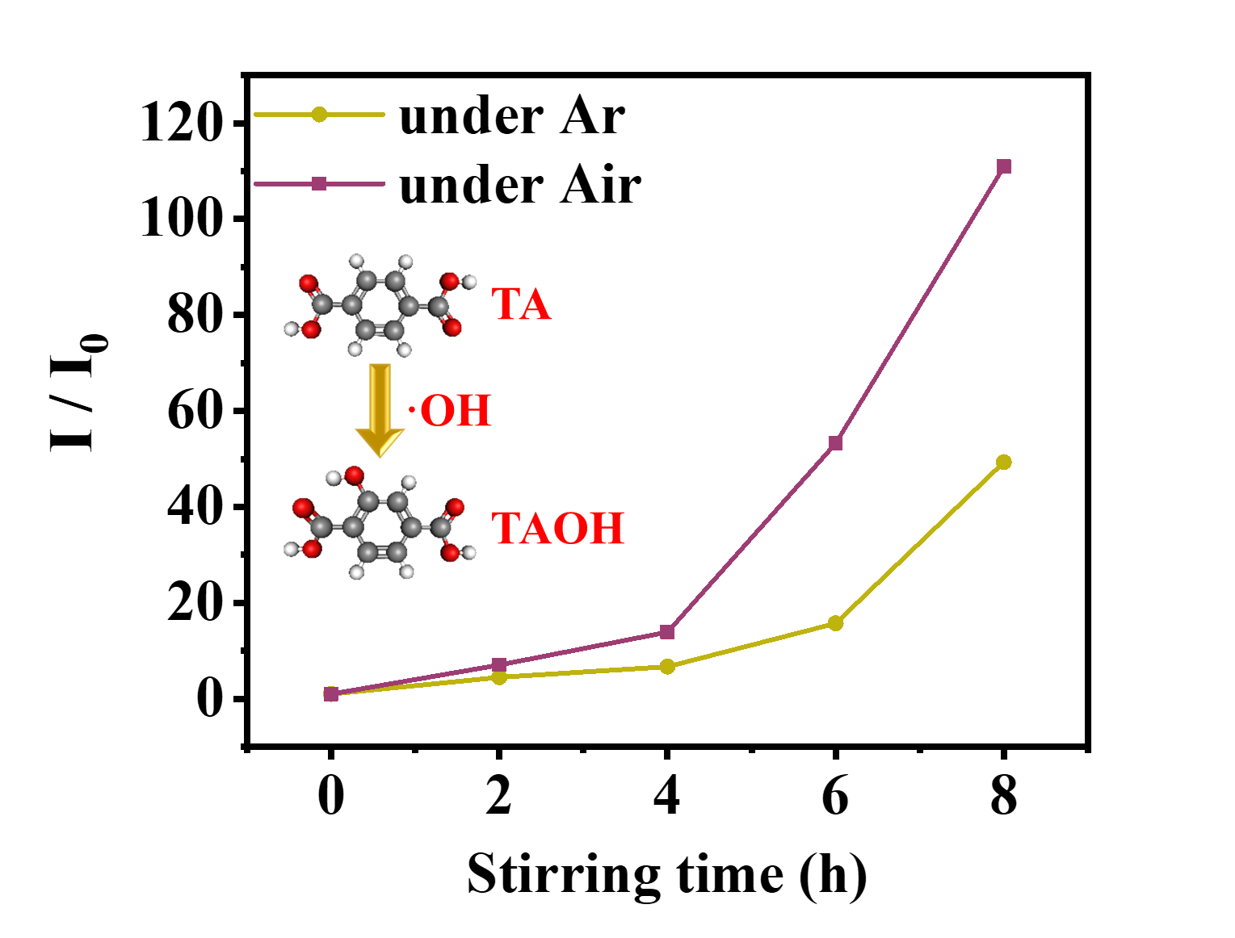
Supplementary Fig. 16. Relative intensity (I/I₀) of TA/TAOH versus stirring time under Argon and Air.

Supplementary Table
Supplementary Table 1. Structural parameters of STZHSN determined from Rietveld refinement.
Unit cell parameters
Crystal system |  | Cubic
Space group |  | Pm$\overline{3}$m
Lattice parameter |  | a = b = c = 4.074(2) Å
Cell volume |  | 67.639 Å³
R-values |  | Rwp = 13.821%
 |  | χ² = 21.80
Atom | Wyckoff position | x | y | z | occupancy from Refinement | occupancy from EDS
Sr | 1a | 0.0000 | 0.0000 | 0.0000 | 1 | 1
Ti | 1b | 0.5000 | 0.5000 | 0.5000 | 0.1440 | 0.1733
Zr |  |  |  |  | 0.2468 | 0.2915
Hf |  |  |  |  | 0.2067 | 0.2188
Sn |  |  |  |  | 0.1603 | 0.1511
Nb |  |  |  |  | 0.2427 | 0.1638
O | 3c | 0.5000 | 0 | 0.5000 | 1 | 1

Supplementary References
- Bugaev, L. A. et al. The experimental and theoretical study of Zr K XAS in SrZrO₃ and BaZrO₃. Phys. B 208–209, 169–170 (1995).
- Marini, C. et al. Nb K-edge x-ray absorption investigation of the pressure induced amorphization in A-site deficient double perovskite La₁/₃NbO₃. J. Phys. Condens. Matter 28, 045401 (2016).
- Tsai, Y.-W., Yadav, R. & Liu, H.-J. Unraveling the role of piezopotential on dye degradation efficiency using high entropy perovskite piezocatalysts. Mater. Chem. Phys. 334, 130467 (2025).
- Qi, X., Wei, M., Lin, Y., et al. High-resolution x-ray diffraction and transmission electron microscopy of multiferroic BiFeO₃ films. Appl. Phys. Lett. 86, 071913 (2005).
- Zhang, S. High entropy design: a new pathway to promote the piezoelectricity and dielectric energy storage in perovskite oxides. Microstructures 3, 2023003 (2023).
- Eichel, R. A. Structural and dynamic properties of oxygen vacancies in perovskite oxides—analysis of defect chemistry by modern multi-frequency and pulsed EPR techniques. Phys. Chem. Chem. Phys. 13, 368–384 (2011).
- Krawczyk, P. A., Salamon, W., Marzec, M., Szuwarzyński, M., Pawlak, J., Kanak, J. et al. High-entropy perovskite thin film in the Gd–Nd–Sm–La–Y–Co system: deposition, structure and optoelectronic properties. Mater. 16, 4210 (2023).
- Yang, L. H., Yang, W. J., Sun, W., Haider, M. R., Sharif, H. M. A. & Lin, H. Utilization of stable and efficient perovskite La(Cr₀.₂Mn₀.₂Fe₀.₂Co₀.₂Ni₀.₂)O₃₋δ catalyst with high-entropy to boost peroxymonosulfate activation towards organics degradation. J. Taiwan Inst. Chem. Eng. 143, 104696 (2023).
- Bößl, F. Piezocatalysis: can catalysts really dance? Curr. Opin. Green Sustain. Chem. 32, 100537 (2021).
- Bößl, F., Menzel, V. C., Chatzisymeon, E., Comyn, T. P., Cowin, P., Cobley, A. J. & Tudela, I. Effect of frequency and power on the piezocatalytic and sonochemical degradation of dyes in water. Chem. Eng. J. Adv. 14, 100477 (2023).
- Zhou, L., Liu, D. & Wang, J. Triboelectric nanogenerators: fundamental physics and potential applications. Friction 8, 481–506 (2020).
- Liu, Z. et al. Creating ultrahigh and long-persistent triboelectric charge density on weak polar polymer via quenching polarization. Adv. Funct. Mater. 33, 2302164 (2023).
- Zarei, M., Ebadi, T., Ramavandi, B. & Peighambardoust, S. J. Photocatalytic decomposition of methylene blue and methyl orange dyes using pistachio biochar/CoFe₂O₄/Mn-Fe-LDH composite as H₂O₂ activator. Surf. Interfaces 43, 103571 (2023).
- Loulidi, I. et al. Adsorption of crystal violet onto an agricultural waste residue: kinetics, isotherm, thermodynamics, and mechanism of adsorption. Sci. World J. 2020, 5873521 (2020).
- Prasanna, G. et al. Impact of stirring regime on piezocatalytic dye degradation using BaTiO₃ nanoparticles. Nano Energy 116, 108794 (2023).

