Supplementary Information

Unveiling the ampere-level current density induced local oxidation of the Ni-based cathode in anion exchange membrane water electrolyzers

Yongsheng Wang^{1,2}, Jiajin Pei¹, Qian Dang², Xingdong Wang¹, XueJiang Zhang¹, Xiaoxuan Guo¹, Mengting Chen¹, Jiansheng Wang¹, Hui Li², Wei Zhu^{1,}*, Zhongbin Zhuang^{1,2,3,}*

- State Key Lab of Organic-Inorganic Composites, Beijing University of Chemical Technology, Beijing, 100029, China.
- Beijing Advanced Innovation Center for Soft Matter Science and Engineering, Beijing University of Chemical Technology, Beijing, 100029, China.
- Beijing Key Laboratory of Intelligent Design and Manufacturing for Hydrogen Energy Materials, Beijing University of Chemical Technology, Beijing, 100029, China

* Corresponding authors: zhuwei@mail.buct.edu.cn (W. Z.), zhuangzb@mail.buct.edu.cn (Z. Z.)

Methods………………………………………………………………………………………….3
Supplementary Notes…………………………………………………………………………8
Supplementary Figures………………………………………………………………………15
Supplementary Tables………………………………………………………………………..40
Supplementary Videos……………………………………………………………….……….43
Supplementary References………………………………………………………….………44

Methods
Electrode preparation.
The Co-NiMo/MoO₂ electrode was grown on the nickel foam substrate. The nickel foam was rolled and cleaned before use. A piece of rolled nickel foam (0.3 mm in thickness) was subjected to ultrasonic cleaning in acetone for 30 min, followed by ultrasonic cleaning in 0.5 M H₂SO₄ (Sinopharm Chemical Reagent Co., 98%) for another 30 min. To grow the electrochemical active Co-NiMo/MoO₂ on the nickel foam substrate, a solution was prepared by dissolving 12.2 g of ammonium molybdate tetrahydrate ((NH₄)₆Mo₇O₂₄·4H₂O, Aladdin Industrial Co., 99.9%), 11.0 g of nickel nitrate hexahydrate (Ni(NO₃)₂ 6H₂O, Sinopharm Chemical Reagent Co.), and 0.6 g of cobalt nitrate hexahydrate (Co(NO₃)₂·6H₂O, Aladdin Industrial Co., 99.9%) in 1000 mL of deionized water. Then the nickel foam was placed in the solution and transferred to a Teflon-lined stainless steel autoclave with a 1500 mL capacity. The autoclave was maintained at a temperature of 165 °C for 6 h. After the reaction, the autoclave was cooled to room temperature, and the nickel foam was rinsed with deionized water and dried in an oven at 60 °C for 4 h to obtain the Co-NiMoO₄ precursor. Then, the precursor was calcined in a tube furnace under a H₂/Ar (10/90) atmosphere at 500 °C for 1 h to obtain the Co-NiMo/MoO₂ electrode.
For the NiMo/MoO₂ electrode, it was prepared by using a similar method without adding Co(NO₃)₂·6H₂O, and the amount of Ni(NO₃)₂·6H₂O was 11.6 g. For the CoMo/MoO₂ electrode, it was prepared by using a similar method without adding Ni(NO₃)₂·6H₂O, and the amount of Co(NO₃)₂·6H₂O was 11.6 g.

Characterizations.
XRD patterns were obtained using a Rigaku D/Max 2500 VB2+/PC X-ray powder diffractometer equipped with Cu Kα radiation (λ = 0.154 nm), operating at 40 kV and 40 mA. The morphology of the sample was examined using a field emission SEM (TESCAN Clara or JEOL JSM-7800F), with an accelerating voltage of 5-15 kV. HRTEM images and EDS spectra were obtained on a JEOL Talos F200S combined with a Super X spectrometer. XPS spectra were recorded with a Specs system using a monochromatic Al Kα X-ray source, and the binding energies from XPS measurements were calibrated to the C 1s peak at 284.8 eV. Zeta potential was obtained on a Malvern Nano ZS90 analyzer. The powder catalysts were ultrasonically exfoliated from the nickel foam, uniformly dispersed in ethanol, and then used for the zeta potential measurements. Bubble contact angles were captured using a high-speed camera (X-Motion, AOS Technologies). The sample was fixed horizontally in the solution, and a 2 µL gas bubble was injected beneath the electrode using a curved needle. The generated bubbles during HER were also recorded using the high-speed camera.

Ex-situ / in-situ XAS measurements.
XAS spectroscopy was conducted at the Beijing Synchrotron Radiation Facility (BSRF) on the 1W1B beamline, utilizing a Si (111) double crystal monochromator. The storage ring operated at 2.5 GeV with a beam current of 250 mA, and energy calibration was achieved using metal foils.
For in-situ XAS measurements, NiM/MoO₂ and Co-NiM/MoO₂ catalyst powders were removed from the Ni foam support and loaded onto carbon paper. A homemade in-situ electrochemical cell facilitated these measurements, employing graphite rods as counter electrodes and Hg/HgO electrodes as references (scheme and photo shown below). Electrochemical measurements were conducted using a CHI 760E workstation, with XAS data collected 10 min after applying the potential. In-situ measurements were performed in fluorescence mode, with the incident X-ray intensity recorded by an ion chamber and fluorescence intensity captured by an Ar-filled Wright detector. Data processing, including normalization, background removal, and Fourier transform, was performed using the ATHENA and ARTEMIS modules of the IFEFFIT software package. Least squares curve fitting analysis of the EXAFS spectra yielded quantitative structural parameters such as bond lengths, coordination numbers, and Debye-Waller factors.
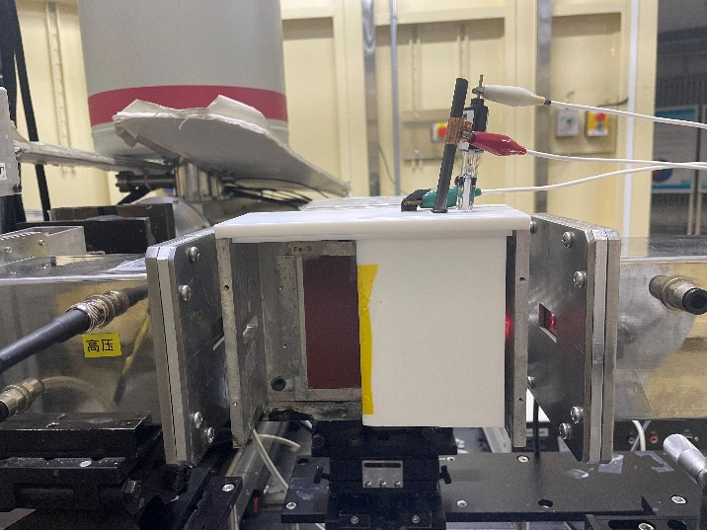
Schematic diagram and photo of the homemade in-situ electrochemical cell.

Electrochemical measurements.
The electrochemical performances were tested using a standard three-electrode system in 1 M KOH controlled by a CHI 760E/1140C electrochemical workstation (CH Instruments, Inc., Shanghai, China). A graphite rod served as the counter electrode (for the stability tests at 1,000 mA cm⁻², a nickel felt was used as the counter electrode), and a Hg/HgO electrode served as the reference electrode. The prepared electrode with 1 cm² of area was used as the working electrode. For the Pt/C control, it was prepared by casting 20% Pt/C (Johnson Matthey) onto 1 cm² nickel foam with the loading of 0.1 mg_{Pt} cm⁻². The polarization curves were conducted at a scanning rate of 5 mV s⁻¹ under H₂-saturated electrolyte. Electrochemical impedance spectroscopy (EIS) was performed at an overpotential of −30 mV, applying an AC voltage of 5 mV over a frequency range of 100 kHz to 0.1 Hz. All potentials were reported concerning the reversible hydrogen electrode (RHE) unless noted. The RHE was calibrated using the equilibrium potential of the Pt/C electrode in H₂-saturated electrolyte.

Open circuit potential (OCP) decay test (Local pH test).
The OCP decay test was conducted in H₂-saturated 1 M KOH. A two-step chronopotentiometry procedure was employed. The electrode was first maintained at a certain current density, and then switched to 0 mA cm⁻² (i.e., at the OCP). The potential of the electrode was acquired at 1 ms intervals. To eliminate the initial transient capacitive decay, the electrode potential at the 20 ms after switching to OCP was used to estimate the local pH. The difference between this potential and the reversible hydrogen electrode (RHE) potential was divided by 59 mV per ΔpH to obtain the ΔpH between the bulk electrolyte and the electrode surface. Adding this value to the bulk pH of 14 gives the local pH at the electrode surface.

In-situ ATR-SEIRAS experiments.
In-situ ATR-SEIRAS experiments were conducted using a Nicolet iS50 Fourier Transform Infrared Spectrometer equipped with an MCT detector. The spectral resolution was set to 4 cm⁻¹, with each spectrum consisting of 64 co-added interferograms. ATR measurements were performed using a PIKE VeeMAX III variable angle ATR sampling accessory, with a silicon prism crystal at a 60° incident angle serving as the reflection element. A gold film was chemically deposited on the crystal to enhance infrared and electronic conductivity. Co-NiMo/MoO₂ and NiMo/MoO₂ were ultrasonically dispersed and drop-cast onto the Au-coated Si crystal as the working electrode. SEIRAS spectra were collected at potentials of −0.1 and 0 V vs. RHE, while the reference single-beam spectrum was taken at 0 V. The absorbance of the spectra was defined as Abs = −lg(R/R₀), where R and R₀ represent the reflected infrared intensities of the sample and reference single-beam spectra, respectively.

AEMWE measurements.
The electrolyzer consisted of a SUS 316 stainless steel cathode plate and a nickel-plated SUS 316 stainless steel anode plate, both featuring a triple serpentine flow field design with an active area of 4.0 cm². An anion exchange membrane (Gen A - 40 μm or 80 μm from Hangzhou Sophon Drive Tech Co., LTD) was used to separate the anode and cathode electrodes, forming a membrane electrode assembly (MEA). The electrolyzer temperature was maintained at 60 or 80 °C, with 1.0 M KOH continuously pumped into the flow fields at a flow rate of 100 sccm using a peristaltic pump. The polarization curve was obtained using an electrochemical workstation (Solartron ModuLab XM paired with a 25 A current booster or ITECH ITM3100-100A). The polarization curve was recorded at a scan rate of 5 mV s⁻¹. EIS was conducted at the cell voltage of 1.7 V, with frequencies ranging from 10 kHz to 0.1 Hz.

Theoretical calculation method.
First-principles computations were performed using the projector augmented wave method (PAW)¹ as implemented in the Vienna ab-initio simulation package (VASP)². The generalized gradient approximation in the form of Perdew-Burke-Ernzerhof (PBE)³ for the exchange-correction potential and a cutoff energy of 500 eV for the plane-wave basis were adopted. For all calculations, spin polarization was adopted. To consider long-range van der Waals (vdW) interactions, Grimme’s DFT-D3 method⁴ was employed. Atomic structures were fully released with converging tolerance for forces on all atoms less than 0.02 eV/Å, and the energy convergence criterion was set to 10⁻⁵ eV. 2 × 2 unit cells of NiMo (111) and Co-NiMo (111) with 4-layers thickness was employed with 15 Å vacuum space in the vacuum-direction to avoid image interactions. The bottom two layers were kept fixed while the top two layers were relaxed during geometry optimization. 3 × 3 × 1 Monkhorst–Pack k-meshes were used to sample the Brillouin zone for geometry relaxation. The computational hydrogen electrode model proposed by Nørskov et al, which was used to evaluate the activity of the catalyst⁵.

Supplementary Notes
Supplementary Note 1. Verification of the measured electrode local pH.
The overall HER overpotential could be divided into the activation overpotential (η_{a}) and diffusion overpotential (η_{d}), and η= η_{a}+ η_{d}.
The η_{a} is determined by the Butler-Volmer equation (Eq. 1).
$j=2j_{0}\left(-e^{\frac{-αF}{RT}η_{a}}+e^{\frac{βF}{RT}η_{a}}\right)$ (1)
where η_{a} is the activation overpotential, j₀ is the exchange current density, and α and β are the charge transfer coefficients. The j₀, α, and β are determined by the polarization curves at low current densities, where the diffusion overpotential is negligible. Then, the η_{a} at a certain current density is estimated by the Butler-Volmer equation.
The η_{a} is estimated by the local product concentration (i.e., local pH) using the Nernst equation (Eq. 2)
$η_{d}=-\frac{2.3RT}{nF}\lg{\frac{C_{{OH}^{-},local}}{C_{{OH}^{-},bulk}}}=-0.0591∆pH$ (2)
where η_{d} is the diffusion overpotential, C_{OH−,local} is the electrode surface local OH⁻ concentration, C_{OH−,bulk} is the bulk electrolyte OH⁻ concentration, and ΔpH is the pH difference between the electrode surface and the bulk electrolyte.
The estimated η_{a} and η_{d} are summarized in Supplementary Note Table 1.

Supplementary Note Table 1. The estimated activation overpotential (η_{a}) and diffusion overpotential (η_{d}).
j (mA cm⁻²) | NiMo/MoO₂ |  | Co-NiMo/MoO₂
j (mA cm⁻²) | η_{a} (mV) | η_{d} (mV) | η_{a} (mV) | η_{d} (mV)
−10 | −10 | -9±5 | −7 | −7±5
−100 | −40 | −48±5 | −30 | −41±5
−1000 | −82 | −102±5 | −73 | −65±5

The estimated overall overpotential is reasonably close to the measured one (Supplementary Note Fig. 1), suggesting the accuracy of the measured local pH.

Supplementary Note Fig.1. Polarization curves of the catalyst and the estimated overall overpotential (including activation and diffusion overpotential) at different current densities (10, 100, and 1000 mA cm⁻²).

Supplementary Note 2. The local pH of the electrode
Based on the Gouy-Chapman-Stern model, the concentration of ion i in the electric double layer could be described by Eq. 3.
$C_{i,x}=C_{i, bulk}\exp\left(-\frac{z_{i}Fϕ_{x}}{RT}\right)$ (3)
Where C_{i,x} is the concentration of ion i at distance x from the electrode surface, C_{i, bulk} is the concentration of ion i in the solution, z_{i} is the charge of ion i, ϕ_{x} is the potential at distance x.
The surface pH is the OH⁻ concentration at x=0, and thus the local pH can be described as Eq. 4.
$Local pH=C_{{OH}^{-}, bulk} exp\left(\frac{Fϕ_{0}}{RT}\right)$ (4)
When OH⁻ is absorbed on the Co sites, the ϕ₀ is reduced for the Co-NiMo/MoO₂ compared with that for NiMo/MoO₂, and thus the local pH is reduced.

Supplementary Note 3. The high pristine activity of the Co-NiMo/MoO₂
It is found that Co promotes the HER performance of the NiMo. The binding strength of the HER intermediates, i.e., adsorbed H (*H), is considered the primary descriptor for HER activity. The density function theory (DFT) calculation demonstrates the downshift in d-band center after doping NiMo with Co (from −1.62 eV to −1.71 eV), suggesting the weakened hydrogen binding on the surface of Co-NiMo, which is more favorable for HER (Supplementary Note Fig. 2).
Supplementary Note Fig. 2. The projected d-band density of states for NiMo and Co-NiMo.

The interfacial water structures are found important for HER in alkaline as well. The in-situ attenuated total reflectance surface-enhanced infrared absorption spectroscopy (ATR-SEIRAS) displays more abundant strong hydrogen-bonded interfacial water (at ca. 3200 cm⁻¹) on Co-NiMo/MoO₂ (63.2%) than that on NiMo/MoO₂ (53.8%) (Supplementary Note Fig. 3). It suggests a strengthened hydrogen bond network for the interfacial water on Co-NiMo/MoO₂, which accelerates ion transfer and thus promotes HER in alkaline ^{6,7}.
Supplementary Note Fig. 3. Electrochemical in-situ ATR-SEIRAS spectra of Co-NiMo/MoO₂ and NiMo/MoO₂ at −0.1 V vs. RHE.

The calculations and characterizations suggest that the hydrogen binding and interfacial water structure are optimized after Co doping, resulting in the high intrinsic HER activity of the Co-NiMo/MoO₂.
Supplementary Note 4. The enhanced mass transfer property of the Co-NiMo/MoO₂
The fast mass transfer property is also important for the electrode working at high current density. Due to the microrod array morphology of the Co-NiMo/MoO₂, the generated hydrogen bubbles could be removed from the electrode surface rapidly, leading to improved HER performance. Supplementary Note Fig. 4a shows that the Co-NiMo/MoO₂ exhibits a larger bubble contact angle of 158°, which is larger than that of the nickel foam electrode drop-casted with Co-NiMo (139°). It indicates that the microrod array morphology provides superior superaerophobicity, which promotes the bubble release. As a result, the Co-NiMo/MoO₂ microrod array electrode shows much higher HER performance than the Co-NiMo coated nickel foam electrode at high current density (Supplementary Note Fig. 4b).
Supplementary Note Fig. 4. a, Bubble contact angle of the Co-NiMo/MoO₂ with microrod array structure (self-supported) and drop-casted Co-NiMo/MoO₂ electrode without microrod array structure. b, The corresponding polarization curves. The insert shows the SEM image of the drop-coated Co-NiMo/MoO₂ electrode.

The operando photomicrography (Supplementary Note Fig. 5a-c) illustrates the H₂ bubbles generated at the electrode surface. For the Co-NiMo/MoO₂, the bubbles are uniform and the sizes are relatively small (the average sizes are 40 and 71 μm at 100 and 1000 mA cm⁻², respectively). While larger and uniform bubbles with a size of hundreds of microns appeared at a current density of 100 mA cm⁻² when using Co-NiMo coated nickel foam electrode (Supplementary Note Fig. 5c). The video also suggests the rapidly removal of the generated bubbles on the Co-NiMo/MoO₂, confirming the enhanced mass transfer (Supplementary Video 1, 2).

Supplementary Note Fig. 5. The operando photomicrography of the electrodes. a,b, the Co-NiMo/MoO₂ with microrod array structure (self-supported): a, at 100 mA·cm⁻². b, at 1000 mA·cm⁻². Insets show the bubble size distribution histogram. c, drop-casted Co-NiMo/MoO₂ electrode without microrod array structure at 100 mA·cm⁻².

Supplementary Figures

Supplementary Fig. 1. Ni 2p core level XPS spectra of the NiMo/MoO₂ electrode before and after HER tests at different current densities.

Supplementary Fig. 2. SEM images of the NiMo/MoO₂ after 100 h of stability test. a, at 10 mA cm⁻². b, at 100 mA cm⁻².

Supplementary Fig. 3. K² χ(k) oscillations of Ni K-edge EXAFS for the NiMo/MoO₂ and references.

Supplementary Fig. 4. Ni Pourbaix diagram ([I] = 10⁻⁷ M, where I represents all the soluble Ni-contained species; 298.15 K). The thermodynamic data is sourced from Ref. 8. The boxed area is shown in Fig. 2c in the main text.

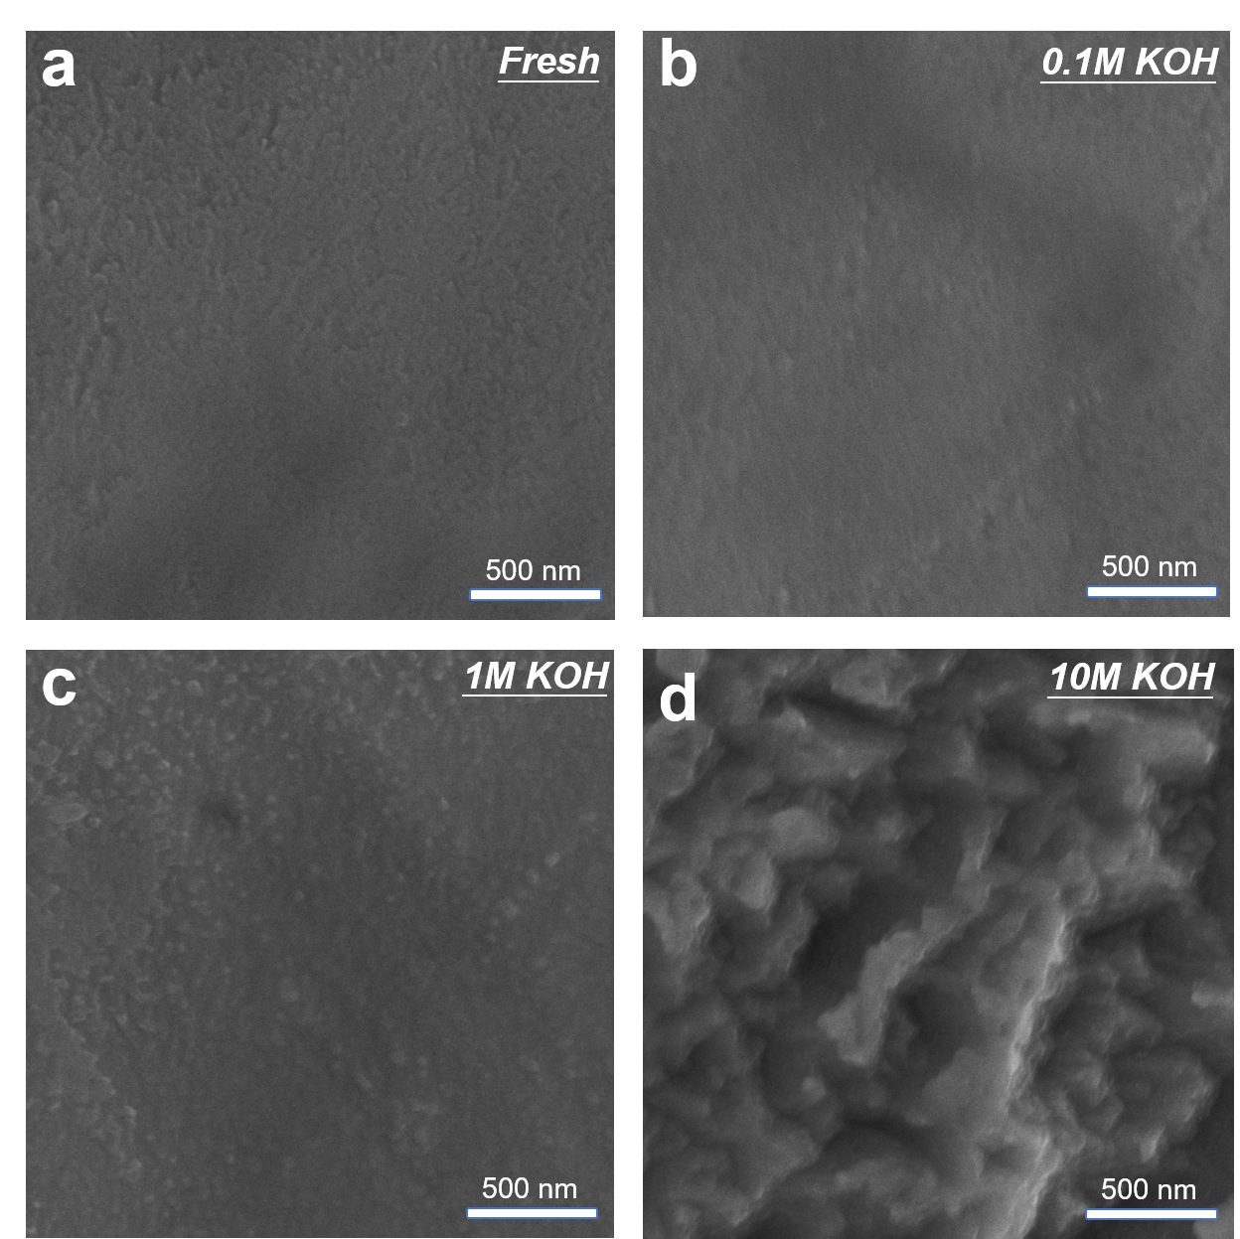
Supplementary Fig. 5. SEM images of Ni foils before and after emerging in alkaline electrolyte for 10 h. The potential was held at −0.03 V vs. RHE. a, pristine Ni foil. b, in 0.1 M KOH. c, in 1 M KOH. d, in 10 M KOH.

Supplementary Fig. 6. OCP decay curves of the NiMo/MoO₂. a, The whole curves. b, Enlarged curves to show the initial decays. The potential is iR uncorrected.

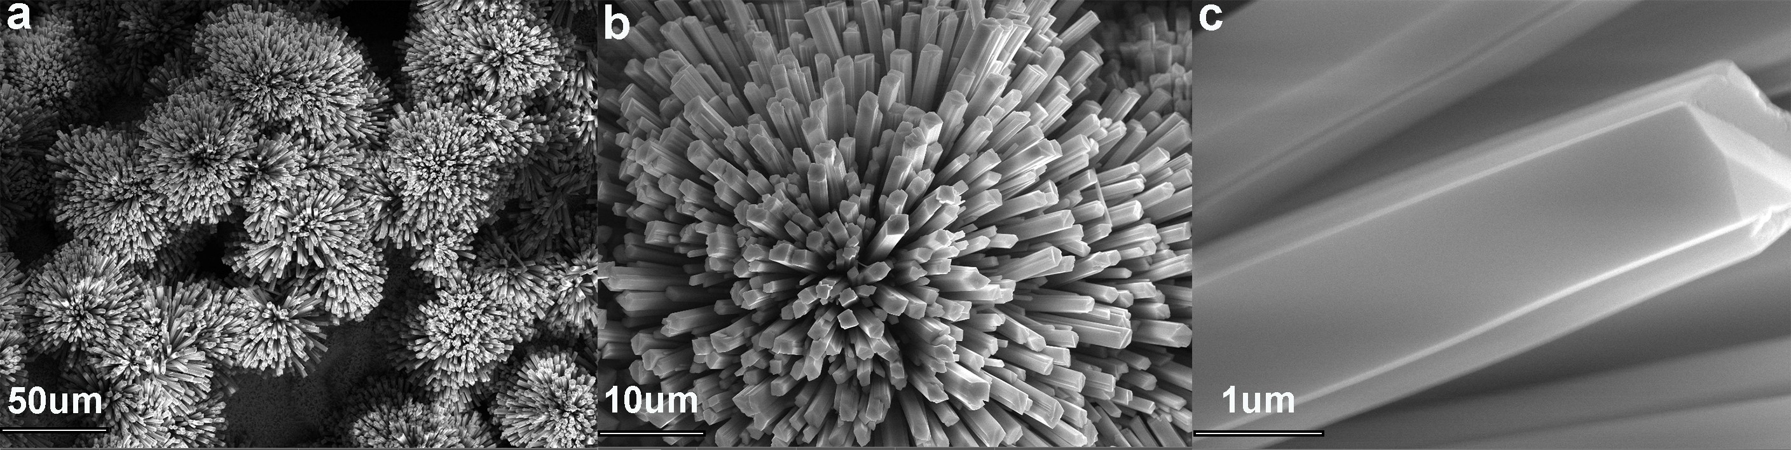
Supplementary Fig. 7. SEM images of the Co-doped NiMoO₄·microrods precursor.

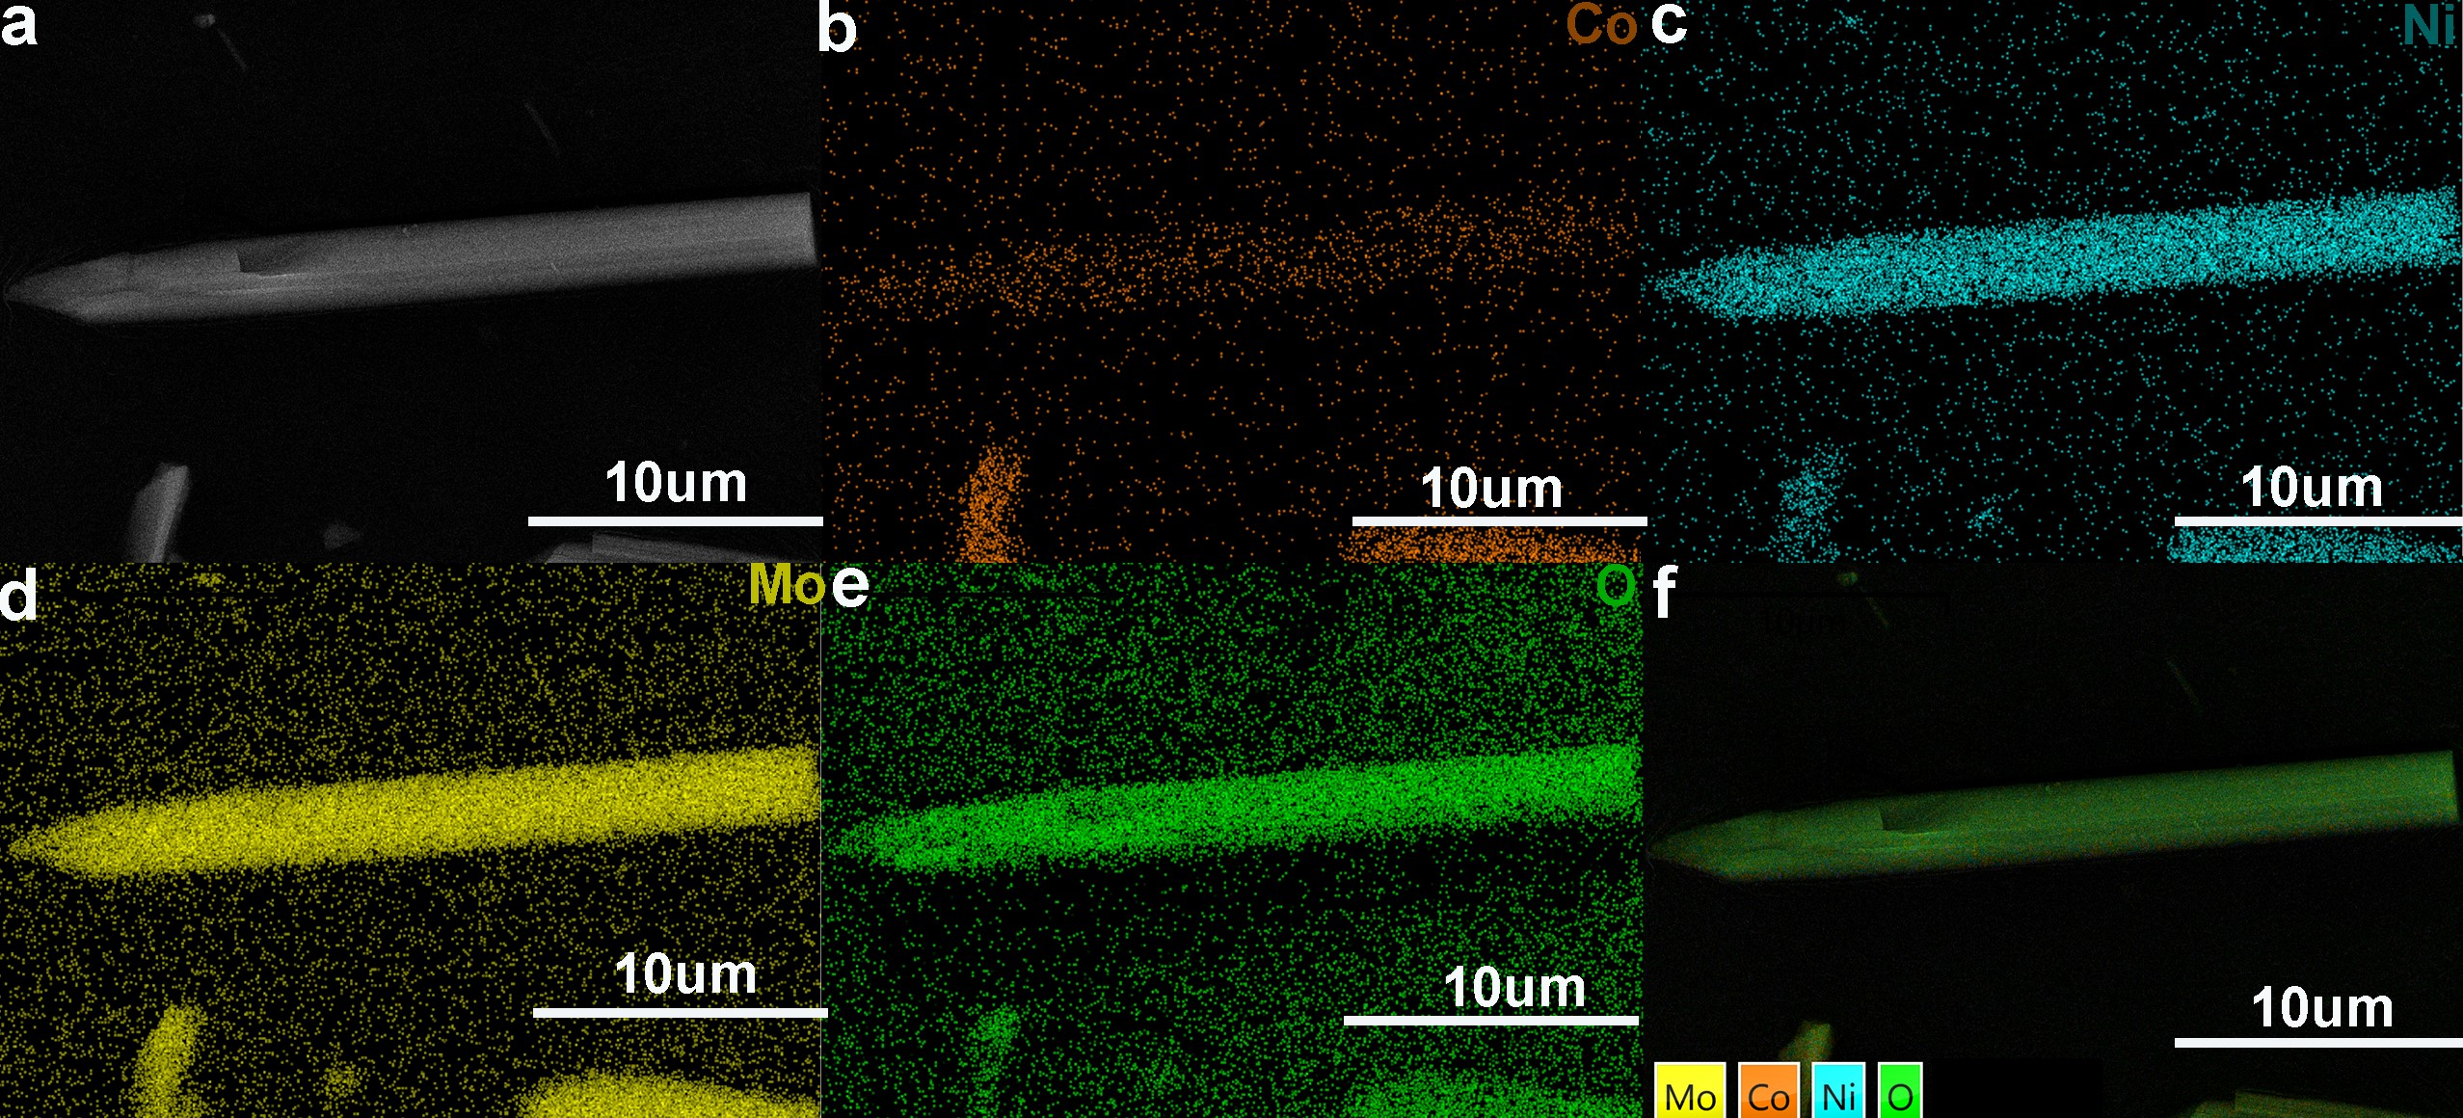
Supplementary Fig. 8. HAADF-STEM image and the corresponding EDS mappings of the Co-doped NiMoO₄ microrods precursor.

Supplementary Fig. 9. XRD pattern of the Co-NiMo/MoO₂.

Supplementary Fig. 10. Size distribution histogram of the Co-NiMo/MoO₂. a, width of the microrods. b, length of the microrods. c, size of the nanoparticles.

Supplementary Fig. 11. HAADF-STEM image and the corresponding EDS mappings of the Co-NiMo/MoO₂.

Supplementary Fig. 12. EDS spectrum and the element amounts of the Co-NiMo/MoO₂.

Supplementary Fig. 13. a, Ni K-edge XANES spectra of the Co-NiMo/MoO₂, NiMo/MoO₂, Ni foil, and NiO. b, Corresponding k² χ(k) oscillations of Ni K-edge EXAFS. c, Ni R-space spectra.

Supplementary Fig. 14. a, Co K-edge XANES spectra of the Co-NiMo/MoO₂ and references. b, Corresponding k² χ(k) oscillations of Co K-edge EXAFS. c, the average oxidation states fitting curve using the edge energy.

Supplementary Fig. 15. OCP decay curves of the Co-NiMo/MoO₂. a, The whole curves. b, Enlarged curves to show the initial decays. The potential is iR uncorrected.

Supplementary Fig. 16. Electrode local pH of the Co-NiMo/MoO₂ and NiMo/MoO₂ at different HER current densities.

Supplementary Fig. 17. Potential curve for the Co-NiMo/MoO₂ in intermittent electrolysis. The test was done in a three-electrode system in 1 M KOH. The working current density is 1 A cm⁻², and the shutdown current is 0 A cm⁻². Each step lasts 100 s. The potential is iR uncorrected.

Supplementary Fig. 18. SEM image of the Co-NiMo/MoO₂ after 2000 h of stability test at 1 A cm⁻².

Supplementary Fig. 19. Ni 2p core level XPS spectra of the Co-NiMo/MoO₂ before and after 2000 h of HER test at 1000 mA cm⁻².

Supplementary Fig. 20. K² χ(k) oscillations of Ni K-edge EXAFS for the Co-NiMo/MoO₂ and references.

Supplementary Fig. 21. a, In-situ Co K-edge XANES spectra of the Co-NiMo/MoO₂ obtained in 1 M KOH at different potentials. b, Corresponding K² χ(k) oscillations of Co K-edge. c, the average oxidation states fitting curve using the edge energy. d, Corresponding k²-weighted FT-XAFS spectra of the Co-NiMo/MoO₂ at different potentials.

Supplementary Fig. 22. Calculated Gibbs free energies for OH⁻ adsorption at Ni and Co site of Co-NiMo. The inset shows the DFT-optimized catalyst models.

Supplementary Fig. 23. Nyquist plots of AEMWEs obtained at 1.7 V with 1 M KOH feeding. The cathodes are listed in the figure. The anode is NiFe-LDH. The AEM is Gen A - 40 μm.

Supplementary Fig. 24. The AEMWE performance using an 80 μm-thick AEM. The cathode is Co-NiMo/MoO₂. The anode is NiFe-LDH. a. The polarization curves. b. The Nyquist plots.

Supplementary Fig. 25. Cell voltage curve of the Co-NiMo/MoO₂ AEMWE in intermittent electrolysis. The working current density is 1 A cm⁻². a, with 4 h intervals between starts and stops. b, with 12 h intervals between starts and stops.

Supplementary Tables

Table S1. Summary of the non-previous metal based HER catalysts in alkaline electrolytes.
Catalysts | Overpotential  at 100 mA cm⁻²  (mV) | Reference
Co-NiMo/MoO₂ | 54 | This work
O-NiCu | 69 | 9
W/WO₂ | 200 | 10
MoNi₄/MoO₂ | 30 | 11
h-NiMoFe | 43 | 12
MoNi₄/MoO_{3-x} | 52 | 13
Int-Ni/MoO₂ | 30 | 14
VCoP | 130 | 15
Ni(OH)₂-W₂C | 213 | 16
Co@NCNT-CoMo_{y}O_{x} | 195 | 17
Co₂Mo₃O₈ | 140 | 18
NiCo₂P_{x} | 127 | 19

Table S2. Summary of the performance and stability of the reported AEMWEs.

Cathode | Anode | Membrane | T  (°C) | J  (A cm⁻²) | V_{BOT}ª  (V) | Time  (h) | V_{EOT}^{b}  (V) | Decay rate  (μV h⁻¹) | Ref.
Co-NiMo/MoO₂ | NiFe-LDH | Gen A | 60 | 1 | 1.682 | 3000 | 1.706 | 8 | This work
Ni₄Mo/MoO₂ | NiFe-LDH | PAQ-5 | 25 | 1 | 1.80 | 1667 | 1.95 | 56 | 20
Ni₄Mo/MoO₂ | z-NiFe | PAP-TP-85 | 25 | 1 | 1.88 | 14000 | 2.04 | 12.3 | 21
Ni₄Mo/MoO₂/NF | Ni₂Fe₈–Ni₃S₂/NF | Sustainion | 60 | 1 | 1.90 | 100 | 2.03 | 1300 | 22
Ni₄Mo/MoO₂/NF | CAPist-L1 | PAP-TP-85 | 25 | 1 | 1.81 | 1500 | 1.90 | - | 23
NiMo/Int/NF | CAPist-L1 | PAP-TP-85 | 25 | 1 | 1.80 | 3000 | 1.87 | 22.4 | 24
NiMo-b-PBP | NiFeOOH-b-PBP | Sustainion  X37-50 | 80 | 1 | 1.78 | 500 | 1.82 | 71 | 25
Int-Ni/MoO₂ | CAPist-L1 | PAP-TP-85 | 60 | 1 | 1.70 | 1000 | 1.77 | 3.96^{c} | 14
Ni₂Mo₃N/NF | NiFeCr  LDH/NF | - | - | 1 | 2.11 | 50 | 2.13 | 800 | 26
NiAlMo | NiAlMo | HMT-PMBI | 60 | 1 | 2.09 | 154 | 2.13 | - | 27
NiFeCo | NiFe₂O₄ | Sustainion X37-50 | 60 | 1 | 1.90 | 1950 | 1.90 | 5 | 28
HNA-CA-H | HNA-CAO | Sustainion  X37-50 | 25 | 1 | 1.89 | 500 | 1.93 | 80 | 29
CoNiS | CoNiS | all-in-one MEA | 60 | 1 | 1.80 | 600 | 1.87 | 133 | 30
Raney nickel | NiFe₂O₄ | Sustainion® (Grade-T) | 60 | 1 | 1.83 | 12000 | 1.84 | 0.7 | 31
Ru-GaSA/N-C | RuO₂ | Sustainion X37-50 | 60 | 1 | 1.82 | 175 | 1.83 | 49.7 | 32
Ru/Ni | NiFe₂O₄ | PBPA | 80 | 1 | 1.84 | 1570 | 2.00 | 100 | 33
Li_{3.0}RuSn_{0.8}  NWs/C | NiFeO_{x}H_{y} | PiperION A20 | 80 | 1 | 1.69 | 1000 | 1.745 | 56 | 34
Pt/C | IrO₂ | PBPA | 60 | 1 | 1.88 | 3500 | 1.92 | 6.5 | 35
Pt/C | NiFe₂O₄ | PBPA | 60 | 1 | 1.70 | 1500 | 1.90 | 32.4 | 35
Pt/C | Ni₃Fe-LDH | DURAION | 60 | 1 | 1.82 | 1000 | 1.87 | 84 | 36
PtRu/C | IrO₂ | x-PDTP-Pr-10 | 60 | 1 | 1.70 | 1000 | 1.80 | 98 | 37
PtRu/C | IrO₂ | PTP-C1 | 80 | 1 | 1.78 | 216 | 1.95 | 787 | 38
PtRu/C | NiFe | MTCP-50 | 60 | 0.5 | 1.61 | 2500 | 1.65 | 15 | 39
Ir-Ni/Mo₅N₆ | Ir-Ni/Mo₅N₆ | Sustainion X37-50 | 80 | 0.4 | 1.50 | 30 | 1.54 | - | 40
NiMo-NH₃/H₂ | Fe-NiMo-NH₃/H₂ | Sustainion X37-50 | 20 | 0.5 | 1.72 | 25 | 1.75 | - | 41
Ni–MoO₂ | Ni_{0.6}Co_{0.2}Fe_{0.2} | Fumapem-3-PE-30 | 50 | 0.5 | 1.97 | 60 | 1.93 | - | 42
Cathode | Anode | Membrane | T  (°C) | J  (A cm⁻²) | V_{BOT}ª  (V) | Time  (h) | V_{EOT}^{b}  (V) | Decay rate  (μV h⁻¹) | Ref.
MoNi₄/MoO₂ | Ni₂P@  FePOxHy | Sustainion  X37–50 | 60 | 0.5 | 1.75 | 72 | - | - | 43
Pt/C | IrO₂ | PTFE- Sustainion | 60 | 0.5 | - | 1100 | 2.09 | - | 44
Pt-AC/Cr-N-C | NiFe LDH | Sustainion X37-50 | 80 | 0.5 | 1.80 | 100 | 1.81 | 90 | 45
Pt/C | RuZn-Co₃O₄ | Versogen-A20 | 60 | 0.5 | 1.73 | 120 | 1.86 | 1300 | 46
ª BOT: Beginning of test
^{b} EOT: End of test
^{c} The initial degradation within 60 h of tests was not accounts into the calculation of the decay rate.

Supplementary Videos

Supplementary Video 1. The video of the Co-NiMo/MoO₂ working at 100 mA cm⁻².
Supplementary Video 2. The video of the Co-NiMo/MoO₂ working at 1000 mA cm⁻².

Supplementary References

1 Perdew, J. P. & Wang, Y. Accurate and simple analytic representation of the electron-gas correlation energy. Phys. Rev. B 45, 13244–13249 (1992).
2 Kresse, G. & Hafner, J. Ab initio molecular dynamics for liquid metals. Phys. Rev. B 47, 558–561 (1993).
3 Perdew, J. P., Burke, K. & Ernzerhof, M. Generalized gradient approximation made simple. Phys. Rev. Lett. 77, 3865–3868 (1996).
4 Grimme, S., Antony, J., Ehrlich, S. & Krieg, H. A consistent and accurate ab initio parametrization of density functional dispersion correction (DFT-D) for the 94 elements H–Pu. J. Chem. Phys. 132, 154104 (2010).
5 Nørskov, J. K. et al. Origin of the overpotential for oxygen reduction at a fuel-cell cathode. J. Phys. Chem. B 108, 17886–17892 (2004).
6 Wang, X. et al. Tuning the apparent hydrogen binding energy to achieve high-performance Ni-based hydrogen oxidation reaction catalyst. Nat. Commun. 15, 1137 (2024).
7 Li, P. et al. Hydrogen bond network connectivity in the electric double layer dominates the kinetic pH effect in hydrogen electrocatalysis on Pt. Nat. Catal. 5, 900–911 (2022).
8 Beverskog, B. & Puigdomenech, I. Revised Pourbaix diagrams for nickel at 25–300 °C. Corros. Sci. 39, 969–980 (1997).
9 Wang, J. et al. Manipulating the water dissociation electrocatalytic sites of bimetallic nickel-based alloys for highly efficient alkaline hydrogen evolution. Angew. Chem. Int. Ed. 61, e202202518 (2022).
10 Chen, Z. et al. Metallic W/WO₂ solid-acid catalyst boosts hydrogen evolution reaction in alkaline electrolyte. Nat. Commun. 14, 5363 (2023).
11 Zhang, J. et al. Efficient hydrogen production on MoNi₄ electrocatalysts with fast water dissociation kinetics. Nat. Commun. 8, 15437 (2017).
12 Luo, Y. et al. Stabilized hydroxide-mediated nickel-based electrocatalysts for high-current-density hydrogen evolution in alkaline media. Energy Environ. Sci. 14, 4610–4619 (2021).
13 Chen, Y.-Y. et al. Self-templated fabrication of MoNi₄/MoO₃ nanorod arrays with dual active components for highly efficient hydrogen evolution. Adv. Mater. 29, 1703311 (2017).
14 Dong, A. et al. Interlayer-bonded Ni/MoO₂ electrocatalyst for efficient hydrogen evolution reaction with stability over 6000 h at 1000 mA cm⁻². Nat. Commun. 16, 4955 (2025).
15 Wan, L., Xu, Z., Xu, Q., Wang, P. & Wang, B. Overall design of novel 3D-ordered MEA with drastically enhanced mass transport for alkaline electrolyzers. Energy Environ. Sci. 15, 1882–1892 (2022).
16 Fu, H. C. et al. Interfacial engineering of Ni(OH)₂ on W₂C for remarkable alkaline hydrogen production. Appl. Catal. B 301, 120818 (2022).
17 Quan, Q. et al. Sequential self-reconstruction of localized Mo species in hierarchical carbon/Co–Mo oxide heterostructures for boosting alkaline hydrogen evolution kinetics and durability. J. Mater. Chem. A 10, 3953–3962 (2022).
18 Zhang, K., Liu, C., Graham, N., Zhang, G. & Yu, W. Modulation of dual centers on cobalt–molybdenum oxides featuring synergistic effect of intermediate activation and radical mediator for electrocatalytic urea splitting. Nano Energy 87, 106217 (2021).
19 Zhang, R. et al. Ternary NiCo₂P nanowires as pH-universal electrocatalysts for highly efficient hydrogen evolution reaction. Adv. Mater. 29, 1605502 (2017).
20 Yin, L. et al. Stable anion exchange membrane bearing quinuclidinium for high-performance water electrolysis. Angew. Chem. Int. Ed. 63, e202400764 (2024).
21 Li, W. et al. Zwitterion-modified NiFe OER catalyst achieving ultrastable anion exchange membrane water electrolysis via dynamic alkaline microenvironment engineering. Angew. Chem. Int. Ed. 64, e202505924 (2025).
22 Ding, G. et al. Highly efficient and durable anion exchange membrane water electrolyzer enabled by a Fe–Ni₃S₂ anode catalyst. Adv. Energy Sustain. Res. 4, 2200130 (2023).
23 Li, Z. et al. Seed-assisted formation of NiFe anode catalysts for anion exchange membrane water electrolysis at industrial-scale current density. Nat. Catal. 7, 944–952 (2024).
24 Lin, G. et al. An interlayer anchored NiMo/MoO₂ electrocatalyst for hydrogen evolution reaction in anion exchange membrane water electrolysis at high current density. Adv. Mater. 37, 2507525 (2025).
25 Zheng, Y. et al. Anion exchange ionomers enable sustained pure-water electrolysis using platinum-group-metal-free electrocatalysts. ACS Energy Lett. 8, 5018–5024 (2023).
26 Zhao, J. Y. et al. Rational nitrogen alloying in nickel–molybdenum nitride can mediate efficient and durable alkaline hydrogen evolution. J. Mater. Chem. A 11, 7256–7263 (2023).
27 Wang, L. et al. High performance anion exchange membrane electrolysis using plasma-sprayed, non-precious-metal electrodes. ACS Appl. Energy Mater. 2, 7903–7912 (2019).
28 Liu, Z. et al. The effect of membrane on an alkaline water electrolyzer. Int. J. Hydrogen Energy 42, 29661–29665 (2017).
29 Jiang, T., Jiang, X., Kyriakou, V., Bouzek, K. & Liao, H. Deep reconstruction of Ni–Al-based pre-catalysts for a highly efficient and durable anion-exchange membrane electrolyzer. J. Mater. Chem. A 11, 26011–26022 (2023).
30 Wan, L. et al. Oriented intergrowth of the catalyst layer in membrane electrode assembly for alkaline water electrolysis. Nat. Commun. 13, 7956 (2022).
31 Motealleh, B. et al. Next-generation anion exchange membrane water electrolyzers operating for commercially relevant lifetimes. Int. J. Hydrogen Energy 46, 3379–3386 (2021).
32 Zhou, C. et al. Oxophilic gallium single atoms bridged ruthenium clusters for practical anion-exchange membrane electrolyzer. Nat. Commun. 15, 6741 (2024).
33 Chen, P. et al. Polysaccharide derived Ru/Ni HER catalysts for long-run anion exchange membrane water electrolysis. Int. J. Hydrogen Energy 96, 210–216 (2024).
34 Mao, J. et al. Electrochemical lithiation regulates the active hydrogen supply on Ru–Sn nanowires for hydrogen evolution toward the high-performing anion exchange membrane water electrolyzer. J. Am. Chem. Soc. 147, 7711–7720 (2025).
35 Jiang, Z. et al. Durable and highly-efficient anion exchange membrane water electrolysis using poly(biphenyl alkylene) membrane. Chem. Eng. J. 467, 143442 (2023).
36 Galkina, I. et al. Stability of Ni–Fe-layered double hydroxide under long-term operation in AEM water electrolysis. Small 20, 2311047 (2024).
37 Hu, C. et al. Stabilizing the catalyst layer for durable and high performance alkaline membrane fuel cells and water electrolyzers. ACS Cent. Sci. 10, 603–614 (2024).
38 Liu, L. et al. Side-chain structural engineering on poly(terphenyl piperidinium) anion exchange membrane for water electrolysers. J. Membr. Sci. 665, 121135 (2023).
39 Song, W. et al. Upscaled production of an ultramicroporous anion-exchange membrane enables long-term operation in electrochemical energy devices. Nat. Commun. 14, 2732 (2023).
40 Wang, H., Tong, Y., Li, K. & Chen, P. Heterostructure engineering of iridium species on nickel/molybdenum nitride for highly-efficient anion exchange membrane water electrolyzer. J. Colloid Interface Sci. 628, 306–314 (2022).
41 Chen, P. & Hu, X. High-efficiency anion exchange membrane water electrolysis employing non-noble metal catalysts. Adv. Energy Mater. 10, 2002285 (2020).
42 Faid, A. Y., Barnett, A. O., Seland, F. & Sunde, S. Tuning Ni–MoO₂ catalyst–ionomer and electrolyte interaction for water electrolyzers with anion exchange membranes. ACS Appl. Energy Mater. 4, 3327–3340 (2021).
43 Meena, A. et al. Crystalline–amorphous interface of mesoporous Ni₂P@FePO_{x}H_{y} for oxygen evolution at high current density in alkaline-anion-exchange-membrane water-electrolyzer. Appl. Catal. B 306, 121127 (2022).
44 Chen, N. et al. High-performance anion exchange membrane water electrolyzers with a current density of 7.68 A cm⁻² and a durability of 1000 hours. Energy Environ. Sci. 14, 6338–6348 (2021).
45 Zeng, L. et al. Single-atom Cr–N₄ sites with high oxophilicity interfaced with Pt atomic clusters for practical alkaline hydrogen evolution catalysis. J. Am. Chem. Soc. 145, 21432–21441 (2023).
46 Zhang, G. et al. Selective activation of lattice oxygen site through coordination engineering to boost the activity and stability of oxygen evolution reaction. Angew. Chem. Int. Ed. 64, e202407509 (2024).

