β-Cyclodextrin Stationary Phase Using Tetrafluoroterephthalonitrile as Spacer Arm for Separation of Phenolic Compounds

Li Jiang¹, Le Duan², Yan Teng², Ineza Urujeni Gisèle², Geyuan Li*³ and Deli Xiao*^{2,4,5}.
1 Department of Pharmacy, Jiangxi Cancer Hospital, Nanchang 330029, China.
2 Department of Analytical Chemistry, China Pharmaceutical University, Nanjing 210009, China.
3 State Key Laboratory on Technologies for Chinese Medicine Pharmaceutical Process Control and Intelligent Manufacture, School of Pharmacy, Nanjing University of Chinese Medicine, Nanjing 210023, China.
4 Key Laboratory of Drug Quality Control and Pharmacovigilance (China Pharmaceutical University), Ministry of Education, 24 Tongjia Lane, Nanjing 210009, China.
5 Key Laboratory of Biomedical Functional Materials, China Pharmaceutical University, Nanjing 210009, China.
† Li Jiang, Le Duan and Yan Teng equally contributed to this work and should be considered co-first authors.
* Corresponding Authors: Deli Xiao, Geyuan Li.
E-mail address: xiao49562001@163.com, 300539@NJUCM.edu.cn.

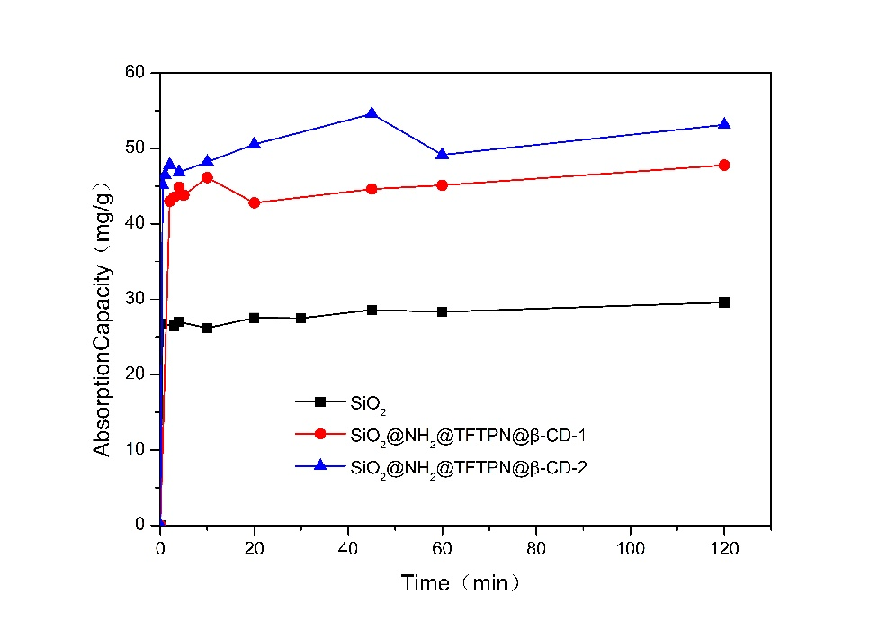
FIGURE S1 Kinetic adsorption curves of 1-naphthol on three kinds of materials

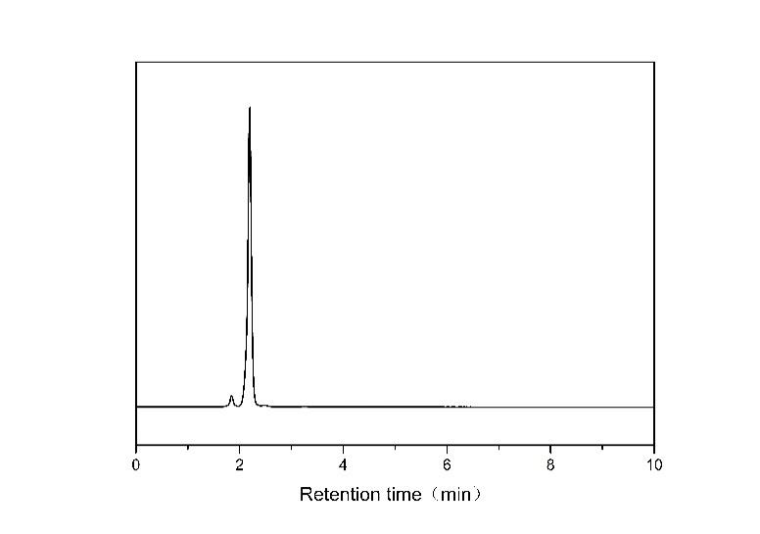
FIGURE S2 Column efficiency evaluation. Chromatographic conditions: mobile phase: Acetonitrile; injection volume: 5 μL; UV detection wavelength: 254 nm; column temperature: 30 ºC; flow rate: 1.0 mL min⁻¹.
FIGURE S3 A stands for the separation of β-cyclodextrin column, left to right, it is phenol, 2- naphthol and 1- naphthol; B represents the separation of C18 column, left to right, it is phenol, 1- naphthol and 2- naphthol.

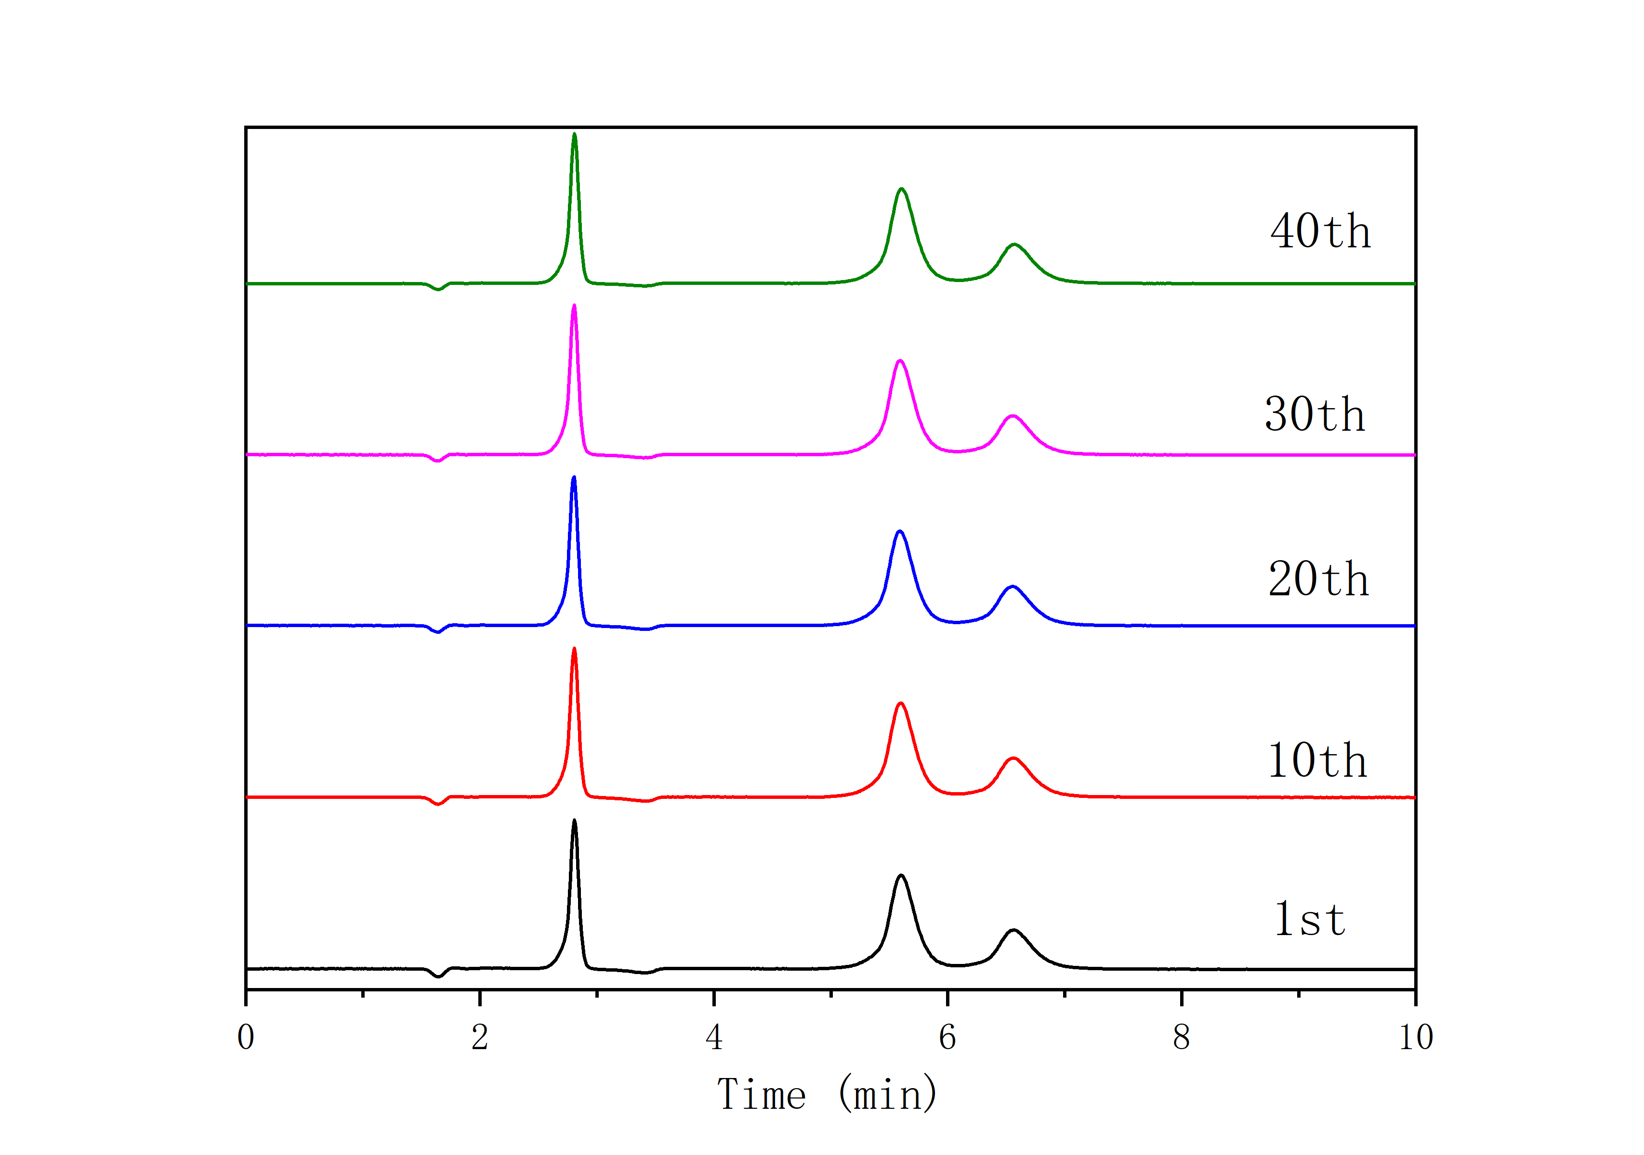 FIGURE S4 Repeatability and stability of cyclodextrin column. Chromatographic conditions: mobile phase: Acetonitrile / 0.01mol/L ammonium acetate at pH 3.0 (50:50, v/v); sample concentration: 50 μg/mL; injection volume: 5 μL; UV detection wavelength: 280 nm; column temperature: 30 ºC; flow rate: 1.0 mL min⁻¹.
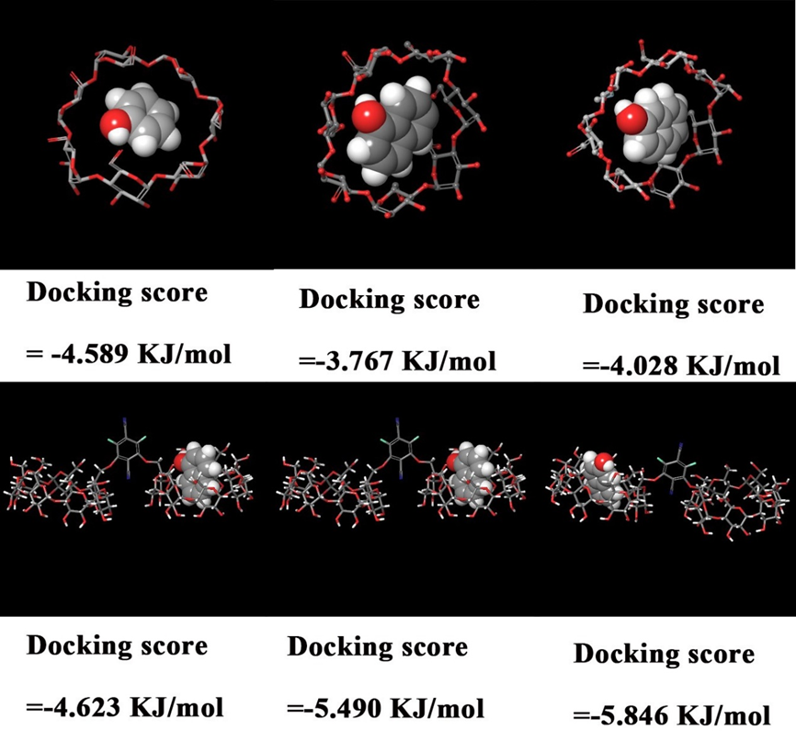 FIGURE S5 β-CD and cyclodextrin stationary phase docking with three phenolic compounds. (a₁-a₃) The docking energies of phenols with β-CD are: phenol (-4.589 kJ/mol), 1-naphthol (-3.767 kJ/mol) and 2-naphthol (-4.028 kJ/mol). (b₁-b₃) The docking energies of phenols with cyclodextrin stationary phase were: phenol (-4.623 kJ/mol), 1-naphthol (-5.490 kJ/mol) and 2-naphthol (-5.846 kJ/mol).
b₂

b₃

b₁

a₃

a₂
a₁

TABLE S1 Common commercial cyclodextrin chromatographic columns
brand | model | Stationary phase | Isolated compound | Apply to system
Singapore  Size of Thai | ChiralCD-1 | β -cyclodextrin derivatives | O -, M -, P-nitroaniline, flavanone etc | Positive phase /  Reverse phase
Singapore  Size of Thai | ChiralCD-3 | β -cyclodextrin derivatives | O -, M -, P-nitrophenol, 4-hydroxyl flavanone, etc | Positive phase /  Reverse phase
Shanghai  Xu in science and technology | Ultimate CD-S | Esterification of β -cyclodextrin by single - bonded phenyl carbamate | Acid compounds, amino acid derivatives | Positive phase /  Reverse phase
Shanghai  Xu in science and technology | Ultimate CD-M | Esterification of β -cyclodextrin by multi-bonded phenyl carbamate | A neutral or acidic compound containing phenyl, naphthalene and cyanide | Positive phase /  Reverse phase
YMC | CD-BR | Bonded cyclodextrin bromide | Optical and structural isomers | Reverse phase
RON peterson | CHIRALLTA T2 | Covalently bonded cyclodextrin - (phenyl carbamate) on silica gel surface | Compounds containing phenyl，naphthalene and cyanides are also suitable for chiral resolution of metal complexes | Positive phase /  Reverse phase
RON peterson | CHIRALLTA T3 | Covalently bonded cyclodextrin - (3-chloro-4-methylphenyl carbamate) on silica gel surface |  | Positive phase /  Reverse phase
RON peterson | CHIRALLTA T5 | Covalently bonded cyclodextrin - (3, 5-dichlorophenyl carbamate) on silica gel surface |  | Positive phase /  the
Japan's sumitomo | OA-7000 | Silicone surface sugar chain bonding  Beta cyclodextrins | Aromatic, aliphatic ketones, aromatic amines and other compounds | Reverse phase

TABLE S2 Elemental analysis results of β-cyclodextrin stationary phase
Material types | Data types | C % | H % | N %
β-CD (theoretical value) | Theoretical value | 44 | 6 | 0
TFTPN (theoretical value) | Theoretical value | 48 | 0 | 14
SiO₂@NH₂(Starting material) | Experimental value | 7.22 | 2.00 | 2.37
SiO₂@NH₂@TFTPN @β-CD-1 | Experimental value | 12.46 | 1.58 | 3.85
SiO₂@NH₂@TFTPN @β-CD-2 | Experimental value | 15.11 | 1.97 | 3.95

TABLE S3 Effect of mobile phase proportion on the separation of phenolic structural analogues
Acetonitrile content | Retention time (min) |  |  | Resolution
Acetonitrile content | Phenol | 2-Naphthol | 1-Naphthol | Phenol,  2-Naphthol | 1-Naphthol,  2-Naphthol
80% | 2.713 | 3.359 | 3.460 | 1.837 | 0.188
70% | 2.924 | 3.835 | 4.054 | 3.924 | 0.694
60% | 3.170 | 4.664 | 5.069 | 5.884 | 1.108
50% | 3.570 | 6.236 | 7.020 | 8.112 | 1.501
40% | 4.164 | 9.478 | 11.155 | 10.728 | 1.850

TABLE S4. Effect of pH values of mobile phase on the separation of phenolic structural analogues
pH | Retention time (min) |  |  | Resolution
pH | Phenol | 2-Naphthol | 1-Naphthol | Phenol,  1-Naphthol | 1-Naphthol,  2-Naphthol
2.5 | 3.570 | 6.236 | 7.020 | 8.112 | 1.501
3 | 3.802 | 6.974 | 7.901 | 8.771 | 1.574
4 | 3.888 | 7.273 | 8.253 | 8.990 | 1.582
5 | 3.890 | 7.285 | 8.246 | 6.924 | 1.139

TABLE S5 Effects of mobile phase composition on the separation results of phenolic compounds
Mobile phase composition | Column efficiency | Asymmetric factor | Degree of separation
Mobile phase composition | 1-Naphthol | 1-Naphthol | Phenol,  2-Naphthol |  | 1-Naphthol,  2-Naphthol
a | 9706/m | 1.186 | 8.755 | 1.386
b | 20926/m | 1.863 | 8.990 | 1.582

