Supplementary Materials
Multi-target cryoprotection of gelatin-tea polyphenol compounds on surimi through ice inhibition and component stabilization
Shichen Zhu^{a*}, Ningning Pengª, Xuan Wangª, Yan Jinª, Yuting Ding^{a,b}, Shulai Liuª, Xuxia Zhou^{a*}
ª Key Laboratory of Green, Low-carbon and Efficient Development of Marine Fishery Resources, National R&D Branch Center for Pelagic Aquatic Products Processing (Hangzhou), College of Food Science and Technology, Zhejiang University of Technology, Hangzhou 310014, Zhejiang, China
^{b} Food Science Research Institute of Zhangzhou, Zhangzhou 363000, Fujian, China
*Corresponding author
E-mail: xzhou@zjut.edu.cn; zhusc@zjut.edu.cn;

Fig. S1 SEM of gelatin-tea polyphenol compounds with different mass ratios
Fig. S2 Freezing diagram of gelatin-tea polyphenol compounds
Fig. S3 Isualization of gel strength (A) and viscosity change (B) of gelatin-tea polyphenol compounds with different mass ratios

Figure S1

Fig. S1 SEM of gelatin-tea polyphenol compounds with different mass ratios

Figure S2

Fig. S2 Freezing diagram of gelatin-tea polyphenol compounds

Figure S3

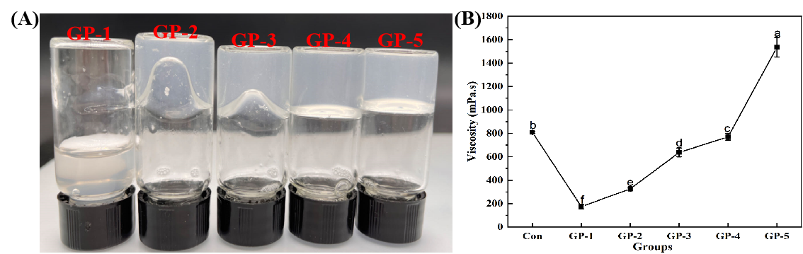
Fig. S3 Isualization of gel strength (A) and viscosity change (B) of gelatin-tea polyphenol compounds with different mass ratios

