Type of Paper: Research Article
Origin, Characterization and Transport Dynamics of the Tena Lahar (Sub-Andean Napo Uplift, Ecuadorian Amazon): Insights from Petrography, Geochemistry, Radiocarbon Dating, and Flow Simulations.
Edgar G. Chulde¹ · Patricia A. Mothes² · Bryan I. Suntaxi³ · Jorge R. Espín⁴

¹ Secretaría Nacional de Gestión de Riesgos, Regional Coordination Office 2 for Risk Management, Tena - Ecuador
² Instituto Geofísico, Escuela Politécnica Nacional, P.O. Box 1701-2759, Quito- Ecuador
³ Escuela Politécnica Nacional, Faculty of Geology and Petroleum Engineering, Quito - Ecuador
⁴ Universidad Regional Amazónica Ikiam, Faculty of Earth and Water Sciences, Earth and Climate Sciences Research Group, Km 7, Muyuna, Tena – Ecuador.

Emails of corresponding author edgar.chulde@gestionderiesgos.gob.ec, geovacf@gmail.com
ORCID: https://orcid.org/0009-0009-6146-1920

Abstract
This study presents the first characterization of the Tena lahar, located in Napo Province, in the eastern Ecuadorian Andes, and genetically linked to the Sierra Azul volcano. Through an integrated approach combining stratigraphic, petrographic, geochemical, radiocarbon, and numerical modeling demonstrate that this was an extremely large lahar deposit (1x10⁸ m³), with thicknesses locally exceeding 15 m in the Tena valley.
Numerical simulations (LAHARZ) indicate that the Misahuallí River acted as the main transport channel, enabling the flow to travel ~45 km from its source area to the Tena Valley. Travel time estimates (40- 50 minutes) and peak discharges (40,000- 100,000 m³/s) fall within the range of other catastrophic lahars in the Andes, although empirical relationship (Pierson, 1998) suggest that modeled times may represent minimum values.
Petrographic and geochemical analyses of volcanic bombs reveal the presence of mafic alkaline rocks (tephrites/basanites) to more evolved (trachytes/trachy-dacites) which are consistent with fractional crystallization of a parental magma. The occurrence of pumice and bread-crust bombs supports a Vulcanian explosive eruption, likely triggering edifice collapse on Sierra Azul’s flanks and subsequent water incorporation generating the lahar flow.
Radiocarbon dating confirms a Holocene age (~4.3 ka BP), documenting previously unrecognized eruptive activity at Sierra Azul volcano. The lahar reshaped the Tena Valley, forming terraces that horst much of the present-day city. These results highlight the need to integrate volcanic hazard into land-use planning and disaster risk reduction in the Ecuadorian Amazon.

Keywords < matrix - rich lahars > · < haüyne > · < Misahuallí river > · · < Tena lahar > · < Sierra Azul volcano >

- Introduction

Contemporary Ecuadorian volcanism is controlled by the eastward subduction of the Nazca Plate beneath the South American Plate at ~ 7 cm/yr (Kellogg et al., 1995; Trenkamp et al., 2002). This geodynamic setting has produced a volcanic arc extending from 1°N to 2°S, where successive eruptions have generated extensive Quaternary deposits across the Northern Andes.

Although numerous geological and petrological studies have addressed Quaternary volcanism in Ecuador (e.g., Barberi et al., 1988; Hall & Beate, 1991; Hall et al., 2008; ; Santamaría et al., 2023) many volcanic centers remain poorly characterized, particulary along the eastern Andean flanks toward the Amazon. Dense vegetation, rugged topography, and persistent cloud cover have historically limited geological mapping. Nevertheless, thick lahar deposits are locally exposed along rivers such as the Misahuallí, Pano, and Tena, though their source has long remained uncertain.

Lahars are among the most destructive volcanic processes, consisting of water-saturated, sediment-rich flows capable of transporting large blocks and affecting areas tens of kilometers from their source (Pierson, 2007; Vallance & Iverson, 2015).(Pierson, 2007).

In Ecuador, historical lahars have caused severe disasters, such as the 1877 Cotopaxi flows that traveled more than 100 km (Mothes et al., 2004; Hall & Mothes, 2008), and the recurrent remobilization of pyroclastic at Tungurahua volcano between 1999 and 2016 (Mothes & Vallance, 2015).

This study integrates stratigraphic, petrographic, geochemical, and geochronological analyses to characterize a large lahar deposit exposed in the Sub-Andean Napo Uplift, near the city of Tena (UTM: 186477–9890266), within the Ecuadorian Amazon. Geological mapping was combined with numerical simulations to evaluate the extent, transport dynamics, and potential hazards of the Tena lahar. These results reveal that volcanic processes traditionally overlooked in local hazard assessments dominated by hydrometeorological risks represent a significant and previously unrecognized threat to the Ecuadorian Amazon.

  - Distribution and Geochemistry of the Ecuadorian Continental Volcanic Arc
The Plio–Quaternary volcanic arc of Ecuador extends ~80 km in width and comprises ~84 eruptive centers, grouped into four belts with distinct petrographic and geochemical features (Barberi et al. 1988; Hall et al., 2008; Bernard & Andrade, 2011) (Fig. 1).

The Western Cordillera hosts mainly andesitic stratovolcanoes and dacitic domes (e.g., Pichincha, Chimborazo, Quilotoa), where edifice collapses have generated debris avalanches. Products are dominantly calc-alkaline with SiO₂ contents of 60 – 66%. (Hall et al., 2008).

(Hall et al., 2008)The Inter-Andean Valley includes smaller andesitic edifices (e.g., Ilaló, Pasochoa, Rumiñahui), most of them extinct, except for Imbabura. Lavas are basaltic andesites with calc – alkaline affinities.

(Hall et al., 2008)(Bernard & Andrade, 2011)The Volcanic Belt of the Cordillera Real is the most active volcanic belt, with major stratovolcanoes such as Tungurahua, Cotopaxi, Sangay, and Reventador. Their compositions range from basaltic andesite to rhyolite, with several caldera systems (e.g., Chalupas, Chacana) displaying dacitic to rhyolitic magmatism.

The Back- Arc belt, located in the Sub-Andean Zone (Fig. 1), is geochemically distinct. It is characterized by alkaline geochemistry, with high K₂O contents (1%–5%) and low SiO₂ levels (42%–53%), contrasting with the calc-alkaline Western and Eastern belts. Representative volcanoes include Pan de Azúcar, Sumaco, and the Puyo cones.

Sumaco volcano is the largest center of this belt and is considered potencially active (Hall et al., 2008). Its lavas are mainly tephrites and basanites, distinguished by feldespathoids —particularly haüyne—being a distinctive feature (Garrison et al., 2018). Microscope-based studies by Salgado (2019) identified four mineral parageneses in Sumaco’s rocks. The most differentiated varieties are characterized by haüyne-bearing assemblages.

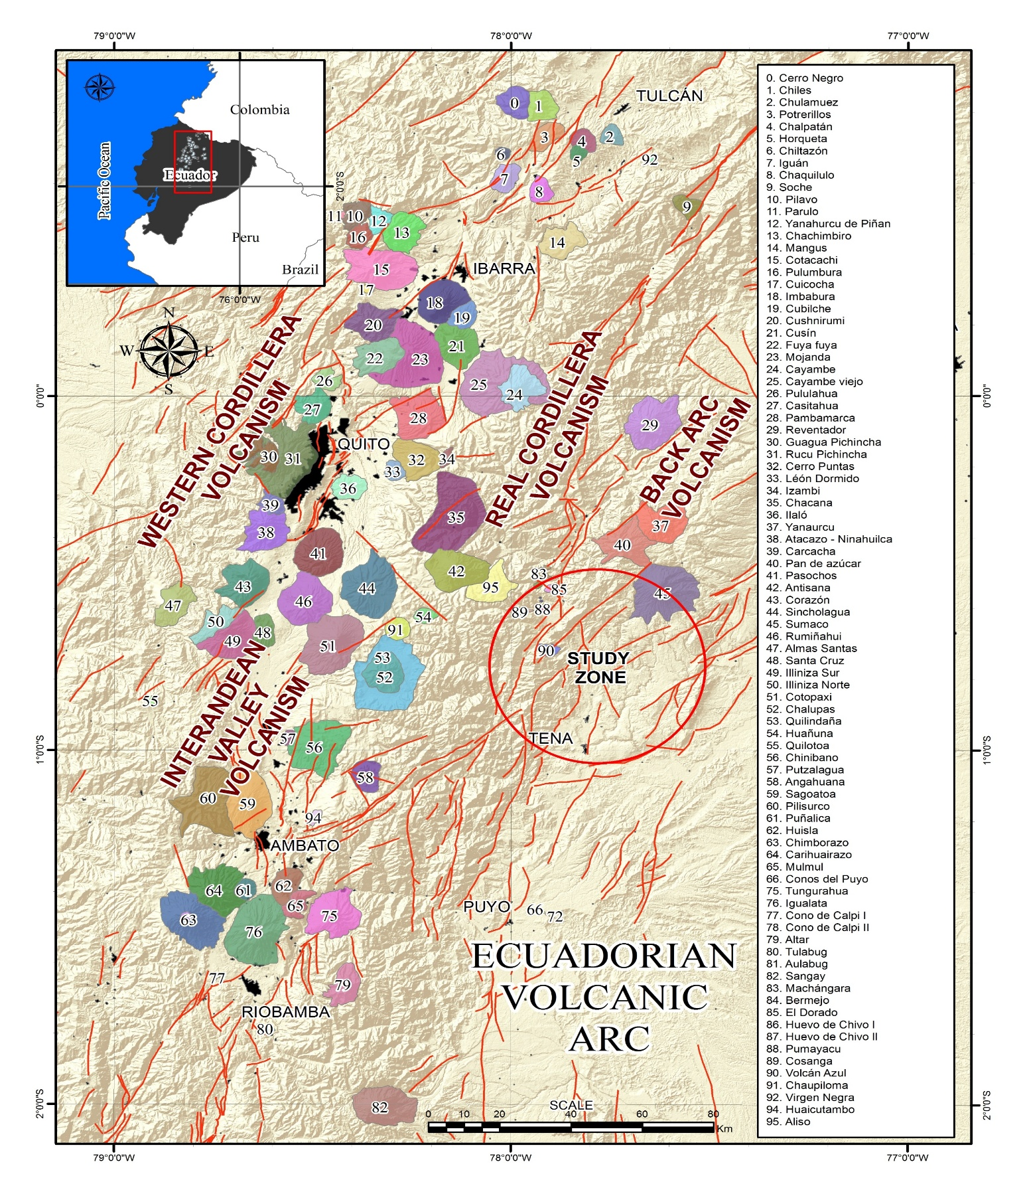
Figure 1. Distribution of the Ecuadorian continental volcanic arc and major tectonic lineaments (red lines). Modified from (Bernard & Andrade,2011). Location of the study area within the back-arc volcanism belt (red circle).

- Methods and Materials

  - Mapping of volcanic deposits

Geological mapping was conducted following the outcrop-based methodology of Barnes & Lisle (2007), during field campaigns from 2022 and 2024. A geological map at 1:36,000 scale was produced using the WGS 84, Zone 18S. . Textural and facies characterization of the lahar followed the criteria of Pettijohn et al. (1987), the United States Department of Agriculture (1949;)Munsell scale), and Miall (2006).

  - Petrographic and whole-rock geochemical analysis

To characterize the Tena lahar deposit and infer its magmatic source, nine thin sections and nine whole-rock geochemical analyses were analyzed. Petrographic descriptions were carried out under polarized light microscopy (PPL, XPL).

Geochemical analyses, reported by Suntaxi (2023), were obtained at the GeoAnalytical Laboratory of Washington State University (USA) using X-ray fluorescence (XRF).

Mayor element contents were normalized to a volatile-free basis, and geochemical interpretations were performed with Igpet software, applying the classification schemes of Peccerillo & Taylor (1976), Le Bas et al. (1986), and Sun & McDonough (1989).

  - Radiometric dating

Radiocarbon (¹⁴C) dating ages were obtained from organic remains within the lahar deposit. Analyses were performed at Beta Analytic Inc. (Florida, USA) and the Radiocarbon Dating Service of North Creek Parkway (USA). Ages were calibrated to calendar years using the R software environment.

  - Geomorphological analysis of hydrographic sub-basins

The geomorphological analysis of the main drainage networks allowed for the identification of potential source areas and flow paths leading to depositional zones. For this purpose, a set of hydrographic sub-basins corresponding to the Pano/Tena, Misahuallí, and Jondachi rivers was delineated to estimate potential clastic contribution from exposed lithologies.

Longitudinal profile analysis and reconstruction of volcanic flow paths were performed using Digital Elevation Models of 5 to 13 m/pixel, spatial resolution, analyzed with ArcGIS software 10.5.

  - Lahar propagation scenario modeling

Lahar flow paths and potential inundation zones were simulated using LAHARZ software (Iverson et al. 1998). Simulations were executed using a DEM (50 m/pixel)..

  - Use of Artificial Intelligence Tools

During the preparation of the manuscript, generative artificial intelligence tools – specifically ChatGPT, OpenAI were employed to support the linguistic refinement and English translation of the text. These tools were used exclusively for the following purposes:
language editing and
translation into English
All outputs generated by the AI were critically reviewed, edited, and, approved by the authors, who remain fully responsible for the accuracy and integrity of the content. No original ideas, data interpretation, or scientific analysis were delegated to the AI tools.

- Results

  - Distribution and extend of the Tena lahar deposit

The Tena lahar deposit is exposed in the Ecuadorian back-arc, within the Sub-Andean Napo Uplift. Discontinuous outcrops along the Misahuallí, Tena, and Pano rivers (MTP rivers) allow delineation of its areal extent across the urban and peri-urban areas of Tena (Napo Province).

The deposit reaches thicknesses of 11 – 14 m in central exposures such as the Misahuallí river at San Luis and the Tena boardwalk (Fig. 2c), with a maximum of 13 m recorded on the left bank of the Tena river near Pepita de Oro. At Peña Colorada, the lahar is widely exposed in the riverbed and adjacent slopes, while in the San Pedro community it thins to ~3m, suggesting downstream continuation toward Muyuna.

More distal exposures occur on the right bank of the Pano river in the San Jorge neighborhood (Fig. 2a, b) and at Guinea Chimbana (Fig. 2d), where massive, matrix-supported deposits are preserved. Additional outcrops are present along the Archidona-Tena road (Fig. 2c) and at the margins of Paushiyacu and Calmitoyacu streams. The most distant exposures, identified near Pivichikta on the Misahuallí river, are separated by ~8 km, representing the farthest extent documented during fieldwork.

Overall, the spatial distribution of these outcrops indicates that the lahar filled small valleys and became incorporated into the regional alluvial terrace sequence, defining a continuous depositional system in the MTP river basins.

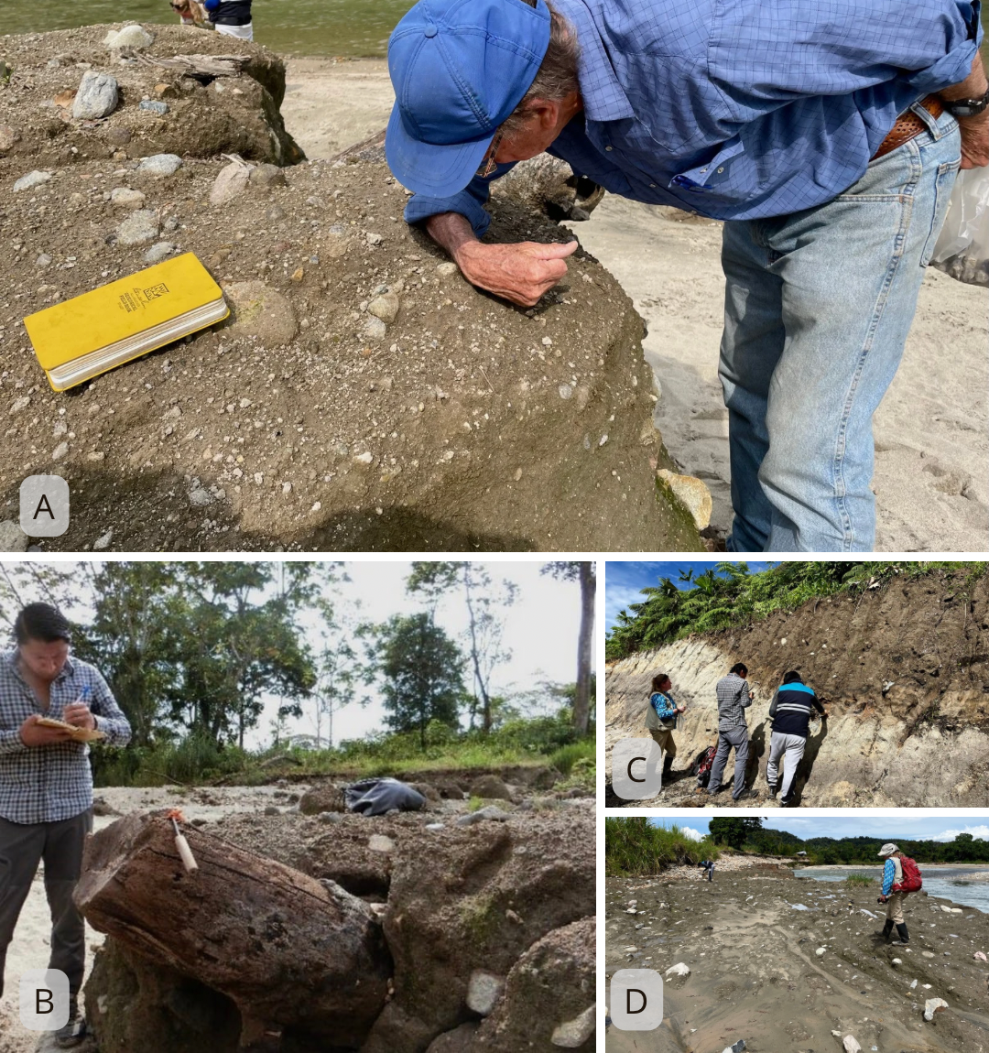
Figure 2. Representative field exposures of the Tena lahar deposit. (A) Sub – meter sized volcanic blocks embedded in the lahar matrix, Pano River (UTM: 185735–9888733). (B) Tree trunks preserved within the massive matrix-supported deposit,San Jorge outcrop along the Pano River. (C) Stratigraphic profile showing the Tena lahar deposit interbedded with local lithostratigraphic units, the Tena–Archidona highway (UTM: 187048–9893043). (D) Lahar deposit exposed at the Guinea Chimbana(UTM: 184019–9888612), underlying post-depositional alluvial sediments from the Pano River.

Based on field observations, the maximum estimated thickness of the volcanic deposit reaches up to 25 m, measured from the Tena river (495 m a.s.l.) to the highest preserved alluvial terraces (520 m a.s.l.).

  - Physical and granulometric characterization of the deposit

The Tena lahar deposit is a matrix-supported deposit (matrix: 85%, clasts: 15%), dark greenish gray color (5G 4/1, Munsell), massive, poorly sorted, and extremely compact. Clasts are hetero lithic and embedded in a sandy–clayey matrix (Fig. 3), that also contains white pumice fragments ≤3 mm.

The matrix often displays vesicular textures, contains charcoal fragments and well-preserved large tree trunks at various urban and riverbank exposures (Fig. 2a, 3e). The deposit is generally without structure (Fig. 3c-f), though incipient normal grading can occasionally be observed. It is highly consolidated and maintains its firmness and hardness both in dry and wet conditions.

Clast sizes range from pebbles to blocks (>0.3 m), with subangular to subrounded shapes and high sphericity. About 75% are volcanic (juvenile basaltic bombs, porphyritic andesites, and aphanitic basaltic andesites—some of them vesiculated); several bombs exhibit breadcrust textures indicative of eruptive dynamics.

The remaining 25% correspond to fragments of the Cretaceous–Paleogene basement, including red beds (Tena Fm.), granitoids (Abitagua batholith ;Fig. 3e-f), quartz and bituminous sandstones (Hollín Fm; Fig. 3a), shales (Napo Fm;Fig. 3b), fibrous pumice with mica/amphibole, and quartz grains of igneous and hydrothermal origin from Eocene conglomerates (Tiyuyacu and Chambira Fms).

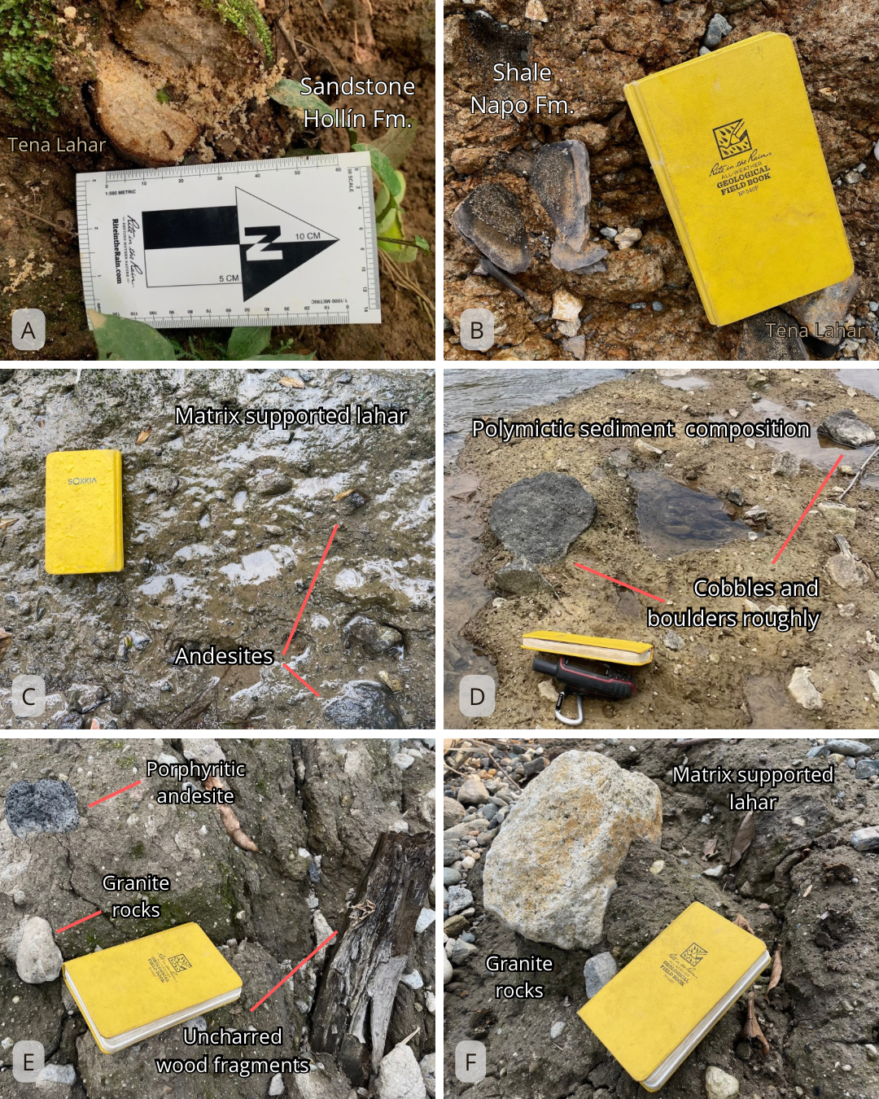
Figure 3. Key characteristics of the Tena lahar. (a) San Jorge sector, Pano River. Massive structure of the Tena lahar (facies Gmm) containing sandstone clasts derived from the Hollín Fm. (b) Volcanic deposit incorporating shale clasts from the Napo Fm. (c) Aguapungo sector, Misahuallí River. Matrix-supported volcanic deposit with subangular andesite clasts of centimetric size. (d) Tena lahar deposit containing cobbles and boulders with poorly defined shape. (e) San Jorge sector, Pano River. Lahar deposit with polymictic clasts and wood fragments supported within a sandy–clayey matrix. (f) Matrix-supported massive structure of the Tena lahar deposit including granite clasts derived from the Abitagua Batholith.
Granulometric analyses by Suntaxi (2023) on several matrix samples indicate that the deposit comprises 3%–7% silt, 1.5%–6% clay, 43%–67% sand, and 26%–49% gravel. The clay content (3%–5%) classifies as cohesive, suggesting incorporation of fine particles during transport and emplacement.

Local variations occur in neighborhoods such as Paushiyacu, Palandacocha, and Peña Colorada, where lighter yellowish-brown tones (10YR 5/4, Munsell) and higher sand contents are linked to granitic input from the Abitagua batholith. Here, matrix-to-clast ratios average 4:1, with clast 0,05 to 0,12 m. Such difference may partly reflect surface weathering.

Despite local variations, the deposit is overall homogeneous. Two gravelly sedimentary facies were identified (Miall, (2006):
Gmm: massive, matrix-supported gravels lacking internal sedimentary structures;
Gmg: – matrix-supported gravels with weak normal grading.

These facies occur both vertically and laterally with gradual transitions, and without well-defined stratification planes or sharp contacts between them.

The occurrence of andesitic blocks up to ~0.45 m suspended in the matrix, suggests hydraulic turbulence during flow transport. Their buoyancy implies that the lahar matrix had density and specific gravity close to that of the incorporated clasts, reinforcing the interpretation of a highly cohesive and dense main flow capable of maintaining large fragments in suspension without deposition at the base of the deposit.

  - Stratigraphic analysis of the Tena lahar

Seven stratigraphic sections were described across the study area (Figs. 4-5).

    - Aguapungo section

Outcrops along the Misahuallí River near Aguapungo (UTM: 187735–9891828), where limited exposures of the Tena lahar are observed. The deposit is characterized by a massive, matrix-supported facies with block-sized clasts ranging from 0.05 to 0.2 m, composed andesitic fragments (Fig. 3c, d) and expose ~4 m of lahar deposit. It overlies limestones (Napo Fm.) and is covered by fluvial deposits and residual soil (Fig. 5).

In relation to the main tectonic structure affecting to Tena city, the volcanic deposit partially overlies the trace of the Porotoyacu Fault.(Fig. 6).

    - Tena/Archidona Avenue section

A temporary roadcut (UTM: 187048–9893043). has allowed to observe the Tena lahar deposit and its stratigraphic relationships.(Fig. 4).

The deposit showing a basal accumulation of volcanic clasts within a channelized context, indicating high-energy transport conditions at the time of emplacement. The average thickness is approximately 1.7 m. The Tena lahar deposit lies in unconformity over a muddy streamflow deposit of granitic composition. This underlying unit incorporates a package of organic-rich material interbedded with fluvial sediments from the Uglo River.

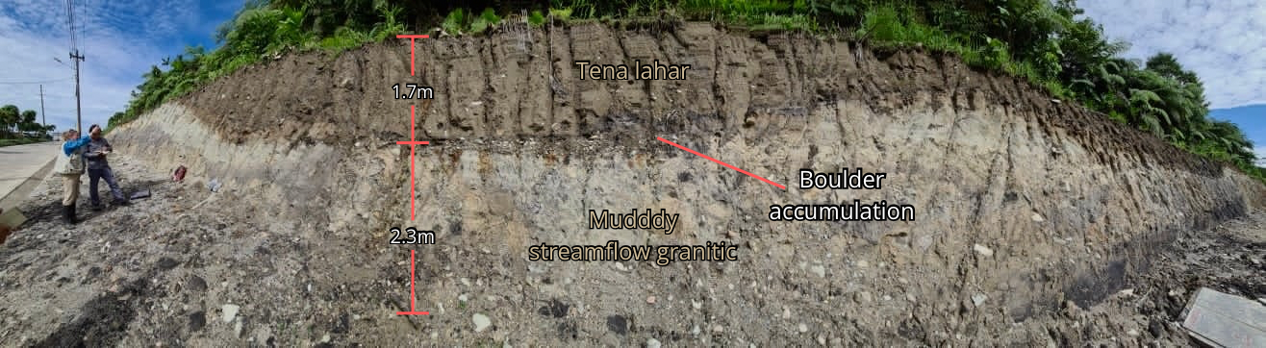
Figure 4. Exposure of the Tena lahar deposit along the Archidona–Tena Road, showing its stratigraphic relationships with the surrounding lithological units. A boulder accumulation at the base of the deposit suggests recirculation and interaction of the largest solid particles within the flow, which could have generated additional kinetic energy facilitating the lahar's transport.

    - Malecón Tena section

On the left bank of the Tena River (UTM: 187081–9890892), the lahar deposit is ~14 m thick, and rests unconformably on a muddy granitic streamflow deposit. At its base, is interbedded with fluvial sediments (Fig. 5). The clast assemblage within the Tena lahar deposit includes andesite, red beds, sandstone, granite, and minor pumice.

    - Guinea Chimbana section

Corresponds to the volcanic deposit exposed along the Pano River (Fig. 3a, b), where the lahar deposit reaches an thickness of ~1.3 m.. The clasts are dominantly andesitic, subangular to subrounded in shape, ranging from ~0.03 to 0.3 m. The surface of the deposit displays ochre-colored patches and desiccation cracks, likely associated with post-depositional cooling of the lahar flow. The Tena lahar deposit is overlain by terraces of the Pano River, indicating a subsequent phase of active sedimentation..

    - Las Sogas section

Describes the lahar deposit exposed near Pepita de Oro (UTM: 185748–9890552), where reaches a thickness of ~6.5 m. Several exposures in the Tena River bed and nearby tributaries suggest that the true thickness may be greater. The lahar deposit is highly consolidated, containing clasts ranging from 0.01to 0.5 m. A slight inverse grading is observed. The deposit is unconformably overlain by Tena River fluvial terraces (~2 m thick) and a residual clay-rich soil layer ~1.6 m thick (Fig. 5).

    - San Jorge section

The Tena lahar deposit is exposed along the margins of the Pano River (UTM: 185735–9888733), where it is a thickness ~ 12.5 m. The clasts are predominantly volcanic but include fragments of red beds, sandstone, shale, and granite derived from the Cretaceous–Paleogene basement. Fragments of tree trunks transported by the lahar deposit are also preserved (Fig. 3e, f). Besides, is overlain by fluvial terraces at the top. Although the base is not exposed, it is inferred to be over red beds (Tena Fm) based on the proximity of outcrops..

    - Stratigraphic section: IESS Hospital

In southern Tena (UTM: 187270–9888190), a deposit with physical characteristics similar to those of the Tena lahar deposit has been identified, it is ~2.3 m thick. According to Salgado (2019), it may be related to the Sumaco volcano, based on petrographic similarities. However, its origin remains uncertain and it is presumed not to be part of the Tena lahar deposit. Although the basal contact was not observed, it is thought to overlie red beds (Tena Fm.) and is capped by undifferentiated sandstones.

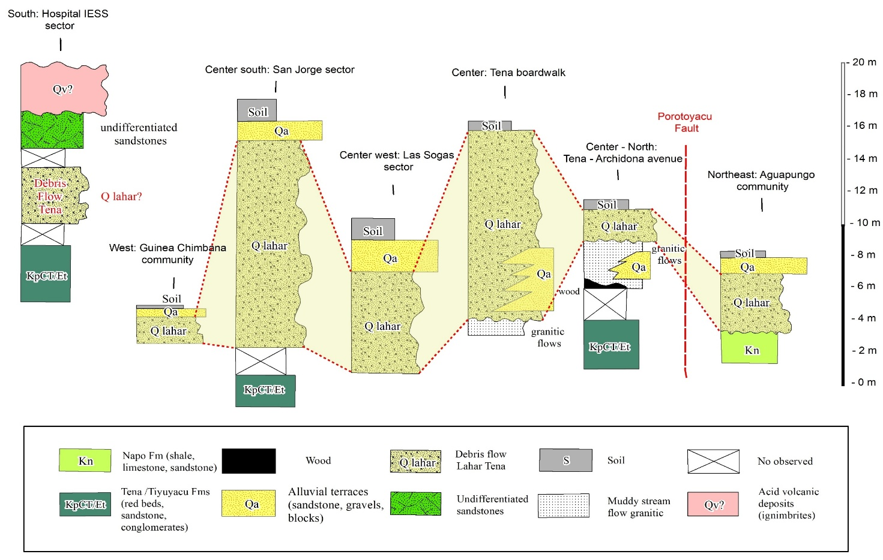
Figure 5. Stratigraphic relationships of the Tena lahar deposit in the study area. From left to right: IESS Hospital, San Jorge, Las Sogas, Tena boardwalk, Tena–Archidona Avenue, and Aguapungo sections.

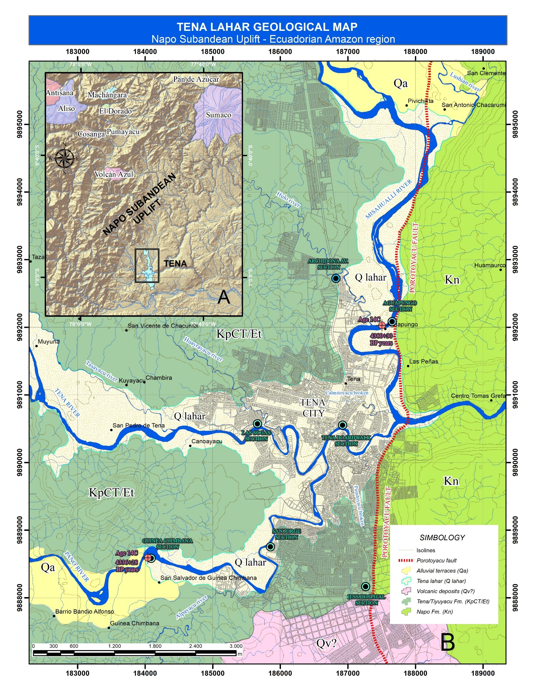
Figure 6. Geological map of the study area showing the extent of the Tena lahar deposit. For better visualization, the overlying Quaternary alluvial terraces have been omitted from the map.

  - Dimensions: Area and Volume of the Tena Lahar

Geological mapping and stratigraphic sections indicate that the Tena lahar deposit covers an area of ~1.18 × 10⁷ m², with an average thickness of 5.5 m, derived from the arithmetic mean of 14 georeferenced outcrops (Table 1). Assuming this average thickness is relatively consistent across the entire depositional area, the minimum volume of the Tena lahar deposit (V_{mlT}) is estimated at:
V_{mlT}= 6.49 × 10⁷ m³.

Additionally, the rheological behavior of mudflows described by Coussot (1997) was considered. According to this model, the sinking of dense fragments in solid–liquid mixtures occurs only when the total solid fraction does not exceed 60%, and the water content is not less than 40%. In settings where the fine particle content (particles ≤0.04 mm) is low, sinking is likely when the solid fraction reaches 68%. However, field observations at several locations revealed clasts up to 0.45 m in diameter suspended, indicating that during the flow event, the matrix–clast mixture reached critical solid–water ratios similar to those described by Coussot (1997), preventing the denser blocks from settling.

Therefore, considering that the observed volume only represents a fraction of the total mass—due to suspended blocks and the increased density of the flow — a more realistic estimate of the total volume of the Tena lahar flow (V_{flT}) is adjusted using the following model (Ec. 1):
$VflT=VmlT+0.4VmlT$(1)
Where:
V_{mlT} = Minimum estimated volume of the Tena lahar deposit
V_{flT} = Total volume of the Tena lahar flow

V_{flT} = 9.09 x 10⁷ m³

This calculation provides a more realistic estimate of the total lahar flow volume accounting for both the deposited mass and the dynamic effects observed.

Table 1. Location of outcrops and quantitative parameter estimates of the Tena lahar deposit.
Outcrop | Location  UTM 18S Zone |  | Thickness (m) | Medium thickness (m) | Area  (m²) | Volume (m³) | Volume (m³) +40%H₂O | Volume  (m³) *
Outcrop | X | Y
Las Sogas | 185748 | 9890552 | 6.5 | 5.5 | 1.18x10⁷ | 6.49x10⁷ | 9.09x10⁷ | 1.1x10⁸ *
San Jorge | 185735 | 9888733 | 12.5
Aguapungo | 187735 | 9891828 | 4
Archidona Av. | 187048 | 9893043 | 1.7
Guinea Ch. | 184018 | 9888612 | 1.4
Pepita de Oro | 185748 | 9890552 | 13
San Luis | 187276 | 9892041 | 11
Peña Colorada | 184042 | 9890524 | 0.7
Pivichikta | 187718 | 9895164 | 0.6
Paushiyacu | 187195 | 9889846 | 2
Calmitoyacu | 186913 | 9890918 | 7
Tena boardwalk | 187081 | 9890892 | 14
Ongota bridge. | 187803 | 9891281 | 2
Misahuallí river | 187661 | 9892175 | 0.3
*From Suntaxi (2023)

  - Volcanic bombs analysis of the Tena lahar deposit

A petrographic analysis was conduced on 17 juvenile volcanic bombs incorporated within the Tena lahar matrix (nine new samples from this study and eight from Suntaxi, 2023) to characterize their mineralogical and textural features (Tabla 2).

All samples exhibit porphyritic microlitic to hyalopilitic textures, with phenocrysts ranging from 1 to 7 mm set in a fine-grained to glassy matrix.. The dominant minerals include plagioclase (An₃₀–An₉₀) and clinopyroxene (titan augite), with subordinate hornblende, orthopyroxene, K-feldspar, olivine, and oxides such as ilmenite and magnetite. Feldspathoids such as nepheline and haüyne were also identified (Table 2). Based on mineral assemblages, the samples can be grouped into three main rock families: alkaline basic rocks (basanites–tephrites; Fig. 7a, b, d, f), intermediate alkaline rocks (trachyandesites–trachytes; Fig. 7e), and subalkaline basic rocks (basalts–basaltic andesites; Fig. 7c).

Several samples display vesicularity (~20%) with a ranging from 0.1 to 2 mm (Fig. 7a, c), often elongated and aligned with flow foliation defined by plagioclase microlites, suggesting syn-eruptive degassing and rapid decompression of ascending magma. Additionally, fractured phenocrysts—particularly plagioclase and augite—are common and indicative of rapid cooling rates, consistent with explosive dynamics of Vulcanian or Strombolian type. This interpretation aligns with the “bread-crust” textures observed in bombs within the Tena lahar deposit.

Table 2. Microscopic description of volcanic bombs incorporated in the Tena lahar deposit
Code | Primary Minerals |  |  |  |  |  |  | Alteration/ Accessory Minerals |  |  |  |  | Texture | Rock Type
Sample | Ol | Opx | Cpx | Hbl | Pl | Kfs | Hyn | Op | Glass | En | Chl | Qtz | Texture | Rock Type
EC-LT-01 |  |  | X | X | An ₃₀₋₇₀ | X |  | X | X |  |  |  | Porphyritic pilotaxitic | Trachyte
EC-LT-02 | X |  | X |  | An ₄₀₋₇₀ |  | X | X | X |  | X |  | Porphyritic microlitic | haüyne  Basanite
EC-LT-03 |  | X | X |  | An ₃₀₋₅₀ | X |  | X | X | X | X |  | Aphanitic fluidal | Tephrite
EC-LT-04 |  |  | X | X | An ₃₀₋₇₀ | X | X | X | X |  | X |  | Porphyritic microlitic | phonolitic Tephrite
EC-LT-05 |  |  | X |  | An  ₃₀₋₇₀ |  |  | X | X |  |  |  | Porphyritic microlitic | Basalt
EC-LT-06 | X |  | X |  | An  ₄₀₋₇₀ |  |  | X | X | X |  |  | Porphyritic microlitic | nepheline Tephrite
EC-LT-07 | X |  | X |  | An  ₄₀₋₇₀ | X | X | X | X | X |  |  | Porphyritic hyalopilitic | phonolitic Tephrite
EC-LT-08 |  |  | X | X | An  ₃₀₋₅₀ |  |  | X | X |  |  |  | Porphyritic hyalopilitic | Trachy - andesite
EC-LT-10 | X |  | X | X | An  ₄₀₋₇₀ | X |  | X | X |  | X |  | Porphyritic hyalopilitic | Basanite
SUM-Mis _Ag21_1* | X |  | X |  | An  ₃₀₋₇₀ | X |  | X | X |  | X | X | Porphyritic hyalopilitic | basaltic Andesite
SUM-Mis _Ag21_2* |  |  | X |  | An  ₄₀₋₇₀ | X |  | X | X |  |  |  | Porphyritic hyalopilitic | Trachyte
SUM-Mis _Ag21_4* | X |  | X |  | An  ₄₀₋₇₀ |  |  | X | X |  |  |  | Porphyritic | basaltic Andesite
PANO_1* | X |  | X |  | An  ₄₀₋₇₀ |  |  | X | X |  |  |  | Porphyritic | Basalt
PANO_2* | X |  | X |  | An  ₄₀₋₇₀ |  |  | X | X |  |  |  | Porphyritic hyalopilitic | vesicular Basalt
PANO_3* | X |  | X |  | An  ₄₀₋₇₀ |  | X | X | X |  |  |  | Porphyritic hyalopilitic | haüyne  Tephrite
PANO_4* |  |  | X |  | An  ₄₀₋₇₀ |  | X | X | X |  |  |  | Porphyritic hyalopilitic | Tephrite
ARCH-TENA* |  |  | X |  | An  ₄₀₋₇₀ |  |  | X | X |  | X |  | Porphyritic hyalopilitic | basaltic Andesite
Mineral assemblages identified in the analyzed samples with corresponding abbreviations (after Kretz, 1989). Ol = olivine; Opx = orthopyroxene; Cpx = clinopyroxene; Hbl = hornblende; Pl = plagioclase; Kfs = K-feldspar; Hyn = haüyne; Op = opaque minerals; En = nepheline; Chl = chlorite; Ep = epidote; Qtz = quartz. * Data partially from Suntaxi (2023)
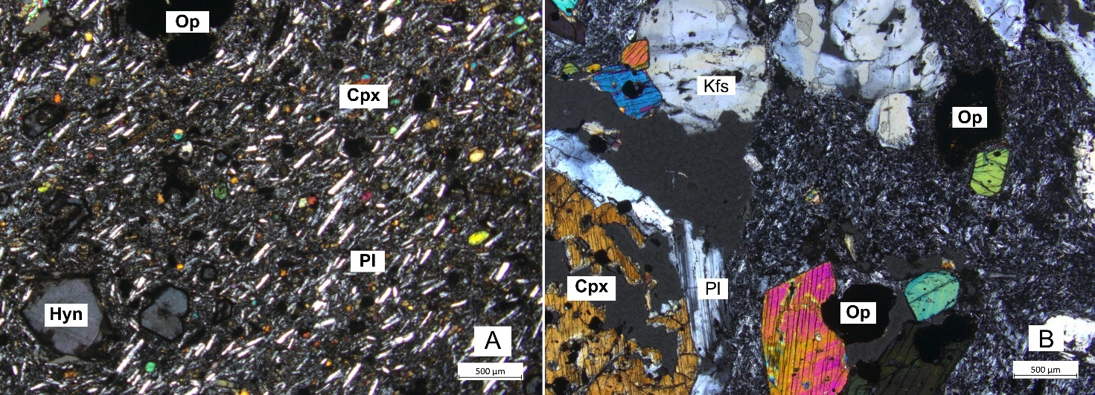
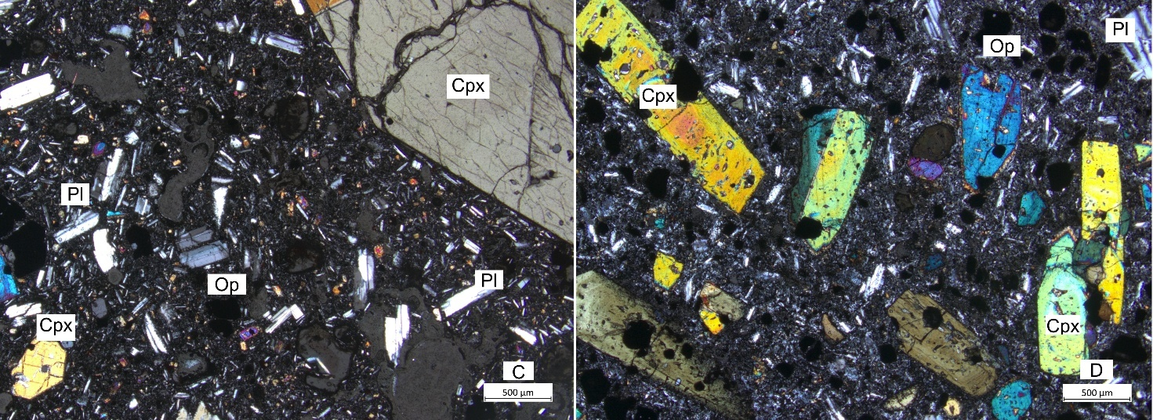
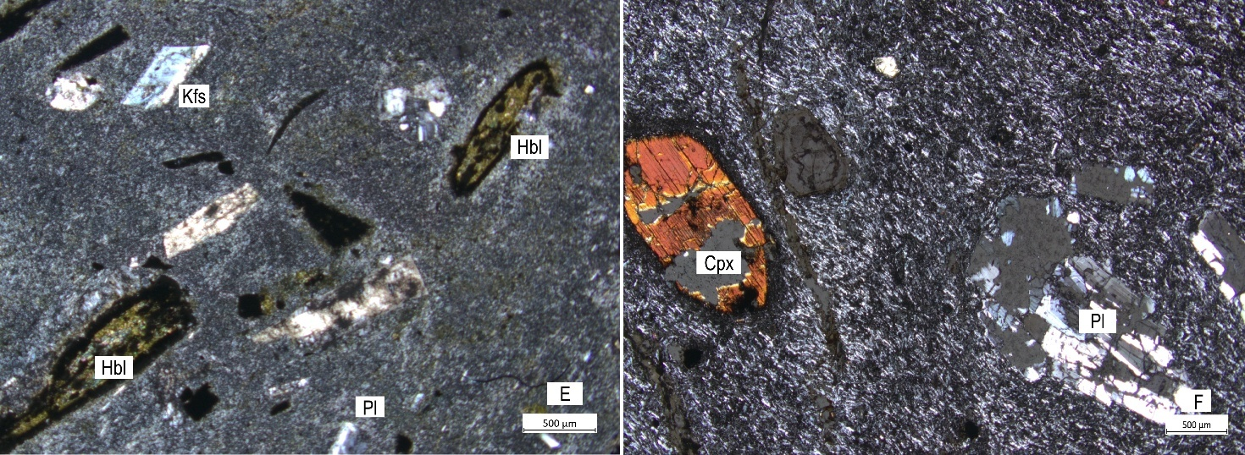
Figure 7. Cross-polarized light (XPL) photomicrographs of volcanic bombs incorporated in the lahar deposit. (a) Sample EC-LT-02. Haüyne basanite. (b) EC-LT-04. Phonolitic tephrite. (c) EC-LT-05. Basalt. (d) EC-LT-06. Nepheline tephrite with clinopyroxene and plagioclase phenocrysts. (e) EC-LT-01. Trachyte with hornblende, K-feldspar, and plagioclase phenocrysts. (f)EC-LT-010. Basanite with clinopyroxene and plagioclase phenocrysts.

  - Geochemical analysis of clasts presents in the Tena lahar

The geochemical dataset compiled by Suntaxi (2023), complemented with two samples from the Sierra Azul volcano (Table 3) reveals that volcanic bombs from the Tena lahar fall into two compositional groups: basic rocks (trachybasalts to tephite-basanites; ~46 wt% SiO₂) and more evolved compositions (trachyte to trachydacite; ~66wt% SiO₂).

Table. 3. Geochemical data of the investigated rocks.
Sample | MOT 2486-14 | MOT 2486-15 | TB | PAM-4-18 | MOT 2550-4 | MOT 2550-5 | MOT 2550-6 | HAL-135 | HAL-136
Type of Rock | volcanic bomb | lahar bomb | lahar bomb | dacite | dacite | vesicular basalt | olivine basalt | lava flow | lava flow
SiO2 | 46.49 | 46.67 | 46.60 | 63.92 | 64.76 | 46.50 | 46.96 | 50.64 | 66.01
TiO2 | 1.53 | 1.53 | 1.33 | 0.58 | 0.62 | 1.51 | 1.52 | 1.06 | 0.43
Al2O3 | 16.96 | 16.87 | 18.84 | 16.85 | 17.05 | 16.75 | 17.11 | 17.89 | 18.21
FeO | 10.47 | 10.40 | 9.81 | 4.66 | 4.20 | 10.46 | 10.09 | 10.54 | 4.22
MnO | 0.20 | 0.20 | 0.29 | 0.11 | 0.09 | 0.20 | 0.20 | 0.20 | 0.07
MgO | 6.66 | 6.69 | 3.90 | 1.54 | 1.30 | 6.61 | 6.39 | 5.73 | 0.43
CaO | 11.64 | 11.55 | 11.71 | 3.99 | 3.19 | 11.47 | 11.31 | 7.82 | 2.62
Na2O | 3.87 | 4.12 | 4.60 | 3.72 | 4.47 | 4.47 | 4.40 | 3.53 | 4.56
K2O | 1.24 | 1.05 | 1.96 | 4.42 | 4.05 | 1.07 | 1.07 | 2.17 | 3.15
P2O5 | 0.94 | 0.94 | 0.97 | 0.20 | 0.26 | 0.96 | 0.94 | 0.42 | 0.30
Total | 100.00 | 100.00 | 100.00 | 100.00 | 100.00 | 100.00 | 100.00 | 100.00 | 100.00
Ni | 68.31 | 68.12 | 12 | 5.5 | 3 | 52 | 49 | 26 | 2
Cr | 192.93 | 195.21 | 17 | 19.0 | 2 | 119 | 125 | 46 | 3
Sc | 35.28 | 35.19 | 11 | 19.0 | 10 | 21 | 21 | 28 | 3
V | 404.69 | 401.81 | 271 | 123.7 | 48 | 274 | 272 | 273 | 28
Ba | 1581.68 | 1597.92 | 1920 | 1178.8 | 1535 | 1404 | 1430 | 657 | 1440
Rb | 77.93 | 105.93 | 122 | 139.2 | 147 | 68 | 95 | 61 | 90
Sr | 2169.13 | 2172.25 | 3373 | 520.7 | 508 | 1873 | 1825 | 843 | 598
Zr | 256.47 | 257.38 | 309 | 374.1 | 250 | 190 | 195 | 64 | 261
Y | 37.00 | 38.37 | 43 | 28.8 | 24,5 | 30.1 | 28.1 | 19 | 19
Nb | 45.70 | 44.44 | 63.1 | 14.9 | 11 | 30 | 32 | 3.8 | 15.1
Ga | 27.69 | 26.82 | 23 | 23.5 | 18 | 22 | 20 | 20 | 20
Cu | 99.54 | 114.22 | 70 | 62.0 | 10 | 85 | 89 | 140 | 3
Zn | 124.14 | 127.64 | 135 | 106.9 | 52 | 103 | 103 | 88 | 81
Pb | 11.17 | 10.39 | 21 | 19.1 | 15 | 11 | 10 | 5 | 16
La | 72.77 | 71.63 | 128 | 32.7 | 31 | 63 | 63 | 14 | 46
Ce | 149.15 | 152.95 | 253 | 69.2 | 62 | 128 | 130 | 35 | 78
Th | 10.12 | 9.69 | 21 | 12.1 | 9 | 8 | 8 | 3 | 12
Nd | 68.95 | 70.33 | 113 | 28.6 | 28 | 56 | 57 | 20 | 34
U | 3.21 | 2.90 | 6 | 3.7 | 3 | 4 | 3 | 2 | 4
From Suntaxi (2023)

This classification follows the scheme of Le Bas et al. (1986), and indicates that the samples are alkaline-rich, with total alkali contents ranging from 5 to 8 wt%. The geochemical data show that most samples fall within the alkaline series, whereas the trachy-dacitic rocks exhibit subalkaline affinities trending toward the alkaline series (Fig. 8a).

Based on the K₂O vs SiO₂ (wt%) diagram, the basic samples belong to the shoshonitic series, similar to the geochemical signatures observed in Ecuadorian back-arc volcanism (Hall et al., 2008). The more evolved samples display high-K calc-alkaline signatures with slight shoshonitic tendencies, as represented in the Peccerillo & Taylor diagram (Fig. 8b).

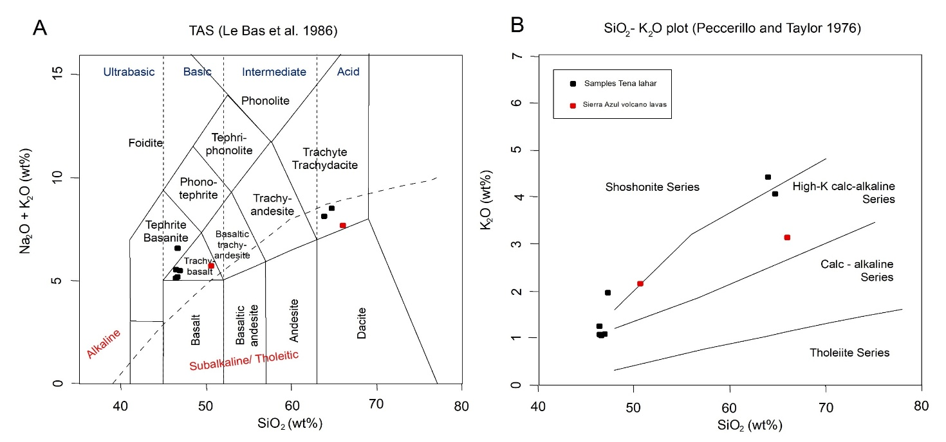
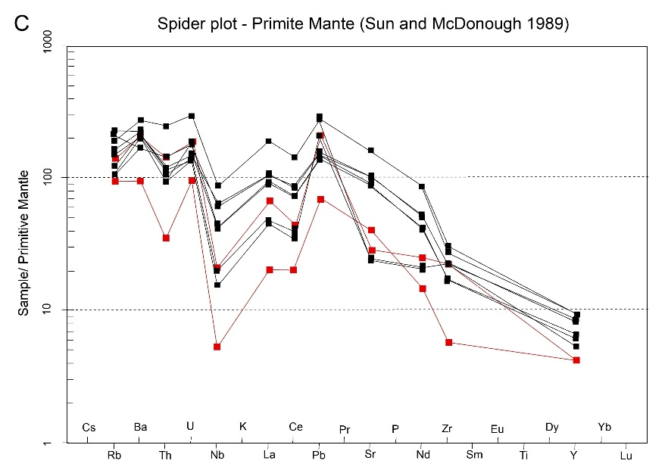
Figure 8. (a) Total alkali vs. silica diagram for rock from the Tena lahar deposit and Sierra Azul volcano lavas (Le Bas et al., 1986), showing compositional fields from basaltic to dacitic. (b) K₂O vs. SiO₂ diagram indicating high-K calc-alkaline geochemical signatures (Peccerillo & Taylor, 1976). (c) Primitive mantle-normalized spider plot for rocks from the lahar deposit and Sierra Azul volcano.

In the rare earth element diagram normalized to primitive mantle by Sun & McDonough (1989), the samples show a enrichment in large-ion lithophile elements (LILE) such as Rb, Ba, and Th, along with a notable depletion in high field strength elements (HFSE) such as Zr, Nb, and Y (Fig. 8c). (Wilson, 1989)The negative Nb anomaly represents a typical signature of magmatism in subduction-related settings where asthenospheric mantle is subducted beneath the continental plate, as proposed by Rollinson (1993).

Overall, volcanic bombs and Sierra Azul lavas exhibit similar geochemical signatures, supporting a genetic link between the Tena lahar deposit and eruptive activity of Sierra Azul volcano. Differences in the degree of differentiation are reflected in slightly lower incompatible elements concentrations in some Sierra Azul lavas.

Harker diagrams reveal systematic trends that are consistent with fractional crystallization processes (Fig. 9). CaO displays a well – define negative correlation with increasing SiO₂, reflecting the early removal of calcic plagioclase from the melt, as also suggested by the abundance of plagioclase phenocrysts observed petrographically. Similarly, MgO and FeOt show decreasing trends, which can be attributed to the crystallization of olivine and titan – augite, both of which occur as phenocryst phases in the analyzed volcanic bombs. TiO₂ also decreases with differentiation, likely relecting the fractionation of titaniferous clinopyroxene and minor Fe Ti oxides. In contrast, Na₂O and K₂O exhibit positive correlations with SiO₂, indicating progressive enrichment of alkalis during magma evolution. This alkali increase is consistent with the presence of feldspathoids (nepheline and haüyne) and sanidine in the more evolved samples, supporting an evolutionary trend from mafic basanites- tephrites toward intermediate trachyandesitic – trachytic compositions.

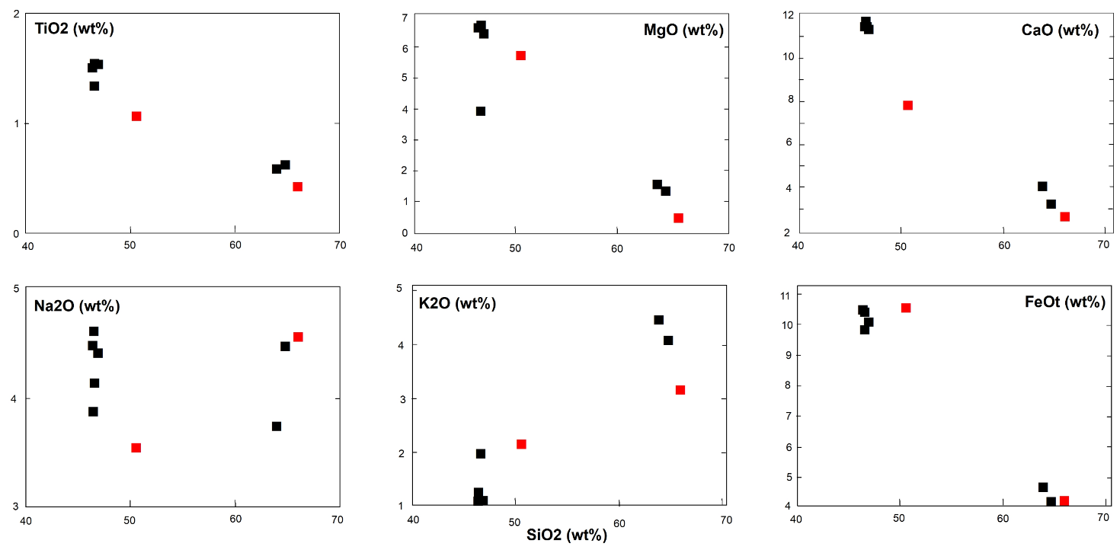
Figure 9. Harker variation diagrams of TiO₂, MgO, CaO, Na₂O, K₂O, and FeOt vs. SiO₂ for rocks from the Tena lahar deposit and lavas of the Sierra Azul volcano, showing similar trends that define two distinct geochemical associations.

Schiano et al. (2010)

  - Radiocarbon dating of samples

To constrain the age of the the Tena lahar deposit, three radiocarbon analyses were conducted using the conventional ¹⁴C method. The first sample, consisting of Chonta (a tropical Amazonian fruit) embedded within the lahar matrix at the Guinea Chimbana, yielded an age of 4336 ± 28 years BP (Table 4). The second sample, 60 grams of wood incorporated in the lahar deposit along the Misahuallí River, returned an age of 4380 ± 30 years BP.. The third sample, a tree branch fragment enclosed in a deposit with similar characteristics to the Tena lahar deposit and exposed along the Jondachi River near its confluence with the Hollín River (outside the study area), yielded an age of 4370 ± 30 years BP.

Suntaxi (2023)

Table 4. Radiometric age (¹⁴C) obtained for the sample Tena lahar deposit
Laboratory Code | Name | Location | UTM – 18 S | Age ¹⁴C  (BP years) | Age calibrada 94.8%  (BP years) |  |  | Age calibrada 94.8%  (BC years)
Direct AMS 047645 | Pano River N1-2022 | Guinea Chimbana Pano River | 184021 9888597 | 4336±28* | 4963-4848* |  |  | 3016-2897*
Beta Analytic INC - 427886 | TENA3-2015 | Misahuallí River | 187510 9892036 | 4380±30⁺ | 4970-4845⁺ |  |  | 3020-2895⁺
*From Suntaxi (2023)
⁺Mothes (2016), not published.

These results are consistent with each other and indicate that the Tena lahar was emplaced during the Middle Holocene, approximately 4400 years BP.

  - Identification of Transport Channels and Flow Mechanisms

The geomorphologicaland lithological analysis of the drainage networks was based on regional geological maps (Instituto Ecuatoriano de Minería, 1986; Litherland et al. 1994; Egüez et al. 2017) complemented by field observations. These sources allowed the identification of potential transport channels and depositional zones of the Tena lahar flow (Fig. 10).

    - Pano/Tena sub-basin

This basin (~240 km²), drains the Sub-Andean foothills and includes the Pano and Tena rivers, which converge in the Tena city. The mapped lithologies comprise granitoids of the Abitagua Batholit, red beds of the Tena Formation, and Paleogene sedimentary units (Tiyuyacu and Chambira Fms). Although lahar deposits are widely exposed along river margins, the limited lithological variability of clasts within these channels-dominated by granitic and sedimentary fragments suggests that the Pano and Tena rivers mainly acted as depositional areas rather than as transport conduits.

    - Misahuallí sub-basin

Covering 332 km2 with a relative relief of 2540m, this is the largest basin in the study area (Fig. 10b). The Misahuallí River flows for 45km before merging with the Tena River and drains the southern flank of the Guacamayos Cordillera and the Sierra Azul volcano.

Lithologies include intrusive rocks of the Abitagua Batholit and sedimentary sequences of the Misahuallí, Napo, and Tena formations. Although the Hollín Formation is not explicitly mapped in this area, the proximity of nearby outcrops suggests it could be present locally. In its upper reaches, the Instituto Ecuatoriano de Minería (1986) documented Holocene-aged volcanic sediments (Cosanga volcano sediments), and Bernard & Andrade (2011) reported the presence of the Azul volcano, further supporting the likelihood of recent volcanic activity in the area (Fig. 11b)

Although continuous lahar deposits have not been preserved along the river, andesitic boulders compatible with the Tena lahar deposit occur near Cotundo and Archidona. Combined with the basin’s lithological diversity and its direct connection to know volcanic centers, these observations support the interpretation that the Misahuallí River was the main transport channel for the Tena lahar flow enabling the movement of large volumes.

    - Jondachi/Hollín sub-basin

This sub-basin (~197 km2) drains Jurassic volcanic rocks (Misahualli Fm), granitoids (Abitagua Batholith) and Cretaceous sedimentary rocks (Napo and Hollín Fm). Volcanoclastic deposits on the northeastern flank of Sierra Azul indicate past volcanic activity (Fig. 10a, 11a). However, the basin’s eastward deflection toward the Hollín River diverts away from the mapped Tena lahar deposits, making it an unlikely transport route for the studied event.
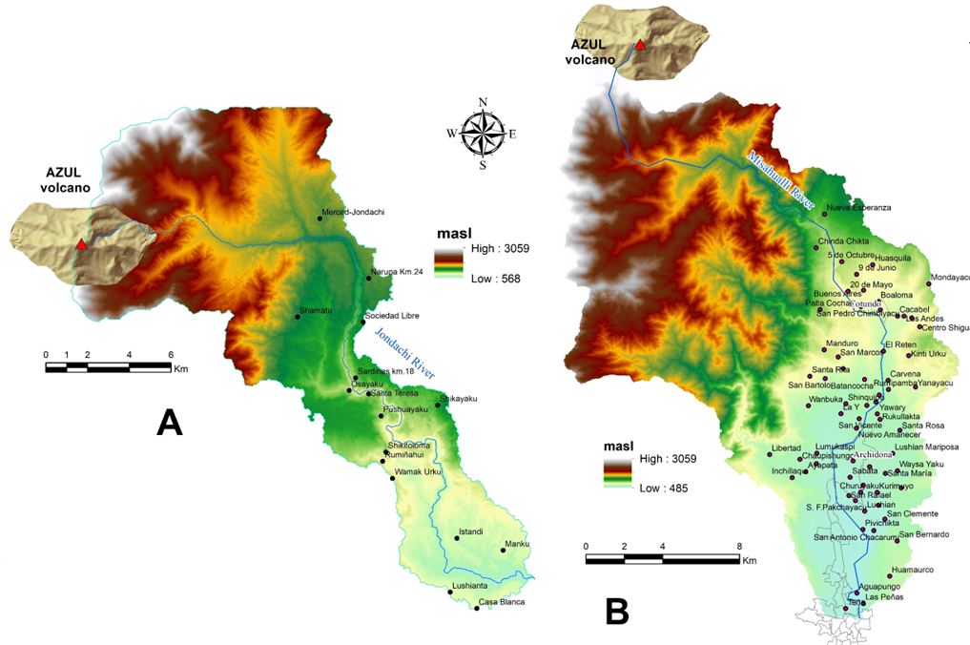
Figure. 10. Relief morphometric features of the sub-basins of the Jondachi (A) and Misahuallí (B) rivers, Sub-Andean Napo Uplift. The maps highlight the main drainage channels flowing eastward from the Azul volcano towards the lower Amazonian foreland.
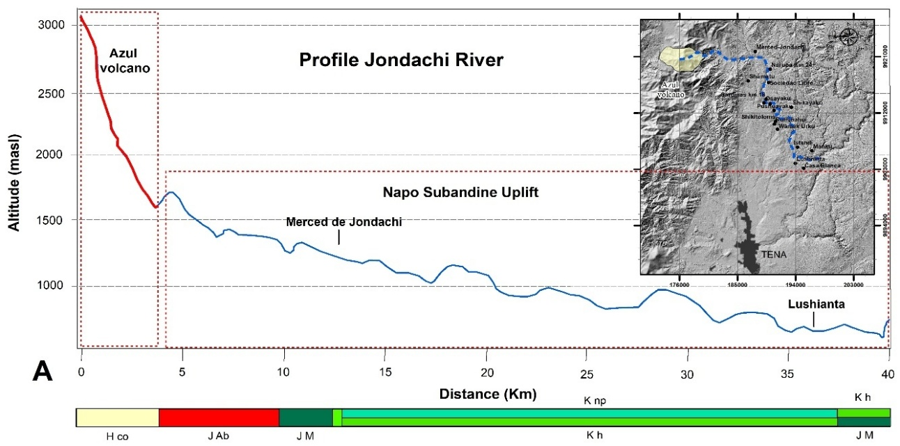
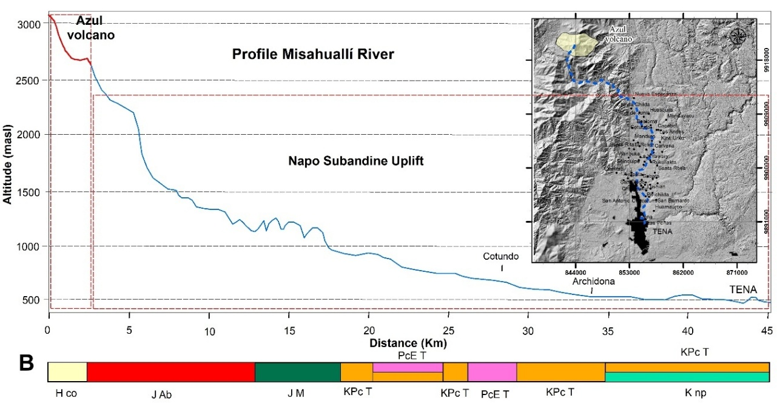
Figure. 11. Diagrams Altitude (m a.s.l) vs. distance (Km) obtenidos de DEM resolution 5- 13m/pixel. Blue and red lines show the longitudinal profile of Jondachi (A) y Misahuallí (B) rivers. The bar located at the bottom of diagram shows the lithological formations crossed by the lahar: Azul volcanics (H_{Co}), Abitagua granitoids (J_{Ab}), Misahuallí Fm. (J_{M}) calc-alkaline lavas and pyroclastics, Tena Fn. (KPc _{T}) red beds, Napo Fm (K_{Np}) black limestone and shales, Hollín Fm (K_{H}) quartz sandstone, Tiyuyacu Fm (PcE_{T}) conglomerates with quartz, sandstones (Instituto Ecuatoriano de Minería, 1986; Egüez et al. 2017).

  - Hydrodynamic modeling of the Tena Lahar flow

Hydrodynamic modeling of the Tena lahar flow was carried out using LAHARZ along the Misahuallí River, considered the main transport channel from the southeastern flank of the Sierra Azul volcano to the mapped depositional areas. Three single-pulse discharge scenarios were simulated (Table 5).

Table 5. Scenarios considered for the simulation of the lahar flow.
Scenarios | Determined volumes (m³) | Volumes for modeling (m³) | Source |  | Colour
Scenario N1 | 64,900,000 | 65,000,000 | Minimum volume estimated from average deposit thickness and mapped area in this study.
Scenario N2 | 91,000,000 | 91,000,000 | Adjusted volume incorporating ~40% adicional water content following rheological parameters for cohesive mudflows (Coussot, 1997)
Scenario N3 | 110,000, 000 | 110,000,000 | Maximum volume proposed by Suntaxi (2023)
Colors were assigned for each scenario performed on the volumes determined

Numerical simulations with LAHARZ indicate that the Tena lahardescended through the Misahuallí River valley, crossing the Abitagua Batholith and entering the Sub-Andean Zone, with deposition beginning near Archidona. In this sector, broad floodplains would have favored sedimentation, consistent with the first lahar outcrops beneath alluvial terraces and its progressive thickening toward Tena city – the main depocenter where the Misahuallí, Tena, and Pano rivers converge (Fig. 12).

Field observations show a local backflow extending upstream from the confluence toward Guinea Chimbana and Peña Colorada, where lahar deposits remain exposed. This indicates lateral expansion of the flow within the accumulation zone. Subsequent fluvial incision and erosion generated terraces with consolidated lahar cores up to 15m high, on which much of northern Tena city is now built.

Numerical simulations reporduce part of the inundated area along the Misahuallí River but fail to match the full extent mapped in the field, particulary upstream along the Tena and Pano rivers. In the maximum-volume scenario (1.1 × 10⁸ m³), the model suggest that the lahar flow could have reached the Napo River near Puerto Misahuallí (Fig. 12). However, no lahar outcrops were observed in this sector, pointing to either model limitations, subsequent erosion, or geomorphic barriers that constrained the flow’s terminal reach.

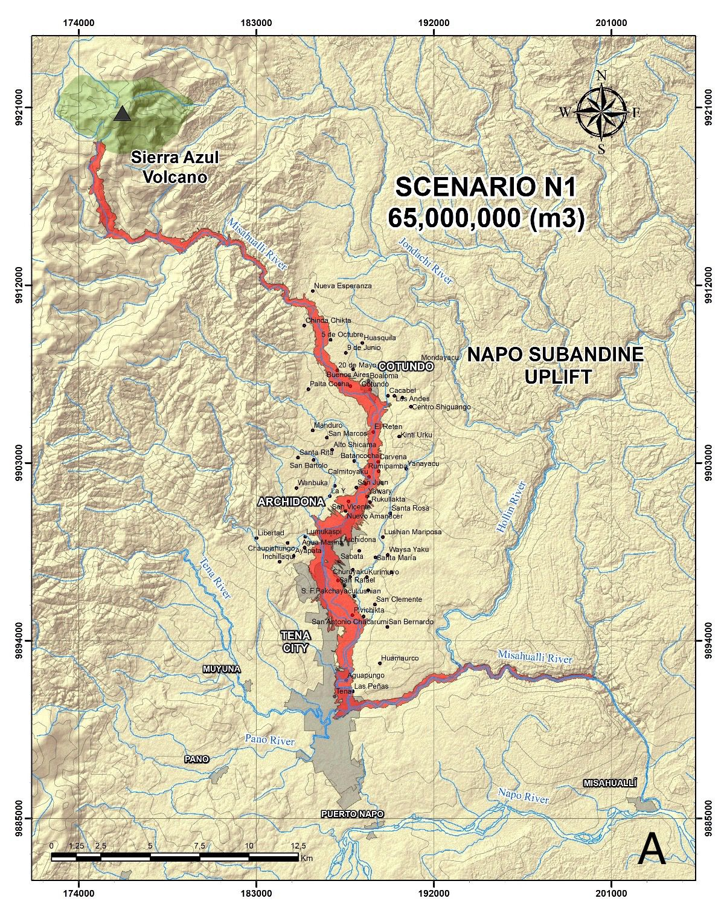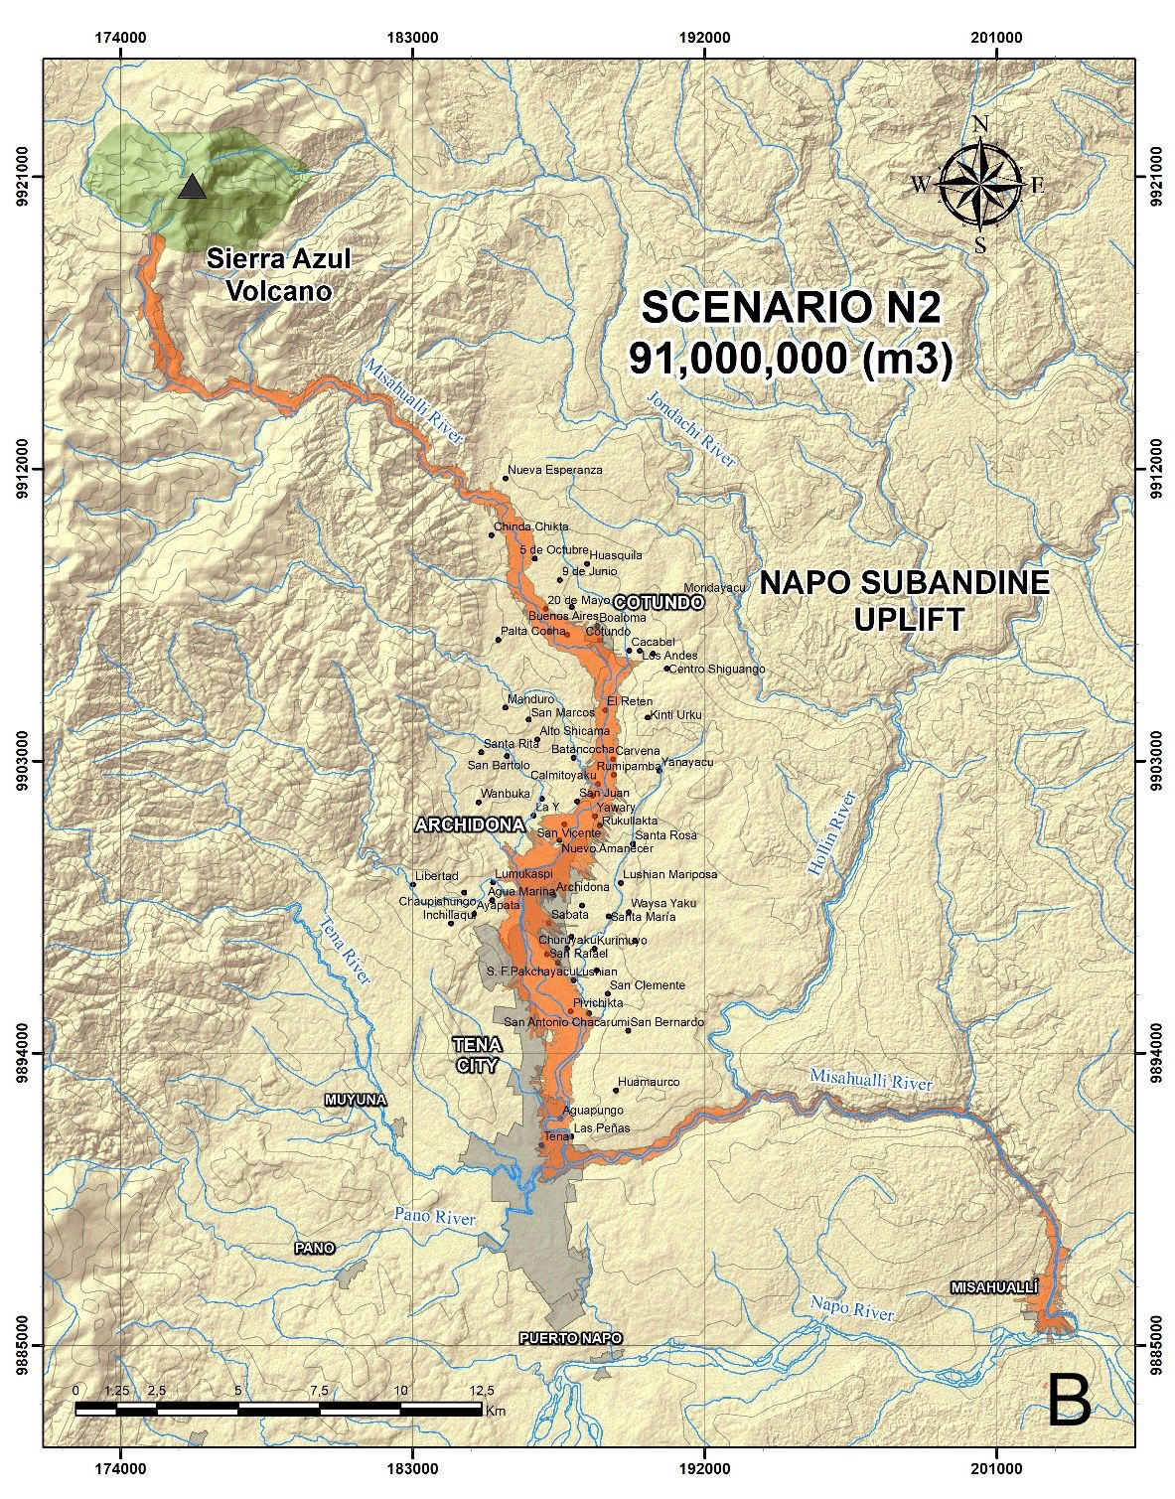
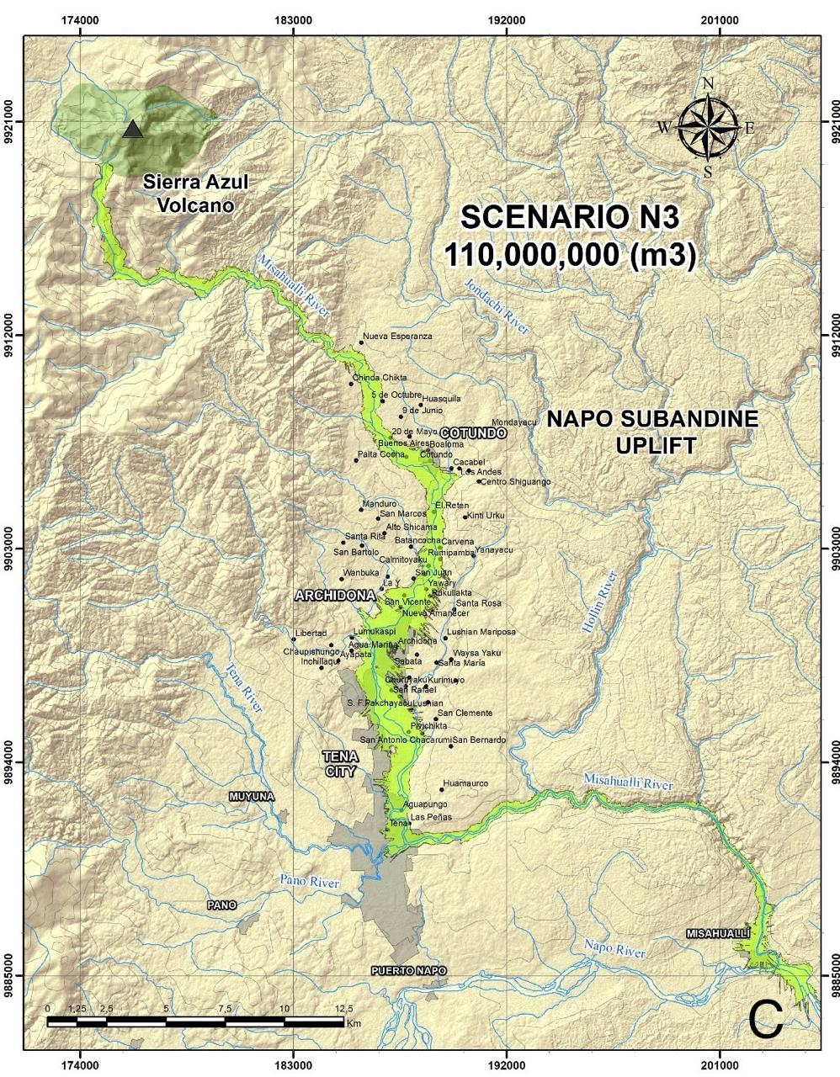 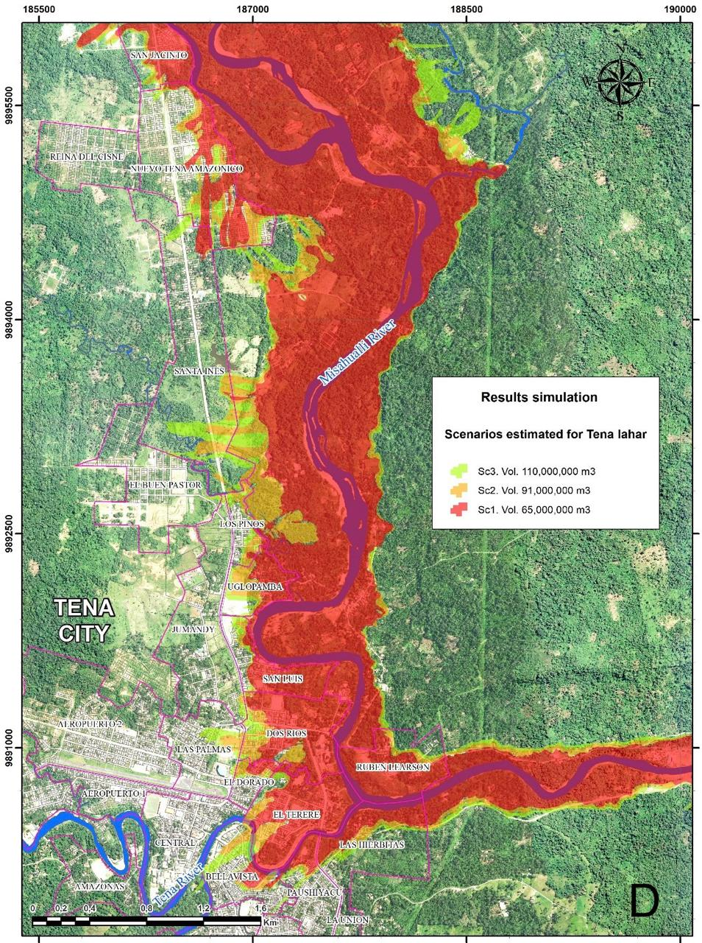
Figure 12. (A, B, C) Results of the lahar flow simulation using the LAHARZ software along the Misahuallí River, based on the three volume scenarios (N1, N2, N3) defined in this study (polygons in red, orange, and green). Urban centers in the study area are shown as black hatched polygons. (D) Scenarios estimated in the Tena city.
The origin of the Tena lahar flow remains uncertain, but the estimated volumes strongly support a scenario of a large-scale gravitational collapse, possibly involving a debris avalanche triggered by structural instability on the flanks of the Sierra Azul volcano. During transit, such a collapse could have incorporated significant amounts of water, favoring the generating of a high-volume lahar flow. Geomorphological evidence in the Misahuallí catchment supports this interpretation: the sector between the volcano and the town of Misahuallí is characterized by steep slopes and narrow canyons of the Sub-Andean Uplift. The absence of continuous lahar deposits along this stretch - except for isolated outcrops near Cotundo – suggests rapid downstream transport with limited intermediate sedimentation.

Based on the quantitative parameters obtained in this study and the classification proposed by Pierson (1998), the Tena lahar qualifies as an extremely large flow, with a volume exceeding 1.0x10⁸ m³. This classification provides a framework for inferring its dynamic behavior. The runout distance, measured from the proposed source area on the flanks of the Sierra Azul volcano to the depositional zone in Tena, is 45.2 km. From this distance, the travel time of the lahar flow is estimated at 40 and 50 minutes based on the T-L plot (Pierson, 1998) (Fig. 13a). Furthermore, the logarithmic relationship between lahar volume and peak discharge rates proposed by Pierson (1998) indicate that the modeled volumes correspond to single-pulse discharges of 40,000 to 100,000 m³/s (Fig. 13b). These values are consistent with catastrophic lahars described in other volcanic settings worldwide and highlight the high mobility and destructive potential of the Tena lahar.

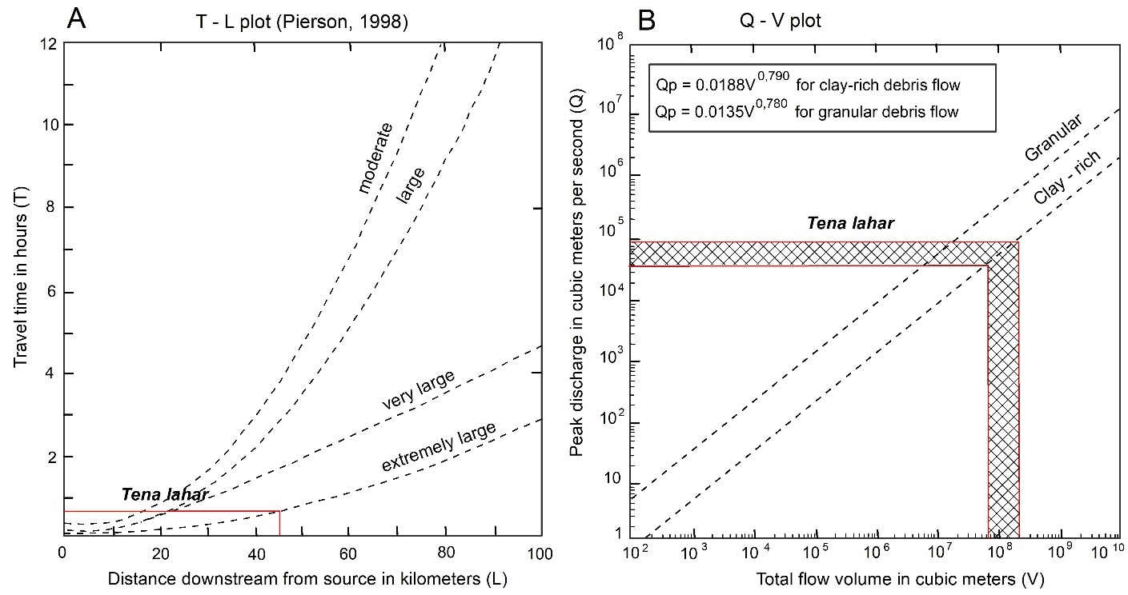
Figure 13. (A) Travel time–distance (T–L) relationship of the Tena lahar plotted on the diagram proposed by Pierson (1998), showing its classification as an extremely large-magnitude flow. (B) Peak discharge–volume (Q–V) relationship of the Tena lahar plotted on the diagram of Pierson et al. (1998), with regression lines from Mizuyama et al. (1992), indicating possible peak discharge values in the range of 4 × 10⁴ to 1 × 10⁵ m³/s.

- Discussion

This study integrates stratigraphic, geomorphological, geochemical, and modeling evidence to reconstruct the origin and dynamics of the Tena lahar flow, associated with Sierra Azul volcano. Field surveys confirm that the lahar deposit is laterally continuous and reaches thicknesses exceeding 15 m in the northern sector of Tena, where the confluence of the Misahuallí, Tena, and Pano rivers acted as the main accumulation zone. Such dimensions indicate that the event was of exceptional magnitude and had a lasting impact on the regional landscape.

Numerical simulations with LAHARZ, combined with field mapping, indicate that the Misahuallí River funcionated as the principal transport channel for the lahar flow, draining the southern flank of Sierra Azul. Empirical relationships corroborate these results, supporting a runout distance ~45 km from the source area to the depositional zone. This mobility was facilitated by steep topographic gradients across the Sub-Andean Uplift and by the incorporation of abundant water, likely sourced from rainfall, surface runoff, or both.

The flow’s high erosive power and transport capacity are evidenced by the presence of granite boulders exceeding 5 m, derived from the Abitagua Batholith. Their entrainment impliesextreme hydraulic conditions along the Misahuallí River and supports the interpretation of a highly cohesive, water-saturated flow. These observations correlate with modeled peak discharge rates of 40,000 and 100,000 m³/s, values that fall within the range excepted for extremely large lahars according to Pierson (1998).

Petrographic and geochemical evidence further indicate that the incorporated volcanic bombs originated from magmas with both subalkaline and alkaline affinities. The high vesicularity and phenocryst content (>4 mm) suggest explosive eruptive dynamics, providing complementary insight into the eruptive environment that contributed juvenile material to the lahar.

Geochemical comparisons demonstrate that the clasts incorporated in the Tena lahar share compositions with lava flows from Sierra Azul volcano. Classification diagrams (Le Bas et al., 1986; Peccerillo & Taylor, 1976; Sun & McDonough, 1989) indicate that the rocks belong to high-K calc-alkaline and alkaline series, a signature typical of subduction-related magmatism in the Northern Andes..

Harker diagrams suggest a magmatic evolution dominated by fractional crystallization and crustal contamination.The similarity of these geochemical trends in both volcanic bombs and Sierra Azul lavas strongly supports a genetic relationship, reinforcing the interpretation that Sierra Azul was the source volcano for the Tena lahar.

The presence of pumice and bread-crust-textured bombs within the lahar matrix points to a Vulcanian-type explosive eruption, involving the fragmentation of silica-rich, viscous magma. Such eruptive activity may have destabilized the volcanic edifice, generating a high-magnitude debris flow that was later remobilized as a lahar flow.

Lahar flow modeling along the Misahuallí River suggests that, depending on the initial volume and water content, the flow could have traveled significant distances (>45 km), potentially reaching the Napo River. However, the absence of Tena lahar deposit exposures between Tena and Puerto Misahuallí suggests flow loss due to sedimentation/erosion, or geomorphic confinement. The observation of a local backflow upstream supports the interpretation of exceptionally high flow energy..

This study estimates travel times of 40 – 50 minutes for a 45 km distance from the source to Tena city, based on empirical relationship proposed by Pierson (1998). However, these values should be regarded as minimum, since factors such as channel morphology, flow discharge and water content may produce significant variations. Comparisons with well documented lahars at Nevado del Ruiz (1985), Mount St. Helens (1980), and Pinatubo (1991) indicate mean velocities of 30 – 40 km/h (Voight, 1990; Pierson, 1985; Pierson et al., 1992), corresponding to travel times of 68-90 minutes over equivalent distances.

Discrepancies between LAHARZ simulation result and the mapped extent of the lahar deposit along the Tena and Pano Rivers may reflect significant post-event topographic modifications that altered the original relief, as well as limitations of the present-day digital elevation model (DEM) used as input. These differences highlight the need to develop more refined models that consider past geomorphological conditions, especially in areas affected by large-scale volcanic sedimentation.

- Conclusions

- The Tena lahar deposit represents an exceptionally large volcanic event, classified as "extremely large" following Pierson (1998), with an estimated volume exceeding 1x10⁸ m³ . These values place it among the largest lahars documented in the Ecuadorian Amazon, comparable in magnitude to the 1877 Cotopaxi lahars, (Mothes et al., 2004). This correlation underscores the need to integrate similar scenarios into volcanic hazard assessments and risk management planning in the Amazonian foothills, where population exposure is high.

- Integrated geomorphological, lithological, and stratigraphic evidence supports the Misahuallí River as the most probable transport channel for the Tena lahar flow. This is based on (a) Itsdirect connection with the southern flank of the Sierra Azul volcano, identified as the likely source; (b) a steep altitudinal gradient enabling high-energy transport; (c) the presence of lithic fragments matching those within the lahar deposit; and (d) its geographic orientation linking volcanic source areas to the mapped depositional zone. These observations, together with numerical simulations, confirm the Misahuallí River as the primary conduit for the Tena lahar.

- Petrographic and geochemical analysis of volcanic bombs and Sierra Azul lava flows reveal a magmatic evolution dominated by fractional crystallization, with contributions from crustal contamination and mantle input. The affinity with alkaline series magmatism is consistent with back arc settings in the Northern Andes.

- The most plausible origin of the Tena lahar involves a Vulcanian-type explosive eruption that destabilized the steep flanks of Sierra Azul, generating a debris avalanche subsequently transformed into a cohesive, water-rich lahar. This mechanism best explains the observed volume, textural features, and transport efficiency of the deposit.

- Limitations of LAHARZ simulations emphasize the need to refine DEM resolution and geological mapping inputs, particularly in remote areas of Sierra Azul. Notably, during fieldwork deposits with similar characteristics were observed along the Jondachi River on the volcano’s eastern flank, with radiocarbon ages matching those of the Tena lahar, suggestiong a broader of synchronous events.

- These findings have direct implications for volcanic risk management in the Ecuadorian Amazon. Large-scale lahars like the Tena event are capable of impacting densely populated areas, highlighting the urgency of incorporating such scenarios into contingency planning and land-use policies for Napo Province.

Acknowledgments
The main author thanks the Secretaría Nacional de Gestión de Riesgos, colleagues for fieldwork assistance, Pedro Espín Bedón for his constructive review and Ernesto Yánez for his support in managing related to the microscopic description. Appreciation is extendedto the Escuela Politécnica Nacional – Faculty of Geology and Petroleum Engineering for access to the micropetrography facilities. Special thanks to Liss “Daterra” Álvarez for her motivation and assistance, particularly in figure preparation.

Declarations
Ethical Approval
Not applicable
Funding
This research received no specific grant from any funding agency in the public, commercial, or not for profit sectors.
Availability of data and material
The datasets generated and/or analyzed during the current study are available from the corresponding author upon reasonable request.
Authors contributions
EC: Conceptualization, Investigation, Fieldwork (geological mapping), Petrographic, Geochemical and Radiocarbon analyses, Flow simulations, Resources, Supervision, and Writing – original draft.
PM: Conceptualization, Investigation, Fieldwork (geological mapping), Resources, and Supervision.
BS: Investigation, Fieldwork (geological mapping), Petrographic, and Radiocarbon analyses.
JE: Investigation, Fieldwork (geological mapping), and Resources.
Conflicts of interest/Competing interests
The authors declare no competing interests.
Code availability
Not applicable

References
Barberi, F., Coltelli, M., Ferrara, G., Innocenti, F., Navarro, J. M., & Santacroce, &r. (1988). Plio-Quaternary volcanism in Ecuador. In Geol. Mag (Vol. 125). http://journals.cambridge.org
Barnes, J. W. ., & Lisle, R. J. . (2007). Basic geological mapping (Fourth edition). Wiley.
Bernard B, & Andrade S. (2011). Volcanes Cuaternarios del Ecuador Continental. https://doi.org/http://dx.doi.org/10.13140/RG.2.1.3851.3683
Egüez, A., Gaona, M., & Albán Andrea. (2017). Mapa geológico de la República del Ecuador escala 1: 1 000 000.
Garrison, J. M., Sims, K. W. W., Yogodzinski, G. M., Escobar, R. D., Scott, S., Mothes, P., Hall, M. L., & Ramon, P. (2018). Shallow-level differentiation of phonolitic lavas from Sumaco Volcano, Ecuador. Contributions to Mineralogy and Petrology, 173(1). https://doi.org/10.1007/s00410-017-1431-4
Hall, M. L., Samaniego, P., Le Pennec, J. L., & Johnson, J. B. (2008). Ecuadorian Andes volcanism: A review of Late Pliocene to present activity. Journal of Volcanology and Geothermal Research, 176(1), 1–6. https://doi.org/10.1016/j.jvolgeores.2008.06.012
Hall, M., & Mothes, P. (2008). The rhyolitic-andesitic eruptive history of Cotopaxi volcano, Ecuador. Bulletin of Volcanology, 70(6), 675–702. https://doi.org/10.1007/s00445-007-0161-2
Instituto Ecuatoriano de Minería (DGGM). (1982). Hoja geológica Tena - escala 1 100.000.
Iverson, R., Schilling, S., & Vallance, J. (1998). Objetive delineation of lahar inundation hazard zones. Geological Society of America Bulletin, 110, 972–984.
Kellogg, J. N., Vega, V., Stailings, T. C., & Aiken, C. L. V. (1995). Tectonic development of Panama, Costa Rica, and the Colombian Andes: Constraints from Global Positioning System geodetic studies and gravity. Geological Society of America, Special Paper 295, 75–90. https://doi.org/http://dx.doi.org/10.1130/SPE295-p75
Le Bas, M. J., Le Maitre, R. W., Streckeisen, A., & Zanettin, B. (1986). A Chemical Classification of Volcanic Rocks Based on the Total Alkali-Silica Diagram. Journal of Petrology, 27, 745–750. http://petrology.oxfordjournals.org/
Litherland, M., Aspden, J., & Jemielita, R. (1994). The metamorphic belts of Ecuador. In Overseas Memoir of the British Geological Survey (11th ed., pp. 1–147).
Miall, A. D. (2006). The Geology of Fluvial Deposits. Sedimentary Facies, Basin Analysis, and Petroleum Geology 4th corrected printing (Springer Berlin Heidelbereg, Ed.).
Mothes, P. A., & Vallance, J. W. (2015). Lahars at Cotopaxi and Tungurahua Volcanoes, Ecuador: Highlights from Stratigraphy and Observational Records and Related Downstream Hazards. In Volcanic Hazards, Risks and Disasters (pp. 141–168). Elsevier Inc. https://doi.org/10.1016/B978-0-12-396453-3.00006-X
Mothes, P., Minard, ·, Hall, L., Andrade, D., Samaniego, P., Pierson, T. C., Gorki Ruiz, · A, & Yepes, H. (2004). Character, stratigraphy and magnitude of historical lahars of Cotopaxi Volcano (Ecuador). Acta Vulcanológica, 16 (1-2), 85–108.
Peccerillo, A., & Taylor, S. R. (1976). Geochemistry of Eocene Calc-Alkaline Volcanic Rocks from the Kastamonu Area, Northern Turkey. In Contrib. Mineral. Petrol (Vol. 58).
Pettijohn, F. J., Potter, P. E., & Siever, R. (1987). Sand and Sandstone. In Sand and Sandstone (Second Edition). Springer New York. https://doi.org/10.1007/978-1-4612-1066-5
Pierson, T. C. (1998). An empirical method for estimating travel times for wet volcanic mass flows. Bulletin of Volcanology, 60(2), 98–109. https://doi.org/10.1007/s004450050219
Pierson, T. C. (2007). Hyperconcentrated flow — transitional process between water flow and debris flow. In Debris-flow Hazards and Related Phenomena (pp. 159–202). Springer Berlin Heidelberg. https://doi.org/10.1007/3-540-27129-5_8
Rollinson, H. (1993). Using Geochemical Data: Evaluation, presentation, interpretation (Cambridge University Press, Ed.; 1st Edition). Routledge. https://doi.org/https://doi.org/10.4324/9781315845548
Salgado J. (2019). Estudio de los Depósitos Volcánicos desde el Pleistoceno superior del volcán Sumaco, provincias de Napo y Orellana. Escuela Politécnica Nacional.
Santamaría, S. D., Bablon, M., Quidelleur, X., & Hidalgo, S. (2023). Geocronología y evolución del arco volcánico Cuaternario del Ecuador: nuevos avances por el método K-Ar (técnica Cassignol-Gillot). XI Congreso Ecuatoriano de Geología, Minas, Petróleo y Ambiental. https://www.researchgate.net/publication/371853684
Sun, S. S., & McDonough, W. F. (1989). Chemical and isotopic systematics of oceanic basalts: Implications for mantle composition and processes. Geological Society Special Publication, 42(1), 313–345. https://doi.org/10.1144/GSL.SP.1989.042.01.19
Suntaxi Chillogalli, B. (2023). Determinación del origen y las características del lahar “Tena”, provincia de Napo. Escuela Politécnica Nacional.
Trenkamp, R., Kellogg, J. N., Freymueller, J. T., & Mora, H. P. (2002). Wide plate margin deformation, southern Central America and northwestern South America, CASA GPS observations. Journal of South American Earth Sciences, 15, 157–171. www.elsevier.com/locate/jsames
United States Department of Agriculture. (1949). Munsell Soil Color Charts.
Vallance, J. W., & Iverson, R. M. (2015). Lahars and Their Deposits. In The Encyclopedia of Volcanoes (pp. 649–664). Elsevier. https://doi.org/10.1016/B978-0-12-385938-9.00037-7

Figure caption listing

Fig. 1 Distribution of the Ecuadorian continental volcanic arc and major tectonic lineaments (red lines). Modified from Bernard B. & Andrade S. (2011). Location of the study area within the back-arc volcanism belt (red circle).
Fig. 2 Representative field exposures of the Tena lahar deposit. (A) Sub – meter sized volcanic blocks embedded in the lahar matrix, Pano River (UTM: 185735–9888733). (B) Tree trunks preserved within the massive matrix-supported deposit,San Jorge outcrop along the Pano River. (C) Stratigraphic profile showing the Tena lahar deposit interbedded with local lithostratigraphic units, the Tena–Archidona highway (UTM: 187048–9893043). (D) Lahar deposit exposed at the Guinea Chimbana(UTM: 184019–9888612), underlying post-depositional alluvial sediments from the Pano River.
Fig. 3 Key characteristics of the Tena lahar. (a) San Jorge sector, Pano River. Massive structure of the Tena lahar (facies Gmm) containing sandstone clasts derived from the Hollín FormationFm. (b) San Jorge sector, Pano River. Volcanic deposit incorporating shale clasts from the Napo FormationFm. (c) Aguapungo sector, Misahuallí River. Matrix-supported volcanic deposit with subangular andesite clasts of centimetric size. (d) Aguapungo sector, Misahuallí River. Tena lahar deposit containing cobbles and boulders with poorly defined shape. (e) San Jorge sector, Pano River. Lahar deposit with polymictic clasts and wood fragments supported within a sandy–clayey matrix. (f) San Jorge sector, Pano River. Matrix-supported massive structure of the Tena lahar deposit including subrounded granite clasts derived from the Abitagua Batholith..
Fig. 4 Exposure of the Tena lahar deposit along the Archidona–Tena Road, showing its stratigraphic relationships with the surrounding lithological units. A boulder accumulation at the base of the deposit suggests recirculation and interaction of the largest solid particles within the flow, which could have generated additional kinetic energy facilitating the lahar's transport..
Fig. 5 Stratigraphic relationships of the Tena lahar deposit in the study area. From left to right: IESS Hospital, San Jorge, Las Sogas, Tena boardwalk, Tena–Archidona Avenue, and Aguapungo sections.
Fig. 6 Geological map of the study area showing the extent of the Tena lahar deposit. For better visualization, the overlying Quaternary alluvial terraces have been omitted from the map.
Fig. 7 Cross-polarized light (XPL) photomicrographs of volcanic bombs incorporated in the lahar deposit. (a) Sample EC-LT-02. Haüyne basanite. (b) EC-LT-04. Phonolitic tephrite. (c) EC-LT-05. Basalt. (d) EC-LT-06. Nepheline tephrite with clinopyroxene and plagioclase phenocrysts. (e) EC-LT-01. Trachyte with hornblende, K-feldspar, and plagioclase phenocrysts. (f)EC-LT-010. Basanite with clinopyroxene and plagioclase phenocrysts.

Fig. 8 (a) Total alkali vs. silica diagram for rock from the Tena lahar deposit and Sierra Azul volcano lavas (Le Bas et al., 1986), showing compositional fields from basaltic to dacitic. (b) K₂O vs. SiO₂ diagram indicating high-K calc-alkaline geochemical signatures (Peccerillo & Taylor, 1976). (c) Primitive mantle-normalized spider plot for rocks from the lahar deposit and Sierra Azul volcano.
Fig. 9 Harker variation diagrams of TiO₂, MgO, CaO, Na₂O, K₂O, and FeOt vs. SiO₂ for rocks from the Tena lahar deposit and lavas of the Sierra Azul volcano, showing similar trends that define two distinct geochemical associations.

Fig. 10 Relief morphometric features of the sub-basins of the Jondachi (A) and Misahuallí (B) rivers. Sub-Andean Napo Uplift. The maps highlight the main drainage channels flowing eastward from the Azul volcano towards the lower Amazonian foreland.
Fig. 11 Diagrams Altitude (m a.s.l) vs. distance (km) obtenidos de DEM resolution 5 - 13m/pixel. Blue and red lines show the longitudinal profile of Jondachi (A) y Misahuallí (B) rivers. The bar located at the bottom of diagram shows the lithological formations crossed by the lahar: Azul volcanics (H_{Co}), Abitagua granitoids (J_{Ab}), Misahuallí Fm. (J_{M}) calc-alkaline lavas and pyroclastics, Tena Fn. (KPc _{T}) red beds, Napo Fm (K_{Np}) black limestone and shales, Hollín Fm (K_{H}) quartz sandstone, Tiyuyacu Fm (PcE_{T}) conglomerates with quartz, sandstones (Instituto Ecuatoriano de Minería, 1986; Egüez et al., 2017).
Fig. 12 Results of the lahar flow simulation using the LAHARZ software along the Misahuallí River, based on the three volume scenarios defined in this study (polygons in red, orange, and green). Urban centers in the study area are shown as black hatched polygons.
Fig. 13 (A) Travel time–distance (T–L) relationship of the Tena lahar plotted on the diagram proposed by Pierson (1998), showing its classification as an extremely large-magnitude flow. (B) Peak discharge–volume (Q–V) relationship of the Tena lahar plotted on the diagram of Pierson et al. (1998), with regression lines from Mizuyama et al. (1992), indicating possible peak discharge values in the range of 4 × 10⁴ to 1 × 10⁵ m³/s.
Table caption listing
Table 1 Location of outcrops and quantitative parameter estimates of the Tena lahar deposit.
Table 2 Microscopic description of volcanic bombs embedded incorporated in the Tena lahar deposit
Table 3 Geochemical data of the investigated rocks.
Table 4 Radiometric age (¹⁴C) obtained for the sample Tena lahar deposit

Table 5 Scenarios considered for the simulation of the volcanic lahar flow

