Genome-wide association study-based identification genes influencing agronomic traits in rice (Oryza sativa L.)
Aijun Wang^{1,2,3}, Xinyue Shu^{1,2,3}, Yuqi Jiang^{1,2,3}, Li Ma^{1,2,3}, Xiaomei Jia², Xiaoying Ye², Qiming Deng^{2,3}, Shuangcheng Li^{1,2,3}, Shiquan Wang^{2,3}, Jun Zhu^{2,3}, Yueyang Liang^{2,3}, Ting Zou^{1,2,3}, Lingxia Wang^{2,3}, Jianqing zhu², Ping Li^{1,2,3*}, Aiping Zheng^{1,2,3*}
¹State Key Laboratory of Crop Gene Exploration and Utilization in Southwest China, Chengdu, China
²Rice Research Institute of Sichuan Agricultural University, Chengdu, China
³Key laboratory of Sichuan Crop Major Disease, Sichuan Agricultural University, Chengdu, China
*Author to whom correspondence should be addressed:
Prof Ping Li, liping6575@163.com
Prof Aiping Zheng, apzh0602@gmail.com

Supplementary Figure

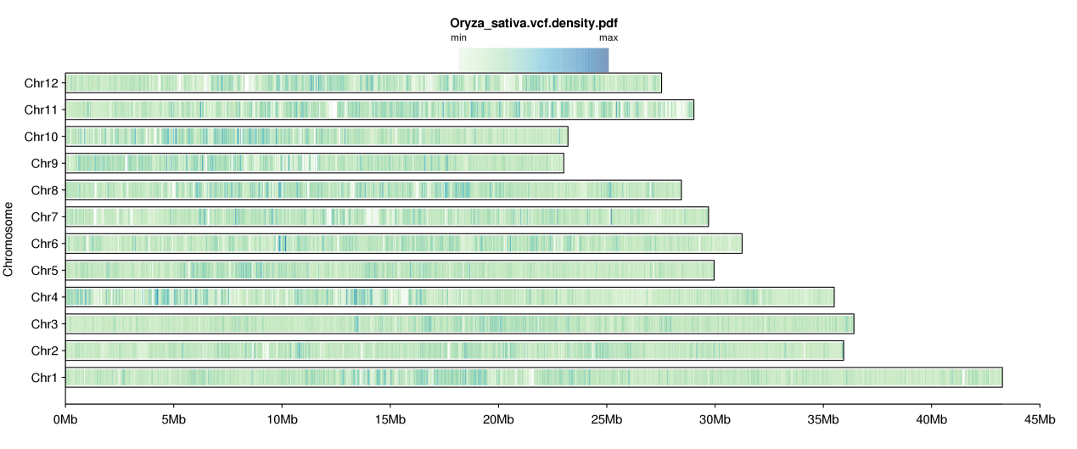
Supplementary Figure S1 Distribution of single nucleotide polymorphisms (SNPs) and nucleotide diversity across the rice Nipponbare genome in the rice association panel.

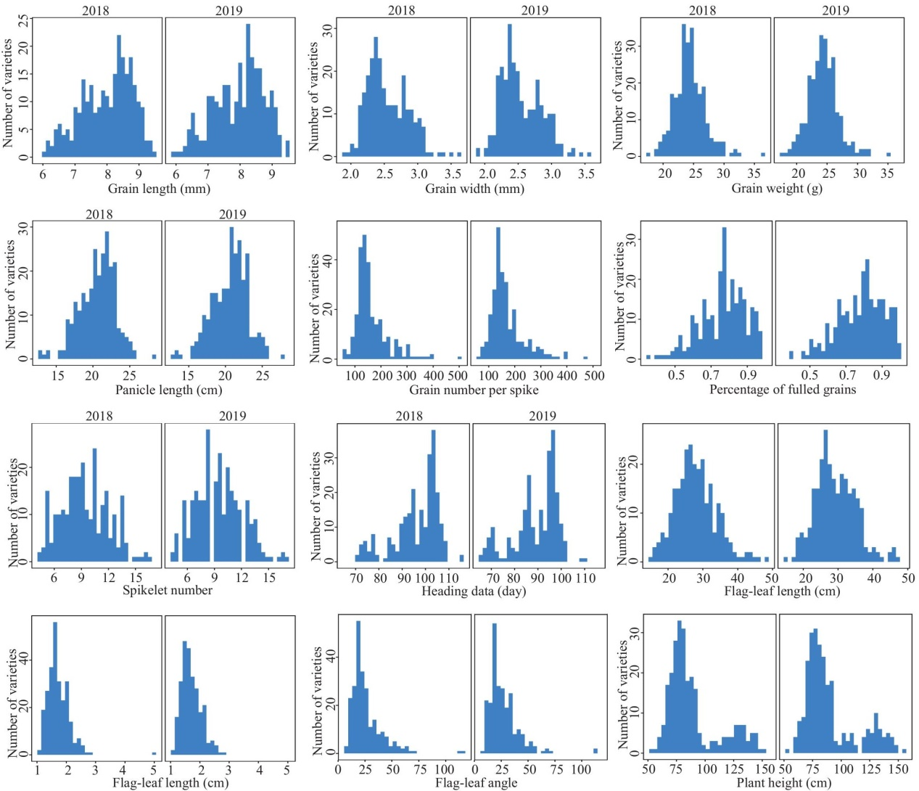

Supplementary Figure S2 Histograms showing the data distribution of 12 traits of 259 rice lines.

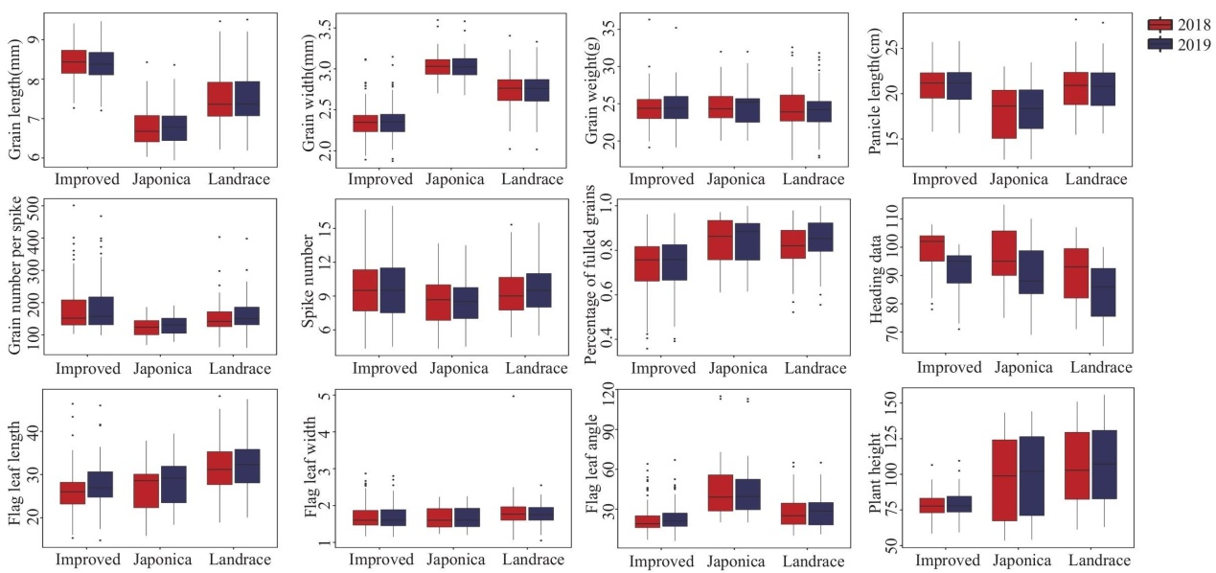
Supplementary Figure S3 Box-plots showing the phenotype data of 13 traits of three rice subgroup.
A
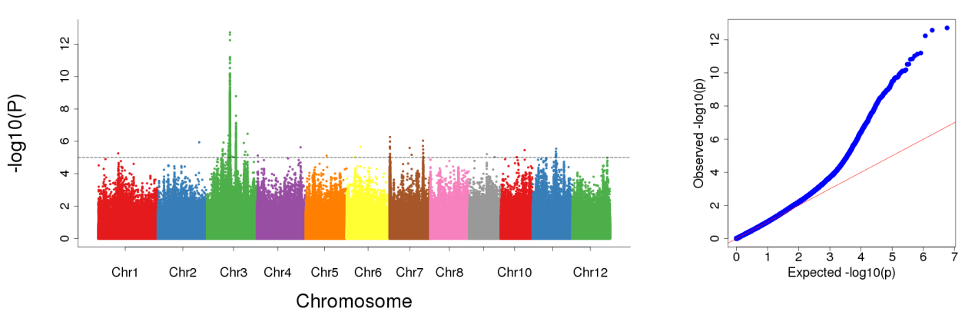

B
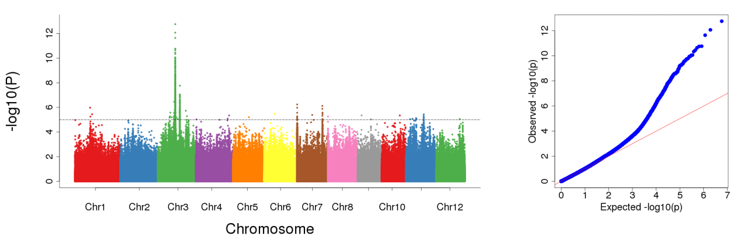

C

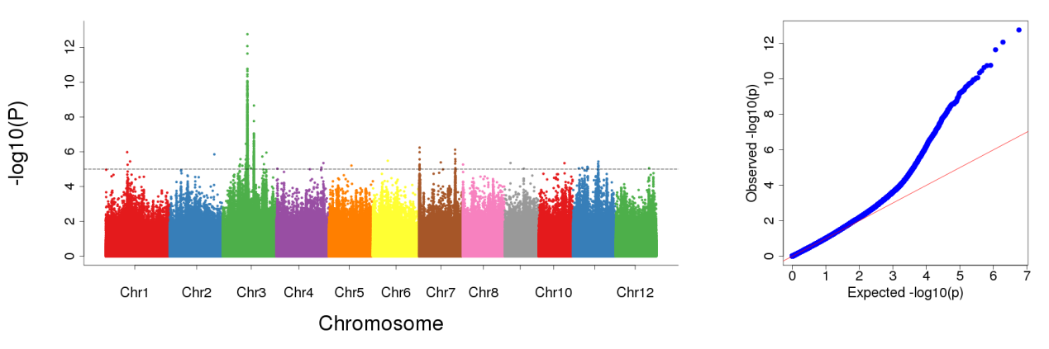

Supplementary Figure S4 Manhattan plots and QQ plots resulting from the SNP-based GWAS for grain length. A: BLUP value; B: 2018; C: 2019.

A
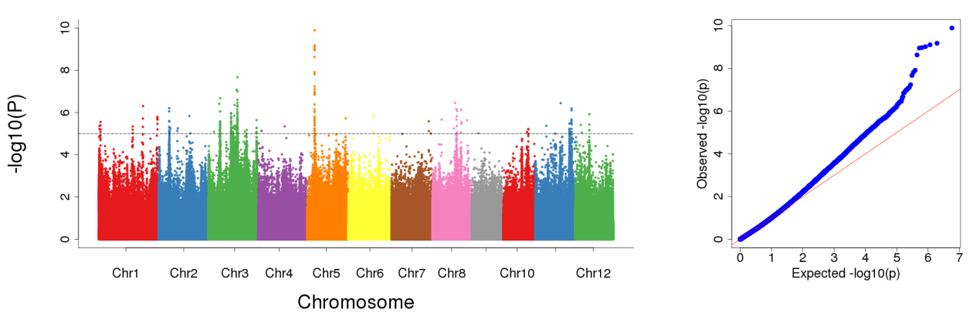

B
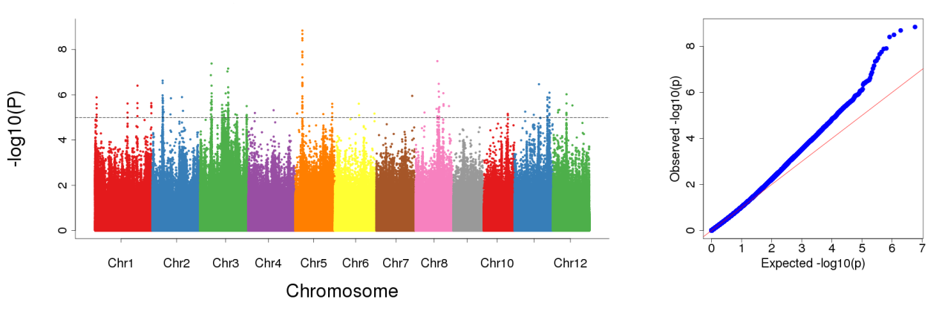

C
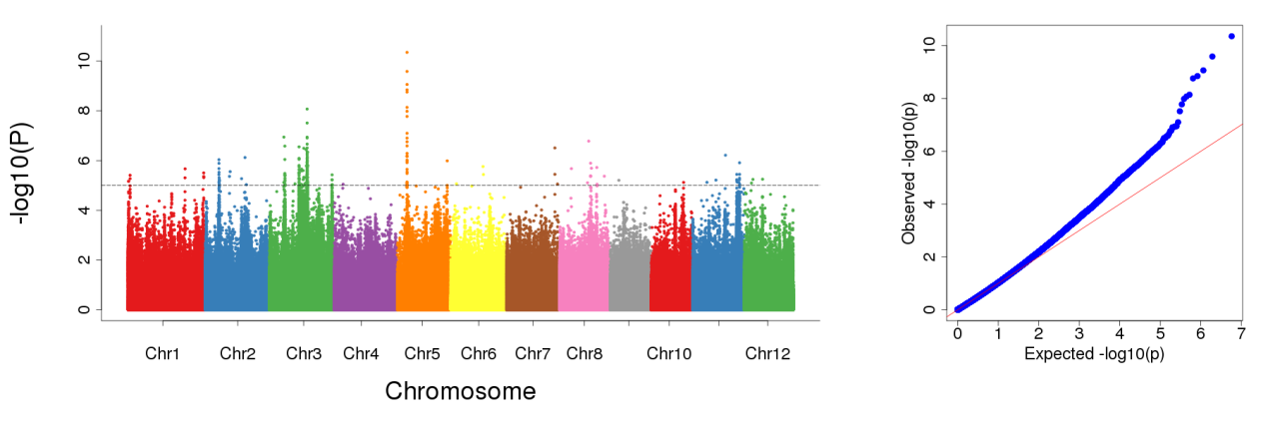

Supplementary Figure S5 Manhattan plots and QQ plots resulting from the SNP-based GWAS for grain width. A: BLUP value; B: 2018; C: 2019.

A
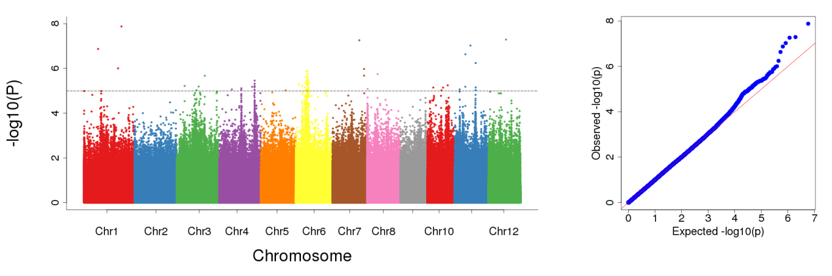
B
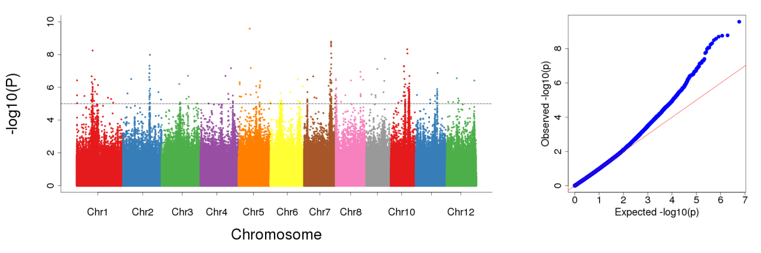
C
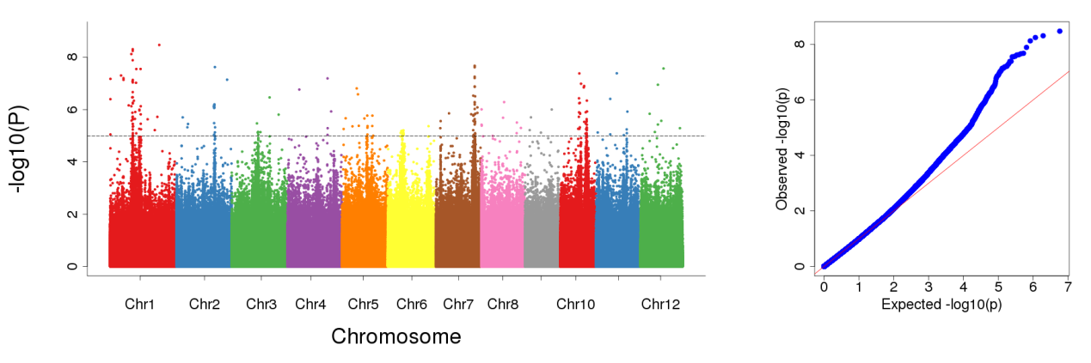
Supplementary Figure S6 Manhattan plots and QQ plots resulting from the SNP-based GWAS for grain weight. A: BLUP value; B: 2018; C: 2019.

A
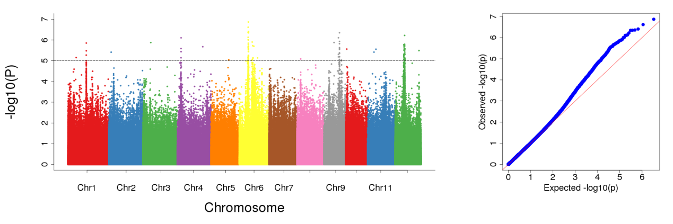
B
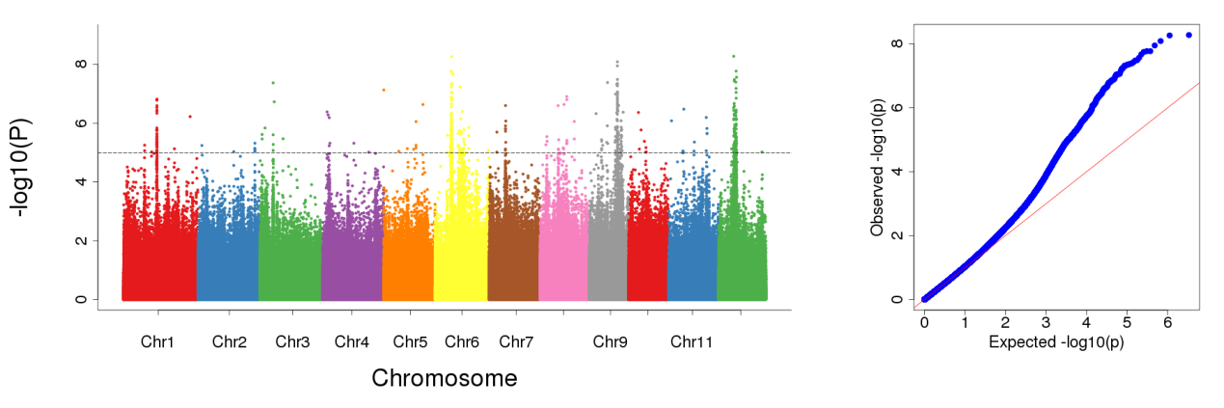
C
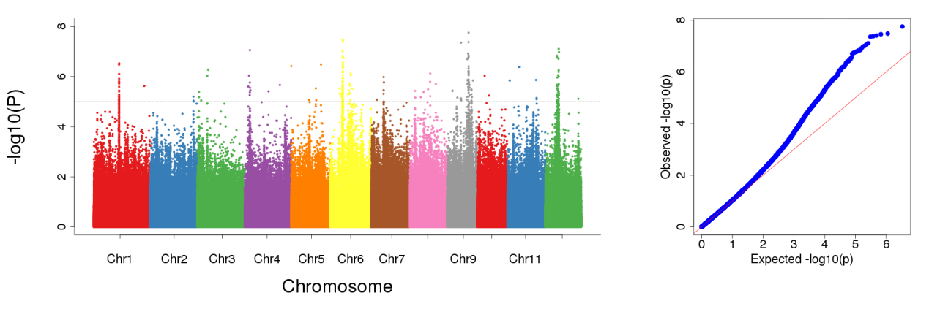

Supplementary Figure S7 Manhattan plots and QQ plots resulting from the SNP-based GWAS for panicle length. A: BLUP value; B: 2018; C: 2019.

A
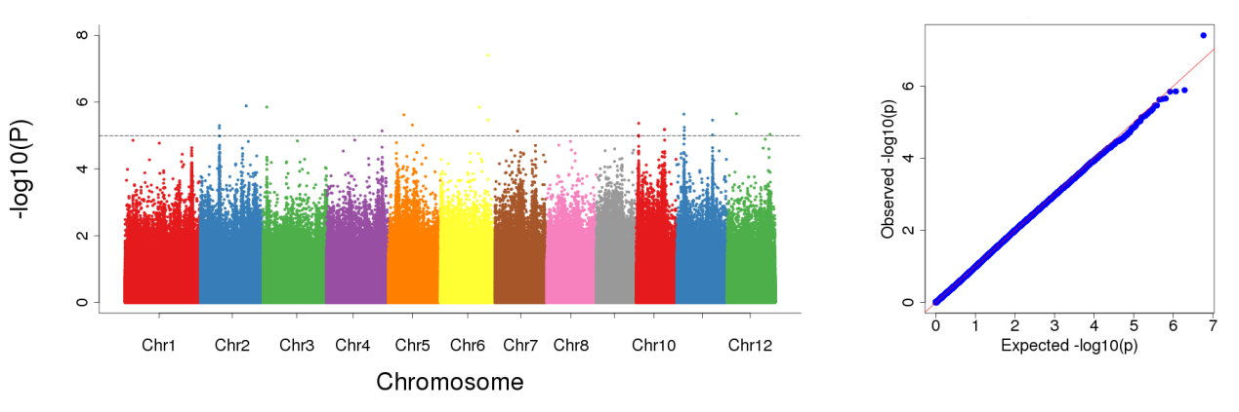

B
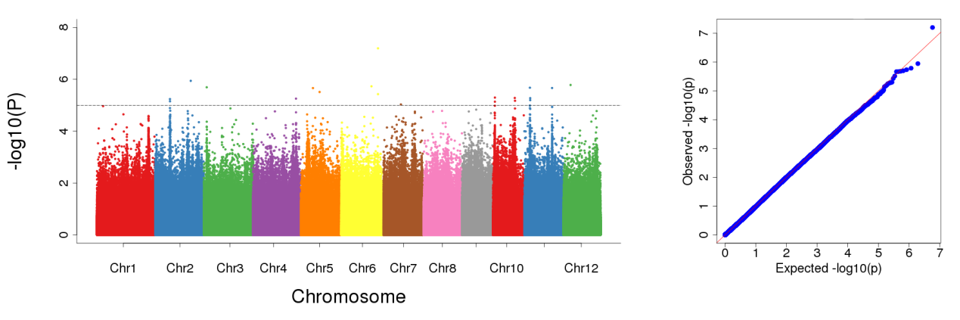

C
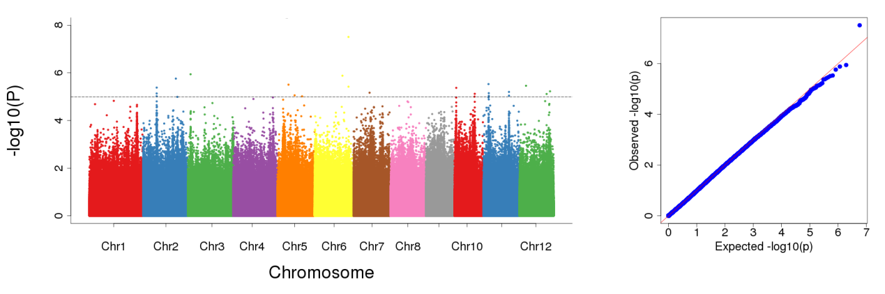

Supplementary Figure S8 Manhattan plots and QQ plots resulting from the SNP-based GWAS for spikelet number. A: BLUP value; B: 2018; C: 2019.

A
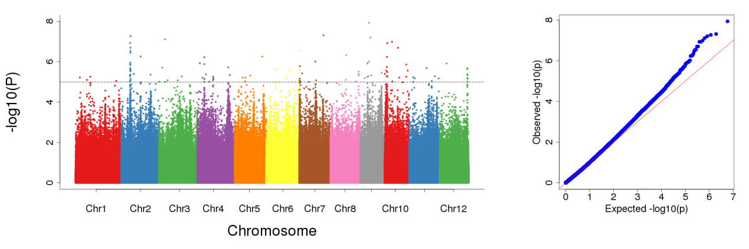
B
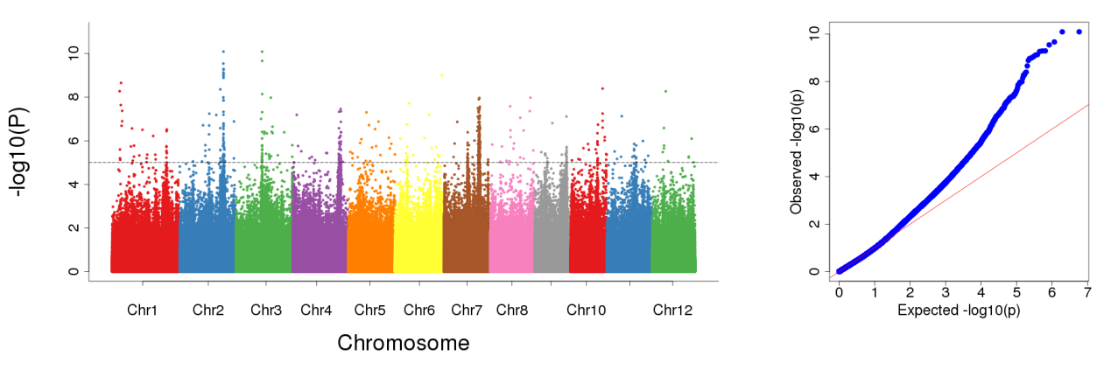
C
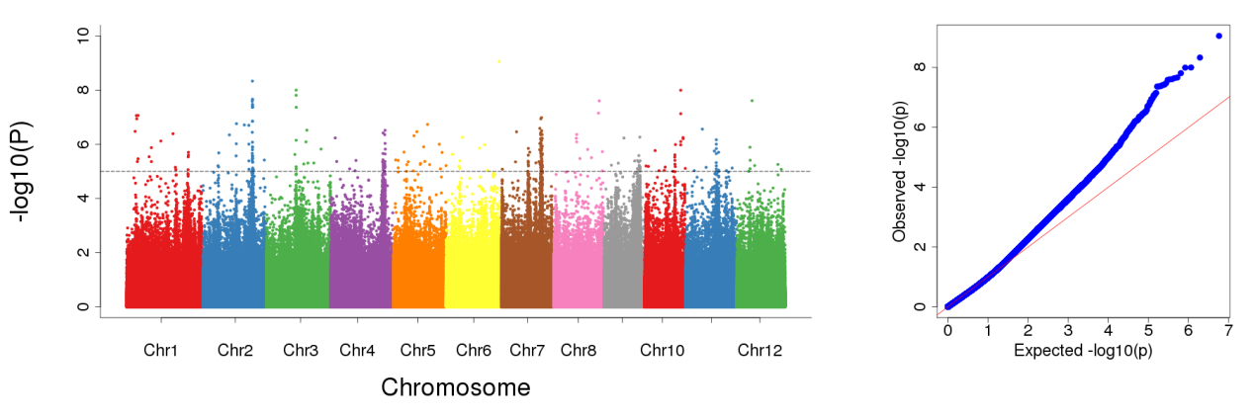

Supplementary Figure S9 Manhattan plots and QQ plots resulting from the SNP-based GWAS for grain number per spike. A: BLUP value; B: 2018; C: 2019.

A
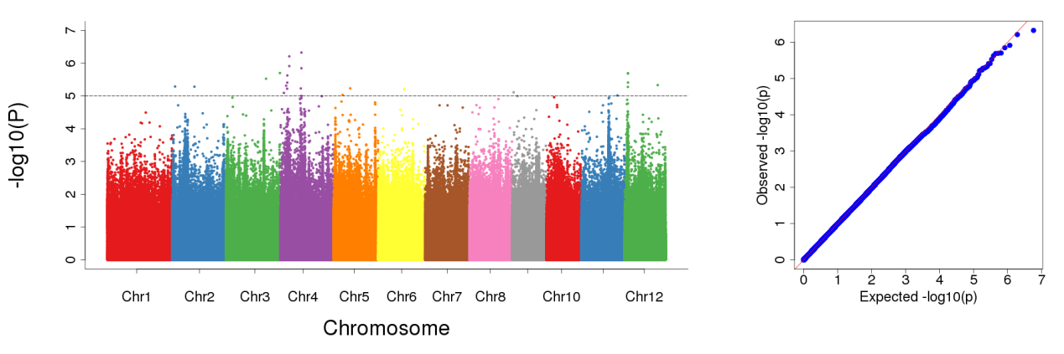
B
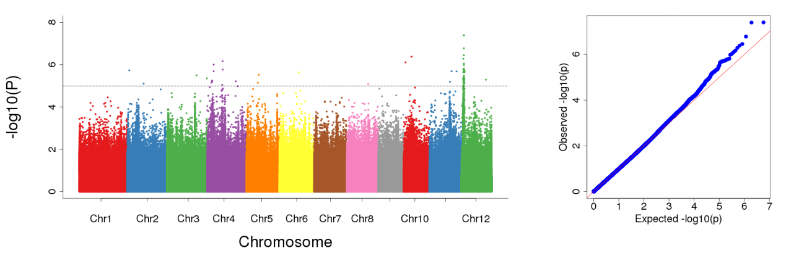
C
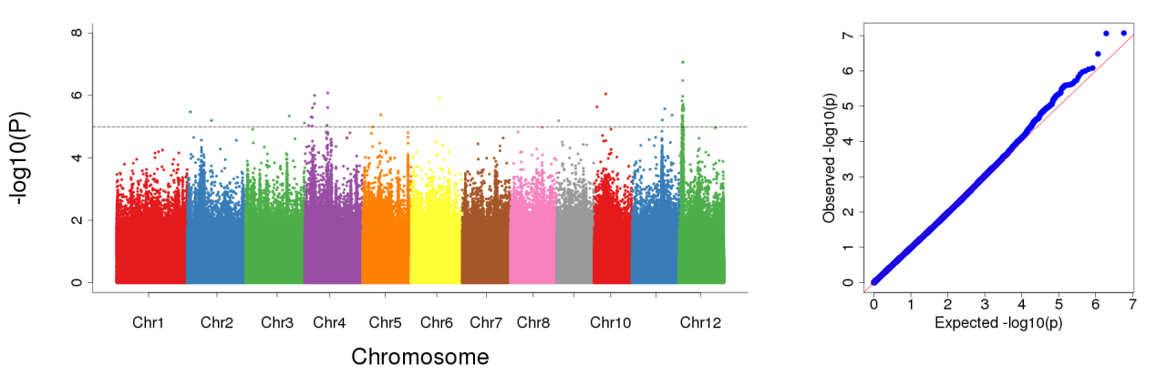

Supplementary Figure S10 Manhattan plots and QQ plots resulting from the SNP-based GWAS for percentage of fulled grains. A: BLUP value; B: 2018; C: 2019.

A
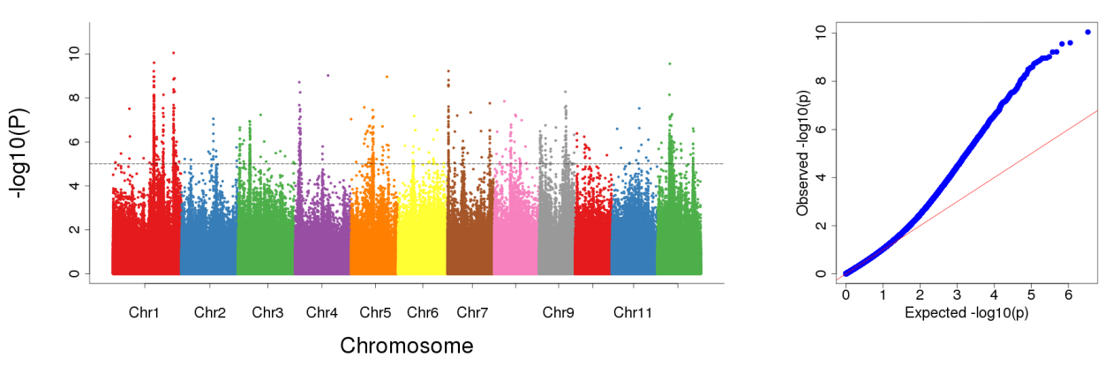
B
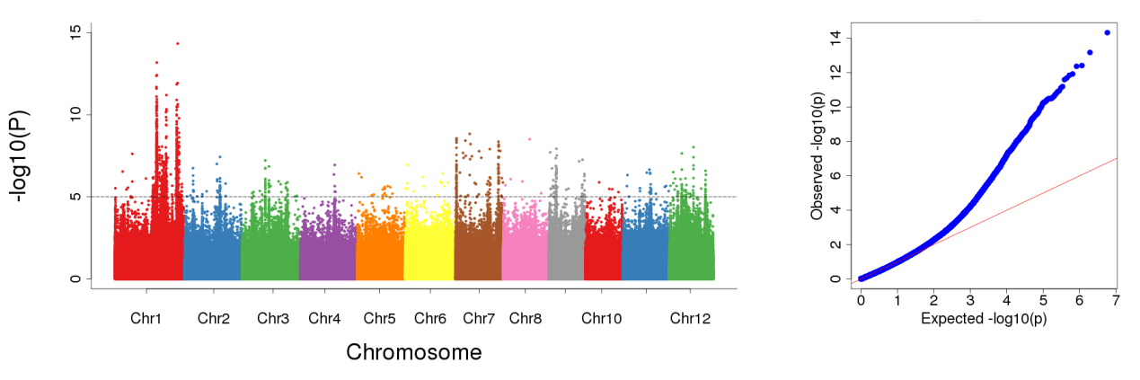
C
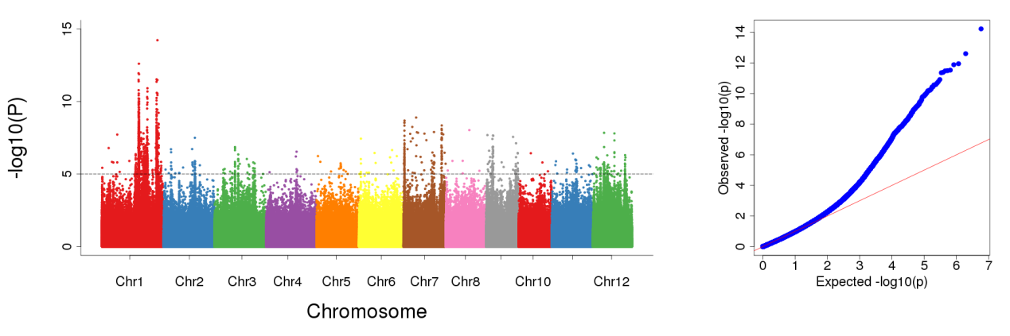

Supplementary Figure S11 Manhattan plots and QQ plots resulting from the SNP-based GWAS for plant height. A: BLUP value; B: 2018; C: 2019.

A
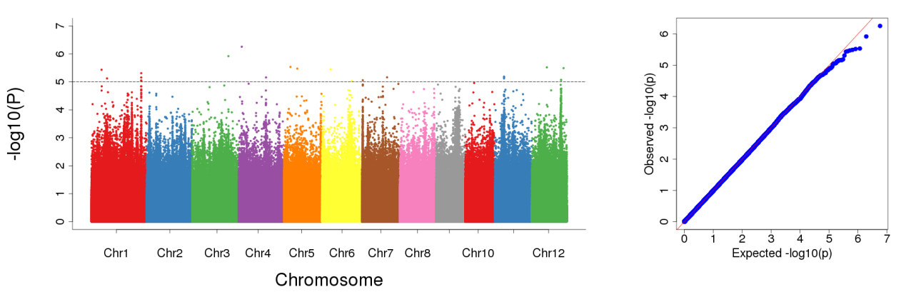
B
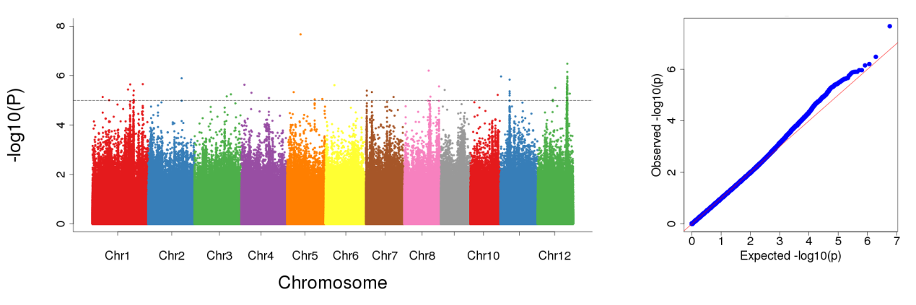
C
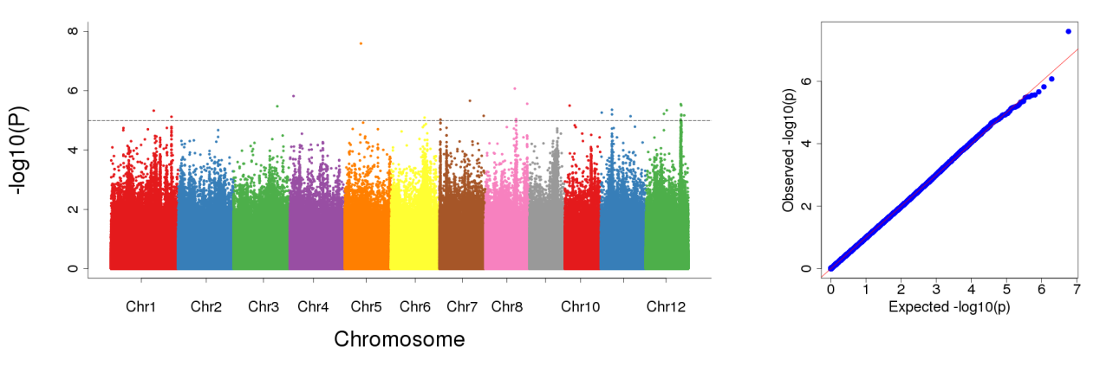

Supplementary Figure S12 Manhattan plots and QQ plots resulting from the SNP-based GWAS for flag-leaf length. A: BLUP value; B: 2018; C: 2019.

A
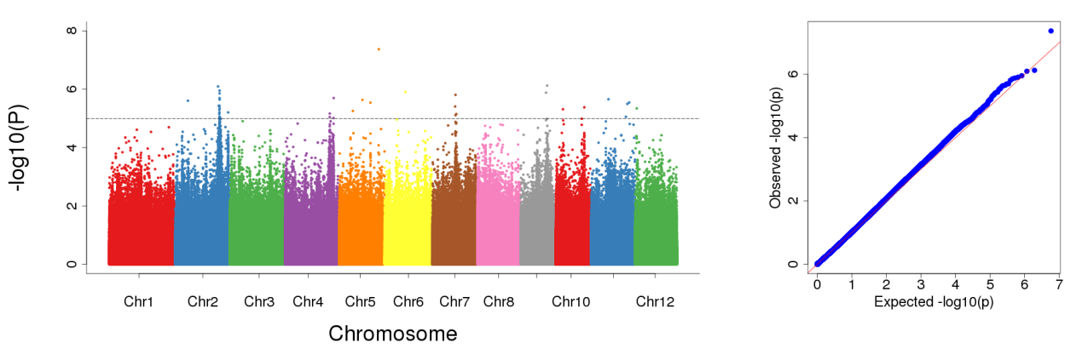
B
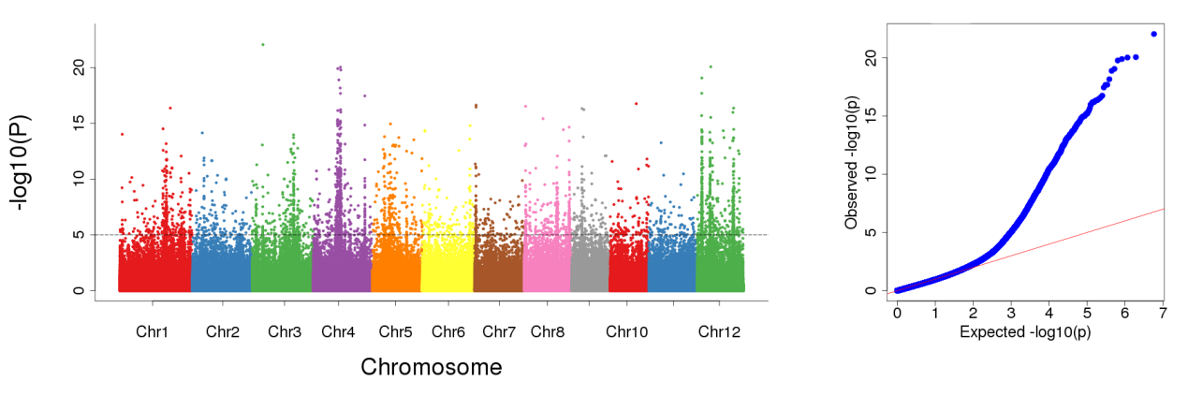
C
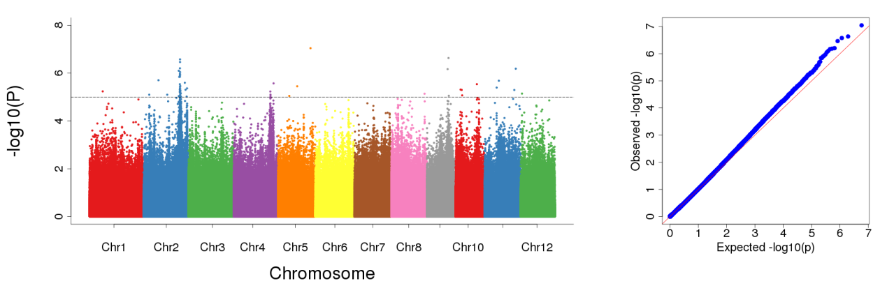
Supplementary Figure S13 Manhattan plots and QQ plots resulting from the SNP-based GWAS for flag-leaf width. A: BLUP value; B: 2018; C: 2019.

A
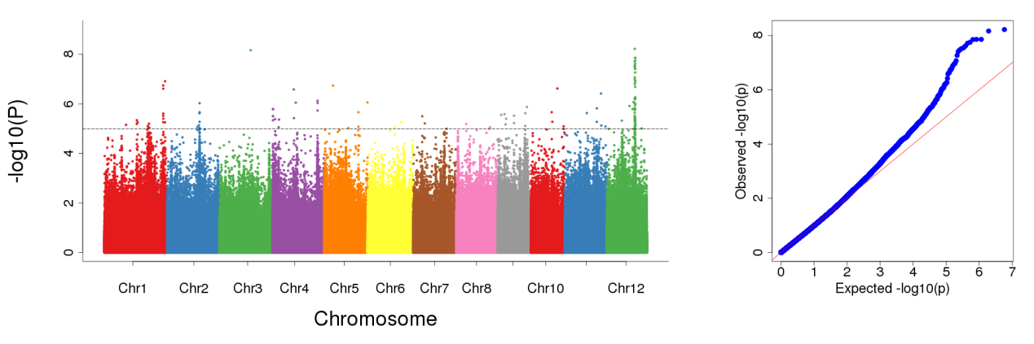

B
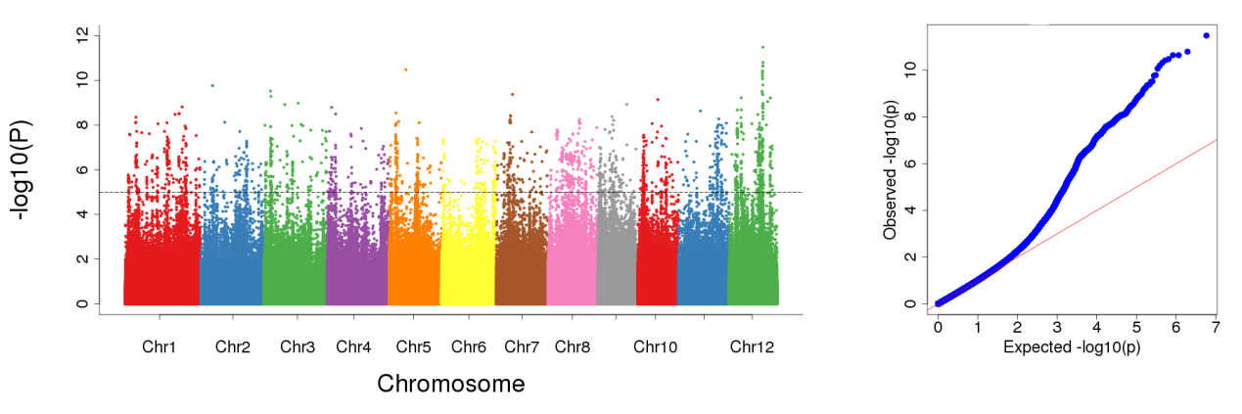

C
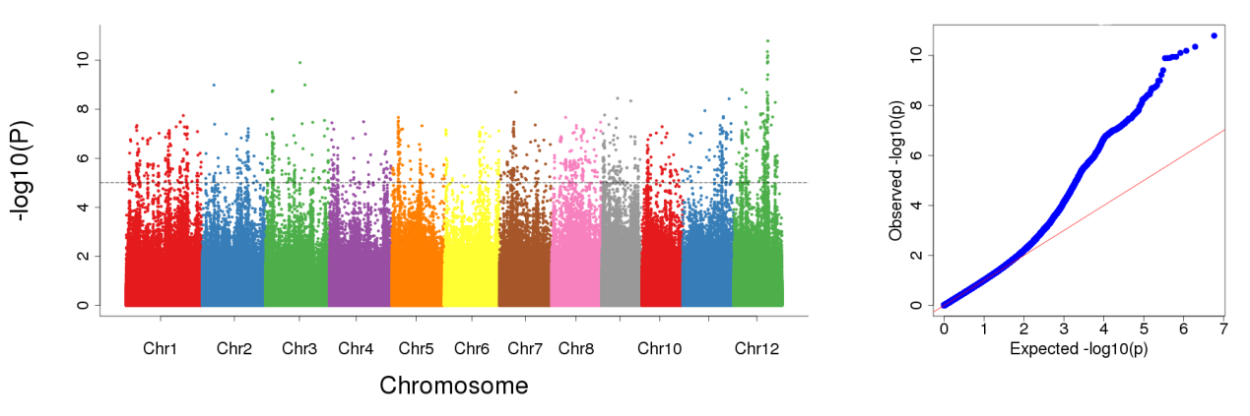
Supplementary Figure S14 Manhattan plots and QQ plots resulting from the SNP-based GWAS for flag-leaf angle. A: BLUP value; B: 2018; C: 2019.

A
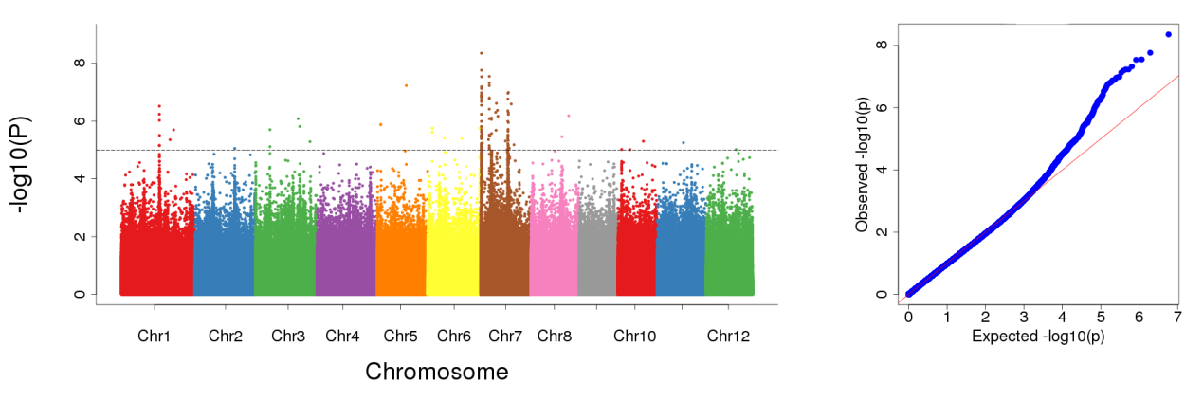

B
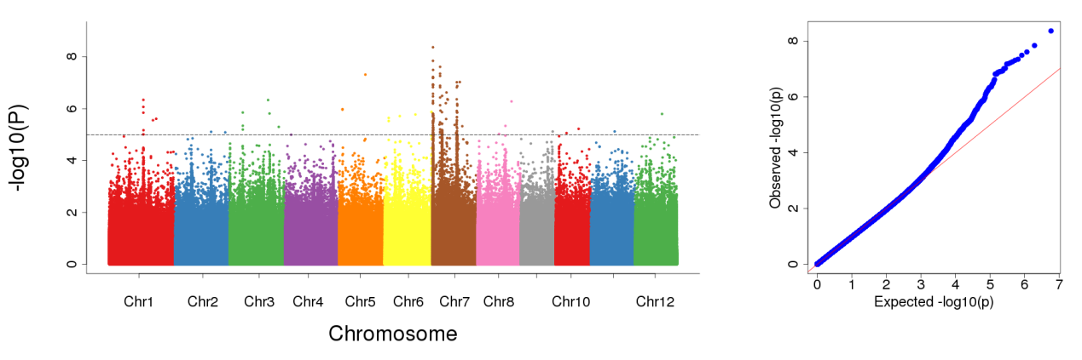

C
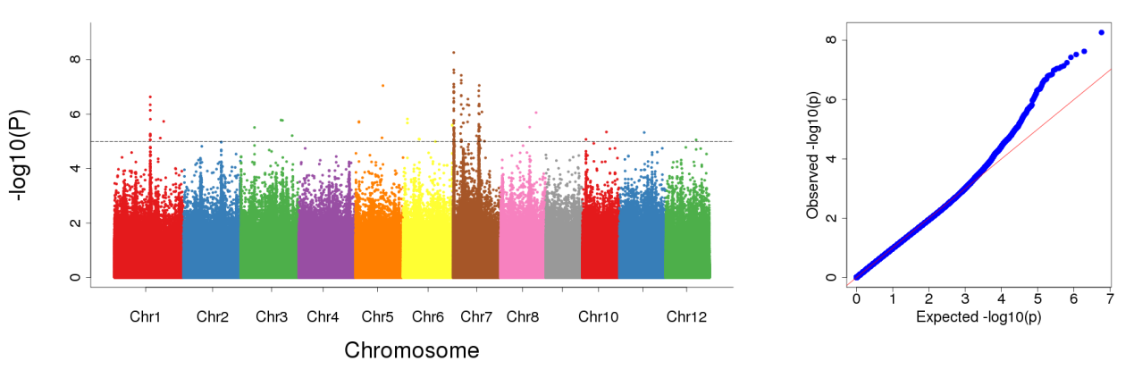

Supplementary Figure S15 Manhattan plots and QQ plots resulting from the SNP-based GWAS for heading date. A: BLUP value; B: 2018; C: 2019.

A
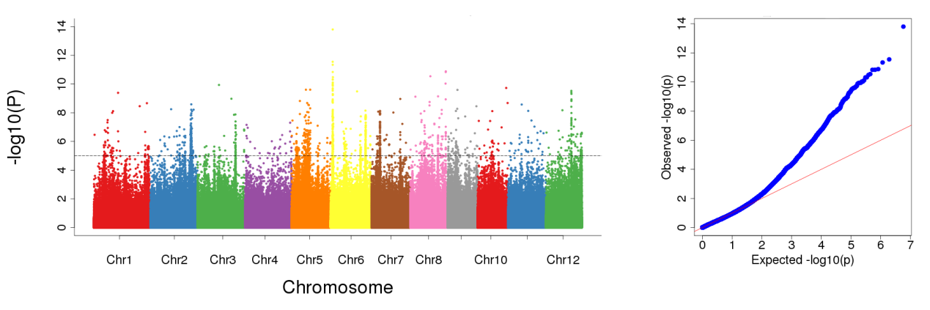
B
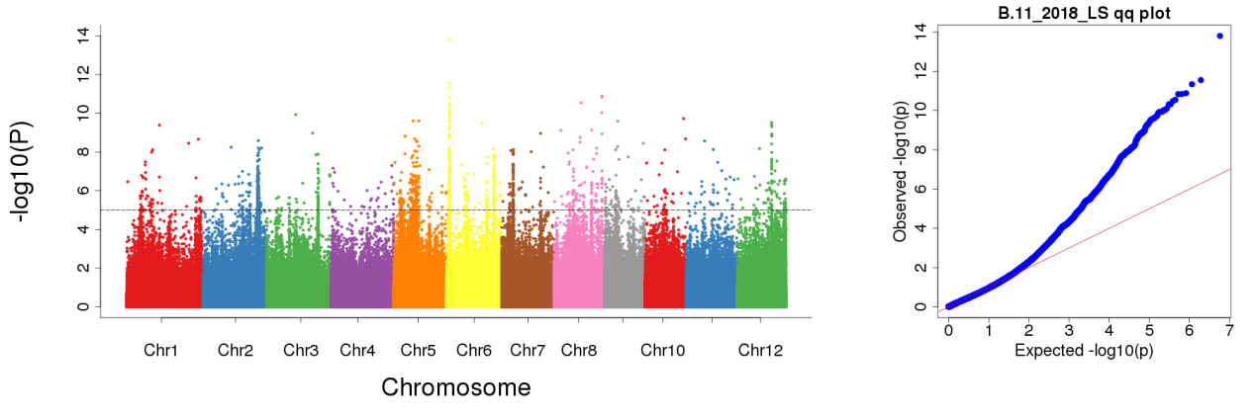

Supplementary Figure S16 Manhattan plots and QQ plots resulting from the SNP-based GWAS for awn. A: 2018; B: 2019.

