Combining Gene Expression Signature with Clinical Features for Survival Stratification of Gastric Cancer

Qiang Sun^{1,†} , Dongyang Guo^{1, †}, Shuang Li^{1,†}, Yanjun Xu², Mingchun Jiang¹, Yang Li¹, Huilong Duan³, Wei Zhuo¹, Wei Liu¹, Shankuan Zhu⁴, Xiangrui Liu¹, Liangjing Wang^{5,6,*}, and Tianhua Zhou^{1,5,7,8,*}

¹Department of Cell Biology and Cancer Institute of the Second Affiliated Hospital, Zhejiang University School of Medicine, Hangzhou 310058, China
² Zhejiang Cancer Hospital, Hangzhou, 310022, China
³College of Biomedical Engineering and Instrument Science, Zhejiang University, Hangzhou, 310027, China
⁴Department of Nutrition and Food Hygiene, Zhejiang University School of Public Health, Hangzhou, 310058, China
⁵Institute of Gastroenterology, Zhejiang University, Hangzhou 310016, China
⁶Department of Gastroenterology, the Second Affiliated Hospital of Zhejiang University School of Medicine, Hangzhou 310016, China
⁷Collaborative Innovation Center for Diagnosis and Treatment of Infectious Diseases, Hangzhou, Zhejiang 310003, China
⁸Department of Molecular Genetics, University of Toronto, Toronto, ONM5S 1A8, Canada

† Contributed equally to this work.
*Correspondence to:
Tianhua Zhou, Ph.D. & M.D., Department of Cell Biology and Cancer Institute of the Second Affiliated Hospital, Zhejiang University School of Medicine, Hangzhou, Zhejiang 310058, P.R. China. Email address: tzhou@zju.edu.cn
Liangjing Wang, M.D., Department of Gastroenterology, the Second Affiliated Hospital of Zhejiang University, Hangzhou, Zhejiang 310016, P.R. China. Email address: wangljzju@zju.edu.cn

Supplementary Materials and Methods
Patients and Tumor Samples
Clinical samples were obtained from patients with gastric cancer who underwent gastrectomy at Zhejiang Cancer Hospital (Hangzhou, China) from 2008 to 2013. All patients were followed up with at least 5 years. The end of follow-up time for the patients was May 2018 and the median follow-up time was 40.6 months. The clinical endpoints were defined as: died from GC before the time of follow-up or being alive at the time of follow-up (at least 5 years after surgery). None of these patients had received radiotherapy or chemotherapy before surgery. The tissue samples were snap-frozen in liquid nitrogen shortly after surgery and stored at -80℃ until RNA isolation. The content of cancer cells was over 60% in all tumor samples and no cancer cells were found in the adjacent normal tissues. All the samples were H&E stained and independently confirmed by two pathologists. For all patients, detailed clinical and pathological information can be found in Supplementary Table 1. The staging was determined according to the AJCC 7th edition staging manual. All aspects of this study were approved by the Ethical Committee Review Board of Zhejiang University School of Medicine. Informed consent was obtained from all patients.
Bioinformatics analysis
We identified microarray and RNASeq studies of gastric cancer with publicly available gene expression profiles and relative clinical information from GEO (Gene Expression Omnibus) and TCGA (The Cancer Genome Atlas) database [1, 2]. For Affymetrix microarray data, the raw CEL files were downloaded and normalized with the MAS5 algorithm using Custom Chip Definition Files that map to gene ensemble identifier (Brainarray v.22 http://brainarray.mbni.med.umich.edu/), followed by log₂ transformation and quantile normalization [3, 4]. For Illumina microarray data, the raw IDAT files were downloaded and normalized by Illumina Genomestudio software, followed by log₂ transformation and quantile normalization. For RNASeq data, we downloaded TCGA gastric cancer RSEM data from firebrowse (http://firebrowse.org/), the RSEM value of each gene was log₂ transformed shift by 0.001. If multiple probes target one gene, the expression was averaged by all probes targeted this gene. To this end, cohorts have at least 150 samples with corresponding clinical information were included (Supplementary Table 1).
The ACRG cohort was randomly split into equal-sized training and test sets using random shuffle function from C++ standard template library. Briefly, for each of analyzed cohorts, AJCC Stage was coded as I = 1, II = 2, III = 3, and IV = 4. OS times were converted to months, with Death = 1 and Censored = 0.
Before survival analysis, the expression of each gene is Z-score transformed. Consequently, the mean expression was zero, and the standard deviation was 1 across all samples. Univariate Cox proportional hazards regression with 10000 times permutation was performed on each gene. Statistically significant genes (P < 0.01 by 10000 times permutation test) were selected for further robustness testing using Multivariate Cox proportional hazards regression method. Glmperm package was used to perform 10000 times permutation of Univariate Cox analysis [5]. After adjustment with other clinical parameters such as AJCC stage, age, gender, and Lauren’s subtype, genes were considered as the dependent variables to evaluate the prognosis of GC patients. To further screen survival related features, we carried out LASSO penalty using glmnet package for feature selection with 10-fold internal cross-validation [6, 7]. Genes were filtered if their coefficient equals 0 after 10-fold cross-validation within glmnet. The final gene risk score (GRS) model was defined by fitting a Multivariate Cox regression model to genes that passed the LASSO penalty. GRS of each patient can be calculated by a formula as follows
$$GRS=\sum_{i=1}^{N}{\left(Expi*Coei\right)}$$
Where N is the number of prognostic genes, Expi is the normalized expression value of gene i, and Coei is the estimated regression coefficient of gene i defined by Multivariate Cox regression model. This GRS model was established by taking the power of each of the prognostic genes into account.
We dichotomized samples into high-GRS or low-GRS groups using the median GRS of the training cohort as the cut-off. Kaplan-Meier survival analysis at 5 years was applied to evaluate the difference between high and low GRS groups, P-values were calculated using the log-rank test (two-sided). All survival analysis was conducted by R survival package. We calculated the Pearson correlation efficient of gene expression and GRS, Genes with |R| > 0.4 and P < 0.01 are considered significantly correlated with GRS (Supplementary Table 3). Then, genes associated with GRS in the training set were clustered using AutoSOME with thresholds at P < 0.05 for sample and gene cluster membership, 1000 ensemble runs, and Euclidean distance as the distance metric [8]. Gene clusters defined by AutoSOME were assessed for enrichment analysis with curated gene sets from MsigDB (Molecular Signatures Database, http://www.broad.mit.edu/gsea/msigdb/index.jsp) by R clusterProfiler package [9, 10]. (Supplementary Table 4)
Differences between different prognostic models were assessed using Area Under the Receiver Operator Curve (AUROC) and Prediction error curve (PEC). The analysis was carried out using the survcomp package and pec package respectively [11, 12]. The nomogram and calibration plot were generated by rms package [13]. The decision curve was generated by rmda package [14].
SEER cohort and analysis
The Surveillance, Epidemiology, and End Results (SEER) database gathers and stores data of cancer patients in the USA [15]. We used the SEER database to screen patients diagnosed with GC since 2004. We excluded patients diagnosed with benign neoplasm and patients whose survival time was 0 month. There were 33,250 cases remained in the SEER cohort, detailed clinical information can be found in Supplementary Table S7.
We obtained gender, AJCC stage, grade, and age at diagnosis from the SEER database. Staging was determined according to the AJCC 6th and AJCC 7th edition staging manual. For patients with both AJCC 6th and AJCC 7th stage, we remained the latest 7th staging information. Tumor grade was classified as grade I (well differentiated), grade II (moderately differentiated), grade III (poorly differentiated), grade IV (Undifferentiated) and unknown.
According to SEER data, OS was defined as the time from GC diagnosis to death or the last follow up date. Survival status and cause of death were recorded by SEER, which utilizes state death certificates as its primary source. Univariate and Multivariate Cox proportional hazards models were used to assess the effect of gender, AJCC stage, grade, and age on OS. P <0.05 was considered statistically significant, and all tests were two-tailed. R version 3.4.4 (https://www.r-project.org/) was used for all analyses.
RNA isolation, reverse transcription, and cDNA amplification
Total RNA was isolated using Trizol reagent (Invitrogen) according to the manufacturer’s protocol. The purity and concentration of RNA were assessed by OD260/280 using spectrophotometer (NanoDrop Spectrophotometer 2000). cDNA was generated and amplificated from 800 ng of total RNA using the High Capacity cDNA Reverse Transcription Kit (Applied Biosystems) in a 20 µL reaction system according to the manufacturer’s protocol.
Quantitative real-time PCR
The pre-amplified products were diluted 1:3 in water, 1 µL diluted cDNA was used in 10 µL reaction volumes for qPCR. Real-time qPCR was performed in the Roche Real-Time PCR System using ChamQ Universal SYBR qPCR Master Mix Kit (Vazyme Biotech) and the specific primers. The primers (Supplementary Table 1) were provided by SunYa Company. Each gene expression assay was performed in 384 well optical plates on a Roche Light Cycler 480 II Systems (Roche). Thermal cycling conditions were: 95°C for 10 minutes; 45 cycles of denaturation at 95°C for 10 seconds and annealing and extension at 60°C for 30 seconds. Triple reactions were performed, and the results were averaged. Relative gene expression was determined by the ∆∆Ct methods [16]. Levels of the nine target genes were each normalized to the expression levels of RNU6-1, a housekeeping small nuclear RNA.

Reference
1. Barrett T, Wilhite S E, Ledoux P, Evangelista C, Kim I F, Tomashevsky M, Marshall K A, Phillippy K H, Sherman P M, Holko M, et al. NCBI GEO: archive for functional genomics data sets--update. Nucleic Acids Res. 2013;41(Database issue):991-995.
2. Cancer Genome Atlas Research N, Weinstein J N, Collisson E A, Mills G B, Shaw K R, Ozenberger B A, Ellrott K, Shmulevich I, Sander C, Stuart J M. The Cancer Genome Atlas Pan-Cancer analysis project. Nat Genet. 2013;45(10):1113-1120.
3. Bolstad B M, Irizarry R A, Astrand M, Speed T P. A comparison of normalization methods for high density oligonucleotide array data based on variance and bias. Bioinformatics. 2003;19(2):185-193.
4. Dai M, Wang P, Boyd A D, Kostov G, Athey B, Jones E G, Bunney W E, Myers R M, Speed T P, Akil H, et al. Evolving gene/transcript definitions significantly alter the interpretation of GeneChip data. Nucleic Acids Res. 2005;33(20):e175.
5. Wiebke W A, B. glmperm: A Permutation of Regressor Residuals Test for Inference in Generalized Linear Models. R Journal. 2010 24.
6. Friedman J, Hastie T, Tibshirani R. Regularization Paths for Generalized Linear Models via Coordinate Descent. J Stat Softw. 2010;33(1):1-22.
7. Tibshirani R. The lasso method for variable selection in the Cox model. Stat Med. 1997;16(4):385-395.
8. Newman A M, Cooper J B. AutoSOME: a clustering method for identifying gene expression modules without prior knowledge of cluster number. BMC Bioinformatics. 2010;11117.
9. Liberzon A, Birger C, Thorvaldsdottir H, Ghandi M, Mesirov J P, Tamayo P. The Molecular Signatures Database (MSigDB) hallmark gene set collection. Cell Syst. 2015;1(6):417-425.
10. Yu G, Wang L G, Han Y, He Q Y. clusterProfiler: an R package for comparing biological themes among gene clusters. OMICS. 2012;16(5):284-287.
11. Mogensen U B, Ishwaran H, Gerds T A. Evaluating Random Forests for Survival Analysis using Prediction Error Curves. J Stat Softw. 2012;50(11):1-23.
12. Schroder M S, Culhane A C, Quackenbush J, Haibe-Kains B. survcomp: an R/Bioconductor package for performance assessment and comparison of survival models. Bioinformatics. 2011;27(22):3206-3208.
13. Walz J, Gallina A, Saad F, Montorsi F, Perrotte P, Shariat S F, Jeldres C, Graefen M, Benard F, McCormack M, et al. A nomogram predicting 10-year life expectancy in candidates for radical prostatectomy or radiotherapy for prostate cancer. J Clin Oncol. 2007;25(24):3576-3581.
14. Fitzgerald M, Saville B R, Lewis R J. Decision curve analysis. JAMA. 2015;313(4):409-410.
15. Hankey B F, Ries L A, Edwards B K. The surveillance, epidemiology, and end results program: a national resource. Cancer Epidemiol Biomarkers Prev. 1999;8(12):1117-1121.
16. Livak K J, Schmittgen T D. Analysis of relative gene expression data using real-time quantitative PCR and the 2(-Delta Delta C(T)) Method. Methods. 2001;25(4):402-408.

Supplementary Figures
Supplementary Fig. 1 Sample size evaluation and screening method used in this study. a, b Robust identification of survival related genes requires sample sizes of >150. c LASSO-Cox penalty algorithm is used to select most prognostic genes. λ represents the tuning parameter. And λ values were determined by 10-fold cross validation via minimum criteria. The dotted vertical lines are drawn at the values determined by minimal deviance (left) and 1-SE (right). The plot shows that 9 genes are significantly associated with GC prognosis.

Supplementary Fig. 2 Kaplan-Meier analysis of 5-year overall survival of GC patients based on CRS. a-g 5-year overall survival prediction of GC patients according to CRS in SEER training set (a), ACRG training set (b), ACRG validation set (c), ACRG (d), Singapore (e), TCGA (f), and Zhejiang (g) cohorts. P values were calculated using log-rank test. Tick marks on curves represent censoring.

Supplementary Fig. 3 Kaplan-Meier analysis of 5-year overall survival of Stage I GC patients based on GRS or CGRS. a-f 5-year overall survival prediction of Stage I GC patients according to GRS in ACRG training set (a), ACRG validation set (b), ACRG (c), Singapore (d), TCGA (e), and Zhejiang (f) cohorts. g-l 5-year overall survival prediction of Stage I GC patients according to CGRS in ACRG training set (g), ACRG validation set (h), ACRG (i), Singapore (j), TCGA (k), and Zhejiang (l) cohorts. P values were calculated using log-rank test. Tick marks on curves represent censoring.

Supplementary Fig. 4 Kaplan-Meier analysis of 5-year overall survival of Stage II GC patients based on GRS or CGRS. a-f 5-year overall survival prediction of Stage II GC patients according to GRS in ACRG training set (a), ACRG validation set (b), ACRG (c), Singapore (d), TCGA (e), and Zhejiang (f) cohorts. g-l 5-year overall survival prediction of Stage II GC patients according to CGRS in ACRG training set (g), ACRG validation set (h), ACRG (i), Singapore (j), TCGA (k), and Zhejiang (l) cohorts. P values were calculated using log-rank test. Tick marks on curves represent censoring.

Supplementary Fig. 5 Kaplan-Meier analysis of 5-year overall survival of Stage IV GC patients based on GRS or CGRS. a-f 5-year overall survival prediction of Stage IV GC patients according to GRS in ACRG training set (a), ACRG validation set (b), ACRG (c), Singapore (d), TCGA (e), and Zhejiang (f) cohorts. g-l 5-year overall survival prediction of Stage IV GC patients according to CGRS in ACRG training set (g), ACRG validation set (h), ACRG (i), Singapore (j), TCGA (k), and Zhejiang (l) cohorts. P values were calculated using log rank test. Tick marks on curves represent censoring.

Supplementary Fig. 6 Relationship between GRS or CGRS and different molecular characteristics. a Kaplan-Meier estimates of overall survival based on TCGA molecular subtypes, P values were determined by log-rank test. b, c The distributions of GRS and CGRS in different TCGA molecular subtypes. P values were determined by Mann-Whitney U-test. d-f Kaplan-Meier estimates of 5-year overall survival based on microsatellite status (d), mutation status (e), and methylation status (f), respectively. P values were determined by log-rank test. g-i The distributions of GRS and CGRS in GC patients with different microsatellite status (g), different mutation status (h), and different methylation status (i), respectively. P values were determined by Mann-Whitney U-test. EBV: Epstein–Barr virus; GS: genomically stable; CIN: chromosome instability; CIMP: CpG island methylator phenotype.

Supplementary Fig. 7 Relationship between GRS or CGRS and molecular subtypes. a Kaplan-Meier estimates of overall survival based on Singapore molecular subtypes, P values were determined by log-rank test. b, c The distributions of GRS and CGRS in different Singapore molecular subtypes, P values were determined by Mann-Whitney U-test. d Kaplan-Meier estimates of overall survival based on ACRG molecular subtypes, P values were determined by log-rank test. e-f The distributions of GRS and CGRS in different ACRG molecular subtypes, P values were determined by Mann-Whitney U-test. MSI: microsatellite instability; MSS: microsatellite stability; EMT: epithelial to mesenchymal transition.

Supplementary Fig. 8 Prediction error curve analysis of different signatures in multiple cohorts. a-d Prediction error curves at 5 years for ACRG (a), TCGA (b), Singapore (c), and Zhejiang (d) cohorts. e The apparent error (AE) and 10-fold cross validated cumulative prediction error (PE) at 5 years for each cohort.

Supplementary Fig. 1

Supplementary Fig. 2

Supplementary Fig. 3

Supplementary Fig. 4

Supplementary Fig. 5
Supplementary Fig. 6

Supplementary Fig. 7

Supplementary Fig. 8

Supplementary Table 1. Characteristics of datasets used to build and validate models in this study
Cohorts | ACRG | Singapore | Korea | Zhejiang | TCGA
Accession | GSE62254 | GSE15459 | GSE84437 | NA | TCGA
Platform | Affymetrix  microarrays | Affymetrix  microarrays | Illumina  microarrays | qPCR | RNASeq
1st author | Cristescu | Ooi CH | Yong-Min | NA | TCGA
PMID | 25894828 | 19798449 | NA | NA | 25079317
Samples | 300 | 192 | 433 | 109 | 388
Survival data | yes | yes | yes | yes | yes
AJCC stage | yes | yes | no | yes | yes

Supplementary Table 2. qRT-PCR primers used in this study
Gene ID | Primer direction | Type | Sequence | Length
APOD | Forward | Prognosis | GAATCAAATCGAAGGTGAAGCCA | 23
APOD | Reverse | Prognosis | ACACGAGGGCATAGTTCTCAT | 21
CCDC92 | Forward | Prognosis | GAGTTACGATGAAGGTCCTCTGG | 23
CCDC92 | Reverse | Prognosis | TGTCTGTTCCGAACTTTTGACTG | 23
ST8SIA5 | Forward | Prognosis | GATGTGCAAATGGGCGATGAA | 21
ST8SIA5 | Reverse | Prognosis | GGTTGATGTGGTAGATGCCACT | 22
GSDME | Forward | Prognosis | TGCTGATGGTGACCTGATTGC | 21
GSDME | Reverse | Prognosis | CGCCAAGGGTGAGGGATAAAA | 21
STARD3NL | Forward | Prognosis | TCCATCAACCCCACACAACTC | 21
STARD3NL | Reverse | Prognosis | CATACTGCATCACCTCCTTCTCT | 23
TMEM245 | Forward | Prognosis | TCACAGGGTATGAATCAAGCAGT | 23
TMEM245 | Reverse | Prognosis | GTCTGCCCAGAGTAGGTGAA | 20
TSPYL5 | Forward | Prognosis | GCCCAGCTCTGCTTTTACAC | 20
TSPYL5 | Reverse | Prognosis | GCATCTCAAGCTTCTCCTGG | 20
VAT1 | Forward | Prognosis | GAAGGAGAATGGGGTCACACA | 21
VAT1 | Reverse | Prognosis | TGGGTTTCAGGAGGTTGTAGC | 21
CYS1 | Forward | Prognosis | GGAGCGGCAATGTCTCTGA | 19
CYS1 | Reverse | Prognosis | CCGAGTGGTCGTAGGAGATG | 20
RNU6-1 | Forward | Reference | CTCGCTTCGGCAGCACA | 17
RNU6-1 | Reverse | Reference | AACGCTTCACGAATTTGCGT | 20

Supplementary Table 3. LASSO penalty results of the prognostic genes
Ensemble_id | Gene Symbol | Gene Name | LASSO coefficient
ENSG00000010270 | STARD3NL | STARD3 N-terminal like | 0.072251114
ENSG00000101638 | ST8SIA5 | ST8 alpha-N-acetyl-neuraminide alpha-2,8-sialyltransferase 5 | -0.243587034
ENSG00000105928 | GSDME | gasdermin E | 0.168120905
ENSG00000106771 | TMEM245 | transmembrane protein 245 | 0.09258841
ENSG00000108828 | VAT1 | vesicle amine transport 1 | 0.217986996
ENSG00000119242 | CCDC92 | coiled-coil domain containing 92 | 0.173117627
ENSG00000180543 | TSPYL5 | TSPY like 5 | 0.033228431
ENSG00000189058 | APOD | apolipoprotein D | 0.123778977
ENSG00000205795 | CYS1 | cystin 1 | 0.118245768

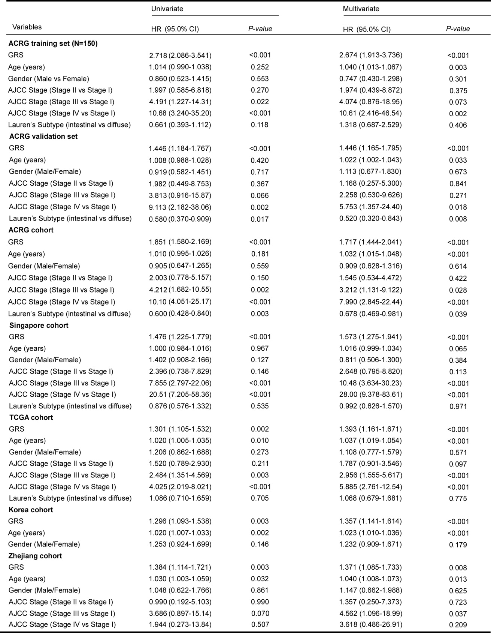
Supplementary Table 4. Univariate and Multivariate survival analysis of GRS and clinical variables in training and validation cohorts.
P values were calculated using two sided likelihood ratio test. CI = confidence interval; HR = hazard ratio; GRS = Genetic risk score;

Supplementary Table 5.Prognostic utility of the GRS within mutational subsets of GC in the ACRG and TCGA sets
Gene | Status | ACRG cohort |  |  |  | TCGA cohort
Gene | Status | N | HR (95% CI) | P-value |  | N | HR (95% CI) | P-value
TP53 | WT | 131 | 2.156 (1.682-2.765) | <0.001 |  | 204 | 1.365 (1.089-1.710) | 0.007
TP53 | MUT | 88 | 1.712 (1.306-2.245) | <0.001 |  | 180 | 1.295 (1.009-1.663) | 0.037
MUC16 | WT | 161 | 1.916 (1.570-2.338) | <0.001 |  | 267 | 1.179 (0.967-1.438) | 0.103
MUC16 | MUT | 58 | 1.757 (1.160-2.662) | 0.005 |  | 117 | 1.643 (1.174-2.300) | 0.002
ARID1A | WT | 179 | 1.814 (1.481-2.223) | <0.001 |  | 289 | 1.233 (1.003-1.514) | 0.044
ARID1A | MUT | 40 | 2.443 (1.600-3.730) | <0.001 |  | 95 | 1.572 (1.144-2.161) | 0.004
PIK3CA | WT | 189 | 1.836 (1.514-2.225) | <0.001 |  | 325 | 1.265 (1.051-1.523) | 0.012
PIK3CA | MUT | 30 | 2.543 (1.450-4.459) | 0.001 |  | 59 | 1.688 (1.079-2.642) | 0.017
P values were calculated using two sided likelihood ratio test. CI = confidence interval; HR = hazard ratio; GRS = Genetic risk score; MUT = mutant; GC= Gastric cancer; WT = wild type.

Supplementary Table 6. Characteristics of GC patients included for clinical risk score modeling from SEER cohort and sample distribution between SEER set and ACRG training set.
Variables | SEER cohort  (n=33250) | ACRG training set  (n=150) | P-value
Age |  |  | 0.064
≥60 | 23987 | 98
< 60 | 9263 | 52
Gender |  |  | 0.984
Male | 21306 (64.1%) | 96 (64.0%)
Female | 11944 (35.9%) | 54 (36.0%)
AJCC stage |  |  | 0.382
Stage I | 10337 (31.1%) | 20 (13.3%)
Stage II | 6020 (18.1%) | 60 (40.0%)
Stage III | 7558 (22.7%) | 34 (22.7%)
Stage IV | 9335 (28.1%) | 35 (23.3%)
P values were calculated using Chi-square test; SEER = seer surveillance epidemiology and end results; GC = gastric cancer.

Supplementary Table 7. Univariate and Multivariate survival analysis of CGRS and clinical variables in training and validation cohorts.
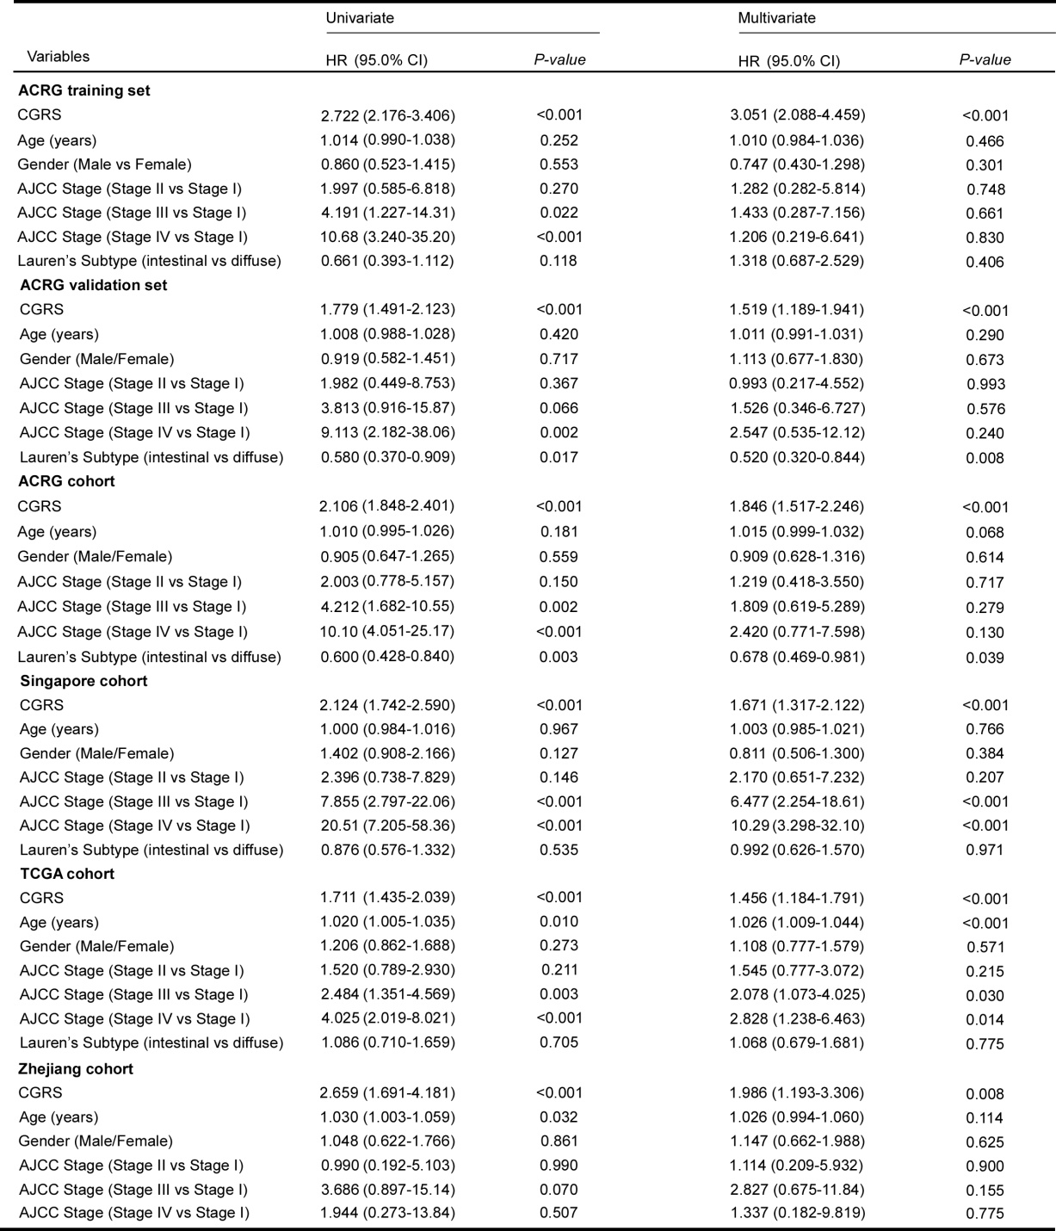
P values were calculated using two sided likelihood ratio test. CI = confidence interval; HR = hazard ratio; CGRS = Combined genetic and clinical risk score.

Supplementary Table 8. Prognostic utility of the CGRS within mutational subsets of GC in the ACRG and TCGA sets
Gene | Status | ACRG cohort |  |  |  | TCGA cohort
Gene | Status | N | HR (95% CI) | P-value |  | N | HR (95% CI) | P-value
TP53 | WT | 131 | 2.312 (1.855-2.883) | <0.001 |  | 204 | 1.722 (1.362-2.177) | <0.001
TP53 | MUT | 88 | 2.141 (1.702-2.694) | <0.001 |  | 180 | 1.737 (1.327-2.274) | <0.001
MUC16 | WT | 161 | 2.104 (1.776-2.494) | <0.001 |  | 267 | 1.549 (1.257-1.909) | <0.001
MUC16 | MUT | 58 | 2.577 (1.702-3.903) | <0.001 |  | 117 | 2.156 (1.518-3.062) | <0.001
ARID1A | WT | 179 | 2.074 (1.754-2.452) | <0.001 |  | 289 | 1.727 (1.385-2.153) | <0.001
ARID1A | MUT | 40 | 2.955 (1.900-4.598) | <0.001 |  | 95 | 1.792 (1.319-2.434) | <0.001
PIK3CA | WT | 189 | 2.097 (1.785-2.464) | <0.001 |  | 325 | 1.690 (1.392-2.052) | 0.002
PIK3CA | MUT | 30 | 2.928 (1.685-5.086) | <0.001 |  | 59 | 2.070 (1.301-3.293) | <0.001
P values were calculated using two sided likelihood ratio test. CI = confidence interval; HR = hazard ratio; CGRS = Combined genetic and clinical risk score; MUT = mutant; GC= Gastric cancer; WT = wild type.

Supplementary Table 9. Univariate and multivariable analysis of GRS, CRS, and CGRS in multiple cohorts
Variables | ACRG training set |  |  |  | ACRG validation set
 | HR (95% CI) | P-value |  |  | HR (95% CI) | P-value
Univariate
GRS (all stages) | 2.712 (2.082-3.531) | <0.001 |  |  | 1.446 (1.183-1.767) | <0.001
GRS (stage III) | 2.278 (1.424-3.643) | <0.001 |  |  | 1.535 (1.077-2.186) | 0.016
CRS (age, stage) | 4.404 (2.889-6.713) | <0.001 |  |  | 3.140 (2.118-4.657) | <0.001
Multivariate (all stages)
GRS | 2.415 (1.827-3.191) | <0.001 |  |  | 1.428 (1.180-1.729) | <0.001
CRS (age, stage) | 3.488 (2.231-5.454) | <0.001 |  |  | 3.136 (2.116-4.647) | <0.001
CGRS (H vs L, all stages) | 5.160 (2.894-9.200) | <0.001 |  |  | 3.463 (2.032-5.902) | <0.001
CGRS (H vs L, stage III) | 4.059 (1.163-14.16) | 0.013 |  |  | 1.875 (0.878-4.004) | 0.089
CGRS (all stages) | 2.718 (2.173-3.400) | <0.001 |  |  | 1.779 (1.491-2.122) | <0.001
CGRS (stage III) | 3.198 (1.770-5.777) | <0.001 |  |  | 1.771 (1.123-2.794) | 0.010
P values were calculated using two sided likelihood ratio test. CI = confidence interval; HR = hazard ratio; GRS = Genetic risk score; CRS = Clinical risk score; CGRS = Combined genetic and clinical risk score; H: high risk; L: low risk.

Supplementary Table 10. Univariate Cox analysis of three published signatures in multiple cohorts
Variables |  | ACRG cohort |  |  | TCGA cohort |  | Singapore cohort
 |  | HR (95% CI) | P-value |  | HR (95% CI) | P-value |  | HR (95% CI) | P-value
SGS |  | 0.641 (0.421-0.976) | 0.041 |  | 0.771 (0.504-1.177) | 0.223 |  | 0.994 (0.605-1.635) | 0.983
TGS |  | 3.191 (1.420-7.171) | 0.005 |  | 2.619 (1.152-5.952) | 0.022 |  | 0.687 (0.275-1.715) | 0.422
EGS |  | 1.993 (1.495-2.656) | <0.001 |  | 1.396 (1.060-1.838) | 0.018 |  | 1.882 (1.260-2.814) | 0.002
SGS (six gene signature, obtained from Cho et.al); TGS (three gene signature, obtained from Chen et.al); EGS (eight gene signature, obtained from Zhu et.al); P values were calculated using two sided likelihood ratio test. CI = confidence interval; HR = hazard ratio.

