Supplementary Figure 1
Images of yield of some of the specialty crops tested.
Various crop plants (A) Broccoli, (B) Daikon radish, (C) Kale, (D) Tomato were grown in greenhouse as described in Methods. Images are shown here for comparison between Control (untreated) and Vitazyme (treated) plants. See Table 1 for number of plants tested, and number and weight of harvest for each crop. Additional crops tested (images not included) were pea and plum purple radish (Table 1).
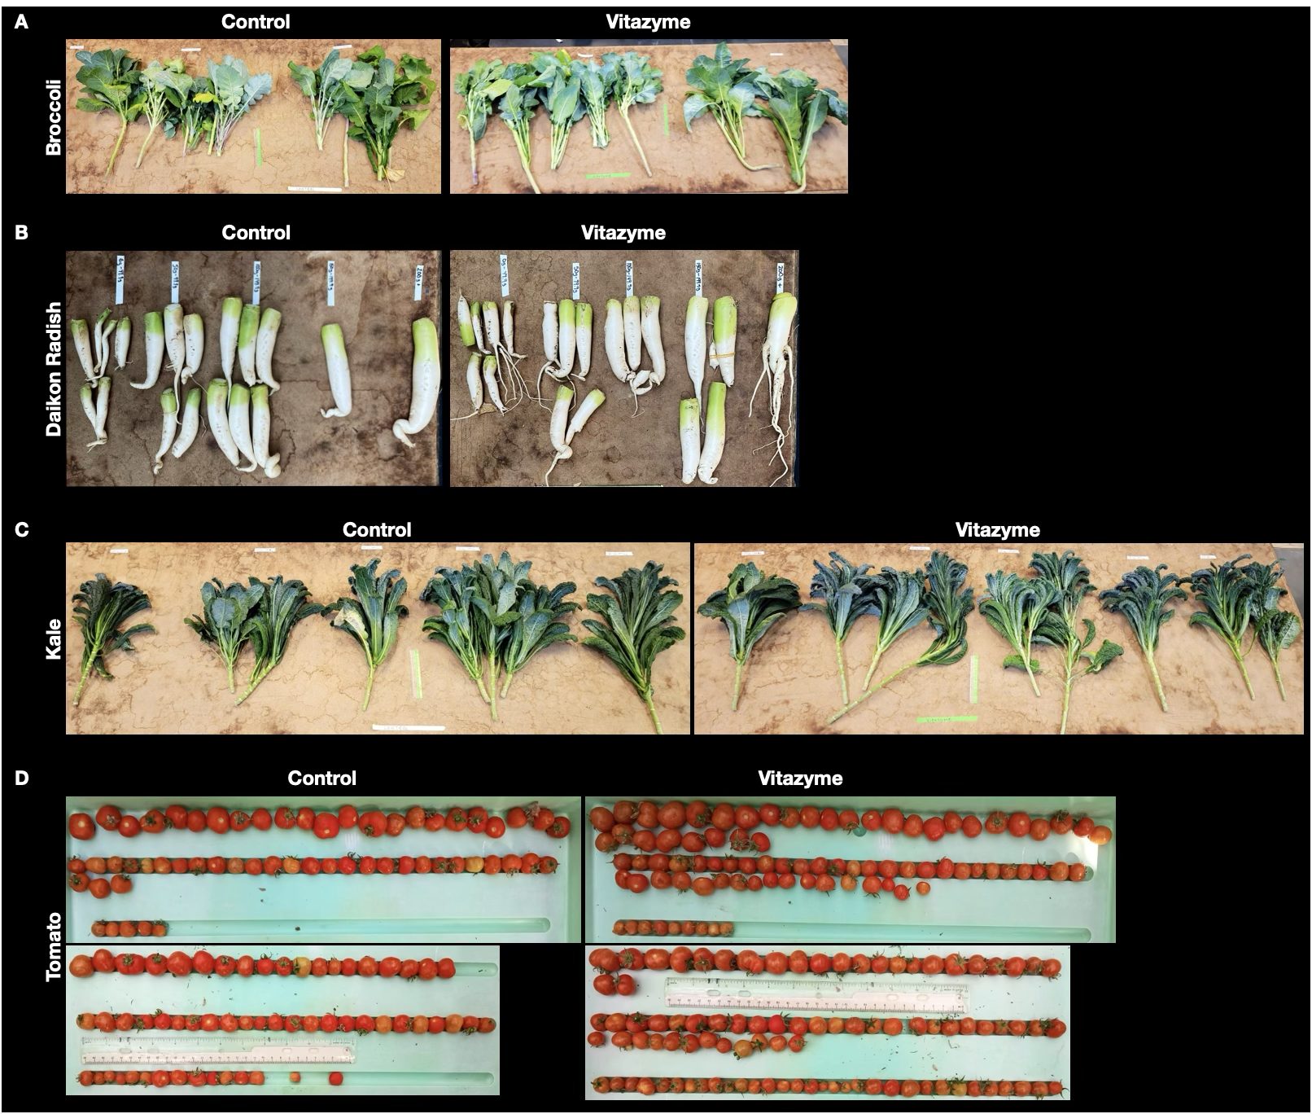
Supplementary Figure 2
LCMS analysis of derivatized HBL standards for quantification. Representative data from LCMS is shown with (A) peaks and (B) linear concentration curve of HBL-DAPBA standard. These data were used to calculate HBL concentrations in Vitazyme (Table 2).

