Table 1: Basic information on minocycline and standard inhibitors for CD38 and PARP2 (Source: PubChem library database).

Compound Name | PubChem ID | Molecular formula | Structure
Minocycline | 54675783 | C₂₃H₂₇N₃O₇ | 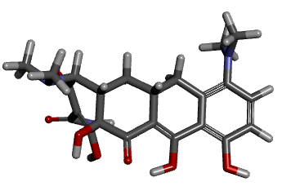
CD38 inhibitor 78c | 118736856 | C₂₂H₂₇N₃O₃S | 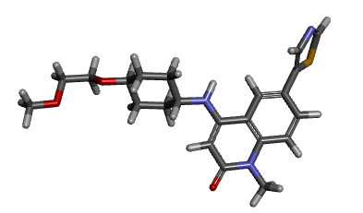
Niraparib | 24958200 | C₁₉H₂₀N₄O | 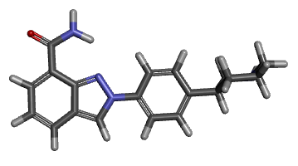
Table 2: Retrieved protein from the PDB database.
PDB ID | Protein name | Resolution | 3D Structure
4CMH | CD38 in complex CD38-targeting antibody SAR650984 | 1.53 Å | 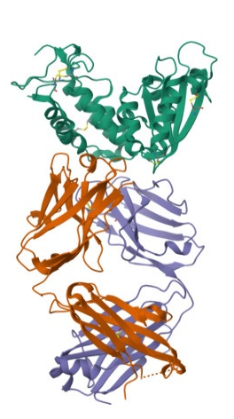
4L7N | PARP2 in complex inhibitor STO1542 | 1.80 Å | 