Supplementary Information
Table S1. Soil physicochemical properties across sites. Mean values and standard deviations of soil chemical properties at each study site.
Sites | Total P | Total C | Total K | Total N | C/N_Ratio
Abou Jaad | 0.12 ± 0.00 | 2.05 ± 0.00 | 0.26 ± 0.00 | 0.06 ± 0.00 | 34.17 ± 0.00
Ait Ali | 0.55 ± 0.05 | 1.89 ± 0.19 | 0.41 ± 0.02 | 0.18 ± 0.03 | 10.60 ± 1.70
Ait Hamou | 0.07 ± 0.01 | 1.88 ± 0.21 | 0.60 ± 0.04 | 0.17 ± 0.01 | 10.81 ± 1.02
Benguerir | 0.09 ± 0.00 | 1.71 ± 0.03 | 0.48 ± 0.00 | 0.18 ± 0.00 | 9.50 ± 0.15
Berrechid | 0.31 ± 0.00 | 2.17 ± 0.08 | 0.40 ± 0.00 | 0.16 ± 0.00 | 13.58 ± 0.52
Bouskoura | 0.15 ± 0.02 | 1.81 ± 0.01 | 0.15 ± 0.00 | 0.14 ± 0.02 | 13.47 ± 1.36
Nkhaila | 0.06 ± 0.00 | 2.50 ± 0.46 | 0.26 ± 0.00 | 0.20 ± 0.00 | 12.53 ± 2.29
Oued Laabid | 0.20 ± 0.00 | 3.43 ± 0.85 | 0.21 ± 0.00 | 0.20 ± 0.00 | 17.13 ± 4.27
Ouled Ayad | 0.35 ± 0.00 | 2.46 ± 0.00 | 0.34 ± 0.00 | 0.48 ± 0.00 | 5.13 ± 0.00
Settat | 0.46 ± 0.14 | 2.60 ± 0.43 | 0.73 ± 0.23 | 0.29 ± 0.02 | 8.88 ± 1.30
Sidi Bettache | 0.07 ± 0.02 | 1.37 ± 0.72 | 0.11 ± 0.06 | 0.12 ± 0.06 | 11.15 ± 1.82
Tassaout | 0.07 ± 0.00 | 2.20 ± 0.00 | 0.26 ± 0.00 | 0.23 ± 0.00 | 9.57 ± 0.00
Zhiliga | 0.10 ± 0.00 | 2.08 ± 0.00 | 0.16 ± 0.00 | 0.25 ± 0.00 | 8.32 ± 0.00

Table S2. Analysis of variance of Malva sylvestris root mycorrhization across sites and soil chemical properties. Numbers in bold indicate significant values (p < 0.05).
Variables | Df | Sum Sq | Mean Sq | F value | Pr(>F)
Sites | 10 | 9599.5 | 959.95 | 2.9229 | 0.01616
TotalC | 1 | 920.6 | 920.62 | 2.8032 | 0.10762
TotalN | 1 | 540.8 | 540.75 | 1.6465 | 0.21221
TotalP | 1 | 2470.6 | 2470.62 | 7.5227 | 0.01159
TotalK | 1 | 39.6 | 39.62 | 0.1207 | 0.73149
C_N_Ratio | 1 | 1025.7 | 1025.73 | 3.1232 | 0.09045
Residuals | 23 | 7553.7 | 328.42

Table S3. Analysis of variance of Malva sylvestris root mycorrhization in relation to precipitation, mean annual temperature, and distance to the coast. Number in bold indicates significant values (p < 0.05).

Variables | Df | Sum Sq | Mean Sq | F value | Pr(>F)
AP | 1 | 2598.4 | 2598.43 | 5.1922 | 0.0289
distance_to_coast_km | 1 | 791.7 | 791.69 | 1.582 | 0.2168
MAT | 1 | 1244.7 | 1244.68 | 2.4871 | 0.1238
Residuals | 35 | 17515.7 | 500.45

Figure S1. Map of the 13 sampled sites in Morocco. The scale bar represents 100 km (map generated using Google Earth).
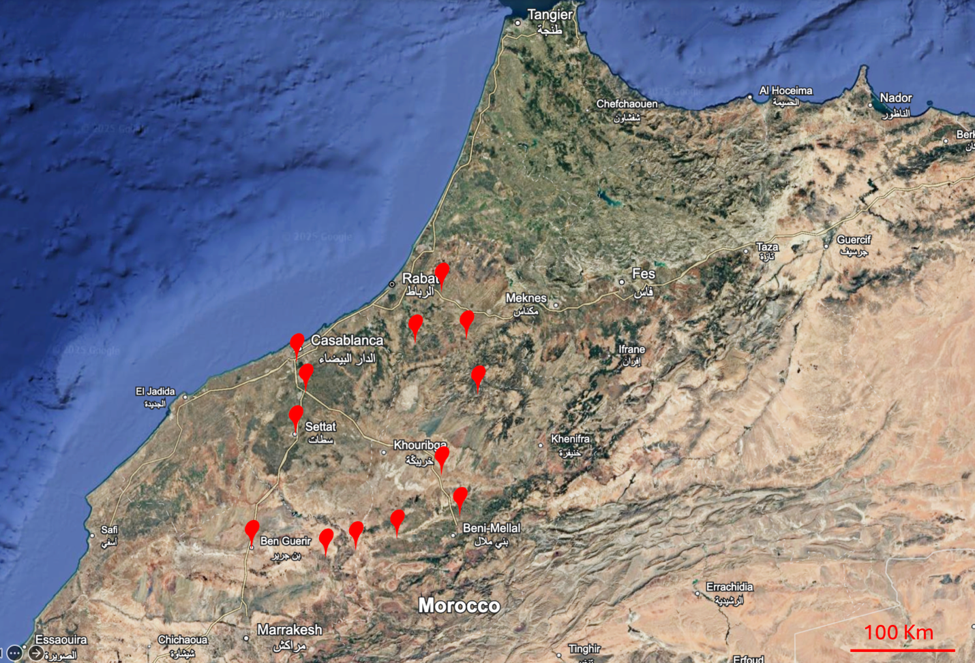

Figure S2. Rarefaction curves for AMF communities showing that sequencing depth was sufficient to reach saturation across all samples.
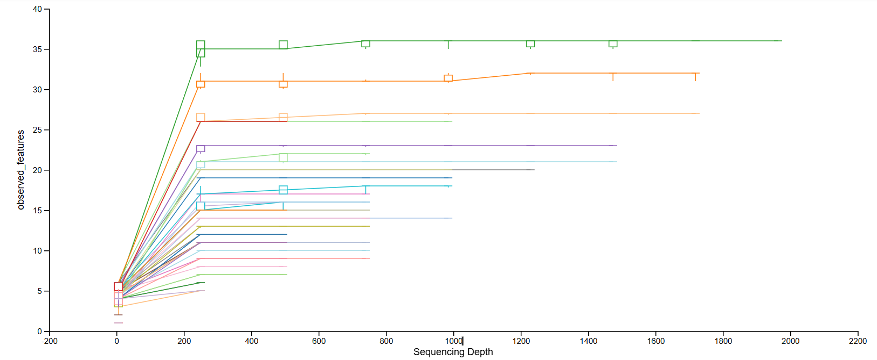

Figure S3. Spearman’s correlation between soil nutrients, precipitation, and distance from the coastline.
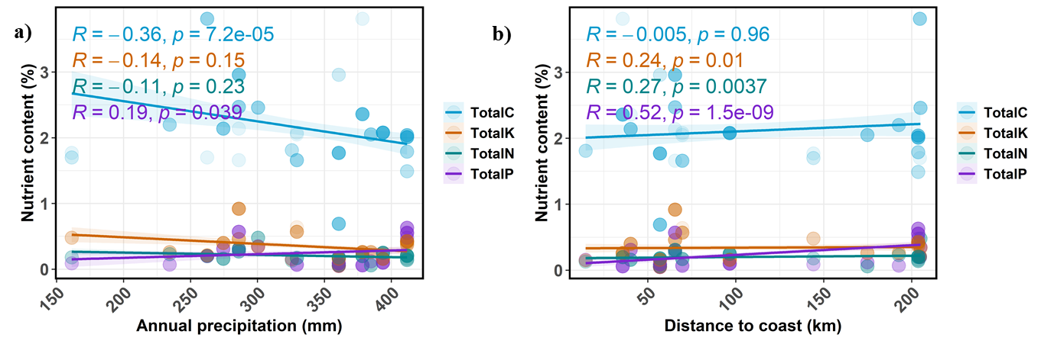

Figure S4. Species Diversity of AMF in Moroccan dryland ecosystems. Presence and absence data of AMF species in various sites a) in rhizosphere b) roots across sites.

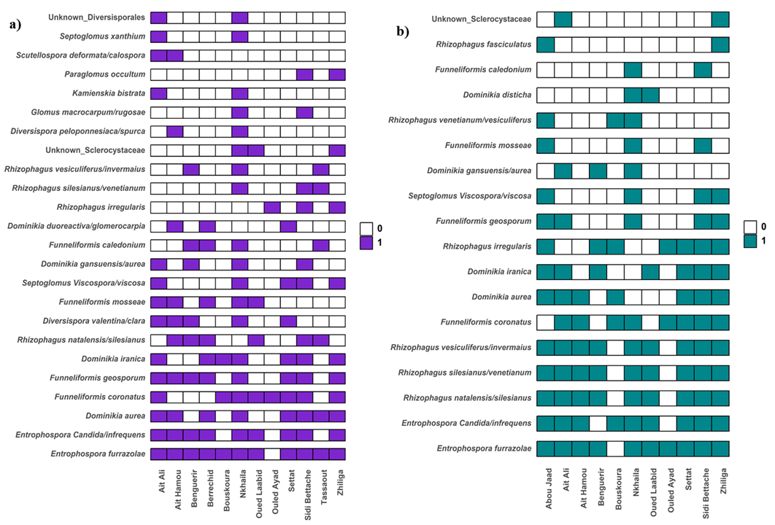

Figure S5. Relative abundance of key AMF genera colonizing Malva roots along soil nutrients and Precipitation gradients. Generalized additive model of a) Entrosphospora, Rhizophagus and Unclassified Glomeromycoata along precipitation gradient; b. Dominikia, Entrophospora Rhizophagus and Unclassified Glomeromycota versus Total soil P c. Entrophospora and Rhizophagus versus Total N.

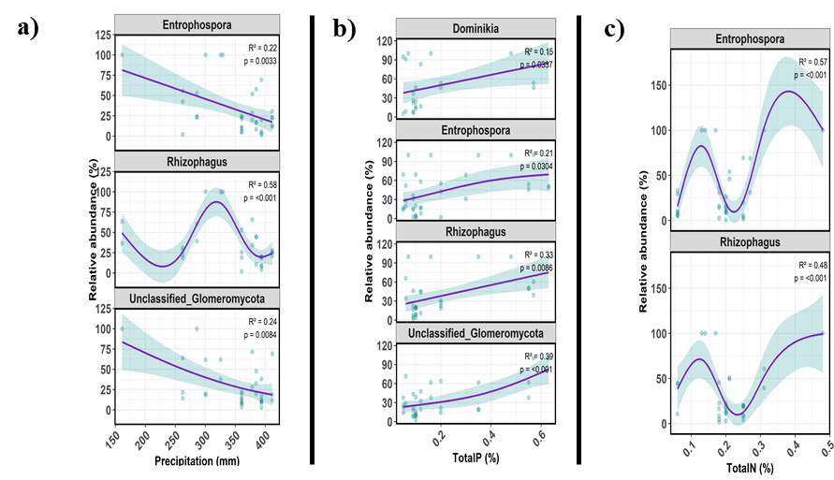

Figure S6. Community assembly processes in the rhizosphere. (a) Predictors of βNTI in the rhizosphere. (b) Mantel test of βNTI versus precipitation.
