Supplementary Information for
Local Deformation Mapping Reveals Diffusion through Microstructures

Arindam Raj^{1,2†}, Michael Aderibigbe^{1,2†}, Ethen Lund^{1,2}, Yi-Xiang Yang^{1,2}, Sungwoo Sohn^{1,2,3} and, Jan Schroers^{1,2*}
¹Department of Mechanical Engineering, Yale University, New Haven, Connecticut 06511, United States
²Department of Materials Science, Yale University, New Haven, Connecticut 06511, United States
³Yale Institute for Nanoscience and Quantum Engineering (YINQE), Yale University,
New Haven, Connecticut 06511, United States

†These authors contributed equally.
*Corresponding author: Jan Schroers (jan.schroers@yale.edu)
15 Prospect St, New Haven, CT 06511
Tel: 203-432-4346, Fax: 203-432-6775

Supplementary section 1: Growth rate equations for different mechanisms dictating the nanorod growth flux, J_{nanorod} during LDM
We describe the growth rate equations, L(t) for the different mechanisms controlling the nanorod growth into the nanopores, J_{nanorod} (simplified as J in this section)during LDM: lattice and interface diffusion, and dislocation slip.
Lattice and Interface Diffusion: Nanorod growth during nanomolding based on diffusion can be derived from Fick’s law and volume conservation considerations. Here, we consider the volume change of a nanorod ($dV/dt$) occurring as a result of the diffusion flux of atoms, J, through the cross-section area of nanorod, S, noted as: $\frac{dV}{dt}=S∙J$.
Here, we use the fact that the diffusion flux resulting in nanorod growth, J is described using Fick’s law $J=\frac{D}{k_{B}T}∇\left( σΩ\right)$, with D as the diffusivity, σ is the applied compressive stress, Ω the mean atomic volume of the diffusing material, k_{B} is the Boltzmann constant, and T is the absolute temperature. We assume that Ω remains constant, and the gradient of σ is noted as linear over the growing nanorod decaying to zero at the free end, $∇σ$ = $σ/L$.
Considering $V=\frac{πd^{2}}{4}∙L$ for a cylindrical nanorod of diameter, d, we can write the growth rate (dL/dt) from (dV/dt),
$\frac{dL}{dt}=\frac{4SDσΩ}{{πd^{2}Lk}_{B}T}$ and integrating for L(t) gives:
$L=\sqrt{{L_{0}}^{2}+\frac{8SDσΩt}{πd^{2}k_{B}T}}$ . (S1)
Here L₀ is an integration constant which is set to L₀ = 0 for no preexisting growth.
In the case of lattice diffusion, the diffusion coefficient is the lattice diffusivity (D = D_{L}) and diffusion occurs throughout the volume of the nanorod ($S=\frac{πd^{2}}{4}$). Inserting this in (S1):
$L=\sqrt{{L_{0}}^{2}+\frac{2D_{L}σΩt}{k_{B}T}}$ (S2)
In the case of interface diffusion, the diffusion coefficient is the interface diffusivity along the nanorod-mold interface (D = D_{I}) and diffusion occurs in an interface layer of thickness δ between the nanorod and mold ($S=πdδ$). Inserting this in (S1):
$L=\sqrt{{L_{0}}^{2}+\frac{8D_{I}σΩt}{k_{B}T}\frac{δ}{d}}$ (S3)
So, for lattice diffusion (from S2), L ∝ d⁰ and for interface diffusion (from S3), L ∝ d^{-1/2}.
Dislocation Slip: Apart from diffusion, the nanorods may also grow by dislocations moving down into the mold pores due to the applied stress. To quantify, we consider a force balance (inertial forces neglected) between the applied compressive stress over the cross section of the nanorod, and the friction along the nanorod surface from the nanorod-mold interface:$σ_{e}\frac{πd^{2}}{4}=τ_{I}πdL$.
Here, $σ$_{e} is the stress at the opening of the nanopore, and $τ_{I}$ is the shear strength of the nanorod-mold interface. The applied molding stress, $σ$ is consumed partially in plastic deformation of the bulk of the feedstock material and partially in the nanorod till the free surface ($σ$ = 0) at the tip of the nanorod. This stress distribution results in a gradient from the feedstock to the various tips of the nanorods and hence, $σ_{e}≤σ_{applied}$.
In a growing nanorod, $σ_{e}$ increases with increasing L until $σ_{e}=σ_{applied}$, and force balance is achieved. This sets the maximum length in dislocation slip controlled nanorod growth, $L≤L_{m}=σ_{applied}d/4τ_{I}$ .
We consider that dislocation slip controlled nanorod growth is based on dislocation motion within the pressed material under the driving force of the stress drop, $σ_{e}-σ_{applied}$. The nanorod growth rate can then be written as:
$\frac{dL}{dt}=Cbu\left(σ_{e}-σ_{applied}\right)N_{d}=Cbuσ\left(1-\frac{L}{L_{m}}\right)N_{d}$ (S4)
Here, C is a material related constant, b is the Burgers vector, u is the average propagating velocity of the dislocations, and N_{d} is the number of dislocations contributing to the nanorod growth.
Integrating and assuming $L_{(t=0)}=0$ gives$L=L_{m}\left(1-e^{-\frac{CbuN_{d}σt}{L_{m}}}\right) .$ (S5)
In the case of pre-existing dislocations within the microstructure which drive this nanorod’s growth, we substitute L_{m} with $σd/4τ_{I}$,$L=\frac{σd}{4τ_{I}}(1-e^{-α{bτ}_{I}uρdt})$. (S6)
Here, $α=Cπ$ is a constant, and $ρ=N_{d}/\frac{πd^{2}}{4}$ is the dislocation density in the material above the nanopore.
In (S6), the scaling coefficient lies between 1<x<2, L ∝ d^{x} for large and small exponential factor values.

Supplementary section 2: Deriving analytical expressions for diffusion coefficients from the L map
To understand how LDM determines intrinsic materials’ properties related to deformation we will hereby discuss how mass transport rates within the microstructure due to deformation are related to the growth of the nanorod, and we extract the rate transport properties from the measured length of the nanorod, L. For the former, it is important to consider that LDM involves two different material fluxes. One is the intrinsic flux through the microstructure, $J_{microstructure}$, and the other is the flux out of the microstructure and into the nanopore, J_{nanorod}, and we correlate these two fluxes. In an LDM experiment, these fluxes are correlated and hence may alter due to mass conservation. First, the atoms within the bulk material diffuse through the microstructure to reach the mold-microstructure interface by following the applied stress gradient. The processes dictating this step are governed by the intrinsic kinetics of the material. Next, the atoms at the mold-microstructure interface grow into the nanopore, and this flux, J_{nanorod} , is dictated by a different form of mass transport within the nanomold’s nanopores (Fig. 2a).
Here, it is important when addressing how to extract the transport properties from the measured length, that for the nano rod array to encode the intrinsic dynamics of the microstructure, $J_{microstructure}$must be the rate limiting step in this two-step growth process. We indeed determine this to be the case, described further below, such that the nano rod growth is dictated by flux through the bulk material, and not by the flux into the cavity, and we argue that $J_{nanorod}$= a $J_{microstructure}$ (a: constant specified in the next section). Appropriate correlations that we discuss below allow to deduce information contained in $J_{nanorod}$ (forming the L-map over the microstructure) to extract $J_{microstructure}$, and hence calculate the local self-diffusivity for the different components in the microstructure.
Broadly speaking, fluxes can be expanded as products of diffusivity coefficient (the rate term) and driving force (the gradient term) as per Fick’s first law. Therefore, with appropriate modeling of the driving force term, we can extract D values appropriate for the microstructure of interest from the flux terms measured during LDM. It is important to mention that the transport or deformation within the nanocavity as shown in Fig. 2.b,c is not identical to that of the microstructure. However, we argue with the help of the above analytical models that diffusion related information about the microstructure can be directly deduced if the nanorod growth is also based on diffusion. This argument is justified due to the mathematical similarity of the flux terms which are similar if both $J_{microstructure}$, and $J_{nanorod}$ are diffusive fluxes.
For both $J_{microstructure}$ and $J_{nanorod}$, the driving force is the stress gradient created by the externally applied compressive force and the boundary condition of the mold-metal interface (Fig. 2a). From our previous results ¹, we observe that this stress permeates into the thickness of the microstructure bulk above the mold-metal interface on the length scale of ~d, and extends down into the nanopore towards the free end of the growing nanorods over the L(t) of each nanorod. Hence, this gradient, which permeates both the bulk microstructure and the nanorods, is modeled as: $∇σ= \frac{σ_{max}-σ_{min}}{L+d}$. Here, $σ_{min}$ approaches zero towards the free end of the growing nanorods, while the $σ_{max}$ is approximated as the applied stress arising from the applied compressive force. Thus, this linear stress gradient can be written as $\frac{σ_{applied}}{L+d}$ and it approximates $\frac{σ_{applied}}{L}$ for long nanorods where L >> d. The microstructure responds by filling, through material flux, into each nanopore to increase L. Hence, the gradient is reduced as the nanorods grow into the nanopores.
Using this description of the stress gradient, we can calculate diffusivities of different atoms within the various features of a general microstructure. First, we construct an equation for flux governed by atomic diffusion within a single phase, polycrystalline microstructure during LDM. In such material, the individual grains and the corresponding grain boundaries are broadly the two features of interest. For now, we ignore the variations amongst the differently oriented grains and grain boundaries. Thus, for atoms diffusing through the microstructure $J_{microstructure}$ ∝ $D_{GB}$, when diffusing through grain boundaries, and $J_{microstructure}$ ∝ $D_{lattice}$, when diffusing through the grains. When these diffusing atoms enter the nanopores, forming the outgoing flux $J_{nanorod}∝D_{I}^{eff}$, where $D_{I}^{eff}$ is the effective diffusivity along the mold-nanorod interface. For the conditions where $J_{microstructure}$ is rate limiting flux, direct correlations can be established between $D_{I}^{eff}$, D_{GB} and $D_{lattice}$. For this we use previously developed models mentioned in the supplementary section 1 correlating $J_{nanorod}$ with diffusivity and dislocation density². Specifically, it allows us to determine the relations between $J_{microstructure}$ and $J_{nanorod}$ for LDM over a polycrystalline microstructure:
For grain boundaries (δ_{I}: nanorod-nanopore interface thickness, δ_{GB}: grain boundary thickness):
$D_{GB}$ = $D_{I}^{eff}$ ($π$δ_{I} /δ_{GB}) (S7)
and, for grains (for nanomold pore diameter, d),
$D_{lattice}$ = $D_{I}^{eff}$ ($\frac{πdδ_{I}}{\frac{πd^{2}}{4}}$) = $D_{I}^{eff}$ ($\frac{4δ_{I}}{d}$). (S8)
Assuming the thickness of a grain boundary δ_{GB} to be 0.5 nm, and the mold-nanorod interfacial thickness within the nanopores, δ_{I} to be 1 nm ^{3, 4, 5}:
$D_{GB}$ ~ 2$πD_{I}^{eff}$; (S9)
$D_{lattice}$ ~ $D_{I}^{eff}$ ($\frac{4}{d}$), which for 80 nm molds = $\frac{D_{I}^{eff}}{20}.$ (S10)
As noted previously, we assume that the rate limiting step in the growth of nanorods is the diffusive flux of material through the microstructure towards the mold-microstructure interface, and this allows us to determine intrinsic material diffusivities from $D_{I}^{eff}$.
Now, for a single phase, multicrystalline microstructure, we have three diffusion coefficients, and they dictate the interplay between $J_{microstructure}$ and $J_{nanorod}$ and the resulting LDM map. We present the following scenarios:
- Firstly, if $D_{I}^{eff}$ is high enough such that interfacial diffusion into the nanopores does not constitute the rate limiting step, then this effective rate captures the intrinsic dynamics of microstructures rate transport. Essentially,$J_{nanorod}$ transport is so fast that the nanorod growth is controlled by $J_{microstructure}$ and hence, with appropriate modeling the intrinsic values of $D_{GB}$/$D_{lattice}$ embedded in $J_{microstructure}$ are directly accessible as described in equations (S9-10).
- On the other hand, if the interfacial diffusion into the nanopores is the rate limiting step for LDM, then $J_{out}$ only measures the mold-nanorod interfacial diffusion coefficient. In this case, the mass transport inside the mold is not faster than the microstructural dynamics, bringing the material flux to the pore openings. Here, we can have three cases:
  - If $D_{GB}$ >> $D_{I}^{eff}$ $≥$ $D_{lattice}$ (more precisely, $D_{GB}$ >> 2$πD_{I}^{eff}$ $≥$ $20D_{lattice}$ ), then transport within the GBs is too fast for the transport within the nanomold to keep up. Thus, the growth of the nanorods over GB regions is dictated by the mold-nanorod dynamics, but that over grains will still be representative of grain self-diffusion in the microstructure.
  - If $D_{GB}$>$D_{I}^{eff}$ >> $D_{lattice}$ , L over GBs will still look longer and those over grains shorter, so a length contrast might be observed, but the dynamics long nanorods will be dictated by the intrinsic mold-nanorod $D_{I}^{eff}$.
  - Finally, if $D_{GB}>$> $D_{lattice}$ > $D_{I}^{eff}$, then transport within both the GBs and the grains is too fast, and the growth of the nanorods over all of the microstructure is dictated by the mold-nanorod dynamics. Thus, mass transport everywhere is regulated solely by interfacial diffusion and would lead to uniform L nanorods everywhere.
So, for microstructural features with D < $D_{I}^{eff}$, the L map can reveal the intrinsic D values. For slow enough rates of $J_{microstructure}$ (with low D_{GB/lattice} values), the nanopore-nanorod interface enables fast enough mass transport and the diffusion coefficients intrinsic to the microstructure can be measured. Next, within a polycrystalline microstructure even if $D_{GB}$>$D_{I}^{eff}$, the LDM map will show L contrast with longer L over GBs so long, $D_{I}^{eff}$ >> $D_{lattice}$ . In the case of $D_{GB}>$> $D_{lattice}$ > $D_{I}^{eff}$, only the mold-material interface properties are measured, and the L map becomes featureless.

Supplementary section 3: Table with diffusivity values calculated using the L maps created experimentally
$L=\sqrt{\frac{8 D_{I}^{eff} σΩt}{k_{B}T}\frac{δ}{d}}$ (δ = 1 nm)
$D_{GB}$ = 2$πD_{I}^{eff}$ and $D_{lattice}$ = $D_{I}^{eff}$ ($\frac{4δ}{d}$)
Atomic volume, Ω (Å³): Ag (17.1), Ni (10.9), Au (16.9).
Mold: Anodic alumina molds with pores of diameter, d (nm)

Table S1. Diffusivity vs temperature for Ag samples
T  (°C) | T_{hom} | Diffusing atom | Parameters  (stress, MPa, diameter, nm, molding time, s) | L_{GB}  (μm) | D_{GB}  (cm²/sec) | L_{Lattice}  (μm) | D_{Lattice} (cm²/sec) | $$\frac{{\text{D}}_{\text{GB}}}{{\text{D}}_{\text{Lattice}}}$$
345 | 0.5 | Ag | 200, 80, 600 | 2.68 | 5.30E-08 | 0.23 | 1.10E-12 | 4.81E+04
468 | 0.6 | Ag | 200, 80, 600 | 5.47 | 2.66E-07 | 0.66 | 1.09E-11 | 2.43E+04
592 | 0.7 | Ag | 200, 80, 600 | 10.63 | 1.17E-06 | 6.49 | 1.23E-09 | 9.53E+02
715 | 0.8 | Ag | 200, 80, 600 | 17.05 | 3.44E-06 | 9.11 | 2.76E-09 | 1.25E+03
839 | 0.9 | Ag | 200, 80, 600 | 24.00 | 7.67E-06 | 20.03 | 1.50E-08 | 5.10E+02

Note: L_{GB} is the long nanowire lengths in the vicinity of the GB region, here typically 8 nanowires thick, hence in D calculations are scaled by a factor of square root 8, accounting for 8 rods of length, L_{GB.}

Table S2. Interphase boundary enhanced diffusivity for AuSi sample
T  (°C) | T_{hom} | Diffusing atom | Parameters  (stress, MPa, diameter, nm, molding time, s) | L_{PB}  (μm) | D_{PB}  (cm²/sec) | L_{Au}  (μm) | D_{Au} (cm²/sec) | $$\frac{{\text{D}}_{\text{PB}}}{{\text{D}}_{\text{Au}}}$$
250 | 0.82 | Au (in AuSi) | 200, 250, 30 | 5.906 | 4.88E-06 | 0.46 | 7.60E-11 | 6.4E+04

Note: L_{GB} is the length of the longest nanowire at Au-Si interface.
Table S3. Nickel Diffusivity vs Grain Boundary Misorientation Angle at 720 ̊C (0.57T_{m})
Parameters  (stress, MPa, diameter, nm, molding time, s) | ϴ (°) | L_{GB}  (μm)  [mean, SD] | L_{GB}  (μm)  [max, min] | D_{GB}  (cm²/sec)  [mean] | D_{GB}  (cm²/sec)  [SD] | D_{GB}  (cm²/sec)  [max] | D_{GB}  (cm²/sec)  [min]
200, 250, 7200 | 15-22 | 0.82, 0.20 | 1.31, 0.53 | 7.42E-10 | 4.20E-11 | 1.88E-09 | 3.05E-10
200, 250, 7200 | 24-26 | 0.99, 0.31 | 1.50, 0.46 | 4.33E-09 | 4.32E-10 | 9.88E-09 | 9.11E-10
200, 250, 7200 | 27-30 | 1.01, 0.24 | 1.47, 0.61 | 4.48E-09 | 2.43E-10 | 9.44E-09 | 1.62E-09
200, 250, 7200 | 30-32 | 1.81, 0.11 | 1.98, 1.65 | 1.44E-08 | 4.92E-11 | 1.72E-08 | 1.19E-08
200, 250, 7200 | 33 | 1.44, 0.016 | 1.45, 1.43 | 9.08E-09 | 1.12E-12 | 9.21E-09 | 8.93E-09
200, 250, 7200 | 35-40 | 1.24, 0.43 | 2.20, 0.46 | 6.75E-09 | 7.94E-10 | 2.13E-08 | 9.35E-10
200, 250, 7200 | 44-45 | 1.39, 0.14 | 1.58, 1.20 | 8.46E-09 | 8.34E-11 | 1.10E-08 | 6.35E-09
200, 250, 7200 | 45-50 | 1.37, 0.16 | 1.59, 1.14 | 8.27E-09 | 1.15E-10 | 1.11E-08 | 5.67E-09
200, 250, 7200 | 46-50 | 1.77, 0.21 | 1.96, 1.42 | 1.37E-08 | 1.90E-10 | 1.68E-08 | 8.78E-09
200, 250, 7200 | 53-56 | 1.09, 0.25 | 1.55, 0.67 | 5.20E-09 | 2.67E-10 | 1.06E-08 | 1.95E-09
200, 250, 7200 | 60, twin | 0.46, 0.15 | 0.74, 0.238 | 2.28E-10 | 2.43E-11 | 5.96E-10 | 6.20E-11

Note: L_{GB} is the sum of the long nanowire lengths over the thickness of the GB added using SEM images (see below).
*The nanowire arrays were tilted at 30 ̊ for the image captured at the Scanning Electron Microscope, hence, each measured apparent length was multiplied by a factor of 2.

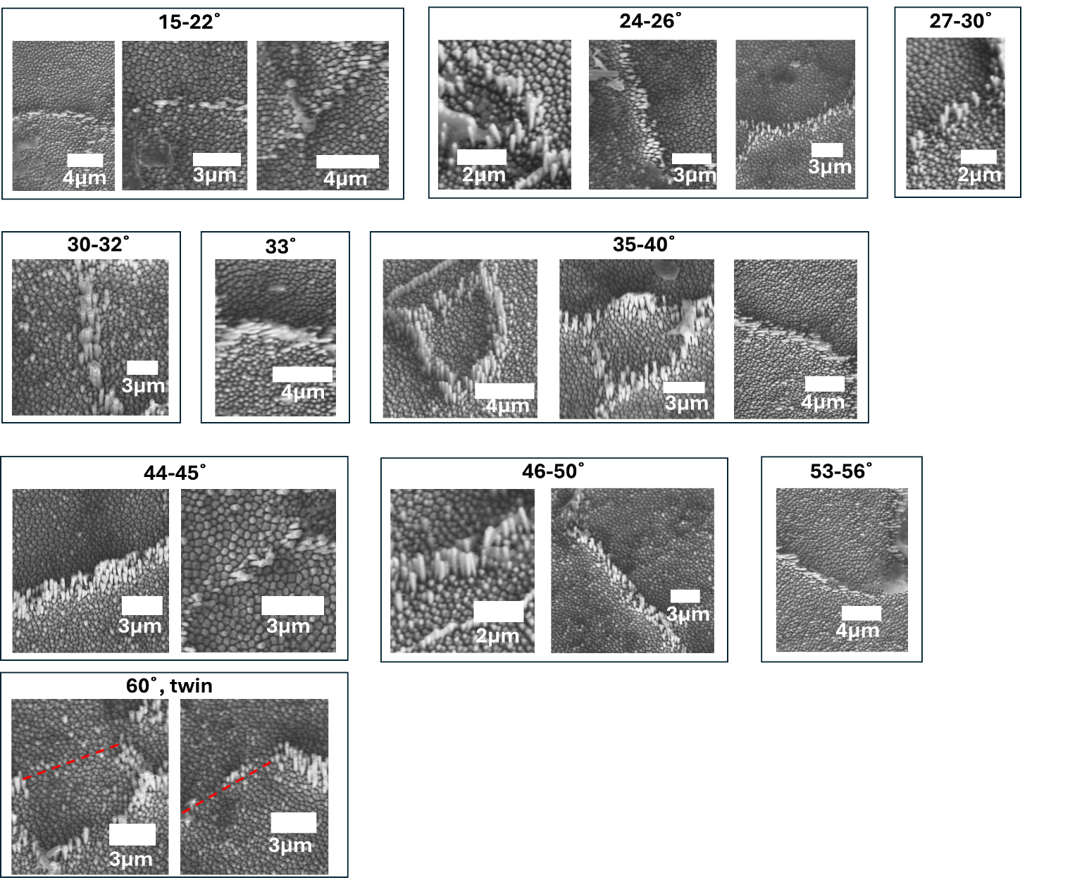
Figure S1. SEM micrographs show the effect of grain boundary misorientation angle on diffusivity of nickel. LDM on polycrystalline nickel sample was performed at 720 °C (0.57 T_{m}), 250 nm, σ = 200 MPa, for 7200 s.

Supplementary References
1. Raj A, Liu NJ, Liu GN, Sohn S, Xiang JX, Liu Z, et al. Nanomolding of Gold and Gold-Silicon Heterostructures at Room Temperature. Acs Nano 2021, 15(9): 14275-14284.

2. Liu N, Liu G, Raj A, Sohn S, Morales-Acosta MD, Liu J, et al. Unleashing nanofabrication through thermomechanical nanomolding. Sci Adv 2021, 7(47): eabi4567.

3. Baram M, Garofalini SH, Kaplan WD. Order in nanometer thick intergranular films at Au-sapphire interfaces. Acta Mater 2011, 59(14): 5710-5715.

4. Avishai A, Scheu C, Kaplan WD. Intergranular films at metal-ceramic interfaces Part I - interface structure and chemistry. Acta Mater 2005, 53(5): 1559-1569.

5. Kim EG, Brédas JL. The nature of the aluminum-aluminum oxide interface: A nanoscale picture of the interfacial structure and energy-level alignment. Org Electron 2013, 14(2): 569-574.

