Supplementary Material

Annex 1 : Interviews list (anonymized)
Table 3: Interviews list (cases)
City | Case number | Sector
Bologna | 1 | Climate
Bologna | 2 | Urbanism
Bologna | 3 | Housing
Bologna | 4 | Mobility, Public works
Lausanne | 5 | Agriculture, Urban greening
Lausanne | 6 | Housing
Lausanne | 7 | Water
Lausanne | 8 | Energy
Lausanne | 9 | Climate
Lausanne | 10 | Public land (forests)
Lausanne | 11 | Education
Lausanne | 12 | Environment
Lausanne | 13 | Climate
Lausanne | 14 | Urbanism
Padua | 15 | Financial
Padua | 16 | Climate
Padua | 17 | Agriculture, Urban greening
Padua | 18 | Digitalisation
Padua | 19 | Government operations
Padua | 20 | Energy
Padua | 21 | Climate
Zurich | 22 | Climate
Zurich | 23 | Energy
Zurich | 24 | Waste
Zurich | 25 | Urban greening
Zurich | 26 | Public works, Mobility
Zurich | 27 | Housing
Zurich | 28 | Housing
Zurich | 29 | Housing
Zurich | 30 | Mobility
Zurich | 31 | Urbanism

Annex 2: Truth tables

The truth table displays configuration of conditions that are sufficient for the outcome (rows in which OUT=1)

Table 4: Truth table, presence of the outcome
 | AUT | FIN | PER | FULL_EXP | INT_cal | OUT | n | incl | PRI | cases
1 | 0 | 0 | 0 | 0 | 0 | ? | 0 | - | -
2 | 0 | 0 | 0 | 0 | 1 | ? | 0 | - | -
3 | 0 | 0 | 0 | 1 | 0 | ? | 0 | - | -
4 | 0 | 0 | 0 | 1 | 1 | 1 | 3 | 0.895480225988701 | 0.701612903225807 | 16,18,21
5 | 0 | 0 | 1 | 0 | 0 | ? | 0 | - | -
6 | 0 | 0 | 1 | 0 | 1 | 1 | 3 | 0.890909090909091 | 0.686567164179104 | 12,13,19
7 | 0 | 0 | 1 | 1 | 0 | ? | 0 | - | -
8 | 0 | 0 | 1 | 1 | 1 | ? | 0 | - | -
9 | 0 | 1 | 0 | 0 | 0 | ? | 0 | - | -
10 | 0 | 1 | 0 | 0 | 1 | ? | 0 | - | -
11 | 0 | 1 | 0 | 1 | 0 | ? | 0 | - | -
12 | 0 | 1 | 0 | 1 | 1 | ? | 0 | - | -
13 | 0 | 1 | 1 | 0 | 0 | ? | 0 | - | -
14 | 0 | 1 | 1 | 0 | 1 | 1 | 2 | 0.997787610619469 | 0.994082840236686 | 8,27
15 | 0 | 1 | 1 | 1 | 0 | ? | 0 | - | -
16 | 0 | 1 | 1 | 1 | 1 | 1 | 1 | 0.830379746835443 | 0.596385542168675 | 31
17 | 1 | 0 | 0 | 0 | 0 | ? | 0 | - | -
18 | 1 | 0 | 0 | 0 | 1 | 1 | 3 | 0.851116625310174 | 0.565217391304348 | 1,2,6
19 | 1 | 0 | 0 | 1 | 0 | ? | 0 | - | -
20 | 1 | 0 | 0 | 1 | 1 | ? | 0 | - | -
21 | 1 | 0 | 1 | 0 | 0 | 0 | 1 | 0.744394618834081 | 0 | 29
22 | 1 | 0 | 1 | 0 | 1 | ? | 0 | - | -
23 | 1 | 0 | 1 | 1 | 0 | ? | 0 | - | -
24 | 1 | 0 | 1 | 1 | 1 | 1 | 3 | 0.884444444444444 | 0.766816143497758 | 11,17,20
25 | 1 | 1 | 0 | 0 | 0 | ? | 0 | - | -
26 | 1 | 1 | 0 | 0 | 1 | 1 | 2 | 0.997448979591837 | 0.992481203007518 | 4,26
27 | 1 | 1 | 0 | 1 | 0 | ? | 0 | - | -
28 | 1 | 1 | 0 | 1 | 1 | ? | 0 | - | -
29 | 1 | 1 | 1 | 0 | 0 | 0 | 1 | 0.871794871794872 | 0.102564102564103 | 7
30 | 1 | 1 | 1 | 0 | 1 | 1 | 4 | 0.998220640569395 | 0.996047430830039 | 15,22,24,25
31 | 1 | 1 | 1 | 1 | 0 | ? | 0 | - | -
32 | 1 | 1 | 1 | 1 | 1 | 1 | 8 | 0.939705882352941 | 0.907239819004525 | 3,5,9,10,14,23,28,30

An XY plot helps visualize the sufficiency relation (see Figure 6 below). It shows that most cases fall above or close on the main diagonal (the area where X is smaller or equal to Y).

Figure 6: Sufficiency plot, entire solution formula, presence of the outcome
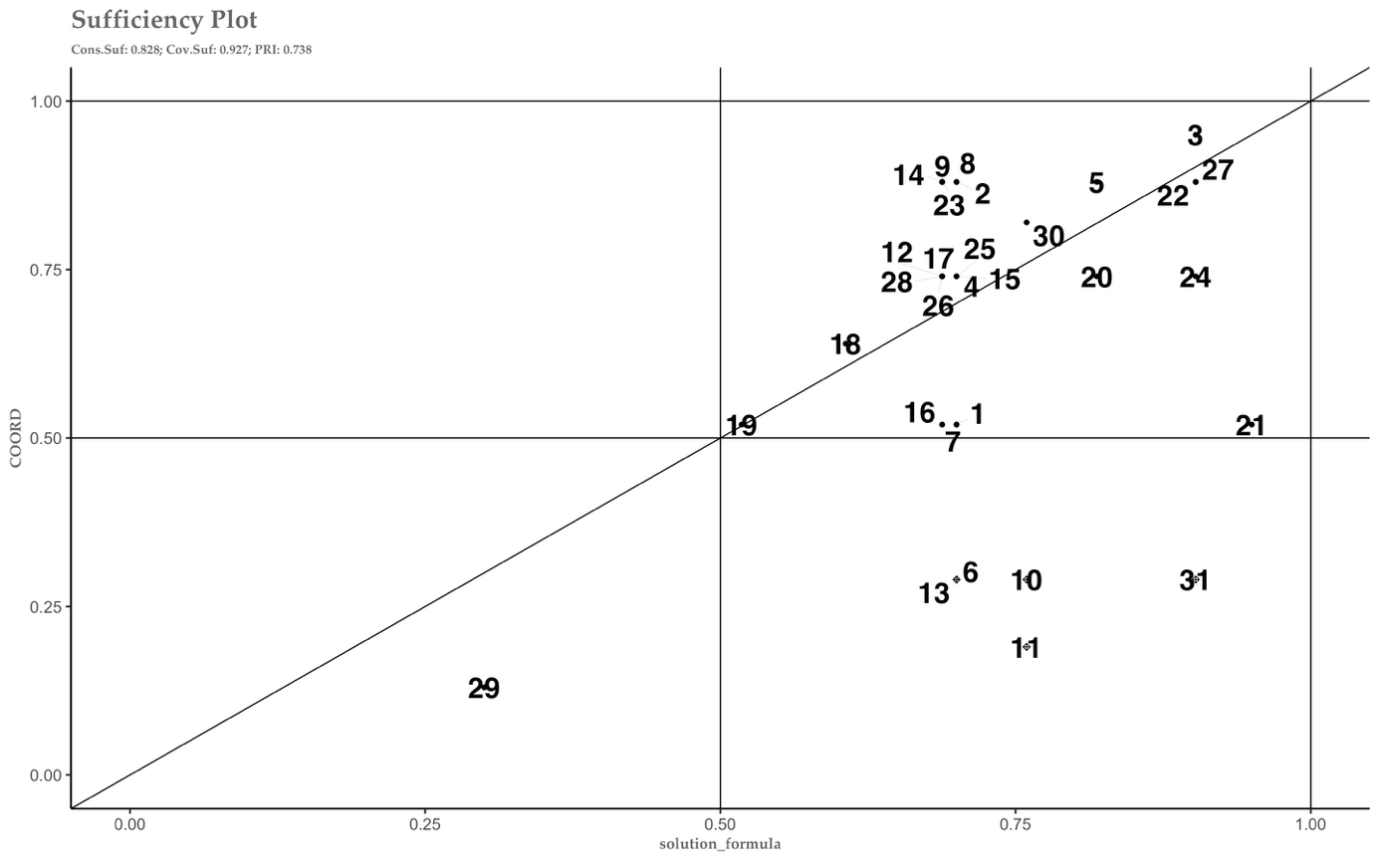
Legend: Bologna (cases 1-4), Lausanne (cases 5-14), Padua (cases 15-21), Zurich (cases 22-31)

The following truth table displays configuration of conditions that are sufficient for the absence of the outcome (rows in which OUT=1)

Table 5: Truth table, absence of the outcome
 | AUT | FIN | PER | FULL_EXP | INT_cal | OUT | n | incl | PRI | cases
1 | 0 | 0 | 0 | 0 | 0 | ? | 0 | - | -
2 | 0 | 0 | 0 | 0 | 1 | ? | 0 | - | -
3 | 0 | 0 | 0 | 1 | 0 | ? | 0 | - | -
4 | 0 | 0 | 0 | 1 | 1 | 0 | 3 | 0.652542372881356 | 0.00806451612903208 | 16,18,21
5 | 0 | 0 | 1 | 0 | 0 | ? | 0 | - | -
6 | 0 | 0 | 1 | 0 | 1 | 0 | 3 | 0.761038961038961 | 0.313432835820895 | 12,13,19
7 | 0 | 0 | 1 | 1 | 0 | ? | 0 | - | -
8 | 0 | 0 | 1 | 1 | 1 | ? | 0 | - | -
9 | 0 | 1 | 0 | 0 | 0 | ? | 0 | - | -
10 | 0 | 1 | 0 | 0 | 1 | ? | 0 | - | -
11 | 0 | 1 | 0 | 1 | 0 | ? | 0 | - | -
12 | 0 | 1 | 0 | 1 | 1 | ? | 0 | - | -
13 | 0 | 1 | 1 | 0 | 0 | ? | 0 | - | -
14 | 0 | 1 | 1 | 0 | 1 | 0 | 2 | 0.628318584070796 | 0.00591715976331401 | 8,27
15 | 0 | 1 | 1 | 1 | 0 | ? | 0 | - | -
16 | 0 | 1 | 1 | 1 | 1 | 0 | 1 | 0.688607594936709 | 0.259036144578313 | 31
17 | 1 | 0 | 0 | 0 | 0 | ? | 0 | - | -
18 | 1 | 0 | 0 | 0 | 1 | 0 | 3 | 0.761786600496278 | 0.304347826086956 | 1,2,6
19 | 1 | 0 | 0 | 1 | 0 | ? | 0 | - | -
20 | 1 | 0 | 0 | 1 | 1 | ? | 0 | - | -
21 | 1 | 0 | 1 | 0 | 0 | 1 | 1 | 1 | 1 | 29
22 | 1 | 0 | 1 | 0 | 1 | ? | 0 | - | -
23 | 1 | 0 | 1 | 1 | 0 | ? | 0 | - | -
24 | 1 | 0 | 1 | 1 | 1 | 0 | 3 | 0.62 | 0.233183856502242 | 11,17,20
25 | 1 | 1 | 0 | 0 | 0 | ? | 0 | - | -
26 | 1 | 1 | 0 | 0 | 1 | 0 | 2 | 0.663265306122449 | 0.00751879699248104 | 4,26
27 | 1 | 1 | 0 | 1 | 0 | ? | 0 | - | -
28 | 1 | 1 | 0 | 1 | 1 | ? | 0 | - | -
29 | 1 | 1 | 1 | 0 | 0 | 0 | 1 | 0.91941391941392 | 0.435897435897436 | 7
30 | 1 | 1 | 1 | 0 | 1 | 0 | 4 | 0.551601423487544 | 0.00395256916996039 | 15,22,24,25
31 | 1 | 1 | 1 | 1 | 0 | ? | 0 | - | -
32 | 1 | 1 | 1 | 1 | 1 | 0 | 8 | 0.410294117647059 | 0.0927601809954751 | 3,5,9,10,14,23,28,30

Figure 7: Sufficiency plot for the entire solution formula (absence of the outcome)
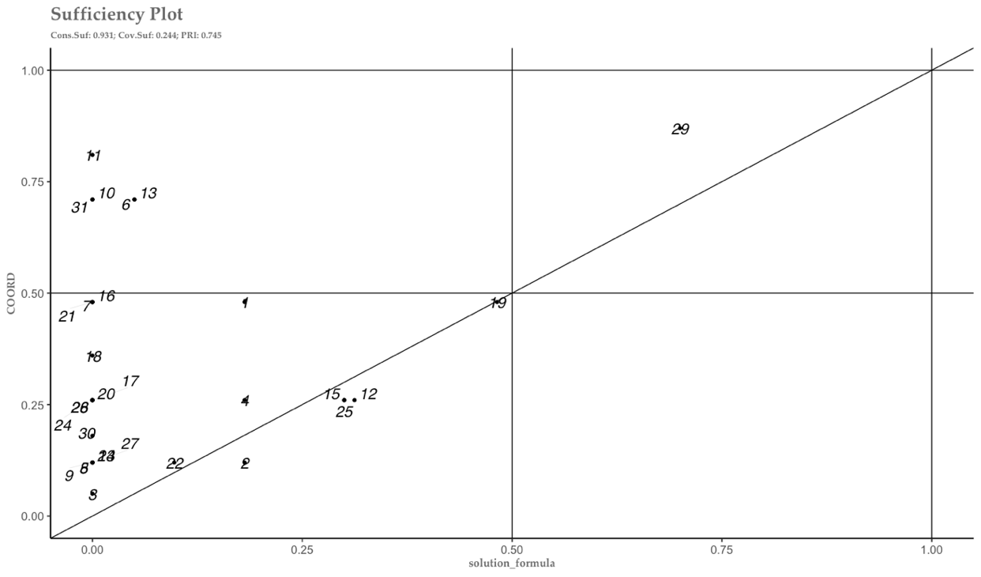

Annex 3 : Robustness checks

Absence of the outcome
Table 6 presents the solutions formula explaining the absence of the outcome, i.e., ineffective coordination. The solution formula identifies one path leading to negative evaluation of administrative coordination among cases, i.e., the situation in which use of expertise is limited, the climate programs is not well integrated, and finances are absent:
~FIN* ~EXP* ~ INT -> ~COORD

Table 6: Sufficiency, intermediate solution, absence of the outcome
Path | inclS | PRI | covS | cases
~FIN* ~EXP* ~ INT | 0.931 | 0.745 | 0.244 | 29
Solution | 0.931 | 0.745 | 0.244

This result indicates a subset relation (inclS = 0.931), i.e., with almost no case contradicting the statement of sufficiency. Nonetheless, the coverage score indicates that the solution covers only a bit more than 20% of cases. In other words, 80% of cases remain unexplained by this solution. In particular, there is only one typical case (29), a bureaucrat working in the housing department of the city of Zurich. These results align with expectations, but have less explanatory power that those illustrated above.

Alternative minimization strategies

Table 7 : Conservative solution, Presence of the outcome
 | inclS | PRI | covS | covU | cases
FIN*PER*INT | 0.908 | 0.850 | 0.667 | 0.112 | 8,27; 31; 15,22,24,25; 3,5,9,10,14,23,28,30
~ AUT*PER*~EXP*INT | 0.932 | 0.837 | 0.283 | 0.031 | 12,13,19; 8,27
AUT*~PER*~EXP*INT | 0.895 | 0.750 | 0.254 | 0.070 | 1,2,6; 4,26
AUT* PER*EXP* INT | 0.890 | 0.841 | 0.368 | 0.051 | 11,17,20; 3,5,9,10,14,23,28,30
~AUT*~FIN*~PER*EXP*INT | 0.895 | 0.702 | 0.157 | 0.053 | 16,18,21
Solution | 0.850 | 0.768 | 0.902

Table 8 : Parsimonious solution, Presence of the outcome
 | inclS | PRI | covS | covU | cases
INT | 0.800 | 0.711 | 0.968 |  | 16,18,21; 12,13,19; 8,27; 31; 1,2,6; 11,17,20; 4,26; 15,22,24,25; 3,5,9,10,14,23,28,30
Solution | 0.800 | 0.711 | 0.968

Table 9 : Conservative solution ; Absence of the outcome
 | inclS | PRI | covS | covU | cases
AUT*~FIN*PER*~EXP*~INT | 1 | 1 | 0.206 |  | 29
Solution | 1 | 1 | 0.206

Table 10 : Parsimonious solution ; Absence of the outcome
 | inclS | PRI | covS | covU | cases
~FIN*~INT | 0.941 | 0.671 | 0.413 | 0.206 | 29
Solution | 0.871 | 0.424 | 0.500

Robustness checks II - Protocol by Oana and Schneider (2024): Alternative threshold for the construction of the truth table

For the robustness checks, I use the protocol developed by Oana and Schneider (2024): First, I considered the initial solution (IS) and identified its “sensitivity ranges”. Second, I created alternative solutions (TS1, TS2, TS3) altering analytical decisions made for the IS. In test solution 1 (TS1), I lowered consistency threshold from 0.81 to 0.7. In test solution 2 (TS2), I decreased frequency threshold from 1 to 0. In test solution 3 (TS3) I increased the calibration threshold from 5.9 to 6.9 for the condition ‘integrated program’ to make it less skewed. I have set the parameters for alternative solutions outside of the sensitivity range, so this was a ‘hard test range’, as suggested by Oana and Schneider (2024). Third, I created TS and the intersection of TS1, TS2 and TS3, and intersected TS with IS in order to obtain the “Robust Core” (RC), which expresses that part of the initial solution that is supported by the robustness’s checks. Finally, I used a function to calculate parameters of fits and perform fit-oriented checks, i.e., to check how much the robust core overlaps with the initial solution (see table 11).

Table 11: Presence of the outcome
 | RF_cov | RF_cons | RF_SC_minTS | RF_SC_maxTS
Robustness_Fit | 0.922 | 0.998 | 0.92 | 0.972

The first two parameters (RF_cov and RF_cons) express how well the RC overlaps in terms of consistency and coverage with the IS. The more RC and IS overlap, the higher these parameters (which go from 0 to 1). The other two parameters of fit (RF_SC_minTS and RF_SC_maxTS) are used to evaluate the degree of overlap of RC and IS. Even in this case, the higher the parameter the better. However, there is no clear threshold in the literature to establish the ‘right’ degree of robustness of findings (Oana and Schneider, 2024). In my case, I can see high robustness of findings according to all metrics, as all of them scoring close to 1 (see table 11).
Finally, I performed case-oriented robustness checks: I visualized cases robustness and categorized cases using the typology developed by Oana and Schneider (2024). In Figure 8, I observe that basically all cases are ‘robust’ (members of both IS and minTS) and are located in the upper-right quadrant. One case in the lower left quadrant (29); It is an ‘irrelevant or extreme deviant case’ (nonmembers of both maxTS and IS). There are no “shaky” cases in the lower right quadrant, meaning cases covered by the IS only. Finally, no cases are located in the upper left corner; these would have been ‘possible’ cases, i.e., cases covered by the MaxTS (newly covered by alternative solutions, but not by the IS). In summary, the findings show high robustness also when it comes to case-oriented checks (RCC rank 1).

Figure 8: Robustness plot, presence of the outcome
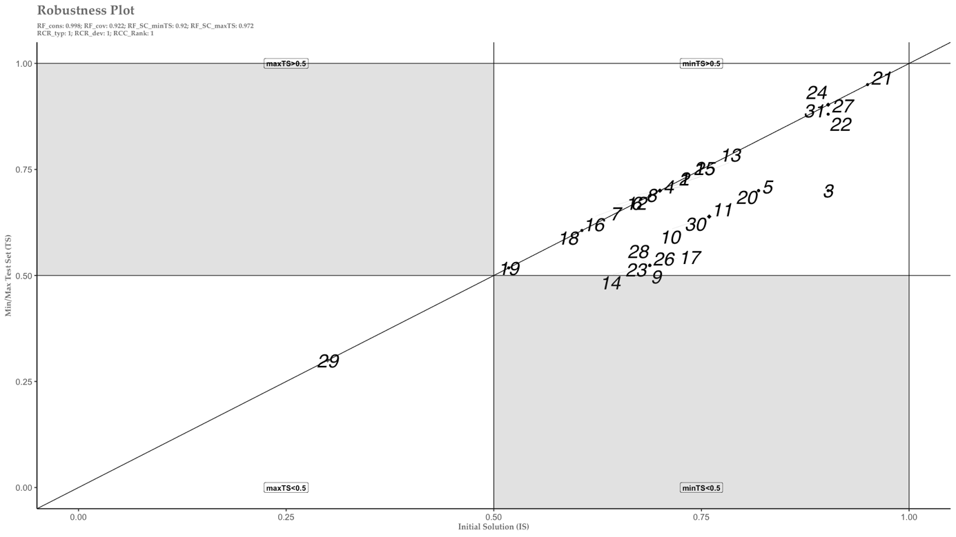

I did the same also for the absence of the outcome. Also in this case, the results are highly robust.

Table 12: Absence of the outcome
 | RF_cov | RF_cons | RF_SC_minTS | RF_SC_maxTS
Robustness_Fit | 0.934 | 1 | 0.931 | 0.916

Figure 9: Robustness plot, absence of the outcome

