Supplementary Table 1 Mangrove area in São Tomé and Príncipe from different sources
Island | District | Sites | Area in ha
Island | District | Sites | Global Mangrove Watch | UNEP [23] | Machava-António et al.  [12] | Afonso et al.  [24] | Afonso, [13] | Haroun et al.  [22] | This study
São Tomé | Caué | Malanza | 38.9 | - | - | 200 | 152 | 68.6 | 126.6
São Tomé | Caué | Angolares | 7.2 | - | - | - | 13 | - | 19.1
São Tomé | Caué | Praia Grande | - | - | - | - | - | - | 11.3
São Tomé | Caué | Angra Toldo Praia | - | - | - | - | - | - | 1.9
São Tomé | Lobata | Praia Das Conchas | 2.3 | - | - | - | 1 | 0.5 | 1.4
São Tomé | Lobata | Diogo Nunes | - | - | - | 1 | 1 | - | 2.0
São Tomé | Lobata | Praia do Tamarindo | - | - | - | - | - | - | 0.5
São Tomé | Lobata | Micolo | - | - | - | - | - | - | 2.7
São Tomé | Lobata | Praia Quinze | - | - | - | - | - | 0.3 | 0.7
São Tomé | Lobata | Praia do Morro Peixe | - | - | - | - | - | - | 3.2
São Tomé | Lobata | Morro Peixe Comunidade | - | - | - | - | - | - | 0.6
São Tomé | Cantagalo | Água Ize | - | - | - | - | - | - | 3.7
São Tomé | Mé-Zóchi | Praia Melao | - | - | - | - | - | - | 1.0
São Tomé | Água Grande | Praia Francesa | - | - | - | - | - | - | 0.101
São Tomé | Whole of São Tomé |  | 48.4 | - | - | 1-200 | - | - | 174.801
Príncipe | Pagué | Praia Caixão | - | - | - | - | - | - | 2.3
Príncipe | Pagué | Praia Grande Norte | - | - | - | - | - | - | 0.3
Príncipe | Pagué | Praia Salgada | - | - | - | - | - |  | 1.2
Príncipe | Pagué | Praia Abade | - | - | - | - | - | - | 0.3
Príncipe | Pagué | Praia Burra | - | - | - | - | - | - | 1.1
Príncipe | Whole of Príncipe |  | - | - | 1.6 | - | - | - | 5.2
Whole Country |  |  | - | 140 | 100-136 | - | - | - | 180.001

Supplementary Table 2 Summary table of potential mangrove restoration and afforestation sites in São Tomé and Príncipe
Island | District | Mangrove Site | Mangrove Species | Mangrove Cover  (ha) | Potential Restoration Area (ha) | Total Mangrove Area (ha)
São Tomé | Lobata | Morro Peixe | Avicennia germinans and Rhizophora spp | 1.3 | 1.9 | 3.2
São Tomé | Lobata | Morro Comunidade | Avicennia germinans | 0.5 | 0.1 | 0.6
São Tomé | Lobata | Praia do Tamarindo | Conocarpus erectus and  Avicennia germinans | 0.1 | 0.4 | 0.5
São Tomé | Lobata | Praia das Conchas | Avicennia germinans | 0.5 | 0.9 | 1.4
São Tomé | Lobata | Micolo | Rhizophora spp | 1.4 | 1.3 | 2.7
São Tomé | Lobata | Diogo Nunes | Avicennia germinans and Rhizophora spp | 1.2 | 0.8 | 2.0
São Tomé | Lobata | Praia Quinze | Avicennia germinans | 0.3 | 0.4 | 0.7
São Tomé | Caué | Malanza | Avicennia germinans and Rhizophora spp | 69.2 | - | 126.6
São Tomé | Caué | Malanza | Acrostichum aureum | 57.4 | - | 126.6
São Tomé | Caué | Praia Grande | Rhizophora spp | 4.3 | 4.2 | 11.3
São Tomé | Caué | Praia Grande | Acrostichum aureum | 2.8 | - | 11.3
São Tomé | Caué | Angolares | Avicennia germinans, Rhizophora spp, and Acrostichum aureum | 10.7 | 8.4 | 19.1
São Tomé | Caué | Angra Toldo Praia | Rhizophora spp | 0.3 | 1.6 | 1.9
São Tomé | Cantagalo | Água Ize | Rhizophora spp and Acrostichum aureum | 2.4 | 1.3 | 3.7
São Tomé | Mé-Zóchi | Praia Melao | Rhizophora sp | 0.1 | 0.9 | 1.0
São Tomé | Água Grande | Praia Francesa | Avicennia germinans | 0.001 | 0.1 | 0.101
São Tomé | Lembá | No mangroves | - | - | - | -
São Tomé | Subtotal | 14 | - | 152.501 | 22.3 | 174.801
Príncipe | Pagué* | Praia Salgada | Rhizophora spp | 0.6 | 0.6 | 1.2
Príncipe | Pagué* | Praia Abade | Rhizophora sp | 0.1 | 0.2 | 0.3
Príncipe | Pagué* | Praia Caixão | Rhizophora spp | 1.1 | 1.2 | 2.3
Príncipe | Pagué* | Praia Grande Norte | Rhizophora spp | 0.2 | 0.1 | 0.3
Príncipe | Pagué* | Praia Burra- proposed site for mangrove afforestation | Acrostichum aureum | - | 1.1 | 1.1
Príncipe | Subtotal | 5 |  | 2.0 | 3.2 | 5.2
Both Islands | Grand total | 19 |  | 154.501 | 25.5 | 180.001
*The Príncipe Island had only one district since 1980 called Pagué, but in 1995, it was replaced by the Autonomous Region of Príncipe (ARP).

Supplementary Maps: Mangrove distribution within the 6 management blocks in São Tomé and Príncipe
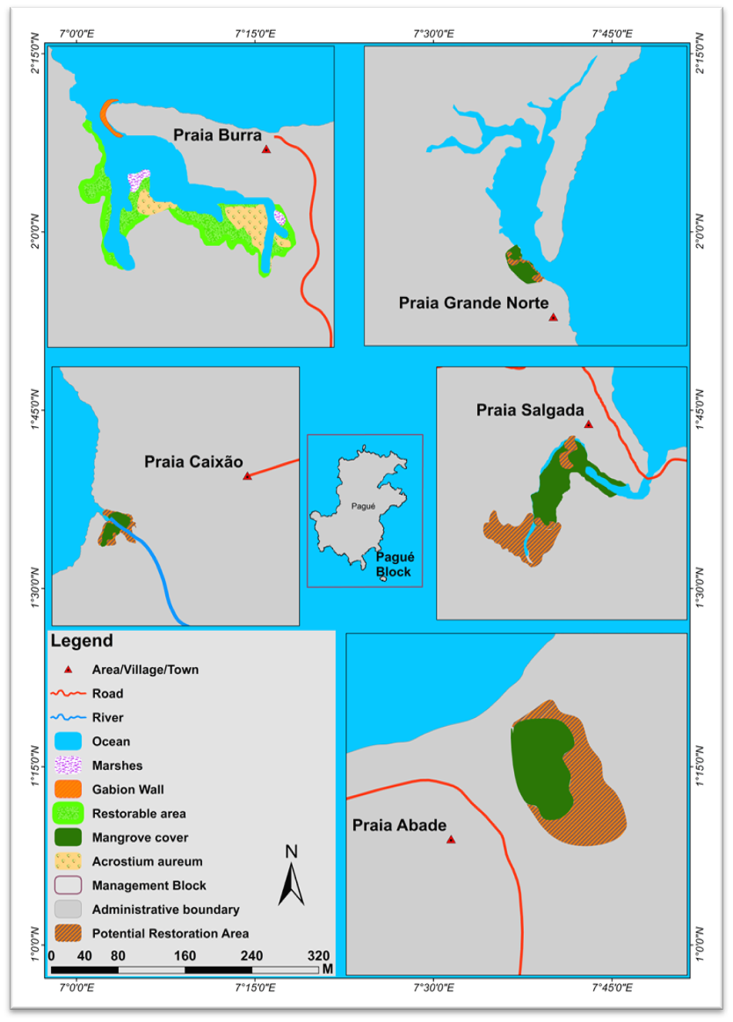
Supplementary Fig. 1 Mangrove distribution within the Pagué management block in Príncipe

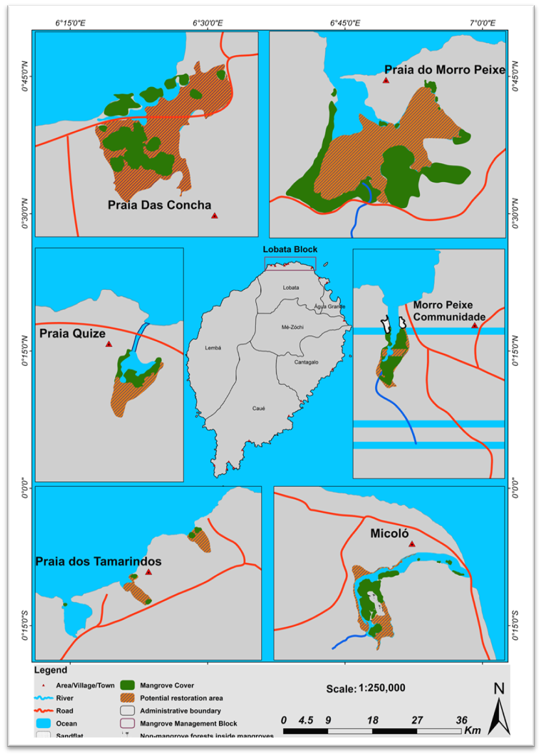
Supplementary Fig. 2 Mangrove distribution within the Lobata management block in São Tomé
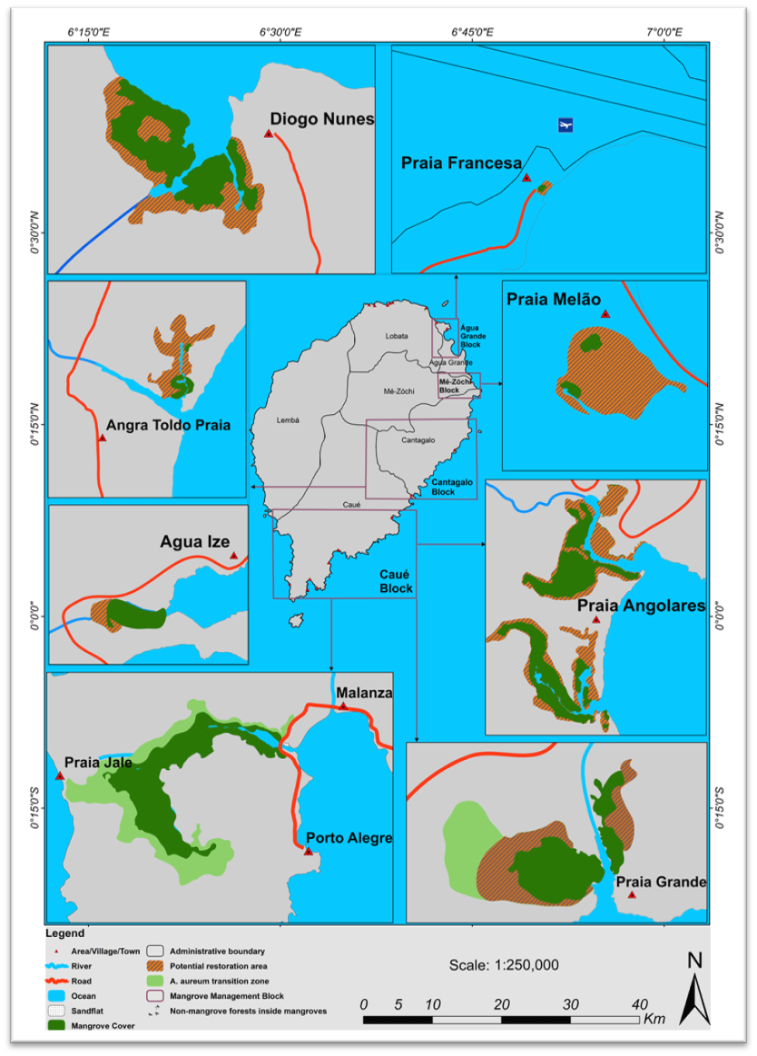
Supplementary Fig. 3 Mangrove distribution within the Caué, Cantagalo, Mé-Zóchi and Água Grande management blocks in São Tomé

Bunting, P., Rosenqvist, A., Lucas, R., Rebelo, L. M., Hilarides, L., Thomas, N., Hardy, A., Itoh, T., Shimada, M., & Finlayson, C. M. (2018). The Global Mangrove Watch — A new 2010 global baseline of mangrove extent. Remote Sensing, 10(10), 1669. https://doi.org/10.3390/rs10101669

