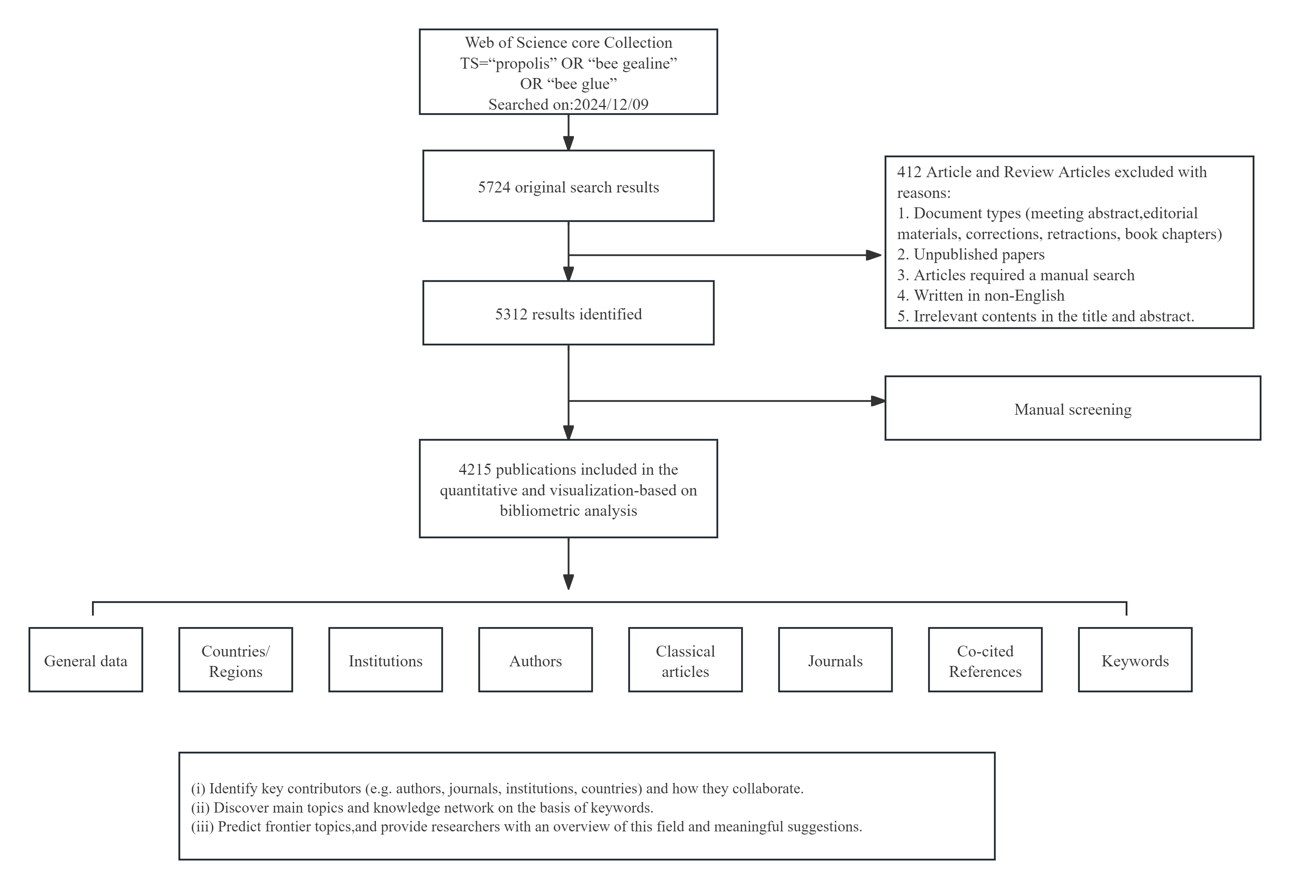
- A bibliometric analysis of 4,215 propolis research papers published between 2014 and 2024 was conducted, with data sourced from the Web of Science Core Collection database and analyzed using ITGInsight software.
- Brazil, China, and Turkey were the leading contributors in propolis research, while the most productive institutions were the University of São Paulo (Brazil), the State University of Maringá (Brazil), and King Saud University (Saudi Arabia).
- Jairo Kenupp Bastos and Vassya Bankova were prominent scholars in the field, and Molecules and the Journal of Apicultural Research were the main publication platforms.
- Sustained research interest focused on the chemical composition and medicinal properties of propolis, with "nanotechnology," "functional foods," and "immune regulation" identified as emerging research frontiers in recent years.
- The global propolis research showed dynamic growth, with a shift from basic science to practical application, providing valuable guidance for future research, policy-making, and industrial development.

