SUPPLEMENTAL MATERIALS
Our supplemental materials include the labels, description, and assignment of the ICD 10 codes used in our comorbidity network (Supplement Table 1), the original centrality analysis depicting strength and expected influence centrality (Supplement Table 2 and Supplement Figure 2), and the sensitivity analyses used to check the robustness of the comorbidity network and centrality metrics. Our sensitivity analyses include reducing ICD 10 code criteria from diagnoses on any two dates to only one date (Supplement Figure 1).
Supplement Table 1. ICD 10 codes and Mental Health Disorder description
ICD 10 Code | Mental Health Disorder
F10 | Alcohol-related disorders
F11 | Opioid-related disorders
F12 | Cannabis-related disorders
F13 | Sedative-related disorders
F14 | Cocaine-related disorders
F15 | Other stimulant-related disorders
F16 | Hallucinogen-related disorders
F17 | Tobacco uses disorder
F18 | Inhalant-related disorders
F19 | Other psychoactive substances
F20 | Schizophrenia and other psychotic disorders
F25 | Schizoaffective disorders
F31 | Bipolar disorder
F32 | Major depressive disorder, single episode
F33 | Major depressive disorder, recurrent
F34 | Dysthymic disorder/ Cyclothymic disorder/ Other persistent mood [affective] disorders
F39 | Unspecified mood [affective] disorder
F40 | Specified phobia/ Anxiety disorders
F41 | Other anxiety disorders
F42 | Obsessive-compulsive disorder
F43 | Post-traumatic stress disorder (PTSD)
F50 | Eating disorder
F51 | Sleep disorders
F60 | Personality disorders
F90 | Attention-deficit hyperactivity disorder
F91 | Conduct disorders

Supplement Table 2 presents the results of the Original Centrality Analysis, which includes all ICD-10 mental health disorder codes beginning with “F.” Each node represents a specific mental health disorder, accompanied by its code description, and is evaluated by two centrality measures: Strength and Expected Influence. These metrics indicate how strongly each disorder is connected to others in the network and the extent of its influence.
Supplement Table 2. Original Centrality Analysis
ICD  Code | Mental Health Disorder | Strength | Expected  Influence
F19 | Other psychoactive substance-related disorders | 6.75 | 6.75
F12 | Cannabis-related disorders | 5.59 | 5.59
F60 | Personality disorders | 5.56 | 5.56
F14 | Cocaine-related disorders | 5.50 | 5.50
F33 | Major depressive disorder, recurrent | 5.17 | 4.68
F25 | Schizoaffective disorders | 4.28 | 4.28
F11 | Opioid-related disorders | 4.14 | 4.14
F41 | Other anxiety disorders | 4.09 | 3.75
F20 | Schizophrenia and other psychotic disorders | 3.96 | 3.96
F39 | Unspecified mood [affective] disorder | 3.64 | 3.64
F13 | Sedative-related disorders | 3.58 | 3.58
F43 | Post-traumatic stress disorder (PTSD) | 3.42 | 3.42
F31 | Bipolar disorder | 3.18 | 3.18
F10 | Alcohol-related disorders | 3.17 | 3.17
F32 | Major depressive disorder, single episode | 2.72 | 2.72
F34 | Other persistent mood [affective] disorders | 2.66 | 2.66
F40 | Specified phobia / Anxiety disorders | 2.20 | 2.20
F17 | Tobacco uses disorder | 2.15 | 1.32
F15 | Other stimulant-related disorders | 1.64 | 1.64
F51 | Sleep disorders | 1.57 | 1.57
F16 | Hallucinogen-related disorders | 1.37 | 1.37
F90 | Attention-deficit hyperactivity disorder | 0.00* | 0.00
F91 | Conduct disorders | 0.00 | 0.00
F50 | Eating disorders | 0.00 | 0.00
F42 | Obsessive-compulsive disorder | 0.00 | 0.00
F18 | Inhalant-related disorders | 0.00 | 0.00

Note: * zero means the node is isolated from other nodes.

Sensitivity Analyses
To evaluate the robustness of the comorbidity network and address potential sources of misclassification, we conducted a series of sensitivity analyses.
In the primary analysis, individuals were classified as having a mental health disorder only if the corresponding ICD-10 diagnostic code appeared on two or more separate dates. This threshold was chosen to reduce the influence of transient or provisionally assigned diagnoses and to enhance diagnostic specificity within the electronic health record (EHR) data.
To determine whether the observed network structure was sensitive to this more stringent definition, we performed a sensitivity analysis using a broader inclusion criterion: individuals were classified as having a mental health condition if they had at least one recorded instance of a relevant ICD-10 code. As in the primary analysis, we generated a binary diagnostic matrix at the parent-code level and re-estimated the network using the Ising model, ensuring methodological consistency across models. This allowed us to assess whether the network’s structure, connectivity, and centrality remained stable when including individuals with potentially less persistent or acute patterns of diagnosis.
Sensitivity Analysis Results
When the inclusion criteria were relaxed to allow individuals with only a single mental health diagnosis, the overall structure of the network remained stable (Figure 1). The binary variable structure and estimation framework remained consistent, and the edges continued to reflect conditional dependencies (Table 3). Minor shifts in edge weights and node positioning were observed, especially for low-prevalence conditions, but these variations did not meaningfully alter the network’s global structure.
Core diagnostic categories, particularly mood, anxiety, and substance-related disorders, continued to form modular clusters and demonstrated high centrality across both strength and expected influence metrics. This suggests that the key nodes in the network maintain strong conditional associations with other diagnoses, even under more inclusive thresholds (Figure 2).
Supplement Table 3. Sensitive test Centrality Analysis
ICD  Code | Mental Health Disorder | Strength | Expected  Influence
F19 | Other psychoactive substance-related disorders | 6.49 | 6.49
F60 | Personality disorders | 5.79 | 5.79
F41 | Other anxiety disorders | 5.70 | 5.12
F14 | Cocaine-related disorders | 5.60 | 5.60
F33 | Major depressive disorder, recurrent | 4.90 | 4.48
F31 | Bipolar disorder | 4.77 | 4.77
F20 | Schizophrenia and other psychotic disorders | 4.60 | 4.60
F25 | Schizoaffective disorders | 4.59 | 4.59
F15 | Other stimulant-related disorders | 4.11 | 4.11
F13 | Sedative-related disorders | 3.95 | 3.95
F11 | Opioid-related disorders | 3.93 | 3.93
F43 | Post-traumatic stress disorder (PTSD) | 3.92 | 3.92
F39 | Unspecified mood [affective] disorder | 3.89 | 3.89
F12 | Cannabis-related disorders | 3.83 | 3.83
F42 | Obsessive-compulsive disorder | 3.18 | 3.18
F18 | Inhalant-related disorders | 3.18 | 3.18
F34 | Other persistent mood [affective] disorders | 3.14 | 3.14
F32 | Major depressive disorder, single episode | 3.12 | 3.12
F17 | Tobacco uses disorder | 2.90 | 1.90
F10 | Alcohol-related disorders | 2.80 | 2.80
F90 | Attention-deficit hyperactivity disorder | 2.09 | 2.09
F40 | Specified phobia/ Anxiety disorders | 1.85 | 1.85
F51 | Sleep disorders | 1.60 | 1.60
F91 | Conduct disorders | 0.00* | 0.00
F50 | Eating disorders | 0.00 | 0.00
F16 | Hallucinogen-related disorders | 0.00 | 0.00
Note: * zero means the node is isolated from other nodes.

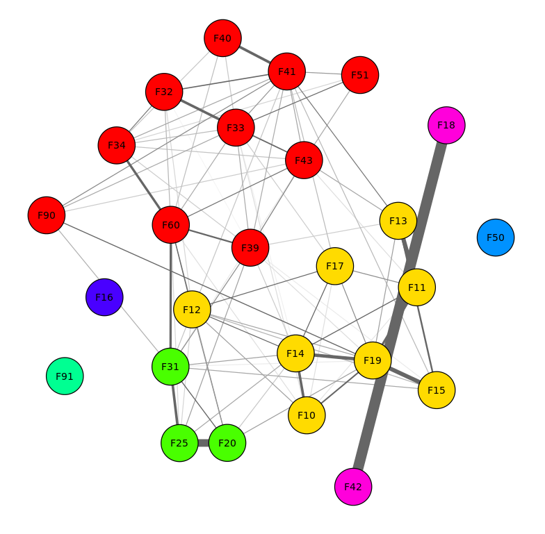
Supplement Figure 1. Community Detection in Sensitivity Analysis Network
Nodes represent ICD-10 diagnostic categories, color-coded according to communities identified by the Louvain clustering algorithm. A large red cluster encompasses mood, affective, and anxiety-related disorders (e.g., F32, F33, F34, F39, F40, F41, F43, F51, F60, F90), reflecting a dense and highly interconnected comorbidity structure. The yellow cluster captures substance use disorders (e.g., F10, F11, F12, F13, F14, F15, F17, F19), forming a coherent addiction-related community. The green cluster comprises psychotic-spectrum and mood instability conditions (e.g., F20, F25, F31, F91), highlighting overlaps with affective dysregulation. In contrast, F42 (obsessive–compulsive disorder) and F18 (volatile solvent use disorders) form a distinct magenta cluster, while F16 (hallucinogen-related disorders, blue) and F50 (eating disorders, cyan) remain relatively isolated.

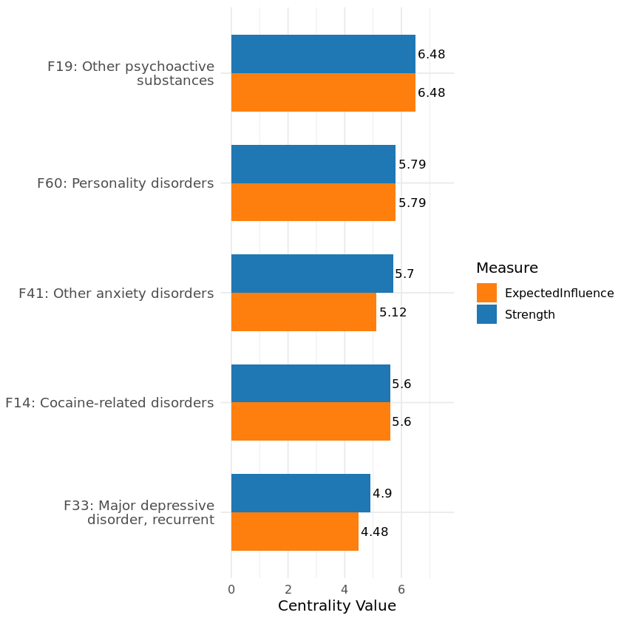

Supplement Figure 2. Top 5 ICD-10 Mental Health Codes by Centrality (Strength and Expected Influence) for sensitivity analysis. The top 5 ICD-10 parent codes bar ranked by strength centrality and expected influence in sensitive test. Nodes with high strength centrality are those with the most and strongest direct connections to other diagnoses, underscoring their influence within the comorbidity network

