Supplementary Information for
Generative model for large-cell crystal structure
Eun Ho Kimª, Jun Hyeong Guª, Hyo Gyeong Shinª, Changhun Kimª, Sangwoo Parkª, Donghwa Lee^{a,b,c*}
ª Department of Materials Science and Engineering (MSE), Pohang University of Science and Technology (POSTECH), Pohang 37673, Republic of Korea
^{b} Division of Advanced Materials Science (AMS), Pohang University of Science and Technology (POSTECH), Pohang 37673, Republic of Korea
^{c} Institute for Convergence Research and Education in Advanced Technology (I_CREATE), Yonsei University, Incheon 21983, Republic of Korea
*Corresponding author: donghwa96@postech.ac.kr

Contents
Supplementary Section 1 | Architecture of denoising network of GenLCS in ACG step.
Supplementary Section 2 | Farthest point sampling (FPS) algorithm.
Supplementary Section 3 | Conditional generation of SCG step.
Figure S1 | Architectures of denoising network in ACG step
Figure S2 | Example of selecting three farthest points among six using the FPS algorithm
Figure S3 | Distribution of energy above hull (E_{hull}) for unconditional and conditional generation.
Figure S4 | Variation of symmetry (Sym.) and unique & novel (U.N.) ratios with increasing number of generated structures in GenLCS, MatterGen, and CrystaLLM.
Figure S5 | Formation energy differences (∆E) for three benchmark structures generated by GenLCS (red) and MatterGen (blue).
Figure S6 | Several examples of metastable structures generated by GenLCS.
Figure S7 | Example of a highly complex symmetric structure generated by GenLCS: Ca₃Al₂O₆ [space group Pa-3, N_{atoms} = 264].
Figure S8 | Phase diagrams of 22 screened ternary LCS generated by GenLCS with energy above hull (Ehull) below 1 meV/atom.
Table S1 | Detailed information on 22 screened ternary LCS generated by GenLCS.

Supplementary Sections
Supplementary Section 1. Architecture of denoising network of GenLCS in ACG step
In the Atomic Coordinate Generation (ACG) step of GenLCS, we employ an equivariant graph neural network (GNN) as the denoising network. Especially, we extend the framework established by Tensor Field Networks (TFN)¹ that maintain invariant to translations and equivariant to rotations. The network is trained to predict noise in the basis atom coordinates as a function of the diffusion timestep t and the structural components generated during the SCG step. These components include the space group $S$, noised basis atom coordinates $x_{i,c}^{b\left(l\right)}$, basis atom elements $B$, corresponding multiplicities $M$ and lattice parameters $L$.
The timestep $t$ is embedded using a sinusoidal positional encoding and transformed into a node feature $x_{i,t}^{b\left(l\right)}$. The $S$, $B$ and $M$ are also embedded as a categorical feature and encoded as $x_{i,sg}^{b\left(l\right)}$, $x_{i,el}^{b\left(l\right)}$ and $x_{i,m}^{b\left(l\right)}$. The full atomic structure, consisting of coordinates $x_{i,c}^{b\left(l\right)}$, element embeddings $x_{i,el}^{f\left(l\right)}$, space group embeddings $x_{i,sg}^{f\left(l\right)}$, and multiplicity embeddings $x_{i,m}^{f\left(l\right)}$ is reconstructed by applying the space group symmetry operations to the basis atom coordinates, followed by selecting a representative subset of atoms using the farthest point sampling algorithm.
The message passing in the network is conducted over two complementary graphs: one constructed from the basis atoms and the other from the full atomic structure. In the basis atom graph, nodes represent basis atoms and edges encode absolute positional relationships using fractional coordinates. Importantly, periodic boundary conditions (PBC) are not applied, and all coordinates are anchored to the fixed reference point (0,0,0), making the absolute Wyckoff positions meaningful. Consequently, both translational invariance and rotational equivariance are intentionally broken in this graph, enabling the model to learn the global spatial arrangement of atoms relative to the reference point. In contrast, the full atom graph is constructed using Cartesian coordinates with periodic boundary conditions applied. There is no anchoring to a global reference point, and thus this graph preserves both translation invariance and rotation equivariance, consistent with conventional physical symmetries in crystal structures. Here, the model captures local geometric relationships between neighboring atoms, which are crucial for modeling favorable interatomic interactions. During the early stages of denoising, when atom positions are widely scattered from the reference point, the model relies more heavily on the basis atom graph to recover global structure. In the later stages, as atoms approach their correct positions, the model increasingly leverages the full atom graph to refine local arrangements and establish physically plausible connections. This dual-graph design allows the model to learn both global and local atomic configurations for generating symmetry-aware, physically realistic crystal structures.
As illustrated in Fig. S1a, node features from both the basis atom graph and full atom graph including timestep embeddings $x_{i,t}^{b/f\left(l\right)}$, element embeddings $x_{i,el}^{b/f\left(l\right)}$, space group embeddings $x_{i,sg}^{b/f\left(l\right)}$ and multiplicity embeddings $x_{i,m}^{b/f\left(l\right)}$ are processed through a sequence of modules: MultiGatedBlock, TPMixingBlock, IrrepHalfSelector, and a readout layer to get predicted noise $ϵ_{θ}\left(x_{i}^{b},t\right)$.
The MultiGatedBlock (Fig. S1b) applies independent linear projections to each input feature type, then fuses them by concatenation, followed by layer normalization and a subsequent linear transformation to get concatenated node feature $x_{i,cat}^{b/f\left(l\right)}$. This module allows flexible integration of heterogeneous node features.
The TPMixingBlock (Fig. S1c) performs equivariant message passing based on tensor product convolutions. It operates separately on the basis and full graphs using node features ($x_{i,cat}^{f\left(l\right)}$, $x_{i,cat}^{b\left(l\right)}$), spherical harmonics ($Y_{i,p}^{f}(r_{ij}$), $Y_{i,p}^{b}(r_{ij}$)) and radial embeddings ($w^{f}(r_{ij}$), $w^{b}(r_{ij}$)). After applying tensor products and aggregating messages, the outputs are passed through the IrrepHalfProjection and then fused to obtain updated node features ($x_{i,cat}^{f\left(l+1\right)}$, $x_{i,cat}^{b\left(l+1\right)}$).
The IrrepHalfProjection (Fig. S1d) processes each irreducible representation (irrep) channel such as scalar (0e), vector (1o), and tensor (2e) types by splitting the tensor into two halves along the hidden dimension $N_{h}$. The first half, acting as a learned weight, is elementwise multiplied by the second half, which serves as the value. The resulting tensor replaces the original first half, allowing the network to adaptively modulate the feature representation based on the timestep. The IrrepHalfSelector splits each irrep channel along the $N_{h}$ and output only first half.
Figure S1. Architectures of denoising network in ACG step. a, Overall process for predicting the noise $ϵ_{θ}(x_{i}^{b}, t)$. $x_{i,t}^{b/f(l)}$, $x_{i,el}^{b/f(l)}$, $x_{i,sg}^{b/f(l)}$ and $x_{i,m}^{b/f(l)}$ represent timestep embeddings, element embeddings, space group embeddings and multiplicity embeddings of basis atom graph or full atom graph, respectively. TPMixingBlock is applied N times. b, Architecture of MultiGatedBlock. $x_{i,cat}^{b/f(l)}$ denotes concatenated node features, $×$ denotes elementwise multiplication, $║$ denotes concatenation. c, Architecture of TPMixingBlock. $Y_{i,p}^{f}(r_{ij}$) and $Y_{i,p}^{b}(r_{ij}$) denotes spherical harmonics, $w^{f}(r_{ij}$) and $w^{b}(r_{ij}$) denotes radial embeddings, each computed separately for the basis and full atom graphs. d, Architecture of IrrepHalfProjection. $N_{h}$ denotes the number of hidden dimension. The output $x_{i}^{'}$ replaces the first half of the tensor after elementwise multiplication. The hatched area indicates the multiplied output.

Supplementary Section 2. Farthest point sampling (FPS) algorithm
The Farthest Point Sampling (FPS) algorithm, initially proposed by Eldar et al., is widely adopted in point cloud processing for selecting spatially dispersed points^{2,3}. In our study, FPS algorithm is applied to preserve number of atoms in the unit cell throughout noising/denoising steps and detailed process is as follows (Fig. S2). Starting from selecting a random point, the algorithm computes the Euclidean distance between each remaining point and the selected point. In our method, these distances are evaluated using the minimum image convention to account for periodic boundary conditions. The distances are stored in a distance array and the point that has the maximum distance from the selected point is chosen as the newly selected point. Then, distances between each remaining point and newly selected point are calculated and for each remaining point, distance array is updated to store the shortest distance to any selected point so far. This process is repeated until the desired number of points is sampled.
Figure S2. Example of selecting three farthest points among six using the FPS algorithm. a, A point S1 is randomly selected (red circle), and its distances (dotted lines) to the remaining five points (blue circle) are computed using the minimum image convention. b, The point S₂, which has the maximum distance (solid line) is selected. c, Distances from the newly selected point S₂ to remaining points are computed (black dotted lines). d, The third point S₃ is chosen as the one with the largest distance (green solid line) among the shortest distance (green dotted lines) from each remaining point to S1 and S2.

Supplementary Section 3. Conditional generation of SCG step
For conditional generation in the SCG step, we adopt the approach used in the original VQ-diffusion model. In particular, we adopt the discrete classifier-free guidance strategy used in VQ-diffusion for conditional image generation⁴. Given conditional information $y$ and generated token $x$, the objective is to optimize $\log\left(x | y\right)+s log\left(y | x\right)$, where $s$ is the guidance scale controlling the strength of the constraint. As described in the original VQ-diffusion paper, this formulation can be derived using Bayes’ theorem as follows:
$$\underset{x}{argmax}\left[\log\left(x | y\right)+s log\left(y | x\right)\right]$$
$$\underset{x}{=argmax}\left[\log{p\left(x\right)+}\left(s+1\right)(log{p(x|y)}-\log{p\left(x\right)})\right]$$
In this study, we found that setting $s=0.5$ provides an optimal trade-off between constraint enforcement and sample diversity. A larger $s$ enforces the condition more strictly, but tends to reduce diversity. To enable the model to estimate the unconditional logits $p\left(x\right)$, we train it with 20% of the conditional inputs replaced by empty (null) conditions.
Figure S3 compares the energy above hull (E_{hull}) (eV/atom) distributions between unconditional generation and conditional generation under the constraints formation energy (E_{form}) < 0 eV/atom and E_{hull} < 0.1 eV/atom. The proportion of structures satisfying these criteria increases from 7.6% in the unconditional case to 10.3% under conditional generation.
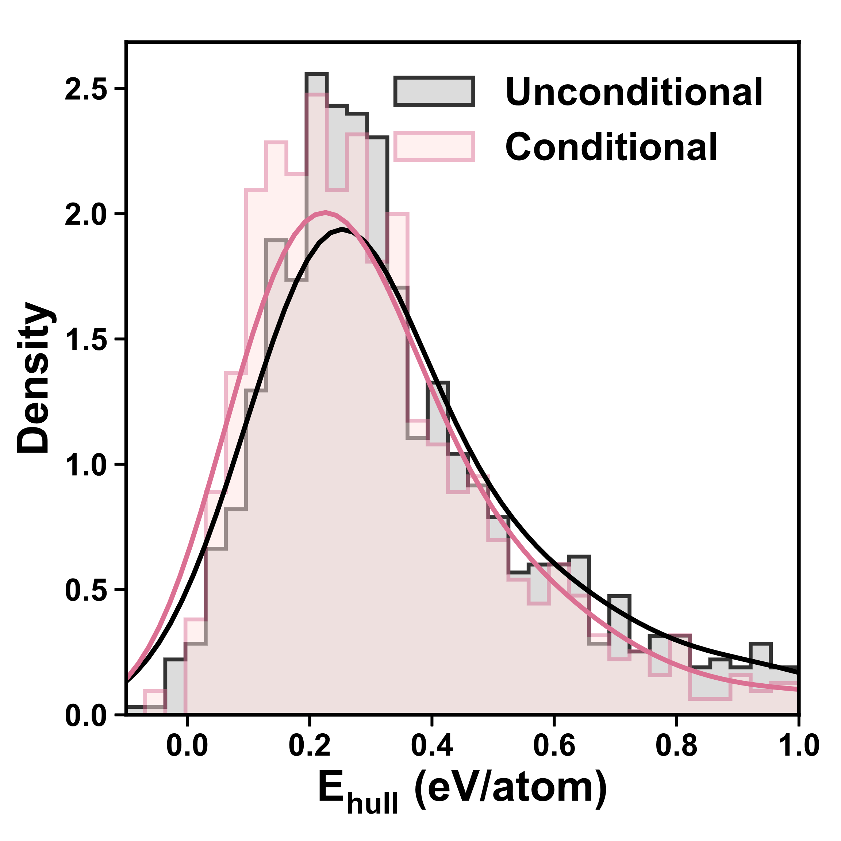
Figure S3. Distribution of energy above hull (E_{hull}) for unconditional and conditional generation. Solid lines indicate kernel density estimates (KDE). The median Ehull is 0.30 eV/atom for unconditional generation and 0.28 eV/atom for conditional generation.

Supplementary Figures
Figure S4. Variation of symmetry (Sym.) and unique & novel (U.N.) ratios with increasing number of generated structures in GenLCS, MatterGen, and CrystaLLM. a, Symmetry ratios remain high in GenLCS (95.8%) and CrystaLLM (91.5%), but are significantly low in MatterGen (7.5%). b, U.N. ratios are consistently maintained in GenLCS (decreasing slightly from 90.3% at 10k to 88.9% at 100k) and MatterGen (88.4% to 88.7%), whereas CrystaLLM shows a significant decline (from 58.7% at 10k to 30.2%) as the number of generated structures increases.

Figure S5. Formation energy differences (∆E) for three benchmark structures generated by GenLCS (red) and MatterGen (blue). ∆E values are computed after structural optimization using a machine learning potential, followed by DFT single-point energy calculations. Red filled circles in the GenLCS results indicate structures with ∆E < 1 meV/atom that also match the reference structures. After structural relaxation, the number of matched structures in GenLCS increases from 6 to 10 for Yb₃Al₅O₁₂, from 8 to 16 for Na₄MgAl(PO₄)₃, and from 21 to 28 for Na₄Ti₂(SiO₄)₃, out of 50 generated samples.
Figure S6. Several examples of metastable structures generated by GenLCS. Reference structures of a, Na₄MgAl(PO₄)₃ and b, Yb₃Al₅O₁₂ benchmark materials are shown on the left. Corresponding metastable structures with formation energy differences (∆E) below 0.1 eV/atom are shown on the right. The generated structures exhibit distinct deviations from the reference geometries, demonstrating GenLCS’s ability to explore structurally diverse metastable configurations.
Figure S7. Example of a highly complex symmetric structure generated by GenLCS: Ca₃Al₂O₆ [space group Pa-3, Nₐₜₒₘₛ = 264]. a, Full atomic structure of the reference Ca₃Al₂O₆ after applying symmetry operations to the basis atom positions (top), and b, corresponding basis atom configuration (bottom). Although the generated basis atom configuration differs from that of the reference, the resulting full atomic structures are identical, demonstrating that the model can successfully construct stable atomic interactions within a highly intricate and previously unseen structural configuration.

(Continue)

Figure S8. Phase diagrams of 22 screened ternary LCS generated by GenLCS with energy above hull (E_{hull}) below 1 meV/atom. All generated structures are novel formulas absent from existing materials databases and are indicated by red stars. Existing stable structures (E_{hull} = 0 eV/atom) are shown as blue filled circles, while known metastable structures (0 < E_{hull} < 0.1 eV/atom) are shown as gray filled circles.
Supplementary Table
Table S1. Detailed information on 22 screened ternary LCS generated by GenLCS.
No. | Structure | formula | N_{atoms} | Space group (No.) | E_{form} (eV/atom)
1 |  | Cd₂Rh_{2s}O₇ | 88 | Fd-3m (227) | -1.21
2 |  | Dy₂Ir₂O₇ | 88 | Fd-3m (227) | -2.51
3 |  | Ca₂Ir₂O₇ | 88 | Fd-3m (227) | -2.06
4 |  | Sc₂Pd₂O₇ | 88 | Fd-3m (227) | -2.29
5 |  | LaMo₄O₁₃ | 72 | Pca2₁  (29) | -2.34
6 |  | Eu₄Re₆O₁₉ | 58 | I23  (197) | -2.51
7 |  | Cu(NsO₃)₃ | 52 | Pca2₁  (29) | -0.74
8 |  | La₆Nd₃Hg₂ | 44 | Ibam  (72) | -0.25
9 |  | Sb(HO)₅ | 44 | P2₁/c  (14) | -1.43
10 |  | Sm₃Sb₄Pt₃ | 40 | I-43d  (220) | -1.09
11 |  | Sm₃Sb₄Pd₃ | 40 | I-43d (220) | -1.02
12 |  | Ag₂Mo₄O₁₃ | 38 | P-1  (2) | -1.72
13 |  | DySnF₇ | 36 | P2₁/c  (14) | -3.48
14 |  | NdSnF₇ | 36 | P2₁/c  (14) | -3.45
15 |  | FeHCl₆ | 32 | P2₁/c  (14) | -0.90
16 |  | Y₂TeO₅ | 32 | P2₁2₁2₁  (19) | -3.11
17 |  | Cs₂PrBr₅ | 32 | Pnma  (62) | -2.23
18 |  | Cs₂WSe₄ | 28 | Pnma  (62) | -1.13
19 |  | Tb₂(CO₃)₃ | 28 | P6₃/m  (176) | -2.65
20 |  | Ca(BrO₄)₂ | 22 | P2₁  (4) | -0.97
21 |  | TeP₂O₇ | 20 | P21  (4) | -2.25
22 |  | PrAsO₃ | 20 | P2₁/c  (14) | -2.78

References
- Thomas, N. et al. Tensor field networks: Rotation- and translation-equivariant neural networks for 3D point clouds. arXiv [cs.LG] (2018) doi:10.48550/arXiv.1802.08219.
- Eldar, Y., Lindenbaum, M., Porat, M. & Zeevi, Y. Y. The farthest point strategy for progressive image sampling. IEEE Trans. Image Process. 6, 1305–1315 (1997).
- Qi, C. R., Yi, L., Su, H. & Guibas, L. J. PointNet++: Deep Hierarchical Feature Learning on Point Sets in a Metric Space. Adv. Neural Inform. Process. Syst., 30 (2017).
- Tang, Z., Gu, S., Bao, J., Chen, D. & Wen, F. Improved vector quantized diffusion models. arXiv [cs.CV] (2022) doi.org/10.48550/arXiv.2205.16007.

