Suporting Information

Stereochemical Determination of Hydroxylated Derivatives of Progesterone by Quantum NMR Calculations

Cassia R. Ramboª; Samuel F. C. de Paula^{b}; André L. M. Porto^{b}; Isac G. Rossetª*

*rosset@ufpr.br

ªDepartamento de Engenharias e Exatas, Universidade Federal do Paraná, Setor Palotina. Rua Pioneiro, 2153, 85950-000, Palotina, PR, Brazil.
^{b}Laboratório de Química Orgânica e Biocatálise - Instituto de Química de São Carlos - Universidade de São Paulo. Av. João Dagnone, 1100, 13563120, Ed. “Prof. Dr. Douglas Wagner Franco”, Jd. Santa Angelina, São Carlos, SP, Brazil.

Contents

Experimental vs. calculated ¹H and ¹³C NMR chemical shifts 2
Δδ(ppm) Exp.-Calc. of ¹H and ¹³C NMR for all isomers 4
Contributions of conformers and xyz coordinates for all representative conformers 6
DP4+ analysis 25

Experimental vs. calculated ¹H and ¹³C NMR chemical shifts
¹H 15β-OH | ¹³C 15β-OH
¹H 15α-OH | ¹³C 15α-OH
¹H 7β,15β-OH | ¹³C 7β,15β-OH

¹H 7β,15α-OH | ¹³C 7β,15α-OH
¹H 7α,15β-OH | ¹³C 7α,15β-OH
¹H 7α,15α-OH | ¹³C 7α,15α-OH

Δδ(ppm) Exp.-Calc. of ¹H and ¹³C NMR for all isomers
¹H 15β-OH 15α-OH
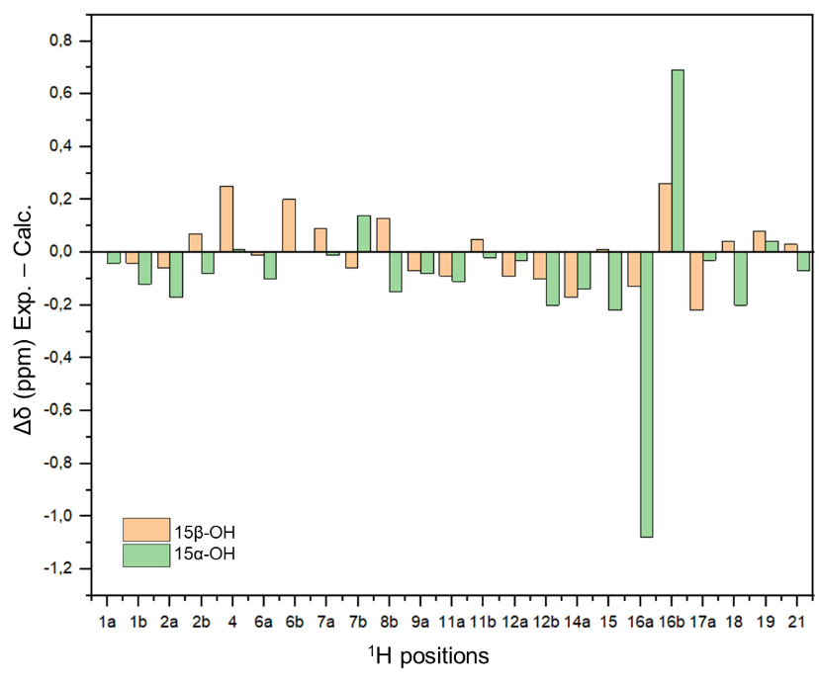

¹³C 15β-OH 15α-OH
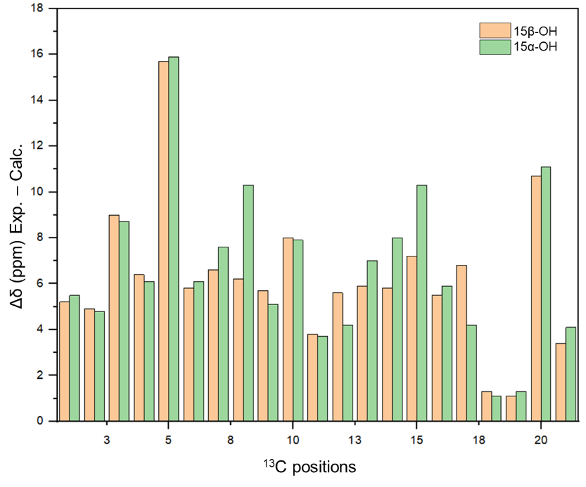

¹H 7β,15β-OH 7β,15α-OH 7α,15β-OH 7α,15α-OH
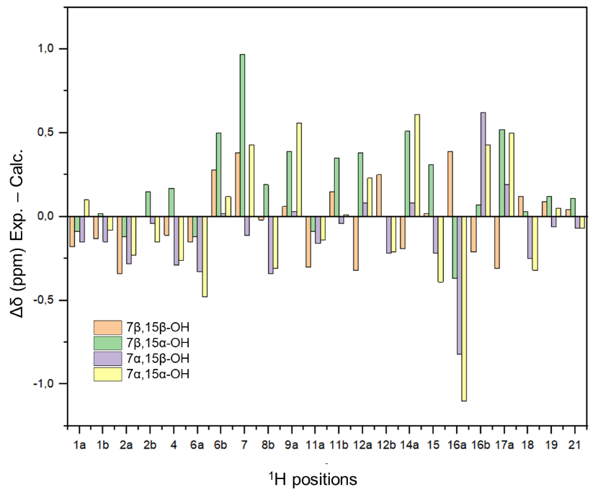

¹³C 7β,15β-OH 7β,15α-OH 7α,15β-OH 7α,15α-OH
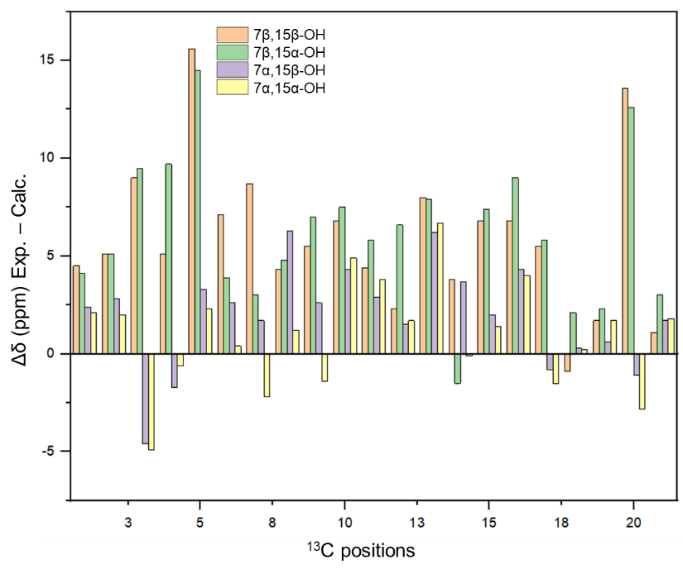

Contributions of conformers and xyz coordinates for all representative conformers

15β-OH
Conformer | Boltzman contribution analysis (%)
15β-OH_conf_1 | 12.44
15β-OH_conf_2 | 12.42
15β-OH_conf_3 | 6.62
15β-OH_conf_4 | 45.18
15β-OH_conf_5 | 23.35

15β-OH_conf_1
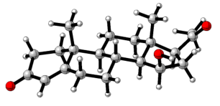
C -1.68990 0.27610 -4.31660
C -3.17200 0.08380 -4.09600
C -3.76560 0.84310 -2.99730
C -3.06590 1.63140 -2.15850
C -1.54250 1.73530 -2.18880
C -0.95120 0.56270 -3.00950
C -3.78840 2.48800 -1.15610
C -3.21650 2.35070 0.25900
C -1.70640 2.60090 0.27560
C -0.99950 1.63840 -0.71360
C -1.11210 2.39120 1.67040
C 0.42090 2.61280 1.76150
C 1.07960 1.60430 0.80900
C 0.53680 1.74360 -0.62640
C -1.71490 3.12110 2.87590
C -0.61510 2.99640 3.96270
C 0.61570 2.33250 3.29660
O -3.85070 -0.62920 -4.82800
C 1.94660 2.78340 3.88070
C 3.10010 1.81130 3.79250
O 2.08420 3.86830 4.41370
C 0.86740 4.04630 1.41500
H -1.25690 1.32680 1.90670
H -1.53100 3.63640 -0.02980
H -1.26450 0.62550 -0.37760
C -1.16620 3.08220 -2.85820
O -2.01320 4.48320 2.52980
H -1.57690 1.10840 -5.02140
H -1.29000 -0.60900 -4.81430
H -4.84700 0.78700 -2.91900
H 0.09960 0.75900 -3.22810
H -0.98000 -0.34170 -2.39260
H -4.85470 2.25410 -1.17030
H -3.69580 3.53580 -1.46800
H -3.42230 1.34210 0.63710
H -3.72390 3.05310 0.92270
H 2.16610 1.73050 0.78580
H 0.88530 0.58770 1.17030
H 0.99760 0.96690 -1.23960
H 0.86970 2.69660 -1.04270
H -2.64180 2.63780 3.19790
H -0.95790 2.41100 4.81780
H -0.34870 3.98710 4.33160
H 0.56140 1.24630 3.42110
H 2.90080 0.96490 4.45770
H 3.19820 1.40240 2.78500
H 4.02750 2.29450 4.09480
H 0.54950 4.33900 0.41480
H 0.46250 4.77840 2.11000
H 1.95780 4.11790 1.44350
H -1.59040 3.14580 -3.86180
H -1.53480 3.93990 -2.29540
H -0.08360 3.18020 -2.94890
H -2.39180 4.91470 3.30440

15β-OH_conf_2
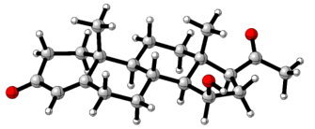
C -0.01110 -0.07580 0.01950
C -0.02170 -0.07950 1.53030
C 1.28500 -0.08440 2.18440
C 2.45910 -0.15360 1.52750
C 2.55870 -0.34910 0.01620
C 1.19600 -0.82720 -0.54210
C 3.74980 -0.00170 2.28380
C 4.75980 -1.10610 1.95490
C 4.99010 -1.21720 0.44580
C 3.63880 -1.45580 -0.28100
C 5.93820 -2.36640 0.09720
C 6.20060 -2.55920 -1.41840
C 4.84760 -2.84510 -2.08350
C 3.82750 -1.73090 -1.78790
C 7.31380 -2.46230 0.77530
C 8.11770 -3.42050 -0.14930
C 7.17720 -3.76150 -1.34430
O -1.06530 -0.03030 2.17360
C 7.87190 -4.22340 -2.61510
C 9.04870 -5.16190 -2.45240
O 7.48140 -3.90390 -3.72160
C 6.88170 -1.34290 -2.08200
H 5.42410 -3.28610 0.41410
H 5.43080 -0.27760 0.10130
H 3.23030 -2.37850 0.15650
C 2.93500 1.01290 -0.62210
O 7.91200 -1.16120 0.88090
H -0.00100 0.97380 -0.29730
H -0.94920 -0.50130 -0.34080
H 1.26950 0.03070 3.26390
H 1.19480 -0.74580 -1.63000
H 1.07860 -1.89020 -0.30670
H 3.54760 0.03630 3.35610
H 4.19350 0.96540 2.01620
H 4.38790 -2.06400 2.33830
H 5.70140 -0.89830 2.46660
H 4.96580 -2.95820 -3.16310
H 4.45760 -3.79830 -1.70530
H 2.87240 -2.01490 -2.23400
H 4.14030 -0.81680 -2.29790
H 7.22170 -2.88050 1.78160
H 8.44610 -4.31550 0.38030
H 9.01260 -2.89920 -0.49400
H 6.58580 -4.64170 -1.04940
H 9.90800 -4.61410 -2.05530
H 8.82060 -5.95740 -1.73860
H 9.31470 -5.59070 -3.41690
H 6.29520 -0.43320 -1.95590
H 7.86460 -1.14520 -1.65600
H 6.99640 -1.52310 -3.15070
H 2.20830 1.78120 -0.35190
H 3.91510 1.36430 -0.29890
H 2.94890 0.93780 -1.71020
H 8.73470 -1.24630 1.37640

15β-OH_conf_3
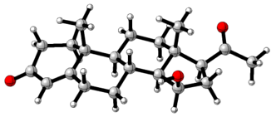
C -0.01500 -0.07400 0.01510
C -0.02790 -0.08050 1.52570
C 1.27860 -0.08310 2.18180
C 2.45280 -0.14810 1.52560
C 2.55580 -0.34000 0.01460
C 1.19500 -0.82080 -0.54660
C 3.74210 0.00530 2.28430
C 4.75630 -1.09370 1.95000
C 4.99350 -1.19880 0.43950
C 3.63880 -1.44430 -0.28180
C 5.95030 -2.34160 0.08700
C 6.19680 -2.54250 -1.42980
C 4.84050 -2.84030 -2.08160
C 3.81960 -1.72730 -1.78770
C 7.34250 -2.42830 0.74670
C 8.13110 -3.38700 -0.17630
C 7.18060 -3.73940 -1.35800
O -1.07160 -0.03570 2.16830
C 7.86510 -4.20140 -2.63460
C 9.06170 -5.11570 -2.48160
O 7.45040 -3.90050 -3.73760
C 6.86490 -1.32720 -2.10890
H 5.44720 -3.26290 0.41870
H 5.42130 -0.25270 0.09240
H 3.23630 -2.36620 0.16240
C 2.92950 1.02330 -0.62190
O 8.06400 -1.18580 0.80670
H -0.00770 0.97620 -0.29970
H -0.95110 -0.50170 -0.34750
H 1.26150 0.02900 3.26150
H 1.19470 -0.73650 -1.63410
H 1.08020 -1.88470 -0.31400
H 3.53940 0.03440 3.35650
H 4.18140 0.97650 2.02390
H 4.38950 -2.05570 2.32610
H 5.68630 -0.88770 2.48780
H 4.95130 -2.96210 -3.16100
H 4.45670 -3.79150 -1.69240
H 2.86230 -2.01690 -2.22480
H 4.12580 -0.81560 -2.30590
H 7.26930 -2.83270 1.76000
H 8.47040 -4.27490 0.35680
H 9.02000 -2.86130 -0.52770
H 6.59580 -4.62140 -1.05510
H 9.91420 -4.54970 -2.09580
H 8.85700 -5.91220 -1.76190
H 9.32510 -5.54360 -3.44710
H 6.28030 -0.41710 -1.97510
H 7.85580 -1.12760 -1.70350
H 6.95870 -1.51040 -3.17920
H 2.19460 1.78680 -0.36020
H 3.90360 1.38310 -0.28950
H 2.95510 0.94680 -1.70960
H 7.64630 -0.61700 1.46330

15β-OH_conf_4
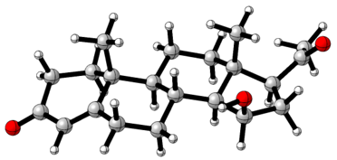
C -0.01240 -0.02110 0.00680
C -0.03510 -0.05440 1.51700
C 1.26680 -0.08400 2.18150
C 2.44480 -0.14940 1.53250
C 2.55590 -0.31150 0.01840
C 1.19440 -0.76870 -0.56080
C 3.73030 -0.02680 2.30280
C 4.73160 -1.13350 1.95540
C 4.98030 -1.21090 0.44520
C 3.63010 -1.42000 -0.29370
C 5.92300 -2.36220 0.07940
C 6.18650 -2.53010 -1.43890
C 4.83240 -2.78570 -2.11450
C 3.82710 -1.66210 -1.80390
C 7.30190 -2.48580 0.75530
C 8.07180 -3.45880 -0.16430
C 7.16280 -3.76130 -1.37890
O -1.08250 -0.00950 2.15330
C 7.92650 -4.05320 -2.66230
C 7.25110 -4.95280 -3.67160
O 9.03720 -3.60360 -2.87090
C 6.88580 -1.31900 -2.08770
H 5.40090 -3.28340 0.38010
H 5.42670 -0.26520 0.12160
H 3.21210 -2.34860 0.12080
C 2.94640 1.06090 -0.58760
O 8.04720 -1.25770 0.82990
H 0.00560 1.03420 -0.28980
H -0.94990 -0.43440 -0.36890
H 1.24350 0.00750 3.26310
H 1.20160 -0.66430 -1.64670
H 1.06820 -1.83560 -0.34870
H 3.52000 -0.01520 3.37390
H 4.18470 0.94290 2.06400
H 4.34710 -2.09740 2.30840
H 5.66000 -0.95230 2.50440
H 4.94010 -2.86970 -3.20000
H 4.42600 -3.74020 -1.76010
H 2.87250 -1.92330 -2.26380
H 4.15760 -0.74180 -2.29070
H 7.20480 -2.89110 1.76620
H 8.34950 -4.37530 0.35780
H 8.99340 -2.98060 -0.49390
H 6.54170 -4.63810 -1.16840
H 7.21550 -5.97040 -3.26900
H 6.21730 -4.64810 -3.84640
H 7.80630 -4.95710 -4.60790
H 6.31800 -0.40000 -1.94410
H 7.87950 -1.15300 -1.67810
H 6.98500 -1.47470 -3.16500
H 2.22300 1.82810 -0.30600
H 3.92630 1.39930 -0.25000
H 2.96770 1.00940 -1.67680
H 7.65240 -0.69620 1.50660

15β-OH_conf_5
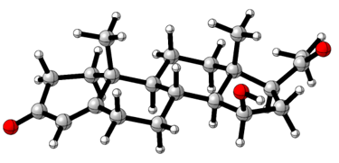
C 0.01340 -0.19790 -0.04550
C -0.00290 -0.08720 1.46100
C 1.30200 -0.01660 2.11610
C 2.47880 -0.11800 1.46850
C 2.58610 -0.43490 -0.02190
C 1.23230 -0.97420 -0.54450
C 3.76580 0.11640 2.21070
C 4.79550 -0.99330 1.97350
C 5.02750 -1.22810 0.47880
C 3.68140 -1.54760 -0.22200
C 5.99650 -2.38680 0.23080
C 6.26870 -2.69420 -1.26490
C 4.92060 -3.06200 -1.90120
C 3.87660 -1.94790 -1.69900
C 7.36660 -2.39830 0.91830
C 8.17190 -3.44650 0.10620
C 7.28710 -3.87970 -1.08930
O -1.04920 -0.00920 2.09650
C 8.07780 -4.25200 -2.33530
C 7.43410 -5.23110 -3.28950
O 9.18680 -3.80320 -2.55550
C 6.92330 -1.53080 -2.03520
H 5.49740 -3.28780 0.61680
H 5.45550 -0.31480 0.05550
H 3.28530 -2.43470 0.29340
C 2.94840 0.87530 -0.76770
O 7.94860 -1.08550 0.87850
H 0.01280 0.82480 -0.44040
H -0.91780 -0.66110 -0.37590
H 1.28130 0.18520 3.18260
H 1.23330 -0.97630 -1.63560
H 1.12820 -2.01760 -0.22830
H 3.56120 0.23700 3.27630
H 4.19300 1.06650 1.86630
H 4.44220 -1.92180 2.43770
H 5.73360 -0.72580 2.46330
H 5.02550 -3.25010 -2.97380
H 4.55020 -3.99000 -1.45040
H 2.92940 -2.29180 -2.11890
H 4.16960 -1.07550 -2.28670
H 7.27320 -2.70120 1.96530
H 8.44660 -4.30690 0.71910
H 9.09590 -2.99810 -0.25930
H 6.69540 -4.75780 -0.81080
H 7.40430 -6.21770 -2.81590
H 6.40010 -4.95480 -3.50430
H 8.00690 -5.29370 -4.21300
H 6.32180 -0.62380 -1.98480
H 7.90920 -1.28730 -1.64530
H 7.03080 -1.79160 -3.09140
H 2.20290 1.64850 -0.57370
H 3.91580 1.27180 -0.45920
H 2.98180 0.71000 -1.84540
H 8.80830 -1.12340 1.31350

15α-OH
Conformer | Boltzman contribution analysis (%)
15α-OH_conf_1 | 45.58
15α-OH_conf_2 | 46.99
15α-OH_conf_3 | 7.42

15α-OH_conf_1
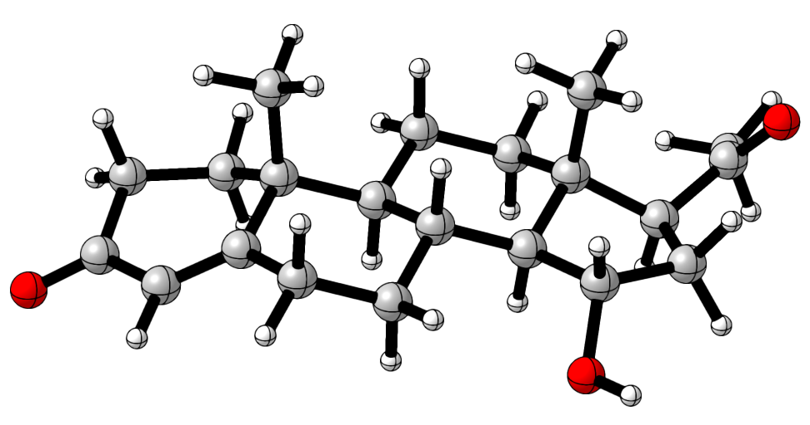
C -0.00300 -0.02660 -0.00590
C -0.02720 -0.03960 1.50490
C 1.27340 -0.06230 2.17070
C 2.45240 -0.13890 1.52390
C 2.56420 -0.32380 0.01280
C 1.20220 -0.78500 -0.56200
C 3.73870 -0.00730 2.28930
C 4.72930 -1.13160 1.96980
C 4.98200 -1.24030 0.46340
C 3.63650 -1.43850 -0.28780
C 5.91620 -2.40590 0.10870
C 6.19900 -2.53900 -1.41020
C 4.85960 -2.78500 -2.11410
C 3.84230 -1.67420 -1.79850
C 7.29280 -2.52270 0.77410
C 8.11310 -3.42840 -0.18510
C 7.18910 -3.75860 -1.37680
O -1.07620 0.01740 2.13840
C 7.92520 -4.04220 -2.67710
C 7.26940 -5.00420 -3.64010
O 9.00120 -3.53540 -2.93410
C 6.89930 -1.30110 -2.00660
H 5.39050 -3.32660 0.39930
H 5.44590 -0.30390 0.13360
H 3.20970 -2.36510 0.12170
C 2.95780 1.04160 -0.60840
O 7.13940 -3.09450 2.08180
H 0.01850 1.02470 -0.31630
H -0.94130 -0.44210 -0.37710
H 1.24970 0.04600 3.25070
H 1.21090 -0.69550 -1.64930
H 1.07300 -1.84840 -0.33530
H 3.52970 0.03290 3.36000
H 4.20020 0.95300 2.02580
H 4.33450 -2.08270 2.34250
H 5.66450 -0.95720 2.50370
H 4.98840 -2.84540 -3.19900
H 4.45520 -3.74960 -1.78650
H 2.89230 -1.94130 -2.26480
H 4.16600 -0.74850 -2.27950
H 7.76500 -1.53980 0.87610
H 9.01070 -2.92260 -0.54010
H 8.42960 -4.33330 0.33610
H 6.58550 -4.64140 -1.14540
H 7.31430 -6.01240 -3.21520
H 6.21210 -4.76920 -3.77790
H 7.78640 -4.99590 -4.59800
H 6.30120 -0.39920 -1.88490
H 7.87120 -1.11390 -1.55020
H 7.06700 -1.43730 -3.07720
H 2.24760 1.81780 -0.31780
H 3.94700 1.37080 -0.28940
H 2.95880 0.98540 -1.69760
H 8.00340 -3.10780 2.50980

15α-OH_conf_2
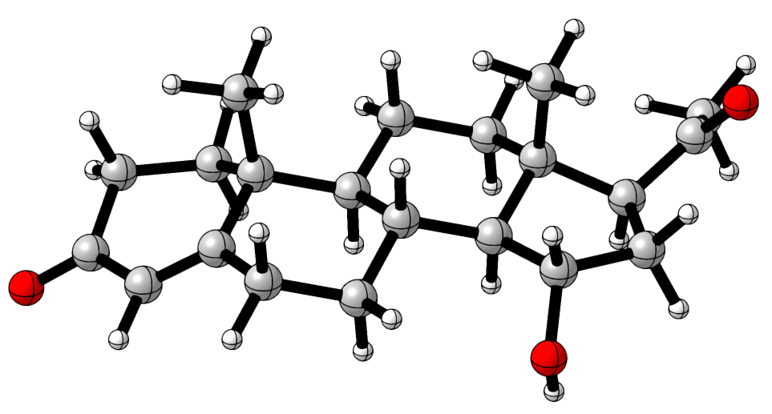
C -0.00890 -0.02730 -0.00780
C -0.03540 -0.03790 1.50290
C 1.26440 -0.06440 2.17030
C 2.44380 -0.14940 1.52520
C 2.55660 -0.33990 0.01490
C 1.19240 -0.79410 -0.56060
C 3.72980 -0.02340 2.29150
C 4.71240 -1.15660 1.97860
C 4.96710 -1.27380 0.47290
C 3.62170 -1.46280 -0.28060
C 5.89620 -2.44610 0.12580
C 6.17420 -2.59750 -1.39310
C 4.83190 -2.82960 -2.09640
C 3.83060 -1.70270 -1.78980
C 7.28670 -2.55270 0.77500
C 8.05800 -3.54090 -0.14360
C 7.14640 -3.83290 -1.35590
O -1.08490 0.02320 2.13510
C 7.89900 -4.10920 -2.64960
C 7.23660 -5.03310 -3.64490
O 8.99220 -3.62600 -2.87580
C 6.89360 -1.37430 -1.99790
H 5.36320 -3.36350 0.42310
H 5.44010 -0.34290 0.14080
H 3.18630 -2.38570 0.12900
C 2.96040 1.02030 -0.61060
O 7.28030 -2.94930 2.14970
H 0.01980 1.02330 -0.31990
H -0.94920 -0.43760 -0.37990
H 1.24010 0.04800 3.24990
H 1.20280 -0.70710 -1.64810
H 1.05640 -1.85630 -0.33190
H 3.52020 0.02320 3.36190
H 4.19970 0.93160 2.02450
H 4.30510 -2.10280 2.35320
H 5.64720 -0.98990 2.51430
H 4.96090 -2.90020 -3.18050
H 4.41350 -3.78600 -1.76220
H 2.87930 -1.95590 -2.26090
H 4.17160 -0.78280 -2.27010
H 7.77930 -1.57920 0.79030
H 9.00650 -3.11930 -0.47440
H 8.29030 -4.45480 0.40670
H 6.52360 -4.70950 -1.15230
H 7.24010 -6.04970 -3.23830
H 6.19070 -4.76240 -3.80330
H 7.77620 -5.02330 -4.59020
H 6.32390 -0.45680 -1.85700
H 7.88190 -1.21800 -1.56580
H 7.03140 -1.50870 -3.07300
H 2.25520 1.80250 -0.32360
H 3.95150 1.34390 -0.29140
H 2.96230 0.96010 -1.69960
H 6.85980 -3.81550 2.21900

15α-OH_conf_3
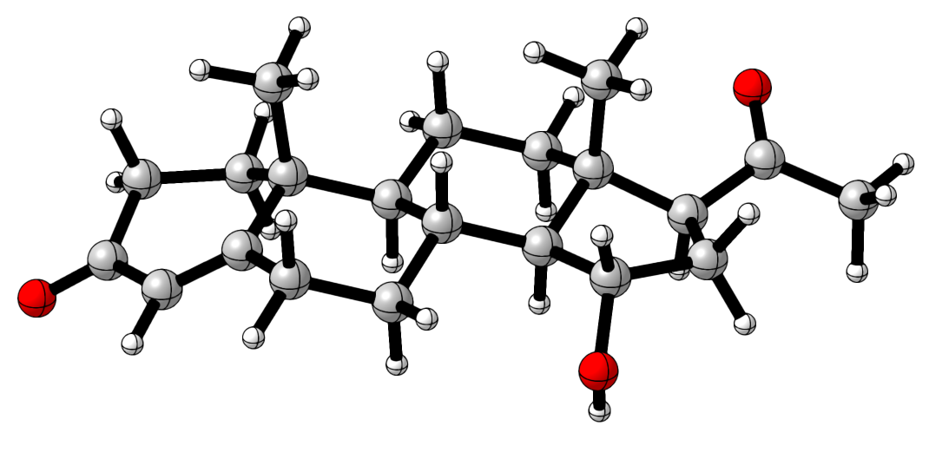
C -0.01180 -0.06680 0.00300
C -0.02880 -0.05520 1.51380
C 1.27560 -0.05980 2.17280
C 2.45120 -0.14510 1.52090
C 2.55580 -0.36070 0.01340
C 1.19150 -0.83360 -0.54580
C 3.74120 0.00650 2.27650
C 4.73450 -1.12010 1.97400
C 4.97750 -1.26060 0.46850
C 3.62760 -1.48050 -0.26980
C 5.91790 -2.42500 0.13120
C 6.18400 -2.60160 -1.38690
C 4.83900 -2.87000 -2.07120
C 3.82240 -1.75420 -1.77610
C 7.31430 -2.50480 0.77410
C 8.11850 -3.45540 -0.16150
C 7.16140 -3.80390 -1.33610
O -1.07460 0.00630 2.15210
C 7.83810 -4.25750 -2.61880
C 8.97200 -5.25030 -2.47570
O 7.47200 -3.88560 -3.71740
C 6.87760 -1.37150 -2.01390
H 5.39870 -3.34390 0.44990
H 5.43470 -0.32950 0.11560
H 3.20490 -2.39790 0.16500
C 2.94590 0.99180 -0.63750
O 7.32020 -2.92810 2.14080
H 0.00840 0.97940 -0.32430
H -0.95160 -0.48840 -0.35740
H 1.25730 0.07010 3.25060
H 1.19490 -0.76340 -1.63440
H 1.06460 -1.89310 -0.29990
H 3.53840 0.06780 3.34750
H 4.19820 0.96240 1.99100
H 4.34230 -2.06440 2.36890
H 5.67210 -0.93200 2.49870
H 4.97050 -2.97160 -3.15040
H 4.44140 -3.82570 -1.70820
H 2.86850 -2.03300 -2.22740
H 4.14070 -0.84010 -2.28260
H 7.78290 -1.52020 0.80620
H 9.02240 -2.96190 -0.52230
H 8.43930 -4.33830 0.39200
H 6.57630 -4.68520 -1.03330
H 9.20740 -5.68470 -3.44560
H 9.85980 -4.74170 -2.08880
H 8.71930 -6.03790 -1.76200
H 6.28310 -0.46600 -1.89990
H 7.85260 -1.17280 -1.56470
H 7.03200 -1.53820 -3.07930
H 2.23290 1.77200 -0.36500
H 3.93370 1.33140 -0.32490
H 2.94840 0.91100 -1.72520
H 6.84360 -3.76500 2.20710

7β,15β-OH
Conformer | Boltzman contribution analysis (%)
7β,15β-OH_conf_1 | 84.77
7β,15β-OH_conf_2 | 6.60
7β,15β-OH_conf_3 | 8.63

7β,15β-OH_conf_1
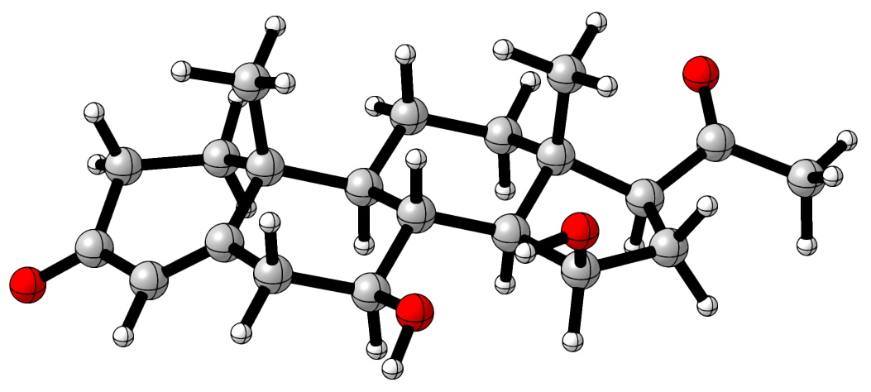
C -6.93440 -3.18340 -0.99000
C -5.90890 -3.27300 0.11530
C -4.51220 -3.37200 -0.31030
C -4.12670 -3.45720 -1.59670
C -5.09860 -3.58470 -2.76200
C -6.50250 -3.96660 -2.23030
C -2.67100 -3.39140 -1.95190
C -2.21530 -4.51600 -2.88460
C -3.09050 -4.60940 -4.13770
C -4.58640 -4.73430 -3.70730
C -2.74760 -5.81980 -5.02940
C -3.64280 -5.94800 -6.29210
C -5.09220 -6.11420 -5.82500
C -5.52080 -4.95530 -4.91570
C -1.30290 -6.07290 -5.52870
C -1.47990 -7.00510 -6.75010
C -3.00940 -7.21600 -6.92030
O -6.21760 -3.21640 1.30010
C -3.46230 -7.64980 -8.30530
C -2.59610 -8.66110 -9.02520
O -4.49670 -7.25090 -8.80600
O -0.59730 -4.90290 -5.94880
C -3.51610 -4.74500 -7.25210
H -2.97840 -6.70840 -4.42290
H -2.94390 -3.68560 -4.70520
H -4.64070 -5.64900 -3.09990
C -5.16860 -2.21860 -3.49090
O -0.85370 -4.26310 -3.27780
H -7.06030 -2.11960 -1.22420
H -7.89480 -3.53550 -0.61030
H -3.77260 -3.31190 0.48190
H -7.24570 -3.82920 -3.01660
H -6.50210 -5.03280 -1.98070
H -2.06210 -3.39100 -1.04460
H -2.47140 -2.44510 -2.46800
H -2.25690 -5.47410 -2.35130
H -5.76770 -6.17940 -6.68020
H -5.18460 -7.05840 -5.27460
H -6.53250 -5.15500 -4.55950
H -5.58330 -4.03960 -5.50760
H -0.71880 -6.56660 -4.74720
H -0.94640 -7.94700 -6.62330
H -1.05200 -6.50530 -7.62020
H -3.29610 -8.06910 -6.28570
H -1.67140 -8.18290 -9.36040
H -2.30830 -9.47710 -8.35790
H -3.12810 -9.05440 -9.88950
H -0.42770 -4.40200 -5.13540
H -3.78310 -3.80680 -6.76580
H -2.49950 -4.62790 -7.62500
H -4.18510 -4.88180 -8.10150
H -5.45940 -1.42640 -2.79890
H -4.21120 -1.93410 -3.92740
H -5.90720 -2.24660 -4.29250
H -0.27760 -4.34690 -2.50890

7β,15β-OH_conf_2
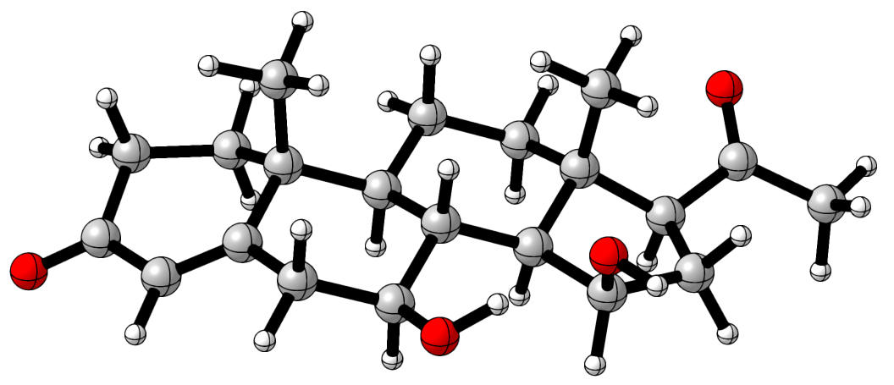
C -7.01080 -3.18340 -0.96000
C -6.01430 -3.29910 0.16970
C -4.60900 -3.40440 -0.22060
C -4.18860 -3.47080 -1.49790
C -5.13220 -3.56860 -2.68950
C -6.55300 -3.94720 -2.20290
C -2.72520 -3.41220 -1.81490
C -2.24570 -4.52570 -2.74960
C -3.09770 -4.59180 -4.02670
C -4.60720 -4.70550 -3.64250
C -2.75650 -5.80200 -4.92230
C -3.60920 -5.90110 -6.21740
C -5.07520 -6.04440 -5.79540
C -5.50900 -4.89070 -4.88170
C -1.31000 -6.09060 -5.36640
C -1.45540 -7.00730 -6.60740
C -2.98370 -7.17670 -6.83700
O -6.35560 -3.25670 1.34670
C -3.39600 -7.58660 -8.24280
C -2.53490 -8.62020 -8.93640
O -4.39720 -7.15130 -8.77770
O -0.62960 -4.85190 -5.67140
C -3.43030 -4.69080 -7.15930
H -3.02640 -6.68930 -4.33270
H -2.92840 -3.66540 -4.58400
H -4.68930 -5.63070 -3.05460
C -5.17080 -2.18870 -3.39470
O -0.85490 -4.29120 -2.98210
H -7.12450 -2.11490 -1.17830
H -7.98280 -3.53590 -0.61100
H -3.88940 -3.36500 0.59100
H -7.27420 -3.78820 -3.00570
H -6.56850 -5.01780 -1.97320
H -2.13290 -3.43190 -0.89860
H -2.50520 -2.45950 -2.31120
H -2.34170 -5.48720 -2.22540
H -5.72480 -6.08530 -6.67170
H -5.20150 -6.99440 -5.26190
H -6.53480 -5.07750 -4.56040
H -5.53720 -3.96530 -5.46120
H -0.75300 -6.59060 -4.57110
H -0.95250 -7.96340 -6.46230
H -0.98330 -6.51890 -7.46210
H -3.31090 -8.02960 -6.22290
H -1.59030 -8.16470 -9.24760
H -2.28590 -9.44220 -8.26120
H -3.05180 -9.00100 -9.81540
H 0.27260 -5.05620 -5.94840
H -3.68830 -3.75310 -6.66800
H -2.40250 -4.59180 -7.50740
H -4.07900 -4.80280 -8.02750
H -5.46870 -1.40600 -2.69470
H -4.19970 -1.90730 -3.80220
H -5.89070 -2.19300 -4.21380
H -0.67480 -4.31100 -3.93900

7β,15β-OH_conf_3
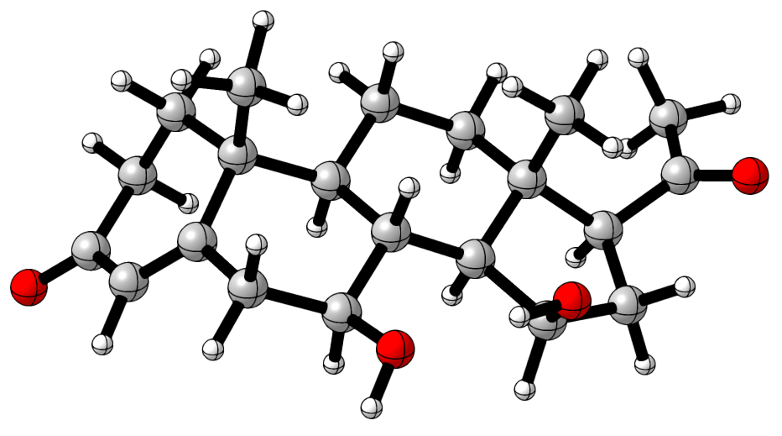
C -6.74940 -4.25940 -1.23520
C -5.81070 -4.00220 -0.07770
C -4.46920 -3.53420 -0.43330
C -4.09030 -3.23070 -1.68890
C -5.03590 -3.21630 -2.87650
C -6.49940 -3.27720 -2.37760
C -2.64500 -3.06370 -2.03370
C -2.20080 -4.24790 -2.91450
C -3.10060 -4.44940 -4.14500
C -4.61560 -4.45850 -3.74870
C -2.81270 -5.76440 -4.90010
C -3.66860 -5.94860 -6.18530
C -5.14580 -5.94040 -5.77300
C -5.50730 -4.67160 -4.98700
C -1.37920 -6.17530 -5.30550
C -1.59870 -7.26790 -6.37360
C -3.11500 -7.34030 -6.65910
O -6.12380 -4.23940 1.08290
C -3.45660 -7.73140 -8.09060
C -4.87310 -8.18210 -8.38040
O -2.63450 -7.68600 -8.98580
O -0.59420 -5.12510 -5.87530
C -3.40630 -4.87950 -7.26530
H -3.13560 -6.57070 -4.22470
H -2.91040 -3.60440 -4.81270
H -4.75400 -5.33880 -3.10720
C -4.89740 -1.89270 -3.66800
O -0.85490 -4.01120 -3.36400
H -7.77820 -4.20230 -0.87620
H -6.58440 -5.29440 -1.55800
H -3.74420 -3.52620 0.37470
H -6.76080 -2.27530 -2.02220
H -7.17480 -3.48320 -3.20810
H -2.02930 -3.03460 -1.13200
H -2.46450 -2.14230 -2.59140
H -2.21800 -5.16110 -2.30670
H -5.80240 -6.01550 -6.64380
H -5.34960 -6.81680 -5.14700
H -6.55110 -4.75060 -4.67920
H -5.44910 -3.80100 -5.64500
H -0.84470 -6.57550 -4.43880
H -1.21590 -8.23580 -6.04730
H -1.05590 -6.99550 -7.27770
H -3.57870 -8.09420 -6.01330
H -5.30450 -8.74200 -7.54990
H -5.50170 -7.30140 -8.54340
H -4.88830 -8.78040 -9.29040
H -0.42140 -4.51000 -5.14490
H -3.60320 -3.87230 -6.89890
H -2.37700 -4.89960 -7.61650
H -4.06390 -5.04210 -8.12380
H -4.98270 -1.03830 -2.99300
H -3.95400 -1.80280 -4.20410
H -5.70310 -1.81300 -4.39980
H -0.25270 -4.07620 -2.61320

7β,15α-OH
Conformer | Boltzman contribution analysis (%)
7β,15α-OH_conf_1 | 94.89

7β,15α-OH_conf_1
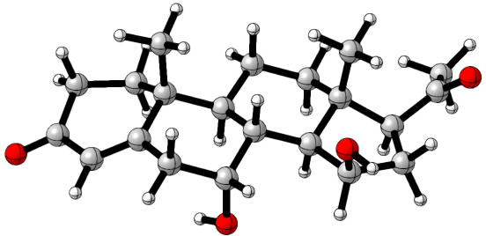
C -2.96800 -4.32820 1.51130
C -2.96820 -2.84780 1.81010
C -4.28310 -2.22510 1.98230
C -5.45040 -2.87690 1.82120
C -5.54320 -4.31120 1.30540
C -4.18880 -4.73780 0.68710
C -6.74440 -2.19600 2.17630
C -7.76850 -2.25030 1.03980
C -7.98620 -3.70440 0.58810
C -6.64570 -4.36770 0.18170
C -8.96650 -3.80540 -0.58160
C -9.24840 -5.25420 -1.05830
C -7.90720 -5.84900 -1.51060
C -6.85520 -5.78670 -0.38800
C -10.33160 -3.11690 -0.49550
C -11.15220 -3.79810 -1.62190
C -10.27590 -4.93390 -2.20580
O -1.93210 -2.20960 1.95230
C -11.07200 -6.12460 -2.71950
C -10.44720 -6.94350 -3.82560
O -12.17220 -6.40470 -2.28220
O -10.90010 -3.30830 0.81160
C -9.89870 -6.15470 0.00970
H -8.47690 -3.31520 -1.43230
H -8.40980 -4.22640 1.45070
H -6.24780 -3.76440 -0.64620
C -5.88480 -5.23440 2.50210
O -7.39560 -1.37600 -0.03690
H -2.95410 -4.84950 2.47580
H -2.03760 -4.58600 1.00290
H -4.27420 -1.19460 2.32340
H -4.17530 -5.81860 0.53850
H -4.10040 -4.28470 -0.30590
H -6.56350 -1.15960 2.46610
H -7.18290 -2.70030 3.04500
H -8.71560 -1.84840 1.39930
H -8.02040 -6.89080 -1.82400
H -7.54150 -5.29200 -2.38090
H -5.91160 -6.16820 -0.78290
H -7.14790 -6.46980 0.41210
H -10.23280 -2.04300 -0.67370
H -11.43620 -3.08680 -2.39940
H -12.07100 -4.21360 -1.20780
H -9.69010 -4.55140 -3.04800
H -10.45690 -6.35300 -4.74760
H -9.40180 -7.17410 -3.61170
H -11.01140 -7.86090 -3.98320
H -11.74440 -2.84370 0.84360
H -9.28880 -6.22040 0.91040
H -10.87920 -5.79180 0.30940
H -10.01680 -7.17020 -0.37720
H -5.14400 -5.12610 3.29610
H -6.86040 -5.00890 2.93320
H -5.88910 -6.28010 2.19340
H -6.46200 -1.50340 -0.24570

7α,15β-OH
Conformer | Boltzman contribution analysis (%)
7α,15β-OH_conf_1 | 52.73
7α,15β-OH_conf_2 | 47.27

7α,15β-OH_conf_1
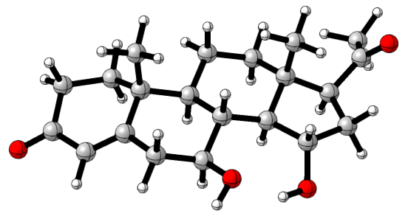
C -1.32390 -1.94430 0.23790
C -2.76860 -1.89540 0.67520
C -3.02380 -1.30230 1.98870
C -2.05410 -0.88300 2.82130
C -0.56860 -1.07310 2.55200
C -0.37350 -2.11720 1.42360
C -2.40740 -0.15170 4.08130
C -1.74040 -0.74120 5.32400
C -0.21830 -0.82160 5.16620
C 0.11260 -1.61850 3.86350
C 0.49220 -1.51660 6.35060
C 2.03300 -1.62230 6.17100
C 2.31730 -2.43460 4.90550
C 1.63090 -1.81670 3.68130
C 0.32810 -1.00720 7.79870
C 1.51010 -1.64260 8.56480
C 2.40040 -2.34390 7.51740
O -3.68260 -2.28180 -0.04370
C 3.88190 -2.35800 7.86430
C 4.68690 -3.54490 7.38760
O 4.40300 -1.46940 8.51150
O -0.89350 -1.40220 8.42340
C 2.72180 -0.24400 6.09440
H 0.11710 -2.54950 6.37350
H 0.14720 0.20660 5.07690
H -0.31810 -2.61780 4.01520
C 0.02360 0.29120 2.11260
O -2.06210 0.09060 6.45750
H -1.11990 -1.00790 -0.29470
H -1.20260 -2.74890 -0.48920
H -4.06850 -1.16050 2.24650
H 0.65490 -2.08490 1.06230
H -0.52750 -3.11630 1.84430
H -3.49240 -0.13700 4.21310
H -2.08030 0.89110 3.99630
H -2.13420 -1.74960 5.50400
H 3.39240 -2.50060 4.71270
H 1.95440 -3.45920 5.04580
H 1.81410 -2.46390 2.82260
H 2.10460 -0.86110 3.44820
H 0.39760 0.08470 7.82740
H 2.08180 -0.89150 9.10820
H 1.12480 -2.35410 9.29590
H 2.08620 -3.38560 7.40280
H 4.38900 -4.42530 7.96670
H 4.47810 -3.77350 6.34060
H 5.75100 -3.36560 7.53060
H -1.58700 -0.90060 7.96270
H 2.32170 0.36660 5.28590
H 2.61290 0.32240 7.01860
H 3.79220 -0.36220 5.91230
H -0.52280 0.69190 1.25710
H -0.02210 1.03700 2.90680
H 1.06740 0.18190 1.81720
H -3.01590 0.24270 6.46460

7α,15β-OH_conf_2
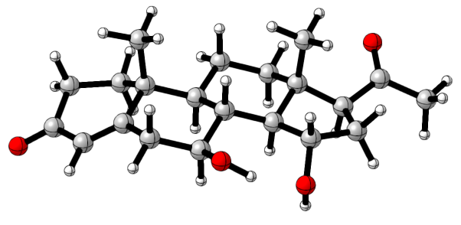
C -1.35050 -2.00280 0.18170
C -2.79720 -1.93230 0.61020
C -3.05550 -1.29610 1.90090
C -2.08880 -0.85400 2.72740
C -0.60300 -1.06670 2.47190
C -0.40810 -2.14550 1.37750
C -2.45020 -0.07800 3.95670
C -1.79040 -0.60310 5.22940
C -0.26360 -0.71960 5.06530
C 0.06420 -1.57720 3.80370
C 0.43380 -1.37030 6.27940
C 1.97460 -1.51560 6.12040
C 2.24740 -2.39160 4.89500
C 1.57940 -1.81840 3.63900
C 0.27830 -0.79080 7.69860
C 1.45550 -1.39390 8.50960
C 2.32010 -2.17310 7.48120
O -3.70850 -2.33870 -0.10250
C 3.78280 -2.35120 7.85890
C 4.07250 -2.73710 9.29330
O 4.68340 -2.23770 7.05010
O -0.99980 -1.04470 8.31280
C 2.68140 -0.14810 5.98490
H 0.04340 -2.39920 6.34240
H 0.11890 0.29780 4.93540
H -0.39000 -2.56090 3.99060
C 0.00480 0.27780 1.99500
O -2.18440 0.29850 6.26040
H -1.13790 -1.08350 -0.37690
H -1.23020 -2.82930 -0.52050
H -4.10050 -1.13890 2.14830
H 0.62280 -2.13100 1.02200
H -0.57140 -3.13050 1.82740
H -3.53210 -0.05850 4.09430
H -2.12890 0.96330 3.83180
H -2.19300 -1.60360 5.44540
H 3.32190 -2.49290 4.73000
H 1.85790 -3.39930 5.08410
H 1.75310 -2.50940 2.81290
H 2.07620 -0.88580 3.36340
H 0.34040 0.29640 7.68610
H 2.02510 -0.60040 8.99500
H 1.07380 -2.03750 9.30320
H 1.94210 -3.20570 7.44760
H 5.10370 -3.07320 9.38390
H 3.92150 -1.87210 9.94540
H 3.39040 -3.51840 9.63670
H -1.14670 -1.99880 8.35530
H 2.29510 0.42870 5.14580
H 2.56290 0.46850 6.87790
H 3.74860 -0.29780 5.82700
H -0.52170 0.64760 1.11350
H -0.05590 1.05300 2.75920
H 1.05440 0.15390 1.72640
H -1.98090 -0.12410 7.11430

7α,15α-OH
Conformer | Boltzman contribution analysis (%)
7α,15α-OH_conf_1 | 52.73
7α,15α-OH_conf_2 | 47.27

7α,15α-OH_conf_1
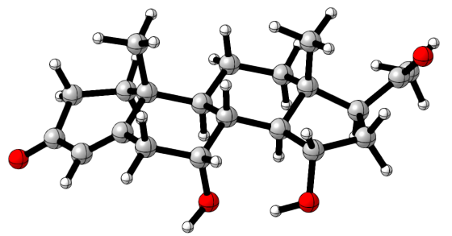
C -2.19260 -3.13800 1.59000
C -3.16440 -2.65550 2.64090
C -4.19440 -1.72010 2.18580
C -4.26310 -1.22930 0.93510
C -3.21060 -1.50510 -0.13340
C -1.92940 -2.07110 0.52700
C -5.45270 -0.41040 0.51670
C -5.08450 0.90020 -0.17660
C -4.07700 0.67530 -1.30740
C -2.84740 -0.14950 -0.84410
C -3.56620 1.99050 -1.91670
C -2.66470 1.77780 -3.15800
C -1.43600 0.98360 -2.69440
C -1.83690 -0.33090 -1.99840
C -4.55470 3.10350 -2.30060
C -3.80270 3.93130 -3.37160
C -2.40910 3.28360 -3.53090
O -3.12970 -3.05960 3.79730
C -1.76260 3.52180 -4.88660
C -0.25450 3.60600 -4.92060
O -2.42090 3.65360 -5.90140
O -4.90480 3.94380 -1.19140
C -3.37740 1.05030 -4.31450
H -2.91500 2.44930 -1.16300
H -4.62250 0.11810 -2.07560
H -2.35490 0.45720 -0.07510
C -3.79290 -2.54530 -1.12530
O -4.51810 1.84830 0.75240
H -2.62960 -4.03800 1.14120
H -1.26890 -3.44990 2.08010
H -4.96170 -1.47630 2.91400
H -1.27130 -2.48390 -0.23890
H -1.38640 -1.24390 0.99550
H -6.10100 -0.21360 1.37470
H -6.05310 -0.99540 -0.19010
H -5.99900 1.33360 -0.59610
H -0.77640 0.74690 -3.53500
H -0.85600 1.59930 -1.99790
H -0.92860 -0.80480 -1.62170
H -2.24860 -1.01530 -2.74330
H -5.47840 2.68850 -2.72020
H -4.32650 3.91450 -4.32660
H -3.73300 4.97140 -3.05250
H -1.72840 3.67860 -2.77060
H 0.10480 3.60640 -5.94820
H 0.05730 4.53330 -4.42870
H 0.19970 2.78610 -4.36010
H -4.81960 3.42070 -0.37720
H -3.69640 0.04860 -4.02910
H -4.25890 1.59010 -4.66100
H -2.70640 0.94320 -5.16920
H -4.11360 -3.44560 -0.59840
H -4.65710 -2.16020 -1.66760
H -3.04230 -2.83970 -1.85900
H -5.07520 1.88380 1.54010

7α,15α-OH_conf_2
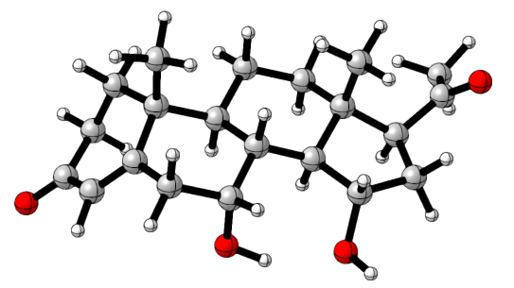
C -1.72270 -2.28800 1.57090
C -2.80870 -2.19390 2.61880
C -4.10210 -1.69460 2.15130
C -4.38680 -1.44790 0.85940
C -3.45900 -1.80900 -0.29200
C -2.30390 -2.70300 0.22090
C -5.59860 -0.65020 0.48140
C -5.15520 0.69760 -0.11280
C -4.14840 0.50170 -1.26620
C -2.96580 -0.43950 -0.89390
C -3.55420 1.82660 -1.76840
C -2.66990 1.66670 -3.03150
C -1.50500 0.73880 -2.66350
C -1.99650 -0.60060 -2.08340
C -4.45760 3.02750 -2.06140
C -3.62180 3.92160 -3.01280
C -2.29280 3.17580 -3.26450
O -2.60000 -2.44920 3.79980
C -1.65030 3.48980 -4.60770
C -0.14440 3.40230 -4.68460
O -2.30960 3.81460 -5.57730
O -4.76630 3.68080 -0.81110
C -3.43740 1.11300 -4.24770
H -2.87760 2.18190 -0.98040
H -4.72060 0.04650 -2.08070
H -2.41620 0.06730 -0.09240
C -4.22390 -2.65130 -1.34400
O -4.62690 1.48690 0.95290
H -0.95960 -2.98980 1.91130
H -1.24650 -1.30200 1.51130
H -4.81180 -1.42680 2.92740
H -2.69850 -3.71910 0.32450
H -1.51300 -2.76680 -0.52700
H -6.23110 -0.46300 1.34970
H -6.19950 -1.17410 -0.26620
H -6.04540 1.19530 -0.51370
H -0.87510 0.53370 -3.53410
H -0.87160 1.23950 -1.92270
H -1.11990 -1.17240 -1.77400
H -2.47380 -1.18330 -2.87510
H -5.39810 2.72570 -2.53080
H -4.14010 4.08730 -3.95690
H -3.45220 4.89730 -2.55540
H -1.56770 3.43650 -2.48790
H 0.28450 4.23760 -4.12120
H 0.22510 2.48690 -4.21820
H 0.18740 3.46090 -5.71960
H -5.46910 4.32550 -0.95370
H -3.83680 0.11780 -4.05630
H -4.27170 1.75070 -4.54210
H -2.77360 1.03390 -5.11120
H -4.72820 -3.49030 -0.85930
H -4.97370 -2.08550 -1.89540
H -3.52350 -3.06750 -2.07040
H -4.63090 2.40460 0.63340

DP4+ analysis

These automatic spreadsheets in Excel format are available for free at: https://sarotti-nmr.weebly.com/

For prog-15-OH
Isomer 1 = 15β-OH
Isomer 2 = 15α-OH
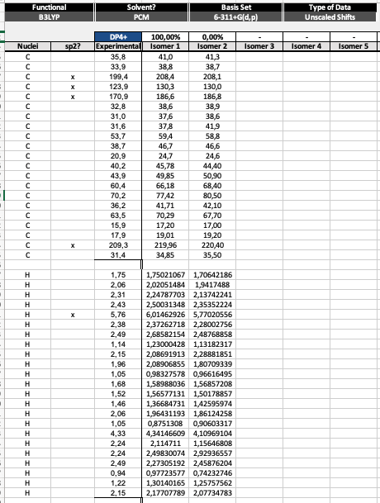

For prog-7,15-OH
Isomer 1 = 7β,15β-OH
Isomer 2 = 7β,15α-OH
Isomer 3 = 7α,15β-OH
Isomer 4 = 7α,15α-OH
