Supplemental figure 1.
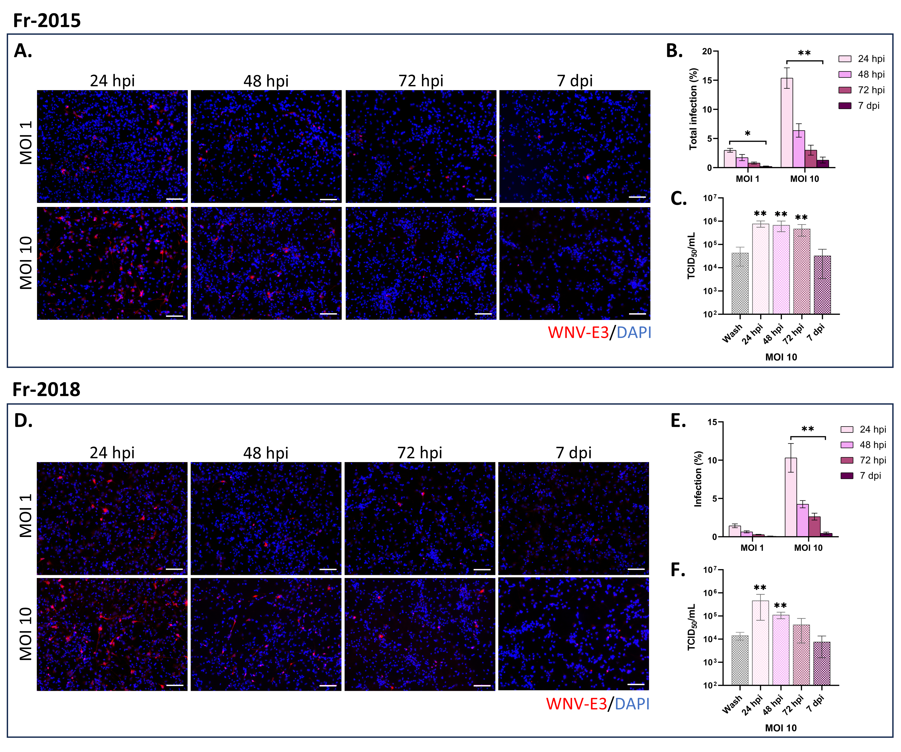
Permissivity of neuronal/glial cells derived from human neural progenitors to WNV_{Fr2015} and WNV_{Fr2018}. (A, D) Immunofluorescence labeling with an antibody against WNV-E3 (red) of hNGC infected for 24, 48, 72 hours or 7 days with WNV_{Fr2015} (A) or WNV_{Fr2018} (D) at MOI 1 or 10. Nuclei are stained with DAPI (blue). Scale bars = 100 µm. (B, E) Automatic enumeration of cells infected with WNV_{Fr2015} (B) or WNV_{Fr2018} (E) based on immunofluorescence staining using an OPERA-Phenix™ Plus instrument. (C, F) Supernatant of hNGC infected with WNV_{Fr2015} (C) or WNV_{Fr2018} (F) at MOI 10 were titrated by endpoint dilution (TCID50) at the indicated time points. Results are representative of three independent experiments performed in six replicates (B, E) or pooled from two independent experiments performed in duplicate or triplicate (C, F). Data are expressed as the mean ± SD. Statistical analysis was performed using a Kruskal-Wallis test with post-hoc Dunn’s test (B, E) or two-tailed unpaired Mann-Whitney tests between the wash and other timepoints (C, F) with GraphPad Prism V10.0.0. *p < 0.05; **p < 0.01.

Supplemental figure 2.
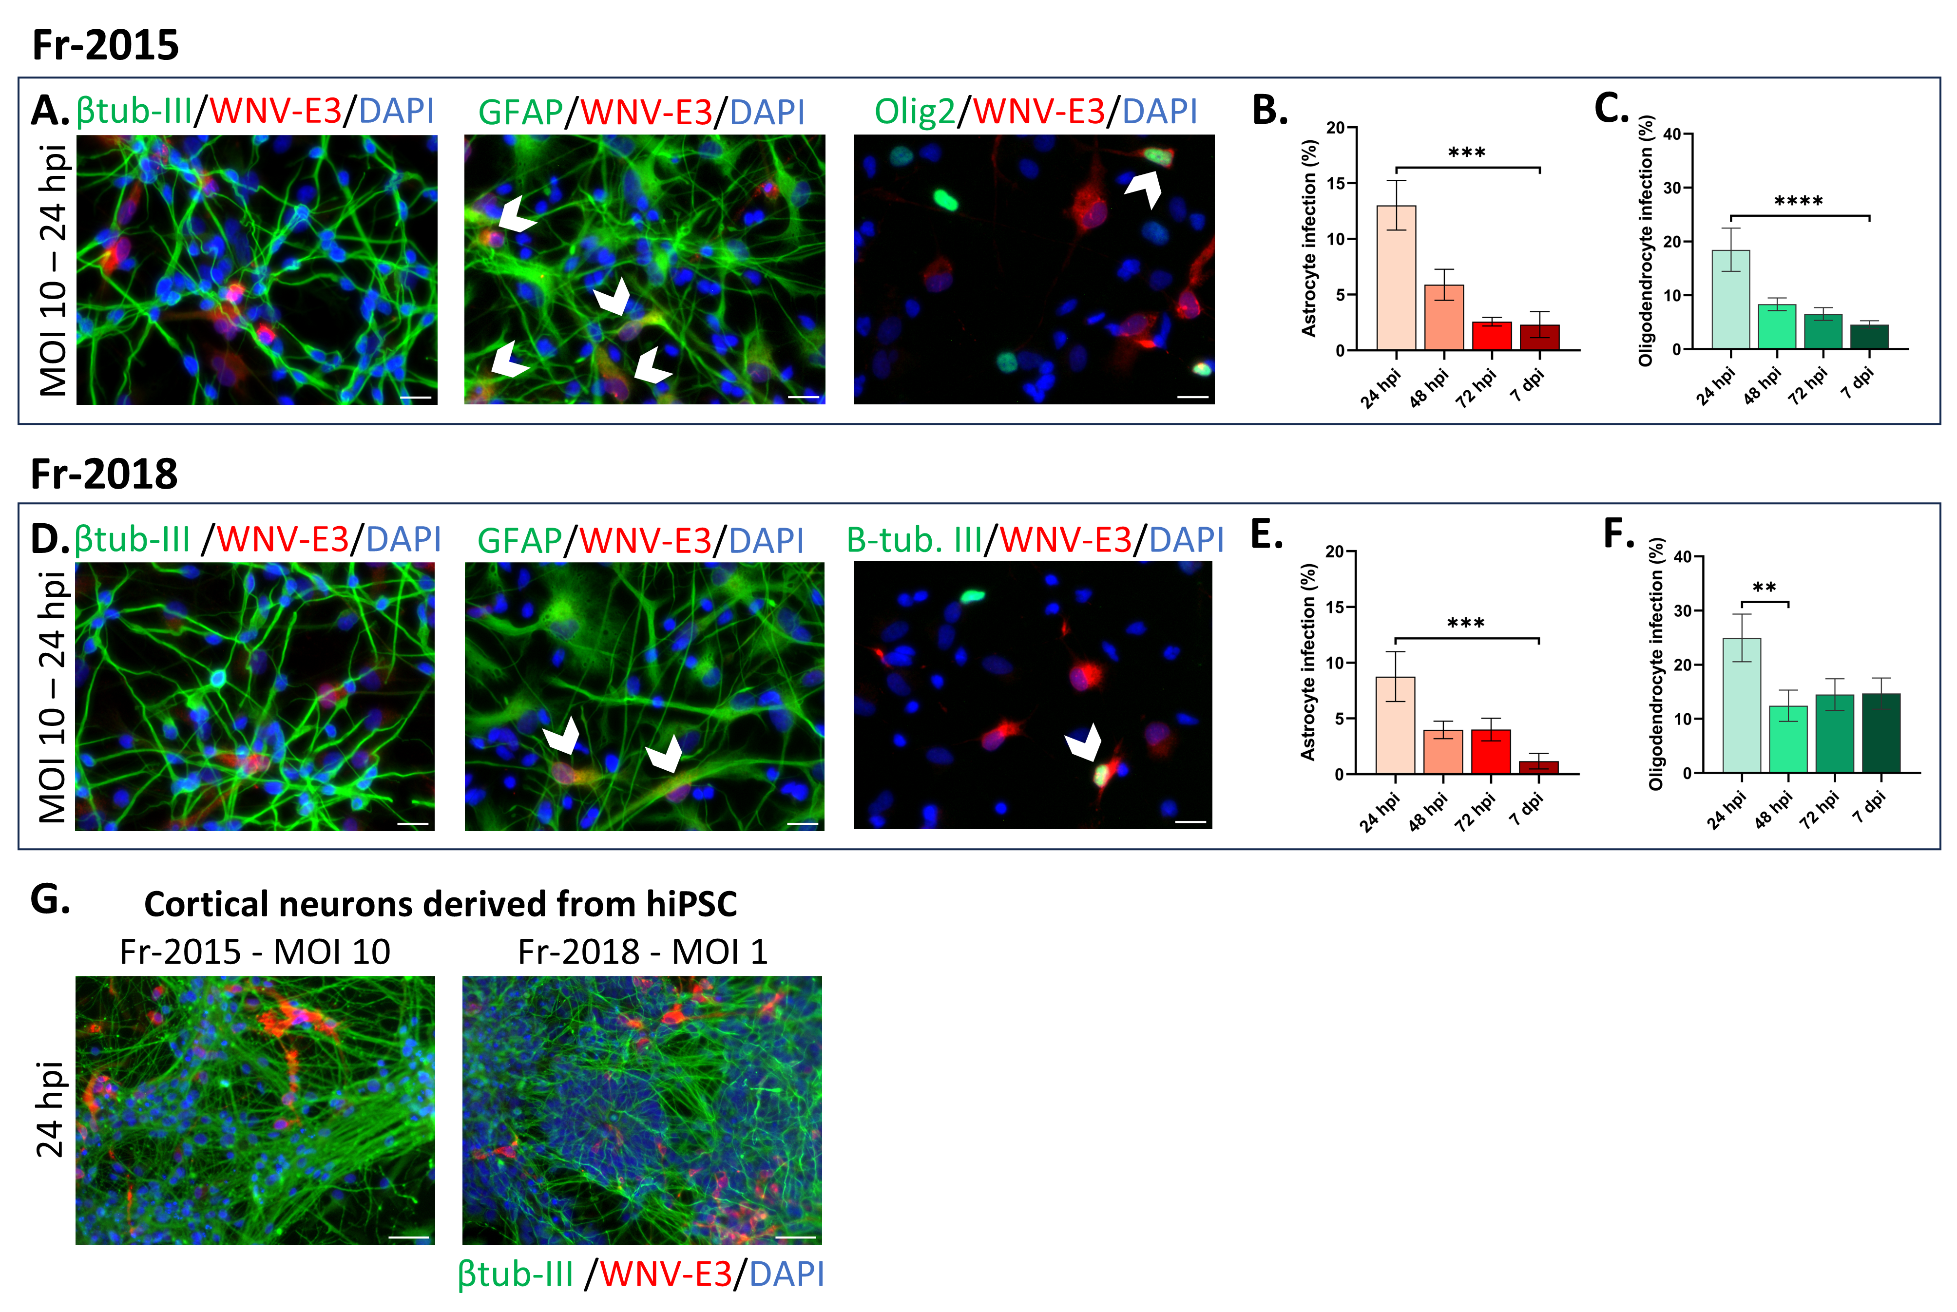WNV_{Fr2015} and WNV_{Fr2018} tropism in hNGC and cortical neurons derived from hiPSC. (A-F) Human NGC were infected with WNV_{Fr2015} (upper panel) or WNV_{Fr2018} (middle panel) at MOI 10 for 24 hours. (A, D) Immunofluorescence labeling of infected cells. Antibodies against βIII-tubulin (neurons), GFAP (astrocytes) or OLIG2 (oligodendrocytes) (green) and WNV-E3 (red) were used. Arrowheads show infected astrocytes and oligodendrocytes. Scale bars = 20 µm. (B, C, E, F) Automatic enumeration of infected astrocytes (B, E) or oligodendrocytes (C, F) at 24, 48, 72 hpi and 7 dpi, based on immunofluorescence staining using an OPERA-Phenix™ Plus instrument. (G) hiPSC-derived cortical neurons were infected with WNV_{Fr2015} and WNV_{Fr2018} for 24 hours. Immunofluorescence labeling using antibodies against βIII-tubulin (green) and WNV-E3 (red). Scale bars = 50 µm. (A, D, G) Note that βIII-tubulin positive cells were not infected. Nuclei were stained with DAPI (blue). Results are representative of three independent experiments performed in at least 5 replicates. Data are expressed as mean ± SD. Statistical analysis was performed using a Kruskal-Wallis test with post-hoc Dunn’s test with GraphPad Prism V10.0.0. **p < 0.01; ***p < 0.001; ****p < 0.0001.

Supplemental figure 3.
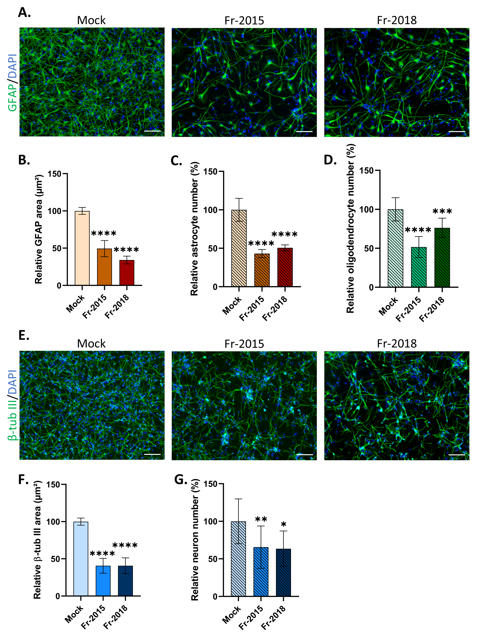
Cell damage induced by WNV_{Fr2015} and WNV_{Fr2018} in hNGC. Human NGC were infected with WNV_{Fr2015} or WNV_{Fr2018} at MOI 10 for 7 days. (A, E) Immunofluorescence labeling using antibodies against GFAP (astrocytes) (A) or βIII-tubulin (neurons) (E) in green. Nuclei were stained with DAPI (blue). Scale bars = 100 µm. (B, F) Automatic quantification of area occupied by astrocytes (B) and neurons (F) (cell bodies and processes), based on immunofluorescence staining using an ImageXpress micro instrument. (C) Automatic enumeration of astrocytes, based on nuclei characteristics, using an OPERA Phenix Plus instrument. (D, G) Automatic enumeration of Olig2-positive (oligodendrocytes) (D) and HuC/D-positive (neurons) (G) cells, using an ImageXpress micro instrument. The results are expressed as the mean ± SD and are representative of three independent experiments performed in 6 replicates (C) or are from a single experiment performed in 6 replicates (WNV_{Fr2018}) or pooled from two independent experiments performed in 6 replicates (WNV_{Fr2015}) (B, D, F, G). Results are normalized relative to mock cells. Statistical analysis was performed using a two-tailed unpaired t test with Graphpad Prism V10.0.0. ***p < 0.001; ****p < 0.0001.

Supplemental table 1. List of cytokines tested in the Proteome Profiler Human Cytokine Array (R&D Sciences) and their coordinates on the blot. Lines are named A to E, from top to bottom of the blot. Dots are numbered 1 to 20, from left to right.
Coordinates | Gene name
A1, A2 | Reference Spots
A3, A4 | CCL1/I-309
A5, A6 | CCL2/MCP-1
A7, A8 | MIP-1α/MIP-1β
A9, A10 | CCL5/RANTES
A11, A12 | CD40 Ligand/TNFSF5
A13, A14 | Complement Component C5/C5a
A15, A16 | CXCL1/GROα
A17, A18 | CXCL10/IP-10
A19, A20 | Reference Spots
B3, B4 | CXCL11/I-TAC
B5, B6 | CXCL12/SDF-1
B7, B8 | G-CSF
B9, B10 | GM-CSF
B11, B12 | ICAM-1/CD54
B13, B14 | IFN-γ
B15, B16 | IL-1α/IL-1F1
B17, B18 | IL-1β/IL-1F2
C3, C4 | IL-1ra/IL-1F3
C5, C6 | IL-2
C7, C8 | IL-4
C9, C10 | IL-5
C11, C12 | IL-6
C13, C14 | IL-8
C15, C16 | IL-10
C17, C18 | IL-12 p70
D3, D4 | IL-13
D5, D6 | IL-16
D7, D8 | IL-17A
D9, D10 | IL-17E
D11, D12 | IL-18/IL-1F4
D13, D14 | IL-21
D15, D16 | IL-27
D17, D18 | IL-32α
E1, E2 | Reference Spots
E3, E4 | MIF
E5, E6 | Serpin E1/PAI-1
E7, E8 | TNF-α
E9, E10 | TREM-1
E19, E20 | Negative Control

Supplemental table 2. Primer pairs used for RT-qPCR analyses.
Gene name | Forward primer | Reverse primer
CXCL10 | GCAGGTACAGCGTACGGTTC | CAGCAGAGGAACCTCCAGTC
GAPDH | CACCATCTTCCAGGAGCGAG | GAGATGATGACCCTTTTGGC
HPRT1 | GGACTAATTATGGACAGGACT | GCTCTTCAGTCTGATAAAATCTAC
IFI6 | TCGCTGATGAGCTGGTCTGC | ATTACCTATGACGACGCTGC
IL-6 | FCCTTCTCCACAAGCGCCTTC | AAGGCAGCAGGCAACACCA
MDA5 | TGCCCATGTTGCTGTTATGT | GTCTGGGGCATGGAGAATAA
OAS2 | TGTTTTCCGTCCATAGGAGC | CTGATCGACGAGATGGTGAA
TNFα | AGATGATCTGACTGCCTGGG | TGCTTGTTCCTCAGCCTCTT
TRAIL | AGCAATGCCACTTTTGGAGT | TTCACAGTGCTCCTGCAGTC
WNV | CCTGTGTGAGCTGACAAACTTAGT | GCGTTTTAGCATATTGACAGCC

