Table S1: Search strategy, original MeSH terms used in this study.

PubMed | SCOPUS | Google Scholar
(“Vitamin D Deficiency” [MeSH]) AND Bangladesh [MeSH] AND Children [MeSH]  (“Vitamin D”[MeSH]) AND Bangladesh[MeSH] AND Children [MeSH]  (“Vitamin D”[MeSH]) AND Bangladesh[MeSH] AND Prevalence [MeSH] AND Children [MeSH] | (INDEXTERMS(“Vitamin D Deficiency”) AND INDEXTERMS(BANGLADESH) AND INDEXTERMS(Children)) OR (TITLE-ABS-KEY(“Vitamin D”) AND TITLE-ABS-KEY(BANGLADESH) AND TITLE-ABS-KEY(Children)) OR INDEXTERMS(prevalence)) AND (TITLE-ABS-KEY(“Vitamin D”) AND TITLE-ABS-KEY(BANGLADESH) AND TITLE-ABS-KEY(Children)) | ((“Vitamin D”) OR (“Vitamin D3”)) AND ((prevalence) OR (deficiency)) AND (Bangladesh) AND Children
(“Vitamin D Deficiency”[MeSH]) AND Bangladesh[MeSH] AND Neonates [MeSH]  (“Vitamin D”[MeSH]) AND Bangladesh[MeSH] AND Prevalence [MeSH] AND Children [MeSH]  (“Vitamin D”[MeSH]) AND Bangladesh[MeSH] AND Neonates [MeSH] | (INDEXTERMS(“Vitamin D Deficiency”) AND INDEXTERMS(BANGLADESH) AND INDEXTERMS(Neonates)) OR (TITLE-ABS-KEY(“Vitamin D”) AND TITLE-ABS-KEY(BANGLADESH) AND TITLE-ABS-KEY(Neonates)) OR INDEXTERMS(prevalence)) AND (TITLE-ABS-KEY(“Vitamin D”) AND TITLE-ABS-KEY(BANGLADESH) AND TITLE-ABS-KEY(Neonates)) | ((“Vitamin D”) OR (“Vitamin D3”)) AND ((prevalence) OR (deficiency)) AND (Bangladesh) AND Newborn
(“Vitamin D”[MeSH]) AND Bangladesh[MeSH] AND Prevalence [MeSH] AND Neonates [MeSH]  (“Vitamin D Deficiency”[MeSH]) AND Bangladesh[MeSH] AND Infants[MeSH]  (“Vitamin D”[MeSH]) AND Bangladesh[MeSH] AND Infants [MeSH]  (“Vitamin D”[MeSH]) AND Bangladesh[MeSH] AND Prevalence [MeSH] AND Newborn [MeSH] | (INDEXTERMS(“Vitamin D Deficiency”) AND INDEXTERMS(BANGLADESH) AND INDEXTERMS(Infants)) OR (TITLE-ABS-KEY(“Vitamin D”) AND TITLE-ABS-KEY(BANGLADESH) AND TITLE-ABS-KEY(Infants)) OR INDEXTERMS(prevalence)) AND (TITLE-ABS-KEY(“Vitamin D”) AND TITLE-ABS-KEY(BANGLADESH) AND TITLE-ABS-KEY(Infants)) | ((“Vitamin D”) OR (“Vitamin D3”)) AND ((prevalence) OR (deficiency)) AND (Bangladesh) AND Neonates
(“Vitamin D Deficiency”[MeSH]) AND Bangladesh[MeSH] AND Newborn [MeSH] (“Vitamin D”[MeSH]) AND Bangladesh[MeSH] AND Newborn [MeSH] | (INDEXTERMS (“Vitamin D Deficiency”) AND INDEXTERMS(BANGLADESH) AND INDEXTERMS(Pediatrics)) OR (TITLE-ABS-KEY (“Vitamin D”) AND TITLE-ABS- KEY(BANGLADESH) AND | ((“Vitamin D”) OR (“Vitamin D3”)) AND ((prevalence) OR (deficiency)) AND (Bangladesh) AND Infants
PubMed | SCOPUS | Google Scholar
(“Vitamin D”[MeSH]) AND Bangladesh[MeSH] AND Prevalence [MeSH] AND Pediatrics [MeSH]  (“Vitamin D”[MeSH]) AND Bangladesh[MeSH] AND Prevalence [MeSH] AND Adolescents [MeSH] | (INDEXTERMS (“Vitamin D Deficiency”) AND INDEXTERMS(BANGLADESH) AND INDEXTERMS(Pediatrics)) OR (TITLE-ABS-KEY (“Vitamin D”) AND TITLE-ABS-KEY(BANGLADESH) AND TITLE-ABS-KEY(Pediatrics)) OR INDEXTERMS (prevalence)) AND (TITLE-ABS-KEY (“Vitamin D”) AND TITLE-ABS-KEY(BANGLADESH) AND TITLE-ABS-KEY(Pediatrics)) | ((“Vitamin D”) OR (“Vitamin D3”)) AND ((prevalence) OR (deficiency)) AND (Bangladesh) AND Pediatrics
(“Vitamin D Deficiency”[MeSH]) AND Bangladesh[MeSH] AND Adolescents [MeSH]  (“Vitamin D”[MeSH]) AND Bangladesh[MeSH] AND Adolescents [MeSH] | (INDEXTERMS(“Vitamin D Deficiency”) AND INDEXTERMS(BANGLADESH) AND INDEXTERMS(Newborn)) OR (TITLE-ABS-KEY(“Vitamin D”) AND TITLE-ABS-KEY(BANGLADESH) AND TITLE-ABS-KEY(Newborn)) OR INDEXTERMS(prevalence)) AND (TITLE-ABS-KEY(“Vitamin D”) AND TITLE-ABS-KEY(BANGLADESH) AND TITLE-ABS-KEY(Newborn)) | ((“Vitamin D”) OR (“Vitamin D3”)) AND ((prevalence) OR (deficiency)) AND (Bangladesh) AND Adolescents
 | (INDEXTERMS(“Vitamin D Deficiency”) AND INDEXTERMS(BANGLADESH) AND INDEXTERMS(Adolescents)) OR (TITLE-ABS-KEY(“Vitamin D”) AND TITLE-ABS-KEY(BANGLADESH) AND TITLE-ABS-KEY(Adolescents)) OR INDEXTERMS(prevalence)) AND (TITLE-ABS-KEY(“Vitamin D”) AND TITLE-ABS-KEY(BANGLADESH) AND TITLE-ABS-KEY(Adolescents))

By replacing the country name (e.g., India, Pakistan Sri Lanka etc.) same types of search terms were used for seven other South Asian countries to complete the search procedures.
Table S2: Quality assessment of selected studies (Q1, Q2, Q3……Q10 denotes ten parameters described by Hoy et al for-quality assessment)
Authors | Q1 | Q2 | Q3 | Q4 | Q5 | Q6 | Q7 | Q8 | Q9 | Q10 | Total score | Quality
Marwaha et al (26) | 0 | 0 | 0 | 0 | 0 | 0 | 0 | 0 | 1 | 0 | 1 | Low
Sahu et al (27) | 1 | 0 | 0 | 0 | 0 | 1 | 0 | 0 | 0 | 0 | 2 | Low
Mandlik et al(28) | 1 | 0 | 0 | 0 | 0 | 0 | 0 | 0 | 1 | 0 | 2 | Low
Kapil et al (29) | 0 | 0 | 0 | 0 | 0 | 0 | 0 | 0 | 1 | 0 | 1 | Low
Basu et al (30) | 1 | 1 | 1 | 0 | 0 | 0 | 0 | 0 | 0 | 0 | 3 | Low
Puri et al (31) | 0 | 0 | 0 | 0 | 0 | 0 | 0 | 0 | 1 | 0 | 1 | Low
Kadam et al (32) | 1 | 1 | 0 | 0 | 0 | 0 | 0 | 0 | 1 | 0 | 3 | Low
Khadgawat et al (33) | 1 | 1 | 1 | 0 | 0 | 0 | 0 | 0 | 1 | 0 | 4 | Moderate
Chaudhuri et al(34) | 1 | 1 | 1 | 0 | 0 | 0 | 0 | 0 | 1 | 0 | 4 | Moderate
Sharawat et al(35) | 1 | 0 | 0 | 0 | 0 | 0 | 0 | 0 | 1 | 0 | 2 | Low
Marwaha et al(36) | 1 | 1 | 1 | 0 | 0 | 0 | 0 | 0 | 1 | 0 | 4 | Moderate
Sarma et al(37) | 1 | 1 | 0 | 0 | 0 | 0 | 0 | 0 | 1 | 0 | 3 | Low
Sanwalka et al(38) | 0 | 0 | 0 | 0 | 0 | 0 | 0 | 0 | 1 | 0 | 1 | Low
Mandlik et al(39) | 1 | 0 | 0 | 0 | 0 | 0 | 0 | 0 | 1 | 0 | 2 | Low
Borker et al(40) | 1 | 1 | 1 | 0 | 0 | 0 | 0 | 0 | 1 | 0 | 4 | Moderate
Garg et al(41) | 1 | 1 | 1 | 0 | 0 | 0 | 0 | 0 | 1 | 0 | 4 | Moderate
Khadilkar et al (42) | 1 | 0 | 0 | 0 | 0 | 0 | 0 | 0 | 1 | 0 | 2 | Low
Patel et al(43) | 0 | 0 | 0 | 0 | 0 | 0 | 0 | 0 | 1 | 0 | 1 | Low
Marwaha et al(44) | 0 | 0 | 0 | 0 | 0 | 0 | 0 | 0 | 1 | 0 | 1 | Low
Prasad et al(45) | 1 | 1 | 1 | 0 | 0 | 0 | 0 | 0 | 1 | 1 | 5 | Moderate
Agarwal et al(46) | 1 | 1 | 1 | 0 | 0 | 0 | 0 | 0 | 0 | 0 | 3 | Low
Wayse et al(47) | 1 | 1 | 1 | 0 | 0 | 0 | 0 | 0 | 0 | 0 | 3 | Low
Filteau et al (48) | 0 | 1 | 1 | 0 | 0 | 0 | 1 | 0 | 1 | 1 | 5 | Moderate
Taru et al (49) | 1 | 1 | 1 | 0 | 0 | 0 | 0 | 0 | 1 | 0 | 4 | Moderate
Sreedharan et al (50) | 1 | 1 | 1 | 0 | 0 | 0 | 0 | 0 | 1 | 1 | 5 | Moderate
Agarwal et al (51) | 1 | 1 | 1 | 0 | 0 | 0 | 0 | 0 | 1 | 0 | 4 | Moderate
Mathur et al (52) | 1 | 0 | 0 | 0 | 0 | 0 | 0 | 0 | 0 | 0 | 1 | Low
Kumar et al (53) | 1 | 0 | 0 | 0 | 0 | 0 | 0 | 0 | 0 | 0 | 1 | Low
Marwaha et al(54) | 1 | 1 | 1 | 0 | 0 | 0 | 1 | 0 | 1 | 1 | 6 | Moderate
Agrawal et al(55) | 1 | 1 | 1 | 0 | 0 | 0 | 0 | 0 | 1 | 1 | 5 | Moderate
Shukla et al(56) | 0 | 1 | 1 | 0 | 0 | 0 | 1 | 0 | 0 | 0 | 3 | Low
Schulze et al (57) | 0 | 0 | 0 | 0 | 0 | 0 | 0 | 0 | 1 | 0 | 1 | Low
Haugen et al(58) | 0 | 0 | 0 | 0 | 0 | 0 | 0 | 0 | 1 | 1 | 2 | Low
Avagyan et al(59) | 1 | 0 | 0 | 0 | 0 | 0 | 0 | 0 | 1 | 0 | 2 | Low
Marasinghe et al(60) | 0 | 0 | 0 | 0 | 0 | 0 | 0 | 0 | 1 | 0 | 1 | Low
Hettiarachchi et al(61) | 0 | 0 | 0 | 0 | 0 | 0 | 0 | 0 | 1 | 1 | 2 | Low
Hettiarachchi et al(62) | 1 | 1 | 0 | 0 | 0 | 0 | 0 | 0 | 1 | 1 | 4 | Moderate
Anwar et al(63) | 1 | 1 | 1 | 0 | 0 | 0 | 0 | 0 | 1 | 0 | 4 | Moderate
Karim et al (64) | 0 | 0 | 0 | 0 | 0 | 0 | 0 | 0 | 1 | 0 | 1 | Low
Ahmed et al(65) | 1 | 0 | 0 | 0 | 0 | 0 | 0 | 0 | 0 | 0 | 1 | Low
Holland et al(66) | 0 | 0 | 0 | 0 | 0 | 0 | 0 | 0 | 1 | 1 | 2 | Low

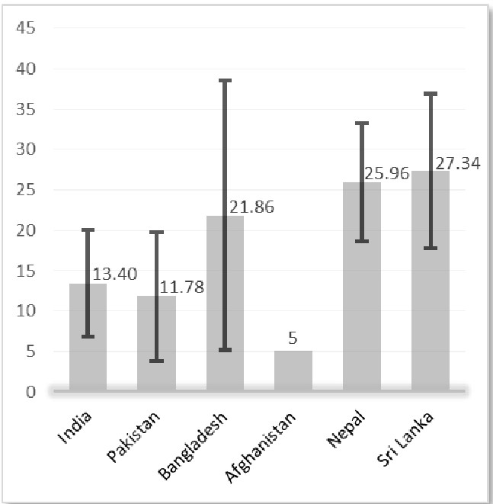
Figure S1: Weighted mean level of serum vitamin D (ng/mL) among South Asian children (on the Y-axis). X-axis represent the name of the South Asian countries. Error bars represent the weighted standard deviations.

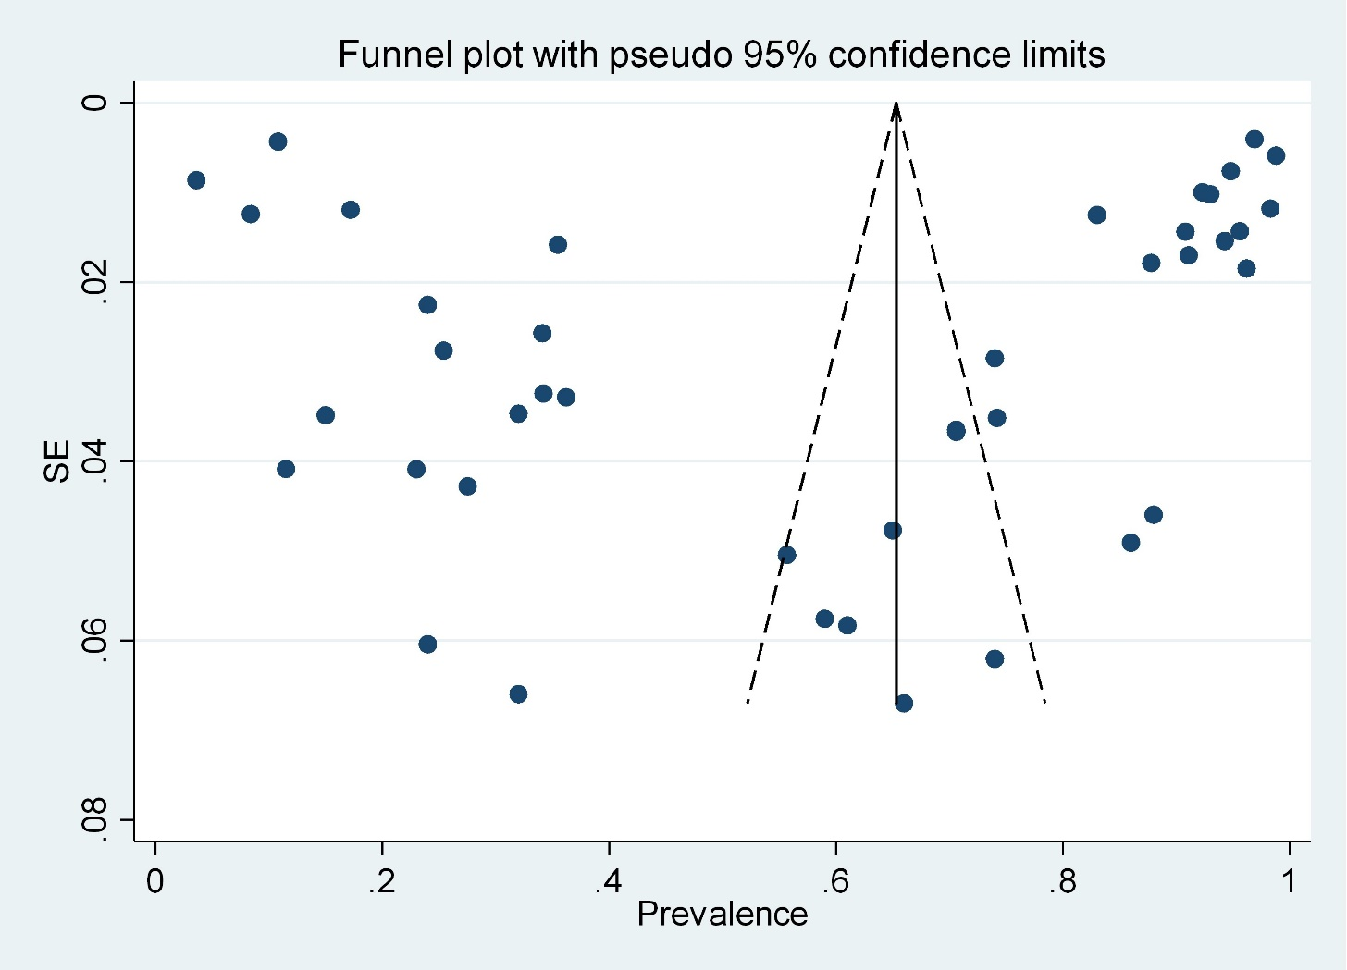

Figure S2: Funnel plot for the publication bias of the selected studies.
Each dot of the funnel plot represents a single study. Y-axis represent the standard error of the effect estimates, and the X-axis shows the result (prevalence) for individual study.

