Supplementary Information

Salt-Free Glycine Electrosynthesis via C−N Coupling Boosted by the Lattice Strain in Atomically Thin p-Block Bismuthene
Minghong Huang, ^{[a, b]} Sheng-Hua Zhou, ^{[c]} Cheng-Jie Yang, ^{[d]} Chung-Li Dong, ^{[d]} Lei Jiao, ^{[e]} Dong-Dong Ma, ^{[b]} Qi-Long Zhu *^{[b]} and Zhenguo Huang *^{[a]}
[a] Dr. M. Huang and Prof. Dr. Z. Huang
School of Civil and Environmental Engineering, University of Technology Sydney, Ultimo, New South Wales 2007, Australia
E-mail: zhenguo.huang@uts.edu.au
[b] Dr. M. Huang, Dr. D. Ma and Prof. Dr. Q. Zhu
State Key Laboratory of Structural Chemistry, Fujian Institute of Research on the Structure of Matter, Chinese Academy of Sciences (CAS), Fuzhou 350002, China
E-mail: qlzhu@fjirsm.ac.cn
[c] Dr. S. Zhou
School of Chemistry and Chemical Engineering, Jiangsu University of Technology, Changzhou 213001, China
[d] C. Yang and Dr. C. Dong
Department of Physics, Tamkang University, Tamsui 25137, Taiwan
[e] L. Jiao
State Key Laboratory of Physical Chemistry of Solid Surfaces, College of Chemistry and Chemical Engineering, Xiamen University, Xiamen 361005, China

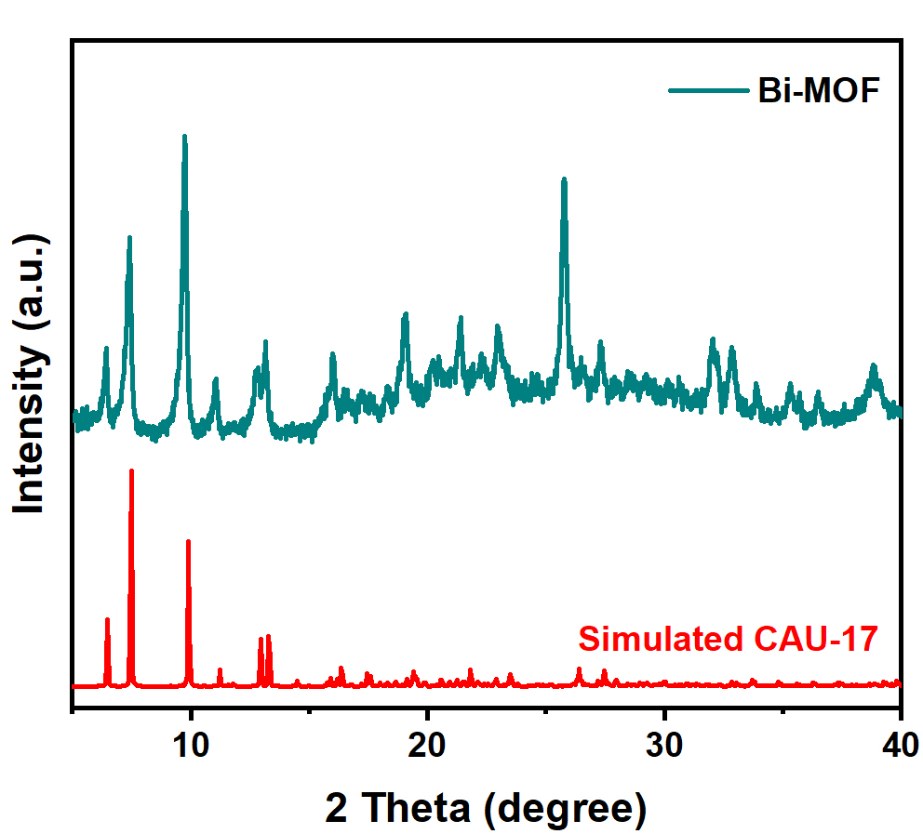
Supplementary Fig. S1. XRD pattern of the as-prepared Bi-CAU-17.

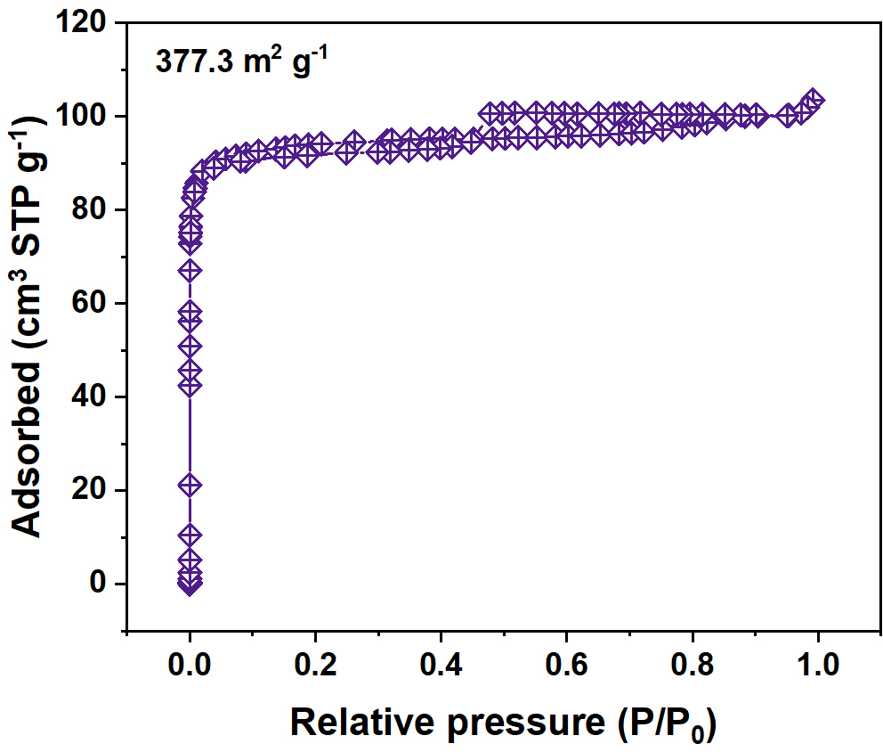
Supplementary Fig. S2. N₂ sorption isotherm of Bi-CAU-17.
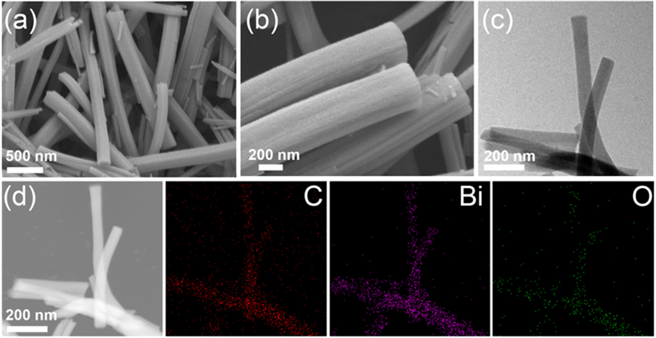
Supplementary Fig. S3. (a-b) SEM, (c) TEM and (d) EDX elemental mapping images of Bi-CAU-17.

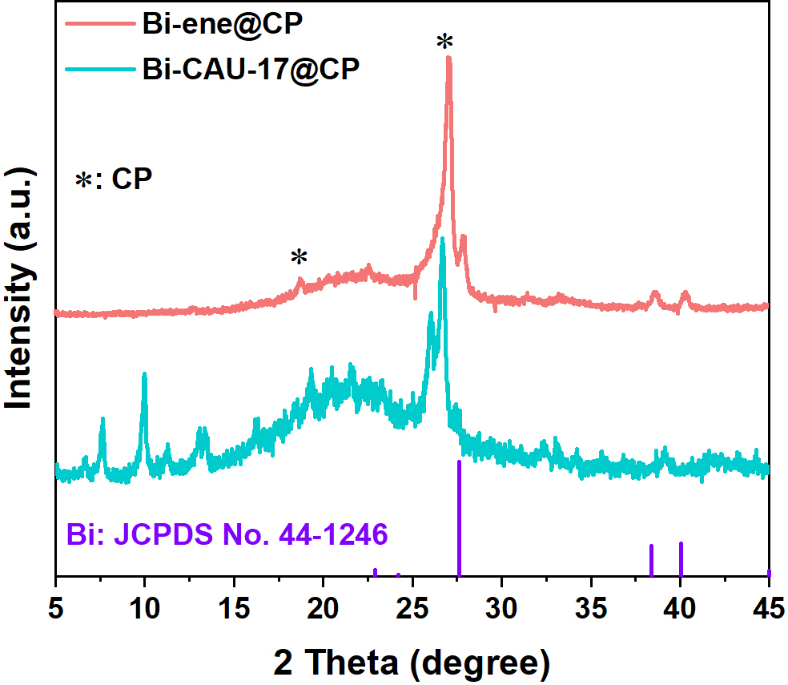
Supplementary Fig. S4. XRD patterns of Bi-CAU-17 and Bi-ene on carbon paper (CP).

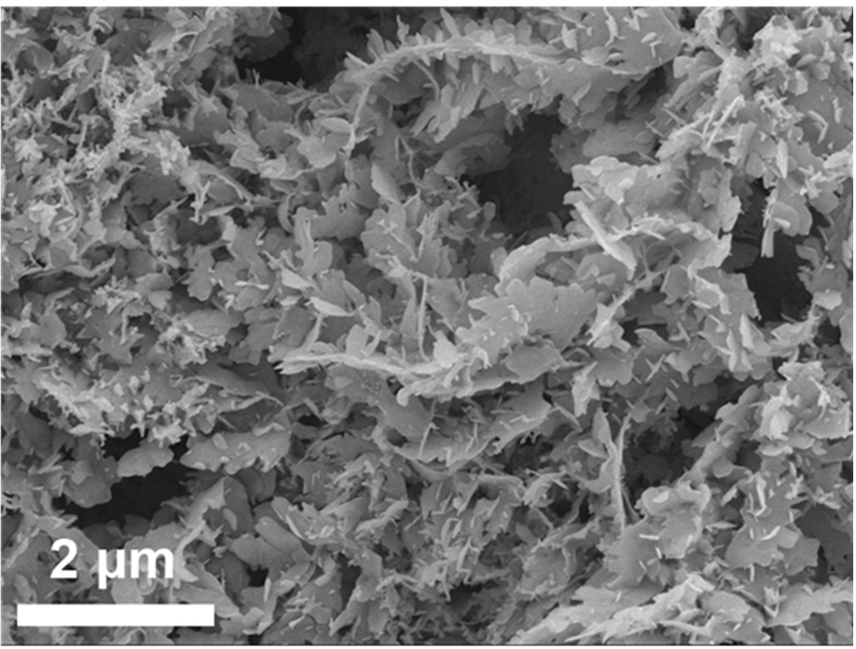
Supplementary Fig. S5. SEM image of Bi-ene obtained via electrochemical reduction of Bi-CAU-17.

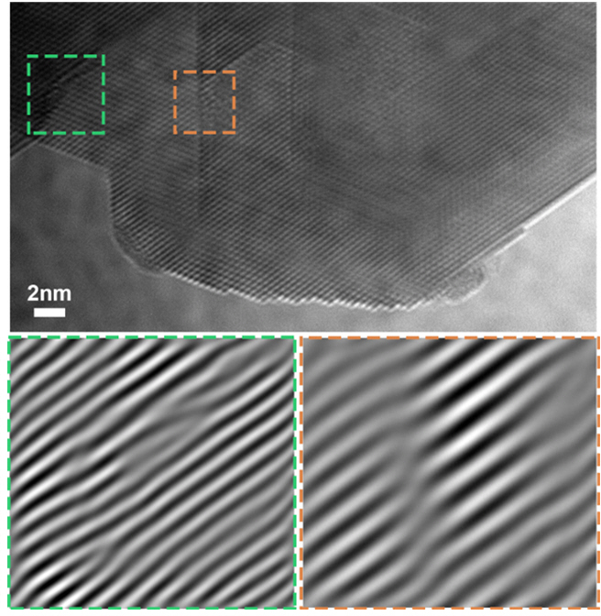
Supplementary Fig. S6. HR-TEM image of Bi-ene and the inverse FFT pattern generated from the green and orange dashed squares.

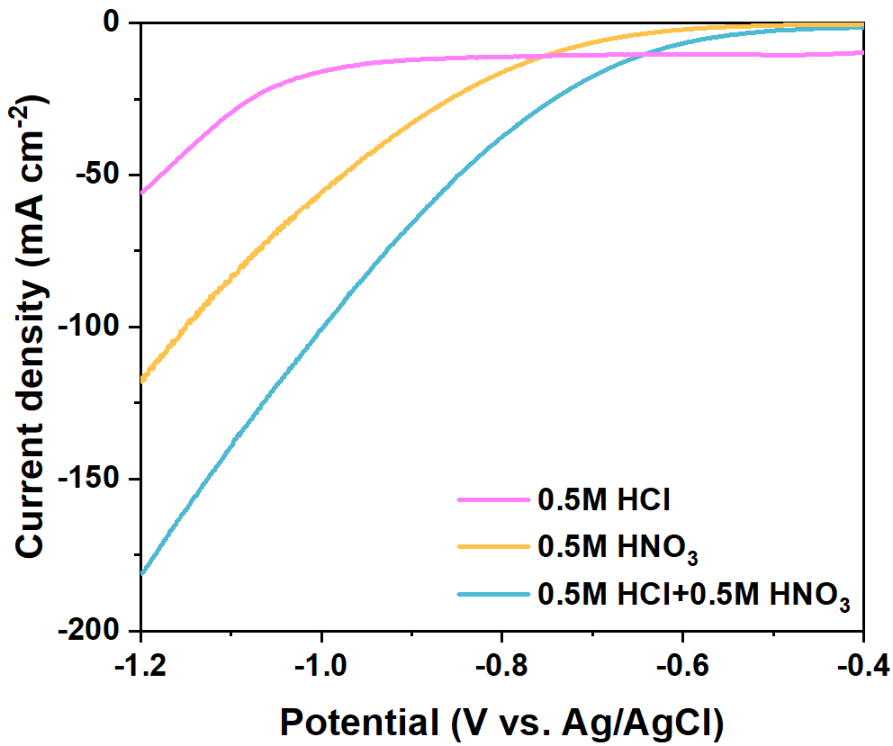
Supplementary Fig. S7. LSV curves for NtrRR in different electrolytes over the Bi-ene catalyst, with a scan rate of 10 mV s⁻¹.
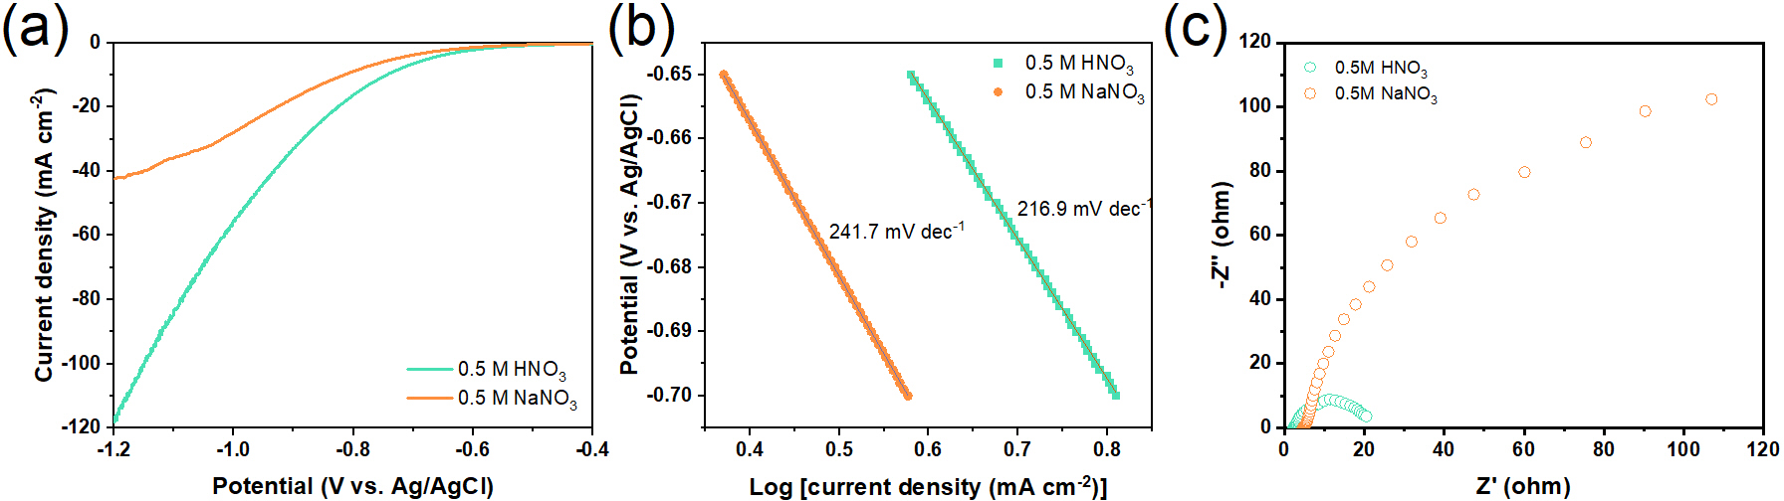
Supplementary Fig. S8. (a) LSV curves, (b) Tafel curves and (c) Nyquist plots for NtrRR over Bi-ene in 0.5 M HNO₃ and 0.5 M NaNO₃.

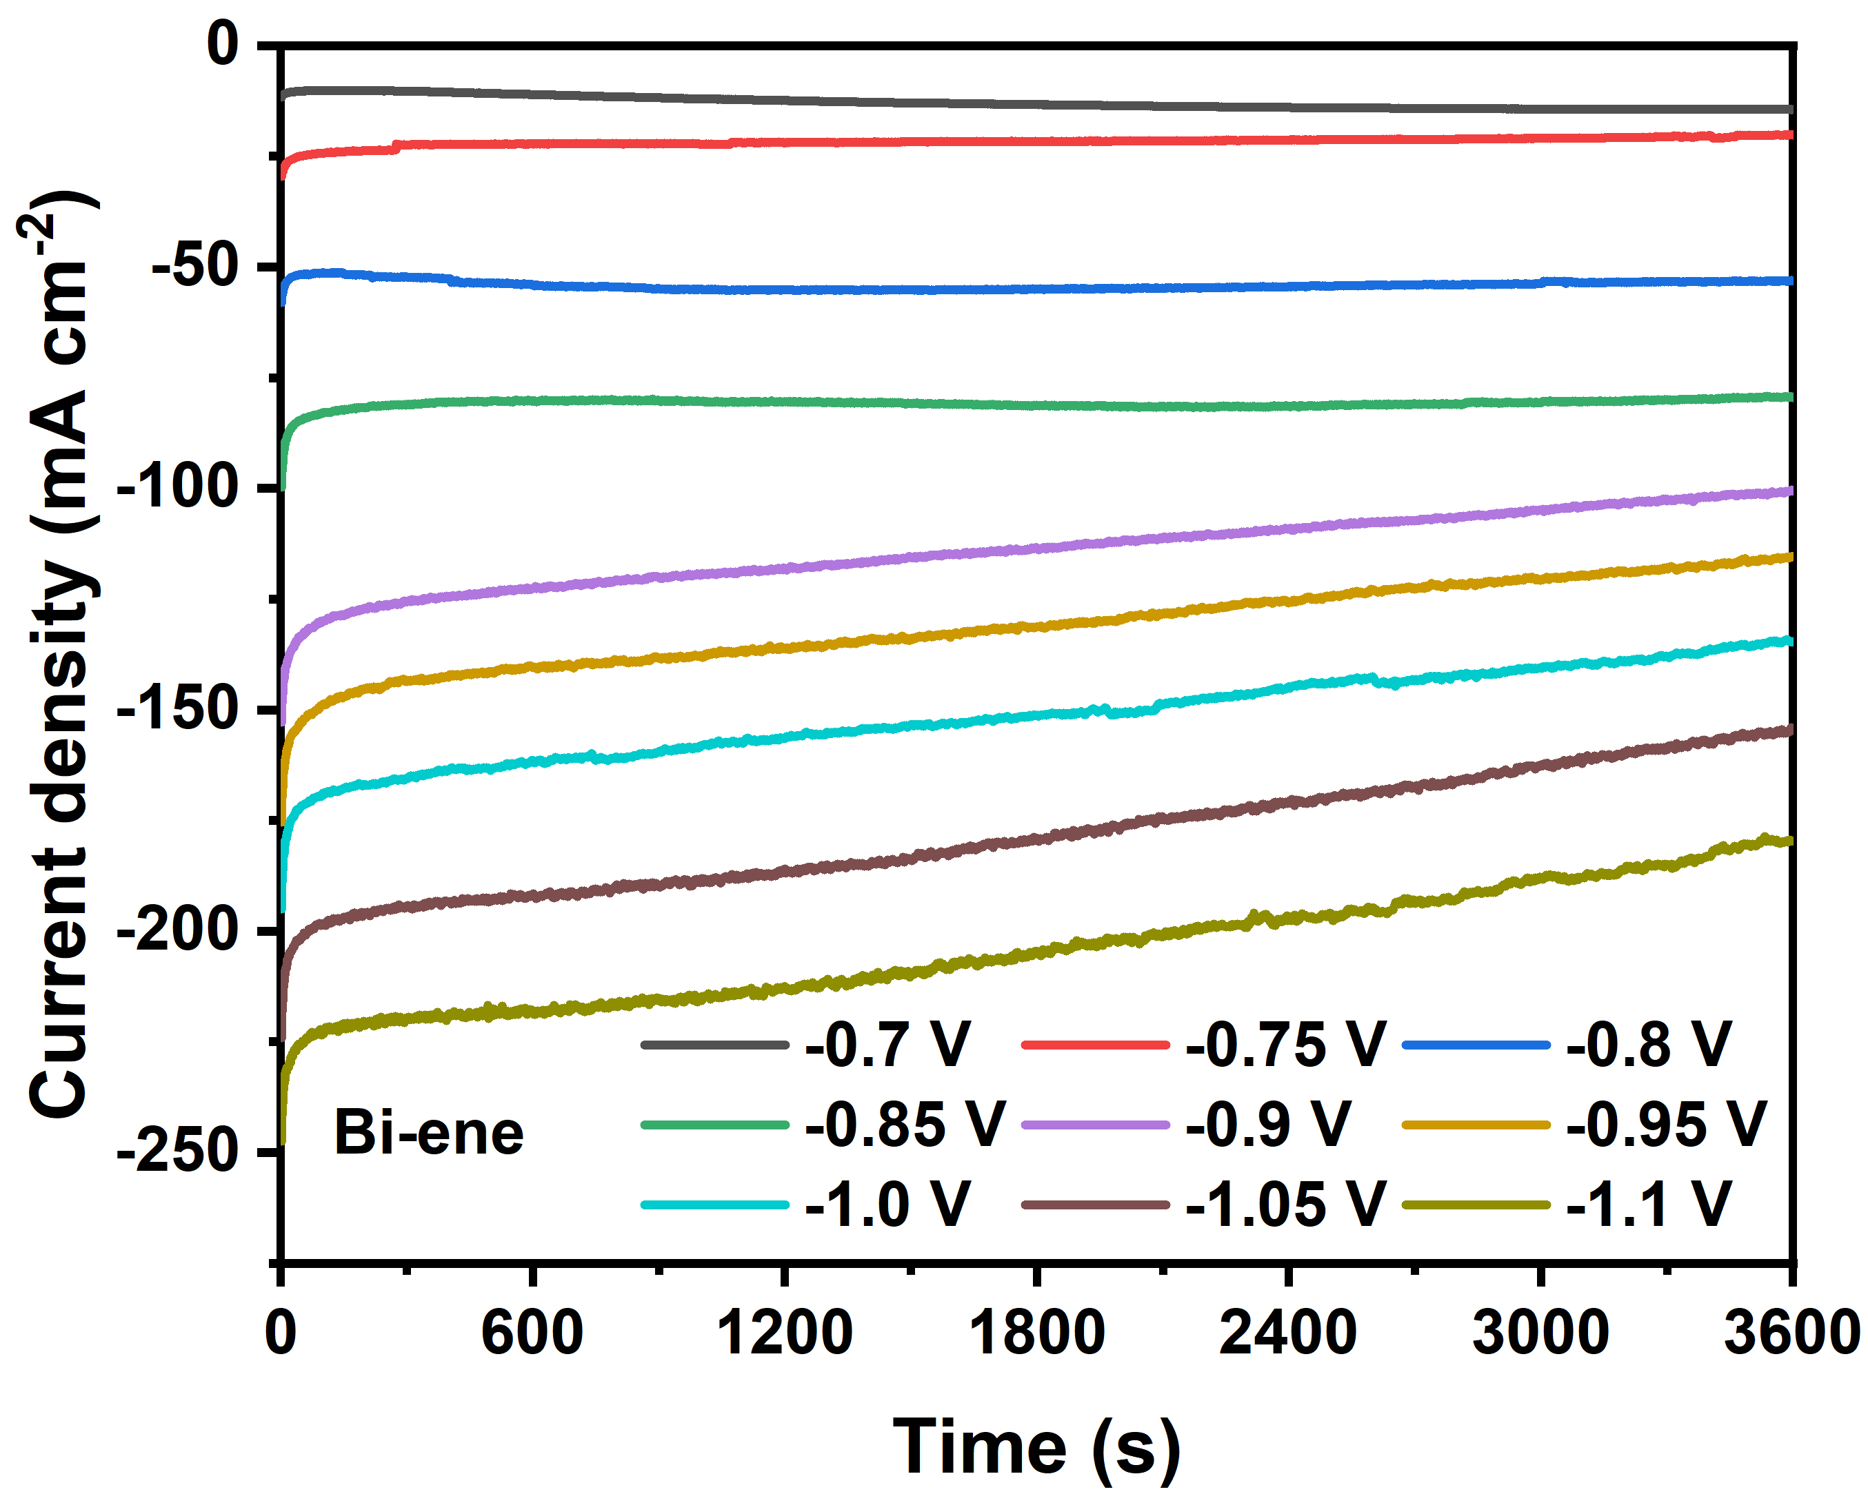
Supplementary Fig. S9. I-t curves for NtrRR over the Bi-ene catalyst in 0.5 M HCl + 0.5 M HNO₃.

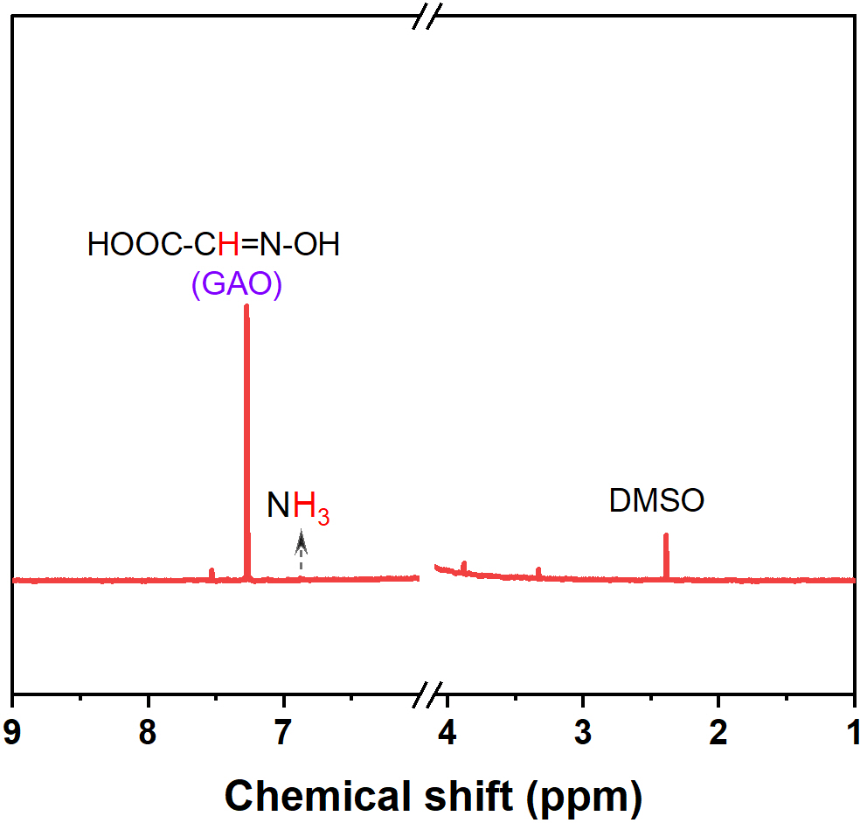
Supplementary Fig. S10. ¹H HMR spectrum of the electrolyte after the 1 h continuous NtrRR with the addition of GX. The liquid product NH₂OH was quantified by reacting it with excess amount of GX through oximation.

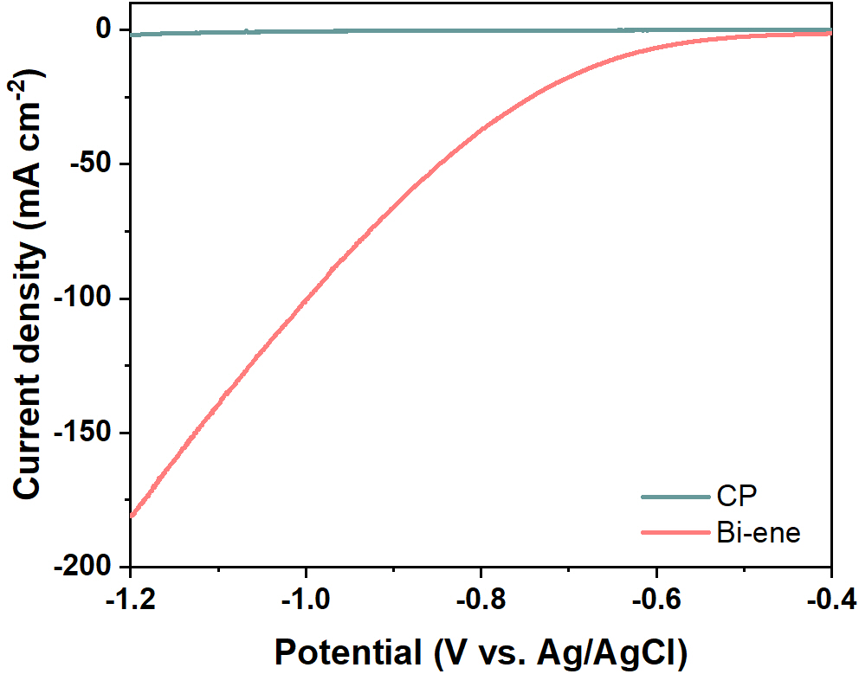
Supplementary Fig. S11. LSV curves for NtrRR over carbon paper (CP) and Bi-ene catalyst in 0.5 M HCl +0.5 M HNO₃.

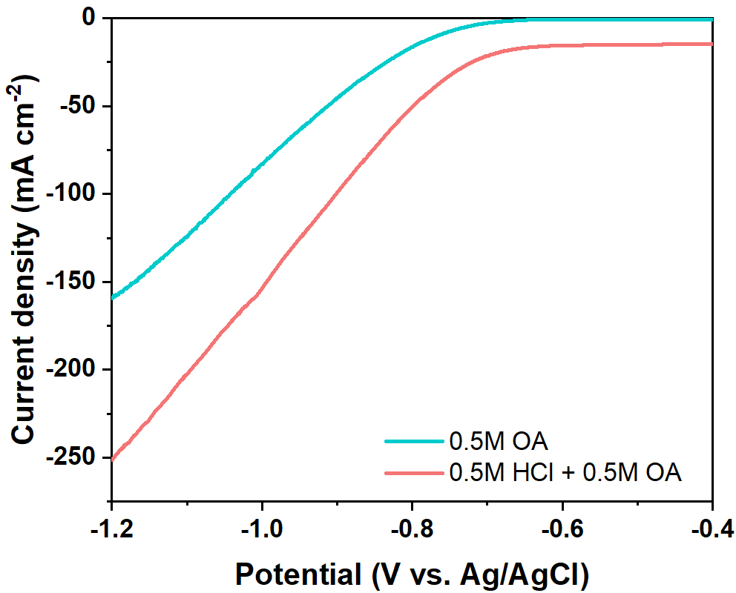
Supplementary Fig. S12. LSV curves for OARR in different electrolytes over Bi-ene catalyst.

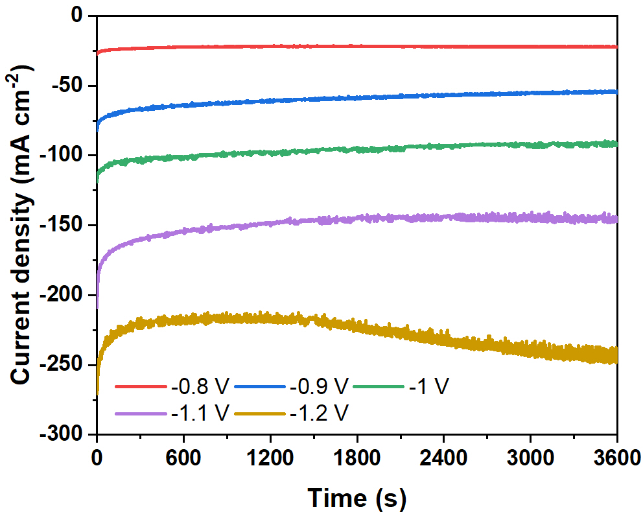
Supplementary Fig. S13. I-t curves for OARR over Bi-ene catalyst in 0.5 M HCl +0.5 M OA.

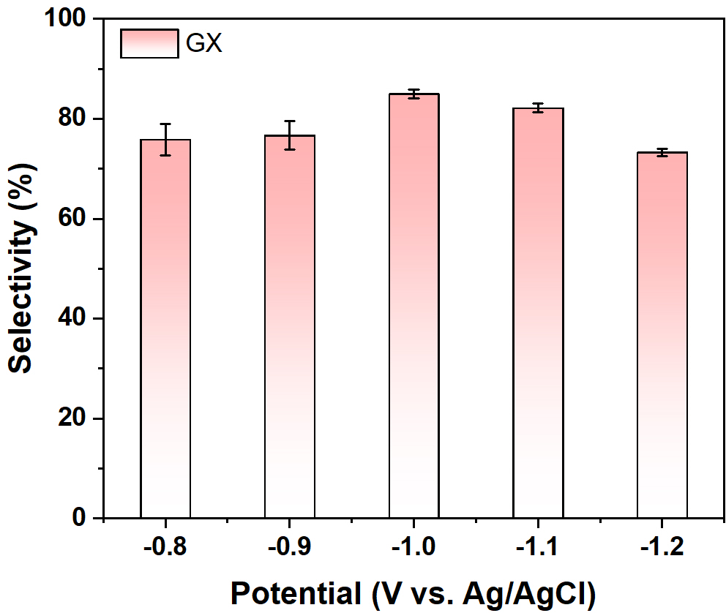
Supplementary Fig. S14. The selectivity for GX at different potentials over Bi-ene catalyst.

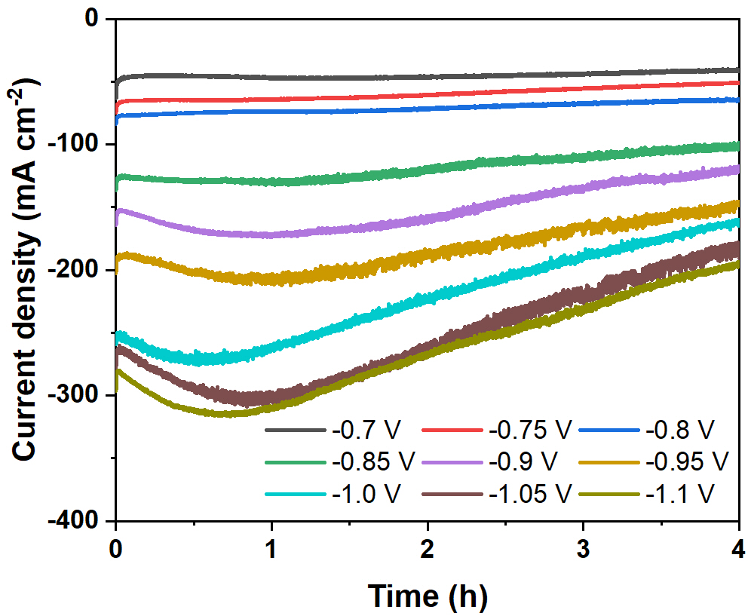
Supplementary Fig. S15. I-t curves for the co-reduction of OA and HNO₃ over Bi-ene catalyst in 0.5 M HCl + 0.5 M HNO₃ + 0.5 M OA.

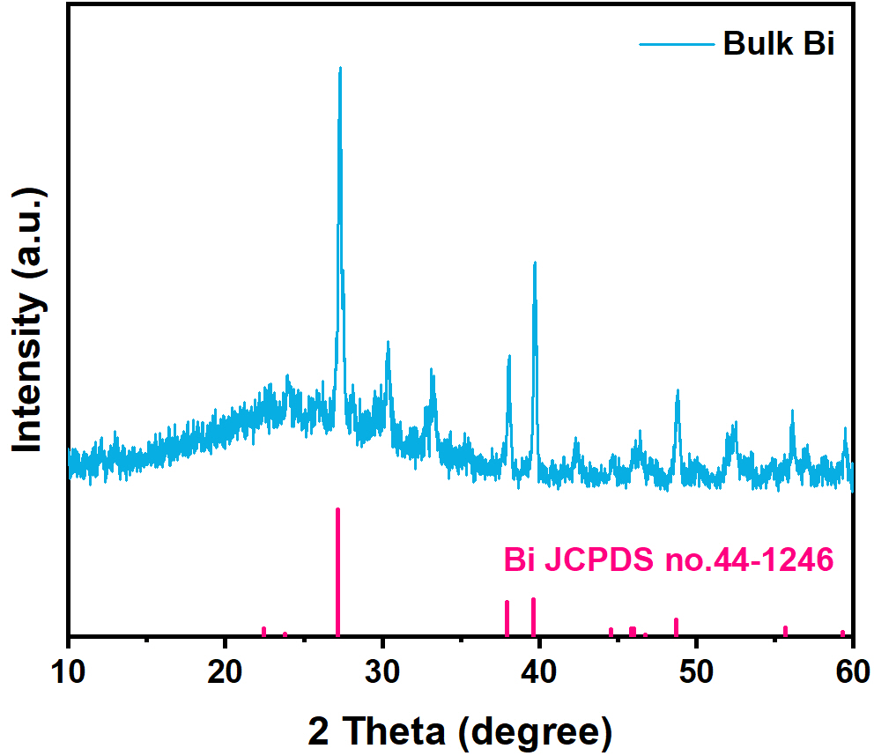
Supplementary Fig. S16. XRD pattern of bulk-Bi.

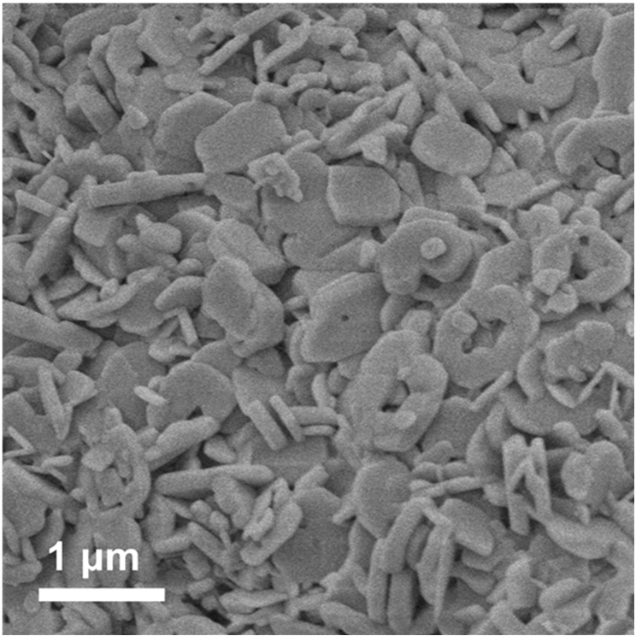
Supplementary Fig. S17. SEM image of bulk-Bi with microparticle morphology.

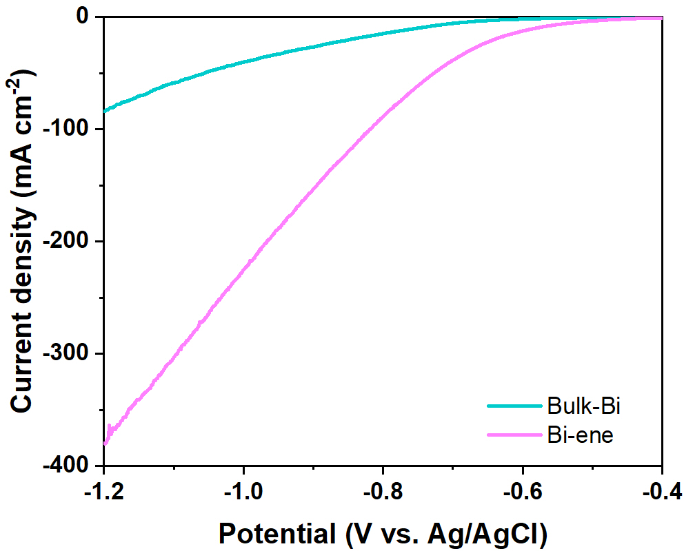
Supplementary Fig. S18. Comparison of LSV curves between Bi-ene and bulk-Bi in 0.5 M HCl + 0.5 M HNO₃ + 0.5 M OA.

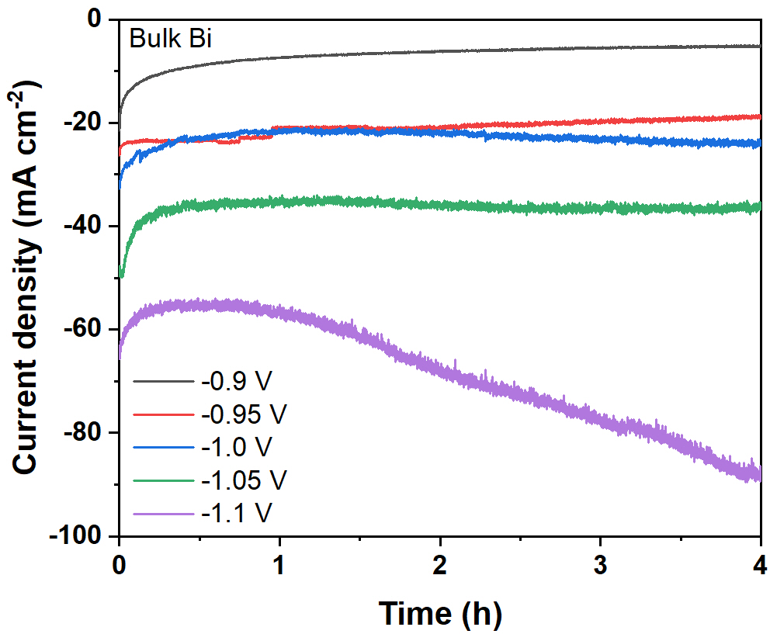
Supplementary Fig. S19. I-t curves for co-reduction of OA and HNO₃ over bulk-Bi catalyst in 0.5 M HCl + 0.5 M HNO₃ + 0.5 M OA.
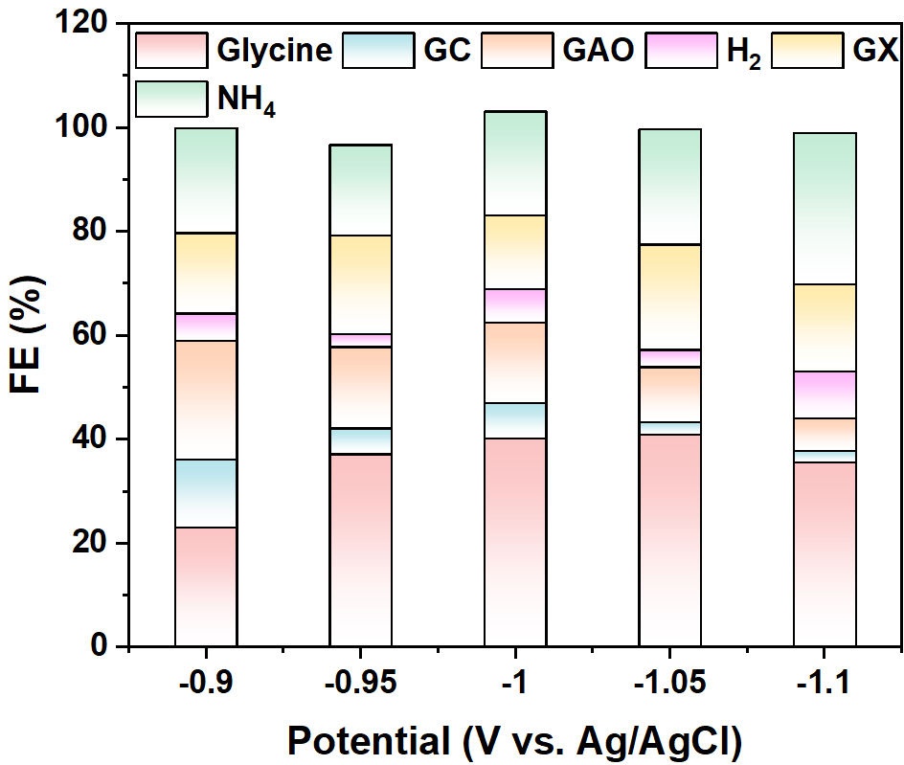
Supplementary Fig. S20. FEs of different products over bulk-Bi at different potentials in 0.5 M HCl + 0.5 M HNO₃ + 0.5 M OA.

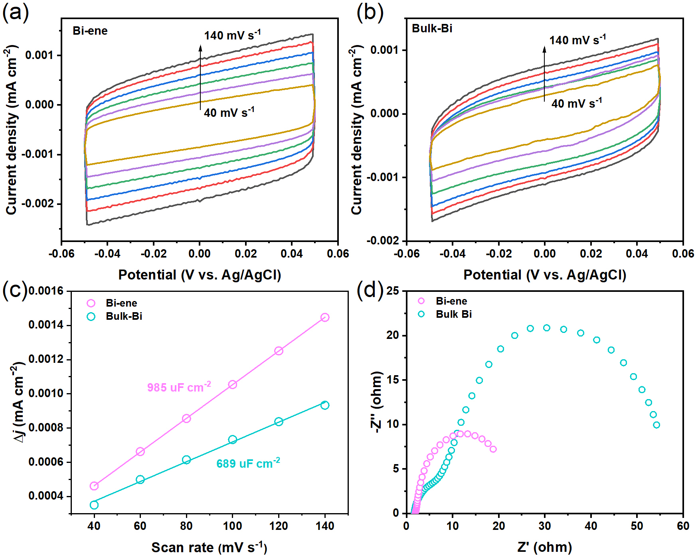
Supplementary Fig. S21. ECSA measurements for Bi-ene and bulk-Bi. (a, b) CV curves at different scan rates, (c) capacitive ▽j=(j_{a}-j_{c}) against scan rates, (d) electrochemical impedance plots for Bi-ene and bulk-Bi.
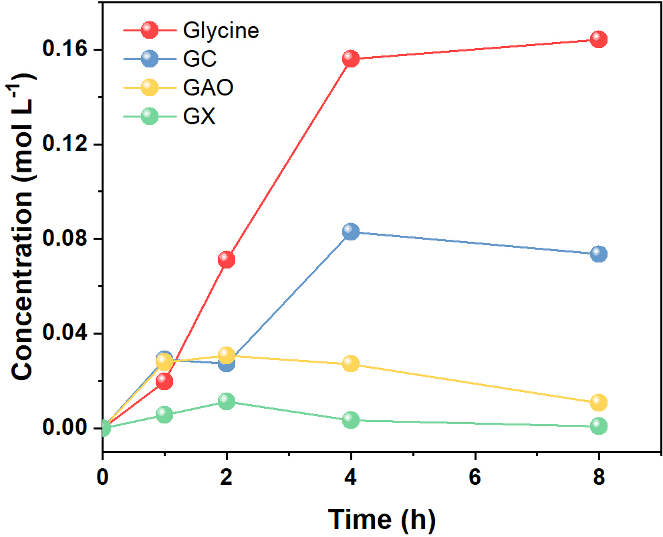
Supplementary Fig. S22. Time-dependence of concentration of diﬀerent products at the potential of −0.95 V in 0.5 M HCl + 0.5 M HNO₃ + 0.5 M OA.

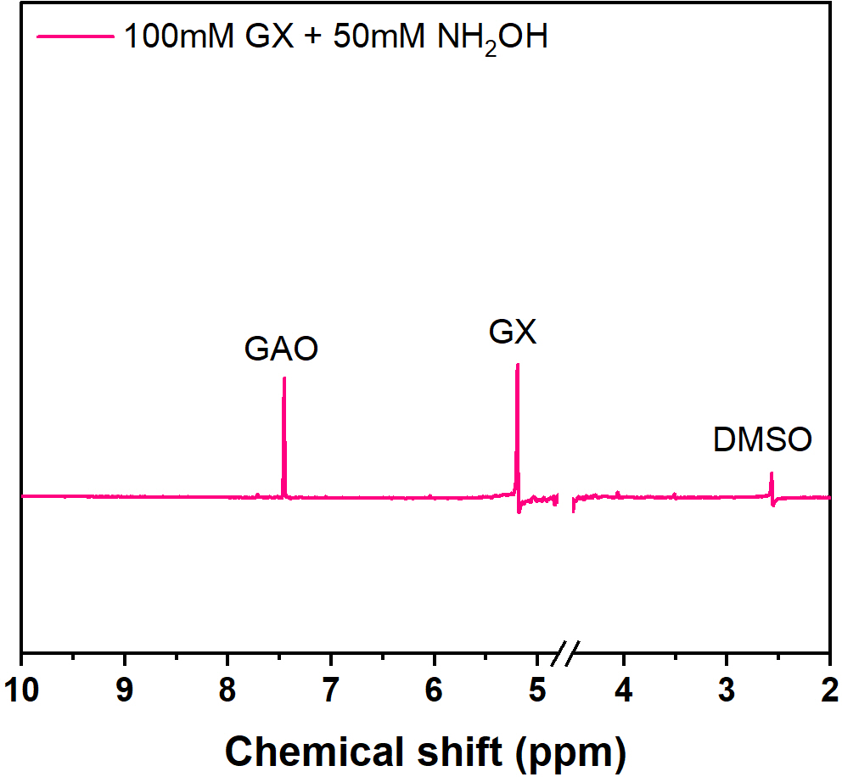
Supplementary Fig. S23. ¹H NMR spectrum after mixing 100 mM of GX with 50 mM of NH₂OH.
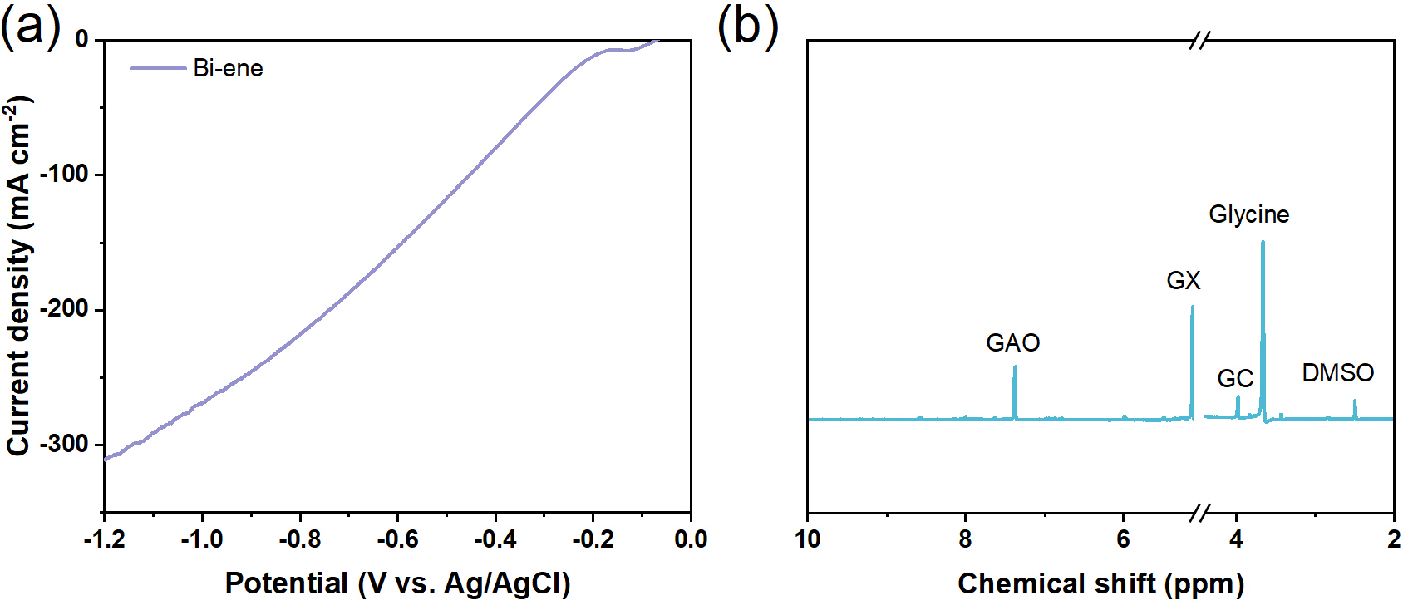
Supplementary Fig. S24. (a) LSV curve and (b) ¹H NMR spectrum of electrolyte by using Bi-ene electrode after 4 h electrolysis in 0.5 M GX + 0.5 M NH₂OH·HCl.

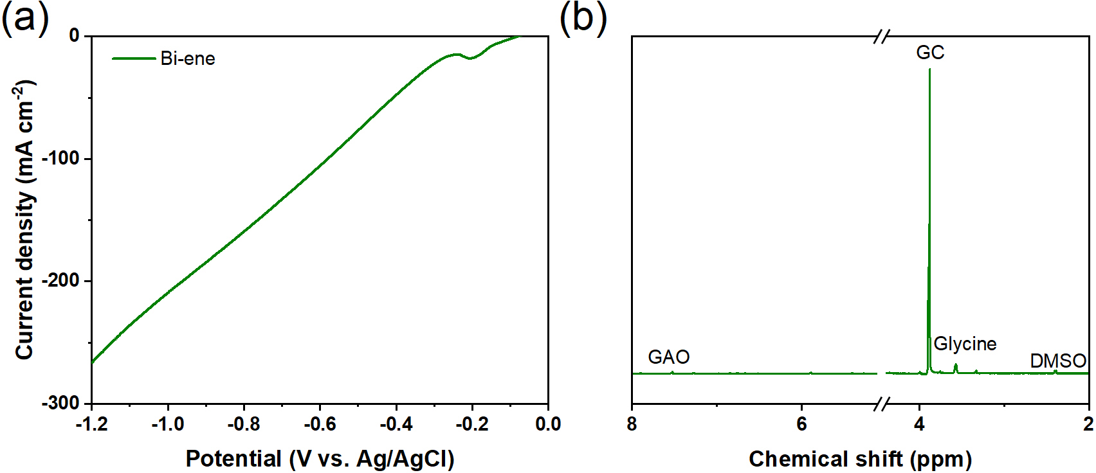
Supplementary Fig. S25. (a) LSV curve and (b) ¹H NMR spectrum of electrolyte by using Bi-ene electrode after 4 h electrolysis in 0.5 M HCl + 0.5 M HNO₃ + 0.5 M GX.

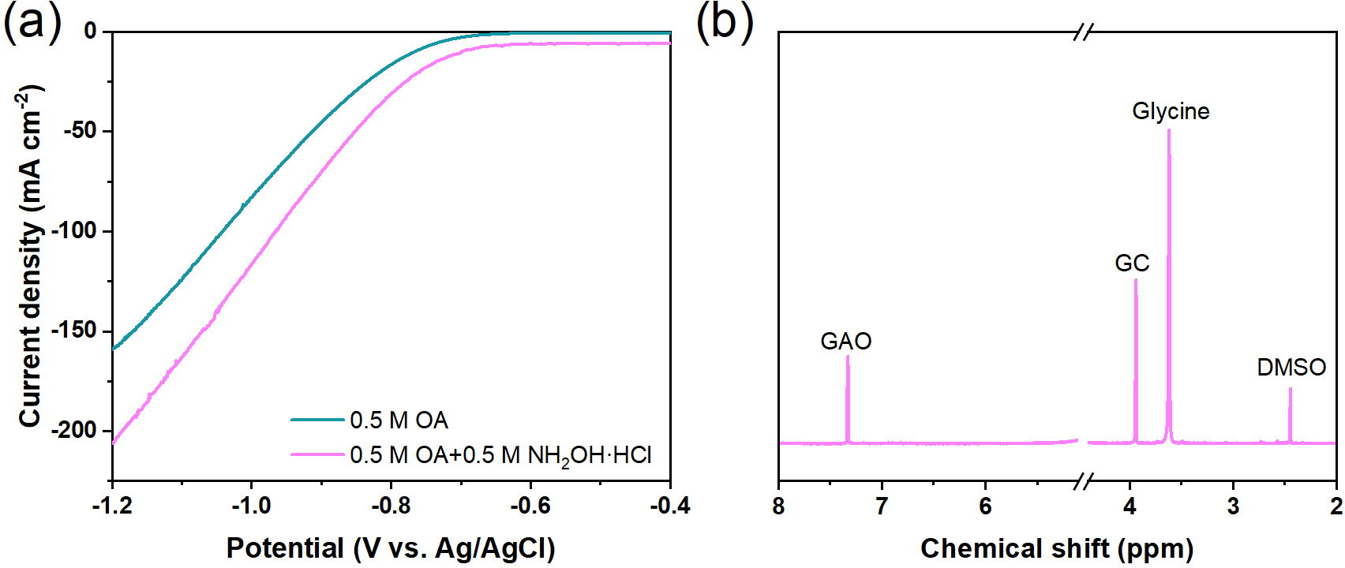
Supplementary Fig. S26. (a) LSV curve and (b) ¹H NMR spectrum of electrolyte by using Bi-ene electrode after 4 h electrolysis in 0.5 M OA + 0.5 M NH₂OH·HCl.

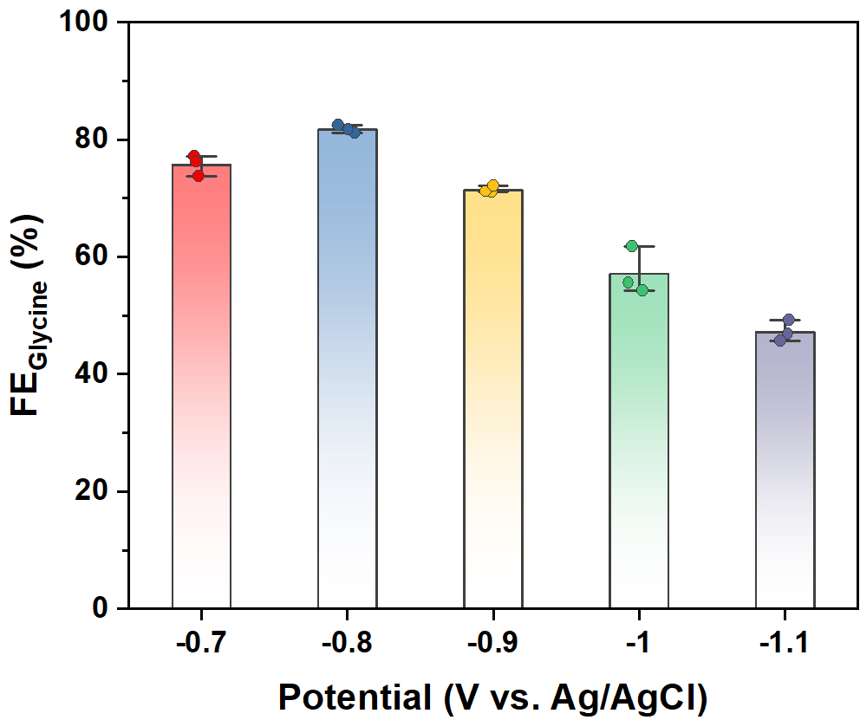
Supplementary Fig. S27. FEs of glycine at different potentials over Bi-ene in 0.5 M OA + 0.5 M NH₂OH·HCl.

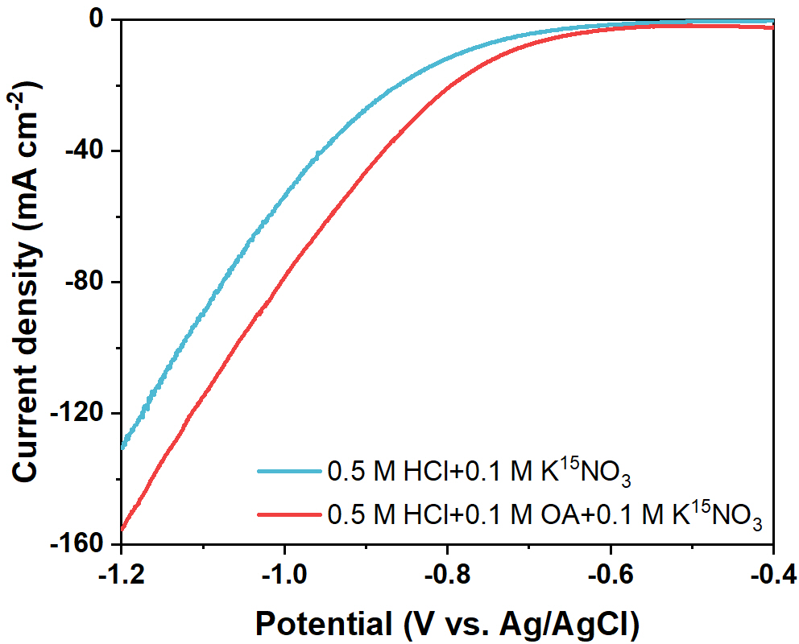
Supplementary Fig. S28. LSV curves in different electrolytes over Bi-ene with a scan rate of 10 mV s⁻¹.

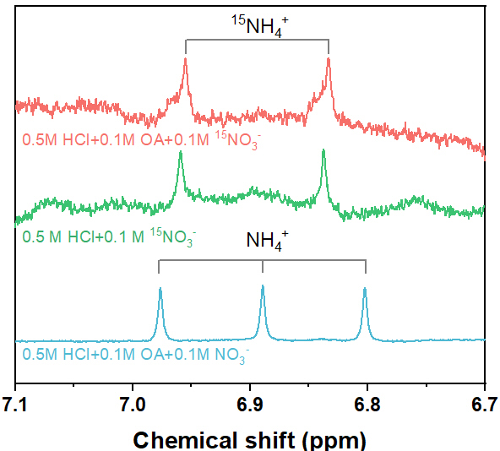
Supplementary Fig. S29. ¹H NMR spectra of the electrolytes with NO₃⁻ and ¹⁵NO₃⁻.

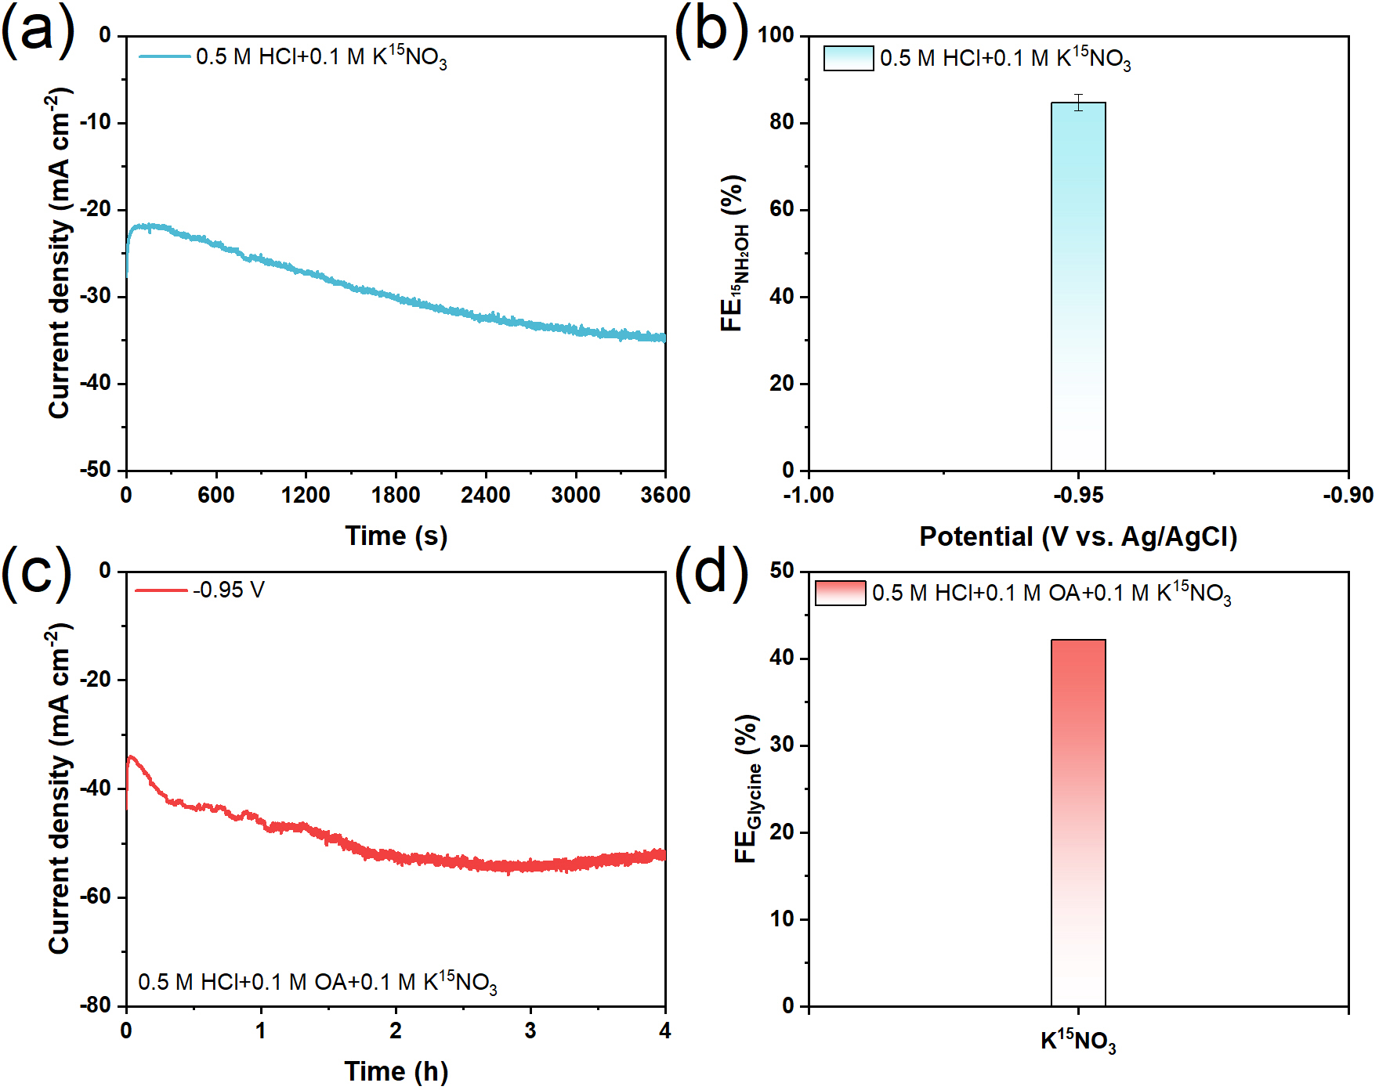
Supplementary Fig. S30. I-t curves and corresponding FEs using electrolytes with ¹⁵NO₃⁻: (a-b) NH₂OH and (c-d) glycine.

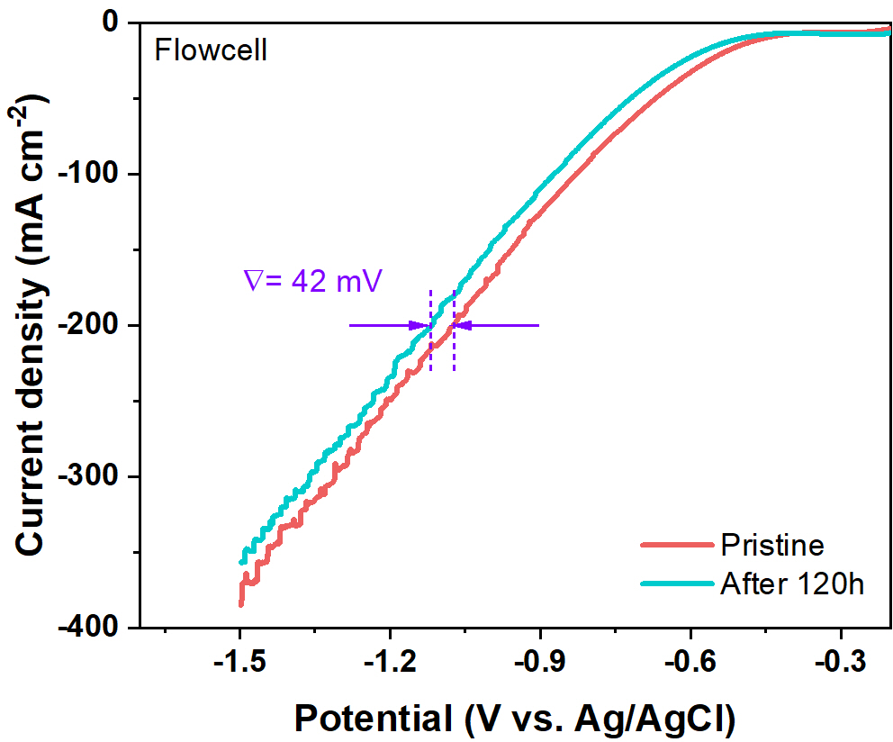
Supplementary Fig. S31. LSV curves recorded before and after a long-term stability test for 120 h over the Bi-ene catalyst. To assess its application potential, a flowing reactor was assembled using a gas-diffusion layer (GDL)-supported Bi-ene as the working electrode, eliminating the need for electrolyte replacement during the extended electrolysis.
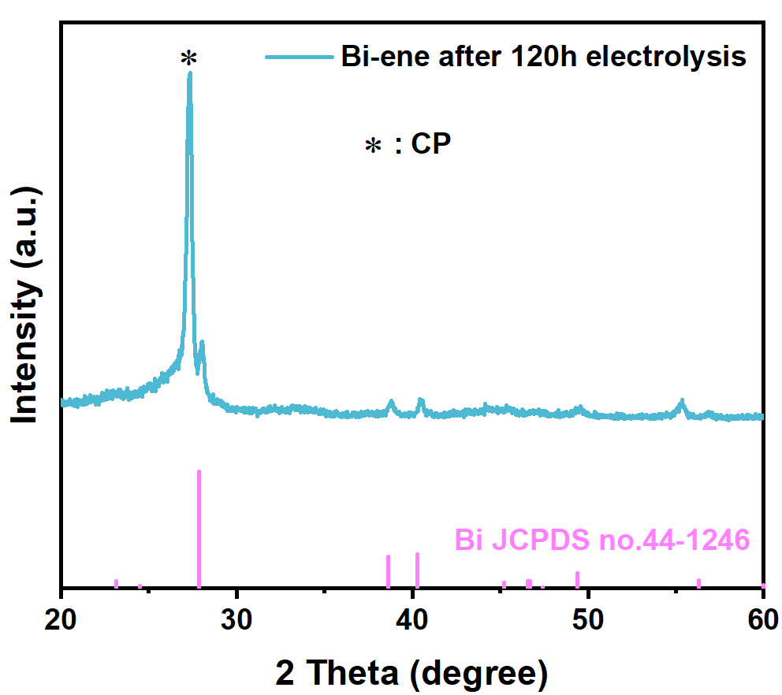
Supplementary Fig. S32. XRD pattern of Bi-ene after the stability test.

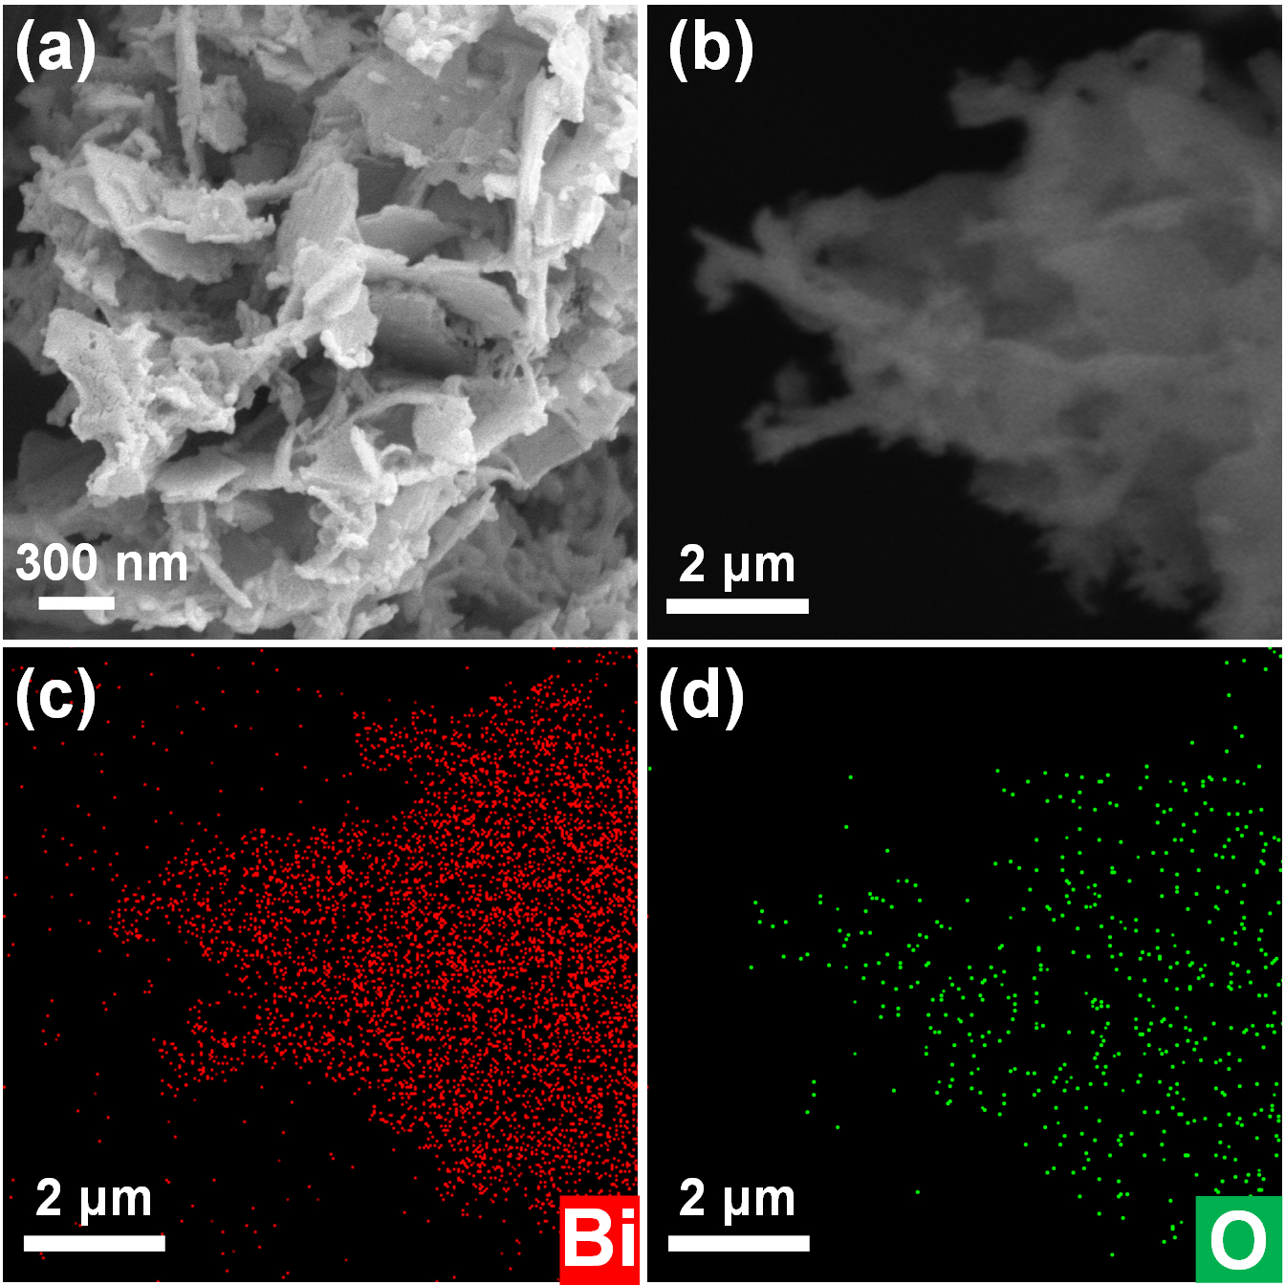
Supplementary Fig. S33. SEM images of Bi-ene after the stability test.
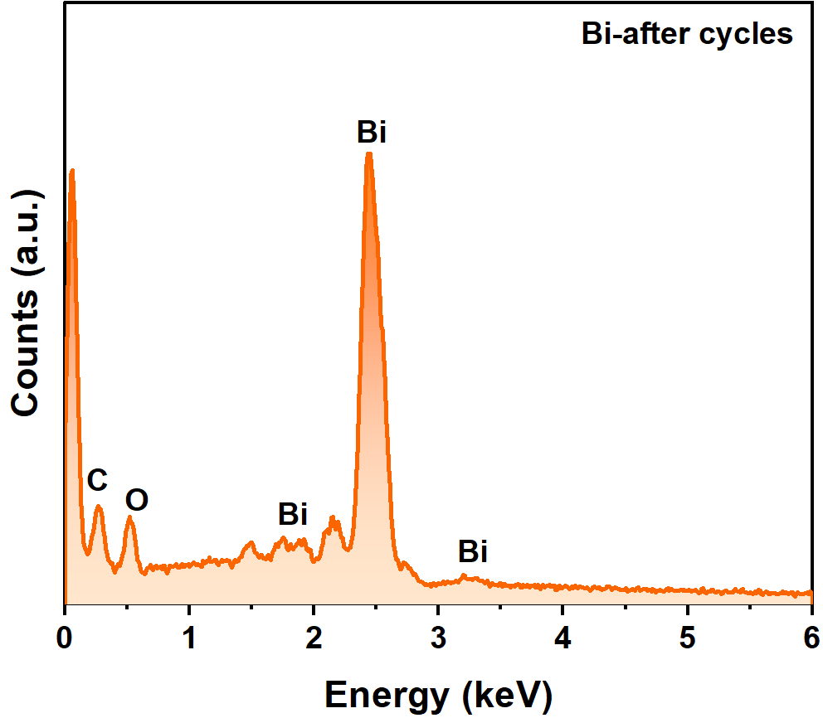
Supplementary Fig. S34. EDX spectrum of Bi-ene after the stability test.

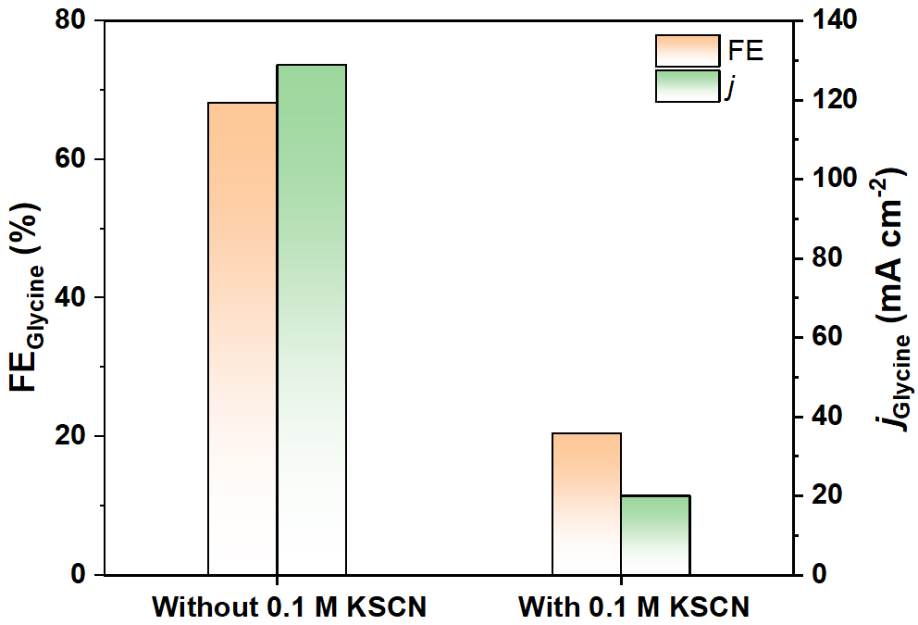
Supplementary Fig. S35. The FE and current density of glycine over Bi-ene at −0.95 V with and without 0.1 M KSCN in the electrolyte.

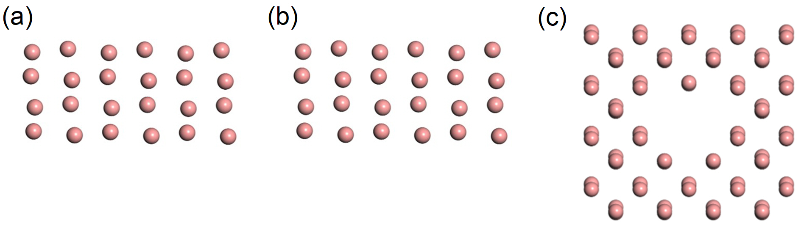
Supplementary Fig. S36. Atomic models of (a) Bi (012) plane, (b) Bi (012) edge, and (c) Bi (012) plane with defects.

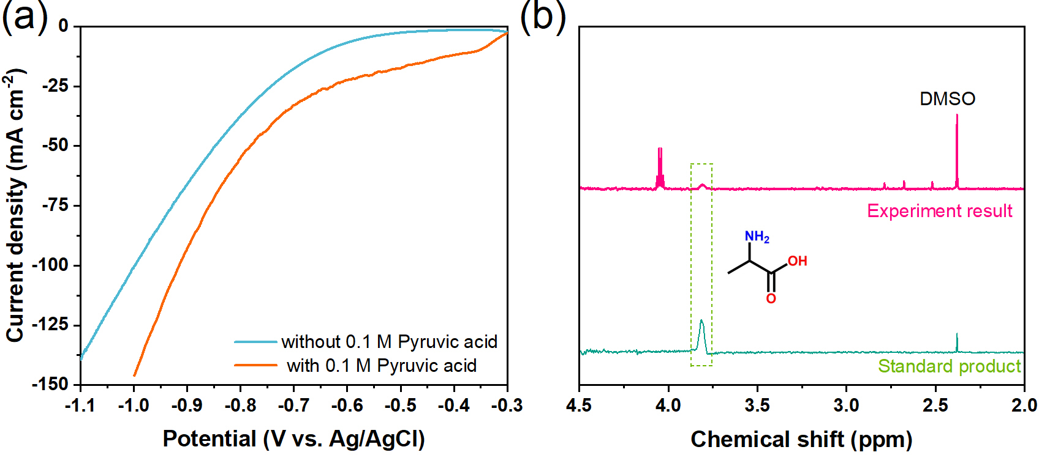
Supplementary Fig. S37. (a) LSV curves and (b) ¹H NMR spectrum of electrolyte after 2 h electrocatalytic synthesis of alanine at −50 mA cm⁻² using Bi-ene electrode.

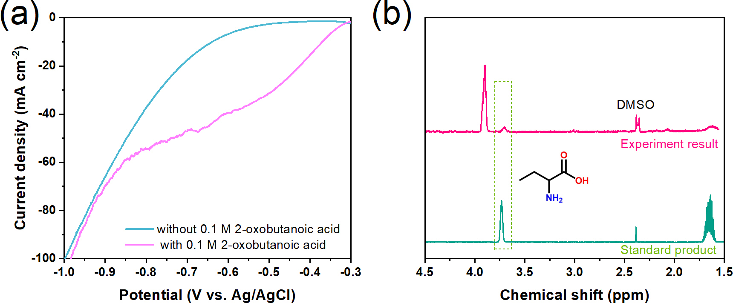
Supplementary Fig. S38. (a) LSV curves and (b) ¹H NMR spectrum of electrolyte after 2 h electrocatalytic synthesis of 2-aminobutyric acid at −50 mA cm⁻² using Bi-ene electrode.
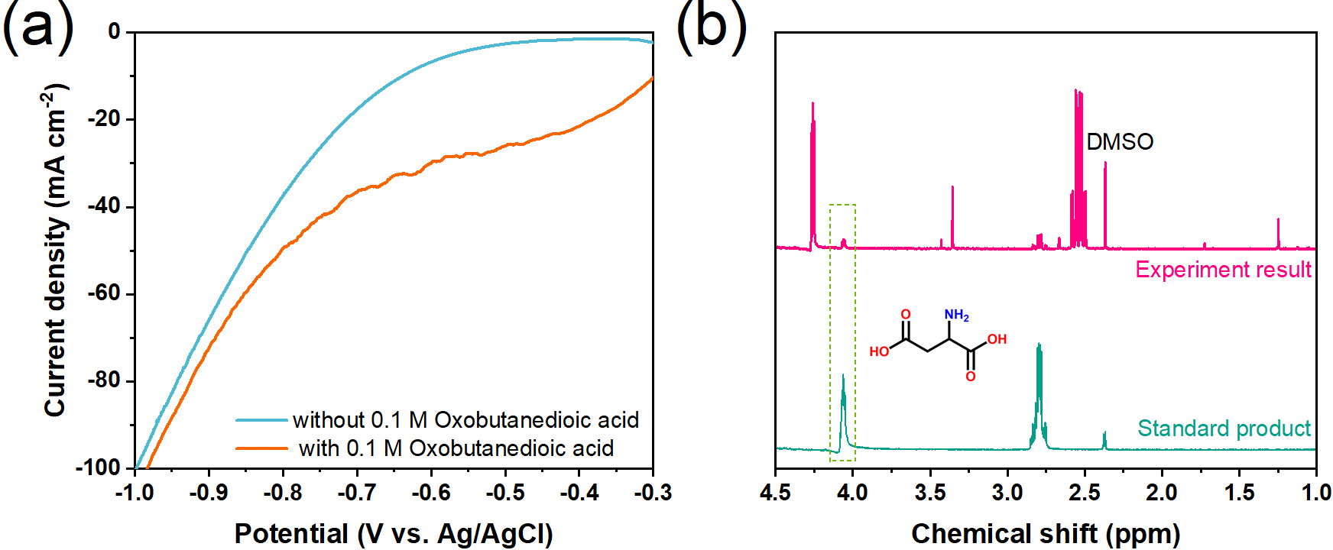
Supplementary Fig. S39. (a) LSV curves and (b) ¹H NMR spectrum of electrolyte after 2 h electrocatalytic synthesis of aspartic acid at −50 mA cm⁻² using Bi-ene electrode.

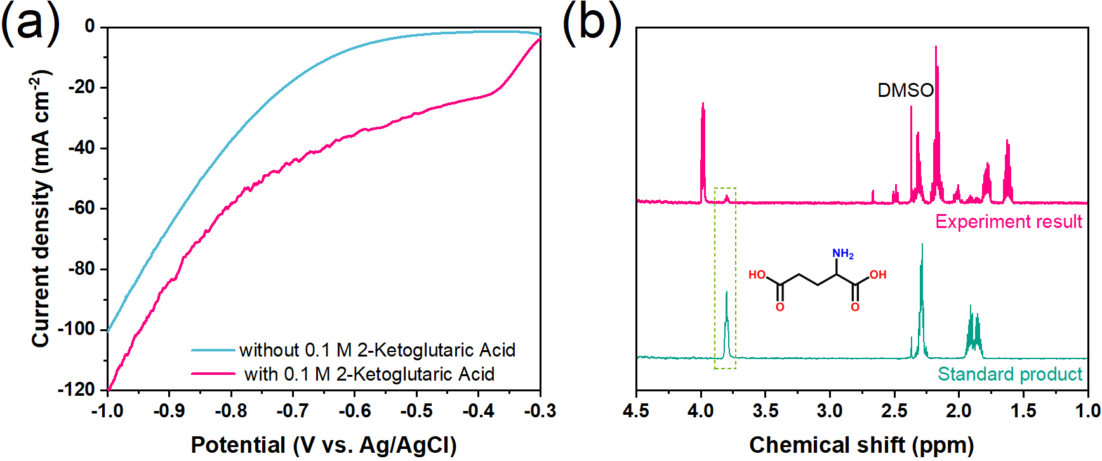
Supplementary Fig. S40. (a) LSV curves and (b) ¹H-NMR spectrum of electrolyte after 2 h electrocatalytic synthesis of glutamic acid at −50 mA cm⁻² using Bi-ene electrode.

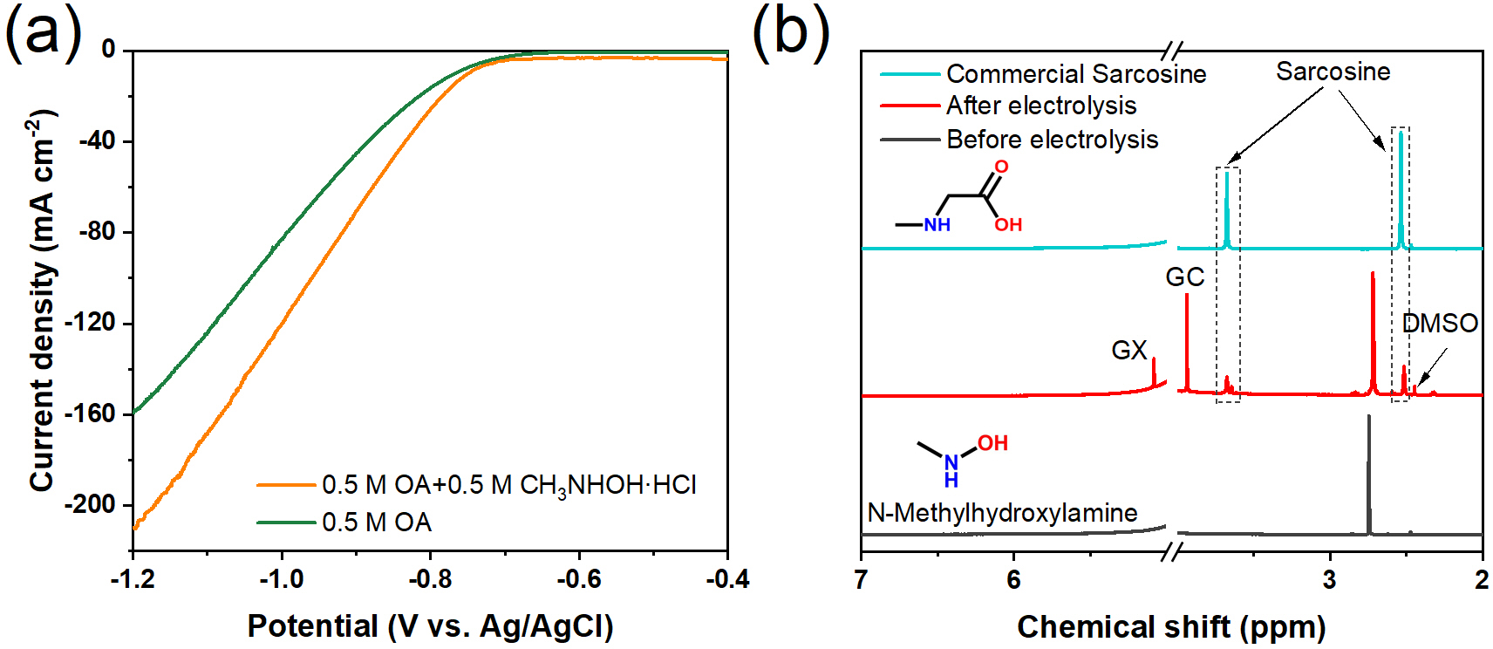
Supplementary Fig. S41. (a) LSV curves and (b) ¹H NMR spectrum of electrolyte after 4 h electrocatalytic synthesis of sarcosine at −0.8 V using Bi-ene electrode.

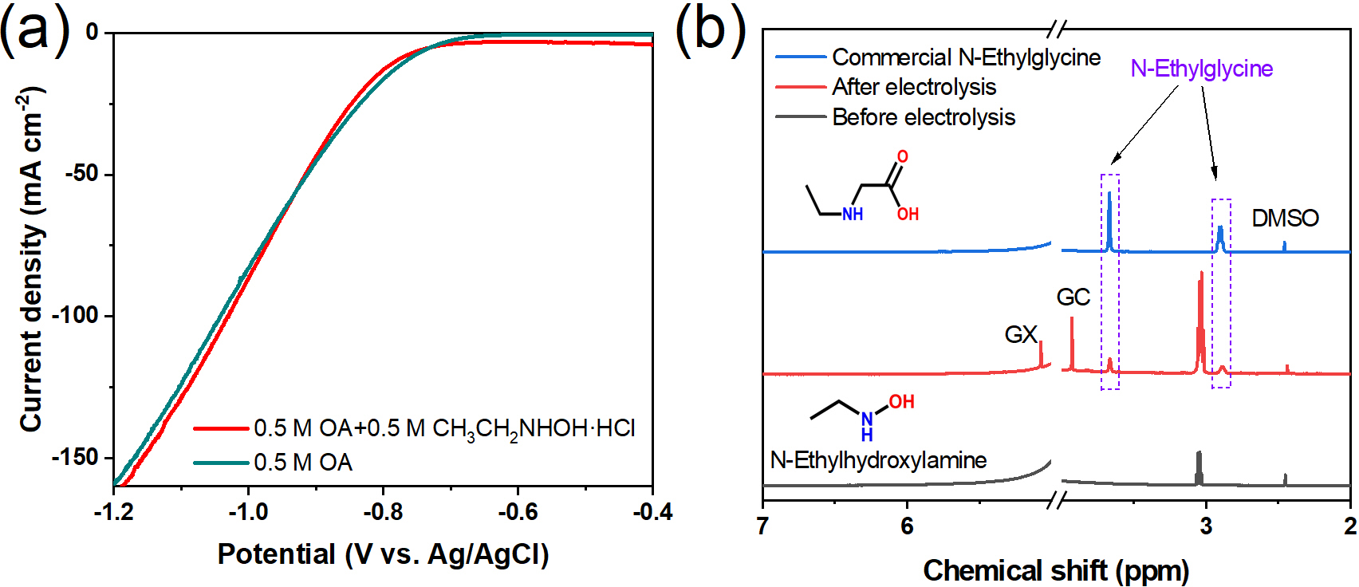
Supplementary Fig. S42. (a) LSV curves and (b) ¹H NMR spectrum of electrolyte after 4 h electrocatalytic synthesis of N-ethylglycine at −0.9 V using Bi-ene electrode.

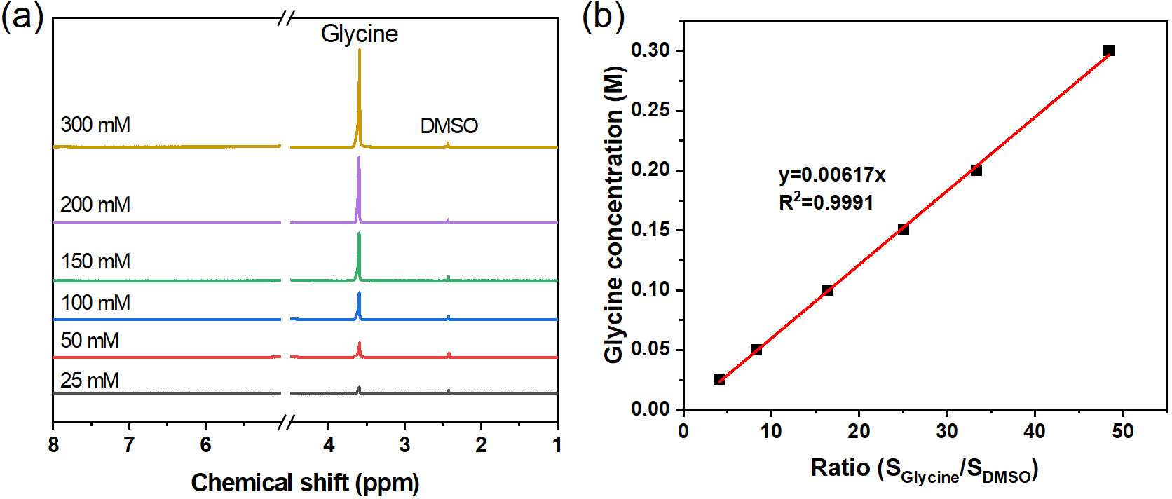
Supplementary Fig. S43. (a) Standard ¹H NMR spectra obtained for glycine at various concentrations were used to construct calibration profiles. (b) The resulting linear calibration plot served as the basis for quantifying glycine.

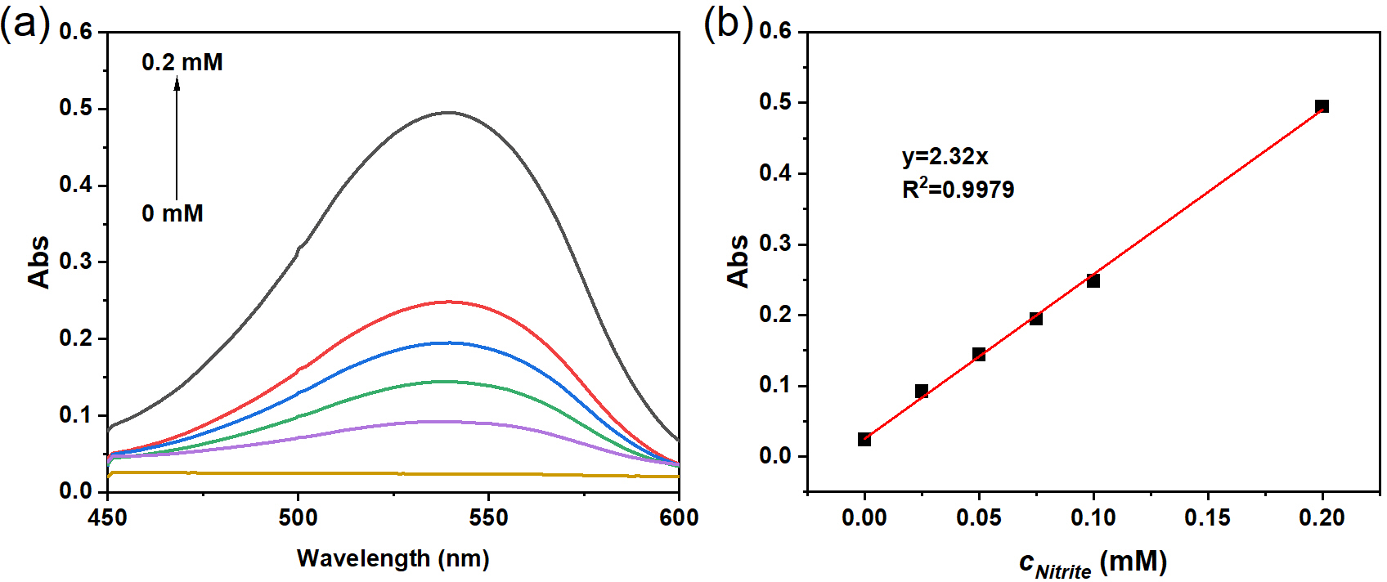
Supplementary Fig. S44. NO₂⁻ determination by a colorimetric method. (a) UV-Vis absorption spectra. (b) The calibration curve of NO₂⁻.

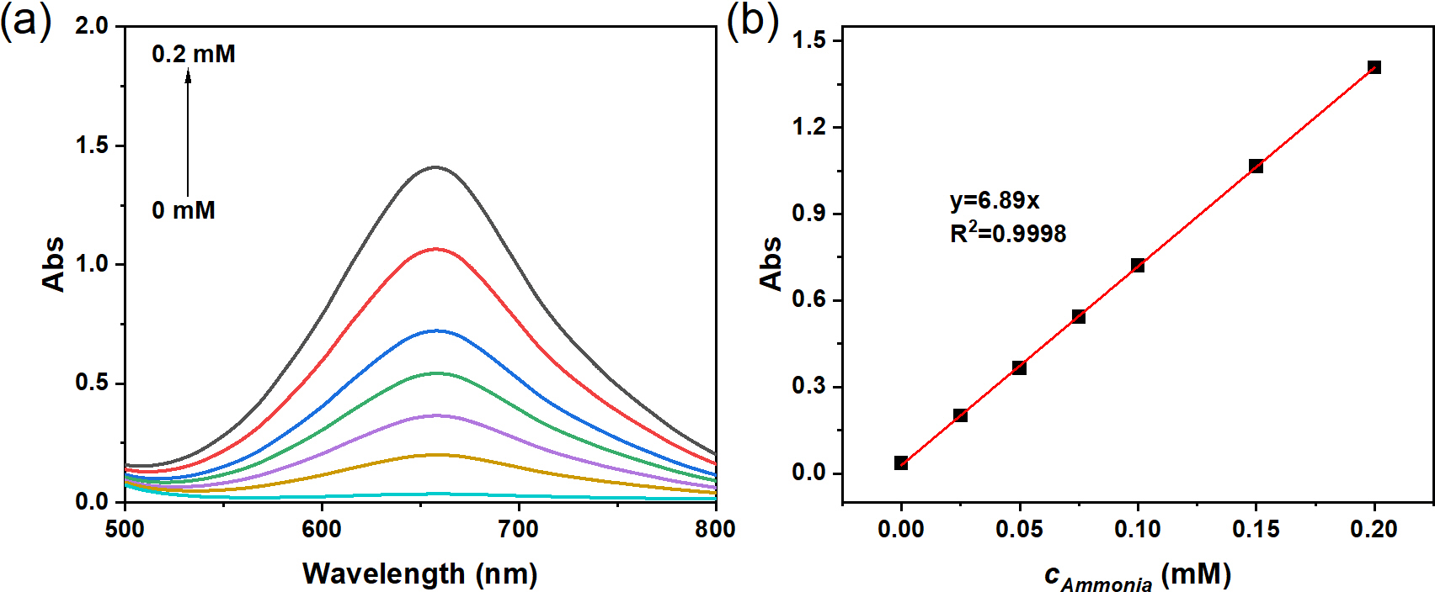
Supplementary Fig. S45. NH₄⁺ determination by a colorimetric method. (a) UV-Vis absorption spectra. (b) The calibration curve of NH₄⁺.

Table S1. Comparison of the electrocatalytic NtrRR performance of Bi-ene with reported electrocatalysts.
Electrocatalysts | N source | FE of NH₂OH  (%) | Yield rate of NH₂OH  (μmol cm⁻² h⁻¹) | Refs.
Bi-ene | 0.5 M HCl+0.5 M HNO₃ | 95.7 | 1161.4 | This work
Bi film/CFP | 0.5 M H₂SO₄+0.1 M HNO₃ | 81.0 | 713.1 | ¹
Fe-PANI-AC-2 | 18% NO | 63 | 119.9 | ²
FeSalen-C | 18% NO | 43 | 46.0 | ³
FePc(0.3)/AC | 10% NO | 80 | 60 | ³
FeNC-dry-0.5 | 10% NO | 71 | 215 | ⁴
Cu-MnO₂H_{x} | 0.5 M K₂SO₄ + 0.2 M NO₃+ 0.2 M Acetone | 91.1 | 396.6 | ⁵
WC | 100% NO | 58 | 153 | ⁶
ZnPc MDE (H) | 1.0 M KOH+ 1.0 M KNO₃ | 53 | 1725.7 | ⁷

Table S2. Comparison of electrocatalytic synthesis of glycine.
Electrocatalysts | N source | FE of glycine  (%) | Potential  (V vs. Ag/AgCl) | Refs.
Bi-ene | 0.5 M HCl+0.5 M HNO₃  +0.5 M OA | 68.2 | −0.95 | This work
Fe−N−C-700 | 0.5 M NaNO₃+0.5 M OA | 64.2 | −0.9  (vs. RHE) | ⁸
Cu-Hg | 15wt% H₂SO₄+0.25 M NaNO₃+0.25 M OA | 43.1 | −1.4 | ⁹
PbSn_{0.5}Bi_{0.125} | 1.5 M H₂SO₄+0.25 M NaNO₃  +0.25 M OA | 57.2 | −1.5 | ¹⁰

References
1. Kong X, et al. Synthesis of hydroxylamine from air and water via a plasma-electrochemical cascade pathway. Nat. Sustain. 7, 652-660 (2024).
2. Daems N, Sheng X, Alvarez-Gallego Y, Vankelecom IFJ, Pescarmona PP. Iron-containing N-doped carbon electrocatalysts for the cogeneration of hydroxylamine and electricity in a H₂–NO fuel cell. Green Chem. 18, 1547-1559 (2016).
3. Sheng X, et al. Carbon-supported iron complexes as electrocatalysts for the cogeneration of hydroxylamine and electricity in a NO-H₂ fuel cell: A combined electrochemical and density functional theory study. J. Power Sources 390, 249-260 (2018).
4. Kim DH, et al. Selective electrochemical reduction of nitric oxide to hydroxylamine by atomically dispersed iron catalyst. Nat. Commun. 12, 1856 (2021).
5. Guo C, Guo M, Zhang Y, Han S, Yu Y. Lattice Hydrogen Involved Electrocatalytic Nitrate Reduction to Hydroxylamine. J. Am. Chem. Soc. 147, 14869-14877 (2025).
6. Bathia ML, Watkinson AP. Hydroxylamine production by electroreduction of nitric oxide in a trickle bed cell. Can. J. Chem. Eng. 57, 631-637 (1979).
7. Tang Y, et al. Selective electrosynthesis of hydroxylamine from aqueous nitrate/nitrite by suppressing further reduction. Nat. Commun. 15, 9800 (2024).
8. Cheng Y, et al. Highly Efficient Electrosynthesis of Glycine over an Atomically Dispersed Iron Catalyst. J. Am. Chem. Soc. 146, 10084-10092 (2024).
9. Kim JE, et al. Electrochemical Synthesis of Glycine from Oxalic Acid and Nitrate. Angew. Chem. Int. Ed. 60, 21943-21951 (2021).
10. Wang K, Li P, Zhang B. Industrial-grade electrocatalytic synthesis of glycine from oxalic acid and nitrate using a porous PbSnBi catalyst. Appl. Catal B-Environ. 361, 124653 (2025).

