Supporting Information

Asymmetric Hydrophilicity-Driven Fast Water Diffusion Enabling Heterogeneous Hygroscopic Gels toward High-Yield Atmospheric Water Harvest
Ruiheng Han^{1,2,3}, Xianzhang Wu^{1,4*}, Yuan Zhu¹, Weiqing Yang^{2,3}, Jianshan Chen¹, Yan Qing¹, Peng Xiao^{2,3*}, Tao Chen^{2,3*}

¹College of Materials and Energy, State Key Laboratory of Utilization of Woody Oil Resource, Central South University of Forestry and Technology, Changsha, 410004 China
² State Key Laboratory of Advanced Marine Materials, Zhejiang Key Laboratory of Extreme-environmental Material Surfaces and Interfaces, Ningbo Institute of Materials Technology and Engineering, Chinese Academy of Sciences, Ningbo, 315201 China.
³ School of Chemical Sciences, University of Chinese Academy of Sciences, Beijing, 100049
China
⁴State Key Laboratory of Solid Lubrication, Lanzhou Institute of Chemical Physics, Chinese Academy of Sciences, Lanzhou, 730000 China

*Corresponding authors,
xianzhangwu_js@163.com(X.Z.Wu);xiaopeng@nimte.ac.cn(P.Xiao);tao.chen@nimte.ac.cn(T.Chen)

Table of Contents
Supplementary Section 1. Design and construction of HPGP
Fig.1 The preparation process of HPGP.
Fig.2 i. Smooth surface image of blank GO interlayers. ii. Wrinkled surface image of GO interlayers. iii. TEM image of blank GO interlayers. iv. TEM image of GO interlayers.
Fig.3 Solvent displacement of external glycerin and internal water results in a tightly structured HPGP.
Fig.4 The surface wrinkles of the completed HPGP build do not change.
Fig.5 Elemental mappings of EDS for HPGP surface maps.
Fig.6 Elemental mappings of energy dispersive spectrometer for HPGP cross sections.
Fig.7 Contact angle testing for Blank GO interlayers, GO interlayers and HPGP.
Supplementary Section 2. Mechanism for continuous and high-capacity moisture sorption of the HPGP
Fig.8 Comparison of gas-liquid conversion capacity of different material surfaces.
Fig.9 i. The moisture sorption process begins simultaneously from both ends of the humidification modules, and eventually, water molecules enter the internal storage module. ii. The water desorption process involves the internal desorption module absorbing heat, and the heat diffusing layer-by-layer from the inside to the outside to complete desorption.
Fig.10 The transport pathways of water molecules within heterogeneous structure were investigated using molecular dynamics simulations over a 1000 ps timescale.
Fig.11 The transport pathways of water molecules within homogeneous structure were investigated using molecular dynamics simulations over a 1000 ps timescale.
Supplementary Section 3. Sorption capacity of HPGP
Fig.12 Comparison of sorption of glycerol, pectin, GO interlayers, GO interlayers-Pectin, and HPGP under the same experimental conditions.
Fig.13 Effect of different layers of GO interlayers on water sorption capacity.
Fig.14 The impact of wrinkles on moisture sorption performance of HPGP.
Fig.15 The weight ratio of glycerin exchanged into the HPGP (W) and the weight of the HPGP (W₀). The glycerol weight was 3.4, 3, 2.6, 2.3, and 2 times the weight of HPGP when the pectin thickness varied from 10 μm to 50 μm, respectively.
Fig.16 The calculated D_{ms} values of heterogeneous and homogeneous at 30%, 60%, and 90% RH, respectively.
Table.1 The linear fitting of the moisture sorption diffusion coefficient (D_{ms}) values at various RHs based on Fick’s second law.
Fig.17 Water sorption capacity of HPGP at different relative humidity conditions ranging from 30% to 90%.
Fig.18 Long-term moisture sorption of HPGP at 90% RH results in significant swelling, as evidenced by the inserted images showing the initial and post-sorption HPGP samples.
Table.2 Comparison of water sorption capacity of different sorbent materials.
Supplementary Section 4. Solar-driven water desorption performance of HPGP
Fig.19 Infrared thermal imaging pictures of the overall temperature changes of GO interlayers, pectin, and HPGP over time.
Fig.20 Temperature changes of HPGP under different solar illuminations.
Fig.21 (a) Desorption process of HPGP under different solar irradiation intensities, where HPGP was saturated with sorption at 25°C and 90% RH. (b) The desorption rate changes of HPGP under different solar irradiation intensities.
Fig.22 The heterogeneous structure has a broader steam diffusion space and additional escape routes for water molecules compared to the homogeneous structure.
Fig.23 Influence of wrinkles on the surface temperature of HPGP.
Fig.24 HPGP can achieve faster average mass changes than Pectin-blank GO interlayers-Pectin.
Fig.25 (a) Desorption process of homogeneous structure under different solar irradiation intensities, where homogeneous structure was saturated with sorption at 25°C and 90% RH. (b) The desorption rate changes of homogeneous structure under different solar illumination.
Fig.26 (a) Desorption process of heterogeneous structure and homogeneous structure under 1.0 solar irradiation. (b)The desorption rate changes of heterogeneous structure and homogeneous structure under 1.0 sun illumination.
Fig.27 Normalized desorption ratios (X_{t}-X_{e})/(X₀-X_{e}) were plotted against the function of t^{1/2}.
Fig.28 Summary of water desorption kinetics performance of reported sorbent materials in the first 50 min under 1.0 sun illumination.
Table.3 The linear fitting for the D_{wd} values of HPGP and HPG under different solar illuminations based on Fick’s second law.
Table.4 Comparison of evaporation rates with different sorbent materials under 1.0 sun illumination.
Table.5 Summary of water desorption kinetics performance of reported sorbent materials in the first 50 min under 1.0 sun illumination.
Supplementary Section 5. Demonstration of the outdoor water-harvesting tests
Fig.29 Sorption/desorption performance in the complete atmospheric water collection process of HPGP.
Fig.30 Comparison of sampling rates between laboratory conditions and outdoor conditions.
Fig.31 FTIR spectroscopy of evaporated water compared to standard glycerol and deionised water.
Fig.32 HPGP can be disassembled in layers by external force.
Fig.33 The pectin layer can be broken down naturally by placing it in the soil.
Table.6 Comparison of water harvesting effect of different adsorbent materials under outdoor conditions.
Supplementary Section 6. Experimental section
Fig.34 Surface wrinkling evolution in GO interlayers.
Fig.35 The surface wrinkles of GO interlayers diminish with increasing layer numbers.
Fig.36 Comparison diagram of homogeneous structure and heterogeneous structure samples.

Supplementary Section 1. Design and construction of HPGP
Fig.1 GO interlayers and pectin were prepared separately. Following the assembly of the GO interlayers, pectin was uniformly coated on the surface to ensure a complete hetero-laminated structure. Glycerol immersion then replaced all water molecules during the preparation of the HPGP.

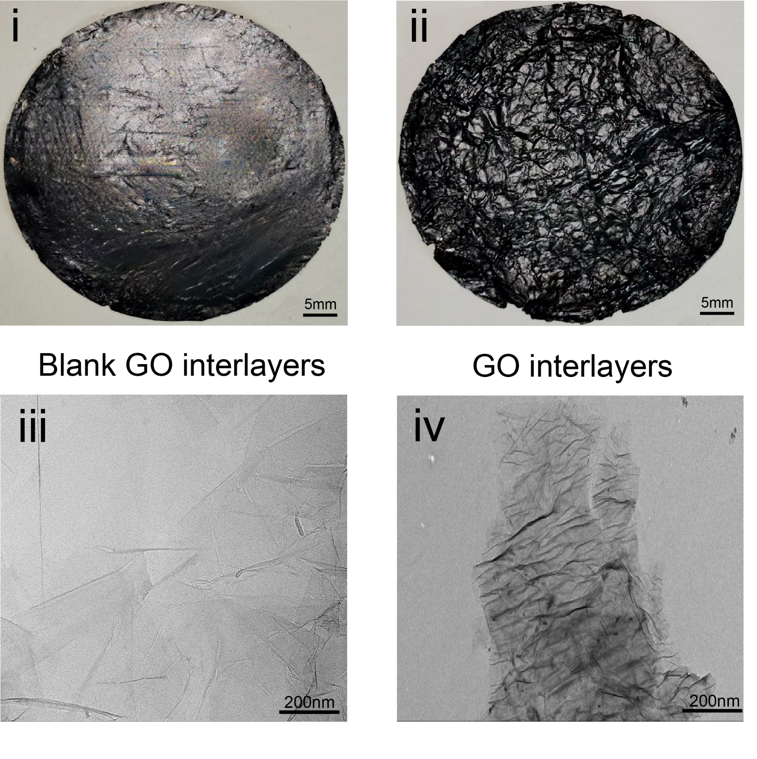
Fig.2 i. Smooth surface image of blank GO interlayers. ii. Wrinkled surface image of GO interlayers. iii. TEM image of blank GO interlayers. iv. TEM image of GO interlayers.

Fig.3 Solvent displacement of external glycerin and internal water results in a tightly structured HPGP.

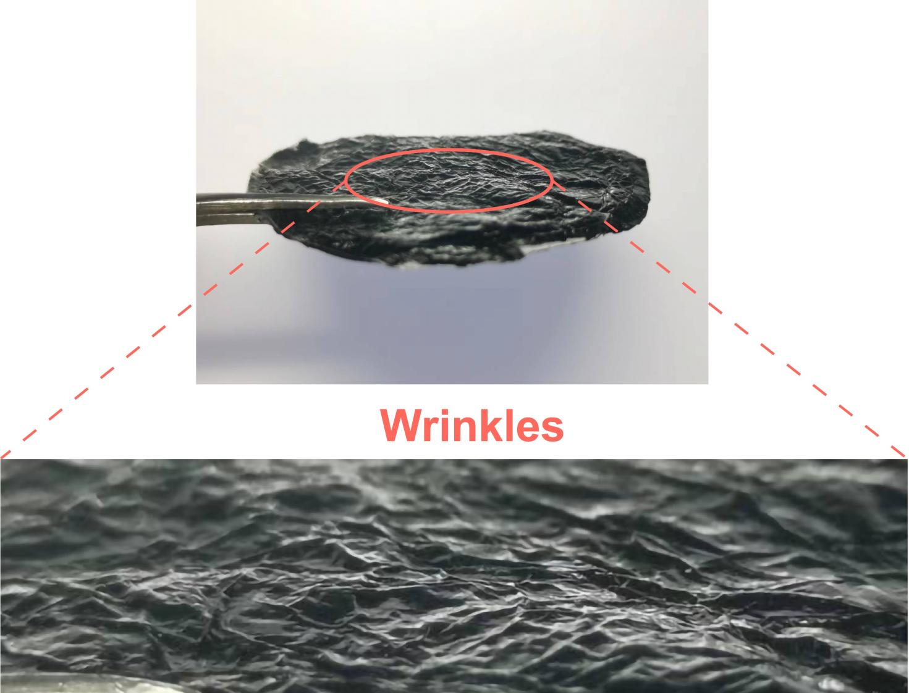
Fig.4 The surface wrinkles of the completed HPGP build do not change.

Fig.5 Elemental mappings of EDS for HPGP surface maps.

Fig.6 Elemental mappings of the energy dispersive spectrometer for HPGP cross sections.

Note 1: Comparative deconvolution analysis of the O1s spectra between non-cross-linked and cross-linked pectin reveals two distinct absorption peaks in the non-cross-linked pectin at 530.5 eV (C=O) and 513.8 eV (C-O). In contrast, the cross-linked pectin spectrum exhibits an additional peak at 532.7 eV, attributed to Zn-O-C bonds. The distribution of these peaks further substantiates the formation of coordination bonds between Zn²⁺ and the carbonyl groups, as well as the establishment of a cross-linked network within the pectin.

Fig.7 Contact angle testing for Blank GO interlayers, GO interlayers, and HPGP.

Supplementary Section 2. Mechanism for continuous and high-capacity moisture sorption of the HPGP
Fig.8 Comparison of gas-liquid conversion capacity of different material surfaces. a) Pectin exhibits water droplets within 11 minutes. b) Sodium alginate (SA) exhibits water droplets within 50 minutes. c) Polyvinyl alcohol (PVA) does not form a film after being soaked in glycerin. d) Konjac glucomannan (KGM) does not form a film after being soaked in glycerin.

Fig.9 i. The moisture sorption process begins simultaneously from both ends of the humidification modules, and eventually, water molecules enter the internal storage module. ii. The water desorption process involves the internal desorption module absorbing heat, and the heat diffusing layer-by-layer from the inside to the outside to complete desorption.

Fig.10 The transport pathways of water molecules within heterogeneous structure were investigated using molecular dynamics simulations over a 1000 ps timescale.
Fig.11 The transport pathways of water molecules within homogeneous structure were investigated using molecular dynamics simulations over a 1000 ps timescale.

Supplementary Section 3. Sorption capacity of HPGP
Fig.12 Comparison of sorption of glycerol, pectin, GO interlayers, GO interlayers-Pectin, and HPGP under the same experimental conditions.

Fig.13 Effect of different layers of GO interlayers on water sorption capacity.

Note 2: The reason for designing the GO interlayers is to be four layers: As the number of GO interlayers increases, surface wrinkles decrease, whereas the drying time required for each additional layer increases significantly. From 75 minutes at four layers, it rises to 150 minutes at six layers, and further to 240 minutes at eight layers, leading to an increasing demand for energy. This results in a wastage of energy and time, while the increase in the number of layers does not significantly enhance the water sorption capacity.
The decrease in water sorption with an increase in the number of layers can be attributed to the continuous reduction in wrinkles. The sorption rate is influenced by the decreasing wrinkles. While the hetero-laminated design theoretically allows for an increase in water storage capacity with more layers, accessing the interior of the GO interlayers layer by layer requires a continuous accumulation of time. Within a three-day sorption period, the enhanced sorption effect from increasing the number of layers does not match the effect of wrinkle reduction. Additionally, as the sorption time lengthens, the time for infiltration to pass through the hetero-laminated structure significantly increases, resulting in a scenario where increasing the number of layers within a fixed time frame does not yield a better moisture sorption effect.

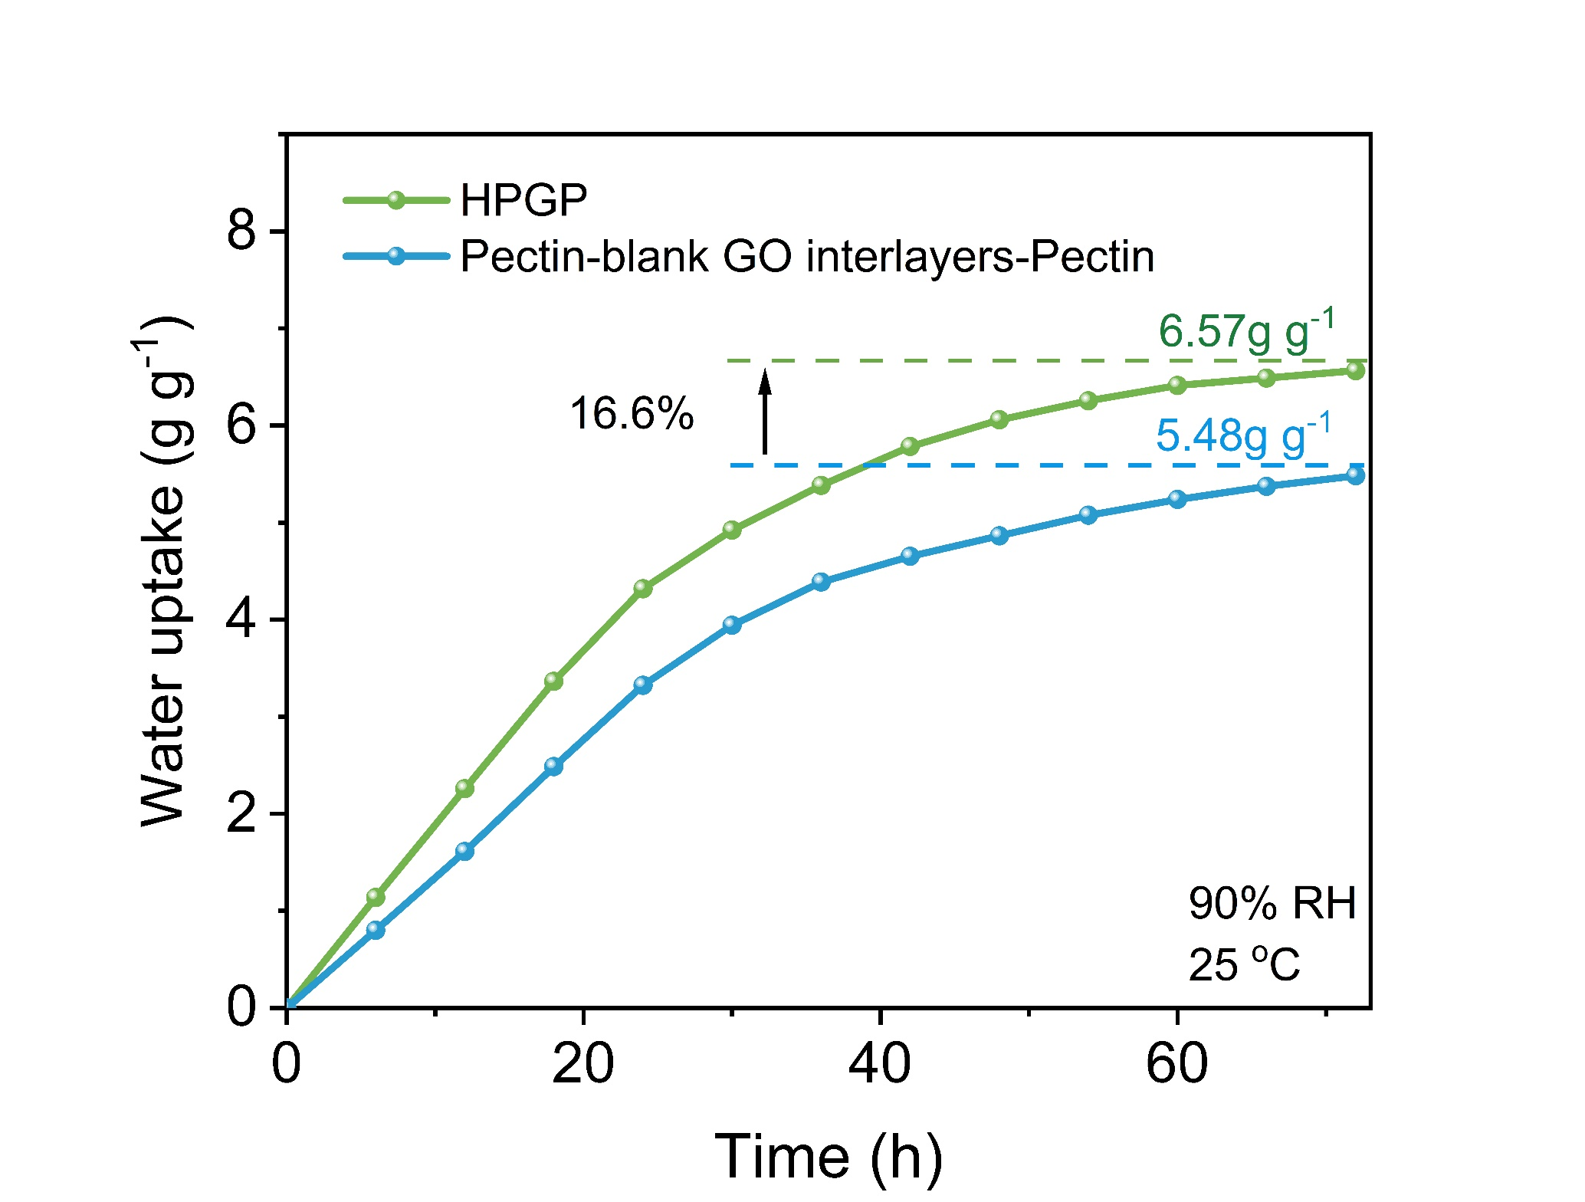
Fig.14 The impact of wrinkles on moisture sorption performance of HPGP.

Fig.15 The weight ratio of glycerin exchanged into the HPGP (W) and the weight of the HPGP (W₀). The glycerol weight was 3.4, 3, 2.6, 2.3, and 2 times the weight of HPGP when the pectin thickness varied from 10 μm to 50 μm, respectively.

Fig.16 The calculated D_{ms} values of HPGP and HPG at 30%, 60%, and 90% RH, respectively.

Table.1 The linear fitting of the moisture sorption diffusion coefficient (D_{ms}) values at various RHs based on Fick’s second law.
RH (%) |  | Fitting equation | R²
30% | Heterogeneous | y=0.00311x-0.2842 | 0.99943
30% | Homogeneous | y=0.00289x-0.26081 | 0.99917
60% | Heterogeneous | y=0.00313x-0.29229 | 0.99725
60% | Homogeneous | y=0.00289x-0.25938 | 0.9961
90% | Heterogeneous | y=0.00365x-0.27489 | 0.99727
90% | Homogeneous | y=0.0026x-0.16977 | 0.99705

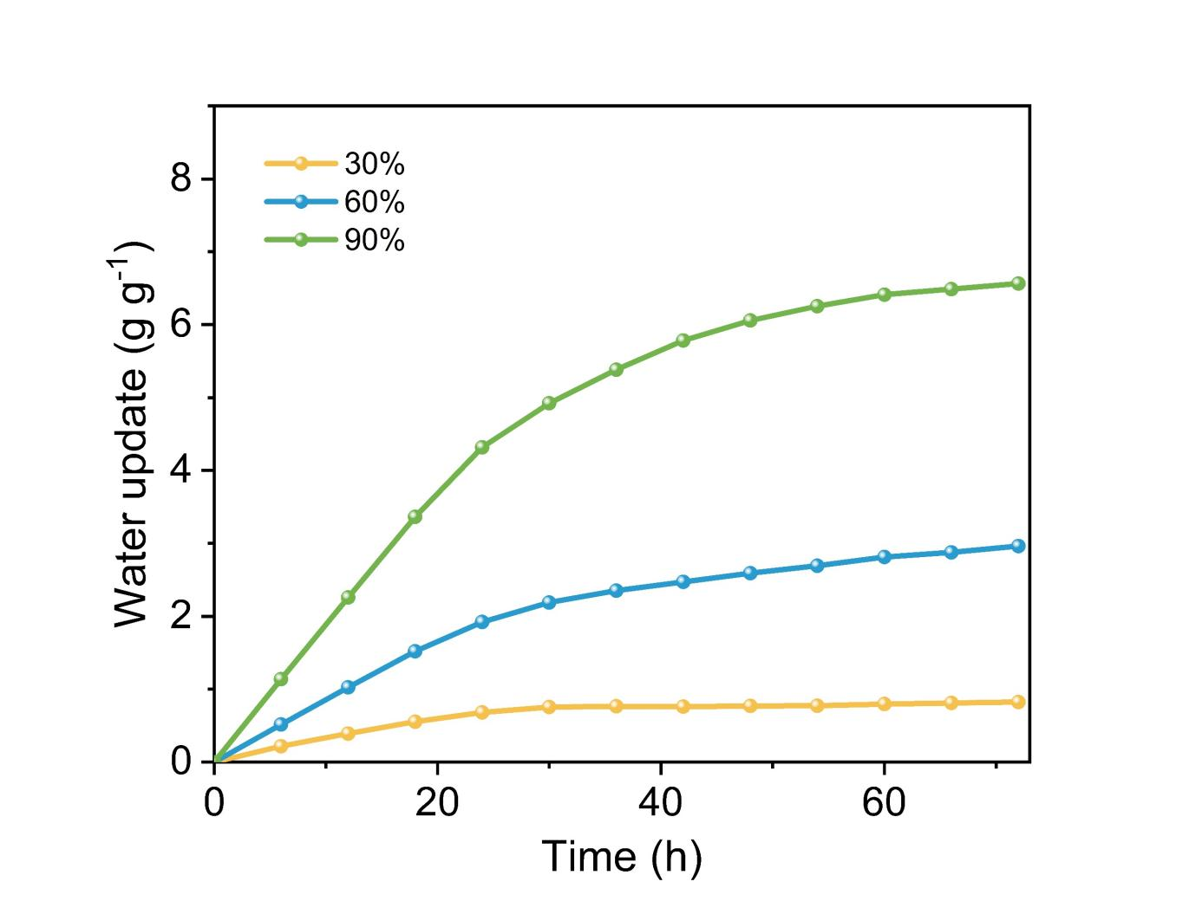Fig.17 Water sorption capacity of HPGP at different relative humidity conditions ranging from 30% to 90%.

Fig.18 Long-term moisture sorption of HPGP at 90% RH results in significant swelling, as evidenced by the inserted images showing the initial and post-sorption HPGP samples.

Table.2 Comparison of water sorption capacity of different sorbent materials.
Sorbent materials | Sorption water capacity (RH) | Reference
RFMP | 2.15–2.68–3.1 g g⁻¹(RH70–80–90%) | ¹
SMCA | 0.5–1–2.5 g g⁻¹ (RH30–60–90%) | ²
ILCA | 0.5–1.15–1.5 g g⁻¹ (RH30–60–90%) | ³
POG | 0.5–2.6–6 g g⁻¹ (RH30–60–90%) | ⁴
CNTs-CILs@cotton rod | 0.75–1.2 g g⁻¹ (RH 60–90%) | ⁵
PDA@PP-Cl Hydrogel | 0.68–1.61–2.76 g g⁻¹ (RH30–60–90%) | ⁶
PAM–CS–MXene–LiCl aerogel | 0.78–2.32–5 g g⁻¹ (RH30–60–90%) | ⁷
PGF | 0.64–3.3 g g⁻¹ (RH60–95%) | ⁸
BHNC | 1.6–2.5–6.2 g g⁻¹ (RH30–60–90%) | ⁹
Bilayer scaffold-1.5 | 0.73–1.32–1.65 g g⁻¹ (RH57–70-95%) | ¹⁰
Agar /GG/PAM hydrogel | 1.623-4.601 g g⁻¹ (RH60–90%) | ¹¹
TCP-Li | 0.90-1.93-3.91 g g⁻¹ (RH30–60-88%) | ¹²
HPGP (This work) | 0.83–2.97–6.57 g g⁻¹(RH30–60–90%)

Supplementary Section 4. Solar-driven water desorption performance
Fig.19 Infrared thermal imaging pictures of the overall temperature changes of GO interlayers, pectin, and HPGP over time.

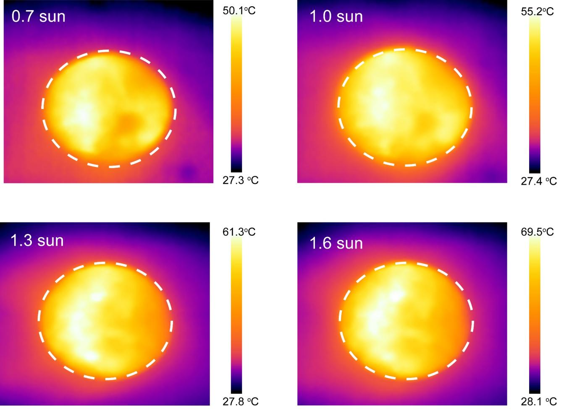
Fig.20 Temperature changes of HPGP under different solar illuminations.

Fig.21 (a) Desorption process of HPGP under different solar irradiation intensities, where HPGP was saturated with sorption at 25°C and 90% RH. (b) The desorption rate changes of HPGP under different solar irradiation intensities.

Fig.22 The heterogeneous structure has a broader steam diffusion space and additional escape routes for water molecules compared to the homogeneous structure.

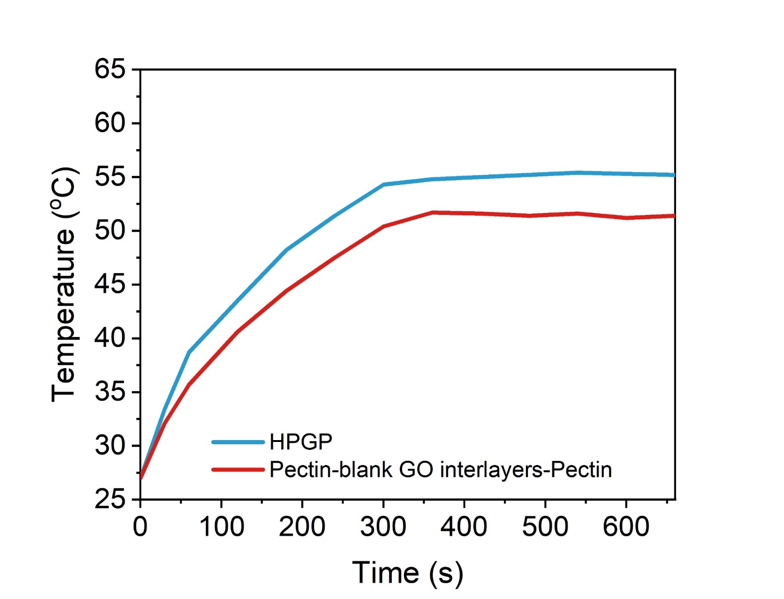
Fig.23 Influence of wrinkles on the surface temperature of HPGP.

Fig.24 HPGP can achieve faster average mass changes than Pectin-blank GO interlayers-Pectin.

Fig.25 (a) Desorption process of homogeneous structure under different solar irradiation intensities, where homogeneous structure was saturated with sorption at 25°C and 90% RH. (b) The desorption rate changes of homogeneous structure under different solar illumination.

Fig.26 (a) Desorption process of heterogeneous structure and homogeneous structure under 1.0 solar irradiation. (b)The desorption rate changes of heterogeneous structure and homogeneous structure under 1.0 sun illumination.

Fig.27 Normalized desorption ratios (X_{t}-X_{e})/(X₀-X_{e}) were plotted against the function of t^{1/2}.

Table.3 The linear fitting for the D_{wd} values of HPGP and HPG under different solar illuminations based on Fick’s second law.
Solar illumination (sun) |  | Fitting equation | R²
0.7 sun | Heterogeneous | y=-9.43365×10⁻⁴e^{(x/6.79996)}-4353.54171e^{(x/1248333.2784)}+4354.51003 | 0.9992
0.7 sun | Homogeneous | y=-0.01832x+1.12609 | 0.99902
1.0 sun | Heterogeneous | y=-0.05665e^{(x/19.94196)}-0.07207e^{(x/19.94165)}+1.20014 | 0.99725
1.0 sun | Homogeneous | y=-0.01838x+1.08449 | 0.99963
1.3 sun | Heterogeneous | y=-0.01543e^{(x/12.16866)}-0.024363e^{(x/12.16836)}+0.96942 | 0.99815
1.3 sun | Homogeneous | y=-0.02477x+1.1831 | 0.99967
1.6 sun | Heterogeneous | y=-0.10991e^{(x/20.71098)}-4353.54171e^{(x/1248333.2784)}+1.26193 | 0.99815
1.6 sun | Homogeneous | y=-0.03474x+1.34326 | 0.98527
Fig.28 Summary of water desorption kinetics performance of reported sorbent materials in the first 50 min under 1.0 sun illumination.

Table.4 Comparison of evaporation rates with different sorbent materials under 1.0 sun illumination.
Sorbent materials | Evaporation rates (kg m⁻² h⁻¹) | Reference
CNTs@SiO₂ | 1.5 | ¹³
SMCA | 1.391 | ²
ILCA | 1.5 | ³
POG | 1.77 | ⁴
CNTs-CILs@cotton rod | 2.0 | ⁵
PDA@PP-Cl Hydrogel | 1.42 | ⁶
RFMP | 1.75 | ¹
Bilayer scaffold-1.5 | 1.46 | ¹⁰
MoCx nanocrystals | 1.59 | ¹⁴
PPy-COF@Trilayer-LiCl | 1.43 | ¹⁵
HPGP (This work) | 2.06

Table.5 Summary of water desorption kinetics performance of reported sorbent materials in the first 50 min under 1.0 sun illumination.
Sorbent materials | Water desorption ratio (%) | Reference
PVA-PAM-LiCl | 84 | ¹⁶
HEMHs | 71 | ¹⁷
LiCl/PMS/CNTs | 80 | ¹⁸
TCP-Li | 98 | ¹²
PVF-PPy-MnC | 70 | ¹⁹
Agar/GG/PAM | 67 | ¹¹
HIPG | 89 | ²⁰
CPPY@LiCl | 79 | ²¹
HPGP (This work) | 94

Supplementary Section 5. Demonstration of the outdoor water-harvesting tests
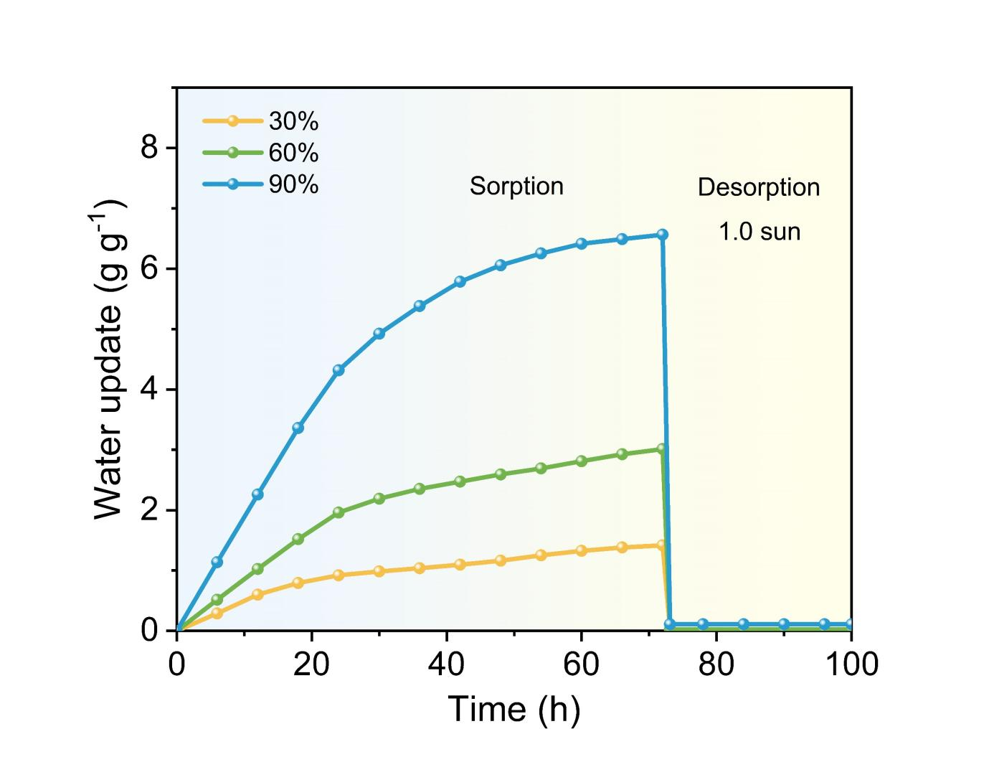
Fig.29 Sorption/desorption performance in the complete atmospheric water collection process of HPGP.
Fig.30 Comparison of sampling rates between laboratory conditions and outdoor conditions.

Note 3: After conducting multiple experiments under laboratory conditions of 25 °C and 60% relative humidity, the efficiency of the collected sample was calculated to be 97% using the ratio of the sorbed mass (1.171g) to the desorbed mass (1.136g). During outdoor testing, with temperature ranging from 23.2 °C to 31.5 °C and relative humidity ranging from 82.6% to 72%, the efficiency of the collected sample was calculated to be 86% using the ratio of the average sorbed mass (1.451g) to the desorbed mass (1.247g) obtained from a single sample. The decrease in collection efficiency can be attributed to (1) evaporated water vapor covering the transparent hood, resulting in reduced solar energy sorption by the HPGP; (2) retention of residual moisture within the HPGP; and (3) variations in external environmental factors such as solar intensity and temperature.

Fig. 31 FTIR spectroscopy of evaporated water compared to standard glycerol and deionised water.

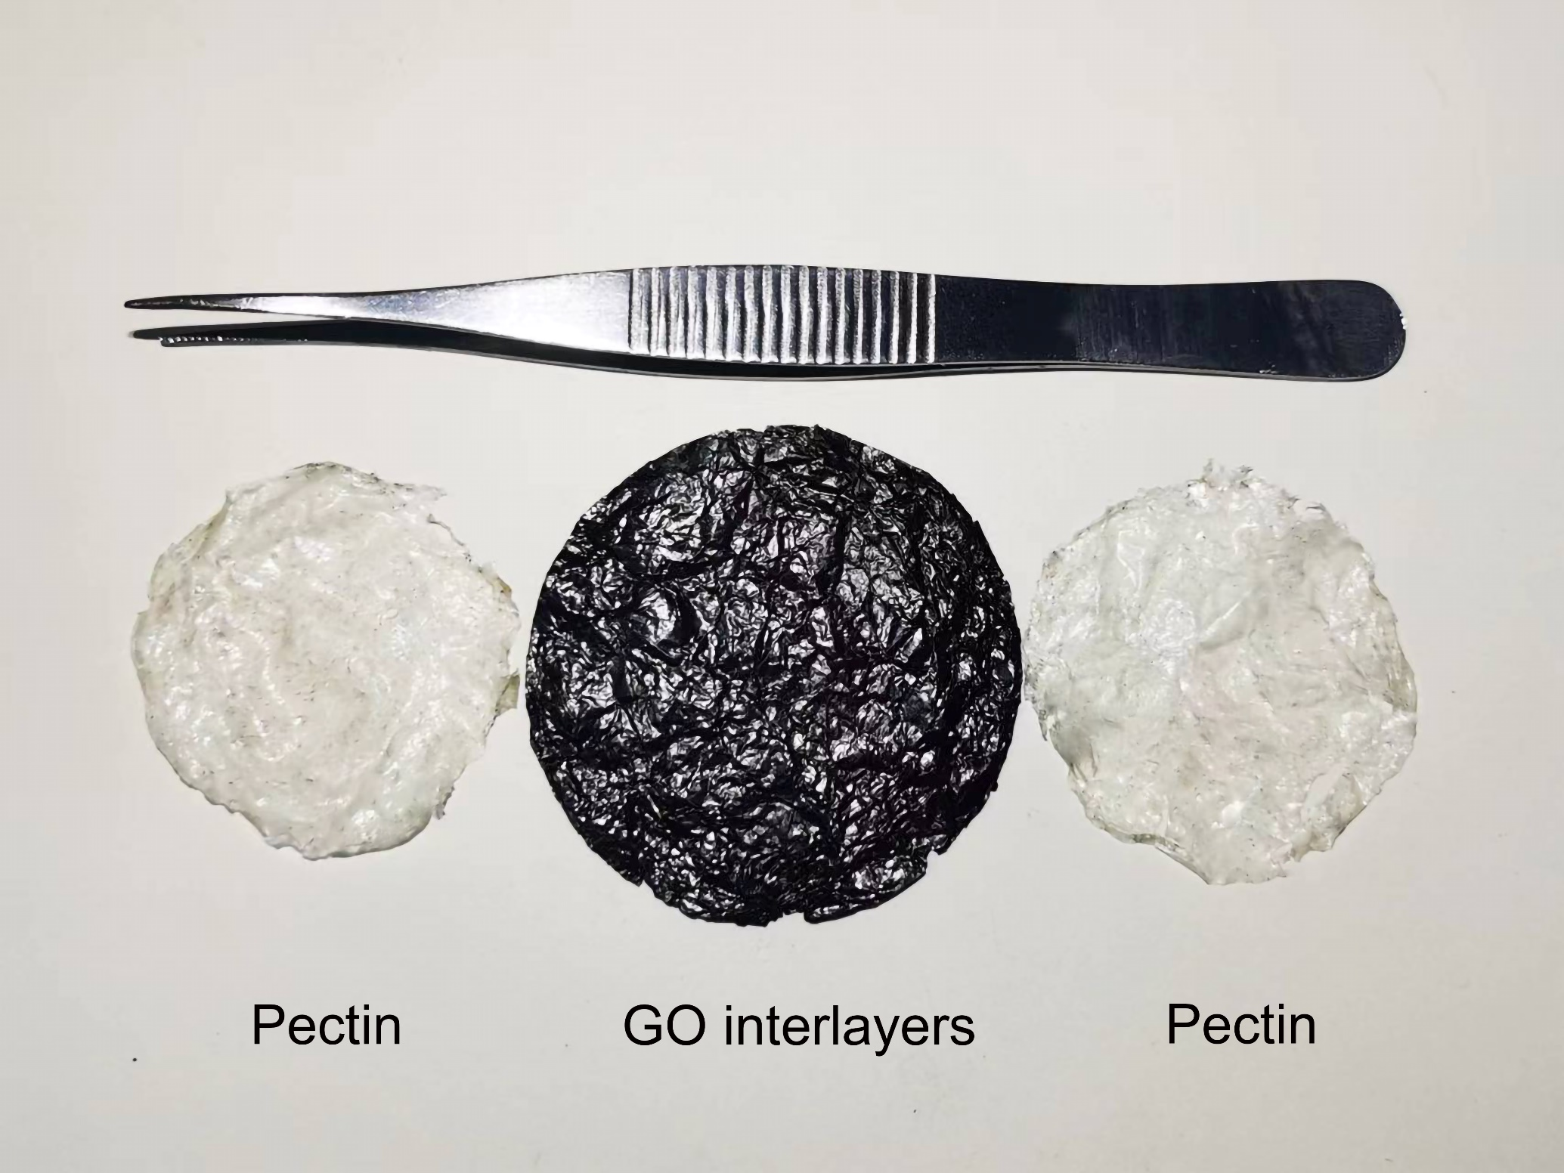
Fig.32 HPGP can be disassembled in layers by external force.

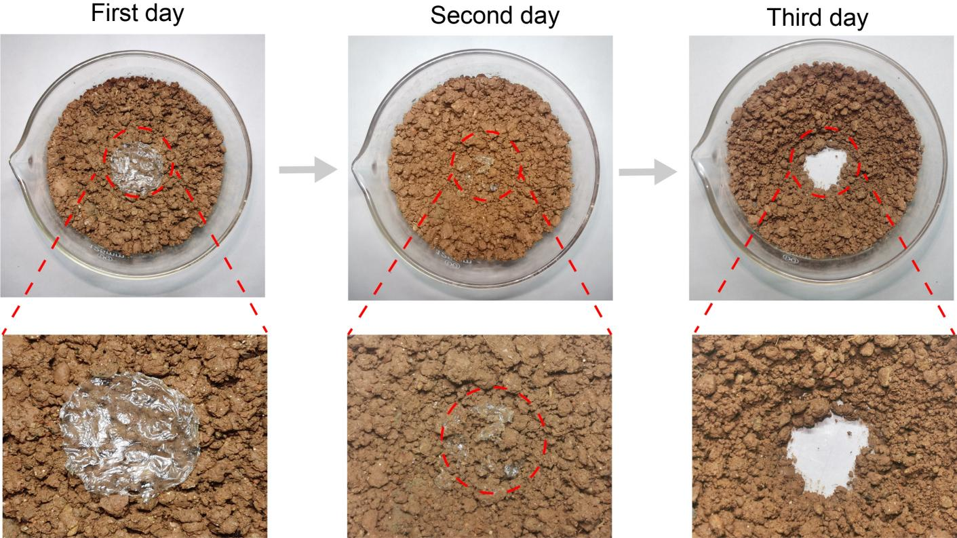
Fig.33 The pectin layer can be broken down naturally by placing it in the soil.

Table.6 Comparison of water harvesting effect of different adsorbent materials under outdoor conditions.
Sorbent materials | Water productivity (L_{water}⁻¹kg_{sorbent}⁻¹d⁻¹) | Reference
BHNC | 2.82 | ⁹
Agar /GG/PAM hydrogel | 2.57 | ¹¹
PAMPS-CNT-LiCl hydrogel | 2.41 | ²²
LiCl@rGO–SA | 2.12 | ²³
LCP | 2.10 | ²⁴
PAM–CS–MXene–LiCl aerogel | 1.92 | ⁷
PCLG | 0.90 | ²⁵
PDMAPS/CNT/LiCl | 0.69 | ²⁶
PAM-CNT-CaCl2 | 0.57 | ²⁷
HPGP (This work) | 2.86

Supplementary Section 6. Experimental section
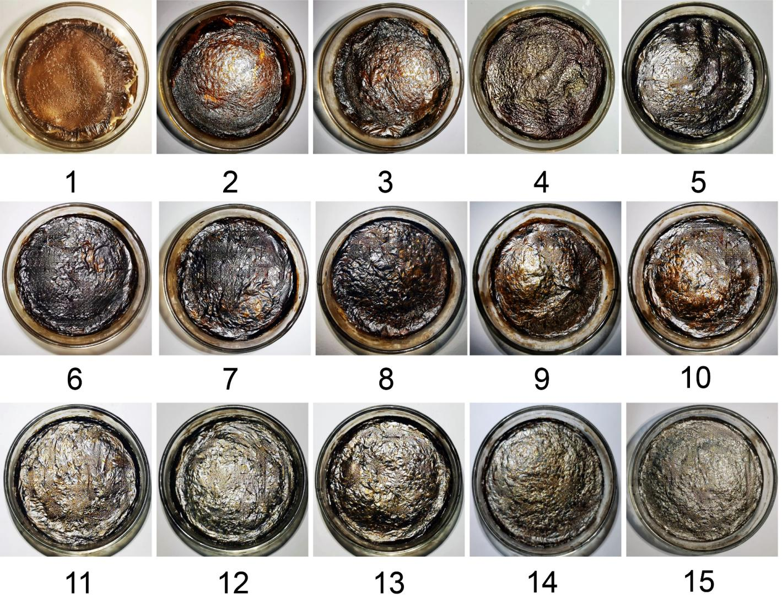
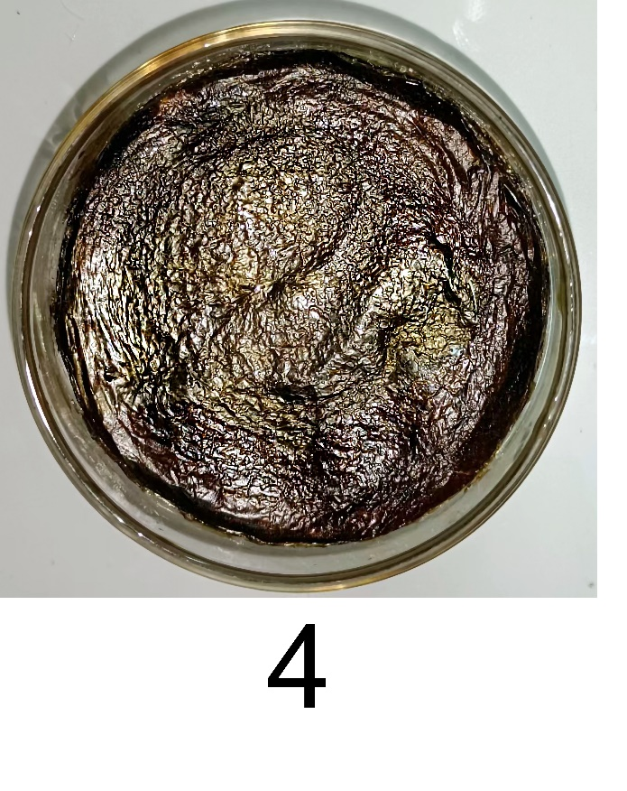
Fig.34 Surface wrinkling evolution in GO interlayers.
Fig.35 The surface wrinkles of GO interlayers diminish with increasing layer numbers.

Note 4: Figure 35 shows the variation of surface wrinkles in GO interlayers with increasing layer numbers. Before reaching four layers, the number of wrinkles increases with each additional layer. At the fourth layer, wave-like diverging wrinkles can be observed on the surface of GO interlayers. As the number of layers exceeds four, the wrinkles begin to show a slow decrease. This may be attributed to the uneven distribution of the GO solution on the surface caused by the protrusions of the wrinkles, with depressions between the prominent wrinkles allowing for more GO solution to accumulate. This gradual accumulation leads to the smoothing of the wrinkles with an increase in the number of layers (Fig.36).

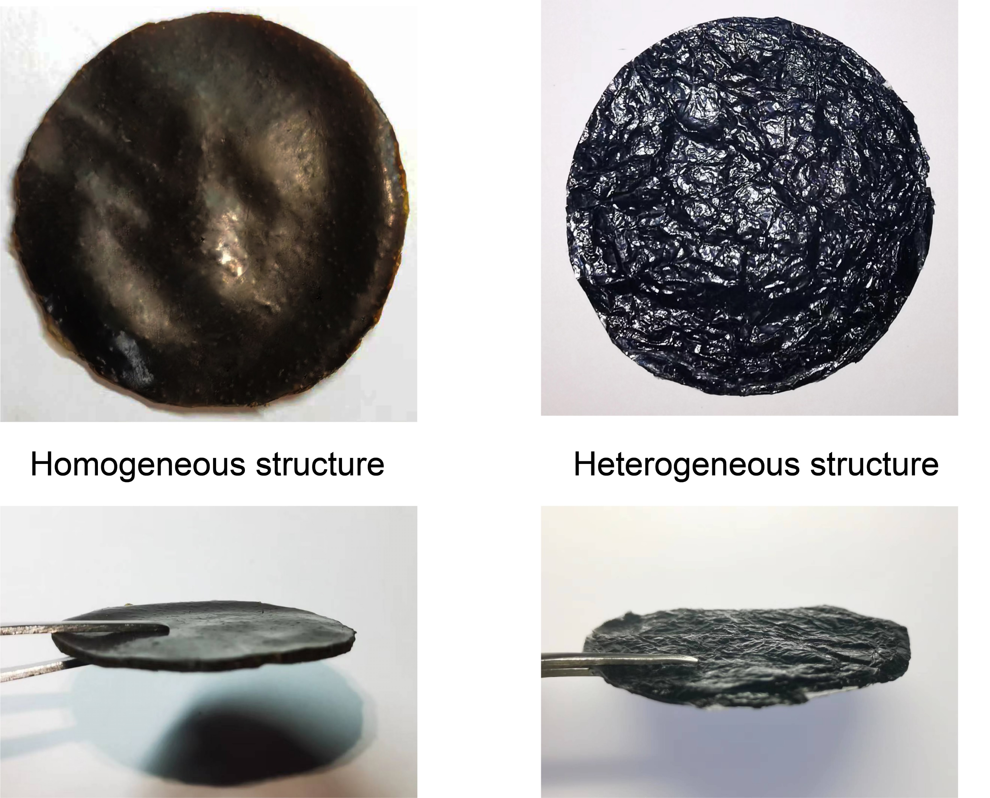
Fig.36 Comparison diagram of homogeneous structure and heterogeneous structure samples.

References
1. Zhang, Z. et al. A humidity/thermal dual response 3D-fabric with porous poly(N-isopropyl acrylamide) hydrogel towards efficient atmospheric water harvesting. Journal of Colloid and Interface Science 653, 1040–1051 (2024).
2. Sun, J. et al. Moisture-indicating cellulose aerogels for multiple atmospheric water harvesting cycles driven by solar energy. J. Mater. Chem. A 9, 24650–24660 (2021).
3. Deng, F., Wang, C., Xiang, C. & Wang, R. Bioinspired topological design of super hygroscopic complex for cost-effective atmospheric water harvesting. Nano Energy 90, 106642 (2021).
4. Ni, F. et al. Tillandsia‐Inspired Hygroscopic Photothermal Organogels for Efficient Atmospheric Water Harvesting. Angew Chem Int Ed 59, 19237–19246 (2020).
5. Zhang, W. et al. Enhanced adsorption-based atmospheric water harvesting using a photothermal cotton rod for freshwater production in cold climates. RSC Adv. 11, 35695–35702 (2021).
6. Zhao, F. et al. Super Moisture‐Absorbent Gels for All‐Weather Atmospheric Water Harvesting. Advanced Materials 31, 1806446 (2019).
7. Zhou, Z., Wang, G., Pei, X. & Zhou, L. Solar-powered MXene biopolymer aerogels for sorption-based atmospheric water harvesting. Journal of Cleaner Production 425, 138948 (2023).
8. Yao, H. et al. Highly Efficient Clean Water Production from Contaminated Air with a Wide Humidity Range. Advanced Materials 32, 1905875 (2020).
9. Li, T. et al. Scalable and efficient solar-driven atmospheric water harvesting enabled by bidirectionally aligned and hierarchically structured nanocomposites. Nat Water 1, 971–981 (2023).
10. Zhu, P. et al. 3D Printed Cellulose Nanofiber Aerogel Scaffold with Hierarchical Porous Structures for Fast Solar‐Driven Atmospheric Water Harvesting. Advanced Materials 36, 2306653 (2024).
11. He, Y. et al. Extremely Fast Wicking Self‐Layered Interpenetrating Network Hydrogel for Rapid All Day Collection of Atmospheric Water. Adv Funct Materials 2416875 (2024) doi:10.1002/adfm.202416875.
12. Zou, H. et al. Solar-driven scalable hygroscopic gel for recycling water from passive plant transpiration and soil evaporation. Nat Water 2, 663–673 (2024).
13. Dong, X., Cao, L., Si, Y., Ding, B. & Deng, H. Cellular Structured CNTs@SiO₂ Nanofibrous Aerogels with Vertically Aligned Vessels for Salt‐Resistant Solar Desalination. Advanced Materials 32, 1908269 (2020).
14. Yu, F. et al. Quasimetallic Molybdenum Carbide–Based Flexible Polyvinyl Alcohol Hydrogels for Enhancing Solar Water Evaporation. Adv Materials Inter 6, 1901168 (2019).
15. Xia, M. et al. Biomimetic Hygroscopic Fibrous Membrane with Hierarchically Porous Structure for Rapid Atmospheric Water Harvesting. Adv Funct Materials 33, 2214813 (2023).
16. Song, M. Spongy hygroscopic hydrogels for efficient atmospheric water harvesting over a wide humidity range. Journal of Cleaner Production (2024).
17. Sun, J. et al. Entangled Mesh Hydrogels with Macroporous Topologies via Cryogelation for Rapid Atmospheric Water Harvesting. Advanced Materials 36, 2314175 (2024).
18. Guo, H. et al. Super Moisture‐Sorbent Sponge for Sustainable Atmospheric Water Harvesting and Power Generation. Advanced Materials 36, 2414285 (2024).
19. Shan, H. et al. Integrating Rooftop Agriculture and Atmospheric Water Harvesting for Water‐Food Production Based on Hygroscopic Manganese Complex. Adv Funct Materials 34, 2402839 (2024).
20. Yang, X., Chen, Z., Xiang, C., Shan, H. & Wang, R. Enhanced continuous atmospheric water harvesting with scalable hygroscopic gel driven by natural sunlight and wind. Nat Commun 15, 7678 (2024).
21. Lin, B. et al. Biomass‐Derived Hydro‐Sponge for Ultra‐Efficient Atmospheric Water Harvesting. Adv Funct Materials 2500679 (2025) doi:10.1002/adfm.202500679.
22. Shan, H. et al. All‐Day Multicyclic Atmospheric Water Harvesting Enabled by Polyelectrolyte Hydrogel with Hybrid Desorption Mode. Advanced Materials 35, 2302038 (2023).
23. Xu, J. et al. Ultrahigh solar-driven atmospheric water production enabled by scalable rapid-cycling water harvester with vertically aligned nanocomposite sorbent. Energy Environ. Sci. 14, 5979–5994 (2021).
24. Lyu, T. et al. Macroporous Hydrogel for High-Performance Atmospheric Water Harvesting. ACS Appl. Mater. Interfaces 14, 32433–32443 (2022).
25. Wang, J. et al. High-yield and scalable water harvesting of honeycomb hygroscopic polymer driven by natural sunlight. Cell Reports Physical Science 3, 100954 (2022).
26. Aleid, S. et al. Salting-in Effect of Zwitterionic Polymer Hydrogel Facilitates Atmospheric Water Harvesting. ACS Materials Lett. 4, 511–520 (2022).
27. Li, R. et al. Hybrid Hydrogel with High Water Vapor Harvesting Capacity for Deployable Solar-Driven Atmospheric Water Generator. Environ. Sci. Technol. 52, 11367–11377 (2018).

