Socioeconomic Inequalities in the Association Between Diet Quality and Incident Cardiovascular Diseases: A Prospective Study in the Netherlands

Supplementary Materials

Ming-Jie Duan^{a*}, Maartje P Poelman^{b}, Eva Corpeleijn^{c}, Sander Biesbroekª
a-Division of Human Nutrition and Health, Wageningen University & Research, Wageningen, The Netherlands
b-Chair Group Consumption and Healthy Lifestyles, Wageningen University & Research, Wageningen, The Netherlands
c-Department of Epidemiology, University Medical Center Groningen, Groningen, The Netherlands
*Corresponding author: Ming-Jie Duan, Frederick.duan@wur.nl

List of Supplementary Tables
Supplementary Table S1. Self-report questionnaires used for assessing education (a) and income level (b) in the Lifelines cohort study
Supplementary Table S2. Baseline characteristics of study participants according to education levels
Supplementary Table S3. Baseline characteristics of study participants according to income levels
Supplementary Table S4. Frequency of incident non-fatal major cardiovascular events and all-cause mortality (secondary outcome) across Lifelines Diet Score quartiles, education levels, and income levels
Supplementary Table S5. Joint associations of Lifelines Diet Score and education with incident non-fatal major cardiovascular events
Supplementary Table S6. Associations of Lifelines Diet Score, education, and income with incident non-fatal major cardiovascular events and all-cause mortality (secondary outcome)
Supplementary Table S7. Associations between Lifelines Diet Score and incident non-fatal major cardiovascular events and all-cause mortality across education levels (secondary outcome)
Supplementary Table S8. Joint associations of Lifelines Diet Score and education with incident non-fatal major cardiovascular events and all-cause mortality (secondary outcome)
Supplementary Table S9. Associations of Lifelines Diet Score, education, and income with incident non-fatal major cardiovascular events, supplementary models
Supplementary Table S10. Effects of other covariates on the associations between Lifelines Diet Score and incident non-fatal major cardiovascular events
Supplementary Table S11. Associations of Lifelines Diet Score, education, and income with incident non-fatal major cardiovascular events, excluding participants with follow-up time ≤ 24 months
Supplementary Table S12. Associations of Lifelines Diet Score, education, and income with incident non-fatal major cardiovascular events, excluding participants with follow-up time ≤ 36 months
Supplementary Table S13. Associations of Lifelines Diet Score, education, and income with incident non-fatal major cardiovascular events, complete case analysis
Supplementary Table S14. Intake of food groups included in Lifelines Diet Score across education level
Supplementary Table S15. Baseline characteristics of study participants who had no follow-up data

List of Supplementary Figures
Supplementary Figure S1. Study flow chart
Supplementary Figure S2. Kaplan-Meier survival curve for incident non-fatal major cardiovascular events
Supplementary Figure S3. Kaplan-Meier survival curve for incident non-fatal major cardiovascular events and all-cause mortality
Supplementary Figure S4. Associations between Lifelines Diet Score and incident cardiovascular diseases, estimated using restricted cubic splines

Supplementary Table S1. Self-report questionnaires used for assessing education (a) and income level (b) in the Lifelines cohort study
(a) Education level*
Question: What is the highest degree you have obtained?
Question in Dutch: Wat is je hoogst behaalde diploma?
Categories | Choices for responses
High education | Higher vocational education (such as HBO, HTS, HEAO); university degree or higher (bachelor, master, doctoral degree).
Middle education | Secondary vocational education or work-based learning pathway (such as MBO-long, VWO, Atheneum, Gymnasium, INAS); senior general secondary education/pre-university secondary education (such as HAVO, VWO, Atheneum, Gymnasium, HBS, MMS).
Low education | No education (did not finish primary school); primary education (primary school, special needs primary school); lower or preparatory secondary vocational education (such as LTS, LEAO, LHNO, VMBO); junior general secondary education (such as MAVO, (M)ULO, MBO-short, VMBO-t).
Other, namely | If participants were not sure about their education level or did not find matching answers for their education level, they could fill out a short description in the questionnaire. These string variables were further checked and re-coded manually into their corresponding education levels.
* High, middle and low education levels correspond to level 0, 1, and 2 from the International Standard Classification of Education [1].
[1] UNESCO. International Standard Classification of Education - ISCED 2011. Montreal, Canada: UNESCO Institute for Statistics; 2012. Available at: http://uis.unesco.org/sites/default/files/documents/isced-2011-en.pdf

(b) Income level
Question: What is the net income per month? (if you share a household, include the net income of your partner(s).
Question in Dutch: Hoeveel bedraagt het netto inkomen per maand? (als u het huishouden met iemand deelt, dan ook de inkomsten van uw partner(s) meetellen).
Categories | Choices for responses
Low <1000 euro/month | <750 euro/month; 750-1000 euro/month.
Lower-middle 1000-2000 euro/month | 1000-1500 euro/month; 1500-2000 euro/month.
Upper-middle 2000-3000 euro/month | 2000-2500 euro/month; 2500-3000 euro/month.
High >3000 euro/month | 3000-3500 euro/month; >3500 euro/month.
No response | I do not know/I prefer not to answer.

Supplementary Table S2. Baseline characteristics of study participants according to education levels*
 | Education levels
 | Low | Middle | High | Total
Number of participants, n | 23,518 | 32,312 | 26,530 | 82,360
Age, years | 50.7 (10.3) | 45.1 (8.8) | 44.9 (9.8) | 46.6 (9.9)
Sex, %
Women | 58.6 | 59.8 | 54.9 | 57.9
Men | 41.4 | 40.2 | 45.1 | 42.2
Lifelines Diet Score | 23.4 (6.0) | 23.4 (5.9) | 25.3 (5.9) | 24.0 (6.0)
Lifelines Diet Score quartiles, %
Q1 (poorest) | 26.6 | 26.0 | 16.9 | 23.2
Q2 | 24.9 | 25.5 | 21.9 | 24.2
Q3 | 23.7 | 23.7 | 25.8 | 24.4
Q4 (best) | 24.8 | 24.8 | 35.4 | 28.2
Total energy intake, kcal/day | 1983 (1629, 2433) | 2021 (1669, 2448) | 2004 (1661, 2391) | 2004 (1656, 2423)
Total alcohol intake, grams/day | 3.6 (0.6, 10.7) | 3.6 (0.8, 10.0) | 6.0 (1.5, 11.6) | 4.0 (0.9, 10.5)
Savory and fast foods intake, grams/day | 23.1 (10.2, 43.2) | 30.9 (15.5, 51.4) | 30.9 (14.9, 50.9) | 28.1 (13.6, 49.1)
Income (euro/month), %
<1000 | 5.1 | 3.0 | 1.4 | 3.1
1000-2000 | 26.9 | 17.9 | 10.8 | 18.2
2000-3000 | 31.1 | 33.9 | 24.1 | 29.9
>3000 | 15.6 | 29.8 | 54.9 | 33.8
No response or missing | 21.4 | 15.5 | 8.8 | 15.0
Employment status, %
Employed, doing a paid job | 70.0 | 86.5 | 89.1 | 82.6
Retired, with a pension | 11.0 | 3.6 | 4.9 | 6.1
Unemployed | 5.5 | 3.5 | 2.7 | 3.9
Unfit for work | 2.9 | 1.5 | 0.9 | 1.7
Other | 10.4 | 4.8 | 2.4 | 5.6
TV watching time, hours/day | 2.9 (1.4) | 2.4 (1.2) | 2.0 (1.1) | 2.4 (1.3)
Moderate-to-vigorous physical activity, minutes/week | 270 (90, 690) | 255 (100, 600) | 240 (105, 420) | 240 (100, 540)
Sleep duration, %
7-9 hours/day | 82.5 | 84.6 | 85.0 | 84.1
<7 or >9 hours/day | 17.1 | 15.2 | 14.8 | 15.6
Smoking status, %
Never | 35.6 | 45.5 | 53.5 | 45.2
Former | 40.5 | 34.0 | 32.6 | 35.4
Current | 23.4 | 20.0 | 13.5 | 18.9
Participation in social or hobby clubs, % | 21.1 | 21.9 | 18.8 | 20.7
Hypertension, %
Yes, treated | 10.4 | 6.5 | 5.3 | 7.2
Yes, untreated | 19.5 | 14.4 | 11.9 | 15.0
No hypertension | 70.2 | 79.2 | 82.9 | 77.8
Systolic blood pressure, mmHg | 128.4 (15.8) | 124.7 (14.6) | 122.9 (14.5) | 125.2 (15.1)
Diastolic blood pressure, mmHg | 75.4 (9.4) | 74.2 (9.3) | 73.3 (9.2) | 74.3 (9.3)
Diabetes, %
Yes, treated | 1.9 | 1.1 | 0.8 | 1.2
Yes, untreated | 2.2 | 1.5 | 1.2 | 1.6
No diabetes | 95.9 | 97.4 | 98.0 | 97.2
Fasting blood glucose, mmol/L | 5.1 (0.8) | 5.0 (0.8) | 4.9 (0.7) | 5.0 (0.8)
HbA_{1c}, % | 5.6 (0.4) | 5.5 (0.4) | 5.5 (0.4) | 5.6 (0.4)
Abnormal blood lipids, %
Yes, treated | 7.6 | 4.0 | 3.2 | 4.8
Yes, untreated | 39.9 | 36.6 | 31.9 | 36.0
No abnormal blood lipids | 52.5 | 59.4 | 65.0 | 59.2
Triglycerides, mmol/L | 1.3 (0.9) | 1.2 (0.8) | 1.1 (0.7) | 1.2 (0.8)
HDL-cholesterol, mmol/L | 1.5 (0.4) | 1.5 (0.4) | 1.5 (0.4) | 1.5 (0.4)
Total cholesterol, mmol/L | 5.4 (1.0) | 5.2 (1.0) | 5.1 (1.0) | 5.2 (1.0)
BMI, kg/m² | 26.8 (4.2) | 26.2 (4.1) | 25.2 (3.7) | 26.1 (4.1)
Chronic stress scores | 1 (0, 3) | 2 (1, 4) | 2 (1, 4) | 2 (1, 3)
Family history of cardiovascular diseases, % | 18.9 | 16.8 | 16.7 | 17.4
* Baseline characteristics of study participants included in the analysis for the primary outcome (non-fatal major cardiovascular events). Data are expressed as unadjusted mean ± standard deviation for age, Lifelines Diet Score (no unit), TV watching time, systolic blood pressure, diastolic blood pressure, fasting blood glucose, HbA_{1c}, triglycerides, HDL-cholesterol, total cholesterol, and BMI; data are expressed as median (interquartile) for total energy intake, total alcohol intake, savory and fast foods intake, moderate-to-vigorous physical activity, and chronic stress scores; data are expressed as observed percentages for other variables in the table if not specified.

Supplementary Table S3. Baseline characteristics of study participants according to income levels*
 | Income levels (euro/month)
 | <1000 | 1000-20000 | 2000-3000 | >3000 | No response or missing
Number of participants, n | 2537 | 14,983 | 24,637 | 27,859 | 12,344
Age, years | 47.1 (10.2) | 47.9 (11.1) | 46.5 (10.0) | 45.5 (9.0) | 47.9 (9.9)
Sex, %
Women | 80.5 | 61.6 | 54.8 | 52.9 | 66.3
Men | 19.5 | 38.4 | 45.3 | 47.1 | 33.7
Lifelines Diet Score | 23.5 (6.4) | 23.8 (6.1) | 23.8 (5.9) | 24.6 (5.9) | 23.5 (6.0)
Lifelines Diet Score quartiles, %
Q1 (poorest) | 27.5 | 24.8 | 24.0 | 20.0 | 26.3
Q2 | 23.7 | 24.0 | 25.0 | 23.3 | 24.9
Q3 | 21.3 | 23.8 | 24.7 | 25.2 | 23.4
Q4 (best) | 27.5 | 27.5 | 26.3 | 31.5 | 25.4
Total energy intake, kcal/day | 1829 (1502, 2238) | 1966 (1613, 2404) | 2047 (1698, 2461) | 2018 (1679, 2423) | 1962 (1607, 2395)
Total alcohol intake, grams/day | 2.0 (0, 7.1) | 3.2 (0.6, 9.8) | 4.0 (0.9, 10.7) | 6.3 (1.7, 12.1) | 2.9 (0.4, 8.9)
Savory and fast foods intake, grams/day | 21.6 (8.7, 42.1) | 24.3 (11.0, 45.1) | 29.6 (15.0, 50.1) | 32.1 (15.9, 52.3) | 24.5 (11.7, 44.1)
Education level, %
Low | 46.8 | 42.2 | 29.7 | 13.2 | 40.7
Middle | 38.2 | 38.6 | 44.4 | 34.5 | 40.5
High | 15.0 | 19.2 | 25.9 | 52.3 | 18.8
Employment status, %
Employed, doing a paid job | 60.9 | 73.6 | 84.3 | 91.9 | 73.9
Retired, with a pension | 4.5 | 9.4 | 6.7 | 4.0 | 6.1
Unemployed | 22.3 | 5.9 | 2.9 | 1.5 | 4.6
Unfit for work | 8.0 | 2.8 | 1.6 | 0.5 | 2.1
Other | 4.3 | 8.2 | 4.5 | 2.1 | 13.1
TV watching time, hours/day | 2.9 (1.7) | 2.7 (1.4) | 2.5 (1.3) | 2.2 (1.1) | 2.5 (1.3)
Moderate-to-vigorous physical activity, minutes/week | 270 (100, 600) | 270 (100, 630) | 260 (100, 600) | 240 (100, 455) | 240 (90, 600)
Sleep duration, %
7-9 hours/day | 79.8 | 82.5 | 85.0 | 84.7 | 84.2
<7 or >9 hours/day | 19.4 | 17.2 | 14.9 | 15.2 | 15.4
Smoking status, %
Never | 40.8 | 40.6 | 43.7 | 48.3 | 48.2
Former | 30.8 | 35.1 | 36.7 | 35.6 | 34.0
Current | 27.9 | 23.8 | 19.2 | 15.8 | 17.4
Participation in social or hobby clubs, % | 16.9 | 19.4 | 21.9 | 20.0 | 23.0
Hypertension, %
Yes, treated | 9.8 | 8.7 | 7.1 | 5.8 | 8.2
Yes, untreated | 13.5 | 16.3 | 15.6 | 13.5 | 16.1
No hypertension | 76.7 | 75.0 | 77.3 | 80.7 | 75.8
Systolic blood pressure, mmHg | 123.5 (16.0) | 126.1 (15.7) | 125.7 (15.0) | 124.1 (14.5) | 125.8 (15.3)
Diastolic blood pressure, mmHg | 73.1 (9.3) | 74.4 (9.5) | 74.6 (9.3) | 74.1 (9.3) | 74.1 (9.3)
Diabetes, %
Yes, treated | 1.8 | 1.8 | 1.1 | 0.9 | 1.4
Yes, untreated | 1.9 | 2.3 | 1.6 | 1.1 | 1.9
No diabetes | 96.3 | 95.9 | 97.3 | 98.0 | 96.7
Fasting blood glucose, mmol/L | 5.0 (0.8) | 5.0 (0.9) | 5.0 (0.7) | 5.0 (0.7) | 5.0 (0.8)
HbA_{1c}, % | 5.6 (0.4) | 5.6 (0.5) | 5.6 (0.4) | 5.5 (0.4) | 5.6 (0.4)
Abnormal blood lipids, %
Yes, treated | 5.6 | 6.2 | 4.7 | 3.8 | 5.3
Yes, untreated | 36.7 | 37.1 | 37.3 | 34.2 | 36.3
No abnormal blood lipids | 57.7 | 56.7 | 58.1 | 62.0 | 58.4
Triglycerides, mmol/L | 1.1 (0.7) | 1.2 (0.8) | 1.2 (0.8) | 1.1 (0.8) | 1.1 (0.8)
HDL-cholesterol, mmol/L | 1.6 (0.4) | 1.5 (0.4) | 1.5 (0.4) | 1.5 (0.4) | 1.5 (0.4)
Total cholesterol, mmol/L | 5.2 (1.0) | 5.2 (1.0) | 5.2 (1.0) | 5.2 (1.0) | 5.2 (1.0)
BMI, kg/m² | 26.3 (5.0) | 26.4 (4.5) | 26.2 (4.1) | 25.6 (3.7) | 26.2 (4.2)
Chronic stress scores | 3 (1, 5) | 2 (1, 4) | 2 (1, 3) | 2 (1, 3) | 1 (0, 3)
Family history of cardiovascular diseases, % | 17.6 | 17.6 | 17.3 | 17.4 | 17.2
* Baseline characteristics of study participants included in the analysis for the primary outcome (non-fatal major cardiovascular events). Data are expressed as unadjusted mean ± standard deviation for age, Lifelines Diet Score (no unit), TV watching time, systolic blood pressure, diastolic blood pressure, fasting blood glucose, HbA_{1c}, triglycerides, HDL-cholesterol, total cholesterol, and BMI; data are expressed as median (interquartile) for total energy intake, total alcohol intake, savory and fast foods intake, moderate-to-vigorous physical activity, and chronic stress scores; data are expressed as observed percentages for other variables in the table if not specified.
Supplementary Table S4. Frequency of incident non-fatal major cardiovascular events and all-cause mortality (secondary outcome) across Lifelines Diet Score quartiles, education levels, and income levels
 | Events/population | Proportion of cases, %* | Incidence, % | Incidence rate (per 1000 person-years)
Lifelines Diet Score quartiles
Q1 (Poorest) | 995/19,235 | 20.5 | 5.2 | 7.3
Q2 | 1125/20,036 | 23.2 | 5.6 | 7.7
Q3 | 1220/20,175 | 25.1 | 6.0 | 8.1
Q4 (Best) | 1512/23,313 | 31.2 | 6.5 | 8.5
Education
Low | 2029/23,728 | 41.8 | 8.6 | 12.4
Middle | 1644/32,420 | 33.9 | 5.1 | 6.9
High | 1179/26,611 | 24.3 | 4.4 | 5.7
Income (euro/month)
<1000 | 190/2566 | 3.9 | 7.4 | 10.9
1000-2000 | 1145/15,098 | 23.6 | 7.6 | 10.6
2000-3000 | 1462/24,743 | 30.1 | 5.9 | 8.0
>3000 | 1311/27,926 | 27.0 | 4.7 | 6.1
No response or missing | 744/12,426 | 15.3 | 6.0 | 8.6
Total | 4852/82,759 | 100 | 5.9 | 8.0
* Proportion of cases was calculated by dividing number of cases in the group of interests by total number of cases.

Supplementary Table S5. Joint associations of Lifelines Diet Score and education with incident non-fatal major cardiovascular events
 | Lifelines Diet Score quartiles
Education levels | Q1 (Poorest) | Q2 | Q3 | Q4 (Best)
Model 1*
Low | 1.91 (1.61, 2.27) | 1.58 (1.33, 1.88) | 1.38 (1.16, 1.63) | 1.29 (1.10, 1.52)
Middle | 1.64 (1.37, 1.95) | 1.53 (1.28, 1.81) | 1.33 (1.13, 1.58) | 1.17 (0.99, 1.38)
High | 1.03 (0.80, 1.32) | 1.14 (0.94, 1.40) | 1.08 (0.90, 1.29) | 1
Model 2†
Low | 1.62 (1.36, 1.93) | 1.41 (1.19, 1.68) | 1.26 (1.06, 1.50) | 1.22 (1.03, 1.44)
Middle | 1.42 (1.18, 1.70) | 1.39 (1.17, 1.65) | 1.22 (1.03, 1.45) | 1.14 (0.96, 1.34)
High | 0.95 (0.74, 1.22) | 1.08 (0.89, 1.32) | 1.03 (0.86, 1.24) | 1
* Model 1: HRs (95% CI) derived from multivariate Cox proportional hazard models adjusted for age (timescale), sex, total energy intake, and income, n = 82,089.
† Model 2: HRs (95% CI) derived from multivariate Cox proportional hazard models adjusted for Model 1 covariates plus total alcohol intake, smoking status, TV watching time, moderate-to-vigorous physical activity, sleep duration, social/hobby clubs participation, chronic stress scores, family history of cardiovascular diseases, and BMI, n = 81,316.

Supplementary Table S6. Associations of Lifelines Diet Score, education, and income with incident non-fatal major cardiovascular events and all-cause mortality (secondary outcome)
 | Model 1* | Model 2† | Model 3‡ | Model 4§
Lifelines Diet Score quartiles
Q1 (Poorest) | 1.48 (1.37, 1.61) | 1.31 (1.21, 1.43) | 1.31 (1.21, 1.43) | 1.29 (1.19, 1.41)
Q2 | 1.29 (1.20, 1.40) | 1.21 (1.12, 1.31) | 1.21 (1.12, 1.32) | 1.20 (1.11, 1.30)
Q3 | 1.13 (1.05, 1.22) | 1.09 (1.01, 1.17) | 1.09 (1.01, 1.17) | 1.08 (1.00, 1.16)
Q4 (Best) | 1 | 1 | 1 | 1
Continuous|| | 1.16 (1.13, 1.20) | 1.11 (1.07, 1.14) | 1.11 (1.07, 1.14) | 1.10 (1.07, 1.14)
Education
Low | 1.33 (1.23, 1.44) | 1.29 (1.19, 1.40) | 1.29 (1.19, 1.40) | 1.26 (1.16, 1.37)
Middle | 1.25 (1.16, 1.35) | 1.23 (1.13, 1.33) | 1.23 (1.13, 1.33) | 1.21 (1.12, 1.31)
High | 1 | 1 | 1 | 1
Income (euro/month)
<1000 | 1.51 (1.30, 1.76) | 1.26 (1.08, 1.47) | 1.26 (1.08, 1.48) | 1.26 (1.08, 1.48)
1000-2000 | 1.23 (1.13, 1.33) | 1.13 (1.04, 1.23) | 1.13 (1.04, 1.23) | 1.12 (1.03, 1.22)
2000-3000 | 1.06 (0.99, 1.15) | 1.04 (0.96, 1.12) | 1.04 (0.96, 1.12) | 1.04 (0.96, 1.12)
>3000 | 1 | 1 | 1 | 1
Multiplicative interaction¶ | Model 1a | Model 2a | Model 3a | Model 4a
Education × Lifelines Diet Score | 1.04 (1.00, 1.07) | 1.03 (0.99, 1.06) | 1.03 (0.99, 1.06) | 1.03 (0.99, 1.07)
P-value interaction | 0.048 | 0.134 | 0.143 | 0.101
Income × Lifelines Diet Score | 1.01 (0.97, 1.04) | 1.00 (0.97, 1.04) | 1.00 (0.97, 1.04) | 1.00 (0.97, 1.04)
P-value interaction | 0.628 | 0.879 | 0.892 | 0.781
* Model 1: HRs (95% CI) derived from multivariate Cox proportional hazard models adjusted for age (timescale), sex, Lifelines Diet Score, total energy intake, education, and income, n = 82,485.
† Model 2: HRs (95% CI) derived from multivariate Cox proportional hazard models adjusted for Model 1 covariates plus total alcohol intake, smoking status, TV watching time, moderate-to-vigorous physical activity, sleep duration, social/hobby clubs participation, and chronic stress scores, n = 81,740.
‡ Model 3: HRs (95% CI) derived from multivariate Cox proportional hazard models adjusted for Model 2 covariates plus family history of cardiovascular diseases, n = 81,740.
§ Model 4: HRs (95% CI) derived from multivariate Cox proportional hazard models adjusted for Model 3 covariates plus BMI, n = 81,707.
|| Continuous models indicate HRs (95% CI) for a one standard deviation decrease in the Lifelines Diet Score.
¶ Multiplicative interaction was assessed with a product term between diet quality (measured as decrease in the Lifelines Diet Score) and education, and between diet quality and income, both treated as continuous variables from low to high. Effects were presented as HRs (95% CI) derived from multivariate Cox proportional hazard models. Model 1a adjusted for Model 1 covariates plus interaction term, n = 82,485. Model 2a adjusted for Model 2 covariates plus interaction term, n = 81,740. Model 3a adjusted for Model 3 covariates plus interaction term, n = 81,740. Model 4a adjusted for Model 4 covariates plus interaction term, n = 81,707. Each interaction term was assessed in separate models.

Supplementary Table S7. Associations between Lifelines Diet Score and incident non-fatal major cardiovascular events and all-cause mortality across education levels (secondary outcome)
 | Lifelines Diet Score quartiles
 | Q1 (Poorest) | Q2 | Q3 | Q4 (Best) | Continuous*
Low education
Model 1† | 1.59 (1.40, 1.81) | 1.33 (1.18, 1.51) | 1.17 (1.04, 1.32) | 1 | 1.19 (1.13, 1.24)
Model 2‡ | 1.36 (1.19, 1.55) | 1.22 (1.08, 1.39) | 1.13 (1.00, 1.27) | 1 | 1.11 (1.06, 1.17)
Middle education
Model 1† | 1.46 (1.27, 1.68) | 1.23 (1.08, 1.41) | 1.07 (0.94, 1.23) | 1 | 1.15 (1.09, 1.22)
Model 2‡§ | 1.28 (1.11, 1.48) | 1.15 (1.00, 1.32) | 1.02 (0.89, 1.16) | 1 | 1.10 (1.04, 1.16)
High education
Model 1† | 1.26 (1.04, 1.52) | 1.35 (1.15, 1.57) | 1.15 (1.00, 1.33) | 1 | 1.13 (1.06, 1.20)
Model 2‡ | 1.12 (0.92, 1.36) | 1.24 (1.06, 1.46) | 1.09 (0.94, 1.26) | 1 | 1.07 (1.01, 1.14)
* Continuous models indicate HRs (95% CI) for a one standard deviation decrease in Lifelines Diet Score.
† Model 1: HRs (95% CI) derived from multivariate Cox proportional hazard models adjusted for age (timescale), sex, Lifelines Diet Score, total energy intake, and income, n = 23,588 (low education), n = 32,331 (middle education), and n = 26,566 (high education).
‡ Model 2: HRs (95% CI) derived from multivariate Cox proportional hazard models adjusted for Model 1 covariates plus total alcohol intake, smoking status, TV watching time, moderate-to-vigorous physical activity, sleep duration, social/hobby clubs participation, chronic stress scores, family history of cardiovascular diseases, and BMI, n = 23,327 (low education), n = 32,053 (middle education), and n = 26,322 (high education).
§ Multivariate Cox proportional hazard models stratified by TV watching time and hypertension.

Supplementary Table S8. Joint associations of Lifelines Diet Score and education with incident non-fatal major cardiovascular events and all-cause mortality (secondary outcome)
 | Lifelines Diet Score quartiles
Education levels | Q1 (Poorest) | Q2 | Q3 | Q4 (Best)
Model 1*
Low | 2.05 (1.80, 2.33) | 1.69 (1.49, 1.93) | 1.48 (1.30, 1.68) | 1.26 (1.11, 1.42)
Middle | 1.84 (1.61, 2.12) | 1.56 (1.36, 1.79) | 1.36 (1.19, 1.56) | 1.27 (1.12, 1.44)
High | 1.23 (1.02, 1.48) | 1.32 (1.14, 1.54) | 1.14 (0.99, 1.32) | 1
Model 2†
Low | 1.68 (1.47, 1.92) | 1.49 (1.30, 1.70) | 1.36 (1.19, 1.55) | 1.19 (1.05, 1.35)
Middle | 1.56 (1.35, 1.79) | 1.40 (1.22, 1.61) | 1.24 (1.08, 1.42) | 1.24 (1.09, 1.41)
High | 1.11 (0.92, 1.34) | 1.23 (1.05, 1.44) | 1.09 (0.94, 1.25) | 1
* Model 1: HRs (95% CI) derived from multivariate Cox proportional hazard models adjusted for age (timescale), sex, total energy intake, and income, n = 82,485.
† Model 2: HRs (95% CI) derived from multivariate Cox proportional hazard models adjusted for Model 1 covariates plus total alcohol intake, smoking status, TV watching time, moderate-to-vigorous physical activity, sleep duration, social/hobby clubs participation, chronic stress scores, family history of cardiovascular diseases, and BMI, n = 81,707.

Supplementary Table S9. Associations of Lifelines Diet Score, education, and income with incident non-fatal major cardiovascular events, supplementary models
(1) Model S1-S4
 | Model S1* | Model S2† | Model S3‡ | Model S4§
Lifelines Diet Score quartiles
Q1 (Poorest) |  | 1.42 (1.27, 1.58) | 1.24 (1.11, 1.39) | 1.21 (1.09, 1.36)
Q2 |  | 1.27 (1.15, 1.40) | 1.17 (1.06, 1.30) | 1.16 (1.04, 1.28)
Q3 |  | 1.11 (1.01, 1.23) | 1.06 (0.96, 1.17) | 1.04 (0.94, 1.15)
Q4 (Best) |  | 1 | 1 | 1
Continuous|| |  | 1.15 (1.10, 1.19) | 1.09 (1.05, 1.13) | 1.08 (1.04, 1.12)
Education
Low | 1.42 (1.28, 1.58) |  | 1.29 (1.16, 1.44) | 1.30 (1.17, 1.45)
Middle | 1.30 (1.18, 1.43) |  | 1.23 (1.11, 1.36) | 1.22 (1.10, 1.35)
High | 1 |  | 1 | 1
Income (euro/month)
<1000 | 1.29 (1.02, 1.61) |  | 1.13 (0.90, 1.43) | 1.01 (0.80, 1.28)
1000-2000 | 1.15 (1.03, 1.28) |  | 1.08 (0.97, 1.21) | 1.05 (0.94, 1.18)
2000-3000 | 1.02 (0.93, 1.13) |  | 1.00 (0.91, 1.11) | 1.00 (0.90, 1.10)
>3000 | 1 |  | 1 | 1
* Model S1: HRs (95% CI) derived from multivariate Cox proportional hazard models adjusted for age (timescale), sex, education, and income, n = 82,089.
† Model S2: HRs (95% CI) derived from multivariate Cox proportional hazard models adjusted for age (timescale), sex, Lifelines Diet Score, and total energy intake, n = 82,360.
‡ Model S3: HRs (95% CI) derived from multivariate Cox proportional hazard models adjusted for Model S2 covariates plus education, income, total alcohol intake, smoking status, TV watching time, moderate-to-vigorous physical activity, sleep duration, and social/hobby clubs participation, n = 81,357.
§ Model S4: HRs (95% CI) derived from multivariate Cox proportional hazard models adjusted for Model S3 covariates plus chronic stress scores, family history of cardiovascular diseases, and employment status, n = 81,308.
|| Continuous models indicate HRs (95% CI) for a one standard deviation decrease in Lifelines Diet Score.

(2) Model S5-S8
 | Model S5* | Model S6† | Model S7‡ | Model S8§
Lifelines Diet Score quartiles
Q1 (Poorest) | 1.18 (1.05, 1.32) | 1.21 (1.08, 1.36) | 1.18 (1.05, 1.32) | 1.18 (1.05, 1.32)
Q2 | 1.13 (1.02, 1.25) | 1.15 (1.04, 1.28) | 1.13 (1.02, 1.26) | 1.13 (1.02, 1.26)
Q3 | 1.03 (0.93, 1.14) | 1.04 (0.94, 1.15) | 1.03 (0.93, 1.14) | 1.03 (0.93, 1.14)
Q4 (Best) | 1 | 1 | 1 | 1
Continuous|| | 1.07 (1.03, 1.11) | 1.08 (1.04, 1.12) | 1.07 (1.02, 1.11) | 1.07 (1.02, 1.11)
Education
Low | 1.29 (1.16, 1.44) | 1.30 (1.17, 1.45) | 1.27 (1.14, 1.41) | 1.27 (1.14, 1.41)
Middle | 1.22 (1.10, 1.35) | 1.22 (1.11, 1.35) | 1.21 (1.09, 1.34) | 1.20 (1.09, 1.33)
High | 1 | 1 | 1 | 1
Income (euro/month)
<1000 | 1.05 (0.83, 1.33) | 1.06 (0.84, 1.33) | 1.03 (0.81, 1.29) | 0.99 (0.78, 1.25)
1000-2000 | 1.05 (0.94, 1.17) | 1.05 (0.94, 1.18) | 1.04 (0.93, 1.16) | 1.04 (0.93, 1.17)
2000-3000 | 0.99 (0.90, 1.09) | 0.99 (0.90, 1.10) | 0.99 (0.90, 1.09) | 0.99 (0.90, 1.09)
>3000 | 1 | 1 | 1 | 1
* Model S5: HRs (95% CI) derived from multivariate Cox proportional hazard models adjusted for Model S3 covariates plus chronic stress scores, family history of cardiovascular diseases, BMI, total cholesterol, HDL-cholesterol, and triglycerides, n = 81,305.
† Model S6: HRs (95% CI) derived from multivariate Cox proportional hazard models adjusted for Model S3 covariates plus chronic stress scores, family history of cardiovascular diseases, BMI, and savory and fast foods, n = 81,316.
‡ Model S7: HRs (95% CI) derived from multivariate Cox proportional hazard models adjusted for Model S5 covariates plus abnormal blood lipids, diabetes, and hypertension, n = 81,305.
§ Model S8: HRs (95% CI) derived from multivariate Cox proportional hazard models adjusted for Model S7 covariates plus employment status, n = 81,297.
|| Continuous models indicate HRs (95% CI) for a one standard deviation decrease in Lifelines Diet Score.

Supplementary Table S10. Effects of other covariates on the associations between Lifelines Diet Score and incident non-fatal major cardiovascular events*
Product term of covariates with Lifelines Diet Score | Total population | Stratified by education levels
Product term of covariates with Lifelines Diet Score |  | Low | Middle | High
Sex
Men | 1 (ref) | 1 (ref) | 1 (ref) | 1 (ref)
Women | 1.01 (0.94, 1.09) | 0.99 (0.88, 1.12) | 1.07 (0.94, 1.21) | 0.99 (0.84, 1.16)
BMI | 1.03 (0.99, 1.07) | 1.00 (0.94, 1.06) | 1.06 (1.00, 1.14)† | 1.02 (0.94, 1.12)
Chronic stress scores | 0.98 (0.96, 1.01) | 1.00 (0.96, 1.04) | 0.98 (0.95, 1.02) | 0.97 (0.93, 1.01)
Family history of cardiovascular diseases
No | 1 (ref) | 1 (ref) | 1 (ref) | 1 (ref)
Yes | 1.00 (0.91, 1.09) | 0.99 (0.86, 1.15) | 1.01 (0.86, 1.19) | 0.97 (0.81, 1.16)
TV watching time | 0.98 (0.94, 1.01) | 0.99 (0.93, 1.05) | 0.97 (0.92, 1.03) | 1.00 (0.94, 1.06)
Sleep duration
7-9 hours/day | 1 (ref) | 1 (ref) | 1 (ref) | 1 (ref)
>9 hours/day | 0.98 (0.71, 1.36) | 0.63 (0.37, 1.09) | 1.56 (0.84, 2.87) | 1.18 (0.74, 1.86)
<7 hours/day | 0.97 (0.88, 1.06) | 0.99 (0.86, 1.14) | 0.97 (0.82, 1.15) | 0.89 (0.73, 1.09)
Total energy intake | 0.97 (0.93, 1.00)† | 0.99 (0.94, 1.05) | 0.95 (0.89, 1.00)† | 0.96 (0.89, 1.04)
Total alcohol intake | 1.03 (1.01, 1.06)‡ | 1.05 (1.00, 1.10)‡ | 1.03 (0.98, 1.08) | 1.01 (0.95, 1.06)
Moderate-to-vigorous physical activity | 0.99 (0.96, 1.02) | 0.99 (0.95, 1.04) | 1.01 (0.96, 1.06) | 0.98 (0.92, 1.05)
Smoking status
Never | 1 (ref) | 1 (ref) | 1 (ref) | 1 (ref)
Former | 1.05 (0.97, 1.15) | 1.03 (0.89, 1.18) | 1.03 (0.89, 1.19) | 1.12 (0.95, 1.33)
Current | 0.90 (0.81, 0.99)§ | 0.89 (0.76, 1.04) | 0.87 (0.73, 1.04) | 1.01 (0.81, 1.27)
Participation in social or hobby clubs
No |  | 1 (ref) | 1 (ref) | 1 (ref)
Yes | 1.02 (0.93, 1.11) | 1.01 (0.88, 1.17) | 1.09 (0.95, 1.26) | 0.91 (0.76, 1.10)
* For all models, HRs (95% CI) were derived from multivariate Cox proportional hazard models adjusted for age (timescale), sex, Lifelines Diet Score, total energy intake, education (except for the models stratified by education level), income, total alcohol intake, smoking status, TV watching time, moderate-to-vigorous physical activity, sleep duration, social/hobby clubs participation, chronic stress scores, family history of cardiovascular diseases, and BMI. Potential effects of other covariates were assessed by fitting a product term (multiplicative interaction) between Lifelines Diet Score and covariate of interests. Each interaction term was assessed in separate models. Total population, n = 81,316; low education, n = 23,123; middle education, n = 31,947; high education, n = 26,246.
† P-interaction-BMI = 0.061 in middle education; P-interaction-total energy intake = 0.079 in total population; P-interaction-total energy intake = 0.061 in middle education.
‡ P-interaction-total alcohol intake = 0.017 in total population; P-interaction-total alcohol intake = 0.041 in low education. Associations between diet quality (a one standard deviation decrease in Lifelines Diet Score) and incident non-fatal major cardiovascular events stratified by total alcohol intake in total population: no alcohol intake HR = 1.38 (95%CI 1.10, 1.73), n = 1997; lowest three quintiles of total alcohol intake HR = 1.08 (95%CI 1.03, 1.14), n = 59,495; highest two quintiles of total alcohol intake HR = 1.03 (95%CI 0.95, 1.11), n = 19,824. Associations between diet quality (a one standard deviation decrease in Lifelines Diet Score) and incident non-fatal major cardiovascular events stratified by total alcohol intake in low education population: no alcohol intake HR = 1.72 (95%CI 1.21, 2.45), n = 780; lowest three quintiles of total alcohol intake HR = 1.12 (95%CI 1.04, 1.21), n = 16,606; highest two quintiles of total alcohol intake HR = 0.95 (95%CI 0.83, 1.10), n = 5737.
§ P-interaction-current smoker = 0.039. Association between diet quality (a one standard deviation decrease in Lifelines Diet Score) and incident non-fatal major cardiovascular events in current smokers and in total population: HR = 1.17 (95%CI 1.07, 1.27), n = 15,399.

Supplementary Table S11. Associations of Lifelines Diet Score, education, and income with incident non-fatal major cardiovascular events, excluding participants with follow-up time ≤ 24 months
(a) Separate associations*
Lifelines Diet Score quartiles
Q1 (Poorest) | 1.21 (1.07, 1.36)
Q2 | 1.17 (1.05, 1.31)
Q3 | 1.04 (0.94, 1.16)
Q4 (Best) | 1
Continuous† | 1.08 (1.03, 1.13)
Education
Low | 1.24 (1.11, 1.39)
Middle | 1.22 (1.10, 1.36)
High | 1
Income (euro/month)
<1000 | 1.01 (0.78, 1.29)
1000-2000 | 1.06 (0.94, 1.19)
2000-3000 | 1.00 (0.90, 1.11)
>3000 | 1
Multiplicative interaction‡
Education × Lifelines Diet Score | 1.05 (1.00, 1.10)
P-value interaction | 0.077
Income × Lifelines Diet Score | 1.03 (0.98, 1.08)
P-value interaction | 0.285
* For all models, HRs (95% CI) derived from multivariate Cox proportional hazard models adjusted for age (timescale), sex, Lifelines Diet Score, total energy intake, education, income, total alcohol intake, smoking status, TV watching time, moderate-to-vigorous physical activity, sleep duration, social/hobby clubs participation, chronic stress scores, family history of cardiovascular diseases, and BMI, n = 76,931.
† Continuous models indicate HRs (95% CI) for a one standard deviation decrease in Lifelines Diet Score.
‡ Multiplicative interaction was assessed with a product term between diet quality (measured as decrease in Lifelines Diet Score) and education, and between diet quality and income, both treated as continuous variables from low to high. Effects were presented as HRs (95% CI) derived from multivariate Cox proportional hazard models. Each interaction term was assessed in separate models.

(b) Associations across education levels*
Lifelines Diet Score quartiles | Education levels
Lifelines Diet Score quartiles | Low | Middle | High
Q1 (Poorest) | 1.27 (1.04, 1.54) | 1.25 (1.03, 1.53) | 1.03 (0.79, 1.34)
Q2 | 1.18 (0.98, 1.41) | 1.22 (1.01, 1.47) | 1.10 (0.89, 1.37)
Q3 | 1.03 (0.86, 1.23) | 1.08 (0.90, 1.30) | 1.04 (0.86, 1.27)
Q4 (Best) | 1 | 1 | 1
Continuous† | 1.10 (1.03, 1.18) | 1.09 (1.02, 1.18) | 1.02 (0.94, 1.11)
* For all models, HRs (95% CI) derived from multivariate Cox proportional hazard models adjusted for age (timescale), sex, Lifelines Diet Score, total energy intake, income, total alcohol intake, smoking status, TV watching time, moderate-to-vigorous physical activity, sleep duration, social/hobby clubs participation, chronic stress scores, family history of cardiovascular diseases, and BMI, n = 21,621 (low education), n = 30,246 (middle education), and n = 25,064 (high education).
† Continuous models indicate HRs (95% CI) for a one standard deviation decrease in Lifelines Diet Score.

(c) Joint associations*
Lifelines Diet Score quartiles | Education levels
Lifelines Diet Score quartiles | Low | Middle | High
Q1 (Poorest) | 1.53 (1.27, 1.85) | 1.42 (1.17, 1.72) | 1.00 (0.77, 1.30)
Q2 | 1.41 (1.17, 1.69) | 1.40 (1.16, 1.68) | 1.09 (0.88, 1.35)
Q3 | 1.21 (1.00, 1.45) | 1.24 (1.03, 1.48) | 1.03 (0.85, 1.25)
Q4 (Best) | 1.16 (0.97, 1.39) | 1.15 (0.97, 1.37) | 1
* HRs (95% CI) derived from multivariate Cox proportional hazard models adjusted for age (timescale), sex, Lifelines Diet Score, total energy intake, income, total alcohol intake, smoking status, TV watching time, moderate-to-vigorous physical activity, sleep duration, social/hobby clubs participation, chronic stress scores, family history of cardiovascular diseases, and BMI, n = 76,931.

Supplementary Table S12. Associations of Lifelines Diet Score, education, and income with incident non-fatal major cardiovascular events, excluding participants with follow-up time ≤ 36 months
(a) Separate associations*
Lifelines Diet Score quartiles
Q1 (Poorest) | 1.31 (1.15, 1.49)
Q2 | 1.23 (1.09, 1.39)
Q3 | 1.06 (0.95, 1.20)
Q4 (Best) | 1
Continuous† | 1.11 (1.06, 1.16)
Education
Low | 1.17 (1.03, 1.32)
Middle | 1.21 (1.08, 1.35)
High | 1
Income (euro/month)
<1000 | 0.91 (0.68, 1.22)
1000-2000 | 1.06 (0.93, 1.21)
2000-3000 | 1.02 (0.92, 1.14)
>3000 | 1
Multiplicative interaction‡
Education × Lifelines Diet Score | 1.05 (0.99, 1.11)
P-value interaction | 0.105
Income × Lifelines Diet Score | 1.02 (0.96, 1.07)
P-value interaction | 0.511
* For all models, HRs (95% CI) derived from multivariate Cox proportional hazard models adjusted for age (timescale), sex, Lifelines Diet Score, total energy intake, education, income, total alcohol intake, smoking status, TV watching time, moderate-to-vigorous physical activity, sleep duration, social/hobby clubs participation, chronic stress scores, family history of cardiovascular diseases, and BMI, n = 67,429.
† Continuous models indicate HRs (95% CI) for a one standard deviation decrease in Lifelines Diet Score.
‡ Multiplicative interaction was assessed with a product term between diet quality (measured as decrease in Lifelines Diet Score) and education, and between diet quality and income, both treated as continuous variables from low to high. Effects were presented as HRs (95% CI) derived from multivariate Cox proportional hazard models. Each interaction term was assessed in separate models.

(b) Associations across education levels*
Lifelines Diet Score quartiles | Education levels
Lifelines Diet Score quartiles | Low | Middle | High
Q1 (Poorest) | 1.39 (1.12, 1.72) | 1.37 (1.11, 1.70) | 1.06 (0.79, 1.41)
Q2 | 1.25 (1.02, 1.53) | 1.25 (1.02, 1.53) | 1.17 (0.93, 1.47)
Q3 | 1.10 (0.90, 1.34) | 1.09 (0.89, 1.32) | 1.02 (0.82, 1.26)
Q4 (Best) | 1 | 1 | 1
Continuous† | 1.14 (1.06, 1.23) | 1.12 (1.04, 1.22) | 1.04 (0.94, 1.14)
* For all models, HRs (95% CI) derived from multivariate Cox proportional hazard models adjusted for age (timescale), sex, Lifelines Diet Score, total energy intake, income, total alcohol intake, smoking status, TV watching time, moderate-to-vigorous physical activity, sleep duration, social/hobby clubs participation, chronic stress scores, family history of cardiovascular diseases, and BMI, n = 18,385 (low education), n = 26,470 (middle education), and n = 22,574 (high education).
† Continuous models indicate HRs (95% CI) for a one standard deviation decrease in Lifelines Diet Score.

(c) Joint associations*
Lifelines Diet Score quartiles | Education levels
Lifelines Diet Score quartiles | Low | Middle | High
Q1 (Poorest) | 1.51 (1.23, 1.86) | 1.55 (1.26, 1.91) | 1.06 (0.80, 1.39)
Q2 | 1.37 (1.12, 1.67) | 1.42 (1.16, 1.73) | 1.17 (0.94, 1.46)
Q3 | 1.18 (0.97, 1.45) | 1.22 (1.00, 1.49) | 1.02 (0.82, 1.25)
Q4 (Best) | 1.08 (0.89, 1.31) | 1.12 (0.93, 1.35) | 1
* HRs (95% CI) derived from multivariate Cox proportional hazard models adjusted for age (timescale), sex, Lifelines Diet Score, total energy intake, income, total alcohol intake, smoking status, TV watching time, moderate-to-vigorous physical activity, sleep duration, social/hobby clubs participation, chronic stress scores, family history of cardiovascular diseases, and BMI, n = 67,429.

Supplementary Table S13. Associations of Lifelines Diet Score, education, and income with incident non-fatal major cardiovascular events, complete case analysis
(a) Separate associations*
Lifelines Diet Score quartiles
Q1 (Poorest) | 1.22 (1.09, 1.37)
Q2 | 1.15 (1.03, 1.29)
Q3 | 1.06 (0.95, 1.17)
Q4 (Best) | 1
Continuous† | 1.08 (1.04, 1.13)
Education
Low | 1.33 (1.19, 1.49)
Middle | 1.26 (1.14, 1.41)
High | 1
Income (euro/month)
<1000 | 0.95 (0.74, 1.22)
1000-2000 | 1.01 (0.89, 1.13)
2000-3000 | 0.96 (0.86, 1.06)
>3000 | 1
No response or missing | 0.94 (0.83, 1.08)
Multiplicative interaction‡
Education × Lifelines Diet Score | 1.05 (1.00, 1.11)
P-value interaction | 0.043
* For all models, HRs (95% CI) derived from multivariate Cox proportional hazard models adjusted for age (timescale), sex, Lifelines Diet Score, total energy intake, education, income, total alcohol intake, smoking status, TV watching time, moderate-to-vigorous physical activity, sleep duration, social/hobby clubs participation, chronic stress scores, family history of cardiovascular diseases, and BMI, n = 74,799.
† Continuous models indicate HRs (95% CI) for a one standard deviation decrement in Lifelines Diet Score.
‡ Multiplicative interaction was assessed with a product term between diet quality (measured as decrease in Lifelines Diet Score) and education, and between diet quality and income, both treated as continuous variables from low to high. Effects were presented as HRs (95% CI) derived from multivariate Cox proportional hazard models. The interaction term was assessed in a separate model.

(b) Associations across education levels*
Lifelines Diet Score quartiles | Education levels
Lifelines Diet Score quartiles | Low | Middle† | High
Q1 (Poorest) | 1.30 (1.08, 1.57) | 1.26 (1.03, 1.53) | 1.00 (0.76, 1.29)
Q2 | 1.12 (0.94, 1.35) | 1.24 (1.03, 1.49) | 1.08 (0.88, 1.34)
Q3 | 1.04 (0.88, 1.25) | 1.12 (0.94, 1.34) | 1.02 (0.84, 1.24)
Q4 (Best) | 1 | 1 | 1
Continuous‡ | 1.10 (1.02, 1.17) | 1.11 (1.03, 1.19) | 1.01 (0.92, 1.10)
* For all models, HRs (95% CI) derived from multivariate Cox proportional hazard models adjusted for age (timescale), sex, Lifelines Diet Score, total energy intake, income, total alcohol intake, smoking status, TV watching time, moderate-to-vigorous physical activity, sleep duration, social/hobby clubs participation, chronic stress scores, family history of cardiovascular diseases, and BMI, n = 20,895 (low education), n = 29,249 (middle education), and n = 24,655 (high education).
† Multivariate Cox proportional hazard models stratified by TV watching time.
‡ Continuous models indicate HRs (95% CI) for a one standard deviation decrease in Lifelines Diet Score.

(c) Joint associations*
Lifelines Diet Score quartiles | Education levels
Lifelines Diet Score quartiles | Low | Middle | High
Q1 (Poorest) | 1.66 (1.38, 2.01) | 1.44 (1.19, 1.74) | 0.97 (0.75, 1.26)
Q2 | 1.42 (1.18, 1.71) | 1.42 (1.18, 1.71) | 1.08 (0.87, 1.33)
Q3 | 1.30 (1.08, 1.55) | 1.29 (1.08, 1.54) | 1.01 (0.84, 1.23)
Q4 (Best) | 1.22 (1.02, 1.46) | 1.16 (0.98, 1.39) | 1
* HRs (95% CI) derived from multivariate Cox proportional hazard models adjusted for age (timescale), sex, Lifelines Diet Score, total energy intake, income, total alcohol intake, smoking status, TV watching time, moderate-to-vigorous physical activity, sleep duration, social/hobby clubs participation, chronic stress scores, family history of cardiovascular diseases, and BMI, n = 74,799.

Supplementary Table S14. Intake of food groups included in Lifelines Diet Score across education level
(a) Quartile 1 (poorest diet quality)*
Q1 (poorest) | Low education | Middle education | High education | Total
Negative food groups
Red meat and processed meat | 36.5 (27.7, 46.2) | 36.8 (28.6, 46.1) | 37.2 (28.3, 46.0) | 36.8 (28.3, 46.1)
Butter and hard margarines | 17.9 (11.2, 24.8) | 16.1 (9.7, 22.7) | 14.9 (8.5, 21.6) | 16.4 (9.8, 23.1)
Sugar-sweetened beverages | 86.2 (38.0, 152.0) | 86.5 (41.4, 145.6) | 85.7 (43.5, 143.2) | 86.3 (40.9, 146.8)
Positive food groups
Vegetables | 33.6 (21.5, 47.4) | 34.6 (22.7, 48.6) | 36.5 (24.0, 50.6) | 34.6 (22.5, 48.8)
Fruit | 23.5 (7.2, 51.3) | 25.1 (9.1, 49.6) | 30.6 (13.1, 54.4) | 25.7 (9.0, 51.2)
Whole grain products | 44.5 (30.4, 59.3) | 45.3 (31.8, 60.0) | 45.4 (31.6, 59.4) | 45.1 (31.2, 59.5)
Legumes and nuts/seeds | 5.6 (2.4, 10.4) | 5.5 (2.4, 10.1) | 5.4 (2.4, 9.7) | 5.5 (2.4, 10.1)
Fish | 2.4 (0, 4.9) | 2.6 (0, 5.2) | 3.2 (0, 5.7) | 2.6 (0, 5.2)
Oils and soft margarines | 5.4 (2.4, 11.6) | 5.3 (2.4, 11.3) | 4.5 (2.1, 9.6) | 5.1 (2.3, 11.0)
Unsweetened dairy products | 43.9 (16.2, 86.6) | 46.1 (17.1, 89.6) | 44.6 (15.0, 89.1) | 44.8 (16.4, 88.7)
Coffee | 188.1 (110.9, 276.4) | 173.6 (97.4, 253.8) | 165.0 (86.2, 240.9) | 175.7 (99.6, 257.7)
Tea | 32.8 (3.0, 99.4) | 47.2 (7.0, 125.8) | 57.8 (9.8, 139.6) | 44.6 (6.2, 119.4)
* Data are expressed as median (interquartile).

(b) Quartile 2*
Q1 (poorest) | Low education | Middle education | High education | Total
Negative food groups
Red meat and processed meat | 34.1 (25.0, 43.9) | 34.4 (26.0, 43.4) | 34.1 (25.5, 43.4) | 34.3 (25.6, 43.6)
Butter and hard margarines | 14.3 (7.9, 21.4) | 12.4 (6.5, 19.3) | 12.1 (5.8, 18.8) | 12.9 (6.7, 19.8)
Sugar-sweetened beverages | 49.0 (14.7, 94.9) | 54.8 (20.8, 102.4) | 55.7 (22.6, 101.3) | 53.7 (19.3, 100.0)
Positive food groups
Vegetables | 41.3 (27.1, 58.0) | 42.8 (28.7, 58.5) | 45.1 (30.6, 62.1) | 42.9 (28.7, 59.5)
Fruit | 45.1 (18.6, 84.9) | 43.5 (20.6, 81.8) | 44.7 (22.6, 82.7) | 44.2 (20.6, 83.1)
Whole grain products | 52.2 (38.0, 67.3) | 52.0 (37.1, 66.7) | 51.2 (36.1, 65.9) | 51.9 (37.1, 66.7)
Legumes and nuts/seeds | 8.0 (3.8, 13.6) | 7.8 (3.9, 13.1) | 7.6 (3.7, 13.2) | 7.8 (3.8, 13.3)
Fish | 4.0 (1.4, 6.7) | 4.2 (1.6, 6.6) | 4.7 (2.0, 7.2) | 4.3 (1.7, 6.8)
Oils and soft margarines | 8.3 (3.0, 15.3) | 8.5 (3.2, 15.0) | 6.4 (2.5, 12.9) | 7.8 (2.9, 14.5)
Unsweetened dairy products | 68.9 (29.5, 122.1) | 71.4 (30.7, 124.0) | 65.7 (29.1, 119.9) | 68.9 (29.9, 122.4)
Coffee | 222.1 (143.6, 311.0) | 202.3 (120.8, 289.5) | 187.8 (107.0, 272.7) | 204.7 (123.6, 291.0)
Tea | 57.1 (8.4, 143.8) | 76.4 (15.8, 164.0) | 89.4 (21.7, 180.3) | 74.7 (14.3, 163.7)
* Data are expressed as median (interquartile).

(b) Quartile 3*
Q1 (poorest) | Low education | Middle education | High education | Total
Negative food groups
Red meat and processed meat | 32.7 (23.5, 42.2) | 33.0 (24.2, 42.2) | 31.4 (22.4, 41.3) | 32.3 (23.3, 41.8)
Butter and hard margarines | 11.9 (6.2, 18.5) | 10.2 (5.0, 16.7) | 9.4 (4.2, 16.0) | 10.4 (4.9, 17.0)
Sugar-sweetened beverages | 29.1 (7.1, 70.5) | 33.5 (10.4, 73.6) | 38.2 (13.4, 78.1) | 33.9 (10.4, 74.3)
Positive food groups
Vegetables | 48.7 (32.8, 67.5) | 50.1 (34.0, 69.2) | 51.6 (35.2, 71.0) | 50.2 (34.1, 69.4)
Fruit | 71.5 (34.7, 119.1) | 62.5 (31.9, 105.8) | 65.4 (35.1, 106.6) | 65.8 (33.8, 109.8)
Whole grain products | 57.7 (42.2, 72.4) | 57.2 (41.3, 72.2) | 55.7 (40.2, 70.8) | 56.8 (41.2, 71.7)
Legumes and nuts/seeds | 9.4 (4.7, 15.3) | 9.4 (4.8, 15.3) | 9.1 (4.7, 15.4) | 9.3 (4.7, 15.4)
Fish | 5.3 (2.3, 8.1) | 5.3 (2.4, 8.1) | 5.7 (3.0, 8.6) | 5.4 (2.5, 8.2)
Oils and soft margarines | 10.3 (3.5, 16.6) | 10.7 (4.1, 16.6) | 7.8 (3.1, 14.4) | 9.6 (3.5, 15.9)
Unsweetened dairy products | 85.5 (40.9, 141.2) | 85.2 (39.2, 140.7) | 80.1 (38.4, 136.1) | 83.2 (39.4, 139.4)
Coffee | 239.8 (158.4, 332.7) | 226.4 (146.9, 316.9) | 212.2 (129.4, 297.6) | 224.6 (144.2, 315.2)
Tea | 89.1 (21.3, 181.1) | 95.3 (26.8, 193.1) | 113.0 (41.2, 212.1) | 99.5 (30.2, 196.0)
* Data are expressed as median (interquartile).

(b) Quartile 4 (best diet quality)*
Q1 (poorest) | Low education | Middle education | High education | Total
Negative food groups
Red meat and processed meat | 28.3 (18.8, 38.4) | 28.1 (18.7, 38.1) | 25.8 (15.8, 35.3) | 27.3 (17.6, 37.0)
Butter and hard margarines | 8.2 (3.0, 13.9) | 6.6 (2.0, 12.1) | 5.4 (1.5, 10.9) | 6.5 (1.9, 12.1)
Sugar-sweetened beverages | 12.7 (0, 38.7) | 16.7 (3.3, 44.8) | 19.8 (6.6, 50.4) | 16.9 (3.4, 45.9)
Positive food groups
Vegetables | 62.5 (43.2, 85.6) | 63.2 (44.5, 86.7) | 67.6 (48.2, 91.7) | 64.8 (45.7, 88.6)
Fruit | 107.7 (61.5, 152.9) | 99.7 (56.4, 143.6) | 99.5 (58.3, 142.2) | 101.4 (58.4, 145.4)
Whole grain products | 64.5 (48.5, 79.4) | 63.1 (46.2, 78.7) | 61.8 (45.3, 77.5) | 62.9 (46.4, 78.3)
Legumes and nuts/seeds | 12.1 (6.6, 18.7) | 12.2 (6.6, 19.1) | 12.9 (7.3, 20.0) | 12.5 (6.8, 19.3)
Fish | 7.5 (4.5, 11.4) | 7.3 (4.3, 11.1) | 7.8 (5.0, 12.3) | 7.6 (4.7, 11.6)
Oils and soft margarines | 12.5 (5.6, 17.9) | 12.3 (5.7, 17.7) | 10.3 (4.1, 16.5) | 11.7 (4.9, 17.3)
Unsweetened dairy products | 112.0 (59.8, 168.9) | 111.5 (59.7, 173.5) | 103.3 (54.7, 163.7) | 108.0 (57.8, 168.2)
Coffee | 267.5 (193.5, 360.9) | 259.0 (177.4, 350.7) | 240.9 (160.1, 328.1) | 254.5 (174.4, 344.7)
Tea | 144.2 (60.8, 251.4) | 144.0 (58.8, 262.0) | 163.8 (74.5, 286.2) | 151.4 (65.6, 268.7)
* Data are expressed as median (interquartile).

Supplementary Table S15. Baseline characteristics of study participants who had no follow-up data*
 | No follow-up data | Analysis sample
Number of participants, n | 8098 | 82,360
Age, years | 43.6 (9.1) | 46.6 (9.9)
Sex, %
Women | 58.6 | 57.9
Men | 41.4 | 42.2
Lifelines Diet Score | 22.7 (6.0) | 24.0 (6.0)
Total energy intake, kcal/day | 1982 (1625, 2437) | 2004 (1656, 2423)
Total alcohol intake, grams/day | 3.1 (0.5, 9.8) | 4.0 (0.9, 10.5)
Education level, %
Low | 37.4 | 28.6
Middle | 40.0 | 39.2
High | 22.6 | 32.2
Income (euro/month), %
<1000 | 5.1 | 3.1
1000-2000 | 21.4 | 18.2
2000-3000 | 26.6 | 29.9
>3000 | 26.7 | 33.8
No response or missing | 20.3 | 15.0
Employment status, %
Employed, doing a paid job | 80.4 | 82.6
Retired, with a pension | 3.3 | 6.1
Unemployed | 6.5 | 3.9
Unfit for work | 3.6 | 1.7
Other | 6.1 | 5.6
TV watching time, hours/day | 2.5 (1.4) | 2.4 (1.3)
Moderate-to-vigorous physical activity, minutes/week | 210 (60, 525) | 240 (100, 540)
Sleep duration, %
7-9 hours/day | 79.9 | 84.1
<7 or >9 hours/day | 19.5 | 15.6
Smoking status, %
Never | 40.0 | 45.2
Former | 28.6 | 35.4
Current | 30.6 | 18.9
Participation in social or hobby clubs, % | 16.8 | 20.7
Hypertension, %
Yes, treated | 6.9 | 7.2
Yes, untreated | 13.9 | 15.0
No hypertension | 79.2 | 77.8
Systolic blood pressure, mmHg | 124.9 (14.8) | 125.2 (15.1)
Diastolic blood pressure, mmHg | 74.2 (9.3) | 74.3 (9.3)
Diabetes, %
Yes, treated | 2.8 | 1.2
Yes, untreated | 2.1 | 1.6
No diabetes | 95.2 | 97.2
Fasting blood glucose, mmol/L | 5.0 (0.9) | 5.0 (0.8)
HbA_{1c}, % | 5.6 (0.5) | 5.6 (0.4)
Abnormal blood lipids, %
Yes, treated | 5.5 | 4.8
Yes, untreated | 39.5 | 36.0
No abnormal blood lipids | 55.0 | 59.2
Triglycerides, mmol/L | 1.2 (1.0) | 1.2 (0.8)
HDL-cholesterol, mmol/L | 1.5 (0.4) | 1.5 (0.4)
Total cholesterol, mmol/L | 5.1 (1.0) | 5.2 (1.0)
BMI, kg/m² | 26.7 (4.6) | 26.1 (4.1)
Chronic stress scores | 2 (1, 4) | 2 (1, 3)
Family history of cardiovascular diseases, % | 19.3 | 17.4
* Data are expressed as unadjusted mean ± standard deviation for age, Lifelines Diet Score (no unit), TV watching time, systolic blood pressure, diastolic blood pressure, fasting blood glucose, HbA_{1c}, triglycerides, HDL-cholesterol, total cholesterol, and BMI; data are expressed as median (interquartile) for total energy intake, total alcohol intake, moderate-to-vigorous physical activity, and chronic stress scores; data are expressed as observed percentages for other variables in the table if not specified.

Supplementary Figure S1. Study flow chart
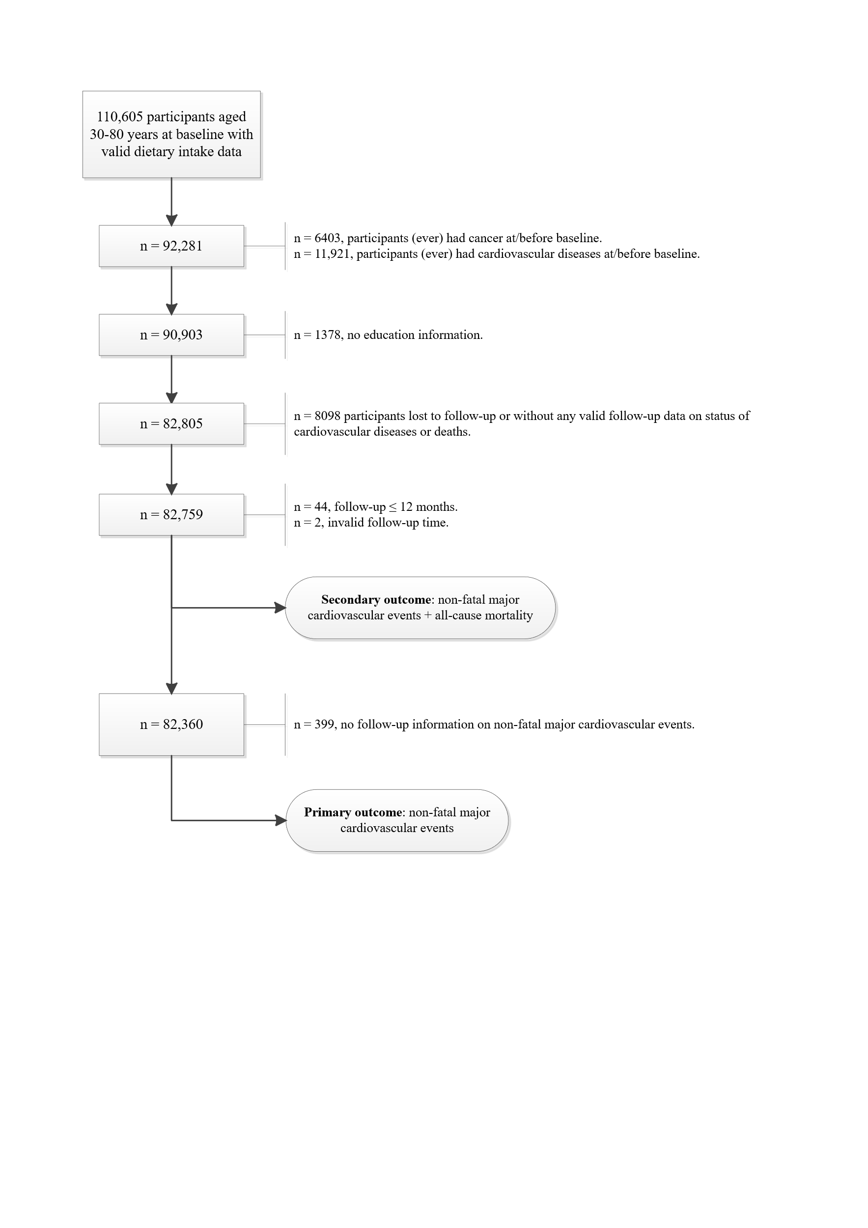

Supplementary Figure S2. Kaplan-Meier survival curve for incident non-fatal major cardiovascular events*
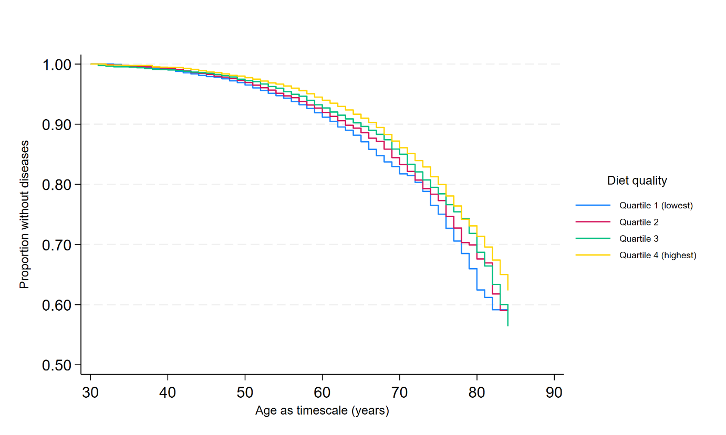
Number at risk table
 | Diet quality (Lifelines Diet Score) quartiles
Age | Q1 (Lowest/poorest) | Q2 | Q3 | Q4 (Highest/best)
35 | 2363 | 2063 | 1715 | 1433
40 | 4162 | 3594 | 3091 | 2759
45 | 5557 | 5326 | 4641 | 4455
50 | 6058 | 6469 | 6074 | 6353
55 | 4023 | 4624 | 4994 | 6133
60 | 2211 | 2959 | 3583 | 5130
65 | 1217 | 1925 | 2706 | 4356
70 | 683 | 1184 | 1806 | 2920
75 | 263 | 517 | 811 | 1324
80 | 75 | 149 | 252 | 376
*Non-adjusted Kaplan-Meier survival estimates, censored at age 85, n = 82,360.

Supplementary Figure S3. Kaplan-Meier survival curve for incident non-fatal major cardiovascular events and all-cause mortality*
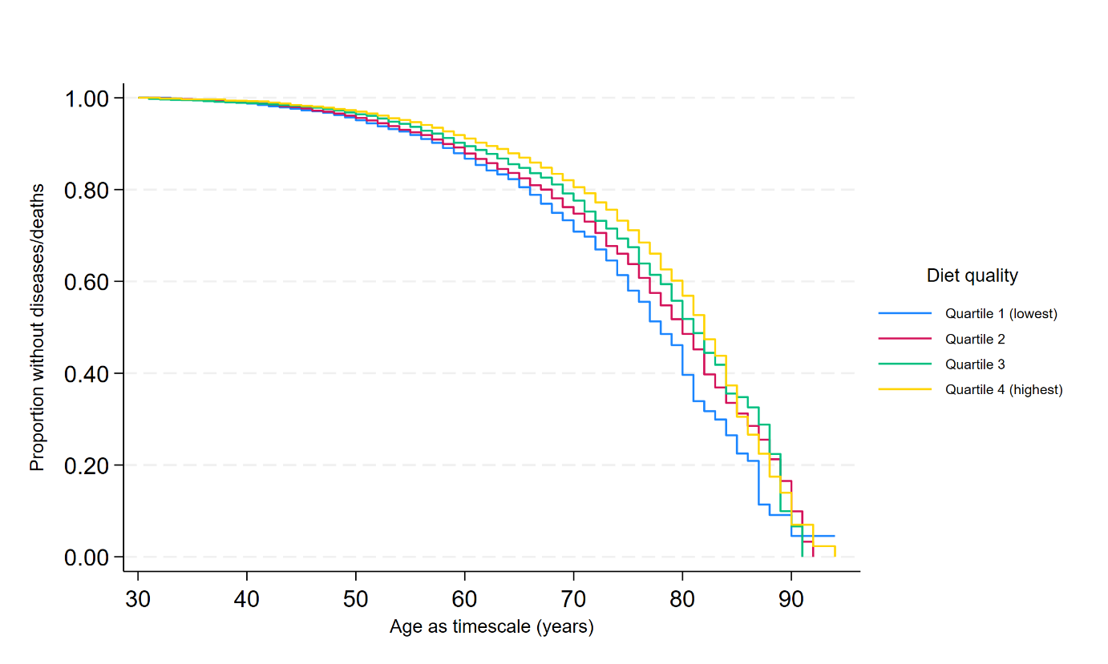
Number at risk table
 | Diet quality (Lifelines Diet Score) quartiles
Age | Q1 (Lowest/poorest) | Q2 | Q3 | Q4 (Highest/best)
35 | 2368 | 2066 | 1718 | 1434
40 | 4180 | 3606 | 3098 | 2766
45 | 5592 | 5360 | 4659 | 4468
50 | 6120 | 6521 | 6126 | 6399
55 | 4101 | 4698 | 5059 | 6210
60 | 2263 | 3021 | 3625 | 5195
65 | 1274 | 1977 | 2758 | 4432
70 | 743 | 1233 | 1885 | 3025
75 | 309 | 558 | 881 | 1408
80 | 107 | 178 | 297 | 459
85 | 20 | 29 | 46 | 71
90 | 2 | 5 | 3 | 8
*Non-adjusted Kaplan-Meier survival estimates, n = 82,759.

Supplementary Figure S4. Associations between Lifelines Diet Score and incident cardiovascular diseases, estimated using restricted cubic splines
(a) Incident non-fatal major cardiovascular events (primary outcome)*
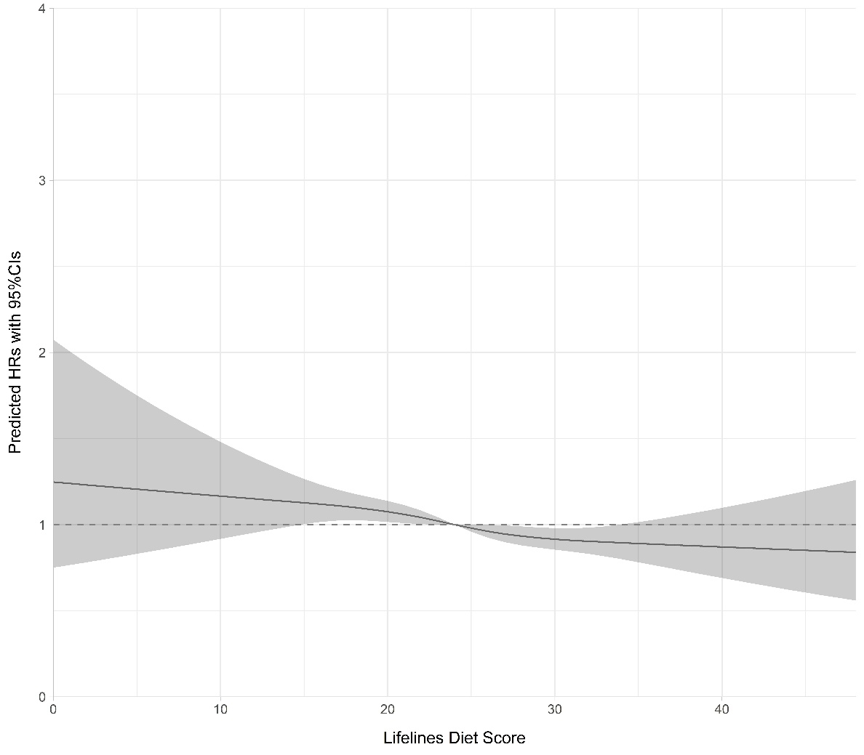
* Predicted HRs (with 95% CI shown as shaded areas) were derived from multivariate Cox proportional hazard models adjusted for age (timescale), sex, Lifelines Diet Score, total energy intake, education, income, total alcohol intake, smoking status, TV watching time, moderate-to-vigorous physical activity, sleep duration, social/hobby clubs participation, chronic stress scores, family history of cardiovascular diseases, and BMI, n = 73,480. Restricted cubic splines for Lifelines Diet Score (4 knots) were used in the model: P-value (Lifelines Diet Score) = 0.005, P-value (non-linearity) = 0.709.

(b) Incident non-fatal major cardiovascular events and all-cause mortality (secondary outcome)†
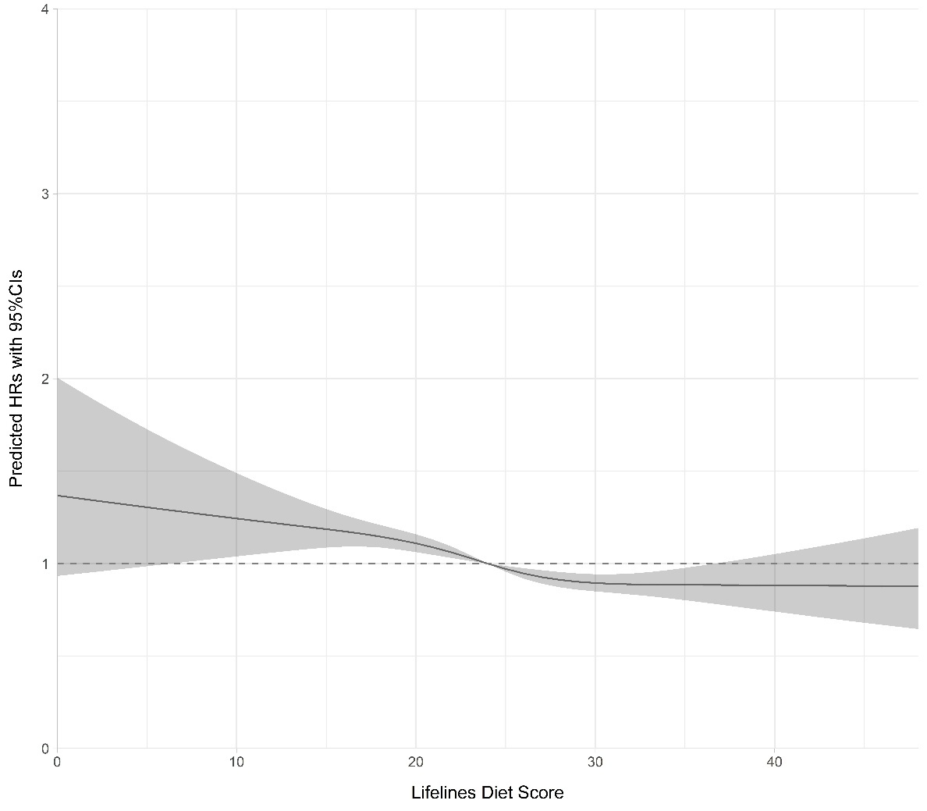
† Predicted HRs (with 95% CI shown as shaded areas) were derived from multivariate Cox proportional hazard models adjusted for age (timescale), sex, Lifelines Diet Score, total energy intake, education, income, total alcohol intake, smoking status, TV watching time, moderate-to-vigorous physical activity, sleep duration, social/hobby clubs participation, chronic stress scores, family history of cardiovascular diseases, and BMI, n = 73,810. Restricted cubic splines for Lifelines Diet Score (4 knots) were used in the model: P-value (Lifelines Diet Score) < 0.001, P-value (non-linearity) = 0.146.

(c) Low education: incident non-fatal major cardiovascular events‡
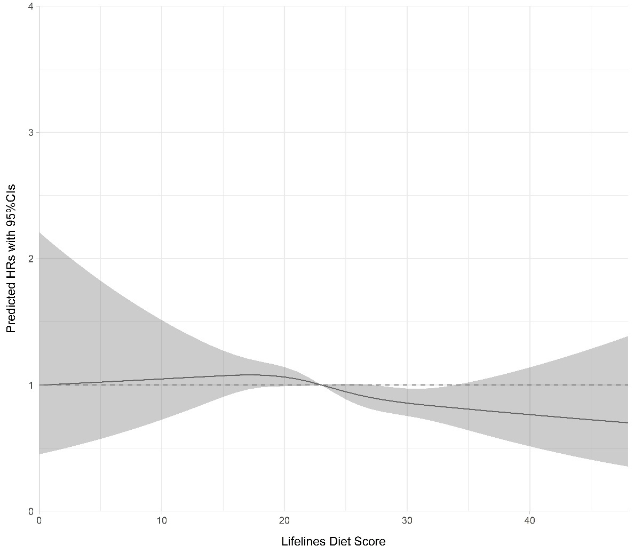
‡ Predicted HRs (with 95% CI shown as shaded areas) were derived from multivariate Cox proportional hazard models adjusted for age (timescale), sex, Lifelines Diet Score, total energy intake, income, total alcohol intake, smoking status, TV watching time, moderate-to-vigorous physical activity, sleep duration, social/hobby clubs participation, chronic stress scores, family history of cardiovascular diseases, and BMI, n = 20,551. Restricted cubic splines for Lifelines Diet Score (4 knots) were used in the model: P-value (Lifelines Diet Score) = 0.055, P-value (non-linearity) = 0.632.

(d) Middle education: incident non-fatal major cardiovascular events§
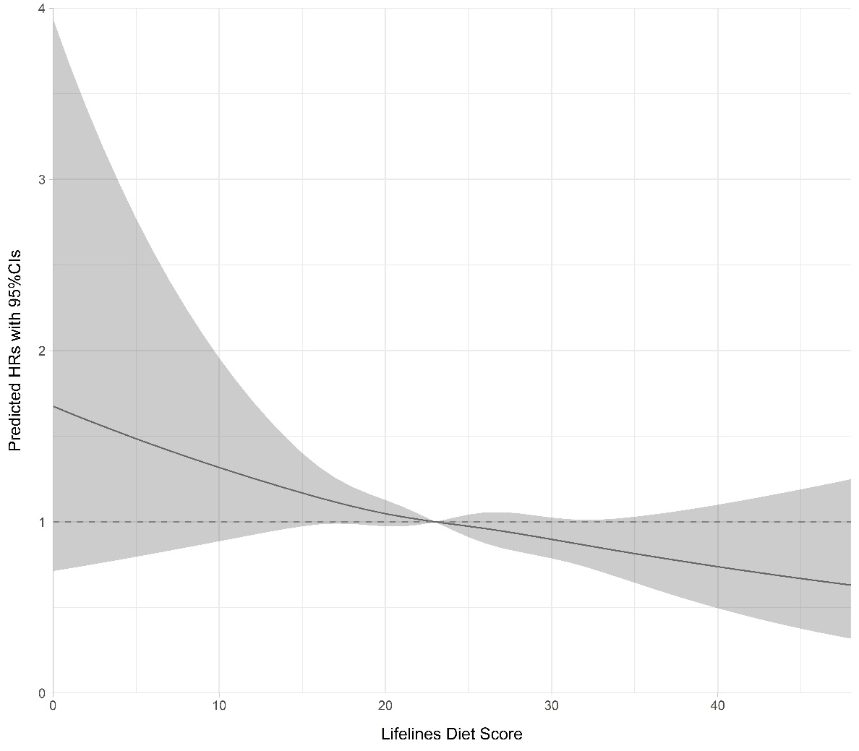
§ Predicted HRs (with 95% CI shown as shaded areas) were derived from multivariate Cox proportional hazard models adjusted for age (timescale), sex, Lifelines Diet Score, total energy intake, income, total alcohol intake, smoking status, TV watching time, moderate-to-vigorous physical activity, sleep duration, social/hobby clubs participation, chronic stress scores, family history of cardiovascular diseases, and BMI, n = 28,735. Restricted cubic splines for Lifelines Diet Score (4 knots) were used in the model: P-value (Lifelines Diet Score) = 0.050, P-value (non-linearity) = 0.958.

(d) High education: incident non-fatal major cardiovascular events||
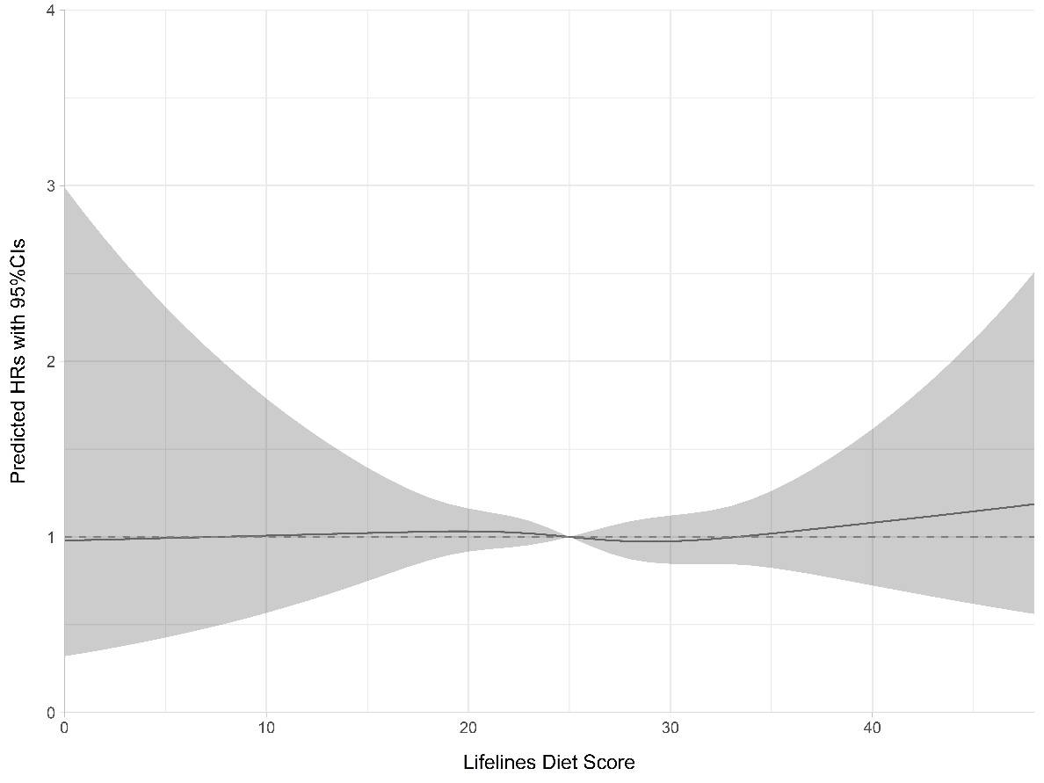
|| Predicted HRs (with 95% CI shown as shaded areas) were derived from multivariate Cox proportional hazard models adjusted for age (timescale), sex, Lifelines Diet Score, total energy intake, income, total alcohol intake, smoking status, TV watching time, moderate-to-vigorous physical activity, sleep duration, social/hobby clubs participation, chronic stress scores, family history of cardiovascular diseases, and BMI, n = 24,194. Restricted cubic splines for Lifelines Diet Score (4 knots) were used in the model: P-value (Lifelines Diet Score) = 0.948, P-value (non-linearity) = 0.843.

