Supporting Information

Environmental and microbial factors shaping SARS-CoV-2 RNA decay in wastewater: insights from batch tests and a lab-scale sewer pipeline simulator
JooAhn Jung^{a,#}, Lan Hee Kim^{b, #}, Sungpyo Kim^{c,*}, Hyun Sik Jun^{a,*}

ªDepartment of Biotechnology and Bioinformatics, College of Science and Technology, Korea University, 2511 Sejong-ro, Sejong city, 30019, Republic of Korea
^{b}Research Institute for Advanced Industrial Technology, Korea University, 2511 Sejong-ro, Sejong city, 30019, Republic of Korea
^{c}Department of Environmental Systems Engineering, Korea University, 2511 Sejong-ro, Sejong city, 30019, Republic of Korea

#These authors contributed equally to this work and share the first authorship.

*Corresponding author.
Sungpyo Kim
Department of Environmental Systems Engineering, Korea University, 2511 Sejong-ro, Sejong city, 30019, Republic of Korea
E-mail: ub1905ub@korea.ac.kr

Hyun Sik Jun
Department of Biotechnology and Bioinformatics, College of Science and Technology, Korea University, Sejong, 30019, Republic of Korea
E-mail: toddjun@korea.ac.kr
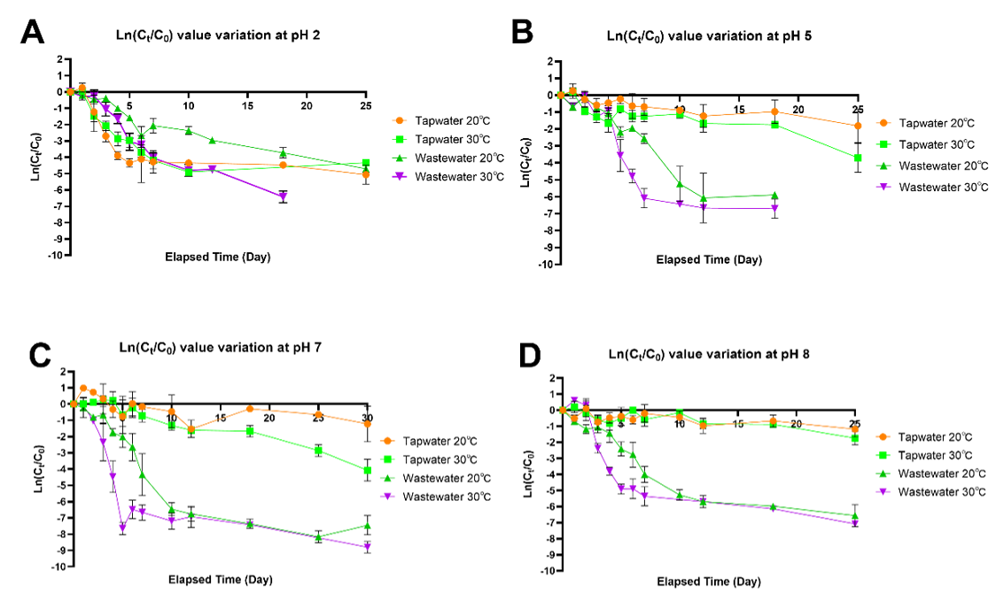
Figure S1. Assessment of HCoV-NL63 virus decay rates under varying physicochemical conditions. (A)–(D) depict the decay rates of HCoV-NL63 in dechlorinated tap water and wastewater, adjusted to pH levels of 2, 5, 7, and 8, at temperatures of 20 °C and 30 °C, over a 25-day period to comprehensively analyze viral stability in different environmental matrices.

Table S1. Viral decay rate in wastewater influent according to Microbial Concentration as biological Factors for 15 days of incubation
Water Matrix | Temperature (℃) | NL63 virus decay rate
Water Matrix | Temperature (℃) | ln(C_{t}/C₀) | k(day⁻¹)
Raw wastewater (WW) | 20 | -4.10 (± 0.21) | 1.72
Raw wastewater (WW) | 30 | -6.90 (± 0.34) | 1.73
10⁻² diluted WW | 20 | -1.83 (± 0.26) | 0.92
10⁻² diluted WW | 30 | -1.78 (± 0.21) | 1.34
10⁻³ diluted WW | 20 | -0.98 (± 0.51) | 0.33
10⁻³ diluted WW | 30 | -0.79 (± 0.15) | 0.27
10⁻⁴ diluted WW | 20 | -0.76 (± 0.18) | 0.25
10⁻⁴ diluted WW | 30 | -1.52 (± 0.22) | 0.51

Table S2. Viral decay rate in wastewater influent according to different concentration of Suspended Solids for 24 h of incubation
SS mg/L | Temperature (℃) | NL63 virus decay rate
SS mg/L | Temperature (℃) | ln(C_{t}/C₀) | k(day⁻¹)
216 | 20 | -1.28 (± 0.19) | 1.28
216 | 30 | -4.00 (± 0.27) | 4.00
134 | 20 | -0.59 (± 0.11) | 0.59
134 | 30 | -3.11 (± 0.41) | 3.11
74 | 20 | 0.30 (± 0.13) | -0.30
74 | 30 | -2.77 (± 0.60) | 2.77
Blank | 20 | 1.00 (± 0.56) | -1.00
Blank | 30 | -1.52 (± 0.22) | -0.37

Table S3. Viral decay rate in wastewater influent by Suspended Solids and Microbes in wastewater for 30 days of incubation at 30 ℃
Water Matrix | NL63 virus decay rate
Water Matrix | ln(C_{t}/C₀) | k(day⁻¹)
Raw wastewater | -7.06 (± 0.95) | 1.77
GF/C filtered wastewater | -4.48 (± 0.26) | 1.12
GF/C filtered and 0.1% NaN₃-treated wastewater | -1.04 (± 0.22) | 0.52
0.1% NaN₃-treated wastewater | -2.81 (± 0.58) | 0.47

Table S4. Viral decay rate in wastewater influent by Lab-scale sewer pipeline system for 23 days of incubation at 25 ℃
Water Matrix | NL63 virus decay rate
Water Matrix | ln(C_{t}/C₀) | k(day⁻¹)
Raw wastewater | -7.06 (± 0.95) | 1.77
GF/C filtered wastewater | -4.48 (± 0.26) | 1.12
GF/C filtered and 0.1% NaN₃-treated wastewater | -1.04 (± 0.22) | 0.52
0.1% NaN₃-treated wastewater | -2.81 (± 0.58) | 0.47

Table S5. Comparison of qPCR Ct values for HCoV-NL63 stock Before and After long-term storage at -80 ℃
Storage Condition | Ct (Mean ± SEM) | t-value | p-value | 95% CI
Before storage | 10.42 ± 0.20 | - | - | -
After 1 year at -80 ℃ | 10.77 ± 0.15 | 1.456 | 0.2827 | -0.6844 to 1.384
Abbreviations: HCoV-NL63 = Human Coronavirus NL63, SEM = Standard Error of the Mean, CI = Confidence Interval.

