Enantioselective adsorption of limonenes and α-pinenes on germanium oxide metal-organic framework
Yulia F. Sharafutdinovaª, Klavdia M. Sufiyarovaª, Adelina S. Samarinaª, Diana O. Bagdanova^{b}, Marat R. Agliullin^{b}, Timur A. Mukhametzyanov^{c} and Vladimir Yu. Guskovª

- Ufa University of Science and Technology, 32 Zaki Validi str., Ufa, Russia.
- Institute of Petrochemistry and Catalysis RAS, 141 Oktyabrya av., Ufa, Russia
- A.M. Butlerov Chemical Institute, Kazan Federal University, Kremlevskaya Str. 18, Kazan 420008, Russia

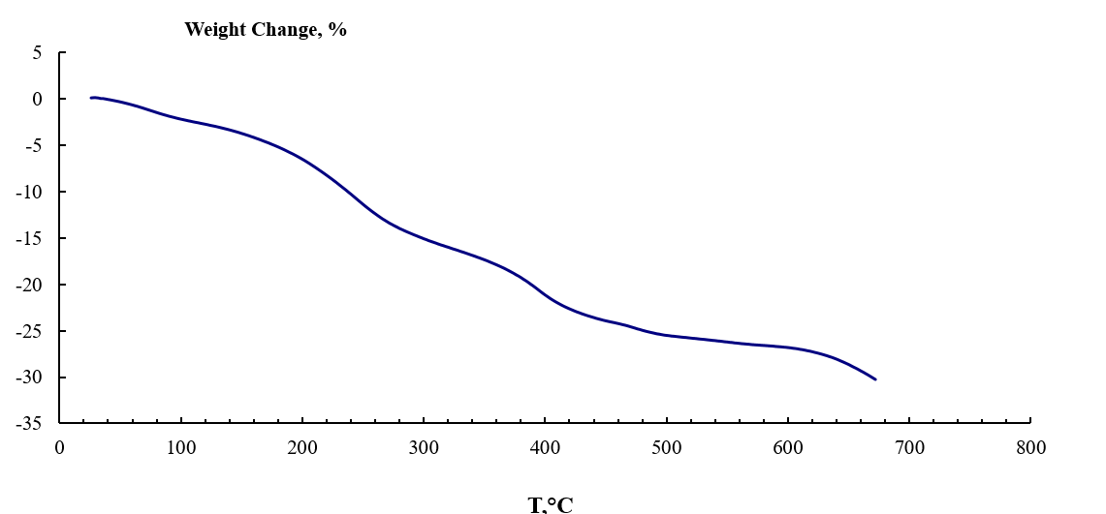
Figure 1S. MOF mass losses with temperature

Figure 2S. DSC curve
Figure 3S. Limonene enantiomers vapors adsorption isotherms at 130 °C

Table 1S. P-values for pairs of points of limonenes vapors adsorption at 130 °C (α = 0.05)
P, Pa | р | P, Pa | р | P, Pa | р
35 | 0.0006 | 261.6 | 0.0321 | 523.3 | 0.0061
558.3 | 0.011 | 784.9 | 0.0008 | 819.9 | 0.0009
854.9 | 0.0009 | 890.0 | 0.0008 | 925.0 | 0.0008
Figure 4S. Limonene enantiomers vapors adsorption isotherms at 140 °C

Table 2S. P-values for pairs of points of limonenes vapors adsorption at 140 °C (α = 0.05)
P, Pa | р | P, Pa | р | P, Pa | р
361.3 | 0.0336 | 409.6 | 0.8245 | 722.6 | 0.0048
770.9 | 0.016 | 819.3 | 0.0306 | 1132.2 | 0.0006
1180.6 | 0.0008 | 1228.9 | 0.0007 | 1277.3 | 0.0006

Figure 5S. Limonene enantiomers vapors adsorption isotherms at 150 °C

Table 3S. P-values for pairs of points of limonenes vapors adsorption at 150 °C (α = 0.05)
P, Pa | р | P, Pa | р | P, Pa | р
438.5 | 0.021 | 876.9 | 0.0022 | 944.8 | 0.0229
1315.4 | 0.0003 | 1384.2 | 0.0001 | 1686.0 | 0.00001
1753.9 | 0.00001 | 1821.7 | 0.00001 | 1889.6 | 0.00001

Figure 6S. α-pinene enantiomers vapors adsorption isotherms at 90 °C (first measurement)

Table 4S. P-values for pairs of points of α-pinenes vapors adsorption at 90 °C (α = 0.05, first measurement)
P, Pa | р*10⁵ | P, Pa | р*10⁵ | P, Pa | р*10⁵
33.1 | 0.2746 | 113 | 0.329 | 146.1 | 0.1632
179.2 | 0.0651 | 226.1 | 0.0529 | 245.4 | 0.0092
292.3 | 0.0041 | 325.4 | 0.0015 | 339.1 | 0.0015

Figure 7S. α-pinene enantiomers vapors adsorption isotherms at 90 °C (second and further measurements)

Table 5S. P-values for pairs of points of α-pinenes vapors adsorption at 90 °C (α = 0.05, second and further measurements)
P, Pa | р*10⁵ | P, Pa | р*10⁵ | P, Pa | р*10⁵
0.04 | 0.0016 | 0.16 | 0.0016 | 0.64 | 0.0168
0.68 | 0.0113 | 0.76 | 0.0061 | 0.80 | 0.0046
0.96 | 0.0016 | 0.99 | 0.0013 | 1.03 | 0.0011

Figure 8S. α-pinene enantiomers vapors adsorption isotherms at 100 °C

Table 6S. P-values for pairs of points of α-pinenes vapors adsorption at 100 °C (α = 0.05)
P, Pa | р*10⁵ | P, Pa | р*10⁵ | P, Pa | р*10⁵
40.9 | 0.0295 | 98.8 | 0.2768 | 156.6 | 0.1038
197.5 | 0.0105 | 255.3 | 0.0041 | 296.3 | 0.002
337.2 | 0.0003 | 354.1 | 0.0005 | 395.0 | 0.0002

Figure 9S. α-pinene enantiomers vapors adsorption isotherms at 120 °C

Table 6S. P-values for pairs of points of α-pinenes vapors adsorption at 120 °C (α = 0.05)
P, Pa | р*10⁵ | P, Pa | р*10⁵ | P, Pa | р*10⁵
13.7 | 0.0011 | 102 | 0.0006 | 142.9 | 0.001
170.2 | 0.0014 | 258.6 | 0.0002 | 285.8 | 0.0001
299.5 | 0.0001 | 374.2 | 0.00004 | 387.8 | 0.00001

Figure 10S. α-pinene enantiomers vapors adsorption isotherms at 130 °C

Table 6S. P-values for pairs of points of α-pinenes vapors adsorption at 130 °C (α = 0.05)
P, Pa | р*10⁵ | P, Pa | р*10⁵ | P, Pa | р*10⁵
18.5 | 0.0329 | 96.7 | 0.0455 | 115.2 | 0.1429
133.6 | 0.2777 | 152.1 | 0.3806 | 239.5 | 0.1548
248.8 | 0.2044 | 258 | 0.2291 | 267.2 | 0.2956

